Supporting Information
Synthesis of densely substituted pyridine derivatives from nitriles by a non-classical [4+2] cycloaddition/1,5-hydrogen shift strategy
Dandan He, Kanghui Duan, Yang Zhou, Meng Li, Huanfeng Jiang*, Wanqing Wu*
State Key Laboratory of Luminescent Materials and Devices, School of Chemistry and Chemical Engineering, South China University of Technology, Guangzhou 510641, China
E-mail: cewuwq@scut.edu.cn

Contents
General Information………………………………….……………………….…....S2
Condition Optimization...…………………………………….……………….…....S2
General Experimental Procedure……………………………………….……..…..S3
References………………………………………….……………………………......S8
Mechanistic Studies.…………...................................................................................S9
Photophysical Spectra of Compounds 8 and 9.…………………………..….......S15
Characterization Data for Substrates and All Products………...……..…….….S16
X-ray Crystallographic Analysis for Product 3i....................................................S36
NMR Spectra for All the Compounds……………………………………..……..S37

General Information
Melting points were determined with a Buchi Melting Point B-545 instrument. ¹H and ¹³C NMR spectra were recorded using a Bruker DRX-400 spectrometer or Bruker DRX-500 spectrometer using Chloroform-d or DMSO-d₆ as solvent. The peaks were internally referenced to TMS (0.00 ppm) or residual solvent signals (7.26 and 77.0 ppm for Chloroform-d, and 2.50 and 40.0 ppm for DMSO-d₆). IR spectra were obtained either as potassium bromide pellets or as liquid films between two potassium bromide pellets with a Bruker TENSOR 27 spectrometer. The data of HRMS was carried out on a high-resolution mass spectrometer (LCMSIT-TOF). TLC was performed by using commercially prepared 100-400 mesh silica gel plates and visualization was effected at 254 nm. Absorption spectra were measured on a Shimadzu UV-2600 spectrophotometer. Photoluminescence spectra were obtained on a Horiba Fluoromax-4 spectrofluorometer. Unless otherwise noted, all reagents and solvents were purchased from commercial suppliers and used without further purification.

Condition Optimization
Table S1. Optimization of the reaction conditionsª
Entryª | Base | Additive | T/ºC | Solvent | Time/h | Yield of 3a (%) | Yield of recovered 1a (%)
1 | LiN(SiMe₃)₂ | t-BuOK | 100 | THF | 12 | 35 | 62
2 | KN(SiMe₃)₂ | t-BuOK | 100 | THF | 12 | 23 | 71
3 | NaN(SiMe₃)₂ | t-BuOK | 100 | THF | 12 | 25 | 75
4 | LiN(SiMe₃)₂ | t-BuOK | 110 | THF | 12 | 50 | 34
5 | LiN(SiMe₃)₂ | t-BuOK | 120 | THF | 12 | 55 | 22
6 | LiN(SiMe₃)₂ | t-BuOK | 130 | THF | 12 | 51 | 14
7 | LiN(SiMe₃)₂ | - | 120 | THF | 12 | trace | 96
8 | - | t-BuOK | 120 | THF | 12 | trace | 95
9 | LiN(SiMe₃)₂ | t-BuONa | 120 | THF | 12 | 43 | 40
10 | LiN(SiMe₃)₂ | Cs₂CO₃ | 120 | THF | 12 | 27 | 68
11 | LiN(SiMe₃)₂ | CsF | 120 | THF | 12 | 51 | 35
12 | LiN(SiMe₃)₂ | t-BuOK | 120 | cyclohexane | 12 | 55 | 8
13 | LiN(SiMe₃)₂ | t-BuOK | 120 | 1,4-dioxane | 12 | 54 | 22
14 | LiN(SiMe₃)₂ | t-BuOK | 120 | CPME | 12 | 57 | 26
15 | LiN(SiMe₃)₂ | t-BuOK | 120 | butyl oxide | 12 | 34 | 43
16 | LiN(SiMe₃)₂ | t-BuOK | 120 | DME | 12 | 52 | 12
17 | LiN(SiMe₃)₂ | t-BuOK | 120 | CPME | 24 | 65 | 14
ª All reactions were performed with 1a (0.2 mmol), 2a (2 equiv), base (2 equiv), additive (2 equiv), solvent (1 mL, Dry) at 100~130 ºC under N₂ for 12 or 24 h. Yield was determined by ¹H-NMR with CH₃NO₂ as internal standard based on 1a. CPME = cyclopentyl methyl ether; DME = 1,2-dimethoxyethane.

Table S2. Quantitative optimization studyª
Entryª | 1a/2a/LiN(SiMe₃)₂/t-BuOK | Yield of 3a (%) | Yield of recovered 1a (%)
1 | 1:2:2:2 | 65 | 14
2 | 1:1.5:2:2 | 38 | 60
3 | 1:1:2:2 | 15 | 80
4 | 1:0.5:2:2 | trace | 97
5 | 1:2.5:2:2 | 67 | 19
6 | 1:3:2:2 | 70 | 8
7 | 1:4:2:2 | 71 | 10
8 | 1:3:1.5:2 | 57 | 20
9 | 1:3:2.5:2 | 62 | 6
10 | 1:3:2:1.5 | 84 (80) | n.d.
11 | 1:3:2:1.2 | 81 | n.d.
12 | 1:3:2:1 | 73 | 9
ª All reactions were performed with different molar ratios of 1a/2a/base/additive, solvent (1 mL, dry) at 120 ºC under N₂ for 24 h; Yield was determined by ¹H-NMR with CH₃NO₂ as internal standard based on 1a. n.d. = not detected.
General Experimental Procedure
- General Procedure for the Preparation of Compound 1
A mixture of o-substituted iodobenzene M₁ (2 mmol), CuI (2 mol %), Pd(PPh₃)₂Cl₂ (1 mol %), and Et₃N (5 mL) was added successively under N₂ and then alkyne M₂ (2.4 mmol) was added via syringe. The mixture was stirred at room temperature for 5-10 h and monitored periodically by TLC. Upon completion, the reaction mixture was diluted with water (10 mL) and extracted with ethyl acetate (10 mL × 3). The combined organic layers were washed with water and brine, dried over Na₂SO₄, and filtered. The solvent was removed under vacuum. The residue was purified by chromatography on silica gel (petroleum ether/ethyl acetate 200:1~100:1 v/v).

Table S3. The structure of compounds 1a-1i,^{[1-7]} 1j, 1k, 1l-1o^{[8-10]}

- General Procedure for the Preparation of Compound 4
The synthesis of 4:^{[11]} 2-Methylbenzo[b]thiophene (N₁, 3 mmol), DMSO, and NH₄I in ethyl acetate (10 mL) were added conc. H₂SO₄ at room temperature under air. The mixture was stirred at 60 ºC and monitored by TLC. After cooling down to room temperature, the residue was concentrated in vacuum and purified by chromatography on silica gel (petroleum ether) to afford compound N₂. Then product 4 was obtained from N₂ according to procedure A.

- General Procedure for the Preparation of Enyne 6^{[12]}
A mixture of cis-1-bromo-1-propene (1.2 g, 10 mmol), Pd(PPh₃)₄ (57.7 mg, 0.05 mmol, 0.5 mol %), and CuI (38 mg, 0.2 mmol, 2 mol %) in Et₂NH (6 mL), cooled in an ice-bath, was added phenylacetylene (1.22 g, 12 mmol). Then the temperature was raised to room temperature and stirred for 12 h. The reaction mixture was diluted with water (10 mL) and extracted with ethyl acetate (10 mL × 3). The combined organic layers were washed with water and brine, dried over Na₂SO₄, and filtered. The solvent was removed under vacuum. The residue was purified by chromatography on silica gel (petroleum ether) to give (Z)-5-phenyl-pent-2-en-4-yne (6, 1.32 g, 93%).

- General Procedure for the Synthesis of Pyridine Derivatives
In a glovebox, an oven-dried Schlenk tube equipped with a magnetic stirring bar was added a mixture of o-substituted aryl alkyne 1 (0.2 mmol), nitrile 2 (0.6 mmol), base (0.4 mmol), additive (0.3 mmol) dissolved in 1.0 mL of dry CPME. The Schlenk tube was sealed with a plug and removed from the glovebox. The mixture was allowed to stir at 120 °C under N₂ for 24 h. The reaction mixture was cooled to room temperature and quenched by 10 mL water. The product was extracted with ethyl acetate (10 mL × 3). The organic phase was dried over Na₂SO₄ and concentrated in vacuum. The resulting residue was purified by silica gel column chromatography using petroleum ether/ethyl acetate (100:1-10:1 v/v) as eluent to afford the corresponding product 3.

In a glovebox, an oven-dried Schlenk tube equipped with a magnetic stirring bar was added a mixture of o-substituted aryl alkyne 4 (0.2 mmol), nitrile 2 (0.6 mmol), base (0.4 mmol), additive (0.24 mmol) dissolved in 0.5 mL of dry CPME. The Schlenk tube was sealed with a plug and removed from the glovebox. The mixture was allowed to stir at 120 °C under N₂ for 24 h. The reaction mixture was cooled to room temperature and quenched by 10 mL water. The product was extracted with ethyl acetate (10 mL × 3). The organic phase was dried over Na₂SO₄ and concentrated in vacuum. The resulting residue was purified by silica gel column chromatography using petroleum ether/ethyl acetate (100:1-10:1 v/v) as eluent to afford the corresponding product 5.

In a glovebox, an oven-dried Schlenk tube equipped with a magnetic stirring bar was added a mixture of 1-methyl-1,3-enyne 6 (0.2 mmol), nitrile 2 (0.6 mmol), base (0.4 mmol), additive (0.24 mmol) dissolved in 0.5 mL of dry 1,4-dioxane. The Schlenk tube was sealed with a plug and removed from the glovebox. The mixture was allowed to stir at 120 °C under N₂ for 12 h. The reaction mixture was cooled to room temperature and quenched by 10 mL water. The product was extracted with ethyl acetate (10 mL × 3). The organic phase was dried over Na₂SO₄ and concentrated in vacuum. The resulting residue was purified by silica gel column chromatography using petroleum ether/ethyl acetate (100:1-50:1 v/v) as eluent to afford the corresponding product 7.

- General Procedure for the Synthesis of 1c-d^{[13, 14]}
Under N₂ atmosphere, the solution of S₁ (4.45 g, 17 mmol) in dry THF (10 mL) was added to a suspension solution of LiAlD₄ (588 mg, 14 mmol) in dry THF (20 mL). The mixture was stirred at room temperature for 6 h. After the reaction was completed, the wet THF was added dropwise to quench the reaction, followed by the addition of 1.4 mL of 10% NaOH aq. The white solid was appeared, then filtered and dried by anhydrous MgSO₄. The solvent was removed by vacuum and the residue was purified by column chromatography to give a white solid S₂ (3.41 g, 85% yield). ¹H NMR (400 MHz, CDCl₃) δ ppm 7.83 – 7.79 (m, 1H), 7.45 – 7.41 (m, 1H), 7.38 – 7.32 (m, 1H), 7.02 – 6.95 (m, 1H), 2.40 (s, 1H).

To a solution of S₂ (3.41 g, 14.5 mmol), PPh₃ (4.6 g, 17.4 mmol) in 40 mL of dry CH₂Cl₂, N-bromosuccinimide (NBS, 3.1 g, 17.4 mmol) was added with several potions at 0 ºC. The mixture was stirred overnight at room temperature. After the reaction was finished, the petroleum ether (100 mL) was added to the mixture solution, and the solid was filtered. The solvent was removed by vacuum, and the residue was purified by column chromatography to afford a white solid S₃ (3.02 g, 70% yield). ¹H NMR (400 MHz, CDCl₃) δ ppm 7.87 – 7.83 (m, 1H), 7.49 – 7.45 (m, 1H), 7.36 – 7.30 (m, 1H), 7.01 – 6.95 (m, 1H).

Under N₂ atmosphere, a mixture of S₃ (3.02 g, 10 mmol) and LiAlD₄ (0.21 g, 5 mmol) dissolved in THF (6 mL) was added in an oven-dried 25 mL Schlenk tube. The reaction was stirred at 50 ºC overnight. Then the reaction was quenched cautiously with water and the ether layer dried (MgSO₄). The solvent was removed by vacuum and residue was purified by column chromatography to give a colorless oil S₄ (1.33 g, 60% yield). ¹H NMR (400 MHz, CDCl₃) δ ppm 7.81 (d, J = 7.6 Hz, 1H), 7.29 – 7.19 (m, 2H), 6.91 – 6.82 (m, 1H).
A mixture of S₄ (1.33 g, 6 mmol), CuI (23 mg, 2 mol %), PdCl₂(PPh₃)₂ (42 mg, 1 mol %), and Et₃N (10 mL) was added successively to a Schlenk tube equipped with a magnetic stirring bar under N₂. Then 1-ethynyl-4-methoxybenzene (0.95 g, 7.2 mmol) was added via syringe. The mixture was stirred at room temperature for 6 h and monitored periodically by TLC. Upon completion, the reaction mixture was diluted with water (30 mL) and extracted with ethyl acetate (30 mL × 3). The combined organic layers were washed with water and brine, dried over Na₂SO₄, and filtered. The solvent was removed under vacuum. The residue was purified by chromatography on silica gel (petroleum ether/ethyl acetate 100:1 v/v) to give a white solid 1c-d (1.22 g, 90% yield). ¹H NMR (400 MHz, CDCl₃) δ ppm 7.55 – 7.44 (m, 3H), 7.25 – 7.21 (m, 2H), 7.21 – 7.14 (m, 1H), 6.95 – 6.83 (m, 2H), 3.84 (s, 3H).

- General Procedure for the Synthesis of 8 and 9
The synthesis of 8:^{[15]} Under N₂ atmosphere, a mixture of Pd(dppf)Cl₂ (7 mg, 0.01 mmol), vinylboronate (86 mg, 0.2 mmol), 5f (206 mg, 0.48 mmol), Cs₂CO₃ (196 mg, 0.6 mmol), H₂O (40 µL, 2.2 mmol) and dioxane (3 mL) was added to a Schlenk tube equipped with a magnetic stirring bar. Then the solution was stirred at 70 °C for 24 h. The mixture was allowed to cool to room temperature and diluted with CH₂Cl₂ (10 mL). The resulting solution was washed with saturated aqueous NH₄Cl (10 mL). The aqueous layer was extracted with CH₂Cl₂ (20 mL × 3). The combined organic layer was dried over anhydrous Na₂SO₄ and concentrated in vacuo. The residue was purified by silica gel chromatography to afford the desired product 8 (105 mg, 60% yield).

The synthesis of 9:^{[16, 17]} To a round-bottom flask containing the acetal 5n (1 mmol) in chloroform (2 mL) was slowly added trifluoroacetic acid (6 equiv) at ambient temperature. The resulting solution was allowed to stir for 20 h, and then the mixture was quenched with water (10 mL) and extracted with EtOAc (10 mL × 3). The organic layer was washed with brine and dried over MgSO₄. The desired aldehyde was obtained directly after the removal of solvent in vacuo. Next, malononitrile (1 mmol) was added to a stirred solution of aldehyde (1 mmol) and piperidine (0.1 mmol) in ethanol (3 mL). The reaction mixture was stirred at room temperature for 1 h. A precipitate was formed and collected by suction filtration, and then purified by recrystallization from CH₂Cl₂ and petroleum ether to afford product 9 (406 mg, 95% yield).
References
[1] N. Kakusawa, K. Yamaguchi, J. Kurita, J. Organomet. Chem. 2005, 690, 2956.
[2] J. Moon, M. Jeong, H. Nam, J. Ju, J. H. Moon, H. M. Jung, S. Lee, Org. Lett. 2008, 10, 945.
[3] R. Bernini, S. Cacchi, G. Fabrizi, G. Forte, F. Petrucci, A. Prastaro, S. Niembro, A. Shafird, A. Vallribera, Green Chem. 2010,12, 150.
[4] C. I. Ezugwu, B. Mousavi, M. A. Asraf, Z. Luo, F. Verpoort, J. Catal. 2016, 344, 445.
[5] Y. Yuan, H. Zhu, D. Zhao, L. Zhang, Synthesis 2011, 1792.
[6] L. Liu, W.-Q. Yu, T. Huang, T. Chen, Tetrahedron Lett. 2020, 61, 151647.
[7] J. Park, K. H. Song, S. Lee, Synthesis 2018, 50, 3197.
[8] L.-L. Chen, J.-W. Zhang, W.-W. Yang, J.-Y. Fu, J.-Y. Zhu, Y.-B. Wang, J. Org. Chem. 2019, 84, 12, 8090.1l
[9] K. Sprenger, C. Golz, M. Alcarazo, Eur. J. Org. Chem. 2020, 6245.
[10] D. Domyati, R. Latifi, L. Tahsini, J. Organomet. Chem. 2018, 860, 98.
[11] S. Song, X. Sun, X. Li, Y. Yuan, N. Jiao, Org. Lett. 2015, 17, 2886.
[12] B. Kang, D. Kim, Y. Do, S. Chang, Org. Lett. 2003, 5, 3041.
[13] R. P. Hanzlik, A. R. Schaefer, J. B. Moon, C. M. Judson, J. Am. Chem. Soc. 1987, 109, 4926.
[14] X. Qi, P. Chen, G. Liu, Angew. Chem. Int. Ed. 2017, 56, 9517.
[15] M. Zhang, Y, Yao, P. J. Stang, W. Zhao, Angew. Chem. Int. Ed. 2020, 59, 20090.
[16] W. Li, J. Li, Y. Wu, N. Fuller, M. A. Markus, J. Org. Chem. 2010, 75, 1077.
[17] J.-R. Xin, J.-T. Guo, D. Vigliaturo, Y.-H. He, Z. Guan, Tetrahedron 2017, 73, 4627.

Mechanistic Studies
¹⁵N-Labling Experiment
Figure S1. HRMS analysis of ¹⁵N-labling experiment

Hammett Studies
In a glovebox, an oven-dried Schlenk tube was charged with 4a (0.1 mmol), several electronically different benzonitriles (0.3 mmol), LiN(SiMe₃)₂ (0.2 mmol), t-BuOK (0.12 mmol) and 0.25 mL CPME. The Schlenk tube was sealed with a plug and removed from the glovebox. All the tubes were allowed to stir at 120 °C under N₂. The progress of the reaction was analyzed by ¹H-NMR with CH₃NO₂ as internal standard. Reactivity towards the cycloaddition from nitrile follows the sequence: p-OMe > p-Me > p-H > p-Cl > p-CF₃. The corresponding results are summarized in the following table.

Table S4. Hammett Analysis with the para-Substitution Constant (σ_{P})
Substrate | K x 10⁻³ (min⁻¹) | K_{X}/K_{H} | Lg(K_{X}/K_{H}) | σ | ρ
4-Methoxy benzonitrile | 415.9 | 4.8025 | 0.6815 | -0.268 | -2.95
4-Methyl benzonitrile | 223.9 | 2.5855 | 0.4125 | -0.17 | -2.95
Benzonitrile | 86.6 | 1 | 0 | 0 | -2.95
4-Chloro benzonitrile | 3.7 | 0.0427 | -1.3696 | 0.227 | -2.95
4-Trifluoromethyl benzonitrile | 2.9 | 0.0335 | -1.4750 | 0.54 | -2.95
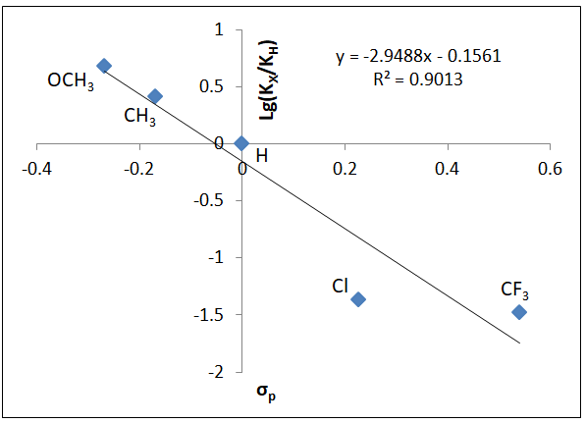
Figure S2. Hammett plot for the cycloaddition

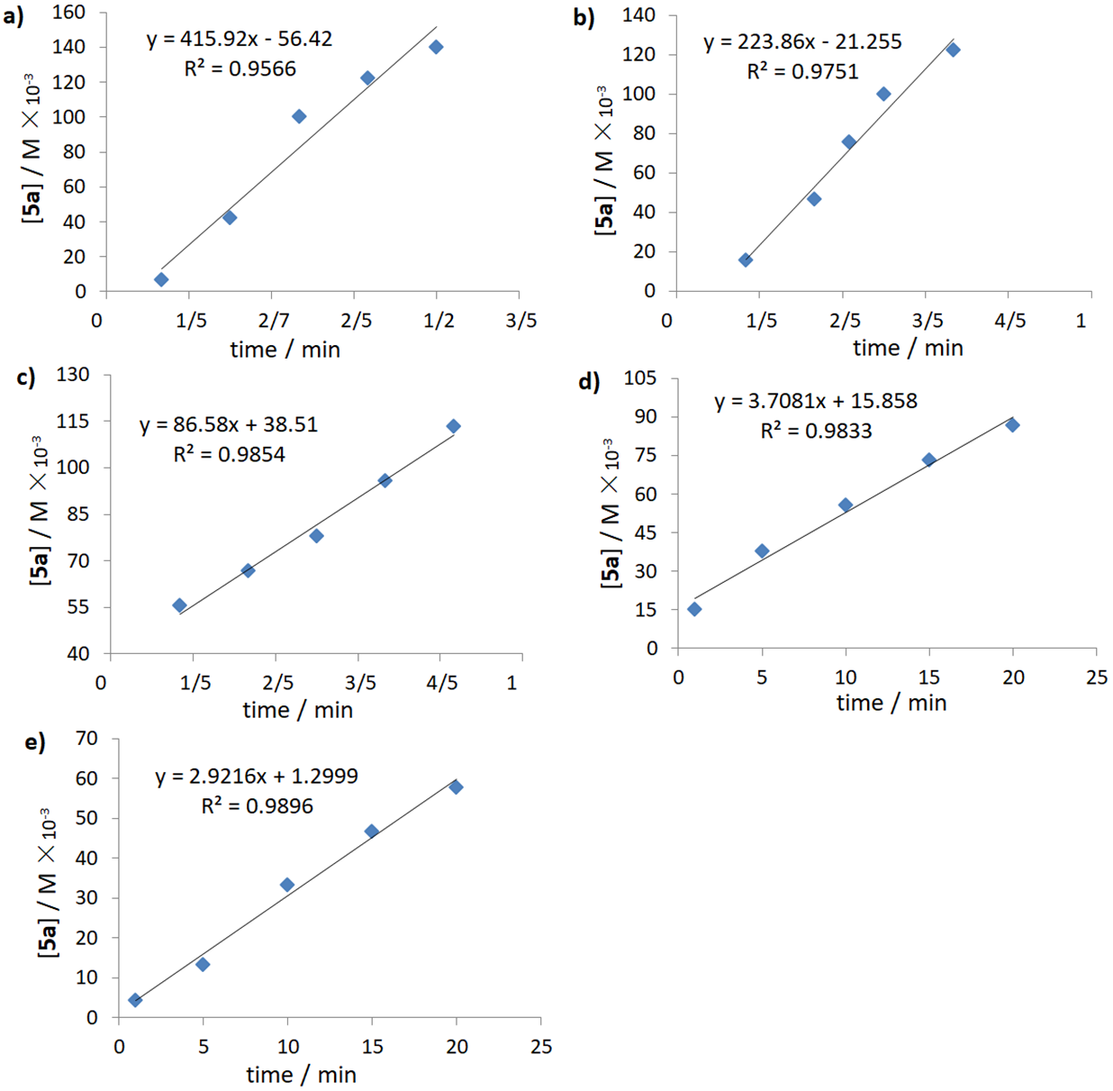
Figure S3. Determination of rate constant for the electronically different nitriles during the cycloaddition process: a) R = OCH₃; b) R = CH₃; c) R = H; d) R = Cl; e) R = CF₃.

Kinetic Studies
The kinetic profile of the reaction was studied by obtaining initial rates of the reaction with different concentrations of 1c, 2a, LiN(SiMe₃)₂, and t-BuOK. The rates were monitored by ¹H-NMR analysis using CH₃NO₂ as an internal standard.

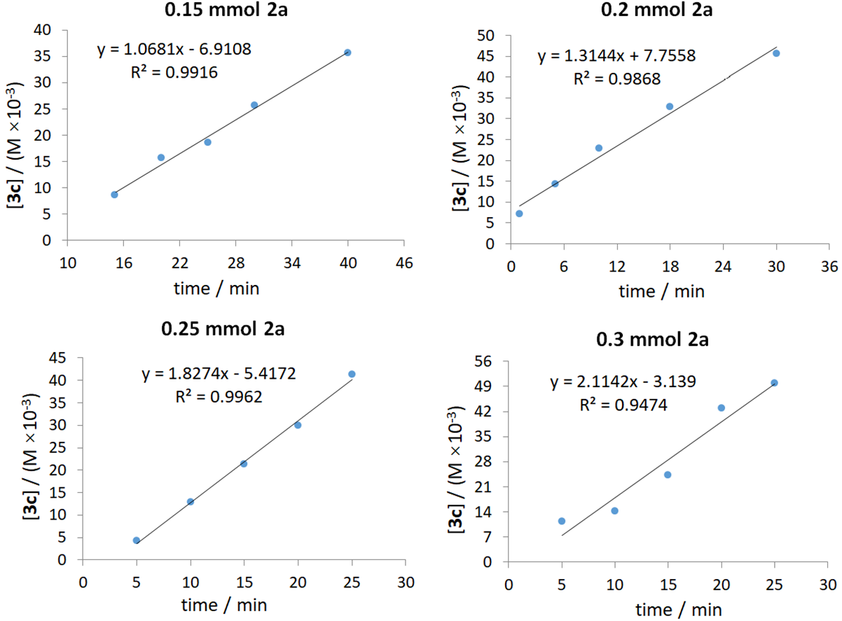
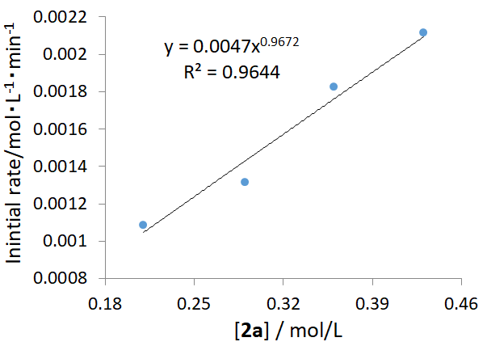
2a / mmol | [2a] / (mol▪L⁻¹) | K (mol▪L⁻¹min⁻¹)
0.15 | 0.21 | 0.0010857
0.2 | 0.29 | 0.0013144
0.25 | 0.36 | 0.0018274
0.3 | 0.43 | 0.0021142

Figure S4. Dependence of the reaction rate on concentration of 2a

Kinetic profiles of different initial concentrations of 2a (from 0.15 mmol to 0.3 mmol). Reaction conditions: 1c (0.1 mmol), LiN(SiMe₃)₂ (0.2 mmol, 1.0 M in THF), t-BuOK (0.15 mmol), carried out in 0.5 mL of CPME at 120 °C.

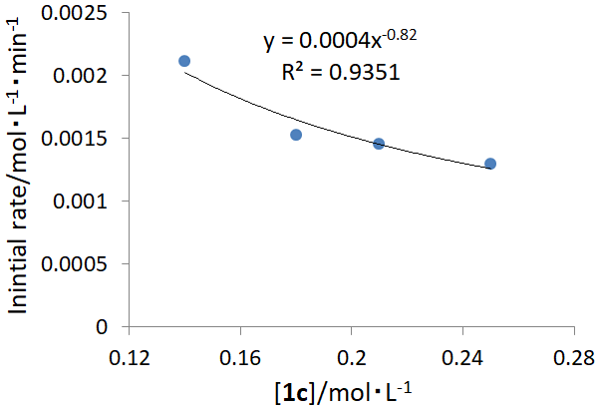
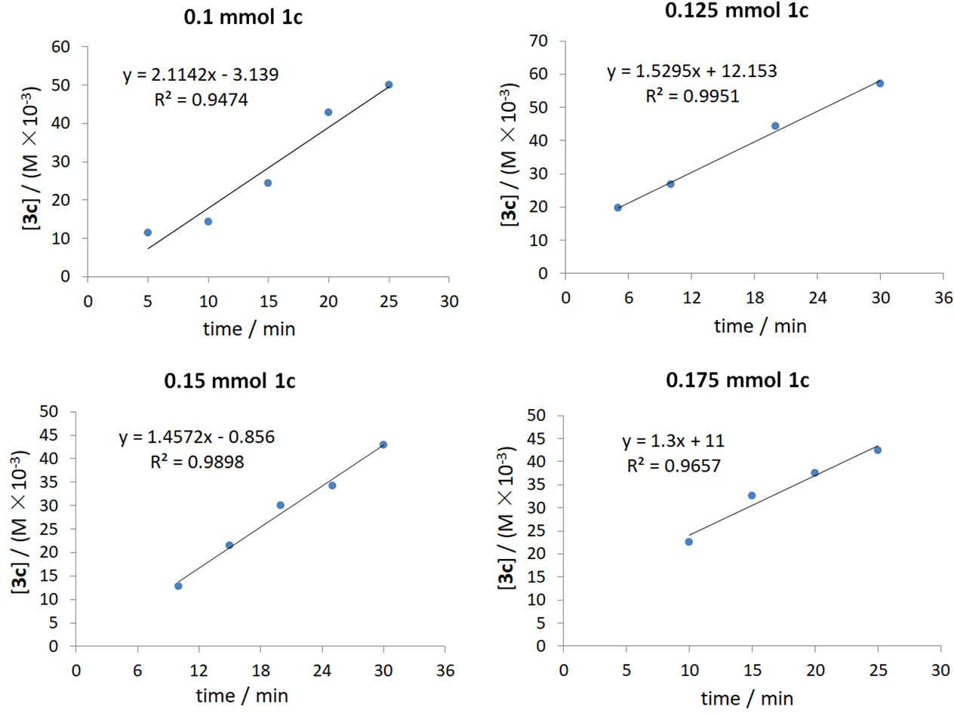

1c / mmol | [1c] / (mol▪L⁻¹) | K (mol▪L⁻¹min⁻¹)
0.1 | 0.14 | 0.0021142
0.125 | 0.18 | 0.0015295
0.15 | 0.21 | 0.0014572
0.175 | 0.25 | 0.0013

Figure S5. Dependence of the reaction rate on concentration of 1c

Kinetic profiles of different initial concentrations of 1c (from 0.1 mmol to 0.175 mmol). Reaction conditions: 2a (0.3 mmol), LiN(SiMe₃)₂ (0.2 mmol, 1.0 M in THF), t-BuOK (0.15 mmol), carried out in 0.5 mL of CPME at 120 °C.
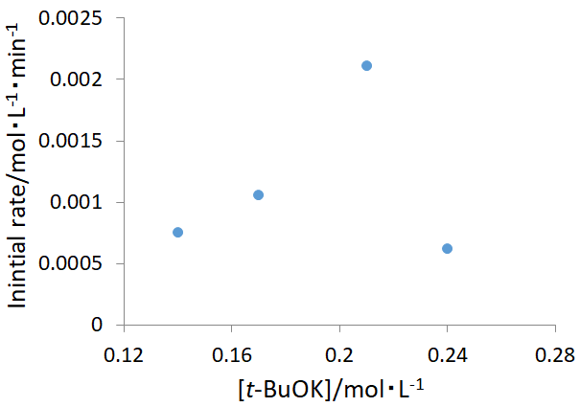
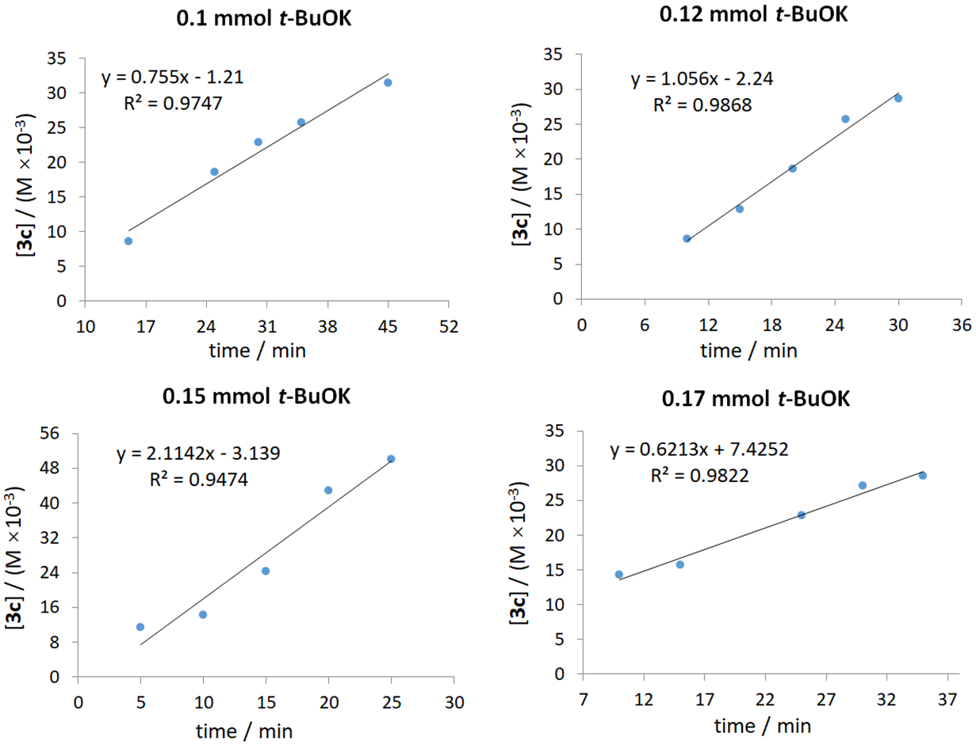

t-BuOK/ mmol | [t-BuOK] / (mol▪L⁻¹) | K (mol▪L⁻¹min⁻¹)
0.1 | 0.14 | 0.000755
0.12 | 0.17 | 0.001056
0.15 | 0.21 | 0.0021142
0.17 | 0.24 | 0.0006213

Figure S6. Dependence of the reaction rate on concentration of t-BuOK

Kinetic profiles of different initial concentrations of t-BuOK (from 0.1 mmol to 0.17 mmol). Reaction conditions: 1c (0.1 mmol), 2a (0.3 mmol), LiN(SiMe₃)₂ (0.2 mmol, 1.0 M in THF), carried out in 0.5 mL of CPME at 120 °C.
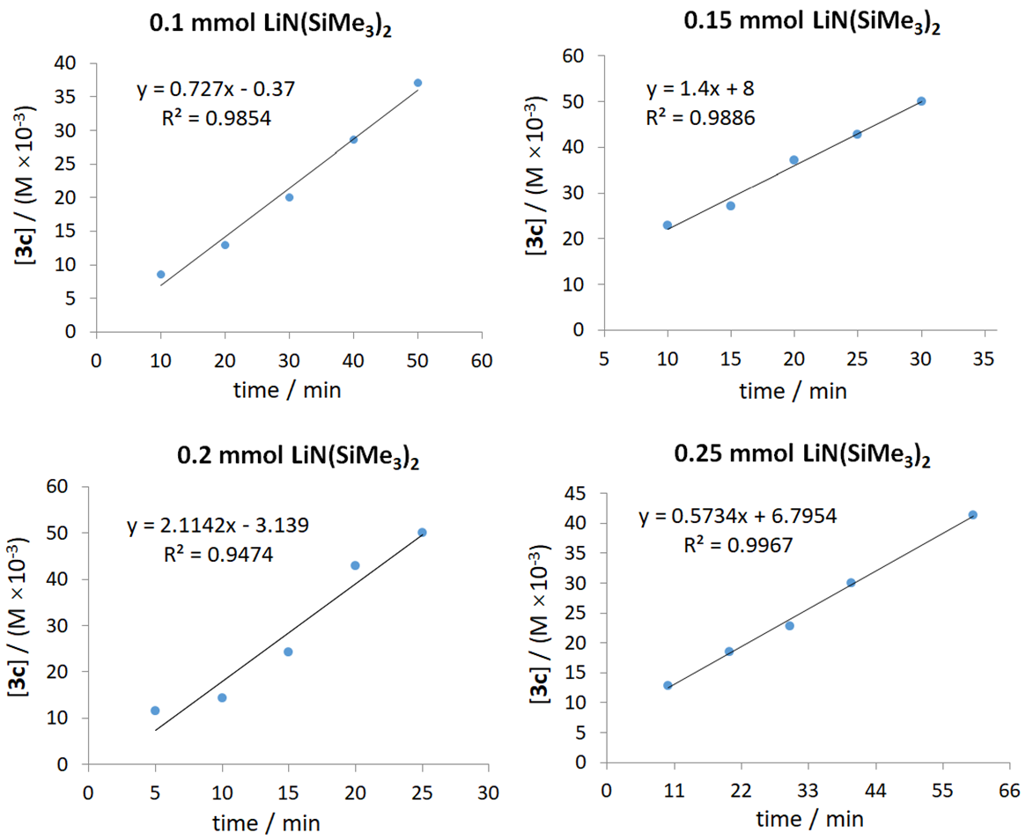
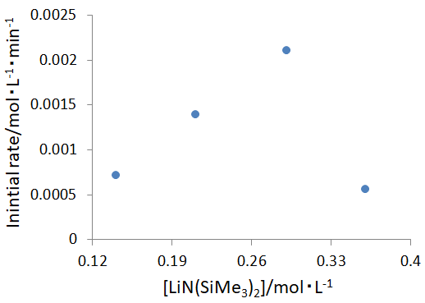
LiN(SiMe₃)₂ / mmol | [LiN(SiMe₃)₂] / (mol▪L⁻¹) | K (mol▪L⁻¹min⁻¹)
0.1 | 0.14 | 0.000727
0.15 | 0.21 | 0.0014
0.2 | 0.29 | 0.002114
0.25 | 0.36 | 0.000573

Figure S7. Dependence of the reaction rate on concentration of LiN(SiMe₃)₂

Kinetic profiles of different initial concentrations of LiN(SiMe₃)₂ (1 M in THF) (from 0.1 mmol to 0.25 mmol). Reaction conditions: 1c (0.1 mmol), 2a (0.3 mmol), t-BuOK (0.15 mmol), carried out in 0.5 mL of CPME (except 0.45 mL for 0.25 mmol) at 120 °C.

Isotopic Effect Study of 1c-d

Figure S8. Hydrogen/deuterium exchange results of 1c-d analyzed by ¹H-NMR

Photophysical Spectra of Compounds 8 and 9
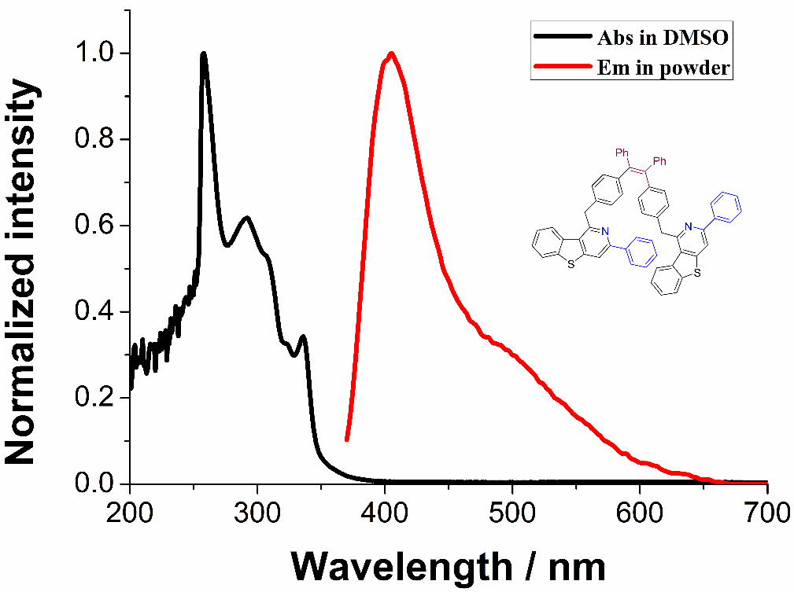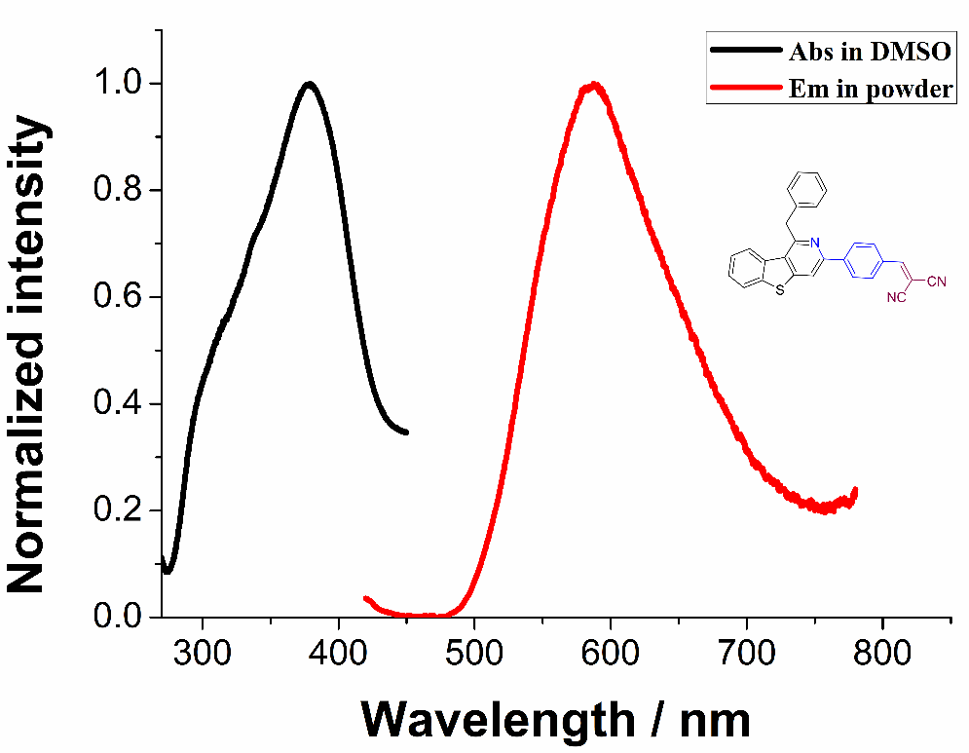
Figure S9. Photophysical spectra of compounds 8 and 9. Absorption in DMSO at 100.0 μM; Emission in powder.
Characterization Data for Substrates and All Products
3-Methyl-4-(phenylethynyl)-1,1'-biphenyl (1j):
¹H NMR (400 MHz, CDCl₃) δ ppm 7.77 – 7.61 (m, 5H), 7.58 – 7.47 (m, 4H), 7.47 – 7.37 (m, 4H), 2.68 (s, 3H); ¹³C NMR (100 MHz, CDCl₃) δ ppm 141.0, 140.5, 140.5, 132.2, 131.5, 128.7, 128.3, 128.1, 128.1, 127.5, 127.0, 124.3, 123.5, 122.0, 94.0, 88.3, 20.86 (d, J = 2.2 Hz); HRMS (ESI) calc. C₂₁H₁₆ [M+H]⁺: 269.1325, found: 269.1321.

4-Methyl-3-(phenylethynyl)-1,1'-biphenyl (1k):
¹H NMR (400 MHz, CDCl₃) δ ppm 7.78 (s, 1H), 7.66 – 7.56 (m, 4H), 7.52 – 7.43 (m, 3H), 7.36 (d, J = 15.2 Hz, 5H), 2.58 (s, 3H); ¹³C NMR (100 MHz, CDCl₃) δ ppm 140.3, 139.1, 138.7, 131.5, 130.4, 129.9, 128.8, 128.4, 128.2, 127.3, 127.0, 126.9, 123.4, 93.4, 88.3, 20.4; HRMS (ESI) calc. C₂₁H₁₆ [M+H]⁺: 269.1325, found: 269.1321.

2-Methyl-3-(phenylethynyl)benzo[b]thiophene (4a):
¹H NMR (400 MHz, CDCl₃) δ 7.93 (d, J = 7.9 Hz, 1H), 7.76 (d, J = 8.0 Hz, 1H), 7.65 – 7.60 (m, 2H), 7.48 – 7.30 (m, 5H), 2.75 (s, 3H); ¹³C NMR (100 MHz, CDCl₃) δ ppm 144.9, 139.9, 137.5, 131.6, 128.4, 124.6, 124.4, 123.4, 122.5, 122.0, 115.8, 94.5, 82.6; HRMS (ESI) calc. C₁₇H₁₂S [M+H]⁺: 249.0732, found: 249.0729.

3-((4-Methoxyphenyl)ethynyl)-2-methylbenzo[b]thiophene (4b):
¹H NMR (400 MHz, CDCl₃) δ ppm 7.94 (d, J = 7.5 Hz, 1H), 7.77 (d, J = 8.7 Hz, 1H), 7.58 (d, J = 8.9 Hz, 2H), 7.45 (t, J = 7.0 Hz, 1H), 7.35 (t, J = 7.6 Hz, 1H), 6.93 (d, J = 8.8 Hz, 2H), 3.85 (s, 3H), 2.75 (s, 3H); ¹³C NMR (100 MHz, CDCl₃) δ ppm 159.6, 144.1, 139.9, 137.5, 133.0, 124.5, 124.3, 122.4, 121.9, 116.0, 115.5, 114.0, 94.4, 81.2, 55.2, 15.3; HRMS (ESI) calc. C₁₈H₁₄OS [M+H]⁺: 279.0838, found: 279.0836.

N,N-Dimethyl-4-((2-methylbenzo[b]thiophen-3-yl)ethynyl)aniline (4c):
¹H NMR (400 MHz, CDCl₃) δ ppm 8.01 (d, J = 7.9 Hz, 1H), 7.80 (d, J = 8.0 Hz, 1H), 7.59 – 7.54 (m, 2H), 7.51 – 7.45 (m, 1H), 7.41 – 7.35 (m, 1H), 6.89 – 6.60 (m, 2H), 3.02 (s, 6H), 2.79 (s, 3H); ¹³C NMR (100 MHz, CDCl₃) δ ppm 150.0, 143.1, 140.0, 137.4, 132.6, 124.4, 124.2, 122.5, 121.9, 116.5, 111.8, 110.1, 95.6, 80.3, 40.0, 15.2; HRMS (ESI) calc. C₁₉H₁₇NS [M+H]⁺: 292.1154, found: 292.1151.

3-((4-Fluorophenyl)ethynyl)-2-methylbenzo[b]thiophene (4d):
¹H NMR (400 MHz, CDCl₃) δ ppm 7.90 (t, J = 8.7 Hz, 1H), 7.78 – 73 (m, 1H), 7.65 – 7.49 (m, 2H), 7.43 (q, J = 7.9, 6.4 Hz, 1H), 7.38 – 7.30 (m, 1H), 7.12 – 7.00 (m, 2), 2.73 (s, 3H); ¹³C NMR (100 MHz, CDCl₃) δ ppm 162.5 (d, J = 249.6 Hz), 145.0, 139.8, 137.5, 133.4 (d, J = 8.3 Hz), 124.6, 124.5, 122.4, 122.0, 119.5 (d, J = 3.3 Hz), 116.0, 115.7 (d, J = 21.9 Hz), 93.4, 82.3, 15.3; HRMS (ESI) calc. C₁₇H₁₁FS [M+H]⁺: 267.0638, found: 267.0634.

3-((4-Chlorophenyl)ethynyl)-2-methylbenzo[b]thiophene (4e):
¹H NMR (400 MHz, CDCl₃) δ ppm 7.90 (d, J = 7.9 Hz, 1H), 7.76 (d, J = 8.0 Hz, 1H), 7.58 – 7.50 (m, 2H), 7.46-7.41 (m, 1H), 7.40 – 7.31 (m, 3H), 2.74 (s, 3H); ¹³C NMR (100 MHz, CDCl₃) δ ppm 145.3, 139.7, 137.5, 134.1, 132.7, 128.7, 124.7, 124.5, 122.3, 122.0, 121.9, 115.5, 93.4, 83.6, 15.3; HRMS (ESI) calc. C₁₇H₁₁ClS [M+H]⁺: 283.0343, found: 283.0339.

3-((4-Bromophenyl)ethynyl)-2-methylbenzo[b]thiophene (4f):
¹H NMR (400 MHz, CDCl₃) δ ppm 7.87 (d, J = 8.0 Hz, 1H), 7.75 (d, J = 8.0 Hz, 1H), 7.56 – 7.49 (m, 2H), 7.48 – 7.39 (m, 3H), 7.34 (t, J = 7.6 Hz, 1H), 2.72 (s, 3H); ¹³C NMR (100 MHz, CDCl₃) δ ppm 145.3, 139.7, 137.5, 132.9, 131.6, 124.7, 124.5, 122.4, 122.4, 122.0, 115.5, 93.4, 83.8, 15.4; HRMS (ESI) calc. C₁₇H₁₁BrS [M+H]⁺: 326.9838, found: 326.9833.

3-((3-Chlorophenyl)ethynyl)-2-methylbenzo[b]thiophene (4g):
¹H NMR (400 MHz, CDCl₃) δ ppm 7.90 (d, J = 7.8 Hz, 1H), 7.76 (d, J = 8.0 Hz, 1H), 7.62 (t, J = 1.5 Hz, 1H), 7.51 – 7.46 (m, 1H), 7.47 – 7.41 (m, 1H), 7.39 – 7.28 (m, 3H), 2.74 (s, 3H); ¹³C NMR (100 MHz, CDCl₃) δ ppm 145.7, 139.8, 137.6, 134.3, 131.4, 129.7, 129.7, 128.5, 125.2, 124.8, 124.6, 122.4, 122.1, 115.4, 93.2, 84.0, 15.4; HRMS (ESI) calc. C₁₇H₁₁ClS [M+H]⁺: 283.0343, found: 283.0339.

3-((3,5-Difluorophenyl)ethynyl)-2-methylbenzo[b]thiophene (4h):
¹H NMR (400 MHz, CDCl₃) δ ppm 7.90 (d, J = 7.9 Hz, 1H), 7.77 (d, J = 8.0 Hz, 1H), 7.50 – 7.43 (m, 1H), 7.40 – 7.34 (m, 1H), 7.18 – 7.10 (m, 2H), 6.89 – 6.81 (m, 1H), 2.73 (s, 3H); ¹³C NMR (100 MHz, CDCl₃) δ 162.9 (d, J = 247.3 Hz), 162.8 (d, J = 247.4 Hz), 146.4, 139.7, 137.6, 126.2 (t, J = 11.8 Hz), 124.8 (d, J = 18.1 Hz), 122.3 (d, J = 22.7 Hz), 115.0, 114.5 (d, J = 11.6 Hz), 114.5 (d, J = 26.7 Hz), 104.3 (t, J = 25.4 Hz), 92.5 (t, J = 3.9 Hz), 84.8, 15.4; HRMS (ESI) calc. C₁₇H₁₀F₂S [M+H]⁺: 285.0544, found: 285.0541.

2-((2-Methylbenzo[b]thiophen-3-yl)ethynyl)pyridine (4i):
¹H NMR (400 MHz, CDCl₃) δ ppm 8.66 – 8.62 (m, 1H), 7.94 (d, J = 7.9 Hz, 1H), 7.73 (d, J = 7.9 Hz, 1H), 7.71 – 7.64 (m, 1H), 7.60 – 7.55 (m, 1H), 7.43 – 7.37 (m, 1H), 7.35 – 7.29 (m, 1H), 7.27 – 7.20 (m, 1H), 2.75 (s, 3H); ¹³C NMR (100 MHz, CDCl₃) δ ppm 150.0, 146.8, 143.6, 139.7, 137.4, 136.1, 127.2, 124.7, 124.5, 122.6, 122.5, 121.9, 114.9, 93.9, 82.6, 15.4; HRMS (ESI) calc. C₁₆H₁₁NS [M+H]⁺: 250.0685, found: 250.0683.

1-Benzyl-3-phenylisoquinoline (3a):
Yield: 47 mg (80%), white solid. M.p.: 64.8 – 66.2 ºC. ¹H NMR (500 MHz, CDCl₃) δ ppm 8.18 (d, J = 7.0 Hz, 2H), 8.12 (d, J = 8.5 Hz, 1H), 7.95 (s, 1H), 7.81 (d, J = 8.2 Hz, 1H), 7.57 (t, J = 7.5 Hz, 1H), 7.51 – 7.42 (m, 3H), 7.39 (t, J = 7.3Hz, 1H), 7.34 (d, J = 7.5 Hz, 2H), 7.27 – 7.20 (m, 2H), 7.15 (t, J = 6.8 Hz, 1H), 4.73 (s, 2H); ¹³C NMR (125 MHz, CDCl₃) δ ppm 160.0, 150.0, 139.8, 139.7, 137.5, 130.0, 128.8, 128.8, 128.5, 128.5, 127.9, 127.1, 127.0, 126.3, 126.3, 125.9, 115.6, 42.3; IR (KBr, cm⁻¹): ν = 1762, 1577, 1497, 1369, 1243, 1059, 755, 689; HRMS (ESI) calc. C₂₂H₁₇N [M+H]⁺: 296.1434, found: 296.1430.

1-(4-Methylbenzyl)-3-phenylisoquinoline (3b):
Yield: 37 mg (60%), white solid. M.p.: 85.6 – 87.3 ºC. ¹H NMR (400 MHz, CDCl₃) δ ppm 8.24 (d, J = 7.7 Hz, 2H), 8.18 (d, J = 8.4 Hz, 1H), 8.00 (s, 1H), 7.86 (d, J = 8.2 Hz, 1H), 7.62 (t, J = 7.5 Hz, 1H), 7.55 (t, J = 7.5 Hz, 2H), 7.50 (t, J = 7.7 Hz, 1H), 7.45 (t, J = 7.3 Hz, 1H), 7.30 (d, J = 7.6 Hz, 2H), 7.11 (d, J = 7.6 Hz, 2H), 4.75 (s, 2H), 2.32 (s, 3H); ¹³C NMR (100 MHz, CDCl₃) δ ppm 160.1, 149.8, 139.7, 137.4, 136.5, 135.6, 129.8, 129.1, 128.7, 128.5, 128.3, 127.7, 127.0, 126.9, 126.1, 125.8, 115.5, 41.8, 21.0; IR (KBr, cm⁻¹): ν = 2991, 1764, 1567, 1378, 1243, 1056, 691; HRMS (ESI) calc. C₂₃H₁₉N [M+H]⁺: 310.1590, found: 310.1586.

1-(4-Methoxybenzyl)-3-phenylisoquinoline (3c):
Yield: 51 mg (78%), white solid. M.p.: 77.8 – 79.3 ºC. ¹H NMR (400 MHz, CDCl₃) δ ppm 8.26 (d, J = 7.6 Hz, 2H), 8.18 (d, J = 8.4 Hz, 1H), 8.00 (s, 1H), 7.86 (d, J = 8.2 Hz, 1H), 7.62 (t, J = 7.5 Hz, 1H), 7.56 (t, J = 7.5 Hz, 2H), 7.51 (t, J = 7.8 Hz, 1H), 7.46 (t, J = 7.3 Hz, 1H), 7.34 (d, J = 8.2 Hz, 2H), 6.85 (d, J = 8.3 Hz, 2H), 4.73 (s, 2H), 3.77 (s, 3H); ¹³C NMR (100 MHz, CDCl₃) δ ppm 160.2 157.9, 149.8, 139.7, 137.4, 131.6, 129.8, 129.6, 128.7, 128.3, 127.7, 126.9, 126.8, 126.1, 125.7, 115.4, 113.8, 55.1, 41.3; IR (KBr, cm⁻¹): ν = 1763, 1579, 1508, 1383, 1244, 1038, 909, 692; HRMS (ESI) calc. C₂₃H₁₉NO [M+H]⁺: 326.1539, found: 326.1535.

1-(4-(tert-Butyl)benzyl)-3-phenylisoquinoline (3d):
Yield: 53 mg (76%), yellow oil. ¹H NMR (400 MHz, CDCl₃) δ ppm 8.18 (t, J = 7.1 Hz, 3H), 7.95 (s, 1H), 7.83 (d, J = 8.0 Hz, 1H), 7.59 (t, J = 7.2 Hz, 1H), 7.48 (q, J = 6.8 Hz, 3H), 7.39 (t, J = 7.1 Hz, 1H), 7.29 (s, 4H), 4.70 (s, 2H), 1.26 (s, 9H); ¹³C NMR (100 MHz, CDCl₃) δ ppm 160.1, 149.9, 148.9, 139.8, 137.5, 136.5, 129.8, 128.7, 128.4, 128.3, 127.8, 127.0, 126.8, 126.3, 125.9, 125.3, 115.4, 41.6, 34.3, 31.3; IR (KBr, cm⁻¹): ν = 2957, 1762, 1569, 1504, 1374, 1245, 1051, 758, 692; HRMS (ESI) calc. C₂₆H₂₅N [M+H]⁺: 352.2060, found: 353.2056.

1-(3-Methylbenzyl)-3-phenylisoquinoline (3e):
Yield: 26 mg (42%), yellow oil. ¹H NMR (500 MHz, CDCl₃) δ ppm 8.20 (dd, J = 6.8, 3.8 Hz, 2H), 8.13 (d, J = 8.4 Hz, 1H), 7.95 (s, 1H), 7.81 (d, J = 8.1 Hz, 1H), 7.58 (t, J = 7.5 Hz, 1H), 7.527.47 (m, 2H), 7.45 (t, J = 7.5 Hz, 1H), 7.40 (dd, J = 8.5, 5.9 Hz, 1H), 7.19 – 7.11 (m, 3H), 6.98 (d, J = 2.8 Hz, 1H), 4.70 (s, 2H), 2.27 (s, 3H); ¹³C NMR (125 MHz, CDCl₃) δ ppm 160.0, 149.8, 139.7, 139.5, 138.0, 137.4, 129.9, 129.4, 128.7, 128.4, 128.3, 127.7, 127.0, 126.9, 126.9, 126.2, 125.8, 125.7, 115.5, 42.2, 21.4; IR (KBr, cm⁻¹): ν = 3051, 2924, 1760, 1573, 1494, 1376, 1243, 1052, 876, 763, 691; HRMS (ESI) calc. C₂₃H₁₉N [M+H]⁺: 310.1590, found: 310.1586.

1-(3-Fluorobenzyl)-3-phenylisoquinoline (3f):
Yield: 9 mg (14%), white solid. M.p.: 62.5 – 64.1 ºC. ¹H NMR (500 MHz, CDCl₃) δ ppm 8.07 (d, J = 7.5 Hz, 2H), 7.96 (d, J = 8.4 Hz, 1H), 7.86 (s, 1H), 7.72 (d, J = 8.2 Hz, 1H), 7.49 (t, J = 7.5 Hz, 1H), 7.43 – 7.34 (m, 3H), 7.30 (t, J = 7.3 Hz, 1H), 7.10 (dd, J = 14.2, 7.6 Hz, 1H), 7.02 (d, J = 7.6 Hz, 1H), 6.94 (d, J = 10.0 Hz, 1H), 6.75 (t, J = 8.3 Hz, 1H), 4.61 (s, 2H); ¹³C NMR (125 MHz, CDCl₃) δ ppm 162.9 (d, J = 240.0 Hz), 159.1, 149.9, 142.0 (d, J = 5.9 Hz), 139.4, 137.4, 130.0, 129.8 (d, J = 6.7 Hz), 128.7, 128.5, 127.8, 127.0, 126.9, 126.1, 125.5, 124.4 (d, J = 2.6 Hz), 115.7 (d, J = 2.2 Hz), 115.6, 113.1 (d, J = 21.0 Hz), 41.7; IR (KBr, cm⁻¹): ν = 3055, 1764, 1579, 1490, 1443, 1245, 1137, 947, 878, 772, 690; HRMS (ESI) calc. C₂₂H₁₆FN [M+H]⁺: 314.1340, found: 314.1335.

1-(Naphthalen-2-ylmethyl)-3-phenylisoquinoline (3g):
Yield: 45 mg (65%), white solid. M.p.: 120.5 – 121.9 ºC. ¹H NMR (500 MHz, CDCl₃) δ ppm 8.28 (d, J = 7.6 Hz, 2H), 8.22 (d, J = 8.4 Hz, 1H), 8.03 (s, 1H), 7.87 (d, J = 8.1 Hz, 1H), 7.80 (t, J = 9.4 Hz, 4H), 7.66 – 7.54 (m, 4H), 7.52 – 7.39 (m, 4H), 4.96 (s, 2H); ¹³C NMR (125 MHz, CDCl₃) δ ppm 159.8, 149.9, 139.6, 137.5, 137.2, 133.5, 132.1, 129.9, 128.7, 128.4, 128.0, 127.8, 127.6, 127.3, 127.0, 126.9, 126.3, 125.9, 125.8, 125.3, 115.7, 42.4; IR (KBr, cm⁻¹): ν = 2991, 1762, 1584, 1375, 1243, 1055, 752, 692; HRMS (ESI) calc. C₂₆H₁₉N [M+H]⁺: 346.1590, found: 346.1587.

1-Benzyl-3-(p-tolyl)isoquinoline (3h):
Yield: 30 mg (48%), white solid. M.p.: 82.5 – 83.7 ºC. ¹H NMR (400 MHz, CDCl₃) δ ppm 8.20 (d, J = 7.9 Hz, 3H), 8.02 (s, 1H), 7.88 (d, J = 8.1 Hz, 1H), 7.65 (t, J = 7.4 Hz, 1H), 7.52 (t, J = 7.6 Hz, 1H), 7.46 (d, J = 7.4 Hz, 2H), 7.41 (d, J = 7.7 Hz, 2H), 7.35 (t, J = 7.4 Hz, 2H), 7.27 (q, J = 7.2 Hz, 1H), 4.83 (s, 2H), 2.52 (s, 3H); ¹³C NMR (100 MHz, CDCl₃) δ ppm 159.7, 149.8, 139.6, 138.2, 137.2, 136.8, 131.9, 129.7, 129.4, 128.7, 128.3, 127.6, 126.8, 126.6, 126.1, 126.0, 125.7, 114.9, 42.1, 21.2; IR (KBr, cm⁻¹): ν = 3061, 3027, 2922, 1744, 1615, 1568, 1500, 1443, 1377, 1245, 1047, 823, 745, 703; HRMS (ESI) calc. C₂₃H₁₉N [M+H]⁺: 310.1590, found: 310.1587.

1-Benzyl-3-(4-(tert-butyl)phenyl)isoquinoline (3i):
Yield: 53 mg (75%), yellow solid. M.p.: 89.5 – 91.1 ºC. ¹H NMR (500 MHz, CDCl₃) δ 8.12 (d, J = 8.4 Hz, 3H), 7.93 (s, 1H), 7.81 (d, J = 8.2 Hz, 1H), 7.57 (t, J = 7.4 Hz, 1H), 7.53 (d, J = 8.4 Hz, 2H), 7.44 (t, J = 7.6 Hz, 1H), 7.35 (d, J = 7.4 Hz, 2H), 7.23 (dd, J = 14.1, 6.4 Hz, 2H), 7.15 (t, J = 7.3 Hz, 1H), 4.73 (s, 2H), 1.38 (s, 9H); ¹³C NMR (126 MHz, CDCl₃) δ 159.8, 151.5, 149.9, 139.6, 137.5, 136.9, 131.9, 129.8, 128.7, 128.4, 127.7, 126.7, 126.1, 126.1, 125.8, 125.7, 115.1, 42.2, 34.6, 31.3; IR (KBr, cm⁻¹): ν = 2957, 1756, 1575, 1451, 1374, 1247, 1051, 837, 745, 699; HRMS (ESI) calc. C₂₆H₂₅N [M+H]⁺: 352.2060, found: 352.2056.

1-Benzyl-3-(4-methoxyphenyl)isoquinoline (3j):
Yield: 40 mg (61%), white solid. M.p.: 130.7 – 131.3 ºC. ¹H NMR (400 MHz, CDCl₃) δ ppm 8.12 (t, J = 9.0 Hz, 3H), 7.87 (s, 1H), 7.79 (d, J = 8.2 Hz, 1H), 7.56 (t, J = 7.4 Hz, 1H), 7.43 (t, J = 7.6 Hz, 1H), 7.35 (d, J = 7.4 Hz, 2H), 7.24 (t, J = 7.6 Hz, 2H), 7.15 (t, J = 7.3 Hz, 1H), 7.02 (d, J = 8.5 Hz, 2H), 4.73 (s, 2H), 3.85 (s, 3H); ¹³C NMR (100 MHz, CDCl₃) δ ppm 160.1, 159.7, 149.5, 139.5, 137.6, 132.1, 129.9, 128.7, 128.4, 128.2, 127.6, 126.6, 126.1, 125.8, 125.8, 114.5, 114.1, 55.3, 42.0; IR (KBr, cm⁻¹): ν = 1571, 1601, 1510, 1245, 1174, 1042, 833, 741; HRMS (ESI) calc. C₂₃H₁₉NO [M+H]⁺: 326.1539, found: 326.1535.

3-([1,1'-Biphenyl]-4-yl)-1-benzylisoquinoline (3k):
Yield: 53 mg (71%), white solid. M.p.: 166.7 – 167.9 ºC. ¹H NMR (400 MHz, CDCl₃) δ ppm 8.27 (d, J = 8.3 Hz, 2H), 8.15 (d, J = 8.4 Hz, 1H), 8.01 (s, 1H), 7.85 (d, J = 8.2 Hz, 1H), 7.74 (d, J = 8.3 Hz, 2H), 7.70 – 7.65 (m, 2H), 7.61 (t, J = 7.5 Hz, 1H), 7.51 – 7.40 (m, 3H), 7.36 (t, J = 7.3 Hz, 3H), 7.28 – 7.20 (m, 2H), 7.17 (t, J = 7.3 Hz, 1H), 4.77 (s, 2H); ¹³C NMR (100 MHz, CDCl₃) δ ppm 159.9, 149.3, 141.0 140.7, 139.5, 138.5, 137.4, 129.9, 128.8, 128.7, 128.4, 127.7, 127.4, 127.3, 127.3, 127.0, 126.9, 126.2, 126.2, 125.7, 115.4, 42.2; IR (KBr, cm⁻¹): ν = 2984, 1762, 1584, 1485, 1379, 1056, 837, 695; HRMS (ESI) calc. : C₂₈H₂₁N [M+H]⁺: 372.1747, found: 372.1744.

1-Benzyl-3-(3-(tert-butyl)phenyl)isoquinoline (3l):
Yield: 58 mg (82%), yellow oil. ¹H NMR (500 MHz, CDCl₃) δ ppm 8.23 (s, 1H), 8.08 (d, J = 6.2 Hz, 1H), 7.96 (s, 1H), 7.91 (d, J = 3.3 Hz, 1H), 7.75 (d, J = 6.3 Hz, 1H), 7.54 – 7.47 (m, 1H), 7.44 – 7.32 (m, 5H), 7.23 (d, J = 6.2 Hz, 2H), 7.14 (d, J = 6.2 Hz, 1H), 4.70 (s, 2H), 1.40 (s, 9H); ¹³C NMR (125 MHz, CDCl₃) δ ppm 159.7, 151.4, 150.3, 139.5, 139.3, 137.4, 129.7, 128.9, 128.4, 128.3, 127.7, 126.7, 126.1, 126.0, 125.6, 125.5, 124.1, 124.1, 115.3, 42.0, 34.8, 31.4; IR (KBr, cm⁻¹): ν = 3060, 2960, 1574, 1490, 1373, 1252, 10278, 882, 799, 749, 701; HRMS (ESI) calc. C₂₆H₂₅N [M+H]⁺: 352.2060, found: 352.2056.

1-Benzyl-6-methyl-3-phenylisoquinoline (3m):
Yield: 42 mg (68%), white solid. M.p.: 81.9 – 83.4 ºC. ¹H NMR (400 MHz, CDCl₃) δ ppm 8.16 (d, J = 7.9 Hz, 2H), 7.98 (d, J = 8.6 Hz, 1H), 7.84 (s, 1H), 7.54 (s, 1H), 7.47 (t, J = 7.6 Hz, 2H), 7.40 – 7.30 (m, 3H), 7.28 – 7.19 (m, 3H), 7.13 (t, J = 7.3 Hz, 1H), 4.68 (s, 2H), 2.43 (s, 3H); ¹³C NMR (100 MHz, CDCl₃) δ ppm 159.5, 149.9, 140.0, 139.8, 139.7, 137.8, 129.1, 128.7, 128.6, 128.4, 128.3, 126.9, 126.6, 126.1, 125.6, 124.6, 115.1, 42.2, 21.7 (d, J = 2.5 Hz); IR (KBr, cm⁻¹): ν = 3051, 2918, 2846, 1750, 1579, 1493, 1375, 1243, 1048, 895, 767, 693; HRMS (ESI) calc. C₂₃H₁₉N [M+H]⁺: 310.1590, found: 310.1587.

1-Benzyl-8-fluoro-3-phenylisoquinoline (3n):
Yield: 23 mg (36%), white solid. M.p.: 86.2 – 87.9 ºC. ¹H NMR (400 MHz, CDCl₃) δ ppm 8.22 (d, J = 7.3 Hz, 2H), 7.97 (d, J = 2.6 Hz, 1H), 7.63 (d, J = 8.1 Hz, 1H), 7.57 – 7.50 (m, 3H), 7.45 (t, J = 7.3 Hz, 1H), 7.40 (d, J = 7.7 Hz, 2H), 7.29 (t, J = 7.6 Hz, 2H), 7.20 (t, J = 7.3 Hz, 1H), 7.14 (dd, J = 12.5, 7.6 Hz, 1H), 4.88 (d, J = 3.4 Hz, 2H); ¹³C NMR (100 MHz, CDCl₃) δ ppm 160.7, 158.2, 157.8 (d, J = 7.0 Hz), 150.2 (d, J = 1.8 Hz), 140.0 (d, J = 3.7 Hz), 139.7, 138.9, 130.2 (d, J = 9.4 Hz), 128.9 (d, J = 1.6 Hz), 128.7, 128.2, 126.9, 126.0, 123.8 (d, J = 4.3 Hz), 116.9 (d, J = 14.1 Hz), 114.6 (d, J = 3.6 Hz), 112.3 (d, J = 23.6 Hz), 45.12 (d, J = 9.6 Hz); IR (KBr, cm⁻¹): ν = 3060, 2923, 2857, 1761, 1627, 1567, 1493, 1450, 1348, 1240, 1028, 865, 775, 691; HRMS (ESI) calc. C₂₂H₁₆FN [M+H]⁺: 314.1340, found: 314.1336.

1-Benzyl-3,6-diphenylisoquinoline (3o):
Yield: 46 mg (62%), yellow solid. M.p.: 104.6 – 106.2 ºC. ¹H NMR (500 MHz, CDCl₃) δ ppm 8.19 (d, J = 7.7 Hz, 2H), 8.15 (d, J = 8.7 Hz, 1H), 7.98 (s, 2H), 7.68 (d, J = 8.8 Hz, 1H), 7.65 (d, J = 7.6 Hz, 2H), 7.52 − 7.43 (m, 4H), 7.41 − 7.34 (m, 4H), 7.25 (t, J = 7.5 Hz, 2H), 7.20 − 7.113 (m, 1H), 4.73 (s, 2H); ¹³C NMR (125 MHz, CDCl₃) δ ppm 159.8, 150.3, 142.5, 140.1, 139.6, 139.6, 137.8, 128.9, 128.7, 128.7, 128.4, 128.0, 127.4, 127.0, 126.6, 126.3, 126.2, 125.4, 125.2, 115.7, 42.2; IR (KBr, cm⁻¹): ν = 3047, 2925, 1614, 1575, 1491, 1449, 1244, 901, 760, 695; HRMS (ESI) calc. C₂₈H₂₁N [M+H]⁺: 372.1747, found: 372.1742.

1,3,7-Triphenylisoquinoline (3p):
Yield: 45 mg (60%), white solid. M.p.: 135.3 – 136.8 ºC. ¹H NMR (500 MHz, CDCl₃) δ ppm 8.32 (s, 1H), 8.19 (d, J = 7.5 Hz, 2H), 7.96 (s, 1H), 7.85 (dd, J = 18.5, 8.4 Hz, 2H), 7.57 (d, J = 7.4 Hz, 2H), 7.52 – 7.43 (m, 4H), 7.41 – 7.35 (m, 4H), 7.27 (t, J = 7.4 Hz, 2H), 7.22 – 7.14 (m, 1H), 4.78 (s, 2H); ¹³C NMR (126 MHz, CDCl₃) δ ppm 160.2, 149.8, 140.6, 139.6, 139.6, 136.6, 129.6, 129.0, 128.8, 128.7, 128.5, 128.4, 128.3, 127.7, 127.3, 126.9, 126.4, 126.2, 123.7, 115.2, 42.3; IR (KBr, cm⁻¹): ν = 3004, 1763, 1565, 1483, 1382, 1243, 1057, 878, 759, 691; HRMS (ESI) calc. C₂₈H₂₁N [M+H]⁺: 372.1747, found: 372.1744.

1-Benzyl-3-phenylisoquinoline-4-carbonitrile (3q):
Yield: 47 mg (74%), white solid. M.p.: 174.6 – 175.7 ºC. ¹H NMR (400 MHz, CDCl₃) δ 8.27 (t, J = 8.8 Hz, 2H), 8.10 (d, J = 6.9 Hz, 2H), 7.82 (t, J = 7.6 Hz, 1H), 7.63 (t, J = 7.6 Hz, 1H), 7.59 – 7.48 (m, 3H), 7.34 – 7.23 (m, 4H), 7.19 (t, J = 7.1 Hz, 1H), 4.75 (s, 2H); ¹³C NMR (100 MHz, CDCl₃) δ 164.1, 156.2, 138.2, 137.8, 136.7, 132.3, 129.9, 129.5, 128.7, 128.6, 128.5, 126.6, 126.4, 125.4, 124.8, 117.2, 101.1, 42.5; IR (KBr, cm⁻¹): ν = 3361, 2920, 2852, 1744, 1657, 1549, 1452, 1375, 1244, 1049, 760, 699; HRMS (ESI) calc. C₂₃H₁₆N₂ [M+H]⁺: 321.1386, found: 321.1383.

1-Benzyl-3-(pyridin-2-yl)isoquinoline-4-carbonitrile (3r):
Yield: 44 mg (69%), white solid. M.p.: 167.8 – 169.3 ºC. ¹H NMR (400 MHz, CDCl₃) δ ppm 8.85 (d, J = 4.4 Hz, 1H), 8.43 (d, J = 8.4 Hz, 1H), 8.38 (d, J = 7.9 Hz, 1H), 8.26 (d, J = 8.4 Hz, 1H), 7.91 − 7.80 (m, 2H), 7.66 (t, J = 7.6 Hz, 1H), 7.41 (t, J = 6.0 Hz, 1H), 7.32 − 7.24 (m, 4H), 7.20 (t, J = 6.8 Hz, 1H), 4.77 (s, 2H); ¹³C NMR (100 MHz, CDCl₃) δ ppm 163.5, 154.9, 152.9, 148.9, 138.2, 137.0, 136.9, 132.3, 128.8, 128.7, 128.6, 126.6, 126.3, 125.8, 125.7, 124.5, 123.6, 116.7, 101.6, 42.3; IR (KBr, cm⁻¹): ν = 3118, 2993, 1764, 1583, 1381, 1243, 1057, 919; HRMS (ESI) calc. C₂₂H₁₅N₃ [M+H]⁺: 322.1339, found: 322.1337.

1-Benzyl-3,4-diphenylisoquinoline (3s):
Yield: 33 mg (45%), white solid. M.p.: 116.8 – 118.0 ºC. ¹H NMR (500 MHz, CDCl₃) δ ppm 8.21 (d, J = 8.3 Hz, 1H), 7.64 (d, J = 8.0 Hz, 1H), 7.55 – 7.46 (m, 3H), 7.43 – 7.39 (m, 4H), 7.37 – 7.31 (m, 3H), 7.28 (t, J = 7.6 Hz, 2H), 7.23 (d, J = 5.9 Hz, 2H), 7.21 – 7.16 (m, 3H), 4.78 (s, 2H); ¹³C NMR (125 MHz, CDCl₃) δ ppm 159.2, 149.3, 140.8, 139.6, 137.5, 136.7, 131.3, 130.4, 129.8, 129.7, 128.7, 128.5, 128.2, 127.6, 127.2, 127.0, 126.6, 126.4, 126.2, 125.7, 42.3; IR (KBr, cm⁻¹): ν = 3062, 2925, 1751, 1600, 1557, 1495, 1444, 1376, 1242, 1043, 761, 700; HRMS (ESI) calc. C₂₈H₂₁N [M+H]⁺: 372.1747, found: 372.1743.

1-Benzyl-4-methyl-3-phenylisoquinoline (3t):
Yield: 17 mg (28%), yellow solid. M.p.: 91.5 – 92.8 ºC. ¹H NMR (400 MHz, CDCl₃) δ ppm 8.17 (d, J = 8.4 Hz, 1H), 8.06 (d, J = 8.5 Hz, 1H), 7.75 – 7.59 (m, 3H), 7.55 – 7.48 (m, 3H), 7.46 – 7.39 (m, 1H), 7.33 (d, J = 7.2 Hz, 2H), 7.25 (t, J = 7.5 Hz, 2H), 7.16 (t, J = 7.3 Hz, 1H), 4.72 (s, 2H), 2.64 (s, 3H); ¹³C NMR (100 MHz, CDCl₃) δ ppm 157.4, 150.7, 141.5, 139.9, 136.9, 130.0, 129.7, 128.5, 128.4, 128.1, 127.5, 126.4, 126.4, 126.1, 125.8, 124.2, 122.9, 42.2, 15.5; IR (KBr, cm⁻¹): ν = 2923, 1761, 1562, 1496, 1448, 1379, 1243, 755, 700; HRMS (ESI) calc. C₂₃H₁₉N [M+H]⁺: 310.1590, found: 310.1586.

1-Benzyl-3-phenylbenzo[4,5]thieno[3,2-c]pyridine (5a):
Yield: 63 mg (90%), white solid. M.p.: 142.5 − 143.8 ºC. ¹H NMR (400 MHz, CDCl₃) δ 8.20 – 8.16 (m, 1H), 8.13 (d, J = 7.0 Hz, 2H), 7.90 – 7.79 (m, 1H), 7.47 (t, J = 7.4 Hz, 1H), 7.43 – 7.36 (m, 3H), 7.29 – 7.20 (m, 2H), 7.20 – 7.14 (m, 1H), 4.89 (s, 2H); ¹³C NMR (100 MHz, CDCl₃) δ ppm 155.1, 152.2, 150.0, 139.0, 138.9, 138.2, 133.6, 128.9, 128.9, 128.7, 128.6, 128.5, 127.1, 126.7, 126.2, 125.2, 125.0, 122.8, 112.3, 43.7; IR (KBr, cm⁻¹): ν = 2992, 1764, 1571, 1374, 1243, 1056, 756, 692; HRMS (ESI) calc. C₂₄H₁₇NS [M+H]⁺: 352.1154, found: 352.1151.

1-(4-Methoxybenzyl)-3-phenylbenzo[4,5]thieno[3,2-c]pyridine (5b):
Yield: 54 mg (71%), yellowish green solid. M.p.: 203.0 – 204.3 ºC. ¹H NMR (400 MHz, CDCl₃) δ ppm 8.23 (dd, J = 7.1, 1.8 Hz, 1H), 8.16 (d, J = 7.2 Hz, 3H), 7.88 (dd, J = 7.0, 1.9 Hz, 1H), 7.62 – 7.36 (m, 5H), 7.20 (d, J = 8.8 Hz, 2H), 6.94 – 6.70 (m, 2H), 4.84 (s, 2H), 3.75 (s, 3H); ¹³C NMR (100 MHz, CDCl₃) δ ppm 158.1, 155.6, 152.3, 149.9, 139.1, 139.0, 133.7, 130.3, 129.6, 128.8, 128.8, 127.1, 126.7, 125.2, 125.1, 122.8, 114.0, 112.2, 55.2, 42.9; IR (KBr, cm⁻¹): ν = 2991, 1764, 1692, 1646, 1559, 1514, 1383, 1243, 1053, 750, 670; HRMS (ESI) calc. C₂₅H₁₉NOS [M+H]⁺: 382.1260, found: 382.1255.

N,N-Dimethyl-4-((3-phenylbenzo[4,5]thieno[3,2-c]pyridin-1-yl)methyl)aniline (5c):
Yield: 65 mg (83%), white solid. M.p.: 147.7 – 149.1 ºC. ¹H NMR (400 MHz, CDCl₃) δ ppm 8.33 – 8.28 (m, 1H), 8.22 – 8.17 (m, 2H), 8.15 (s, 1H), 7.95 – 7.77 (m, 1H), 7.52 (t, J = 7.5 Hz, 2H), 7.48 – 7.41 (m, 3H), 7.20 (d, J = 8.7 Hz, 2H), 6.70 (d, J = 8.7 Hz, 2H), 4.83 (s, 2H), 2.89 (s, 6H); ¹³C NMR (100 MHz, CDCl₃) δ ppm 156.0, 152.2, 149.8, 149.1, 139.1, 138.9, 133.7, 129.2, 128.8, 128.7, 128.7, 127.1, 126.5, 126.2, 125.2, 125.1, 122.6, 113.0, 112.0, 42.8, 40.7; IR (KBr, cm⁻¹): ν = 3060, 2920, 1763, 1676, 1611, 1570, 1519, 1435, 1353, 1239, 1062, 941, 811, 759, 692; HRMS (ESI) calc. C₂₆H₂₂N₂S [M+H]⁺: 395.1576, found: 395.1573.

1-(4-Fluorobenzyl)-3-phenylbenzo[4,5]thieno[3,2-c]pyridine (5d):
Yield: 49 mg (67%), yellowish green solid. M.p.: 157.5 – 158.9 ºC. ¹H NMR (400 MHz, CDCl₃) δ ppm 8.23 – 8.12 (m, 4H), 7.96 – 7.82 (m, 1H), 7.59 – 7.40 (m, 5H), 7.27 (t, J = 7.0 Hz, 2H), 7.00 (t, J = 8.7 Hz, 2H), 4.87 (s, 2H); ¹³C NMR (100 MHz, CDCl₃) δ ppm 161.47 (d, J = 242.7 Hz), 154.9, 152.2, 150.0, 139.0, 138.8, 133.8 (d, J = 3.2 Hz), 133.4, 130.1, 130.1, 128.9, 128.7, 127.0, 126.7, 125.1, 124.8, 122.8, 115.3 (d, J = 21.1 Hz), 112.2, 42.8; IR (KBr, cm⁻¹): ν = 3317, 3058, 2990, 1764, 1572, 1506, 1434, 1374, 1237, 1158, 1058, 915, 823, 762, 691; HRMS (ESI) calc. C₂₄H₁₆FNS [M+H]⁺: 370.1060 , found: 370.1058.

1-(4-Chlorobenzyl)-3-phenylbenzo[4,5]thieno[3,2-c]pyridine (5e):
Yield: 50 mg (65%), white solid. M.p.: 205.8 – 207.3 ºC. ¹H NMR (400 MHz, CDCl₃) δ ppm 8.26 – 8.05 (m, 4H), 7.87 (d, J = 7.6 Hz, 1H), 7.55 – 7.37 (m, 5H), 7.25 – 7.17 (m, 4H), 4.84 (s, 2H); ¹³C NMR (100 MHz, CDCl₃) δ ppm 154.6, 152.3, 145.0, 139.1, 138.9, 136.7, 133.5, 132.1, 130.0, 128.9, 128.8, 128.6, 127.1, 126.8, 125.2, 124.8, 122.9, 112.3, 43.1; IR (KBr, cm⁻¹): ν = 2920, 1765, 1571, 1486, 1243, 1061, 693, 629; HRMS (ESI) calc. C₂₄H₁₆ClNS [M+H]⁺: 386.0765, found: 386.0761.

1-(4-Bromobenzyl)-3-phenylbenzo[4,5]thieno[3,2-c]pyridine (5f):
Yield: 49 mg (57%), white solid. M.p.: 186.1 – 187.8 ºC. ¹H NMR (400 MHz, CDCl₃) δ ppm 8.30 – 8.06 (m, 4H), 7.89 (d, J = 7.5 Hz, 1H), 7.52 – 7.38 (m, 7H), 7.17 (t, J = 8.8 Hz, 2H), 4.85 (s, 2H); ¹³C NMR (100 MHz, CDCl₃) δ ppm 154.5, 152.3, 150.0, 139.1, 138.9, 137.2, 133.4, 131.6, 130.4, 129.0, 128.8, 127.1, 126.8, 125.2, 124.8, 122.9, 120.2, 112.4, 43.2; IR (KBr, cm⁻¹): ν = 2991, 1764, 1566, 1485, 1376, 1243, 1058, 977, 909; HRMS (ESI) calc. C₂₄H₁₆BrNS [M+H]⁺: 430.0260, found: 430.0255.

1-(3-Chlorobenzyl)-3-phenylbenzo[4,5]thieno[3,2-c]pyridine (5g):
Yield: 27 mg (35%), yellowish green solid. M.p.: 150.8 – 152.1 ºC. ¹H NMR (400 MHz, CDCl₃) δ ppm 8.38 – 8.06 (m, 4H), 7.89 (d, J = 8.8 Hz, 1H), 7.54 – 7.40 (m, 5H), 7.30 (s, 1H), 7.22 – 7.14 (m, 3H), 4.88 (s, 2H); ¹³C NMR (100 MHz, CDCl₃) δ ppm 154.2, 152.3, 150.0, 140.3, 139.1, 138.8, 134.3, 133.4, 129.7, 128.9, 128.8, 128.8, 127.1, 126.9, 126.8, 126.5, 125.2, 124.8, 122.9, 112.4, 43.3; IR (KBr, cm⁻¹): ν = 3057, 2994, 2917, 1764, 1568, 1475, 1423, 1373, 1242, 1061, 759, 691; HRMS (ESI) calc. C₂₄H₁₆ClNS [M+H]⁺: 386.0765, found: 386.0762.

1-(3,5-Difluorobenzyl)-3-phenylbenzo[4,5]thieno[3,2-c]pyridine (5h):
Yield: 31 mg (40%), white solid. M.p.: 170.1 – 171.4 ºC. ¹H NMR (400 MHz, CDCl₃) δ ppm 8.19 (s, 1H), 8.12 (t, J = 7.6 Hz, 3H), 7.90 (d, J = 7.2 Hz, 1H), 7.56 – 7.38 (m, 5H), 6.81 (d, J = 6.6 Hz, 2H), 6.66 (t, J = 9.0 Hz, 1H), 4.86 (s, 2H); ¹³C NMR (100 MHz, CDCl₃) δ ppm 164.3 (d, J = 12.9 Hz), 161.9 (d, J = 12.8 Hz), 153.5, 152.4, 150.2, 142.2 (t, J = 9.2 Hz), 139.1, 138.7, 133.3, 128.8, 128.0 (d, J = 210 Hz), 127.1, 125.3, 124.6, 123.0, 112.7, 111.6 (d, J = 25.2 Hz), 111.6 (d, J = 11.6 Hz), 101.9 (t, J = 25.4 Hz), 43.3; IR (KBr, cm⁻¹): ν = 2990, 2913, 1764, 1580, 1452, 1377, 1243, 1110, 1057, 985, 846, 759, 694, 837; HRMS (ESI) calc. C₂₄H₁₅F₂NS [M+H]⁺: 388.0966, found: 388.0962.

3-Phenyl-1-(pyridin-2-ylmethyl)benzo[4,5]thieno[3,2-c]pyridine (5i):
Yield: 51 mg (72%), white solid. M.p.: 133.6 – 134.9 ºC. ¹H NMR (400 MHz, CDCl₃) δ ppm 8.63 (d, J = 4.4 Hz, 1H), 8.45 – 8.35 (m, 1H), 8.23 – 8.04 (m, 3H), 7.92 – 7.79 (m, 1H), 7.57 – 7.34 (m, 6H), 7.17 – 7.06 (m, 2H), 5.09 (s, 2H); ¹³C NMR (101 MHz, CDCl₃) δ ppm 158.8, 154.2, 152.3, 150.0, 149.3, 139.0, 138.9, 136.5, 133.6, 129.1, 128.9, 128.8, 127.1, 126.8, 125.4, 125.3, 123.1, 122.6, 121.4, 112.4, 47.0; IR (KBr, cm⁻¹): ν = 3058, 2997, 1756, 1572, 1429, 1375, 1243, 1051, 853, 757, 692; HRMS (ESI) calc. C₂₃H₁₆N₂S [M+H]⁺: 353.1107, found: 353.1101.

1-Benzyl-3-(4-chlorophenyl)benzo[4,5]thieno[3,2-c]pyridine (5j):
Yield: 41 mg (53%), white solid. M.p.: 166.9 – 167.8 ºC. ¹H NMR (400 MHz, CDCl₃) δ ppm 8.18 (d, J = 6.6 Hz, 1H), 8.12 – 8.00 (m, 3H), 7.89 – 7.76 (m, 1H), 7.42 (s, 4H), 7.32 – 7.22 (m, 4H), 7.20 (s, 1H), 4.87 (s, 2H); ¹³C NMR (100 MHz, CDCl₃) δ ppm 155.3, 150.9, 150.0, 139.1, 138.1, 137.4, 134.9, 133.5, 129.1, 128.9, 128.6, 128.5, 128.3, 126.8, 126.3, 125.2, 125.0, 122.8, 112.0, 43.7; IR (KBr, cm⁻¹): ν = 2992, 1763, 1566, 1485, 1242, 1065, 930, 826, 724, 630; HRMS (ESI) calc. C₂₄H₁₆ClNS [M+H]⁺: 386.0765, found: 386.0760.

1-Benzyl-3-(4-(trifluoromethyl)phenyl)benzo[4,5]thieno[3,2-c]pyridine (5k):
Yield: 25 mg (30%), yellow solid. M.p.: 139.6 – 141.2 ºC. ¹H NMR (400 MHz, CDCl₃) δ ppm 8.24 (d, J = 8.2 Hz, 3H), 8.20 (s, 1H), 7.92 – 7.87 (m, 1H), 7.73 (d, J = 8.2 Hz, 2H), 7.52 – 7.40 (m, 2H), 7.33 – 7.27 (m, 4H), 7.25 – 7.18 (m, 1H), 4.91 (s, 2H); ¹³C NMR (101 MHz, CDCl₃) δ ppm 155.5, 150.5, 145.0, 142.3, 139.2, 138.0, 133.4, 130.6 (q, J = 32.3 Hz), 129.6, 128.7, 128.6, 127.3, 127.0, 126.4, 125.7 (q, J = 3.8 Hz), 125.3, 125.2, 122.9, 112.7, 43.8; IR (KBr, cm⁻¹): 2985, 2345, 1763, 1581, 1322, 1243, 1059, 841, 749, 684; HRMS (ESI) calc. C₂₅H₁₆F₃NS [M+H]⁺: 420.1028, found: 420.1027.

1-Benzyl-3-(4-(methoxymethoxy)phenyl)benzo[4,5]thieno[3,2-c]pyridine (5l):
Yield: 58 mg (71%), white solid. M.p.: 141.9 – 143.0 ºC. ¹H NMR (400 MHz, CDCl₃) δ ppm 8.20 (dd, J = 7.1, 1.9 Hz, 1H), 8.15 – 8.05 (m, 3H), 7.85 (dd, J = 6.9, 2.0 Hz, 1H), 7.49 – 7.37 (m, 2H), 7.34 – 7.27 (m, 4H), 7.24 – 7.19 (m, 1H), 7.19 – 7.14 (m, 2H), 5.26 (s, 2H), 4.89 (s, 2H), 3.53 (s, 3H); ¹³C NMR (101 MHz, CDCl₃) δ ppm 158.0, 155.0, 151.8, 149.9, 138.8, 138.2, 133.6, 132.7, 128.6, 128.5, 128.4, 128.3, 126.5, 126.2, 125.1, 124.9, 122.7, 116.3, 111.4, 94.3, 56.0, 43.7; IR (KBr, cm⁻¹): ν = 2920, 2852, 1764, 1569, 1503, 1421, 1237, 1150, 1070, 992, 831, 729, 634; HRMS (ESI) calc. C₂₆H₂₁NO₂S [M+H]⁺: 412.1366, found: 412.1360.

1-Benzyl-3-(3-(methoxymethoxy)phenyl)benzo[4,5]thieno[3,2-c]pyridine (5m):
Yield: 54 mg (66%), yellow solid. M.p.: 92.8 – 93.6 ºC. ¹H NMR (400 MHz, CDCl₃) δ ppm 8.23 (dd, J = 7.1, 1.8 Hz, 1H), 8.15 (s, 1H), 7.87 (dd, J = 9.2, 2.1 Hz, 2H), 7.79 (d, J = 7.8 Hz, 1H), 7.49 – 7.38 (m, 3H), 7.34 – 7.27 (m, 4H), 7.22 (tt, J = 5.4, 2.8 Hz, 1H), 7.13 (dd, J = 7.9, 2.1 Hz, 1H), 5.29 (s, 2H), 4.91 (s, 2H), 3.56 (s, 3H); ¹³C NMR (101 MHz, CDCl₃) δ ppm 157.6, 155.1, 151.7, 149.8, 140.5, 139.0, 138.2, 133.5, 129.7, 129.0, 128. 7, 128.5, 126.6, 126.2, 125.1, 125.0, 122.7, 120.6, 116.7, 114.9, 112.3, 94.4, 56.0, 43.7; IR (KBr, cm⁻¹): ν = 2934, 1573, 1487, 1443, 1220, 1152, 1079, 1013, 928, 861, 784, 734, 700; HRMS (ESI) calc. C₂₆H₂₁NO₂S [M+H]⁺: 412.1366, found: 412.1363.

3-(4-(1,3-Dioxolan-2-yl)phenyl)-1-benzylbenzo[4,5]thieno[3,2-c]pyridine (5n):
Yield: 51 mg (60%), white solid. M.p.: 178.2 – 179.8 ºC. ¹H NMR (400 MHz, CDCl₃) δ ppm 8.24 – 8.14 (m, 4H), 7.89 – 7.83 (m, 1H), 7.62 (d, J = 8.2 Hz, 2H), 7.48 – 7.38 (m, 2H), 7.32 – 7.25 (m, 4H), 7.23 – 7.18 (m, 1H), 5.91 (s, 1H), 4.91 (s, 2H), 4.20 – 4.01 (m, 4H); ¹³C NMR (101 MHz, CDCl₃) δ ppm 155.1, 151.6, 149.9, 139.7, 139.0, 138.5, 138.1, 133.5, 129.0, 128.6, 128.5, 127.1, 126.8, 126.7, 126. 2, 125.1, 125.0, 122.7, 112.3, 103.5, 65.2, 43.6; IR (KBr, cm⁻¹): ν = 2922, 2855, 2227, 1713, 1567, 1447, 1243, 1080, 1020, 949, 830, 736, 703; HRMS (ESI) calc. C₂₇H₂₁NO₂S [M+H]⁺: 424.1366, found: 424.1359.

1-Benzyl-3-(3,5-dimethylphenyl)benzo[4,5]thieno[3,2-c]pyridine (5o):
Yield: 55 mg (72%), yellow solid. M.p.: 152.3 – 153.7 ºC. ¹H NMR (400 MHz, CDCl₃) δ 8.26 – 8.19 (m, 1H), 8.17 (s, 1H), 7.90 – 7.84 (m, 1H), 7.81 (s, 2H), 7.48 – 7.35 (m, 2H), 7.33 (d, J = 4.2 Hz, 4H), 7.24 (dd, J = 8.9, 4.6 Hz, 1H), 7.11 (s, 1H), 4.95 (s, 2H), 2.46 (s, 6H); ¹³C NMR (101 MHz, CDCl₃) δ 154.9, 152.5, 149.8, 138.9, 138.8, 138.2, 138.2, 133.6, 130.5, 128.8, 128.6, 128.5, 126.5, 126.2, 125.0, 125.0, 124.9, 122.7, 112.3, 43.7, 21.4; IR (KBr, cm⁻¹): ν = 3056, 2919, 1761, 1705, 1569, 1438, 1241, 1076, 913, 851, 707; HRMS (ESI) calc. C₂₆H₂₁NS [M+H]⁺: 380.1467, found: 380.1463.

1-Benzyl-3-(naphthalen-2-yl)benzo[4,5]thieno[3,2-c]pyridine (5p):
Yield: 53 mg (66%), white solid. M.p.: 185.7 – 187.3 ºC. ¹H NMR (400 MHz, CDCl₃) δ ppm 8.67 – 8.59 (m, 1H), 8.31 (s, 1H), 8.28 (dd, J = 8.6, 1.9 Hz, 1H), 8.25 – 8.19 (m, 1H), 7.99 – 7.92 (m, 2H), 7.92 – 7.84 (m, 2H), 7.54 – 7.48 (m, 2H), 7.47 – 7.40 (m, 2H), 7.36 – 7.27 (m, 4H), 7.25 – 7.19 (m, 1H), 4.95 (s, 2H); ¹³C NMR (100 MHz, CDCl₃) δ ppm 155.3, 152.1, 150.0, 139.1, 138.3, 136.3, 133.7, 133.7, 133.6, 129.0, 128.7, 128.7, 128.6, 128.4, 127.7, 126.7, 126.5, 126.4, 126.3, 126.2, 125.2, 125.1, 124.8, 122.8, 112.5, 43.8; IR (KBr, cm⁻¹): ν = 2994, 2917, 1764, 1571, 1378, 1243, 1057, 739, 631; HRMS (ESI) calc. C₂₈H₁₉NS [M+H]⁺: 402.1311, found: 402.1307.

1-Benzyl-3-(pyridin-2-yl)benzo[4,5]thieno[3,2-c]pyridine (5q):
Yield: 25 mg (70%), white solid. M.p.: 152.7 – 154.0 ºC. ¹H NMR (400 MHz, CDCl₃) δ ppm 8.85 (s, 1H), 8.65 (d, J = 4.0 Hz, 1H), 8.47 (d, J = 8.0 Hz, 1H), 8.28 – 8.12 (m, 1H), 7.84 – 7.78 (m, 1H), 7.76 – 7.67 (m, 1H), 7.41 – 7.30 (m, 2H), 7.28 – 7.11 (m, 6H), 4.85 (s, 2H); ¹³C NMR (101 MHz, CDCl₃) δ ppm 155.8, 154.7, 150.8, 149.9, 149.0, 139.5, 138.1, 136.8, 133.5, 130.0, 128.6, 128.5, 126.7, 126.2, 125.0, 125.0, 123.5, 122.7, 121.6, 113.1, 43.7; IR (KBr, cm⁻¹): ν = 2990, 1764, 1583, 1372, 1243, 1057, 926, 489; HRMS (ESI) calc. C₂₃H₁₆N₂S [M+H]⁺: 353.1107, found: 353.1103.

3-(Pyridin-2-yl)-1-(pyridin-2-ylmethyl)benzo[4,5]thieno[3,2-c]pyridine (5r):
Yield: 45 mg (64%), white solid. M.p.: 154.5 – 156.0 ºC. ¹H NMR (400 MHz, CDCl₃) δ ppm 8.89 (s, 1H), 8.70 (d, J = 4.0 Hz, 1H), 8.65 (d, J = 4.2 Hz, 1H), 8.49 (d, J = 7.9 Hz, 1H), 8.44 – 8.30 (m, 1H), 7.90 – 7.83 (m, 1H), 7.83 – 7.77 (m, 1H), 7.58 – 7.38 (m, 3H), 7.35 – 7.24 (m, 1H), 7.16 – 7.08 (m, 2H), 5.10 (s, 2H); ¹³C NMR (101 MHz, CDCl₃) δ ppm 158.7, 155.9, 153.7, 151.0, 150.1, 149.1, 149.1, 139.5, 136.9, 136.6, 133.5, 130.3, 127.0, 125.4, 125.2, 123.6, 123.2, 122.7, 121.6, 121.5, 113.4, 46.8; IR (KBr, cm⁻¹): ν = 2928, 1763, 1576, 1468, 1242, 1060, 749, 629; HRMS (ESI) calc. C₂₂H₁₅N₃S [M+H]⁺: 354.1059, found: 354.1053.

3-(5-(1-Benzylbenzo[4,5]thieno[3,2-c]pyridin-3-yl)-1-(4-fluorophenyl)-1,3-dihydroisobenzofuran-1-yl)-N,N-dimethylpropan-1-amine (5s):
Yield: 77 mg (67%), yellowish green solid. M.p.: 155.8 – 157.3 ºC. ¹H NMR (400 MHz, CDCl₃) δ ppm 8.16 (d, J = 7.8 Hz, 1H), 8.09 (s, 1H), 8.03 – 7.95 (m, 2H), 7.83 (d, J = 7.6 Hz, 1H), 7.49 (dd, J = 8.7, 5.5 Hz, 2H), 7.45 – 7.31 (m, 3H), 7.24 (d, J = 4.9 Hz, 4H), 7.21 – 7.11 (m, 1H), 6.99 (t, J = 8.7 Hz, 2H), 5.33 – 5.13 (m, 2H), 4.86 (s, 2H), 2.26 (t, J = 7.3 Hz, 2H), 2.20 (ddd, J = 10.2, 6.5, 3.9 Hz, 2H), 2.15 (s, 6H), 1.64 – 1.32 (m, 2H); ¹³C NMR (100 MHz, CDCl₃) δ ppm 161.8 (d, J = 245.2 Hz), 155.2, 151.8, 149.9, 144.8, 141.0 (d, J = 3.0 Hz), 139.9, 138.9, 138.9, 138.1, 133.5, 128.5, 128.5, 126.9, 126.8, 126.7, 126.6, 126.2, 125.2, 125.0, 122.7, 122.1, 120.0, 114.9 (d, J = 21.2 Hz), 112.2, 90.8, 71.9, 59.6, 45.3, 43.7, 39.2, 22.2; IR (KBr, cm⁻¹): ν = 3062, 2947, 2769, 1755, 1571, 1505, 1451, 1372, 1234, 1158, 1033, 830, 739; HRMS (ESI) calc. C₃₇H₃₃FN₂OS [M+H]⁺: 573.2370, found: 573.2365.

2-Benzyl-6-phenylpyridine (7a):
Yield: 29 mg (60%), yellow oil. ¹H NMR (400 MHz, CDCl₃) δ ppm 8.12 – 8.01 (m, 2H), 7.64 (t, J = 7.7 Hz, 1H), 7.56 (d, J = 7.3 Hz, 1H), 7.53 – 7.47 (m, 2H), 7.46 – 7.41 (m, 1H), 7.40 – 7.32 (m, 4H), 7.30 – 7.22 (m, 1H), 7.04 (d, J = 7.0 Hz, 1H), 4.28 (s, 2H); ¹³C NMR (100 MHz, CDCl₃) δ ppm 160.8, 156.8, 139.6, 139.5, 137.1, 129.2, 128.8, 128.6, 128.5, 127.0, 126.3, 121.3, 118.0, 44.8; IR (KBr, cm⁻¹): ν = 3055, 2920, 1574, 1445, 1242, 1025, 754, 698; HRMS (ESI) calc. C₁₈H₁₅N [M+H]⁺: 246.1277, found: 246.1274.

2-Benzyl-6-(4-(tert-butyl)phenyl)pyridine (7b):
Yield: 35 mg (58%), yellow oil. ¹H NMR (400 MHz, CDCl₃) δ ppm 7.94 (d, J = 8.4 Hz, 2H), 7.56 (t, J = 7.7 Hz, 1H), 7.51 – 7.46 (m, 3H), 7.37 – 7.25 (m, 4H), 7.20 (t, J = 7.0 Hz, 1H), 6.96 (d, J = 7.5 Hz, 1H), 4.21 (s, 2H), 1.35 (s, 9H); ¹³C NMR (100 MHz, CDCl₃) δ ppm 160.7, 156.8, 151.9, 139.7, 137.0, 136.8, 129.2, 128.4, 126.7, 126.2, 125.6, 121.0, 117.7, 44.9, 34.6, 31.3; IR (KBr, cm⁻¹): ν = 2956, 1747, 1579, 1451, 1374, 1248, 841, 791, 700; HRMS (ESI) calc. C₂₂H₂₃N [M+H]⁺: 302.1903, found: 302.1901.

2-Benzyl-6-(4-methoxyphenyl)pyridine (7c):
Yield: 19 mg (35%), yellow oil. ¹H NMR (400 MHz, CDCl₃) δ ppm 8.01 – 7.95 (m, 2H), 7.59 (t, J = 7.7 Hz, 1H), 7.49 (d, J = 7.6 Hz, 1H), 7.39 – 7.28 (m, 4H), 7.26 – 7.20 (m, 1H), 7.02 – 6.98 (m, 2H), 6.96 (d, J = 7.6 Hz, 1H), 4.23 (s, 2H), 3.87 (s, 3H); ¹³C NMR (100 MHz, CDCl₃) δ ppm 160.7, 160.4, 156.5, 139.7, 137.2, 132.2, 129.3, 128.5, 128.3, 126.3, 120.7, 117.3, 114.1, 55.4, 44.8; IR (KBr, cm⁻¹): ν = 1761, 1707, 1566, 1507, 1439, 1242, 1171, 1021, 784, 701, 625; HRMS (ESI) calc. C₁₉H₁₇NO [M+H]⁺: 276.1383, found: 276.1379.

2-([1,1'-Biphenyl]-4-yl)-6-benzylpyridine (7d):
Yield: 33 mg (52%), white solid. M.p.: 102.9 – 104.3 ºC. ¹H NMR (400 MHz, CDCl₃) δ ppm 8.15 (dd, J = 8.3, 2.6 Hz, 2H), 7.75 (dd, J = 8.4, 2.1 Hz, 2H), 7.72 – 7.66 (m, 2H), 7.66 – 7.58 (m, 2H), 7.53 – 7.46 (m, 2H), 7.42 – 7.33 (m, 5H), 7.32 – 7.24 (m, 1H), 7.05 (d, J = 7.3 Hz, 1H), 4.30 (s, 2H); ¹³C NMR (100 MHz, CDCl₃) δ ppm 160.9, 156.4, 141.6, 140.7, 139.6, 138.4, 137.2, 129.3, 128.8, 128.5, 127.5, 127.4, 127.1, 126.3, 121.4, 117.9, 44.8; IR (KBr, cm⁻¹): ν = 2956, 2345, 1757, 1592, 1493, 1241, 1054, 690; HRMS (ESI) calc. C₂₄H₁₉N [M+H]⁺: 322.1590, found: 322.1585.

2-Benzyl-6-(m-tolyl)pyridine (7e):
Yield: 26 mg (50%), yellow oil. ¹H NMR (400 MHz, CDCl₃) δ ppm 7.86 (s, 1H), 7.80 (d, J = 7.7 Hz, 1H), 7.62 (t, J = 7.7 Hz, 1H), 7.54 (d, J = 7.4 Hz, 1H), 7.42 – 7.30 (m, 5H), 7.28 – 7.21 (m, 2H), 7.01 (d, J = 7.6 Hz, 1H), 4.26 (s, 2H), 2.46 (s, 3H); ¹³C NMR (100 MHz, CDCl₃) δ ppm 160.8, 157.0, 139.7, 139.6, 138.3, 137.1, 129.6, 129.3, 128.6, 128.5, 127.7, 126.3, 124.1, 121.2, 118.1, 44.9, 21.6; IR (KBr, cm⁻¹): ν = 3062, 2997, 1763, 1700, 1575, 1441, 1242, 1059, 768, 699; HRMS (ESI) calc. C₁₉H₁₇N [M+H]⁺: 260.1434, found: 260.1431.

2-Benzyl-6-(3,5-dimethylphenyl)pyridine (7f):
Yield: 25 mg (45%), yellow oil. ¹H NMR (400 MHz, CDCl₃) δ ppm 7.68 – 7.58 (m, 3H), 7.54 (d, J = 7.7 Hz, 1H), 7.35 (d, J = 6.2 Hz, 4H), 7.27 (s, 1H), 7.08 (s, 1H), 7.00 (d, J = 7.5 Hz, 1H), 4.28 (s, 2H), 2.43 (s, 6H); ¹³C NMR (100 MHz, CDCl₃) δ ppm 160.7, 157.2, 139.7, 139.6, 138.1, 137.0, 130.4, 129.2, 128.5, 126.3, 124.9, 121.1, 118.1, 44.9, 21.4; IR (KBr, cm⁻¹): ν = 2927, 2346, 1763, 1579, 1452, 1243, 1057, 685; HRMS (ESI) calc. C₂₀H₁₉N [M+H]⁺: 274.1590, found: 274.1586.

(Z)-1,2-Diphenyl-1,2-bis(4-((3-phenylbenzo[4,5]thieno[3,2-c]pyridin-1-yl)methyl)phenyl)ethene (8):
white solid. M.p.: 237.5 – 238.9 ºC. ¹H NMR (400 MHz, DMSO-d₆) δ ppm 8.65 (s, 2H), 8.18 (d, J = 7.4 Hz, 4H), 8.09 (d, J = 7.9 Hz, 4H), 7.53 – 7.46 (m, 6H), 7.46 – 7.37 (m, 4H), 7.07 (d, J = 6.0 Hz, 6H), 6.95 – 6.68 (m, 12H), 4.71 (s, 4H); ¹³C NMR (100 MHz, DMSO-d₆) δ ppm 155.2, 151.4, 150.0, 143.7, 141.5, 140.6, 139.1, 138.7, 136.7, 133.3, 131.2, 131.1, 129.5, 129.2, 128.7, 128.7, 128.5, 128.2, 127.5, 127.2, 126.9, 125.7, 125.5, 123.7, 112.8, 43.3; IR (KBr, cm⁻¹): ν = 2925, 2858, 1756, 1458, 1376, 1244, 1052, 933, 850, 754, 609; HRMS (ESI) calc. C₆₂H₄₂N₂S₂ [M+H]⁺: 879.2862, found: 879.2847.

2-(4-(1-Benzylbenzo[4,5]thieno[3,2-c]pyridin-3-yl)benzylidene)malononitrile (9):
yellow solid. M.p.: 255.7 – 257.1 ºC. ¹H NMR (400 MHz, DMSO-d₆) δ ppm 8.80 (s, 1H), 8.53 (s, 1H), 8.40 (d, J = 8.2 Hz, 2H), 8.33 (d, J = 7.8 Hz, 1H), 8.14 (d, J = 7.6 Hz, 1H), 8.04 (d, J = 8.2 Hz, 2H), 7.59 – 7.49 (m, 2H), 7.27 (s, 4H), 7.23 – 7.16 (m, 1H), 4.87 (s, 2H); ¹³C NMR (100 MHz, DMSO-d₆) δ ppm 161.0, 155.8, 150.1, 149.4, 143.8, 139.5, 138.5, 133.1, 132.0, 131.5, 129.5, 129.1, 129.0, 128.0, 127.8, 126.7, 126.1, 125.7, 123.9, 114.8, 114.2, 113.9, 81.7, 43.4; IR (KBr, cm⁻¹): ν = 2921, 2341, 1758, 1639, 1380, 1244, 1047, 832, 757, 673; HRMS (ESI) calc. C₂₈H₁₇N₃S [M+H]⁺: 428.1216, found: 428.1217.
X-ray Crystallographic Analysis for Product 3i
Table S4. Crystal data and structure refinement for 3i
Empirical formula | C₂₆H₂₅N
Formula weight | 351.47
Temperature | 100(10) K
Wavelength | 0.71073 Å
Crystal system | triclinic
Space group | P-1
Unit cell dimensions | a = 9.5286(8) Å, α = 96.109(6) º
Unit cell dimensions | b = 10.7411(8) Å, β = 113.718(7) º
Unit cell dimensions | c = 11.4614(8) Å, γ = 109.108(7) º
Density (calculated) | 1.196
Absorption coefficient | 0.069 mm⁻¹
F(000) | 376.0
Crystal size | 0.13 × 0.12 × 0.11
Theta range for data collection | 4.82 to 49.992
Index ranges | -11 ≤ h ≤ 11, -12 ≤ k ≤ 12, -13 ≤ l ≤ 13
Reflections collected | 7248
Independent reflections | 3427 [R_{int} = 0.0291, R_{sigma} = 0.0479]
Completeness to theta | 99.9%
Refinement method | Full-matrix least-squares on F²
Data/restraints/parameters | 3427/0/280
Goodness-of-fit on F² | 1.050
Final R indices [I > 2sigma(I)] | R₁ = 0.0502, wR₂ = 0.1281
Final R indices (all data) | R₁ = 0.0677, wR₂ = 0.1440

NMR Spectra for All the Compounds

¹H NMR (500 MHz, CDCl₃) spectrum of compound 3a
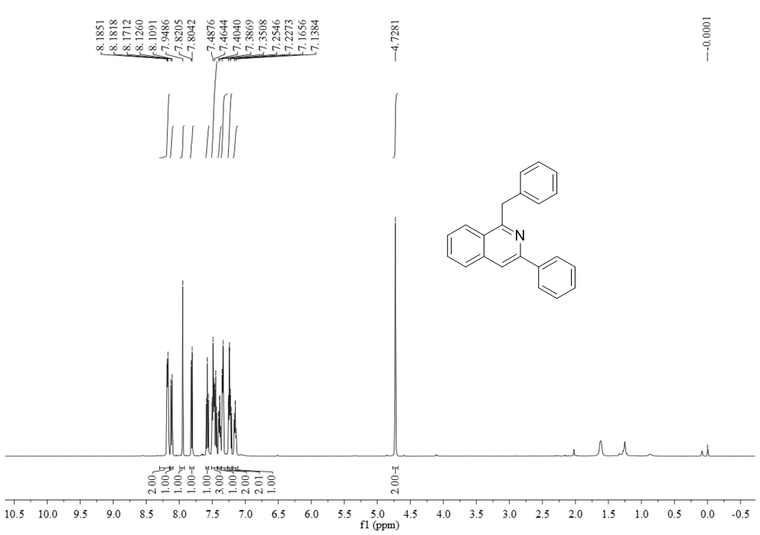
¹³C NMR (125 MHz, CDCl₃) spectrum of compound 3a
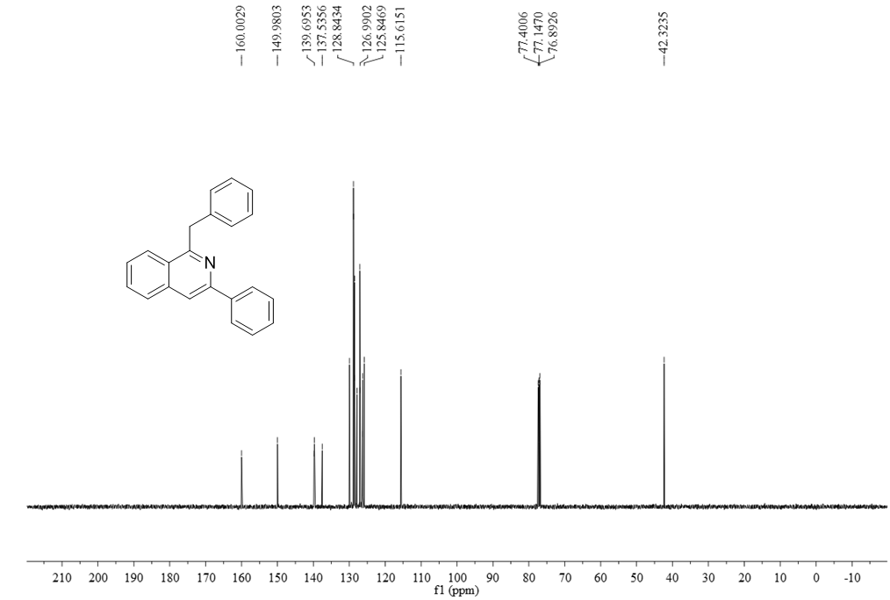

¹H NMR (400 MHz, CDCl₃) spectrum of compound 3b
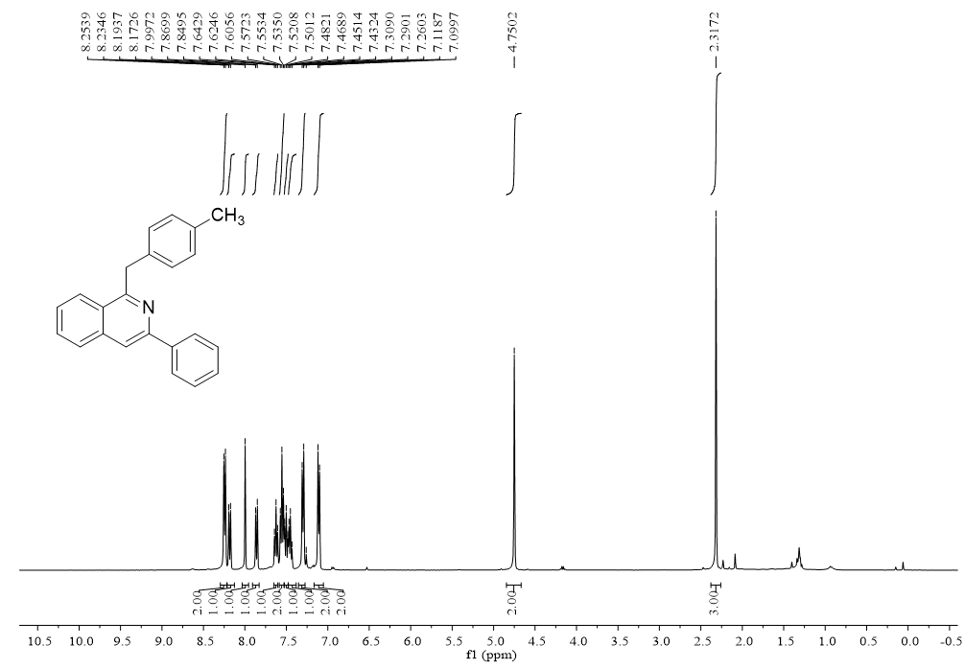
¹³C NMR (100 MHz, CDCl₃) spectrum of compound 3b
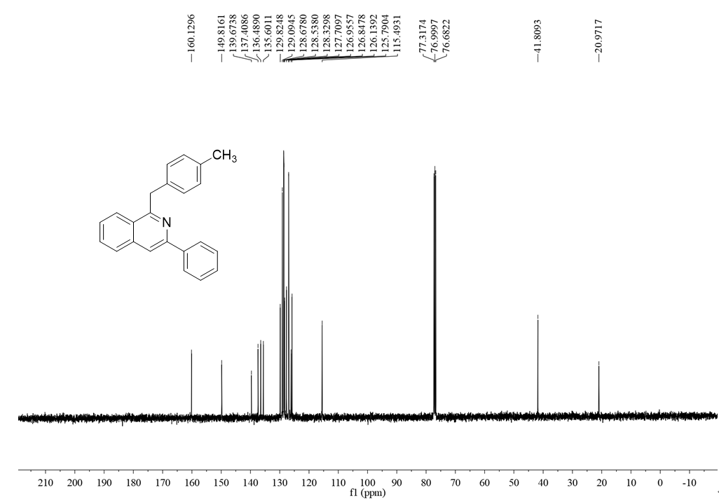

¹H NMR (400 MHz, CDCl₃) spectrum of compound 3c
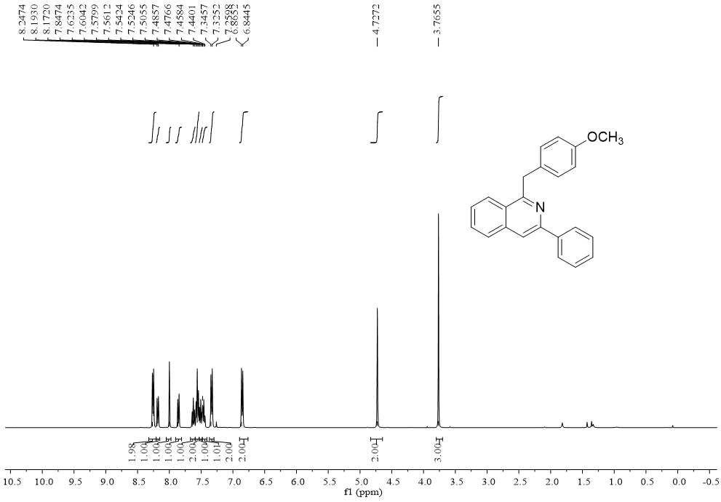
¹³C NMR (100 MHz, CDCl₃) spectrum of compound 3c
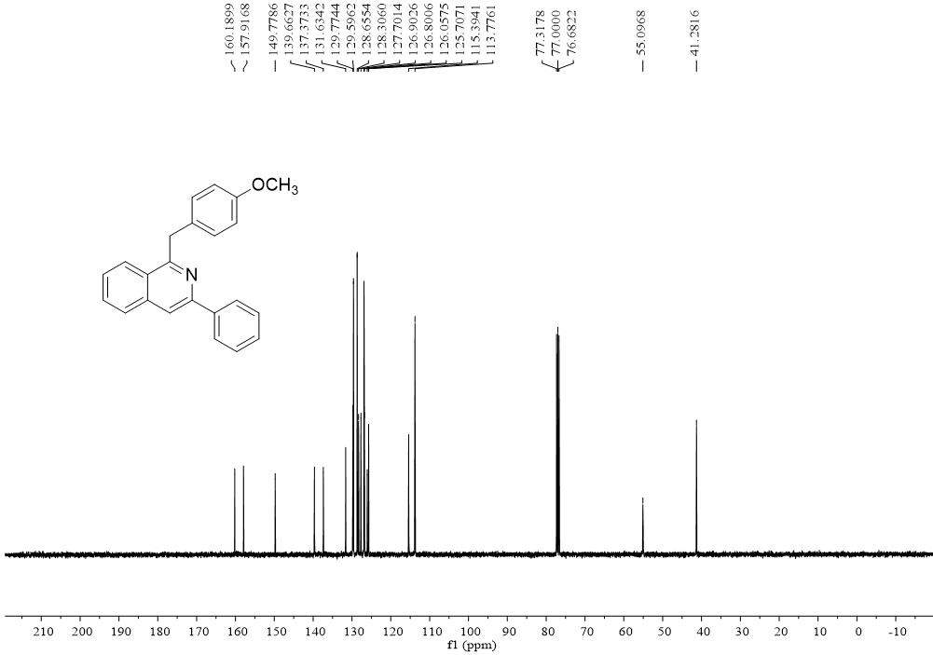

¹H NMR (400 MHz, CDCl₃) spectrum of compound 3d
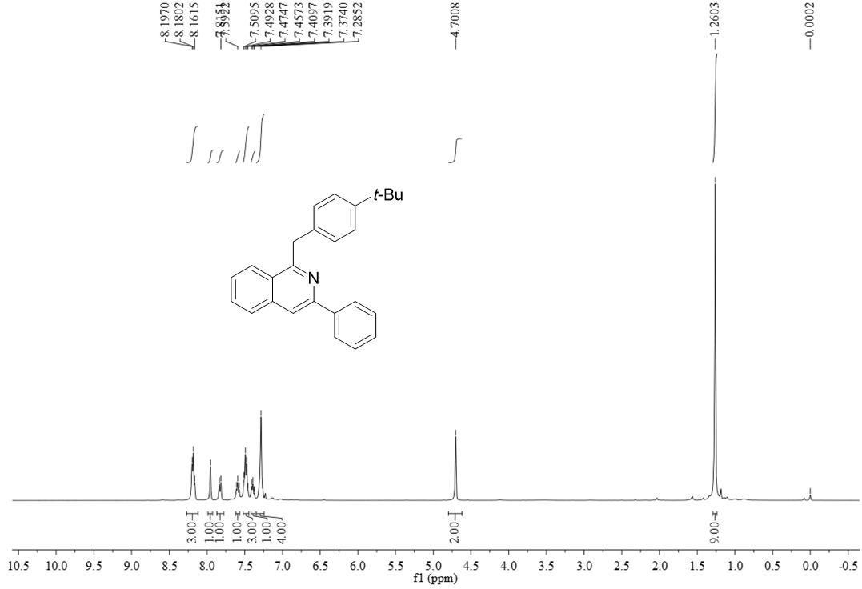
¹³C NMR (100 MHz, CDCl₃) spectrum of compound 3d
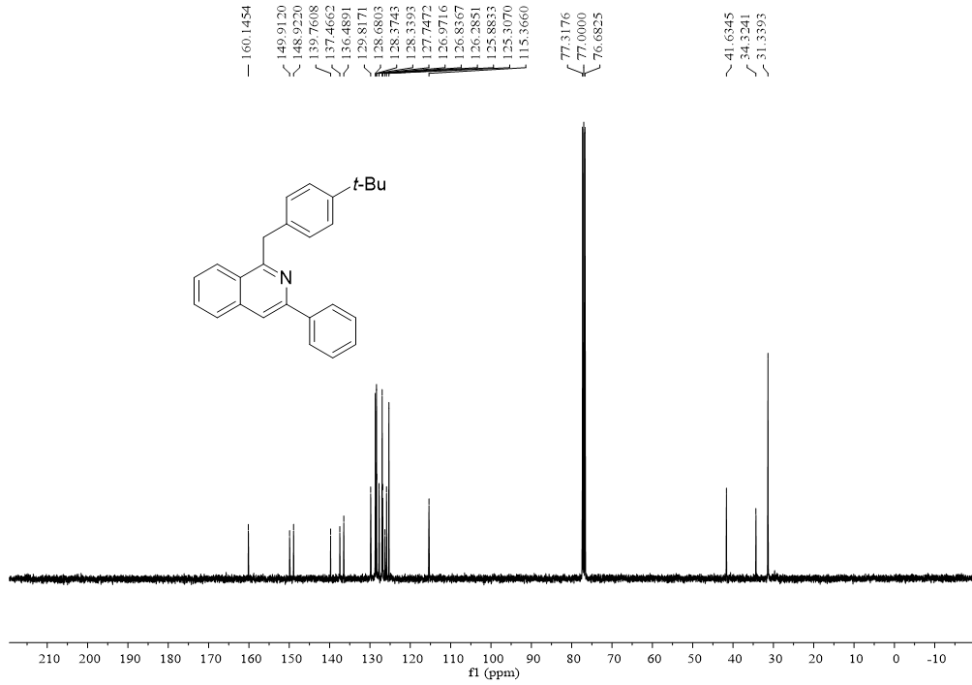

¹H NMR (500 MHz, CDCl₃) spectrum of compound 3e
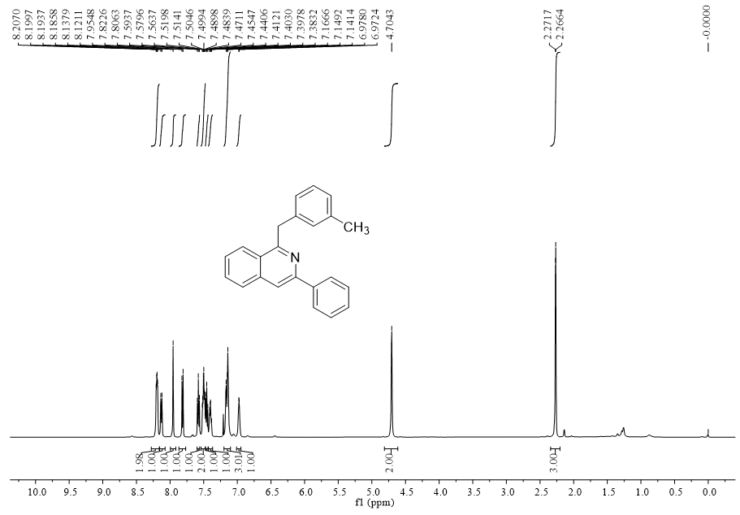
¹³C NMR (125 MHz, CDCl₃) spectrum of compound 3e
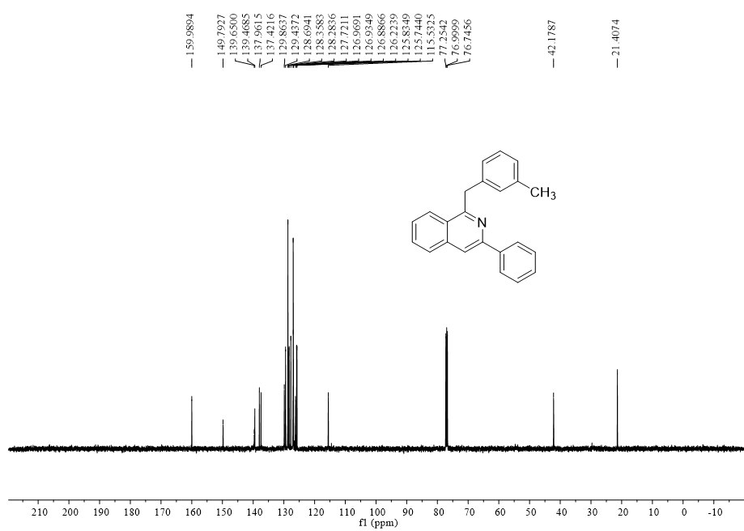

¹H NMR (500 MHz, CDCl₃) spectrum of compound 3f
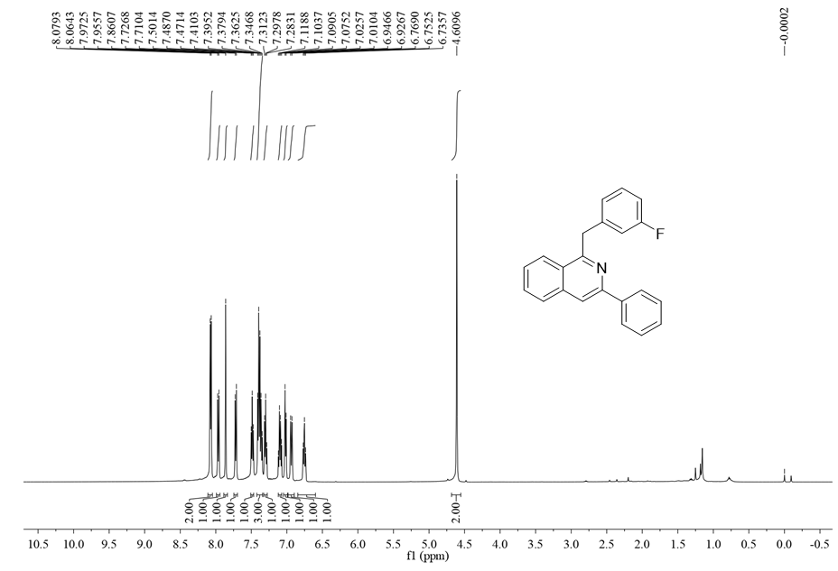
¹³C NMR (125 MHz, CDCl₃) spectrum of compound 3f
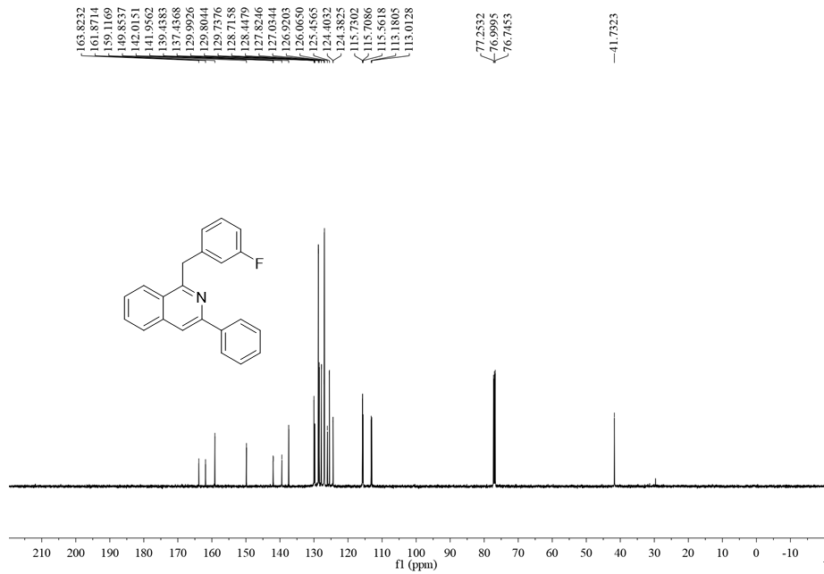

¹H NMR (500 MHz, CDCl₃) spectrum of compound 3g
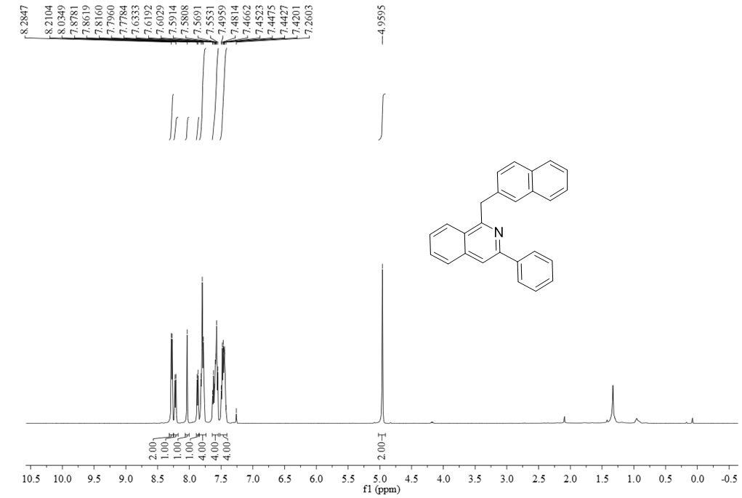
¹³C NMR (125 MHz, CDCl₃) spectrum of compound 3g
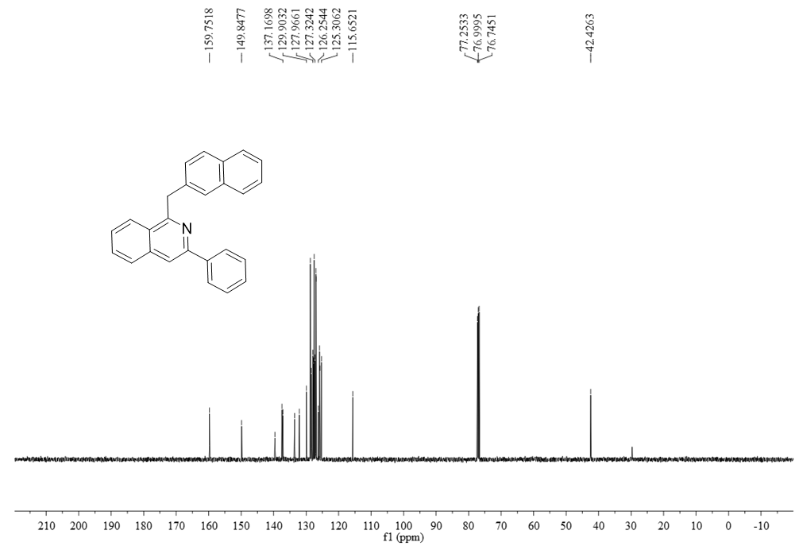

¹H NMR (400 MHz, CDCl₃) spectrum of compound 3h
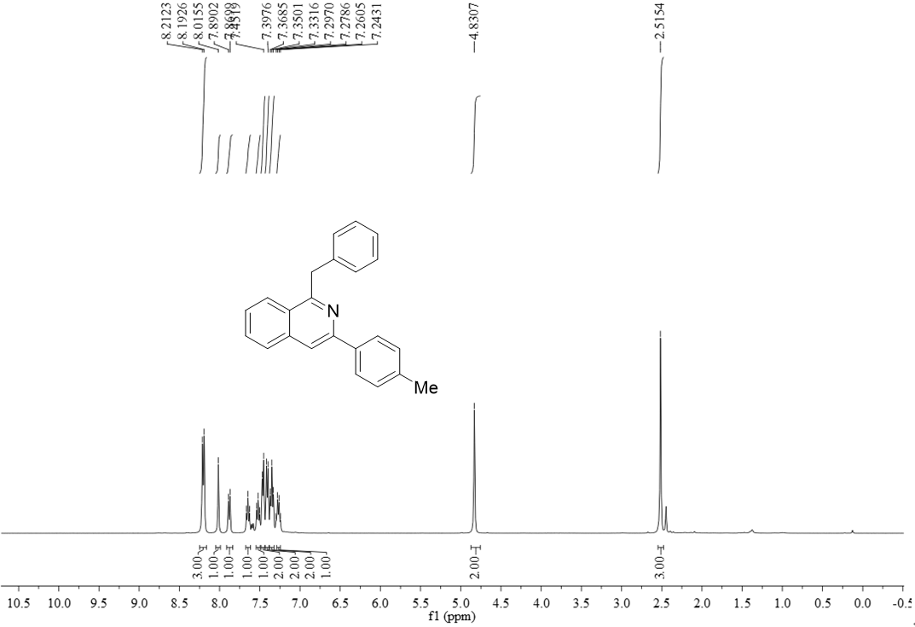
¹³C NMR (100 MHz, CDCl₃) spectrum of compound 3h
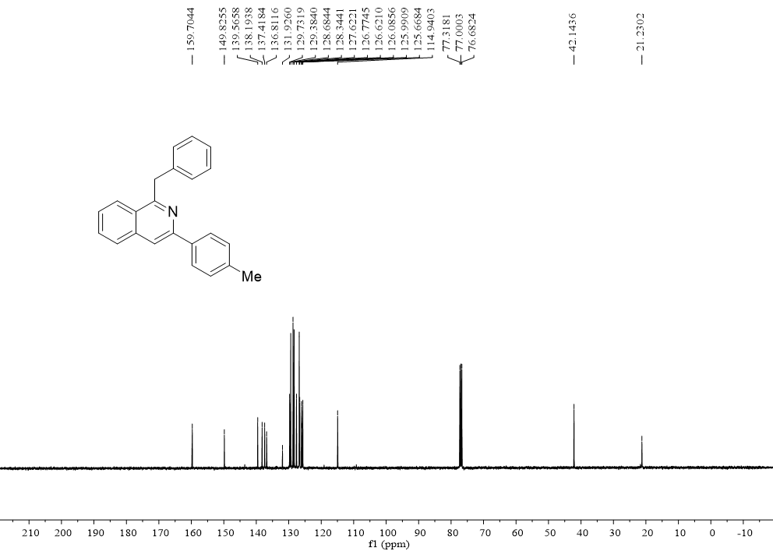

¹H NMR (500 MHz, CDCl₃) spectrum of compound 3i
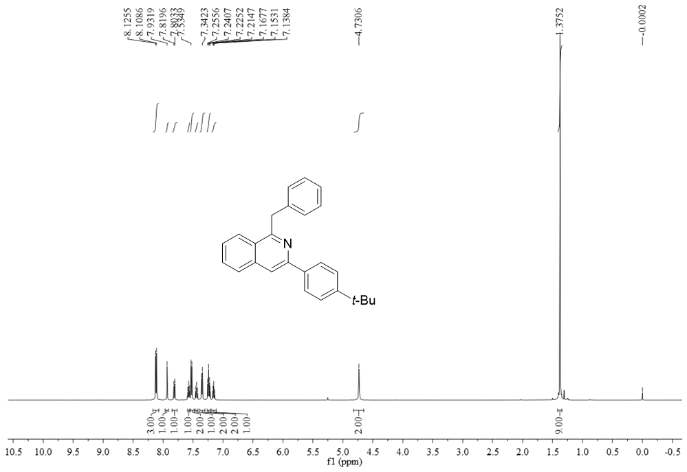
¹³C NMR (125 MHz, CDCl₃) spectrum of compound 3i
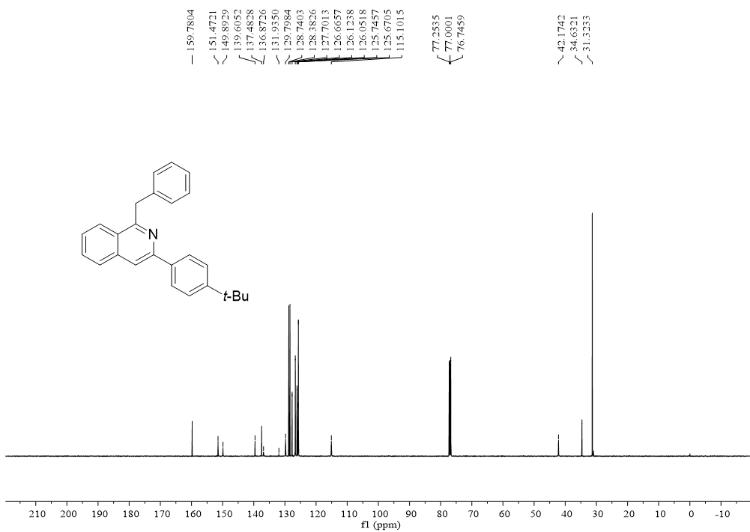

¹H NMR (400 MHz, CDCl₃) spectrum of compound 3j
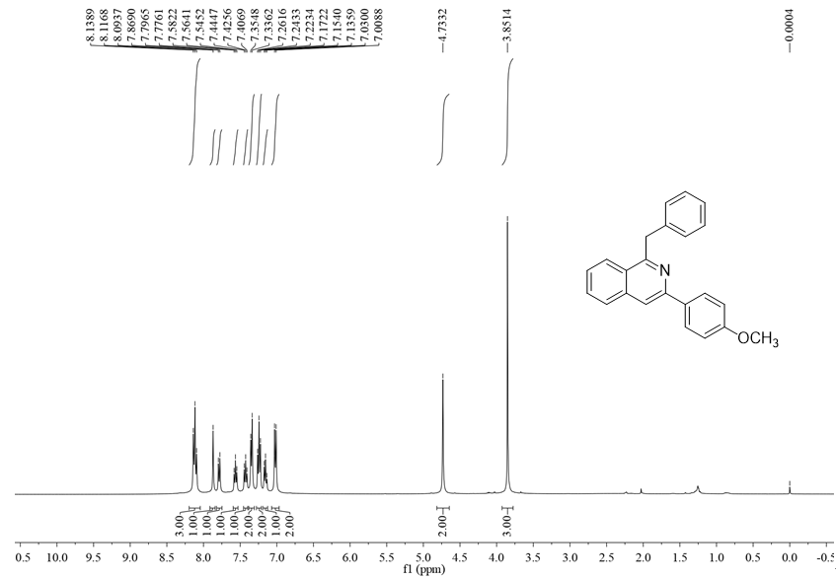
¹³C NMR (100 MHz, CDCl₃) spectrum of compound 3j
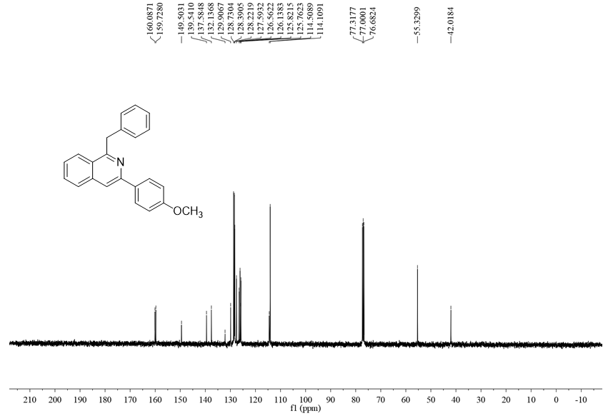

¹H NMR (400 MHz, CDCl₃) spectrum of compound 3k
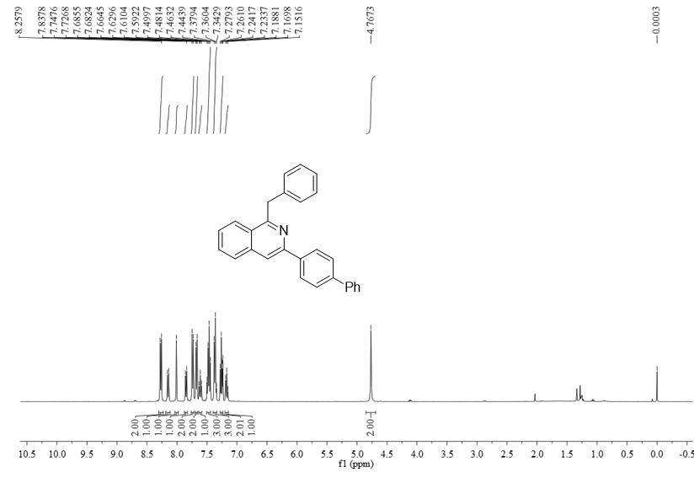
¹³C NMR (100 MHz, CDCl₃) spectrum of compound 3k
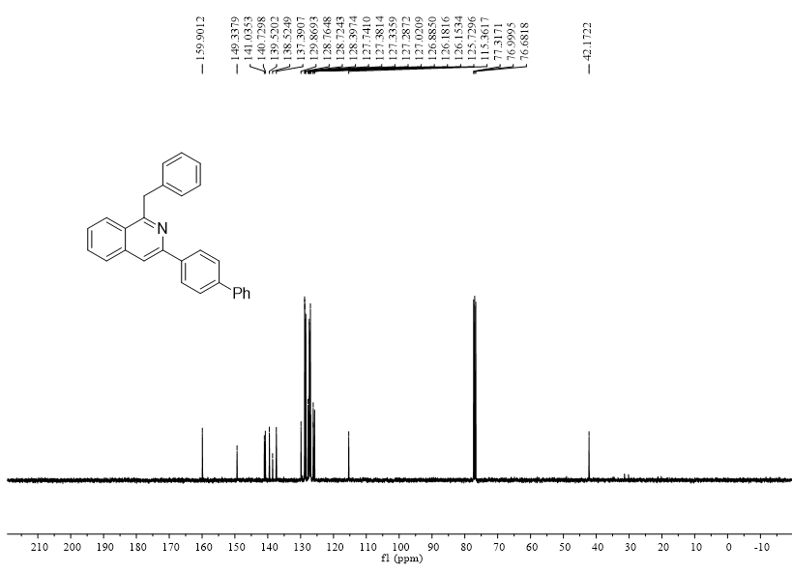

¹H NMR (500 MHz, CDCl₃) spectrum of compound 3l
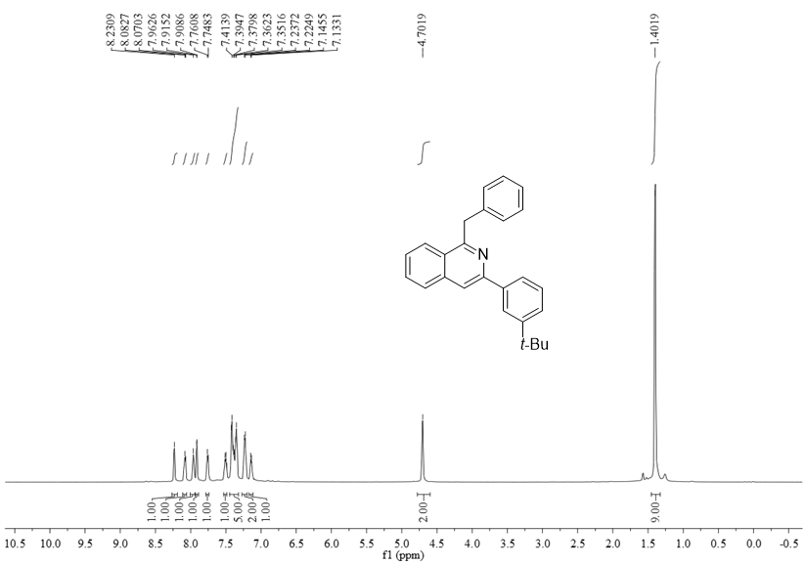
¹³C NMR (125 MHz, CDCl₃) spectrum of compound 3l
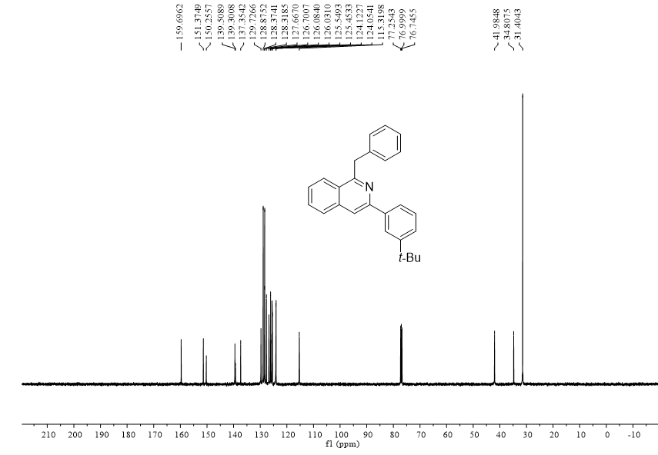

¹H NMR (400 MHz, CDCl₃) spectrum of compound 3m
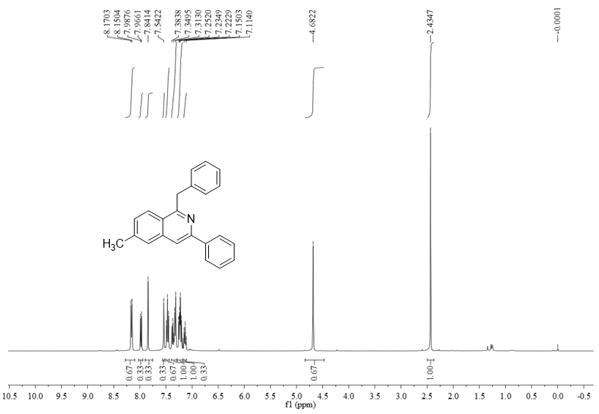
¹³C NMR (100 MHz, CDCl₃) spectrum of compound 3m
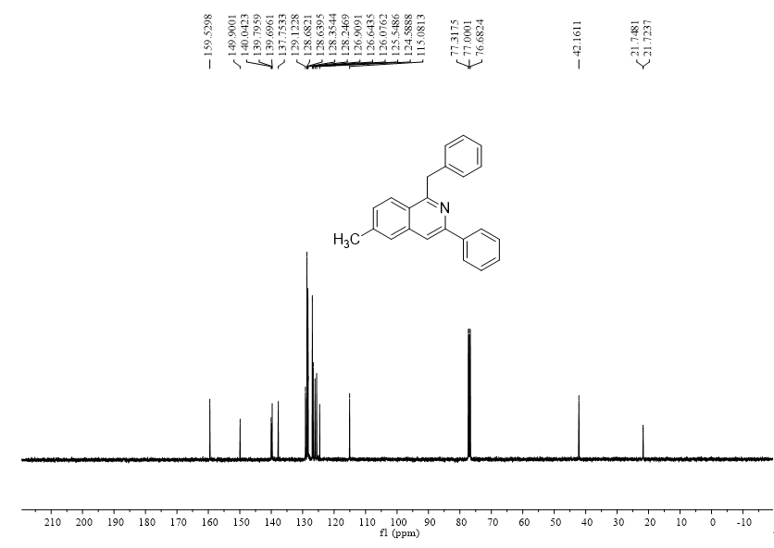

¹H NMR (400 MHz, CDCl₃) spectrum of compound 3n
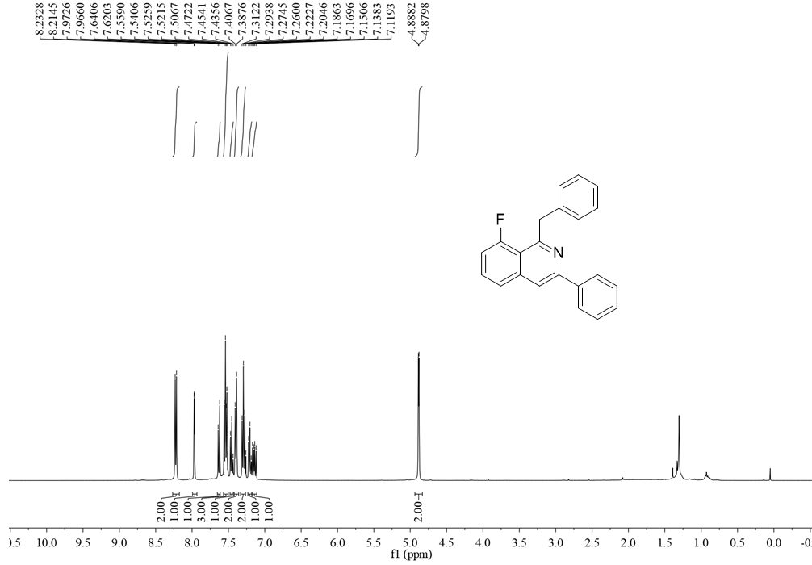
¹³C NMR (100 MHz, CDCl₃) spectrum of compound 3n
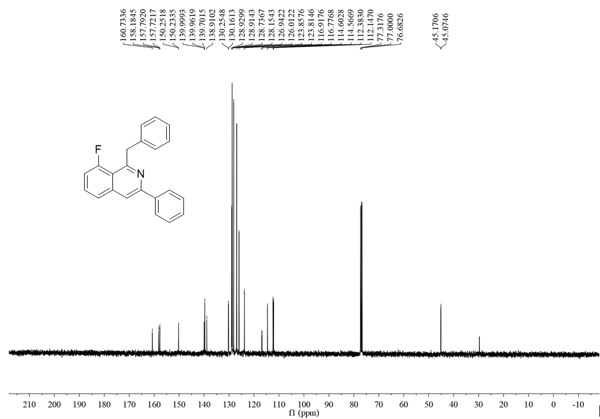

¹H NMR (500 MHz, CDCl₃) spectrum of compound 3o
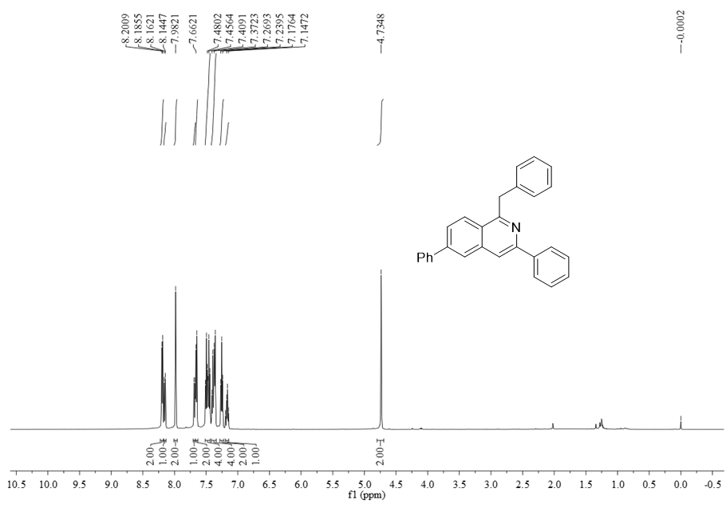
¹³C NMR (125 MHz, CDCl₃) spectrum of compound 3o
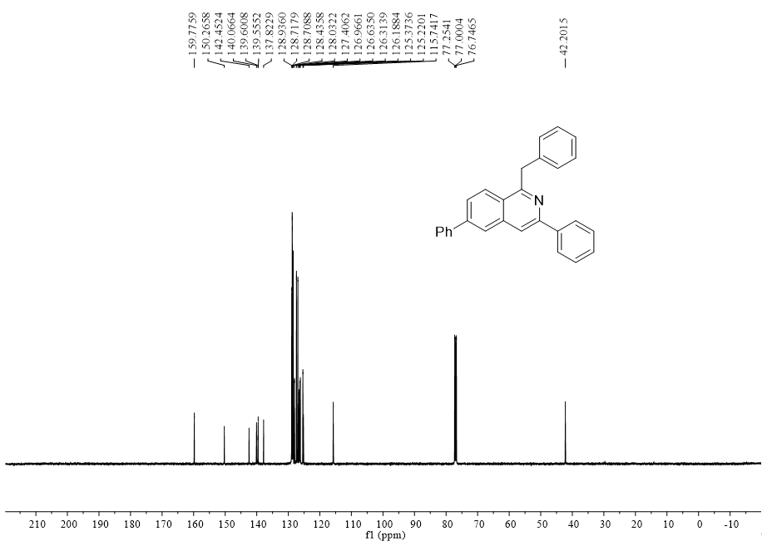

¹H NMR (500 MHz, CDCl₃) spectrum of compound 3p
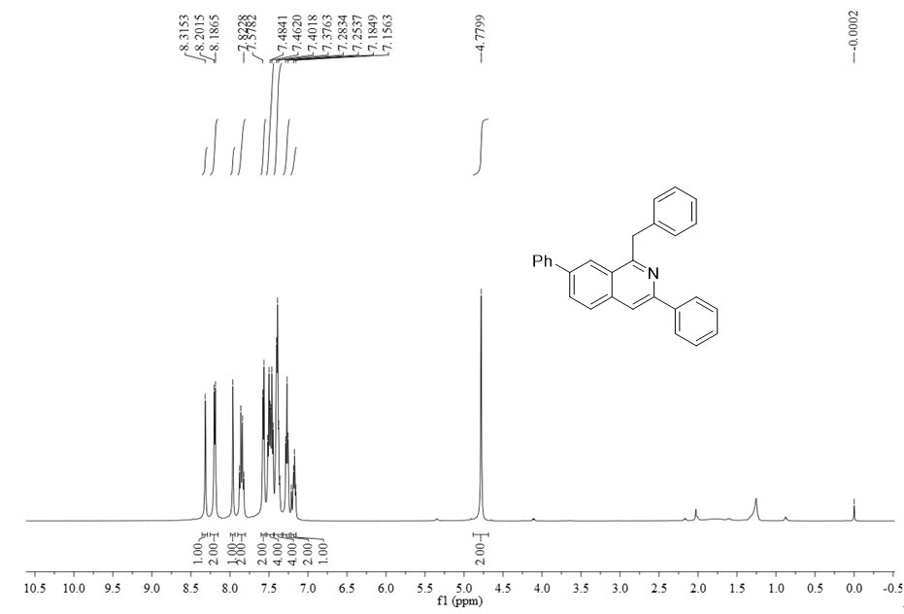
¹³C NMR (125 MHz, CDCl₃) spectrum of compound 3p
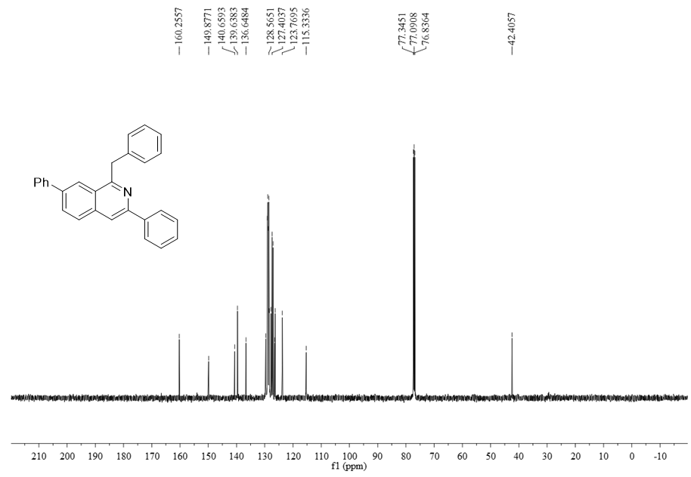

¹H NMR (400 MHz, CDCl₃) spectrum of compound 3q
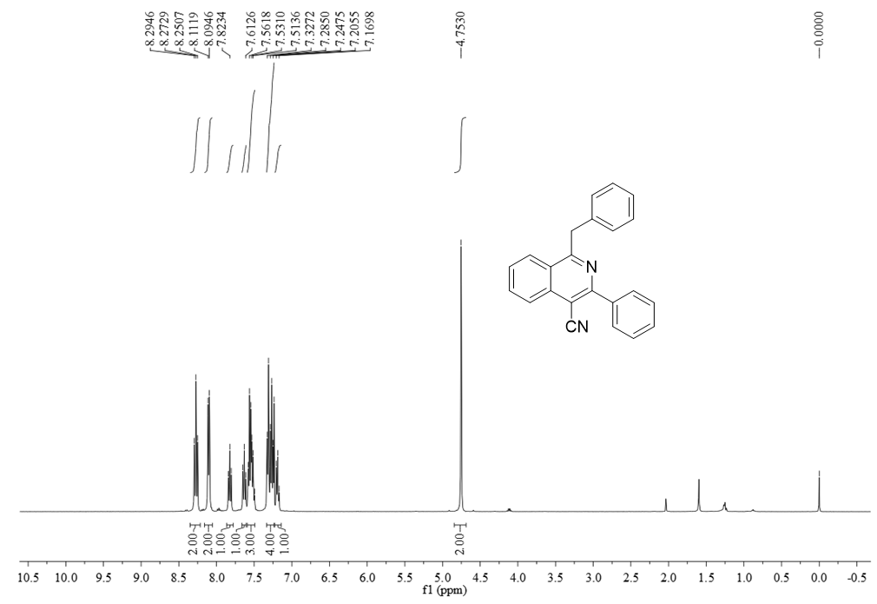
¹³C NMR (100 MHz, CDCl₃) spectrum of compound 3q
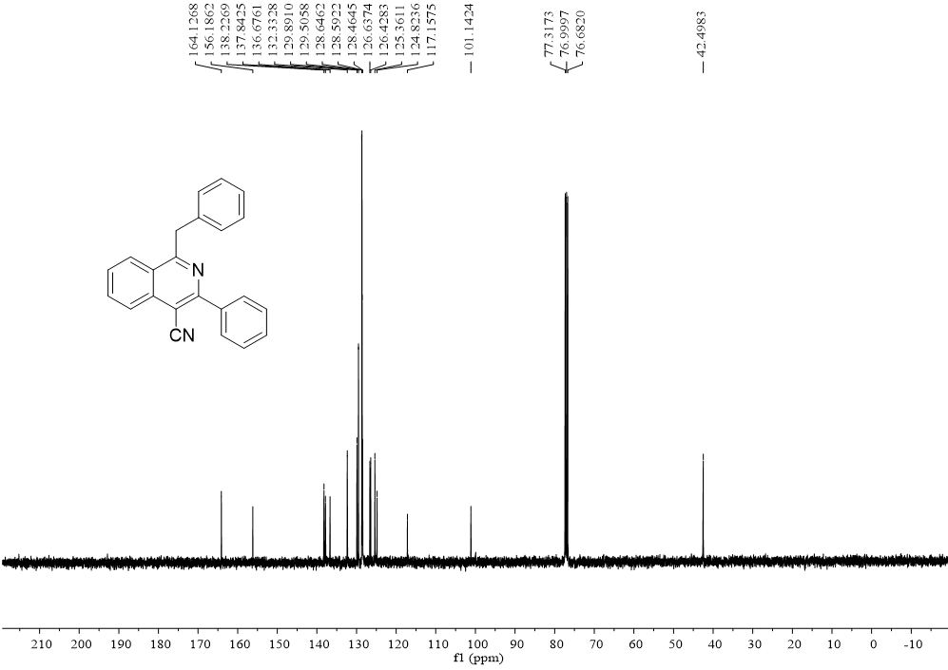

¹H NMR (400 MHz, CDCl₃) spectrum of compound 3r
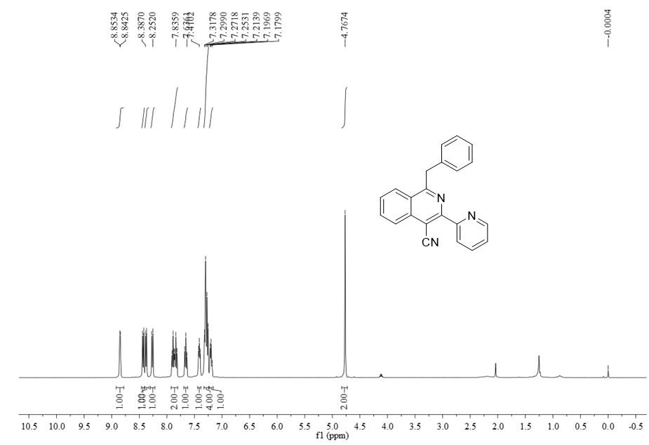
¹³C NMR (100 MHz, CDCl₃) spectrum of compound 3r
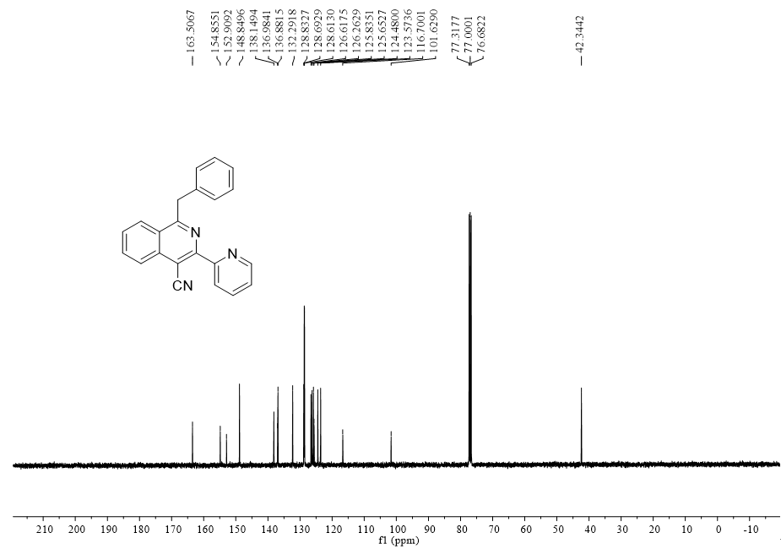

¹H NMR (500 MHz, CDCl₃) spectrum of compound 3s
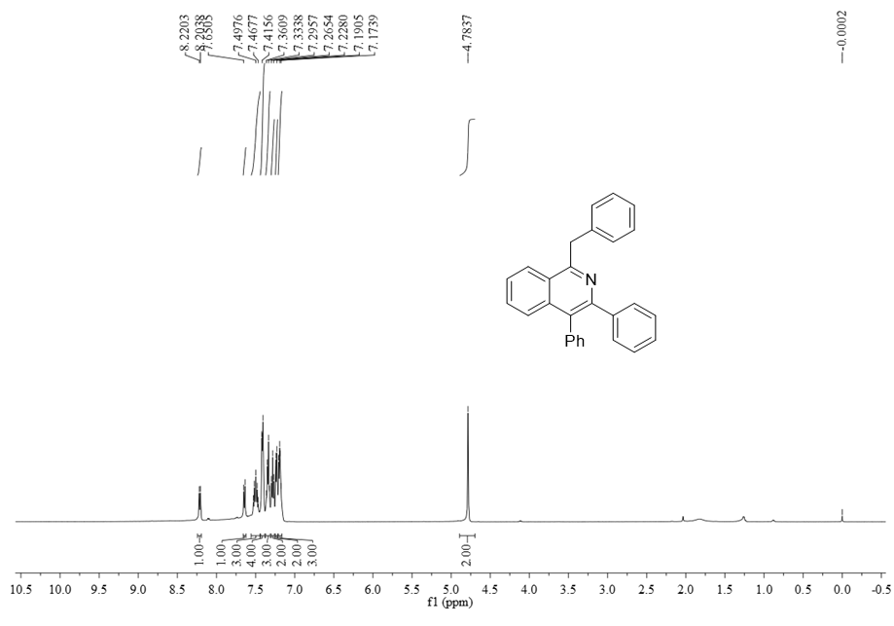
¹³C NMR (125 MHz, CDCl₃) spectrum of compound 3s
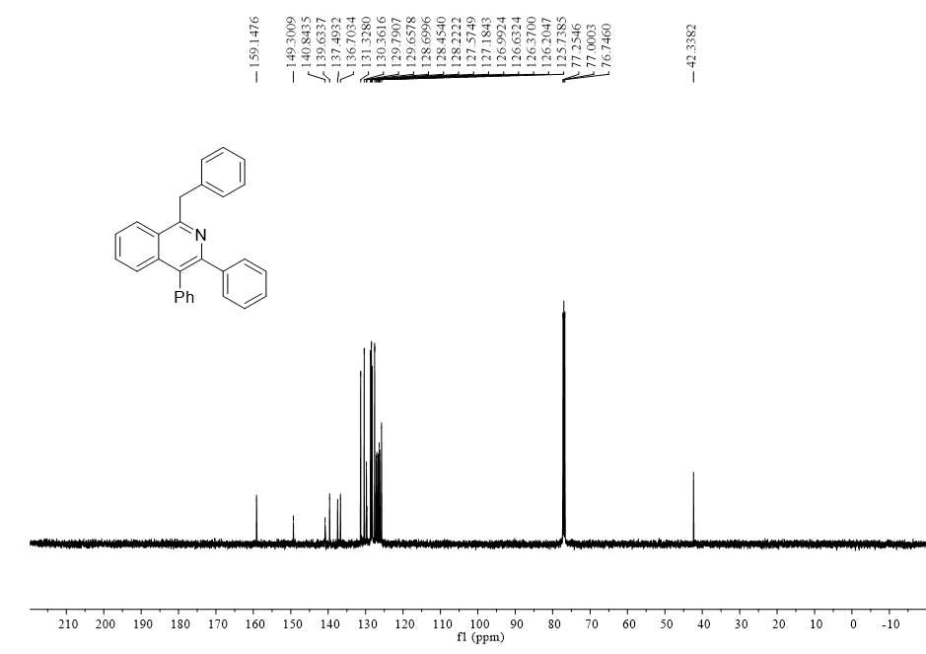

¹H NMR (400 MHz, CDCl₃) spectrum of compound 3t
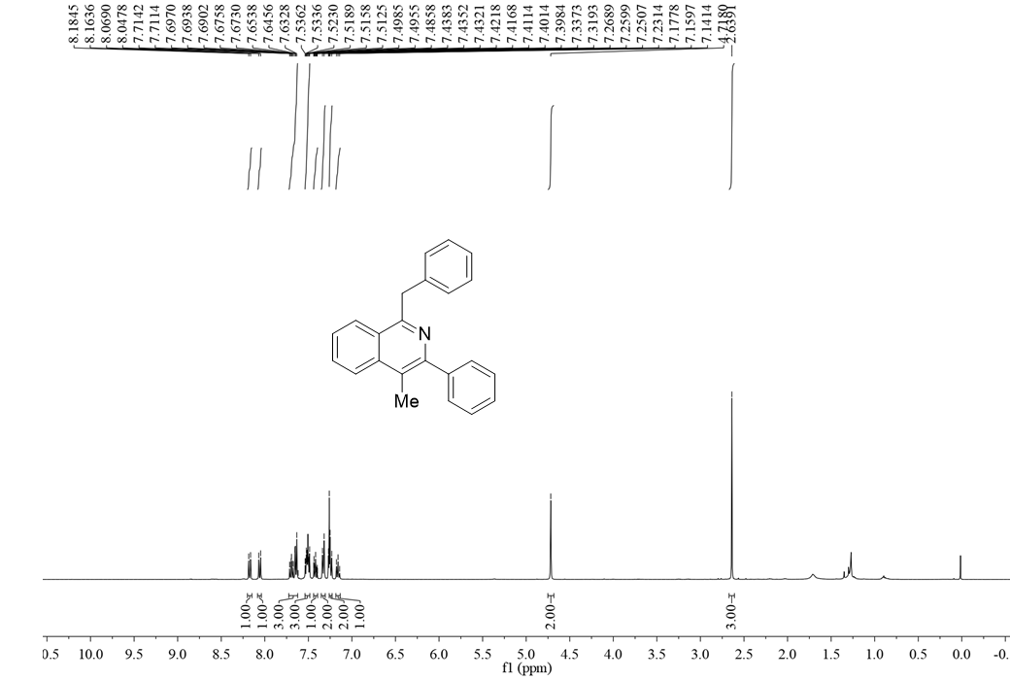

¹³C NMR (100 MHz, CDCl₃) spectrum of compound 3t
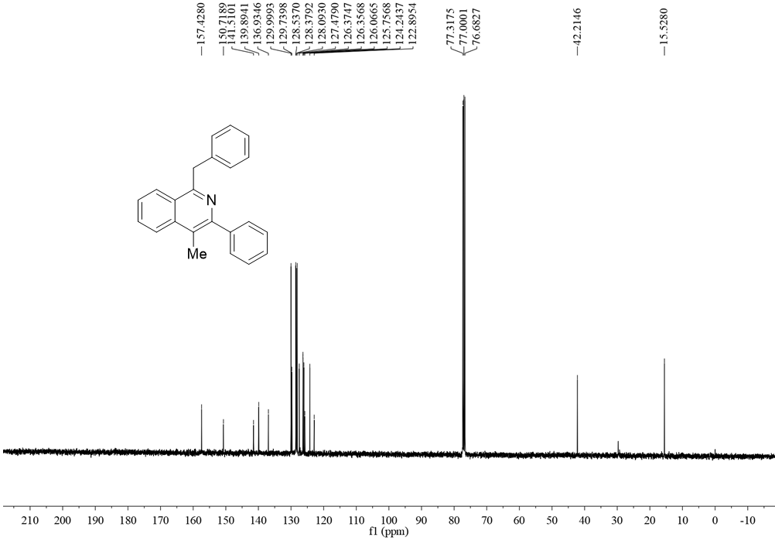

¹H NMR (400 MHz, CDCl₃) spectrum of compound 5a
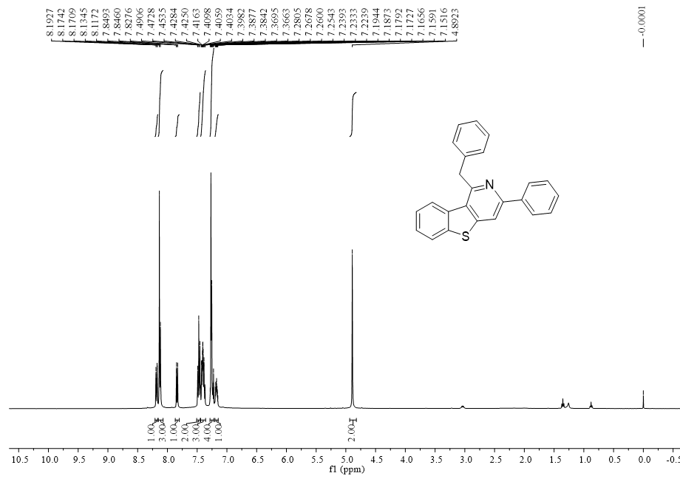
¹³C NMR (100 MHz, CDCl₃) spectrum of compound 5a
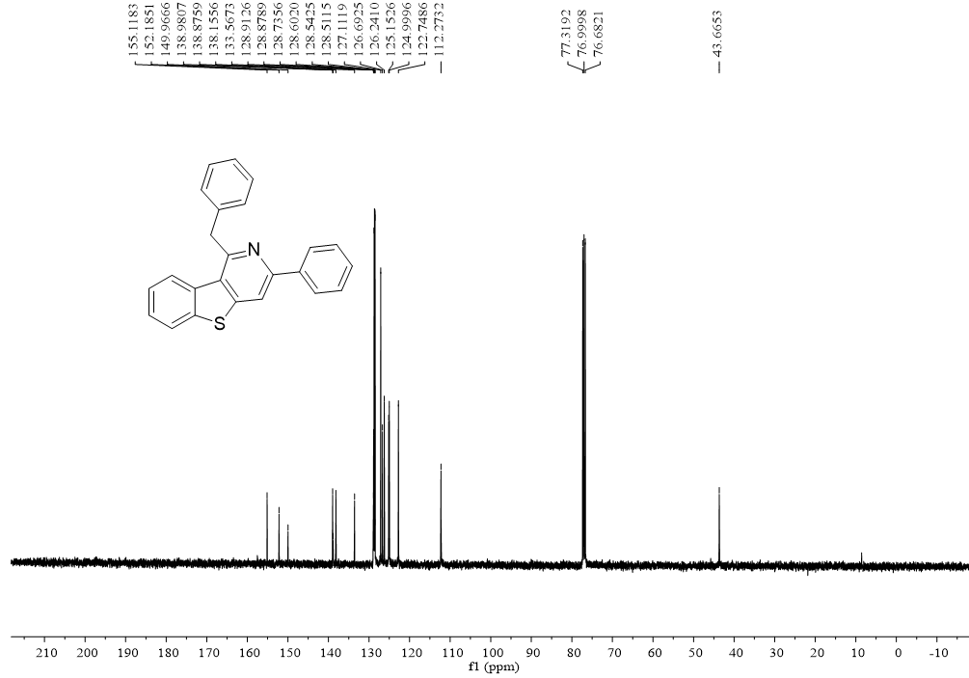

¹H NMR (400 MHz, CDCl₃) spectrum of compound 5b
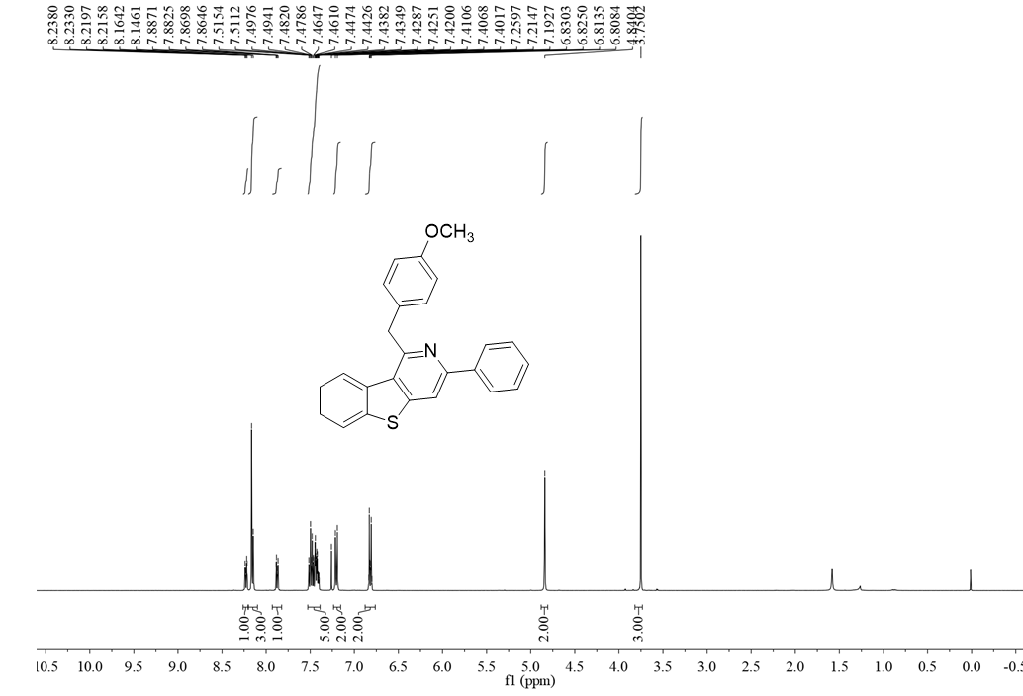
¹³C NMR (100 MHz, CDCl₃) spectrum of compound 5b
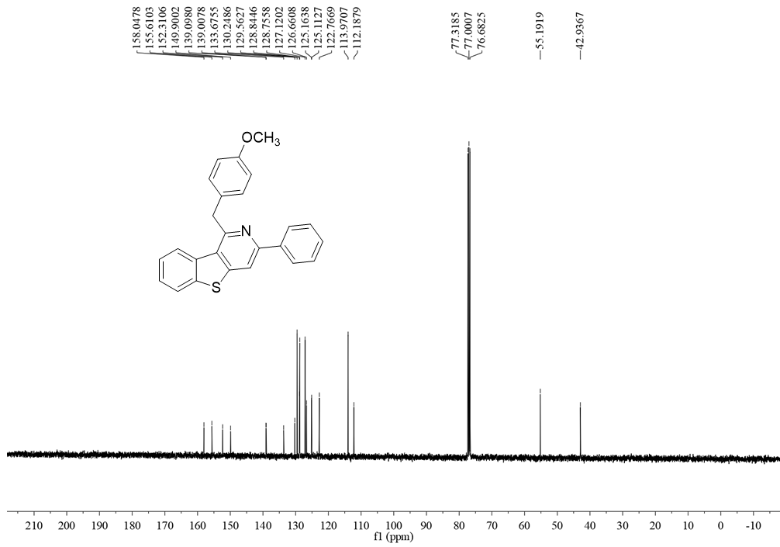

¹H NMR (400 MHz, CDCl₃) spectrum of compound 5c
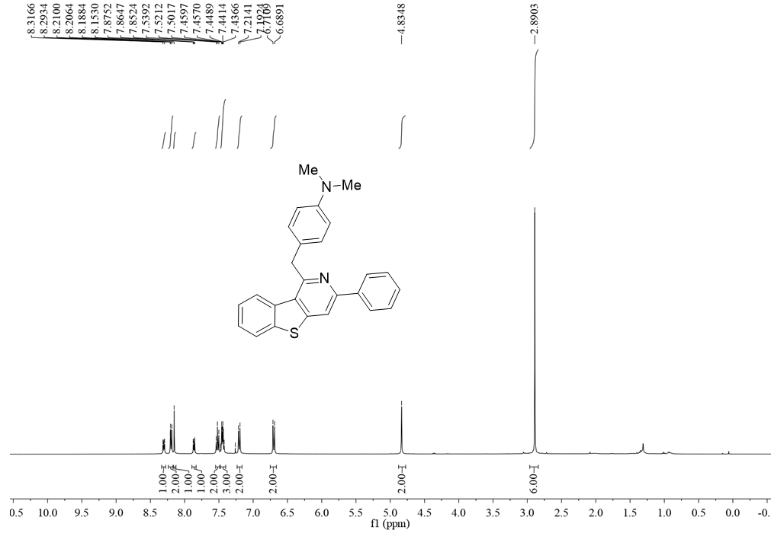
¹³C NMR (100 MHz, CDCl₃) spectrum of compound 5c
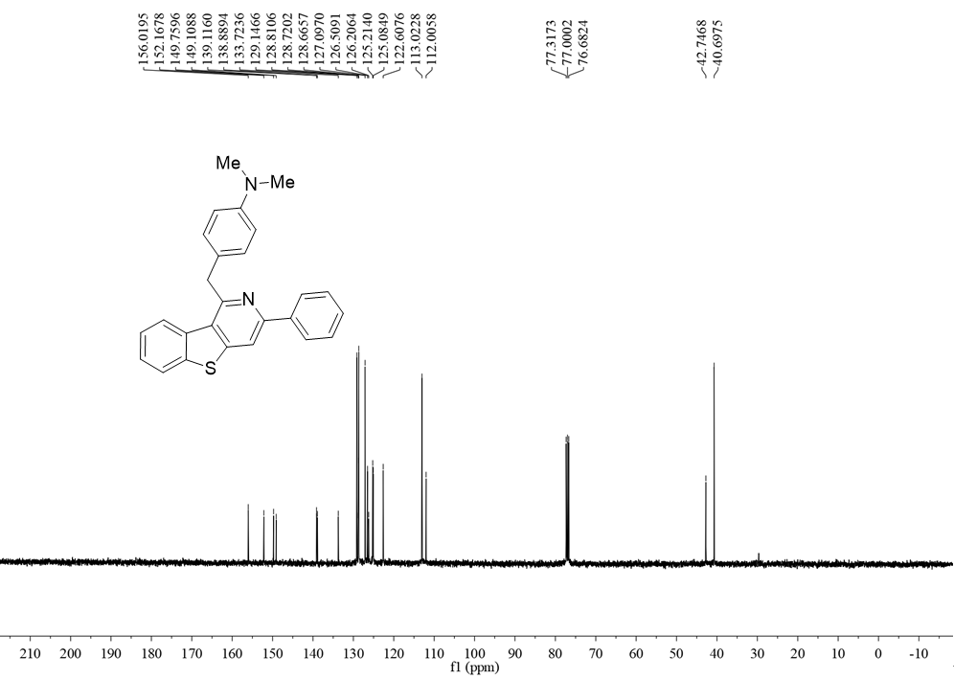

¹H NMR (400 MHz, CDCl₃) spectrum of compound 5d
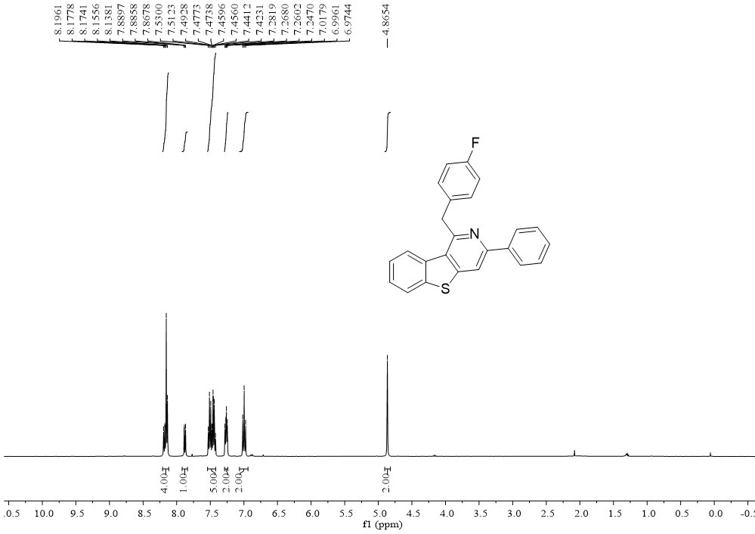
¹³C NMR (100 MHz, CDCl₃) spectrum of compound 5d
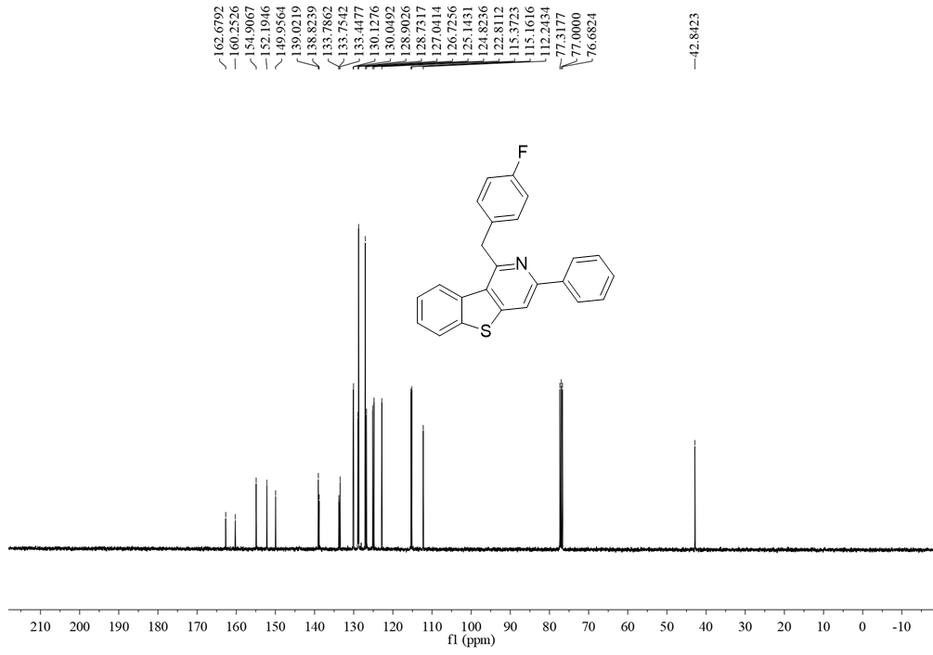

¹H NMR (400 MHz, CDCl₃) spectrum of compound 5e
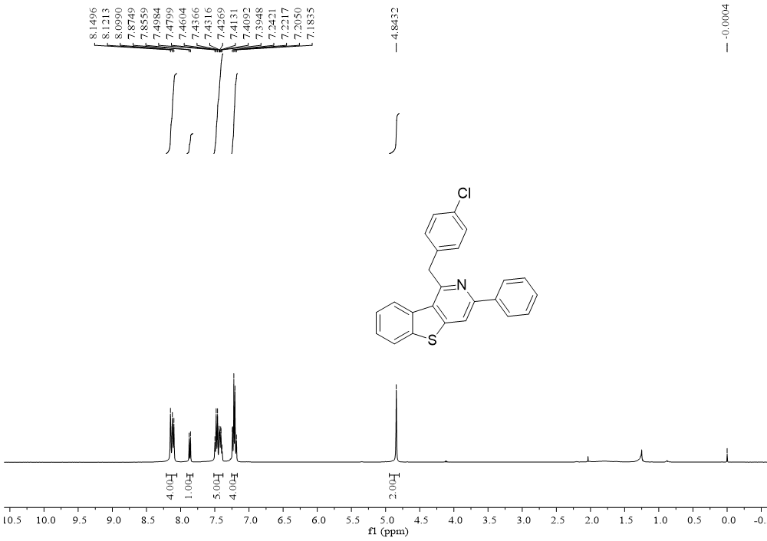

¹³C NMR (100 MHz, CDCl₃) spectrum of compound 5e
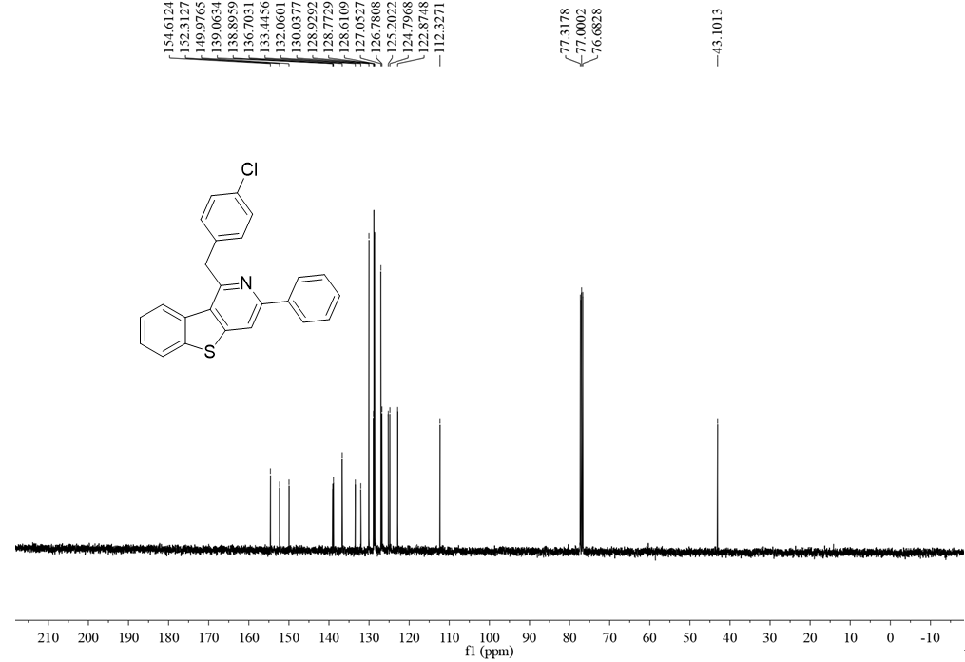

¹H NMR (400 MHz, CDCl₃) spectrum of compound 5f
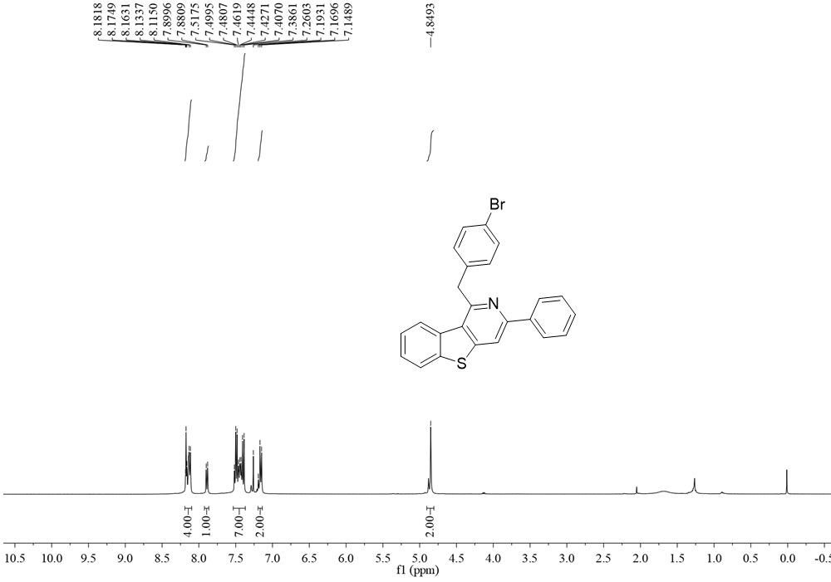

¹³C NMR (100 MHz, CDCl₃) spectrum of compound 5f
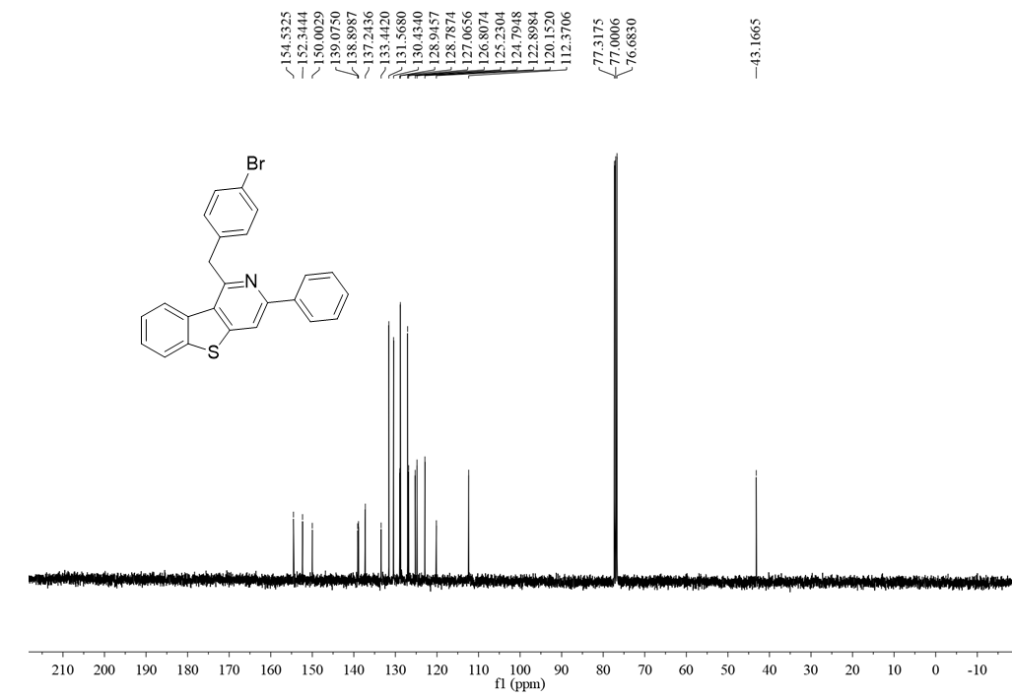

¹H NMR (400 MHz, CDCl₃) spectrum of compound 5g
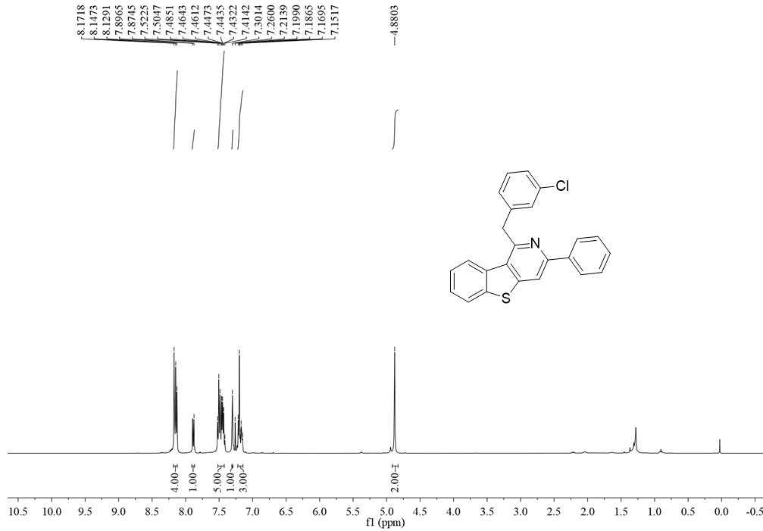
¹³C NMR (100 MHz, CDCl₃) spectrum of compound 5g
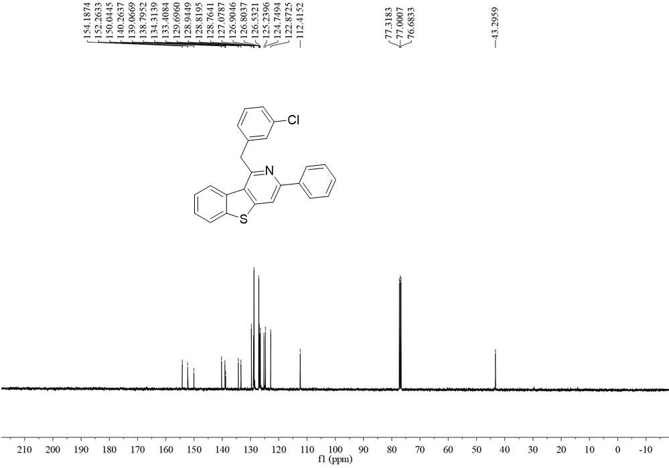

¹H NMR (400 MHz, CDCl₃) spectrum of compound 5h
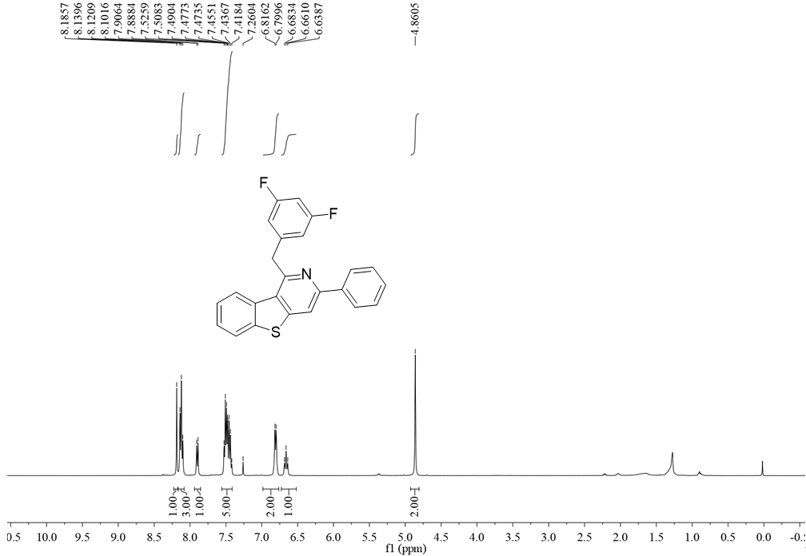
¹³C NMR (100 MHz, CDCl₃) spectrum of compound 5h
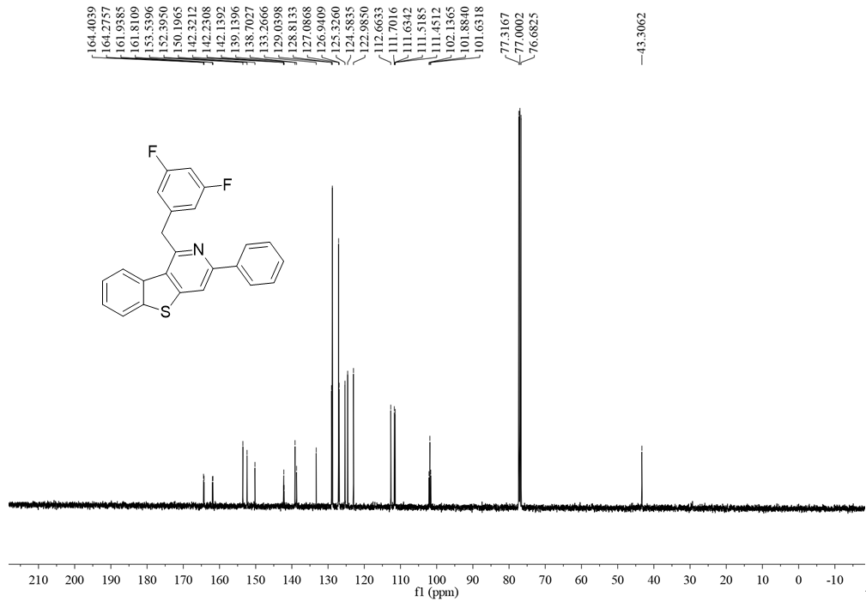

¹H NMR (400 MHz, CDCl₃) spectrum of compound 5i
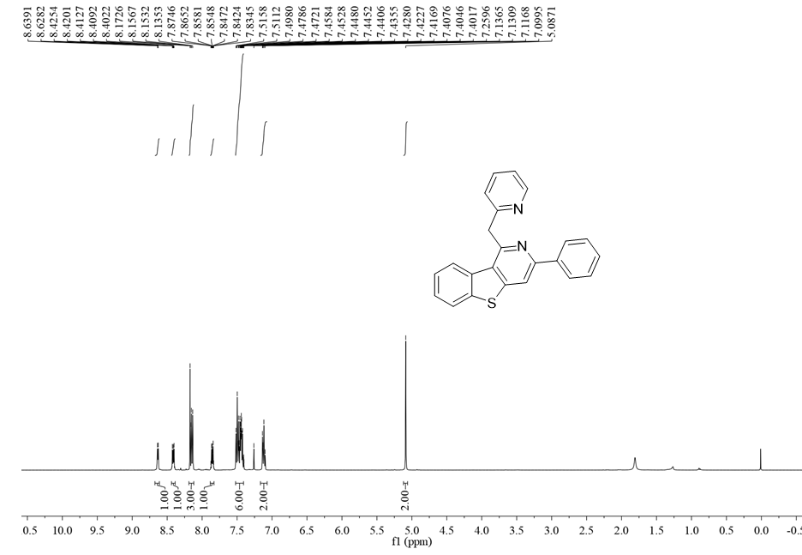
¹³C NMR (100 MHz, CDCl₃) spectrum of compound 5i
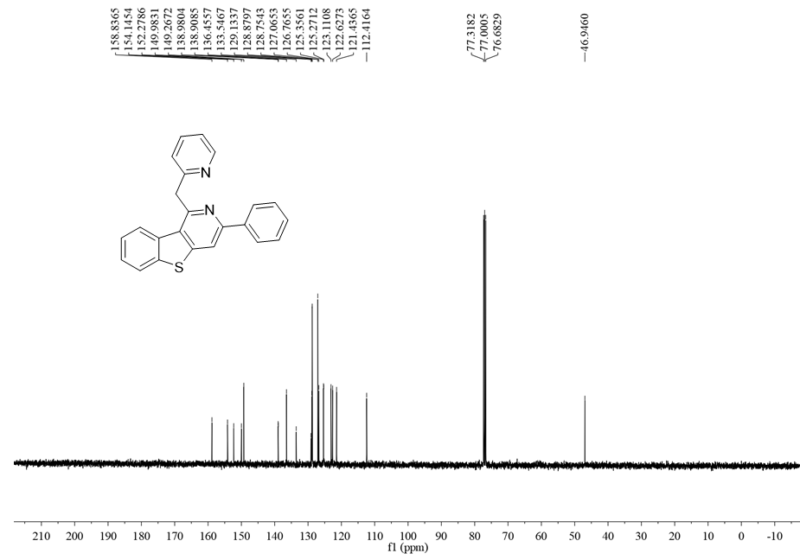

¹H NMR (400 MHz, CDCl₃) spectrum of compound 5j
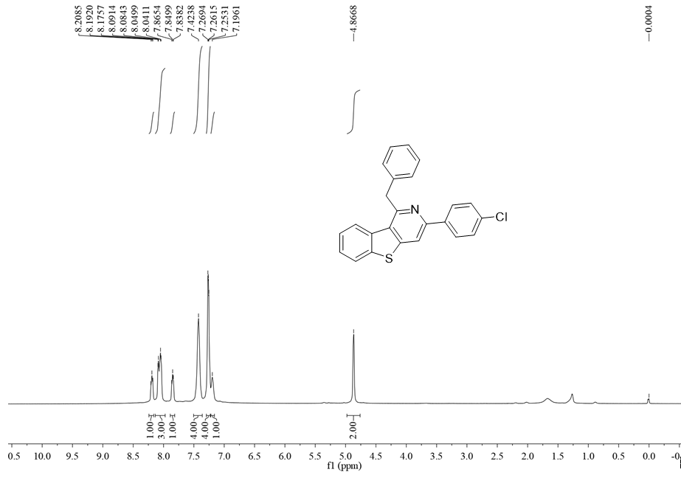

¹³C NMR (100 MHz, CDCl₃) spectrum of compound 5j
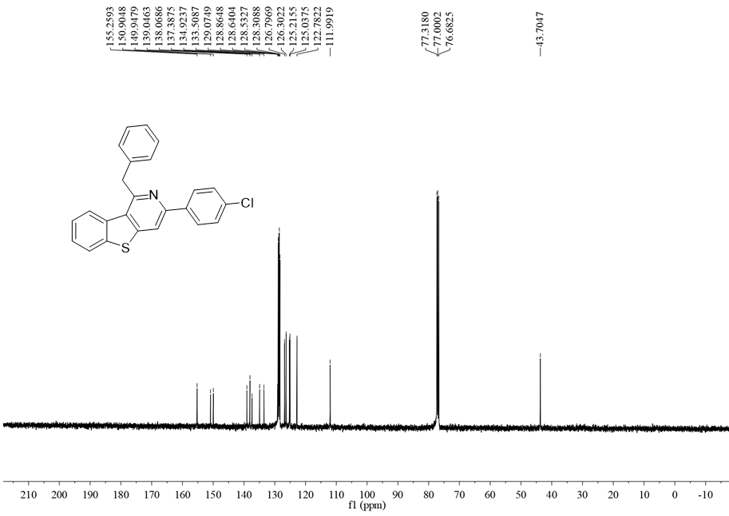

¹H NMR (400 MHz, CDCl₃) spectrum of compound 5k
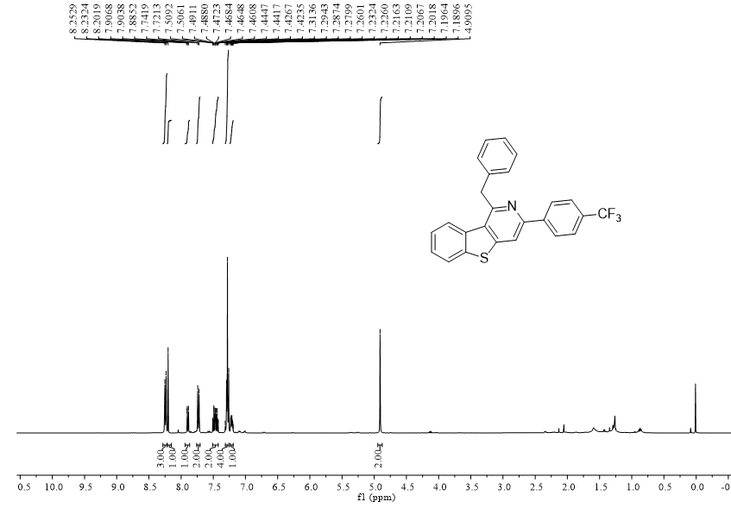

¹³C NMR (100 MHz, CDCl₃) spectrum of compound 5k
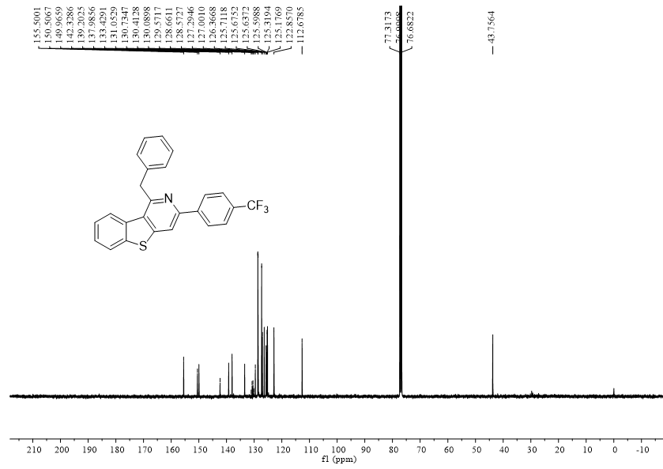

¹H NMR (400 MHz, CDCl₃) spectrum of compound 5l
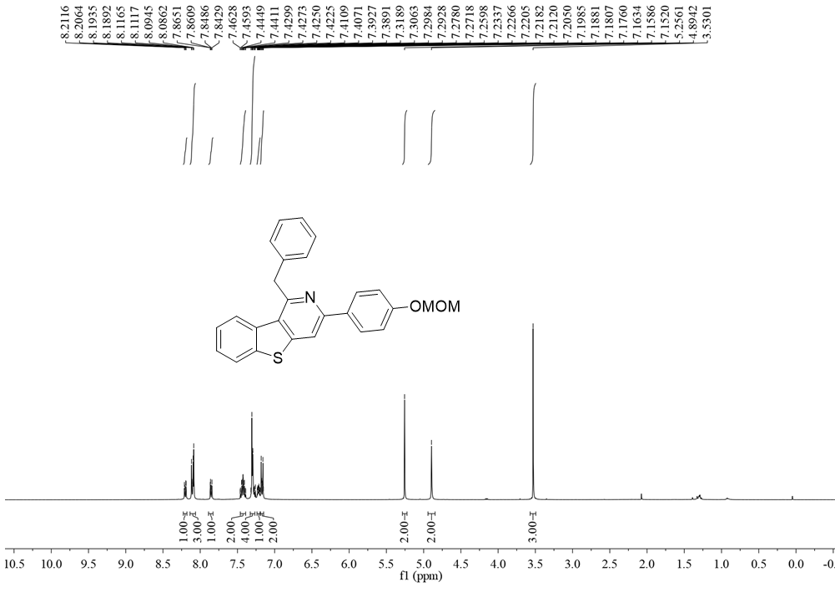

¹³C NMR (100 MHz, CDCl₃) spectrum of compound 5l
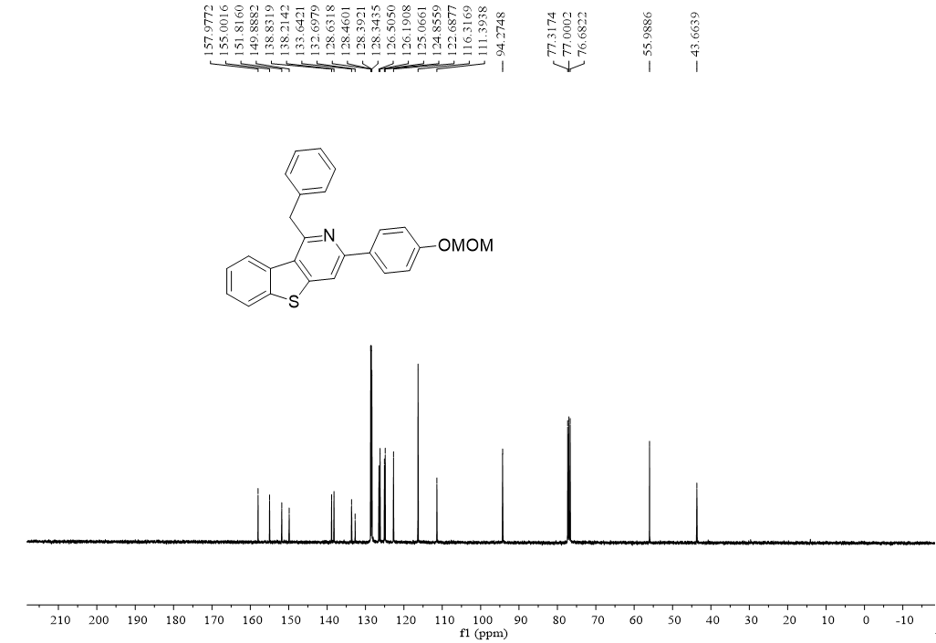

¹H NMR (400 MHz, CDCl₃) spectrum of compound 5m
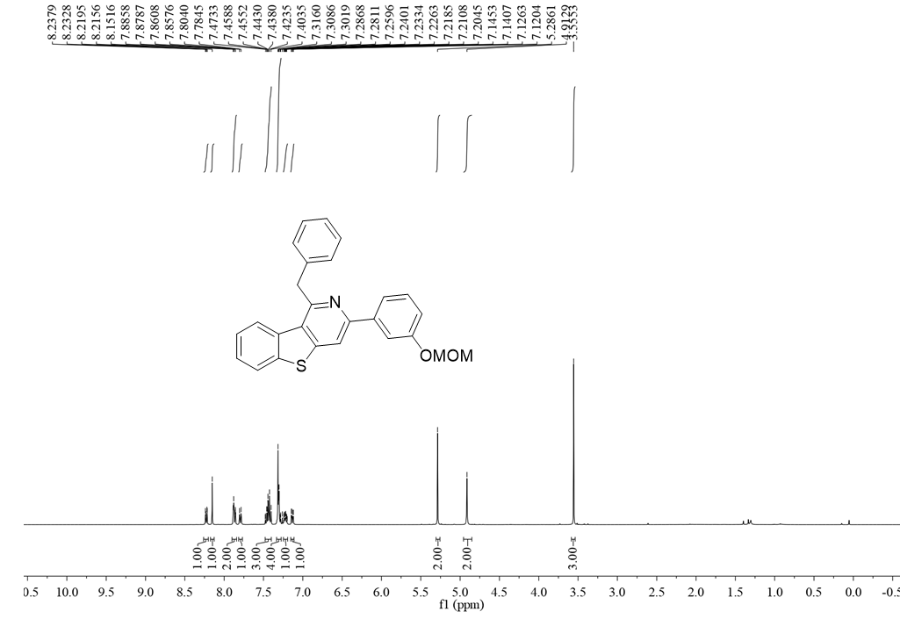

¹³C NMR (100 MHz, CDCl₃) spectrum of compound 5m
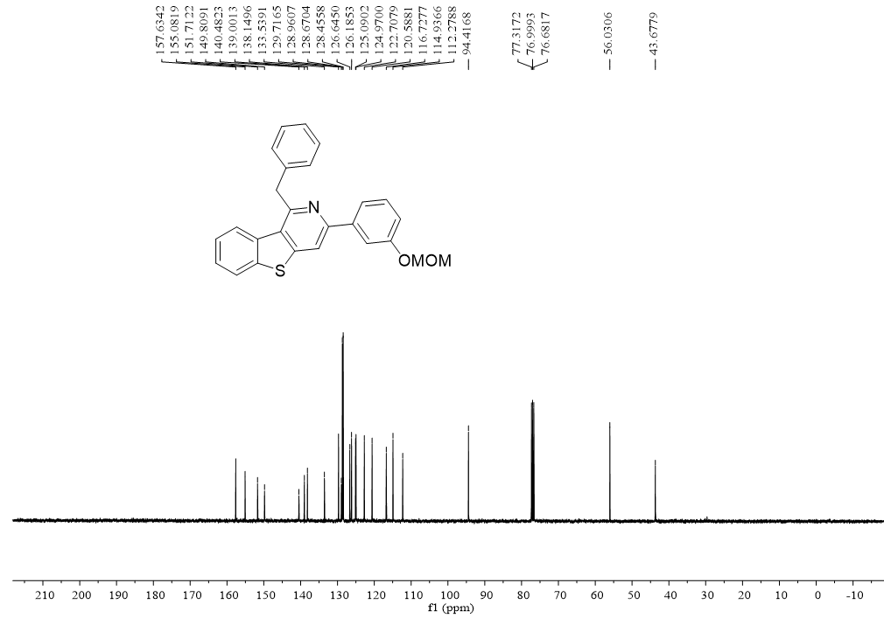

¹H NMR (400 MHz, CDCl₃) spectrum of compound 5n
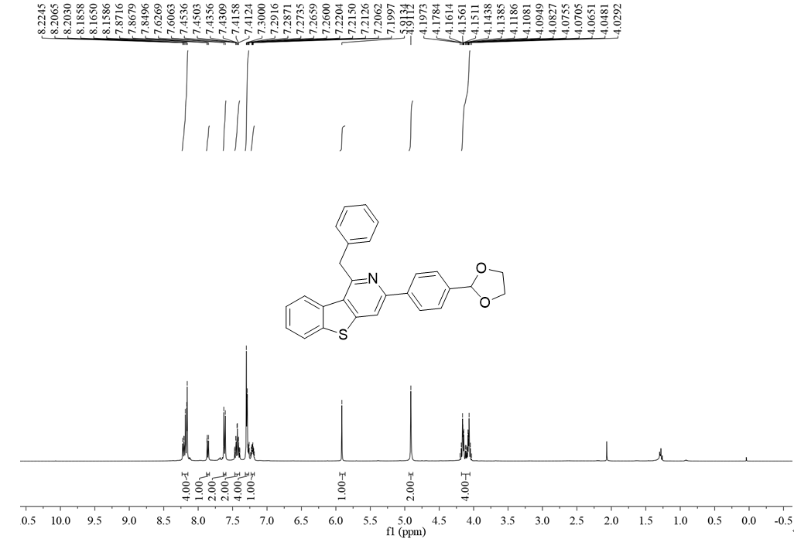

¹³C NMR (100 MHz, CDCl₃) spectrum of compound 5n
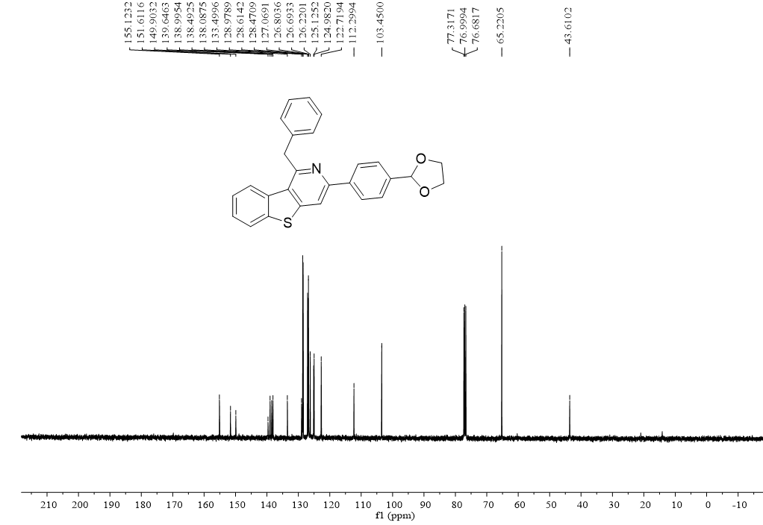

¹H NMR (400 MHz, CDCl₃) spectrum of compound 5o
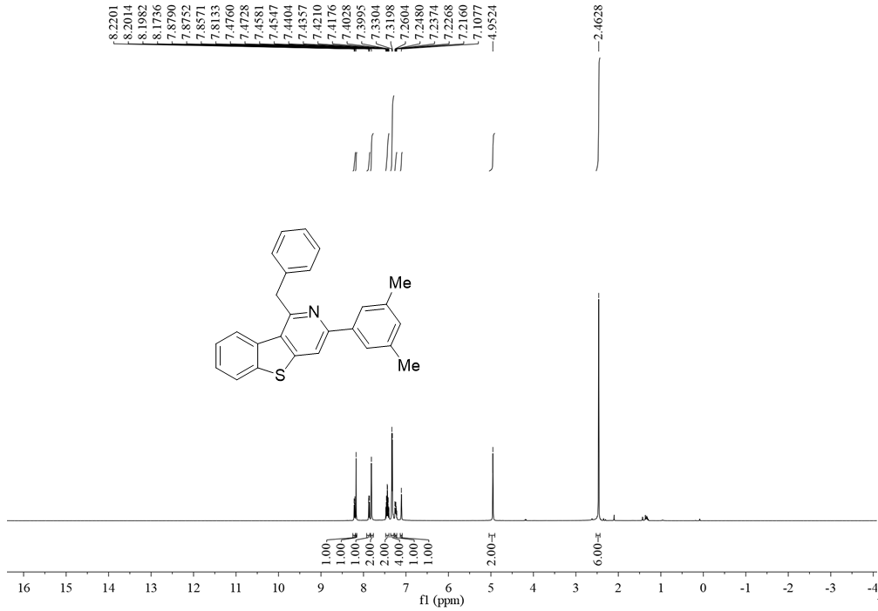

¹³C NMR (100 MHz, CDCl₃) spectrum of compound 5o
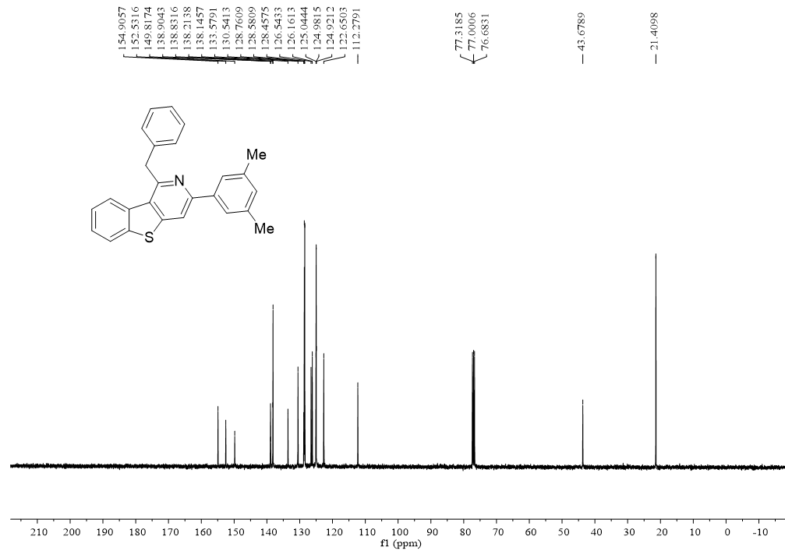

¹H NMR (400 MHz, CDCl₃) spectrum of compound 5p
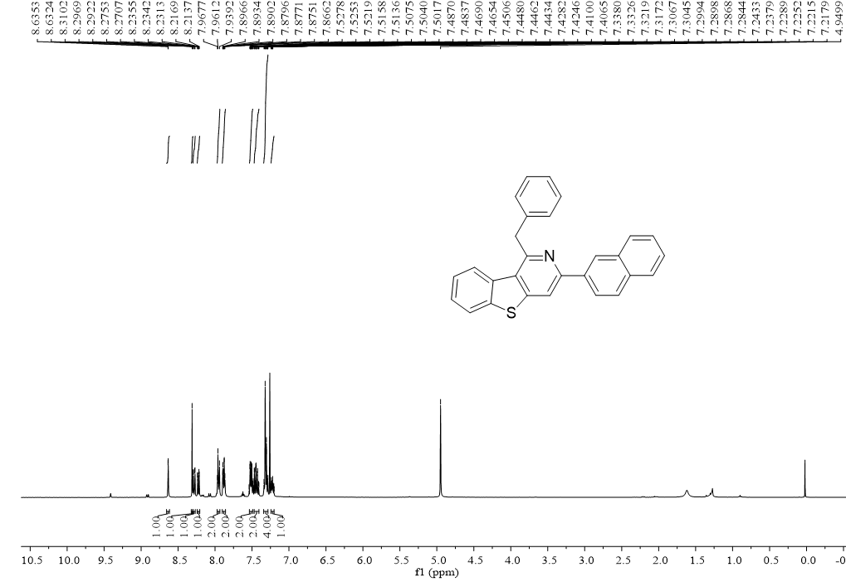

¹³C NMR (100 MHz, CDCl₃) spectrum of compound 5p
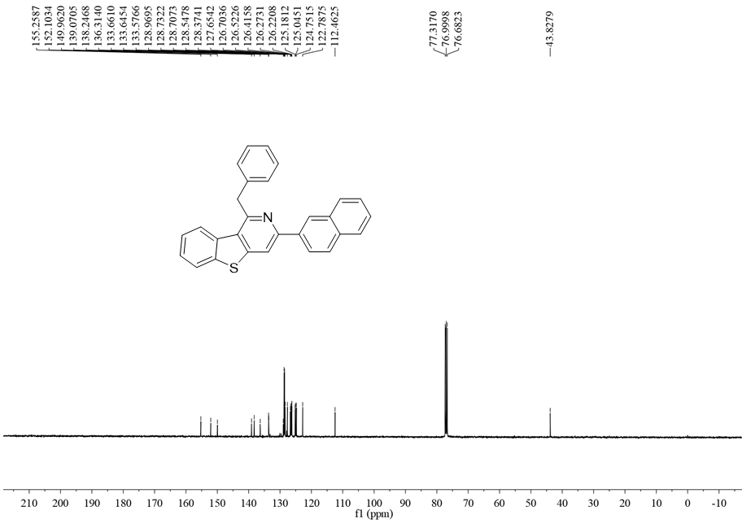

¹H NMR (400 MHz, CDCl₃) spectrum of compound 5q
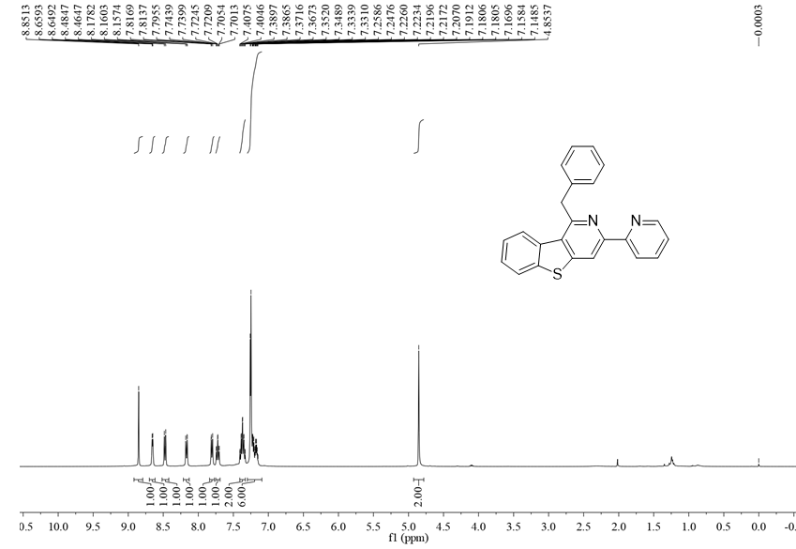

¹³C NMR (100 MHz, CDCl₃) spectrum of compound 5q
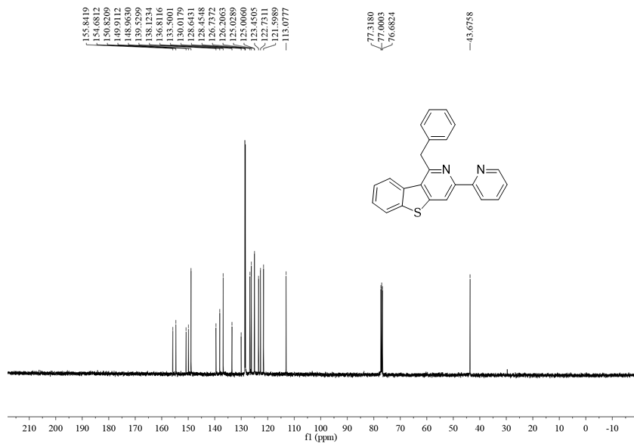

¹H NMR (400 MHz, CDCl₃) spectrum of compound 5r
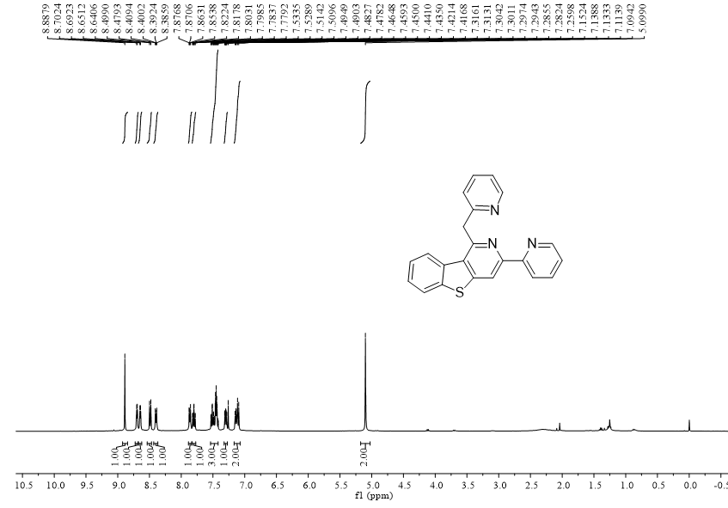

¹³C NMR (100 MHz, CDCl₃) spectrum of compound 5r
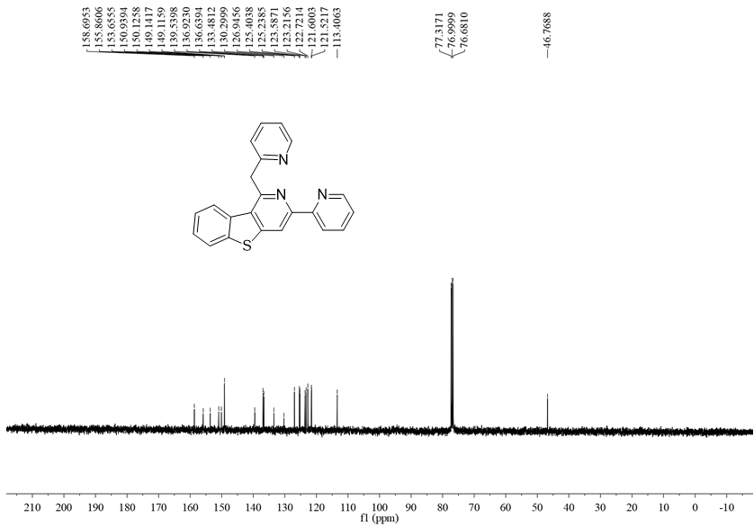

¹H NMR (400 MHz, CDCl₃) spectrum of compound 5s
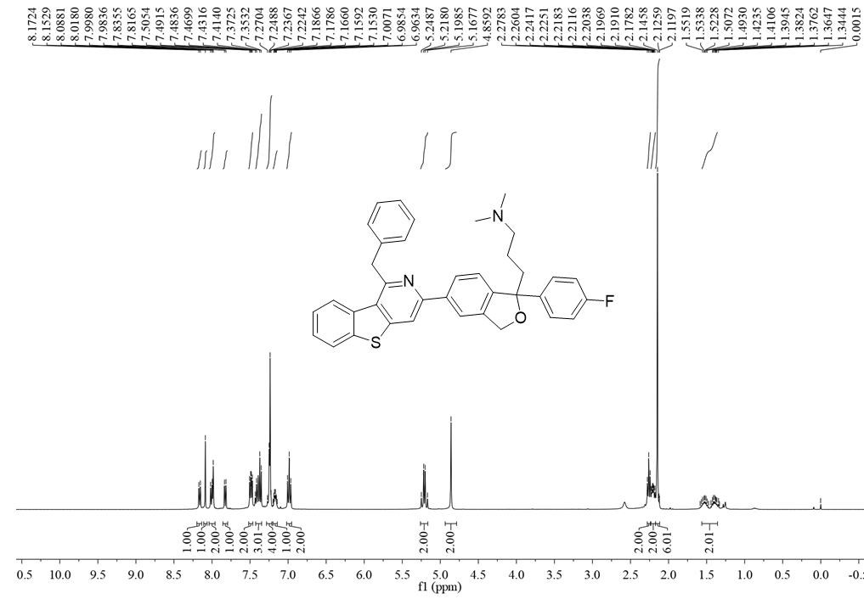

¹³C NMR (100 MHz, CDCl₃) spectrum of compound 5s
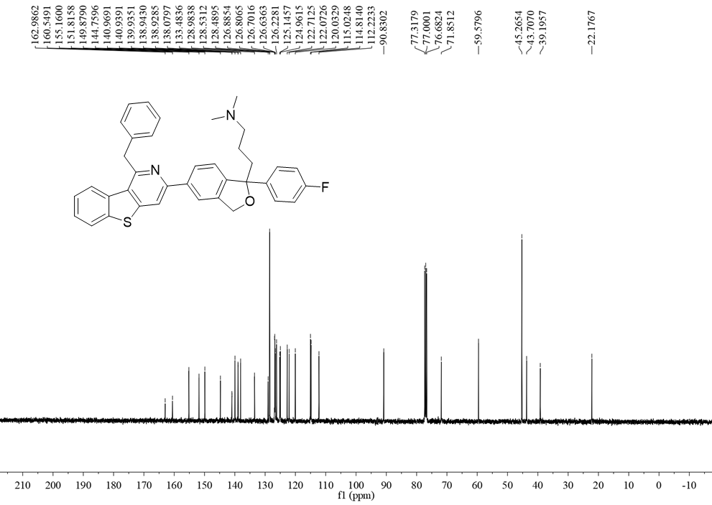

¹H NMR (400 MHz, CDCl₃) spectrum of compound 7a
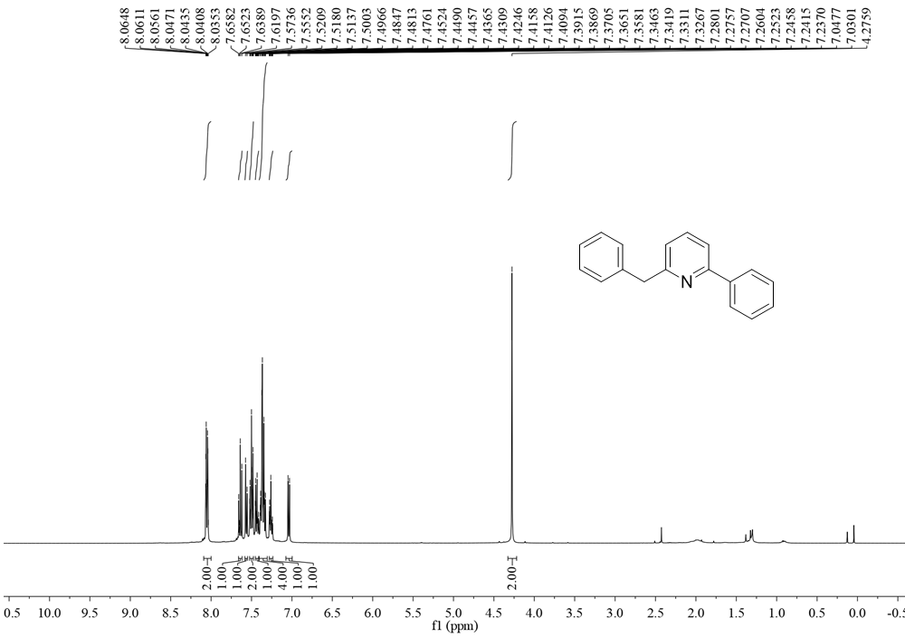

¹³C NMR (100 MHz, CDCl₃) spectrum of compound 7a
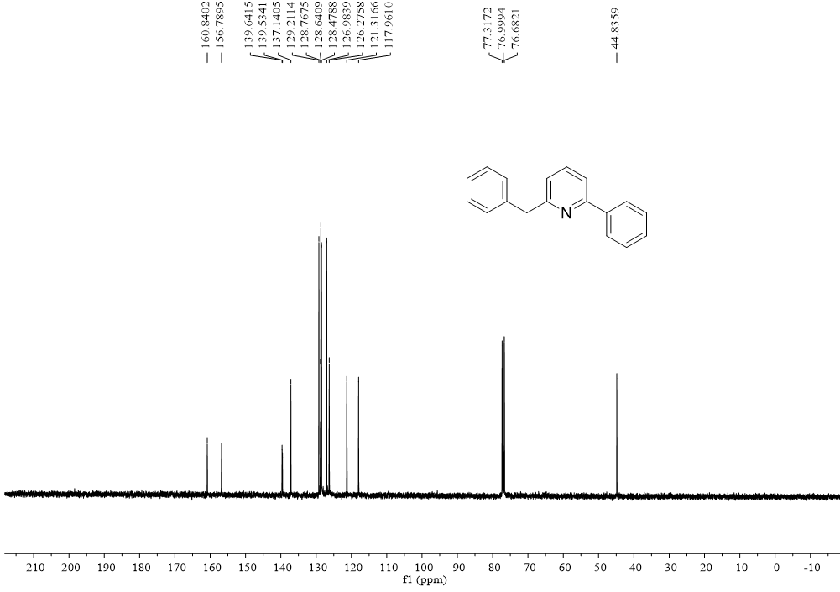

¹H NMR (400 MHz, CDCl₃) spectrum of compound 7b
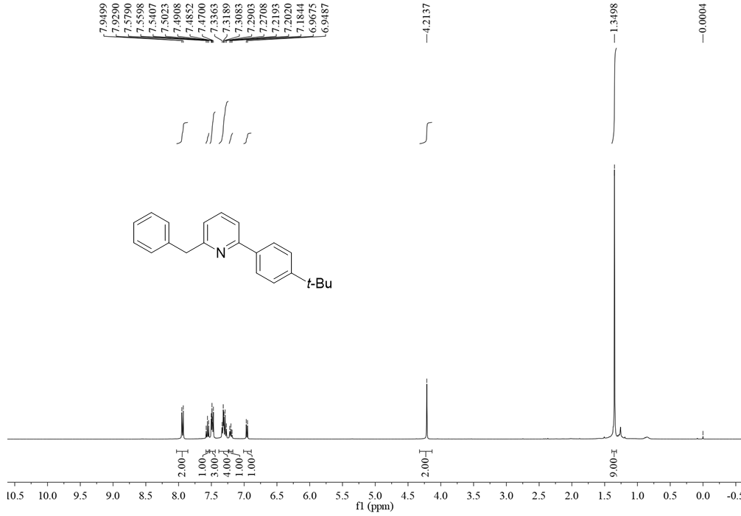

¹³C NMR (100 MHz, CDCl₃) spectrum of compound 7b
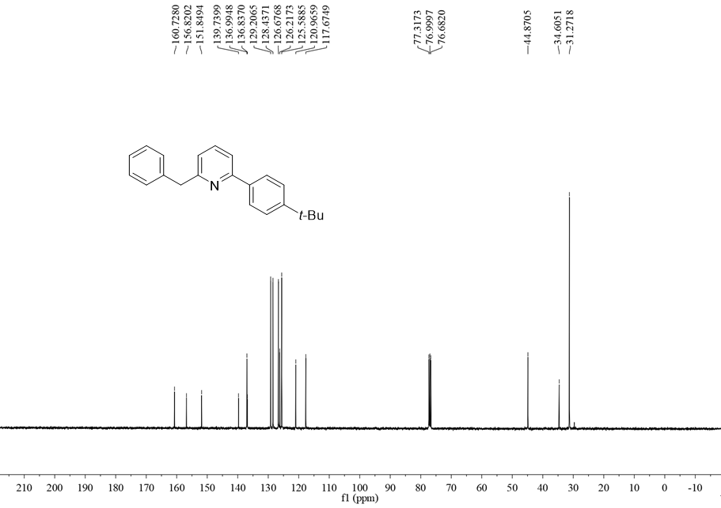

¹H NMR (400 MHz, CDCl₃) spectrum of compound 7c
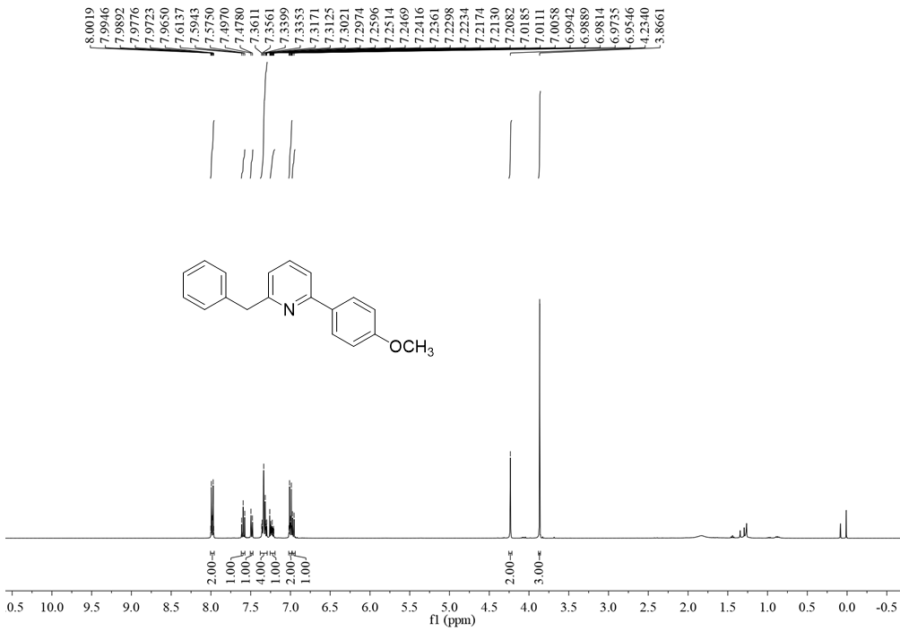

¹³C NMR (100 MHz, CDCl₃) spectrum of compound 7c
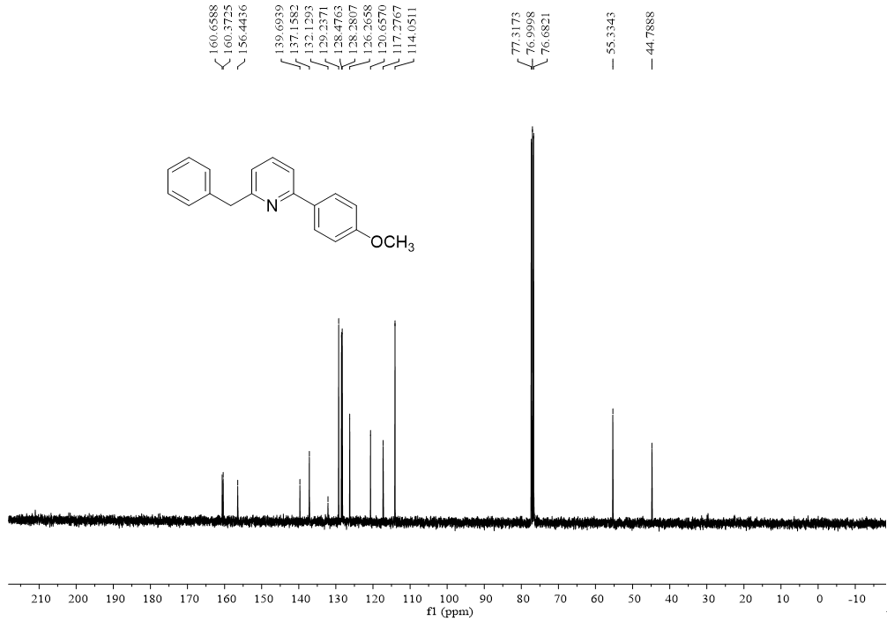

¹H NMR (400 MHz, CDCl₃) spectrum of compound 7d
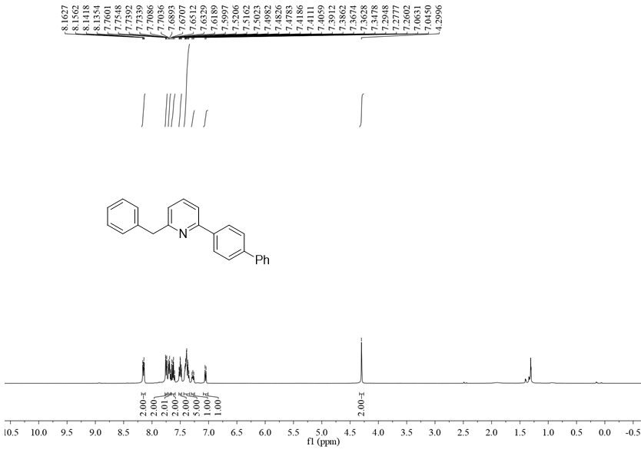

¹³C NMR (100 MHz, CDCl₃) spectrum of compound 7d
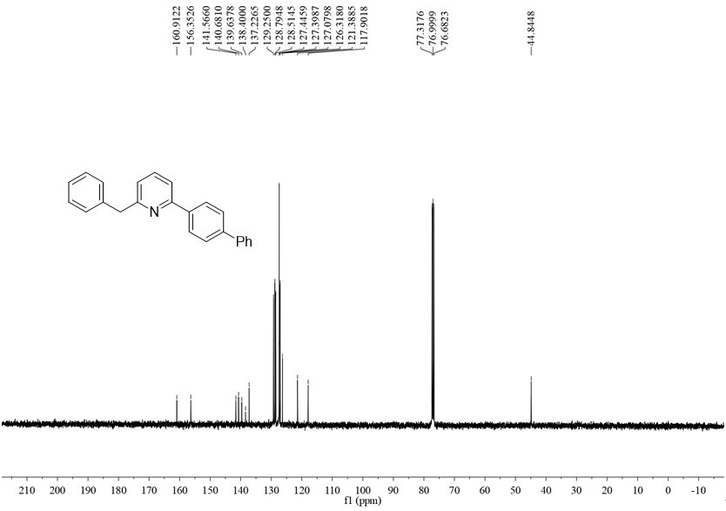

¹H NMR (400 MHz, CDCl₃) spectrum of compound 7e
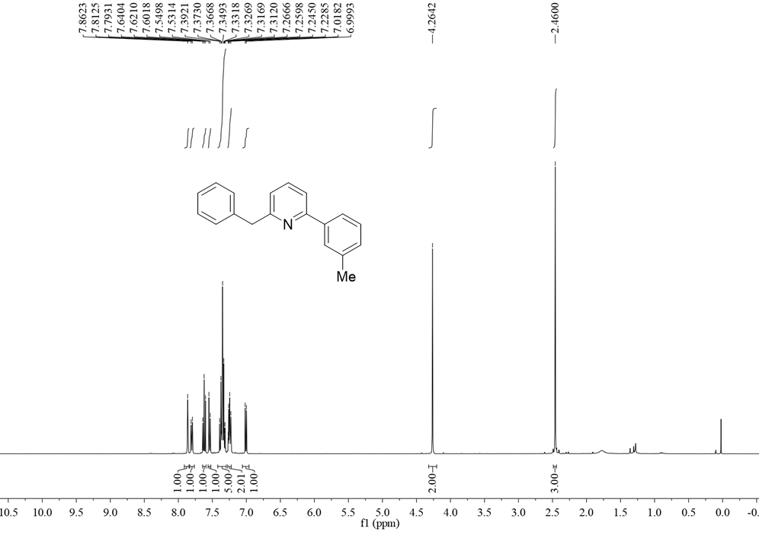

¹³C NMR (100 MHz, CDCl₃) spectrum of compound 7e
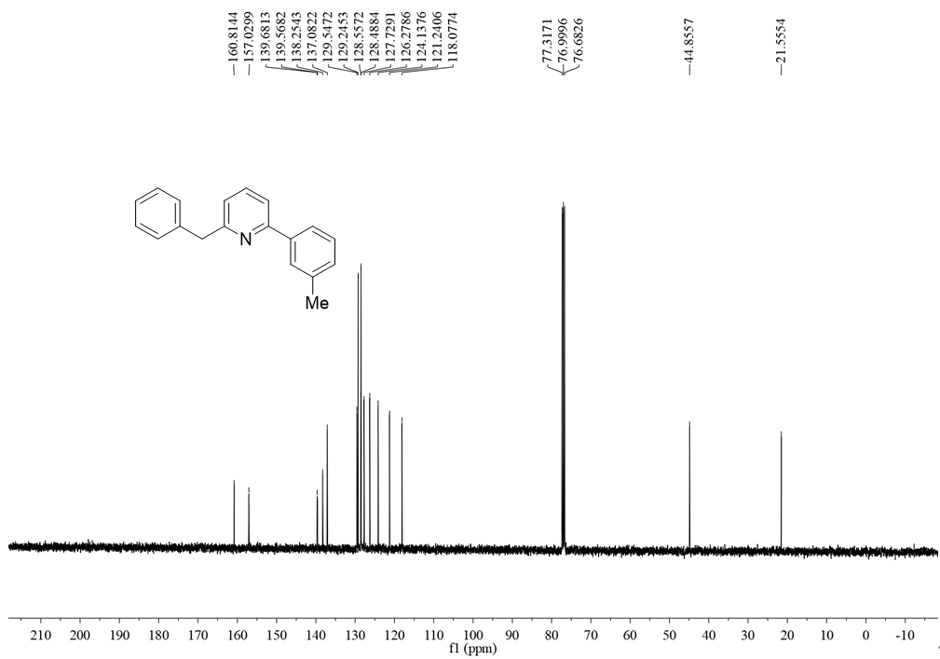

¹H NMR (400 MHz, CDCl₃) spectrum of compound 7f
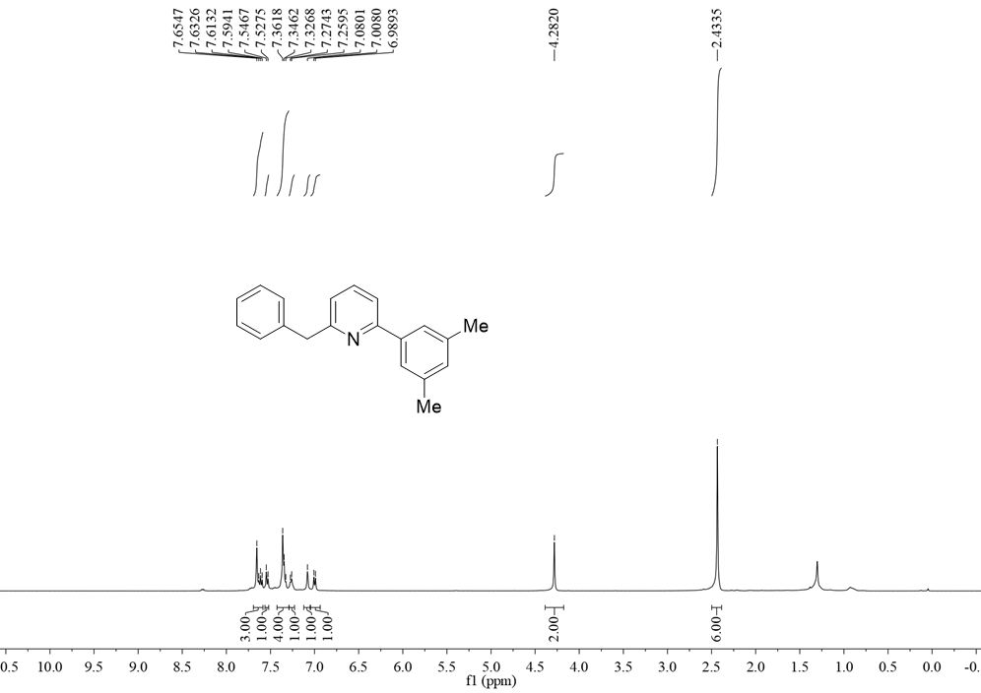

¹³C NMR (100 MHz, CDCl₃) spectrum of compound 7f
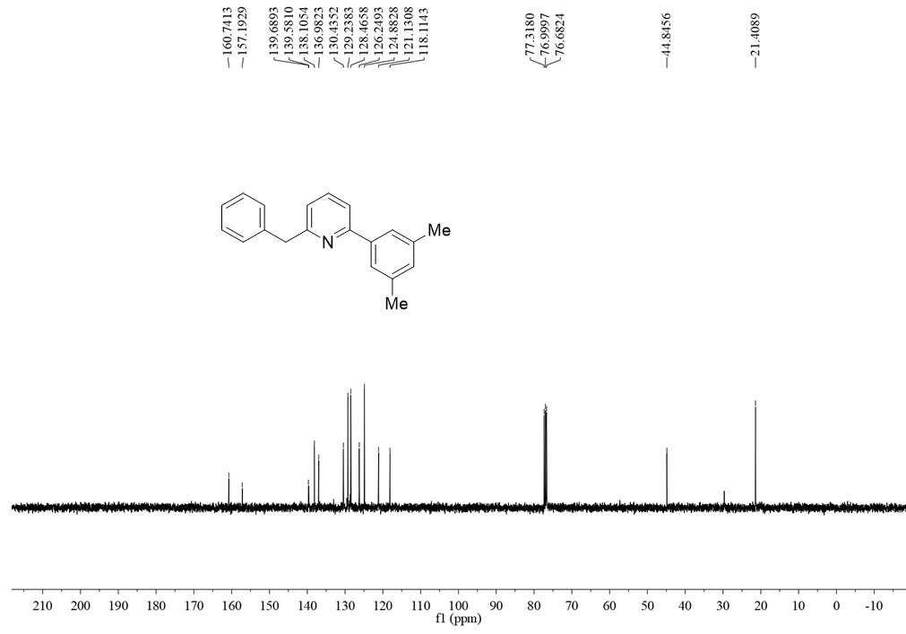

¹H NMR (400 MHz, DMSO) spectrum of compound 8
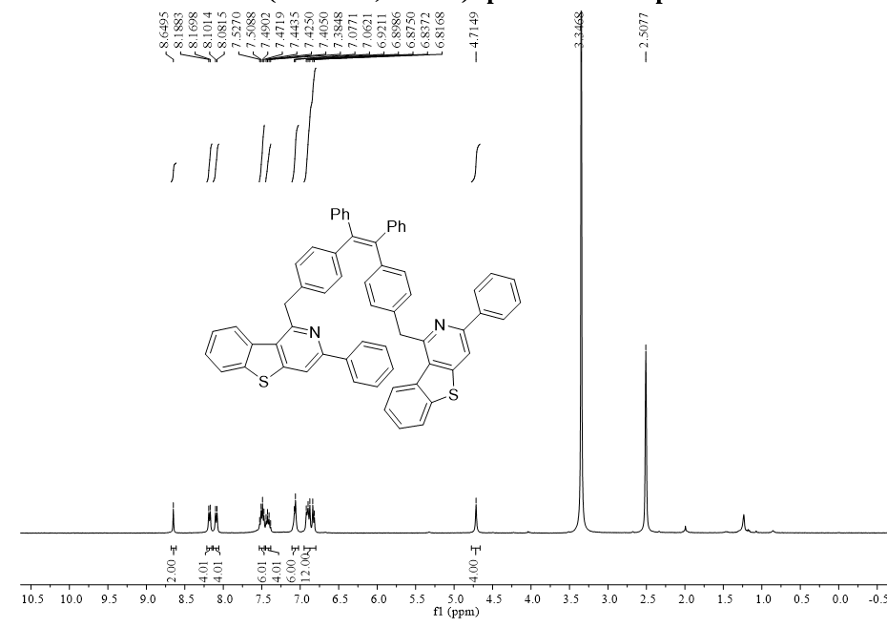

¹³C NMR (100 MHz, DMSO) spectrum of compound 8
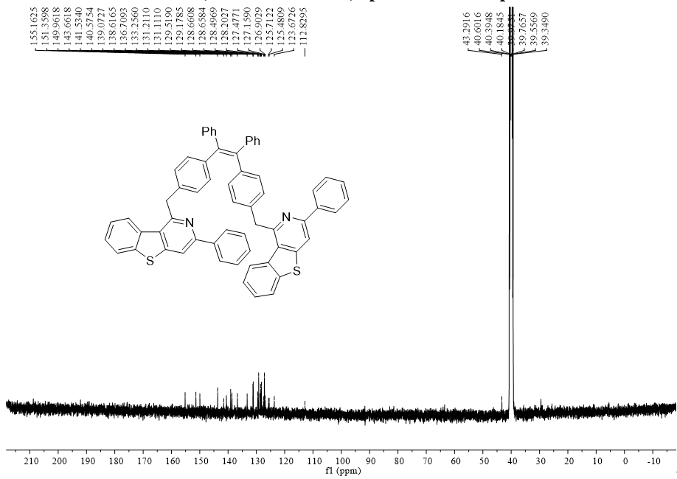

¹H NMR (400 MHz, DMSO) spectrum of compound 9
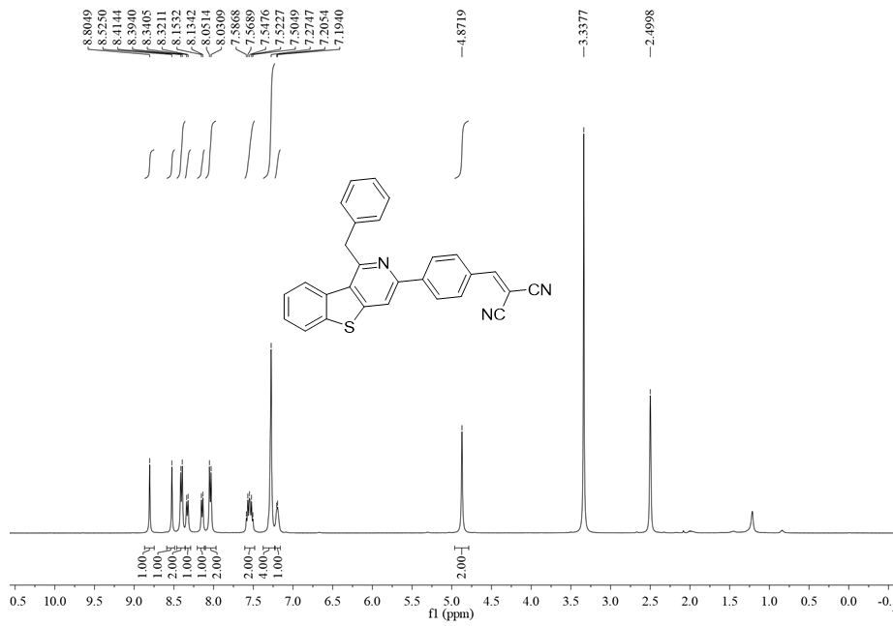

¹³C NMR (100 MHz, DMSO) spectrum of compound 9

