Supplementary Table 1. Summary of the records of wild ungulates obtained from the camera traps placed in the study plots both in stages 1 (Exp.1) and 2 (Exp.2) of the experiment. The table shows both the number of visits recorded and the total number of images taken per wild ungulate species throughout the habitat of the study plots.

Experiment stage | Habitat | Red deer |  | Roe deer |  | Wild boar
Experiment stage | Habitat | No. visits | No. images | No. visits | No. images | No. visits | No. images
Exp.1 | Grassland | 101 | 2611 | 2 | 12 | 2 | 4
Exp.1 | Shrubland | 185 | 2705 | 3 | 48 | 22 | 40
Exp.1 | Forest | 38 | 152 | 11 | 44 | 15 | 135
Subtotal Exp.1 |  | 324 | 5468 | 16 | 104 | 40 | 179
Exp.2 | Grassland | 85 | 664 | 0 | 0 | 0 | 0
Exp.2 | Shrubland | 12 | 303 | 0 | 0 | 0 | 0
Exp.2 | Forest | 43 | 342 | 1 | 4 | 2 | 6
Subtotal Exp.1 |  | 141 | 1309 | 1 | 4 | 2 | 6

Supplementary Figure 1. Average accumulated time (minutes) of plot use by Hyalomma lusitanicum hosts as estimated from two camera traps per plot and habitat type in stage 1 of the experiment.

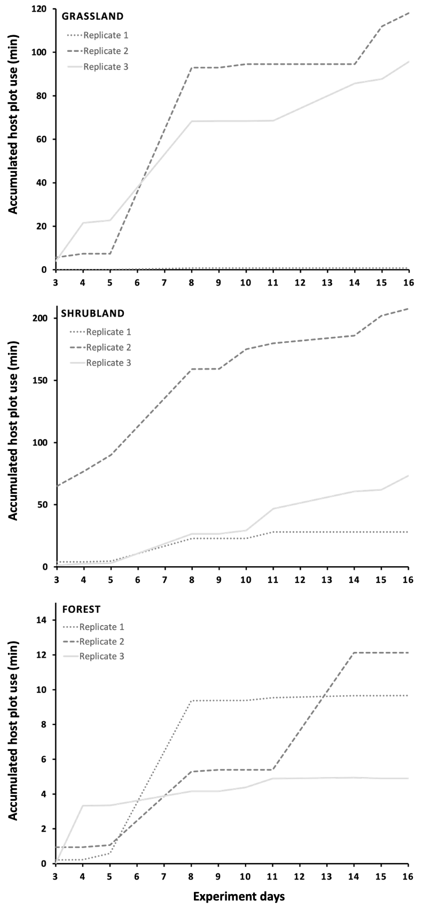

Supplementary Figure 2. Average accumulated time (minutes) of plot use by Hyalomma lusitanicum hosts as estimated from two camera traps per plot and habitat type in stage 2 of the experiment.
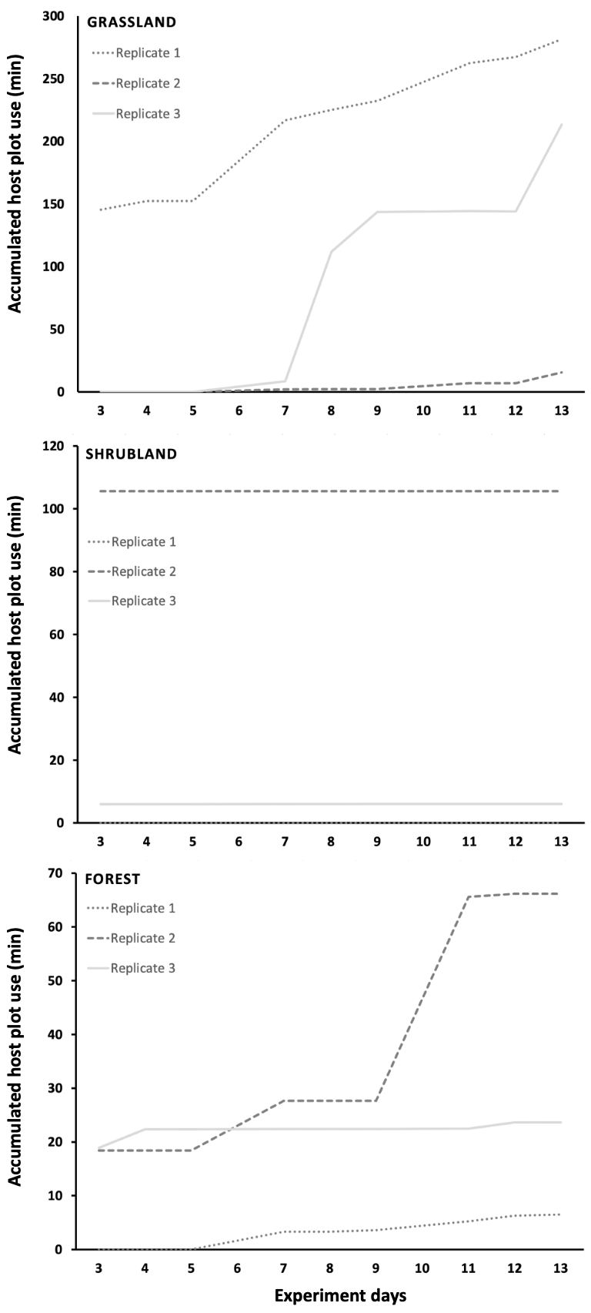

Supplementary Figure 3. Variation in average daily soil temperature (ºC; red line) and relative humidity (%; blue line) along experimental stages 1 and 2 as estimated from the registers of data loggers.

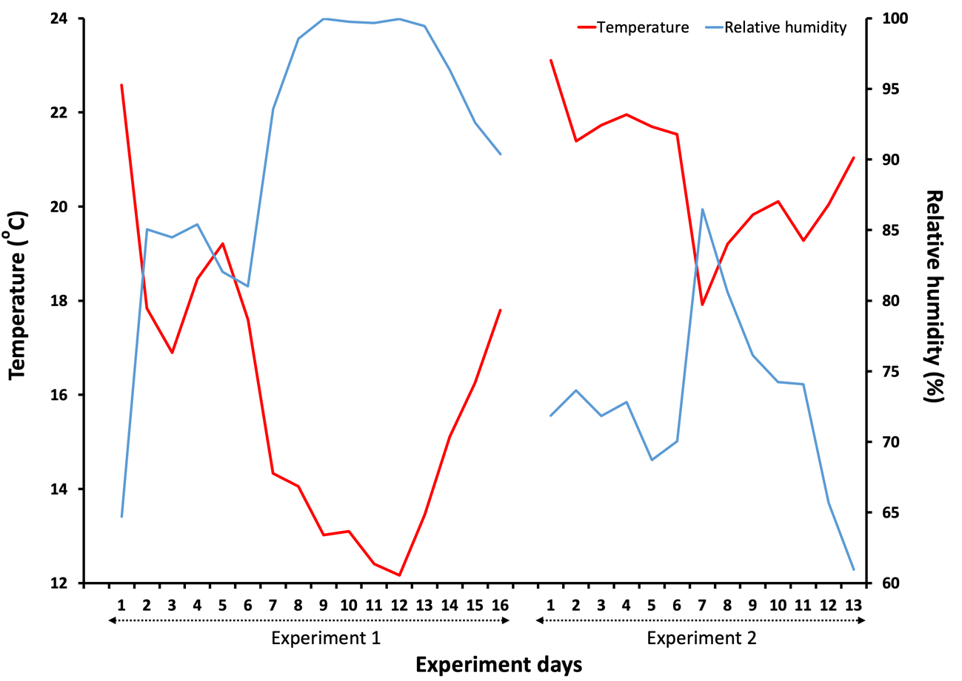

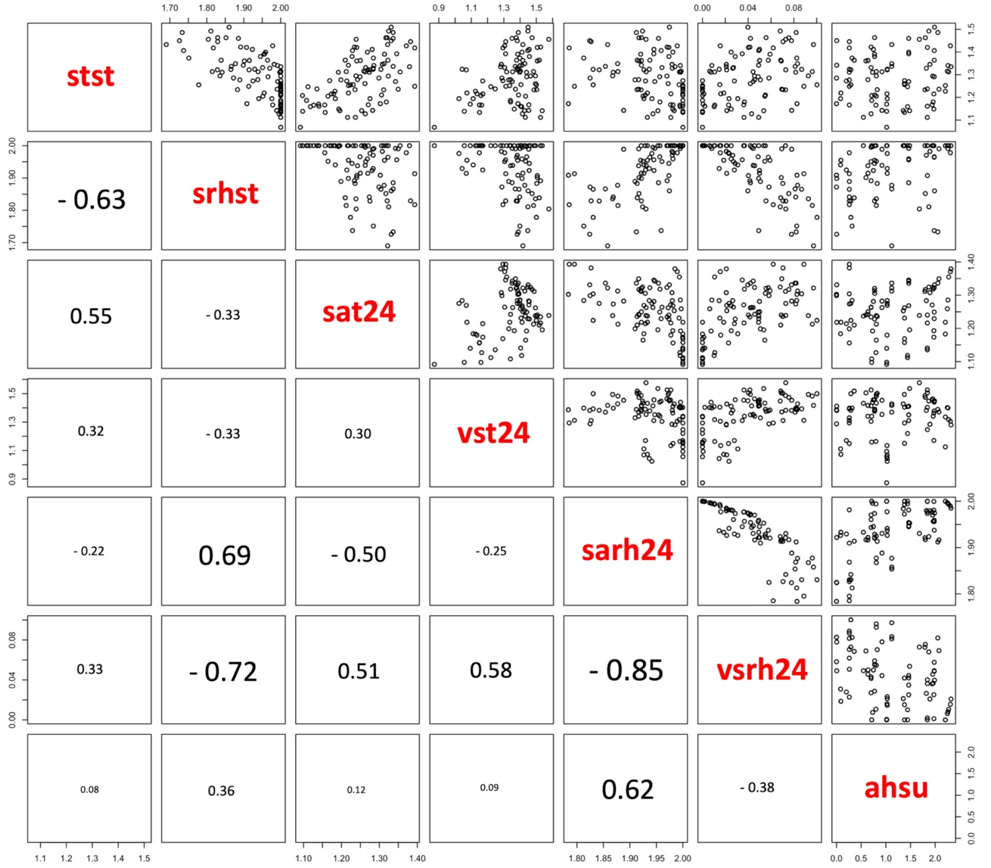
Supplementary Figure 4. Pearson correlation matrix between the continuous predictors estimated from camera trapping and data logger registers of soil temperature and relative humidity in stage 1 of the experiment. The Pearson correlation coefficient (r) of each paired relationship between predictors is shown in the lower left half of the chart.

stst: soil temperature (ºC) at sampling time; srhst: soil relative humidity (%) at sampling time; sat24: soil average temperature (ºC) in the 24h before sampling; vst24: variation in soil temperature registers (ºC) in the previous 24h to sampling; sarh24: soil average relative humidity (%) in the previous 24h to sampling; vsrh24: variation in soil relative humidity registers (%) in the 24h before sampling; ahsu: accumulated host (wild ungulates) space use of the experimental plots.

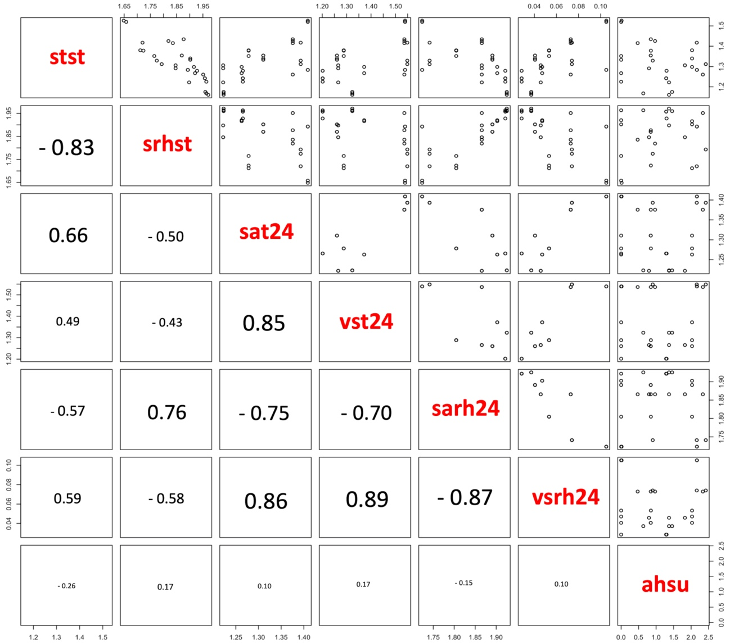
Supplementary Figure 5. Pearson correlation matrix between the continuous predictors estimated from camera trapping and data logger registers of soil temperature and relative humidity in stage 2 of the experiment. The Pearson correlation coefficient (r) of each paired relationship between predictors is shown in the lower left half of the chart.

stst: soil temperature (ºC) at sampling time; srhst: soil relative humidity (%) at sampling time; sat24: soil average temperature (ºC) in the 24h before sampling; vst24: variation in soil temperature registers (ºC) in the previous 24h to sampling; sarh24: soil average relative humidity (%) in the previous 24h to sampling; vsrh24: variation in soil relative humidity registers (%) in the 24h before sampling; ahsu: accumulated host (wild ungulates) space use of the experimental plots.

