Supporting Materials

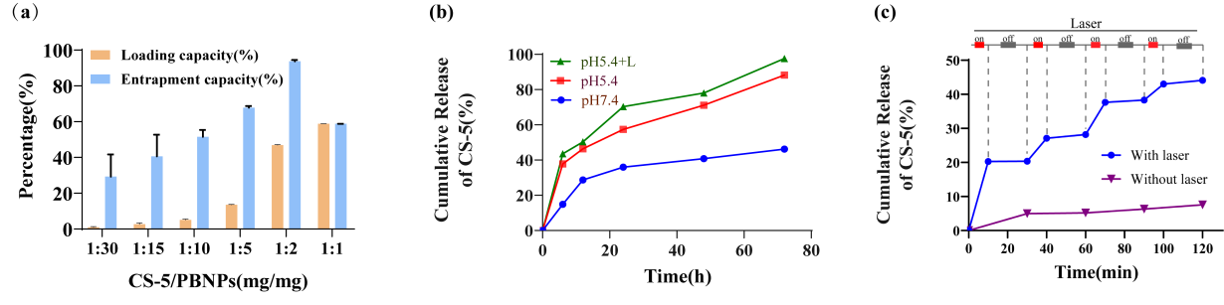
Fig. S1. Drug loading and controlled releases. (a) CS-5 loading efficiency and encapsulation efficiency of PBNPs@CS-5 when the CS-5 concentration was 0.033, 0.067, 0.1, 0.2, 0.5 and 1.0 mg mL-1, respectively. (b) CS-5 release behavior from PCM at various simulated conditions: pH 7.4, pH 5.4, and pH 5.4 with 808 nm laser irradiation. (c) CS-5 release behavior from PCM with 4 laser on/off cycles after 808 nm laser irradiation (1.2W/cm², 5 min).

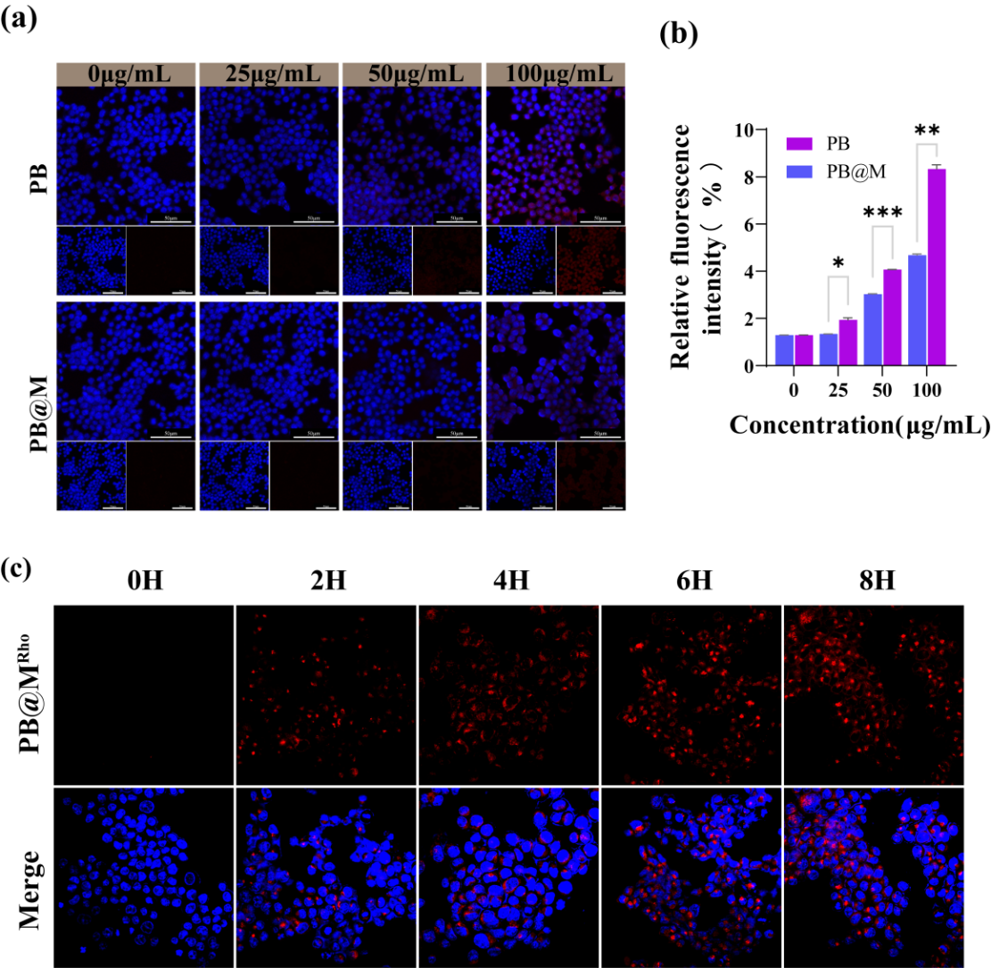
Fig. S2 Cell uptake and immune escape assay. (a) CLSM images and (b) fluorescence quantification of RAW 264.7 cells after culturing with PB^{Rho} or PB@M^{Rho} with different concentrations. (c) CLSM image of the subcellular localization of PB@M in HCT116 cells.

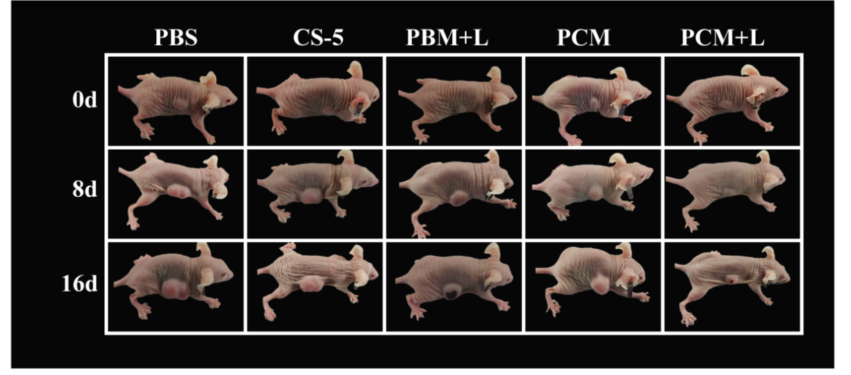
Figure S3. Representative photographs of mice at 0, 8, and 16 days.

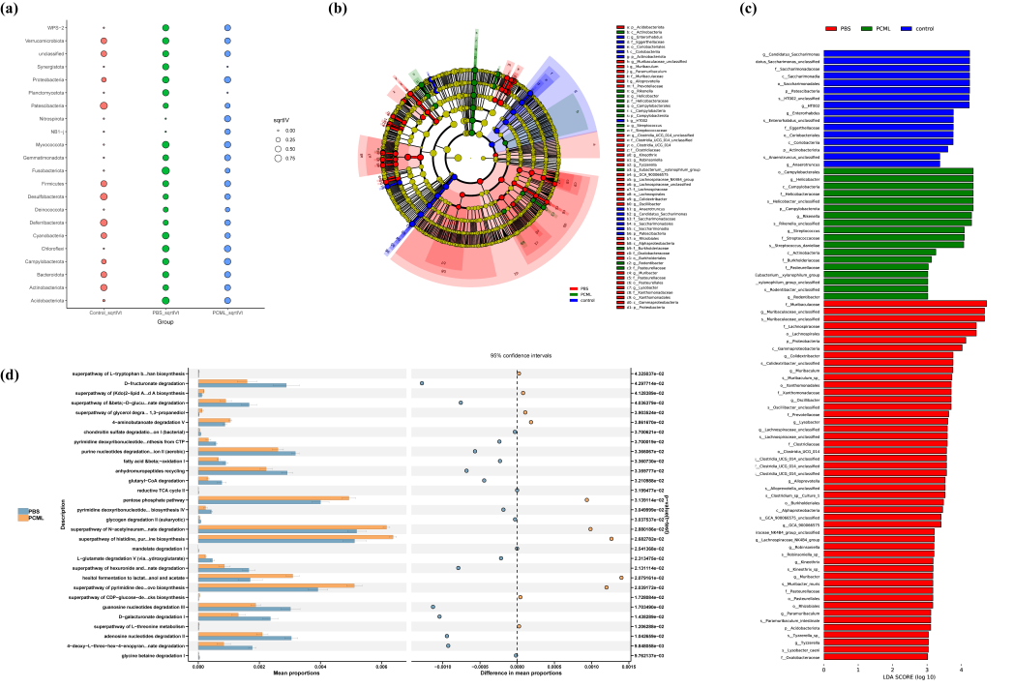
FigureS4. The biomarker and function analysis of gut microbiota. (a) Indicator analysis based on sqrtIVt value at the phylum level for screening indicative microbiota biomarker. (b) The Cladogram exhibited the phylogeny status of species from phylum to genus level. (c) Histogram of LDA based on LDA score revealed species with enriched differences. (d) Predicted function of gut microbiota based on pathway database analysis. LDA, Linear discriminant analysis.
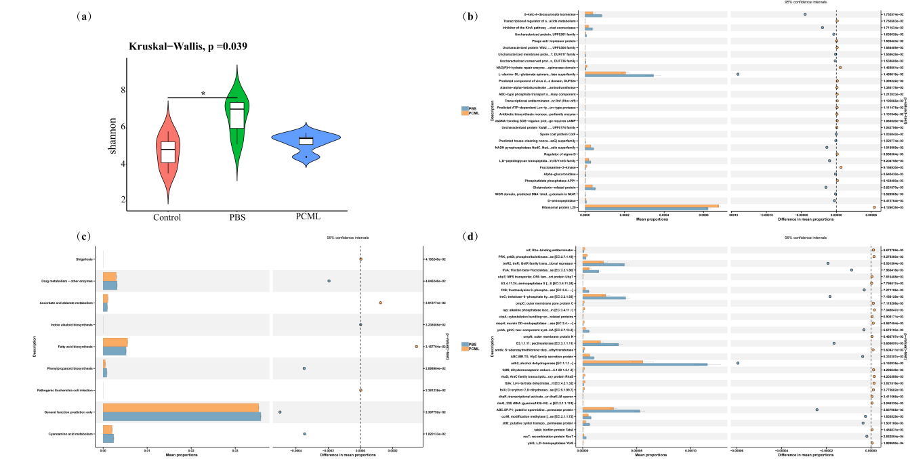
FigureS5. The alpha diversity presentation and function analysis. (a) The alpha diversity of gut microbiota was estimated by the Shannon species indexes. Predicted function of gut microbiota based on the COGs (b), KEGG (c), and KO (d) database analysis. COGs: Clusters of Orthologous Genes; KEGG: Kyoto Encyclopedia of Genes and Genomes; KO, KEGG orthology functional orthologues

