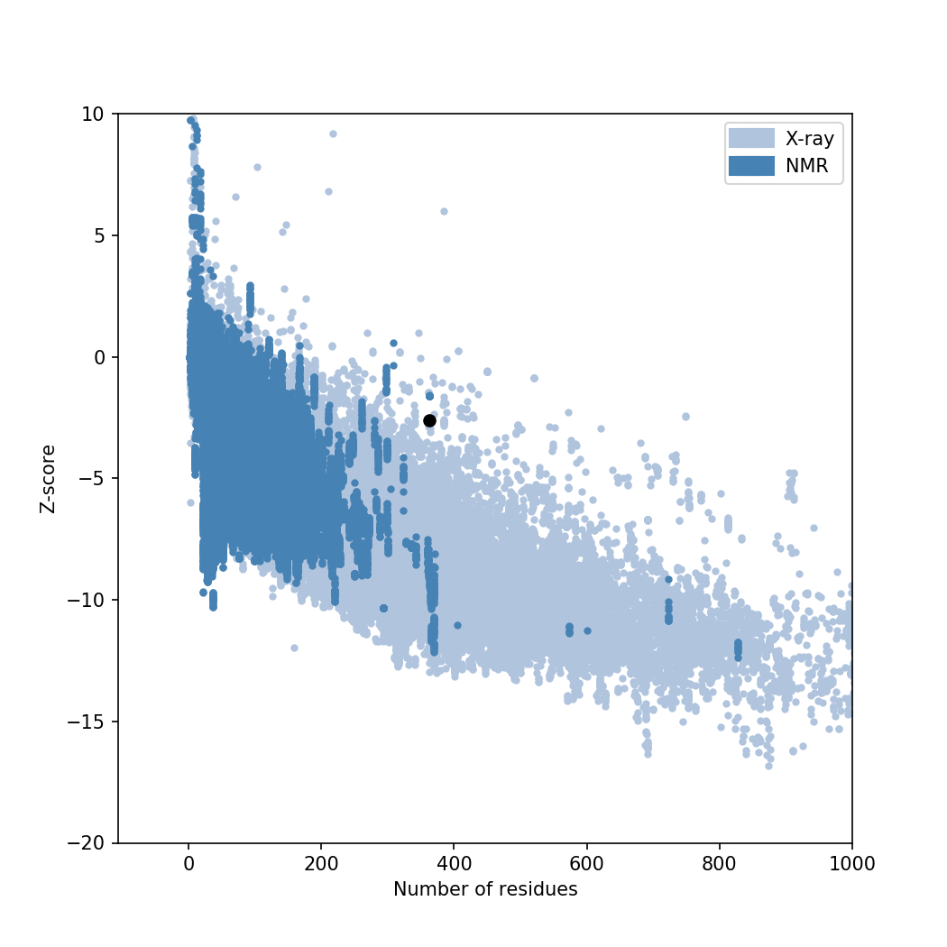
Z-Score: -2.62
Supplementary Fig. 3: Estimated Z score by prosaweb.

