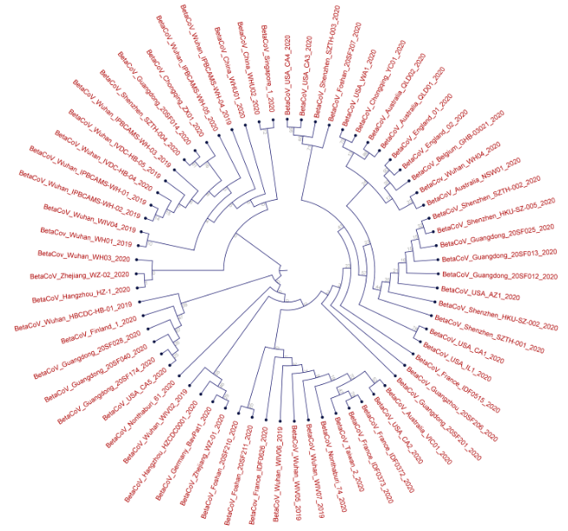
Supplementary Fig. 1 Phylogenetic relationship among the SARS-CoV-2 whole genomes of 67 countries.

