Supplementary Materials
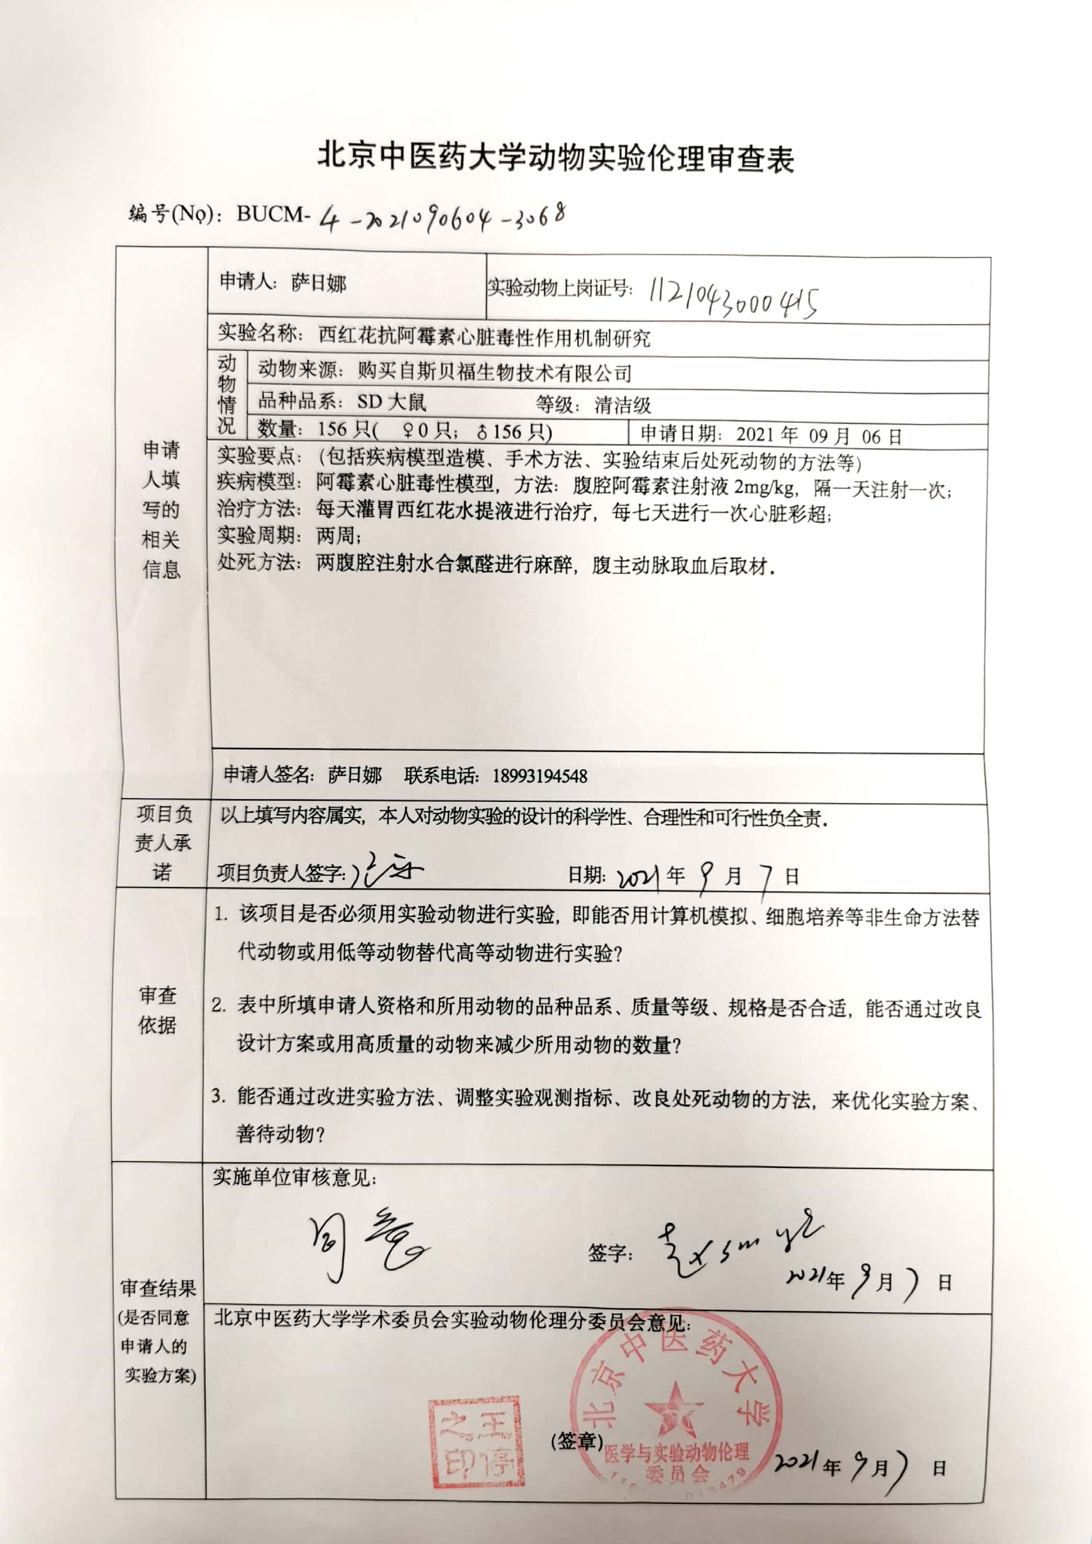
Supplementary Figure 1: The ethics statement for animal experimentation.
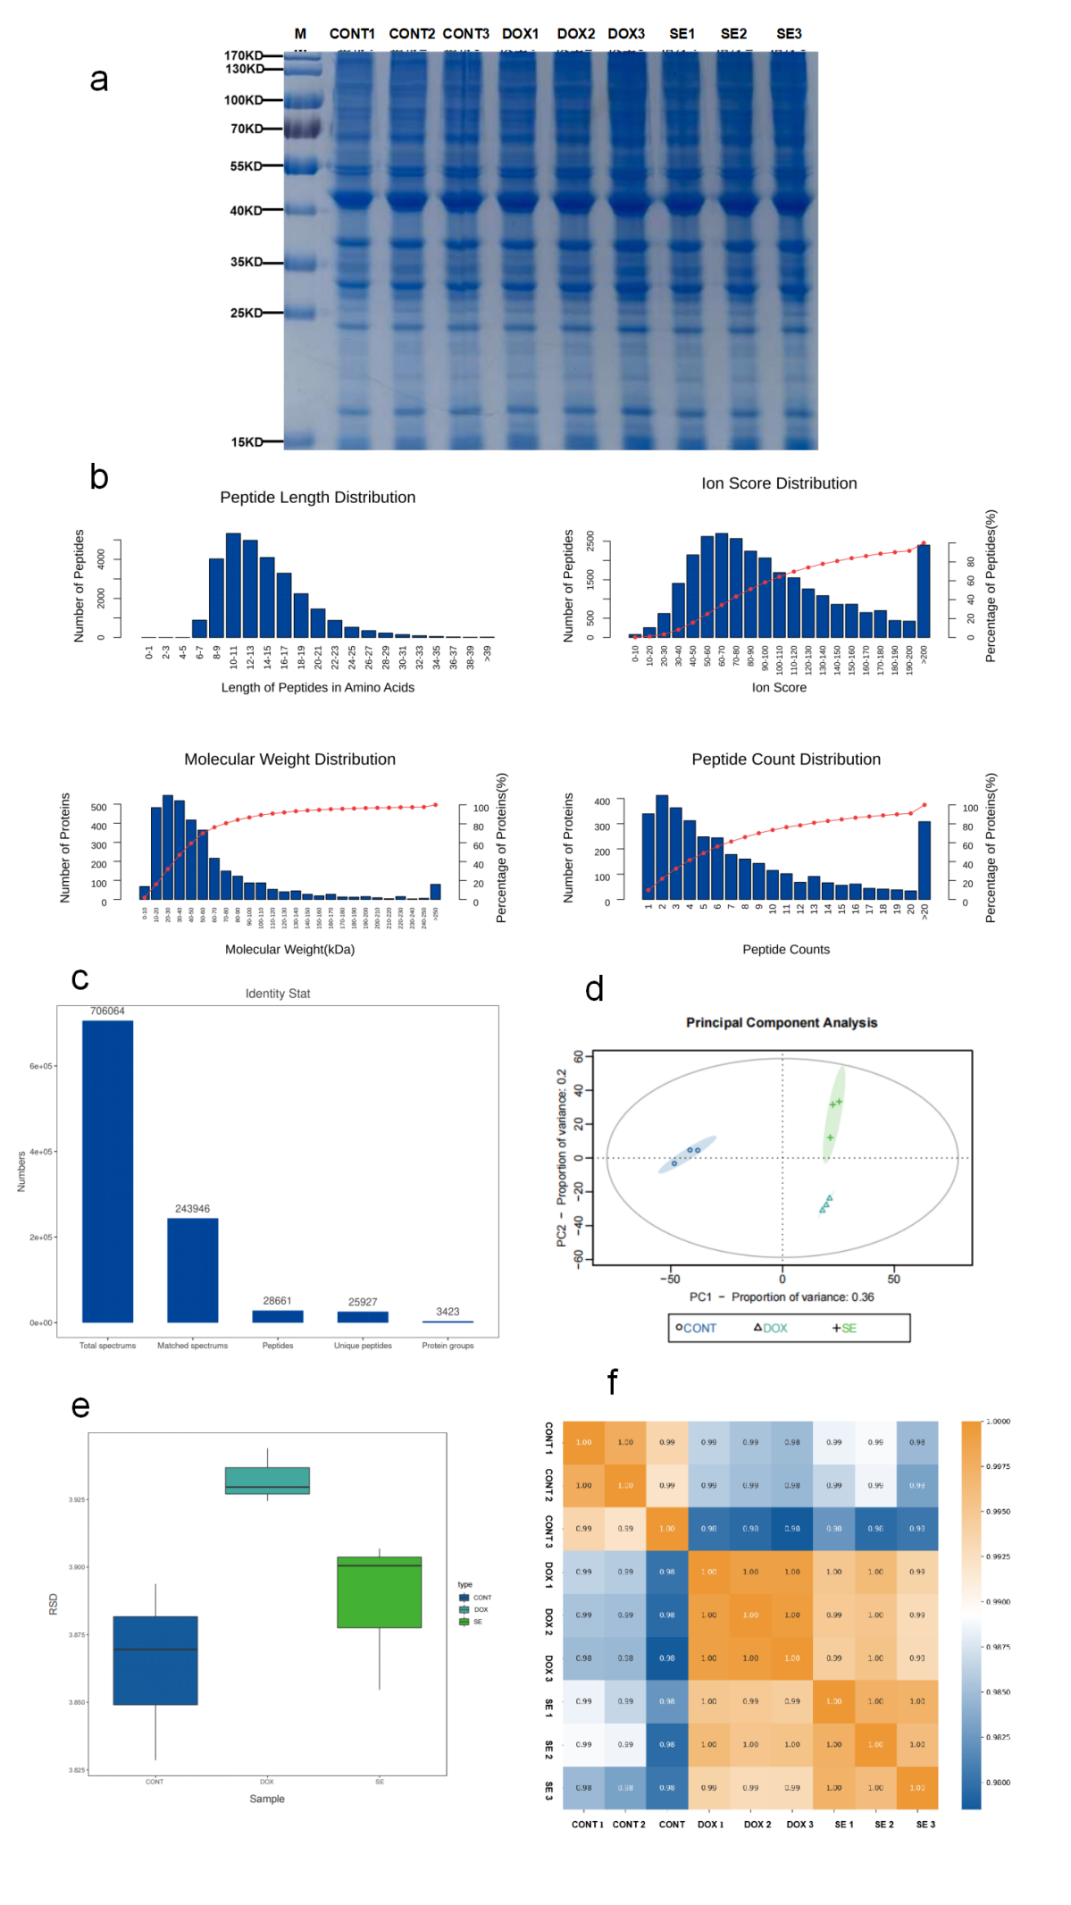
Supplementary Figure 2: Proteomics quality control results. (a) SDS-PAGE analysis. (b) Peptide sequence length distribution, peptide ion score distribution, protein relative molecular mass distribution and identified peptide number distribution evaluated. (c) Statistical plots of protein identification results. (d) PCA analysis. (e) RSD analysis. (f) Pearson correlation coefficient analysis.

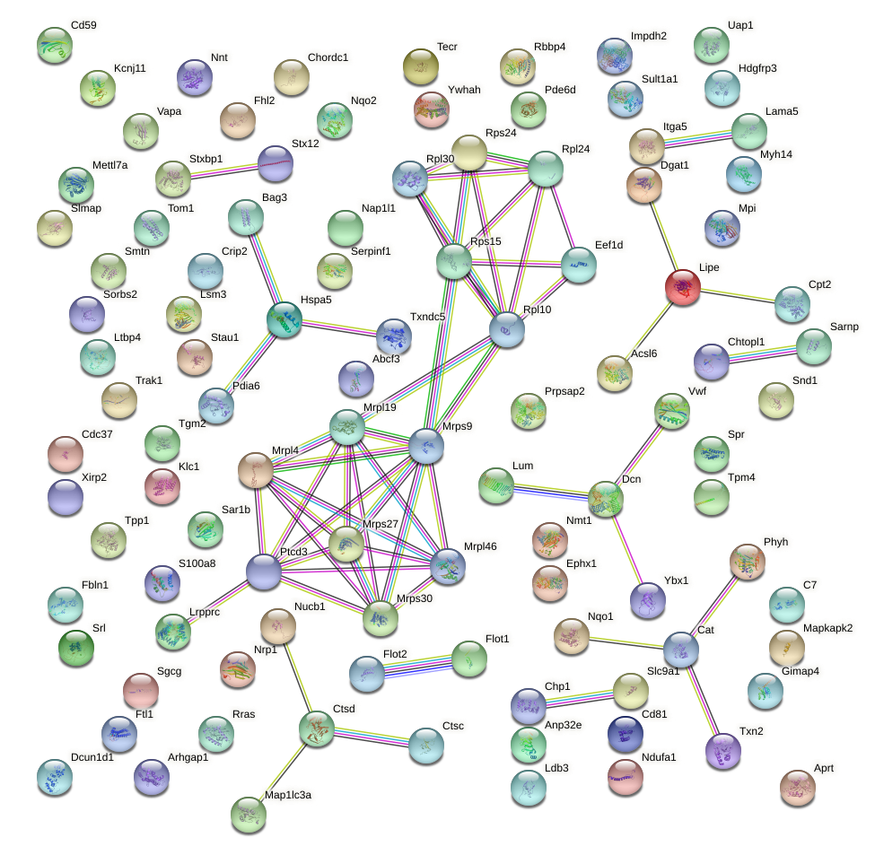
Supplementary Figure 3:Protein-protein interaction (PPI) network of 103 DOX cardiotoxicity targets.
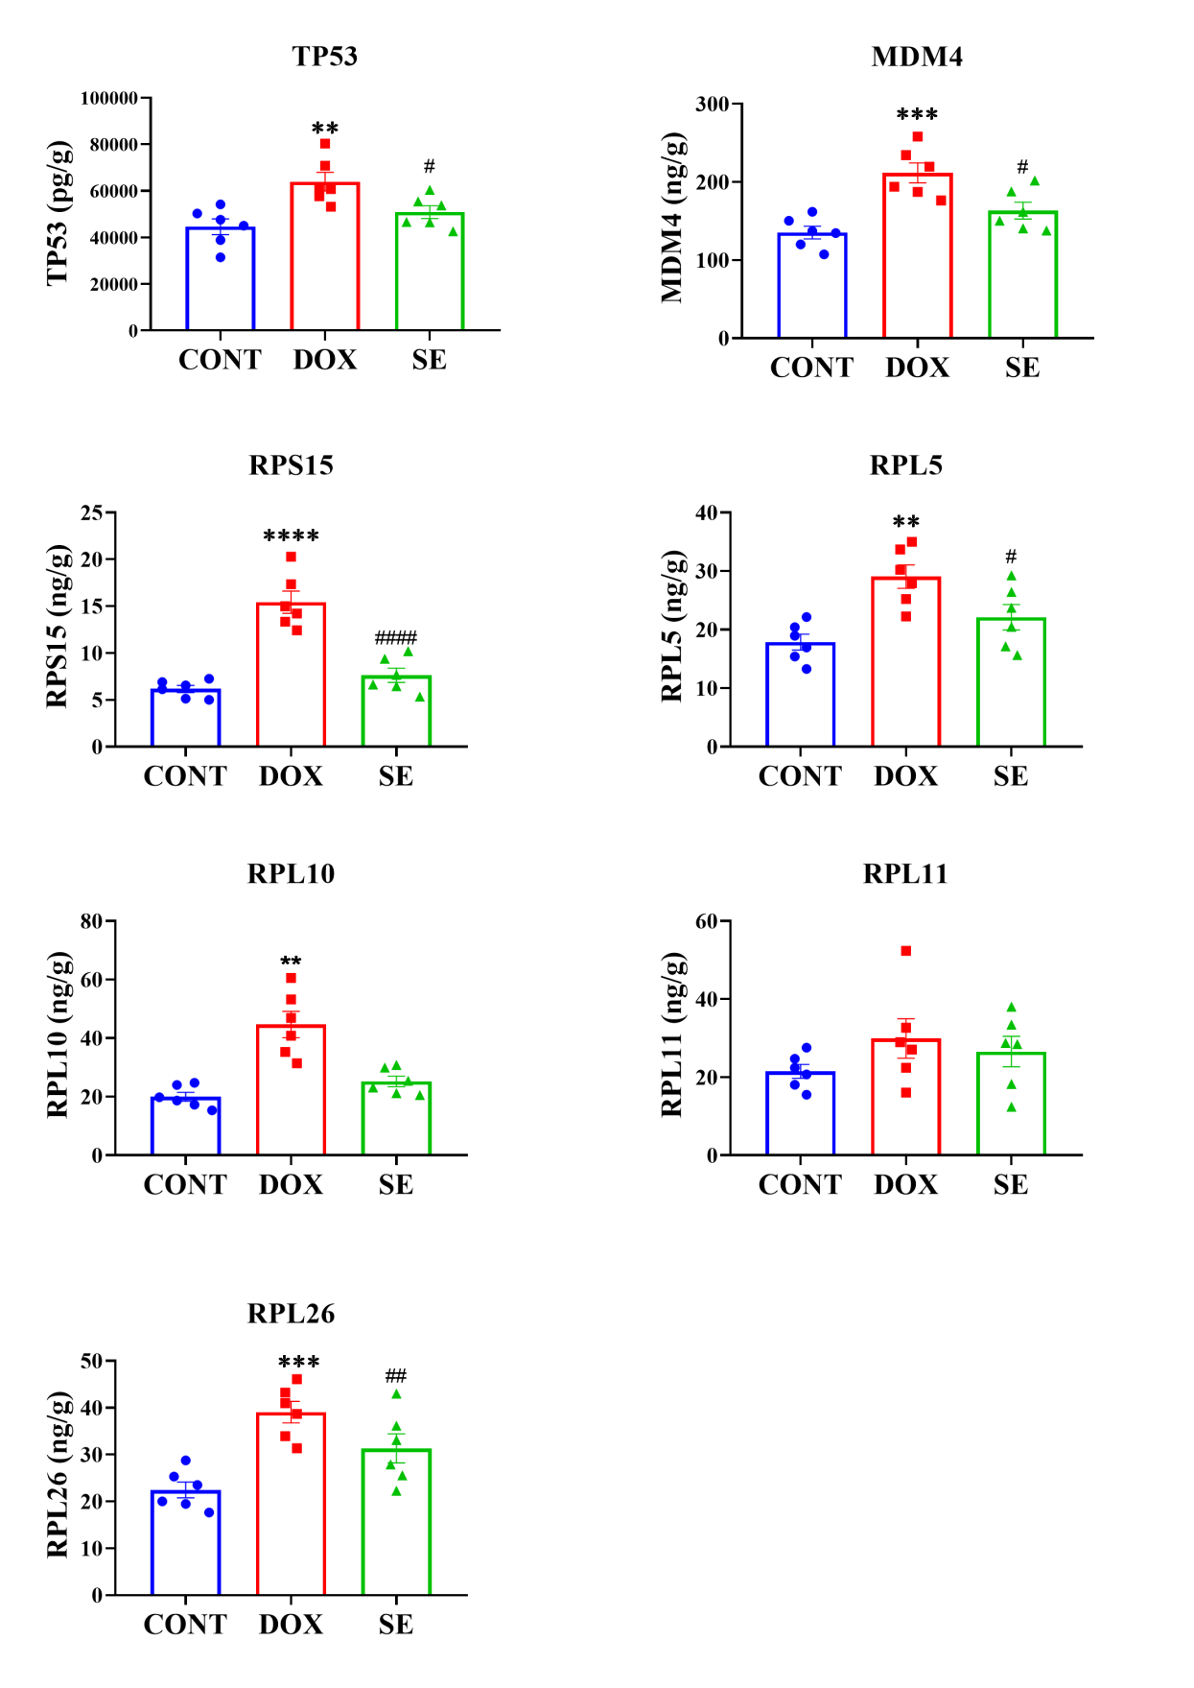
Supplementary Figure 4: ELISA validates several critical targets in the hypothesized mechanism of ribosomal involvement in DOX cardiotoxicity. The horizontal coordinates are groups, vertical coordinates are protein content, and different colors and shapes represent different groups. *p < 0.05, **p < 0.01, ***p < 0.001, ****p < 0.0001 vs. CONT; #p < 0.05, ##p < 0.01, ###p < 0.001, ####p < 0.0001 vs. DOX. Data represent mean ± SEM.

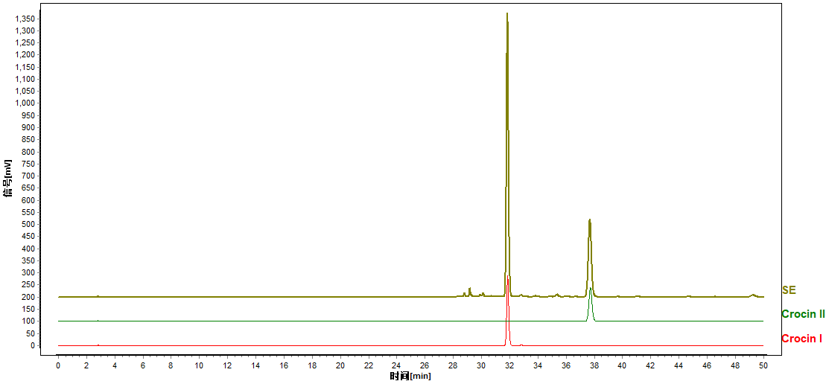
Supplementary Figure 5: HPLC chromatogram of saffron extract

