Supporting Information
Anchoring Ni₃S₂/Cr(OH)₃ hybrid nanospheres on Ti₃C₂@NF dual substrates for efficient urea electrolysis by ion exchange
Yifeng Liu, Qianqiao Chen* and Qin zhong
*Email:cqq@njust.edu.cn(Qianqiao Chen)

Experimental Section
- Materials
Ni(NO₃)₃·6H₂O，Cr(NO₃)₃·9H₂O，Na₂S·9H₂O，Ti₃AlC₂(200 mesh)，LiF，HCl，KOH，urea and nickel foam(NF) were purchased from Shanghai Aladdin Biochemical Technology Co. Ltd.De-ionized water (resistance of 18.2 MΩ·cm⁻¹ at 25 °C) was used for all experiments. Unless otherwise specified, all reagents are analytically pure without further processed.
- Sample preparation
Synthesis of few-layered Ti₃C₂
Before selective etching of Ti₃AlC₂ MAX power, the size of Ti₃AlC₂ particles was screened to less than 40μm by 400 mesh sieve. Firstly,1.6g LiF was added into 20mL 12M HCl under strring for 5min. Then,1g Ti₃AlC₂ powder was slowly added into the solution to prevent the mixed solution from boiling over. The mixed solution was stirred at room temperature for 48h to obtain Ti₃C₂ MXene. Afterward,the sample was centrifuged several times with deionized water until the pH of the supernatant was neutral. Subsequently, the as-prepared Ti₃C₂ precipitate was dissolved in deionized water, sonicated in ice bath for 1h.Finally the dark green supernatant was obtained by centrifugation at 3000rpm for 30min and named as few-layered Ti₃C₂. The Ti₃C₂ suspension was stored in a 4°C refrigerator.
Synthesis of Ti₃C₂@NF
First of all, The NF (1cm×2cm) was cleaned with 3M HCl, acetone, deionized water and ethanol by ultrasonic cleaning for 10min to remove the surface oxide layer and improve its hydrophilicity, and dried under vacuum at 60°C for 12h.Then, The few layered Ti₃C₂ was adsorbed on NF by electrostatic adsorption method. Cleaned NF was soaked in the prepared Ti₃C₂ suspension for 2h and taken out. Ti₃C₂@NF was obtained after vacuum drying for 12h. The comparison chart is shown in Fig. S1.
Synthesis of Ni₃S₂/Cr(OH)₃-Ti₃C₂@NF electrode
Firstly,0.8mM Ni(NO₃)₃·6H₂O and 0.2mM Cr(NO₃)₃·9H₂O were dissolved in 20mL deionized water, and then Ti₃C₂@NF was put into the mixed solution and stirred for 1h. Then 20mL 0.025M Na₂S solution was dropped into the above solution using a micro syringe. Ni₃S₂ is formed by ion exchange, while Cr(OH)₃ is formed by double hydrolysis reaction in aqueous solution with continuous stirring during the reaction. Finally, the NF was taken out and dried at 60°C for 12h under vacuum to obtain Ni₃S₂/Cr(OH)₃-Ti₃C₂@NF electrode.
- Materials characterization
The XRD patterns were obtained by using a Pgeneral XD-30 system with Cu kα radiation. The scanning electron microscopy(SEM) images were recorded by JEOL JSM-6700F SEM. The high-resolution TEM(HRTEM) was performed on a JEOL-2010 microscopy operated at 200kV. X-ray photoelectron spectroscopy(XPS) spectra was obtained on a Thermo Scientific ESCALAB 250Xi spectrometer with Al Kα radiation.
- Electrochemical measurements
All electrochemical tests were measured at room temperature in a three-electrode system linked with the Ivium-N-Stat electrochemical workstation. The catalyst-loaded NF(1×1cm²)was used as the working electrode directly. Saturated calomel electrode(SCE)and graphite electrode were used as reference electrode and counter electrode, respectively. All potentials in this work were converted to a reversible hydrogen electrode (RHE) by the formula of : E(RHE)=E(Hg/HgO)+0.059×pH+0.098. All the catalytic performance were tested in the eletrolyte of 1M KOH with 0.5M urea. The catalyst activity was assessed by scanning the LSV at a rate of 5mV s⁻¹. 95% iR-correction was performed to all the polarization curves.The electrochemical impedance spectroscopy(EIS)were measured in the frequency range from 100kHz to 0.1Hz. In the non-Faradaic reaction zone, the cyclic voltammetry(CV) curves of the sample was recorded at different scan rate (20-100mV s⁻¹), and the value of double layer capacitance (C_{dl}) was calculated from CV curves.The stability of samples were tested by i-t
Chronoamperometry.
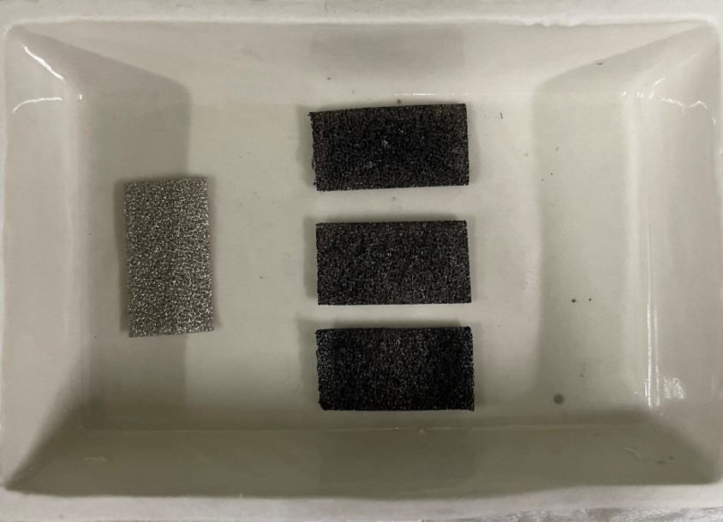
Fig. S1 Comparison chart of NF and Ti₃C₂@NF

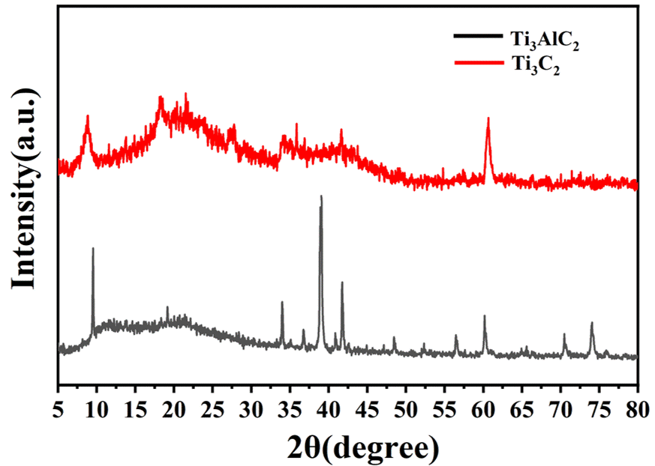
Fig. S2 XRD pattern of Ti₃AlC₂ and Ti₃C₂.
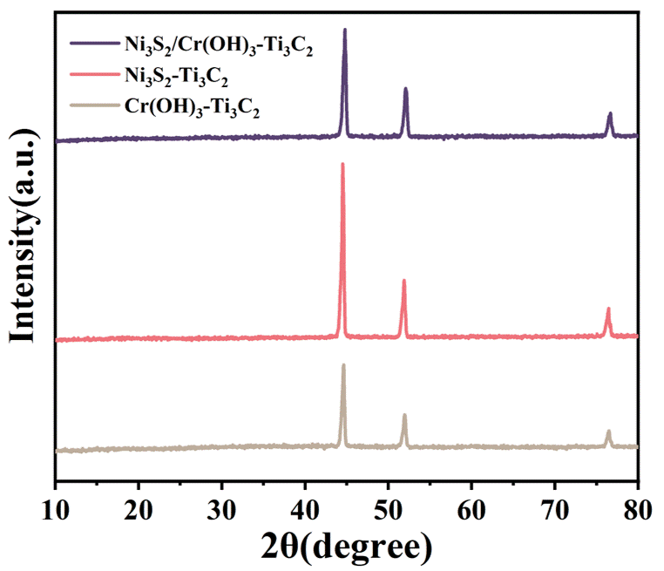
Fig. S3 XRD patterns of Ni₃S₂/Cr(OH)₃-Ti₃C₂, Ni₃S₂-Ti₃C₂ and Cr(OH)₃-Ti₃C₂.
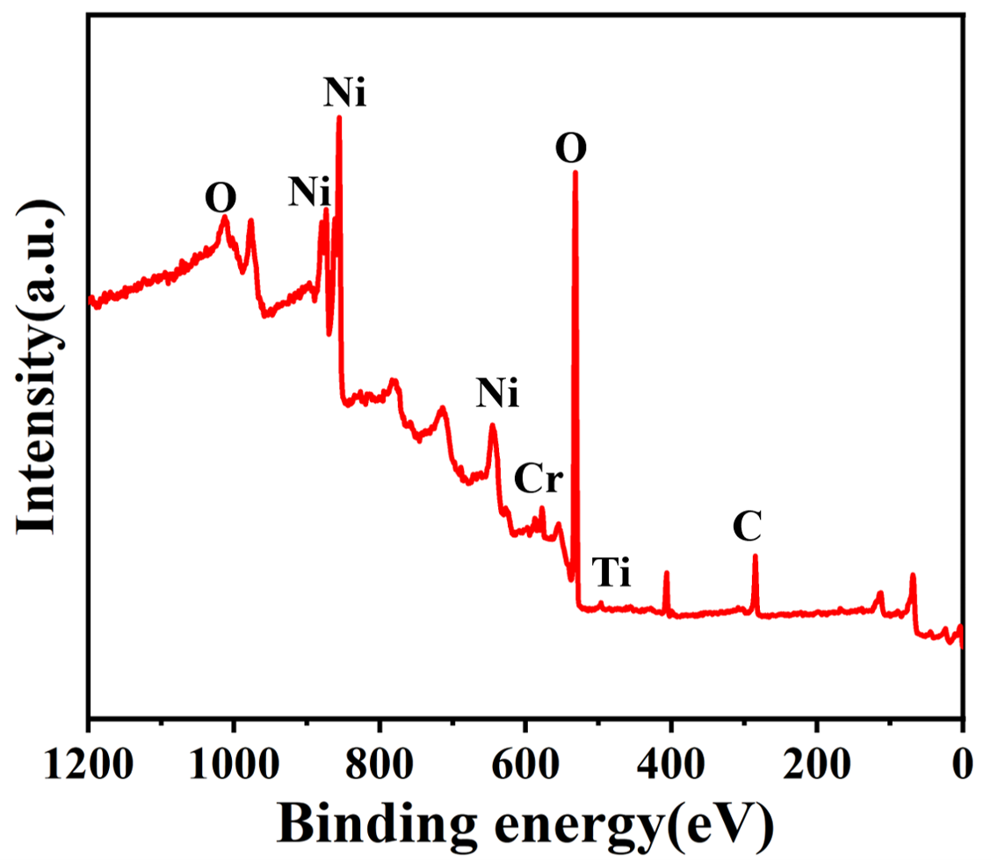
Fig. S4 Full XPS spectrum of Ni₃S₂/Cr(OH)₃-Ti₃C₂@NF.
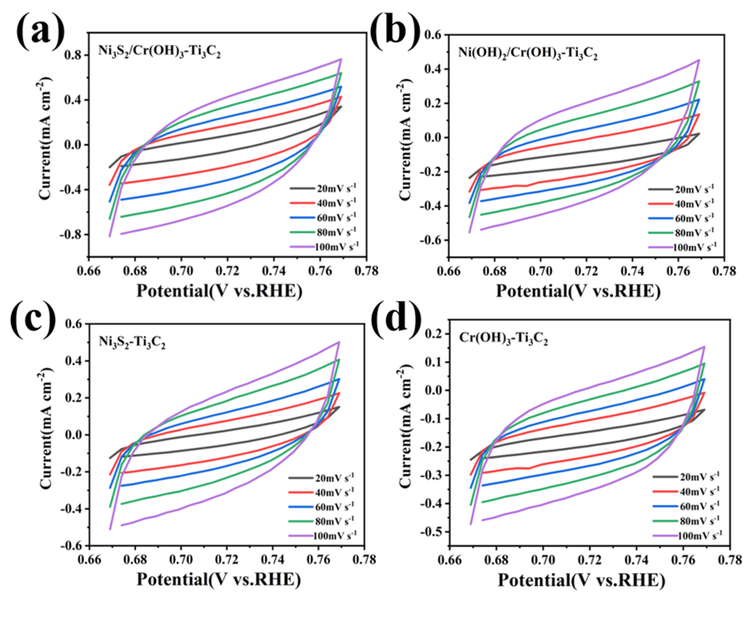
Fig. S5 CV curves of (a) Ni₃S₂/Cr(OH)₃-Ti₃C₂,(b) Ni(OH)₂/Cr(OH)₃-Ti₃C₂,(c) Ni₃S₂-Ti₃C₂,(d)Cr(OH)₃-Ti₃C₂.

Table S1. Comparison of different catalysts for urea electrolysis.
Catalysts | Urea concentration | Performance  （mA cm⁻²） | Corresponding  V | References
Ni₃S₂/Cr(OH)₃-Ti₃C₂ | 0.5M | 10  100 | 1.36  1.39 | This work
CoMn/CoMn₂O₄ | 0.5M | 10 | 1.32 | Advanced Functional Materials, 2020, 30(21).
graphene–MnO₂ | 0.5M | 10 | 1.33 | Angew . Chem. Int. Ed. 2016, 55, 3804.
NiMoO₄ | 0.5 M | 10 | 1.37 | Energy Environ. Sci. 2018, 11, 1890.
Ni(OH)₂ | 0.33 M | 10 | 1.38 | Angew . Chem. Int. Ed. 2016, 55, 12465
MnO₂/MnCo₂O₄ | 0.5M | 10 | 1.33 | J. Mater . Chem. A 2017, 5, 7825.
Ni-Mo nanotube | 0.1M | 10 | 1.36 | Nano Energy 2019, 60, 894.
NiCo₂O₄ | 0.33 M | 250 | 1.62 | Nanoscale 2014, 6, 1369.
Ni₃N | 0.33 M | 10 | 1.35 | norg. Chem. Front. 2017, 4, 1120.
Ni-MOF | 0.33 M | 10 | 1.36 | Chem. Commun. 2017, 53, 10906.
CoS₂ NA/Ti//CoS₂ NA/Ti | 0.33M | 10 | 1.59 | Electrochim. Acta 246 (2017) 776.
NiO-NiPi | 0.5M | 10  100 | 1.349  1.444 | Chem. Eng. J. 2021, 425, 130514-130524
N-NiFe/WRIF// N-NiFe/WRIF | 0.33M | 100 | 1.58 | Chem. Eng. J. 2021, 414, 128753-128762.
Ni₃S₂@CoMoS₄/NiFeOOH// | 0.5M | 100 | 1.66 | Int. J.Hydrogen. Energ. 2021, 46, 24078-24093.
NF/NiMoO-Ar | 0.33M | 100 | 1.42 | Energy & Environmental Science,vol. 11, no. 7, pp. 1890-1897, 2018.
Ni₂P NF/CC | 0.33M | 100 | 1.52 | Journal of Materials Chemistry A,vol. 5, no. 7, pp. 3208-3213, 2017.
Ni₃N/MOF-350//Ni₃N/MOF-350 | 0.5M | 100 | 1.503 | ACS Sustainable Chem. Eng. 8 (2020)
CoFeCr LDH | 0.3M | 100 | 1.41 | Appl. Catal B.Environ.2020, 272,118959
NiClO-D | 0.3M | 100 | 1.44 | Angew. Chem. Int.Edit. 2019,58, 16820
Mo-Co-S-Se | 0.5M | 100 | 1.42 | ACS Sustain. Chem.Eng. 2019, 7, 16577
NF-Ni₂P-Fe₂P | 0.5M | 100 | 1.46 | J. Colloid InterfaceSci.2019, 541, 279.
S-MnO₂ | 0.5M | 100 | 1.46 | Angew. Chem. Int.Ed., 2016, 55, 3804.
1% Fe:α-Ni(OH)₂ | 0.33M | 100 | ~1.41 | Chem. Eur. J. 2018,24, 18408.
NF/MiMoO-A | 0.5M | 100 | 1.42 | Energy Environ. Sci.,2018, 11, 1890.

