<Additional materials>
Crenolanib inhibits retinal fibrosis associated with resistance to anti-VEGF in neovascular age-related macular degeneration in retinal Müller cells
Jin-Ho Joo, MD, PhD,¹ Junkyu Chung, MD,² Jung-Woo Seo, PhD,³ Sang Woong Moon, MD, PhD.⁴
¹Department of Ophthalmology, Uijeongbu St. Mary's Hospital, College of Medicine, The Catholic University of Korea, Seoul, South Korea
²Department of Ophthalmology, Gyeong-in Regional Military Manpower Administration, Gyeonggi-do Province, Republic of Korea
³Core Research Laboratory, Medical Science Institute, Kyung Hee University Hospital at Gangdong, Seoul, Republic of Korea
⁴Department of Ophthalmology, Kyung Hee University Hospital at Gangdong, Seoul, Republic of Korea

Supplementary Fig. 1. The original gel of western blot analysis of Figure 3.
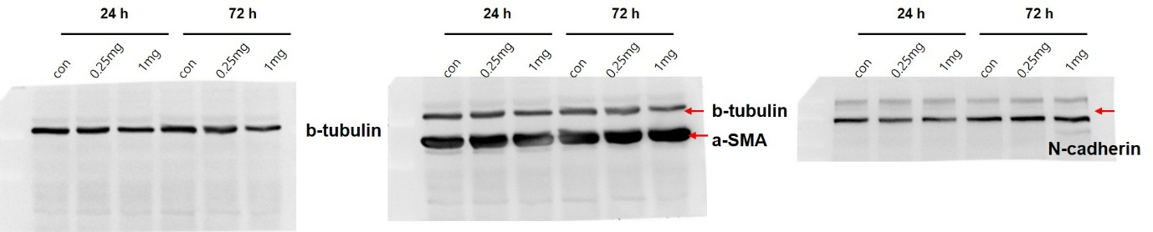

Supplementary Fig. 2. The original gel of western blot analysis of Figure 4.
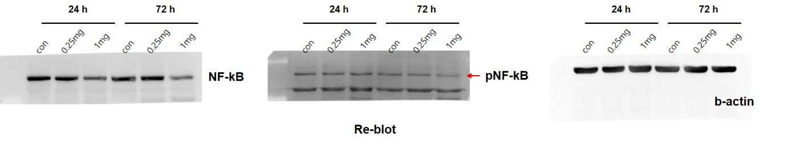

Supplementary Fig. 3. The original gel of western blot analysis of Figure 5.
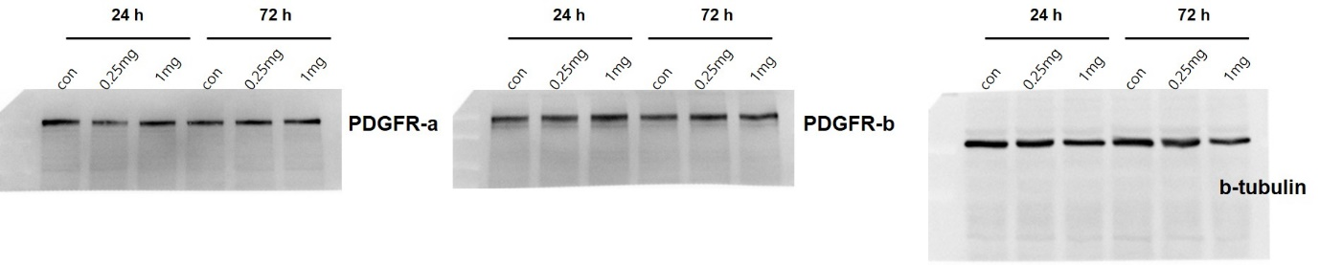

Supplementary Fig. 4. The original gel of western blot analysis of Figure 7.
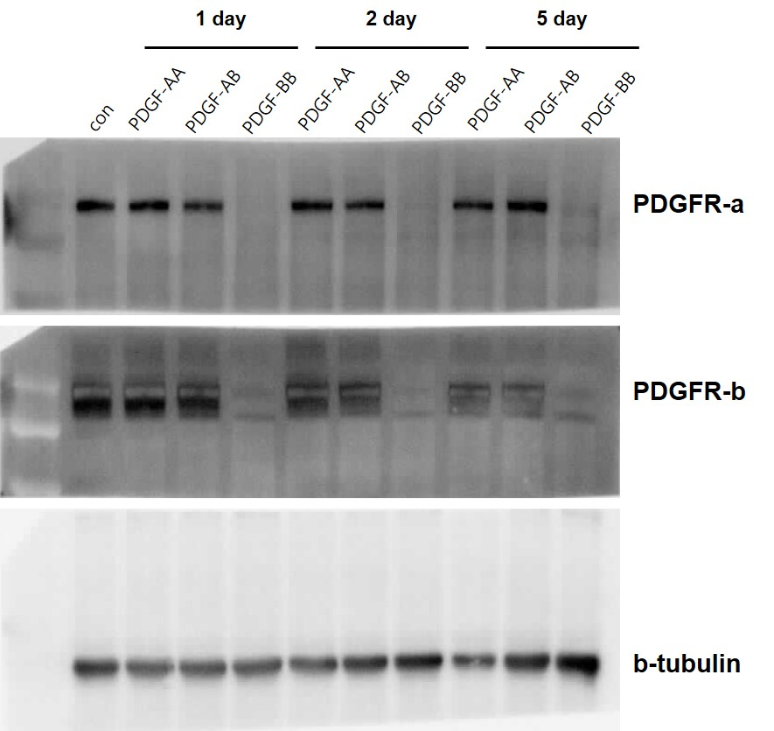

Supplementary Fig. 5. The original gel of western blot analysis of Figure 8.
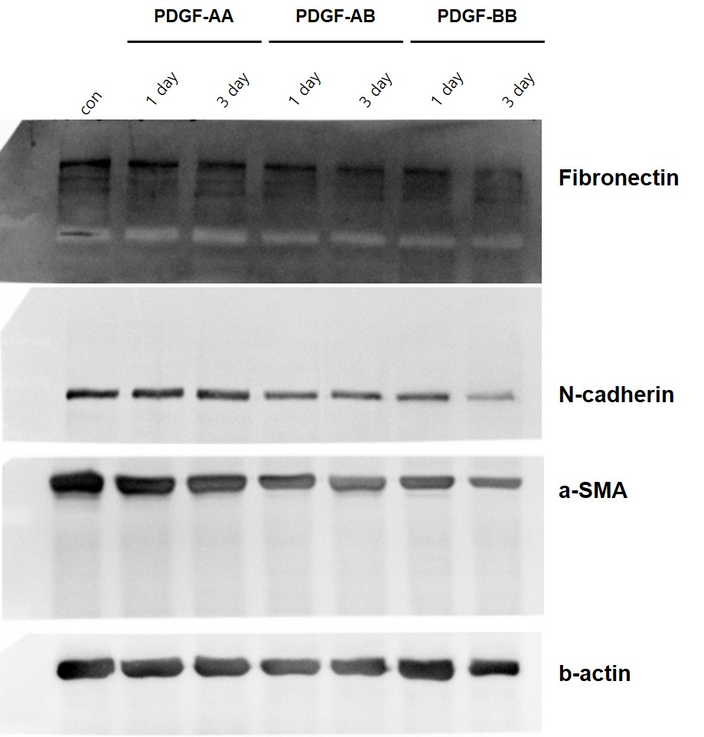

Supplementary Fig. 6. The original gel of western blot analysis of Figure 9.
