Effect of High Nitrate Vegetable Juice Supplementation on Plasma Nitrate and Blood Pressure in Healthy Adults (NIVJUS)

Sponsor:
Queen's University, Belfast (QUB).
The University of Petra, Amman. Jordan (UOP).

Note: Please I need QUB my first Affiliation and UOP the second affiliation.

Information provided by (Responsible Party):
Jayne Woodside, PhD, Queen's University, Belfast.

Brief Summary:

Aims: The aim of this study is to carry out a randomised crossover intervention study examining the effect of two different high nitrate vegetable juices on plasma nitrate levels and blood pressure (BP) in healthy adults.

Objectives: 1) to conduct a pilot cross-over randomized intervention study testing the hypothesis that the health benefits of two different high nitrate vegetable juices products will be similar; 2) to measure the volunteers' BP as the primary outcome; and 3) to collect biological samples over the course of this study for the measurement of proposed biomarkers of nutritional status, including plasma nitrate.

Conclusion
In conclusion, Hills and Armitage analysis of a two-period crossover trial testing consuming BRJ and GLVJ by healthy volunteers for 7 days indicated that there was no significant difference in change in BP between the two juices in both periods. In addition, within group analysis of the results indicated that clinic and home SBP reduced significantly after BRJ consumption and home DBP reduced significantly after GLVJ consumption. Due to the low sample size and pilot design of the study, a retrospective power calculation based on this study will inform the design of a larger intervention study, which will be required to examine the effect of different high nitrate vegetables juice on BP, as evidence from current studies is extremely limited. Additional studies with high nitrate vegetables juice in larger groups of healthy people are needed to determine whether they affect BP, and also explore mechanism of action.

Condition or disease: Blood Pressure
Intervention/treatment: beetroot juice, and leafy green vegetable juice.
Actual Enrollment: 18 participants
Allocation: Randomized
Primary Purpose: Prevention

Table1. Eligibility Criteria

Ages Eligible for Study | 30 Years to 65 Years (Adult, Older Adult)
Sexes Eligible for Study | All
Accepts Healthy Volunteers | Yes

All the required references mentioned in the Main manuscript.

Study Design
After screening and recruitment, participants were randomised to one of two groups: either BRJ or green leafy vegetable juice (GLVJ) by use of a block design (block size n=4; www.randomization.com). Each individual was then given a unique participant number which was used throughout the study and ensured anonymity (only the study researcher knew the names of the participants taking part). The two groups were randomised to consume one of the juices as shown in Figure 1. Both juices were made were UK. The amount of each juice to be consumed was chosen based on the nitrate content as shown in Table 2. The amount of nitrate in the GLVJ (340.30 mg/ 250 ml) was less than the amount of the nitrate in BRJ (735.75mg/ 250 ml). Therefore, the participants were asked to drink 250 ml of the GLVJ daily for 7 days and 115 ml BRJ daily for 7 days, which equaled 340.30 mg nitrate daily (dose the same from both juices). Participants were advised to follow their usual diet and not to make any changes to dietary or lifestyle habits and that body weight was to remain stable for the duration of the intervention. They were also advised to avoid mouth wash during the study, as antibacterial mouthwash has been shown to attenuate the rise in plasma nitrite.

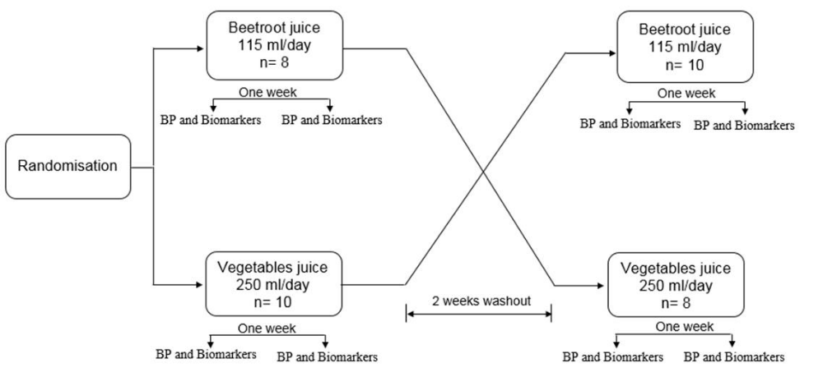
Figure 1. Overview of NIVJUS study design

Table 2: Nitrate content estimation in the BRJ and the GGLVJ in NIVJUS study
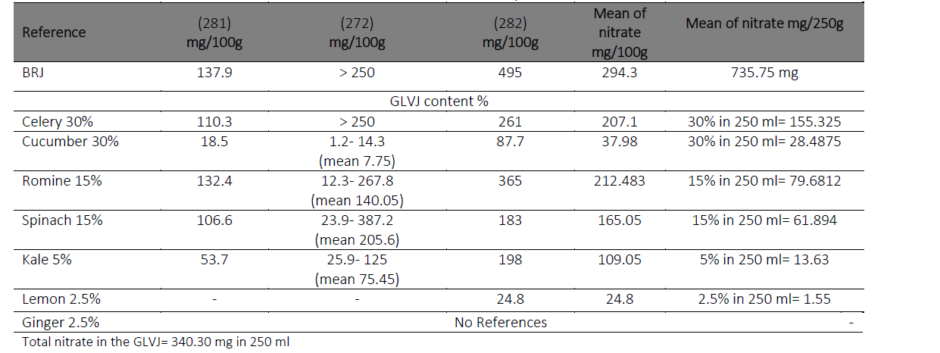

Criteria
Inclusion Criteria:
- Healthy volunteers
- Aged 30-65 years.
Exclusion Criteria:
- Diabetes mellitus
- An acute coronary syndrome or transient ischaemic attack within the past 3 months
- Special dietary requirements, food sensitivities or vegetarian/ vegan diet by choice
- Oral anticoagulation therapy
- Recent beetroot juice (or another nitrate) supplementation.
- BMI>35 kg/m2
- Excessive alcohol consumption ( >14 U/week for men and women)
- Current smoker
- Pregnancy/ lactation
- Medical conditions or dietary restrictions that would substantially limit ability to complete the study requirements.

Compliance
To encourage compliance with the study, participants received daily mobile messages from the researcher to drink the required juice amount to ensure they were consuming study juice. In addition, a reminder sheet was given to each participant to help them remember the date of clinic visits and avoid use of mouthwash. Advice was also given on storage and expiry date for both juices. Enough of each juice was delivered by the researcher for the participants at baseline of each visit. Compliance was self- reported to the researcher.

Measurement Procedures
Participants attended the assessment room in the Centre for Public Health on 4 separate occasions, before and after each intervention week to give a blood sample and have BP measured. The visits lasted approximately 20 minutes, the visits took place in the mornings between 9 am and 11 am. Clinic BP was measured twice from the right arm, using an automated Omron M10 BP monitor (Omron Healthcare, The Netherlands), with the participant sitting quietly for at least five minutes (detailed below). Non- fasted blood samples (20 ml) were drawn from the antecubital vein and immediately separated and stored for the proposed assays. All blood samples stored at -70°C until analysis.

Anthropometric Measurements
Height and weight were assessed at baseline of each intervention period. Height was assessed using a Leicester portable height measure. Participants were asked to remove footwear, stand upright with feet together and shoulder blades against the vertical backboard of the stadiometer. The head was in the Frankfort horizontal plane position with arms hanging loosely at the sides. The movable headboard was lowered onto the crown of the head and the measurement recorded to the nearest 0.1 cm. Body weight was measured using recently calibrated digital weighing scales (seca 876, SECA, Birmingham, UK). Participants were asked to remove footwear and any items that were contained in their pockets. The participant stood straight and still over the centre of the scale platform, looking straight ahead, with body weight evenly distributed between both feet. Body weight was recorded in kilograms (kg) to the nearest 0.1 kg. Body Mass Index (BMI, Kg/ m2) was calculated as weight (kg)/ height2 (m2).

Blood Pressure Measurements
Rested Clinic Blood Pressure Measurements
BP was assessed from the right arm of each participant, using a recently automated Omron sphygmomanometer BP monitor (Omron Healthcare, The Netherlands). Participants were asked to sit quietly for at least five minutes prior measurement to ensure they were rested. Three consecutive readings were taken and recorded, an average BP was also recorded, which was calculated from the 2nd and 3rd readings. BP was measured at each of the four clinic visits.

Daily Home Blood Pressure Monitoring
The same BP monitor (Omron Healthcare, The Netherlands) was provided to each volunteer to measure daily BP at home. Volunteer were asked to conduct duplicate measurements, in a seated position, before and two hours after juice consumption. Volunteers were trained on how to use the monitor, with an emphasis on the correct positioning of the arm. In addition, written instructions on measuring BP were provided. A detailed recorded sheet for home measured BP during the interventions was given, which included a timetable for home BP measures. The average of each daily reading was calculated.

Blood Samples
A total of 32 ml non- fasting whole blood, collected into serum and EDTA tubes, was obtained from participants, using standard phlebotomy procedures before and after each intervention period. All participants were seated for venepuncture. These samples were obtained as soon as possible after the participant arrived for the visit. Samples were collected according to the protocol as describe in the MS. Serum samples were stored at room temperature in the dark, whilst plasma EDTA samples were stored in the refrigerator. These samples were processed within two hours of collection. Samples were centrifuged at 3000 rpm for 15 minutes at 4oC and separated appropriately for the proposed assays. Sample aliquots were stored at -80oC until analysis. The time of sampling was recorded for each sample collection.

Three questionnaires in hard copy format were given to the participants. The first questionnaire assessed physical activity level (PAL). The second questionnaire assessed education level of the participants. The PAL and education level questionnaire given to the participants at baseline, before starting the interventions. The third questionnaire was given to assess tolerability of the study products they had consumed. The tolerability questionnaire was given after consuming each intervention.
Participants completed the questionnaires in the Centre for Public Health assessment room. The researcher explained each questionnaire and gave participants time to ask any questions they had. Participants then completed the questionnaires alone although the researcher was on hand if any further questions needed to be answered.

7.2.10.1 General Physical Activity Questionnaire (PAL)
General physical activity was assessed (i.e. over the last 4 weeks) using a validated questionnaire from the Medical Research Council MRC Epidemiology Unit, Cambridge, UK). This questionnaire firstly assessed the type and the amount of physical activity involving the work for the participants in three parts (i.e. not employer, or full time career, or most time standing, etc.). Secondly, participants were asked about the type of the sport they doing such as swimming or gym or football, etc and the frequency, i.e. less than 1 hour or 3 hours and more, etc. finally, participants were asked to choose the usual walking pace (i.e. slow pace or brisk pace, etc). Participants were asked to record activity at baseline, before starting any intervention. For the purposes of analysis, all educational data analysed by using the statistical programme SPSS v22.0 for Windows (SPSS Inc, Chicago, IL).

7.2.10.2 Education Level Questionnaire
Recent educational level achieved for each participant was assessed (i.e. over the last year). This questionnaire assessed the education status in 7 levels: Some primary (not complete), Primary or equivalent, GCSE/O level/ Intermediate/ junior/ group certificate or equivalent, A- level/Leaving certificate or equivalent, Diploma/ certificate, Undergraduate Primary degree, Postgraduate/higher degree. For the purposes of analysis, all educational data analyses by using the statistical programmes SPSS v22.0 for Windows (SPSS Inc, Chicago, IL).

Tolerability Questionnaire
The tolerability questionnaire was amended from one used in a similar study where they participants were fed dark chocolate (rich in polyphenols) and accessed participants’ acceptability/tolerability to the products (283). Questionnaires were obtained from the study researcher. The questionnaire contained 5- point Likert- scales to assess ease of consumption (very easy, easy, sometimes hard sometimes easy, hard, very hard), acceptability (very acceptable, acceptable, unsure, unacceptable, very unacceptable) and how much they agreed with the statements given (strongly agree, agree, unsure, disagree, strongly disagree). Open and closed questions were also used such as whether the participants found the study products gave any side effects and if they would be willing to continue taking the products post- intervention, if found to be beneficial to health.

Nitrate and Nitrite Analysis
Nitrite/ nitrate concentrations were determined using a commercial kit (R&D Systems, Minneapolis, MN, USA) according to the manufacturers’ instructions. Kits were run on a Triturus automated ELISA analyser supplied by Grifols UK Ltd. Concentrations were determined from the optical density (O.D.) of each well using a microplate reader set at 540 nm (wavelength correction at 690 nm).
Nitrite Assay Procedure
This assay procedure measured the concentration of endogenous nitrite present in the sample. All reagents, standards and samples were prepared according to the kit instructions. Plasma samples were filtered using Amicon Ultra 2, 10,000 MW centrifugal filter units (Millipore UK Ltd) and used neat. 50 μL of Reaction Diluent (1X) was added to the Blank wells, then 50 μL of standard or sample was added to the remaining wells. A further 50ul of Reaction Diluent (1X) was added to all wells. 50 μL of Griess Reagent (I) was added to all wells followed by 50 μL of Griess Reagent (II). The plate was shaken to ensure even mixing of the samples and reagents. It was then incubated at room temperature for 10 minutes and read at 540 nm with wavelength correction at 690 nm.

Nitrate Reduction Assay Procedure
This assay procedure measures total nitrite by converting nitrate to nitrite. To determine the nitrate concentration in the sample, the endogenous nitrite concentration measured from the Nitrite Assay Procedure must be subtracted from the nitrite concentration measured in this procedure. Again, all reagents, standards and samples were prepared according to the kit instructions. Plasma samples were filtered using Amicon Ultra 2, 10,000 MW centrifugal filter units (Millipore UK Ltd) and used neat. 50 μL of Reaction Diluent (1X) was added to the Blank wells then 50 μL of Nitrate Standard added to the remaining wells, and 25 μL of NADH was added to all wells. Then 25 μL of diluted Nitrate Reductase was added to all wells. Samples were mixed well and incubated at 37 °C for 30 minutes. 50 μL of Griess Reagent I was added to all wells followed by 50 μL of Griess Reagent II. The plate was shaken to ensure even mixing of the samples and reagents. The plate was then incubated at room temperature for 10 minutes and samples were read at 540 nm with wavelength correction at 690 nm.
Calculation of results; to determine the concentration of nitrate in the sample:
The endogenous nitrite concentration (X μmol/L) was measured by using nitrite assay procedure. The total nitrate concentration (Y μmol/L) was measured after conversion of nitrate to nitrite by using the Nitrate Reduction Assay Procedure. Nitrate concentration was determined by subtracting the endogenous nitrite concentration from the total nitrite concentration.
Nitrite concentration= (Y- X) μmol/L
Since the samples were run neat, the concentration was read straight from the standard curve and no adjustments were necessary.

Nitrate Reduction Assay Sensitivity
Sensitivity analyses had been conducted by the kit manufacturer. Fifty- two samples were evaluated and the minimum detectable dose (MDD) ranged from 0.09- 0.78 μmol/L. The mean MDD was 0.25 μmol/L. the MDD was determined by adding two standard deviations to the mean optical density value of twenty zero standard replicates and calculating the corresponding concentration.

Arm | Intervention/treatment
Experimental: Beetroot juice  115 ml of beetroot juice per day for seven days | Other: Food-based - beetroot juice  Beetroot juice containing approximately 340 mg nitrate daily
Experimental: Leafy green vegetable juice  250 ml of green leafy vegetable juice per day for seven days | Other: Food-based - leafy green vegetable juice  Leafy green vegetable juice containing approximately 340 mg nitrate daily

Outcome Measures
Primary Outcome Measures
Blood pressure (clinic-based) [ Time Frame: At baseline]
Clinic-based blood pressure using automated, calibrated blood pressure monitor, measured twice from the right arm, using an automated Omron sphygmomanometer, with the participant sitting quietly for at least five minutes.
Blood pressure (clinic-based) [ Time Frame: After seven days]
Clinic-based blood pressure using automated, calibrated blood pressure monitor, measured twice from the right arm, using an automated Omron sphygmomanometer, with the participant sitting quietly for at least five minutes.
Blood pressure (home-assessed) [ Time Frame: Pre juice consumption during the intervention]
An automated BP monitor (Omron M2Basic, Omron Healthcare) will be provided to each participant to measure daily resting BP at home. Participants will be asked to conduct duplicate measurements, in a seated position prior to juice consumption and at 2 hours after juice drinking and they will be trained on how to use the monitor, with an emphasis on the correct positioning of the cuff and arm. In addition, written instructions on measuring BP will be provided. Participants will be provided with a record sheet to record their measurements.
Blood pressure (home-assessed) [ Time Frame: Two hours post juice consumption during the intervention]
An automated BP monitor (Omron M2Basic, Omron Healthcare) will be provided to each participant to measure daily resting BP at home. Participants will be asked to conduct duplicate measurements, in a seated position prior to juice consumption and at 2 hours after juice drinking and they will be trained on how to use the monitor, with an emphasis on the correct positioning of the cuff and arm. In addition, written instructions on measuring BP will be provided. Participants will be provided with a record sheet to record their measurements.
Secondary Outcome Measures
- Serum nitrate and nitrite concentrations [ Time Frame: At baseline]
Serum concentrations of nitrate and nitrite. Total Nitric Oxide, nitrate and nitrite in plasma will be determined by an automated ELISA method (R&D Systems).

- Serum nitrate and nitrite concentrations [ Time Frame: After seven days]
Serum concentrations of nitrate and nitrite. Total Nitric Oxide, nitrate and nitrite in plasma will be determined by an automated ELISA method (R&D Systems).

- Participant views on interventions [ Time Frame: At end of the seven-day intervention]
Acceptability and ease of consumption assessed via questionnaire with Likert scale responses

Locations
United Kingdom
Centre for Public Health, Queen's University Belfast
Belfast, Northern Ireland, United Kingdom, BT12 6BJ

