Supplementary Tables and Figures in order of appearance in text

Supplementary Table 1. Number of rice accessions that were infected with each of the six M. oryzae isolates. For each of the six inoculation tests performed, the number of rice accessions which had consistent disease severity scores (SD <1.3) are indicated in bold. Data collected from accessions meeting this criterion was used for GWAS.
M. oryzae isolate | Mo15-23 | Mo15-24 | M64-1-3-9-1 | IK81-25 | Mo15-125 | C923-49
Number of accessions with one or more biological replicates | 480 | 476 | 458 | 494 | 479 | 490
Number of accessions with disease severity SD <1.3 | 404 | 416 | 390 | 442 | 425 | 440
Accessions with 10 biological replicates | 233 | 292 | 400 | 195 | 421 | 304
Accessions with 9 biological replicates | 36 | 21 | 20 | 45 | 15 | 28
Accessions with 8 biological replicates | 60 | 38 | 17 | 80 | 12 | 28
Accessions with 7 biological replicates | 55 | 44 | 11 | 59 | 4 | 32
Accessions with 6 biological replicates | 49 | 35 | 7 | 47 | 8 | 41
Accessions with 5 biological replicates | 27 | 10 | 6 | 43 | 5 | 24
Accessions with 4 biological replicates | 13 | 19 | 9 | 9 | 2 | 13
Accessions with 3 biological replicates | 5 | 10 | 2 | 7 | 2 | 10
Accessions with 2 biological replicates | 4 | 5 | 3 | 6 | 8 | 7
Accessions with 1 biological replicate | 1 | 1 | 1 | 3 | 2 | 3

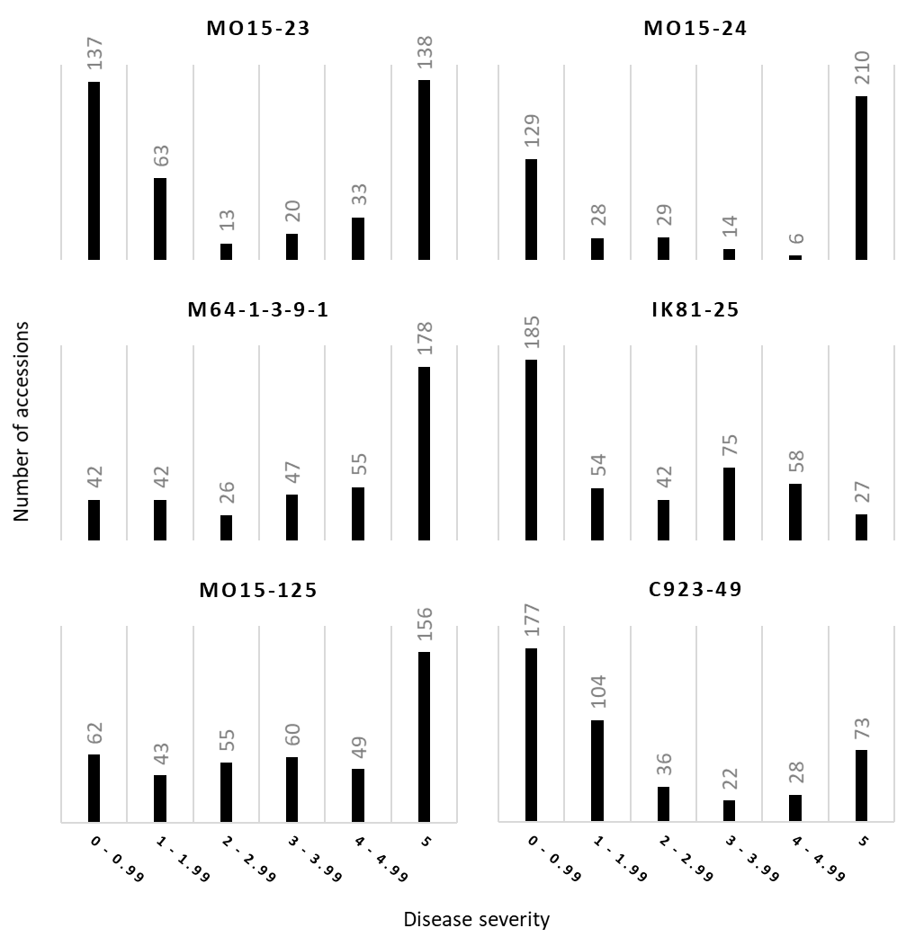
Supplementary Figure 1. Distribution of rice blast disease severity scores. Distribution of M. oryzae inoculation scores shown for each of the six pathogen isolates. Rice accessions with a standard deviation greater than 1.3 between across replicates were excluded. 0 = no symptoms; 5 = lesions greater than 2 mm. The average rice blast severity score for each accession infected with six different M. oryzae isolates is presented as the frequency of occurrence in the bin ranges indicated on the X-axis (disease severity).

Supplementary Table 2. Proportion of susceptible accessions carrying peak associated SNPs. In general, accessions carrying peak resistance associated SNPs to M. oryzae isolates had disease severity scores <3, consistent with the strong GWAS associations detected. Mo15-125 and IK81-25 peak resistance associations were expections with 22.22% and 29.49% of accessions having a susceptible average lesion score (>3).
Isolate | Peak SNP association | Proportion of susceptible accessions carrying association
Mo15-125 | Chr 12 : 10,926,845 (A) | 24/108 associated accessions have average lesion score >3 (22.22 %)
M64-1-3-9-1 | Chr 12 : 10,926,845 (A) | 23/78 associated accessions have average lesion score >3 (29.49 %)
IK81-25 | Chr 12 : 10,830,098 (T) | 2/98 associated accessions have average lesion score >3 (2.04 %)
C923-49 | Chr 11 : 6,540,075 (A) | 1/196 associated accessions has average lesion score >3 (1.02 %)
Mo15-23 | Chr 12 : 10,797,768 (T) | 5/82 associated accessions have average lesion score >3 (6.10 %)
Mo15-24 | Chr 12 : 10,806,802 (C) | 4/87 associated accessions have average lesion score >3 (4.60 %)

Supplementary Table 3. Virulence spectra of M. oryzae isolates used in this study. Isolates used for diversity panel screening and GWAS are shown in bold. Virulence to Pita and Pita2/Ptr are underlined and in bold. Isolates not in bold were used for subsequent specificity analysis and validation experiments. Virulence spectra were determined by infecting near-isogenic lines containing various resistance genes.
Isolate | Virulent to near-isogenic rice lines containing:
Mo15-125 | Pia, Piks, Pik, Pikp, Pikh, Pita, Pib, Pit, Pi1, Pi7, Pi12, Pi19, Pikm, Pi20, Pita2/Ptr, Pi11
M64-1-3-9-1 | Pia, Pii, Piks, Pik, Pikp, Pib, Pit, Pi1, Pi3, Pi12, Pi19, Pi20, Pi11
IK81-25 | Pia, Piks, Pikp, Pikh, Pizt, Pib, Pit, Pi1, Pi7, Pi12, Pi19, Pikm, Pi20, Pita, Pi11
C923-49 | Pii, Piks, Pit, Pish, Pi3, Pi5, Pi19, Pita
Mo15-23 | Pia, Piks, Pik, Pikp, Pikh, Piz5, Pizt, Pita, Pib, Pit, Pi1, Pi7, Pi12, Pi19, Pikm, Pi11
Mo15-24 | Pia, Pii, Piks, Pikp, Pita, Pib, Pit, Pi3, Pi5, Pi7, Pi12, Pi19, Pi11
M101-1-2-9-1 | Pia, Pii, Piks, Piz5, Pizt, Pita, Pit, Pi3, Pi19, Pi20, Pi11
Ca89 | Pia, Pii, Piks, Piz, Pizt, Pita, Pib, Pit, Pish, Pi3, Pi5, Pi12, Pi19, Pi20, Pita2/Ptr, Pi11
Mo15-27 | Pia, Piks, Pik, Pikp, Pikh, Pizt, Pita, Pib, Pi1, Pi7, Pi12, Pi19, Pikm, Pi20, Pita2/Ptr, Pi11

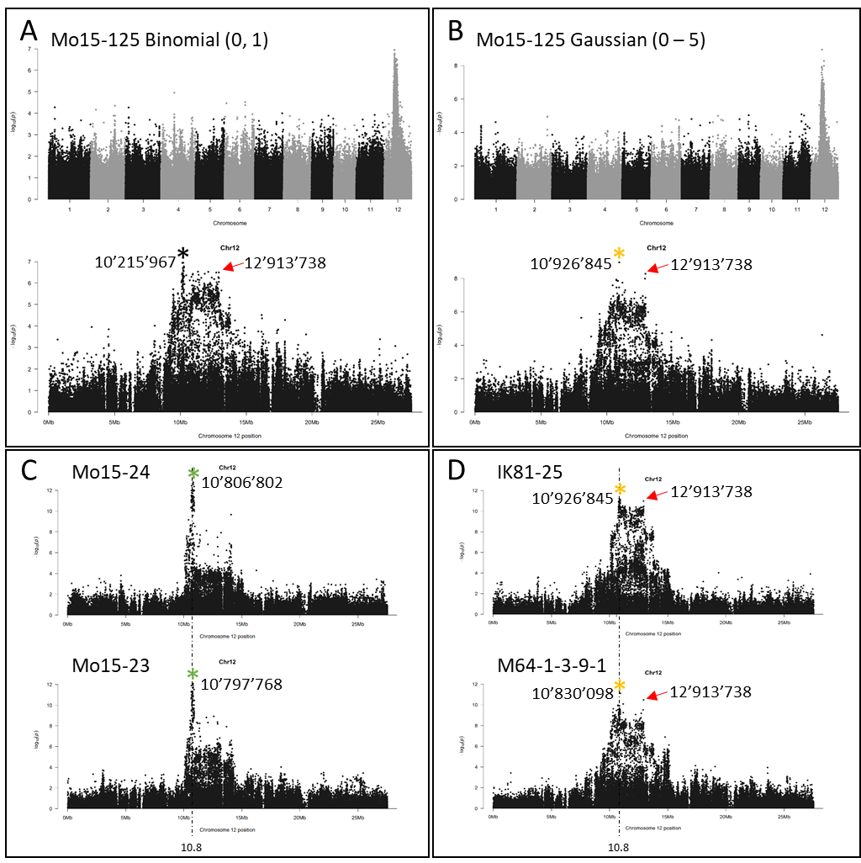Supplementary Figure 2. Additional chromosome 12 association peaks produced by different M. oryzae isolates and treatments of input data. A, B GWAS performed on the Mo15-125 infection data set produces different peak associations when infection scores were treated as binomial (resistant vs susceptible) or gaussian (0-5 disease severity score), and used as input for GWAS. Peak SNPs are indicated by an asterisk symbol and the nucleotide position (based on Nipponbare reference assembly) is indicated. Red arrows indicate the position of a second peak SNP. The Mo15-125 Gaussian GWAS peak SNP is identical to the M64-1-3-9-1 GWAS peak SNP at position 10,926,845 (shown in panel D). C, D Manhattan plots of chromosome 12 associations are shown for Mo15-23/24 (group 2), as well as for IK81-25 and M64-1-3-9-1 (group 1), based on binomial input data. Peak SNPs are marked with an asterisk and the nucleotide position is indicated. D Red arrows indicate the position of a second peak SNP that co-associates with the peak SNPs of IK81-25 and M64-1-3-9-1 at 10.92 and 10.83 Mb. All nucleotide positions are relative to the Nipponbare reference genome. The asterisks denoting chromosome 12 peak SNPs are color coded to indicate that particular subsets of accessions carrying the associated variant of the chromosome 12 peak SNPs are shared for Mo15-24 and 23 (green – group 2), and for Mo15-125, IK81-25 and M64-1-3-9-1 (yellow – group 1).
Supplementary Table 4. Linked read sequencing (10x Genomics, Inc) de novo assembly statistics.
Accession | Total sequence length | Number of scaffolds | Scaffold N50 | Number of contigs | Contig N50 | Fold Coverage
IRIS_313-12190 | 427,606,848 | 12,202 | 4,158,354 | 22,621 | 42,536 | 62.7425
IRIS_313-11127 | 424,149,202 | 11,576 | 4,571,059 | 21,764 | 43,459 | 63.3593
IRIS_313-11360 | 427,369,838 | 12,303 | 3,690,457 | 22,405 | 44,083 | 63.4671
IRIS_313-7914 | 412,462,330 | 11,525 | 3,715,755 | 22,146 | 41,065 | 63.3939
IRIS_313-8554 | 419,730,278 | 12,563 | 3,205,731 | 23,357 | 39,580 | 62.324
IRIS_313-10314 | 419,189,211 | 12,856 | 2,026,036 | 23,689 | 41,008 | 61.6208
IRIS_313-10059 | 502,613,927 | 31,755 | 773,075 | 44,898 | 29,682 | 63.6699
IRIS_313-10879 | 427,931,591 | 12,764 | 3,896,250 | 23,025 | 43,059 | 62.1701
IRIS_313-11786 | 411,001,814 | 10,313 | 2,314,655 | 19,112 | 56,607 | 62.9281
IRIS_313-10738 | 419,096,195 | 11,832 | 3,389,810 | 20,766 | 54,370 | 65.4986

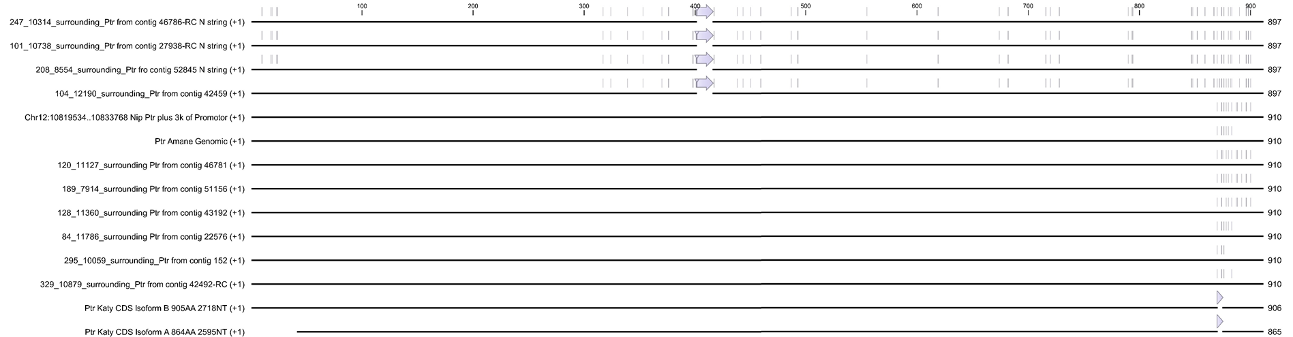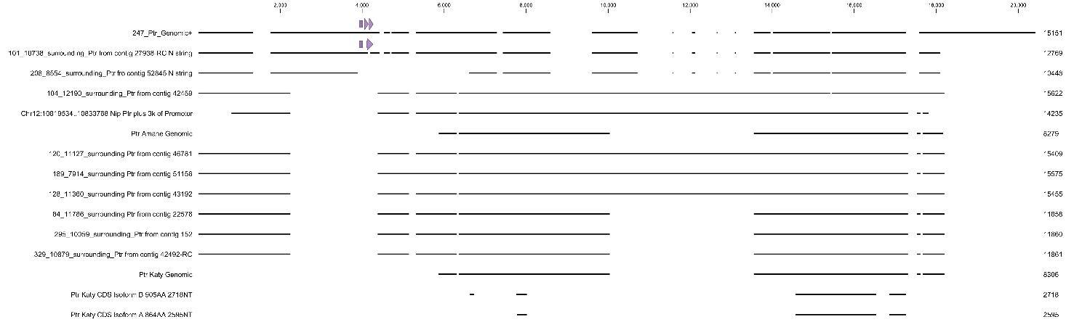
IRIS_313-10314
IRIS_313-10738
IRIS_313-8554
IRIS_313-12190
Nipponbare
Amane
IRIS_313-10059
IRIS_313-10879
Katy CDS B
Katy CDS A
IRIS_313-11127
IRIS_313-7914
IRIS_313-11360
IRIS_313-11786
IRIS_313-10314
IRIS_313-10738
IRIS_313-8554
IRIS_313-12190
Nipponbare
Amane
IRIS_313-10059
IRIS_313-10879
Katy
Katy CDS
IRIS_313-11127
IRIS_313-7914
IRIS_313-11360
IRIS_313-11786
b PTR protein sequence alignment
a Genomic sequence alignment surrounding Ptr
Transmembrane
Armadillo-type fold/Armadillo repeat
Cytoplasmic
\
\
\
\
\
\
\
\
\
\
\
\
\
\
\
Non-cytoplasmic
Supplementary Figure 3. Schematic representation of multiple sequence alignments of genomic sequence surrounding Ptr and Ptr protein sequence alignment. a Genomic sequence surrounding Ptr and, b Ptr protein sequence alignment shown for associated and non-associated de-novo assembled accessions, and for Nipponbare, Amane (identical to CO39 Ptr) and Katy (previously identified Ptr allele). Mo15-23 and Mo15-24 resistance associated accessions are shown in green, Ik81-25, M64-1-3-9-1 and Mo15-125 resistance associations are shown in yellow, and IRIS-313-12190 which carried resistance associations to Mo15-23, Mo15-24, Ik81-25, M64-1-3-9-1 and Mo15-125 at chromosome 12 are shown in grey. a Purple arrows above genomic sequence indicate the position of tandem repeats detected using Tandem repeats finder (Benson, 1999). A dashed line on IRIS_313-8554 genomic sequence indicates a gap in assembled sequence due to tandem repeat. PCR amplification using primers flanking the ambiguous region allowed for the sequence to be resolved for the IRIS-313-10314 accession. All sequences are trimmed for alignment to include 3 kb of sequence upstream of Ptr start site (except for IRIS-313-10314 where 5 kb of sequence upstream of Ptr start codon is included) and 3 kb downstream of Ptr stop codon. Trimmed sequence ends are denoted by a backslash (\). All other gaps in genomic sequence represent the position are in-dels. Genomic sequence for the Ptr locus from the accessions Katy and Amane represents the maximum available sequence reported (Zhao et al., 2018). b A schematic of the protein multiple sequence alignment of the largest isoform of Ptr is shown with AA changes and in-dels relative to the Katy allele shown in pale purple. The four amino acid deletion found in the Katy allele is shown as a pale purple triangle above the Katy isoforms. Predicted domain structure of Ptr is shown below the protein alignment schematic.

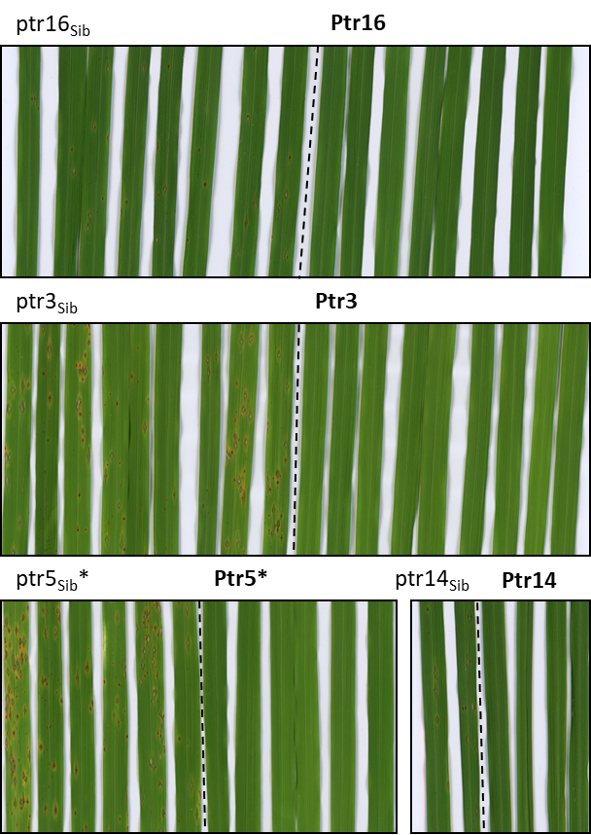
Supplementary Figure 4. T1 Transgenic rice plants expressing the Mo15-23/24 resistance associated allele of Ptr under its native promotor are resistant to rice blast. T1 plants were genotyped to differentiate non-transgenic siblings (ptr#_{sib}) from transgenic plants (Ptr#). Four-week-old plants were spray inoculated with M. oryzae isolate Mo15-24, except for Ptr5_{Sib}* and Ptr5* plants which were spray infected with the Mo15-23 isolate. Images were taken seven days post inoculation.

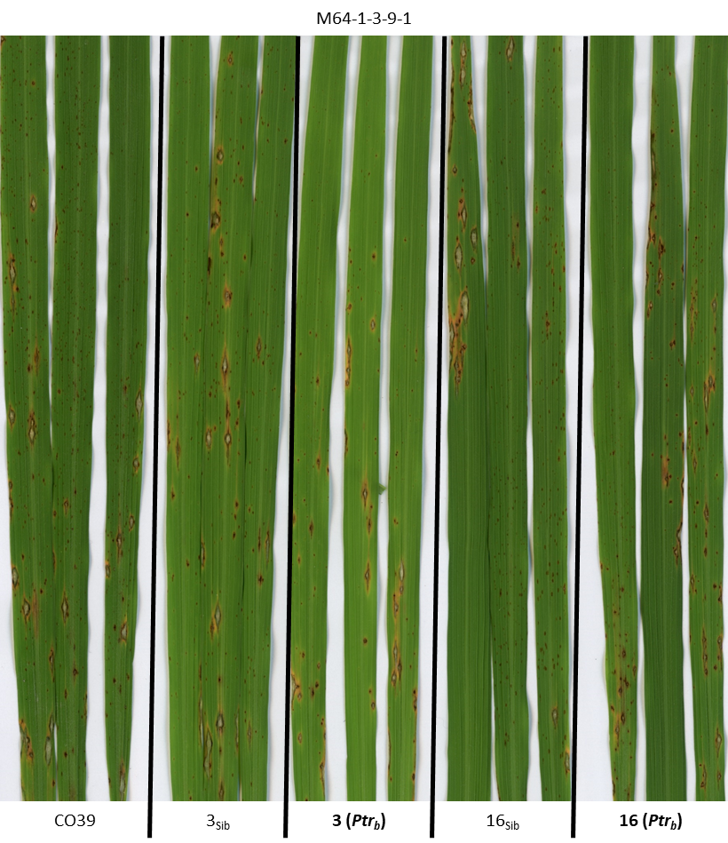
Supplementary Figure 5. Ptr_{b} acts as a race specific resistance gene conferring resistance to M. oryzae isolates Mo15-23 and Mo15-24, but not M64-1-3-9-1. T1 plants were genotyped to determine the presence of the transgene and differentiate non-transgenic siblings from transgenic siblings. At 4 weeks old, transgenic lines, non-transgenic siblings and the susceptible parental line CO39 were spray inoculated with the M. oryzae isolate M64-1-3-9-1. Images were taken seven days post inoculation.

Supplementary table 5. Results of M. oryzae diagnostic isolate infection testing on Ptr_{a} and Ptr_{b} containing genotypes. Ptr_{a} NIL CO39 contains an introgression region containing Ptr_{a} in the CO39 genetic background. This line was resistant to all isolates tested but Ca89. However, given this introgressed region may contain other resistance genes, infection testing was also performed using ptr_{a} mutants #377 and #6599 in the IR64 background, which was subsequently crossed to CO39. In the case of Mo15-24, M101-1-2-9-1, and IK81-25 infection testing, the ptr_{a} mutants were resistant, but this response may be due to lingering sources of resistance carried in the IR64 background. The ptr_{a} mutants showed susceptibility when infected with Mo15-23 and M64-1-3-9-1, while Ptr_{b} transgenics (Ptr_{b} CO39) only gain resistance to Mo15-23 when compared to the susceptible parent line CO39, or non-transgenic siblings. Virulence responses of the various isolates to the presence of Ptr_{a} and Ptr_{b} are summarised in the final two rows of the table.

Genotype | Mo15-23 | Mo15-24 | M64-1-3-9-1 | M101-1-2-9-1 | IK81-25 | Ca89
Ptr_{a} NIL CO39 | R | R | R | R | R | S
Ptr_{a} IR64 | R | R | R | R | R | S
ptr_{a} #377 | S | R | S | R | R | S
ptr_{a} #6599 | S | R | S | R | R | S
CO39 | S | S | S | S | S | S
Ptr_{b} CO39 | R | R | S | S | S | S
Virulence summary

Ptr_{a} | R | ? | R | ? | ? | S
Ptr_{b} | R | R | S | S | S | S

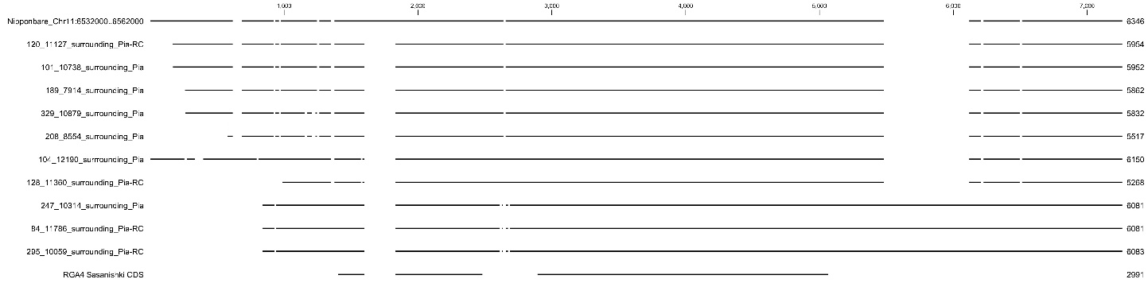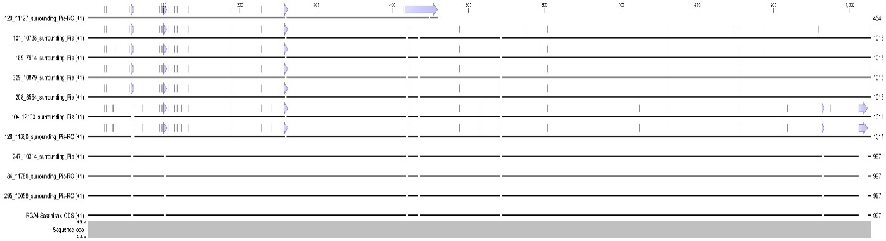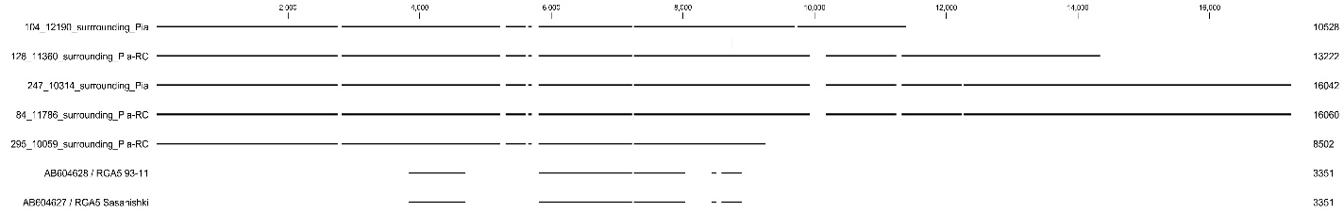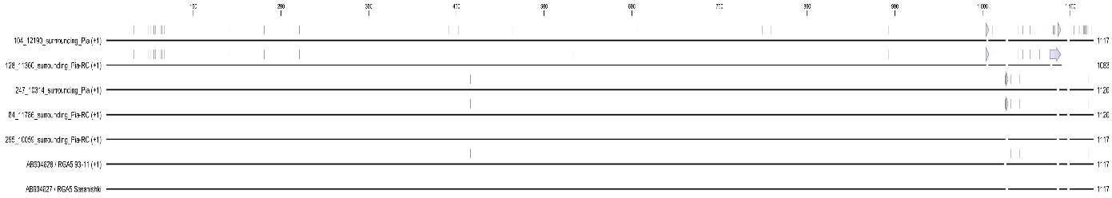
a Rga4 reverse complement genomic sequence alignment
IRIS_313-10314
IRIS_313-10738
IRIS_313-8554
IRIS_313-12190
IRIS_313-10059
IRIS_313-10879
Sasanishki CDS
IRIS_313-11127
IRIS_313-7914
IRIS_313-11360
IRIS_313-11786
Nipponbare
LOC_Os11g11790 / Rga4
LOC_Os11g11780
IRIS_313-10314
IRIS_313-10738
IRIS_313-8554
IRIS_313-12190
IRIS_313-10059
IRIS_313-10879
Sasanishki
IRIS_313-11127
IRIS_313-7914
IRIS_313-11360
IRIS_313-11786
b RGA4 protein sequence alignment
CC domain
NB-ARC domain
LRR domain
c Rga5 genomic sequence alignment
IRIS_313-10314
Sasanishki CDS
IRIS_313-12190
IRIS_313-10059
IRIS_313-11360
IRIS_313-11786
IRIS_313-10314
93-11
IRIS_313-12190
IRIS_313-10059
Sasanishki
IRIS_313-11360
IRIS_313-11786
d RGA5 protein sequence alignment
CC domain
NB-ARC domain
LRR domain
HMA domain
*
Supplementary Figure 6. Pia locus genomic and protein sequence alignment schematics. a, c Alignment schematics of Rga4 and 5 genomic sequence showing positions of in-dels. a The Nipponbare genomic sequence features a tandem duplication in Rga4 sequence resulting in a truncated Rga4 gene (Position of duplication is marked*). The Nipponbare gene annotation LOC_Os11g11790 which overlaps RGA4 is shown under the genomic sequence alignment. a, c The RGA4 & 5 CDS from Sasanishki is indicated by green boxes in position of exon sequence. b, d RGA4 and 5 protein sequence alignments with positions of AA polymorphisms shown by pale blue vertical lines and AA in-dels shown as pale blue arrows. Positions of conserved protein domains are shown below protein sequence alignments. a-d Sequence from rice accessions carrying the C923-49 rice blast resistance association are shown in blue.
Supplementary Table 6. Summary of PISA (Proteins, Interfaces, Structures and Assemblies) analysis of the model structures AVR1-CO39/HMA complexes. Details of total interface area (Å2), solvation free energy gain upon complex formation (DiG), number of H-Bonds and number of involved residues lare given. For the reference Sasanishki RGA5 HMA-AVR1CO39 the values given between parenthesis correspond to the initial PDB structure 5ZNG. For IRIS-313-11786 (*) the ASVNGVESMQ-loop sequence was modelled by RCD+ server and the complex was refined on GalaxyWEB server.
Accession | No. of interacting residues in  AVR1-CO39 | No. of interacting residues in  RGA5 HMA | Interface area  Å² | D^{i}G  kcal/mol | No. of H-Bonds
Sasanishki | 12 (12) | 16 (16) | 495 (493) | -4.7 (-4.6) | 8 (7)
IRIS_313-11786 * | 17 | 18 | 617 | -7.9 | 9
93-11 | 12 | 16 | 502 | -4.4 | 7
CO39 | 12 | 16 | 491 | -5.0 | 7
IRIS_313-12190 | 12 | 16 | 489 | -5.1 | 8
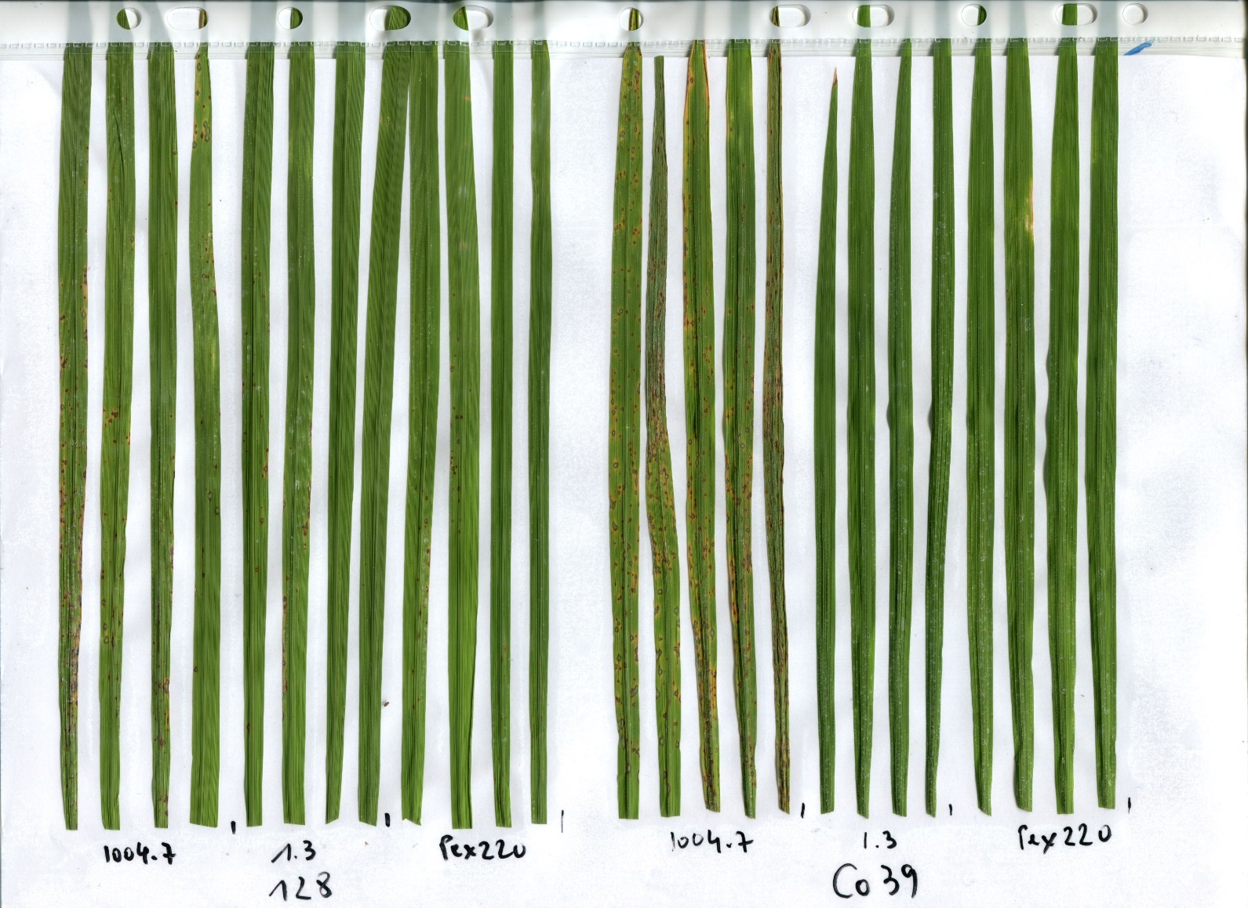
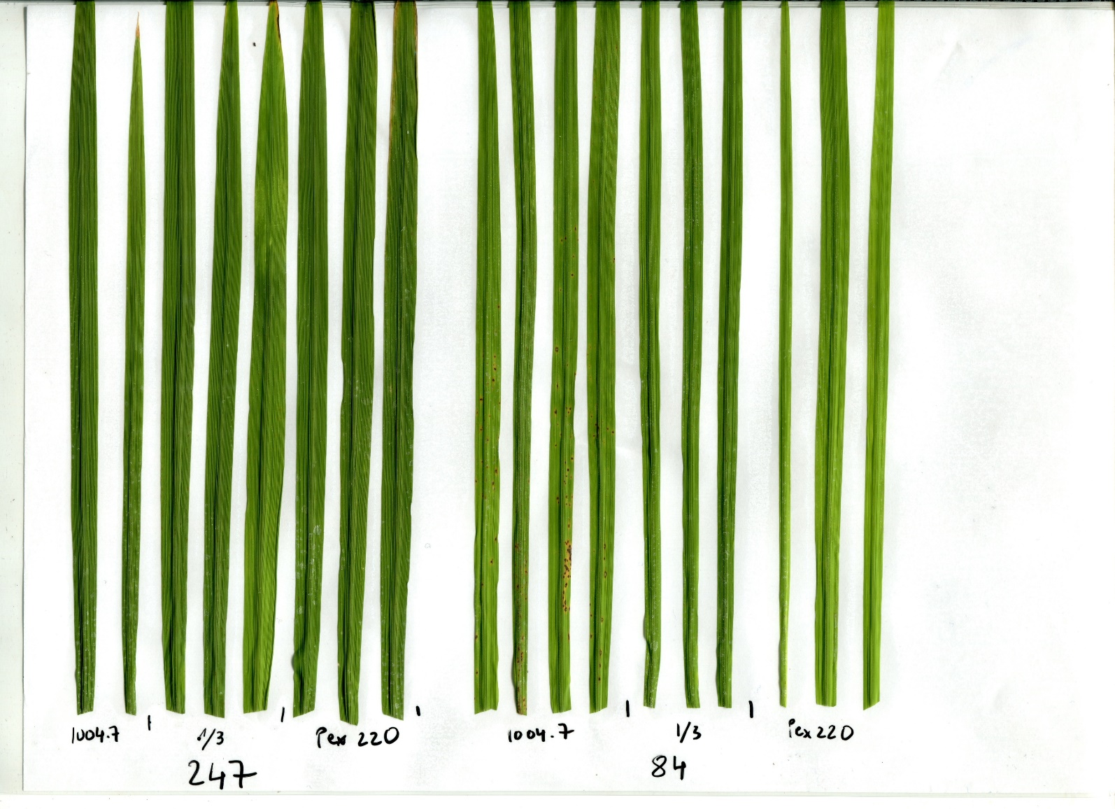
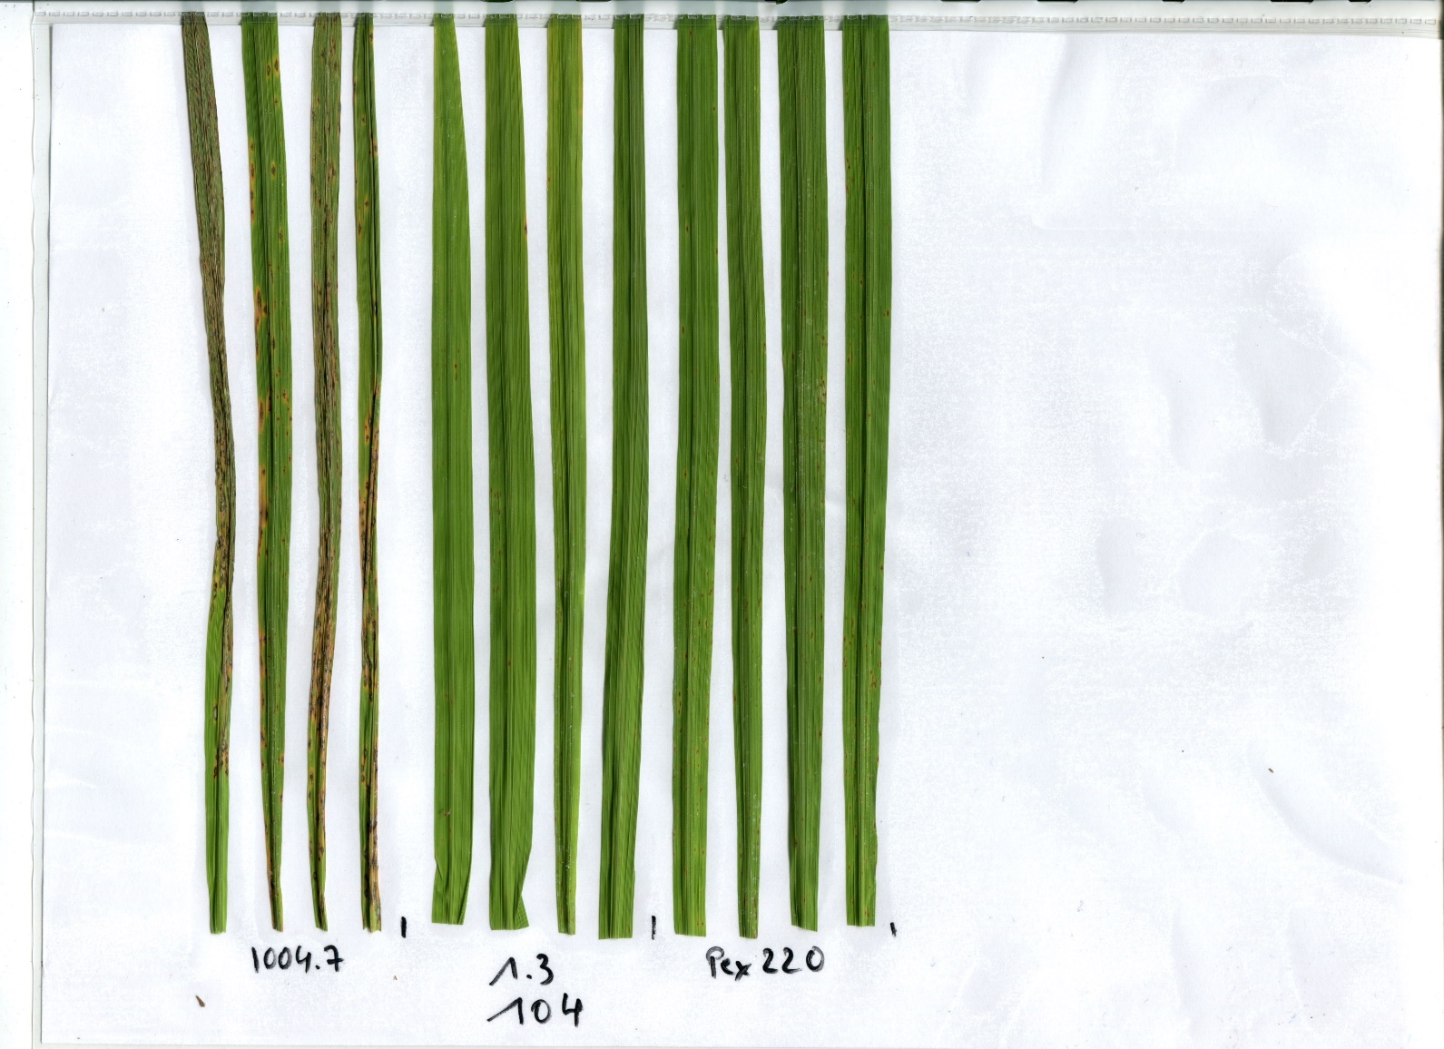
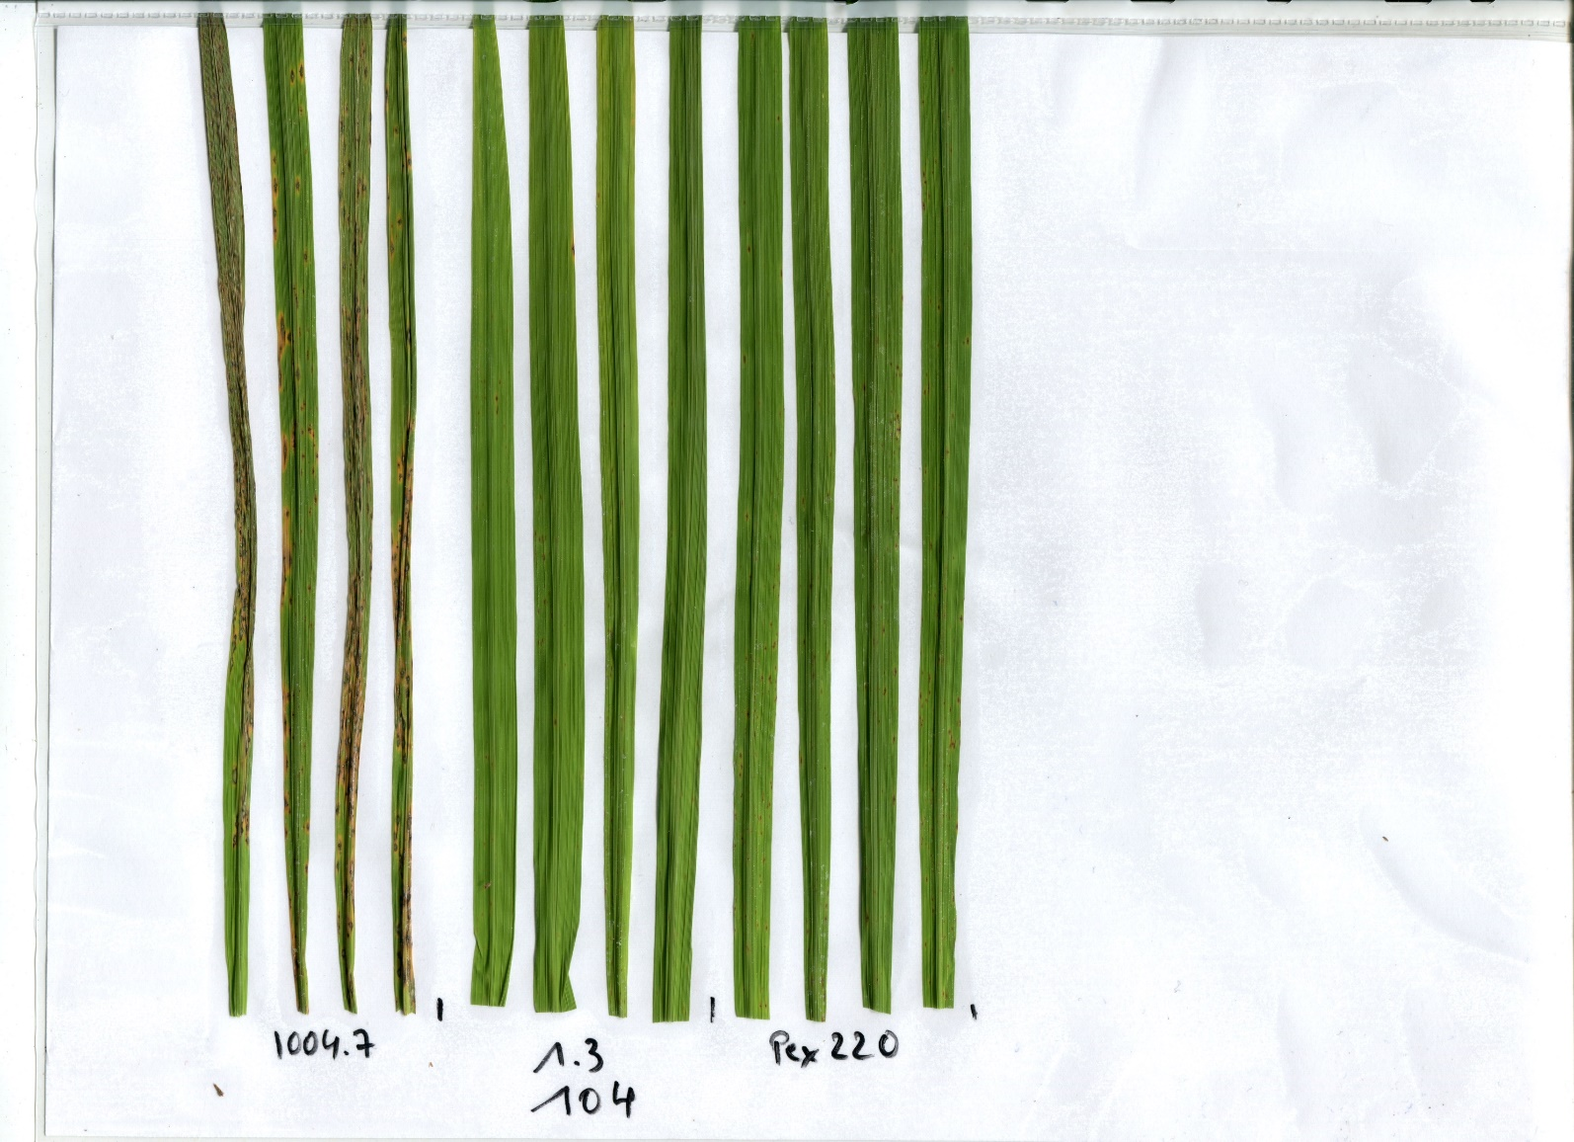
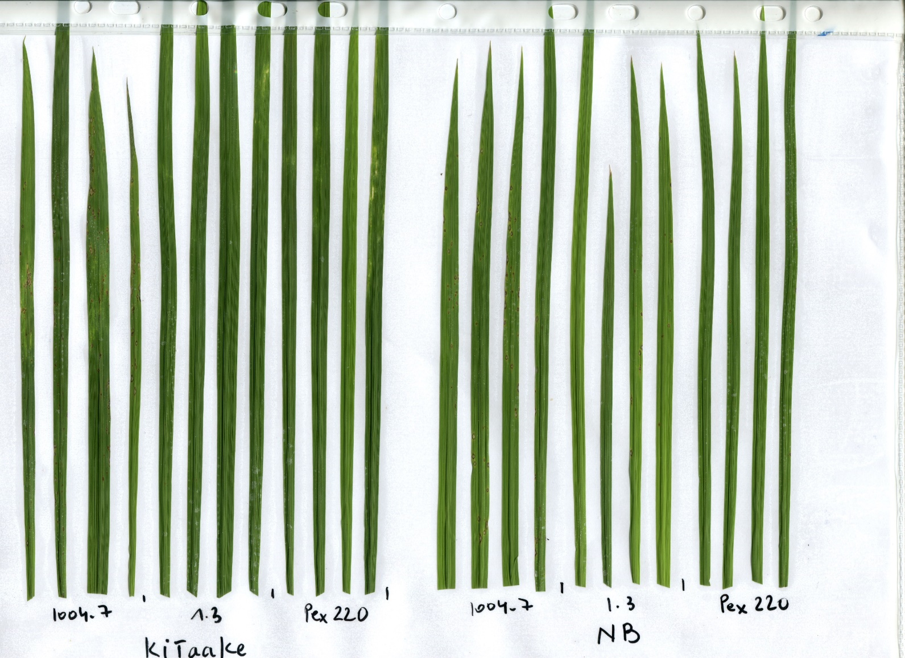
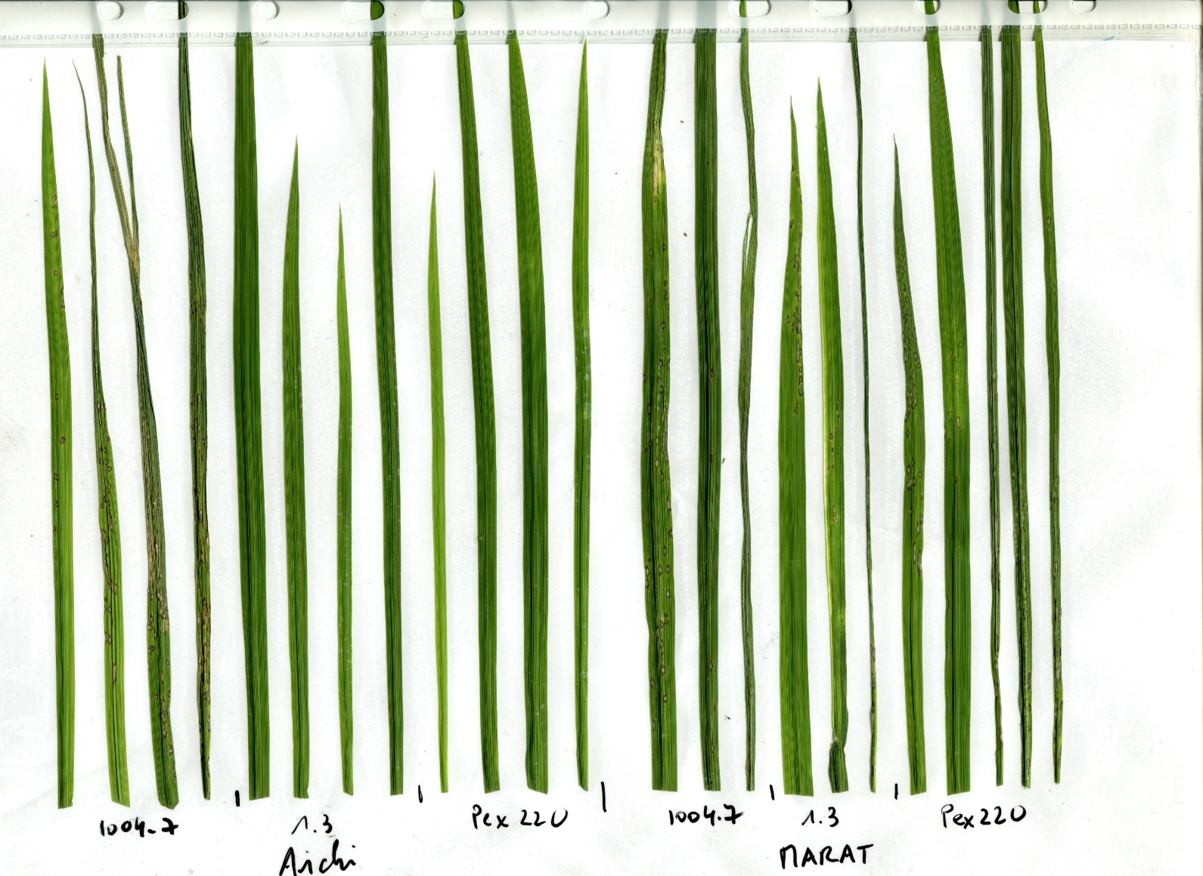
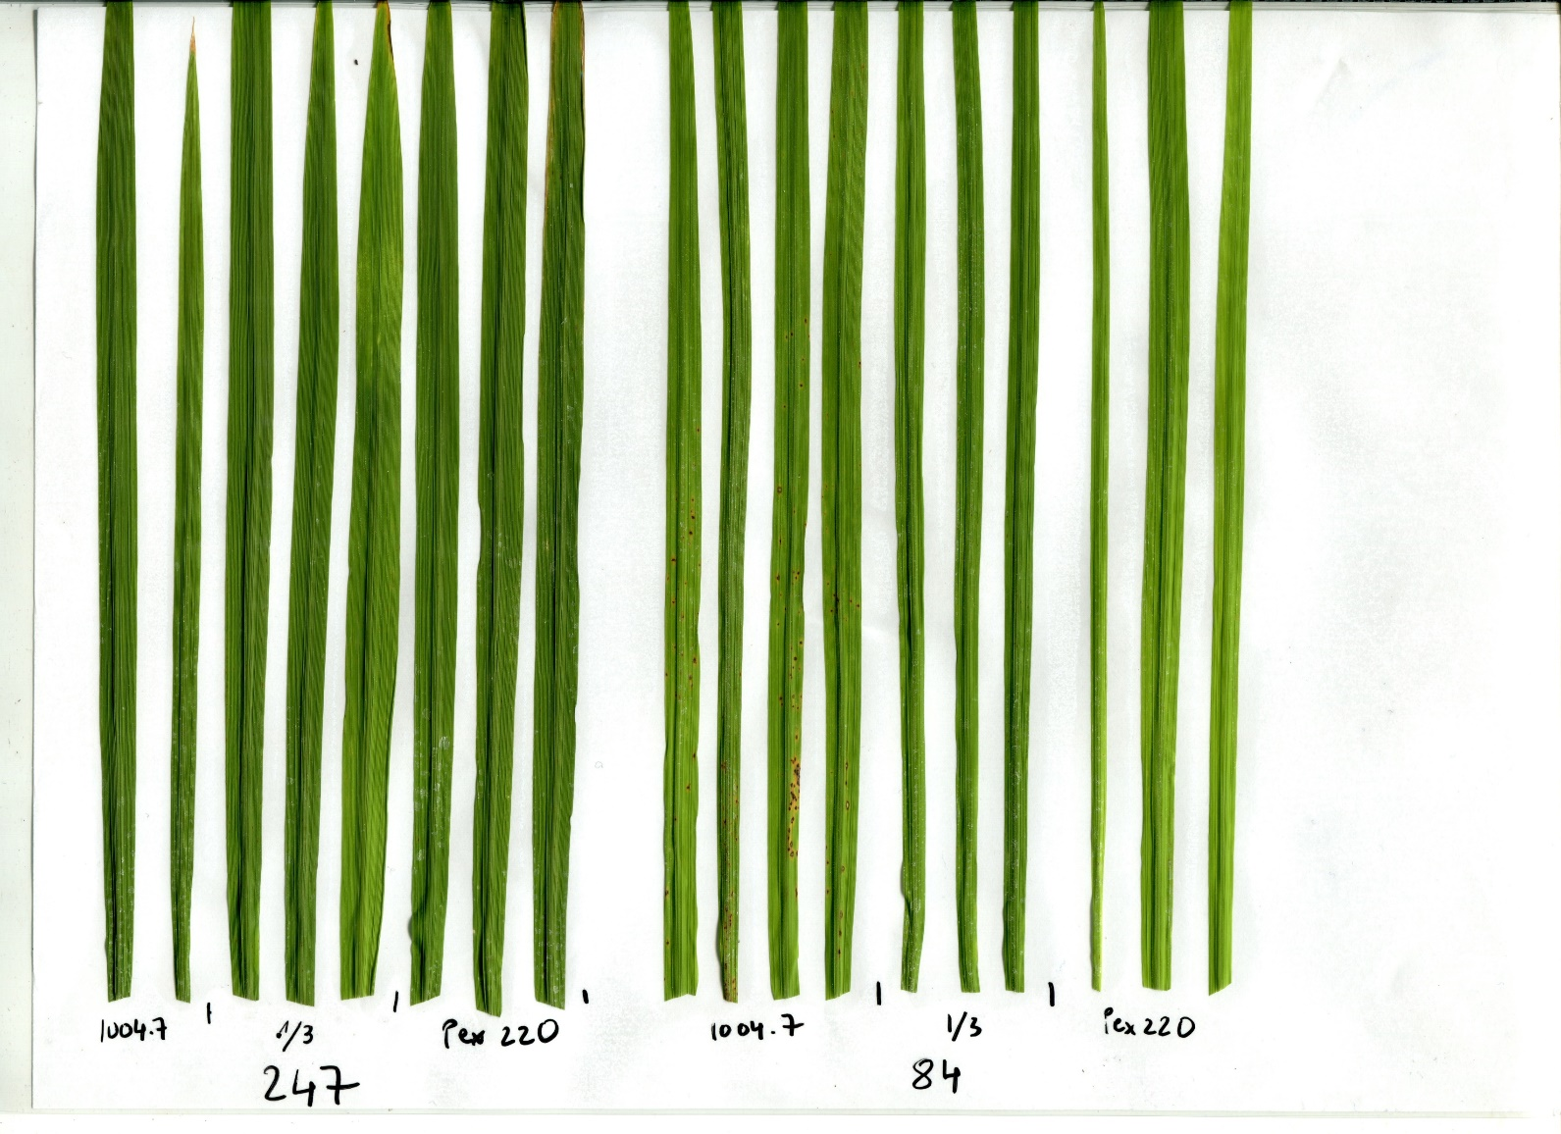
IRIS_313-12190
Guy11
EV
Guy11
AVR-Pia
Guy11
AVR1-CO39
Guy11
EV
Guy11
AVR-Pia
Guy11
AVR1-CO39
Nipponbare
Aichi Asahi (Sasanishki RGA5)
IRIS_313-11786
IRIS_313-11360*
IRIS_313-10314
Supplementary Figure 7. C923-49 resistance associated accessions replicate infection test. Infection testing of C923-49 resistance associated accessions with transgenic M. Oryzae isolates expressing AVR-CO39, AVR1-Pia or carrying an empty vector (EV). Colored lines either side of accession names indicate the HMA domain sequence aligned in Fig. 3 a and modelled in Fig. 3 b/c. IRIS_313-11360* contains a frameshift mutation after the HMA domain of Rga5.

Supplementary Table 7. Summary of Guy11 isolate infection testing on Pia variant containing rice accessions. Accessions are color coded to match the HMA domain sequence aligned in Fig. 3 a and modelled in Fig. 3 b/c. IRIS_313-11360* contains a frameshift mutation after the HMA domain of Rga5. Resistance/susceptibility responses in white are indicative of functional RGA4 and RGA5, responses in grey are indicative of non-functional RGA4 and RGA5, and responses in black are indicative of accessions carrying resistance to the Guy11 strain which prevents assessment of RGA4 and RGA5 function.
Accession | Guy11_EV | Guy11_AVR1-CO39 | Guy11_AVR-Pia | Functional RGA4 and RGA5
Aichi Asahi | S | R | R | yes
CO39 | S | R | R | yes
Kitaake | S | R | R | yes
IRIS_313-11786 | S | R | R | yes
IRIS_313-12190 | S | R | R | yes
Maratelli | S | S | S | no
Nipponbare | S | S | S | no
IRIS_313-11360* | S | S | S | no
IRIS_313-10314 | R | R | R | ~
IRIS_313-10059 | R | R | R | ~

