Supplementary Data

Analysis of genetic variation in circadian rhythm genes and risk of ovarian cancer.
Sonali Verma^{1,3}, Gresh Chander^{1,3}, Amrita Bhat³, Gh.Rasool Bhat³, Divya Bakshi³, Bhanu Sharma³, Himanshu Rana⁴, Jyotsna Suri⁵, Ajay Wakhloo⁶, Supinder Singh⁷, Audesh Bhat⁸, Raies Ahmad Qadri², Ruchi Shah², and Rakesh Kumar^{1,3*}
- Indian Council of Medical Research-Centre for Advance Research, Shri Mata Vaishno Devi University -Katra J&K, India, Email: Sonali.verma@smvdu.ac.in, gresh.chander@smvdu.ac.in & kumar.rakesh@smvdu.ac.in
- Department of Biotechnology, Kashmir University, J&K, India, Email: scientistdobt@gmail.com, raies@kashmiruniversity.ac.in
- School of Biotechnology, Shri Mata Vaishno Devi University, Katra, India, Email: amritabhatt88@gmail.com, seithbhat11@gmail.com
- Department of Pathology, Government Medical College, Doda. Email: talk2himanshu4@gmail.com
- Department of Pathology, Government Medical College Jammu, J&K, India. Email: jyotsnavivek9@gmail.com.
- Department of Obstetrics and Gynecology, Government Medical College Jammu, J&K, India. Email: drajaywakhloo@gmail.com.
- Department of Medicine, ASCOMS, Sidhra, Jammu, Email: supindersingh109@gmail.com
- Centre for Molecular Biology, Central University of Jammu, J&K, India Email: audeshs2002@gmail.com
Corresponding authors
- Dr. Ruchi Shah
Scientist B, Department of Biotechnology,
Kashmir University, J&K, India
Email: scientistdobt@gmail.com
- Dr. Rakesh Kumar, Ph.D.
Principal Investigator, ICMR-CAR, School of Biotechnology,
Shri Mata Vaishno Devi University, Katra, Jammu and Kashmir, India
Email: kumar.rakesh@smvdu.ac.in

Table S1: Details of SNP
SNP | GENE NAME | FUNCTION OF SNP | DNA CHANGE | CHROMOSOME NO | M.A.F value
rs3792152 | REVI | INTRON VARIANT | A>G | 2:99415089 | A=0.4119
rs4757151 | ARNTL /BMALI | INTRON VARIANT | A>G | 11:13370666 | G=0.4024
rs7302060 | TIMELESS | INTRON VARIANT | T>A / T>C | 12:56435308 | C=0.3872
rs228644 | PER3 | INTRON VARIANT | G>A | 1:7806023 | A=0.3075
rs1026071 | ARNTL /BMALI | INTRON VARIANT | A>G | 11:13343165 | G=0.308
Table S2: Variant Function Prediction.
Gene | SNP | Position | Enhancer histone marks | Motifs changed | Linked Genes  eQTL
REV1 | rs3792152 | Intronic | ADRL | 6 Motifs changed | C2orf15, LIPT1, LYG1, MITD1, REV1, TSGA10, TXNDC9
ARNTL/ BMAL1 | rs4757151 | Intronic | ESDR | 9 motifs changed | RN7SKP151 & BTBD10

Table S3: Details of Primers used in the study.

S.No | Gene | SNP ID | FORWARD PRIMER | REVERSE PRIMER | UEP PRIMER
1 | ARNTL | rs1026071 | ACGTTGGATGACAGGCTAAATGTTGTGCCC | ACGTTGGATGTGTATGAGTGCCTAGGGTTC | TGCCTAGGGTTCAAATCT
2 | REV1 | rs3792152 | ACGTTGGATGGGAATGAAATGGCCTGAACC | ACGTTGGATGCCACTCAATAGGAGTTGGAG | gaggTGGAGGTACACCACA
3 | PER3 | rs228644 | ACGTTGGATGGTAGGTATTAATCTTGCTC | ACGTTGGATGTTACATTCTCAAGGCCCAGC | cctccAGGCCCAGCACACTGTCTTACA
4 | ARNTL | rs4757151 | ACGTTGGATGGTTTGTCCCTTTCCATGCTG | ACGTTGGATGATGAGACCTGGTGAGAGTTG | ggcgACTTTCACTCAGCTCC
5 | TIMELESS | rs7302060 | ACGTTGGATGCAGAACAGGTGAGGAAATGG | ACGTTGGATGCTTTGGGAGATAGTGATAGG | cccctATAGGGAATGTACCAGTTTCT

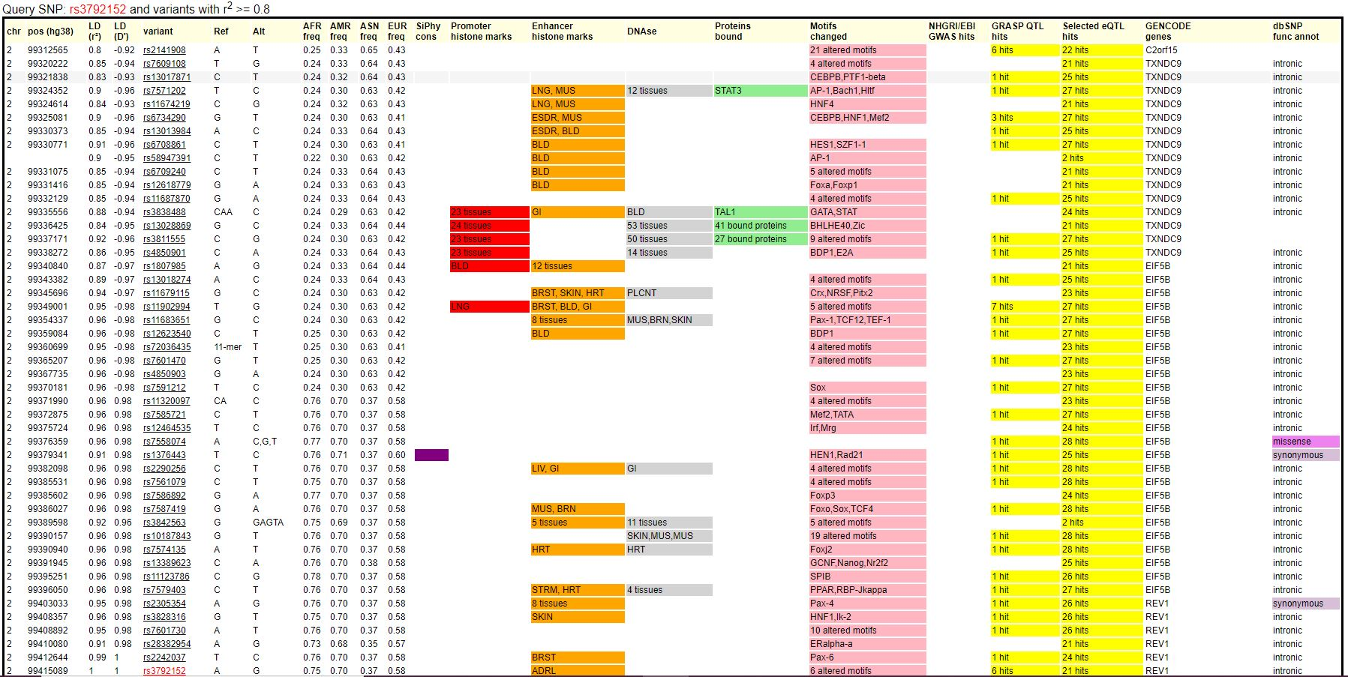

Supplementary Figure S1. Results from the Haploreg showing regulatory binding motifs changed for the rs3792152 REV1.

Supplementary Figure S2. Results from the Haploreg showing regulatory binding motifs changed for the rs4757151 BMAL1.

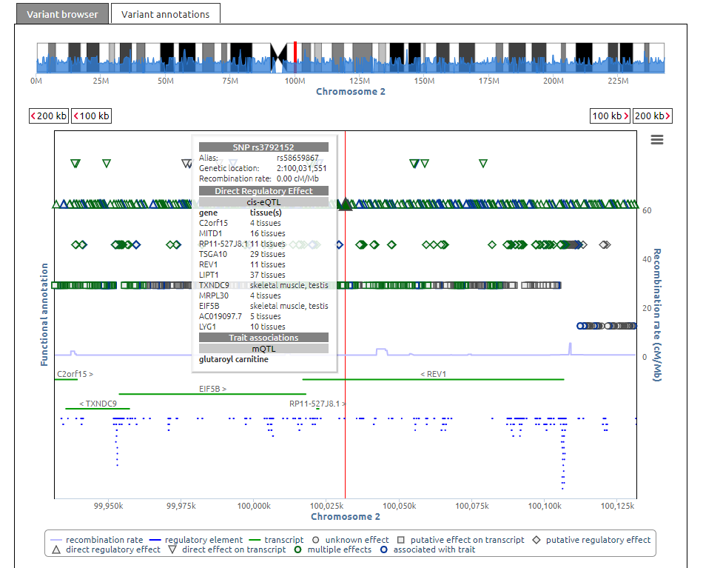
Supplementary Figure S3. Results from SNIPA for variant rs3792152 showing direct regulatory effect on C2orf15, LIPT1, LYG1, MITD1, REV1, TSGA10, TXNDC9 through eQTL (Expression quantitative trait loci) with REV1 gene.

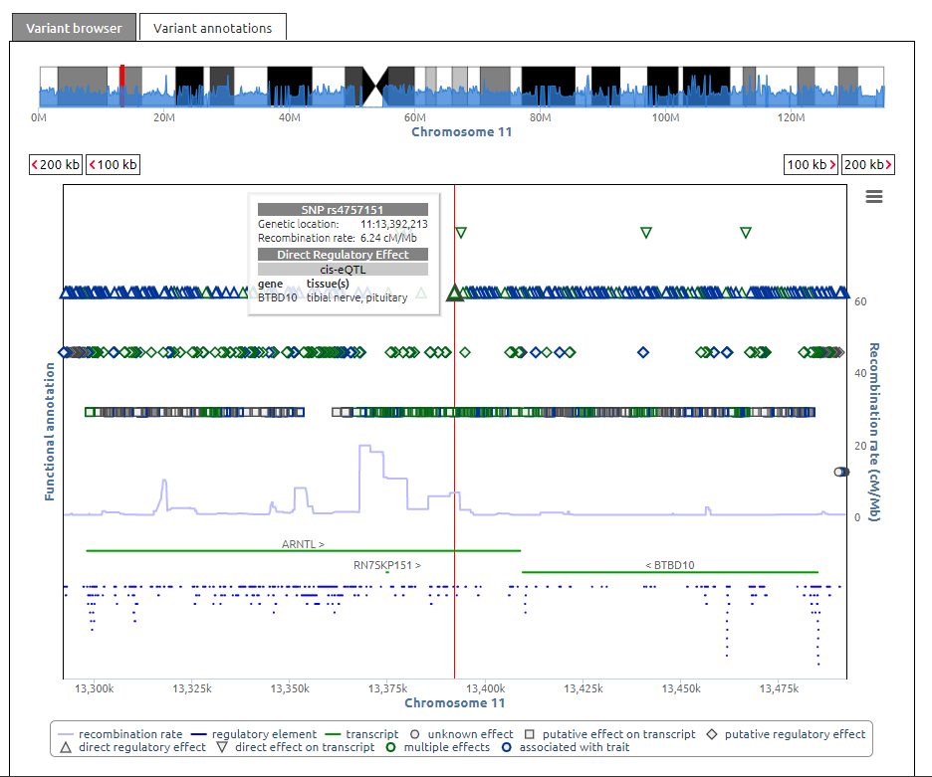
Supplementary Figure S4. Results from SNIPA for variant rs4757151 showing direct regulatory effect on transcripts (RN7SKP151 & BTBD10) through eQTL ARNTL gene.

