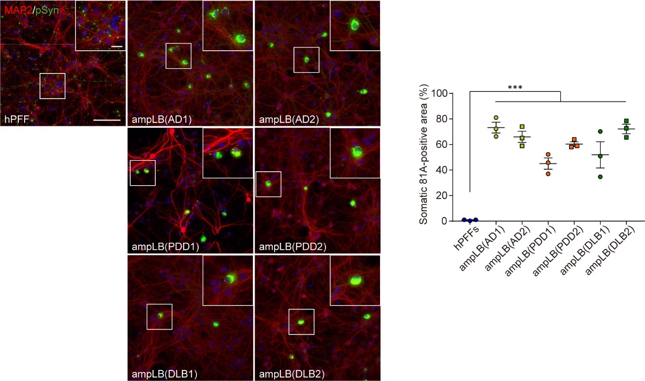
Figure S1 Validation of LB-αSyn amplification in mouse primary neurons. Left panels: Mouse primary hippocampal neurons treated with hPFF and ampLB preparations. Immunocytochemistry with anti-MAP2 and pSyn (81A) antibodies. Scale bars 100 µm, 20 µm (inset). Right panel: Percent of total pSyn-positive pathology in somatic inclusions (n = 3 per group). One-way ANOVA with a Tukey’s post-hoc test was performed; ***p < 0.001. Data are represented as mean ± SEM.

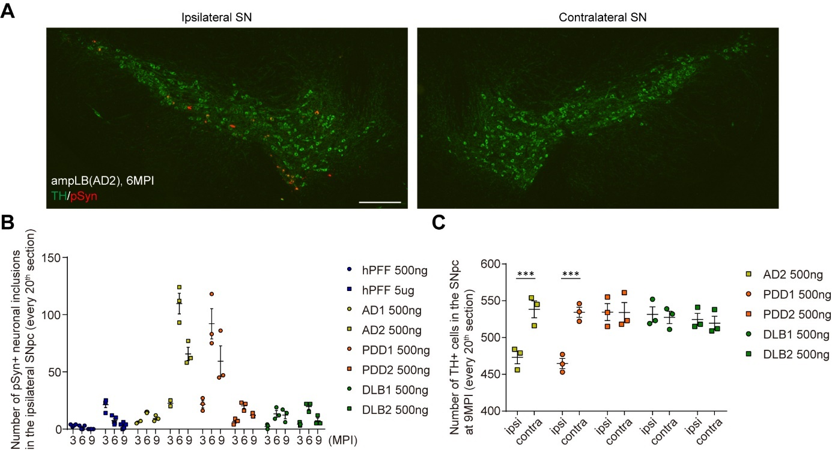
Figure S2 αSyn pathology in the SNpc of ampLB-injected WT mice. (A) Double immunofluorescence for tyrosine hydroxylase (TH, green) and pSyn (EP1536Y, red) in the SN of ampLB-injected mice at 6MPI. Scale bar 200 µm. (B) Number of pSyn-positive neuronal inclusions in the SNpc (n = 2–5 per group). (C) Number of TH-positive cells in the ipsilateral (ipsi) and contralateral (contra) SNpc at 9MPI (n = 3 per group). A two-tailed unpaired Student’s t-test was performed between the ipsilateral and contralateral sides for each group; ***p < 0.001. Data are represented as mean ± SEM.

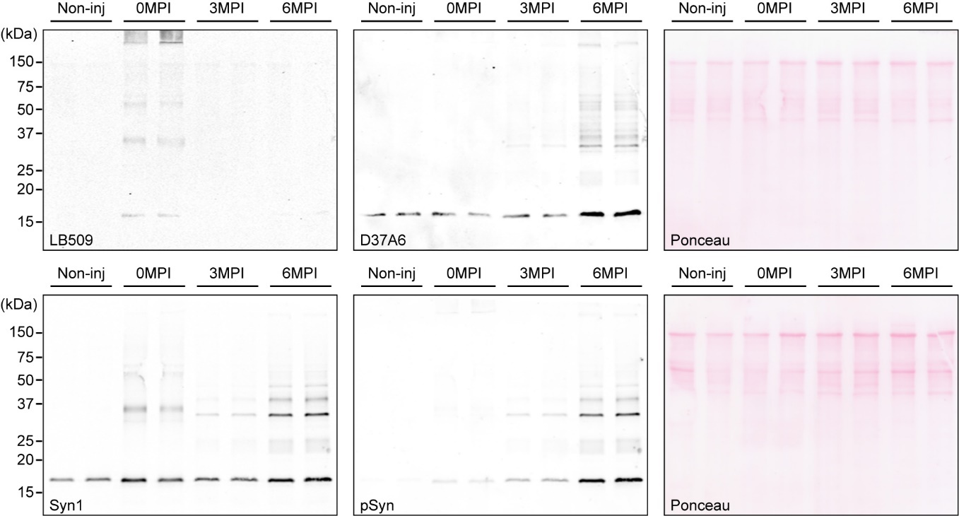
Figure S3 Biochemical analysis of ampLB-injected WT mouse brains. Western blot analysis of sarkosyl-insoluble brain lysates of non-injected mice (Non-inj), ampLB (DLB2)-injected mice at 0MPI (just after injection), 3MPI, and 6MPI. Immunoblots with anti-αSyn antibodies LB509 (human αSyn), D37A6 (mouse αSyn), and Syn1 (human + mouse αSyn), and an anti-pSyn antibody EP1536Y.

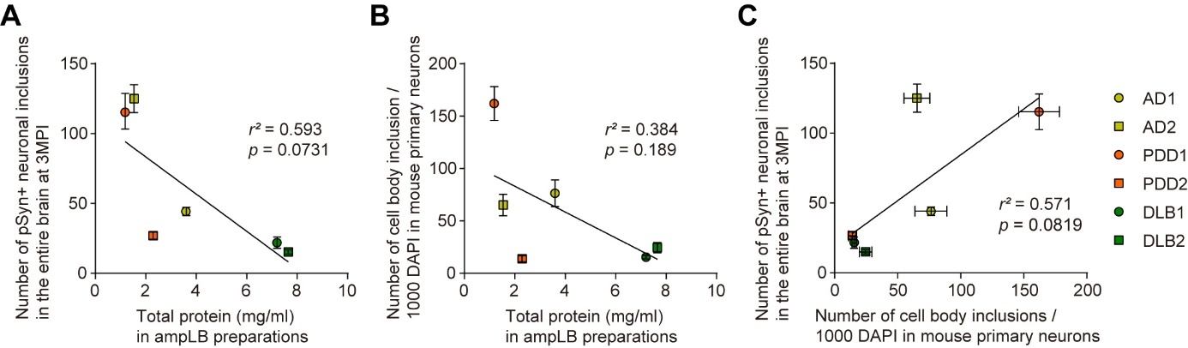
Figure S4 Correlation among in vivo and in vitro seeding activity and total protein of ampLB preparations. (A) Correlation between number of pSyn-positive neuronal inclusions in the entire brains of ampLB-injected mice at 3MPI and total protein in ampLB preparations; r² = 0.593, p = 0.0731. (B) Correlation between number of pSyn-positive cell body inclusions per 1,000 DAPI-positive nuclei in mouse primary hippocampal neurons treated with ampLB and total protein in ampLB preparations; r² = 0.384, p = 0.189. (C) Correlation between number of pSyn-positive neuronal inclusions in the entire brains of ampLB-injected mice at 3MPI and number of pSyn-positive cell body inclusions per 1,000 DAPI-positive nuclei in mouse primary hippocampal neurons treated with ampLB; r² = 0.572, p = 0.0819. Data are represented as mean ± SEM.

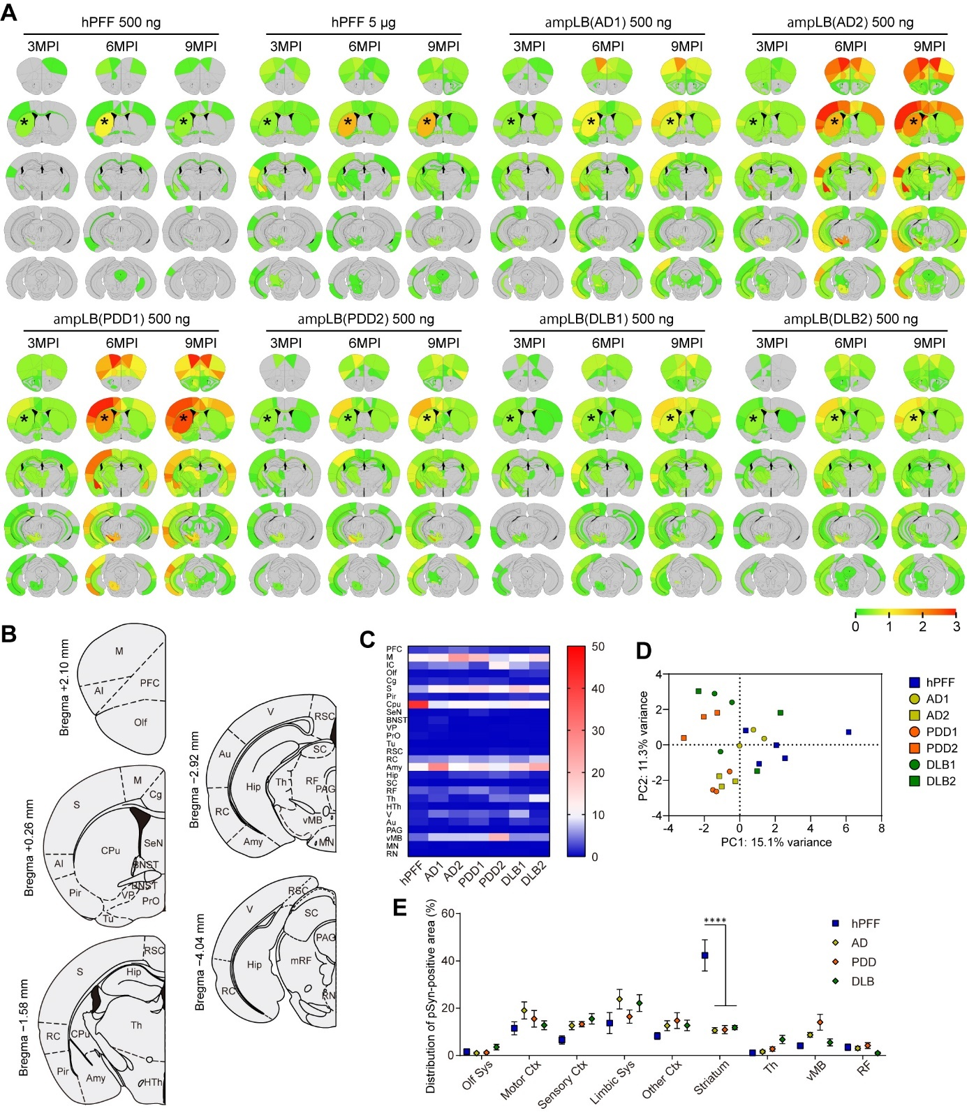
Figure S5 Differences in distribution of αSyn pathology between hPFF and ampLB in WT mice. (A) Heat map colors represent extent of pSyn-positive pathology. (B) Classification of brain regions for quantitative analyses of pSyn-positive area. (C) Heat map colors represent proportion of pSyn-positive area in each brain region shown in Figure S5B at 6MPI. (D) Primary component analysis of the distribution of pSyn-positive pathology at 6MPI. (E) Distribution of pSyn-positive pathology in the brain systems (n = 5–6 per group). Olf Sys, olfactory system; Motor Ctx, motor cortex; Sensory Ctx, sensory cortex; Limbic Sys, limbic system; Th, thalamus; vMB, ventral midbrain; RF, reticular formation. Two-way ANOVA with a Sidak’s post-hoc test was performed; interaction (p < 0.0001) and ****p < 0.0001. Data are represented as mean ± SEM.

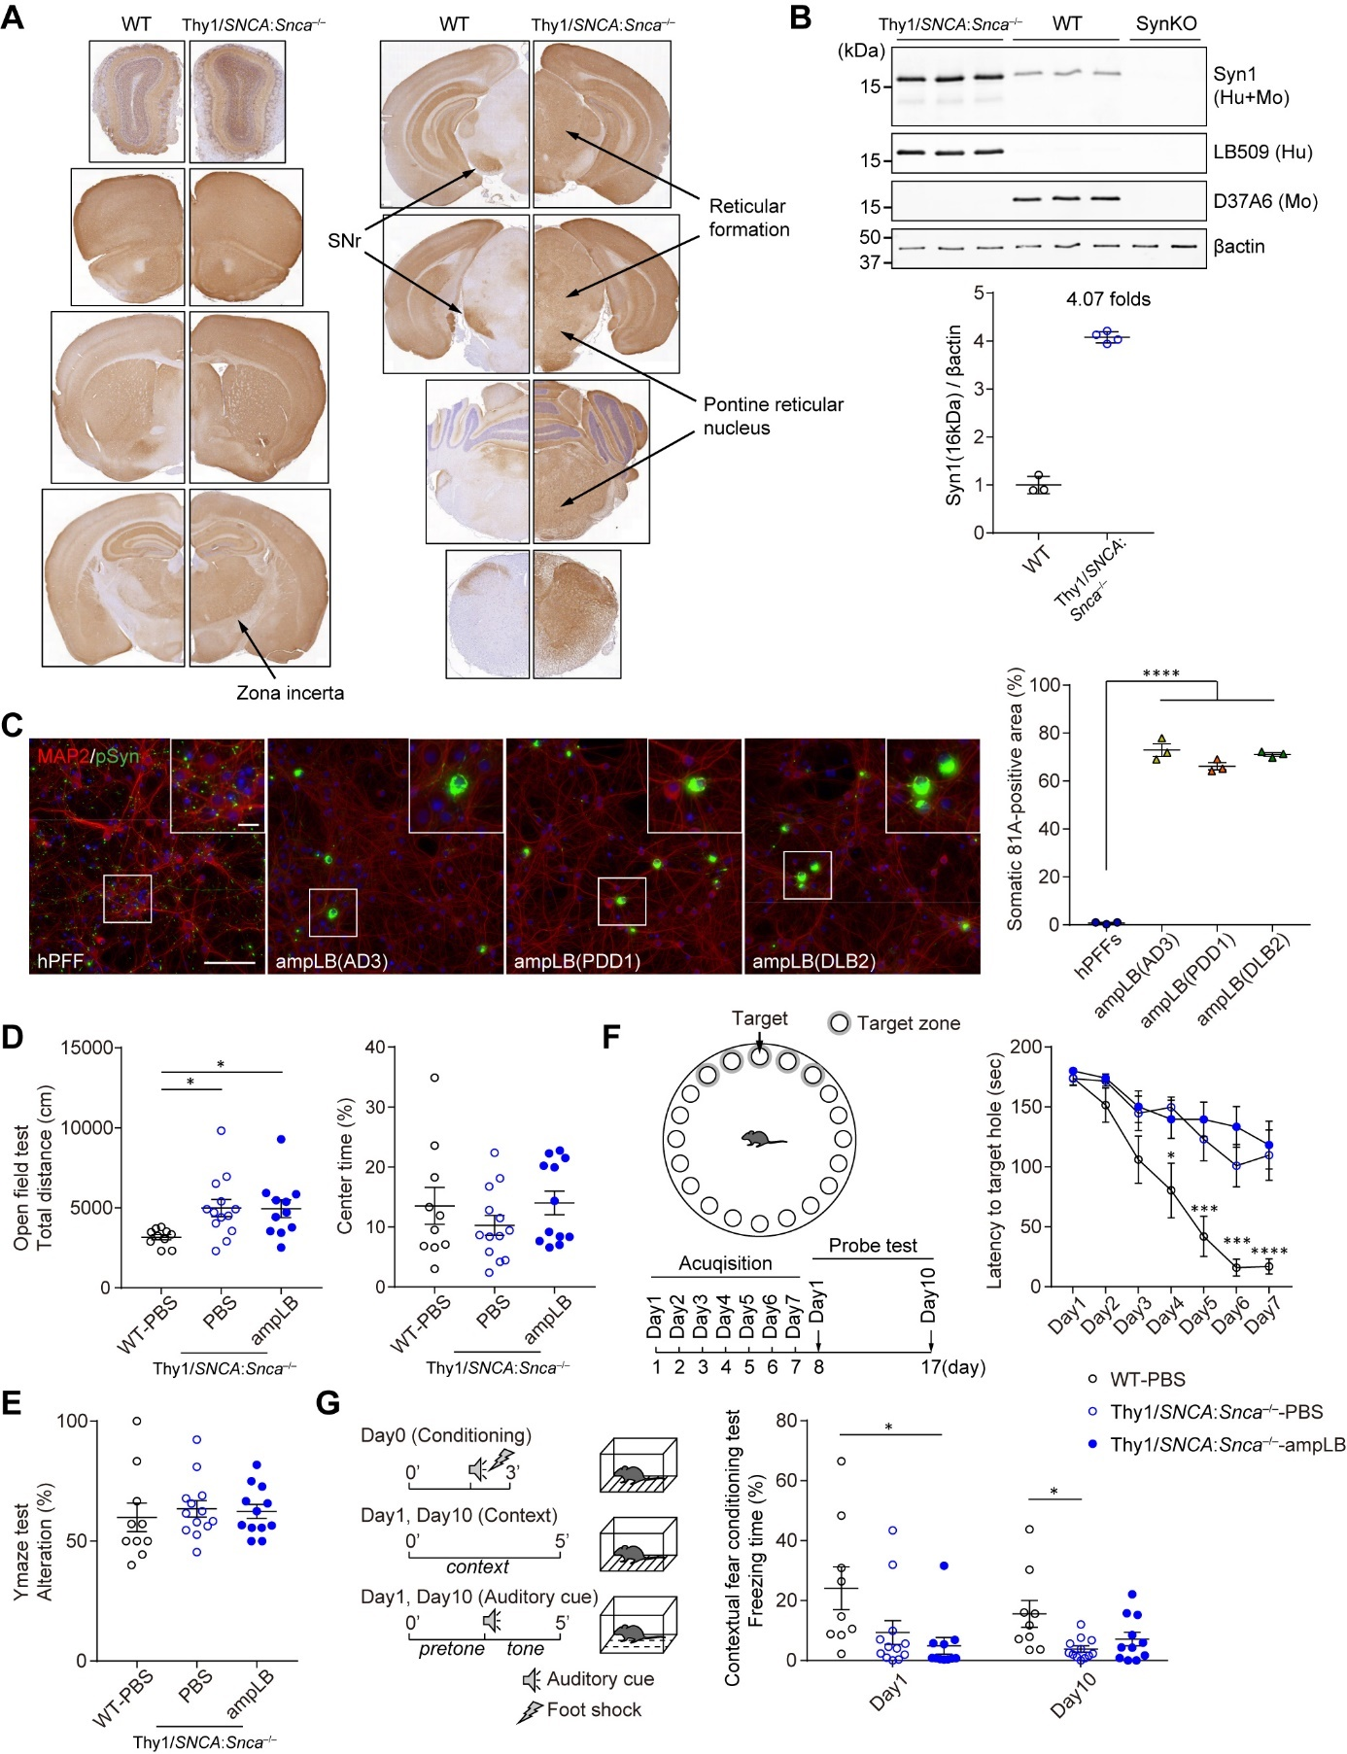
Figure S6 Modeling LBDs in Thy1:SNCA/Snca–/– mice. (A) Immunohistochemistry with an anti-αSyn antibody (Syn1). SNr, substantia nigra reticulata. (B) Upper panel: Western blot analysis of Triton X-soluble brain lysates of Thy1:SNCA/Snca–/– mice, WT mice, and SynKO mice with anti-αSyn (Syn1 [human and mouse αSyn], LB509 [human αSyn], and D37A6 [mouse αSyn]) and βactin antibodies. Lower panel: quantification of Syn1 (16kDa) bands normalized by βactin bands (n = 3–4 per group). (C) Left panels: Mouse primary hippocampal neurons treated with hPFF and ampLB preparations which were used for injections into Thy1:SNCA/Snca–/– mice. The amounts of αSyn transduced were 25 ng/well (hPFF) and 50 ng/well (ampLB). Immunocytochemistry with anti-MAP2 and pSyn (81A) antibodies. Scale bars 100 µm, 20 µm (inset). Right panel: Percent of total pSyn-positive pathology in somatic inclusions (n = 3 per group). (D) Open field test at 7MPI (n = 10–13 per group). Left panel: Total distance traveled. Right panel: Time spent in center area. One-way ANOVA with a Tukey’s post-hoc test was performed; *p < 0.05. (E) Y maze test at 7MPI (n = 10–13 per group). (F) Barnes maze test at 7MPI (n = 10–12 per group). Left panel: Schematic representation of experimental design. Right panel: Latency to target hole in acquisition trials. One-way ANOVA with a Tukey’s post-hoc test was performed for each day; *p < 0.05, ***p < 0.001, ****p < 0.0001. (G) Fear conditioning test at 8MPI (n = 9–12 per group). Left panel: Schematic representation of experimental design. Right panel: Freezing time in a contextual fear conditioning test. One-way ANOVA with a Tukey’s post-hoc test was performed for day1 and day10; *p < 0.05.

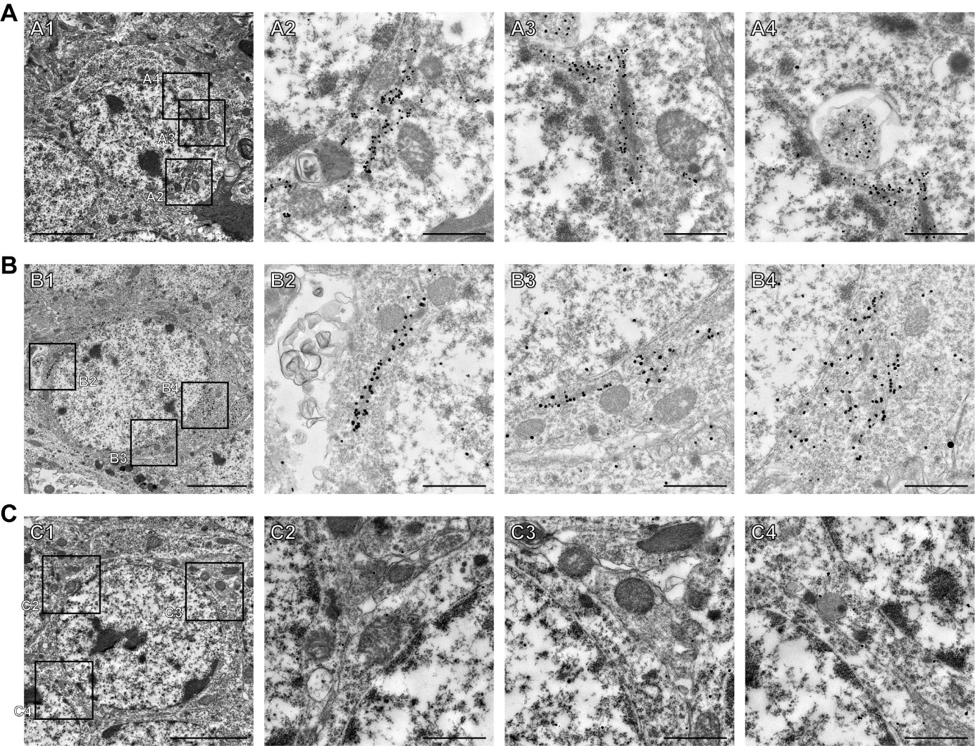
Figure S7 Immunoelectron microscopy images of neuronal inclusions in ampLB- and hPFF-injected Thy1:SNCA/Snca–/– mice. (A–C) Immunoelectron micrograph of neurons in the DG with immunogold-labeled pSyn (EP1536Y). (A) pSyn-positive neuron in ampLB-injected Thy1:SNCA/Snca–/– mice. (B) pSyn-positive neuron in hPFF-injected Thy1:SNCA/Snca–/– mice. (C) pSyn-negative neuron in ampLB-injected Thy1:SNCA/Snca–/– mice. Bundles of pSyn-positive filamentous structures in the cytosol (A2, A3, and B2–4) and pSyn-positive amorphous structures in an autophagosome-like vacuole (A4). Scale bars 5 µm (A1, B1, and C1) and 1 µm (A2–4, B2–4, C2–4).

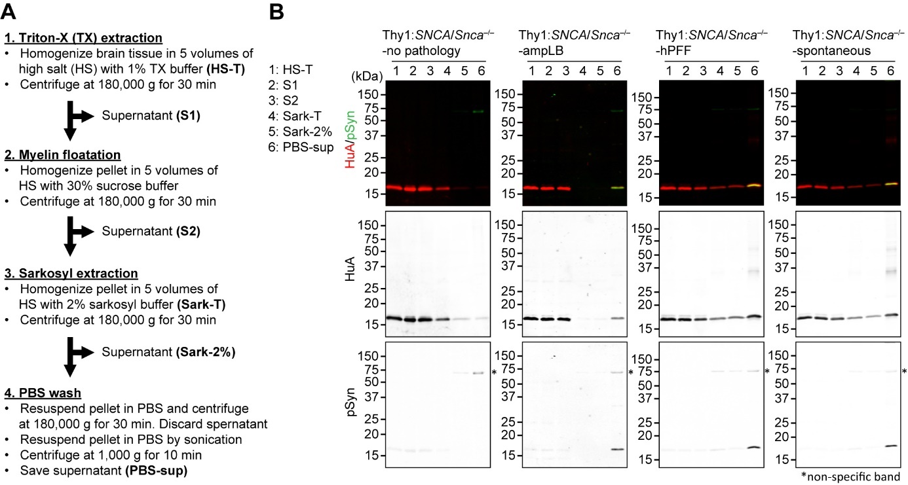
Figure S8 Biochemical extraction of pathological αSyn from Thy1:SNCA/Snca–/– mouse brains. (A) Brief description of the mouse brain extraction protocol. (B) Western blot analysis of brain lysates of Thy1:SNCA/Snca–/– mice without αSyn pathology (Thy1:SNCA/Snca–/–-no pathology), ampLB-injected Thy1:SNCA/Snca–/– mice (Thy1:SNCA/Snca–/–-ampLB), hPFF-injected Thy1:SNCA/Snca–/– mice (Thy1:SNCA/Snca–/–-hPFF), and Thy1:SNCA/Snca–/– mice with spontaneous αSyn pathology (Thy1:SNCA/Snca–/–-spontaneous). Samples containing 10 µg of total protein was loaded to each lane. Immunoblots with anti-human αSyn (HuA) and pSyn (81A) antibodies.

Table S1. Clinical information. Clinical information of the cases used for the extraction of pathological αSyn and immunohistochemistry.
For extraction of pathological αSyn
Case | Clinical Diagnosis | Pathological Diagnosis | Race | Sex | Age of Disease Onset | Age at Death | PMI (h)
AD1 | DLB | AD, LBD | White | M | 68 | 74 | 19
AD2 | AD | AD, LBD | White | M | 64 | 72 | 8
AD3 | AD | AD, LBD | White | F | 59 | 70 | 18
PDD1 | PDD | LBD, AD | White | F | 60 | 72 | 19
PDD2 | PDD | LBD, AD | White | F | 72 | 79 | 6
PDD3 | PDD | LBD, AD | White | M | 42 | 59 | 10
DLB1 | DLB | LBD, AD | White | M | 78 | 83 | 9
DLB2 | DLB | LBD, AD | White | M | 53 | 63 | 9
Control | Normal | Unremarkable Adult Brain | Black or African American | M | - | 62 | 16

For immunohistochemistry shown in Fig. 6
Case | Clinical Diagnosis | Pathological Diagnosis | Race | Sex | Age of Disease Onset | Age at Death | PMI (h)
LBD | PDD | LBD, LATE | White | F | 59 | 76 | 18.5
LATE: limbic-predominant age-related TDP-43 encephalopathy

Table S2. Biochemical information for sarkosyl-insoluble fractions of LBD brain extractions.
Case | Brain region used | Total protein (µg/µl) | αSyn (ng/µl) | Used for
AD1 | Middle Frontal Gyrus | 14.6 | 43 | AmpLB injection into WT mice
AD2 | Middle Frontal Gyrus | 8.5 | 58 | AmpLB injection into WT mice
AD3 | Middle Frontal Gyrus | 13.5 | 144 | AmpLB injection into Thy1:SNCA/Snca–/– mice
PDD1 | Middle Frontal Gyrus | 9.3 | 95 | AmpLB injection into WT and Thy1:SNCA/Snca–/– mice
PDD2 | Middle Frontal Gyrus | 7.6 | 36 | AmpLB injection into WT mice
PDD3 | Middle Frontal Gyrus | 17.5 | 68 | Brain lysate injection into WT mice
DLB1 | Middle Frontal Gyrus | 7.2 | 12 | AmpLB injection into WT mice
DLB2 | Middle Frontal Gyrus | 14.9 | 20 | AmpLB injection into WT mice
DLB2 | Middle Frontal Gyrus | 8.8 | 140 | AmpLB injection into Thy1:SNCA/Snca–/– mice
Control | Middle Frontal Gyrus | 4.8 | N.D. | Brain lysate injection into WT mice
N.D., not determined.

Table S3. Biochemical information for sarkosyl-insoluble fractions of Thy1/SynKO mouse brain extractions.
Mice | Total protein (µg/µl) | αSyn (ng/µl)
Thy1:SNCA/Snca–/–-ampLB(PDD1)-1 | 5.11 | 15.0
Thy1:SNCA/Snca–/–-ampLB(PDD1)-2 | 3.26 | 6.32
Thy1:SNCA/Snca–/–-ampLB(DLB2)-1 | 3.75 | 10.2
Thy1:SNCA/Snca–/–-ampLB(DLB2)-2 | 5.55 | 15.85
Thy1:SNCA/Snca–/–-hPFF-1 | 4.21 | 40.0
Thy1:SNCA/Snca–/–-hPFF-2 | 2.49 | 65.0
Thy1:SNCA/Snca–/–-spontaneous-1 | 1.68 | 26.8
Thy1:SNCA/Snca–/–-spontaneous-2 | 4.25 | 53.5
Thy1:SNCA/Snca–/–-no pathology | 4.18 | 1.57

Movie S1. Motor dysfunction in hPFF-injected Thy1:SNCA/Snca–/– mice

