Table 1. Statistical details of the meta-analysis of the significant “general” effects of each treatment on C, N, P, and K concentrations, contents, release rates, ratios, ratio between the rates of change, rates of litter decomposition, and remaining litter mass. When the treatment effect and the treatment intensity effect have the same sign, it indicates a direct relationship between the general effect of the treatment and the intensity of the treatment; indirect relationships are depicted when they have opposite signs.
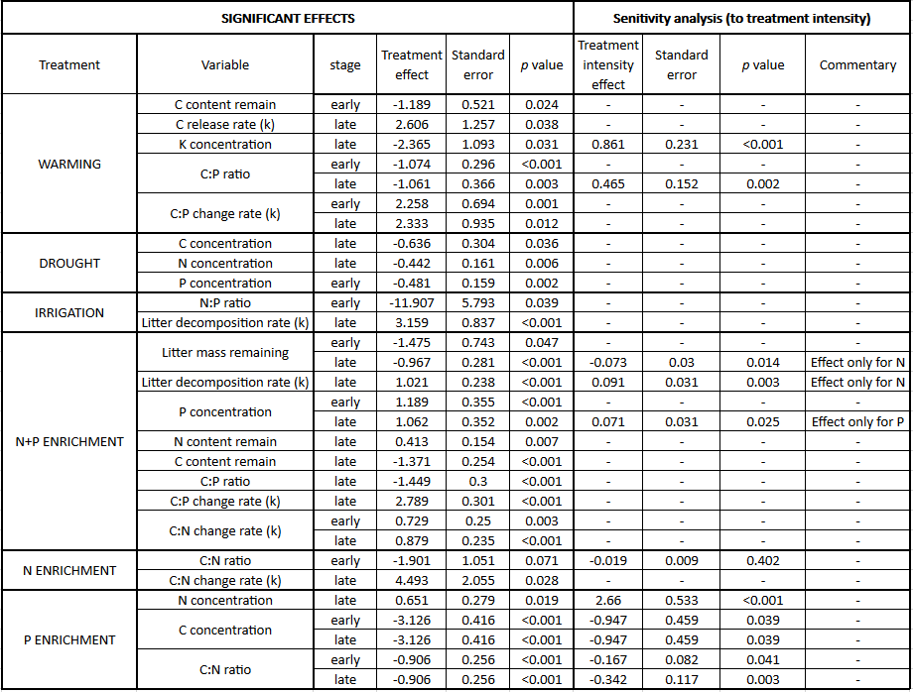

Table 2. Statistical details of the meta-analysis of the significant effects considering the climate of the sampling area (according to Köppen-Geiger classification; in the brackets) as a moderator. The number of experiments under each climate is expressed relative to the total of experiments from which the general effect was calculated. These analyses were only carried out in early stage of decomposition for litter decomposition rate; C, N and P contents; K concentration; and C:N, C:P and N:P ratios.
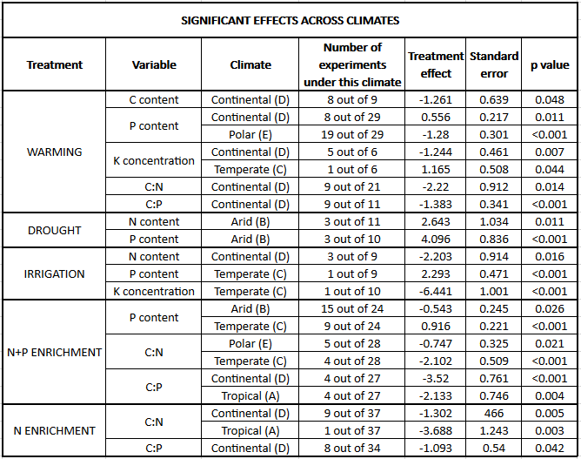

Table 3. Statistical details of the meta-analysis of the significant effects considering the specie type of the sampling area as a moderator. The number of experiments using each specie type is expressed relative to the total number of experiments from which the general effect was calculated. This analysis were only carried out in early stage of decomposition for litter decomposition rate; C, N and P contents; K concentration; and C:N, C:P and N:P ratios.
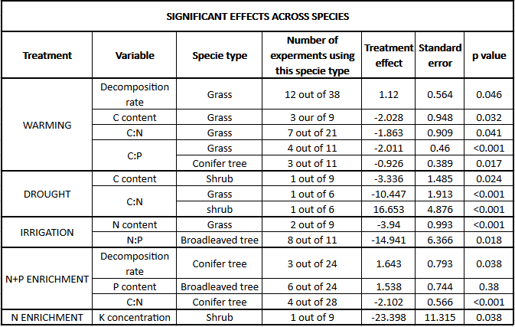

Table 4. Statistical details of the meta-analysis of the significant effects considering the ecosystem type of the sampling area as a moderator. The number of experiments under each climate is expressed relative to the total number of experiments from which the general effect was calculated. These analyses were only carried out in early stage of decomposition for litter decomposition rate; C, N and P contents; K concentration; and C:N, C:P and N:P ratios.
