SUPPLEMENTARY INFORMATION

A case for improved assessment of gut permeability – a meta-analysis quantifying the lactulose:mannitol ratio in coeliac and Crohn’s disease

Jonathan Gan¹, Scarlet Nazarian¹, Julian Teare¹, Ara Darzi¹, Hutan Ashrafian¹*†, Alex J. Thompson^{1,2†}

¹Department of Surgery & Cancer, 10th Floor, Queen Elizabeth the Queen Mother Wing, St Mary’s Hospital, Imperial College London, South Wharf Road, London, W2 1NY, UK
²Hamlyn Centre for Robotic Surgery, Level 3 Paterson Building, St Mary’s Hospital, Imperial College London, South Wharf Road, London, W2 1NY, UK

*Corresponding author: Hutan Ashrafian, Institute of Global Health Innovation, Imperial College London, email: h.ashrafian@imperial.ac.uk

†These authors contributed equally to this work

This PDF file contains:
- Appendices 1-3 (Search Strategies)
- Supplementary Figures S1-S5
- Supplementary Tables S1-S4
- Tables B1-B7

Search Strategies
The following search strategies were used to identify studies using the lactulose mannitol test in measuring gut permeability in disease. Subsequently studies in Crohn’s and coeliac disease were manually identified from within these groups.

Appendix 1: Search Strategy for gut permeability and lactulose mannitol test in disease in Medline

Database: Ovid MEDLINE(R) and Epub Ahead of Print, In-Process & Other Non-Indexed Citations and Daily <1946 to December 16, 2019>
Search Strategy:
--------------------------------------------------------------------------------
1 Permeability/ (34317)
2 Permeability.mp. (158534)
3 (leaky or leakiness).mp. (7152)
4 or/1-3 (164265)
5 lactulose mannitol.mp. (467)
6 4 and 5 (429)
7 exp Animals/ (22810673)
8 Humans/ (18159647)
9 7 not 8 (4651026)
10 6 not 9 (381)
11 rat$1.ti. (951083)
12 10 not 11 (377)

Appendix 2: Search Strategy for gut permeability and lactulose mannitol test in disease in Embase

Database: Embase <1974 to 2019 December 16>
Search Strategy:
--------------------------------------------------------------------------------
1 Permeability/ (25617)
2 intestine mucosa permeability/ (6768)
3 Permeability.mp. (199965)
4 (leaky or leakiness).mp. (8451)
5 or/1-4 (206514)
6 lactulose mannitol.mp. (699)
7 5 and 6 (649)
8 exp animal/ (24871330)
9 exp human/ (20320781)
10 8 not 9 (4550549)
11 7 not 10 (569)
12 rat$1.ti. (1027775)
13 11 not 12 (569)

Appendix 3: Search Strategy for gut permeability and lactulose mannitol test in disease in Cochrane

ID Search Hits
#1 MeSH descriptor: [Permeability] this term only 373
#2 permeability 3098
#3 leaky or leakiness 102
#4 #1 or #2 or #3 3164
#5 "lactulose mannitol" 230
#6 #4 and #5 191
#7 MeSH descriptor: [Animals] explode all trees 15676
#8 MeSH descriptor: [Humans] this term only 8475
#9 #7 not #8 7201
#10 #6 not #9 190


Studies included in quantitative synthesis (meta-analysis)
(n = 19)
Studies included in qualitative synthesis
(n = 19)
Full-text articles excluded, with reasons
(n = 31)
Full-text articles assessed for eligibility
(n = 50)
Records excluded
(n = 613)
Records screened
(n = 663)
Records after duplicates removed
(n = 663)
Additional records identified through other sources
(n = 1)

Identification

Eligibility

Included

Screening
Records identified through database searching
(n = 1135)

Fig. S1. PRISMA 2009 Flow diagram for coeliac disease.

Studies included in quantitative synthesis (meta-analysis)
(n = 17)
Studies included in qualitative synthesis
(n = 17)
Full-text articles excluded, with reasons
(n = 80)
Full-text articles assessed for eligibility
(n = 97)
Records excluded
(n = 566)
Records screened
(n = 663)
Records after duplicates removed
(n = 663)
Additional records identified through other sources
(n = 1)

Identification

Eligibility

Included

Screening
Records identified through database searching
(n = 1135)
Fig. S2. PRISMA 2009 Flow diagram for Crohn’s disease.

Study | Study type | Method of diagnosis | Definition of active Crohn’s/relapse | Definition of inactive Crohn’s/remission | Number of people who had surgery | Management | Controls | Patient population compared | Recruitment setting of patients with Crohn’s disease | Time of urine collection | L:M solute ratio | NBM period pre-solute ingestion | Method of analysis
Marsilio et al 1998 | cross sectional | A | PCDAI>30 |  | unk | unk | healthy | Patients with moderate/severe Crohn’s iliocolitis, moderate/severe coeliac disease | Unk | 6 hours | 2:1 and 5:2 | unk | HPLC
Vilela et al 2008 | cross sectional | unk |  | CDAI<150 | 0% | A (32%) , B (32%) , A/B (6.5%), A/B and C (12.9%), D (3.2%) , D/E (3.2%), F (9.6%) | healthy | Terminal ileum/ileocolic Crohn’s disease in remission, coeliac patients after 1 year in GFD | Gastroenterology clinic in a university hospital | 6 hours | 2:1 | >6 hours | HPLC
Sturniolo et al 2001 | cohort | B+C+D+E |  | CDAI<150 for >3 months | 0% | A | n/a | Ileal/ileocolic/colonic Crohn's disease in remission | Gastroenterology clinic in a university hospital | 6 hours | 2:1 | >6 hours | enzymatic analysis
Dastych et al 2008 | cross sectional | unk | CDAI 220-280 |  | unk | unk | healthy | Active Crohn’s in terminal ileum and colon, patients with liver cirrhosis | Unk | 5 hours | 2:1 | >6 hours | enzymatic analysis
D'Inca et al 2006 | cross sectional | B+C+D+E |  | Patients not manifesting clinical symptoms and not on steroids | 14.80% | A/G (64%), no C | healthy | Inactive ileal/ileocolic/colonic Crohn's Disease, relatives of patients with Crohn's disease | Gastroenterology department in 2 hospitals | 6 hours | 2:1 | >6 hours | unk
Buhner et al 2006 | cross sectional | B+C+D+E |  | CDAI<150 | 0% | A (70%), C (39%), G (4%), F (16.4%) | healthy | Terminal ileal/ileocolic/colonic/UGI Crohn's disease in remission, first degree relatives and non-blood relatives | Gastroenterology department in a university hospital | 5 hours | 2:1 | >6 hours | HPLC
D'Inca et al 1999 | cohort | B+C+D+E | Combination of either CDAI>150, increase in CDAI value by 50 (or 75 if underwent resection) points and requiring steroids | CDAI<150 for more than 3 months | 42.30% | A (33.8%) | n/a | Patients with Crohn's disease in remission | Gastroenterology clinic in a university hospital | 6 hours | 2:1 | >6 hours | enzymatic analysis
Swanson et al 2011 | case control | unk |  | CDAI<150 | unk | A (66%), B (17%) | healthy | Patients with inactive Crohn's, inactive UC | Gastroenterology clinic in a university hospital | unk | 2:1 | >6 hours | gas chromatography
Wild et al 2003* | cohort | C+D+E | CDAI>200(active diseease)  CDAI >150 and 100 points increase above baseline and/or need for surgery (relapse) | CDAI<150 | 16.70% | A+C | n/a | Patients with active ileal/ileocolic Crohn’s before 10 weeks of tapering steroids treatment, same cohort of patients in remission post steroids treatment whose Crohn’s disease eventually relapse, same cohort of patients in remission post steroids treatment who did not experience relapse | Gastroenterology clinic in a university hospital | 7 hours | 2:1 | unk | HPLC
Garcia Vilela et al 2008 | RCT | unk |  | CDAI<150 | unk | A (35%), B (32.3%), A/B/C (12.9%), A/B (6.5%), D (3.2%), D/E (3.2%) | n/a | Terminal ileum/ileocolic Crohn’s disease in remission (LMR measured before intervention with Saccharomyces boulardii) | Gastroenterology clinic in a university hospital | 6 hours | 2:1 | >6 hours | HPLC
Sigalet et al 2013 | cohort | A+D | CDAI 180-220 | CDAI 60-120 | 0% | On A or C at admission. Then treated with B and/or C | healthy | Paediatric Crohn's patients with acute ileal disease before 8-12 weeks treatment with steroids and/or azathioprine, same cohort of paediatric Crohn's patients in remission after 8-12 weeks treatment with steroids and/or azathioprine | Admission from a Gastroenterology department clinic in a university hospital | 12 hours | 5:2 | <6 hours | HPLC
Zamora et al 1999 | case control | A | PCDAI>30 |  | unk | unk, no A | healthy | Paediatric Crohn's patients in remission, parents and first-degree relatives | Gastroenterology clinic in a university hospital | unk | 5:2 | <6 hours | HPLC
Andre et al 1988 | cross sectional | B+C+D+E | HBI>4 | HBI 0-2 | 29.8% | unk | healthy | Crohn's patients in remission, patients with relapsing Crohn's, patients with mild Crohn's disease | Unk | 5 hours | 1:1 | >6 hours | gas chromatography
Benjamin et al 2012 | RCT | B+C+D+E |  | CDAI<150 | 13.30% | A+B+C+H | n/a | Upper GI/Ileocolonic/ colonic Crohn's in remission (LMR measured before intervention with whey protein or glutamine) | Gastroenterology and Inflammatory Bowel Disease (IBD) clinic in a university hospital | 5 hours | 5:2 | >6 hours | enzymatic analysis
Hilsden et al 1996 | case control | unk |  | CDAI<150 | unk | unk | healthy | Crohn's disease in remission, first degree relatives | Gastroenterology clinic in a university hospital | 7 hours | 5:2 | <6 hours | HPLC
Hilsden et al 1999 | cohort | unk | CDAI>150 or increase by 100 points or if high dose steroids/surgery are needed | CDAI<150 for last 30 days | unk | A (24.6%), B (2%), Low dose C, (8.2%), I (61%) | n/a | Small or large bowel Crohn’s disease in remission | Gastroenterology/surgical clinic in a university hospital | unk | 5:2 | unk | HPLC
Breslin et al 2001 | case control | unk |  | CDAI<130 | unk | unk | healthy | Spouses of patients with inactive Crohn’s disease | Recruited from the community | unk | 5:2 | <6 hours | HPLC
 |  | A) CDAI/PCDAI criteria  B) Clinical (non-specific)  C) Radiological  D) Endoscopic  E) Histological / pathological  F) Modified HBI |  |  |  | A) Aminosalicylates  B) Azathioprine  C) Steroids  D) Thalidomide  E) Metronidazole  F) No meds  G) Sulphursalazine  H) Hematinics, multivitamins, calcium supplements  I)Surgery
Table S1. Summary of studies of gut permeability in Crohn’s disease. Methods of diagnosis were separated into six categories (A-F) as defined at the base of the column. Management was separated into eight categories (A-H) as defined in the key at the base of the column. Abbreviations: RCT – Randomised Control Trial, CDAI – Crohn’s Disease Activity Index, PCDAI—Paediatric Crohn’s Disease Activity Index, unk – unknown, n/a – not applicable, GFD – Gluten Free Diet, UC – Ulcerative Colitis, CABG – Coronary Artery Bypass Graft surgery, UGI – Upper Gastrointestinal, HBI – Harvey Bradshaw Index, HPLC – High Performance Liquid Chromatography, NBM – nil by mouth. * In Wild et al 2003, 8 patients were excluded as they did not respond to steroid treatment, and the remaining 22 patients who experienced remission after steroid treatment were followed up.

Study | Study type | Method of diagnosis | Number of people who had surgery | Management | Controls | Patient population compared | Recruitment setting of coeliac patients | Time of urine collection | L:M solute ratio | NBM period pre-solute ingestion | Method of analysis
Marsilio et al 1998 | cross sectional | A | unk | unk | healthy | Active Crohn’s iliocolitis, moderate/severe coeliac disease | unk | 6 hours | 2:1 and 5:2 | unk | enzymatic analysis
Novacek et al 1999 | cohort | A+B | unk | A | n/a | Newly diagnosed coeliac with normal ALT/AST, newly diagnosed coeliac with abnormal ALT/AST | unk | 5 hours | 2:1 | unk | HPLC
Vogelsang et al 2001 | cross sectional | B | 0% | B | Patients with non-specific gastroenterology symptoms | Partly treated coeliac disease, untreated coeliac disease and relatives of coeliac patients | Gastroenterology clinic in a university hospital | 5 hours | 2:1 | >6 hours | HPLC
Elia et al 1991 | cross sectional | unk | unk | C | healthy | Untreated coeliac disease, patients with acute infections admitted into hospital | Unk | 6 hours | 2:1 | >6 hours | enzymatic analysis
Kuitunen et al 1996 | cross sectional | B | 0% | B | healthy | Coeliac patients on gluten free diet, coeliac patients given gluten provocation | Gastroenterology department in a university children’s hospital | 5 hours | 2:1 | >6 hours | unk
Ukabam et al 1985 | cohort | B | unk | B | healthy | Coeliac disease before and after 5-8 months of GFD | Unk | 6 hours | 2:1 | >6 hours | unk
Vilela et al 2008 | cross sectional | unk | 0% | A | healthy | Coeliac patients after 1 year in GFD, Terminal ileum/ileocolic disease in remission | Gastroenterology clinic in a university hospital | 6 hours | 2:1 | >6 hours | HPLC
Vecsei et al 2009 | cohort | B | 0% | B | n/a | Newly diagnosed coeliac | Gastroenterology department in a university hospital | 5 hours | 2:1 | unk | HPLC
Johnston et al 2000 | cohort | B | unk | B | healthy | Untreated coeliac disease, treated coeliac disease | National screening programme | 5 hours | 5:2 | >6 hours | enzymatic analysis
Hamilton et al 1987 | cross sectional | B | unk | C | healthy | Newly diagnosed coeliac disease, subjects with cow milk intolerance, giardiasis | Gastroenterology paediatric clinic in a university hospital | 5 hours | 5:2 | unk | gas-liquid chromatography
Catassi et al 1997 | cross sectional | A+B | unk | C | Subjects serologically free of coeliac disease | Subjects with coeliac disease detected by screening | Secondary school screening programme | 5 hours | 5:2 | >6 hours | enzymatic analysis
Van Elburg et al 1993 | cross sectional | B | unk | C | healthy | Newly diagnosed coeliac, coeliac in partial remission and not adhering to GFD, relatives of patients with coeliac disease, patients with aspecific GI symptoms | Paediatric department in a university hospital | 5 hours | 5:2 | >6 hours | gas chromatography
Rajani et al 2016 | cohort | B+C | unk | A | healthy | Paediatric patients with new serological diagnosis of coeliac disease, paediatric patients with new endoscopic diagnosis of coeliac disease, before and after 1 year of GFD | Coeliac clinic in a children’s hospital | unk | 5:2 | unk | HPLC
Smecuol et al 1999 | cross sectional | B | unk | C | n/a | Newly diagnosed coeliac disease patients (mixture of subclinical, asymptomatic, and classical symptoms), first degree relatives of patients with established coeliac disease | Small bowel section of a gastroenterology hospital | unk | 5:2 | <6 hours | HPLC
Smecuol et al 2005 | cross sectional | B+C+D | unk | B | healthy | Patients with coeliac disease on normal diet, dermatitis herpeformis, IgA dermatosis | Small bowel section of a gastroenterology hospital | 5 hours | 5:2 | <6 hours | HPLC
Gatti et al 2013 | RCT | B | unk | A | n/a | Coeliac after GFD diet for 2 years with oats, or with placebo (LMR measured before intervention) | Multicentred paediatric gastroenterology services in Italy | 5 hours | 5:2 | >6 hours | HPLC
Smecuol et al 1997 | cohort | B+D | unk | D | n/a | Coeliac at baseline and post treatment with 2 months of GFD | Small bowel section of a gastroenterology hospital (both inpatient and outpatient) | unk | 5:2 | <6 hours | HPLC
Smecuol et al 2013 | RCT | C | unk | D | n/a | Active coeliac (mixture of subclinical and symptomatic coeliac disease) given probiotic or treated with placebo (LMR measured before intervention) | Small bowel section of a gastroenterology hospital | 5 hours | 5:2 | >6 hours | HPLC
Juby et al 1989 | case control | B+D | unk | C | healthy | Newly diagnosed coeliac disease before given GFD | General gastroenterology clinic in a university hospital | 5 hours | 5:2 | >6 hours | HPLC
 |  | - European Society of Paediatric Gastroenterology criteria  - Small bowel biopsies  - Serological diagnosis  - Clinical features |  | - >6 months GFD  - Unknown/varying duration of GFD  - Untreated coeliac disease  - <6 months GFD
Table S2. Summary of studies of gut permeability in coeliac disease. Methods of diagnosis were separated into five categories (A-E) as defined at the base of the column. Management was separated into four categories (A-D) as defined in the key at the base of the column. Abbreviations: RCT – Randomised Control Trial, CDAI – Crohn’s Disease Activity Index, unk – unknown, n/a – not applicable, GFD – Gluten Free Diet, HPLC – High Performance Liquid Chromatography, NBM – nil by mouth.

Data | Variation
Study design | Cross sectional, cohort, case control, randomised control trials
Sample size | Is the sample size appropriate, and has a power calculation been performed?
Participant selection | Is the inclusion and exclusion criteria the same in all the studies? In some studies, some patients had history of surgery. Patients were diagnosed either through CDAI criteria, PCDAI criteria, clinically, endoscopically, radiologically, via histology, or the modified Harvey Bradshaw index
Control selection | Was there any variation in selection of control population in all studies, and were they all healthy controls?
Methods
Populations and patient characteristics | Patients were either in remission, active or relapsing disease. Crohn’s patients were managed by either aminosalicylates, azathiopine, steroids, thalidomide, metronidazole, not on medications, sulphursalazine, hematinics/multivitamins/calcium supplements or any combination of above. Coeliac patients had different lengths of gluten free diet regime.  Have premucosal factors (incomplete ingestion of test solution, vomiting, gastric emptying, dilution by secretion, rate of transit) or disposal factors (systemic distribution, solute metabolism, rate of renal clearance) been addressed?
Disease relapse | Any mention of patients who relapsed, or definition of relapse explicitly mentioned in study?
Type of compounds | What is the ratio of lactulose: mannitol given in the solute? Some studies used a L:M ratio of 5:2, or 2:1 or a combination. Some solutes have additional compounds such as sucrose. Is the solute osmolality different between studies?
Study protocol when drinking solute | There is a variation of NBM period (<6 hours or > 6 hours)
Study protocol after drinking solute | There is a variation in urine collection period- 5, 6, 7 or 12 hours
Urine storage | Is there uniformity in how the urine was stored, and the temperature used to keep the urine before analysis?
Urine analysis | Urine analysed either using HPLC, gas/liquid chromatography, or enzymatic analysis
Statistical analysis | Different forms of statistical analysis used in interpreting the results
Results
How results were presented | Was the mean or median used, and was the standard deviation or range also used as well?
ROC curve | Only 1 out of 9 studies used the ROC curve to measure sensitivity/specificity
Table S3. Sources of variability for the studies included in the meta-analysis.

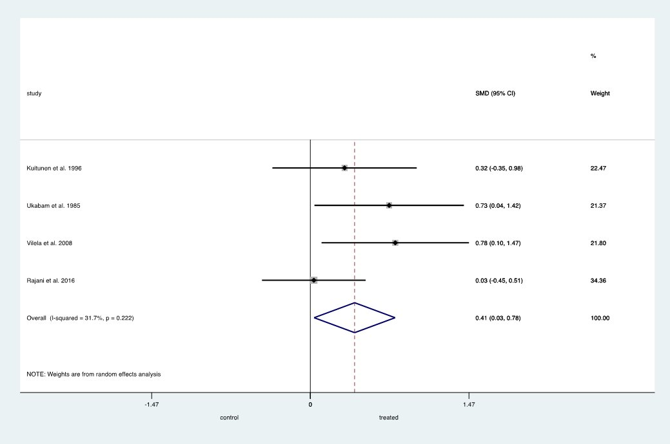

Fig. S3(A). Standard Mean Difference (SMD) in LMR between treated coeliac disease and healthy controls.

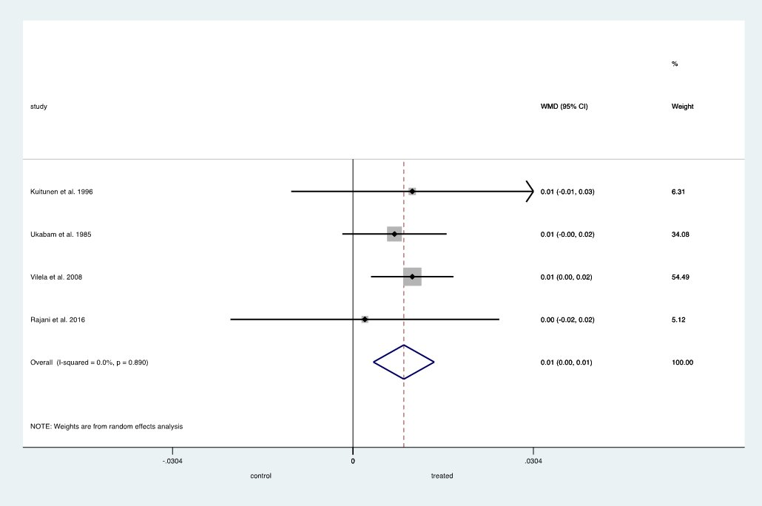
Fig. S3(B). Weighted Mean Difference (WMD) in LMR between treated coeliac disease and healthy controls.

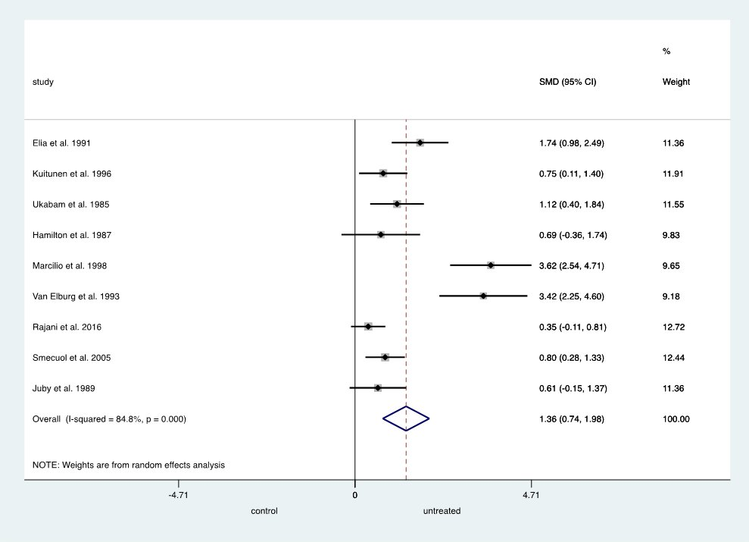
Fig. S3(C). Standard Mean Difference (SMD) in LMR between untreated coeliac disease and healthy controls.
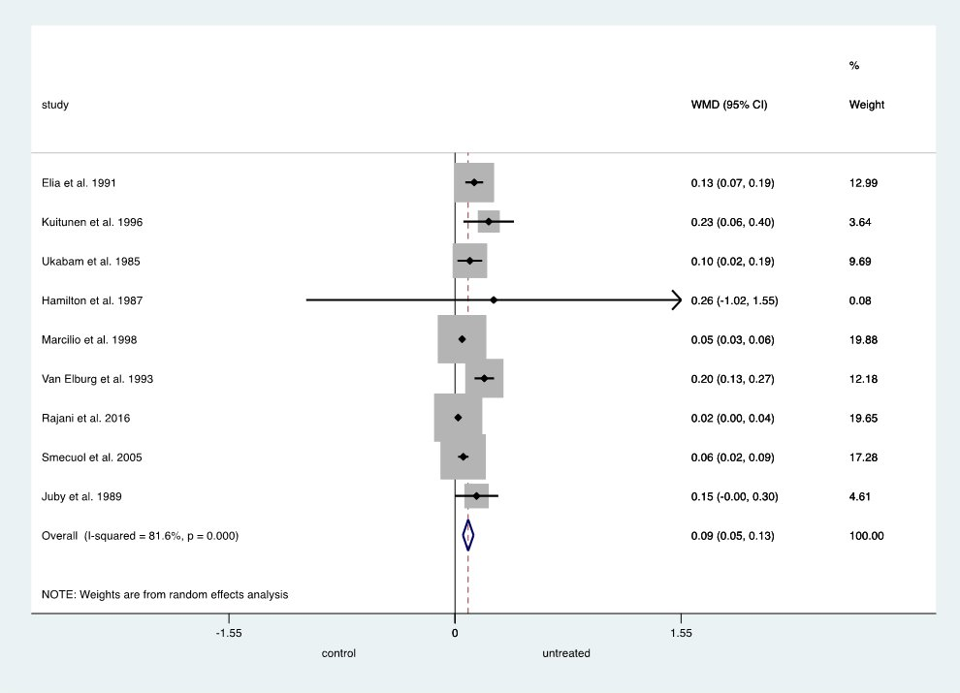

Fig. S3(D). Weighted Mean Difference (WMD) in LMR between untreated coeliac disease and healthy controls.
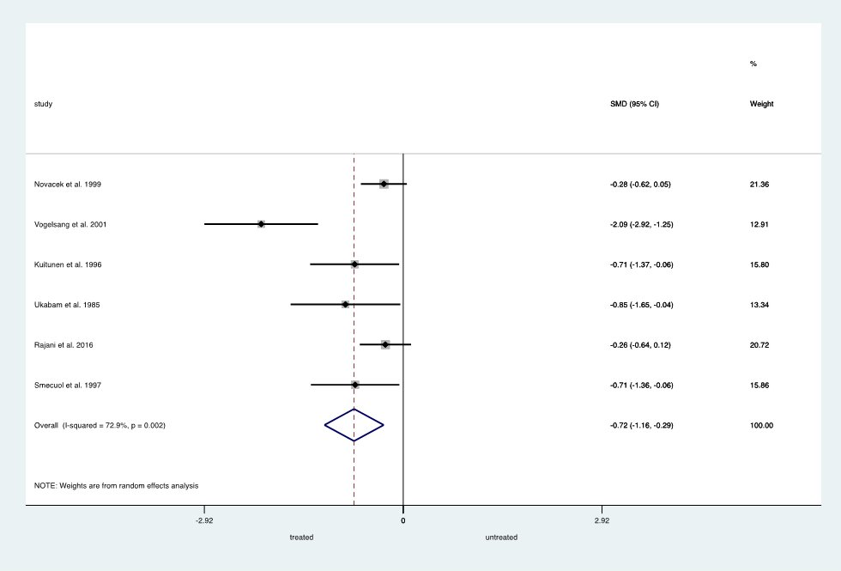

Fig. S3(E). Standard Mean Difference (SMD) in LMR between untreated and treated coeliac disease.
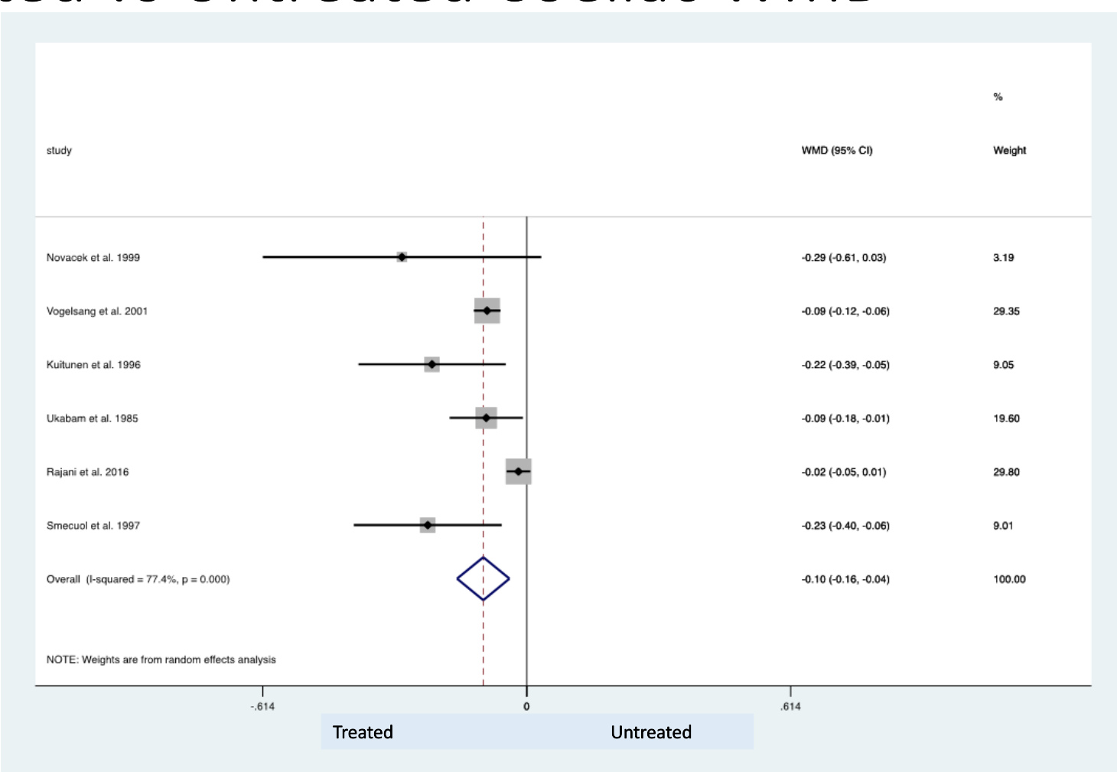
Fig. S3(F). Weighted Mean Difference (WMD) in LMR between untreated and treated coeliac disease.
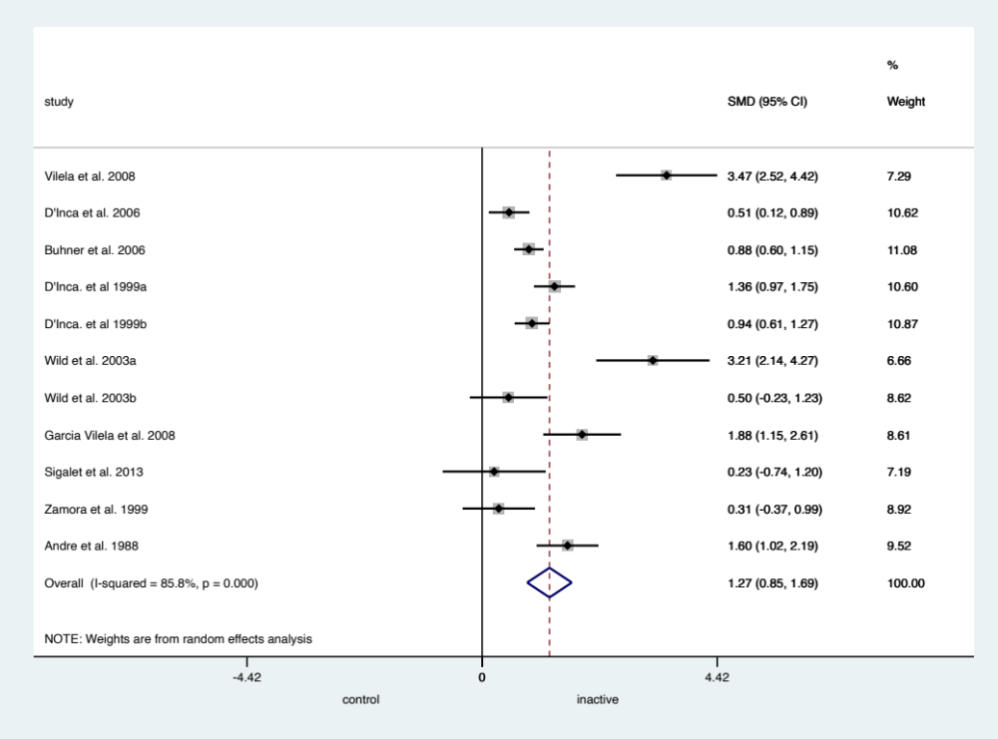
Fig. S4(A). Standard Mean Difference (SMD) in LMR between healthy controls and inactive Crohn's disease.
Active Crohns
Inactive Crohns
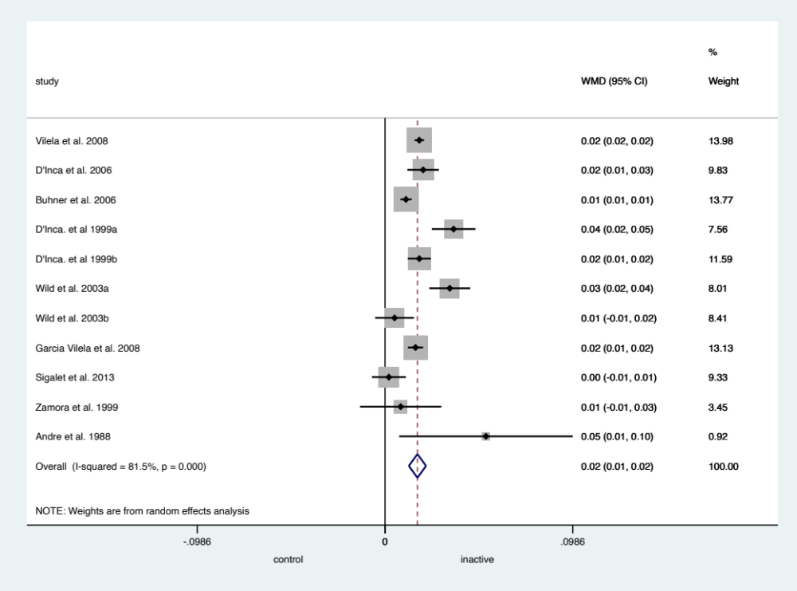
Fig. S4(B). Weighted Mean Difference (WMD) in LMR between healthy controls and inactive Crohn's disease.
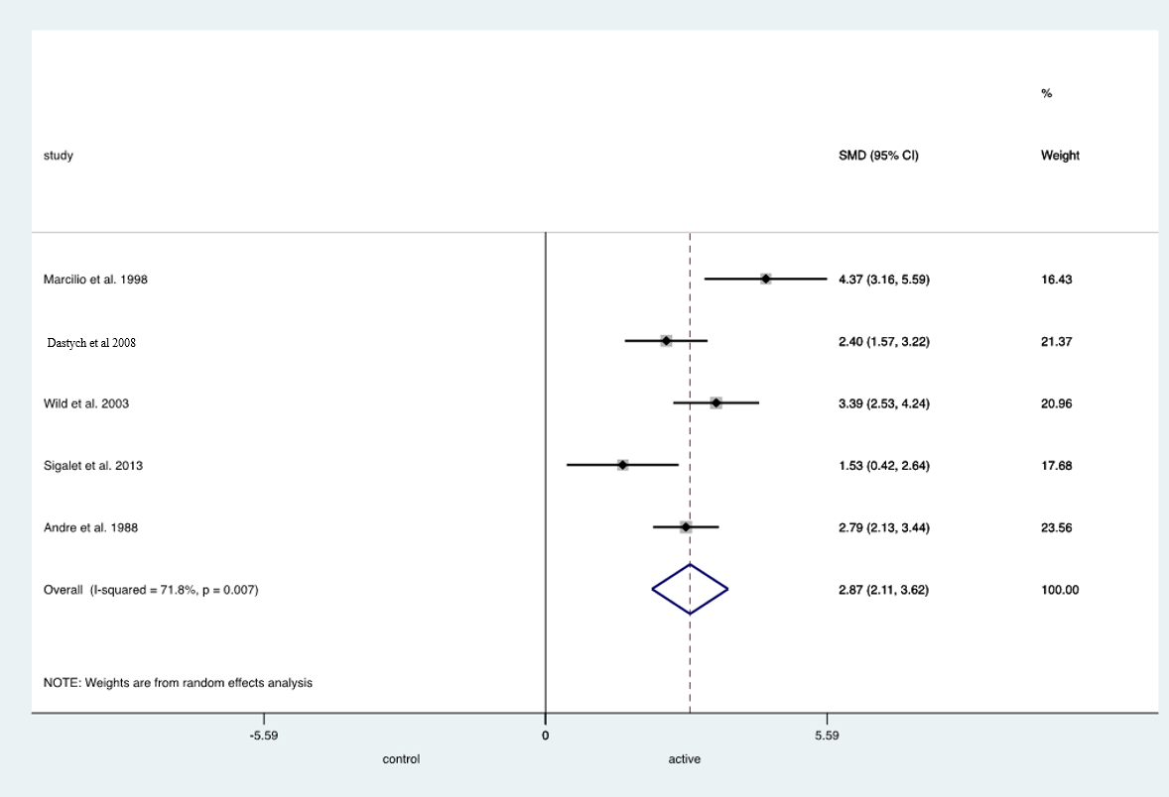

Fig. S4(C). Standard Mean Difference (SMD) in LMR between active Crohn's disease and healthy controls.
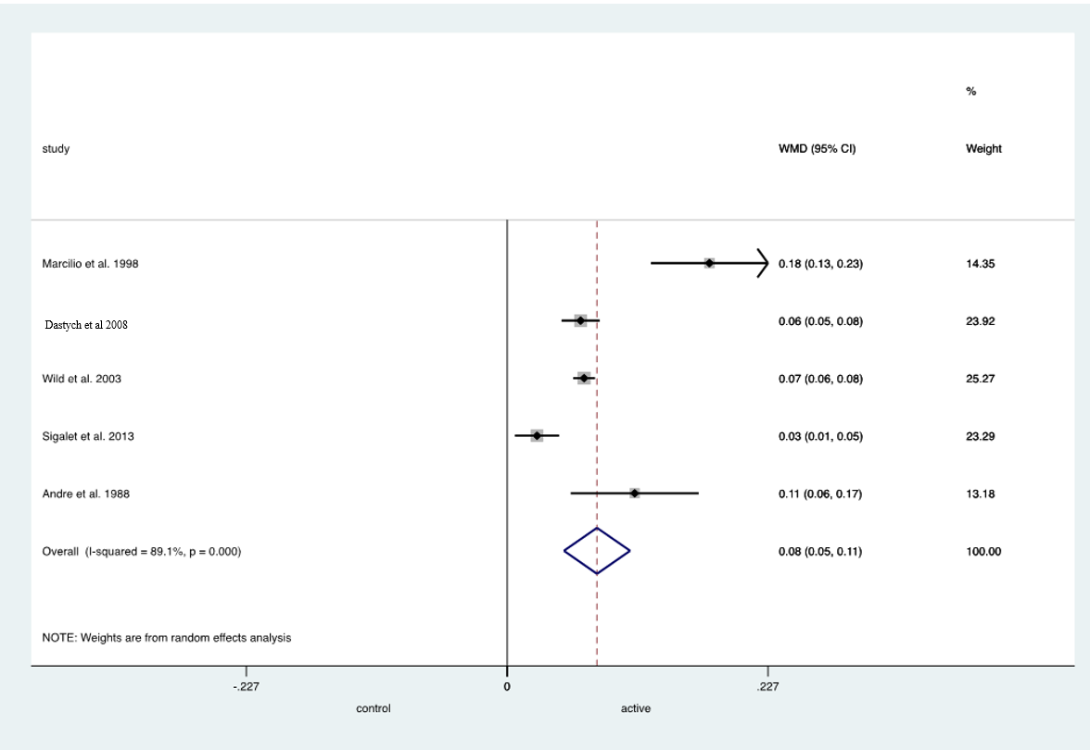

Fig. S4(D). Weighted Mean Difference (WMD) in LMR between active Crohn's disease and healthy controls.

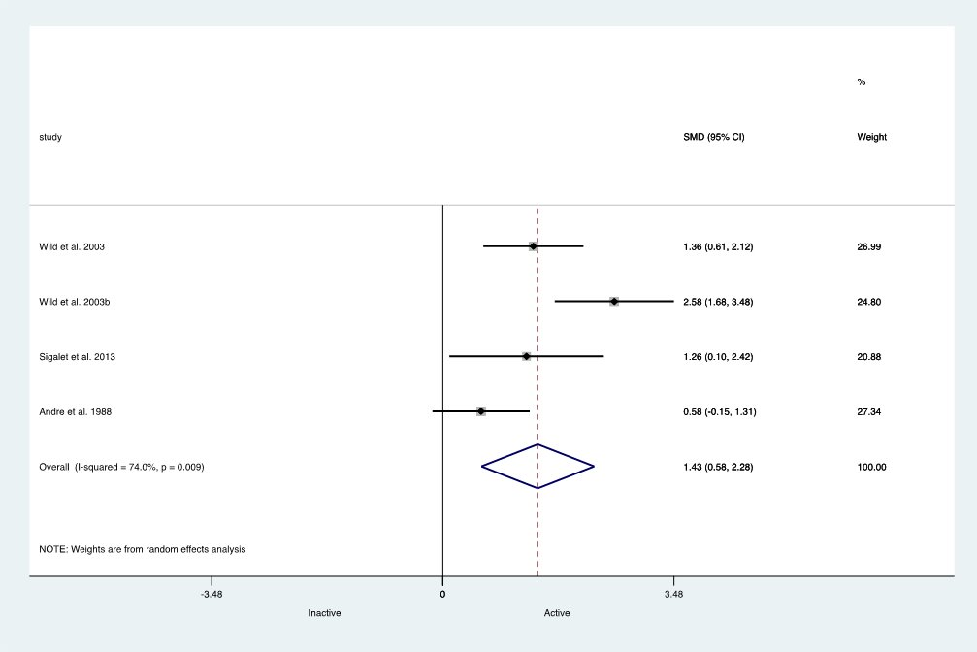

Fig. S4(E). Standard Mean Difference (SMD) in LMR between active and inactive Crohn's disease.

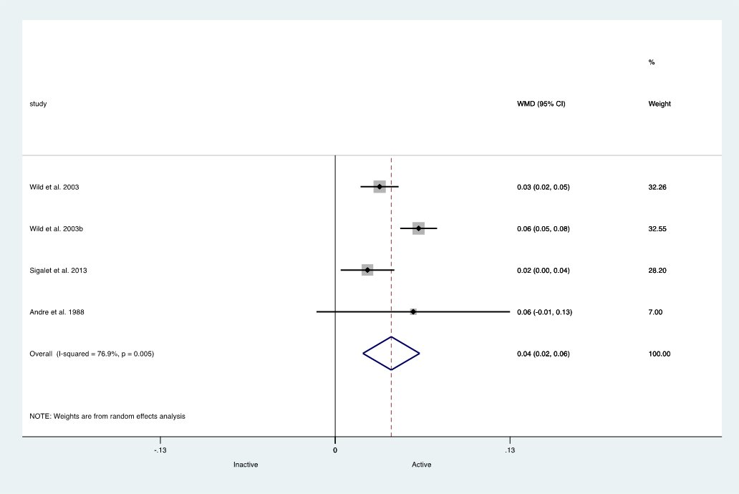

Fig. S4(F). Weighted Mean Difference (WMD) in LMR between active and inactive Crohn's disease.
Study | Total Number of Patients | Cut-off value for coeliac disease diagnosis | Sensitivity (%) | Specificity (%) | Clinical Relevance | How cut-off is derived
Juby et al.1989 | 44 | 0.028 | 89 | 54 | Screening of coeliac disease in general population | Mean + 2 SD of a previous Cellubiose/Mannitol ( Ce/Ma) study
Johnston et al.2000 | 77 | 0.024 | 87 | 71 | Screening of coeliac disease in general population | Mean + 1.28 SD of log transformed LMR (representing the 90th percentile) for healthy volunteer group
Catassi et al.1997 | 29 | 0.044 | 45 | Not Reported | Screening of coeliac disease in general population | Mean + 1.65 SD of the square root of LMR
Smecuol et al.1999 | 41 | 0.025 | 100 | 83 | Screening of coeliac disease among first degree relatives | Not Reported

Table S4. Studies depicting sensitivity and specificity of LMR in screening for coeliac disease. Abbreviations: SD – standard deviation. LMR: Lactulose Mannitol Ratio

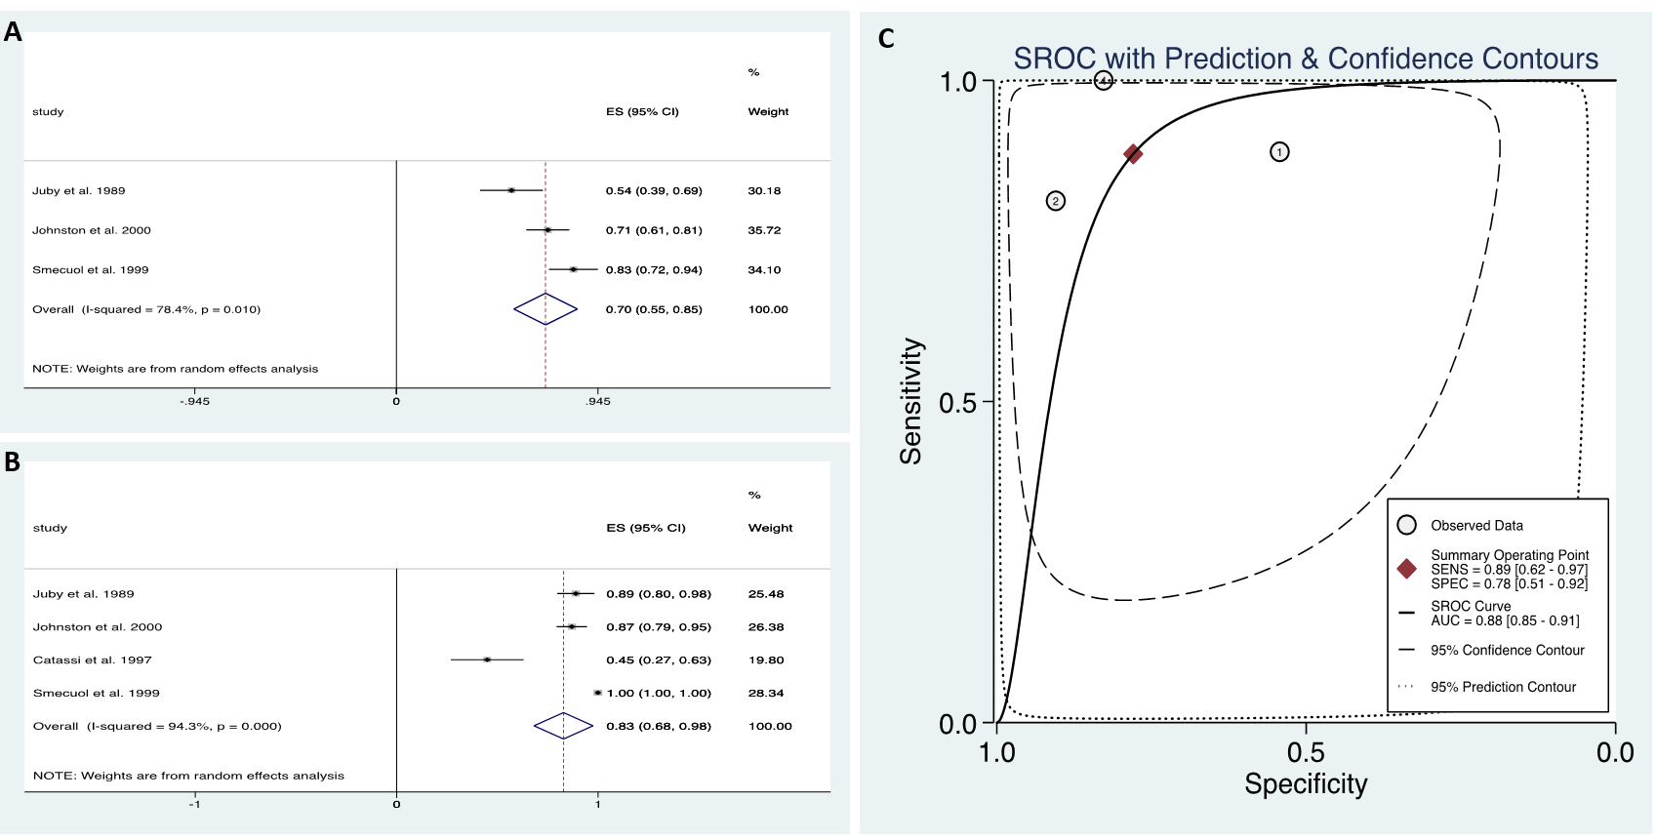
Fig. S5. Sensitivity and specificity of the L:M test in coeliac disease. (A) Pooled specificity values for the L:M test in coeliac disease. (B) Pooled sensitivity values for the L:M test in coeliac disease. (C) Summary Receiver Operating Characteristic (SROC) curve for coeliac disease, showing prediction and confidence contours.
Table B1. Newcastle Ottawa Score Assessing Risk of Bias for Cohort Studies (* denotes 1 point)
 | Selection |  |  |  | Comparability | Outcome
Study | Representativeness of the exposed cohort | Selection of the non- exposed cohort | Ascertainment of exposure | Demonstration that outcome of interest was not present at start of study | comparability of cases and controls on the basis of the design or analysis | Assessment of outcome | Was follow-up long enough for outcomes to occur? | Adequacy of follow up of cohorts | Total score
Ukabam et al 1985 |  |  | * |  | ** | * |  | * | 6
Johnston et al 2000 | * | * | * |  | ** | * | * |  | 7
Novacek et al 1999 |  |  | * |  |  | * | * | * | 4
Rajani et al 2016 | * |  | * |  | * | * | * | * | 6
Vecsei et al 2009 | * | * | * |  | * | * | * |  | 6
Sigalet et al 2013 | * | * | * |  |  | * |  | * | 5
Sturniolo et al 2001 | * |  | * |  |  | * |  | * | 4
D'Inca et al 1999 | * | * | * |  |  | * | * | * | 6
Wild et al 2003 | * |  | * |  |  | * |  | * | 4
Smecuol et al 1997 | * |  | * |  |  | * |  |  | 3
Hilsden et al 1999 | * | * | * |  | * | * | * | * | 7

Table B2. Newcastle Ottawa Score Assessing Risk of Bias for Case Control Studies (* denotes 1 point).
 | Selection |  |  |  | Comparability | Exposure
Study | Is the case definition adequate? | Representativeness of the cases | Selection of controls | Definition of controls | Comparability of cases and controls on basis of the design or analysis | Ascertainment of exposure | Same method of ascertainment for cases and control | Non-response rate | Total score
Zamora et al 1999 |  | * | * | * | ** | * | * | * | 8
Hilsden et al 1996 |  |  | * | * |  | * | * |  | 4
Swanson et al 2011 | * |  |  | * | * | * | * | * | 6
Juby et al 1989 | * | * | * | * |  | * | * | * | 7
Breslin et al 2001 | * |  | * | * | ** | * | * | * | 8
Table B3. Newcastle Ottawa Score Assessing Risk of Bias for Cross Sectional Studies (* denotes 1 point).
 | Selection |  |  |  | Comparability | Outcome
Study | Representativeness of the sample | Sample size | Ascertainment of exposure | Presence of Non-respondents | The subjects in different outcome groups are comparable based on the study design or analysis, Confounding factors are controlled | Assessment of outcome | Presence of Statistical test | Total score
Catassi et al 1997 | * | * | ** |  | * | ** |  | 7
Elia et al 1991 |  |  | * |  | * | ** |  | 4
Hamilton et al 1987 |  |  | ** |  |  | ** |  | 4
Marsilio et al 1998 |  |  | ** |  |  | ** |  | 4
Vogelsang et al 2001 | * |  | ** |  |  | ** | * | 6
Van Elburg et al 1993 | * |  | ** |  |  | ** |  | 5
Kuitunen et al 1996 | * |  | ** |  |  | ** | * | 6
Andre et al 1988 |  | * | ** |  |  | ** |  | 5
Vilela et al 2008 |  |  | ** |  |  | ** | * | 5
Dastych et al 2008 |  | * | * |  |  | ** | * | 5
D'Inca et al 2006 | * | * | ** |  |  | ** | * | 7
Buhner et al 2006 | * | * | ** |  |  | ** | * | 7
Smecuol et al 2005 | * | * | * |  | * | ** | * | 7
Smecuol et al 1999 | * |  | ** |  |  | ** | * | 6

Table B4. Assessing Risk of Bias for Randomised Control Trials (RCT) using the Jadad Score (* denotes 1 point).
Study | Type of study | Randomisation | Blinding | An account of all patients | Total score
Smecuol et al 2013 | RCT | ** | * |  | 3
Garcia Vilela et al 2008 | RCT | ** | * | * | 4
Benjamin et al 2012 | RCT | ** | ** | * | 5
Gatti et al 2013 | RCT | * | * |  | 2

Table B5. Risk of bias in non-randomised trials using the ROBINS-I score.
 | Pre-intervention |  | At intervention | Post intervention
Study | Bias due to confounding | Bias in selection of participants into the study | Bias in classifications of interventions | Bias due to deviations from intended interventions | Bias due to missing data | Bias in measurement of outcome | Bias in selection of the reported result | Overall bias
Zamora et al 1999 | low | low | low | low | low | moderate | moderate | moderate
Sturniolo et al 2001 | low | moderate | low | moderate | low | serious | moderate | serious
Hilsden et al 1996 | low | moderate | low | moderate | moderate | serious | moderate | serious
Swanson et al 2011 | low | moderate | low | low | low | moderate | low | moderate
Wild et al 2003 | low | serious | low | low | low | serious | moderate | serious

Table B6. Study quality assessment in Crohn's disease by the QUADAS 2 Criteria (Low = low risk, High = high risk, Unknown = risk unclear).
 | Risk of bias |  |  |  | Applicability Concerns
Study | Patient selection | Index test | Reference Standard | Flow and Timing | Patient Selection | Index Test | Reference Standard
Marsilio et al 1998 | Unknown | Low | Unknown | Low | Low | High | Low
Vilela et al 2008 | Unknown | Low | Unknown | Low | Low | High | Low
Sturniolo et al 2001 | Low | Low | Unknown | Unknown | Low | High | Low
Dastych et al 2008 | Unknown | Low | Unknown | Unknown | Low | High | Low
D'Inca et al 2006 | Unknown | Low | Unknown | Unknown | Low | High | Low
Buhner et al 2006 | Unknown | Low | Unknown | Low | Low | High | Low
Swanson et al 2011 | High | Low | Unknown | Low | Low | High | Low
Wild et al 2003 | Low | Low | Unknown | Low | Low | High | Low
Garcia Vilela et al 2008 | High | Low | Unknown | High | Low | High | Low
Sigalet et al 2013 | Low | Low | Unknown | Low | Low | High | Low
Zamora et al 1999 | High | Low | Unknown | Low | Low | High | Low
Hilsden et al 1999 | Unknown | High | High | Low | Low | High | Low
D'Inca et al 1999 | Unknown | Low | Unknown | High | Low | High | Low
Andre et al 1988 | Unknown | Low | Unknown | Low | Low | High | Low
Benjamin et al 2012 | Low | Low | Unknown | High | Low | High | Low
Hilsden et al 1996 | Unknown | Low | Unknown | High | Low | High | Low
Breslin et al 2001 | High | Low | Low | Low | Low | High | Low

Table B7. Study quality assessment in coeliac disease by the QUADAS 2 Criteria (Low = low risk, High = high risk, Unknown = risk unclear).
 | Risk of bias |  |  |  | Applicability Concerns
Study | Patient selection | Index test | Reference Standard | Flow and Timing | Patient Selection | Index Test | Reference Standard
Novacek et al 1999 | Low | High | High | Low | Low | High | Low
Vogelsang et al 2001 | Low | Low | Unknown | Low | Low | High | Low
Elia et al 1991 | Unknown | Low | Unknown | Unknown | Low | High | Low
Kuitunen et al 1996 | Unknown | Low | Unknown | Low | Low | High | Low
Ukabam et al 1985 | Unknown | Low | Unknown | Low | Low | High | Low
Vecsei et al 2009 | High | Low | Unknown | High | Low | High | Low
Johnston et al 2000 | High | Low | Unknown | High | Low | High | Low
Hamilton et al 1987 | High | Low | Unknown | High | Low | High | Low
Catassi et al 1997 | High | Low | Unknown | High | Low | High | Low
Van Elburg et al 1993 | Unknown | Low | Unknown | Low | Low | High | Low
Rajani et al 2016 | Low | Low | Unknown | High | Low | High | Low
Smecuol et al 1999 | Unknown | High | Unknown | Low | Low | High | Low
Smecuol et al 2005 | Low | Low | Unknown | Low | Low | High | Low
Gatti et al 2013 | High | Low | Low | High | Low | high | Low
Smecuol et al 1997 | Unknown | High | High | High | Low | High | Low
Smecuol et al 2013 | High | Unknown | Low | Low | Low | High | Low
Juby et al 1989 | Low | Unknown | Unknown | Unknown | Low | High | Low

