Supplementary Information for

Zoom in: A Psycho-Institutional Intervention Improves Minority Student’s Grades in Two Field Experiments
Authors: Kinneret Endevelt¹, Eran Halperin¹ & Roni Porat*²
Affiliations:
¹ Department of Psychology, The Hebrew University of Jerusalem, Jerusalem, Israel
² Department of Political Science & Department of International Relations, The Hebrew University of Jerusalem, Jerusalem, Israel
*Corresponding author. Roni Porat Email: Roni.porat@mail.huji.ac.il,

Contents

Description of the Intervention 3

Materials of the Intervention 4-6

Demographic balance check 7

Models 8-9

Deviations from Pre-Registration 9

Outcomes 10-15

Self-Report Primary Outcome Reported in the Manuscript 10

Self-Report Primary Outcome Not Reported in Manuscript 11

Primary Behavioral Outcomes Reported in the Manuscript 12

Primary Behavioral Measures Not Reported in the Manuscript 12

Achievements Reported in the Manuscript 12

Robustness checks (replication of the results with lm_robust) 13-16

Self-Report Primary Outcome Reported in the Manuscript 13

Self-Report Primary Outcome Not Reported in Manuscript 14

Primary Behavioral Outcomes Reported in the Manuscript 15

Achievements Reported in the Manuscript 16

Description of the Intervention

The goal of the intervention was to examine the influence of an institutional signal of inclusion on Palestinian students’ sense of belongingness and achievements. To operationalize an institutional signal of inclusion, lecturers in the experimental condition in both studies were asked to change the way their name appeared on Zoom so that instead of the default, English or Hebrew appearance only (which served as the control condition), their name would appear in Arabic, Hebrew, and English (i.e. the experimental condition). We included the Hebrew and English name transcripts in the experimental condition for two reasons: First, given that most Jews can’t read (or speak) Arabic, we wanted to ensure that Jewish students could still read the name of their lecturer. Second, we thought that having the lecturer’s name written only in Arabic could backfire by making Jewish students feel that their language and identity is threatened. However, given how scarce the Arabic language is in the Israeli public sphere, we assumed that the addition of the Arabic transcript would be highly salient to both Jewish and Palestinian students, and as such, serve as a significant institutional signal of inclusion.



Fig. 1.
The letter sent by the university Rector to the lecturers in the experimental condition in Study 2.

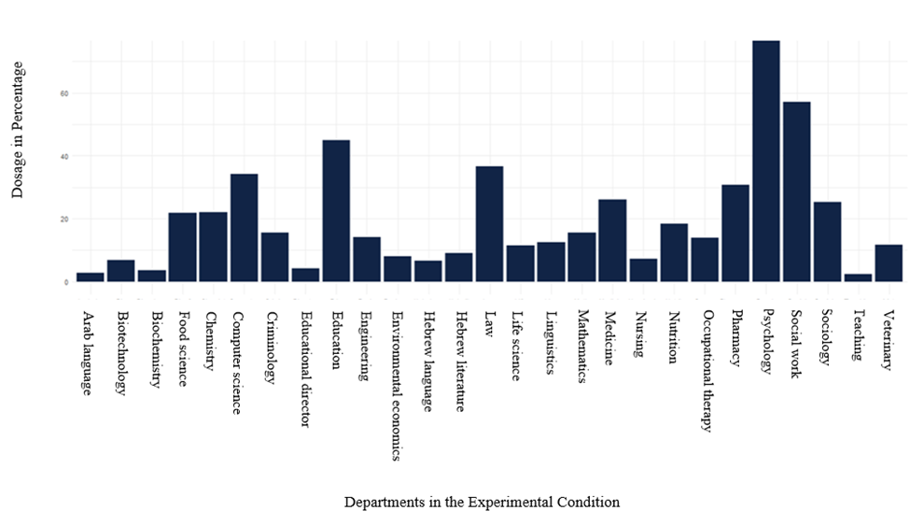

Fig. 2.

The percentage of lecturers in each department that was assigned to the experimental condition who confirmed via email that they had changed the way their name appeared on Zoom (Study 2).



Fig. 3.
Email sent by the Dean of Student’s Office to students who studied in the 54 departments that participated in Study 2, inviting them to fill out a brief questionnaire.

Study 1:

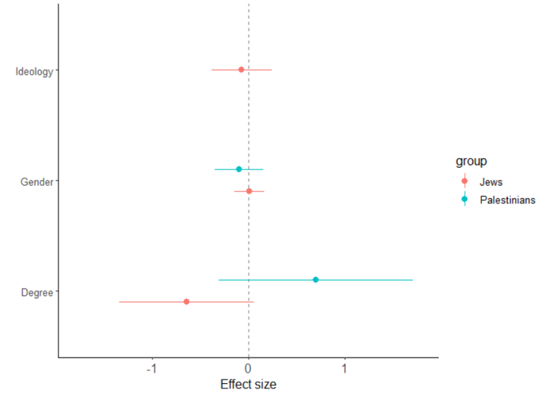

Study 2 first and second questionnaire:

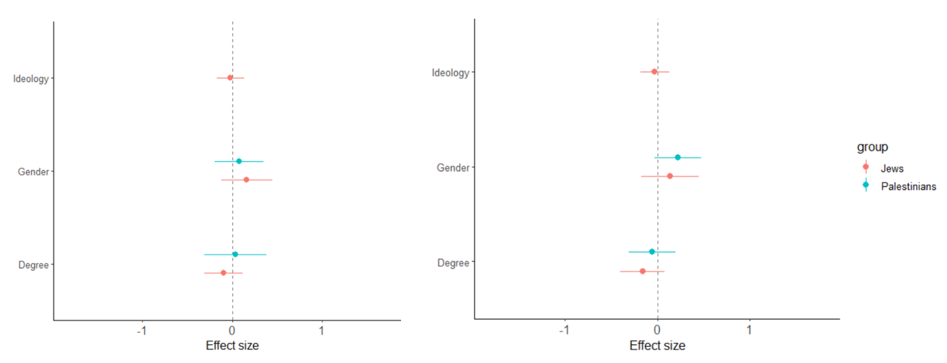

Fig. 4.
Demographic balance checks for Studies 1 (top figure) & 2 (bottom figures). Each point estimate and its corresponding 95% confidence interval is extracted from a separate MLM model in which treatment (experimental condition) is regressed over a demographic variable. Models include class (Study 1) or department (Study 2) random effects to account for the clustered design. All outcomes are standardized. The results of Palestinian students appear in blue, while the results of the Jewish students appear in red.
Models
To test that our results were robust to different model specifications we tested the following three models:

- Unadjusted Model
Y_{ij} = β₀ + β₁T_{ij} + (β₀|Course) + µ_{ij}

Where Y is an outcome, i denotes participant, and j denotes class (Study 1) or department (Study 2). The regression coefficient β₁ represents the average causal effect of the treatment. T_{ij} represents a binary variable of the experimental manipulation randomly assigned to classes (Study 1) or departments (Study 2), in which T_{ij} = 1 refers to the experimental condition, and T_{ij} = 0 refers to the control condition. (β₀|Course) denotes class (Study 1) or department (Study 2) random effects, and µ is the error term.

- Unadjusted Model with Weights
For the self-report measures in both studies, we used the same unadjusted model. However, given that for these measures we do not have observations for all students, we added weights to correct for bias. These weights represent the inverse probability of participating in the questionnaire. We calculated the weight in the following manner:

$$Zij=a/b$$

Where Z is the weight, i denotes participant, and j denotes either class (Study 1) or department (Study 2). a represents the overall number of students in each class (Study 1) or department (Study 2), while b represents the number of participants who answered the questionnaire from that class (Study 1) or department (Study 2).

- Adjusted Model
Y_{ij} = β₀ + β₁T_{ij} +β₂Z_{ij} + g_{i} + µ_{ij}

Where Y is an outcome, i denotes participant, and j denotes class (Study 1) or department (Study 2). The regression coefficient β₁ represents the average causal effect of the treatment. T_{ij} represents a binary variable of the experimental manipulation randomly assigned to classes (Study 1) or departments (Study 2), in which T_{ij} = 1 refers to the experimental condition, and T_{ij} = 0 refers to the control condition. g_{i} denotes class (Study 1) or department (Study 2) random effects, Z_{ij} is a vector of individual level participant characteristics that are unaffected by treatment (see description of these below). g_{i} denotes class or department random effect, and µ is the error term. Importantly, for self-report outcomes measured via the questionnaire, we also added weights (specified earlier) to the model.

Covariates:
- Study 1 covariates include: gender, Palestinian proportion in the class, class size, self-reported Hebrew proficiency (for Palestinian students), and course content (whether the content of the course involved intergroup relations). For the behavioral measures, we also controlled for coder.
- Study 2 covariates include: gender, Palestinian proportion in the department, and department size.

In the manuscript, we report results of this model (the adjusted model) for behavioral and achievement outcomes (without weights), and for the self-report outcomes for both Studies 1 & 2 (with weights).

In the supplementary information we replicate the results for both the adjusted and the unadjusted models with lm_robust.

Deviations from Pre-Registration
For the self-report measures we deviated from the original model that we preregistered to a model that included weights so we could account for self-selection into survey by class (Study 1) or department (Study 2). In addition, to simplify the model, we conducted a separate analysis for Jews and Palestinians instead of including both populations in one regression with an interaction term.
Outcomes

Self-Report Primary Outcome Reported in the Manuscript

Sense of belonging – Study 1. Following Jansen and colleagues (2014), we asked participants to rate nine items measuring their sense of belonging in the course, the department, and the university, on a scale of 1 (strongly disagree) to 5 (strongly agree). Items include:
- I felt that I was a part of the course.
- I felt that I belong in the course.
- I felt comfortable in the course.
- I felt other students in the class perceived me as a part of the group.
- My lecturer perceived me as a central part of the group.
- My lecturer appreciates me.
- I feel that I belong in my department.
- My department cares about me.
- Being a student at the Hebrew University constitutes a central part of my identity.
The scale demonstrated high reliability (α = .88).

Sense of belonging – Study 2. In the first questionnaire we again followed Jansen and colleagues (2014), asking participants to rate eight items measuring their sense of belonging. However, given that the intervention in Study 2 was a campus wide effort, we pre-registered separate analyses for items about belonging to the university, and items about belonging to the department. We also dropped item nine that was measured in Study 1, as we felt that it wasn’t appropriate for the Israeli context. Participants were asked to rate the following three items on a scale of 1 (strongly disagree) to 5 (strongly agree):
- I feel comfortable in my university.
- I feel that I belong in my university.
- My university cares about me.
The scale demonstrated high reliability in both questionnaires (first questionnaire: α = .79; second questionnaire: α = .78).

Self-Report Primary Outcome not Reported in Manuscript

Sense of belonging to the department – Study 2. As reported earlier, in Study 2 we measured student’s sense of belonging to the university, and their sense of belonging to the department, however we pre-registered these as two separate scales. Below we report on the second scale that refers to students’ sense of belonging to the department. Interestingly, while we find that the intervention affected student’s sense of belonging to the university, it did not effect their sense of belonging to the department. This may be because of the low compliance in some departments. Given these findings, we did not measure this in the second questionnaire. The scale followed Jansen and colleagues (2014), where students were asked to rate five items on a scale of 1 (strongly disagree) to 5 (strongly agree). Items include:
- I feel that I am a part of my department.
- I feel comfortable in my department.
- I feel I belong in my department.
- My lecturers appreciate me.
- My department cares about me.
The scale demonstrated high reliability (α = .88).

Primary Behavioral Outcomes Reported in the Manuscript

Attendance and camera usage - Study 1. We coded participants attendance and camera usage through the class recordings.

Primary Behavioral Measures Not Reported in the Manuscript
We measured students’ length of participation, video participation, chat comments and questions, confrontational participation, interruptions, degrading and compliments, whether students added their Arabic name on Zoom and lecturers’ behavior toward the students.
For length of participation (the number of seconds the students participated in each class), we found an interaction effect between time and condition (b=0.68, p<001). We calculated the simple effects of these interaction with Tukey adjustments for multiple comparisons. With the adjustments, we found a simple effect (b=-0.66, p<001) where only for Jewish students in the experimental condition, there was an increase in participation following the intervention.
For students chat comments and questions and confrontational participation, we did not find an interaction effect between condition and time. For video participation, and lecturers’ behavior we found an interaction effect between time and condition only for the Jewish students. We calculated the simple effects of these interactions with Tukey adjustments for multiple comparisons. With the adjustments, none of the simple effects were significant.
The coded observations of student’s interruptions, degrading and compliments, and whether they added their Arabic name on Zoom, were very limited and therefore we did not analyze these outcomes.

Achievements Reported in the Manuscript
Students’ grades – Studies 1 & 2. In Study 1, we obtained student’s final course grade. In Study 2, we obtained the department’s average grade score.

Results
Self-Report Primary Outcome Reported in the Manuscript.

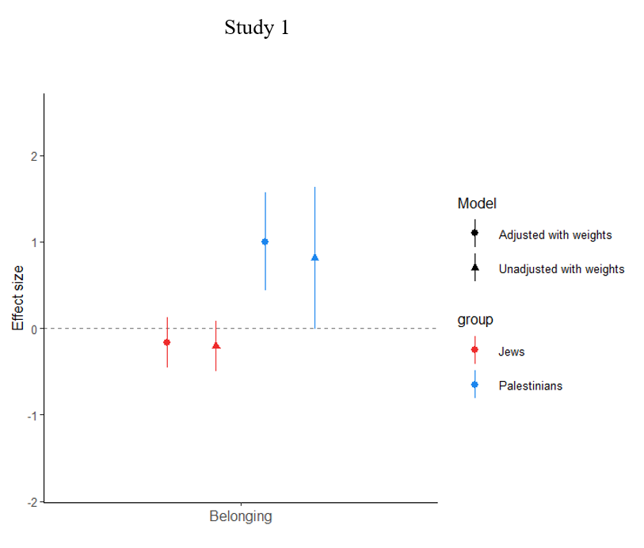
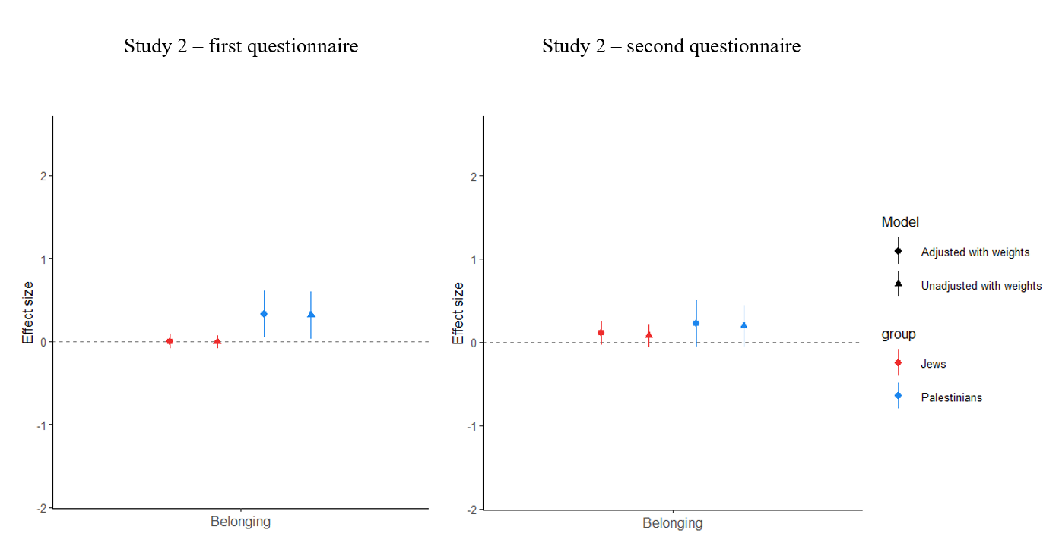

Fig. 5. Effects of condition on students’ belonging in Studies 1 (top figure) & 2 (bottom figure). Condition is coded such that experimental condition = 1, control condition = 0. Each point estimate and its corresponding 95% confidence interval is extracted from two regression models: an unadjusted model with weights while clustering the standard errors; an adjusted model with weights, covariates, while clustering the standard errors. All outcomes are standardized. The results of Palestinian students appear in blue, while the results of the Jewish students appear in red.

Self-Report Primary Outcome Not Reported in Manuscript

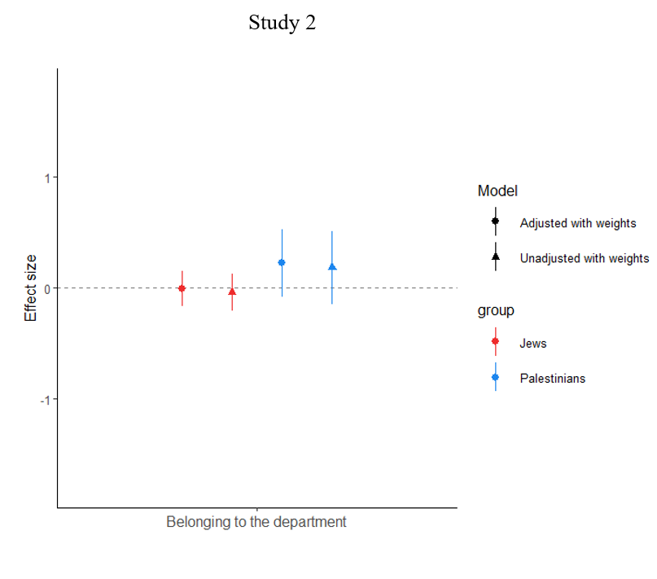

Fig. 6.
Effects of condition on belonging to the department in Study 2 (first questionnaire). Condition is coded such that experimental condition = 1, control condition = 0. Each point estimate and its corresponding 95% confidence interval is extracted from two regression models: an unadjusted model with weights while clustering the standard errors; an adjusted model with weights, covariates, while clustering the standard errors. All outcomes are standardized. The results of Palestinian students appear in blue, while the results of the Jewish students appear in red.

Primary Behavioral Outcomes Reported in the Manuscript

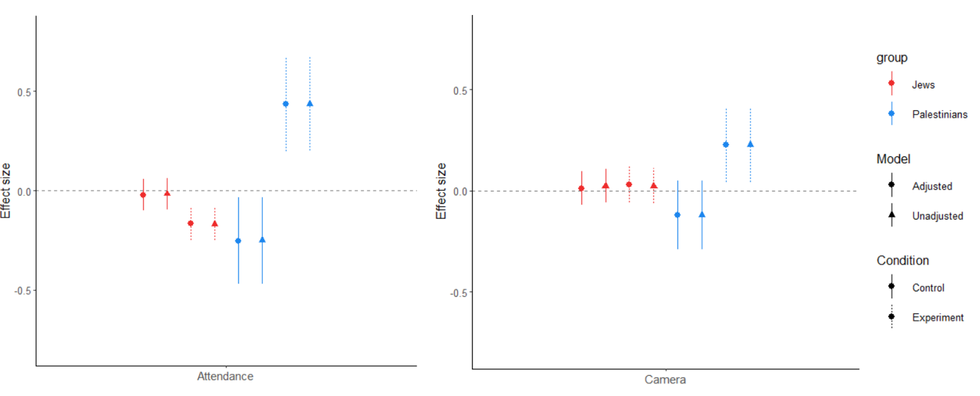

Fig. 7.
Behavioral indices of student’s attendance and camera usage in Study 1. Each point estimate and its corresponding 95% CI are extracted from a separate regression with cluster (class) random effects in which we identify the interaction simple effects of the difference between the Pre and Post intervention time for each condition. All outcomes are standardized. The results of Palestinian students appear in blue, while the results of the Jewish students appear in red.

Achievements Reported in the Manuscript
Students’ grades – Studies 1 & 2. In Study 1, we obtained student’s final course grade. In Study 2, we obtained the department’s average grade score.

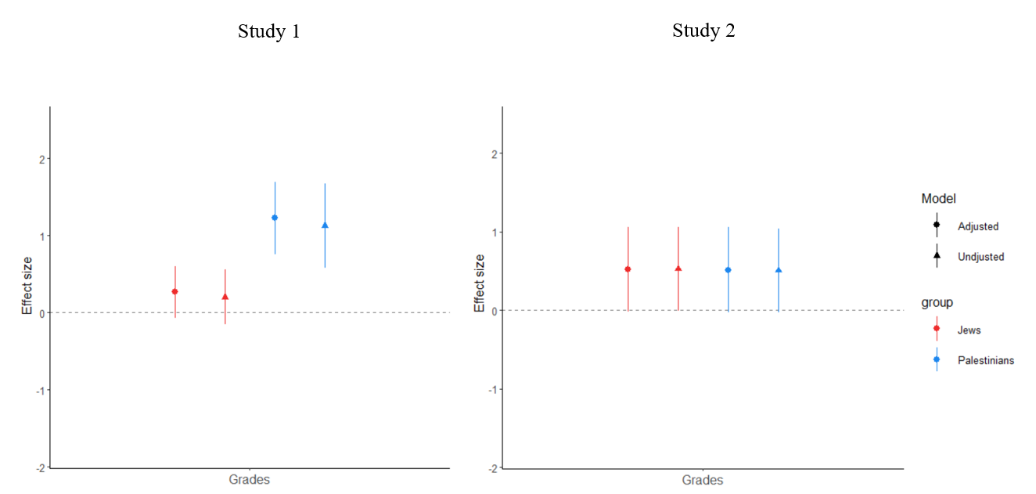

Fig. 8.

Regression results for student’s final course grade in Study 1 and average grade at the department level in Study 2. Condition is coded such that experimental condition = 1, control condition = 0. Each point estimate and its corresponding 95% confidence interval is extracted from two regression models: an unadjusted model while clustering the standard errors; an adjusted model with covariates, while clustering the standard errors. All outcomes are standardized. The results of Palestinian students appear in blue, while the results of the Jewish students appear in red.

