-Supplementary-
Distinct decadal modulation of Atlantic-Niño influence on ENSO

Jae-Heung Park^{1*}, Jong-Seong Kug^{1,2*}, Young-Min Yang^{3,4}, Mi-Kyung Sung⁵,
Sunyong Kim^{6,7}, Hyo-Jeong Kim⁸, Hyo-Jin Park⁹, and Soon-Il An^{1,9}

¹Division of Environmental Science and Engineering, Pohang University of Science and Technology (POSTECH), Pohang, South Korea.
²Institute for Convergence Research and Education in Advanced Technology, Yonsei University, Seoul, South Korea
³Key Laboratory of Meteorological Disaster, Ministry of Education (KLME)/Joint International Research Laboratory of Climate and Environment Change (ILCEC)/Collaborative Innovation Center on Forecast and Evaluation of Meteorological Disasters (CIC-FEMD), Nanjing University of Information Science and Technology, Nanjing 210044, China.
⁴State Key Laboratory of Numerical Modeling for Atmospheric Sciences and Geophysical Fluid Dynamics, Institute of Atmospheric Physics, Chinese Academy of Sciences, Beijing 100029, China.
⁵Center for Sustainable Environment Research, Korea Institute of Science and Technology, Seoul, Korea
⁶Climate Analytics Department, APEC Climate Center, Busan, South Korea
⁷Physical Oceanography Department, Woods Hole Oceanographic Institution, Falmouth, United States
⁸Low-Carbon and Climate Impact Research Centre, School of Energy and Environment, City University of Hong Kong, Tat Chee Ave, Kowloon Tong, Hong Kong, People’s Republic of China
⁹Department of Atmospheric Sciences/Irreversible Climate Change Research Center, Yonsei University, Seoul, South Korea

Submitted to NPJ-Climate and Atmospheric Science

Corresponding authors:
Dr. Jae-Heung Park (e-mail: jhp11010@gmail.com) & Prof. Jong-Seong Kug (e-mail: jskug1@gmail.com), Division of Environmental Science and Engineering, Pohang University of Science and Technology (POSTECH), Pohang, South Korea
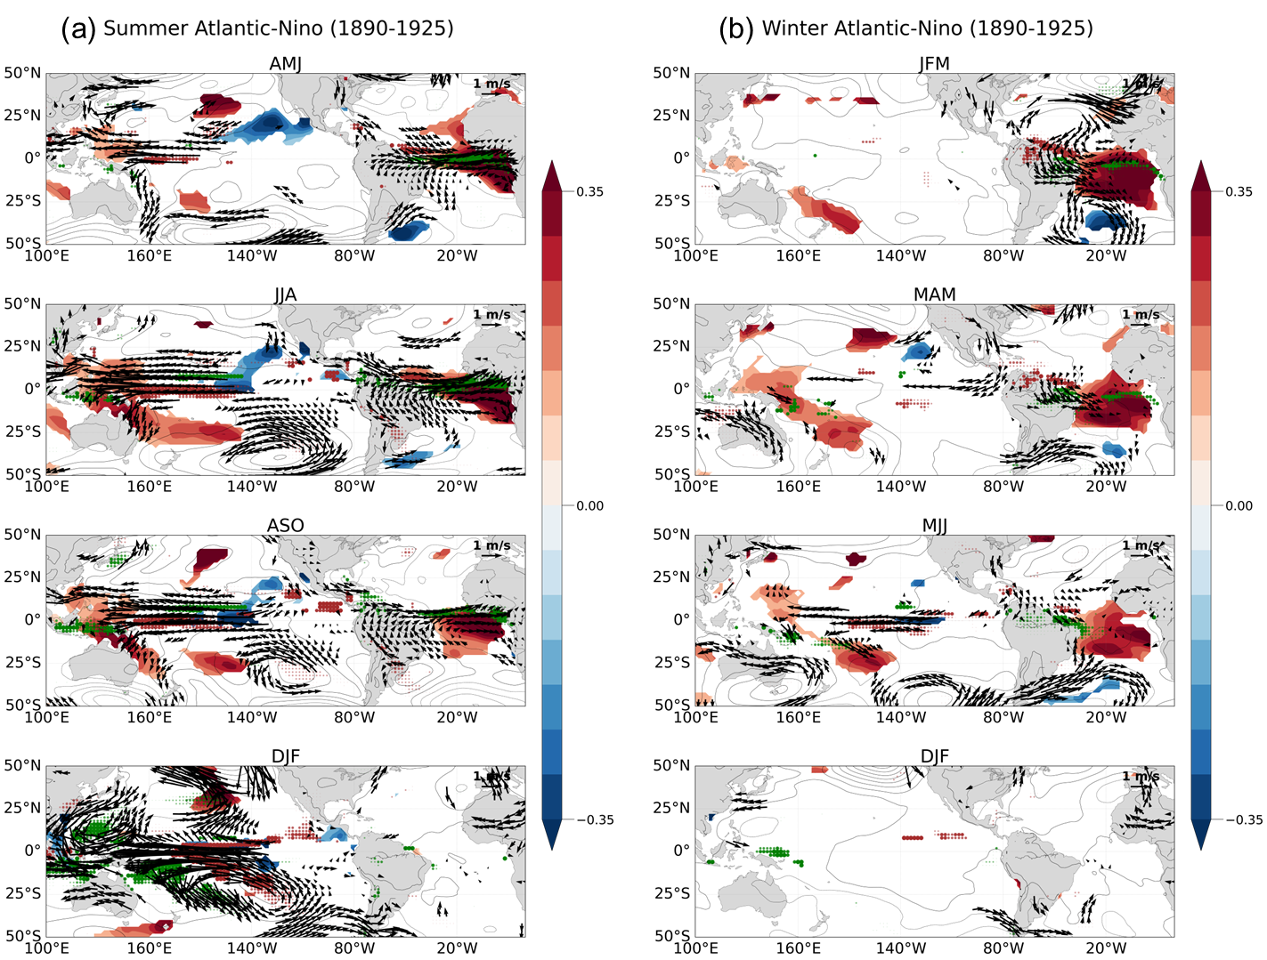
Supplementary Figure 1. (a) Regressed SSTA (shading, °C, shading bar at right), SLPA (contour, 0.5 hPa), low-level wind anomaly (vector, at 850 hPa), and precipitation anomaly (dots, green and brown for positive and negative) against the summer (JJA) Atlantic-Niño index during the 1890–1925. Top to bottom panels correspond to the March-April-May (MAM) mean, June-July-August (JJA) mean, September-October-Novemner (SON) mean, and December-January-February (DJF) mean, respectively. Anomalous SST, winds, and precipitation are marked when a 95% confidence level by Student’s t-test is satisfied. (b) Similar as (a), but against winter (DJF) Atlantic-Nino. Top to bottom panels show to the March-April-May (MAM) mean, June-July-August (JJA) mean, September-October-Novemner (SON) mean, and December-January-February (DJF) mean, respectively.

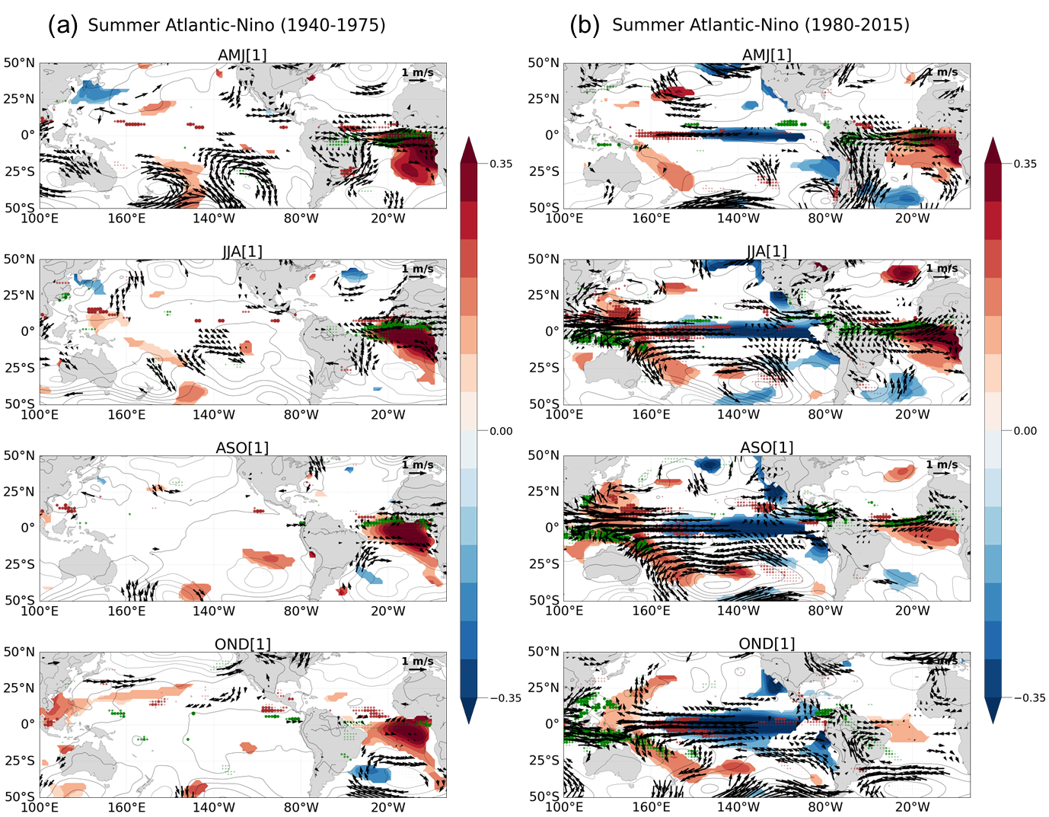
Supplementary Figure 2. (a) Regressed SSTA (shading, °C, shading bar at right), SLPA (contour, 0.5 hPa), low-level wind anomaly (vector, at 850 hPa), and precipitation anomaly (dots, green and brown for positive and negative) against the summer (JJA) Atlantic-Niño index during the 1940–1975. Top to bottom panels correspond to the April-May-June (AMJ) mean, June-July-August (JJA) mean, August-September-October (ASO) mean, and October-November-December (OND) mean, respectively. Anomalous SST, winds, and precipitation are marked when a 95% confidence level by Student’s t-test is satisfied. (b) same as (a), but during the 1980-2015.
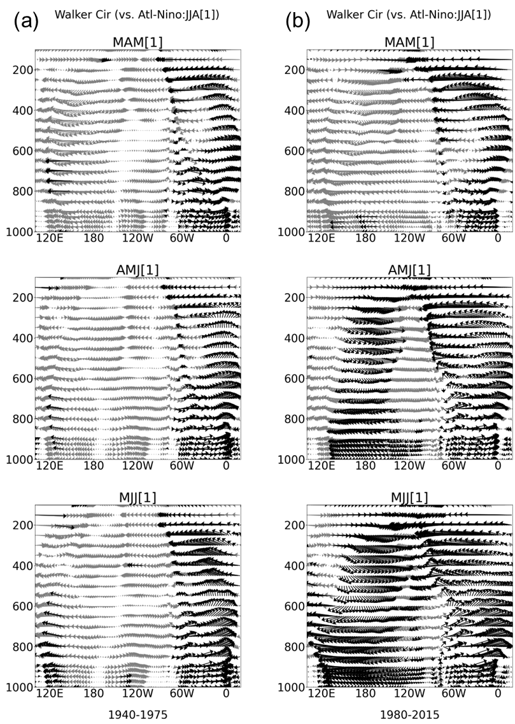
Supplementary Fig. 3 (a) Lead-lagged correlation coefficients of anomalous zonal-vertical circulation (5°S–5°N) in AMJ, MJJ, JJA, seasons against the summer Atlantic-Niño index during 1948–1978. Bold-black arrows are indicated above 95% confidence level by two-tailed t-test. (b) Similar to the (a), but during 1980-2010. Top to bottom corresponds to the FMA, MAM, AMJ seasons, respectively.

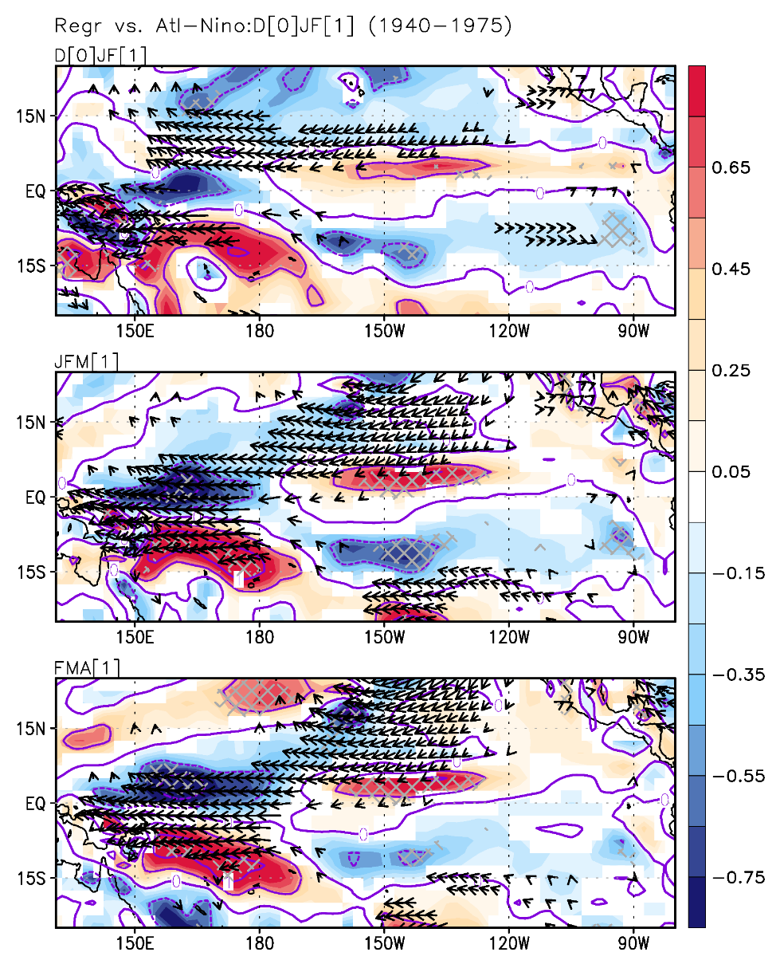
Supplementary Figure 4. Regressed low-level vorticity (x 10⁶ s⁻¹, 1000-hPa, shading bar at right, contour intervals 0.5), low-level wind anomaly (m/s, vector, 850-hPa) against the winter (DJF) Atlantic-Niño index during the 1940–1975. Top to bottom panels correspond to the December-January-February (DJF) mean, January-February-March (JFM), and February-March-April (FMA), respectively. For vorticity, 95% confidence level is hatched by grey color.

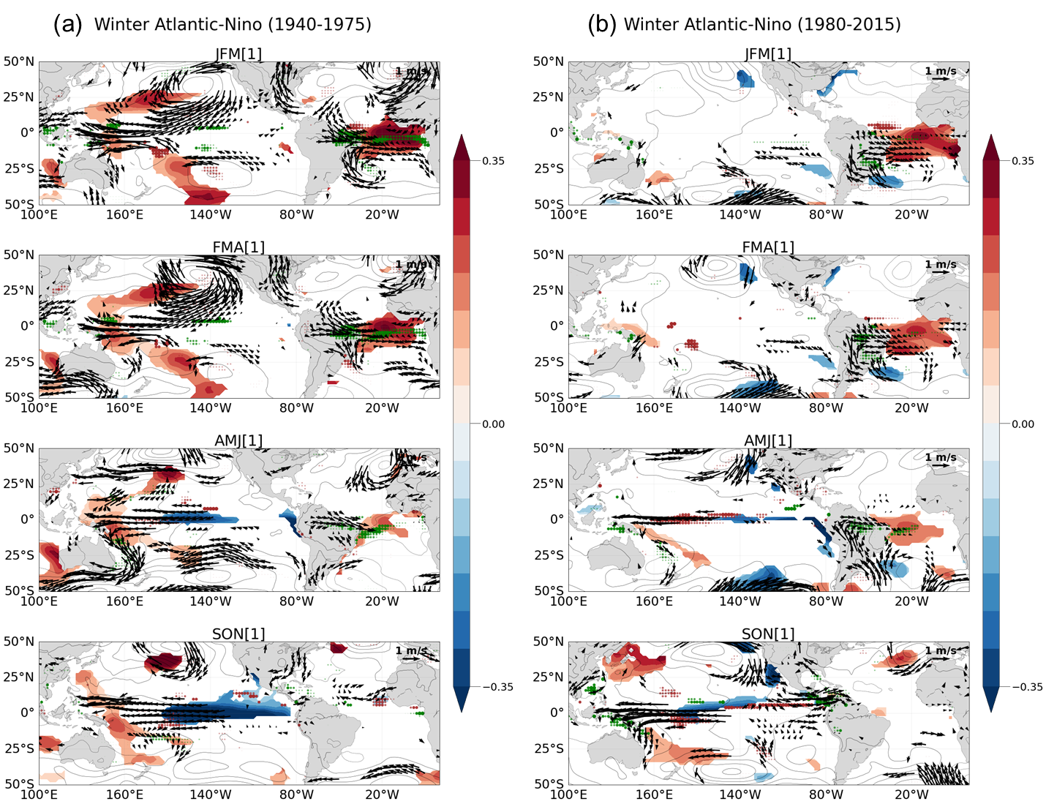
Supplementary Figure 5. (a) Regressed SSTA (shading, °C, shading bar at right), SLPA (contour, 0.5 hPa), low-level wind anomaly (vector, at 850 hPa), and precipitation anomaly (dots, green and brown for positive and negative) against the winter (DJF) Atlantic-Niño index during the 1940–1975. Top to bottom panels correspond to the January-February-March (JFM) mean, February-March-April (FMA) mean, April-May-June (AMJ) mean, and September-October-November (SON) mean, respectively. Anomalous SST, winds, and precipitation are marked when a 95% confidence level by Student’s t-test is satisfied. (b) same as (a), but during the 1980-2015.

