Supporting Information
Photo-manipulated polyunsaturated fatty acid-doped liposomal hydrogel for flexible photoimmunotherapy

Xinyue Lan^{1,3,†}, Junguang Liang^{3,†}, Churan Wen³, Xiaolong Quan¹, Huimin Lin¹, Qinqin Xu¹, Wei Luo⁵, Guangyu Yao^{3,}*, Dan Zhou^{4,}*, Meng Yu^{1,2,}*

†Xinyue Lan and Junguang Liang contributed equally to this work.
* Correspondence
Guangyu Yao
yaogy@smu.edu.cn
Dan Zhou
zdan14@fsyyy.com
Meng Yu
yumeng999@smu.edu.cn
Full list of author information is available at the end of the article

FIGURE SUPPORTING
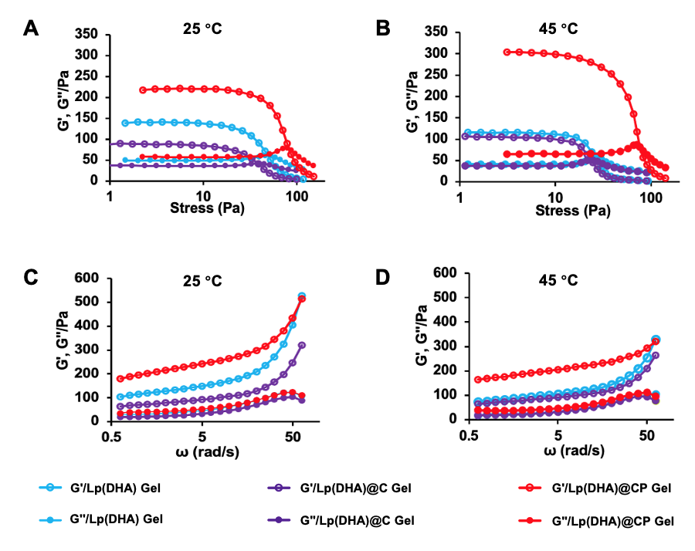
Fig. S1. Storage modulus G' and loss modulus G" of the prepared hydrogel samples at different stress (A, B) and frequency (C, D) at 25 °C and 45 °C.

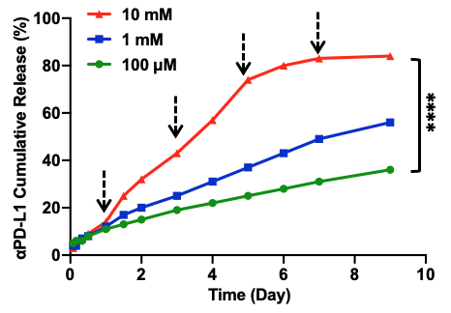
Fig. S2. The drug release under different concentrations of H₂O₂ instead of irradiation at the time indicated by arrows.

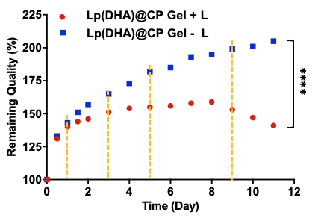
Fig. S3. The remaining quality of hydrogel under NIR light irradiation (671 nm, 100 mW/cm²) at different time points indicated by dotted lines.

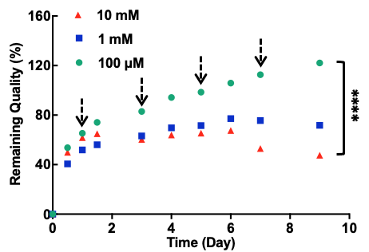
Fig. S4. The remaining quality of hydrogel under different concentrations of H₂O₂ instead of irradiation at the time indicated by arrows.

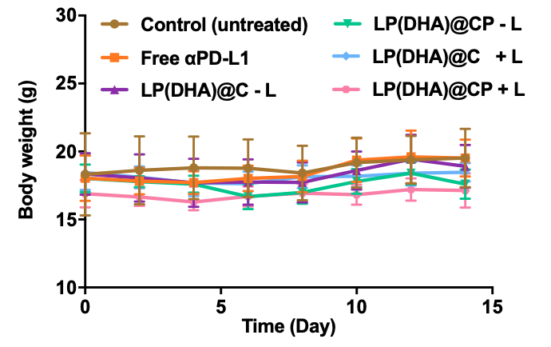
Fig. S5. The body weight changes of 4T1 tumor-bearing mice during the treatment.

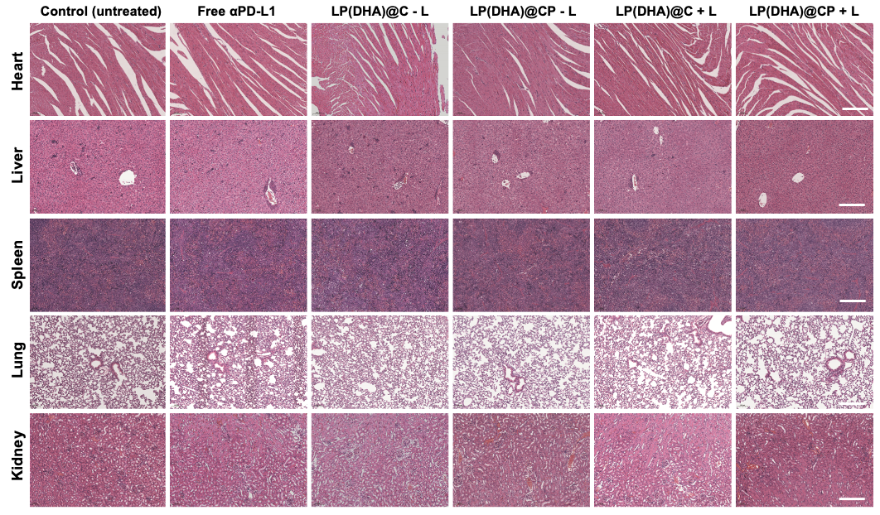
Fig. S6. H&E staining of major organs (heart, liver, spleen, lung, and kidney) from mice receiving different formulations. Scale bar: 100 μm

