Extended data figures and legends
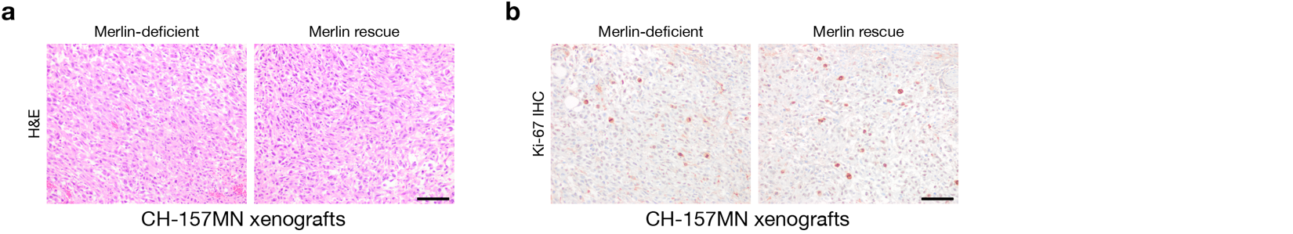
Extended Data Fig. 1. CH-157MN xenograft model of Merlin-deficient or Merlin rescue meningiomas. a-b, Images of H&E staining a or Ki-67 immunohistochemistry b from CH-157MN meningioma xenografts in NU/NU mice with or without doxycycline-inducible Merlin-rescue. Images are representative of n=3 xenografts/condition. Scale bars, 100 μm.

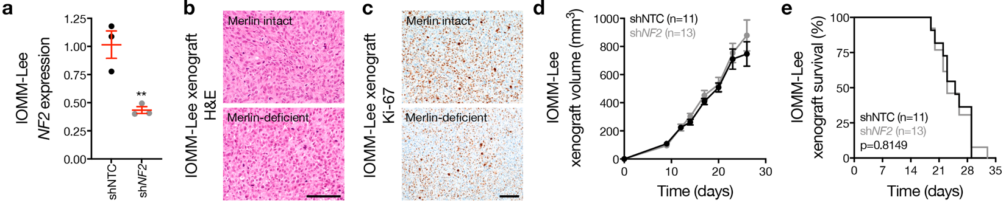Extended Data Fig. 2. IOMM-Lee xenograft model of Merlin intact or Merlin-deficient meningiomas. a, QPCR for NF2 in IOMM-Lee meningioma cells expressing non-targeted control shRNAs (shNTC) or shRNAs suppressing NF2. b-c, Images of H&E staining b or Ki-67 immunohistochemistry c from IOMM-Lee meningioma xenografts in NU/NU mice with or without shRNA suppression of NF2. Images are representative of n=3 xenografts/condition. Scale bars, 100 μm. d, IOMM-Lee xenograft measurements in NU/NU mice with or without shRNA suppression of NF2. e, Kaplan-Meier survival curve for IOMM-Lee xenograft overall survival in NU/NU mice as in d (log-rank test). Lines represent means, and error bar represent standard error of the means. **P≤0.01 (Student’s t-test, one sided).

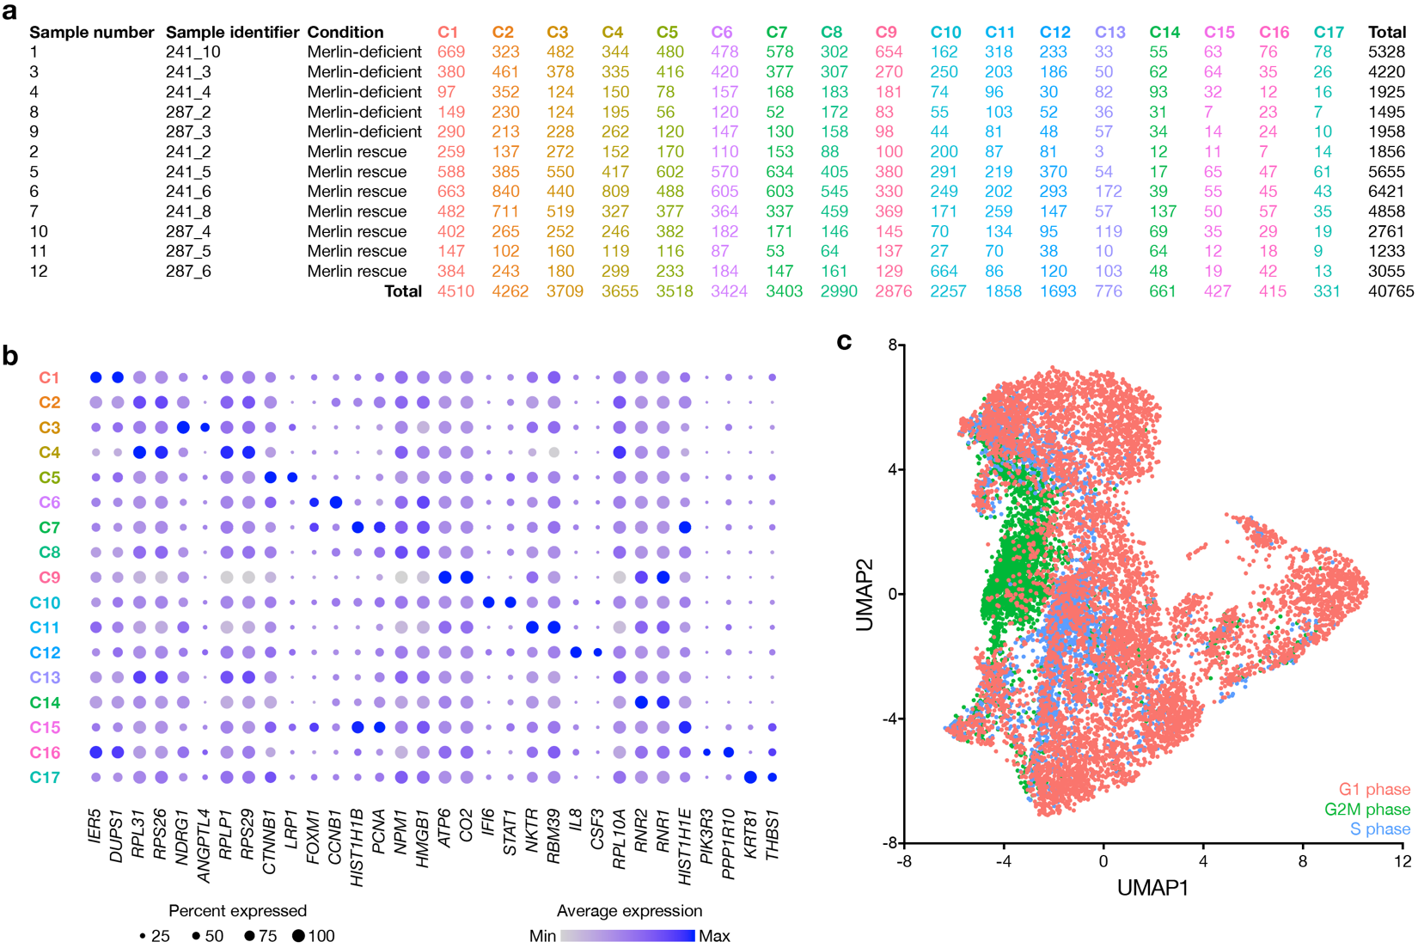Extended Data Fig. 3. Single-cell RNA sequencing of CH-157MN xenograft models of Merlin-deficient or Merlin rescue meningiomas. a, Single-cell RNA sequencing of CH-157MN meningioma xenografts in NU/NU mice with or without Merlin rescue identifies 17 cell states. Table shows number of cells per sample contributing to each cell state colored by assignments from Louvain clustering. b, Dot plot of single-cell RNA sequencing showing marker genes for each cell state cluster. c, Uniform manifold approximation and projection (UMAP) of single-cell RNA sequencing transcriptomes of 40,765 CH-157MN cells from 12 xenografts as in Fig. 1a-c showing cell cycle distribution.

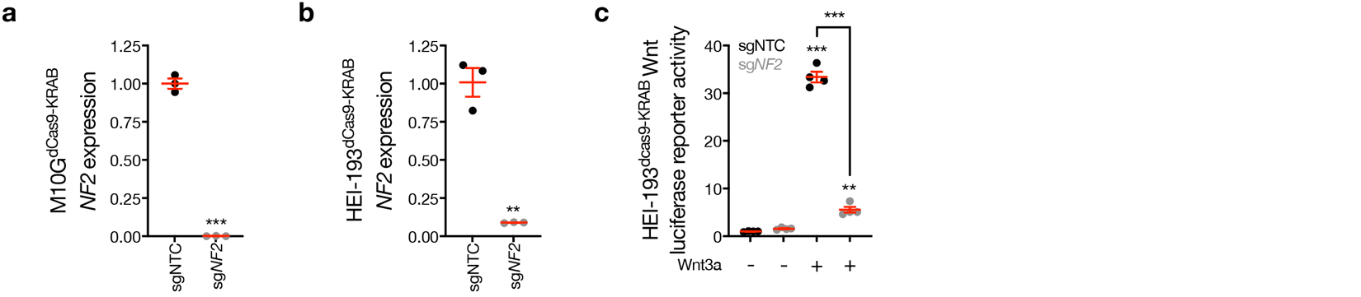Extended Data Fig. 4. Merlin suppression inhibits Wnt signaling. a, QPCR for NF2 in M10G^{dCas9-KRAB} meningioma cells expressing non-targeted control sgRNAs (sgNTC) or sgRNAs suppressing NF2 (sgNF2). b, QPCR for NF2 in HEI-193^{dCas9-KRAB} schwannoma cells expressing sgNTC or sgNF2. c, TOP-Flash Tcf/Lef luciferase reporter assay in HEI-193^{dCas9-KRAB} schwannoma cells expressing sgNTC or sgNF2 with or without 24-hours of Wnt3a treatment (100ng/μl). Lines represent means, and error bar represent standard error of the means. **P≤0.01, ***P≤0.0001 (Student’s t-test, one sided).

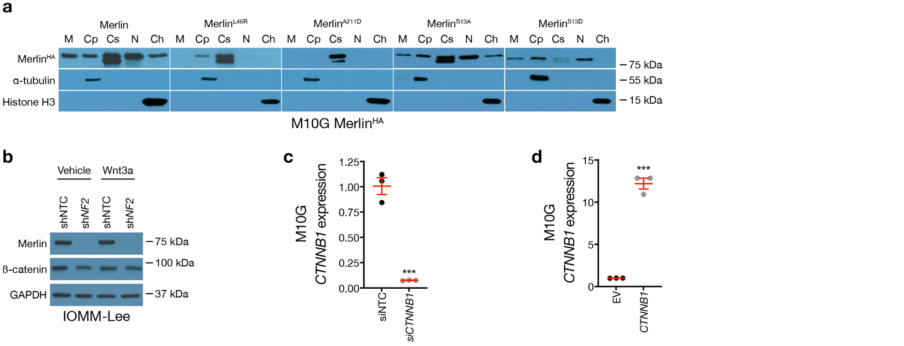Extended Data Fig. 5. Genetic perturbation of Merlin or β-catenin in meningioma cells. a, Immunoblots for HA (Merlin) after biochemical fractionation of M10G meningioma cells overexpressing Merlin constructs. Immunoblots for α-tubulin or histone H3 mark cytoplasmic or chromatin fractions, respectively. b, Immunoblots for Merlin, β-catenin, or GAPDH in IOMM-Lee meningioma cells expressing non-targeted control shRNAs (shNTC) or shRNAs suppressing NF2 (shNF2) with or without 24-hours of Wnt3a treatment (100ng/ul). c, QPCR for β-catenin (CTNNB1) in M10G meningioma cells expressing non-targeted control siRNAs (siNTC) or siRNAs suppressing β-catenin (siCTNNB1). d, QPCR for β-catenin (CTNNB1) in M10G meningioma cells with or without β-catenin overexpression. Lines represent means, and error bar represent standard error of the means. ***P≤0.0001 (Student’s t-test, one sided).
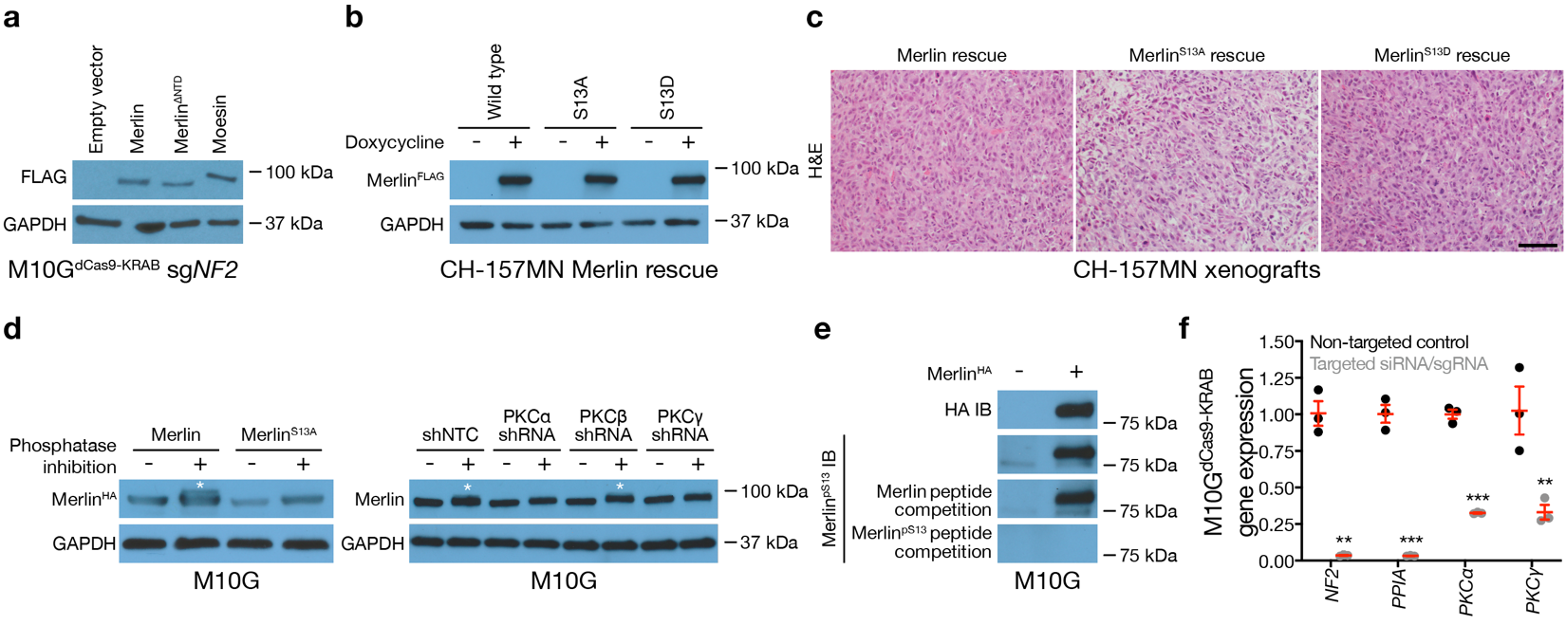Extended Data Fig. 6. PKC and PP1A regulate Serine 13 phosphorylation on Merlin. a, Immunoblots for FLAG (Merlin constructs or Moesin) or GAPDH in M10G^{dCas9-KRAB} meningioma cells expressing sgRNAs suppressing NF2 (sgNF2) with or without rescue of Merlin constructs or overexpression of the FERM family member Moesin. b, Immunoblots for FLAG (Merlin) or GAPDH in CH-157MN meningioma cells with or without 24-hours of doxycycline-inducible Merlin rescue (20μg/ml). c, Images of H&E staining CH-157MN xenografts in NU/NU mice with doxycycline-inducible Merlin-rescue. Images are representative of n=3 xenografts/condition. Scale bars, 100 μm. d, Immunoblots of HA (Merlin), endogenous Merlin or GAPDH in M10G meningioma cells with or without (1) phosphatase inhibition, (2) doxycycline-inducible Merlin overexpression, or (3) expression of non-targeted control shRNAs (shNTC) or shRNAs suppressing PKC isoforms. Asterisks show doublets suggestive of phosphorylation events. e, Immunoblots for HA (Merlin) or Merlin with phosphorylated S13 (Merlin^{pS13}) after Merlin overexpression. Immunoblots were performed using native lysates (top 2 blots), lysates with spike-in synthetic Merlin phospho-peptides used for rabbit immunization and phospho-specific antibody generation showing competition for Merlin^{pS13} binding (bottom blot, CSRMSFS(pS)LKRKQP-amide, 100μg), or immunoprecipitated lysates with spike-in synthetic Merlin peptides without phosphorylation used for negative selection during phospho-specific antibody purification showing no competition for Merlin^{pS13} binding (second to bottom blot, CSRMSFSSLKRKQP-amide, 100μg). f, QPCR for the genes indicated on the x-axis in M10G^{dCas9-KRAB} meningioma cells expressing non-targeted control sgRNAs suppressing NF2 (sgNF2, first pair) or siRNAs suppressing PP1A or PKC isoforms (second through fourth pairs). Expression of genes of interest in experimental conditions were compared to appropriate non-targeted control sgRNAs (for NF2 suppression using sgRNAs) or siRNAs (for PP1A and PKC isoform suppression using siRNAs). Lines represent means, and error bar represent standard error of the means. **P≤0.01, ***P≤0.0001 (Student’s t-test, one sided).

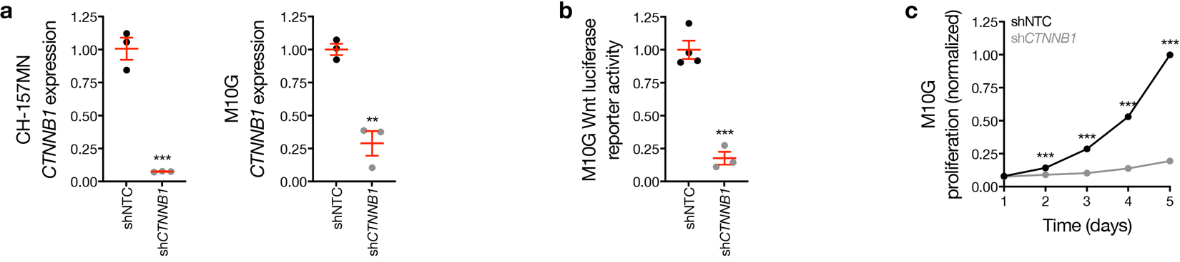Extended Data Fig. 7. Wnt pathway inhibition blocks meningioma cell proliferation. a, QPCR for β-catenin (CTNNB1) in CH-157MN or M10G meningioma cells expressing non-targeted control shRNAs (shNTC) or shRNAs suppressing β-catenin (shCTNNB1). b, TOP-Flash Tcf/Lef luciferase reporter assay in M10G cells expressing shNTC or shCTNNB1 with or without 24-hours of Wnt3a treatment (100ng/μl). c, M10G cell MTT assays for cell proliferation with shNTC or shCTNNB1 expression. Lines represent means, and error bar represent standard error of the means. **P≤0.01, ***P≤0.0001 (Student’s t-test, one sided).

