The use of mono- and combination pharmacotherapy in men and women with lower urinary tract symptoms (LUTS) in the UK: a retrospective observational study
Mahmood Ali, et al

Supplementary Information
Contents
Supplementary Table 1. Drugs of interest in male and female cohorts 2
Supplementary Table 2a. Read codes for LUTS symptoms 3
Supplementary Table 2b. Read codes for OAB and storage LUTS [1] 3
Supplementary Table 2c. Read codes for voiding LUTS, prostatism, and storage LUTS [1] 4
Supplementary Table 3a. Distribution of the male cohort by sub-cohorts 6
Supplementary Table 3b. Distribution of the female cohort by sub-cohorts 6
Supplementary Table 4. Extent of drug class use in all men (N = 48690) 7
Supplementary Table 5. Extent of mono- and combination pharmacotherapy use in the male LUTS (including OAB) sub-cohort 8
Supplementary Table 6. Extent of mono- and combination pharmacotherapy use in the male BPO sub-cohort 10
Supplementary Table 7. Extent of mono- and combination pharmacotherapy use in the female LUTS (including OAB) sub-cohort 12
Supplementary Table 8. Persistence in post-index period in the male BPO sub-cohort 14
Supplementary Table 9. Persistence at 1 month, 6 months and 1 year in the male BPO population 15
Supplementary Table 10. Persistence in post-index period in the female LUTS (including OAB) sub-cohort 19
Supplementary Table 11. Persistence at 1 month, 6 months and 1 year in female LUTS (including OAB) population 20
Supplementary Table 12. Extent of mono- and combination pharmacotherapy use in the male BPO sub-cohort - Sensitivity analyses 25
Supplementary Figure 1. TTD for monopharmacotherapies in male BPO sub-cohort (Kaplan-Meier estimates) 27
Supplementary Figure 2. TTD for combinations in male BPO sub-cohort (Kaplan-Meier estimates)† 28
Supplementary Figure 3. TTD for duloxetine in female SUI sub-cohort (Kaplan-Meier estimates) 29
Supplementary Figure 4. Kaplan-Meier curves for TTD sensitivity analysis: (A) monopharmacotherapy; (B) combination pharmacotherapy (male BPO/LUTS population†) 30

Supplementary Table 1. Drugs of interest in male and female cohorts
Male cohort: |  | Female cohort:
Drug class | Drugs | Drug class | Drugs
LUTS (incl. OAB) |  | LUTS (incl. OAB)
Antimuscarinics | darifenacin, flavoxate, fesoterodine, oxybutynin, propiverine, solifenacin*, tolterodine and trospium | Antimuscarinics | darifenacin, flavoxate, fesoterodine, oxybutynin, propiverine, solifenacin, tolterodine and trospium
Beta(3)-adrenoceptor agonists | mirabegron | Beta(3)-adrenoceptor agonists | mirabegron
BPO |  | SUI
Alpha-blockers | alfuzosin, doxazosin, indoramin, prazosin, tamsulosin*, terazosin | Serotonin and noradrenaline re-uptake inhibitors | duloxetine
5-alpha reductase inhibitors | finasteride, dutasteride* | – | –
Fixed-dose combinations | tamsulosin + solifenacin,  tamsulosin + dutasteride | – | –
BPO: benign prostatic obstruction; LUTS: lower urinary tract symptoms; OAB: overactive bladder; SUI: stress urinary incontinence
The fixed-dose combinations are products Vesomni™ (tamsulosin + solifenacin), Combodart® (tamsulosin + dutasteride); *Including fixed-dose combination products Vesomni™, Combodart®.

Supplementary Table 2a. Read codes for LUTS symptoms
Diagnosis | medcode | readcode | readterm
LUTS | 99784 | 1AZ6.00 | Lower urinary tract symptoms
LUTS | 104539 | 1AZ6000 | Mild lower urinary tract symptoms
LUTS | 104390 | 1AZ6100 | Moderate lower urinary tract symptoms
LUTS | 104344 | 1AZ6200 | Severe lower urinary tract symptoms
LUTS: lower urinary tract symptoms

Supplementary Table 2b. Read codes for OAB and storage LUTS [1]
Diagnosis | medcode | readcode | readterm
OAB & storage LUTS | 6724 | 1A1..00 | Micturition frequency
OAB & storage LUTS | 4160 | 1A1..11 | Frequency of micturition
OAB & storage LUTS | 729 | 1A1..13 | Urinary frequency
OAB & storage LUTS | 6558 | 1A2..00 | Micturition control
OAB & storage LUTS | 17567 | 1A2..11 | Urinary control
OAB & storage LUTS | 5959 | 1A25.00 | Urgency
OAB & storage LUTS | 583 | 1A25.11 | Urgency of micturition
OAB & storage LUTS | 3887 | 1A26.00 | Urge incontinence of urine
OAB & storage LUTS | 12289 | K16..00 | Other disorders of bladder
OAB & storage LUTS | 6676 | K165300 | Detrusor instability
OAB & storage LUTS | 5993 | K165400 | Unstable bladder
OAB & storage LUTS | 25836 | K165z00 | Other bladder function disorder NOS
OAB & storage LUTS | 887 | K16y400 | Irritable bladder
OAB & storage LUTS | 2248 | K16y411 | Detrusor instability
OAB & storage LUTS | 31318 | K16y412 | Unstable bladder
OAB & storage LUTS | 33913 | K16z.00 | Bladder disorders NOS
OAB & storage LUTS | 108426 | Kyu5200 | [X] Other neuromuscular dysfunction of bladder
OAB & storage LUTS | 65634 | Kyu5300 | [X] Other specified disorders of bladder
OAB & storage LUTS | 90866 | Kyu5E00 | [X] Neuromuscular dysfunction of bladder, unspecified
OAB & storage LUTS | 98627 | Kyu5F00 | [X] Urethral disorder, unspecified
OAB & storage LUTS | 17320 | R083200 | [D] Urge incontinence
OAB & storage LUTS | 503 | R084000 | [D] Frequency of micturition, unspecified
LUTS: lower urinary tract symptoms; NOS: not otherwise specified; OAB: overactive bladder

Supplementary Table 2c. Read codes for voiding LUTS, prostatism, and storage LUTS [1]
Diagnosis | medcode | readcode | readterm
Voiding LUTS, prostatism, and storage LUTS | 9589 | 1A3..00 | Micturition stream
Voiding LUTS, prostatism, and storage LUTS | 7027 | 1A3..11 | Urine stream
Voiding LUTS, prostatism, and storage LUTS | 9274 | 1A33.00 | Micturition stream poor
Voiding LUTS, prostatism, and storage LUTS | 25649 | 1A34.00 | Hesitancy
Voiding LUTS, prostatism, and storage LUTS | 7487 | 1A34.11 | Hesitancy of micturition
Voiding LUTS, prostatism, and storage LUTS | 42735 | 1A35.11 | Precipitancy of micturition
Voiding LUTS, prostatism, and storage LUTS | 2756 | 1A36.00 | Terminal dribbling of urine
Voiding LUTS, prostatism, and storage LUTS | 5705 | 1A37.00 | Dribbling of urine
Voiding LUTS, prostatism, and storage LUTS | 36366 | 1A3Z.00 | Micturition stream NOS
Voiding LUTS, prostatism, and storage LUTS | 5906 | 1AA..00 | Prostatism
Voiding LUTS, prostatism, and storage LUTS | 6938 | K160.13 | BOO - Bladder outflow obstruction
Voiding LUTS, prostatism, and storage LUTS | 16921 | K165200 | Bladder outflow obstruction
Voiding LUTS, prostatism, and storage LUTS | 3045 | K20..00 | Benign prostatic hypertrophy
Voiding LUTS, prostatism, and storage LUTS | 15346 | K20..11 | Benign adenoma of prostate
Voiding LUTS, prostatism, and storage LUTS | 25711 | K20..12 | Benign fibroma of prostate
Voiding LUTS, prostatism, and storage LUTS | 71354 | K20..13 | Benign myoma of prostate
Voiding LUTS, prostatism, and storage LUTS | 7702 | K20..14 | Enlarged prostate - benign
Voiding LUTS, prostatism, and storage LUTS | 7555 | K20..15 | BPH - benign prostatic hypertrophy
Voiding LUTS, prostatism, and storage LUTS | 2627 | K20..16 | Prostatism
Voiding LUTS, prostatism, and storage LUTS | 929 | K200.00 | Prostatic hyperplasia unspecified
Voiding LUTS, prostatism, and storage LUTS | 64296 | K201.00 | Prostatic hyperplasia of the lateral lobe
Voiding LUTS, prostatism, and storage LUTS | 35676 | K202.00 | Prostatic hyperplasia of the medial lobe
Voiding LUTS, prostatism, and storage LUTS | 16035 | K20z.00 | Prostatic hyperplasia NOS
BOO: bladder outlet obstruction; BPH: benign prostatic hyperplasia; LUTS: lower urinary tract symptoms; NOS: not otherwise specified

Supplementary Table 3a. Distribution of the male cohort by sub-cohorts
 | N | %
Male cohort | 48690 | 100.0
- LUTS (including OAB) sub-cohort | 12383 | 25.4
LUTS alone | 8525 | 17.5
- Monopharmacotherapy | 7946 | 16.3
- Combinations | 579 | 1.2
LUTS + BPO | 3858 | 7.9
- BPO sub-cohort (BPO alone) | 36307 | 74.6
- Monopharmacotherapy | 29739 | 61.1
- Combinations | 6568 | 13.5
BPO: benign prostatic obstruction; LUTS: lower urinary tract symptoms; OAB: overactive bladder

Supplementary Table 3b. Distribution of the female cohort by sub-cohorts
 | N | %
Female cohort | 30782 | 100.0
- LUTS including (OAB) sub-cohort | 29094 | 94.5
OAB alone | 28950 | 94.0
- Monopharmacotherapy | 26338 | 85.6
- Combinations | 2612 | 8.5
OAB + SUI | 144 | 0.5
- SUI sub-cohort (SUI alone) | 1688 | 5.5
LUTS: lower urinary tract symptoms; OAB: overactive bladder; SUI: stress urinary incontinence

Supplementary Table 4. Extent of drug class use in all men (N = 48690)
Drug class/drug class combination | N | % of male patients
Any OAB drug | 12383 | 25.4
Any antimuscarinic | 11653 | 23.9
Total mirabegron | 1039 | 2.1
Any BPO drug | 40170 | 82.5
Any alpha-blocker | 37522 | 77.1
Any 5-ARI | 9180 | 18.9
Any BPO drug + any OAB drug | 3863 | 7.9
Any alpha-blocker + any OAB drug | 3538 | 7.3
Any alpha-blocker + any antimuscarinic | 3330 | 6.8
Any alpha-blocker + mirabegron | 326 | 0.7
Any alpha-blocker + any 5-ARI | 6531 | 13.4
Mirabegron + any antimuscarinic (±BPO drug) | 307 | 0.6
Any ≥ 2 OAB (±BPO drug) drug | 964 | 2.0
Any ≥ 2 OAB (no BPO drug) drug | 574 | 1.2
Any ≥ 2 antimuscarinics (±BPO drug and/or mirabegron) | 666 | 1.4
Any ≥ 2 alpha-blocker | 1427 | 2.9
Any ≥ 2 5-ARI | 210 | 0.4
5-ARI: 5-alpha reductase inhibitor; BPO: benign prostatic obstruction; OAB: overactive bladder

Supplementary Table 5. Extent of mono- and combination pharmacotherapy use in the male LUTS (including OAB) sub-cohort
Monopharmacotherapy | N | % of monopharmacotherapy patients | % of all patients | Presence of a LUTS diagnosis Read code  n (%)
All monopharmacotherapy | 7946 | 100.0 | 64.2 | 1610 (20.3)
Solifenacin | 2759 | 34.7 | 22.3 | 565 (20.5)
Oxybutynin | 2613 | 32.9 | 21.1 | 517 (19.8)
Tolterodine | 1445 | 18.2 | 11.7 | 280 (19.4)
Mirabegron | 503 | 6.3 | 4.1 | 111 (22.1)
Fesoterodine | 285 | 3.6 | 2.3 | 63 (22.1)
Trospium | 227 | 2.9 | 1.8 | 53 (23.3)
Flavoxate | 49 | 0.6 | 0.4 | 7 (14.3)
Darifenacin | 47 | 0.6 | 0.4 | 12 (25.5)
Propiverine | 18 | 0.2 | 0.1 | 2 (11.1)
Combination pharmacotherapy | N | % of combination pharmacotherapy patients | % of all patients | Presence of a LUTS diagnosis Read code  n (%)
All combination pharmacotherapy | 4437 | 100.0 | 35.8 | 1088 (24.5)
Solifenacin + tamsulosin | 902 | 20.3 | 7.3 | 226 (25.1)
Oxybutynin + tamsulosin | 364 | 8.2 | 2.9 | 97 (26.6)
Tamsulosin + tolterodine | 248 | 5.6 | 2.0 | 56 (22.6)
Finasteride + solifenacin + tamsulosin | 233 | 5.3 | 1.9 | 65 (27.9)
Doxazosin + solifenacin | 114 | 2.6 | 0.9 | 27 (23.7)
Solifenacin + tolterodine | 114 | 2.6 | 0.9 | 20 (17.5)
Finasteride + oxybutynin + tamsulosin | 111 | 2.5 | 0.9 | 24 (21.6)
Oxybutynin + solifenacin | 102 | 2.3 | 0.8 | 20 (19.6)
Finasteride + solifenacin | 96 | 2.2 | 0.8 | 22 (22.9)
Mirabegron + tamsulosin | 96 | 2.2 | 0.8 | 23 (24.0)
Doxazosin + oxybutynin | 95 | 2.1 | 0.8 | 19 (20.0)
Mirabegron + solifenacin | 95 | 2.1 | 0.8 | 20 (21.1)
Fesoterodine + tamsulosin | 83 | 1.9 | 0.7 | 26 (31.3)
Dutasteride + solifenacin + tamsulosin | 79 | 1.8 | 0.6 | 24 (30.4)
Doxazosin + tolterodine | 69 | 1.6 | 0.6 | 12 (17.4)
Tamsulosin + trospium | 65 | 1.5 | 0.5 | 16 (24.6)
Finasteride + oxybutynin | 62 | 1.4 | 0.5 | 18 (29.0)
Finasteride + tamsulosin + tolterodine | 57 | 1.3 | 0.5 | 18 (31.6)
Alfuzosin + solifenacin | 47 | 1.1 | 0.4 | 11 (23.4)
Finasteride + tolterodine | 41 | 0.9 | 0.3 | 9 (22.0)
Other combinations | 1364 | 30.7 | 11.0 | 335 (24.6)
LUTS: lower urinary tract symptoms; OAB: overactive bladder

Supplementary Table 6. Extent of mono- and combination pharmacotherapy use in the male BPO sub-cohort
Monopharmacotherapy | N | % of monopharmacotherapy patients | % of all patients | Presence of a LUTS diagnosis Read code  n (%)
All monopharmacotherapy | 29739 | 100.0 | 81.9 | 4973 (16.7)
Tamsulosin | 21158 | 71.1 | 58.3 | 4270 (20.2)
Doxazosin | 5456 | 18.3 | 15.0 | 164 (3.0)
Finasteride | 2131 | 7.2 | 5.9 | 344 (16.1)
Alfuzosin | 665 | 2.2 | 1.8 | 141 (21.2)
Dutasteride | 146 | 0.5 | 0.4 | 34 (23.3)
Prazosin | 101 | 0.3 | 0.3 | 2 (2.0)
Terazosin | 44 | 0.1 | 0.1 | 10 (22.7)
Indoramin | 38 | 0.1 | 0.1 | 8 (21.1)
Combination pharmacotherapy | N | % of combination pharmacotherapy patients | % of all patients | Presence of a LUTS diagnosis Read code  n (%)
All combination pharmacotherapy | 6568 | 100.0 | 18.1 | 1399 (21.3)
Finasteride + tamsulosin | 3262 | 49.7 | 9.0 | 736 (22.6)
Dutasteride + tamsulosin | 1189 | 18.1 | 3.3 | 286 (24.1)
Doxazosin + tamsulosin | 614 | 9.3 | 1.7 | 101 (16.4)
Doxazosin + finasteride | 289 | 4.4 | 0.8 | 62 (21.5)
Alfuzosin + finasteride | 233 | 3.5 | 0.6 | 50 (21.5)
Alfuzosin + tamsulosin | 208 | 3.2 | 0.6 | 42 (20.2)
Doxazosin + finasteride + tamsulosin | 167 | 2.5 | 0.5 | 26 (15.6)
Dutasteride + finasteride + tamsulosin | 125 | 1.9 | 0.3 | 21 (16.8)
Doxazosin + dutasteride + tamsulosin | 55 | 0.8 | 0.2 | 9 (16.4)
Dutasteride + finasteride | 46 | 0.7 | <0.2 | 5 (10.9)
Alfuzosin + dutasteride + tamsulosin | 44 | 0.7 | <0.2 | 9 (20.5)
Alfuzosin + finasteride + tamsulosin | 41 | 0.6 | <0.2 | 6 (14.6)
Tamsulosin + terazosin | 29 | 0.4 | <0.2 | 3 (10.3)
Alfuzosin + dutasteride | 25 | 0.4 | <0.2 | 6 (24.0)
Finasteride + terazosin | 25 | 0.4 | <0.2 | 10 (40.0)
Prazosin + tamsulosin | 23 | 0.4 | <0.2 | 3 (13.0)
Alfuzosin + doxazosin | 20 | 0.3 | <0.2 | 2 (10.0)
Indoramin + tamsulosin | 19 | 0.3 | <0.2 | 2 (10.5)
Doxazosin + dutasteride | 18 | 0.3 | <0.1 | 2 (11.1)
Finasteride + indoramin | 15 | 0.2 | <0.1 | 4 (26.7)
Other combinations | 121 | 1.8 | 0.3 | 14 (11.6)
BPO: benign prostatic obstruction; LUTS: lower urinary tract symptoms

Supplementary Table 7. Extent of mono- and combination pharmacotherapy use in the female LUTS (including OAB) sub-cohort
Monopharmacotherapy | N | % of monopharmacotherapy patients | % of all patients | Presence of a LUTS diagnosis Read code  n (%)
All monopharmacotherapy | 26338 | 100.0 | 90.5 | 3475 (13.2)
Solifenacin | 10083 | 38.3 | 34.7 | 1303 (12.9)
Oxybutynin | 7852 | 29.8 | 27.0 | 963 (12.3)
Tolterodine | 4020 | 15.3 | 13.8 | 511 (12.7)
Mirabegron | 2075 | 7.9 | 7.1 | 342 (16.5)
Fesoterodine | 1173 | 4.5 | 4.0 | 191 (16.3)
Trospium | 754 | 2.9 | 2.6 | 109 (14.5)
Darifenacin | 209 | 0.8 | 0.7 | 35 (16.7)
Flavoxate | 96 | 0.4 | 0.3 | 15 (15.6)
Propiverine | 76 | 0.3 | 0.3 | 6 (7.9)
Combination pharmacotherapy | N | % of combination pharmacotherapy patients | % of all patients | Presence of a LUTS diagnosis Read code  n (%)
All combination pharmacotherapy | 2756 | 100.0 | 9.5 | 390 (14.2)
Solifenacin + tolterodine | 507 | 18.4 | 1.7 | 55 (10.8)
Oxybutynin + solifenacin | 458 | 16.6 | 1.6 | 66 (14.4)
Mirabegron + solifenacin | 417 | 15.1 | 1.4 | 72 (17.3)
Fesoterodine + solifenacin | 174 | 6.3 | 0.6 | 30 (17.2)
Oxybutynin + tolterodine | 174 | 6.3 | 0.6 | 23 (13.2)
Solifenacin + trospium | 127 | 4.6 | 0.4 | 26 (20.5)
Fesoterodine + mirabegron | 114 | 4.1 | 0.4 | 13 (11.4)
Mirabegron + tolterodine | 89 | 3.2 | 0.3 | 11 (12.4)
Mirabegron + oxybutynin | 83 | 3.0 | 0.3 | 12 (14.5)
Fesoterodine + tolterodine | 63 | 2.3 | 0.2 | 9 (14.3)
Duloxetine + solifenacin | 62 | 2.2 | 0.2 | 4 (6.5)
Tolterodine + trospium | 57 | 2.1 | 0.2 | 10 (17.5)
Darifenacin + solifenacin | 56 | 2.0 | 0.2 | 3 (5.4)
Mirabegron + trospium | 48 | 1.7 | 0.2 | 10 (20.8)
Oxybutynin + trospium | 47 | 1.7 | 0.2 | 10 (21.3)
Fesoterodine + oxybutynin | 39 | 1.4 | 0.1 | 4 (10.3)
Fesoterodine + trospium | 26 | 0.9 | 0.1 | 3 (11.5)
Duloxetine + tolterodine | 23 | 0.8 | 0.1 | 1 (4.3)
Propiverine + solifenacin | 20 | 0.7 | 0.1 | 1 (5.0)
Duloxetine + oxybutynin | 18 | 0.7 | 0.1 | 3 (16.7)
Other combinations | 154 | 5.6 | 0.5 | 24 (15.6)
LUTS: lower urinary tract symptoms; OAB: overactive bladder

Supplementary Table 8. Persistence in post-index period in the male BPO sub-cohort
 | Index drug | N | Persistence days  Median (Q1 – Q3)
Monopharmacotherapy | Tamsulosin | 21158 | 329 (58–365†)
Monopharmacotherapy | Doxazosin | 5456 | > 365* (163–365†)
Monopharmacotherapy | Finasteride | 2131 | > 365* (84–365†)
Monopharmacotherapy | Alfuzosin | 665 | 126 (34–365†)
Monopharmacotherapy | Dutasteride | 146 | 305 (56–365†)
Monopharmacotherapy | Prazosin | 101 | 201 (60–365†)
Monopharmacotherapy | Terazosin | 44 | 150 (32–365†)
Monopharmacotherapy | Indoramin | 38 | 192 (30–365†)
Combination pharmacotherapy | Finasteride + tamsulosin | 3262 | > 365* (112–365†)
Combination pharmacotherapy | Dutasteride + tamsulosin | 1189 | > 365* (113–365†)
Combination pharmacotherapy | Doxazosin + tamsulosin | 614 | 109 (51–365†)
Combination pharmacotherapy | Doxazosin + finasteride | 289 | 339 (105–365†)
Combination pharmacotherapy | Alfuzosin + finasteride | 233 | 335 (66–365†)
Combination pharmacotherapy | Alfuzosin + tamsulosin | 208 | 56 (36.5–94.5)
Combination pharmacotherapy | Doxazosin + finasteride + tamsulosin | 167 | 107 (55–365†)
Combination pharmacotherapy | Dutasteride + finasteride + tamsulosin | 125 | 49 (30–69)
Combination pharmacotherapy | Doxazosin + dutasteride + tamsulosin | 55 | 223 (58–365†)
Combination pharmacotherapy | Dutasteride + finasteride | 46 | 48 (29–61)
Combination pharmacotherapy | Alfuzosin + dutasteride + tamsulosin | 44 | 65 (38.5–98)
Combination pharmacotherapy | Alfuzosin + finasteride + tamsulosin | 41 | 55 (30–88)
Combination pharmacotherapy | Tamsulosin + terazosin | 29 | 49 (31–82)
Combination pharmacotherapy | Alfuzosin + dutasteride | 25 | 249 (66–365†)
Combination pharmacotherapy | Finasteride + terazosin | 25 | 334 (59–365†)
Combination pharmacotherapy | Prazosin + tamsulosin | 23 | 87 (43–136)
Combination pharmacotherapy | Alfuzosin + doxazosin | 20 | 86 (34–213)
Combination pharmacotherapy | Indoramin + tamsulosin | 19 | 61 (45–103)
Combination pharmacotherapy | Doxazosin + dutasteride | 18 | > 365* (87–365†)
Combination pharmacotherapy | Other combinations | 136 | 66 (42.5–109)
BPO: benign prostatic obstruction; Q1: lower quartile; Q3: upper quartile
†Q3 not reached by 365 days, *Median not reached by 365 days

Supplementary Table 9. Persistence at 1 month, 6 months and 1 year in the male BPO population
 | N | 1 month  % [95% CI] | 6 months  % [95% CI] | 1 year  % [95% CI] | Median  (months)  [95% CI]
All  Number of patients still at risk* | 36307 | 84.6 | 60.0 | 50.8 | 12.6
All  Number of patients still at risk* |  | [84.2, 85.0] | [59.5, 60.5] | [50.2, 51.3] | [12.2, 13.1]
All  Number of patients still at risk* |  | 30721 | 21783 | 18357
Monopharmacotherapy  Number of patients still at risk* | 29739 | 83.0 | 60.8 | 52.0 | 13.8
Monopharmacotherapy  Number of patients still at risk* |  | [82.6, 83.4] | [60.3, 61.4] | [51.4, 52.5] | [13.2, 14.4]
Monopharmacotherapy  Number of patients still at risk* |  | 24689 | 18095 | 15390
Combination pharmacotherapy  Number of patients still at risk* | 6568 | 91.8 | 56.2 | 45.3 | 8.8
 |  | [91.2, 92.5] | [54.9, 57.3] | [44.1, 46.5] | [8.2, 9.4]
 |  | 6032 | 3688 | 2967
Monopharmacotherapy
Alfuzosin  Number of patients still at risk* | 665 | 75.9 | 44.1 | 34.9 | 4.1
Alfuzosin  Number of patients still at risk* |  | [72.5, 79.0] | [40.3, 47.8] | [31.3, 38.5] | [3.1, 5.1]
Alfuzosin  Number of patients still at risk* |  | 505 | 293 | 232
Doxazosin  Number of patients still at risk* | 5456 | 89.0 | 74.1 | 67.8 | 38.5
Doxazosin  Number of patients still at risk* |  | [88.1, 89.8] | [73.0, 75.3] | [66.6, 69.1] | [36.3, 42.7]
Doxazosin  Number of patients still at risk* |  | 4854 | 4045 | 3682
Dutasteride  Number of patients still at risk* | 146 | 82.9 | 59.6 | 46.6 | 10
Dutasteride  Number of patients still at risk* |  | [75.7, 88.1] | [51.2, 67.0] | [38.3, 54.4] | [6.1, 13.8]
Dutasteride  Number of patients still at risk* |  | 121 | 87 | 68
Finasteride  Number of patients still at risk* | 2131 | 87.8 | 64.0 | 53.3 | 14.8
Finasteride  Number of patients still at risk* |  | [86.3, 89.1] | [61.9, 66.0] | [51.1, 55.3] | [12.9, 17.6]
Finasteride  Number of patients still at risk* |  | 1871 | 1364 | 1126
Indoramin  Number of patients still at risk* | 38 | 73.7 | 52.6 | 42.1 | 6.3
Indoramin  Number of patients still at risk* |  | [56.6, 84.9] | [35.8, 67.0] | [26.4, 57.0] | [2.8, 17.2]
Indoramin  Number of patients still at risk* |  | 28 | 20 | 16
Prazosin  Number of patients still at risk* | 101 | 84.2 | 51.5 | 45.5 | 6.6
Prazosin  Number of patients still at risk* |  | [75.5, 90.0] | [41.4, 60.7] | [35.6, 54.9] | [3.8, 16.6]
Prazosin  Number of patients still at risk* |  | 85 | 52 | 46
Tamsulosin  Number of patients still at risk* | 21158 | 81.3 | 57.7 | 48.4 | 10.8
Tamsulosin  Number of patients still at risk* |  | [80.7, 81.8] | [57.0, 58.4] | [47.7, 49.1] | [10.3, 11.3]
Tamsulosin  Number of patients still at risk* |  | 17192 | 12212 | 10204
Terazosin  Number of patients still at risk* | 44 | 75.0 | 50.0 | 36.4 | 4.9
Terazosin  Number of patients still at risk* |  | [59.4, 85.3] | [34.6, 63.6] | [22.6, 50.3] | [1.8, 12.8]
Terazosin  Number of patients still at risk* |  | 33 | 22 | 16
Combination pharmacotherapy
Alfuzosin + doxazosin  Number of patients still at risk* | 20 | 85.0 | 25.0 | NO | 2.8
Alfuzosin + doxazosin  Number of patients still at risk* |  | [60.4, 94.9] | [9.1, 44.9] | — | [1.1, 4.3]
Alfuzosin + doxazosin  Number of patients still at risk* |  | 17 | 5 | 4
Alfuzosin + dutasteride  Number of patients still at risk* | 25 | 96.0 | 52.0 | 44.0 | 8.2
Alfuzosin + dutasteride  Number of patients still at risk* |  | [74.8, 99.4] | [31.2, 69.2] | [24.5, 61.9] | [2.3, 18.8]
Alfuzosin + dutasteride  Number of patients still at risk* |  | 24 | 13 | 11
Alfuzosin + dutasteride  + tamsulosin  Number of patients still at risk* | 44 | 84.1 | NO | NO | 2.1
 |  | [69.5, 92.1] | — | — | [1.6, 2.7]
 |  | 37 | 3 | 2
Alfuzosin + finasteride  Number of patients still at risk* | 233 | 92.3 | 59.2 | 48.9 | 11
Alfuzosin + finasteride  Number of patients still at risk* |  | [88.0, 95.1] | [52.6, 65.2] | [42.4, 55.2] | [6.8, 16.0]
Alfuzosin + finasteride  Number of patients still at risk* |  | 215 | 138 | 114
Alfuzosin + finasteride  + tamsulosin  Number of patients still at risk* | 41 | 73.2 | NO | NO | 1.8
 |  | [56.8, 84.1] | — | — | [1.1, 2.5]
 |  | 30 | 1 | 1
Alfuzosin + tamsulosin  Number of patients still at risk* | 208 | 83.7 | NO | NO | 1.8
Alfuzosin + tamsulosin  Number of patients still at risk* |  | [77.9, 88.0] | — | — | [1.7, 2.0]
Alfuzosin + tamsulosin  Number of patients still at risk* |  | 174 | 8 | 4
Doxazosin + dutasteride  Number of patients still at risk* | 18 | 100.0 | 66.7 | 55.6 | 12.9
Doxazosin + dutasteride  Number of patients still at risk* |  | — | [40.4, 83.4] | [30.5, 74.8] | [2.9, 18.2]
Doxazosin + dutasteride  Number of patients still at risk* |  | 18 | 12 | 10
Doxazosin + dutasteride  + tamsulosin  Number of patients still at risk* | 55 | 92.7 | 54.5 | 40.0 | 7.3
 |  | [81.8, 97.2] | [40.6, 66.6] | [27.1, 52.5] | [2.6, 13.0]
 |  | 51 | 30 | 22
Doxazosin + finasteride  Number of patients still at risk* | 289 | 95.5 | 63.3 | 48.8 | 11.1
Doxazosin + finasteride  Number of patients still at risk* |  | [92.4, 97.4] | [57.5, 68.6] | [42.9, 54.4] | [8.0, 13.8]
Doxazosin + finasteride  Number of patients still at risk* |  | 276 | 183 | 140
Doxazosin + finasteride  + tamsulosin  Number of patients still at risk* | 167 | 95.2 | 37.7 | 31.1 | 3.5
 |  | [90.6; 97.6] | [30.4, 45.0] | [24.3, 38.2] | [2.9, 4.4]
 |  | 159 | 63 | 52
Doxazosin + tamsulosin  Number of patients still at risk* | 614 | 87.9 | 38.1 | 28.7 | 3.6
Doxazosin + tamsulosin  Number of patients still at risk* |  | [85.1, 90.3] | [34.3, 41.9] | [25.1, 32.3] | [2.9, 3.9]
Doxazosin + tamsulosin  Number of patients still at risk* |  | 540 | 234 | 176
Dutasteride + finasteride  Number of patients still at risk* | 46 | 71.7 | NO | NO | 1.6
Dutasteride + finasteride  Number of patients still at risk* |  | [56.4, 82.5] | — | — | [1.0, 1.8]
Dutasteride + finasteride  Number of patients still at risk* |  | 33 | 0 | 0
Dutasteride + finasteride  + tamsulosin  Number of patients still at risk* | 125 | 74.4 | NO | NO | 1.6
 |  | [65.8, 81.2] | — | — | [1.4, 1.8]
 |  | 93 | 4 | 1
Dutasteride + tamsulosin  Number of patients still at risk* | 1189 | 89.8 | 68.0 | 56.3 | 18
Dutasteride + tamsulosin  Number of patients still at risk* |  | [88.0, 91.4] | [65.3, 70.6] | [53.5, 59.1] | [15.4, 20.8]
Dutasteride + tamsulosin  Number of patients still at risk* |  | 1068 | 809 | 668
Finasteride + indoramin  Number of patients still at risk* | 15 | 86.7 | 60.0 | 53.3 | 13.8
Finasteride + indoramin  Number of patients still at risk* |  | [56.4, 96.5] | [31.8, 79.7] | [26.3, 74.4] | [2.3, — ]
Finasteride + indoramin  Number of patients still at risk* |  | 13 | 9 | 8
Finasteride + tamsulosin  Number of patients still at risk* | 3262 | 95.1 | 65.7 | 53.1 | 13.6
Finasteride + tamsulosin  Number of patients still at risk* |  | [94.3, 95.8] | [64.0, 67.3] | [51.4, 54.8] | [12.7, 14.9]
Finasteride + tamsulosin  Number of patients still at risk* |  | 3101 | 2143 | 1728
Finasteride + terazosin  Number of patients still at risk* | 25 | 92.0 | 56.0 | 48.0 | 11
Finasteride + terazosin  Number of patients still at risk* |  | [71.6, 97.9] | [34.8, 72.7] | [27.8, 65.6] | [2.8, 23.2]
Finasteride + terazosin  Number of patients still at risk* |  | 23 | 14 | 12
Indoramin + tamsulosin  Number of patients still at risk* | 19 | 94.7 | NO | NO | 2
Indoramin + tamsulosin  Number of patients still at risk* |  | [68.1, 99.2] | — | — | [1.5, 2.9]
Indoramin + tamsulosin  Number of patients still at risk* |  | 18 | 1 | 0
Prazosin + tamsulosin  Number of patients still at risk* | 23 | 78.3 | NO | NO | 2.9
Prazosin + tamsulosin  Number of patients still at risk* |  | [55.4, 90.3] | — | — | [1.8, 3.6]
Prazosin + tamsulosin  Number of patients still at risk* |  | 18 | 3 | 3
Tamsulosin + terazosin  Number of patients still at risk* | 29 | 79.3 | NO | NO | 1.6
Tamsulosin + terazosin  Number of patients still at risk* |  | [59.6, 90.1] | — | — | [1.1, 2.2]
Tamsulosin + terazosin  Number of patients still at risk* |  | 23 | 1 | 1
Other combinations  Number of patients still at risk* | 121 | 83.5 | NO | NO | 2
Other combinations  Number of patients still at risk* |  | [75.6, 89.0] | — | — | [1.7, 2.3]
Other combinations  Number of patients still at risk* |  | 101 | 14 | 10
BPO: benign prostatic obstruction; CI: confidence interval, NO: not observable
*Number of patients still observable at a given time and for whom no events occurred.
Not Observable indicates that the number of patients still at risk was below the 20% of the initial sample threshold required to calculate persistence, or the median was not reached.

Supplementary Table 10. Persistence in post-index period in the female LUTS (including OAB) sub-cohort
 | Index drug | N | Persistence days  Median (Q1 - Q3)
Monopharmacotherapy | Solifenacin | 10083 | 127 (30–365†)
Monopharmacotherapy | Oxybutynin | 7852 | 57 (28–365†)
Monopharmacotherapy | Tolterodine | 4020 | 82 (28–365†)
Monopharmacotherapy | Mirabegron | 2075 | 244 (42–365†)
Monopharmacotherapy | Fesoterodine | 1173 | 105 (28–365†)
Monopharmacotherapy | Trospium | 754 | 89 (30–365†)
Monopharmacotherapy | Darifenacin | 209 | 167 (29–365†)
Monopharmacotherapy | Flavoxate | 96 | 30 (30–85)
Monopharmacotherapy | Propiverine | 76 | 52 (28–365†)
Combination pharmacotherapy | Solifenacin + tolterodine | 507 | 48 (30–69)
Combination pharmacotherapy | Oxybutynin + solifenacin | 458 | 51 (34–72)
Combination pharmacotherapy | Mirabegron + solifenacin | 417 | 57 (36–105)
Combination pharmacotherapy | Fesoterodine + solifenacin | 174 | 49 (31–83)
Combination pharmacotherapy | Oxybutynin + tolterodine | 174 | 45 (29–67)
Combination pharmacotherapy | Solifenacin + trospium | 127 | 50 (33–68)
Combination pharmacotherapy | Fesoterodine + mirabegron | 114 | 70 (40–116)
Combination pharmacotherapy | Mirabegron + tolterodine | 89 | 52 (36–86)
Combination pharmacotherapy | Mirabegron + oxybutynin | 83 | 50 (37–65)
Combination pharmacotherapy | Fesoterodine + tolterodine | 63 | 48 (31–57)
Combination pharmacotherapy | Duloxetine + solifenacin | 62 | 61 (31–188)
Combination pharmacotherapy | Tolterodine + trospium | 57 | 46 (30–69)
Combination pharmacotherapy | Darifenacin + solifenacin | 56 | 34 (28–46)
Combination pharmacotherapy | Mirabegron + trospium | 48 | 56 (41–98.5)
Combination pharmacotherapy | Oxybutynin + trospium | 47 | 42 (28–60)
Combination pharmacotherapy | Fesoterodine + oxybutynin | 39 | 61 (47–100)
Combination pharmacotherapy | Fesoterodine + trospium | 26 | 48 (40–76)
Combination pharmacotherapy | Duloxetine + tolterodine | 23 | 69 (28–116)
Combination pharmacotherapy | Propiverine + solifenacin | 20 | 39 (27.5–48.5)
Combination pharmacotherapy | Other combinations | 172 | 51 (34–80)
LUTS: lower urinary tract symptoms; OAB: overactive bladder; Q1: lower quartile; Q3: upper quartile
†Q3 not reached by 365 days

Supplementary Table 11. Persistence at 1 month, 6 months and 1 year in female LUTS (including OAB) population
 | N |  | 1 month  % [95% CI] | 6 months  % [95% CI] | 1 year  % [95% CI] | Median  (months)  [95% CI]
All  Number of patients still at risk* | 29094 |  | 67.1 | 38.4 | 29.6 | 2.6
All  Number of patients still at risk* |  |  | [66.5, 67.6] | [37.8, 38.9] | [29.1, 30.1] | [2.5, 2.7]
All  Number of patients still at risk* |  |  | 19519 | 11168 | 8573
Monopharmacotherapy  Number of patients still at risk* | 26338 |  | 66.0 | 41.7 | 32.2 | 3.1
Monopharmacotherapy  Number of patients still at risk* |  |  | [65.5, 66.6] | [41.1, 42.3] | [31.7, 32.8] | [3.0, 3.3]
Monopharmacotherapy  Number of patients still at risk* |  |  | 17394 | 10973 | 8445
Combination pharmacotherapy  Number of patients still at risk* | 2756 |  | 77.1 | NO | NO | 1.6
 |  |  | [75.5, 78.6] | — | — | [1.6, 1.7]
 |  |  | 2125 | 195 | 128
Monopharmacotherapy
Darifenacin  Number of patients still at risk* | 209 |  | 73.2 | 49.3 | 38.3 | 5.5
Darifenacin  Number of patients still at risk* |  |  | [66.7, 78.7] | [42.3, 55.8] | [31.7, 44.8] | [3.9, 8.5]
Darifenacin  Number of patients still at risk* |  |  | 153 | 103 | 79
Fesoterodine  Number of patients still at risk* | 1173 |  | 67.7 | 42.7 | 31.3 | 3.4
Fesoterodine  Number of patients still at risk* |  |  | [64.9, 70.3] | [39.9, 45.5] | [28.7, 34.0] | [2.8, 4.1]
Fesoterodine  Number of patients still at risk* |  |  | 794 | 501 | 367
Flavoxate  Number of patients still at risk* | 96 |  | 41.7 | 19.8 | NO | 1
Flavoxate  Number of patients still at risk* |  |  | [31.8, 51.3] | [12.5, 28.3] | — | [1.0, 1.1]
Flavoxate  Number of patients still at risk* |  |  | 40 | 19 | 12
Mirabegron  Number of patients still at risk* | 2075 |  | 76.5 | 54.1 | 43.5 | 8
Mirabegron  Number of patients still at risk* |  |  | [74.6, 78.3] | [51.9, 56.2] | [41.3, 45.6] | [6.9, 9.3]
Mirabegron  Number of patients still at risk* |  |  | 1588 | 1122 | 899
Oxybutynin  Number of patients still at risk* | 7852 |  | 60.4 | 35.2 | 27.3 | 1.9
Oxybutynin  Number of patients still at risk* |  |  | [59.3, 61.5] | [34.1, 36.2] | [26.3, 28.3] | [1.8, 2.0]
Oxybutynin  Number of patients still at risk* |  |  | 4743 | 2763 | 2140
Propiverine  Number of patients still at risk* | 76 |  | 64.5 | 35.5 | 30.3 | 1.7
Propiverine  Number of patients still at risk* |  |  | [52.6, 74.1] | [25.0, 46.2] | [20.4, 40.7] | [1.2, 3.2]
Propiverine  Number of patients still at risk* |  |  | 49 | 27 | 23
Solifenacin  Number of patients still at risk* | 10083 |  | 68.9 | 45.0 | 34.8 | 4.2
Solifenacin  Number of patients still at risk* |  |  | [68.0, 69.8] | [44.0, 46.0] | [33.8, 35.7] | [3.9, 4.4]
Solifenacin  Number of patients still at risk* |  |  | 6948 | 4539 | 3483
Tolterodine  Number of patients still at risk* | 4020 |  | 64.0 | 39.7 | 30.4 | 2.7
Tolterodine  Number of patients still at risk* |  |  | [62.5, 65.5] | [38.2, 41.2] | [29.0, 31.8] | [2.4, 3.0]
Tolterodine  Number of patients still at risk* |  |  | 2574 | 1595 | 1212
Trospium  Number of patients still at risk* | 754 |  | 67.0 | 40.3 | 30.8 | 2.9
Trospium  Number of patients still at risk* |  |  | [63.5, 70.2] | [36.8, 43.8] | [27.5, 34.1] | [2.4, 3.8]
Trospium  Number of patients still at risk* |  |  | 505 | 304 | 230
Combination pharmacotherapy
Darifenacin + solifenacin  Number of patients still at risk* | 56 |  | 60.7 | NO | NO | 1.1
Darifenacin + solifenacin  Number of patients still at risk* |  |  | [46.7, 72.1] | — | — | [1.0, 1.3]
Darifenacin + solifenacin  Number of patients still at risk* |  |  | 34 | 1 | 0
Duloxetine + oxybutynin  Number of patients still at risk* | 18 |  | 88.9 | 27.8 | NO | 2.0
Duloxetine + oxybutynin  Number of patients still at risk* |  |  | [62.4, 97.1] | [10.1, 48.9] |  | [1.4, 4.1]
Duloxetine + oxybutynin  Number of patients still at risk* |  |  | 16 | 5 | 2
Duloxetine + solifenacin  Number of patients still at risk* | 62 |  | 77.4 | 27.4 | NO | 2.0
Duloxetine + solifenacin  Number of patients still at risk* |  |  | [64.9, 86.0] | [17.0, 38.8] | — | [1.6, 2.9]
Duloxetine + solifenacin  Number of patients still at risk* |  |  | 48 | 17 | 10
Duloxetine + tolterodine  Number of patients still at risk* | 23 |  | 73.9 | NO | NO | 2.3
Duloxetine + tolterodine  Number of patients still at risk* |  |  | [50.9, 87.3] | — | — | [1.4, 3.5]
Duloxetine + tolterodine  Number of patients still at risk* |  |  | 17 | 4 | 1
Fesoterodine + mirabegron  Number of patients still at risk* | 114 |  | 80.7 | 17.5 | NO | 2.3
Fesoterodine + mirabegron  Number of patients still at risk* |  |  | [72.2, 86.8] | [11.2, 25.0] | — | [1.8, 2.8]
Fesoterodine + mirabegron  Number of patients still at risk* |  |  | 92 | 20 | 17
Fesoterodine + oxybutynin  Number of patients still at risk* | 39 |  | 87.2 | NO | NO | 2
Fesoterodine + oxybutynin  Number of patients still at risk* |  |  | [71.9, 94.5] | — | — | [1.7, 2.9]
Fesoterodine + oxybutynin  Number of patients still at risk* |  |  | 34 | 1 | 0
Fesoterodine + solifenacin  Number of patients still at risk* | 174 |  | 75.3 | NO | NO | 1.6
 |  |  | [68.2, 81.0] | — | — | [1.4, 1.8]
 |  |  | 131 | 7 | 5
Fesoterodine + tolterodine  Number of patients still at risk* | 63 |  | 76.2 | NO | NO | 1.6
 |  |  | [63.6, 84.9] | — | — | [1.2, 1.7]
 |  |  | 48 | 1 | 0
Fesoterodine + trospium  Number of patients still at risk* | 26 |  | 80.8 | NO | NO | 1.6
Fesoterodine + trospium  Number of patients still at risk* |  |  | [59.8, 91.5] | — | — | [1.3, 2.0]
Fesoterodine + trospium  Number of patients still at risk* |  |  | 21 | 1 | 0
Mirabegron + oxybutynin  Number of patients still at risk* | 83 |  | 84.3 | NO | NO | 1.6
Mirabegron + oxybutynin  Number of patients still at risk* |  |  | [74.6, 90.6] | — | — | [1.5, 1.8]
Mirabegron + oxybutynin  Number of patients still at risk* |  |  | 70 | 9 | 9
Mirabegron + solifenacin  Number of patients still at risk* | 417 |  | 80.3 | 17.0 | NO | 1.9
Mirabegron + solifenacin  Number of patients still at risk* |  |  | [76.2, 83.8] | [13.6, 20.8] | — | [1.8, 2.1]
Mirabegron + solifenacin  Number of patients still at risk* |  |  | 335 | 71 | 49
Mirabegron + tolterodine  Number of patients still at risk* | 89 |  | 79.8 | NO | NO | 1.7
Mirabegron + tolterodine  Number of patients still at risk* |  |  | [69.8, 86.7] | — | — | [1.5, 1.9]
Mirabegron + tolterodine  Number of patients still at risk* |  |  | 71 | 6 | 4
Mirabegron + trospium  Number of patients still at risk* | 48 |  | 87.5 | NO | NO | 1.8
Mirabegron + trospium  Number of patients still at risk* |  |  | [74.3, 94.2] | — | — | [1.5, 2.6]
Mirabegron + trospium  Number of patients still at risk* |  |  | 42 | 7 | 5
Oxybutynin + solifenacin  Number of patients still at risk* | 458 |  | 79.9 | NO | NO | 1.7
Oxybutynin + solifenacin  Number of patients still at risk* |  |  | [75.9, 83.3] | — | — | [1.6, 1.8]
Oxybutynin + solifenacin  Number of patients still at risk* |  |  | 366 | 14 | 8
Oxybutynin + tolterodine  Number of patients still at risk* | 174 |  | 72.4 | NO | NO | 1.5
Oxybutynin + tolterodine  Number of patients still at risk* |  |  | [65.1, 78.4] | — | — | [1.3, 1.6]
Oxybutynin + tolterodine  Number of patients still at risk* |  |  | 126 | 5 | 2
Oxybutynin + trospium  Number of patients still at risk* | 47 |  | 72.3 | NO | NO | 1.4
Oxybutynin + trospium  Number of patients still at risk* |  |  | [57.2, 82.9] | — | — | [1.1, 1.7]
Oxybutynin + trospium  Number of patients still at risk* |  |  | 34 | 0 | 0
Other combinations  Number of patients still at risk* | 154 |  | 75.3 | NO | NO | 1.6
Other combinations  Number of patients still at risk* |  |  | [67.7, 81.4] | — | — | [1.4, 1.7]
Other combinations  Number of patients still at risk* |  |  | 116 | 16 | 11
Propiverine + solifenacin  Number of patients still at risk* | 20 |  | 60.0 | NO | NO | 1.3
Propiverine + solifenacin  Number of patients still at risk* |  |  | [35.7, 77.6] | — | — | [0.9, 1.6]
Propiverine + solifenacin  Number of patients still at risk* |  |  | 12 | 0 | 0
Solifenacin + tolterodine  Number of patients still at risk* | 507 |  | 73.4 | NO | NO | 1.6
Solifenacin + tolterodine  Number of patients still at risk* |  |  | [69.3, 77.0] | — | — | [1.5, 1.6]
Solifenacin + tolterodine  Number of patients still at risk* |  |  | 372 | 4 | 2
Solifenacin + trospium  Number of patients still at risk* | 127 |  | 77.2 | NO | NO | 1.6
Solifenacin + trospium  Number of patients still at risk* |  |  | [68.8, 83.5] | — | — | [1.5, 1.9]
Solifenacin + trospium  Number of patients still at risk* |  |  | 98 | 5 | 3
Tolterodine + trospium  Number of patients still at risk* | 57 |  | 73.7 | NO | NO | 1.5
Tolterodine + trospium  Number of patients still at risk* |  |  | [60.2, 83.2] | — | — | [1.3, 1.7]
Tolterodine + trospium  Number of patients still at risk* |  |  | 42 | 1 | 0
CI: confidence interval; LUTS: lower urinary tract symptoms; NO: not observable; OAB: overactive bladder
*Number of patients still observable at a given time and for whom no events occurred.
Not Observable indicates that the number of patients still at risk was below the 20% of the initial sample threshold required to calculate persistence, or the median was not reached.

Supplementary Table 12. Extent of mono- and combination pharmacotherapy use in the male BPO sub-cohort - Sensitivity analyses
 | Main analysis | SA1 | SA2 | SA3 | SA4 | SA5 | SA6 | SA7
Monopharmacotherapy | Proportions of all monopharmacotherapy, %
Tamsulosin | 71.1 | 71.4 | 66.5 | 71.1 | 71.1 | 71.2 | 91.9 | 79.3
Doxazosin | 18.3 | 18.6 | 16.9 | 18.3 | 18.3 | 18.4 | 1.6 | 8.9
Finasteride | 7.2 | 6.9 | 12.4 | 7.2 | 7.2 | 7.1 | 2.7 | 8.1
Alfuzosin | 2.2 | 2.2 | 2.6 | 2.2 | 2.3 | 2.2 | 2.9 | 2.6
Dutasteride | 0.5 | 0.5 | 0.9 | 0.5 | 0.5 | 0.5 | 0.6 | 0.5
Prazosin | 0.3 | 0.3 | 0.3 | 0.3 | 0.3 | 0.3 | 0.1 | 0.4
Terazosin | 0.1 | 0.1 | 0.2 | 0.1 | 0.1 | 0.1 | 0.1 | 0.2
Indoramin | 0.1 | 0.1 | 0.2 | 0.1 | 0.1 | 0.1 | 0.1 | 0.1
Combination pharmacotherapy | Proportions of all combination pharmacotherapy, %
Finasteride + tamsulosin | 49.7 | 48.8 | 50.8 | 56.4 | 49.9 | 49.6 | 44.1 | 53.1
Dutasteride + tamsulosin | 18.1 | 17.0 | 37.1 | 20.1 | 18.4 | 18.0 | 26.0 | 19.0
Doxazosin + tamsulosin | 9.3 | 9.6 | 3.0 | 7.2 | 9.3 | 9.3 | 10.2 | 5.8
Doxazosin + finasteride | 4.4 | 4.3 | 2.9 | 4.9 | 4.4 | 4.4 | 1.9 | 3.5
Alfuzosin + finasteride | 3.5 | 3.4 | 3.2 | 3.6 | 3.5 | 3.5 | 2.6 | 4.0
Alfuzosin + tamsulosin | 3.2 | 3.5 | 0.4 | 1.3 | 3.0 | 3.2 | 4.5 | 3.4
Doxazosin + finasteride + tamsulosin | 2.5 | 2.7 | 0.8 | 2.0 | 2.5 | 2.5 | 2.2 | 1.6
Dutasteride + finasteride + tamsulosin | 1.9 | 2.3 | 0.2 | 0.5 | 1.7 | 2.0 | 1.6 | 2.3
Doxazosin + dutasteride + tamsulosin | 0.8 | 0.9 | 0.2 | 0.7 | 0.8 | 0.8 | 0.9 | 0.5
Dutasteride + finasteride | 0.7 | 1.1 | 0.1 | 0.1 | 0.6 | 0.7 | 0.3 | 0.8
Alfuzosin + dutasteride + tamsulosin | 0.7 | 0.7 | 0.0 | 0.3 | 0.6 | 0.7 | 1.0 | 0.7
Alfuzosin + finasteride + tamsulosin | 0.6 | 0.7 | 0.1 | 0.2 | 0.6 | 0.6 | 0.9 | 0.8
Tamsulosin + terazosin | 0.4 | 0.5 | 0.0 | 0.2 | 0.4 | 0.4 | 0.5 | 0.5
Alfuzosin + dutasteride | 0.4 | 0.4 | 0.3 | 0.3 | 0.4 | 0.4 | 0.5 | 0.6
Finasteride + terazosin | 0.4 | 0.3 | 0.2 | 0.4 | 0.4 | 0.4 | 0.3 | 0.4
Prazosin + tamsulosin | 0.4 | 0.3 | 0.0 | 0.2 | 0.4 | 0.3 | 0.5 | 0.3
Alfuzosin + doxazosin | 0.3 | 0.4 | 0.1 | 0.2 | 0.3 | 0.3 | 0.3 | 0.2
Indoramin + tamsulosin | 0.3 | 0.4 | 0.1 | 0.0 | 0.2 | 0.3 | 0.3 | 0.4
Doxazosin + dutasteride | 0.3 | 0.3 | 0.1 | 0.3 | 0.3 | 0.3 | 0.2 | 0.0
Finasteride + indoramin | 0.2 | 0.0 | 0.2 | 0.2 | 0.2 | 0.2 | 0.0 | 0.3
Other combinations | 1.8 | 2.1 | 0.2 | 0.7 | 1.8 | 1.9 | 1.2 | 1.7
BPO: benign prostatic obstruction; SA: sensitivity analysis

Supplementary Figure 1. TTD for monopharmacotherapies in male BPO sub-cohort (Kaplan-Meier estimates)
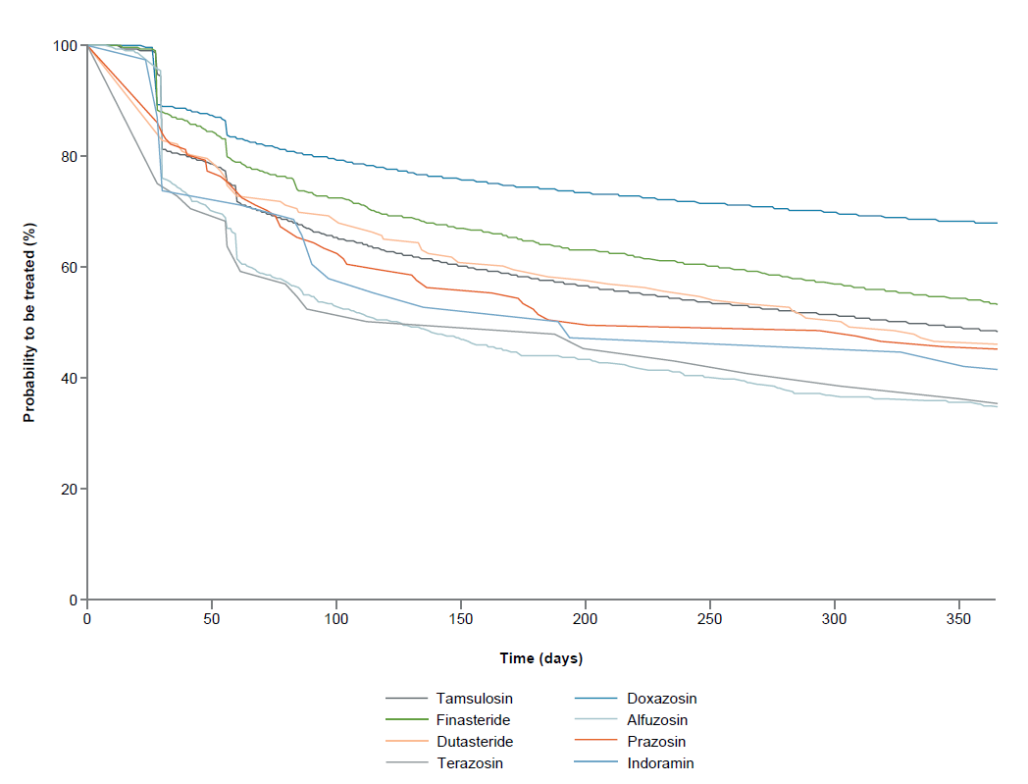

BPO: benign prostatic obstruction; TTD: time to discontinuation

Supplementary Figure 2. TTD for combinations in male BPO sub-cohort (Kaplan-Meier estimates)†
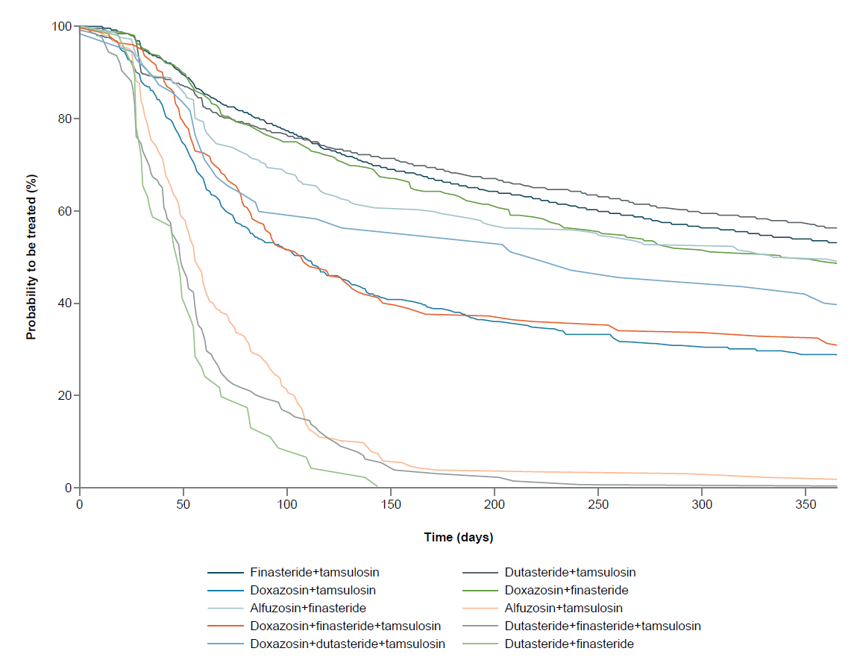
BPO: benign prostatic obstruction; TTD: time to discontinuation
†The 10 most frequent combination pharmacotherapies have been plotted

Supplementary Figure 3. TTD for duloxetine in female SUI sub-cohort (Kaplan-Meier estimates)

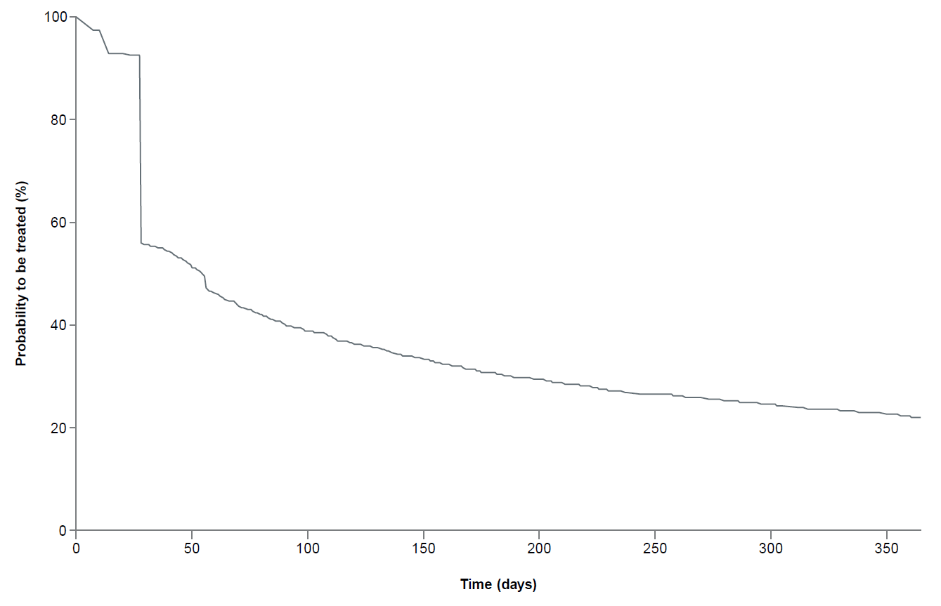
SUI: stress urinary incontinence; TTD: time to discontinuation

Supplementary Figure 4. Kaplan-Meier curves for TTD sensitivity analysis: (A) monopharmacotherapy; (B) combination pharmacotherapy (male BPO/LUTS population†)
A
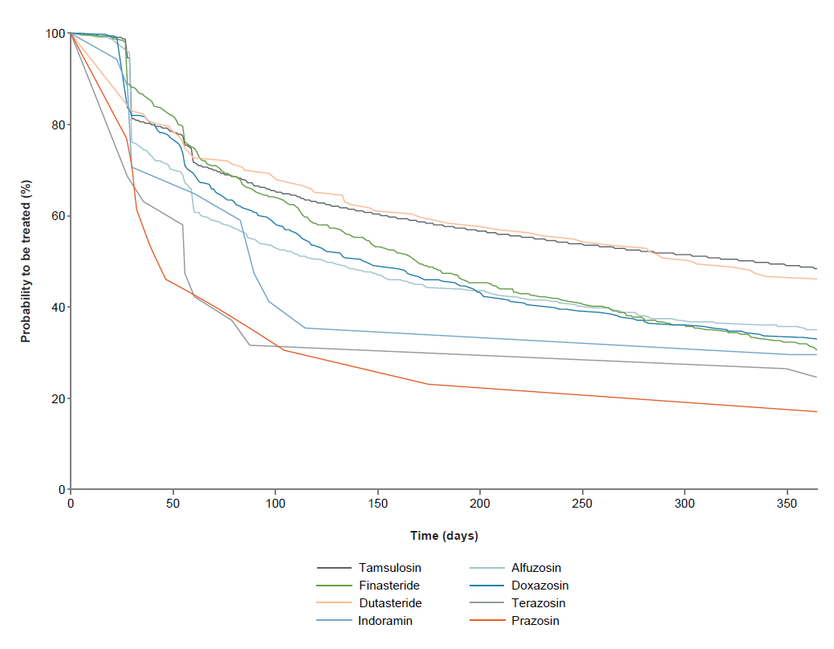
B
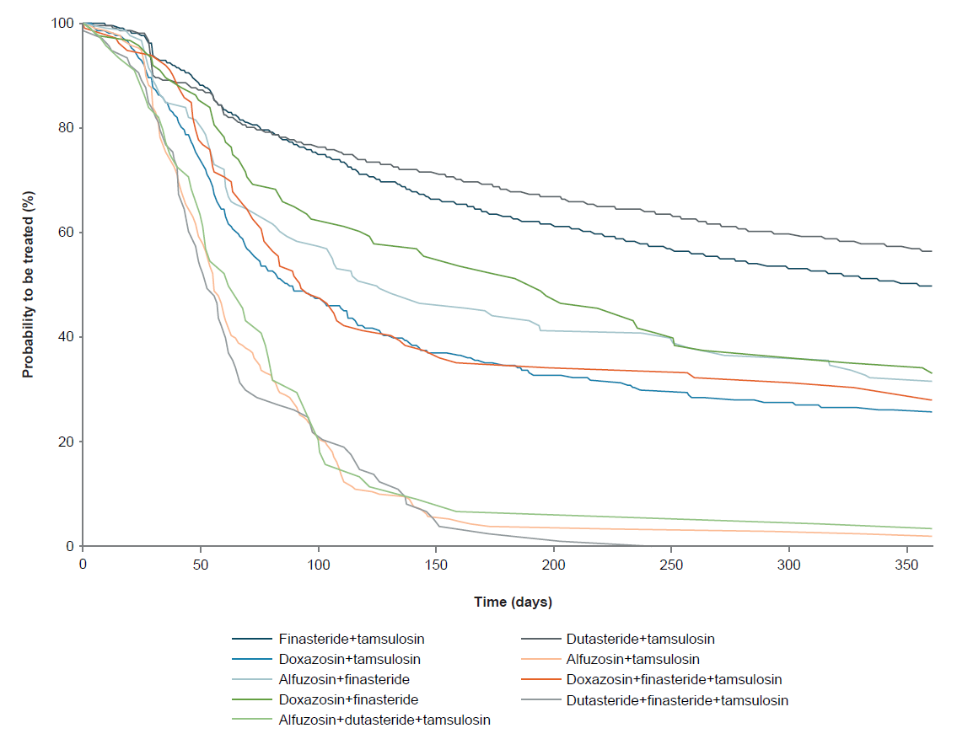
BPO: benign prostatic obstruction; LUTS: lower urinary tract symptoms; TTD: time to discontinuation
†patients with a confirmed LUTS diagnosis only
References
1. Morant SV, Reilly K, Bloomfield GA, Chapple C: Diagnosis and treatment of lower urinary tract symptoms suggestive of overactive bladder and bladder outlet obstruction among men in general practice in the UK. Int J Clin Pract 2008, 62(5):688-694.

