Source: Secretariat of Finance and Public Credit – SHCP, Mexico
Source: Secretariat of Finance and Public Credit – SHCP, Mexico

Source: Secretariat of Finance and Public Credit – SHCP, Mexico

Source: Secretariat of Finance and Public Credit – SHCP, Mexico
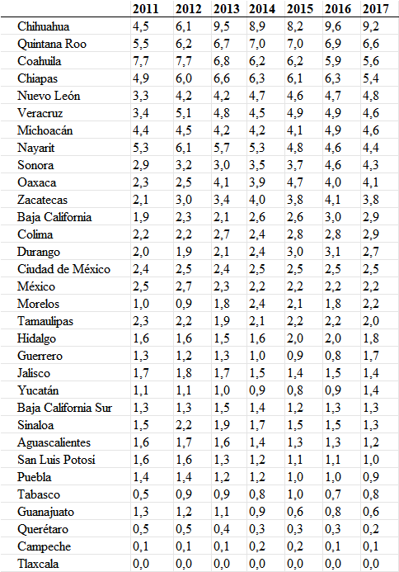
Source: Secretariat of Finance and Public Credit – SHCP, Mexico

