Dietary mannose supplementation in phosphomannomutase 2 deficiency (PMM2-CDG)

Roman Taday¹, Marianne Grüneberg¹, Ingrid DuChesne¹, Janine Reunert¹,
Thorsten Marquardt¹

¹University Children’s Hospital Münster, Department of General Pediatrics, Münster, Germany

Supplements

Figure S1: Layout showing the metabolic fate of mannose in mammalian cells. PMM2 is an
essential enzyme, catalyzing the conversion of mannose-6-phosphate to mannose-1
phosphate, which is the first step in the synthesis of glycosylation intermediates including
GDG mannose, GDP-fucose and dolichol-P-mannose. These activated mannose donors are
required for N- and O- glycosylation, the biosynthesis of glycophosphotidylinositol anchors
and C- mannosylation. PMM2 deficiency results in reduced amounts of Man-1-P and Man-6-P
and unoccupied N-linked glycosylation sites on a number of proteins. [1] Substances enhancing the impact of check points (green box) of glycosylation flux may improve the effect of exogenous mannose supplementation.

A)

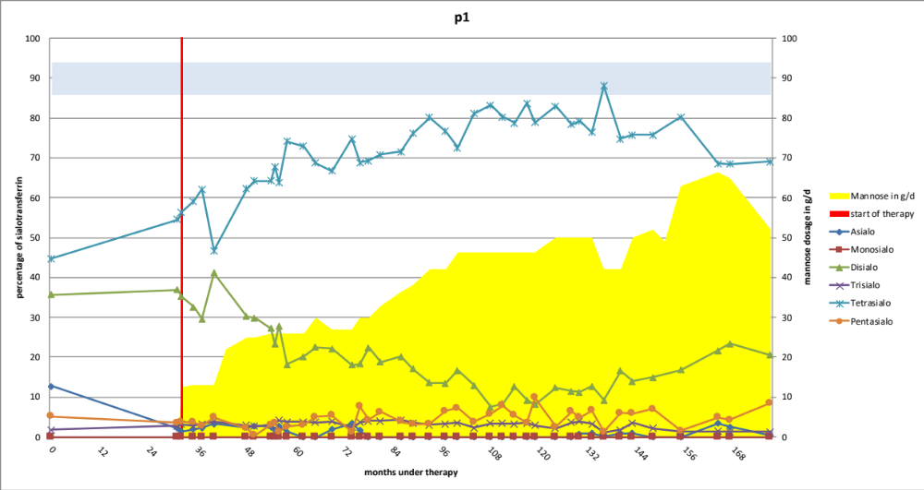

C)

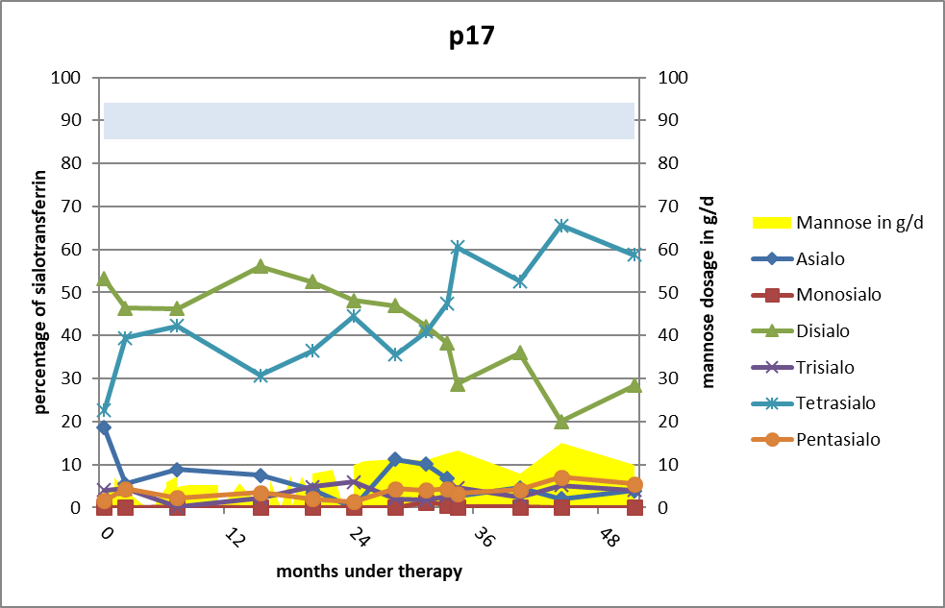

Figure S2: Two patients, who were still treated with mannose at the time the data was collected. Sialo-transferrin values quantified by HPLC during mannose supplementation. Tetrasialo-Tf reference is labelled in blue area. We find a lag- time of stagnating values, before we have a rather rapid increase of the sialo-transferrin pattern.

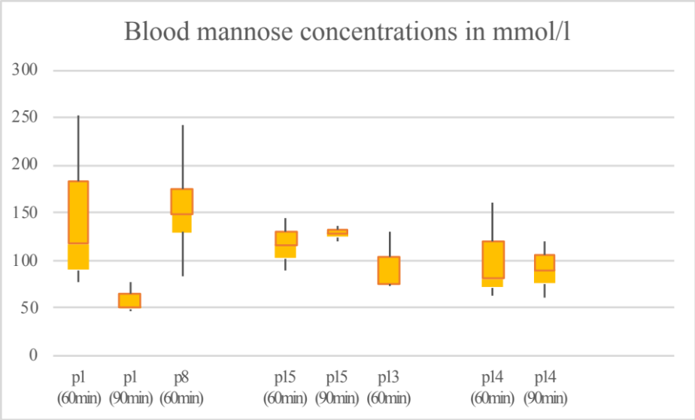

Figure S3: Blood mannose concentration of n=5 patients obtained 60 and 90 min after ingestion of 1g/kg b.w. mannose. It can be seen, that the respective patients showed a broad variance of blood mannose concentration at the same time after ingestion.

Table S1: Age and genotype of the patients treated with mannose, divided as per response
Patient | Age when started mannose treatment | Mutation  RefSeq NM_000303.3(PMM2)  NP_000294.1
Responders
p1 | 4 years 1 month | c.{422G>A} (p.Arg141His) [R141H]+  c.{686A>C} (p.Tyr229Ser) [Y229S]
p4 | 23 years 7 months | c.{357C>A} (p.Phe119Leu) [F119L]+  c.{422G>A} (p.Arg141His) [R141H]
p7 | 1 year | c.{377T>C} (p.Met126Thr) [M126T]+  c.{422G>A} (p.Arg141His) [R141H
p9 | 3 years 8 months | c.{357C>A} (p.Phe119Leu) [F119L]+  c.{422G>A} (p.Arg141His) [R141H]
p10 | 8 years | c.{377T>C} (p.Met126Thr) [M126T]+  c.{422G>A} (p.Arg141His) [R141H
p12 | 2 years | c.{338C>T} (p.Pro113Leu) [P113L]+  c.{422G>A} (p.Arg141His) [R141H
p13 | 1 year 8 months | c.{470T>C} (p.Phe157Ser) [F157S] +  c.{710C>T} (p.Thr237Met) [T237M]
p14 | 8 months | c.{640-15479C>T} [IVS7+19138]  c.{667G>A} (p.Asp223Asn) [D223H]
p16 | 1 year | c.{422G>A} (p.Arg141His) [R141H]+  c.{338C>T} (p.Pro113Leu) [P113L]
p17 | 1year | c.{357C>A} (p.Phe119Leu) [F119L]+  c.{422G>A} (p.Arg141His) [R141H]
p19 | 1 year | c.{422G>A} (p.Arg141His) [R141H]+  c.{640-9T>A} [IVS7-9T>A]
p20 | 5 years 2 months | c.{199G>A}(p.Val67Met) [V48M]* +  c.{422G>A} (p.Arg141His) [R141H]
Non-Responders
p2 | 27 years | c.{357C>A} (p.Phe119Leu) [F119L]+  c.{669C>G} (p.Asp223Glu) [D223E]
p3 | 11 years 11 months | c.{357C>A} (p.Phe119Leu) [F119L]+  c.{422G>A} (p.Arg141His) [R141H]
p5 | 3 years 7 months | c.{422G>A} (p.Arg141His) [R141H]+  c.{663C>G}(p.Phe221Leu) [F221L]
p6 | 2 years | c.{338C>T} (p.Pro113Leu) [P113L]+  c.{422G>A} (p.Arg141His) [R141H]
p8 | 1 year | c.{357C>A} (p.Phe119Leu) [F119L]+  c.{357C>A} (p.Phe119Leu) [F119L]
p11 | 17 years | c.{422G>A} (p.Arg141His) [R141H]+  c.{677C>G} (p.Thr226Ser) [T226S]
p15 | 2 years | c.{422G>A} (p.Arg141His) [R141H]+  c. {531 G>C}(p.Gln177His) [Q177H]
p18 | 9 months | c.{422G>A} (p.Arg141His) [R141H]+  c.{710C>T} (p.Thr237Met) [T237M]
Table S1: The mean PMM2-activity = 3,625% ± 4,6% (n=8). Median age of responders: 1,85 years. Median age of non-responders: 2,8 years.
* RefSeq: NG_009209.1:g.11975G>A

References
1. Ichikawa, M.; Scott, D.A.; Losfeld, M.-E.; Freeze, H.H. The metabolic origins of mannose in glycoproteins. J. Biol. Chem. 2014, 289, 6751–6761.

