APPENDIX D
Calibration plots for the females of any age target population
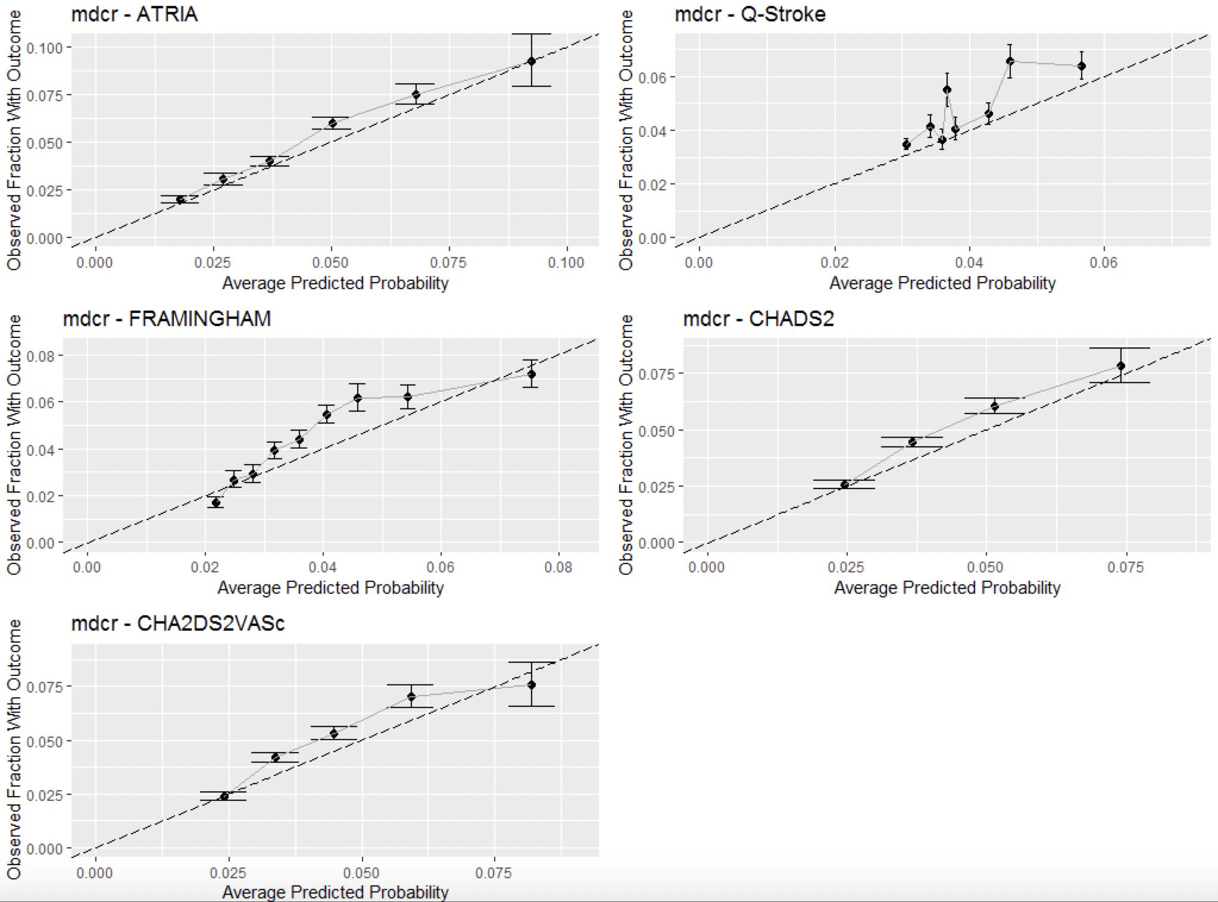
Figure 1- Calibration plots of the models applied to MDCR claims data after recalibrating
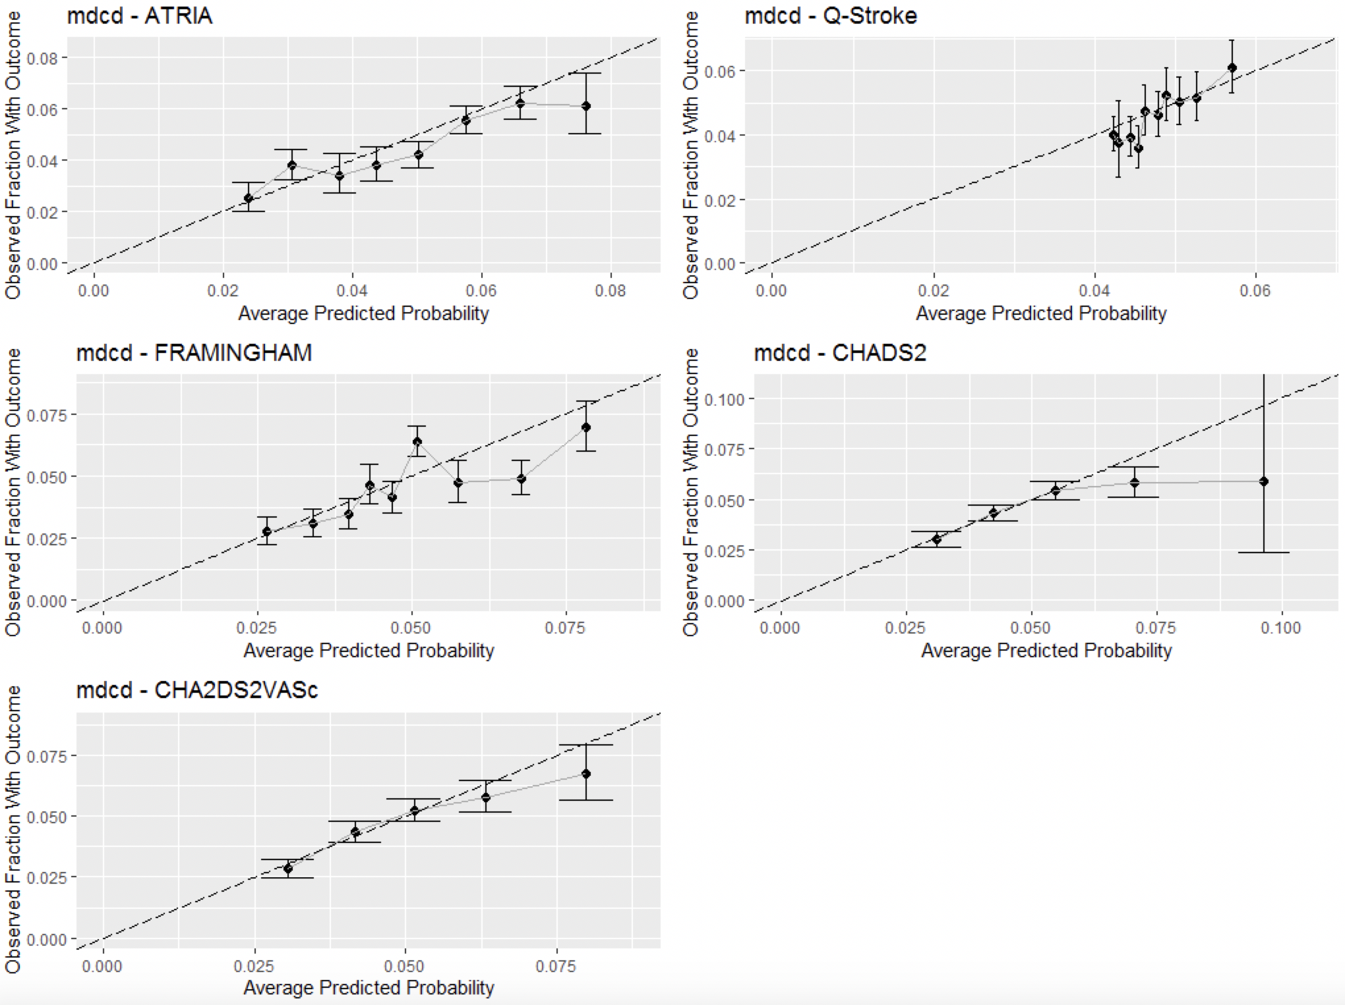
Figure 2- Calibration plots of the models applied to MDCD claims data after recalibrating
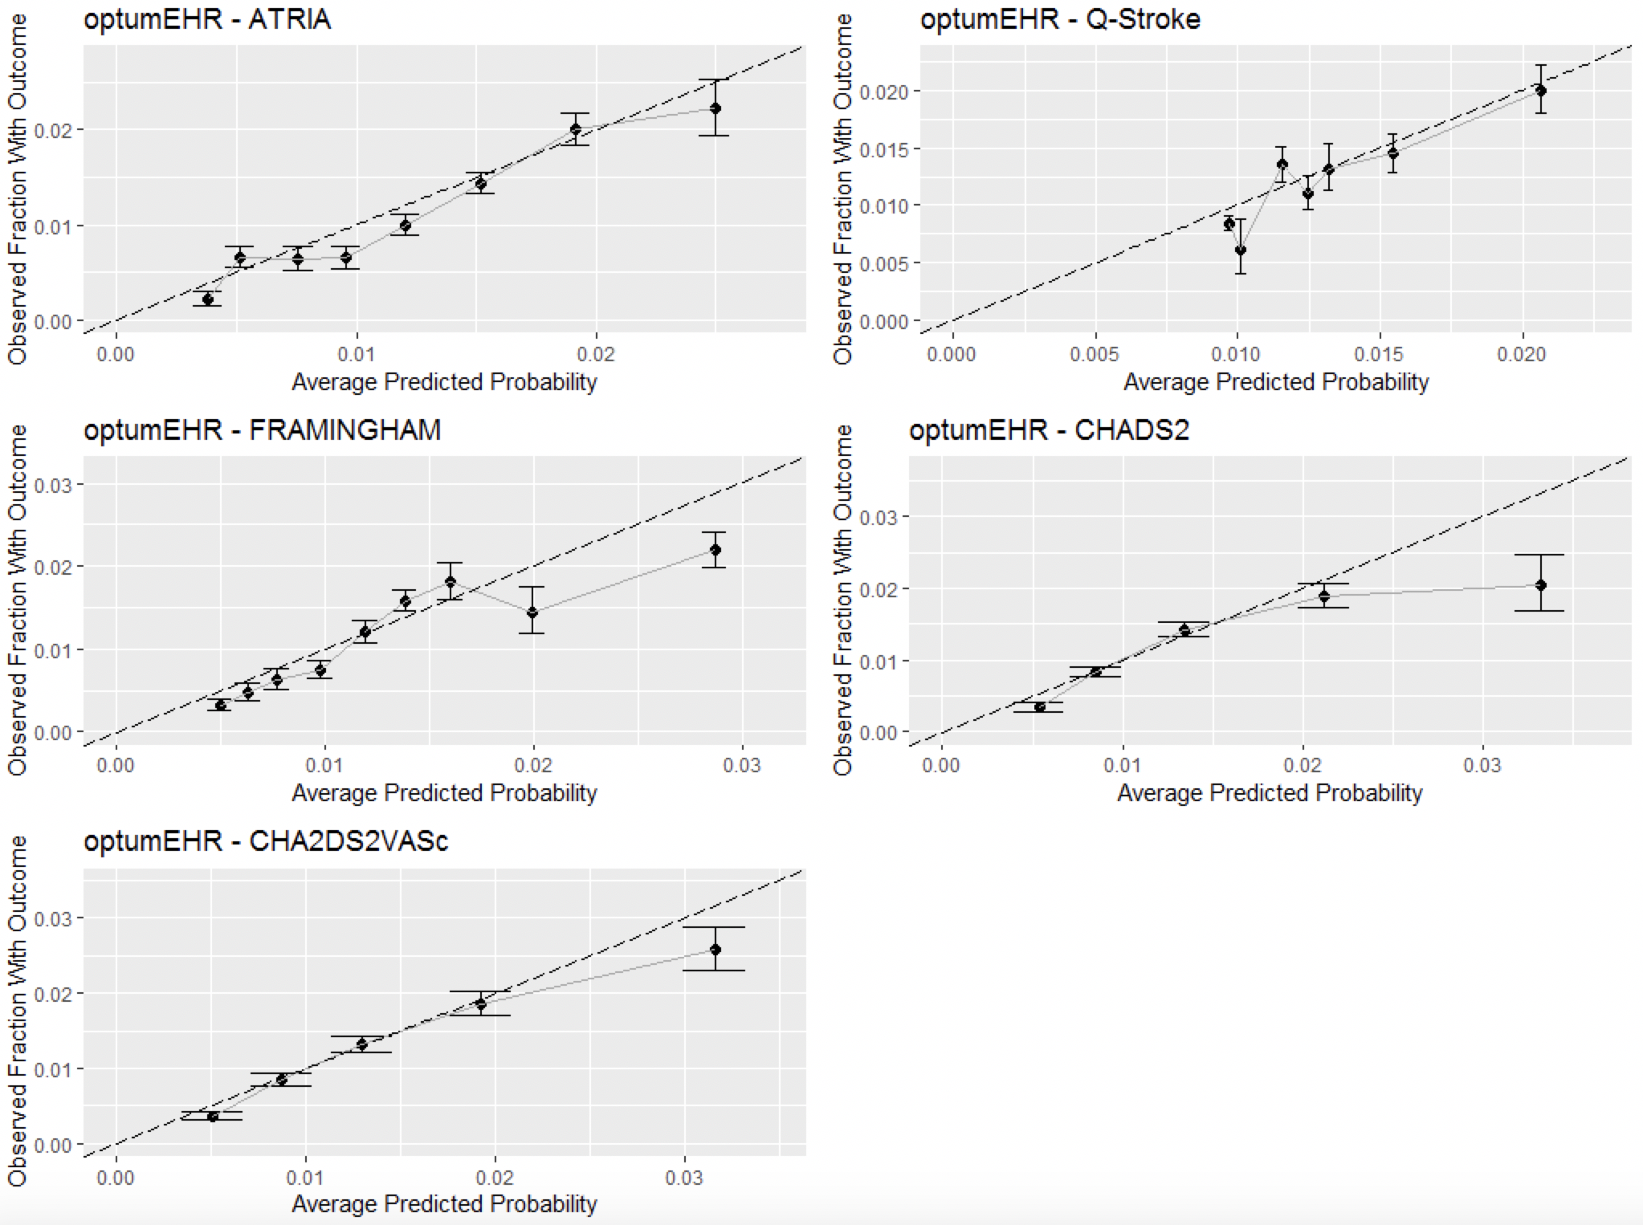
Figure 3- Calibration plots of the models applied to Optum EHR data after recalibrating
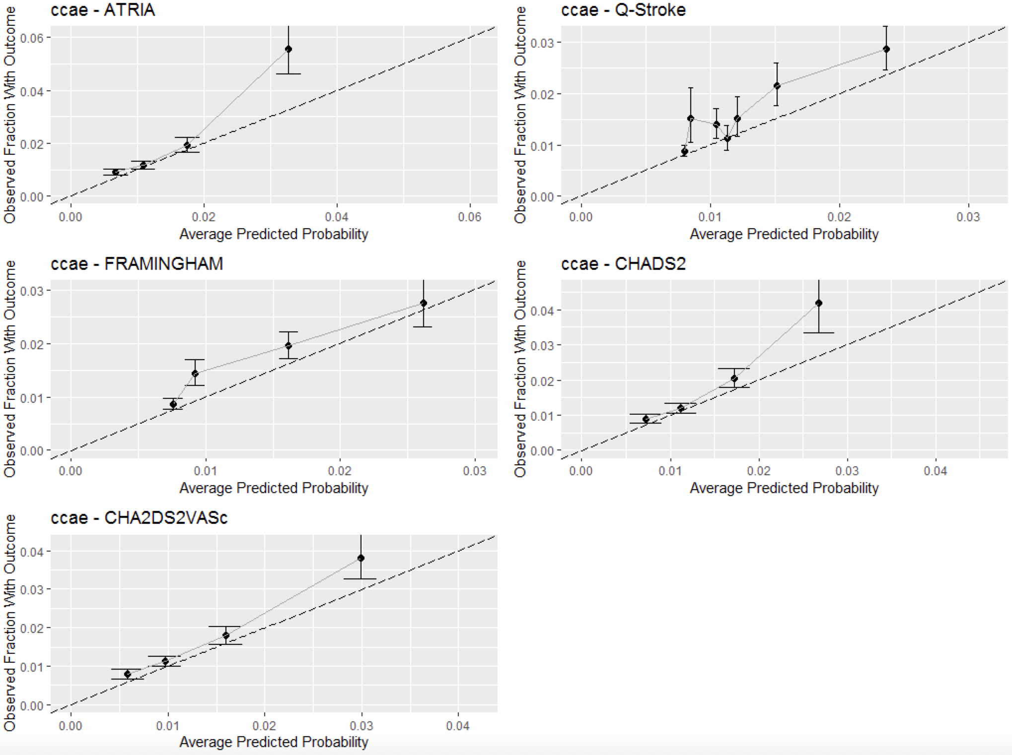
Figure 4- Calibration plots of the models applied to CCAE claims data after recalibrating
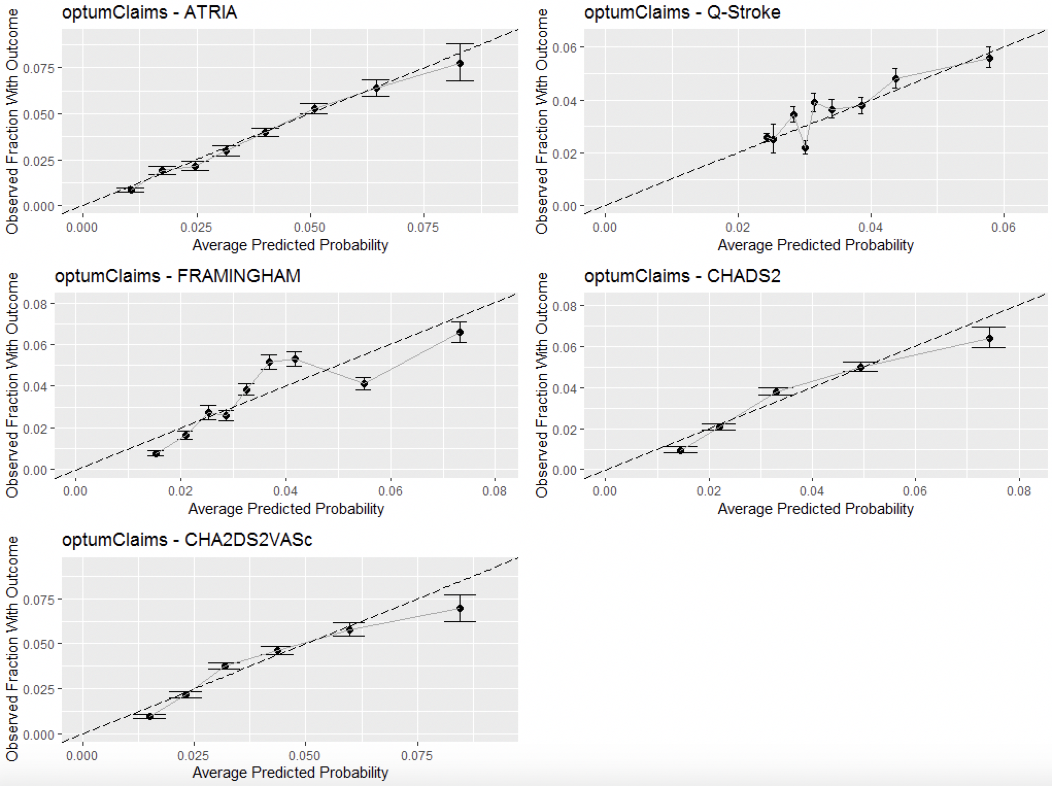
Figure 5- Calibration plots of the models applied to Optum claims data after recalibrating
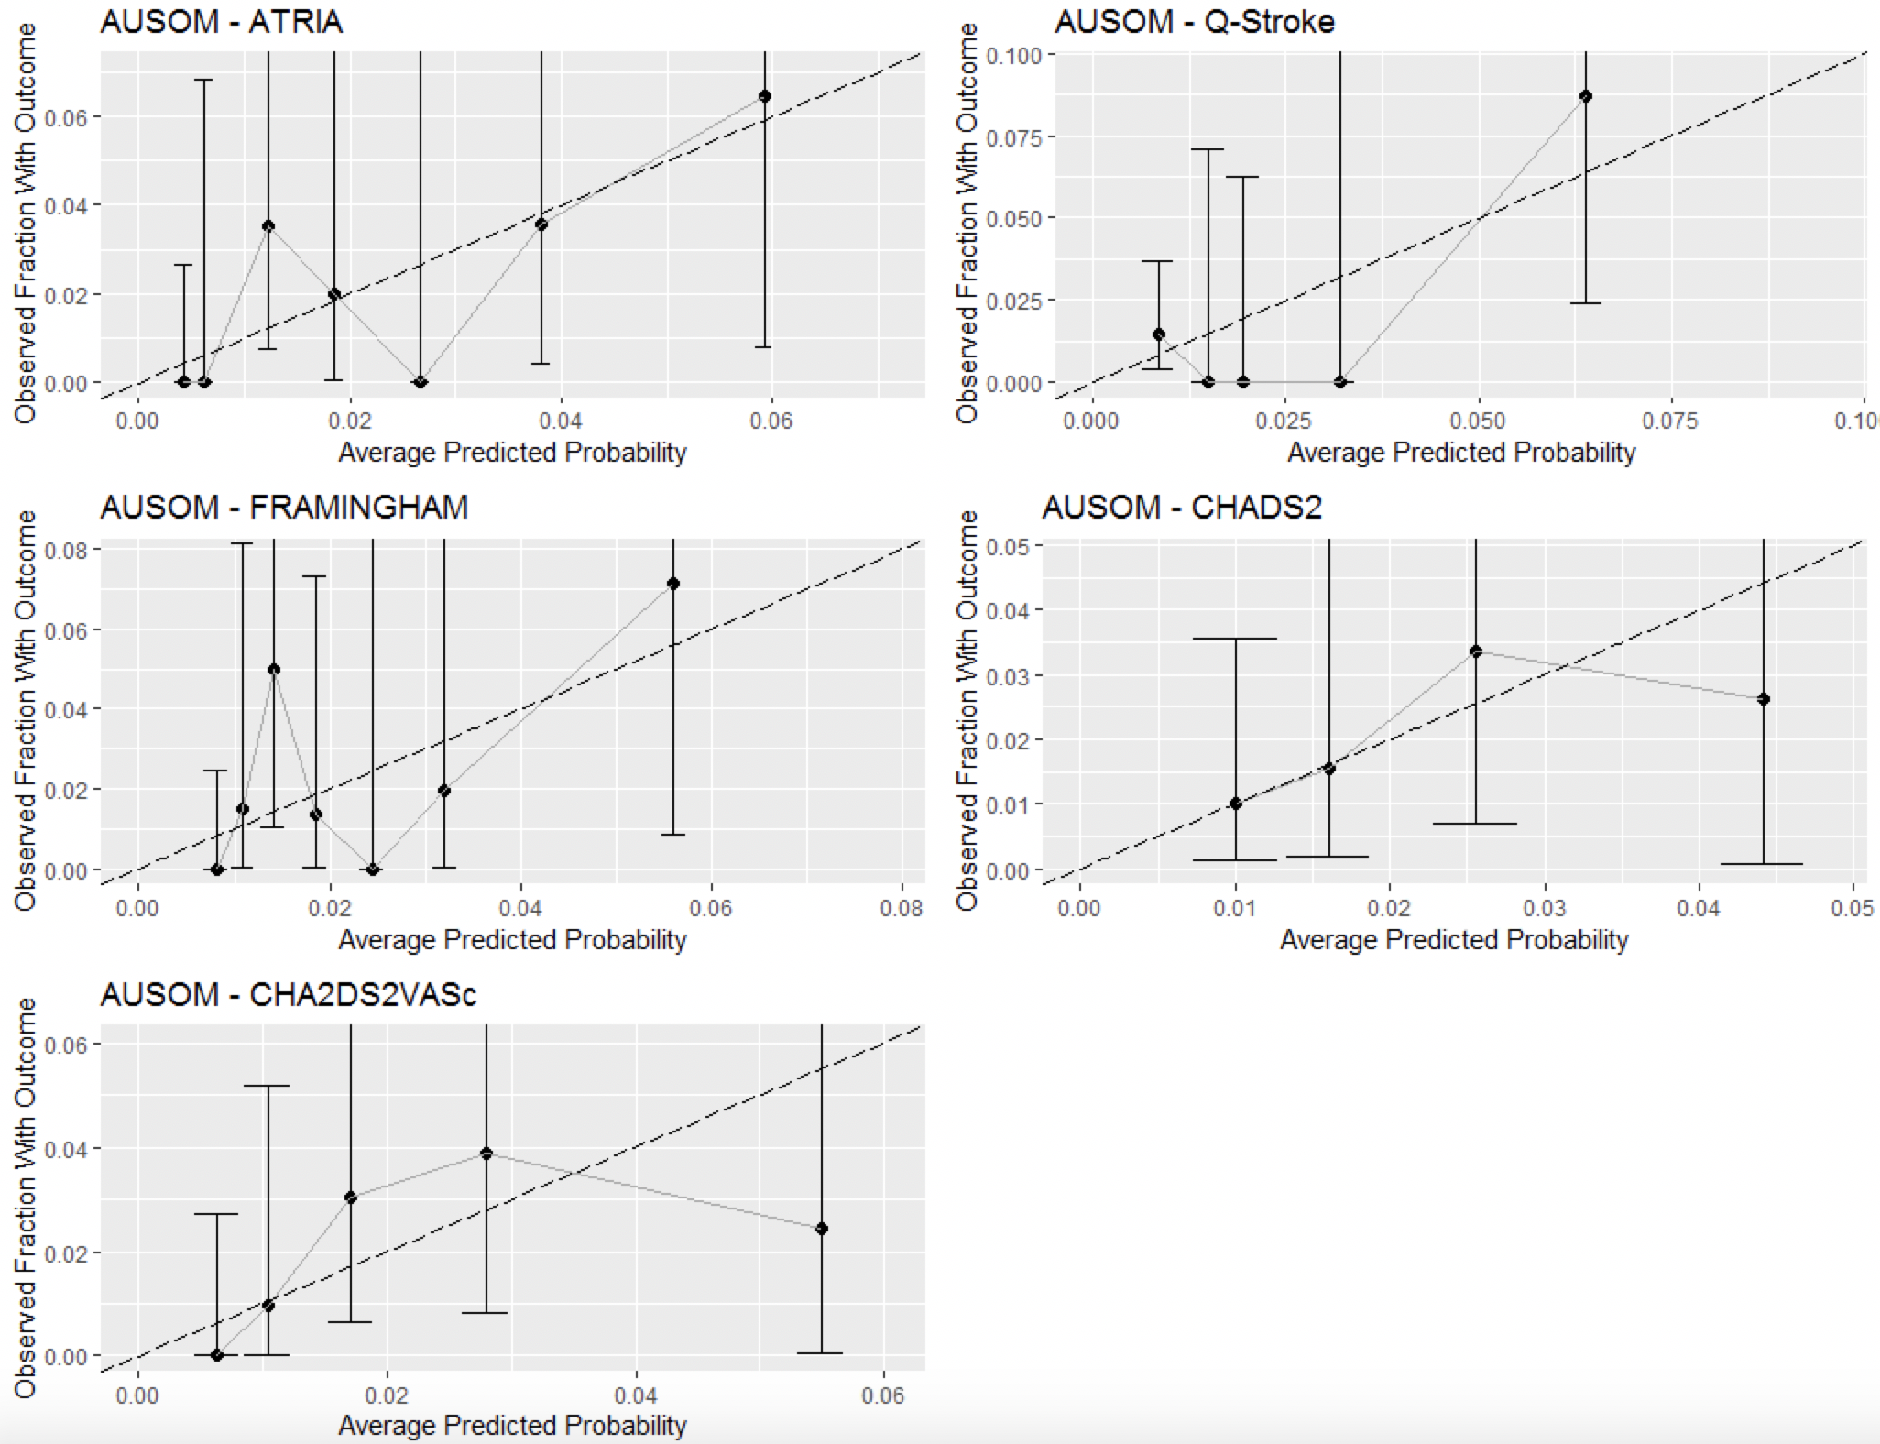
Figure 6 - Calibration plots of the models applied to AUSOM data after recalibrating

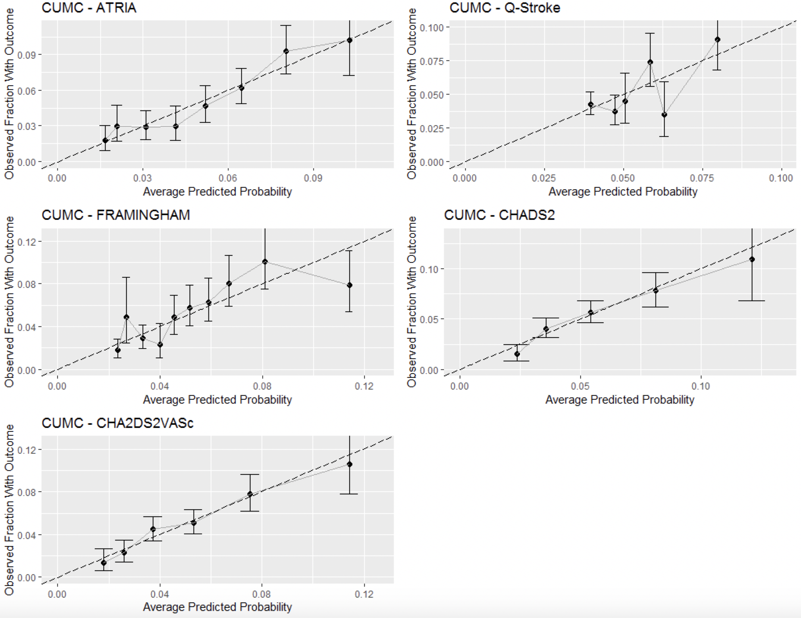
Figure 7 Calibration plots of the models applied to CUMC data after recalibrating

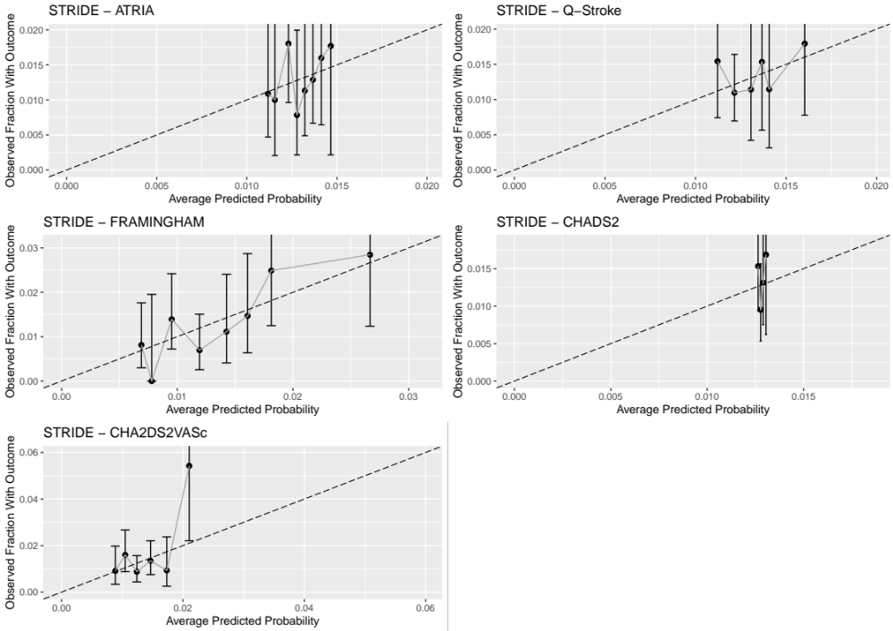
Figure 8 Calibration plots of the models applied to STRIDE data after recalibrating

The recalibration intercept and gradient (when recalibrating using a linear model where x is the total model score and y is the outcome class) for the target population of any age female.

Table 7 - The recalibration intercept and gradient values per database and model
Database | Model | Intercept | Gradient
Optum Claims | ATRIA | -4.93 | 0.25
 | Q-stroke | -3.96 | 0.56
 | Framingham | -4.95 | 0.13
 | CHADS₂ | -4.22 | 0.42
 | CHA₂DS₂VASc | -4.74 | 0.33
Optum EHR | ATRIA | -5.81 | 0.23
 | Q-stroke | -4.93 | 0.63
 | Framingham | -6.19 | 0.15
 | CHADS₂ | -5.22 | 0.46
 | CHA₂DS₂VASc | -5.95 | 0.40
CCAE | ATRIA | -5.48 | 0.48
 | Q-stroke | -5.26 | 0.90
 | Framingham | -6.03 | 0.19
 | CHADS₂ | -4.92 | 0.44
 | CHA₂DS₂VASc | -5.65 | 0.51
MDCD | ATRIA | -3.96 | 0.15
 | Q-stroke | -3.19 | 0.17
 | Framingham | -4.13 | 0.09
 | CHADS₂ | -3.66 | 0.27
 | CHA₂DS₂VASc | -4.02 | 0.22
MDCR | ATRIA | -5.51 | 0.32
 | Q-stroke | -3.66 | 0.43
 | Framingham | -4.95 | 0.13
 | CHADS₂ | -3.97 | 0.35
 | CHA₂DS₂VASc | -4.53 | 0.29
AUSOM | ATRIA | -5.82 | 0.37
 | Q-stroke | -5.80 | 2.11
 | Framingham | -5.93 | 0.19
 | CHADS₂ | -4.59 | 0.48
 | CHA₂DS₂VASc | -5.57 | 0.50
CUMC | ATRIA | -4.32 | 0.23
 | Q-stroke | -3.45 | 0.55
 | Framingham | -4.55 | 0.14
 | CHADS₂ | -3.73 | 0.43
 | CHA₂DS₂VASc | -4.37 | 0.37
STRIDE | ATRIA | -4.52 | 0.04
 | Q-stroke | -4.55 | 0.31
 | Framingham | -5.70 | 0.12
 | CHADS₂ | -4.36 | 0.01
 | CHA₂DS₂VASc | -4.89 | 0.17

