APPENDIX A – Variable definitions

Variable | Snomed concept ids | ICD10CM mapped | ICD9CM mapped | Read mapped
Stroke or transient ischemic attack | 4110192, 45767658, 45772786, 4108356, 4110190, 4110189, 4043731, 374060, 373503, 374055, 4338523, 4112020, 4110194, 4108357, 4110195, 4108360, 4043734, 4048785, 40485430, 46272244, 4139517, 36712813, 36712812 | I63.349, I63.19, I63.49, I63.441, I63.231, I63.011, I63.00, I63.429, I63.332, I63.131, I63.30, I63.412, I63.341, I63.439, I63.12, I63.031, I63.419, I63.39, I63.331, I63.322, I63.139, I63.449, I63.132, I63.339, I63.312, I63.10, I63.411, I63.232, I63.119, I63.032, I63.019, I63.321, I63.311, I63.112, I63.442, I63.422, I63.40, I63.20, I63.02, I63.432, I63.431, I63.319, I63.29, I63.421, I63.342, I63.329, I63.239, I63.111, I63.039, I63.09, I63.012, I63.443, I63.433, I63.423, I63.413, I63.343, I63.333, I63.323, I63.313, I63.233, I63.133, I63.113, I63.033, I63.013, G46.2, G46.1, G46.0, G45.9, G45.8, G45.3, G45.1, G45.0, I63.44, I63.43, I63.42, I63.41, I63.4, I63.34, I63.33, I63.32, I63.31, I63.3, I63.23, I63.2, I63.13, I63.11, I63.1, I63.03, I63.01, I63.0, G45 | 434.91, 434.01, 434.11, 433.11, 433.21, 433.31, 433.81, 433.91, 436, 435, 435.0, 435.8, 435.9 | G640000, G641000, G63..11, G63y000, G63y100, F423600, Fyu5500, G65..00, G65..12, G65..13 ,G650.00, G650.11, G653.00, G654.00, G656.00, G657.00, G65y.00, G65z.00, G65zz00, G660.00, G661.00, G662.00,
Diabetes | 46274096, 45766052, 45766051, 45766050, 45757789, 45757674, 45757474, 45757129, 45757124, 45757079, 45757077, 44793114, 44793113, 44792134, 44787902, 43531645, 43531644, 43531643, 43531642, 43531641, 43531640, 43531020, 43531019, 43531018, 43531017, 43531016, 43531015, 43531014, 43531013, 43531012, 43531011, 43531010, 43531009, 43531008, 43531007, 43531006, 42538715, 42537681, 42536605, 42536604, 42535539, 40482883, 37396524, 37117810, 37117219, 37116960, 37116379, 37110117, 37110068, 37110041, 37109305, 37018765, 37018566, 36717215, 36716258, 36715417, 36715051, 36714116, 36713275, 4327944, 4326434, 4322638, 4321756, 4304377, 4263902, 4252384, 4245270, 4240589, 4237068, 4235410, 4230254, 4212631, 4202383, 4200875, 4198296, 4196141, 4193704, 4192852, 4178790, 4178452, 4166381, 4152858, 4151281, 4145827, 4144583, 4143529, 4140808, 4136889, 4131907, 4130166, 4130164, 4130162, 4129524, 4129519, 4129516, 4129378, 4102018, 4099741, 4099653, 4099652, 4099651, 4099334, 4099217, 4099215, 4099214, 4096671, 4096670, 4096668, 4096042, 4096041, 4084643, 4079850, 4063043, 4063042, 4062687, 4062686, 4062685, 4058243, 4048202, 4047906, 4034962, 4034960, 4030061, 4024659, 4008576, 4006979, 765478, 443412, 443012, 201826, 201820, 201531, 201530, 201254, 195771, 194700, 193323, 192691 | O24.32, O24.119, O24.02, E11.65, E10.621, E09.638, E08.8, E08.618, E08.44, E08.40, O24.813, E13.69, E11.622, E11.610, E10.649, E10.10, E09.52, E08.329, E08.321, O24.911, E13.65, E11.69, E11.22, E08.65, E08.51, E08.49, E08.43, O24.83, O24.439, E11.649, E09.618, E09.49, E08.351, O24.92, O24.319, O24.12, O24.111, O24.012, E13.610, E11.618, E11.01, E09.8, E09.359, E09.341, E09.11, E08.00, O24.434, O24.429, O24.414, O24.13, O24.112, E13.630, E13.618, E11.621, E10.622, E09.649, E09.51, E09.41, E09.349, E08.621, E08.59, E08.341, O24.812, O24.03, E10.610, E09.621, E09.321, E09.319, E09.311, E09.29, E09.01, O24.919, O24.430, E09.44, E08.9, E08.630, E08.628, E08.10, O24.912, O24.113, E13.638, E13.621, E13.10, E11.638, E09.620, E09.59, E09.339, E08.36, O24.93, O24.811, O24.424, O24.311, E13.00, E11.641, E09.39, E09.22, E09.00, E08.649, E08.52, E08.41, E08.359, O24.419, O24.312, E13.622, E10.630, E09.65, E09.622, E08.01, O24.819, O24.410, E09.641, E09.329, E09.21, E08.641, E08.39, E08.319, E08.22, O24.011, E10.69, E10.638, E09.40, E09.351, E08.622, E08.42, O24.913, O24.019, E11.00, E10.52, E09.630, E09.42, E09.36, E08.69, E08.610, E08.349, E08.29, O24.420, O24.013, E10.618, E09.69, E09.628, E09.10, E08.638, E08.11, O24.82, O24.33, O24.313, E13.649, E11.630, E11.52, E10.65, E09.9, E09.610, E09.43, E09.331, E08.620, E08.311, E08.21, O24.435, O24.425, O24.415, E11.37X9, E11.37X3, E11.37X2, E11.37X1, E11.37, E09.37X9, E09.37X3, E09.37X2, E09.37X1, E09.37, E09.3599, E09.3593, E09.3592, E09.3591, E09.3559, E09.3553, E09.3552, E09.3551, E09.355, E09.3549, E09.3543, E09.3542, E09.3541, E09.354, E09.3539, E09.3533, E09.3532, E09.3531, E09.353, E09.3529, E09.3523, E09.3522, E09.3521, E09.352, E09.3519, E09.3513, E09.3512, E09.3511, E09.3499, E09.3493, E09.3492, E09.3491, E09.3419, E09.3413, E09.3412, E09.3411, E09.3399, E09.3393, E09.3392, E09.3391, E09.3319, E09.3313, E09.3312, E09.3311, E09.3299, E09.3293, E09.3292, E09.3219, E09.3213, E09.3212, E09.3211, E08.37X9, E08.37X3, E08.37X2, E08.37X1, E08.37, E08.3599, E08.3593, E08.3592, E08.3591, E08.3559, E08.3553, E08.3552, E08.3551, E08.355, E08.3549, E08.3543, E08.3542, E08.3541, E08.354, E08.3539, E08.3533, E08.3532, E08.3531, E08.353, E08.3529, E08.3523, E08.3522, E08.3521, E08.352, E08.3519, E08.3513, E08.3512, E08.3511, E08.3499, E08.3493, E08.3492, E08.3491, E08.3419, E08.3413, E08.3412, E08.3411, E08.3393, E08.3392, E08.3391, E08.3313, E08.3312, E08.3311, E08.3299, E08.3293, E08.3292, E08.3291, E08.3219, E08.3213, E08.3212, E08.3211, P70.2, E13.9, E13.8, E11.9, E11.8, E10.9, E10.8, O24.91, O24.9, O24.81, O24.8, O24.43, O24.42, O24.41, O24.4, O24.31, O24.3, O24.11, O24.1, O24.01, O24.0, O24, E13.64, E13.63, E13.61, E13.6, E13.1, E13.0, E13, E11.64, E11.63, E11.61, E11.6, E11.0, E11, E10.64, E10.63, E10.61, E10.6, E10.1, E10, E09.64, E09.63, E09.62, E09.61, E09.6, E09.5, E09.4, E09.35, E09.34, E09.33, E09.32, E09.31, E09.3, E09.2, E09.1, E09.0, E09, E08.64, E08.63, E08.62, E08.61, E08.6, E08.5, E08.4, E08.35, E08.34, E08.32, E08.31, E08.3, E08.2, E08.1, E08.0, E08, E11.10, E11.1 | 648, 250.2, 250.02, 250, 249.51, 249.31, 249, 648.01, 249.71, 249.41, 249.3, 249.1, 249.1, 250, 249.4, 250, 249.4, 648.02, 648, 250.21, 249.3, 249.01, 249, 249.2, 648.04, 249.91, 249.6, 249.9, 249.9, 249.8, 249.7, 249.5, 249.81, 249.6, 250.22, 249.61, 249.5, 648.03, 250.03, 249.8, 249.7, 250.01, 249.11, 249, 775.1, 249.21, 249.2 | C10Q.00, C10M.00, C10F411, C10EH00, C10EE11, C109J11, C109G12, C100011, C10K000, C108512, C10P000, C10ER00, C10EE12, C10E611, C108E11, L180900, C10y100, C10H.00, C10FD11, C109F11, C109512, C100112, C100000, C10E912, C10E312, C10A100, C109G00, C10J000, C108E12, C1zy600, C10P111, C10P100, C10FF00, C10F500, C10A500, C11y000, C10yy00, C10EA12, C10E911, C10B000, C10AW00, C109G11, C109400, C108H12, C108.00, C10..00, L180800, L180300, C10P.00, C10F900, C10EA00, C109H00, C109F00, C108A12, C100111, L180z00, C10yz00, C10N000, C10M000, C10EE00, C109D12, C109911, C109.11, C109.00, C102000, L180X00, C10H000, C10E511, C109J00, C109411, L180400, Cyu2100, C10L.00, C10F.11, C10AX00, C10A600, C10A.11, C109500, PKyP.00, L180600, L180000, C1zy311, C10FG00, C10D.11, C109D11, C10E.00, C10A700, C10A200, C109J12, C108.11, C100100, L180700, C10FS00, C10D.00, C10C.12, C109H11, C108A00, Cyu2.00, C10J.00, C10FH11, C10FF11, C109D00, C109912, C109412, C108z00, C108E00, C108611, Q441.00, C10FG11, C10F911, C108A11, Cyu2000, C10y000, C108y00, C10G.00, C10E600, C108511, C102100, C100z00, L180100, C10E.11, C109511, C109.13, C108911, C10K.00, C10F400, C10G000, C10EH11, L180811, L180.00, C10FJ11, C10FJ00, C10C.00, C10B.00, C10A.00, L180200, C1zy300, C10P011, C10FD00, C10EA11, C10E900, C109F12, C108612, C108300, C108.13, PKyP.11, Lyu2900, C10N.00, C10EH12, C108H11, C108912, C108900, Cyu2200, C10E500, C10N100, C10E.12, C108H00, C100.00, C10F511, C10C.11, L180500, C10FH00, C10F.00, C109H12, C109900, C109.12, C108.12, L180B00, L180A00
Type 1 Diabetes | 45766051, 45757674, 43531009, 43531008, 42535539, 37018566, 36717215, 4152858, 4151281, 4145827, 4102018, 4099215, 4099214, 4096668, 4063042, 4047906, 443412, 201531, 201254 | E10.621, E10.649, E10.10, O24.012, E10.622, O24.03, E10.610, E10.630, O24.011, E10.69, E10.638, O24.019, E10.52, O24.013, E10.618, E10.65, E10.9, E10.8, O24.01, O24.0, E10.64, E10.63, E10.61, E10.6, E10.1, E10 | 250.01, 250.03, 250.21 | C10EH00, C10EE11, C100011, C108512, C10P000, C10ER00, C10EE12, C10E611, C108E11, C100000, C108E12, C10EA12, C10E911, C108H12, C108.00, C10EA00, C108A12, C10EE00, C102000, C10E511, C10E.00, C108.11, C108A00, C108E00, C108611, C108A11, C10y000, C10E600, C108511, C10E.11, C108911, C10EH11, C10P011, C10EA11, C10E900, C108612, C108.13, C10EH12, C108H11, C108912, C10E500, C10E.12, C108H00, L180500, C108.12
Type 2 Diabetes | 45766052, 45757474, 43531010, 36714116, 4321756, 4304377, 4230254, 4200875, 4198296, 4196141, 4193704, 4130162, 4129519, 4099651, 4099217, 4063043, 201826, 201530 | O24.119, E11.65, E11.622, E11.610, E11.69, E11.22, E11.649, O24.111, E11.618, E11.01, O24.13, O24.112, E11.621, O24.113, E11.638, E11.641, E11.00, E11.630, E11.52, E11.37X9, E11.37X3, E11.37X2, E11.37X1, E11.37, E11.9, E11.8, O24.11, O24.1, E11.64, E11.63, E11.61, E11.6, E11.0, E11, E11.10, E11.1 | 250.00, 250.02, 250.20, 250.22 | C10F411, C109J11, C109G12, C10FD11, C109F11, C109512, C100112, C109G00, C10P111, C10P100, C10FF00, C10F500, C109G11, C109400, C10F900, C109H00, C109F00, C100111, C109D12, C109911, C109.11, C109.00, C109J00, C109411, C10F.11, C109500, L180600, C10FG00, C109D11, C109J12, C100100, C109H11, C10FH11, C10FF11, C109D00, C109912, C109412, C10FG11, C10F911, C102100, C109511, C109.13, C10F400, C10FJ11, C10FJ00, C10FD00, C109F12, C10F511, C10FH00, C10F.00, C109H12, C109900, C109.12, L180B00
Hypertension [Part 1 of treated hypertension – must have hypertension codes in prior year and part 2 (antihypertensive) in prior 30 days] | 45757787, 4321603, 4302591, 4269358, 4263067, 4217486, 4215640, 4180283, 4159755, 4148205, 4083723, 4058987, 4034031, 320128, 317898, 312648 | I10 | 401, 401.0, 401.1, 401.9 | G20..00, G20..12, G200.00, G201.00, G20z.00
Proteinuria | 42689513, 37016364, 36712846, 36712845, 4338683, 4298811, 4265332, 4262273, 4252269, 4252096, 4247664, 4237908, 4231294, 4228055, 4211056, 4207847, 4205617, 4205574, 4198209, 4195061, 4185287, 4180750, 4173241, 4168230, 4156996, 4147279, 4140559, 4137160, 4132125, 4131811, 4128528, 4119281, 4099759, 4075748, 4059585, 4059124, 4059122, 4059121, 4056483, 4056482, 4056481, 4055902, 4055901, 4033489, 4008125, 75650, 74080 | R80.9, R80.8, R80.1, R80.3, R80.0, R80.2, N06.9, N06.8, N06.7, N06.6, N06.5, N06.4, N06.3, N06.2, N06.1, N06.0, R80, N06 | 791.0, 593.6 | R110z00, K0A4000, K0A4500, K0A4300, K0A4100, K0A4700, K0A4400, K0A4.00, K0A4600, K190X00, R110200, Kyu5G00, K136.00, K0A4200, K136.11, 4678.00, R110300, R110.00, R110100
eGFR<45 or end stage renal disease | 46273164, 45772751, 45769906, 45769904, 45768813, 45757393, 45757392, 44782717, 43021864, 43020455, 37018886, 4128200, 4125970, 4030520, 762973, 193782 | N18.6 | 585.6, 403.01 | K05..12, K050.00, K0D..00
Former smoker | 37109024, 37109023, 4103418, 4103417, 4099811, 765685, 765451, 764471, 764470, 764469, 764468, 437264 | O99.335, F17.221, F17.201, O99.330, F17.211, F17.291, O99.33 | 305.1 | E251.00, E251000, E251100, E251200, E251300, E251z00
Family history of coronary heart disease | 44789401 |  | - | -
Atrial fibrillation | 45768480, 44782442, 37395821, 4232697, 4232691, 4199501, 4154290, 4141360, 4119602, 4119601, 4117112, 4108832, 313217 | I48.91, I48.1, I48.0, I48.9, I48.2, I48, I48.21, I48.20, I48.19, I48.11 | 427.3, 427.31 | G573300, G573200, G573000, G573z00, G573500, G573.00, G573400, G573700
Coronary heart disease | 4113303, 4109649, 4109491, 4109490, 4109489, 4208928, 4265210, 43022038, 4020601, 44783200, 37115756, 4121641, 45766238, 44784623, 36712779, 4252385, 4048534, 4046022, 764507, 316995, 4304192, 4225958, 4209308, 4153091, 4134723, 4108215, 761921, 4127089, 315830, 42536628, 4124846, 45766267, 43021619, 43021618, 43021617, 43021616, 43020480, 40491974, 40491973, 4188546, 4187852, 4160783, 4160782, 4160781, 4113302, 4109648, 4109488, 4109487, 4108875, 4030427, 4029827, 4029362, 4029361, 4027245, 4016142, 4270354, 46269996, 44806109, 42872402, 40481919, 37016181, 36714444, 36712983, 36712982, 4242670, 4199962, 4178622, 4178321, 4175846, 4168972, 4161455, 4155962, 4155007, 4124682, 4119951, 4111393, 4108673, 764149, 764123, 317576, 43022037, 43022026, 43022025, 43021973, 43021937, 43021888, 43021886, 43021885, 43021796, 43021795, 43021631, 43021630, 43021628, 43021627, 43021615, 43021582, 43021581, 43021580, 43021579, 43021578, 43021574, 43021572, 43021570, 43021476, 43021475, 43021474, 43021472, 43021470, 43021437, 43021436, 43021435, 43021434, 43021432, 43021314, 43021313, 43021312, 43021311, 43021310, 43021309, 43021308, 43021307, 43021306, 43021305, 43021304, 43021303, 43021302, 43021301, 43021294, 43021193, 43020880, 43020689, 43020580, 43020579, 43020576, 43020575, 43020574, 43020573, 43020572, 43020571, 43020570, 43020569, 43020561, 42873052, 42873051, 42873050, 40491973, 4329430, 4328721, 4253217, 4206334, 4178750, 4152843, 4113303, 4113301, 4113300, 4113299, 4113298, 4113297, 4109649, 4109647, 4109646, 4109644, 4109642, 4109491, 4109487, 4109486, 4109485, 4109484, 4109483, 4108876, 4108874, 4108873, 4108872, 4069186, 4069185, 4030427, 4029827, 4029362, 4029361, 4027245, 4016142, 321109, 42536629, 42536628, 4069185, 316427, 43022045, 4243371, 4119613, 4108172, 4097848, 4069186 | I25.791, I25.110, I25.82, I25.721, I25.119, I25.751, I25.711, I25.111, I25.10, I25.118, I25.84, I25.41, I25.83, I25.701, I25.761, I25.731, I25.42, Q24.5, I24.0, I20.1, I25.81, I25.4, I25.11, I25.1 | 414.2, 411.81, 414.0, 414.00, 414.01, 414.3, 414.4, 746.85, 414.11 | P6y4600, G341200, P6y4500, 6y4300, P6y4100, P6y4z00, P6y4400, P6y4411, P6y4000, P6y4200, P6y4.00, P6y4500, P6y4600, G340000, G340.12, G340.00, G3...12, G340.11, G39..00, G3...11, G340100, G34z000, G704.00, P6y4411, G331.11, G331.00, G332.00, G311011, G30..12, G311000, G312.00, G30..16, SP07600, G72B100, SP00300
Congestive cardiac failure | 44784442, 44784345, 44782728, 44782713, 44782655, 44782428, 43022068, 43021826, 43021825, 36713488, 36712928, 36712927, 4327205, 4284562, 4242669, 4229440, 4215446, 4206009, 4184497, 4142561, 4139864, 4023479, 764874, 762003, 762002, 439698, 439696, 439694, 319835, 316994, 315295, 314378 | I50.30, I50.41, I50.42, I50.20, I50.22, I50.43, I50.23, I50.33, I50.31, I50.21, I50.40, I50.32, I13.0, I50.4, I50.3, I50.2, I50.82 | 402.01, 402.91, 428.0, 404.93, 402.11, 398.91, 404.13, 404.91, 404.11, 404.03, 404.01 | G580100, G580.11, G580.00, G211100, G1yz100, G580400, G210100, G234.00, G580000, G232.00, G580.14
Rheumatoid arthritis | 42539550, 42536657, 42534837, 42534836, 42534835, 42534834, 37395590, 37117421, 37108714, 37108591, 37108590, 4347065, 4344494, 4343936, 4311391, 4297651, 4296152, 4271003, 4269880, 4200987, 4179536, 4179378, 4162539, 4147418, 4117687, 4117686, 4116446, 4116445, 4116444, 4116443, 4116442, 4116441, 4116440, 4116439, 4116153, 4116152, 4116151, 4116150, 4116149, 4116148, 4115161, 4115051, 4115050, 4114444, 4114442, 4114441, 4114440, 4114439, 4103516, 4083556, 4035611, 4035427, 81097, 80809, 78230 | M08.972, M08.931, M08.912, M08.872, M08.842, M08.841, M08.449, M08.419, M08.242, M08.222, M08.079, M08.071, M08.061, M08.052, M08.041, M06.871, M06.841, M06.259, M06.242, M06.239, M06.20, M06.08, M06.041, M06.031, M06.011, M05.851, M05.741, M05.731, M05.672, M05.669, M05.661, M05.512, M05.449, M05.422, M05.242, M05.239, M05.219, M05.179, M05.011, M08.939, M08.469, M08.439, M08.421, M08.29, M08.232, M08.229, M08.049, M08.039, M08.031, M06.861, M06.819, M06.252, M06.222, M06.061, M05.852, M05.849, M05.822, M05.821, M05.679, M05.632, M05.621, M05.349, M05.211, M05.171, M08.269, M08.211, M06.829, M06.211, M06.00, M05.832, M05.779, M05.771, M05.742, M05.711, M05.529, M05.519, M05.442, M05.419, M05.412, M05.411, M05.29, M05.259, M05.241, M05.221, M08.839, M08.821, M08.471, M08.452, M08.221, M08.212, M06.872, M06.212, M06.019, M05.772, M05.662, M05.641, M05.629, M05.622, M05.551, M05.541, M05.532, M05.469, M05.271, M05.269, M05.229, M05.141, M05.112, M05.10, M05.051, M08.949, M08.851, M08.462, M08.279, M08.272, M08.252, M08.029, M06.89, M06.272, M06.261, M06.251, M05.872, M05.841, M05.372, M05.30, M05.222, M05.111, M05.00, M08.239, M05.842, M05.749, M05.732, M05.572, M05.562, M05.559, M05.552, M05.432, M05.341, M05.339, M05.172, M05.132, M05.122, M05.119, M05.031, M08.879, M08.812, M08.461, M08.451, M08.262, M08.241, M08.231, M06.849, M06.839, M06.831, M06.271, M06.249, M06.221, M06.219, M06.071, M06.059, M06.049, M06.039, M06.029, M06.022, M05.631, M05.49, M05.439, M05.39, M05.251, M05.161, M05.149, M05.142, M05.09, M05.069, M05.052, M08.459, M08.062, M08.022, M06.811, M06.29, M06.232, M06.09, M06.042, M05.831, M05.751, M05.722, M05.649, M05.642, M05.479, M05.452, M05.371, M05.361, M05.332, M05.261, M05.20, M05.062, M08.942, M08.479, M08.251, M08.072, M08.012, M06.88, M06.879, M06.859, M06.832, M06.812, M06.072, M05.759, M05.719, M05.69, M05.659, M05.59, M05.521, M05.461, M05.431, M05.369, M05.312, M05.262, M05.169, M05.139, M05.049, M05.032, M05.019, M08.961, M08.929, M08.911, M08.871, M08.861, M08.822, M08.431, M08.042, M06.862, M06.842, M06.822, M06.279, M06.269, M06.262, M06.032, M05.811, M05.729, M05.569, M05.421, M05.362, M05.342, M05.331, M05.311, M05.232, M05.121, M05.022, M08.952, M08.922, M08.921, M08.869, M08.862, M08.849, M08.811, M08.442, M08.441, M08.429, M08.411, M08.069, M06.231, M06.051, M06.021, M05.819, M05.639, M05.471, M05.429, M05.379, M05.352, M05.319, M05.19, M05.021, M08.979, M08.962, M08.941, M08.919, M08.831, M08.819, M08.019, M06.062, M05.89, M05.862, M05.839, M05.80, M05.79, M05.739, M05.671, M05.619, M05.579, M05.322, M05.321, M05.212, M05.162, M05.079, M08.932, M08.832, M08.829, M08.432, M08.422, M08.412, M08.271, M08.261, M08.249, M08.219, M08.09, M06.869, M06.80, M05.879, M05.871, M05.869, M05.762, M05.761, M05.721, M05.651, M05.60, M05.561, M05.531, M05.459, M05.359, M05.152, M05.151, M05.072, M05.061, M05.042, M05.041, M05.029, M08.971, M08.852, M08.032, M08.021, M06.852, M06.851, M06.241, M05.861, M05.712, M05.70, M05.549, M05.451, M05.231, M05.131, M05.129, M05.059, M08.859, M08.059, M08.051, M06.821, M06.229, M06.069, M05.752, M05.571, M05.542, M05.539, M05.511, M05.472, M05.351, M05.279, M05.272, M05.249, M05.159, M05.039, M08.969, M08.959, M08.951, M08.472, M08.259, M06.079, M06.052, M06.012, M05.859, M05.829, M05.812, M05.769, M05.652, M05.522, M05.462, M05.441, M05.329, M05.252, M05.071, M05.012, M06.9, M05.9, M08.94, M08.93, M08.41, M08.26, M08.25, M08.23, M08.22, M08.06, M08.03, M08.02, M06.87, M06.86, M06.85, M06.84, M06.83, M06.82, M06.81, M06.8, M06.27, M06.26, M06.25, M06.24, M06.23, M06.22, M06.21, M06.07, M06.06, M06.05, M06.04, M06.03, M06.02, M06.01, M06.0, M06, M05.87, M05.86, M05.85, M05.84, M05.83, M05.82, M05.81, M05.8, M05.77, M05.76, M05.75, M05.74, M05.73, M05.72, M05.71, M05.7, M05.67, M05.66, M05.65, M05.64, M05.63, M05.62, M05.61, M05.6, M05.57, M05.56, M05.55, M05.54, M05.53, M05.52, M05.51, M05.47, M05.46, M05.45, M05.44, M05.43, M05.42, M05.41, M05.37, M05.36, M05.35, M05.34, M05.33, M05.32, M05.31, M05.3, M05.27, M05.26, M05.25, M05.24, M05.23, M05.22, M05.21, M05.2, M05.17, M05.16, M05.15, M05.14, M05.13, M05.12, M05.11, M05.1, M05.07, M05.06, M05.05, M05.04, M05.03, M05.02, M05.01, M05.0, M05 | 714.0, 714.1, 714.2 | N040J00, N047.00, N040P00, N041.00, N040E00, N040500, N040A00, N040900, N040800, N040C00, N04y011, N040L00, Nyu1G00, N040H00, N040B00, N040200, G5yA.00, N040K00, N040F00, N040700, N040G00, N040.00, Nyu1000, N040D00, N040000, N040600, N040T00, Nyu1200, N040N00, Nyu1100, N042z00, N040S00, N040400, N040300, N04..00, N04X.00, N042.00, N040M00
Chronic renal disease | 6287169, 46286992, 46284603, 46284602, 46284600, 46284599, 46284598, 46284597, 46284593, 46284592, 46284591, 46284588, 46284587, 46284575, 46284572, 46284570, 46284567, 46284566, 46273636, 46273514, 46271022, 46270356, 46270355, 46270354, 46270353, 45773688, 45773576, 45771075, 45771067, 45771064, 45769903, 45769902, 45769901, 45763855, 45763854, 45757447, 45757446, 45757445, 45757444, 45757356, 45757139, 45757137, 44792255, 44792254, 44792253, 44792252, 44792251, 44792250, 44792249, 44792232, 44792231, 44792230, 44792229, 44792228, 44792227, 44792226, 44784640, 44784639, 44784638, 44784637, 44784621, 44782703, 44782692, 44782691, 44782690, 44782689, 44782429, 43531653, 43531578, 43531577, 43531566, 43531562, 43531559, 43021854, 43021853, 43021852, 43021836, 43021835, 43020457, 43020456, 43020437, 42872405, 37019193, 37018761, 37017813, 37017104, 36717534, 36717349, 36716947, 36716455, 36716184, 4322556, 4239804, 4128067, 765536, 765535, 764011, 762034, 762033, 762001, 762000, 760850, 443961, 443614, 443612, 443611, 443601, 443597, 198185 | I13.11, E11.22, O10.311, O10.213, O10.33, O10.312, O10.211, O10.32, O10.313, E08.22, O10.212, I13.10, O10.319, O10.23, O10.22, O10.219, N18.9, N18.5, N18.4, N18.3, N18.2, N18.1, I13.2, I12.9, O10.31, O10.21, O10.2, N18, I13.1, I13, I12 | 585.5, 585.1, 585.9, 404.9, 404, 403, 285.21, 585.2, 585, 403.91, 585.3, 404, 585.4, 404.1 | 1Z1T.00, 1Z1Q.00, 1Z1V.00, 1Z1X.00, 1Z1Y.00, 1Z1b.00, 1Z1M.00, 1Z1c.00, 1Z1R.00, 1Z1N.00, 1Z1S.00, 1Z1f.00, 1Z1a.00, 1Z1Z.00, 1Z1e.00, 1Z1W.00, 1Z1P.00, 1Z1d.00, 1Z1A.00, K051.00, 1Z1F.00, 1Z1A.11, 1Z17.00, 1Z11.00, K0E..00, 1Z1K.00, 1Z1E.00, K05..11, 1Z1D.00, 1Z16.00, 1Z1L.11, 1Z1B.00, 1Z1J.00, 1Z1H.00, 1Z15.00, D215000, 1Z1J.11, K053.00, K05..13, 1Z1E.11, 1Z1L.00, Kyu2100, 1Z1C.11, 1Z1C.00, 1Z19.11, 1Z19.00, 1Z18.00, 1Z1G.00, 1Z14.00, 1Z13.00, K052.00, 1Z17.11, K055.00, K054.00, 1Z1F.11, 1Z1..00, K05..00, 1Z1B.11, 1Z10.00, 1Z12.00, 1Z1K.11, 1Z18.11, 1Z1H.11, 1Z1G.11, 1Z1D.11
Valvular heart disease | 45773168, 45773080, 45773076, 45771327, 45771326, 45771323, 45771320, 45771318, 45771317, 45769461, 45766240, 45766214, 45766213, 45766212, 45766211, 45766210, 45766209, 45766208, 45766207, 45766206, 45766205, 45766186, 45766185, 45766182, 45766181, 45766180, 45766179, 45766178, 45766177, 45766153, 45766136, 45766127, 45766126, 45766125, 45766124, 45766103, 45766100, 45766099, 45766097, 45766096, 45766095, 45766094, 45766093, 45766092, 45766089, 45766087, 45766086, 45766084, 45766083, 45766082, 45766081, 45766080, 45766079, 45766078, 45766072, 45766071, 45766069, 45757194, 45757096, 44813665, 44804855, 44804854, 44804853, 44804852, 44804851, 44804848, 44804847, 44804762, 44804761, 44804760, 44804759, 44804758, 44804757, 44804756, 44804755, 44804754, 44804753, 44804752, 44804751, 44804750, 44804745, 44803307, 43022061, 43022049, 43022048, 43022047, 43022027, 43021953, 43021947, 43021946, 43021945, 43021944, 43021943, 43021941, 43021898, 43021897, 43021896, 43021895, 43021894, 43021893, 43021892, 43021891, 43021890, 43021833, 43021806, 43021803, 43021713, 43021711, 43021710, 43021709, 43021708, 43021625, 43021624, 43021479, 43021473, 43021336, 43021327, 43021326, 43021325, 43021324, 43021071, 43021070, 43021063, 43021061, 43021051, 43021049, 43021048, 43021045, 43021044, 43021043, 43020964, 43020963, 43020962, 43020961, 43020960, 43020959, 43020958, 43020957, 43020956, 43020955, 43020951, 43020950, 43020949, 43020948, 43020947, 43020946, 43020945, 43020923, 43020882, 43020881, 43020688, 43020641, 43020640, 43020639, 43020638, 43020637, 43020636, 43020635, 43020634, 43020633, 43020632, 43020631, 43020630, 43020629, 43020628, 43020627, 43020626, 43020625, 43020624, 43020623, 43020622, 43020621, 43020620, 43020619, 43020618, 43020617, 43020616, 43020504, 43020466, 43020465, 43020459, 42539373, 42539157, 42538803, 42538759, 42538671, 42538531, 42537638, 42535092, 40493497, 40493487, 40493477, 40493476, 40493473, 40493470, 40493460, 40493459, 40493454, 40493451, 40493447, 40493446, 40493444, 40493431, 40493430, 40493418, 40493417, 40492991, 40492988, 40492983, 40492982, 40492979, 40492960, 40492956, 40492953, 40492502, 40492501, 40492500, 40492470, 40492455, 40492453, 40492189, 40491995, 40491986, 40491977, 40491976, 40491971, 40491970, 40491968, 40491967, 40491938, 40491868, 40491529, 40491519, 40491515, 40491481, 40491480, 40491479, 40491478, 40491457, 40491456, 40491011, 40490966, 40490956, 40490947, 40490938, 40490515, 40490483, 40490430, 40489995, 40489971, 40489903, 40489423, 40489419, 40489373, 40489368, 40488970, 40488873, 40488841, 40488801, 40488797, 40488795, 40488469, 40488468, 40488467, 40488444, 40488437, 40488397, 40488396, 40488395, 40488394, 40488079, 40488075, 40488037, 40488036, 40488033, 40488032, 40488026, 40488014, 40488012, 40488008, 40488007, 40488006, 40487992, 40487980, 40487979, 40487966, 40487672, 40487660, 40487654, 40487653, 40487652, 40487649, 40487643, 40487625, 40487624, 40487600, 40487571, 40487547, 40487186, 40487184, 40487183, 40487182, 40487107, 40487083, 40487038, 40486743, 40486738, 40486737, 40486733, 40486706, 40486664, 40486663, 40486635, 40486626, 40486625, 40486616, 40486615, 40486608, 40486559, 40486554, 40486225, 40486179, 40486135, 40486132, 40486073, 40486072, 40486071, 40486070, 40486057, 40486056, 40486055, 40486045, 40486044, 40486042, 40484305, 40484273, 40483337, 40483294, 40483289, 40482926, 40482925, 40482912, 40482911, 40482910, 40482894, 40482888, 40481625, 40481579, 40404007, 37397481, 37396391, 37111410, 37109669, 37109597, 36716985, 36716030, 36715308, 36715123, 36714644, 4354071, 4354070, 4354066, 4354065, 4354064, 4354063, 4353836, 4353822, 4353743, 4353740, 4339544, 4334321, 4332658, 4331802, 4331669, 4329095, 4329088, 4326746, 4324704, 4324608, 4322316, 4315010, 4314505, 4313828, 4312621, 4305961, 4304541, 4301771, 4301373, 4300644, 4300540, 4298429, 4294530, 4290023, 4289152, 4281749, 4269199, 4263915, 4263730, 4263510, 4262976, 4261611, 4259295, 4252872, 4246514, 4245933, 4245920, 4245811, 4245810, 4245803, 4245692, 4245443, 4245321, 4245227, 4245104, 4244966, 4244935, 4244437, 4244374, 4244184, 4244173, 4244027, 4242188, 4242177, 4242036, 4240733, 4240289, 4239569, 4238986, 4238914, 4237202, 4232337, 4231819, 4231818, 4231452, 4230774, 4227091, 4226024, 4226023, 4225090, 4222174, 4221806, 4220765, 4219047, 4218450, 4218343, 4215741, 4215619, 4213379, 4209011, 4203920, 4197259, 4195690, 4195677, 4195003, 4189522, 4189343, 4188554, 4187858, 4184499, 4184129, 4183844, 4182602, 4182346, 4182110, 4181949, 4179187, 4178585, 4178551, 4178128, 4177860, 4176161, 4176099, 4175807, 4175580, 4172866, 4171708, 4171268, 4169568, 4164798, 4163292, 4161975, 4161459, 4161458, 4161245, 4160899, 4158911, 4156119, 4155964, 4154293, 4152613, 4152384, 4148905, 4147787, 4146080, 4144901, 4143971, 4143921, 4143607, 4141491, 4133509, 4125008, 4125007, 4125006, 4125005, 4125004, 4124690, 4123286, 4122764, 4122085, 4121472, 4121471, 4121469, 4120279, 4120278, 4120277, 4119957, 4119956, 4119955, 4119589, 4119463, 4119462, 4119461, 4119459, 4117862, 4117268, 4117132, 4112096, 4112093, 4112092, 4112091, 4112090, 4112089, 4112088, 4112087, 4112086, 4112085, 4112084, 4112083, 4112017, 4112016, 4111566, 4111565, 4111416, 4111414, 4111413, 4111412, 4111409, 4111099, 4111098, 4110937, 4109466, 4109465, 4109463, 4109347, 4109341, 4109340, 4109339, 4109338, 4109337, 4109336, 4109335, 4109334, 4109202, 4109201, 4109200, 4109199, 4108819, 4108817, 4108815, 4108736, 4108732, 4108731, 4108730, 4108729, 4108728, 4108727, 4108726, 4108725, 4108724, 4108723, 4108659, 4108608, 4108603, 4108602, 4108601, 4108598, 4108597, 4108596, 4108595, 4108235, 4108234, 4108233, 4108220, 4108219, 4108170, 4108168, 4108166, 4108165, 4108164, 4108085, 4104799, 4103319, 4103187, 4103131, 4103129, 4103015, 4103014, 4103013, 4103012, 4103010, 4103009, 4103008, 4103006, 4103005, 4103004, 4103003, 4103002, 4103000, 4102999, 4102998, 4102997, 4102996, 4102995, 4102994, 4102993, 4102992, 4102991, 4102989, 4102988, 4102867, 4102866, 4102865, 4102864, 4102863, 4102862, 4102861, 4102860, 4102859, 4102857, 4101633, 4101620, 4101619, 4101618, 4101616, 4101615, 4101614, 4101613, 4101612, 4101611, 4101609, 4101608, 4101607, 4101606, 4101605, 4101494, 4101493, 4101492, 4101491, 4101490, 4101489, 4101488, 4101486, 4101485, 4101484, 4101483, 4101482, 4101481, 4101315, 4101314, 4101313, 4101189, 4101188, 4101187, 4101186, 4101185, 4101184, 4101183, 4101182, 4101181, 4101179, 4101178, 4101177, 4101176, 4101175, 4101174, 4101173, 4101171, 4101170, 4101169, 4101168, 4101167, 4101166, 4101165, 4101164, 4101162, 4101161, 4101160, 4101036, 4101035, 4101034, 4101013, 4100882, 4100880, 4100879, 4100878, 4100877, 4100876, 4100875, 4100277, 4100276, 4100275, 4100274, 4100273, 4100272, 4100271, 4100270, 4100269, 4100268, 4100267, 4100266, 4100265, 4100264, 4100263, 4100262, 4100261, 4100260, 4100259, 4100258, 4100256, 4100255, 4100153, 4100152, 4100151, 4100150, 4100149, 4100148, 4100146, 4100145, 4100144, 4100143, 4097813, 4081037, 4078214, 4070926, 4070916, 4070914, 4070821, 4070798, 4070795, 4070297, 4069182, 4069180, 4069096, 4066746, 4058643, 4058384, 4057759, 4049296, 4048535, 4048213, 4048042, 4046114, 4046113, 4040820, 4035467, 4033905, 4030224, 4020602, 4020159, 4012483, 4011131, 4006971, 762783, 762045, 762035, 443962, 439834, 438777, 438171, 437897, 437461, 435829, 433010, 432937, 321107, 321041, 320835, 320429, 320416, 320206, 320115, 319921, 319845, 319843, 318776, 318689, 317890, 317296, 316993, 315564, 315282, 315273, 314457, 314368, 314054, 313964, 313698, 313416, 313221, 313007, 313006, 313005, 312728 | T82.09XD, T82.09XA, T82.03XD, T82.02XD, T82.6XXA, T82.02XA, T82.01XA, T82.03XA, T82.6XXD, T82.01XD, Q25.3, Q23.3, Q23.2, Q23.1, Q23.0, Q22.9, Q22.8, Q22.5, Q22.4, Q22.3, Q22.2, Q22.1, Q22.0, Q21.3, Q21.2, I51.2, I51.1, I38, I37.9, I37.8, I37.2, I37.1, I37.0, I36.9, I36.8, I36.2, I36.1, I36.0, I35.9, I35.8, I35.2, I35.1, I35.0, I34.9, I34.8, I34.2, I34.1, I34.0, I23.5, I23.4, I09.1, I08.9, I08.8, I08.3, I08.2, I08.1, I08.0, I07.9, I07.8, I07.2, I07.1, I07.0, I06.9, I06.8, I06.2, I06.1, I06.0, I05.9, I05.8, I05.2, I05.1, I05.0, I01.1, T82.0, Q22, I37, I36, I35, I34, I08, I07, I06, I05, T82.6, T82.09, T82.03, T82.02, T82.01 | 394.1, 391.1, 93.23, 424.3, 746, 424.2, 746.02, 424.99, 397, 395.2, 429.81, 424, 396, 394, 93.21, 746.01, 395, 394.2, 394, 996.71, 746.3, 394.9, 746.6, 746.2, 424.9, 396.8, 396.1, 396.2, 746.4, 396.3, 93.22, 429.5, 746.09, 424.9, 93.24, 429.6, 395.1, 746.1, 745.2, 424.1, 397.9, 397.1, 395.9, 395, 746.5, 746, 396.9, 396 | 62..00, P60zz00, P602000, P52..00, Gyu5C00, G54z500, G544200, G544100, G544.00, G543.00, G140200, G122.00, G540.15, G121.12, Pyu2200, P65z.00, P60z.00, G543200, G140511, G12..00, G112.00, P61..00, Gyu5700, G54z014, G543000, G541z00, G541700, G120.00, G11..11, P6z0.00, Gyu5A00, G540.12, G121.00, P60z000, G541100, G540100, G111.11, P640.00, G543z00, G542.00, G541600, G140413, G11z.00, G110.00, A932400, P61z.00, Gyu1100, G544X00, G543215, G141100, Pyu2G00, P6X..00, G543311, G540.16, G14z.00, G133.00, G131.13, P6yyC00, Gyu1200, G54z200, G54z013, G54z000, G140412, G140400, P60..00, P553.00, G140000, Pyu2400, P722411, P60z200, P52z.00, Gyu1500, G5y5.00, G541400, G541211, G541.00, SP00400, Pyu2300, P722400, P6W..00, P653.00, P60z100, G71A.00, G5yy100, G5y6.00, G540200, G140100, P520.12, G54z100, G541200, G541011, G140z00, P6yy.11, P602.00, Gyu1000, G543300, G542000, G54..11, G141.00, G132.12, P65..11, P65..00, P520.00, Gyu5D00, G542200, G11..00, G54z.00, G141z00, G13y.00, G110.11, P610.00, P601z00, P601000, P521.00, Gyu5500, G541500, G540300, G130.00, G121.11, Pyu2H00, G54zz00, G54z300, G543011, G140300, G14..00, G111.12, A932100, SP00200, P64z.00, Gyu5f00, Gyu5900, G14021Y, G140111, G133.11, P72z000, P63..00, G544000, G542100, G541300, G540.14, G13z.00, G112.13, P66..00, P602z00, G5yy300, G540000, G112.12, Gyu5B00, G113.00, G111.00, G011.00, A932200, P602100, P600.00, G5yy000, G543213, G542z00, G541012, G140500, G131.00, P641.00, Gyu5800, G140112, G131.14, P64..00, G543012, G542011, G541212, G30y100, G140514, G12z.00, A932300, P650.00, G5yy400, G5yy200, G365.00, G364.00, G133.12, G132.13, G132.00, G13..00, G543100, G540z00, G141200, P611.00, P520.11, Gyu5600, G5yy.11, G542X00, G542012, G541000, G540.00, A932.11, P652.00, Gyu1300, G140.00, P651.00, P601.00, G719.00, G543400, G141000, G14021X, G114.00
 | rxNorm ingredients
Part 2 of treated hypertension – must have these codes in prior 30 days and part 1 (hypertension) in prior year | 44507580, 44506752, 19115050, 19101849, 19093166, 19085688, 19078808, 19062195, 19055531, 19027413, 19026448, 19022533, 19020994, 19011951, 19011021, 19005658, 1401581, 1398937, 1394333, 1387219, 1373928, 1363053, 1362225, 1350489, 1344965, 1337068, 1326378, 1321636, 1309068, 1305496, 1305447

APPENDIX B

Snomed codes defining atrial fibrillation
Id | Code | Name
45768480 | 706923002 | Longstanding persistent atrial fibrillation
44782442 | 1.2004E+14 | Atrial fibrillation with rapid ventricular response
37395821 | 715395008 | Familial atrial fibrillation
4232697 | 440059007 | Persistent atrial fibrillation
4232691 | 440028005 | Permanent atrial fibrillation
4199501 | 314208002 | Rapid atrial fibrillation
4154290 | 282825002 | Paroxysmal atrial fibrillation
4141360 | 426749004 | Chronic atrial fibrillation
4119602 | 233911009 | Non-rheumatic atrial fibrillation
4119601 | 233910005 | Lone atrial fibrillation
4117112 | 300996004 | Controlled atrial fibrillation
4108832 | 195080001 | Atrial fibrillation and flutter
313217 | 49436004 | Atrial fibrillation

Codes defining ECG

Id | Code | Name
46273550 | 709187004 | Electrocardiography via fetal scalp electrodes
46271135 | 709186008 | Noninvasive abdominal fetal electrocardiography
45772774 | 705012007 | Anterior and lateral ST segment elevation
45767628 | 705096009 | Deep symmetric anterior T wave inversion
45767627 | 705095008 | Inferior and right sided ST segment elevation
45767560 | 705013002 | Inferior and lateral ST segment elevation
45767559 | 705011000 | Anterior ST segment depression
45767558 | 705010004 | Posterior ST segment elevation
45767557 | 705009009 | Posterior ST segment depression
45767556 | 705008001 | Anterior ST segment elevation
45767555 | 705007006 | Inferior ST segment elevation
45767554 | 705006002 | Lateral ST segment elevation
45767549 | 704999008 | Anterior T wave inversion
45767548 | 704998000 | Diffuse ST segment depression
45767547 | 704997005 | Inferior ST segment depression
45767546 | 704996001 | Inverted biphasic anterior T wave
44808009 | 8.4741E+14 | Electrocardiogram rhythm strip monitoring
44514180 | U30.1 | Tilt table testing
44514102 | U19.9 | Unspecified diagnostic electrocardiography
44514101 | U19.8 | Other specified diagnostic electrocardiography
44514099 | U19.6 | Cardiomemo electrocardiographic monitoring
44514098 | U19.5 | Holter extended electrocardiographic recording
44514096 | U19.3 | 48 hour ambulatory electrocardiography
44514095 | U19.2 | 24 hour ambulatory electrocardiography
44513816 | R43.8 | Other specified ultrasound monitoring
43527887 | 0298T | External electrocardiographic recording for more than 48 hours up to 21 days by continuous rhythm recording and storage; review and interpretation
43527886 | 0297T | External electrocardiographic recording for more than 48 hours up to 21 days by continuous rhythm recording and storage; scanning analysis with report
43527885 | 0296T | External electrocardiographic recording for more than 48 hours up to 21 days by continuous rhythm recording and storage; recording (includes connection and initial recording)
43527884 | 0295T | External electrocardiographic recording for more than 48 hours up to 21 days by continuous rhythm recording and storage; includes recording, scanning analysis with report, review and interpretation
40756895 | 0206T | Computerized database analysis of multiple cycles of digitized cardiac electrical data from two or more ECG leads, including transmission to a remote center, application of multiple nonlinear mathematical transformations, with coronary artery obstruction
40491313 | 447114004 | 12 lead electrocardiogram during exercise
40491312 | 447113005 | 12 lead electrocardiogram at rest
40483798 | 445481009 | Bifascicular block on electrocardiogram
40483359 | 445393004 | Right bundle branch block and left posterior fascicular block on electrocardiogram
40482938 | 445309007 | Trifascicular block on electrocardiogram
40482887 | 445263008 | Right bundle branch block and left anterior fascicular block on electrocardiogram
40482505 | 445211001 | Left posterior fascicular block on electrocardiogram
40482086 | 445118002 | Left anterior fascicular block on electrocardiogram
37396252 | 715994002 | 72 hour ambulatory electrocardiographic monitoring
37118682 | 733534002 | Electrocardiographic complete left bundle branch block
37019050 | 713424004 | EKG: focal atrial tachycardia
37017194 | 713427006 | EKG: complete right bundle branch block
37017193 | 713426002 | EKG: Incomplete right bundle branch block
37017191 | 713423005 | EKG: multifocal atrial tachycardia
37017190 | 713422000 | EKG: atrial tachycardia
37017189 | 713421007 | EKG ventricular tachycardia monomorphic
37017188 | 713420008 | EKG ventricular tachycardia polymorphic
4337811 | 87469009 | Left atrial hypertrophy by EKG
4327859 | 428750005 | Nonspecific ST-T abnormality on electrocardiogram
4327042 | 75444003 | Fetal electrocardiogram
4326653 | 428549008 | Secondary ST-T abnormality on electrocardiogram
4324770 | 428803005 | 3 lead electrocardiographic monitoring
4323962 | 70878000 | Electrocardiogram, rhythm
4321877 | 991002 | Wide QRS complex
4314809 | 86688004 | Apexcardiogram with ECG lead
4311995 | 422952004 | Cardiac telemetry
4311809 | 85734009 | Monitoring of ECG, pressure, blood gases and cardiac output
4311428 | 423863005 | Electrical alternation of heart
4306615 | 83370008 | Ventricular hypertrophy by EKG
4305516 | 82281000 | Atrial hypertrophy by EKG
4300288 | 77566008 | Right atrial hypertrophy by electrocardiogram
4299242 | 77867006 | Shortened QT interval
4295129 | 76388001 | ST segment elevation
4286037 | 68611002 | Electrocardiographic recording from artificial pacemaker
4281078 | 66812002 | Flattened T wave
4277091 | 65331008 | Electrocardiogram, intracardiac
4273023 | 365417009 | QT interval - finding
4273022 | 365416000 | ST segment - finding
4273021 | 365415001 | QRS complex - finding
4272343 | 6412007 | Digitalis toxicity by EKG
4267875 | 61721007 | Counterclockwise vectorcardiographic loop
4261794 | 46136006 | Electrocardiogram with exercise test
4261616 | 45076008 | Masters' stress test, two-step
4261488 | 44998009 | Right ventricular ST changes
4253065 | 73999000 | Posterior myocardial infarction on electrocardiogram
4250762 | 73605004 | Electrocardiogram with vectorcardiogram
4247796 | 7326005 | Inferior myocardial infarction on electrocardiogram
4245977 | 59931005 | Inverted T wave
4244435 | 59462000 | Decreased electrocardiogram voltage
4243318 | 38531000 | Diminished LV forces by EKG
4238879 | 69318006 | Shortened ST interval
4237055 | 91096005 | Monitoring of ECG at surgery
4236501 | 91090004 | Monitoring of ECG and pressure during major surgery
4235899 | 90728002 | Intra-atrial recording
4235362 | 438605009 | Measurement of microvolt T wave alternans for ventricular arrhythmia assessment
4225910 | 85090007 | Dextrocardia/situs inversus finding
4225900 | 85038003 | Tracing of carotid pulse with ECG lead
4218204 | 398002 | Left axis deviation greater than -90 degrees by EKG
4215796 | 71869000 | Right ventricular recording
4215406 | 39732003 | Left axis deviation
4211365 | 56743000 | Ventricular inversion
4211020 | 57338000 | Electrocardiogram, esophageal lead
4206924 | 56260006 | Prolonged ST segment
4204712 | 55106003 | Apexcardiography
4195787 | 44325009 | Diminished RV forces by EKG
4187078 | 46825001 | Electrocardiographic monitoring
4184762 | 55930002 | EKG ST segment changes
4184348 | 43630006 | Anterolateral infarction by electrocardiogram
4181994 | 366170001 | QRS Axis - finding
4181448 | 428813002 | Pharmacologic and exercise stress test
4180609 | 429731003 | Anterior myocardial infarction on electrocardiogram
4179374 | 429163003 | 15 lead electrocardiographic monitoring
4171521 | 49578007 | Shortened PR interval
4166218 | 47665007 | Right axis deviation
4163951 | 29303009 | Electrocardiographic procedure
4155644 | 284020009 | EKG ST segment monitoring
4154744 | 284021008 | ECG automated dysrhythmia monitoring
4153511 | 370365005 | EKG: left ventricular strain
4151424 | 3130004 | Monitoring of cardiac output by ECG
4150682 | 31303001 | Electrocardiogram with sub-maximal exercise test
4148302 | 30597000 | Bundle of His recording
4146418 | 427485008 | EKG: asystole
4146297 | 427446001 | 48 hour ambulatory electrocardiographic monitoring
4145916 | 34455003 | Electrocardiogram monitoring, 10 hour portrait
4145510 | 426761007 | EKG: supraventricular tachycardia
4145308 | 268400002 | 12 lead ECG
4144544 | 34405006 | Continuous electrocardiogram
4141663 | 426995002 | EKG: junctional escape rhythm
4141651 | 266706003 | Continuous ECG monitoring
4141527 | 426882006 | EKG: torsades de pointes
4140912 | 425808002 | 18 lead electrocardiographic monitoring
4140676 | 33442008 | Signal-averaged electrocardiography
4140473 | 427047002 | Holter extended electrocardiographic recording
4139185 | 426434006 | EKG: anterior ischemia
4138921 | 426183003 | EKG: Mobitz type II atrioventricular block
4137879 | 425623009 | EKG: lateral ischemia
4137237 | 425529000 | Cardiomemo electrocardiographic monitoring
4137208 | 425419005 | EKG: inferior ischemia
4119098 | 22872007 | Stimulation of carotid sinus with simultaneous electrocardiographic monitoring
4111551 | 195101003 | Wandering atrial pacemaker
4104995 | 29489007 | EKG axis perpendicular to frontal plane
4102780 | 28630001 | Narrow QRS complex
4102533 | 25488008 | Left ventricular hypertrophy by electrocardiogram
4100215 | 27649004 | Left ventricular ST changes
4098508 | 252417001 | 24 Hour ECG
4095285 | 26141007 | ST segment depression
4092036 | 251264001 | Bifid U wave
4092035 | 251262002 | Flat U wave
4092034 | 251259000 | High T-voltage
4092033 | 251257003 | Reverse tick ST segment
4092030 | 251240002 | Inverted U wave
4092027 | 251232008 | S wave height decreased
4092025 | 251228002 | R wave height increased
4092024 | 251225004 | Q wave height increased
4092019 | 251206002 | Shortened P wave
4092016 | 251194000 | P wave right axis deviation
4091456 | 251148003 | Low QRS voltages in the precordial leads
4089486 | 251261009 | TU depression
4089485 | 251258008 | Bifid T wave
4089481 | 251245007 | PR depression
4089479 | 251242005 | Tall U wave
4089478 | 251238007 | Tall tented T wave
4089477 | 251237002 | Tall T wave
4089476 | 251235005 | QRS complex height decreased
4089475 | 251234009 | QRS complex height increased
4089474 | 251229005 | R wave height decreased
4089473 | 251218006 | Shortened U wave
4089471 | 251212007 | Shortened T wave
4089470 | 251209009 | Shortened ST segment
4089467 | 251198002 | Clockwise cardiac rotation
4088997 | 251256007 | Sloping ST segment
4088993 | 251217001 | Prolonged U wave
4088991 | 251215009 | Shortened TU interval
4088990 | 251214008 | Prolonged TU interval
4088526 | 251260005 | TU elevation
4088525 | 251255006 | Sloping PR interval
4088523 | 251244006 | PR elevation
4088522 | 251241003 | Flattened U wave
4088520 | 251231001 | S wave height increased
4088518 | 251226003 | Q wave height decreased
4088517 | 251223006 | Tall P wave
4088516 | 251222001 | Flattened P wave
4088513 | 251211000 | Prolonged T wave
4088511 | 251205003 | Prolonged P wave
4088510 | 251199005 | Counterclockwise cardiac rotation
4088509 | 251197007 | Superior axis
4088500 | 251147008 | Low QRS voltages in the limb leads
4088499 | 251146004 | Low QRS voltages
4088494 | 251117006 | Type B Wolff-Parkinson-White pattern
4088334 | 251118001 | Lown-Ganong-Levine pattern
4088333 | 251116002 | Type A Wolff-Parkinson-White pattern
4067326 | 20329001 | Low ventricular voltage by EKG
4065394 | 164951009 | EKG: QRS complex abnormal
4065391 | 164937009 | EKG: U wave abnormal
4065390 | 164934002 | EKG: T wave abnormal
4065387 | 164918000 | Pathological Q wave
4065386 | 164917005 | EKG: Q wave abnormal
4065385 | 164916001 | ECG: Q wave normal
4065288 | 164890007 | EKG: atrial flutter
4065287 | 164887001 | EKG: supraventricular arrhythmia
4065283 | 164877000 | EKG: right ventricle hypertrophy
4065282 | 164873001 | EKG:left ventricle hypertrophy
4065279 | 164854000 | ECG normal
4065278 | 164850009 | Ambulatory ECG
4065277 | 164847006 | Standard ECG
4064885 | 164947007 | Prolonged PR interval
4064880 | 164926008 | Deep S wave
4064879 | 164921003 | EKG: R wave abnormal
4064876 | 164912004 | EKG: P wave abnormal
4064874 | 164906009 | EKG: complete atrioventricular block
4064872 | 164901004 | EKG: complete sinoatrial block
4064871 | 164895002 | EKG: ventricular tachycardia
4064746 | 165082004 | Exercise tolerance test normal
4064627 | 164956004 | ECG: Q-T interval abnormal
4064626 | 164955000 | ECG: Q-T interval normal
4064621 | 164929001 | ECG: ST interval normal
4064619 | 164925007 | EKG: S wave abnormal
4064618 | 164922005 | Tall R wave
4064615 | 164911006 | EKG: P wave normal
4064614 | 164909002 | EKG: left bundle branch block
4064611 | 164870003 | EKG: subendocardial infarct
4064610 | 164868007 | Anteroseptal infarction on electrocardiogram
4064609 | 164865005 | EKG: myocardial infarction
4064608 | 164851008 | Ambulatory ECG normal
4064487 | 165084003 | Exercise tolerance test abnormal
4064468 | 164950005 | ECG: QRS complex normal
4064467 | 164946003 | EKG: P-R interval abnormal
4064462 | 164933008 | ECG: T wave normal
4064461 | 164930006 | ECG: ST interval abnormal
4064460 | 164907000 | EKG: right bundle branch block
4064459 | 164905008 | Mobitz type I second degree atrioventricular block on electrocardiogram
4064457 | 164898000 | EKG: heart block
4064455 | 164896001 | EKG: ventricular fibrillation
4064453 | 164893009 | EKG: ventricular arrhythmia
4064452 | 164889003 | ECG: atrial fibrillation
4064350 | 164871004 | Lateral infarction on electrocardiogram
4064349 | 164869004 | EKG:posterior/inferior infarct
4064348 | 164867002 | EKG: old myocardial infarction
4064346 | 164861001 | EKG myocardial ischemia
4064345 | 164852001 | Ambulatory ECG abnormal
4053165 | 23638006 | Electrocardiogram with maximal exercise test
4044736 | 129099008 | Ramp protocol
4044735 | 129098000 | Ellestad protocol
4043543 | 129100000 | Pepper protocol
4034869 | 15291005 | Left ventricular recording
4033557 | 14769009 | Tilt table test
4032141 | 14431003 | Electrocardiogram, single lead
4030021 | 1077002 | Septal infarction by electrocardiogram
4028481 | 13478008 | Electrocardiogram, intracardiac, His bundle recording
4020195 | 1155004 | EKG hypertrophy
4018841 | 175131000 | Percutaneous transluminal electrophysiological studies on conducting system of heart
4008859 | 111975006 | Prolonged QT interval
4006458 | 11148001 | Intracardiac electrophysiologic procedure with ECG
2617472 | G0405 | Electrocardiogram, routine ecg with 12 leads; interpretation and report only, performed as a screening for the initial preventive physical examination
2617471 | G0404 | Electrocardiogram, routine ecg with 12 leads; tracing only, without interpretation and report, performed as a screening for the initial preventive physical examination
2617470 | G0403 | Electrocardiogram, routine ecg with 12 leads; performed as a screening for the initial preventive physical examination with interpretation and report
2313972 | 93798 | Physician or other qualified health care professional services for outpatient cardiac rehabilitation; with continuous ECG monitoring (per session)
2313963 | 93745 | Initial set-up and programming by a physician or other qualified health care professional of wearable cardioverter-defibrillator includes initial programming of system, establishing baseline electronic ECG, transmission of data to data repository, patient
2313941 | 93660 | Evaluation of cardiovascular function with tilt table evaluation, with continuous ECG monitoring and intermittent blood pressure monitoring, with or without pharmacological intervention
2313930 | 93621 | Comprehensive electrophysiologic evaluation including insertion and repositioning of multiple electrode catheters with induction or attempted induction of arrhythmia; with left atrial pacing and recording from coronary sinus or left atrium (List separatel
2313929 | 93620 | Comprehensive electrophysiologic evaluation including insertion and repositioning of multiple electrode catheters with induction or attempted induction of arrhythmia; with right atrial pacing and recording, right ventricular pacing and recording, His bund
2313926 | 93616 | Esophageal recording of atrial electrogram with or without ventricular electrogram(s); with pacing
2313925 | 93615 | Esophageal recording of atrial electrogram with or without ventricular electrogram(s)
2313919 | 93603 | Right ventricular recording
2313918 | 93602 | Intra-atrial recording
2313917 | 93600 | Bundle of His recording
2313866 | 93299 | Interrogation device evaluation(s), (remote) up to 30 days; implantable cardiovascular monitor system or implantable loop recorder system, remote data acquisition(s), receipt of transmissions and technician review, technical support and distribution of re
2313865 | 93298 | Interrogation device evaluation(s), (remote) up to 30 days; implantable loop recorder system, including analysis of recorded heart rhythm data, analysis, review(s) and report(s) by a physician or other qualified health care professional
2313858 | 93291 | Interrogation device evaluation (in person) with analysis, review and report by a physician or other qualified health care professional, includes connection, recording and disconnection per patient encounter; implantable loop recorder system, including he
2313852 | 93285 | Programming device evaluation (in person) with iterative adjustment of the implantable device to test the function of the device and select optimal permanent programmed values with analysis, review and report by a physician or other qualified health care
2313845 | 93278 | Signal-averaged electrocardiography (SAECG), with or without ECG
2313844 | 93272 | External patient and, when performed, auto activated electrocardiographic rhythm derived event recording with symptom-related memory loop with remote download capability up to 30 days, 24-hour attended monitoring; review and interpretation by a physician
2313843 | 93271 | External patient and, when performed, auto activated electrocardiographic rhythm derived event recording with symptom-related memory loop with remote download capability up to 30 days, 24-hour attended monitoring; transmission and analysis
2313842 | 93270 | External patient and, when performed, auto activated electrocardiographic rhythm derived event recording with symptom-related memory loop with remote download capability up to 30 days, 24-hour attended monitoring; recording (includes connection, recording
2313841 | 93268 | External patient and, when performed, auto activated electrocardiographic rhythm derived event recording with symptom-related memory loop with remote download capability up to 30 days, 24-hour attended monitoring; includes transmission, review and interpr
2313833 | 93229 | External mobile cardiovascular telemetry with electrocardiographic recording, concurrent computerized real time data analysis and greater than 24 hours of accessible ECG data storage (retrievable with query) with ECG triggered and patient selected events
2313832 | 93228 | External mobile cardiovascular telemetry with electrocardiographic recording, concurrent computerized real time data analysis and greater than 24 hours of accessible ECG data storage (retrievable with query) with ECG triggered and patient selected events
2313831 | 93227 | External electrocardiographic recording up to 48 hours by continuous rhythm recording and storage; review and interpretation by a physician or other qualified health care professional
2313830 | 93226 | External electrocardiographic recording up to 48 hours by continuous rhythm recording and storage; scanning analysis with report
2313829 | 93225 | External electrocardiographic recording up to 48 hours by continuous rhythm recording and storage; recording (includes connection, recording, and disconnection)
2313828 | 93224 | External electrocardiographic recording up to 48 hours by continuous rhythm recording and storage; includes recording, scanning analysis with report, review and interpretation by a physician or other qualified health care professional
2313827 | 93042 | Rhythm ECG, 1-3 leads; interpretation and report only
2313826 | 93041 | Rhythm ECG, 1-3 leads; tracing only without interpretation and report
2313825 | 93040 | Rhythm ECG, 1-3 leads; with interpretation and report
2313824 | 93025 | Microvolt T-wave alternans for assessment of ventricular arrhythmias
2313822 | 93018 | Cardiovascular stress test using maximal or submaximal treadmill or bicycle exercise, continuous electrocardiographic monitoring, and/or pharmacological stress; interpretation and report only
2313821 | 93017 | Cardiovascular stress test using maximal or submaximal treadmill or bicycle exercise, continuous electrocardiographic monitoring, and/or pharmacological stress; tracing only, without interpretation and report
2313820 | 93016 | Cardiovascular stress test using maximal or submaximal treadmill or bicycle exercise, continuous electrocardiographic monitoring, and/or pharmacological stress; supervision only, without interpretation and report
2313819 | 93015 | Cardiovascular stress test using maximal or submaximal treadmill or bicycle exercise, continuous electrocardiographic monitoring, and/or pharmacological stress; with supervision, interpretation and report
2313816 | 93010 | Electrocardiogram, routine ECG with at least 12 leads; interpretation and report only
2313815 | 93005 | Electrocardiogram, routine ECG with at least 12 leads; tracing only, without interpretation and report
2313814 | 93000 | Electrocardiogram, routine ECG with at least 12 leads; with interpretation and report
2106386 | 3120F | 12-Lead ECG Performed (EM)
2106185 | 3020F | Left ventricular function (LVF) assessment (eg, echocardiography, nuclear test, or ventriculography) documented in the medical record (Includes quantitative or qualitative assessment results) (NMA-No Measure Associated)
2101754 | 0180T | Electrocardiogram, 64 leads or greater, with graphic presentation and analysis; interpretation and report only
2101753 | 0179T | Electrocardiogram, 64 leads or greater, with graphic presentation and analysis; tracing and graphics only, without interpretation and report
2101752 | 0178T | Electrocardiogram, 64 leads or greater, with graphic presentation and analysis; with interpretation and report
2007082 | 89.57 | Apexcardiogram (with ECG lead)
2007081 | 89.56 | Carotid pulse tracing with ECG lead
2007079 | 89.54 | Electrographic monitoring
2007077 | 89.52 | Electrocardiogram
2007076 | 89.51 | Rhythm electrocardiogram
2007075 | 89.5 | Ambulatory cardiac monitoring
2007056 | 89.42 | Masters' two-step stress test
320536 | 102594003 | Electrocardiogram abnormal

Snomed codes defining ischemic or hemorrhagic stroke

Id | Code | Name
46273649 | 3.4181E+13 | Cerebral infarction due to occlusion of basilar artery
46270381 | 2.93831E+14 | Cerebral infarction due to stenosis of precerebral artery
46270380 | 2.93811E+14 | Cerebral infarction due to vertebral artery stenosis
46270031 | 1.25081E+14 | Cerebral infarction due to occlusion of precerebral artery
45772786 | 705128004 | Cerebral infarction due to embolism of middle cerebral artery
45767658 | 705130002 | Cerebral infarction due to thrombosis of middle cerebral artery
44782773 | 3.4191E+13 | Cerebral infarction due to vertebral artery occlusion
43531607 | 9.9451E+13 | Cerebral infarction due to stenosis of carotid artery
43530683 | 1.49821E+14 | Cerebral infarction due to carotid artery occlusion
42535524 | 3.30421E+14 | Lacunar ataxic hemiparesis of right nondominant side
42535523 | 3.30411E+14 | Lacunar ataxic hemiparesis of left nondominant side
42535466 | 2.92861E+14 | Lacunar ataxic hemiparesis of left dominant side
42535465 | 2.92851E+14 | Lacunar ataxic hemiparesis of right dominant side
40479572 | 441526008 | Infarct of cerebrum due to iatrogenic cerebrovascular accident
37395562 | 1.06021E+14 | Multi-infarct dementia due to atherosclerosis
37116473 | 733199002 | Multifocal cerebral infarction due to and following procedure on cardiovascular system
37110679 | 724994008 | Cerebral ischaemic stroke due to stenosis of extracranial large artery
37110678 | 724993002 | Cerebral ischaemic stroke due to occlusion of extracranial large artery
36717605 | 723082006 | Silent cerebral infarct
4319146 | 95830009 | Pituitary infarction
4146185 | 307767006 | Right sided cerebral infarction
4145897 | 307363008 | Multiple lacunar infarcts
4142739 | 427296003 | Thalamic infarction
4141405 | 307766002 | Left sided cerebral infarction
4138327 | 426107000 | Acute lacunar infarction
4131383 | 413102000 | Infarction of basal ganglia
4129534 | 237701005 | Pituitary apoplexy
4119140 | 302904002 | Infarction of visual cortex
4111714 | 195230003 | Cerebral infarction due to cerebral venous thrombosis, non-pyogenic
4110192 | 195189003 | Cerebral infarction due to thrombosis of cerebral arteries
4110190 | 195186005 | Cerebral infarction due to embolism of precerebral arteries
4110189 | 195185009 | Cerebral infarct due to thrombosis of precerebral arteries
4108356 | 195190007 | Cerebral infarction due to embolism of cerebral arteries
4077086 | 276219001 | Occipital cerebral infarction
4048784 | 230707007 | Anterior cerebral circulation hemorrhagic infarction
4046362 | 230706003 | Hemorrhagic cerebral infarction
4046361 | 230701008 | Pure sensorimotor lacunar infarction
4046360 | 230698000 | Lacunar infarction
4046359 | 230695002 | Partial anterior cerebral circulation infarction
4046358 | 230694003 | Total anterior cerebral circulation infarction
4046237 | 230523009 | Infarction of optic radiation
4046090 | 230287006 | Mixed cortical and subcortical vascular dementia
4046089 | 230285003 | Vascular dementia of acute onset
4045741 | 230703006 | Dysarthria-clumsy hand syndrome
4045740 | 230702001 | Lacunar ataxic hemiparesis
4045738 | 230700009 | Pure sensory lacunar infarction
4045737 | 230699008 | Pure motor lacunar infarction
4045735 | 230693009 | Anterior cerebral circulation infarction
4043732 | 230708002 | Posterior cerebral circulation hemorrhagic infarction
4043731 | 230692004 | Infarction - precerebral
4031045 | 14309005 | Anterior choroidal artery syndrome
765515 | 4.34991E+14 | Cerebral infarction due to basilar artery stenosis
763015 | 4.34961E+14 | Cerebral infarction due to middle cerebral artery occlusion
762951 | 4.34151E+14 | Cerebral infarction due to anterior cerebral artery occlusion
762937 | 4.33961E+14 | Cerebral infarction due to cerebral venous thrombosis
762935 | 4.33931E+14 | Cerebral infarction due to internal carotid artery occlusion
762934 | 4.33911E+14 | Cerebral infarction due to posterior cerebral artery occlusion
762933 | 4.33891E+14 | Cerebral infarction due to cerebral artery occlusion
761110 | 1.51161E+14 | Bilateral cerebral infarction due to precererbral arterial occlusion
444091 | 10349009 | Multi-infarct dementia with delirium
443864 | 14070001 | Multi-infarct dementia with depression
443790 | 25772007 | Multi-infarct dementia with delusions
443454 | 432504007 | Cerebral infarction
441874 | 71444005 | Cerebral thrombosis
439847 | 1386000 | Intracranial hemorrhage
432923 | 21454007 | Subarachnoid hemorrhage
379778 | 56267009 | Multi-infarct dementia
377254 | 70936005 | Multi-infarct dementia, uncomplicated
376713 | 274100004 | Cerebral hemorrhage
375557 | 75543006 | Cerebral embolism
372924 | 20059004 | Cerebral artery occlusion

Anticoagulants RxNorm ingredients:

Id | Code | Name
1112807 | 1191 | Aspirin
1301025 | 67108 | Enoxaparin
1310149 | 11289 | Warfarin
1367571 | 5224 | heparin
1322184 | 32968 | clopidogrel
40241331 | 1114195 | rivaroxaban
43013024 | 1364430 | apixaban
977968 | 56466 | sodium citrate
1331270 | 3521 | Dipyridamole
1350310 | 21107 | cilostazol
40228152 | 1037042 | dabigatran etexilate
40163718 | 613391 | prasugrel
40241186 | 1116632 | Ticagrelor
1322199 | 75635 | eptifibatide
1301065 | 67109 | Dalteparin
19084670 | 60819 | bivalirudin
19035344 | 8150 | Phenprocoumon
1315865 | 321208 | fondaparinux
1302398 | 10594 | Ticlopidine
19047423 | 83929 | abciximab
1308473 | 69646 | tinzaparin
45892847 | 1599538 | edoxaban
19113013 | 50097 | fluindione
1322207 | 15202 | argatroban
1354118 | 8814 | Epoprostenol
1327256 | 343048 | Treprostinil
19001014 | 67031 | Nadroparin
19017067 | 73137 | tirofiban
42801108 | 8834 | Protein C
19098548 | 259280 | Tenecteplase
1436169 | 1009 | Antithrombin III
19129274 | 75960 | reviparin
35604848 | 1729002 | selexipag
19024063 | 154 | Acenocoumarol
1344992 | 40138 | Iloprost
44818499 | 1537034 | vorapaxar
19024191 | 76895 | Reteplase
1307515 | 11055 | Urokinase
46275677 | 1656052 | cangrelor
19077421 | 5556 | Hymecromone
19026343 | 78484 | danaparoid
19008276 | 69528 | parnaparin
19092139 | 237057 | lepirudin
19136187 | 10106 | Streptokinase
1731597 | 352374 | drotrecogin alfa
954696 | 4388 | Plasmin
42898933 | 1311089 | defibrotide
19044890 | 40028 | Anistreplase
19011712 | 114934 | desirudin
19069137 | 280611 | bemiparin
19069107 | 27518 | indobufen
19053746 | 87866 | ardeparin
19042778 | 38655 | triflusal
19033934 | 8130 | Phenindione
19024544 | 772 | Ancrod
19018364 | 163426 | tioclomarol
1332661 | 17941 | anisindione
1325124 | 1598 | Dicumarol

APPENDIX C
Characterization of patients
 | Fraction of patients with stroke in 1-year who had the covariate |  |  |  |  |  |  | Fraction of patients with no stroke in 1-year who had the covariate
Covariate | CCAE | MDCD | MDCR | Optum claims | Optum EHR | CUMC | STRIDE | CCAE | MDCD | MDCR | Optum claims | Optum EHR | CUMC | STRIDE
Age 65-74 | 0.03 | 0.18 | 0.16 | 0.17 | 0.16 | 0.18 | 0.37 | 0.00 | 0.21 | 0.31 | 0.25 | 0.24 | 0.26 | 0.29
Age 75-84 | 0.00 | 0.30 | 0.39 | 0.51 | 0.54 | 0.36 | 0.26 | 0.00 | 0.31 | 0.42 | 0.41 | 0.43 | 0.29 | 0.33
Age >=85 | 0.00 | 0.35 | 0.44 | 0.25 | 0.20 | 0.31 | 0.18 | 0.00 | 0.24 | 0.27 | 0.12 | 0.11 | 0.16 | 0.13
CHF | 0.19 | 0.50 | 0.31 | 0.35 | 0.26 | 0.38 | - | 0.08 | 0.41 | 0.21 | 0.23 | 0.15 | 0.21 | -
Chronic renal disease | 0.11 | 0.26 | 0.13 | 0.23 | 0.19 | 0.12 | - | 0.03 | 0.20 | 0.09 | 0.16 | 0.10 | 0.06 | -
Congestive cardiac failure | 0.20 | 0.50 | 0.32 | 0.36 | 0.26 | 0.40 | - | 0.08 | 0.41 | 0.22 | 0.24 | 0.15 | 0.23 | -
Coronary heart disease | 0.17 | 0.37 | 0.28 | 0.31 | 0.22 | 0.17 | - | 0.11 | 0.34 | 0.25 | 0.24 | 0.16 | 0.18 | -
diabetes | 0.31 | 0.46 | 0.26 | 0.32 | 0.24 | 0.22 | 0.18 | 0.19 | 0.44 | 0.22 | 0.27 | 0.19 | 0.17 | 0.10
eGFR<45 or ESRD | 0.03 | 0.05 | 0.01 | 0.02 | 0.02 | - | - | 0.01 | 0.03 | 0.01 | 0.01 | 0.01 | - | -
Former smoker | 0.13 | 0.14 | 0.03 | 0.08 | 0.05 | - | - | 0.07 | 0.16 | 0.03 | 0.08 | 0.05 | - | -
Hypertension | 0.65 | 0.89 | 0.81 | 0.87 | 0.72 | 0.60 | 0.35 | 0.55 | 0.87 | 0.76 | 0.78 | 0.60 | 0.55 | 0.46
proteinuria | 0.05 | 0.02 | 0.01 | 0.03 | 0.02 | - | - | 0.02 | 0.02 | 0.01 | 0.03 | 0.01 | - | -
Rheumatoid arthritis | 0.06 | 0.05 | 0.05 | 0.06 | 0.03 | 0.04 | - | 0.03 | 0.05 | 0.04 | 0.05 | 0.03 | 0.03 | -
Treated hypertension | 0.04 | 0.03 | 0.05 | 0.04 | 0.02 | - | - | 0.01 | 0.01 | 0.03 | 0.03 | 0.02 | - | -
Valvular heart disease | 0.29 | 0.35 | 0.32 | 0.36 | 0.18 | 0.44 | 0.25 | 0.24 | 0.31 | 0.30 | 0.33 | 0.17 | 0.38 | 0.18
Table 6 – all counts in the AUSOM data were <10 for patients with stroke due to the low number of patients with stroke and are therefore not included in this table. Cells corresponding to counts < 10 are represented by -.
APPENDIX D
Calibration plots for the females of any age target population
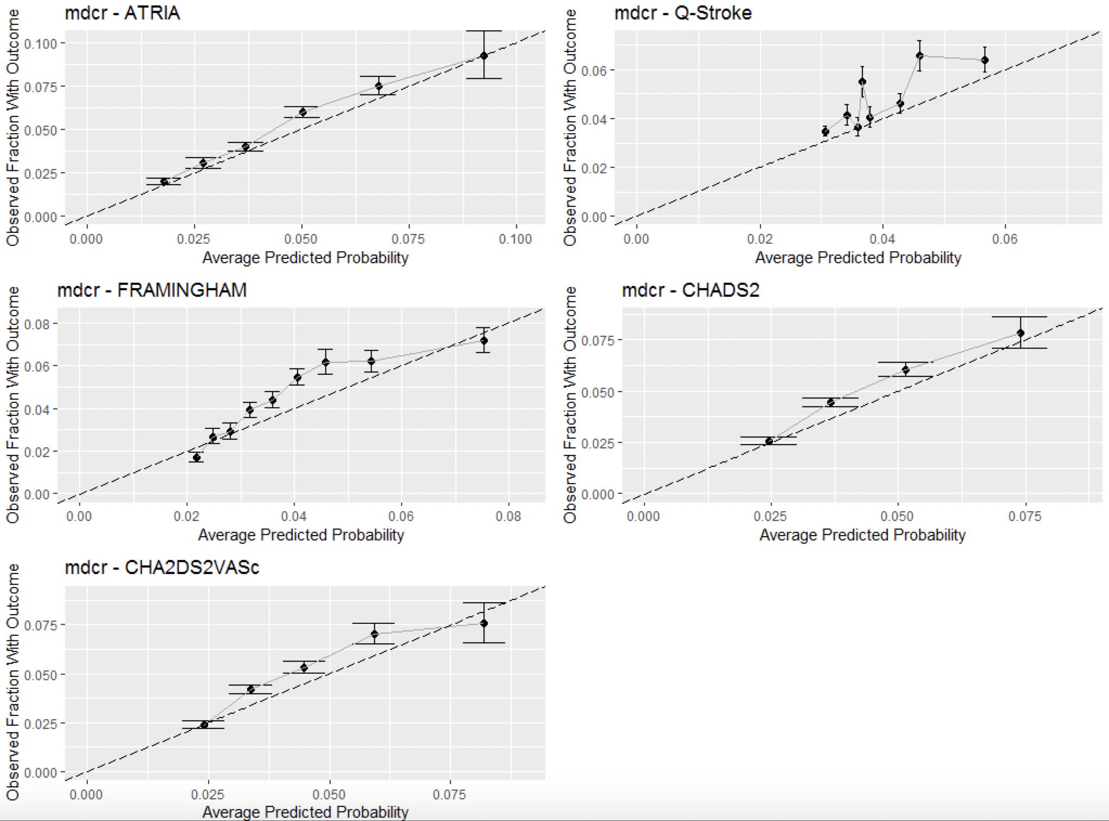
Figure 1- Calibration plots of the models applied to MDCR claims data after recalibrating
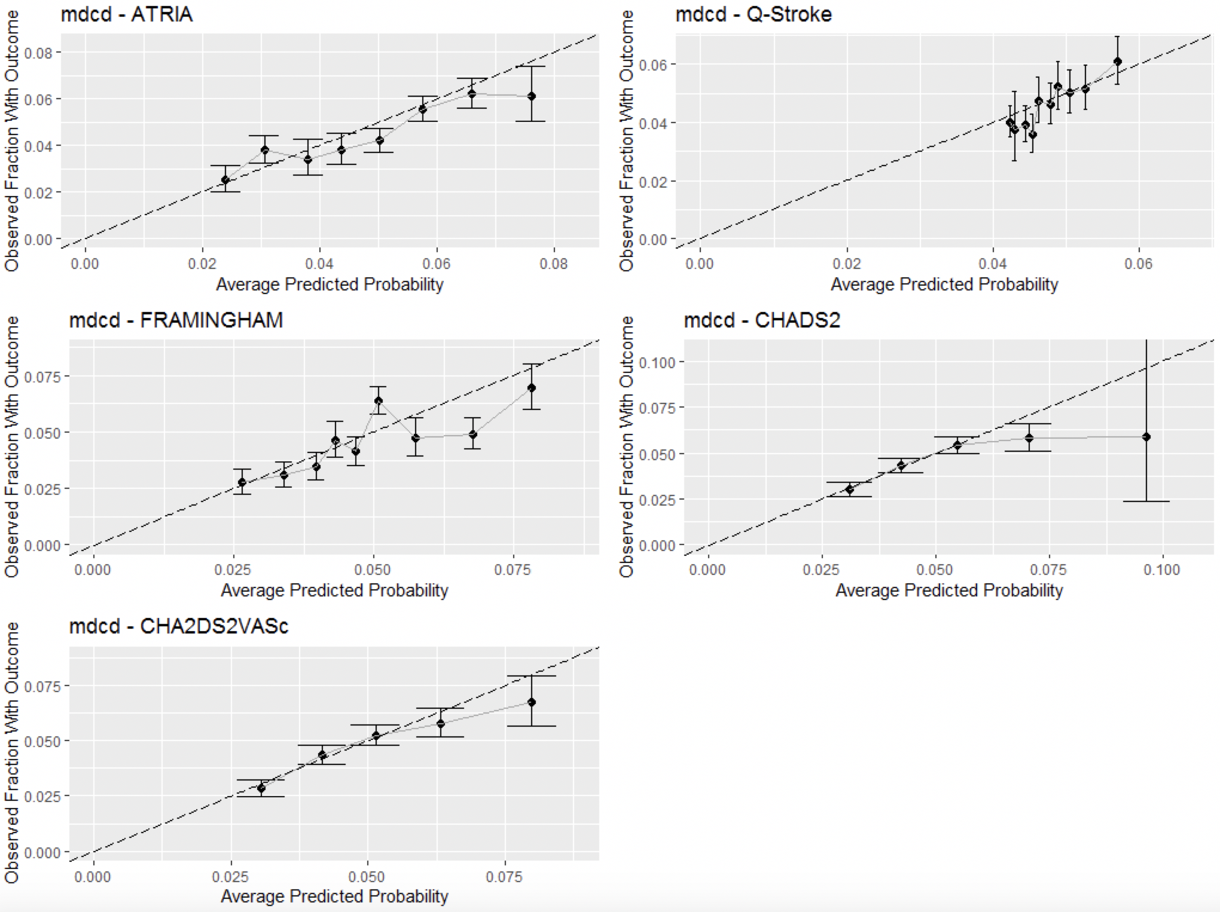
Figure 2- Calibration plots of the models applied to MDCD claims data after recalibrating
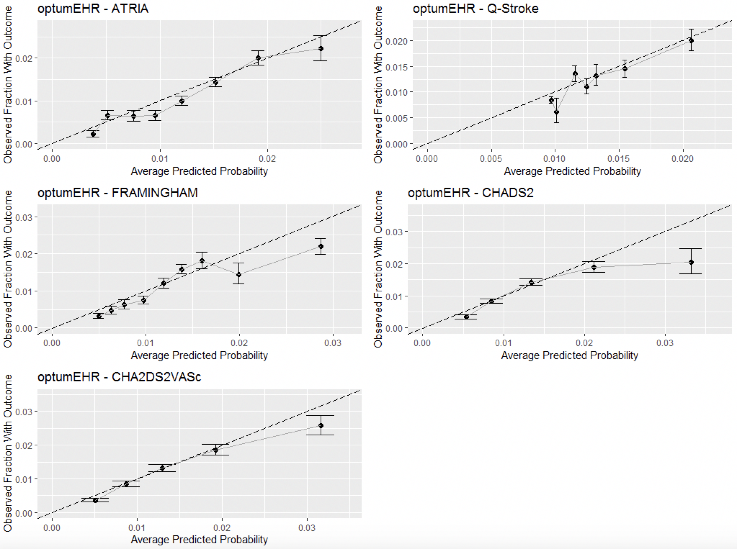
Figure 3- Calibration plots of the models applied to Optum EHR data after recalibrating
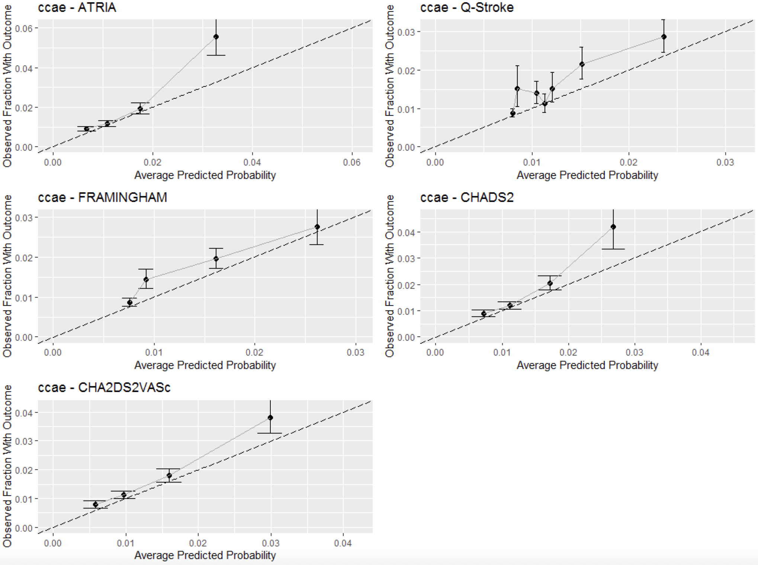
Figure 4- Calibration plots of the models applied to CCAE claims data after recalibrating
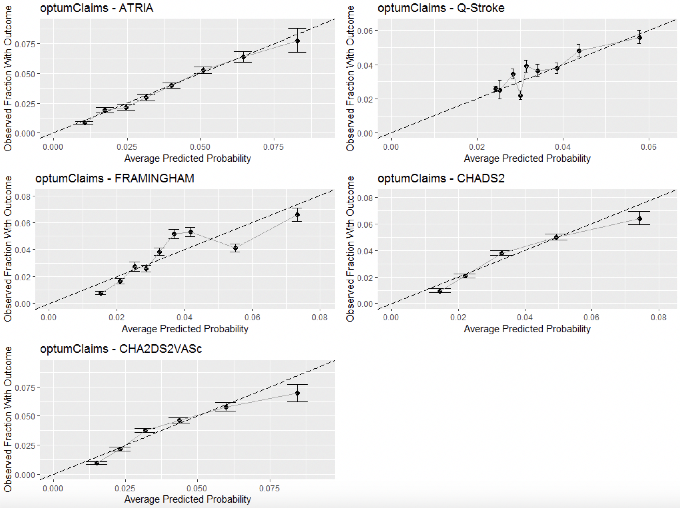
Figure 5- Calibration plots of the models applied to Optum claims data after recalibrating
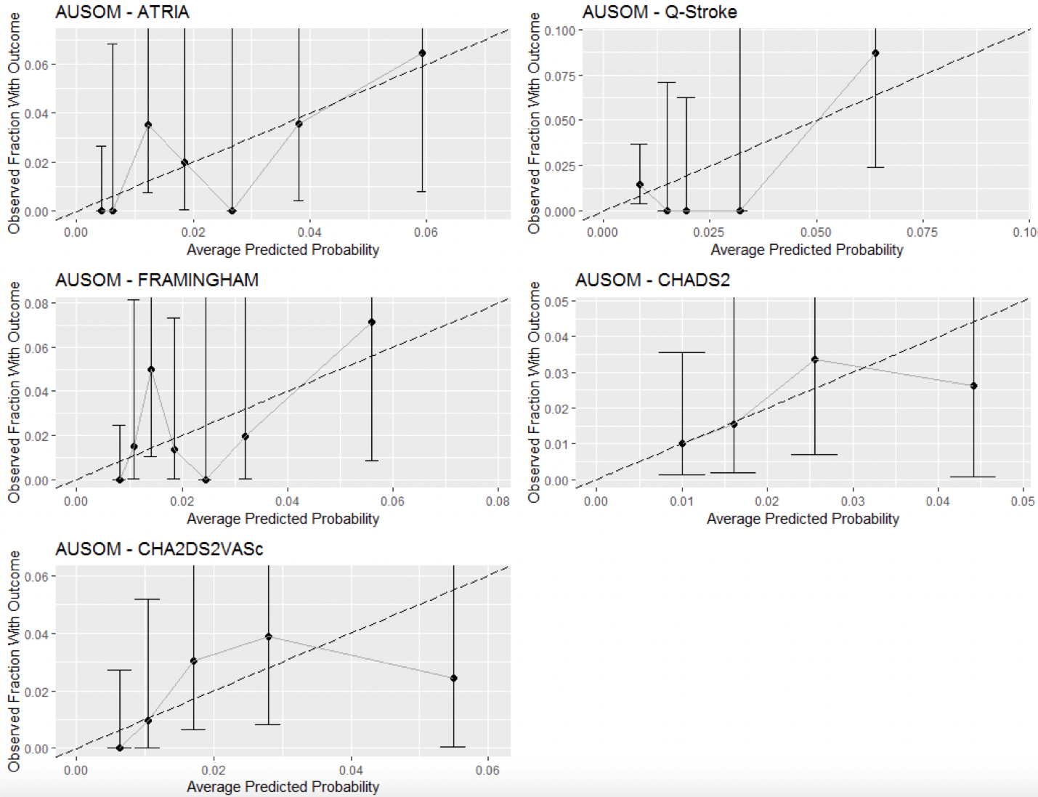
Figure 6 - Calibration plots of the models applied to AUSOM data after recalibrating

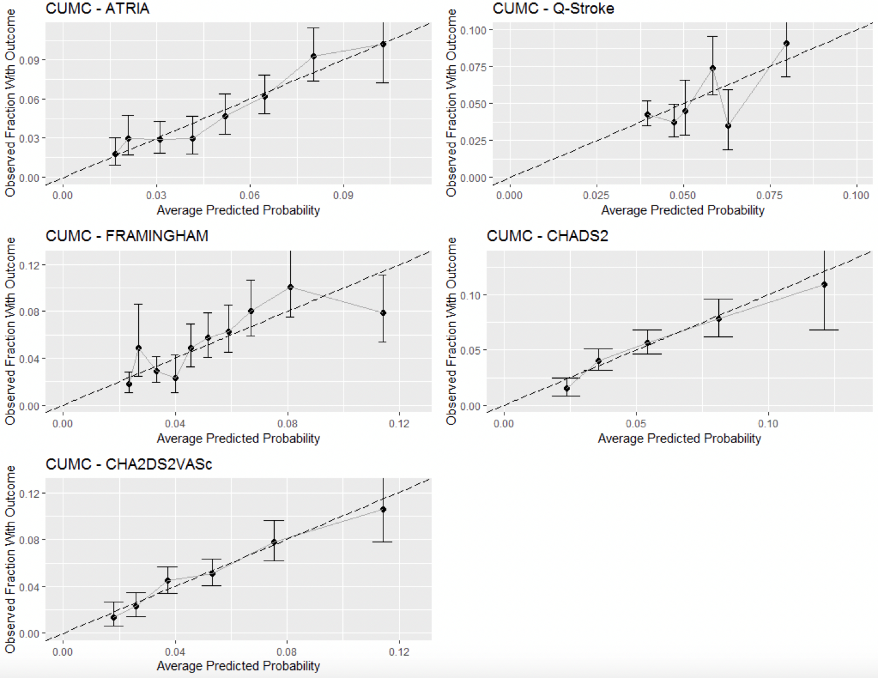
Figure 7 Calibration plots of the models applied to CUMC data after recalibrating

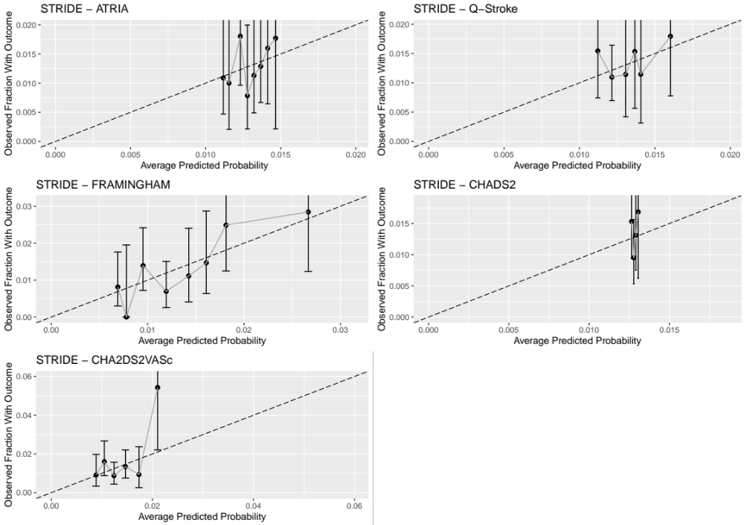
Figure 8 Calibration plots of the models applied to STRIDE data after recalibrating

The recalibration intercept and gradient (when recalibrating using a linear model where x is the total model score and y is the outcome class) for the target population of any age female.

Table 7 - The recalibration intercept and gradient values per database and model
Database | Model | Intercept | Gradient
Optum Claims | ATRIA | -4.93 | 0.25
 | Q-stroke | -3.96 | 0.56
 | Framingham | -4.95 | 0.13
 | CHADS₂ | -4.22 | 0.42
 | CHA₂DS₂VASc | -4.74 | 0.33
Optum EHR | ATRIA | -5.81 | 0.23
 | Q-stroke | -4.93 | 0.63
 | Framingham | -6.19 | 0.15
 | CHADS₂ | -5.22 | 0.46
 | CHA₂DS₂VASc | -5.95 | 0.40
CCAE | ATRIA | -5.48 | 0.48
 | Q-stroke | -5.26 | 0.90
 | Framingham | -6.03 | 0.19
 | CHADS₂ | -4.92 | 0.44
 | CHA₂DS₂VASc | -5.65 | 0.51
MDCD | ATRIA | -3.96 | 0.15
 | Q-stroke | -3.19 | 0.17
 | Framingham | -4.13 | 0.09
 | CHADS₂ | -3.66 | 0.27
 | CHA₂DS₂VASc | -4.02 | 0.22
MDCR | ATRIA | -5.51 | 0.32
 | Q-stroke | -3.66 | 0.43
 | Framingham | -4.95 | 0.13
 | CHADS₂ | -3.97 | 0.35
 | CHA₂DS₂VASc | -4.53 | 0.29
AUSOM | ATRIA | -5.82 | 0.37
 | Q-stroke | -5.80 | 2.11
 | Framingham | -5.93 | 0.19
 | CHADS₂ | -4.59 | 0.48
 | CHA₂DS₂VASc | -5.57 | 0.50
CUMC | ATRIA | -4.32 | 0.23
 | Q-stroke | -3.45 | 0.55
 | Framingham | -4.55 | 0.14
 | CHADS₂ | -3.73 | 0.43
 | CHA₂DS₂VASc | -4.37 | 0.37
STRIDE | ATRIA | -4.52 | 0.04
 | Q-stroke | -4.55 | 0.31
 | Framingham | -5.70 | 0.12
 | CHADS₂ | -4.36 | 0.01
 | CHA₂DS₂VASc | -4.89 | 0.17

