Supplementary Material
For
Development of Word Count Data Corpus for Hindi and Marathi Literature
Vivek Belhekar¹, Radhika Bhargava¹
¹ Department of Applied Psychology, University of Mumbai, Maharashtra, India

Author Note

Vivek Belhekar  https://orcid.org/0000-0001-9588-9938
Radhika Bhargava. https://orcid.org/0000-0002-9698-3333

We have no known conflict of interest to disclose.
Correspondence regarding this article should be addressed to Vivek Belhekar, Department of Applied Psychology, C.D. Deshmukh Bhavan, University of Mumbai, Santacruz East, Mumbai 400098, India. vivek@psychology.mu.ac.in

Supplementary Material

Supplementary Material 1: About Hindi and Marathi

Hindi and Marathi are an Indo-Aryan languages spoken in India. The predominant Hindi speaking Indian states include Uttar Pradesh, Bihar, Madhya Pradesh, Rajasthan, Haryana, Chhattisgarh, Jharkhand, Himachal Pradesh, Uttarakhand, and West Bengal and Union territories of Delhi and Chandigarh. Marathi is spoken majorly in the state of Maharashtra in India. While both languages are scheduled languages in India, Hindi is one of the two official languages of the Government of India along with English while Marathi is an official language in the state of Maharashtra and Goa. Hindi encompasses dialect groups of Western Hindi (e.g., Brij Bhasha, Kanauji, Bundeli, etc.), Eastern Hindi (e.g., Awadhi, Bagheli, Chhattisgarhi, etc.), Speech of Rajasthan (e.g., Rajasthani, Marwari, etc.), Bihari (e.g., Bhojpuri, Maithili, etc.), and Pahari (e.g., Garhwali, Kumauni, etc.). The dialects of Marathi include Varhadi, Ahirani, Khandeshi, etc. Hindi and Marathi rank 4th and 11th, respectively in the list of most spoken native language in the world. In India, Marathi has the third largest number of native speakers, after Hindi and Bengali.

Hindi and Marathi are written in Devnagari script which has a left-to-right abugida writing system. Devnagari used to write Marathi is slightly different from the Devnagari used for other languages including Hindi. For example, Marathi has an additional letter “ळ”. This variant is known as the Balbodh version of Devnagari script which is characterized by more frequent and regular use of both ळ /ɭ/ and र्‍ (called the eyelash reph/raphar). Devnagari script is also characterized by the use of consonant clusters or ‘jodakshar’. When two or more consecutive consonants are followed by a vowel, a consonant cluster is formed. For example, while writing the city ‘Kolhapur’, the consonants ‘l’ and ‘h’ are followed by the vowel ‘a’. Similarly in Hindi or Marathi, the consonant ‘ल’ (la) and ‘ह’ (ha) are followed by a consonant ‘आ’ (Aā). Hence, it will be written as ‘कोल्हापुर’ (Ko = को; lhā = ल्हा; pu = पु; r = र).
The Devnagari script is written exactly the way it is pronounced and pronounced exactly the way it is written. There are no silent alphabets in words.

Table 1. Number of Texts in every genre and decade in Hindi Metadata
 | Decades
Genre | Pre 1920s | 1920s | 1930s | 1940s | 1950s | 1960s | 1970s | 1980s | 1990s | 2000s | 2010s | 2020s | Undated | Grand Total
Autobiography/ Biography |  | 1 |  |  |  |  |  | 1 |  | 1 | 3 |  | 1 | 7
Children |  |  |  |  |  |  | 1 |  |  | 47 | 140 |  | 43 | 231
Drama | 1 | 1 | 1 | 1 | 3 |  | 5 | 3 | 2 | 2 |  |  |  | 19
Magazine |  |  |  |  |  |  |  |  |  |  |  | 44 |  | 44
Non-fiction/ Informative |  |  |  | 1 |  | 2 | 1 | 3 | 1 | 4 | 11 |  | 1 | 24
Novel | 2 | 4 | 8 | 10 | 24 | 21 | 18 | 22 | 20 | 15 | 33 | 1 | 23 | 201
Poetry |  | 1 | 2 | 1 | 5 | 1 |  | 2 | 2 | 4 | 5 |  |  | 23
Spiritual/ philosophy | 4 |  |  |  | 1 |  |  |  |  |  | 1 |  | 5 | 11
Stories |  | 1 | 7 | 10 | 12 | 4 | 8 | 8 | 5 | 9 | 5 |  | 11 | 80
Grand Total | 7 | 8 | 18 | 23 | 45 | 28 | 33 | 39 | 30 | 82 | 198 | 45 | 84 | 640
Supplementary Material 2: Understanding the Corpora Metadata

This section outlines more details about the number of texts and words in every decade and genre. Table 1 and 2 provide the number of texts and number of words, respectively, in every decade and genre in the Hindi metadata. Table 3 and 4 provide the number of texts and number of words, respectively, in every decade and genre in the Marathi metadata.

Table 2. Number of Words in every genre and decade in Hindi Metadata
 | Decades
Genre | Pre 1920s | 1920s | 1930s | 1940s | 1950s | 1960s | 1970s | 1980s | 1990s | 2000s | 2010s | 2020s | Undated | Grand Total
Autobiography/ Biography |  | 115662 |  |  |  |  |  | 15059 |  | 31605 | 108107 |  | 94548 | 364981
Children |  |  |  |  |  |  | 111105 |  |  | 78964 | 200448 |  | 841670 | 1232187
Drama | 21419 | 14585 | 25064 | 22476 | 55048 |  | 94632 | 50548 | 18482 | 33608 |  |  |  | 335862
Magazine |  |  |  |  |  |  |  |  |  |  |  | 1171732 |  | 1171732
Non-fiction/ Informative |  |  |  | 31534 |  | 74687 | 15503 | 228067 | 59161 | 119587 | 444514 |  | 27176 | 1000229
Novel | 72738 | 297041 | 429545 | 314156 | 1067941 | 1058534 | 888503 | 959346 | 1625337 | 811338 | 2305238 | 33243 | 1003301 | 10866261
Poetry |  | 17663 | 8839 | 25653 | 57523 | 14326 |  | 12901 | 25124 | 36821 | 44904 |  |  | 243754
Spiritual/ Philosophy | 147960 |  |  |  | 22356 |  |  |  |  |  | 30897 |  | 202068 | 403281
Stories |  | 30547 | 231135 | 275660 | 500007 | 129025 | 291719 | 221769 | 146777 | 170883 | 147600 |  | 403737 | 2548859
Grand Total | 242117 | 475498 | 694583 | 669479 | 1702875 | 1276572 | 1401462 | 1487690 | 1874881 | 1282806 | 3281708 | 1204975 | 2572500 | 18167146

Table 3. Number of Books in every genre and decade in Marathi Metadata
 | Decades
Genre | Pre 1920s | 1920s | 1930s | 1940s | 1950s | 1960s | 1970s | 1980s | 1990s | 2000s | 2010s | 2020s | Undated | Grand Total
Autobiography/ Biography | 1 | 3 | 4 |  | 1 | 1 | 2 | 3 | 4 | 4 | 20 |  | 14 | 57
Children's |  | 1 |  |  | 1 | 1 | 1 |  |  |  | 5 | 1 | 25 | 35
Drama | 1 | 1 | 4 | 4 | 6 | 3 | 1 | 1 |  |  | 38 | 4 | 3 | 66
Historical | 5 | 3 | 5 | 4 | 5 |  |  | 4 |  |  | 19 | 1 | 4 | 50
Non-fiction/ Informative | 5 | 1 | 3 | 8 | 3 | 4 | 4 | 3 | 4 | 8 | 29 |  | 5 | 77
Novel | 4 | 2 | 7 | 15 | 8 | 3 | 5 | 8 | 5 | 7 | 82 | 7 | 9 | 162
Poetry | 2 |  | 2 | 1 | 2 | 1 |  | 5 |  | 1 | 11 | 2 | 6 | 33
Spiritual/ Philosophy |  |  |  | 1 | 1 |  |  | 2 |  | 1 | 2 |  | 2 | 9
Stories | 1 | 1 | 13 | 21 | 8 | 2 | 5 | 10 | 3 | 7 | 118 | 14 | 20 | 223
Grand Total | 19 | 12 | 38 | 54 | 35 | 15 | 18 | 36 | 16 | 28 | 324 | 29 | 88 | 712

Table 4. Number of Words in every genre and decade in Marathi Metadata
 | Decades
Genre | Pre 1920s | 1920s | 1930s | 1940s | 1950s | 1960s | 1970s | 1980s | 1990s | 2000s | 2010s | 2020s | Undated | Grand Total
Autobiography/ Biography | 42987 | 155602 | 89608 |  | 32526 | 17186 | 104216 | 95826 | 361672 | 100519 | 794720 |  | 233984 | 2028846
Children's |  | 19772 |  |  | 18472 | 38795 | 11123 |  |  |  | 69022 | 11782 | 61158 | 230124
Drama | 12006 | 17597 | 89663 | 86168 | 112916 | 48003 | 15911 | 13981 |  |  | 403637 | 66512 | 42463 | 908857
Historical | 246187 | 158645 | 166364 | 152660 | 92472 |  |  | 93327 |  |  | 507796 | 32631 | 196767 | 1646849
Non-fiction/ Informative | 108037 | 16182 | 103476 | 318315 | 103668 | 155203 | 142454 | 175627 | 127874 | 152144 | 578529 |  | 187820 | 2169329
Novel | 92435 | 54112 | 299163 | 450292 | 277337 | 139980 | 179628 | 620626 | 197463 | 655307 | 2661872 | 136124 | 529174 | 6293513
Poetry | 54524 |  | 22332 | 13443 | 232965 | 947 |  | 90542 |  | 5111 | 212731 | 65327 | 70242 | 768164
Spiritual/ Philosophy |  |  |  | 15556 | 42951 |  |  | 80377 |  | 9832 | 26613 |  | 2213 | 177542
Stories | 48636 | 29760 | 384856 | 612469 | 246538 | 75784 | 157366 | 318410 | 94265 | 251775 | 1610053 | 238798 | 442557 | 4511267
Grand Total | 604812 | 451670 | 1155462 | 1648903 | 1159845 | 475898 | 610698 | 1488716 | 781274 | 1174688 | 6864973 | 551174 | 1766378 | 18734491

Supplementary Material 3: Common Errors in Hindi and Marathi OCR

Nature of Error | Actual Text | Error Text | Examples
Misrecognized letters | ग  न  ष | ण  त  प | “ग्रामीणोंने” recognized as “ग्रामीगोने”  “ग्रामोफ़ोन” recognized as “ग्रामोफ़ोत”  “सम्मान” recognized as “सम्मात”  “भाषा” recognized as “भापा”  “आळशी” recognized as “आकशी”
Diacritical Marks | ड़  फ़  सं | ड  फ  स | “ककड़ी” recognized as “ककडी”  “संगीत” recognized as “सगीत”  “आकर्षक” recognized as “आकषक”
Misrecognized vowels | ो  ई | ी  इ | “कठिनाई” recognized as “कठिनाइ”
Error in consonant clusters (or jodakshar) | त्त्वा  म्म  ज्ञ | त्त्या  म्प  ज्ज | “महत्त्वाकांक्षा” recognized as “महत्त्याकांक्षा”  “मरम्मत” recognized as “मरम्पत”  “यज्ञ” recognized as “यज्ज”
Hyphenation | Hyphen is deleted during OCR and two words are read as a single word. |  | “छोटी-छोटी” is recorded as “छोटीछोटी”

Marathi has a letter “ळ” which has been consistently misread by the OCR engine, potentially because of a lack of training data. As a result the word दयाळू (dayālu) is misread by OCR in different ways. Following are the examples.
दयाव्ह्‌ | दयालुः | दयाक्वू | दयात्ठू | दयाव्ठू | दयाकू | दयाछ्‌ | दयात्हू
दयाव्यू | दयाऋु | दयाक्ु | दयात्धू | दयाव्डू | दयाक्‌ | दयाछ्ु | दयात्ा
दयाव्तू | दयाक | दयाक्ू | दयात्यू | दयालू | दयाक्र | दयात्टू | दयात्ु
दयाव्दू | दयाकछू | दयाछु | दयात्र | दयालु | दयाक्रु॒ | दयात्ट्‌ | दयाब्ट
दयाव्द्‌ | दयाकु | दयाछू | दयात्व | दयाब्ठ | दयाक्रू | दयात्ठ | दयाब्टू

Supplementary Material 4: Some Comments on (Re-) Computing Frequencies for Hindi and Marathi using the Dataset

This section throws light on some distinctive features of the two languages in question, with a focus on the available dataset. Authors and researchers in future, are encouraged to be mindful of these points so that they can get better estimates of the frequencies.

A: Use of Suffixes
Both languages under study make use of suffixes to create variations of the root words. These suffixed words often serve as synonyms of the root words, or convert the root word into different part of speech like nouns, adjectives, adverb, verb, etc. For example, in English, the root word “honest” which is an adjective takes broadly two suffixes and can be used as “honestly” (an adverb), and “honesty” (a noun). Similarly in Hindi, the root word “दया” [noun; daya] meaning kindness, can be used in numerous ways some of which are: “दयामय” [adjective; dayamay], “दयायुक्त” [adjective; dayayukt], “दयालु” [adjective; dayalu], “दयावान” [adjective; dayavaan], “दयाशीलता” [noun; dayasheelta], “दयाहीन” [adjective; dayaheen], “दयाहीनता” [noun; dayaheenata]. Some more examples with the same root word in Marathi are “दयाघन” [adjective; dayaghan], “दयासागर” [adjective; dayasaagar], “दयासिंधु” [adjective; dayasindhu], and “दयाबुद्धि” [noun; dayabuddhi]

In the present Hindi WordCorp, there are 608 words that have the word “दया” [noun; daya] in them, of which 250 words start with “दया” [noun; daya]. Whereas in the Marathi WordCorp, there are 2,018 words that have the word “दया” [noun; daya] in them, of which 478 words start with “दया” [noun; daya].

Sometimes, names of cities, states, or other places, change overtime. For example, the city of Bombay was renamed as Mumbai in 1995. Hence, literature might also reflect these changes in the form of increasing or decreasing frequencies.

B: Words with Alternate spellings
Another important characteristic in both languages is that same words are sometimes written is different spellings. For example, the word Hindi itself can be written as “हिंदी” and “हिन्दी”. The former uses a diacritical mark while the latter uses a consonant cluster (or jodakshar). This is the case in Hindi and Marathi, both.

In both of the above cases (A & B), the researcher can consider adding up the frequencies of the variations available after the raw data is downloaded.

Supplementary Material 5: Figures for Zipf and Heaps’ Law on Hindi and Marathi Word Corpus
Figure 1. Demonstrating Zipf’s Law in Hindi WordCorp: Intercept = 13.05; Coefficient = - 0.98
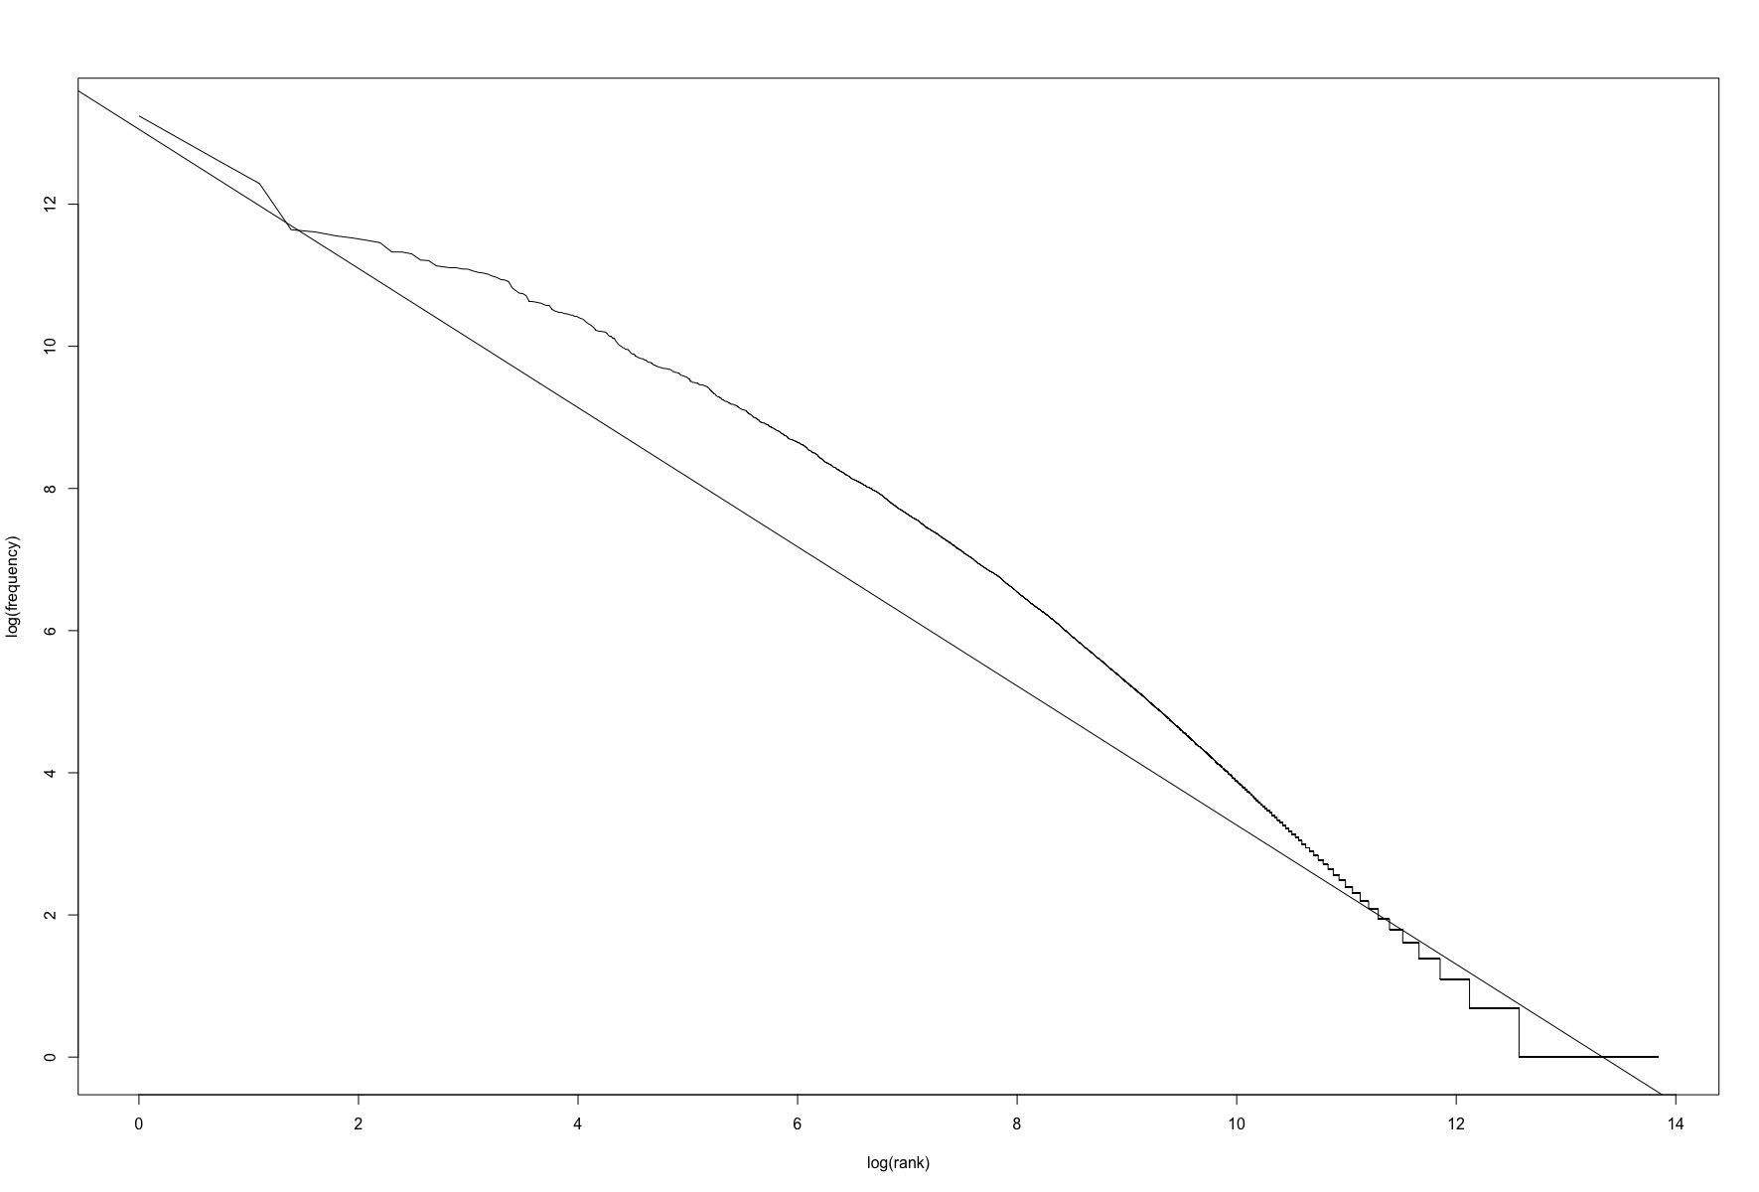

Figure 2. Demonstrating Heap’s Law in Hindi WordCorp: Intercept = 1.61; coefficient = 0.74
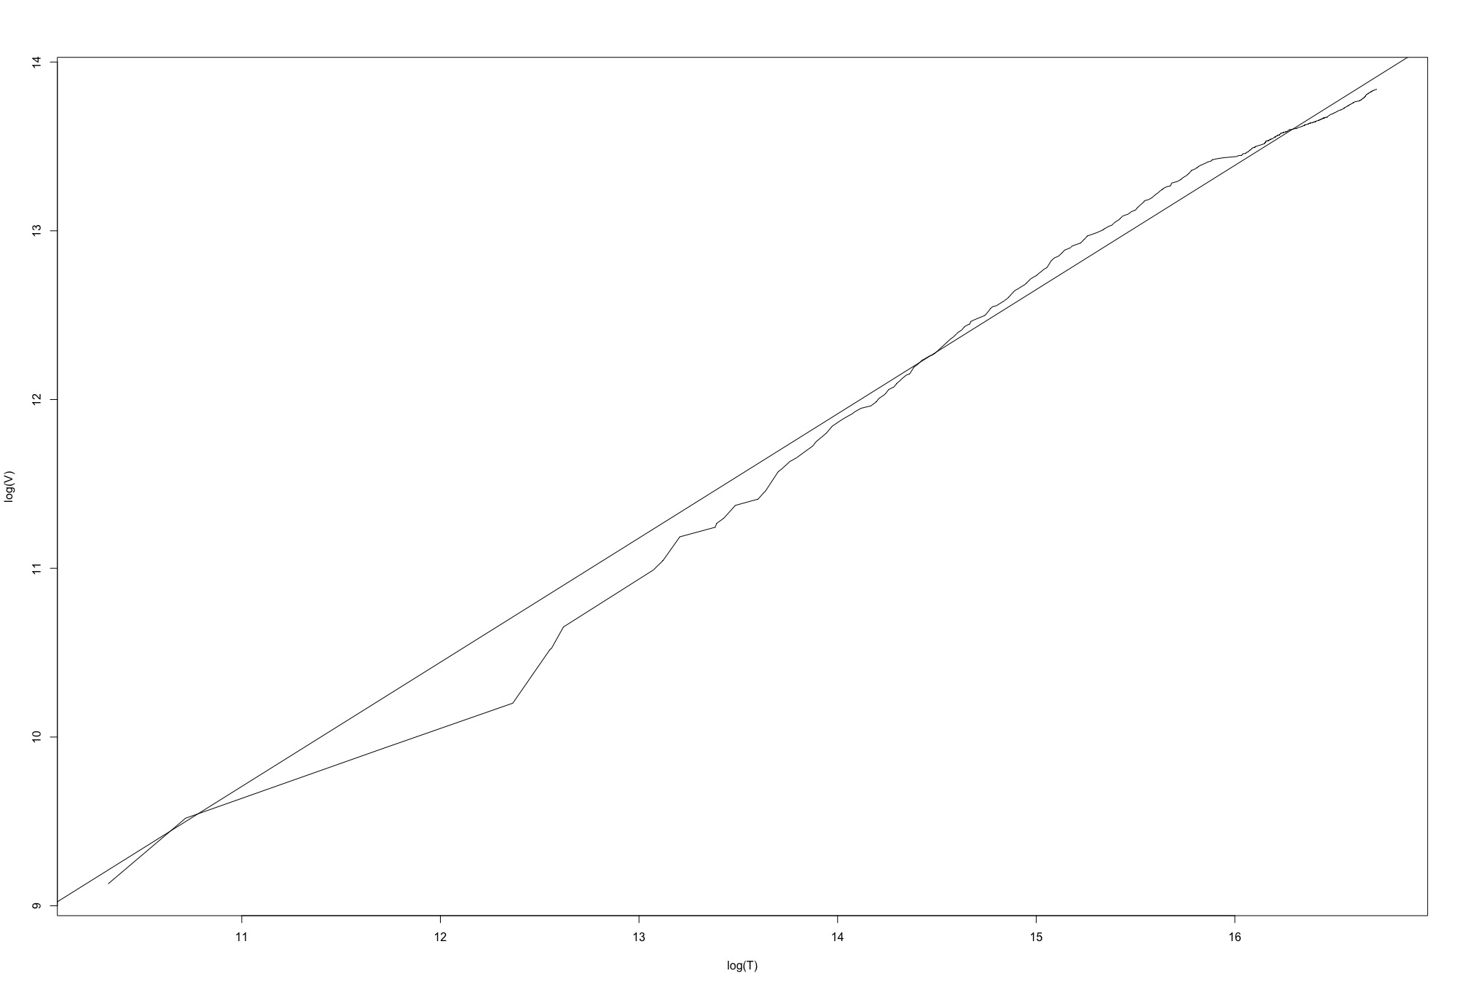

Figure 4. Demonstrating Heap’s Law in Marathi WordCorp: Intercept = 2.48; coefficient = 0.73

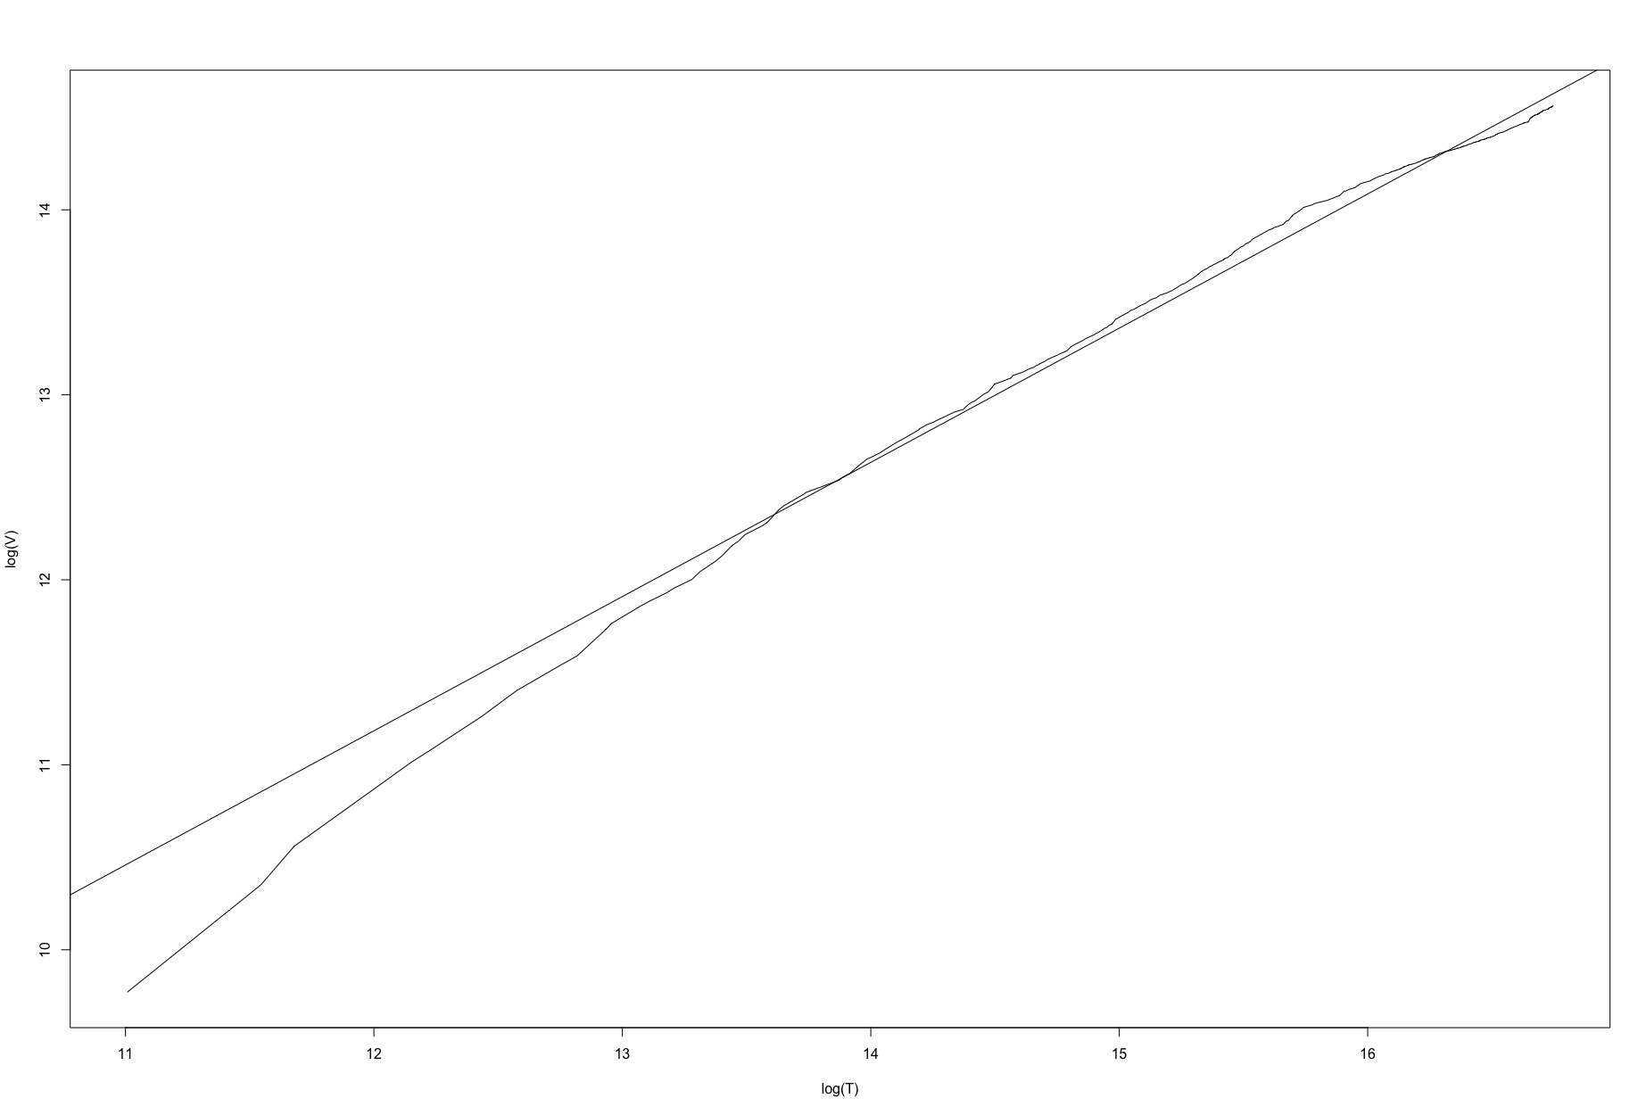
Figure 3. Demonstrating Zipf’s Law in Marathi WordCorp: Intercept = 12.49; coefficient = - 0.89
