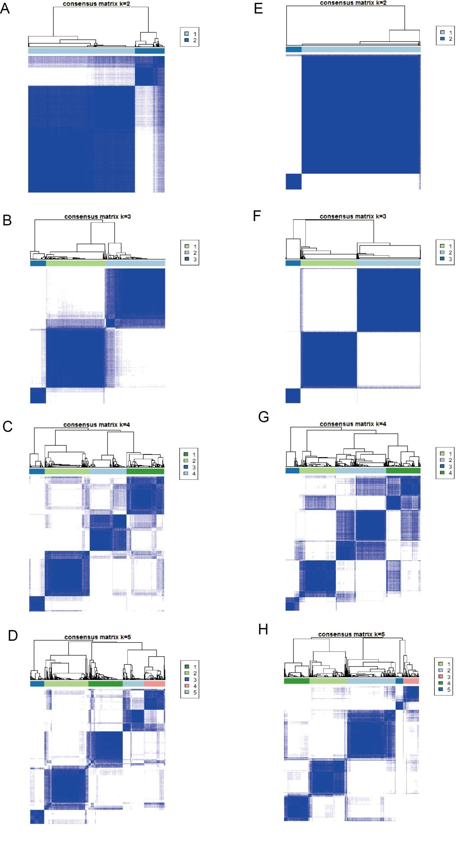
Figure S1. A-D. Unsupervised clustering of m⁶A modification patterns in melanoma cohort and consensus matrices for k = 2 - 5. E-H. Unsupervised clustering of 845 m⁶A phenotype-related genes in melanoma cohort and consensus matrices for k = 2 - 5.

