Supplementary Information

Detection and characterization of small-sized microplastics (≥ 4 µm) in milk products
Paulo A. Da Costa Filho, Daniel Andrey, Bjorn Ericksen, Rafael Peixoto, Benoit M. Carreres, Mark Ambühl, Josep Busom Descarrega, Stephane Dubascoux, Pascal Zbinden, Alexandre Panchaud & Eric Poitevin

Société des Produits Nestlé S.A. Nestlé Research, Route du Jorat 57, Lausanne, Switzerland.
Correspondence and requests for materials should be addressed to P.A.D.C.F (PauloAugusto.DaCostaFilho@rdls.nestle.com).

Table S1. Raman band assignment of PMMA, PS, PP, PE and PA. (1-4)

PMMA |  | PS |  | PP |  | PE |  | PA
Raman shift/cm⁻¹ | Mode | Raman shift/cm⁻¹ | Mode | Raman shift/cm⁻¹ | Mode | Raman shift/cm⁻¹ | Mode | Raman shift/cm⁻¹ | Mode
814 | ν (C=O) | 621 | Φ_{d} | 808 | r (CH₂)  ν (C-C) | 1063 | ν_{as} (C-C) | 1636 | ν_{s} (C=O)
1730 | ν_{as} (C-O-C) | 1001 | Φ_{b} | 841 | r (CH₂) | 1080 | ν (C-C) | 1466 | ν (C-N) & δ (NH)
 |  | 1031 |  | 972 | r (CH₃)  ν (C-C) | 1130 | ν_{s} (C-C) | 1442 | δ (CH₂)
 |  | 1155 | ν (C-C) | 998 | r (CH₃) | 1298 | ν_{t} (C-C) | 1307 | ν_{t} (CH₂)
 |  | 1450 | δ (CH₂) | 1151 | ν (C-C)  δ (CH) | 1418 | δ (CH₂)  ω (CH₂) | 1280 | ν (C-N) & δ (NH)
 |  | 1583 | ν (C=C) | 1168 | ν (C-C)  r (CH₃)  ω (C-C) | 1440 | δ (CH₂) | 1126 | ν (C-C)
 |  | 1602 | Φ_{s} | 1220 | ν_{t} (C-C)  ω (C-H)  ν (C-C) | 1460 | δ (CH₂) | 1078 | ν (C-C)
 |  |  |  | 1435 | δ (CH₂) |  |  | 1062 | ν (C-C)
 |  |  |  | 1458 | δ (CH₂) |  |  | 931 | ν (C-CO)

r rocking; Φ_{d} ring deformation, Φ_{b} ring breath; ν stretching; Φ_{s} ring stretching, ν_{as} anti-symmetric stretching; ν_{s} symmetric stretching; ν_{t} twisting; δ bending, ω wagging.

Table S2. List of milk samples used for this study

Sample Description | Type | Amount | Packaging | Collection Date
Raw Milk (Milking machine) - 1st collection | Liquid | 200 mL | PF Glass bottle | 13.03.2019
Raw Milk (Milking machine) - 2nd collection | Liquid | 200 mL | PF Glass bottle | 25.04.2019
Brand A Milk (3.5% Fat) | Liquid | 250 mL | Brick | 25.02.2019
Brand B Milk 1 (3.9% Fat) | Liquid | 250 mL | Brick | 25.02.2019
Brand C Milk (3.5% Fat) | Liquid | 500 mL | PP Bottle | 25.02.2019
Brand A Milk | Powder | 350 g | PE Bag | 04.05.2020
Brand B Milk | Powder | 350 g | PE Bag | 04.05.2020
Brand B Milk 2 (3.5% Fat) (spiking experiment) | Liquid | 500 mL | Carton Brick | 28.05.2020
Brand C Milk (0.1% Fat) (spiking experiment) | Liquid | 1000 mL | Carton Brick | 08.09.2020

Table S3. Concentrations of polymer standard solutions and related physical properties
Polymer Type | Shape | Diameter (µm) | Spiked Mother Solutions  Concentration (MPs/µL)
PMMA | Spherical | 8 | 1045
PS | Spherical | 6 | 652
PP | Fragment | 5-20 | 157
PE | Fragment | 5-20 | 74
PA | Fragment | 5-40 | 348

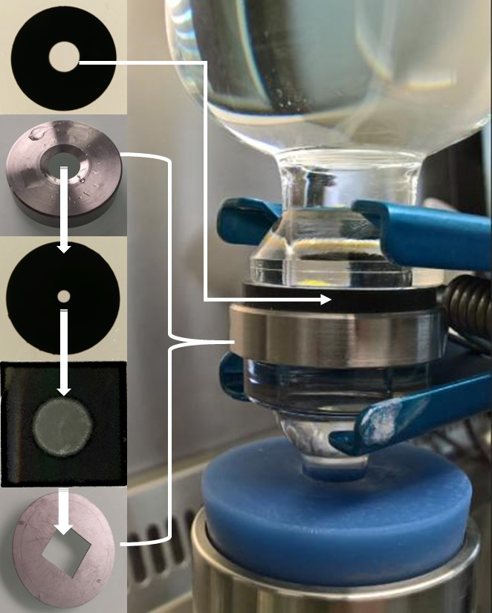
Figure S1. Home-made filter mounting system for MPs isolation.

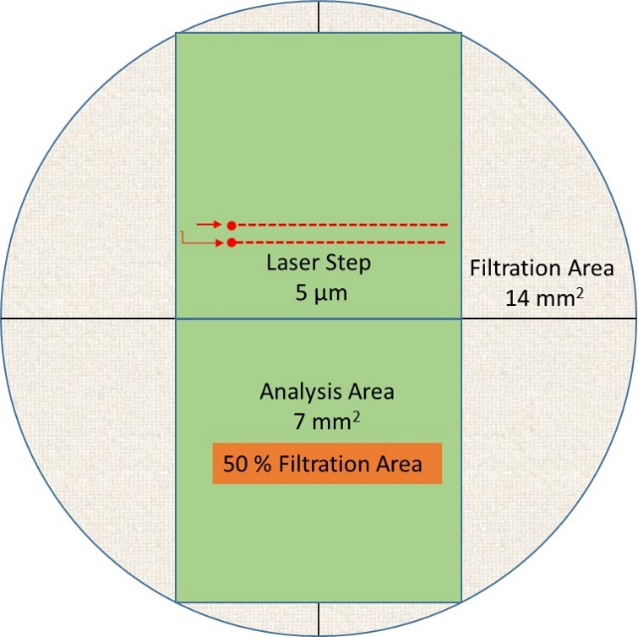

Figure S2. Filtration area (14 mm²) used for µRaman point by point approach method with a step of 5 µm

References

1. Miller, J. V. & Bartick, G. E., Forensic analysis of single fibers by Raman spectroscopy. Applied spectroscopy, 55, 12, 1729-1732 (2001).
2. Kida, T., Hiejima, Y. & Nitta, K-h., Raman spectroscopy study of high-density polyethylene during tensile deformation. International Journal of Experimental spectroscopy, 1-6, (2016).
3. Nielsen, A. S., Batchelder, D. N. & Pyrz, R., Estimation of crystallinity of isotactic polypropylene using Raman spectrsocopy. Polymer 43, 2671-2676, (2002).
4. Hu, C., Chen, X., Chen, J. Zhang, W. & Zhang, M. Q., Observation of mutual diffusion of macromolecules in PS/PMMA binary films by confocal Raman microscopy. Soft Matter, 8,17, 4780-4787 (2012).

