Event-Mode Neutron Imaging using the TPX3Cam - breaking the boundaries of conventional neutron imaging techniques

A.S. Losko^{1*}, Y. Han¹, B. Schillinger¹, A. Tartaglione¹, M. Morgano², M. Strobl², J. Long³, A.S. Tremsin⁴ and M. Schulz¹
- Forschungs-Neutronenquelle Heinz Maier-Leibnitz, 85748 Garching, Germany
- Paul Scherer Institute, 5232 Villigen, Switzerland
- Amsterdam Scientific Instruments, 1098XG Amsterdam, Netherlands
4. Space Sciences Laboratory at UC-Berkeley, 94720 Berkeley, California, USA
*Corresponding author: Tel: +49 89 289 14756 Email: Adrian.losko@frm2.tum.de

Methods

With the presented results of the neutron imaging measurements providing a new concept to radiography detectors using scintillators, the steps towards reaching a functional system for neutron imaging in itself provided insight on potential use of this system for other applications, such as for example scintillator characterization as will be shown in this section. However, the main focus is given to the use of the system for neutron imaging applications.

Data acquisition and processing
The data of the TPX3Cam is recorded in a 64-bit data format for each event on the sensor (single pixel event or hit), containing the ToA, ToT, x and y coordinate of the pixel in list form [3]. To avoid creating large files, individual acquisitions were limited to 20 sec each. For long acquisitions, the 20 sec acquisition was executed repeatedly to reach the desired statistics. Each 20 sec data-block, with a size of up to ~3 GB depending on the flux of visible light (or photons), was temporarily saved onto a ram disc on the PC and consequently processed using straightforward CoM calculations. In the case of ToF measurements, the t₀ signal of the chopper was fed into the camera. During the data acquisition, trigger signals are recorded as trigger-events with a timestamp. Based on the readout of the chip, the incoming events may not be in chronological order. Therefore, the event-list of the acquired data-blocks was first sorted chronologically. After sorting, the list was parsed to identify single photons (clusters of activated neighboring pixels). With a chronological order, the identification of photon events becomes trivial since each photon event will appear as a continuous block of activated single pixels in the list. Setting a limit in x and y coordinate deviation from the first activated pixel of each photon event (30 pixels for this work), as well as a limit in time deviation (1 ms for this work), individual photon events were identified and the CoM for each interaction in x and y coordinates, as well as average ToA, was computed with the weighting in position based on the ToT (proportional to light output registered by each pixel). Single pixel events, attributed to detector noise, and clusters larger than 200 pixels, attributed to particles directly interacting with the sensor, were discarded in this process. Despite the relatively large acceptance in the deviation in space and time for the events, individual photons were detected with little errors, such as for example neighboring photon events being detected as one. Considering a random location for two consecutive photon events, the probability of two events being within a 30 pixel search radius in x and in y coordinate can be roughly calculated by using the search radius relative to the size of the chip in pixels squared: (30/256)² = 0.014. Each detected photon-event was then saved in list form, with CoM in x and y coordinate weighted by the ToT, average ToA, total number of pixels and integrated ToT, each saved in 32-bit float format, resulting in a total of 16 Byte for each photon event entry. For measurements using the chopper, the average ToA was saved relative to the t₀ signal. The initial data containing the single pixel information stored on the ram-disc was deleted after the photon event list was created and subsequently saved on a large (14TB) non-volatile memory express solid-state drive. In a final step, for neutron-event counting, the individual photon-events were parsed to find clusters of photons within a 10 pixel search radius in x and y coordinate, a limit of 100 μs between individual photons and a limit for the total duration of neutron events of 500 μs was set to discriminate between individual neutron interactions (parameters that were determined from ToF measurements using the double crystal monochromator setup, as will be shown in and discussed for fig. 8). Finally, images were constructed from the event list by defining the effective pixel pitch (or resolution of the image), whereby the grey-value of each pixel represents the number of events (photons or neutrons, depending on what was computed) measured within the bounds of the sub-pixel. Additionally, for ToF measurements, the time information was defined in form of an image sequence, with each image representing a time-bin, set to 25 μs for this work. All images were stored in raw 32-bit unsigned data format.

Photon event-mode proof of concept using visible light
Prior to measurements using neutrons, the concept of photon event-based image reconstruction was tested using visible light. For that matter, a black and white test image, shown in fig. 6 A), was printed onto a regular piece of paper with dimensions of ~10×10 cm². The test image was then “photographed” within a light tight box, with visible light only being able to enter the box by penetrating the test image, essentially simulating light emitted from a scintillator. It should be noted that the printed test image was covered with two layers of black optical tape to reduce the flux of photons to a level of roughly 1.5×10⁶ s⁻¹ on the sensor. The purpose for this test was to confirm the detection of single photons, since only if the events on the camera can be attributed to single photons, rather than a random light emission from the image intensifier connected to the camera, the resolution of the photon event-based image would increase. A “photograph” of the image, that is recorded similar to a regular photo-camera using the integrated response of the sensor at the native detector resolution is shown in fig. 6 B). In contrast, a photograph constructed from the CoM of individual photon events on the chip is shown in fig. 6 C). Comparing the two photographs, the improved resolution and quality of the photon event-based photograph is significantly higher as compared to that of the “regular” integrated photograph, resolving features down to ~4.2 lp/mm or a resolution of ~120 μm, an effective resolution that is ⅕ of the pixel-pitch of the sensor, agreeing with already reported results of photon event-based image reconstruction using the TPX3Cam with an image intensifier [4,5].
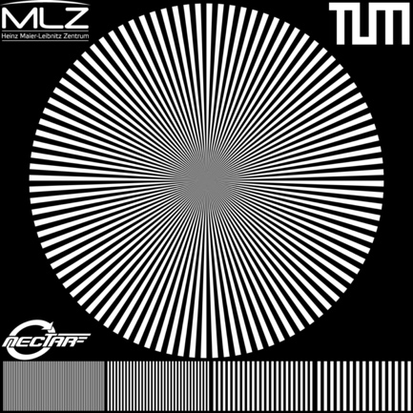
Figure 6: Test image for photon event-based proof of concept in A. Photograph using the integrated response of the camera system at native pixel resolution in B. Photograph produced from single photons via event-based CoM image reconstruction at sub-pixel resolution in C.

Time resolved imaging
To furthermore test and prepare software of the system for time resolved measurements, a light tight enclosure containing an incandescent 12V DC bulb was used to simulate a time-structured signal, such as in the case for ToF neutron imaging. The 12V bulb was connected to a variable DC power supply and gated by a solid-state relay. The input of the relay was connected to a signal generator operating in pulse-width modulation (PWM) mode at 20Hz and 20% modulation width, such that the bulb would be switched on for 10 ms and switched off for 40 ms. It should be noted that an incandescent bulb was used instead of a light-emitting diode, making use of the exponential increase and decrease of the light emitted in time by the bulb induced by the PWM input signal, as well as the capability of controlling the photon flux by increasing or decreasing the voltage on the lab power-supply. The light bulb was positioned in the enclosure such that only indirect light would be detected to avoid saturation of the detector. Varying the voltage supplied to the bulb that was gated by the PWM signal, the event rate was monitored and the voltage was increased until the detector reached ~15 Mhits/s (single pixel events). It was observed that at event rates close to the maximum of what the system is capable of processing (~80 Mhits/s), the detector response would deviate from a linear behavior.
Using the described setup, an image of the light flash produced by the 12V light bulb is shown in fig. 7 A). The integrated profile over the entire FoV as a function of time using photon event-based image reconstruction is shown in fig. 7 B) with the y-axis on a logarithmic scale, showing a nearly linear response of the detector by assuming an exponential response of the light bulb. Furthermore, the response shows an abrupt change in intensity at 10 ms, when the light bulb is “turned off”, owing to the high temporal resolution of the system.

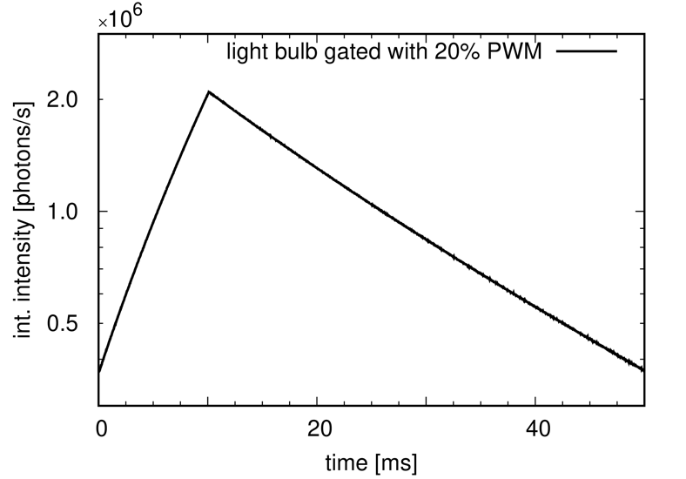
Figure 7: Integrated image of light flashes from a 12V light bulb gated by a 20% pulse-width modulated input signal at 20Hz in A. Light-yield response thereof as a function of time integrated over the entire FoV in B.

Neutron event detection and scintillator response
In a first approach to characterize the detector response for neutrons, measurements using the intensified TPX3Cam Optical Camera with a ZnS:LiF scintillator were performed at the BOA beamline at PSI [18]. The beamline was operating in ToF mode using a chopper spinning at 25 Hz with an ~1% wavelength resolution, $Δλ/λ$, at 4 Å. Furthermore, a double crystal monochromator was placed in the direct beam-path, only transmitting neutrons at 3 Å and 6 Å with the scintillator placed at 4.43 m distance to the chopper. Data were acquired in ToF mode for a total of 15 min using a ~15×15 cm² FoV and processed in real-time for photon-event identification. The measured profile of the ZnS:LiF scintillator (50 μm thickness) response is shown in fig. 8. Two peaks in the profile can be observed at ToF t = 3.28 ms and t = 6.80 ms, corresponding to the transmitted neutron wavelengths of 3 Å and 6 Å, respectively. The profile shows a sharp initial increase in intensity at the peak positions, following an exponential decay. Given that the transmission curve of the double crystal monochromator is roughly symmetric with respect to the peak position, this exponential decay can be attributed to the fluorescent lifetime of the scintillator material. Using a single exponential decay to describe the decrease in intensity, the decay constant was determined to be 0.10(9) ms. For an exponential decay, this means that after the duration of five decay constants the intensity will reduce to < 99%. This result was used to set the boundary for the duration of single neutron events to 500 μs with respect to the first observed photon. Using this boundary, as well as an acceptance radius in x and y coordinate of 10 pixels, single neutron events were observed with on average 10 photons, whereby events with less than 3 photons were discarded. With half of the photons per neutron event being emitted within one half-life, t_{½} = 76 μs, a second limit for consecutive photons being not more than 100 μs separated in time was set, furthermore reducing the probability of two consecutive neutron events detected as one.

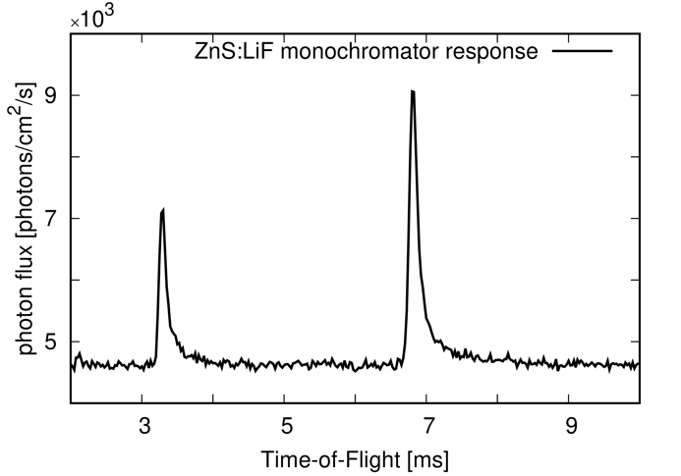
Figure 8: Detector response in photon event-mode for ZnS:LiF scintillator (50 μm thickness) using a double crystal monochromator at BOA.

