Supplementary Materials
Table S1. Temporal, demographic, and harvest characteristics of the nasal swabs and serum samples collected from white-tailed deer are shown stratified by real-time reverse transcriptase PCR (rRT-PCR) and surrogate virus neutralization results.
 |  | rRT-PCR results |  |  |  | Surrogate virus neutralization results
 |  | SARS-CoV-2 Negative | SARS-CoV-2 Positive | Estimated Prevalence |  | Sero-negative | Sero-positive | Estimated Sero-prevalence
Total |  | 1359 | 163 | 10.7% |  | 890 | 274 | 23.5%
Sex
 | Female | 649 | 60 | 8.5% |  | 405 | 126 | 23.7%
 | Male | 704 | 102 | 12.7% |  | 481 | 145 | 23.2%
Age
 | Adult | 1063 | 136 | 11.3% |  | 679 | 224 | 24.8%
 | Juvenile | 273 | 25 | 8.4% |  | 193 | 45 | 18.9%
Manner of death
 | Culled | 755 | 46 | 5.7% |  | 421 | 124 | 22.8%
 | Hunter harvested | 597 | 116 | 16.3% |  | 464 | 149 | 24.3%
County urban classification
 | Rural | 716 | 121 | 14.5% |  | 502 | 174 | 25.7%
 | Urban | 643 | 42 | 6.1% |  | 388 | 100 | 20.5%
Month of collection
 | October | 2 | 0 | 0.0% |  | 0 | 0
 | November | 829 | 93 | 10.1% |  | 578 | 172 | 22.9%
 | December | 221 | 40 | 15.3% |  | 118 | 50 | 29.8%
 | January | 234 | 30 | 11.4% |  | 148 | 40 | 21.3%
 | February | 72 | 0 | 0.0% |  | 46 | 11 | 19.3%
 | March | 1 | 0 | 0.0% |  | 0 | 1 | 100.0%

Table S2. Estimated SARS-CoV-2 prevalence is shown by county with total number of samples collected and urban/rural classification. Number of samples that were collected from white-tailed deer culled in population management programs are indicated.
County | Urban | Total Samples | Culled Deer Samples | Positive Samples | Prevalence
Adams | Rural | 17 | 0 | 3 | 18%
Ashland | Rural | 20 | 0 | 1 | 5%
Ashtabula | Rural | 2 | 0 | 0 | 0%
Athens | Rural | 33 | 0 | 12 | 36%
Belmont | Rural | 3 | 0 | 2 | 67%
Brown | Urban | 27 | 0 | 11 | 41%
Butler | Urban | 6 | 0 | 0 | 0%
Carroll | Rural | 4 | 0 | 0 | 0%
Champaign | Rural | 10 | 0 | 2 | 20%
Clark | Rural | 7 | 0 | 1 | 14%
Clermont | Urban | 26 | 0 | 6 | 23%
Clinton | Rural | 5 | 0 | 1 | 20%
Columbiana | Rural | 4 | 0 | 1 | 25%
Coshocton | Rural | 11 | 0 | 1 | 9%
Crawford | Rural | 11 | 0 | 3 | 27%
Cuyahoga | Urban | 183 | 179 | 1 | 1%
Darke | Rural | 1 | 0 | 0 | 0%
Defiance | Rural | 3 | 0 | 0 | 0%
Delaware | Urban | 55 | 40 | 1 | 2%
Erie | Rural | 179 | 177 | 2 | 1%
Fairfield | Urban | 35 | 25 | 4 | 11%
Franklin | Urban | 151 | 149 | 0 | 0%
Fulton | Rural | 1 | 0 | 0 | 0%
Gallia | Rural | 4 | 0 | 1 | 25%
Geauga | Urban | 1 | 0 | 0 | 0%
Greene | Rural | 11 | 0 | 0 | 0%
Guernsey | Rural | 4 | 0 | 0 | 0%
Hamilton | Urban | 9 | 0 | 1 | 11%
Hancock | Rural | 1 | 0 | 0 | 0%
Hardin | Rural | 4 | 0 | 0 | 0%
Harrison | Rural | 5 | 0 | 3 | 60%
Henry | Rural | 2 | 0 | 0 | 0%
Highland | Rural | 9 | 0 | 4 | 44%
Hocking | Urban | 12 | 0 | 3 | 25%
Holmes | Rural | 8 | 0 | 1 | 13%
Huron | Rural | 25 | 0 | 6 | 24%
Jackson | Rural | 9 | 0 | 3 | 33%
Jefferson | Rural | 3 | 0 | 0 | 0%
Knox | Rural | 5 | 0 | 1 | 20%
Lawrence | Rural | 1 | 0 | 1 | 100%
Licking | Urban | 30 | 0 | 0 | 0%
Logan | Rural | 23 | 0 | 1 | 4%
Lorain | Urban | 40 | 35 | 2 | 5%
Lucas | Rural | 43 | 41 | 13 | 30%
Madison | Urban | 3 | 0 | 1 | 33%
Mahoning | Rural | 2 | 0 | 0 | 0%
Marion | Rural | 7 | 0 | 0 | 0%
Medina | Urban | 9 | 0 | 3 | 33%
Meigs | Rural | 14 | 0 | 5 | 36%
Miami | Rural | 7 | 0 | 2 | 29%
Monroe | Rural | 2 | 0 | 0 | 0%
Montgomery | Rural | 1 | 0 | 0 | 0%
Morgan | Rural | 16 | 0 | 0 | 0%
Morrow | Urban | 5 | 0 | 0 | 0%
Muskingum | Rural | 10 | 0 | 1 | 10%
Noble | Rural | 8 | 0 | 1 | 13%
Ottawa | Rural | 1 | 0 | 0 | 0%
Paulding | Rural | 1 | 0 | 0 | 0%
Perry | Urban | 4 | 0 | 1 | 25%
Pickaway | Urban | 15 | 0 | 5 | 33%
Pike | Rural | 8 | 0 | 0 | 0%
Portage | Rural | 13 | 0 | 0 | 0%
Preble | Rural | 3 | 0 | 0 | 0%
Putnam | Rural | 1 | 0 | 0 | 0%
Richland | Rural | 28 | 0 | 0 | 0%
Ross | Rural | 3 | 0 | 2 | 67%
Sandusky | Rural | 4 | 0 | 1 | 25%
Scioto | Rural | 9 | 0 | 2 | 22%
Seneca | Rural | 7 | 0 | 2 | 29%
Shelby | Rural | 4 | 0 | 0 | 0%
Stark | Rural | 14 | 0 | 2 | 14%
Summit | Rural | 110 | 106 | 30 | 27%
Trumbull | Rural | 2 | 0 | 1 | 50%
Tuscarawas | Rural | 4 | 0 | 1 | 25%
Union | Urban | 58 | 49 | 0 | 0%
Van Wert | Rural | 1 | 0 | 0 | 0%
Vinton | Rural | 2 | 0 | 1 | 50%
Warren | Urban | 16 | 0 | 3 | 19%
Washington | Rural | 47 | 0 | 5 | 11%
Wayne | Rural | 11 | 0 | 0 | 0%
Williams | Rural | 6 | 0 | 0 | 0%
Wood | Rural | 4 | 0 | 0 | 0%
Wyandot | Rural | 19 | 0 | 2 | 11%
Total |  | 1522 | 801 | 163 | 11%

Table S3a. Results from mixed-effects logistic regression with random effects accounting for county level clustering is shown for all of the covariates for which we adjusted. The reference category for each risk factor is indicated as the top row. October, February, and March were excluded from the model because no nasal swabs collected from white-tailed deer during those months tested positive for SARS-CoV-2 (Figure S1).
Covariate | Categories | Model coefficient | Odds Ratio | 95% Confidence interval | P-value
Manner of death interaction with urban county classification (effect modification) | Culled from urban counties
 | Culled from rural counties | 2.69 | 14.7 | 2.2 – 100.0 | 0.006
 | Hunter-harvested from urban counties | 2.84 | 17.1 | 4.0 – 73.5 | <0.0005
 | Hunter-harvested from rural counties | 2.63 | 14.0 | 3.2 – 60.0 | <0.0005
Sex | Female
Sex | Male | 0.42 | 1.5 | 1.0 – 2.2 | 0.034
Age | Adult
Age | Juvenile | - 0.32 | 0.7 | 0.4 – 1.2 | 0.214
Month of collection | November
Month of collection | December | 0.58 | 1.8 | 1.0 – 3.0 | 0.035
Month of collection | January | - 0.17 | 0.8 | 0.2 – 3.8 | 0.821

Table S3b. The estimated prevalence and seroprevalence of SARS-CoV-2 is shown stratified based on the manner of death and the urban/rural designation of the county from which the WTD was harvested. Sample size for each category is indicated parenthetically.
 |  | County designation
 | Prevalence
 |  | Rural | Urban | Total
Manner of death | Culled | 13.3% (324) | 0.6% (477) | 5.7% (801)
Manner of death | Hunted | 15.2% (508) | 19.0% (205) | 16.3% (713)
Manner of death | Total | 14.4% (832) | 6.2% (682) | 10.7% (1514)
Manner of death | Seroprevalence
Manner of death |  | Rural | Urban | Total
Manner of death | Culled | 23.6% (225) | 22.2% (320) | 22.8% (545)
Manner of death | Hunted | 26.8% (447) | 17.5% (166) | 24.3% (613)
Manner of death | Total | 25.7% (672) | 20.6% (486) | 23.6% (1158)
Table S4. SARS-CoV-2 viruses sequenced from white-tailed deer shown with county, date of collection, lineage, and variant data.
 | Virus Name | Metropolitan Area | County | Environ-ment | Collection date | Lineage | Variant
1 | hCoV-19/deer/USA/OH-OSU-1331/2021 | Cincinnati–Wilmington–Maysville | Brown | Urban | 11/13/2021 | B.1.1.7 | Alpha
2 | hCoV-19/deer/USA/OH-OSU-1335/2021 | Cincinnati–Wilmington–Maysville | Brown | Urban | 11/13/2021 | B.1.1.7 | Alpha
3 | hCoV-19/deer/USA/OH-OSU-1338/2021 | Cincinnati–Wilmington–Maysville | Brown | Urban | 11/13/2021 | B.1.1.7 | Alpha
4 | hCoV-19/deer/USA/OH-OSU-2088/2021 | Cincinnati–Wilmington–Maysville | Brown | Urban | 11/30/2021 | AY.103 | Delta
5 | hCoV-19/deer/USA/OH-OSU-2070/2021 | Cincinnati–Wilmington–Maysville | Brown | Urban | 12/4/2021 | AY.103 | Delta
6 | hCoV-19/deer/USA/OH-OSU-2072/2021 | Cincinnati–Wilmington–Maysville | Brown | Urban | 12/4/2021 | B.1.617.2 | Delta
7 | hCoV-19/deer/USA/OH-OSU-1271/2021 | Cincinnati–Wilmington–Maysville | Clermont | Urban | 11/6/2021 | AY.103 | Delta
8 | hCoV-19/deer/USA/OH-OSU-1292/2021 | Cincinnati–Wilmington–Maysville | Clermont | Urban | 11/6/2021 | AY.39 | Delta
9 | hCoV-19/deer/USA/OH-OSU-2083/2021 | Cincinnati–Wilmington–Maysville | Clermont | Urban | 11/30/2021 | AY.103 | Delta
10 | hCoV-19/deer/USA/OH-OSU-2084/2021 | Cincinnati–Wilmington–Maysville | Clermont | Urban | 11/30/2021 | AY.103 | Delta
11 | hCoV-19/deer/USA/OH-OSU-1297/2021 | Cincinnati–Wilmington–Maysville | Warren | Urban | 11/6/2021 | B.1.617.2 | Delta
12 | hCoV-19/deer/USA/OH-OSU-2069/2021 | Cincinnati–Wilmington–Maysville | Warren | Urban | 12/4/2021 | AY.103 | Delta
13 | hCoV-19/deer/USA/OH-OSU-1106/2021 | Cleveland–Akron–Canton | Erie | Rural | 11/15/2021 | AY.25 | Delta
14 | hCoV-19/deer/USA/OH-OSU-1114/2021 | Cleveland–Akron–Canton | Huron | Rural | 11/13/2021 | AY.25 | Delta
15 | hCoV-19/deer/USA/OH-OSU-1950/2021 | Cleveland–Akron–Canton | Huron | Rural | 11/29/2021 | AY.25 | Delta
16 | hCoV-19/deer/USA/OH-OSU-2016/2021 | Cleveland–Akron–Canton | Medina | Urban | 11/30/2021 | AY.25 | Delta
17 | hCoV-19/deer/USA/OH-OSU-2320/2021 | Cleveland–Akron–Canton | Medina | Urban | 12/4/2021 | AY.25 | Delta
18 | hCoV-19/deer/USA/OH-OSU-2323/2021 | Cleveland–Akron–Canton | Medina | Urban | 12/4/2021 | AY.25 | Delta
19 | hCoV-19/deer/USA/OH-OSU-1206/2021 | Cleveland–Akron–Canton | Summit | Rural | 11/13/2021 | AY.25 | Delta
20 | hCoV-19/deer/USA/OH-OSU-0735/2022 | Cleveland–Akron–Canton | Summit | Rural | 1/19/2022 | AY.3 | Delta
21 | hCoV-19/deer/USA/OH-OSU-0921/2022 | Cleveland–Akron–Canton | Summit | Rural | 1/19/2022 | AY.3 | Delta
22 | hCoV-19/deer/USA/OH-OSU-0716/2022 | Cleveland–Akron–Canton | Summit | Rural | 1/20/2022 | AY.103 | Delta
23 | hCoV-19/deer/USA/OH-OSU-0926/2022 | Cleveland–Akron–Canton | Summit | Rural | 1/20/2022 | AY.103 | Delta
24 | hCoV-19/deer/USA/OH-OSU-2307/2021 | Cleveland–Akron–Canton | Tuscarawas | Rural | 12/4/2021 | AY.103 | Delta
25 | hCoV-19/deer/USA/OH-OSU-2105/2021 | Columbus–Marion–Zanesville | Fairfield | Urban | 11/29/2021 | AY.103 | Delta
26 | hCoV-19/deer/USA/OH-OSU-2126/2021 | Columbus–Marion–Zanesville | Fairfield | Urban | 11/29/2021 | AY.103 | Delta
27 | hCoV-19/deer/USA/OH-OSU-2111/2021 | Columbus–Marion–Zanesville | Fairfield | Urban | 11/29/2021 | AY.25 | Delta
28 | hCoV-19/deer/USA/OH-OSU-2125/2021 | Columbus–Marion–Zanesville | Hocking | Urban | 11/29/2021 | AY.25 | Delta
29 | hCoV-19/deer/USA/OH-OSU-1214/2021 | Columbus–Marion–Zanesville | Knox | Rural | 11/13/2021 | AY.118 | Delta
30 | hCoV-19/deer/USA/OH-OSU-1790/2021 | Columbus–Marion–Zanesville | Licking | Urban | 11/8/2021 | B.1.617.2 | Delta
31 | hCoV-19/deer/USA/OH-OSU-2222/2021 | Columbus–Marion–Zanesville | Logan | Rural | 12/4/2021 | AY.25 | Delta
32 | hCoV-19/deer/USA/OH-OSU-1434/2021 | Columbus–Marion–Zanesville | Madison | Urban | 11/6/2021 | AY.25 | Delta
33 | hCoV-19/deer/USA/OH-OSU-2113/2021 | Columbus–Marion–Zanesville | Perry | Urban | 11/29/2021 | AY.100 | Delta
34 | hCoV-19/deer/USA/OH-OSU-1459/2021 | Columbus–Marion–Zanesville | Pickaway | Urban | 11/13/2021 | B.1.1.7 | Alpha
35 | hCoV-19/deer/USA/OH-OSU-1480/2021 | Columbus–Marion–Zanesville | Pickaway | Urban | 11/13/2021 | B.1.1.7 | Alpha
36 | hCoV-19/deer/USA/OH-OSU-1490/2021 | Columbus–Marion–Zanesville | Pickaway | Urban | 11/13/2021 | B.1.1.7 | Alpha
37 | hCoV-19/deer/USA/OH-OSU-1419/2021 | Dayton–Springfield–Kettering | Champaign | Rural | 11/13/2021 | AY.25 | Delta
38 | hCoV-19/deer/USA/OH-OSU-1429/2021 | Dayton–Springfield–Kettering | Champaign | Rural | 11/13/2021 | AY.25 | Delta
39 | hCoV-19/deer/USA/OH-OSU-1440/2021 | Dayton–Springfield–Kettering | Clark | Rural | 11/8/2021 | AY.25 | Delta
40 | hCoV-19/deer/USA/OH-OSU-1710/2021 | Dayton–Springfield–Kettering | Miami | Rural | 12/4/2021 | AY.103 | Delta
41 | hCoV-19/deer/USA/OH-OSU-1734/2021 | Dayton–Springfield–Kettering | Miami | Rural | 12/4/2021 | AY.103 | Delta
42 | hCoV-19/deer/USA/OH-OSU-1111/2021 | Mansfield–Ashland–Bucyrus | Crawford | Rural | 11/22/2021 | AY.25 | Delta
43 | hCoV-19/deer/USA/OH-OSU-2011/2021 | Mansfield–Ashland–Bucyrus | Crawford | Rural | 11/30/2021 | AY.25 | Delta
44 | hCoV-19/deer/USA/OH-OSU-1983/2021 | Parkersburg-Marietta-Vienna | Washington | Rural | 11/29/2021 | AY.3 | Delta
45 | hCoV-19/deer/USA/OH-OSU-1985/2021 | Parkersburg-Marietta-Vienna | Washington | Rural | 11/29/2021 | AY.3 | Delta
46 | hCoV-19/deer/USA/OH-OSU-1988/2021 | Parkersburg-Marietta-Vienna | Washington | Rural | 11/29/2021 | AY.3.1 | Delta
47 | hCoV-19/deer/USA/OH-OSU-1842/2021 | Parkersburg-Marietta-Vienna | Washington | Rural | 11/30/2021 | AY.44 | Delta
48 | hCoV-19/deer/USA/OH-OSU-2184/2021 | Parkersburg-Marietta-Vienna | Washington | Rural | 12/4/2021 | AY.25.1 | Delta
49 | hCoV-19/deer/USA/OH-OSU-1263/2021 | Rural | Adams | Rural | 11/13/2021 | AY.25 | Delta
50 | hCoV-19/deer/USA/OH-OSU-1265/2021 | Rural | Adams | Rural | 11/13/2021 | AY.3 | Delta
51 | hCoV-19/deer/USA/OH-OSU-1756/2021 | Rural | Athens | Rural | 11/6/2021 | AY.3.1 | Delta
52 | hCoV-19/deer/USA/OH-OSU-1793/2021 | Rural | Athens | Rural | 11/7/2021 | AY.44 | Delta
53 | hCoV-19/deer/USA/OH-OSU-1834/2021 | Rural | Athens | Rural | 11/30/2021 | AY.20 | Delta
54 | hCoV-19/deer/USA/OH-OSU-1839/2021 | Rural | Athens | Rural | 11/30/2021 | AY.25.1 | Delta
55 | hCoV-19/deer/USA/OH-OSU-1703/2021 | Rural | Athens | Rural | 11/30/2021 | AY.44 | Delta
56 | hCoV-19/deer/USA/OH-OSU-1828/2021 | Rural | Athens | Rural | 11/30/2021 | AY.44 | Delta
57 | hCoV-19/deer/USA/OH-OSU-1830/2021 | Rural | Athens | Rural | 11/30/2021 | AY.44 | Delta
58 | hCoV-19/deer/USA/OH-OSU-1833/2021 | Rural | Athens | Rural | 11/30/2021 | AY.44 | Delta
59 | hCoV-19/deer/USA/OH-OSU-1744/2021 | Rural | Athens | Rural | 11/30/2021 | AY.75 | Delta
60 | hCoV-19/deer/USA/OH-OSU-1243/2021 | Rural | Harrison | Rural | 11/13/2021 | AY.103 | Delta
61 | hCoV-19/deer/USA/OH-OSU-2249/2021 | Rural | Harrison | Rural | 12/4/2021 | AY.103 | Delta
62 | hCoV-19/deer/USA/OH-OSU-1403/2021 | Rural | Highland | Rural | 11/8/2021 | B.1.1.7 | Alpha
63 | hCoV-19/deer/USA/OH-OSU-2169/2021 | Rural | Highland | Rural | 12/4/2021 | AY.109 | Delta
64 | hCoV-19/deer/USA/OH-OSU-2077/2021 | Rural | Highland | Rural | 12/4/2021 | B.1.1.7 | Alpha
65 | hCoV-19/deer/USA/OH-OSU-1778/2021 | Rural | Jackson | Rural | 11/6/2021 | AY.103 | Delta
66 | hCoV-19/deer/USA/OH-OSU-1439/2021 | Rural | Jackson | Rural | 11/13/2021 | AY.39 | Delta
67 | hCoV-19/deer/USA/OH-OSU-2152/2021 | Rural | Meigs | Rural | 12/4/2021 | AY.20 | Delta
68 | hCoV-19/deer/USA/OH-OSU-2153/2021 | Rural | Meigs | Rural | 12/4/2021 | B.1.1.7 | Alpha
69 | hCoV-19/deer/USA/OH-OSU-2306/2021 | Rural | Noble | Rural | 12/4/2021 | AY.25.1 | Delta
70 | hCoV-19/deer/USA/OH-OSU-1720/2021 | Rural | Vinton | Rural | 11/13/2021 | AY.75 | Delta
71 | hCoV-19/deer/USA/OH-OSU-1099/2021 | Rural | Wyandot | Rural | 11/14/2021 | AY.25 | Delta
72 | hCoV-19/deer/USA/OH-OSU-1100/2021 | Rural | Wyandot | Rural | 11/14/2021 | AY.25 | Delta
73 | hCoV-19/deer/USA/OH-OSU-2156/2021 | Toledo–Findlay-Tiffin | Lucas | Rural | 12/7/2021 | AY.103 | Delta
74 | hCoV-19/deer/USA/OH-OSU-2158/2021 | Toledo–Findlay-Tiffin | Lucas | Rural | 12/7/2021 | AY.103 | Delta
75 | hCoV-19/deer/USA/OH-OSU-2324/2021 | Toledo–Findlay-Tiffin | Lucas | Rural | 12/7/2021 | AY.103 | Delta
76 | hCoV-19/deer/USA/OH-OSU-2326/2021 | Toledo–Findlay-Tiffin | Lucas | Rural | 12/7/2021 | AY.103 | Delta
77 | hCoV-19/deer/USA/OH-OSU-2327/2021 | Toledo–Findlay-Tiffin | Lucas | Rural | 12/7/2021 | AY.103 | Delta
78 | hCoV-19/deer/USA/OH-OSU-1144/2021 | Toledo–Findlay-Tiffin | Sandusky | Rural | 11/15/2021 | AY.3 | Delta
79 | hCoV-19/deer/USA/OH-OSU-1104/2021 | Toledo–Findlay-Tiffin | Seneca | Rural | 11/15/2021 | B.1.617.2 | Delta
80 | hCoV-19/deer/USA/OH-OSU-2253/2021 | Youngstown–Warren | Columbiana | Rural | 12/4/2021 | AY.103 | Delta

Table S5. Evolutionary rates in white-tailed deer and humans (nucleotide subs/st/yr)

Host | Variant | Mean | 95% HPD
Deer | Alpha | 1.76 x 10⁻³ | 1.57 – 1.97 x 10⁻³
Human | Alpha | 5.93 x 10⁻⁴ | 5.48 – 6.38 x 10⁻⁴
Deer | Delta | 1.61 x 10⁻³ | 1.46 – 1.75 x 10⁻³
Human | Delta | 6.02 x 10⁻⁴ | 5.91 – 6.57 x 10⁻⁴

Table S6. All mutations in white-tailed deer clusters for Delta and Alpha datasets.

Table S7. Prevalence of different types of mutations in white-tailed deer clusters and in humans. For both Alpha and Delta samples counts provided for transmission clusters including branches leading to clusters, and both values for all mutational events and synonymous mutations are provided. Data for human is provided based on states on the UShER phylogenetic tree (see Materials and Methods).
 |  | Delta Deer |  |  |  | Alpha Deer |  |  |  | Human
REF | ALT | Syn | %(Syn) | All | %(All) | Syn | %(Syn) | All | %(All) | UShER_all | %(UShER) | UShER_syn | %(UShER_syn)
A | C | 7 | 3.17 | 4 | 0.92 | 0 | 0.00 | 3 | 0.67 | 77574 | 1.82 | 14112 | 0.82
A | G | 0 | 0.00 | 18 | 4.14 | 7 | 2.82 | 19 | 4.22 | 414733 | 9.71 | 156893 | 9.15
A | T | 1 | 0.45 | 9 | 2.07 | 3 | 1.21 | 6 | 1.33 | 70454 | 1.65 | 24353 | 1.42
C | A | 3 | 1.36 | 11 | 2.53 | 0 | 0.00 | 4 | 0.89 | 108080 | 2.53 | 23273 | 1.36
C | G | 1 | 0.45 | 2 | 0.46 | 0 | 0.00 | 3 | 0.67 | 24135 | 0.57 | 6895 | 0.40
C | T | 176 | 79.64 | 299 | 68.74 | 202 | 81.45 | 318 | 70.67 | 1903905 | 44.59 | 904026 | 52.70
G | A | 6 | 2.71 | 16 | 3.68 | 4 | 1.61 | 19 | 4.22 | 352838 | 8.26 | 96505 | 5.63
G | C | 0 | 0.00 | 3 | 0.69 | 0 | 0.00 | 6 | 1.33 | 60632 | 1.42 | 4898 | 0.29
G | T | 3 | 1.36 | 27 | 6.21 | 3 | 1.21 | 25 | 5.56 | 580823 | 13.60 | 92853 | 5.41
T | A | 2 | 0.90 | 6 | 1.38 | 2 | 0.81 | 6 | 1.33 | 58581 | 1.37 | 29124 | 1.70
T | C | 20 | 9.05 | 33 | 7.59 | 27 | 10.89 | 37 | 8.22 | 532552 | 12.47 | 344300 | 20.07
T | G | 2 | 0.90 | 7 | 1.61 | 0 | 0.00 | 4 | 0.89 | 85567 | 2.00 | 18169 | 1.06

Table S8. Recurrent mutations and mutations with known phenotypes in delta and alpha datasets. Delta clusters include only Ohio white-tailed deer; Alpha clusters include all available white-tailed deer samples.

Table S9. dN/dS values for four selected genes estimated with BUSTED. White-tailed deer – dN/dS within transmission clusters. Deer all – dN/dS for all white-tailed deer samples, Human – dN/dS for all human samples in dataset.
 | Delta |  |  | Alpha
 | Deer all | Deer clusters | Human | Deer all | Deer clusters | Human
N | 0.77 | 0.94 | 0.69 | 0.25 | 0.29 | 0.78
nsp3 | 0.47 | 0.69 | 0.60 | 0.17 | 0.19 | 0.59
ORF3a | 1.26 | 0.51 | 1.38 | 0.68 | 4.30 | 1.54
S | 0.40 | 0.65 | 0.84 | 0.38 | 0.46 | 0.57

Table S10. Representative SARS-CoV-2 viral isolates which were selected for further characterization in vitro and in vivo.

Lineage | Virus Selected
AY.109 Delta (B.1.617.2-like) | hCoV-19/deer/USA/OH-OSU-2169/2021
AY.118 Delta (B.1.617.2-like) | hCoV-19/deer/USA/OH-OSU-1214/2021
AY.3 Delta (B.1.617.2-like) | hCoV-19/deer/USA/OH-OSU-1265/2021
AY.39 Delta (B.1.617.2-like) | hCoV-19/deer/USA/OH-OSU-1292/2021
AY.44 Delta (B.1.617.2-like) | hCoV-19/deer/USA/OH-OSU-1828/2021
AY.75 Delta (B.1.617.2-like) | hCoV-19/deer/USA/OH-OSU-1744/2021
B.1.1.7 Alpha (B.1.1.7-like) | hCoV-19/deer/USA/OH-OSU-1338/2021
AY.25 Delta (B.1.617.2-like) | hCoV-19/deer/USA/OH-OSU-1440/2021
AY.103 Delta (B.1.617.2-like) | hCoV-19/deer/USA/OH-OSU-2158/2021

Table S11. GenBank accession numbers for 80 SARS-CoV-2 strain consensus sequences from white-tailed deer. (Pending)

Table S12. National Center for Biotechnology Information (NCBI) Sequence Read Archive (SRA) run accessions numbers for the raw sequence read data generated for 80 SARS-CoV-2 strains from white-tailed deer. (Pending)

Table S13. GISAID acknowledgment of data contributors table for deer origin SARS-CoV-2 background sequence dataset used in analyses for this study.

Table S14. GISAID acknowledgment of data contributors table for human origin SARS-CoV-2 background sequence dataset used in analyses for this study.

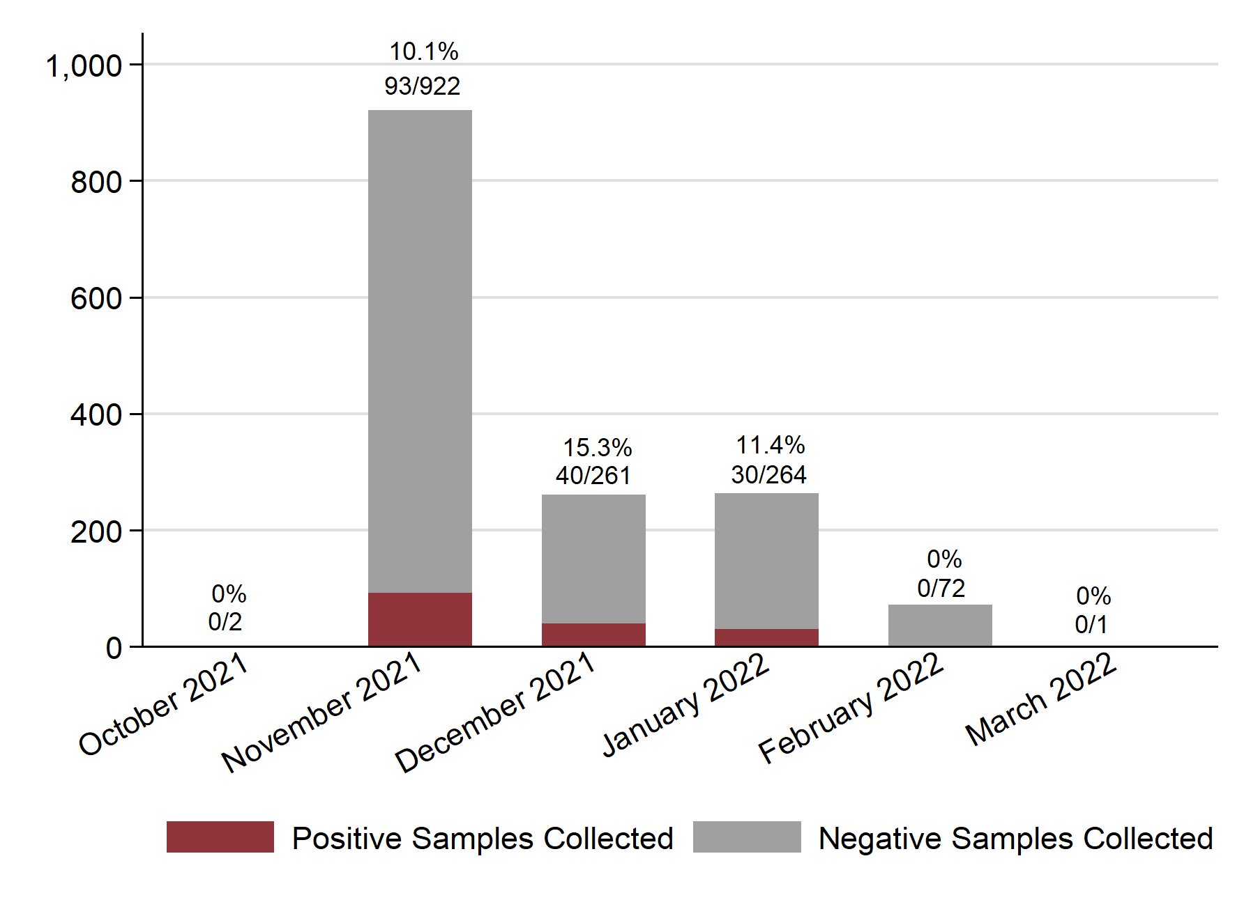
Figure S1. Number of nasal swabs collected from white-tailed deer is shown by month of collection with rRT-PCR positive samples shown in red and negative samples in gray. Number of positive samples and total sample size for each month is indicated above each bar along with estimated SARS-CoV-2 prevalence.

Figure S2. Maximum likelihood phylogenetic tree of SARS-CoV-2 in humans, mink, and white-tailed deer in North America. Tips (circles) are shaded by host species and location. Viruses from white-tailed deer in Ohio (red circles) are labeled to indicate whether they were collected from our previous study (B.1.2, B.1.596, and B.1.582) or the present study (delta and alpha).

Figure S3. Heat map of human COVID-19 cases over time and space in Ohio. For each Ohio county (y-axis), the number of COVID-19 cases per 100,000 population is indicated over time (weekly, x-axis) by the shade of the box (red = high, white = low). Ohio counties listed on the y-axis are ordered by population size, from the largest, most urban counties (top) to the smallest, most rural counties (bottom).

Figure S4. Time-scaled MCC tree inferred for delta variant viruses in humans and white-tailed deer in Ohio. Branches shaded by host species: gray = human, dark gray = deer from outside Ohio, colored branches = Ohio deer. Ohio deer branches are colored by county. Posterior probabilities are provided for key nodes. PANGO lineages for Ohio deer viruses are listed. Raw tree file is available in GitHub repository.

Figure S5. Dominant delta variant lineages in humans and white-tailed deer in Ohio. The size of the box is proportional to the number of viruses belonging to the Pango lineage in white-tailed deer (left) and humans (right) in Ohio.

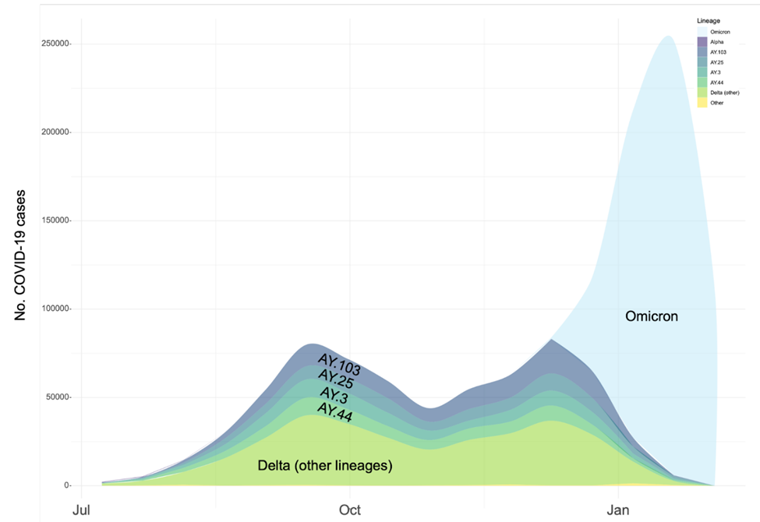
Fig S6. Co-circulation of delta variant lineages in humans in Ohio. The number of weekly COVID-19 cases in humans from July 1, 2021 to Jan 22, 2022. Shading indicates the proportion of 22,200 sequenced human viruses in Ohio, categorized as collected for “baseline surveillance,” that belong to one of the four dominant AY lineages of the delta variant, omicron, or one of the other lineages of the delta variant.
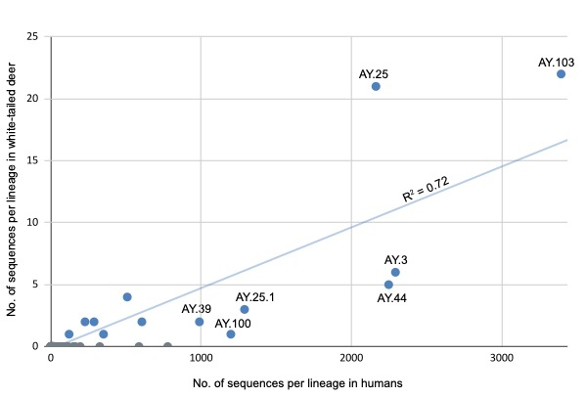

Figure S7. Plot of delta variant lineage frequency in humans and white-tailed deer in Ohio. The x-axis represents the number of sequences from SARS-CoV-2 viruses collected in humans in Ohio that belong to AY PANGO lineages. The y-axis represents the number of sequences from SARS-CoV-2 viruses collected in deer in Ohio for this study that belong to AY PANGO lineages.

Figure S8. Co-circulation of SARS-CoV-2 lineages in Ohio white-tailed deer by week and county. SARS-CoV-2 lineages identified in white-tailed deer per county per week (week 44 begins November 1, 2021). Counties located within that larger metropolitan areas are listed first, followed by rural counties.

Figure S9. Size of white-tailed deer transmission clusters. (A) The frequency of deer transmission clusters of different sizes (minimum size = 2 viruses; maximum size = 7 viruses) is presented on the y-axis. (B) The frequency of deer transmission clusters spanning different numbers of counties (minimum size = 1 county; maximum size = 4 counties).

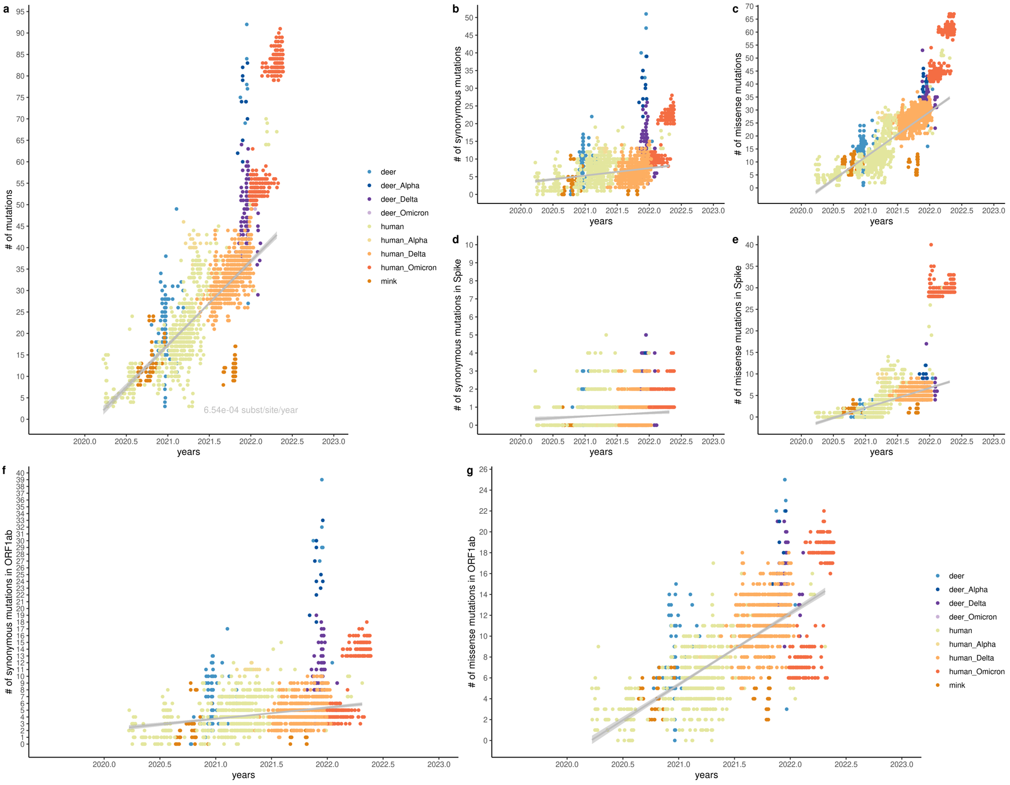

Figure S10. Root-to-tip regression for the global SARS-CoV-2 dataset in humans, mink, and white-tailed deer in North America. Each plot shows the number of mutations accumulated from root to leaves versus collection date of leaves. Each point (representing one leaf on the phylogenetic tree) colored by the category it belongs to: white-tailed deer samples from either alpha (dark blue), delta (purple) or omicron(violet) VOCs or other lineages (light blue), human samples from alpha (dark green), delta (light orange) or omicron (dark orange) or other lineages (light green), or mink samples (orange). (a) number of all mutations in the whole genome, (b) only synonymous mutations and (c) missense mutations. Separately we considered synonymous and missense mutations in Spike (d, e) and ORF1ab (f, g). The state at each node on the global ML tree (Figure S2) was reconstructed with TreeTime.

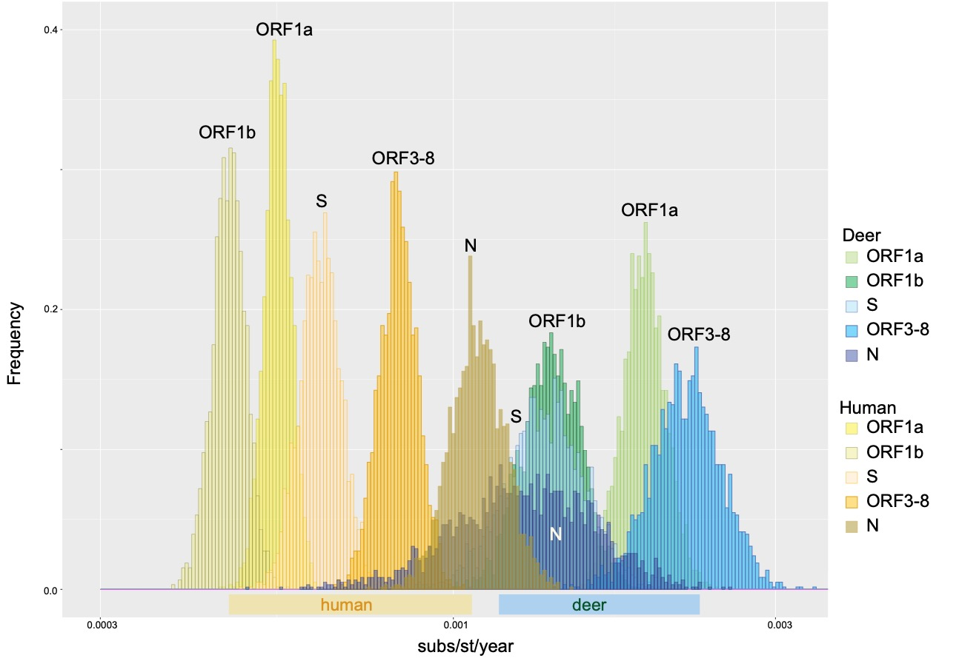

Figure S11. Evolutionary rates in humans and white-tailed deer. The posterior distributions of evolutionary rates (substitutions per site per year) for five partitions of the SARS-CoV-2 genome (ORF1a, ORF1b, ORF3 – ORF8, spike (S), and nucleocapsid (N) are presented for human (yellow/brown shades) and white-tailed deer (green/blue shades) for the alpha variant. Similar plot for delta variant is available in Figure 4C.
Figure S12. Rates of synonymous and non-synonymous substitution in humans and white-tailed deer. The ratio of non-synonymous to synonymous substitution rates (dN/dS) is presented for the alpha (A) and delta (B) variants for deer (blue boxes) and humans (pink boxes) for five genome partitions: open reading frame 1a, open reading frame 1b, open reading frames 3-8 with envelope and membrane proteins, spike protein, and nucleocapsid. Whisker plots present the mean value, upper and lower quartiles, and minimum and maximum. A black line where dN/dS = 1 indicates the threshold between positive and purifying selection. Synonymous substitutions per site per year is presented for the alpha (C) and delta (D) variants. Non-synonymous substitutions per site per year is presented for the alpha (E) and delta (F) variants.

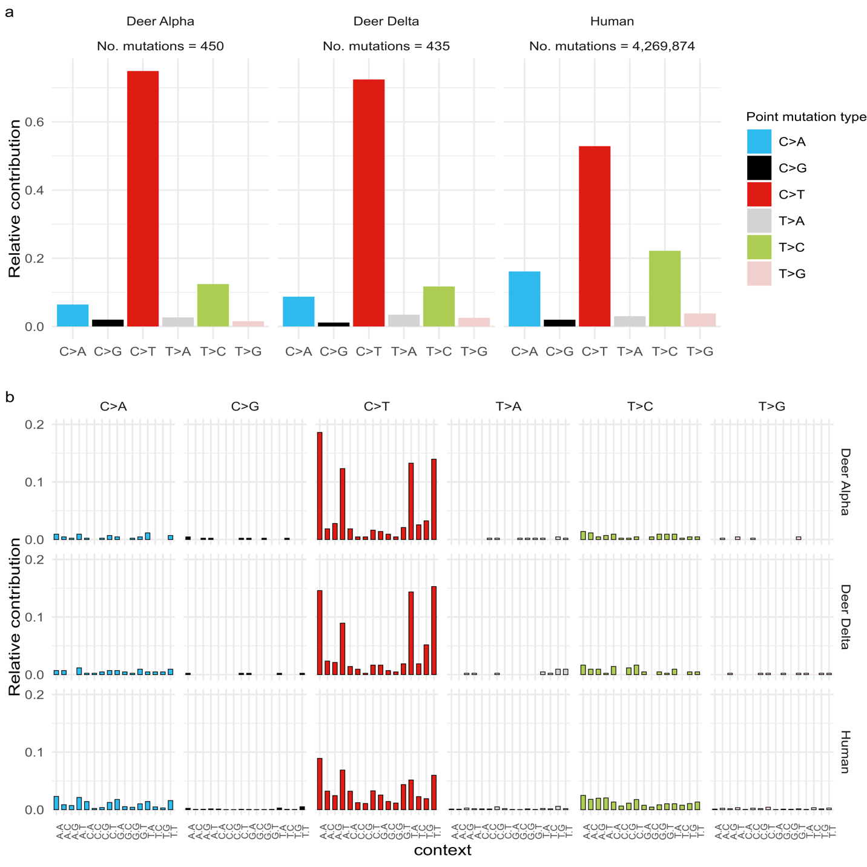
Figure S13. Mutational spectrum for all types of mutations in white-tailed deer and human. (a) Single nucleotide substitutions (b) Three letter contexts. Mutations in deer calculated for deer clusters (including branches leading to clusters): Delta white-tailed deer –Ohio white-tailed deer clusters from Delta dataset; Alpha white-tailed deer – all white-tailed deer clusters from Alpha dataset. Data for human is extracted from public version of UShER tree (see Materials and Methods).

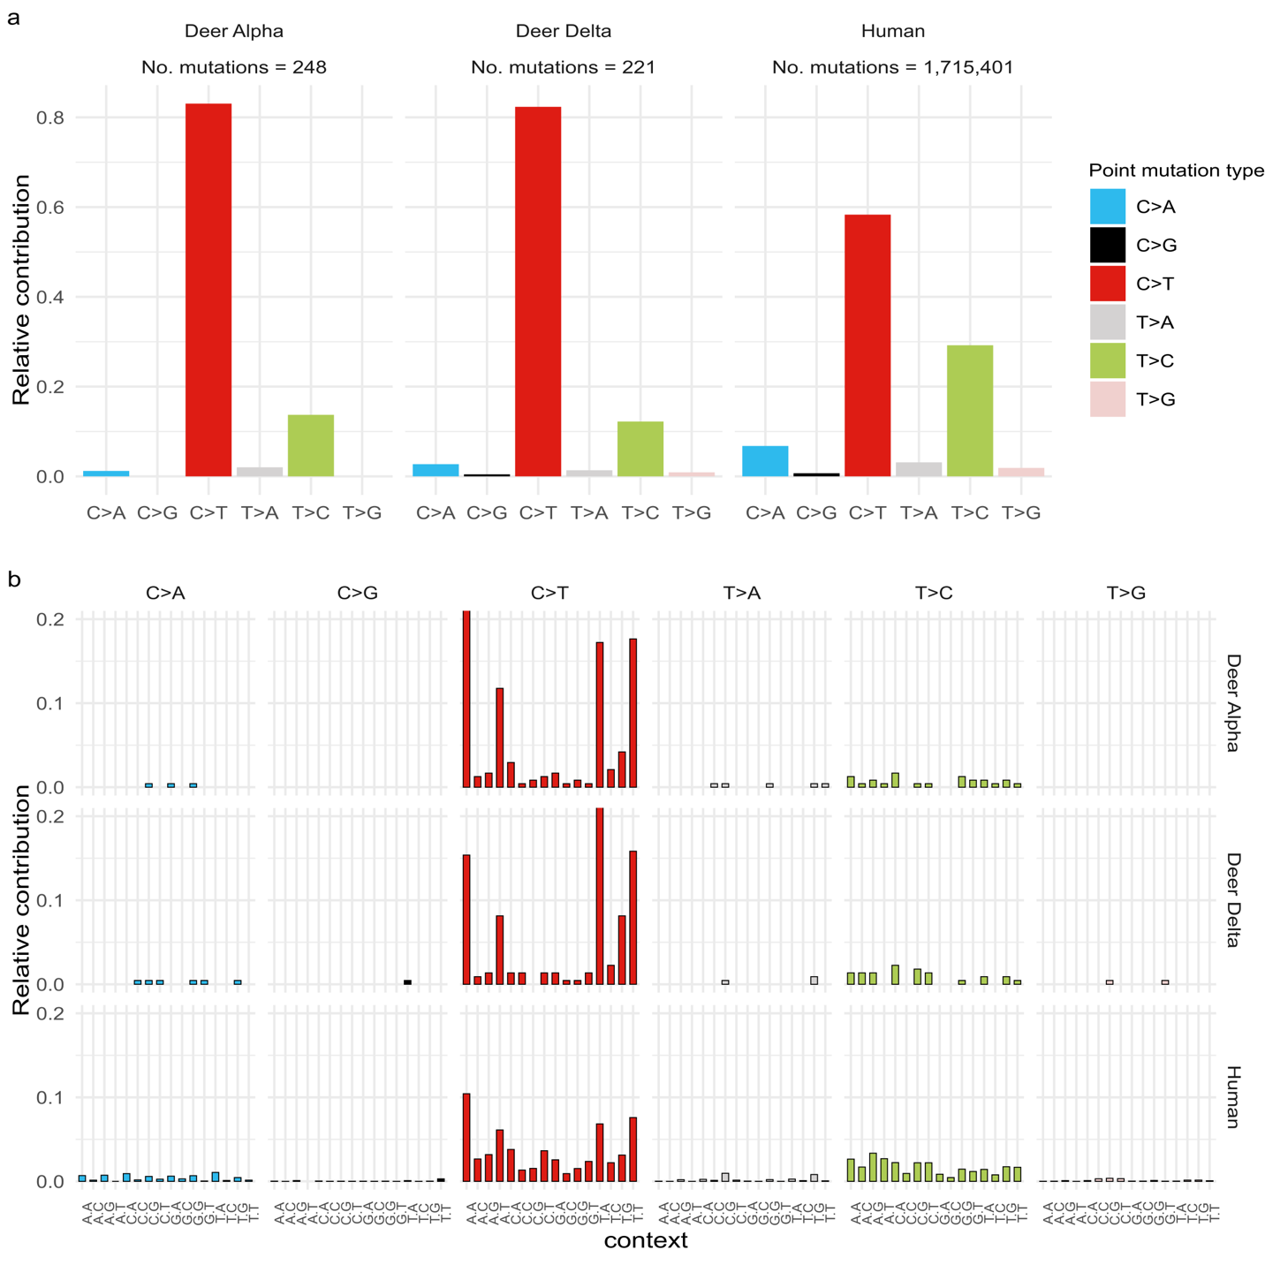
Figure S14. Mutational spectrum for synonymous mutations only in white-tailed deer and human. (a) Single nucleotide substitutions (b) Three letter contexts. Mutations in white-tailed deer calculated for white-tailed deer clusters (including branches leading to clusters): Delta white-tailed deer –Ohio white-tailed deer clusters from Delta dataset; Alpha white-tailed deer – all white-tailed deer clusters from Alpha dataset

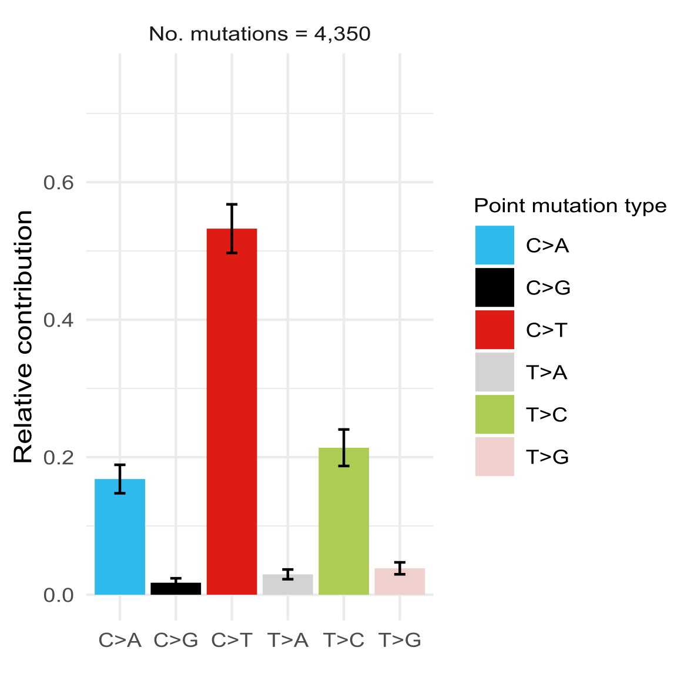
Figure S15. Low variability of mutational spectrum in humans. To test whether the elevated C-to-T rate could be explained by high variability in the white-tailed deer mutation spectrum arising from a small deer sample size, 10 random subsamples of the same size as the delta white-tailed deer dataset were selected to estimate spectrum variability.
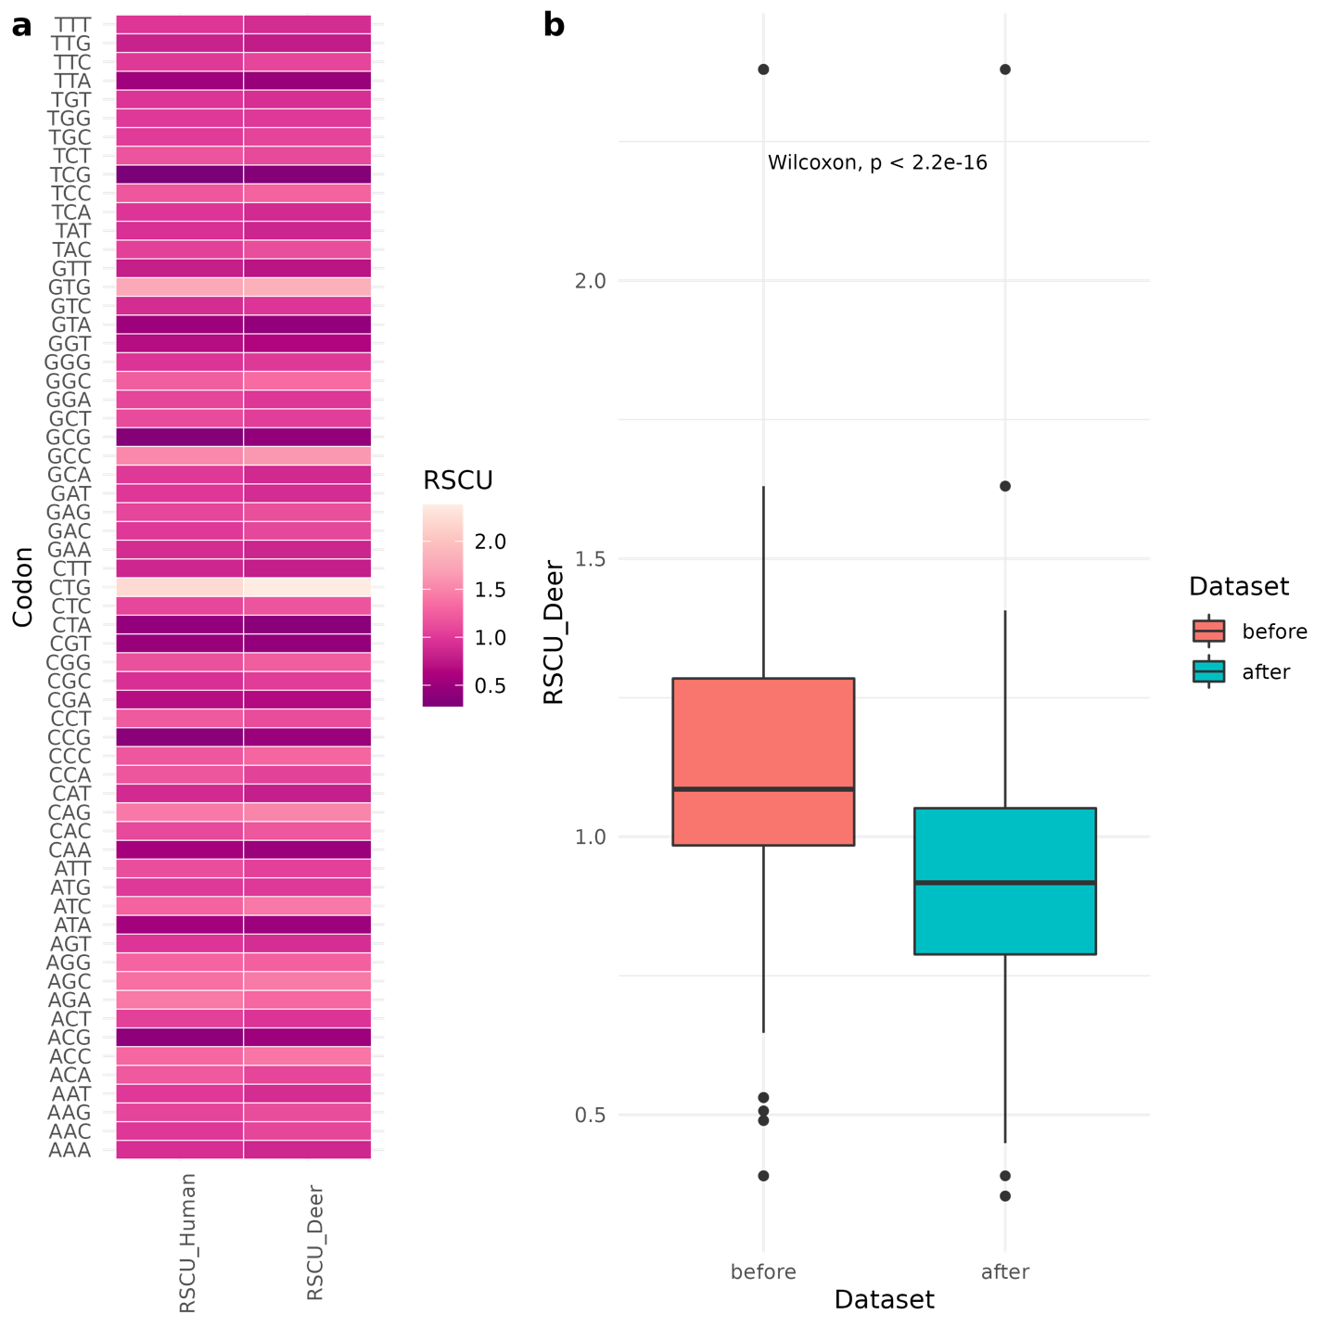

Figure S16. Codon bias in white-tailed deer calculated for synonymous substitutions in Delta white-tailed deer clusters. (a) Comparison of relative synonymous codon usage (RSCU) in human and white-tailed deer. (b) Changes in codon RSCU by introduction of mutation. Distribution of RSCU values in ancestral codons (before mutation was introduced) are shown in coral and after - in cyan. RSCU calculated as described in Sharp et al., 1986 (https://academic.oup.com/nar/article/14/13/5125/1143812). Information on codon usage in white-tailed deer and humans was obtained from CoCoPUTS database (https://dnahive.fda.gov/dna.cgi?cmd=codon_usage&id=537&mode=cocoputs).

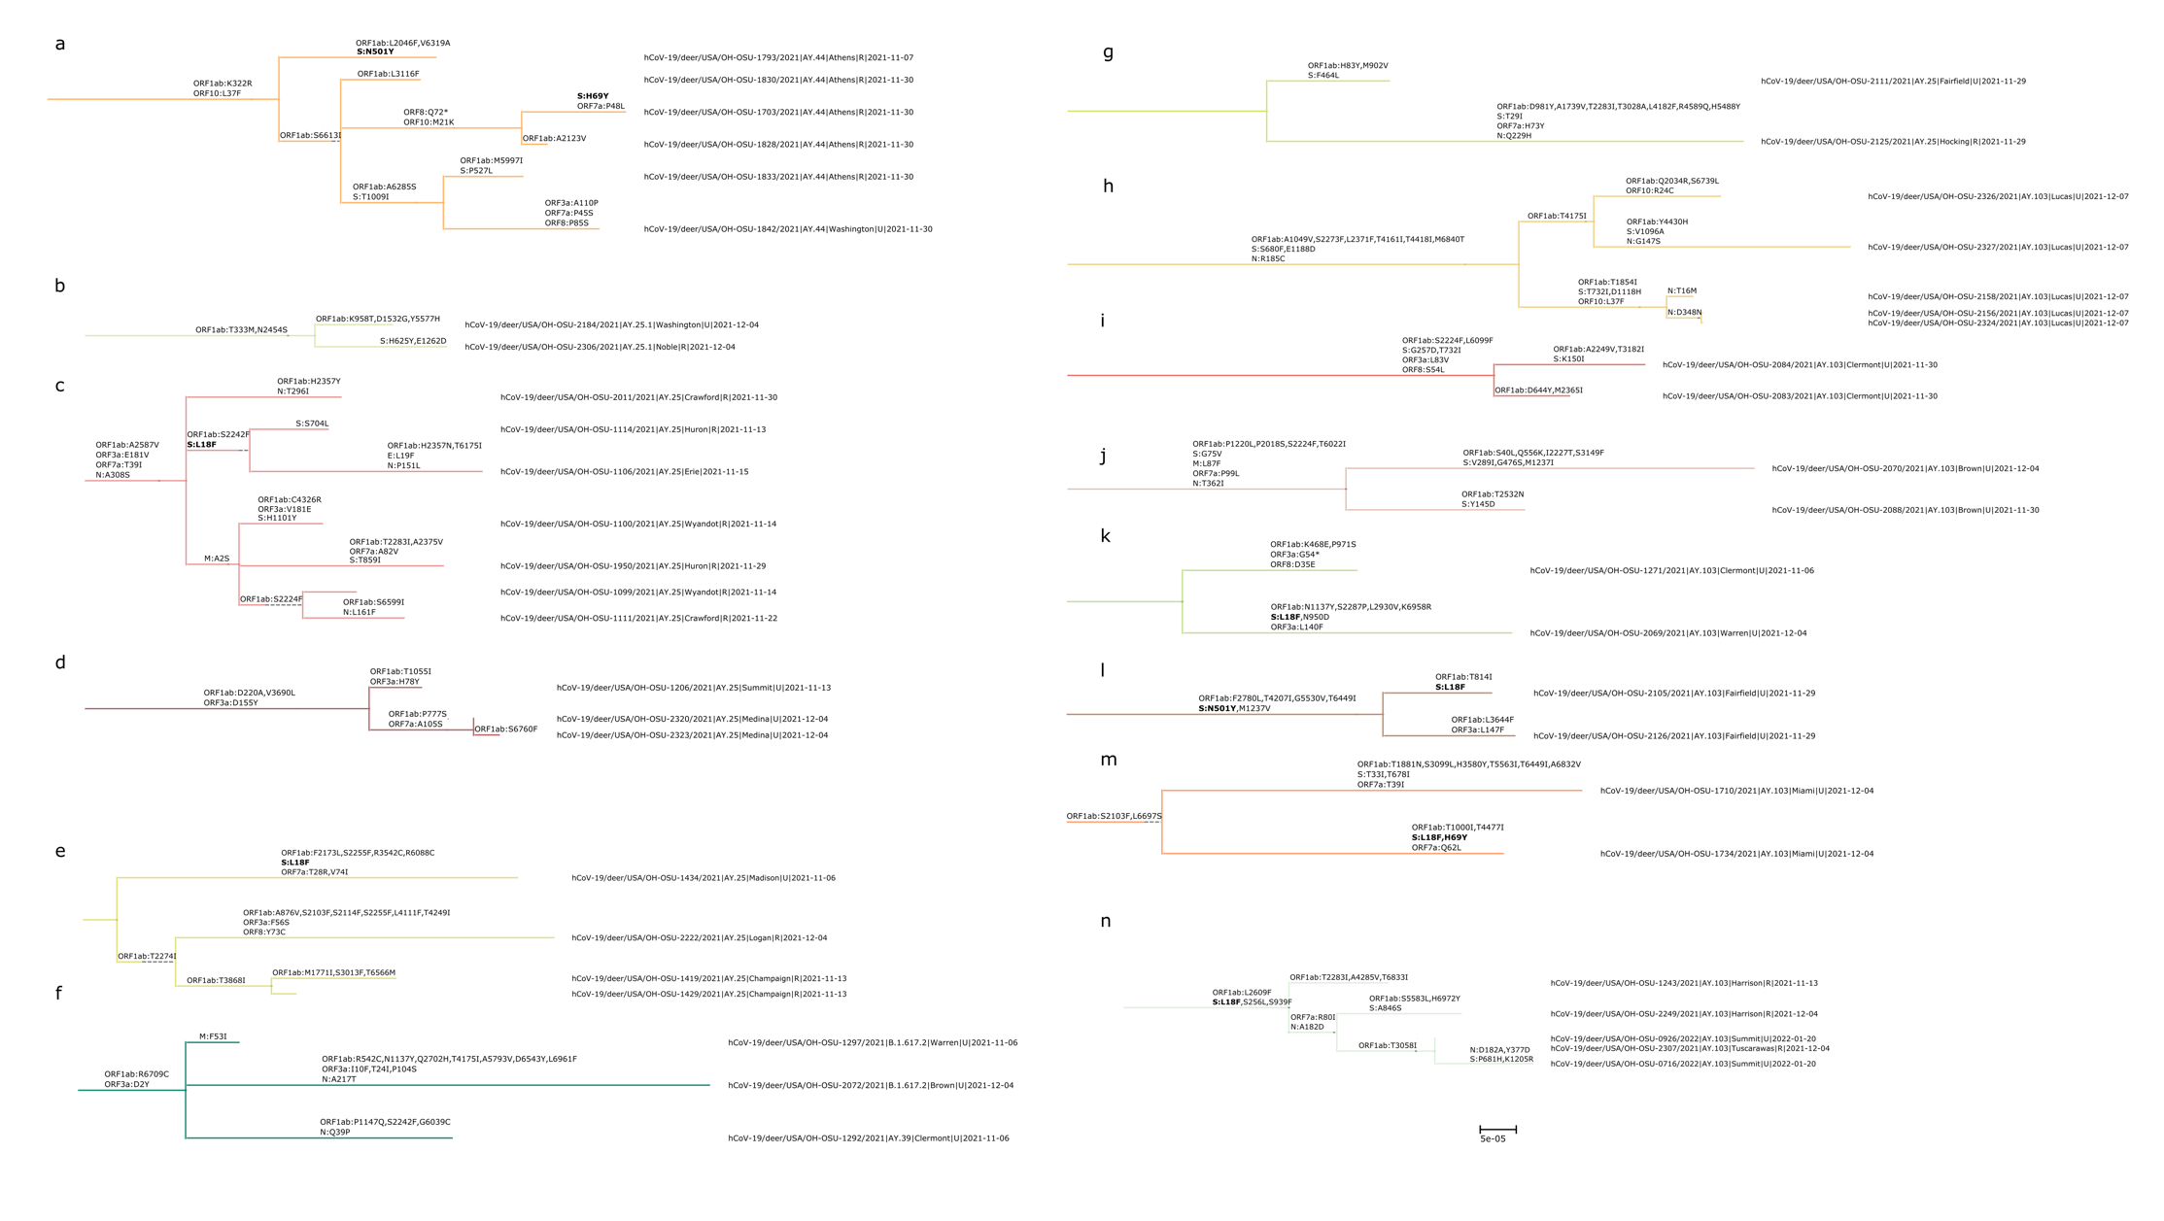
Figure S17. Transmission clusters in white-tailed deer Delta dataset. Missense mutations are shown on the branches. Recurring mutations in Spike with known phenotypic effects are shown in bold.

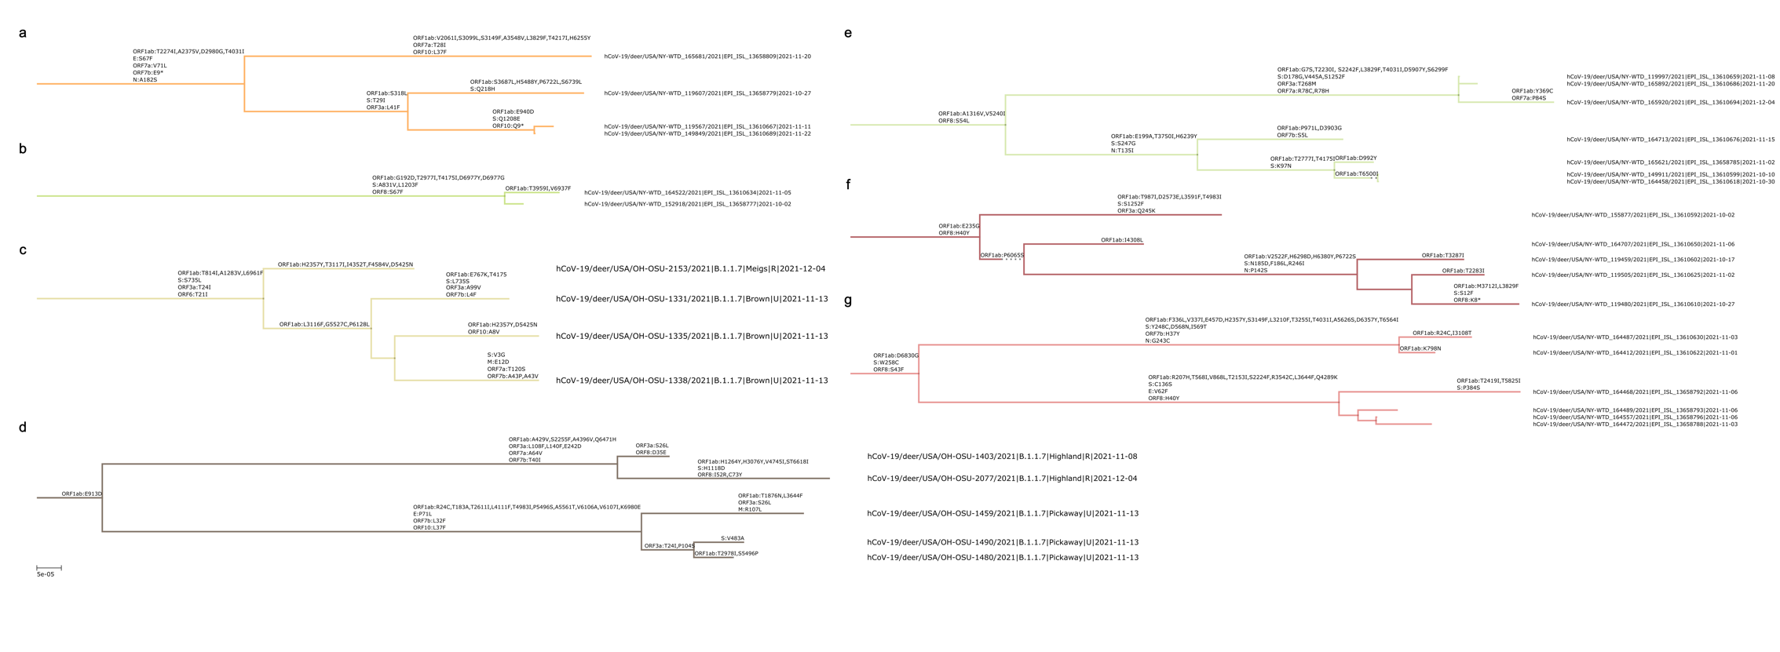
Figure S18. All transmission clusters in white-tailed deer Alpha dataset. (c) and (d) correspond to two clusters found in Ohio, members of which were sequenced in this study, while other clusters correspond to data collected in NY state and was downloaded from GISAID. Missense mutations are shown on the branches. Recurring mutations in Spike with known phenotypic effects are shown in bold.

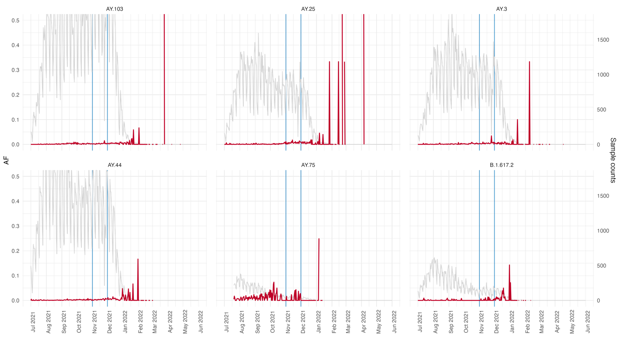
Figure S19. Changes in S:L18F in various Delta lineages. Red line – portion of samples with mutation among all samples from this lineage on the particular day. Grey line – total number of samples collected from the lineage on that day. Blue lines show the interval in which samples from white-tailed deer with L18F were collected.

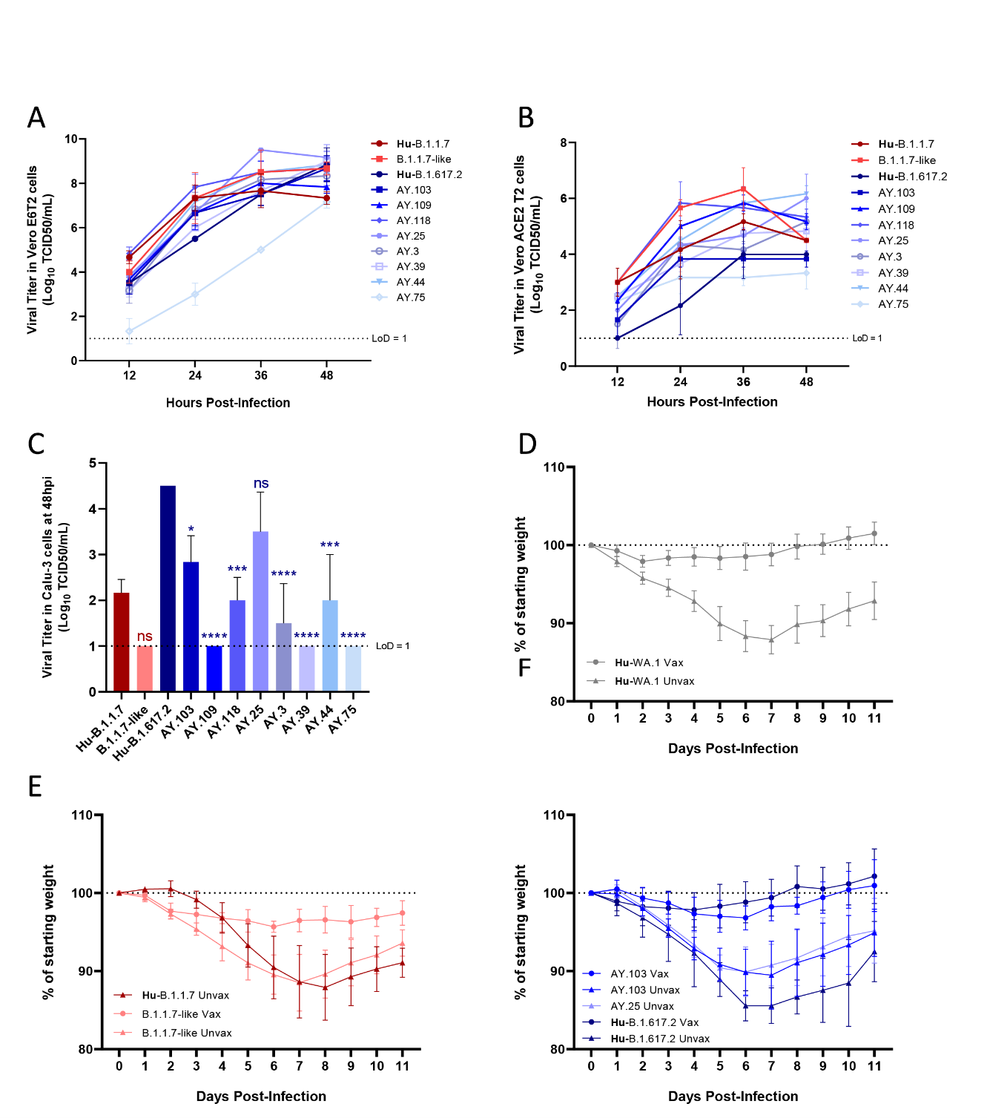
Figure S20. Growth analysis in vitro and body weight loss for Syrian hamsters experimentally infected with SARS-CoV-2. (A) Replication kinetics in VeroE6T2 cells. (B) Replication kinetics in VeroE6A2T2 cells. (C) Virus titers in Calu-3 cells at 48-hour post infection. Viral titers expressed as log10 TCID50/mL were plotted. (D-F) Body weight loss comparison between unvaccinated and BNT162b2 vaccinated animals. Mean weights as a percentage of starting weight were plotted.
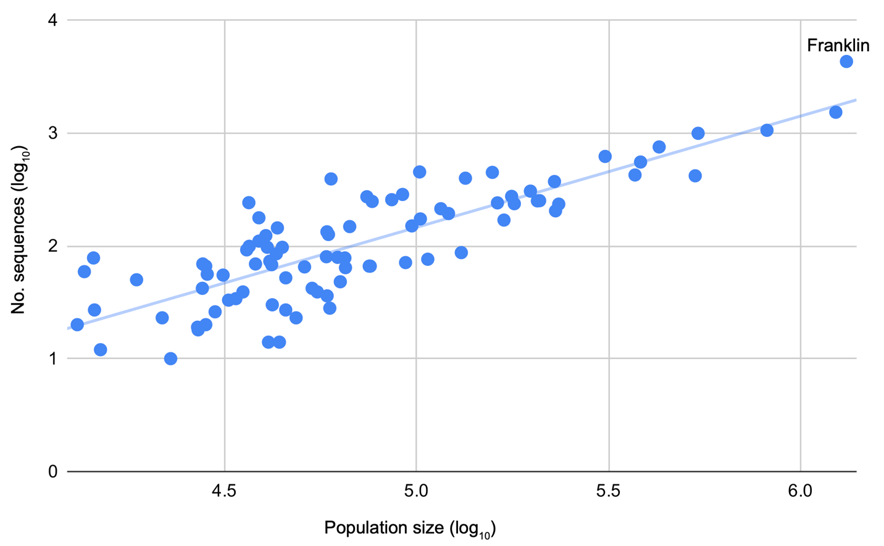

Figure S21. Spatial representation of Ohio SARS-CoV-2 sequences. The number of SARS-CoV-2 sequences an Ohio county that are available from GISAID during the study period (y-axis) is proportional to the population size of that county (x-axis).

