Supplementary Information:

Rapid Design of Top-Performing Metal-Organic Frameworks with Qualitative Representations of Building Blocks
Yigitcan Comlek¹, Thang Pham², Randall Q. Snurr², Wei Chen¹
¹Department of Mechanical Engineering, Northwestern University, Evanston, IL, USA,
²Department of Chemical and Biological Engineering, Northwestern University, Evanston, IL, USA
Contents
Supplementary Figures 2
Supplementary Figure 1. The building blocks that make up the design spaces. 2
Supplementary Figure 2. The distribution of the largest cavity diameter (LCD) of 1001 MOFs in the Reduced Design Space (RDS) for different building blocks. 3
Supplementary Figure 4. Latent Variable Plots after the LVGP-MOBBO campaign on Large Building Block Design Space. 5
Supplementary Table 6
Supplementary Table 1. Force field parameters for the metal in the metal nodes. 6

Supplementary Figures
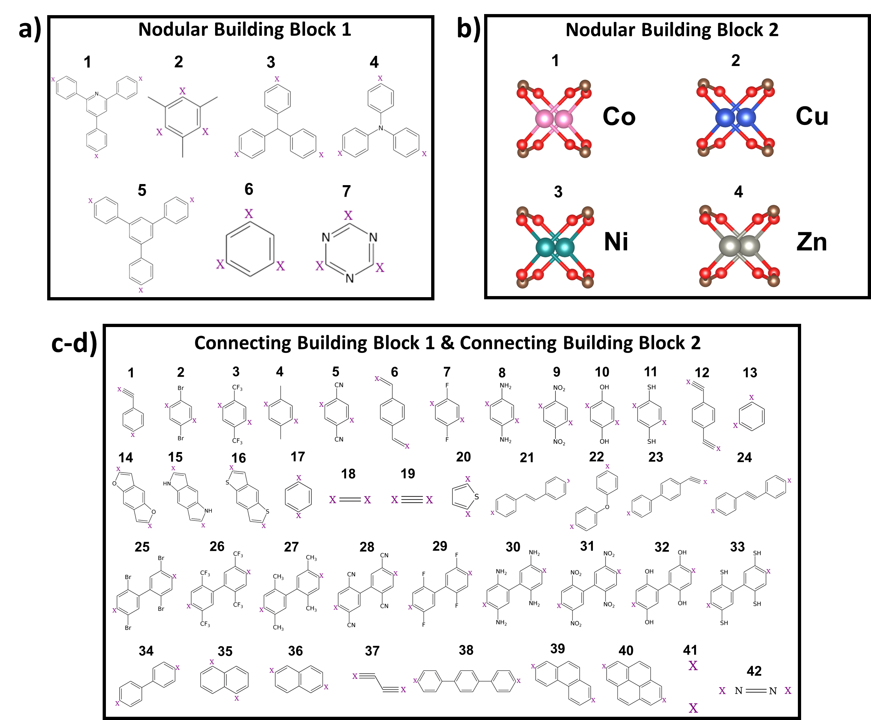Supplementary Figure 1. The building blocks that make up the design spaces. There are (a) 7 Nodular Building Block 1 (Inorganic Node) and (b) 4 Nodular Building Block 2 (Organic Node) design options. (c-d) The Connecting Building Block 1 (c) and the Connecting Building Block 2 (d) have 41 and 42 different design options, respectively.
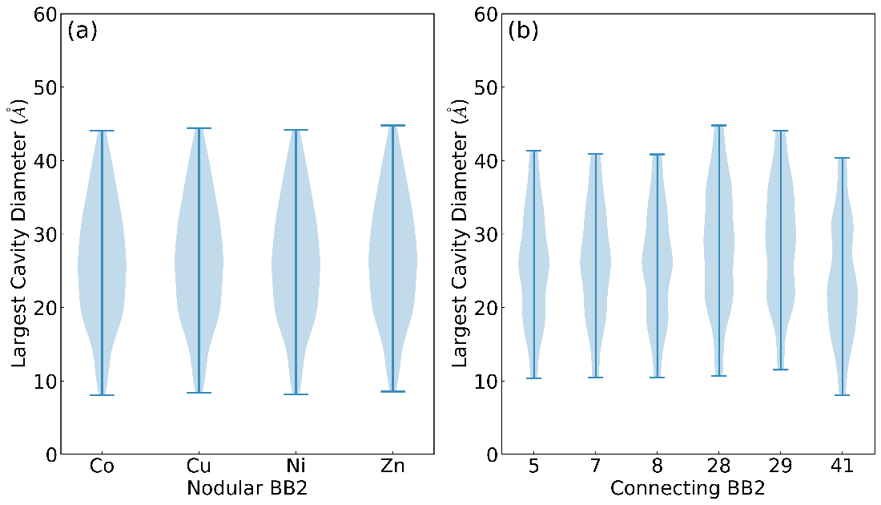
Supplementary Figure 2. The distribution of the largest cavity diameter (LCD) of 1001 MOFs in the Reduced Design Space (RDS) for different building blocks. LCD distribution for different (a) Nodular Building Block 2 and (b) Connecting Building Block 2 on the RDS.

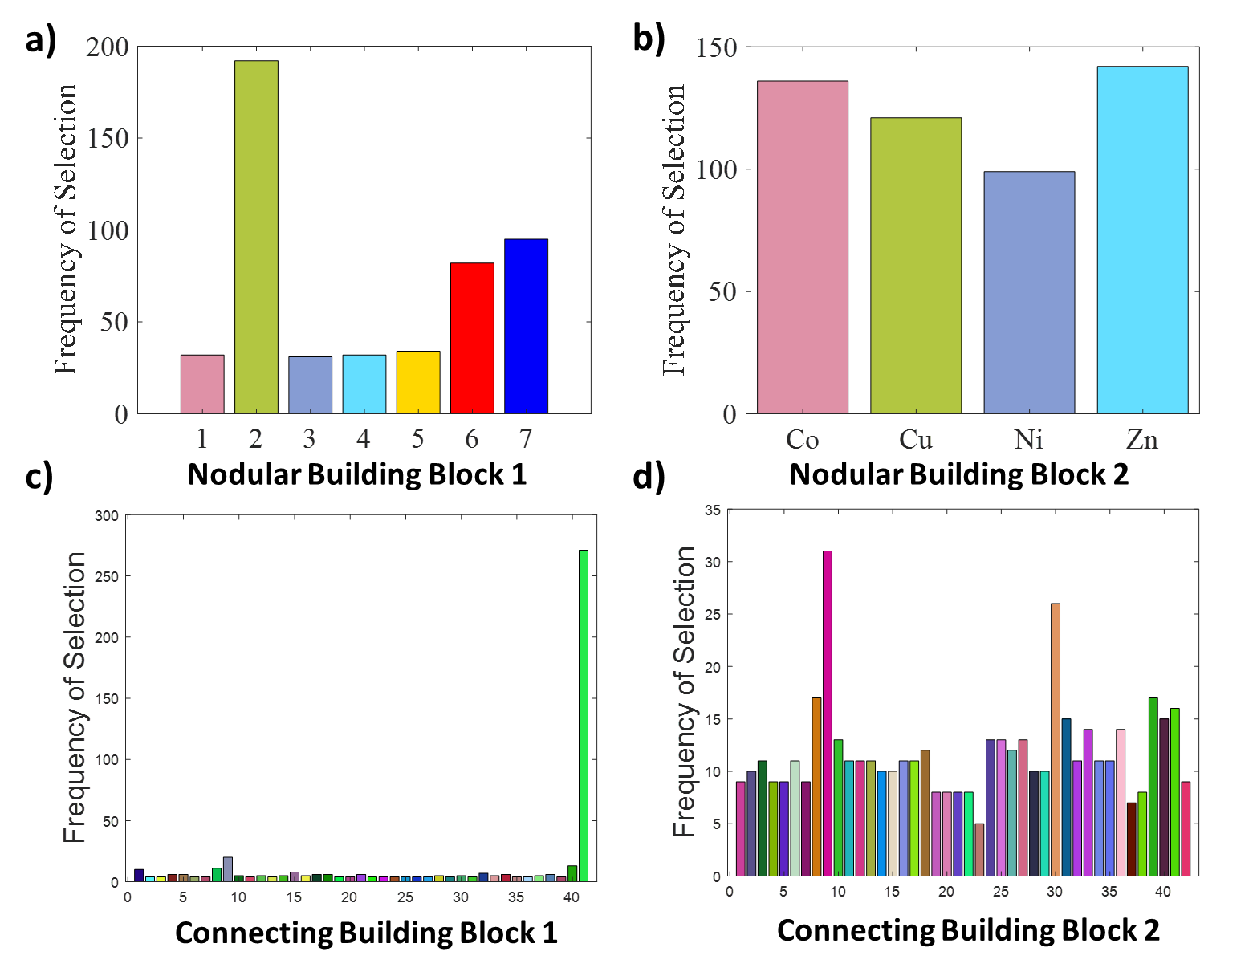Supplementary Figure 3. Histogram of the building blocks selected after the 66 iterations of LVGP-MOBBO on the Entire Design Space (EDS). (a) Design decisions for the Nodular Building Block 1, (b) Nodular Building Block 2, (c) Connecting Building Block 1, and (d) Connecting Building Block 2.

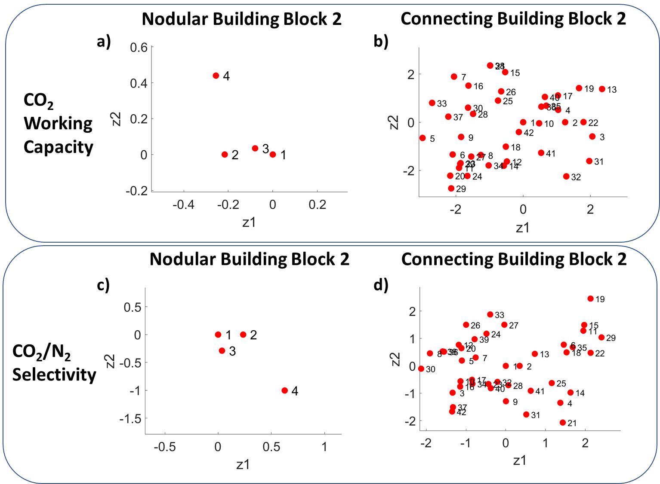

Supplementary Figure 4. Latent Variable Plots after the LVGP-MOBBO campaign on Large Building Block Design Space. Latent spaces of the (a) Nodular Building Block 2 and (b) Connecting Building Block 2 for the CO₂ working capacity. (c) Latent spaces for the Nodular Building Block 2 and (d) Connecting Building Block 2 for the CO₂/N₂ selectivity.

Supplementary Table
Supplementary Table 1. Force field parameters for the metal in the metal nodes. Lennard Jones parameters and the range of partial charges of the metal in the inorganic building blocks.
Atoms | 𝜎 (Å) | ɛ/k_{B} (K) | Range of Partial Charges
Co | 2.56 | 7.040 | 0.73 - 1.08
Cu | 2.52 | 3.114 | 0.72 - 1.04
Ni | 2.52 | 7.550 | 0.71 – 1.05
Zn | 2.46 | 62.40 | 0.68 – 1.00

