Supplementary Figure 1. Comparison of endophytic colonization of rice roots by PsJN with P. kururiensis and B. vietnamiensis.
(a) Epifluorescence and confocal microscopy pictures of the of the surface and crosssection of rice primary root respectively at 7 and 17 days post-inoculation by Pk::pIN29 and Bv::pIN29 cells. White bars represent 100 μm. White arrows indicate endophytic colonization (b) Population dynamics of DsRed-tagged PsJN associated with rice roots. The data reported are the median of bacterial population size from 9 plants for 1 dpi and 18 plants -conducted in two independent experiments- for 7 and 14 dpi. For the endophytic compartment the data correspond to 5 biological replicates

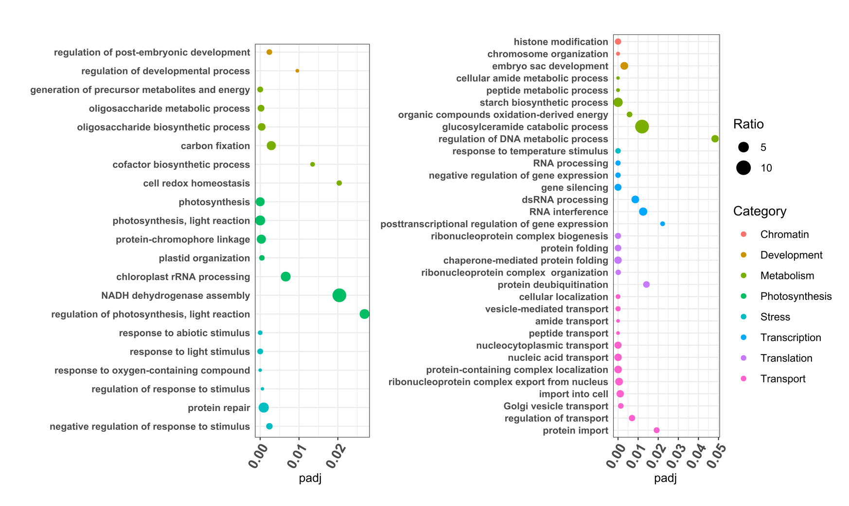

Supplementary Figure 2. Enrichment analysis of Biological Process GO terms of PsJN-treated rice leaf transcriptome. Y-axis corresponds to the significantly enriched GO terms (FDR < 0.05 and an enrichment ratio threshold of 2), X-axis corresponds to the adjusted p-value, the enrichment ratio represent by the size of the dots corresponds to the ratio between the proportion of genes related to the given GO term in the transcriptome and the proportion of genes related to the given GO term in the rice genome. Left and right panels respectively correspond to up- and down-regulated DEGs.

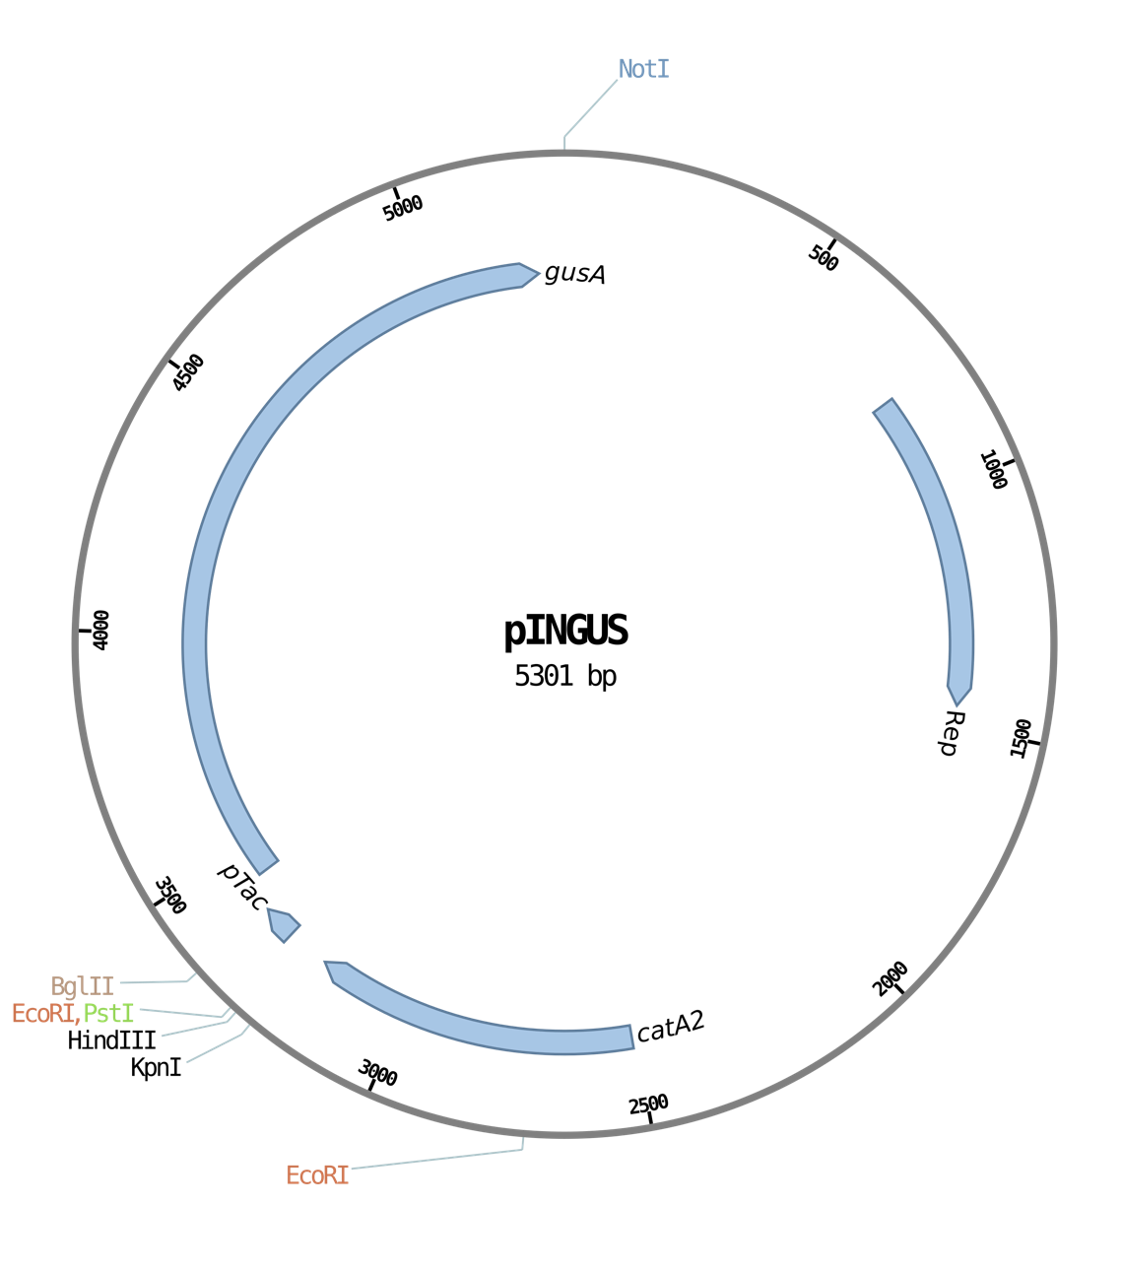

Supplementary Figure 3. Physical maps of pINGUS plasmid constructed in this study. Abbreviations: catA2, chloramphenicol resistance gene; Rep, required for replication; gusA, gene encoding a β-glucuronidase; pTac, tac promoter sequence.

