High-performance Supercapacitors Enabled by N/S Dual-doped Porous Carbon and DMO-regulated Electrolyte
Jingyuan Zhao¹, Meng Wang¹, Chaojie Jiang¹, Zhenyan Liu¹, Jiayu Lin¹, Xue Meng¹, Pengfei Zhang^{2*}, Kuilin Deng^{1*}
1. College of Chemistry and Materials Science, Hebei University, Baoding 071002, China
2. College of Biochemical Engineering & Environmental Engineering, Baoding University, Baoding 071000, China
* Corresponding author: Email: 274558659@qq.com; dengkl_hbu@163.com
Material characterization
The structure and morphology of C were analyzed by testing on Bruker advance ΙΙΙ 400M solid-state nuclear magnetic instrument. The total reflection technique is used to measure FT-IR in the range of 400-4000 cm⁻¹ on the Nicolet iS10 FT-IR spectrometer. The morphology of N, S-PTMs was observed by scanning electron microscope (SEM, JSM-7500) and transmission electron microscope (TEM, Tecnai G2 F20 S-Twin). The pyrolysis behavior of PTM was studied in nitrogen using a thermogravimetric analyzer (TGA 4000, PerkinElmer) at a heating rate of 20 ℃·min⁻¹ from room temperature to 800 ℃. Specific structural properties of the resulting carbon were confirmed by Raman spectroscopy (LabRAM HR Evolution, France, laser excitation λ_{exc} = 514 nm). The XRD patterns of the samples were examined using Cu Kα radiation (λ = 1.5418 A) at 40 kV and 40 mA on A diffrotometer (D8 ADV ANCE, Bruker). SSA and pore size distribution (ASAP2460) were analyzed by nitrogen adsorption/desorption isotherms at −196℃. The pore size distribution was derived from the adsorption branch of the isotherm by BJH method. XPS was performed on a Thermo ScientificTM K-AlphaTM⁺ spectrometer equipped with a monochrome Al Kα X emission source (1486.6 eV) at 100 W. CV, GCD and EIS were tested on CHI660E electrochemical workstation, and N, S-PTM-D cyclic performance was tested on blue electric test system.
Materials
N-Aminorhodanine (NAR, ≥ 99%), dimethyl oxalate (DMO, ≥ 99%) and p-phthalaldehyde (PPD, ≥ 99%) were provided from Shanghai Aladdin Blochemlcal Technology Co, Ltd. Poly(vinylidene fluoride) (PVDF) and zinc trifluoromethylsulfonate [Zn(CF3SO3)2, ≥ 99%] were purchased from Shanghai Macklin Biochemical Co, Ltd. (China), and were used without further purification. N-methyl-2-pyrrolidone (NMP), butyl acetate, triethylamine (TEA, 99%) and acetonitrile were analytical reagent grades. Acetylene black (ACET) was purchased from TIMICAL (Tianjin, China). Carbon cloth was provided from Carbon Energy Technology Co, Ltd.
Electrochemical measurements
In the three-electrode system, the electrolyte used in the test is 6 M KOH solution, the reference electrode is saturated mercuric oxide electrode, the counter electrode is platinum electrode, and the working electrode is made of carbon cloth loaded with active material. The CV and GCD measurements are carried out in the voltage window of -1~0 V. In the two-electrode system, the working electrode is loaded with the titanium foil of N/S-DDPC8, and the load of each working electrode is 0.5 mg. The CV and GCD tests were carried out under the voltage window of 0-1 V, and the electrolyte was 2 M Zn (CF₃SO₃)₂. The CV and GCD tests were carried out under the voltage window of 0-1.6 V, and the electrolyte was Zn (CF₃SO₃)₂-Dimethyl oxalate (2 M+0.1 M).
Calculation of performance parameters
The specific capacitance of a single electrode was calculated by the following formula:
$C=\frac{I∆t}{m∆V}$ (1.1)
Where $I ,∆t$ , $m$ and $∆V$ represent: the discharge current (A), discharge time (s), the quality of N-PCMs on the working electrode (g) and potential window during discharge (V), respectively.
Under a two-electrode configuration, the specific capacitance (Cs, F·g⁻¹) is calculated based on the GCD curves using the following equation.
$Cs=4·C_{cell}=4·\frac{I∆t}{M ∆V}$ (1.2)
where I (A), M (g), ΔV (V), and Δt (s) are the discharge current, mass of active materials in the single electrode, operating potential window, and discharge time, respectively.
Where the $k_{1}v$ and $k_{2}v^{1/2}$ represented the surface dependent part and the diffusion-dependent part, respectively, the i represented the current density.
The energy density (E_{d}, Wh·kg⁻¹) and power density (P_{d}, W·kg⁻¹) are calculated based on the flowing equations.
$E_{d}=\frac{C_{S}×∆V^{2}}{2×4×3.6}$ （1.3）
$P_{d}=\frac{E_{d}×3600}{∆t}$ （1.4）
Supplementary Figures
Fig. S1 Changes of D3 and IG contents
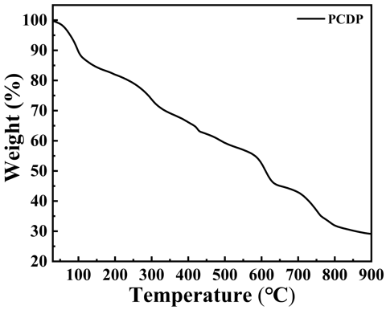
Fig. S2 TGA curves of PCDP
Fig. S2 showed the thermogravimetric analysis of PCDP at N₂ atmosphere from 30 ℃ to 800 ℃. As for the pure PCDP sample, the first step of decomposition between 50 and 90 °C corresponds to loss of water. The second step of decomposition start from 100 to 270 °C, representing to the degradation of carbonyl group. The third step of decomposition range between 270 and 500 °C is assigned to the decomposition of benzene rings along with thiazole rings. And, the fourth step of decomposition corresponds to a complete loss of the molecules between the range of 500–800 °C. The KOH and C could react and create pores at 640 °C, at the high temperature (> 640 °C) the two solid matters were active and reacted, the reaction produced abundant CO gas and K atoms, the reduce of C atoms caused the formation of disorder porous structure, and the K insertion carbon lattices and the release of CO also could create rich porous structures and the reaction equation was as follow: $KOH + C→CO↑+ K$.

Table S1 N-5, N-6 and N-Q content ratio change
SAMPLES | N-5 : N-6 : N-Q
N/S-DDPC6 | 1:0.99:0.97
N/S-DDPC7 | 1:0.94:0.92
N/S-DDPC8 | 1:0.88:0.90
N/S-DDPC9 | 1:0.66:0.81

Table S2 Elemental composition of C, N, O and S in N/S-DDPCs
SAMPLES | C  (AT %) | O  (AT %) | S  (AT %) | N  (AT %) | N-5  (AT %) | N-6  (AT %) | N-Q  (AT %)
N/S-DDPC6 | 72.89 | 16.93 | 5.36 | 4.82 | 1.63 | 1.61 | 1.58
N/S-DDPC7 | 74.10 | 18.21 | 3.16 | 4.53 | 1.58 | 1.49 | 1.46
N/S-DDPC8 | 77.62 | 16.50 | 2.31 | 3.57 | 1.28 | 1.13 | 1.16
N/S-DDPC9 | 80.76 | 15.38 | 2.06 | 1.80 | 0.73 | 0.48 | 0.59

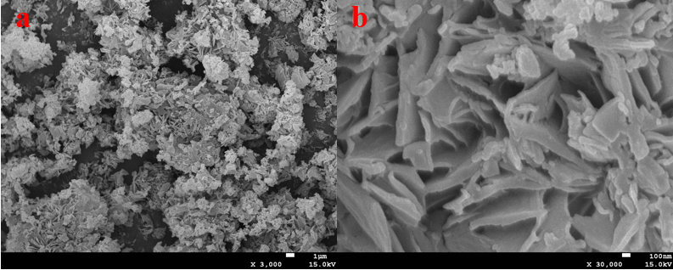
Fig. S3 SEM image of PCDP

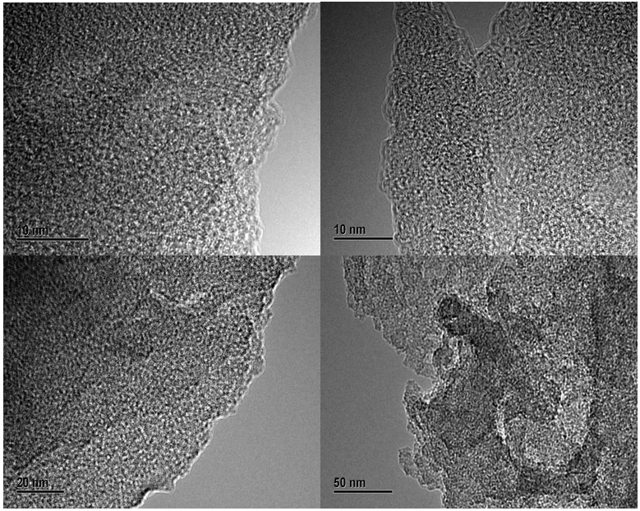
Fig. S4 TEM of N/S-DDPC8 at high magnification
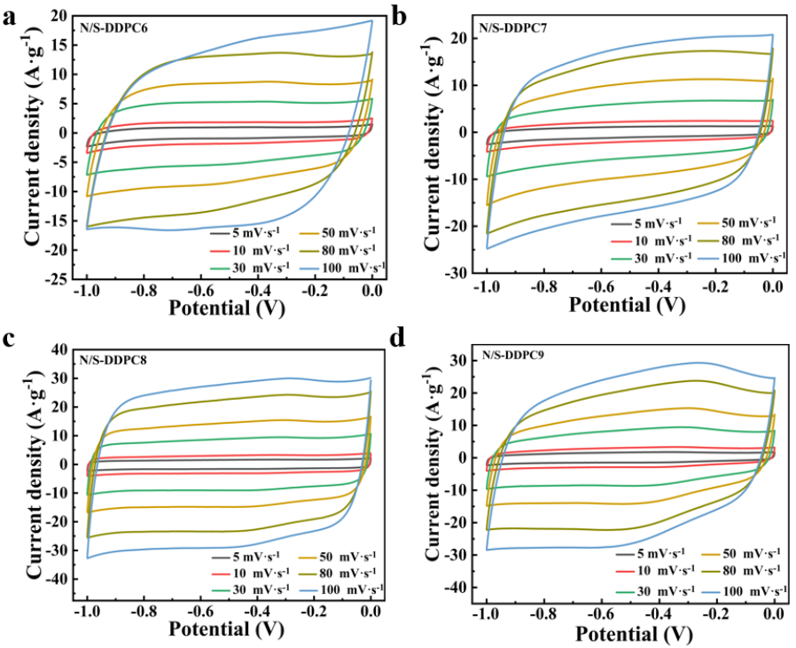
Fig. S5 CV curves of N/S-DDPCs in 6 M KOH solution at scan rates 5-100 mV·s⁻¹. (a) N/S-DDPC6, (b) N/S-DDPC7, (c) N/S-DDPC8 and (d) N/S-DDPC9
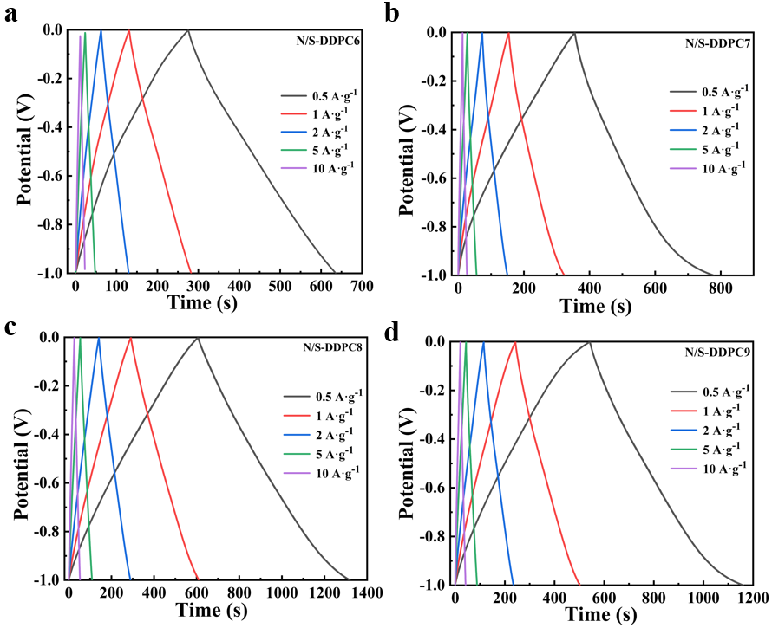
Fig. S6 GCD curves of N/S-DDPCs at different current densities in 6 M KOH
solution. (a) N/S-DDPC6, (b) N/S-DDPC7, (c) N/S-DDPC8 and (d) N/S-DDPC9

The Dunn’s method was employed to quantify the capacitance contribution from fast-kinetic processes (including electrical double-layer capacitive processes and surface rapid redox reactions) and slow-kinetic processes (redox reactions that are diffusion-controlled). The charge-storage kinetic information can be collected by analyzing the relationship between current (i) and the scan rate (v), which can be expressed as the following:
$$i=k_{1}v+k_{2}v^{1/2}$$
where the $k_{1}$ and $k_{2}$ are constants, k1v accounts for the current density contributed from fastkinetic process. The second term $k_{2}v^{1/2}$ corresponds to the current density associated with slow-kinetic process. Dividing $v^{1/2}$ on both sides of the equation yields:
$$iv^{-0.5}=k_{1}v^{0.5}+k_{2}$$
Therefore, $iv^{-0.5}$ and $v^{0.5}$ are expected to generate a linear relationship, the capacitance contribution from fast/slow kinetics can be differentiated by linear fitting. The slope corresponds to $k_{1}$ and the y-intercept equals $k_{2}$. By repeating the above steps for other potentials and scan rates, the respective capacitance contribution from fast and slow reactions can be quantitatively mapped out. The ratio of fast capacitance to total capacitance equals the ratio of the area of the marked region to the area of the total CV region.
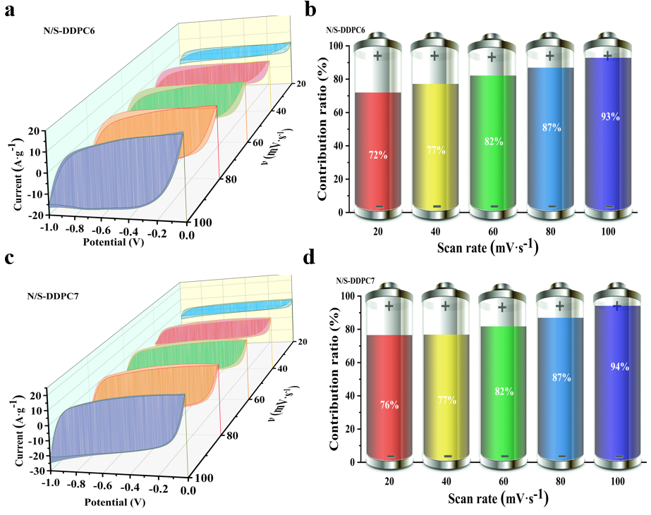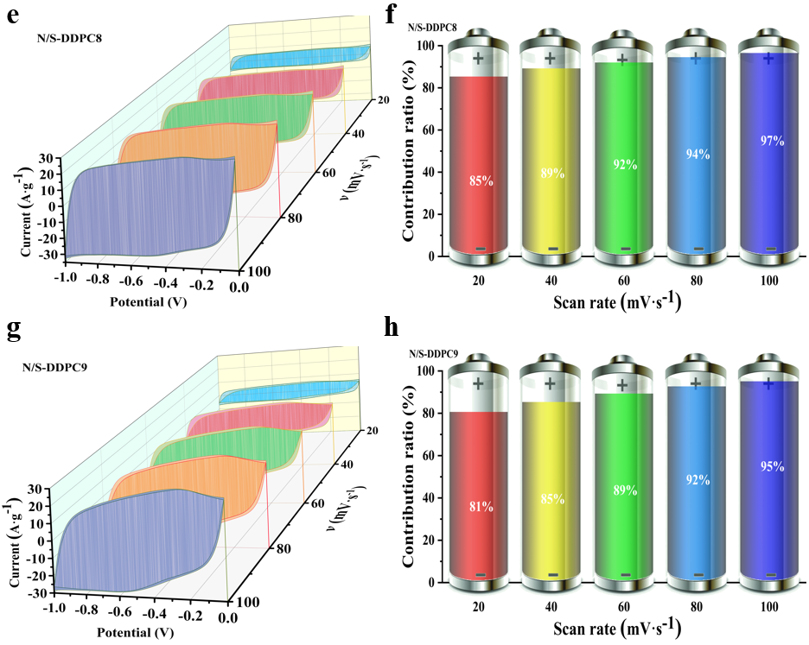
Fig. S7 (a, c, e, and g) Pseudocapacitance contribution rate 3D waterfall chart, and (b, d, f and h) the histograms of capacitance contributions from the fast-kinetic and slow-kinetic intercalation processes at different rates.

Table S3 Metal-free polymer-based supercapacitors reported previously
Electrode materials | Electrolytes | Capacitance  (F·g⁻¹) | Current density /Scan rate | Cell  configuration | Ref.
S-PANI/OCNT | H₂SO₄ | 310 | 5 mV·s⁻¹ | three-electrode | [1]
GO/CR-PEDOT | Na₂SO₄ | 227 | 1 A·g⁻¹ | three-electrode | [2]
2%RGO/PMMA | NaOH | 30.4 | 1 A·g⁻¹ | three-electrode | [3]

Table S4 Metal oxide containing electrodes reported previously
Electrode materials | Electrolytes | Capacitance  (F·g⁻¹) | Current density /Scan rate | Cell  configuration | Ref.
CP/MoS₂-GO-PANI | H₂SO₄ | 255.1 | 1 A·g⁻¹ | three-electrode | [4]
PANI/MnO₂ | H₂SO₄ | 215 | 0.3 A·g⁻¹ | three-electrode | [5]
N-Doped TiO₂ | Na₂SO₄ | 216 | 1 A·g⁻¹ | three-electrode | [6]

Table S5 Metal-free polymer-based supercapacitors reported previously
Electrode materials | Electrolytes | Capacitance  (F·g⁻¹) | Current density /Scan rate | Cell  configuration | Ref.
CPC-700-2 | KOH | 71.26 | 0.5 A·g⁻¹ | two-electrode | [7]
HCM-3-800 | K₂CO₃-glycol | 71.8 | 0.5 A·g⁻¹ | two-electrode | [8]
Poly  (3,4-ethylenedioxythiophene) | HClO₄ | 74 | 1 A·g⁻¹ | two-electrode | [9]

Table S6 Metal oxide containing electrodes reported previously
Electrode materials | Electrolytes | Capacitance  (F·g⁻¹) | Current density /Scan rate | Cell  configuration | Ref.
B-C@CoCuSi-(1-3) | KOH | 80.4 | 0.5 A·g⁻¹ | two-electrode | [10]
MnO₂/CNTs | Na₂SO₄ | 85.8 | 0.2 A·g⁻¹ | two-electrode | [11]
PPy/MnFe₂O₄ | Na₂SO₄ | 66.1 | 0.5 A·g⁻¹ | two-electrode | [12]

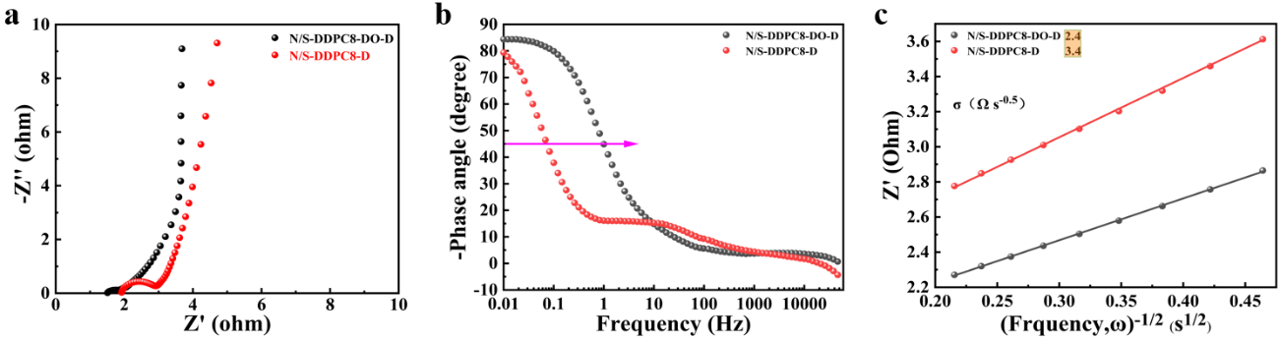
Fig. S8 (a) Nyquist plots of N/S-DDPC8-DMO-D and N/S-DDPC8-D electrodes with frequency range of 10⁻² to 10⁵ Hz, (b) diagrams of phase angle and frequency and (c) Z’ vs. the reciprocal of the square root of frequency (ω^{−0.5}) in the intermediate frequency range. The solid lines are best fitting lines to calculate the diffusion resistance, σ.

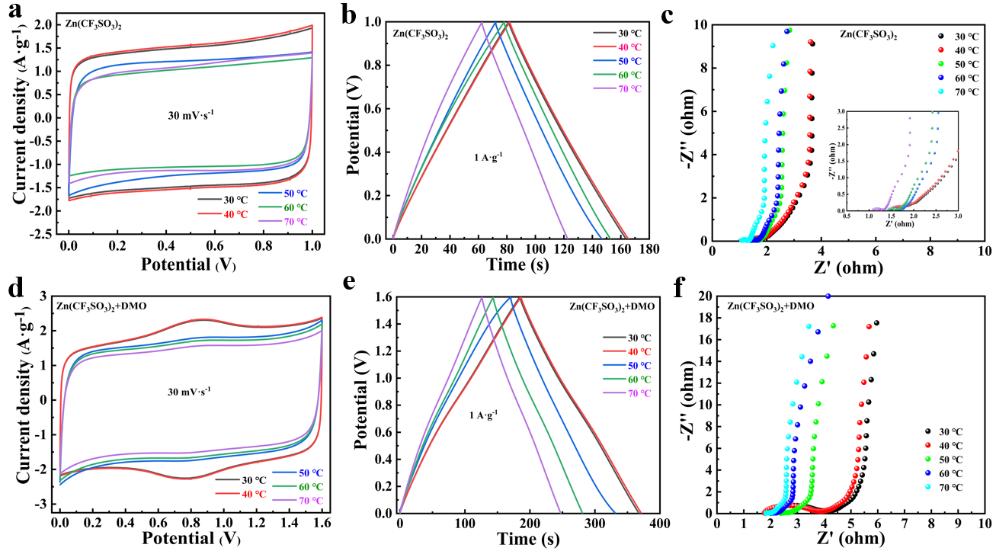
Fig. S9 CV, GCD and EIS curves of assembled supercapacitors at different temperatures (a-c) Zn(CF₃SO₃)₂-based and (d-f) Zn(CF₃SO₃)₂+DMO-based electrolytes.

Table S7 Specific capacitance of Zn(CF₃SO₃)₂ electrolyte and Zn(CF₃SO₃)₂+DMO electrolyte at different temperatures
Temperature
Electrolyte  Capacitance (F·g⁻¹) | 30 ℃ | 40 ℃ | 50 ℃ | 60 ℃ | 70 ℃
Zn(CF₃SO₃)₂ | 320 | 323 | 248 | 220 | 196
Zn(CF₃SO₃)₂+DMO | 458 | 460 | 407 | 345 | 303

References
[1] J.M. Gonçalves, P.R. Martins, K. Araki, L. Angnes, Recent progress in water splitting and hybrid supercapacitors based on nickel-vanadium layered double hydroxides, Journal of Energy Chemistry, 57 (2021) 496-515.
[2] H. Jia, J. Zhu, M. Zhang, S. Sang, F. Hu, F. Zhang, Fluorine and nitrogen co-doped mesoporous carbon derived from polytetrafluoroethylene@melamine sponge for supercapacitor application, Journal of Energy Storage, 38 (2021) 102613.
[3] M. Wang, J. Zhao, D. Zhang, Z. Chen, J. Zheng, P. Zhang, K. Deng, Honeycomb-like N-doped porous carbon derived from poly(Schiff-base) as an electrode material for high-performance supercapacitor, Journal of Electroanalytical Chemistry, 908 (2022) 116109.
[4] M. Ren, C.-y. Zhang, Y.-l. Wang, J.-j. Cai, Development of N-doped carbons from zeolite-templating route as potential electrode materials for symmetric supercapacitors, International Journal of Minerals, Metallurgy, and Materials, 25 (2019) 1482-1492.
[5] T. Panja, D. Bhattacharjya, J.-S. Yu, Nitrogen and phosphorus co-doped cubic ordered mesoporous carbon as a supercapacitor electrode material with extraordinary cyclic stability, Journal of Materials Chemistry A, 3 (2015) 18001-18009.
[6] W. Li, X. Yang, Z. Chen, T. Lv, X. Wang, J. Qiu, Synthesis and structure regulation of armor-wearing biomass-based porous carbon: Suppression the leakage current and self-discharge of supercapacitors, Carbon, 196 (2022) 136-145.
[7] J. Xiao, Y. Wang, T.C. Zhang, L. Ouyang, S. Yuan, Phytic acid-induced self-assembled chitosan gel-derived N, P–co-doped porous carbon for high-performance CO₂ capture and supercapacitor, Journal of Power Sources, 517 (2022) 230727.
[8] L. Wan, W. Wei, M. Xie, Y. Zhang, X. Li, R. Xiao, J. Chen, C. Du, Nitrogen, sulfur co-doped hierarchically porous carbon from rape pollen as high-performance supercapacitor electrode, Electrochimica Acta, 311 (2019) 72-82.
[9] R.J. Wesley, A. Durairaj, S. Ramanathan, R.J. abraham, A. Obadiah, S. Ramasundaram, X. Lv, S. Vasanthkumar, Tea waste biochar composite with nickel phthalocyanine as a potential supercapacitor electrode material, Biomass Conversion and Biorefinery, 24 (2022) 100828.
[10] X. Hou, L. Chen, H. Xu, Q. Zhang, C. Zhao, L. Xuan, Y. Jiang, Y. Yuan, Engineering of Two-dimensional Cobalt-Glycine Complex Thin Sheets of Vertically Aligned Nanosheet Basic Building Blocks for High Performance Supercapacitor Electrode Materials, Electrochimica Acta, 210 (2016) 462-473.
[11] C.L. Hao Jiang, Ting Sun and Jan Ma, A green and high energy density asymmetric supercapacitor based on ultrathin MnO₂ nanostructures and functional mesoporous carbon nanotube electrodes, Nanoscale, 4 (2012) 807-812.
[12] H. Xu, L. Wang, Y. Zhang, Y. Chen, S. Gao, Pore-structure regulation of biomass-derived carbon materials for an enhanced supercapacitor performance, Nanoscale, 13 (2021) 10051-10060.

