Supplementary information:
Tailoring energy barriers of Bloch-point-mediated transitions between topological spin textures
Yu Li^{1,2*}, Yuzhe Zang¹, Runze Chen¹, Christoforos Moutafis^{1*}
¹Nano Engineering and Spintronic Technologies (NEST) Group, Department of Computer Science, University of Manchester, Manchester M13 9PL, United Kingdom.
²Frontier Institute of Chip and System, Fudan University, Shanghai, 200438, China.
*Email: YuLi.nano@outlook.com; Christoforos.Moutafis@manchester.ac.uk.

Supplementary note 1: Geometry-dependent critical field of conical-saturated transition
In chiral magnets, the critical field $B_{\text{c}}$ could indicate the transition field between the conical and saturated states. They will undergo the second-order transitions with continuous variations of the magnetic susceptibility $χ=∂m/∂B_{ext}$ (second derivative of the energy) as a function of the external magnetic field $B_{ext}$. Its analytical solution can be expressed as: $B_{0}=D^{2}/2AM_{\text{s}}$ ($∼0.37 \text{T}$ for FeGe) regarding the micromagnetic parameters^{S1–S3}. Its derivation is based on the system without the contribution of magnetostatic interactions. However, we find the magnetostatic interaction could play a significant role in modulating conical-saturated transitions, which is dependent on the sample geometry (Fig. S1). It gives rise to a shape anisotropy which has a tendency of reducing the total magnetic moment by driving the magnetisation vectors away from the surface normal. Therefore, in a relatively flat nanodisk with a small length-to-diameter ratio, the magnetisation tends to align in the $xy$ plane accompanied by a high critical field ($B_{\text{c}}>B_{0}$), in analogy to a hard-axis model with a negative uniaxial anisotropy constant ($K_{\text{u1}}<0$); in contrast, for a large length-to-diameter ratio, the system can be intuitively regarded as a nanorod, where an easy axis points along the rod ($z$ axis) with a positive $K_{\text{u1}}$, which has an effect of lowering the critical field ($B_{\text{c}}<B_{0}$).
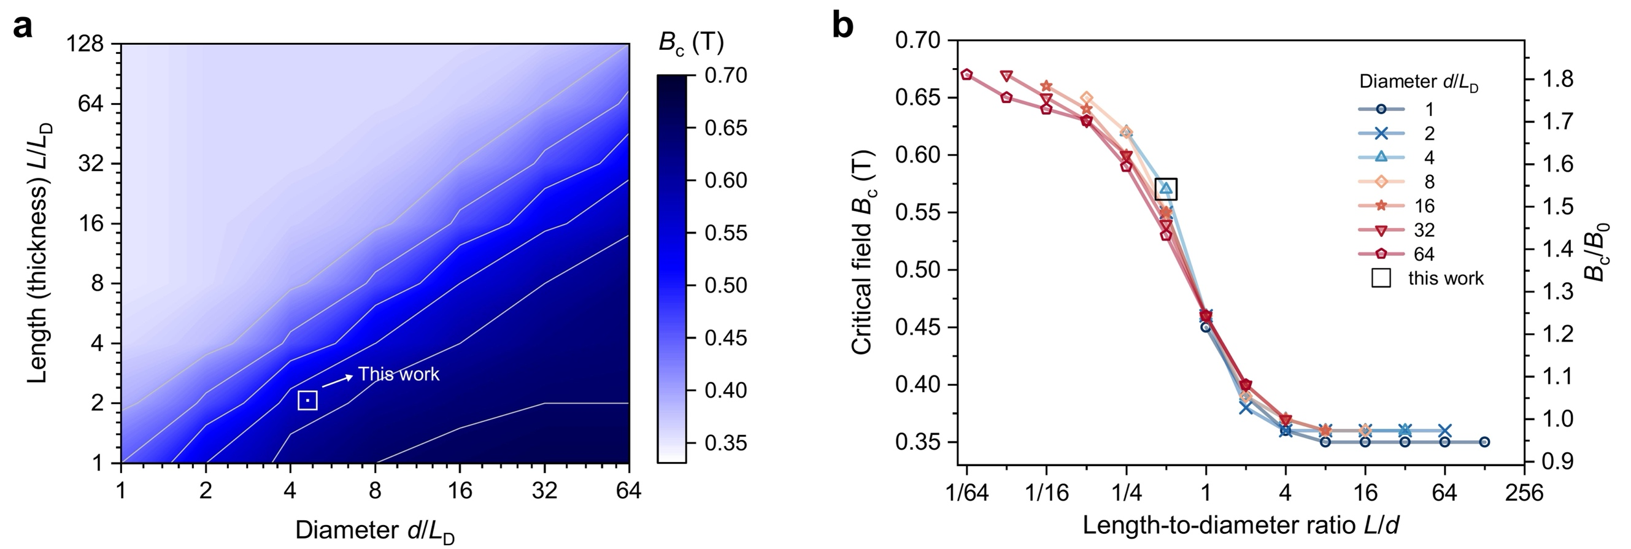
Fig. S1 Critical field of transitions between the conical and saturated states. a Contour plot of the critical field $B_{\text{c}}$ (background colour) regarding the sample diameter $d$ and length (thickness) $L$, in the units of $L_{\text{D}}=70 \text{nm}$. b Critical field $B_{\text{c}}$ shown as a function of the length divided by diameter $L/d$. The nanodisk geometries simulated in this work are indicated by the square, with the diameter of $4L_{\text{D}}$ and the length (thickness) of $2L_{\text{D}}$, and the adjusted critical field is $B_{0}^{'}=0.57 \text{T}$. $B_{0}=0.37 \text{T}$ indicates the critical field of FeGe chiral magnets without considering the effect of magnetostatic interactions.

In this work, the geometry of nanodisks is chosen with the diameter $d=4L_{\text{D}}$ and length (thickness) $L=2L_{\text{D}}$ unless specified elsewhere, and it leads to an adjusted critical field $B_{0}^{'}=0.57 \text{T}$. The results are directly extracted from the micromagnetic simulations, and the critical fields with respect to the sample geometry are shown in Fig. S1.

Supplementary note 2: Metastable chiral bobbers in $4L_{\text{D}}$-thick nanodisks
We have shown that single chiral bobbers can exist with two different penetration depths $L_{\text{P}}$ in $2L_{\text{D}}$-thick nanodisks (Fig. 1i in the main text). The presence of finite energy barriers between them prevents their transitions from one type to another (Fig. 3b in the main text). These objects can be imaged by various techniques, such as Lorentz transmission electron microscopy (LTEM)^{S4–S6}, TEM mode of off-axis electron holography^{S5–S8}, scanning transmission x-ray microscopy (STXM)^{S4}, and x-ray photoemission electron microscopy (XPEEM)^{S9}. As chiral bobbers with different $L_{\text{P}}$ have unique topological Hall responses (Fig. 2b in the main text), their detection and distinction can also be realised by electrical measurements. It paves the way for being utilised as multi-bit information carriers, and theoretically, the total number of possible states increases as a function of the thickness (in the order of $nL_{\text{D}}$). Here we present four types of chiral bobbers that can be stabilised as metastable states, at the bottom surface (bCB) of $4L_{\text{D}}$-thick nanodisks (Fig. S2). HC states and skyrmion tubes can be regarded as special chiral bobbers with no penetration into the film ($L_{\text{P}}=0$, Fig. S2a) and penetration through the film ($L_{\text{P}}=4L_{\text{D}}$, Fig. S2f), respectively. Based on the relative total energy (Fig. S2g) and the minimum energy path (Fig. S2h), these chiral bobbers have distinct energy landscapes, and although bCB₄ and SkT are approximately identical in energy, a large energy barrier ($>10 \text{eV} @B_{\text{ext}}=0.50 \text{T}$ in this work) still exists between their transition paths.

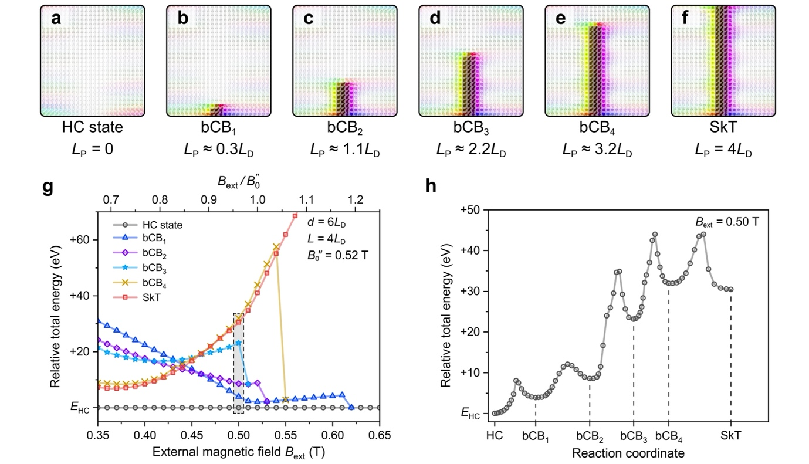
Fig. S2 Chiral bobbers in $4L_{\text{D}}$-thick nanodisks. a-f A single chiral bobber at the bottom surface (bCB) can be stabilised with different penetration depths $L_{\text{P}}$ (in the units of $L_{\text{D}}=70 \text{nm}$ for FeGe). The sample geometry is a nanodisk with the diameter of $d=6L_{\text{D}}$ and thickness of $L=4L_{\text{D}}$, and the critical field of conical-saturated transitions is $B_{0}^{'}=0.52 \text{T}$. g Relative total energy of these textures as a function of the magnetic field $B_{\text{ext}}$. h Minimum energy path between the HC state and SkT, and the local minima correspond to the states at $B_{\text{ext}}=0.50 \text{T}$ in the dashed square region of g.

References
S1. Rybakov, F. N., Borisov, A. B., Blügel, S. & Kiselev, N. S. New type of stable particlelike states in chiral magnets. Phys. Rev. Lett. 115, 117201 (2015).
S2. Rybakov, F. N., Borisov, A. B., Blügel, S. & Kiselev, N. S. New spiral state and skyrmion lattice in 3D model of chiral magnets. New J. Phys. 18, 045002 (2016).
S3. Bogdanov, A. & Hubert, A. Thermodynamically stable magnetic vortex states in magnetic crystals. J. Magn. Magn. Mater. 138, 255–269 (1994).
S4. Birch, M. T. et al. Real-space imaging of confined magnetic skyrmion tubes. Nat. Commun. 11, 1726 (2020).
S5. Pierobon, L. et al. Unconventional magnetization textures and domain-wall pinning in Sm-Co magnets. Sci. Rep. 10, 21209 (2020).
S6. Pierobon, L. et al. Temperature dependence of magnetization processes in Sm(Co, Fe, Cu, Zr)_{z} magnets with different nanoscale microstructures. J. Appl. Phys. 129, 183903 (2021).
S7. Zheng, F. et al. Experimental observation of chiral magnetic bobbers in B20-type FeGe. Nat. Nanotechnol. 13, 451–455 (2018).
S8. Midgley, P. A. & Dunin-Borkowski, R. E. Electron tomography and holography in materials science. Nat. Mater. 8, 271–280 (2009).
S9. Vijayakumar, J. et al. Meronlike spin textures in in-plane-magnetized thin films. Phys. Rev. Appl. 14, 054031 (2020).

