The ratio of monocyte count and high-density lipoprotein cholesterol mediates the association between urinary tungsten and cardiovascular disease: A study from NHANES 2005-2018
Yudong Wu^{a, b,1}, Yajie Meng^{c,1}, Weizhuo Yi^{a, b,1}, Rubing Pan^{a, b,1}, Yunfeng Liang^{a, b}, Yuxuan Li^{a, b}, Xiaoyu Jin^{a, b}, Xiaoni Sun^{a, b}, Shuangshuang Yan^{a, b}, Lu Mei^{a, b}, Jian Song^{a, b}, Shasha Song^{a, b}, Jian Cheng^{a, b}, Hong Su^{a, b, *}
Supplemental File
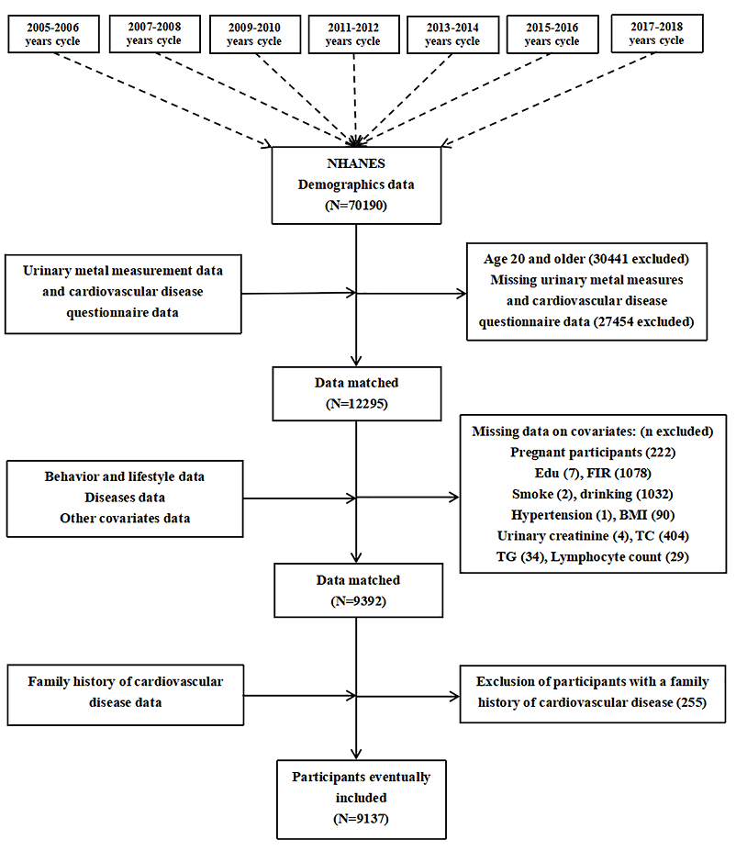

Figure S1. The process of inclusion and exclusion of study subjects.

Table S1 Distribution levels of urinary metals in the study population in NHANES 2005–2018.
Urine metal（μg/L) | ≧LOD  (%) | Mean | Different quantiles
Urine metal（μg/L) | ≧LOD  (%) | Mean | 5th | 25th | 50th | 75th | 95th
Ba | 99.42 | 2.02 | 0.23 | 0.61 | 1.25 | 2.43 | 5.78
Co | 99.67 | 0.53 | 0.09 | 0.21 | 0.36 | 0.56 | 1.28
W | 85.30 | 0.12 | 0.01 | 0.03 | 0.06 | 0.13 | 0.35
Mo | 99.98 | 49.99 | 7.09 | 19.12 | 37.34 | 66.60 | 135.00
Tl | 99.52 | 0.19 | 0.04 | 0.09 | 0.16 | 0.25 | 0.42
Cs | 99.99 | 5.19 | 1.14 | 2.62 | 4.40 | 6.72 | 11.50
Sb | 73.88 | 0.08 | 0.02 | 0.03 | 0.05 | 0.08 | 1.22
Pb | 98.25 | 0.59 | 0.07 | 0.21 | 0.39 | 0.71 | 1.64
Cd | 93.95 | 0.32 | 0.03 | 0.09 | 0.20 | 0.38 | 1.01
Notes: W: Tungsten; Ba: barium; Co: cobalt; Cs: cesium; Tl: thallium; Pb: lead; Cd: cadmium; Mo: molybdenum; Sb: Antimony; LOD: Limit of Detection.

Table S2 Associations between mediating variables and exposure and outcome.
X | β (95%CI) | M | β (95%CI) | Y
W | 0.090 (0.041,0.139) * | Neutrophil count | 0.036(-0.019,0.091) | CVD
W | 0.056 (-0.006, 0.119) | lymphocyte count | 0.035 (0.0003, 0.070) * | CVD
W | 0.164 (0.078, 0.250) * | White blood cell count | 0.033 (0.005, 0.061) * | CVD
W | 0.016 (0.010, 0.022) * | monocyte count | 0.504 (0.016, 0.992) * | CVD
W | 0.0004 (0.0003, 0.0006) * | MHR | 28.687 (9.380, 47.994) * | CVD
W | -0.463 (-0.857, -0.071) * | HDL | -0.013 (-0.021, -0.004) * | CVD
W | -1.085 (-1.704, -0.466) * | LDL | 0.002 (-0.005, 0.009) | CVD
W | -2.865 (-4.132, -1.599) | TC | -0.006 (-0.009, -0.003) * | CVD
W | 4.770 (1.154, 8.386) | TG | 0.001 (-0.0001, 0.002) | CVD
Notes: X: exposure; M: mediating variable; Y: outcome; *: P<005; The red words: the mediator variables that satisfy the mediation condition;
β: Correlation coefficient; 95%CI: 95% Confidence interval. MHR: the monocyte level/HDL cholesterol ratio.
Table S3 Sensitivity analysis of the association between urinary W and CVD.
W | Model
W | V | VI
Continuous | 1.20(1.07,1.36) | 1.22(1.07,1.39)
Q1 | Ref. (1.00)
Q2 | 1.16(0.89,1.52) | 1.17(0.88,1.56)
Q3 | 1.22(0.91,1.63) | 1.21(0.88,1.66)
Q4 | 1.63(1.19,2.24) | 1.68(1.18,2.39)
P for trend | 0.004 | 0.006
Notes: W: Tungsten; OR: Odds ratio; 95%CI: 95% Confidence interval; Q, quartile.
Model V： Model adjusting for age, gender, race, educational level, FIR, BMI, marital status, ln-transformed urinary creatinine, NHANES cycle, physical activity, drinking, smoking, hypertension, diabetes, TC, CVDF, glomerular filtration rate (GFR) and sleep status.
Model VI: Model V+ adjusting for urinary barium; cobalt; cesium; thallium; lead; cadmium; molybdenum;
Table S4 Subgroup sensitivity analysis of urinary W association with CVD further controls for sleep status
Quartile  group | Continuous | Different quantile groups [OR (95CI)]
Quartile  group | Continuous | Q1 | Q2 | Q3 | Q4 | P for trend
Gender |  | Ref. (1.00)
Male | 1.11(0.94,1.31) | Ref. (1.00) | 1.03(0.66,1.61) | 1.02(0.65,1.59) | 1.43(0.87,2.34) | 0.191
Female | 1.33(1.11,1.59) | Ref. (1.00) | 1.61(1.04,2.48) | 1.53(0.92,2.54) | 2.21(1.37,3.57) | 0.009
Age |  | Ref. (1.00)
<55 | 1.06(0.83,1.35) | Ref. (1.00) | 0.88(0.47,1.64) | 0.93(0.53,1.61) | 1.04(0.54,1.98) | 0.840
≧55 | 1.24(1.08,1.41) | Ref. (1.00) | 1.33(0.98,1.80) | 1.30(0.94,1.78) | 1.86(1.30,2.66) | 0.003
Diabetes |  | Ref. (1.00)
non-DM | 1.17(0.99,1.39) | Ref. (1.00) | 1.02(0.66,1.58) | 1.18(0.80,1.76) | 1.46(0.90,2.38) | 0.095
DM | 1.26(1.01,1.58) | Ref. (1.00) | 1.01(0.60,1.69) | 1.05(0.59,1.88) | 1.50(0.85,2.64) | 0.179
Hypertension |  | Ref. (1.00)
non-Hyp | 0.83(0.64,1.07) | Ref. (1.00) | 0.63(0.36,1.11) | 0.64(0.34,1.20) | 0.59(0.31,1.14) | 0.118
Hyp | 1.35(1.18,1.56) | Ref. (1.00) | 1.50(1.11,2.03) | 1.55(1.11,2.16) | 2.24(1.53,3.27) | <0.001
Notes: W: Tungsten; OR: Odds ratio; 95%CI: 95% Confidence interval; Q, quartile. DM: Diabetes mellitus; Hyp: Hypertension; Model adjusting for age, gender, race, educational level, FIR, BMI, marital status, ln-transformed urinary creatinine, NHANES cycle, physical activity, drinking, smoking, hypertension, diabetes, TC, CVDF and glomerular filtration rate (GFR).
Table S5 Subgroup sensitivity analysis of urinary W association with CVD further controls for other metals
Quartile  group | Continuous | Different quantile groups [OR (95CI)]
Quartile  group | Continuous | Q1 | Q2 | Q3 | Q4 | P for trend
Gender |  | Ref. (1.00)
Male | 1.15(0.96,1.38) | Ref. (1.00) | 1.07(0.68,1.70) | 1.08(0.67,1.72) | 1.58(0.93,2.69) | 0.107
Female | 1.31(1.09,1.58) | Ref. (1.00) | 1.59(1.04,2.45) | 1.49(0.89,2.50) | 2.09(1.24,3.50) | 0.029
Age |  | Ref. (1.00)
<55 | 1.12(0.86,1.47) | Ref. (1.00) | 0.96(0.50,1.82) | 1.02(0.53,1.95) | 1.20(0.57,2.55) | 0.568
≧55 | 1.20(1.03,1.39) | Ref. (1.00) | 1.28(0.92,1.78) | 1.20(0.84,1.72) | 1.67(1.12,2.49) | 0.029
Diabetes |  | Ref. (1.00)
non-DM | 1.23(1.03,1.47) | Ref. (1.00) | 1.09(0.70,1.72) | 1.29(0.85,1.94) | 1.66(1.00,2.76) | 0.033
DM | 1.24(0.98,1.55) | Ref. (1.00) | 0.91(0.54,1.55) | 0.85(0.47,1.52) | 1.31(0.72,2.39) | 0.433
Hypertension |  | Ref. (1.00)
non-Hyp | 0.92(0.72,1.17) | Ref. (1.00) | 0.67(0.38,1.18) | 0.77(0.41,1.48) | 0.79(0.43,1.48) | 0.513
Hyp | 1.35(1.16,1.56) | Ref. (1.00) | 1.48(1.09,2.00) | 1.45(1.02,2.07) | 2.17(1.46,3.24) | 0.001
Notes: W: Tungsten; OR: Odds ratio; 95%CI: 95% Confidence interval; Q, quartile. DM: Diabetes mellitus; Hyp: Hypertension; Model adjusting for age, gender, race, educational level, FIR, BMI, marital status, ln-transformed urinary creatinine, NHANES cycle, physical activity, drinking, smoking, hypertension, diabetes, TC, CVDF and glomerular filtration rate (GFR).

