Supplemental Materials

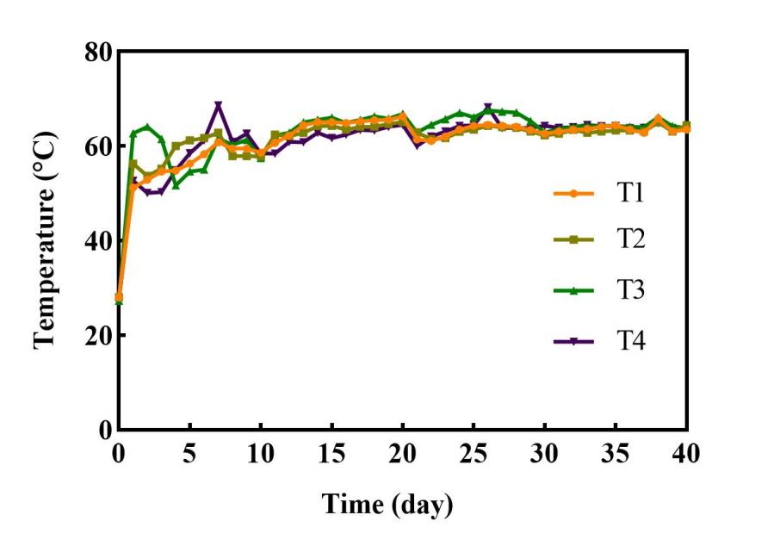
Fig. S1 Variations of temperature during composting. T1: C/N ratio of 20; T2: C/N ratio of 30;T3: C/N ratio of 40;T4: C/N ratio of 50.

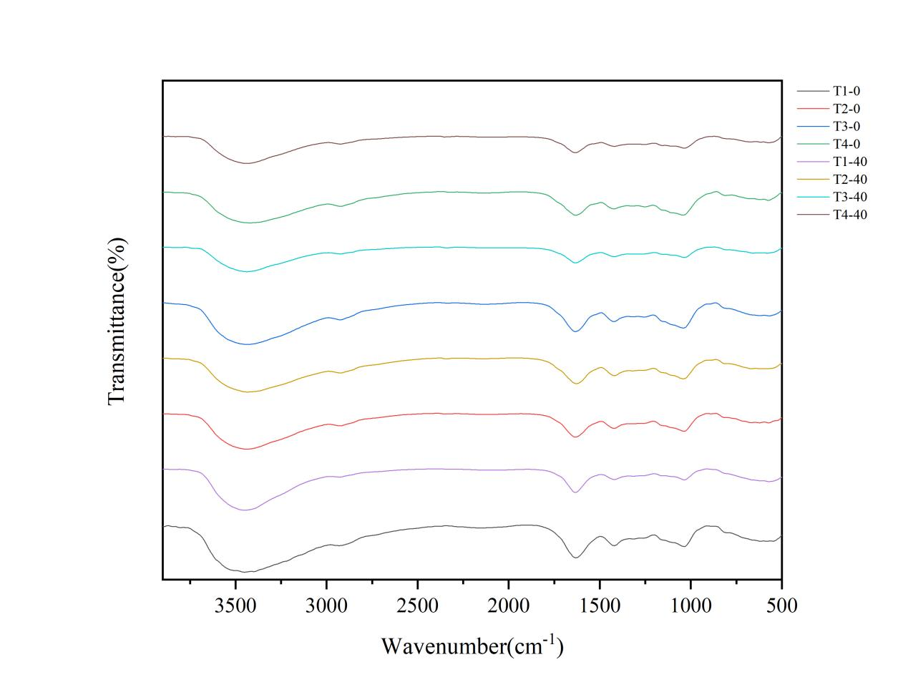
Fig. S2 FTIR spectra of different samples at 0 and 40 during the composting. T1: C/N ratio of 20; T2: C/N ratio of 30;T3: C/N ratio of 40;T4: C/N ratio of 50.

