Sex
Supplementary Figure 1: Odds ratio of lifetime prevalence of each CRM and MH condition in men compared with women in CPRD Aurum, 2020
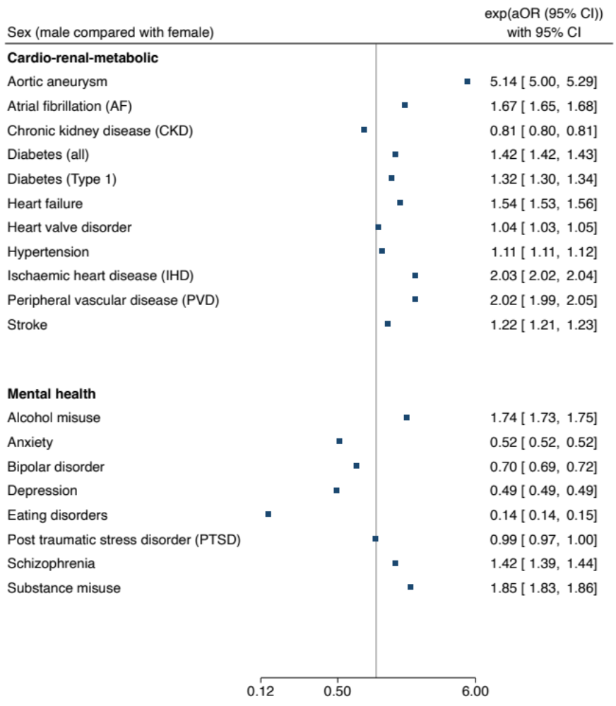
More common in women More common in men

Adjusted for age, ethnicity, and socio-economic status

Socio-economic status
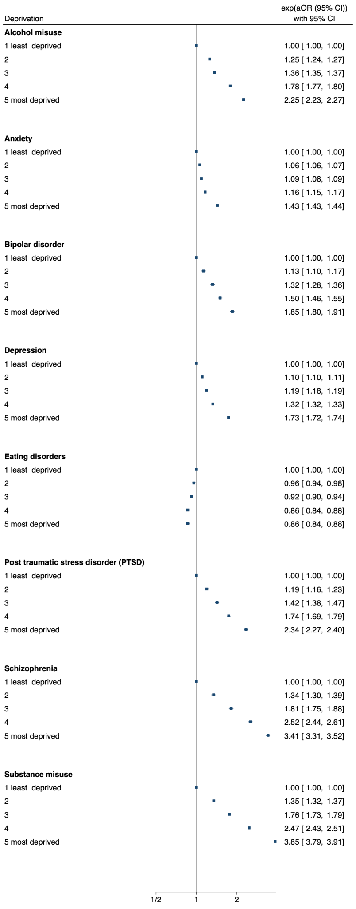
Supplementary Figure 2: relative odds of lifetime prevalence of each CRM and MH condition by deprivation quintile
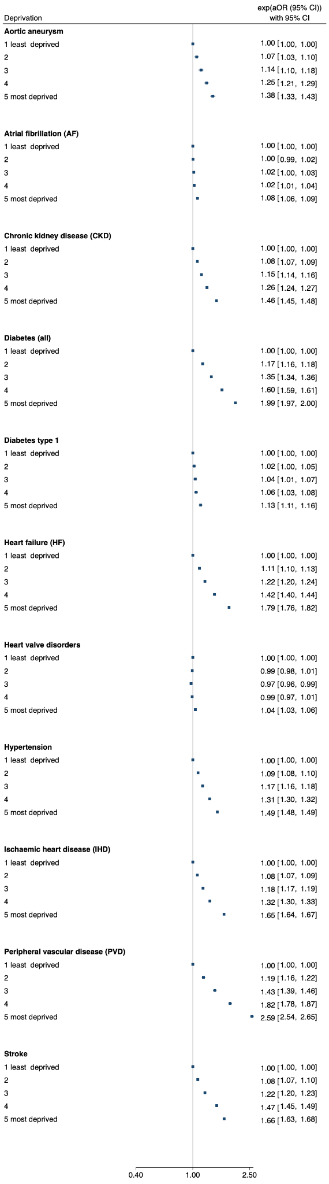

Adjusted for age, sex, and ethnicity

Age categories
Supplementary Figure 3: relative odds of lifetime prevalence of CRM and MH conditions by age category with 41–50-year-olds as the reference category
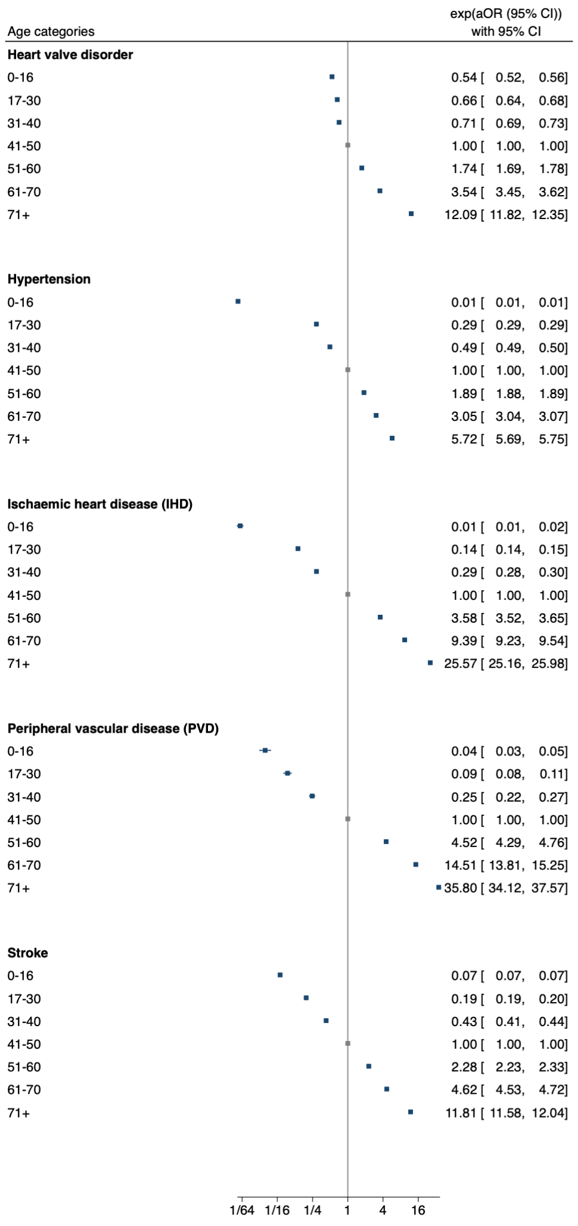
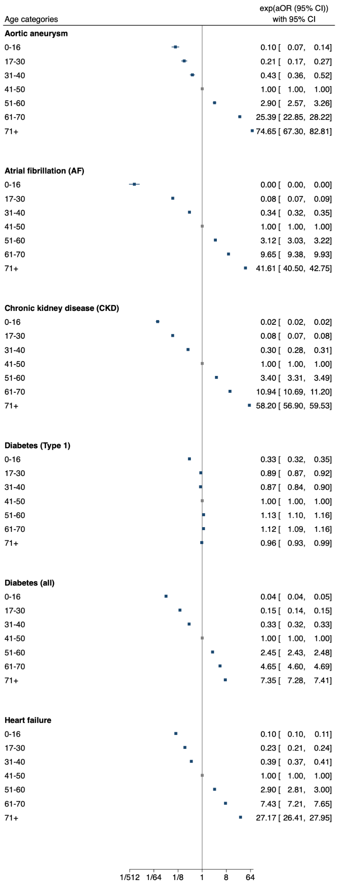

Ethnicity

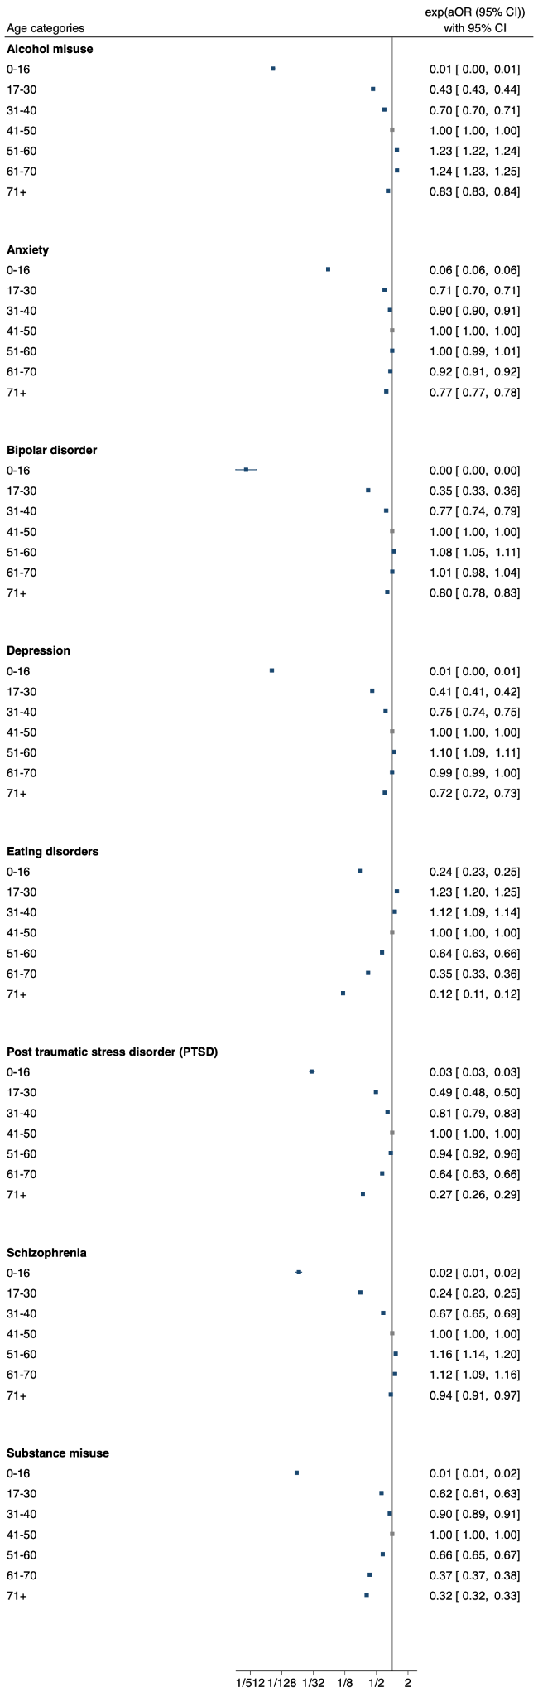

Adjusted for sex, ethnicity,
and socio-economic status.

Ethnicity
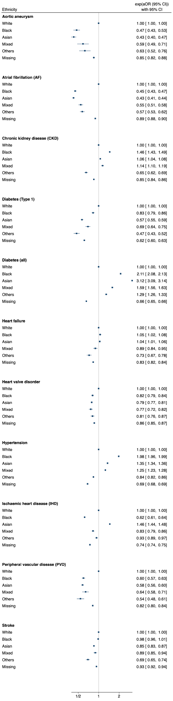
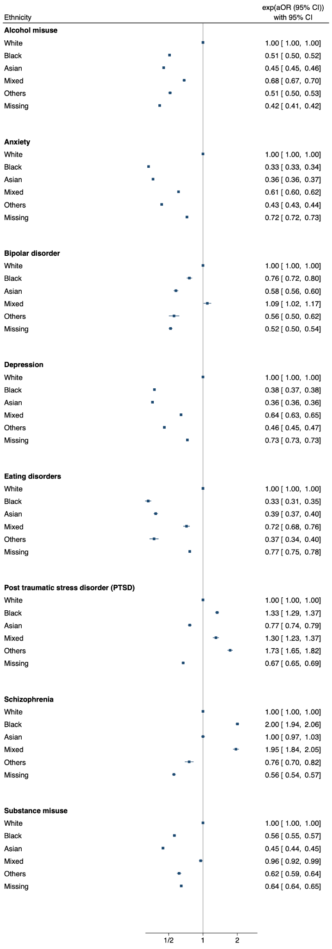
Supplementary Figure 4: relative odds of lifetime prevalence each CRM and MH condition by ethnicity

Adjusted for age, sex, and socio-economic status

