Supplementary Information

Acute brain slice elastic modulus decreases over time.

John Exton¹, Jonathan M.G. Higgins² and Jinju Chen^{1*}

¹ School of Engineering, Newcastle University, Newcastle Upon Tyne, NE1 7RU, UK.
² Biosciences Institute, Faculty of Medical Sciences, Newcastle University, Framlington Place, Newcastle upon Tyne, NE2 4HH, UK.

* Corresponding author:
Jinju Chen
ORCID: 0000-0002-9792-6285
E-mail: Jinju.chen@ncl.ac.uk
Telephone: +44 (0) 191 208 5434
Fax: +44(0) 191 208 8600
Address: School of Engineering, Newcastle University, Newcastle Upon Tyne, NE1 7RU, UK

Temporal change in elastic modulus, hydration and volume
There appears to be some correlation between temporal change in elastic modulus, hydration and volume in 300 mOsm, 400 mOsm and CABC, as shown in Fig.S1 below.
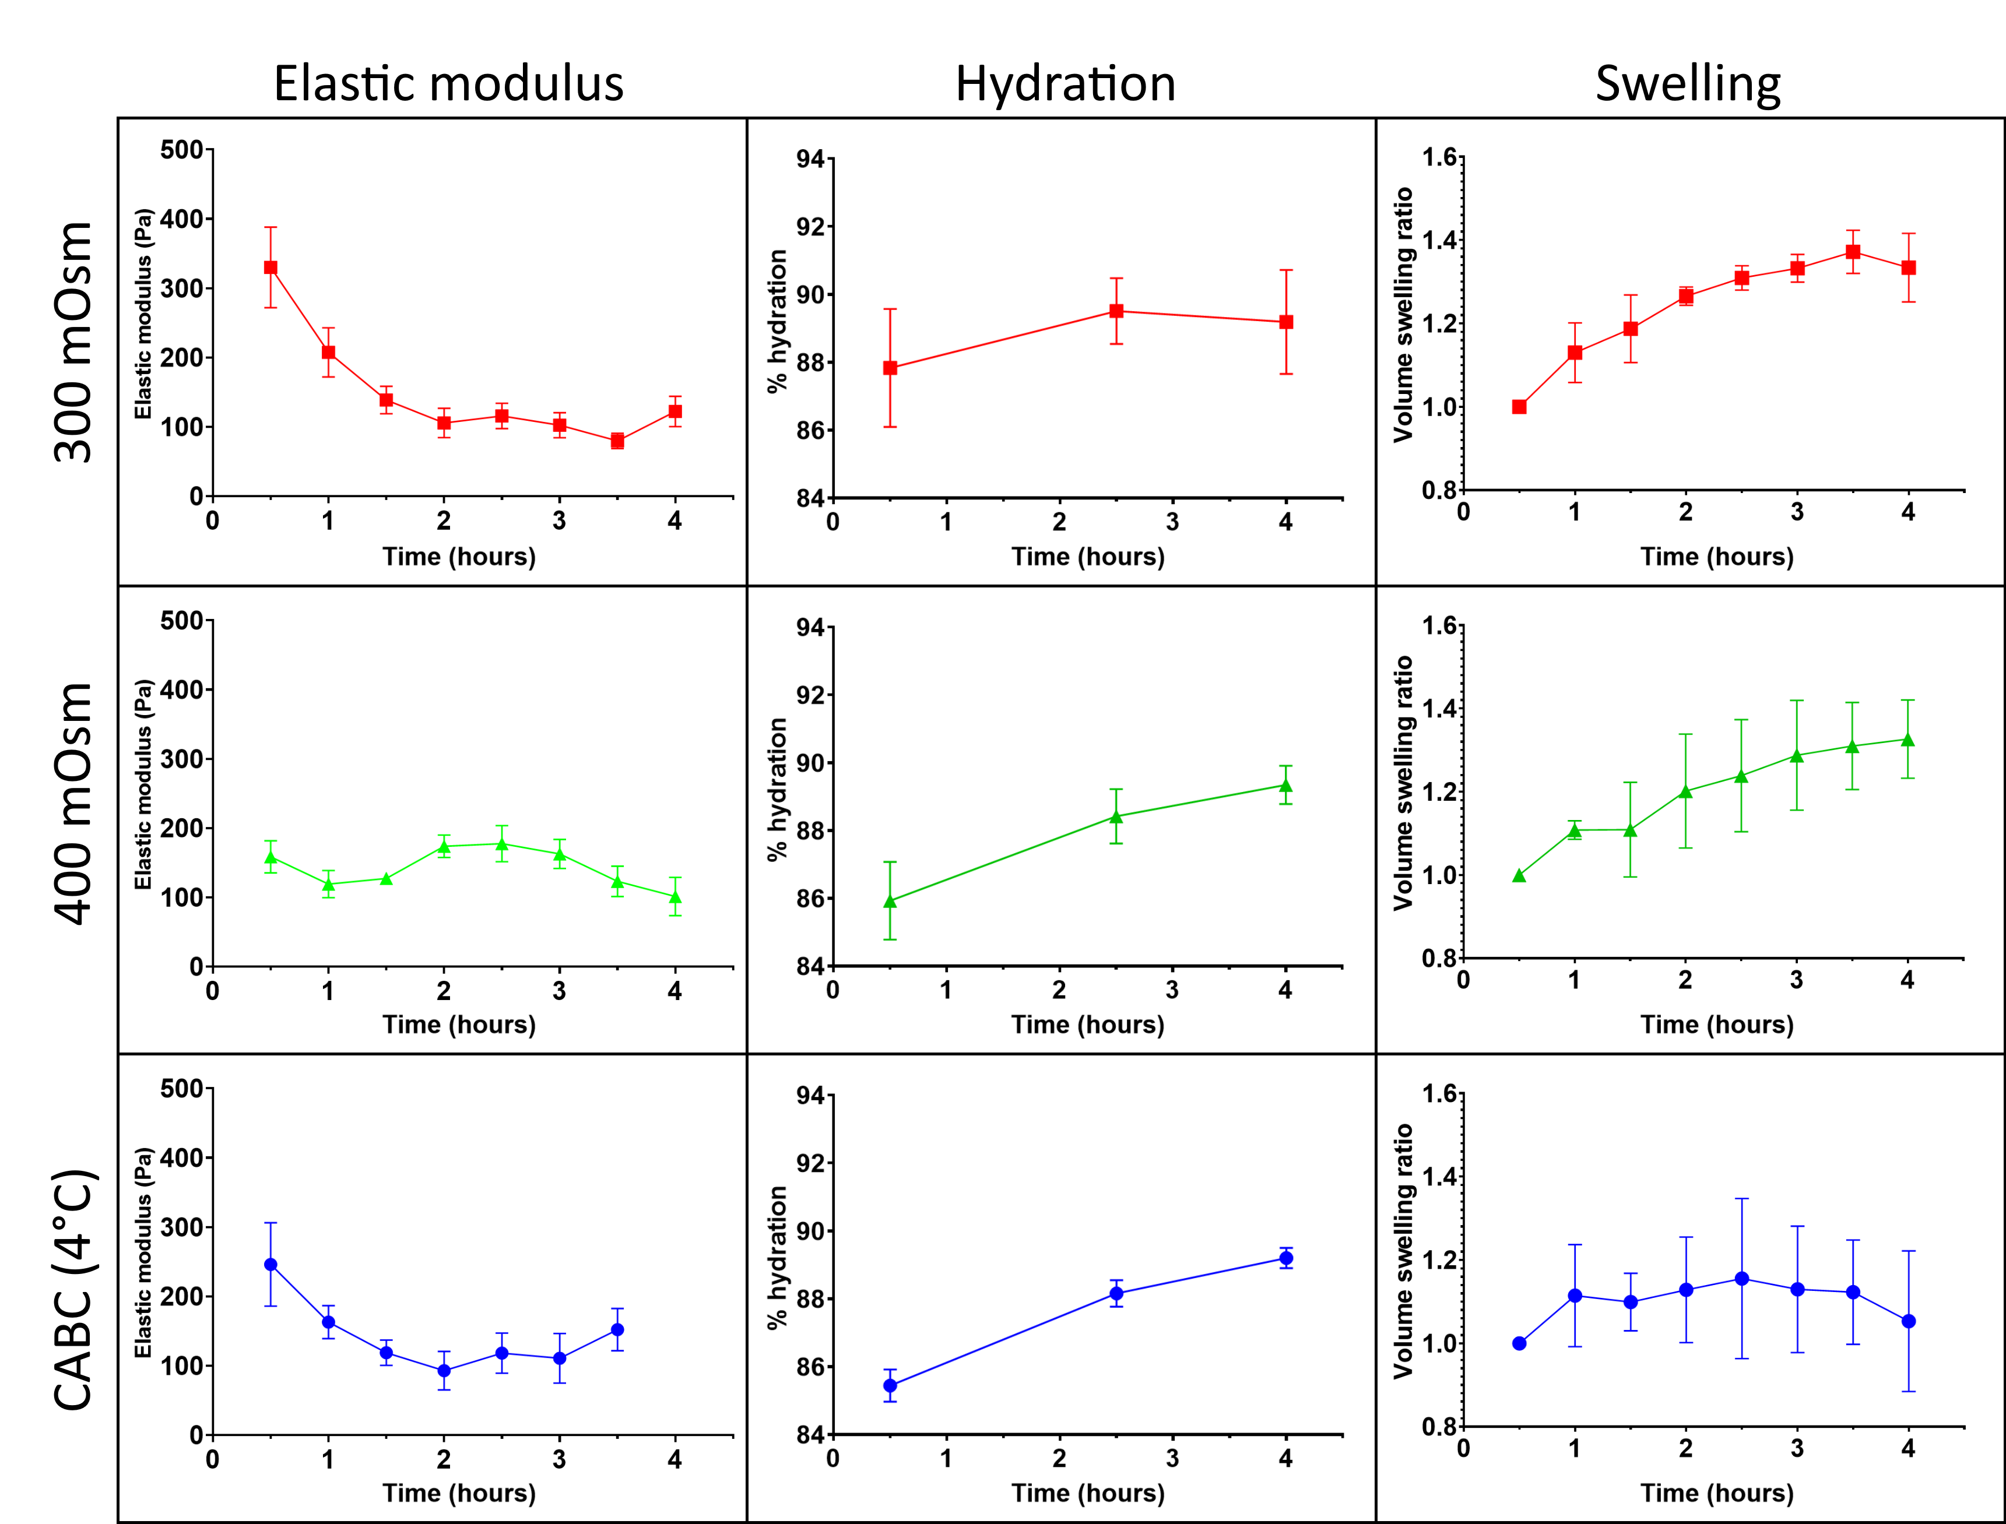
Fig. S1. Side-by-side comparison of elastic modulus, hydration and volume in 300 mOsm, 400 mOsm and CABC – all at 4°C.

