Supplemental Figures

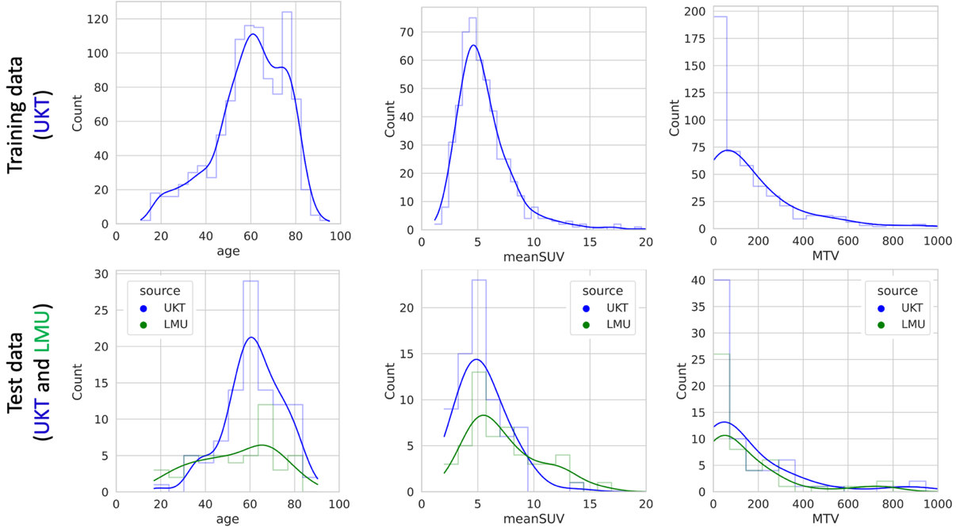

Figure S1: Quantitative comparison of training data (top) and test data (bottom).
Training data were drawn from UKT (blue), test data partially from UKT (blue) and partially from LMU (green). As shown in the histogram plots, the distribution of age, mean Standardized Uptake Value (SUV) of lesions and Metabolic Tumor Volume (MTV) of lesions was similar between training and test data and between the two data sources (UKT and LMU).

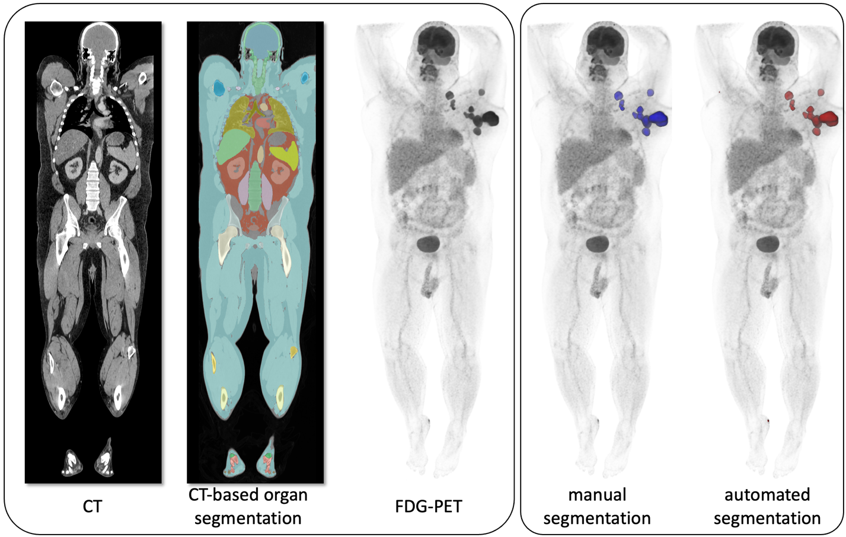

Figure S2: Example of a complete data set.
Computed tomography (CT) volumes, CT-based organ segmentation masks and Fluorodeoxyglucose Positron Emission Tomography (FDG-PET/CT) volumes (or subsets of these volumes) were used as input data. Metabolically active tumor lesions were segmented manually (colored in blue) and automatically (colored in red). This particular dataset is drawn from the UKT test set and shows excellent alignment between manual lesion segmentation and automated lesion segmentation using an nnUNet baseline with CT and FDG-PET as input.

