Online supplement

Prospective multi-centre evaluation of the incidence of unplanned extubation and its outcomes in intensive care units. The Safe-ICU study.

Jérémie Guillemin MD, Benjamin Rieu MD, Olivier Huet MD PhD, Léonie Villeret MD, Stéphanie Pons MD, Anne Bignon MD, Quentin de Roux MD, Raphaël Cinotti, Vincent Legros MD, Gaëtan Plantefeve MD, Claire Dayhot-Fizelier PhD, Edris Omar MD, Cyril Cadoz MD, Fanny Bounes MD PhD, Cécile Caplin MD, Karim Toumert MD, Thibault Martinez MD, Damien Bouvier MD, Maxime Coutrot MD, Thomas Godet MD PhD, Pierre Garçon MD, Mona Assefi MD and Jean-Michel Constantin PhD on behalf of SFAR research network.

Corresponding author : Pr JM Constantin, General ICU, GH Pitié-Salpêtrière, 83 Bd de l’Hôpital, 75013 Paris, France. +33142177300. jean-michel.constantin@aphp.fr

Supplementary Appendix

Authors’ contributions 3
List of centers and investigators involved in SAFE-ICU Study 4
Acknowledgments 6
STROBE Statement 7
Supplementary figure 1 - Localisation of participating ICUs. 10
Supplementary figure 2 – Epidemiological study period 11
Supplementary figure 3: Unplanned and planned extubation incidence in 45 ICUs included in the epidemiological analysis 12
Supplementary table 1: Comparison of unplanned extubation incidence according to ICU characteristics 13
Supplementary figure 4: Unplanned extubation by time of day (hours) 14
Supplementary table 2 - Immediate complications and outcomes of succeed or failed self-extubation 15
Supplementary table 3: Characteristics of the self-extubated patients 16

Authors’ contributions

Study concept and design: Constantin, Guillemin
Acquisition, Analysis or interpretation of data: Constantin, Guillemin, Rieu, Huet, Villeret, Pons, Bignon, de Roux, Cinotti, Legros, Plantefeve, Dahyot-Fizelier, Omar, Cadoz, Bounes, Caplin, Toumert, Martinez, Bouvier, Coutrot, Godet, Garçon, Assefi.
First drafting of the manuscript-Writing committee: Constantin, Guillemin, Assefi
Critical revision for important intellectual content and final approval of the manuscript: Constantin, Guillemin, Rieu, Huet, Villeret, Pons, Bignon, de Roux, Cinotti, Legros, Plantefeve, Dahyot-Fizelier, Omar, Cadoz, Bounes, Caplin, Toumert, Martinez, Bouvier, Coutrot, Godet, Garçon, Assefi.
Data management: Guillemin.
Statistical analysis: Assefi.
Administrative, technical or material support: Constantin
Study supervision: Constantin.
Only Constantin, Guillemin had full access to all data study and takes responsibility for the integrity of the data.

List of centers and investigators involved in SAFE-ICU Study

Centre N° | City/Hospital | Type | Name | Surname | email
1 | Paris  /Pitié-Salpêtrière  (Gaston Cordier) | University | Constantin  Guillemin  Assefi | Jean-Michel  Jérémie  Mona | jmconstantin@chu-clermontferrand.fr  jeremie.guillemin@aphp.fr  mona.assefi@aphp.fr
2 | Paris  /Saint-Antoine | University | Garnier  Flis-Richard | Marc  Hugo | marc.garnier@aphp.fr  hugo.flisrichard@aphp.fr
3 | Lille  /Claude Huriez | University | Bignon  Garot | Anne  Matthias | anne.bignon@chru-lille.fr  matthias.garot@chru-lille.fr
4 | Poitiers | University | Dahyot-Fizelier  Damien | Claire  Marie | c.dahyot-fizelier@chu-poitiers.fr  damien.marie01@gmail.com
5 | Paris  /Saint-Louis | University | Coutrot  Dépret | Maxime  François | maxime.coutrot@aphp.fr  francois.depret@aphp.fr
6 | Nantes  /Hotel-Dieu | University | Cinotti  Flattres-Duchaussoy | Raphaël  Delphine | raphael.cinotti@chu-nantes.fr  delphine.flattresduchaussoy@chu-nantes.fr
7 | Nantes  /Laennec | University | Cinotti  Flattres-Duchaussoy | Raphaël  Delphine | raphael.cinotti@chu-nantes.fr  delphine.flattresduchaussoy@chu-nantes.fr
8 | Toulouse | University | Bounes  Centelles | Fanny  Magali | bounes.f@chu-toulouse.fr  centelles.m@chu-toulouse.fr
9 | Monaco | General | Rouquette  Rijo | Isabelle  Nicolas | isabelle.rouquette-vincenti@chpg.mc  recherche.clinique@chpg.mc
10 | Cholet | General | Jarousseau  Auchabie  Seguin | Fabien  Johann  Laetita | jarousseau.fabien@gmail.com  johann.auchabie@ch-cholet.fr  laetitia.seguin@ch-cholet.fr
11 | Brest  /Clermont Tonnerre | Military | Danguy des Déserts  Pichon | Marc  Isabelle | marc.danguydesdeserts@intradef.gouv.fr  isabelle.pichon@chu-brest.fr
12 | Clamart  /Antoine Béclère | University | Toumert  Damoisel | Karim  Charles | karim.toumert@aphp.fr  charles.damoisel@aphp.fr
13 | Rennes  /Cardiovascular and thoracic ICU | University | Nesseler | Nicolas | nicolas.nesseler@chu-rennes.fr
14 | Rennes  /medico-surgical ICU | University | Launey | Yoann | yoann.launey@chu-rennes.fr
15 | Mont de Marsan | General | Sément  Dimet | Arnaud  Jérôme | arnaud.sement@ch-mdm.fr  jerome dimet, jerome.dimet@ght40.fr
16 | Clermont-Ferrand  /Gabriel Montpied | University | Rieu  Futier  Jabaudon-gandet | Benjamin  Emmanuel  Matthieu | brieu@chu-clermontferrand.fr  efutier@chu-clermontferrand.fr  mjabaudon@chu-clermontferrand.fr
17 | Beauvais  /Simone Veil | General | Caplin  Luis  Huysman | Cécile  David  Fabienne | cecile.caplin@laposte.net  davidluis.icu@gmail.com  f.huysman@ch-beauvais.fr
18 | Paris  / Pitié-Salpêtrière  (cardiac ICU) | University | Omar  Bouglé | Edris  Adrien | edris.omar@aphp.fr  adrien.bougle@aphp.fr
19 | Argenteuil | General | Plantefeve  Leparco | Gaëta  Cécile | gaetan.plantefeve@ch-argenteuil.fr  cecile.leparco@ch-argenteuil.fr
20 | Chartres | General | Kalfon  Mauchien | Pierre  Bénédicte | pkalfon@ch-chartres.fr  bmauchien@ch-chartres.fr
21 | Mayotte | General | Caujolle | Marie | m.caujolle@chmayotte.fr
22 | Dax | General | Auvet  Dimet  Boivin | Adrien  Jérôm  Anne-Hélène | auveta@ch-dax.fr  jerome.dimet@ght40.fr  anne-helene.boivin@ght40.fr
23 | Clamart  /Percy | Military | Martinez  De Rudnicki | Thibault  Stéphane | thibault.martinez@hotmail.fr  stephane.de-rudnicki@intradef.gouv.fr
24 | Reims | University | Legros | Vincent | vlegros@chu-reims.fr
25 | Tarbes | General | Castanera  Latry | Jérémy  Vanessa | jcastanera@ch-tarbes-vic.fr  vlatry@ch-tarbes-vic.fr
26 | Villejuif  / Institut Gustave Roussy | General | Bezu | Lucillia | lucilliabe@gmail.com
27 | Clermont-Ferrand  /Estaing | University | Godet  Nathalie | Thomas  Bourguignon | tgodet@chu-clermontferrand.fr  n_bourguignon@chu-clermontferrand.fr
28 | Brest | University | Huet  Floch | Olivier  Hervé | oliver.huet@chu-brest.fr  herve.floch@chu-brest.fr
29 | Amiens | University | Villeret  Dupont  Brisset | Léonie  Hervé  Sandrine | villeret.leonie@chu-amiens.fr  dupont.herve@chu-amiens.fr  brisset.sandrine@chu-amiens.fr
30 | Paris  /Fondation Adolphe de Rothschild | General | Bouvié  Engrand  De Mesmay  Trouiller | Damien  Nicolas  Marine  Pierre | dbouvier@for.paris  nengrand@for.paris  mdemesmay@for.paris  ptrouiller@for.paris
31 | Marne la Vallée | General | Garçon | Pierre | pierregarcon84@gmail.com
32 | Tours | University | Laffon  Piat | Marc  Charlène | marc.laffon@univ-tours.fr  c.piat@chu-tours.fr
33 | Paris  /Pitié-Salpêtrière  (neuro-surgical ICU) | University | Virolle  Degos | Sara  Vincent | sara.virolle@aphp.fr  vincent.degos@aphp.fr
34 | Metz-Thionville | General | Cadoz | Cyril | c.cadoz@chr-metz-thionville.fr
35 | Saint-Lô | General | Leclerc | Maxime | maxime.leclerc@ch-stlo.fr
36 | Rouen | University | Boubèche | Samia | samia.boubeche@chu-rouen.fr
37 | Nice | University | Dellamonica  Eliasz  Bilger | Jean  Nathalie  Florent | dellamonica.j@chu-nice.fr  nathalie.eliasz@gmail.com  bilger.f@chu-nice.fr
38 | Dragignan et Fréjus | General | Bele | Nicolas | bele-n@chi-fsr.fr
39 | La Rochelle | General | Levrat | Quentin | quentin.levrat@ght-atlantique17.fr
40 | Paris  /Pitié-Salpêtrière  (Husson Mourrier ICU) | University | Monsel  Le Dinh  Lakhal | Antoine  Matthieu  Samia | antoine.monsel@aphp.fr  matthieu.ledinh@aphp.fr  samia.lakhal@aphp.fr
41 | Saint Nazaire | General | Lemarié  Jonas | Michel  Maud | michel.lemarie@hospigrandouest.fr  maudjonas@yahoo.fr
42 | Créteil  /Henri Mondor | University | De Roux  Mongardon | Quentin  Nicolas | quentin.deroux@aphp.fr  nicolas.mongardon@aphp.fr
43 | Laon | General | Ferd | Kamal | ferd_kim@yahoo.fr
44 | Bordeaux  /Saint-André | University | Mourissoux | Gaëlle | gaelle.mourissoux@chu-bordeaux.fr
45 | Toulon  /Saint-Anne | Military | D’Aranda | Erwan | erwan.daranda@intradef.gouv.fr
46 | Marseille  /La Timone | University | Bourenne | Jérémy | jeremy.bourenne@ap-hm.fr
47 | Paris  /Lariboisière | University | Chousterman  Kindermans | Benjamin Glenn  Manuel | benjamin.chousterman@aphp.fr  manuel.kindermans@aphp.fr

Acknowledgments

We would like to aknowledge all SAFE-ICU investigators (list below) for collecting and providing the data for this study.
We would like to acknowledge Chafia Daoui and the SFAR research network for providing administrative and data management support.

STROBE Statement

Checklist of items that should be included in reports of observational studies

 |  | Item No | Recommendation | Page/  observation
Title and abstract |  | 1 | (a) Indicate the study’s design with a commonly used term in the title or the abstract | done
 |  | 1 | (b) Provide in the abstract an informative and balanced summary of what was done and what was found | done
Introduction
Background/rationale |  | 2 | Explain the scientific background and rationale for the investigation being reported | 1
Objectives |  | 3 | State specific objectives, including any prespecified hypotheses | 1
Methods
Study design |  | 4 | Present key elements of study design early in the paper | 2
Setting |  | 5 | Describe the setting, locations, and relevant dates, including periods of recruitment, exposure, follow-up, and data collection | 2
Participants |  | 6 | (a) Cohort study—Give the eligibility criteria, and the sources and methods of selection of participants. Describe methods of follow-up  Case-control study—Give the eligibility criteria, and the sources and methods of case ascertainment and control selection. Give the rationale for the choice of cases and controls  Cross-sectional study—Give the eligibility criteria, and the sources and methods of selection of participants | 2  NA
 |  | 6 | (b) Cohort study—For matched studies, give matching criteria and number of exposed and unexposed  Case-control study—For matched studies, give matching criteria and the number of controls per case | NA
Variables |  | 7 | Clearly define all outcomes, exposures, predictors, potential confounders, and effect modifiers. Give diagnostic criteria, if applicable | 2-3
Data sources/ measurement |  | 8* | For each variable of interest, give sources of data and details of methods of assessment (measurement). Describe comparability of assessment methods if there is more than one group
Bias |  | 9 | Describe any efforts to address potential sources of bias | 2
Study size |  | 10 | Explain how the study size was arrived at | 3
Quantitative variables |  | 11 | Explain how quantitative variables were handled in the analyses. If applicable, describe which groupings were chosen and why | 3
Statistical methods |  | 12 | (a) Describe all statistical methods, including those used to control for confounding | 3
 |  | 12 | (b) Describe any methods used to examine subgroups and interactions | 3
 |  | 12 | (c) Explain how missing data were addressed | 3
 |  | 12 | (d) Cohort study—If applicable, explain how loss to follow-up was addressed  Case-control study—If applicable, explain how matching of cases and controls was addressed  Cross-sectional study—If applicable, describe analytical methods taking account of sampling strategy | NA  NA
 |  | 12 | (e) Describe any sensitivity analyses | 3
Results
Participants | 13* | (a) Report numbers of individuals at each stage of study—eg numbers potentially eligible, examined for eligibility, confirmed eligible, included in the study, completing follow-up, and analysed |  | 5
Participants | 13* | (b) Give reasons for non-participation at each stage |  | NA
Participants | 13* | (c) Consider use of a flow diagram |  | Fig 1
Descriptive data | 14* | (a) Give characteristics of study participants (eg demographic, clinical, social) and information on exposures and potential confounders |  | Table 1
Descriptive data | 14* | (b) Indicate number of participants with missing data for each variable of interest |  | Tables
Descriptive data | 14* | (c) Cohort study—Summarise follow-up time (eg, average and total amount) |  | 5
Outcome data | 15* | Cohort study—Report numbers of outcome events or summary measures over time |  | 5
Outcome data | 15* | Case-control study—Report numbers in each exposure category, or summary measures of exposure |  | NA
Outcome data | 15* | Cross-sectional study—Report numbers of outcome events or summary measures |  | NA
Main results | 16 | (a) Give unadjusted estimates and, if applicable, confounder-adjusted estimates and their precision (eg, 95% confidence interval). Make clear which confounders were adjusted for and why they were included |  | 5
Main results | 16 | (b) Report category boundaries when continuous variables were categorized |  | NA
Main results | 16 | (c) If relevant, consider translating estimates of relative risk into absolute risk for a meaningful time period |  | NA
Other analyses | 17 | Report other analyses done—eg analyses of subgroups and interactions, and sensitivity analyses |  | 5-6
Discussion
Key results | 18 | Summarise key results with reference to study objectives |  | 7
Limitations | 19 | Discuss limitations of the study, taking into account sources of potential bias or imprecision. Discuss both direction and magnitude of any potential bias |  | 8
Interpretation | 20 | Give a cautious overall interpretation of results considering objectives, limitations, multiplicity of analyses, results from similar studies, and other relevant evidence |  | 8
Generalisability | 21 | Discuss the generalisability (external validity) of the study results |  | 7
Other information
Funding | 22 | Give the source of funding and the role of the funders for the present study and, if applicable, for the original study on which the present article is based |  | Title page

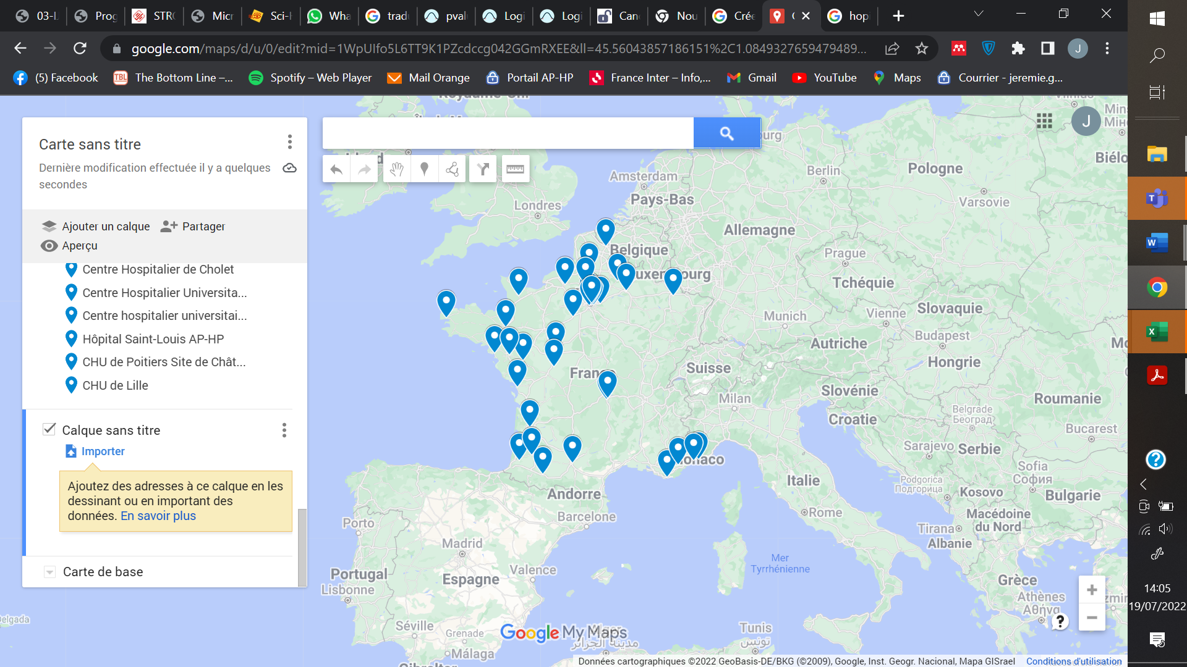
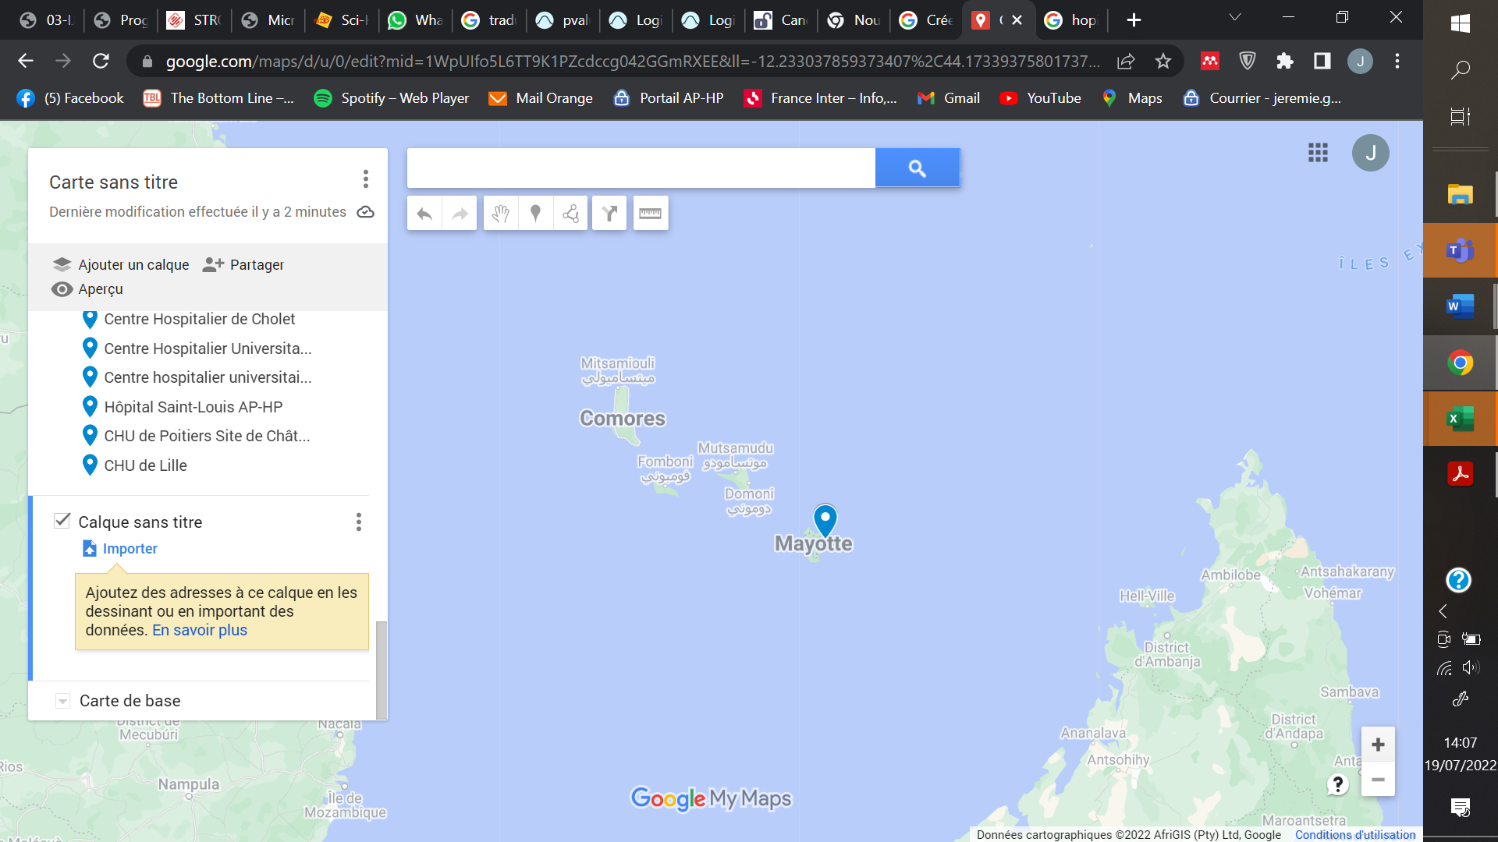

Supplementary figure 1 - Localisation of participating ICUs.
Google maps

Supplementary figure 2 – Epidemiological study period

Supplementary figure 3: Unplanned and planned extubation incidence in 45 ICUs included in the epidemiological analysis
UE, unplanned extubation; PE, planned extubation; IQR, interquartile range

ICU’s characteristics | n =47 | UE incidence | Missing data | p

ICU type  - medical  - surgical | 20 (45%)  24 (55%) | 1.03 [0.54;1.50]  0.85 [0.53;1.24] | 3 | 0.50

Number of beds | 15 [12; 23] |  | 3 | Pearson correlation coefficent = 0.27  p = 0.08
Family visit time  - 24/24h  - Limited | 20 (43%)  27 (57%) |  | 0 | 0.62
Family visit time  - 24/24h  - Limited | 20 (43%)  27 (57%) | 0.84 [0.57; 1.30]
Family visit time  - 24/24h  - Limited | 20 (43%)  27 (57%) | 0.99 [0.55; 1.53]
Start of physical restraints by medical order | 41 (87%) | 0.94 [0.6; 1.47] | 0 | 0.32
Use of pain and sedation protocols | 37 (79%) | 0.98 [0.53; 1.51] | 0 | 0.54
Use of weening protocol | 20 (43%) | 0.96 [0.54; 1.34] | 1 | 0.82
Systematic CAM-ICU evaluation | 6 (13%) | 1.48 [1.36; 1.81] | 5 | 0.03
Patient to nurse ratio  - > 0.5  - ≤ 0.5 | 29 (62%) | 0.94 [0.55; 1.34] | 0 | 0.70
Patient to nurse ratio  - > 0.5  - ≤ 0.5 | 18 (38%) | 0.99 [0.56; 1.53]
Patient to nurse assistant ratio  - > 0.25  - ≤ 0.25 | 11 (23%)  36 (77%) | 0.94 [0.44; 1.04]  0.94 [0.60; 1.53] | 0 | 0.28
Patient to physician ratio (nightshift)  - > 0.12  - ≤ 0.12 | 27 (57%) | 0.84 [0.57; 1.11] | 0 | 0.14
Patient to physician ratio (nightshift)  - > 0.12  - ≤ 0.12 | 20 (43%) | 1.17 [0.54; 1.52]
Patient to physician ratio (dayshift)  - > 0.42  - ≤ 0.42 | 23 (49%) | 1.05 [0.67; 1.48] | 0 | 0.34
Patient to physician ratio (dayshift)  - > 0.42  - ≤ 0.42 | 24 (51%) | 0.93 [0.48; 1.16]
Planned extubation incidence | 44 | 7.39 [6.22; 12.0] | 3 | Pearson correlation coefficient = 0.30  p = 0.04

Supplementary table 1: Comparison of unplanned extubation incidence according to ICU characteristics

Data expressed in number (%) or median [interquartile range Q1; Q3].

Supplementary figure 4: Unplanned extubation by time of day (hours)
Self-extubation (top), accidental extubation (bottom)

 |  | Total population  n = 535 | Succeed self-extubation (n = 349) | Failed self-extubation (n = 186) | Missing data | p
Immediate complications (1 hour post UE)
Cardio-respiratory arrest |  | 0 (0%) | 0 (0%) | 0 (0%) | 0 | -
Severe hemodynamic complication |  | 12 (2.2%) | 1 (0.3%) | 11 (5.9%) | 0 | <0.001
Severe respiratory complication |  | 168 (31%) | 54 (16%) | 114 (61%) | 0 | <0.001
ICU mortality (day 28 post UE or discharge) |  | 42 (8%) | 14 (4%) | 28 (15%) | 1 | <0.001
Length of mechanical ventilation time, days |  | 6 [2; 15] | 3 [1; 8] | 16 [9; 26] | 0 | <0.001
ICU-LOS, days |  | 13 [6; 24] | 8 [4; 16] | 24 [16; 33] | 0 | <0.001

Supplementary table 2 - Immediate complications and outcomes of succeed or failed self-extubation

Data expressed in number (%) or median [interquartile range Q1; Q3].

UE, unplanned extubation; ICU-LOS, ICU length of stay

 | Total  population  n = 535 | Succeed self-extubation  (n = 349) | Failed self-extubation  (n = 186) | Missing data | p
Demographic and clinical
Age, years | 56 [43; 66] | 53 [40; 66] | 58 [48; 69] | 0 | <0.01
Sexe, man | 407 (76%) | 264 (76%) | 143 (77%) | 0 | 0.75
BMI, kg/m² | 26 [23; 30] | 26 [23; 30] | 26 [23; 31] | 15 | 0.18
Comorbidities
Smoking | 156 (29%) | 101 (29%) | 55 (30%) | 0 | 0.88
Alcohol addiction | 117 (22%) | 76 (22%) | 41 (22%) | 0 | 0.94
Other substance addiction | 38 (7.1%) | 32 (9.2%) | 6 (3.2%) | 0 | 0.011
Underlying heart disease | 97 (18%) | 50 (14%) | 29 (16%) | 0 | 0.69
Underlying lung disease | 79 (15%) | 11 (16%) | 79 (15%) | 0 | 0.83
Liver cirrhosis | 29 (5.4%) | 20 (5.7%) | 9 (4.8%) | 0 | 0.66
End stage renal disease | 16 (3%) | 14 (4%) | 2 (1.1%) | 1 | 0.06
Cancer | 65 (12%) | 33 (9.5%) | 32 (17%) | 0 | <0.01
Immunodepression | 52 (9.7%) | 37 (11%) | 15 (8.1%) | 0 | 0.35
Admission type |  |  |  | 0 | 0.47
Medical | 305 (57%) | 195 (56%) | 110 (59%)
Surgical | 230 (43%) | 154 (44 %) | 76 (41 %)
SARS-CoV2 infection (admission) | 88 (16%) | 47 (13%) | 41 (22%) | 0 | 0.011
SAPS-2 (admission) | 44 [29; 57] | 44 [29; 56] | 44 [30; 60] | 29 | 0.30
ICU-LOS before UE, days | 3.8 [1.3; 9.2] | 3.2 [1; 8.1] | 5 [2.5; 11.2] | 0 | <0.01
Most recent data before UE
Respiratory rate, min⁻¹ | 21 [18; 26] | 20 [17; 25] | 23 [20; 29] | 6 | <0.001
PaO2/FiO2, mmHg | 246 [187; 322] | 264 [200; 342] | 212 [162; 274] | 57 | <0.001
SpO2, % | 97 [95; 99] | 98 [96; 99] | 97 [95; 98] | 6 | <0.001
Ventilation |  |  |  | 0 | 0.18
Controlled | 115 (21%) | 69 (20%) | 46 (25%) |  | -
Assisted | 420 (79%) | 280 (80%) | 140 (75%) |  | -
Weening started ª | 355 (66%) | 215 (62%) | 140 (75%) | 0 | <0.01
RASS | 0 [-2; 0] | 0 [-1; 0] | 0 [-2; 0] | 38 | 0.32
BPS | 3 [3; 4] | 3 [3; 4] | 3 [3; 3] | 69 | 0.24
Continuous sedation
Any | 259 (48%) | 184 (53%) | 75 (40%) | 0 | <0.01
propofol/midazolam | 157 (29%) | 94 (27%) | 63 (34%) | 0 | 0.09
Halogen | 3 (0.6%) | 0 (0%) | 3 (1.6%) | 0 | 0.042
Dexmedetomidine | 93 (17%) | 58 (17%) | 35 (19%) | 0 | 0.52
Opioids | 154 (29%) | 87 (25%) | 67 (36%) | 0 | <0.01
Delirium | 56 (12%) | 36 (12%) | 20 (13%) | 85 | 0.80
Physical restraints | 407 (76%) | 277 (79%) | 139 (76%) | 0 | 0.31

Supplementary table 3: Characteristics of the self-extubated patients
- Spontaneous breathing trial in the last 24-hours.

BMI, body mass index; SAPS-2, Simplified Acute Physiology Score-2; ICU-LOS, ICU length of stay

