Supporting Information
Eco-friendly one-step synthesis of highly functionalized-spirooxindole-pyranopyrazoles and their in-vitro anticancer studies
Mohd Asif ¹, Farrukh Aqil ², Fatmah Ali Alasmary ³, Amani salem almalki ³,
Abdul Rahman Khan ¹, Malik Nasibullah ^{1,*}

¹Department of Chemistry, Integral University, Lucknow, 226026, U.P., India
²UofL Health-Brown Cancer Center and Department of Medicine, University of Louisville-KY40202 USA
³Chemistry Department, College of Science, King Saud University, Riyadh 11451, Saudi Arabia

Corresponding author
Dr. Malik Nasibullah*
Associate Professor
Department of Chemistry
Integral University, Lucknow, 226026, U.P., India
Email: malik7860@gmail.com
Contact No. +91-9919695886

General Information
The melting point of all the synthesized compounds were carried out with the help of open capillary tube method using IA 9100 MK-Digital uncorrected melting point analyzer Griffin Apparatus at Department of Chemistry, Integral University, Lucknow. Infrared Spectra were done on Model - Agilent Cary 630 FT-IR Spectrometer (Range: 4000-450 cm-1), Perkin-Elmer Spectrum version 10.03.06 at CSIR-CDRI, Lucknow and expressed in wave number (cm⁻¹), with KBr discs. ¹H NMR Spectra were carried out using Advance-400 MHz Brucker, Switzerland and Bruker AVLL-300 MHz (Brucker, Switzerland) using DMSO-d₆ as a solvent. The chemical shifts were denoted by δ ppm units using trimethylsilane as the internal standard. ¹³C NMR spectra were carried out using Brucker AVLL-100 MHz (Brucker, Switzerland) using DMSO-d₆. High Resolution Mass Spectra was taken on Acquisition SW-6200 series TOF, version Q-TOF B.05.00 at SGPGIMS campus, Lucknow. The reactions were monitored by thin layer chromatography and using ethyl acetate and n-hexane solvents.
Synthesis of spirooxindole-pyranopyrazoles (5a-g)
In this synthesis, there were used different four components; indoline-2,3-dione 1;a-g (1.0 m mol), malononitrile 2 (1.0 mmol), dialkyl acetylenedicarboxylate 3;a-b (1.1 mmol) and hydrazine 4 (1.1 mmol) in the presence of a Lewis base catalyst Et₃N (triethylamine). These components were reacted in 10.0 mL ethanol and stirred at room temperature. Therefore, it was stirred in a single pot at room temperature for 6 to 8 hours. The reaction was monitored by TLC, after the completion of reaction then it filtered. So obtained precipitates were washed by polar solvent after that it was purified by column chromatography using silica gel ( 60- 120 mesh) and 40% ethyl acetate in n-hexane solution and pure spirooxindoles derivatives obtained.
Copies of FT-IR, 1H NMR, 13C NMR and HRMS spectra of compounds
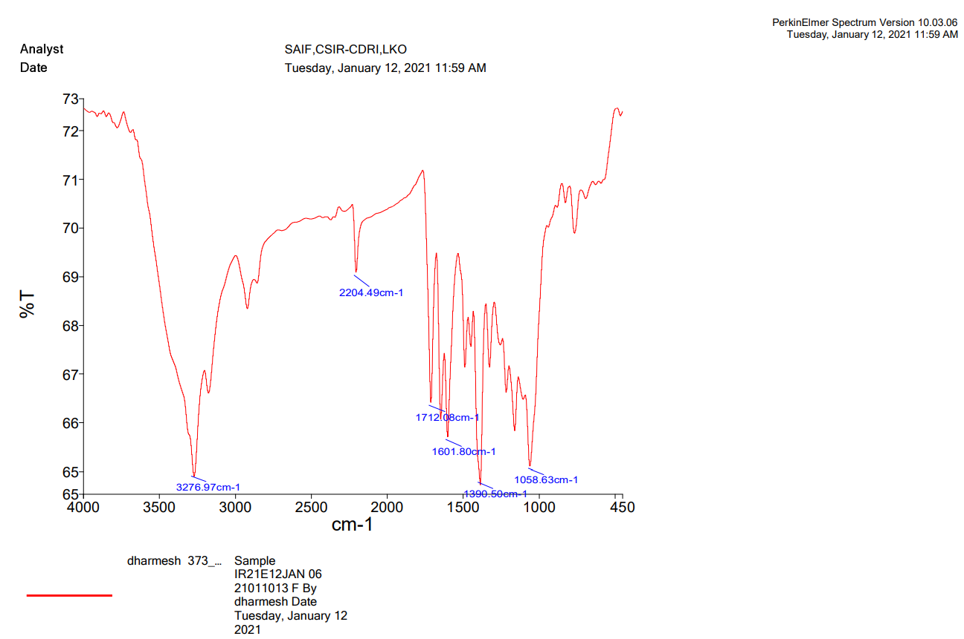
(a)

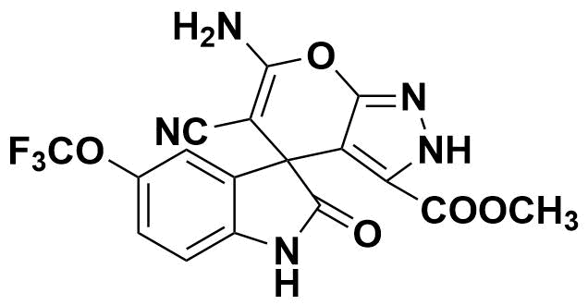

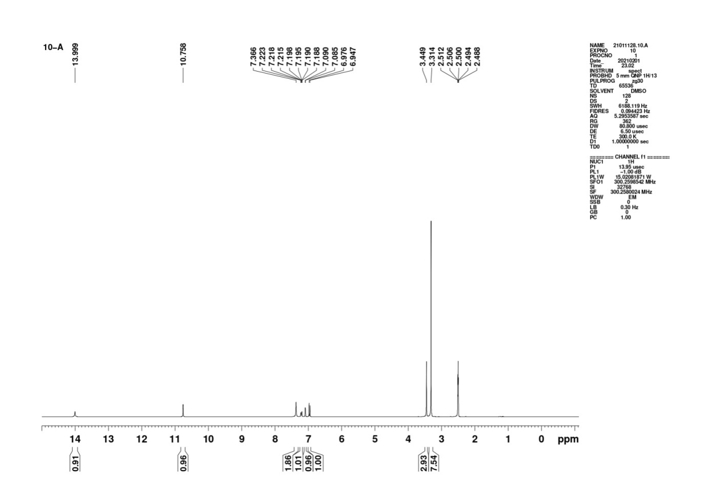
(b)

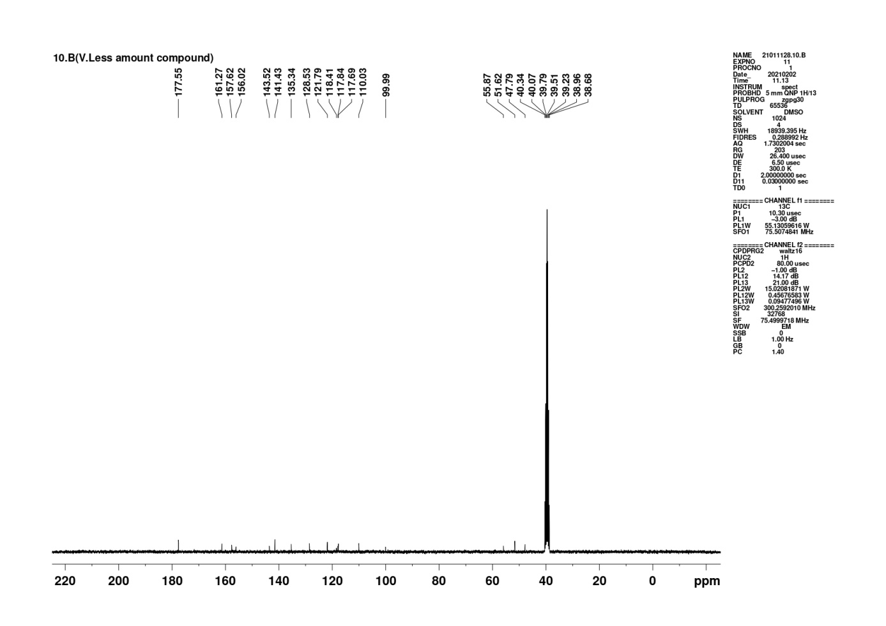
(c)

(d)
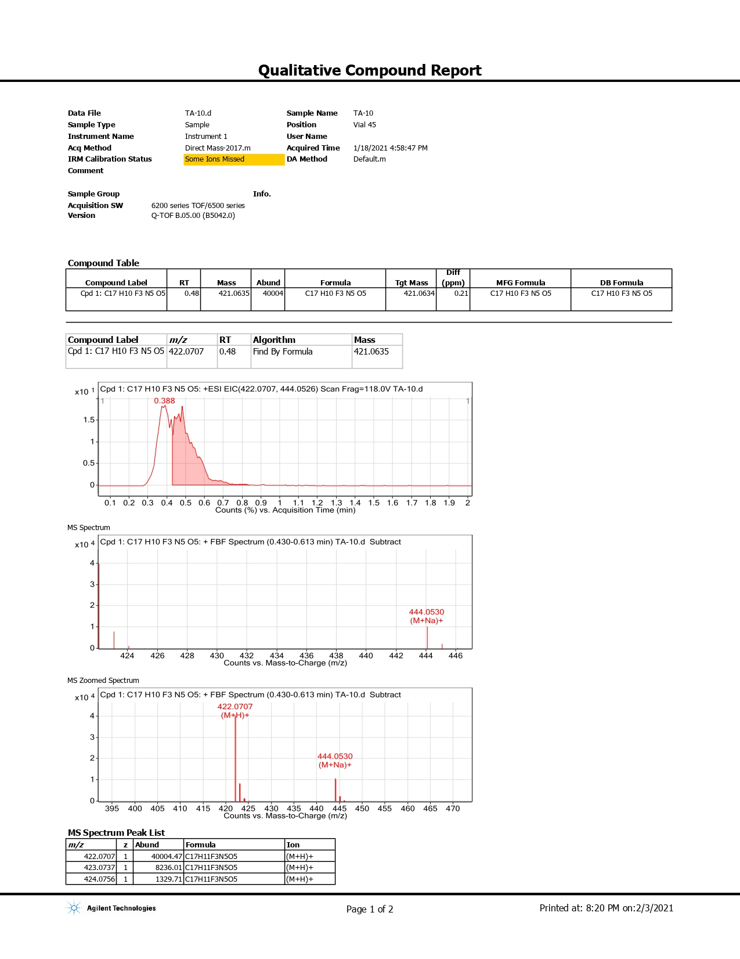

Supplementary Figure S1. Characterization of 5a. Panel (a): FT-IR; Panel (b): 1H-NMR, Panel (c): 13C NMR and Panel (d): HRMS.

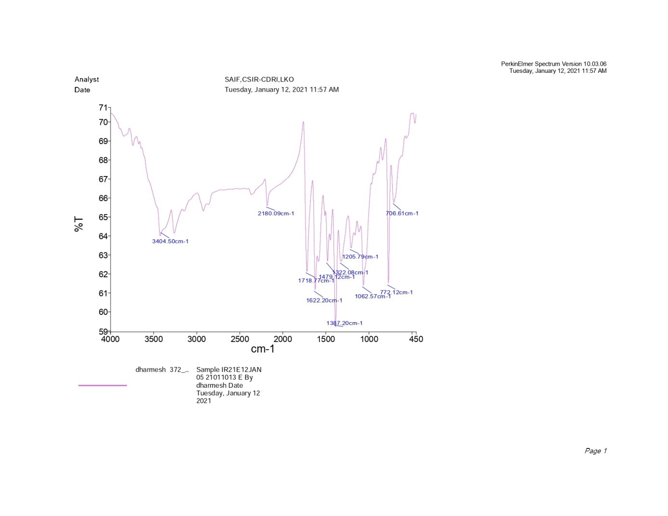
(a)

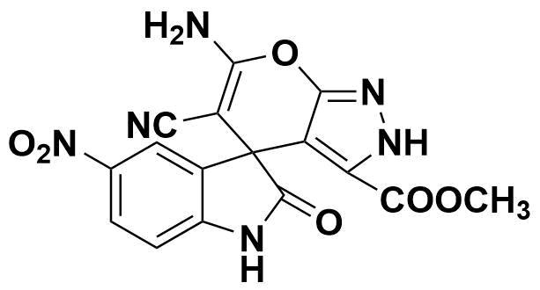

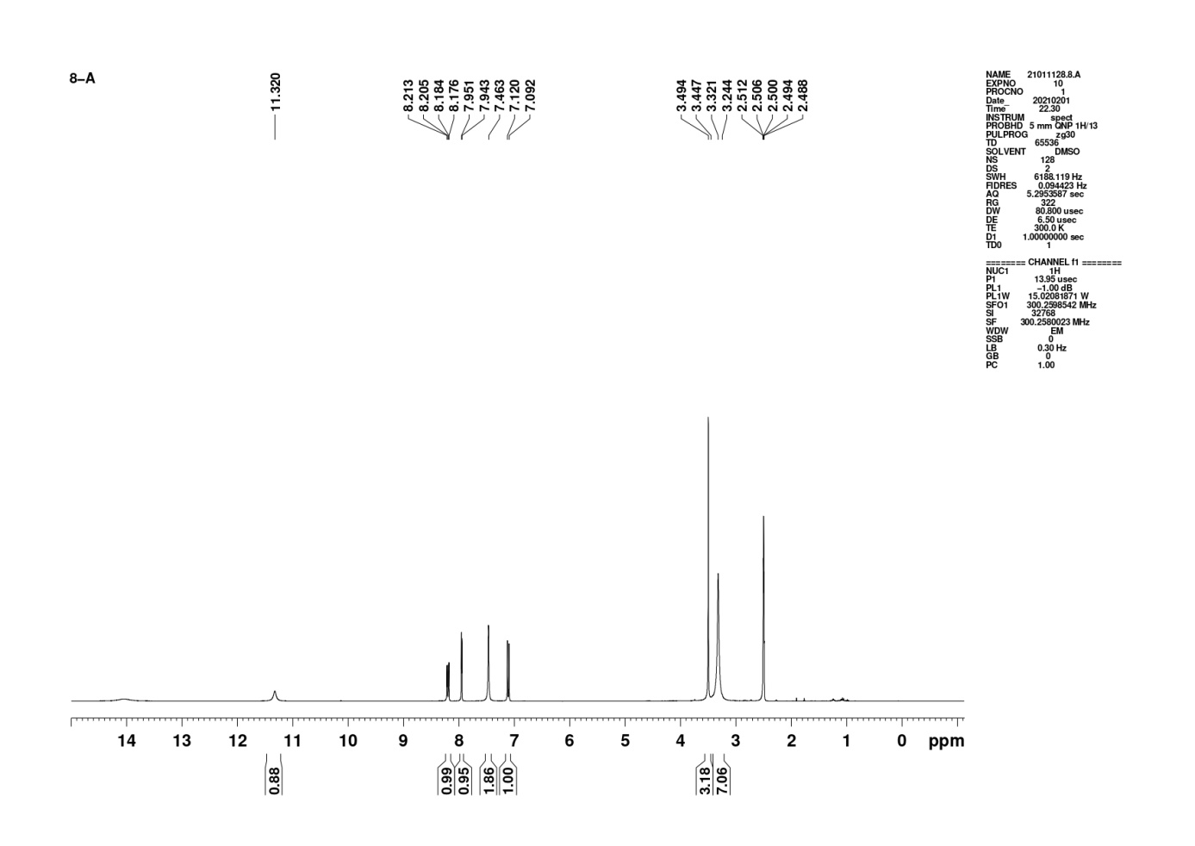
(b)
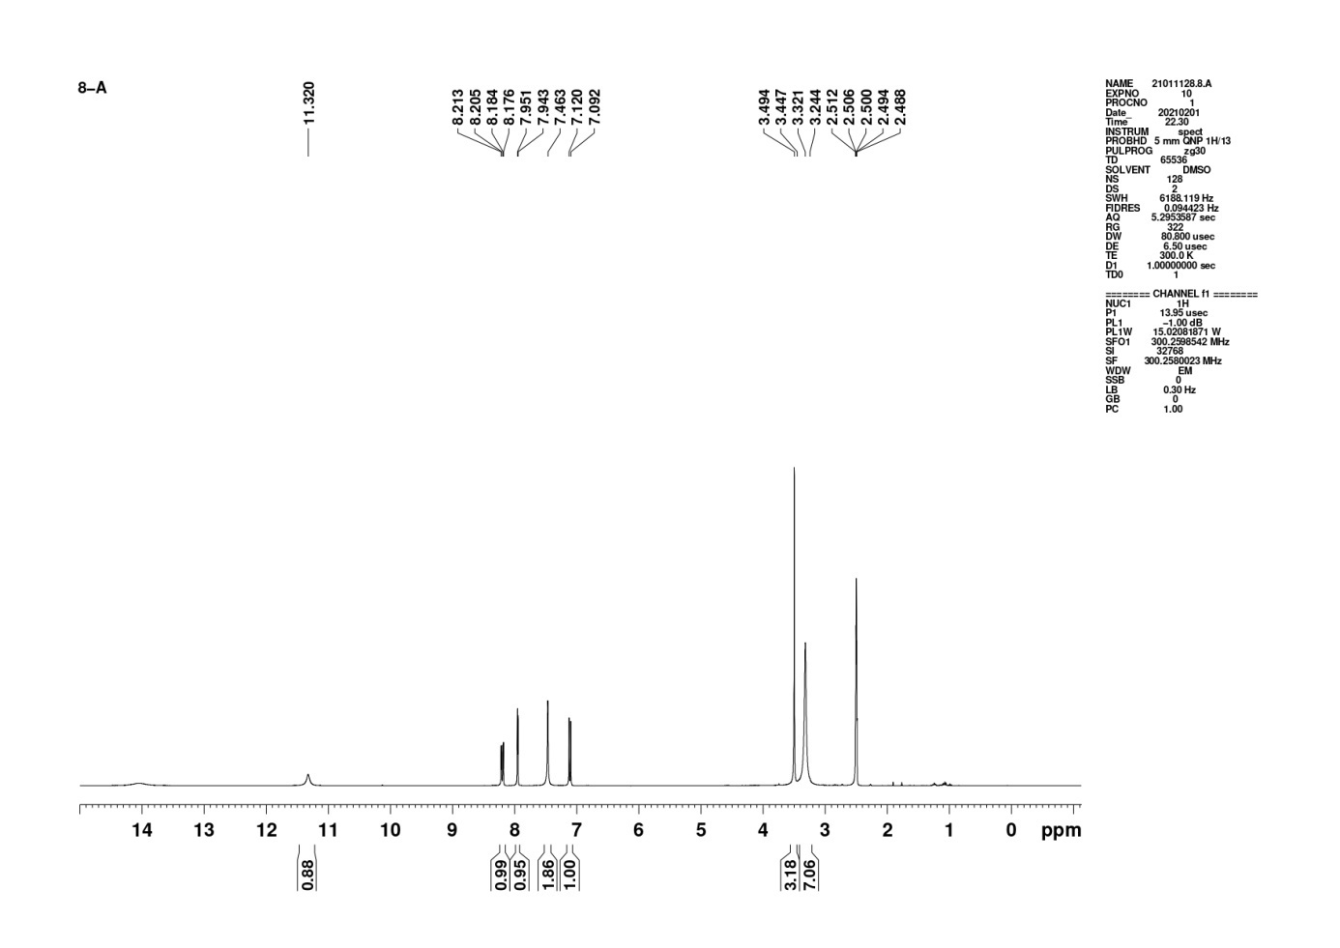

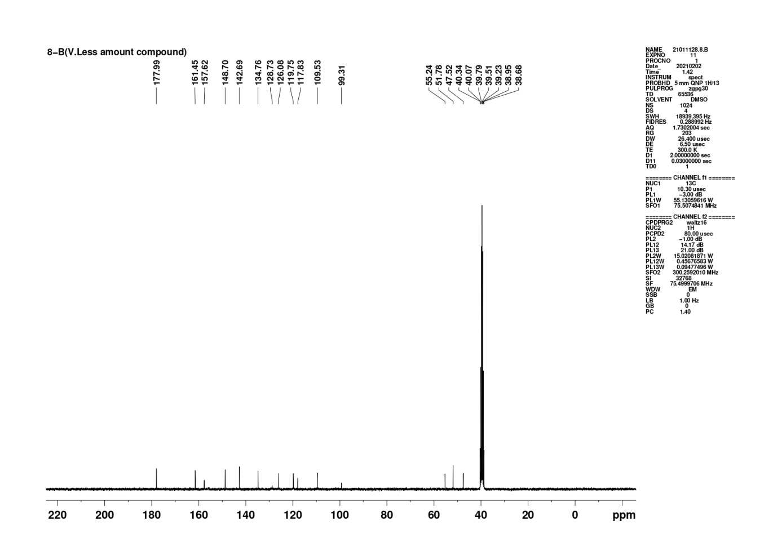
(c)

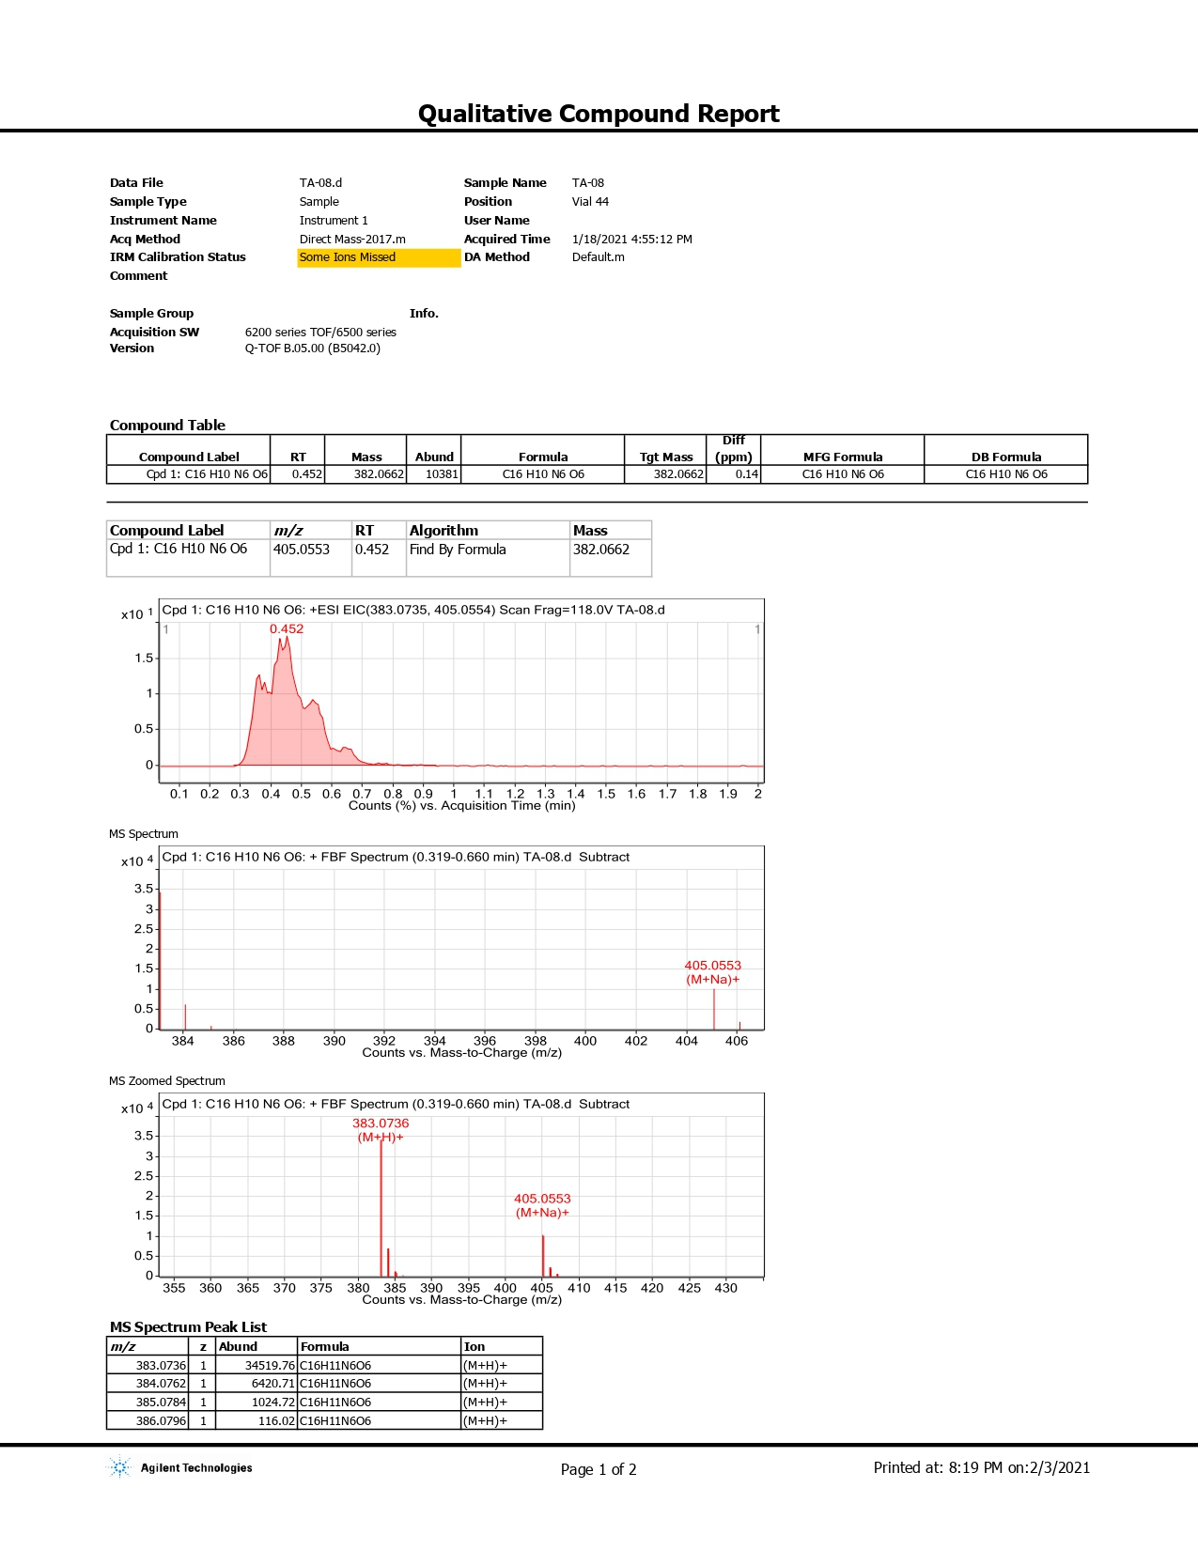
(d)

Supplementary Figure S2. Characterization of 5b. Panel (a): FT-IR; Panel (b): 1H-NMR, Panel (c): 13C NMR and Panel (d): HRMS.

(a)
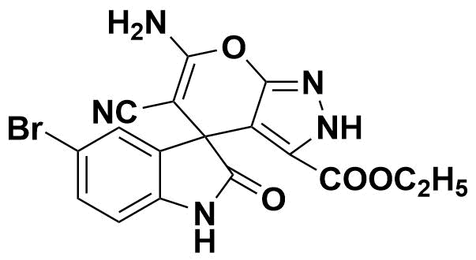
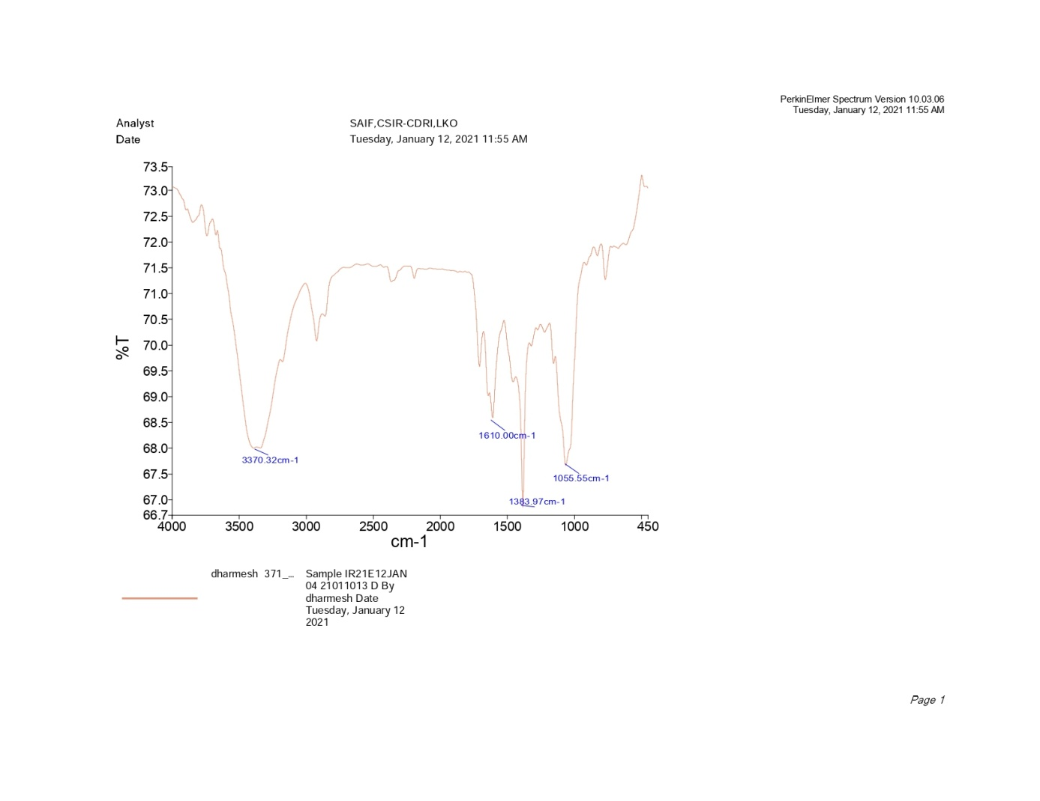

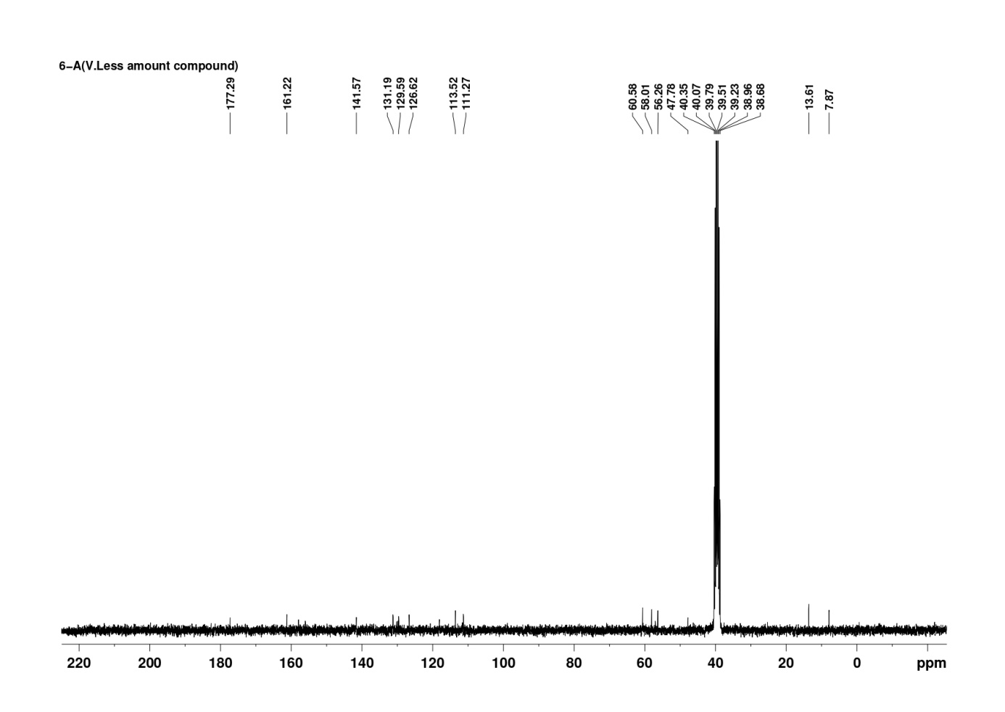
(b)

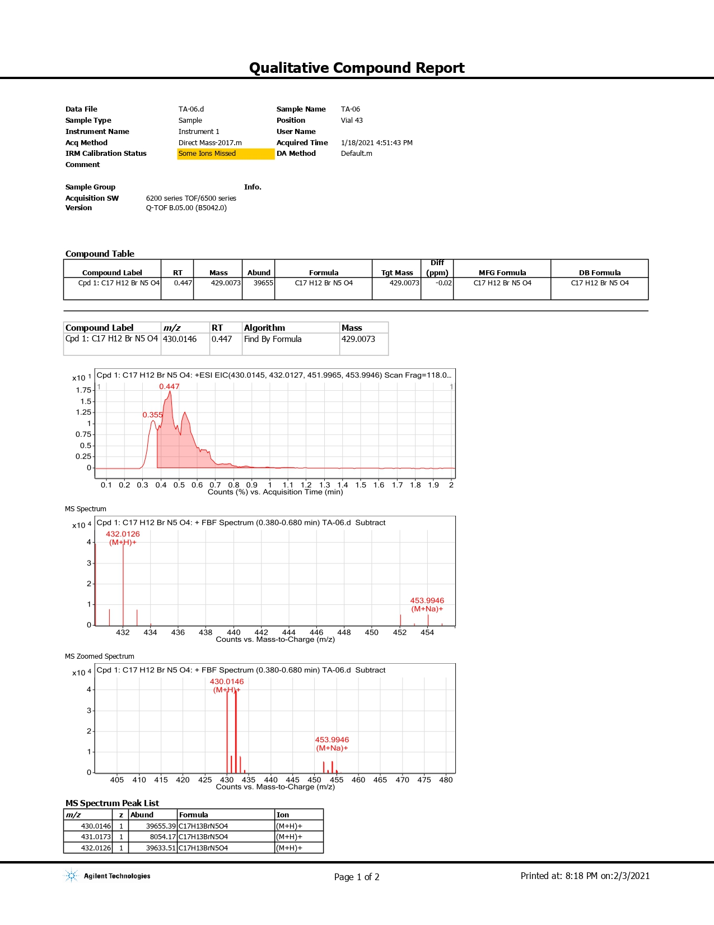
(c)

Supplementary Figure S3. Characterization of 5c. Panel (a): FT-IR; Panel (b): 13C NMR and Panel (c): HRMS.

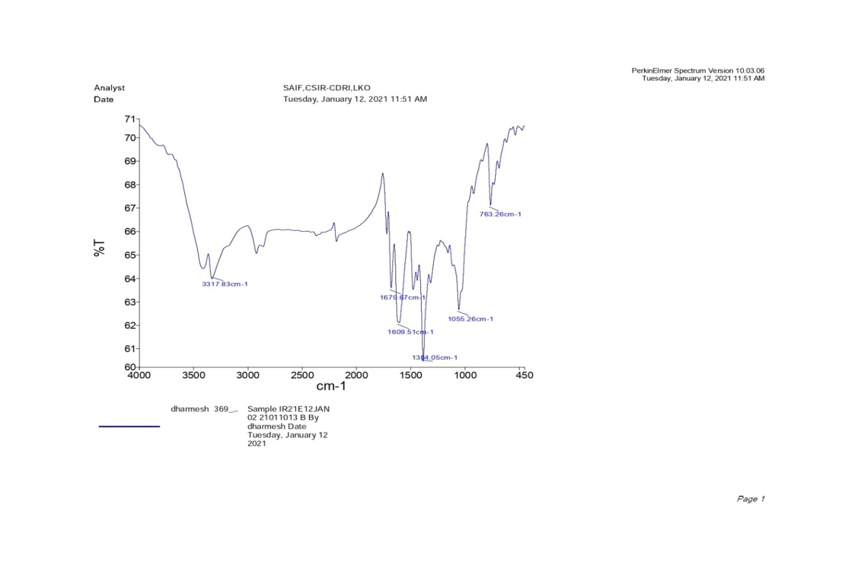
(a)

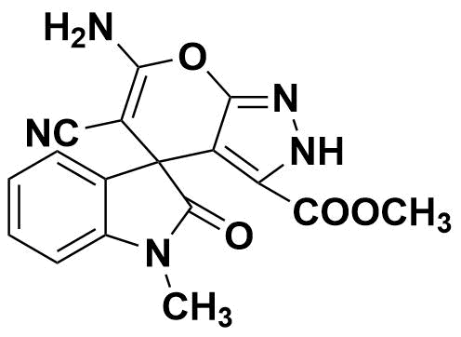

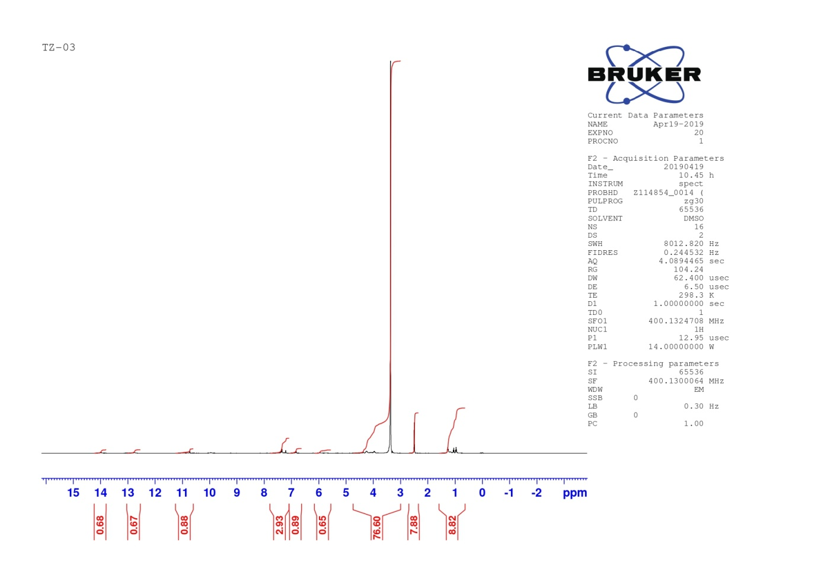
(b)

Supplementary Figure S4. Characterization of 5d. Panel (a): FT-IR; Panel (b): 1H-NMR.
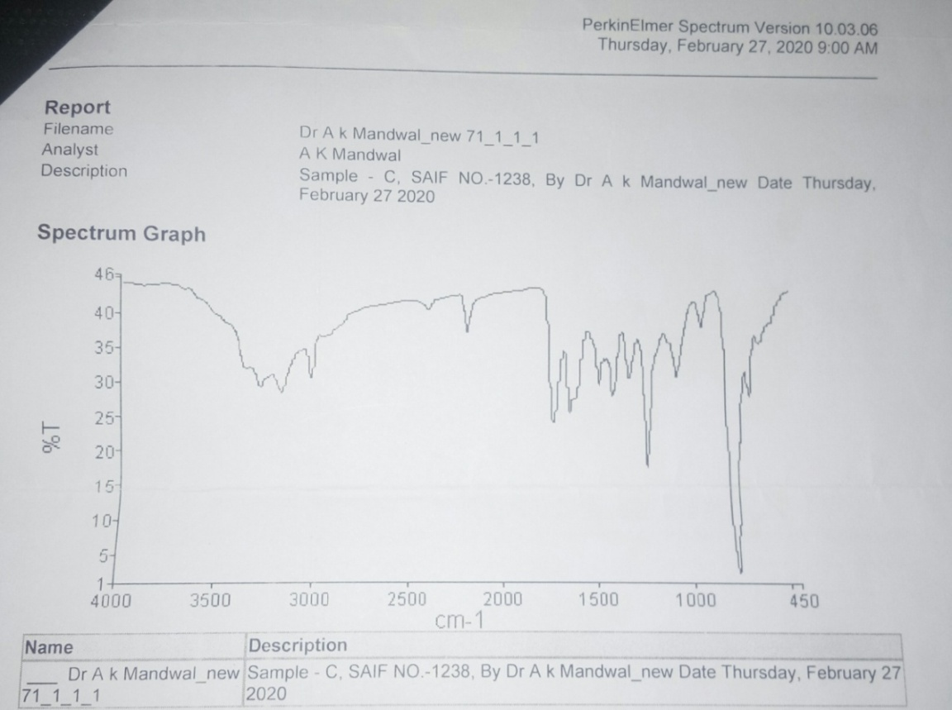
(a)

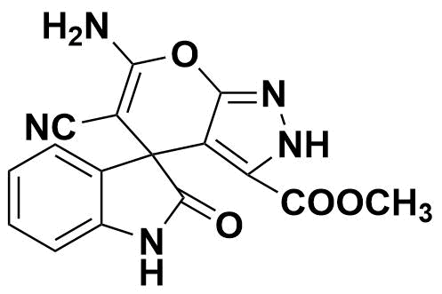

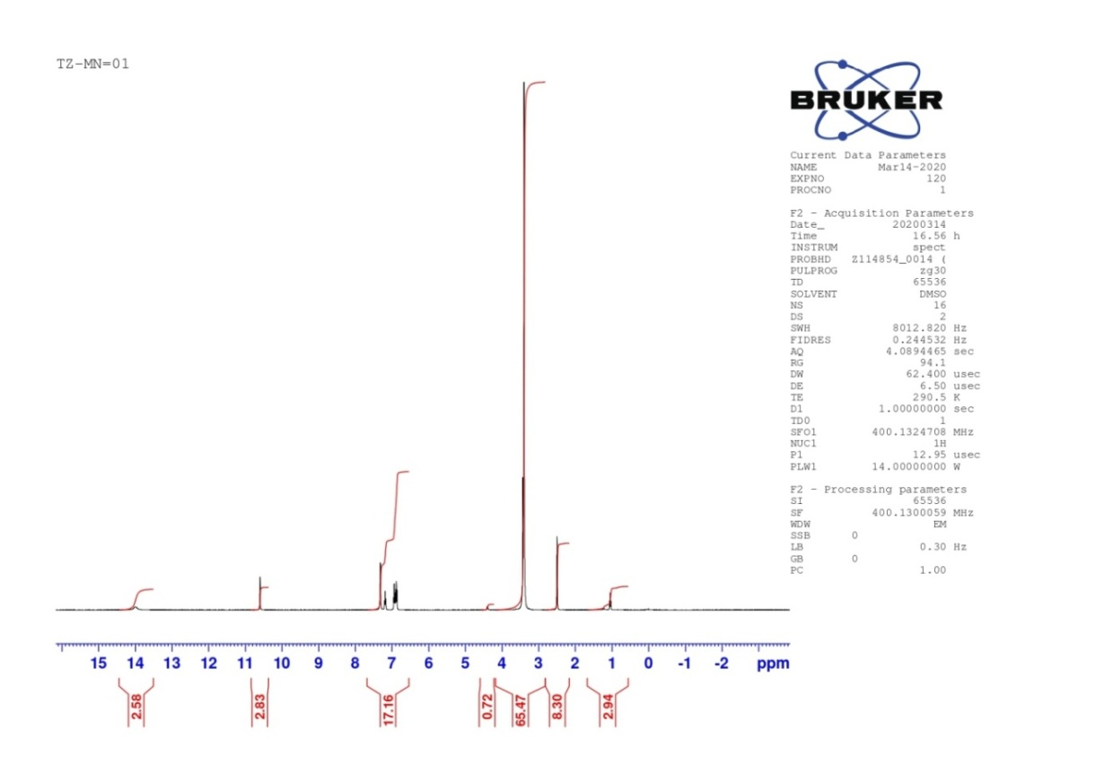
(b)

Supplementary Figure S5. Characterization of 5e. Panel (a): FT-IR; Panel (b): 1H-NMR.
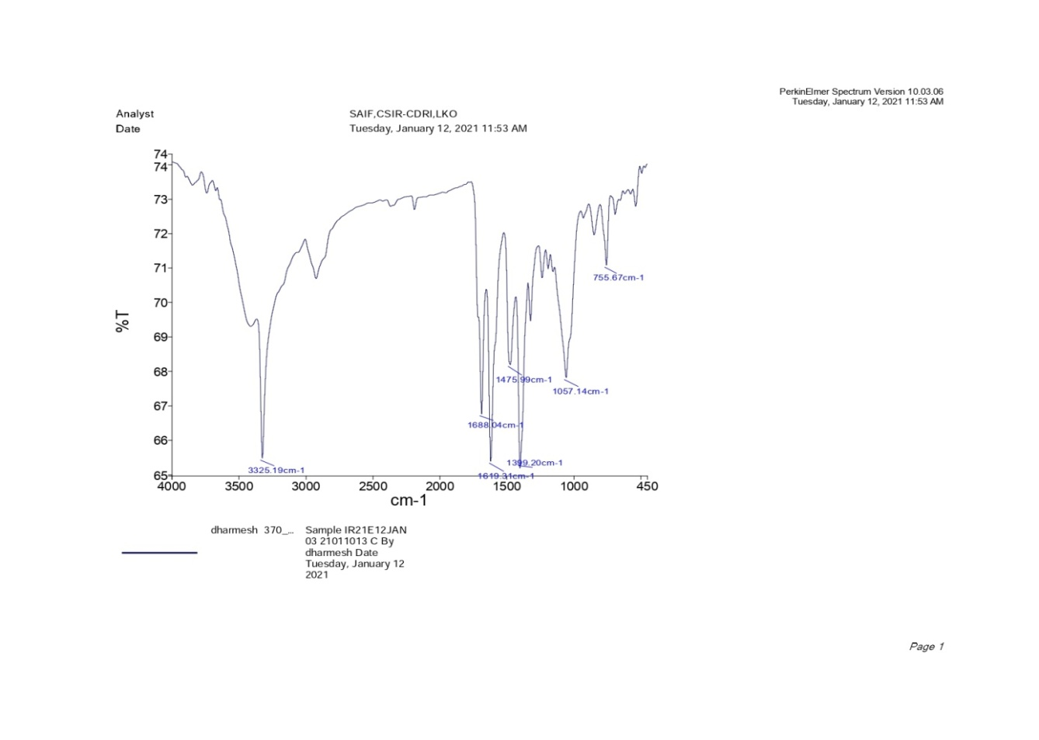
(a)

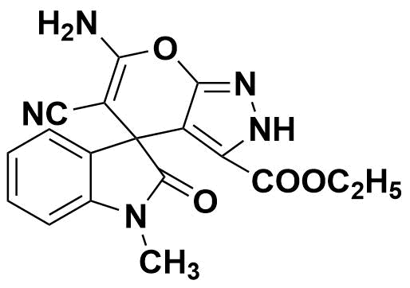

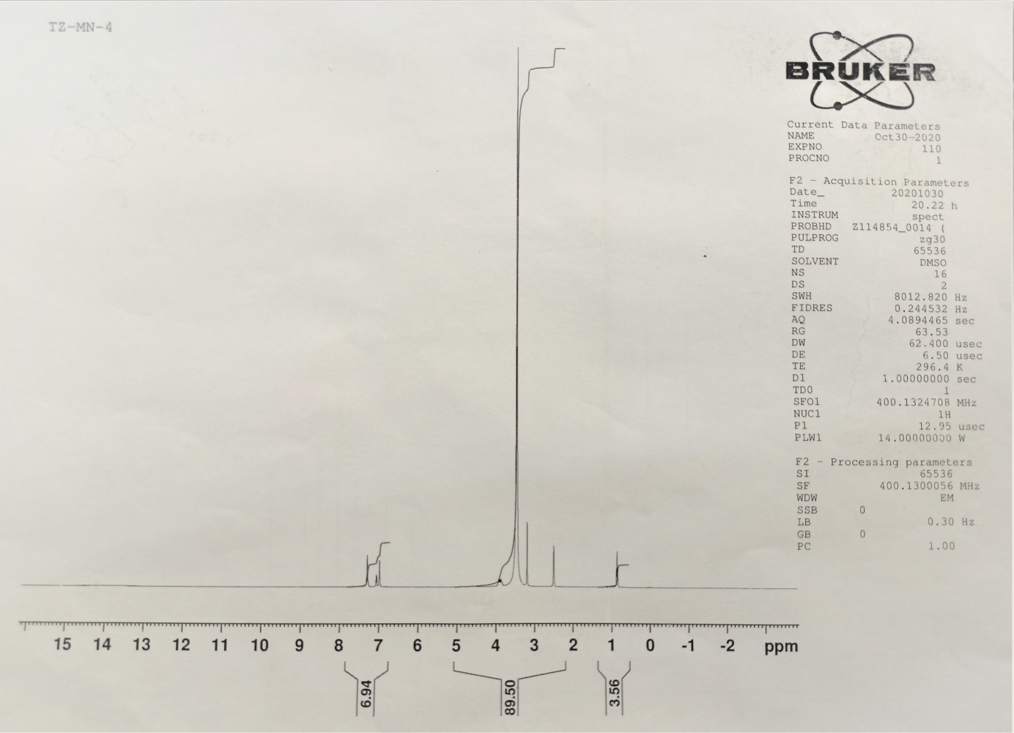
(b)

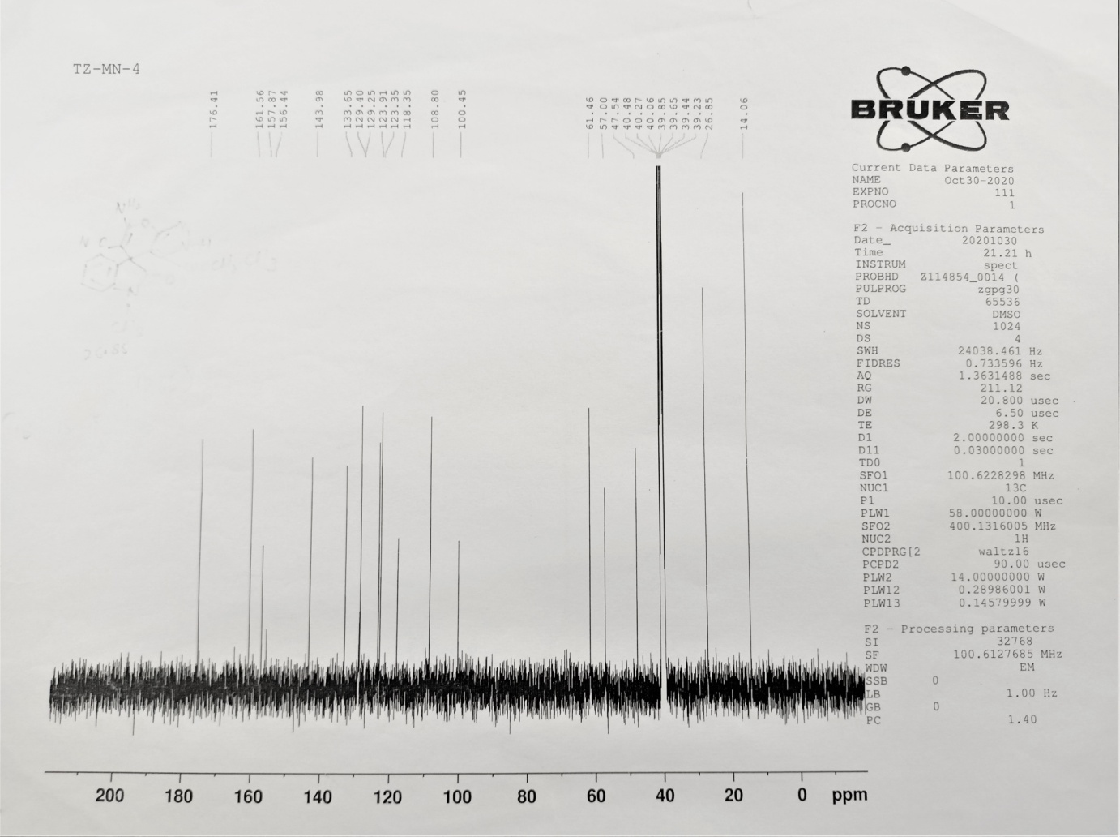
(c)
(d)
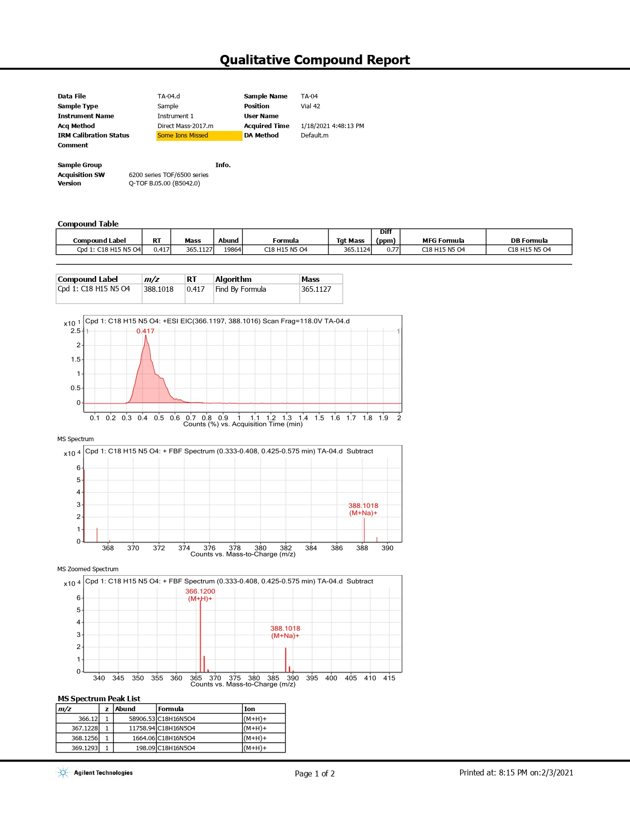

Supplementary Figure S6. Characterization of 5f. Panel (a): FT-IR; Panel (b): 1H-NMR, Panel (c): 13C NMR and Panel (d): HRMS.
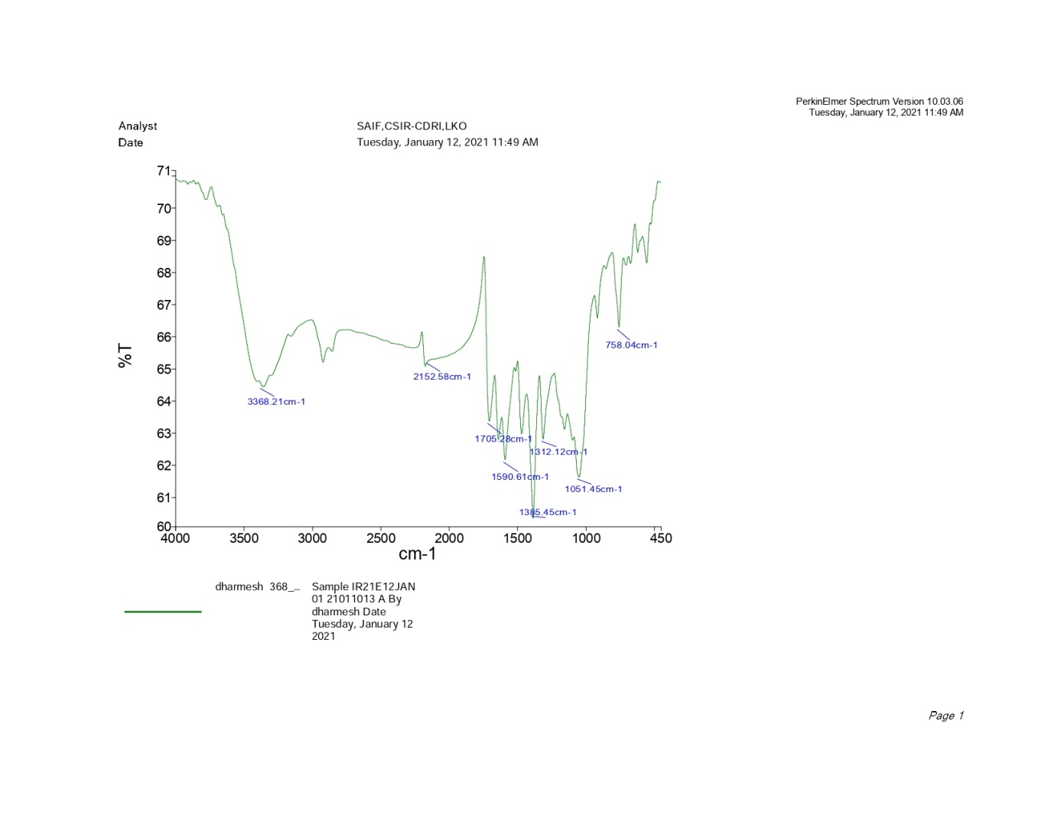
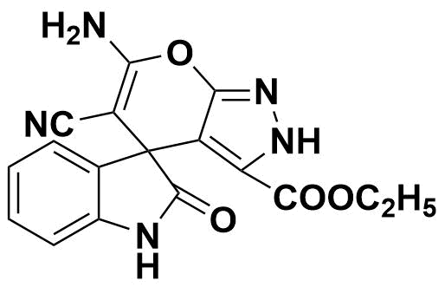
(a)

(b)
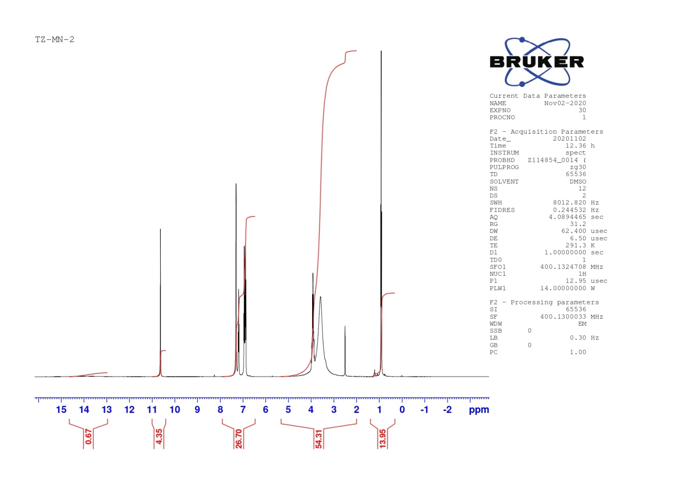

(c)
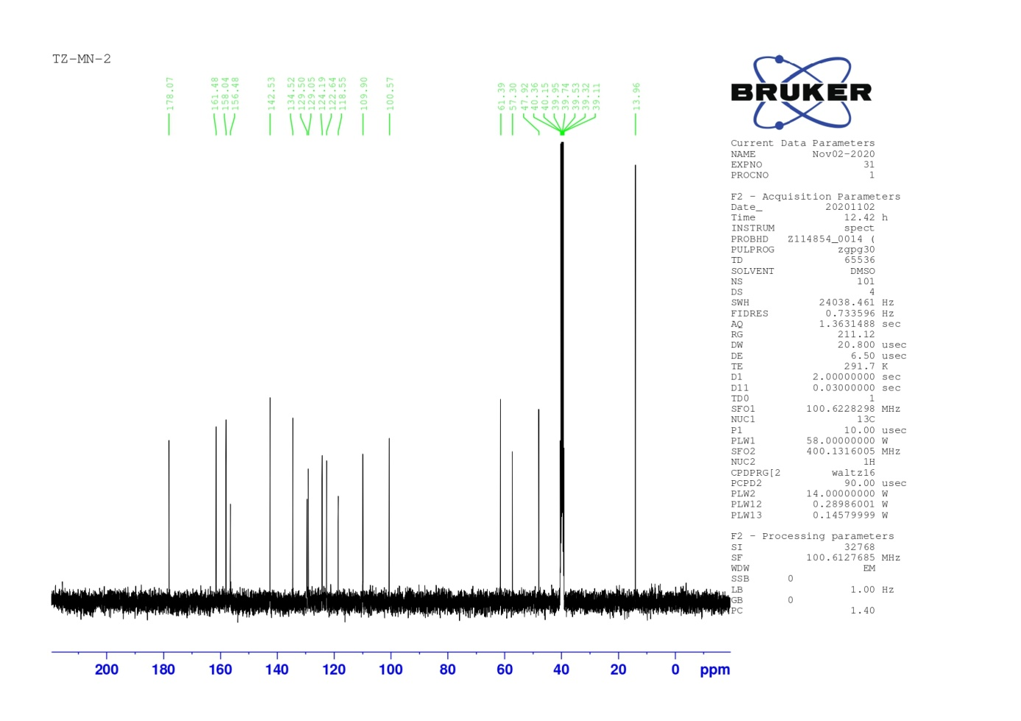

Supplementary Figure S7. Characterization of 5g. Panel (a): FT-IR; Panel (b): 1H-NMR, Panel (c): 13C NMR.

Percentage Growth inhibition by one dose mean graph screening reports: copies for spirooxindole-pyranopyrazoles (5a-g)
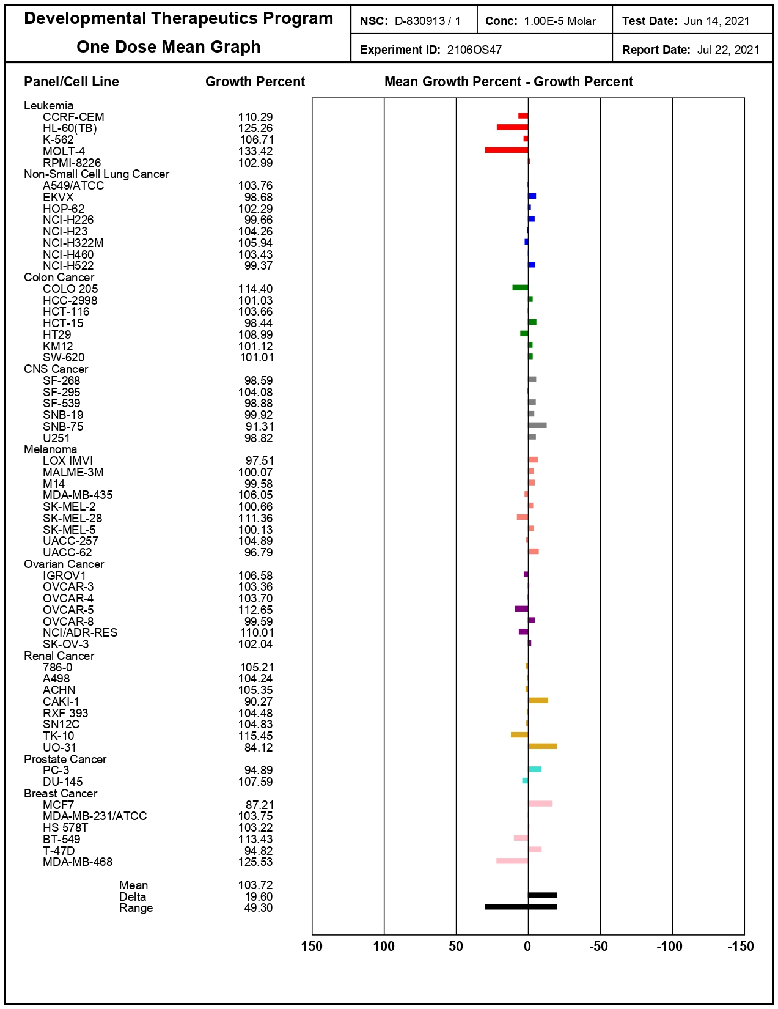
5a

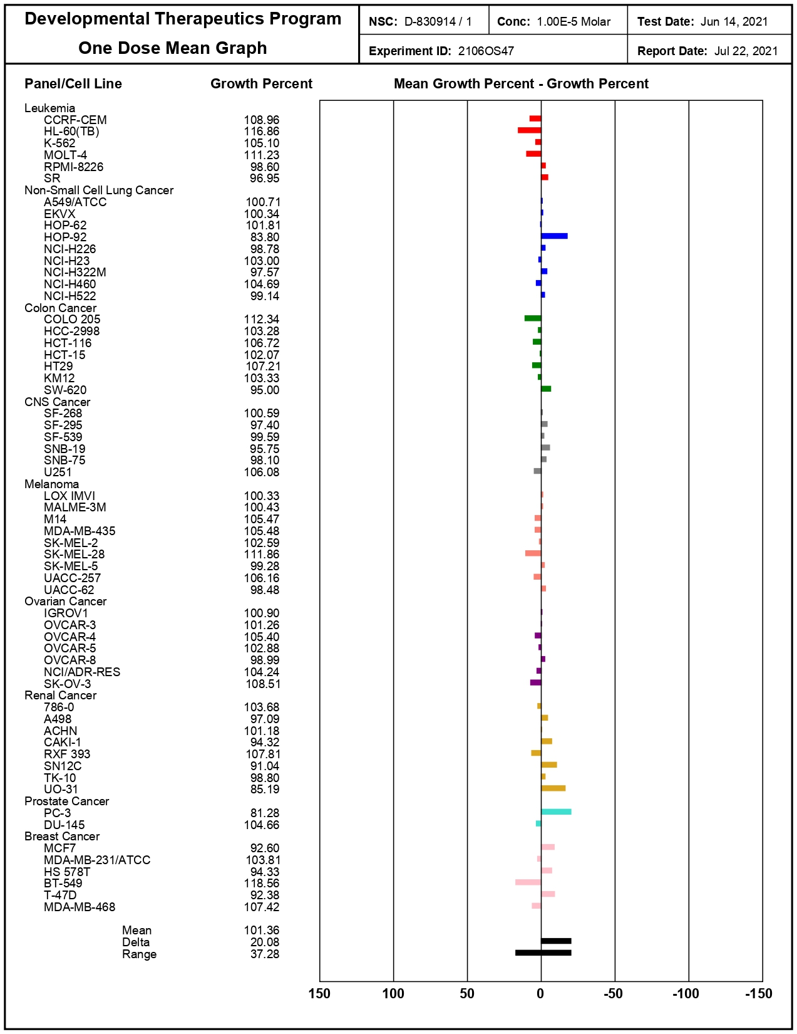
5b

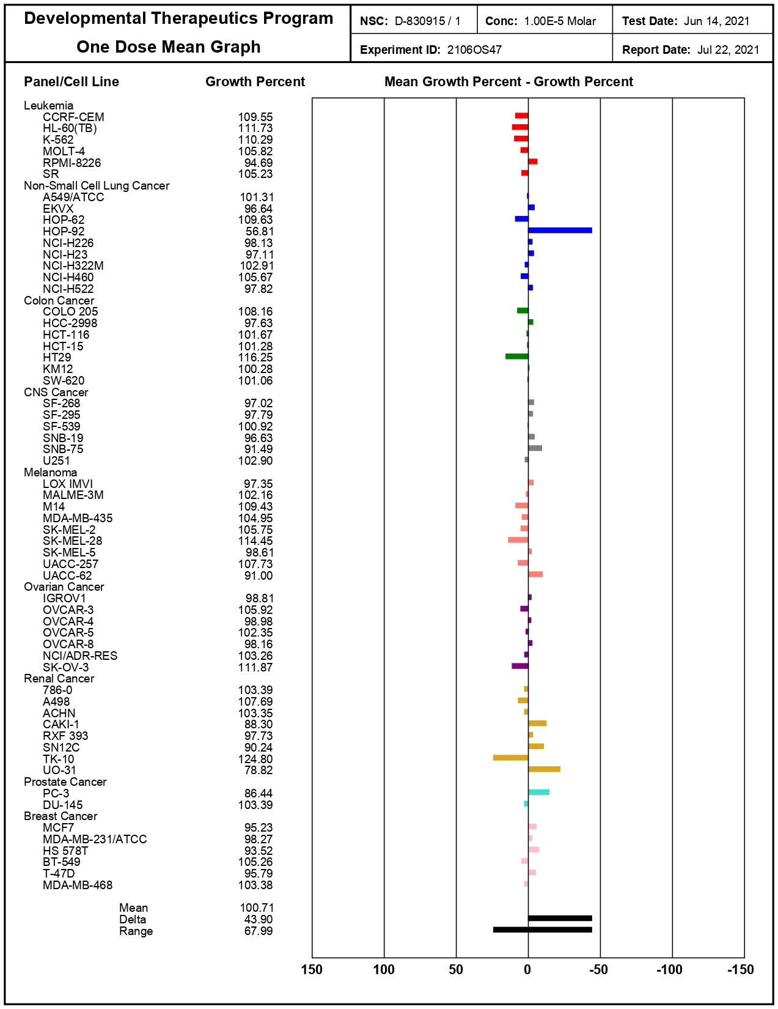
5c

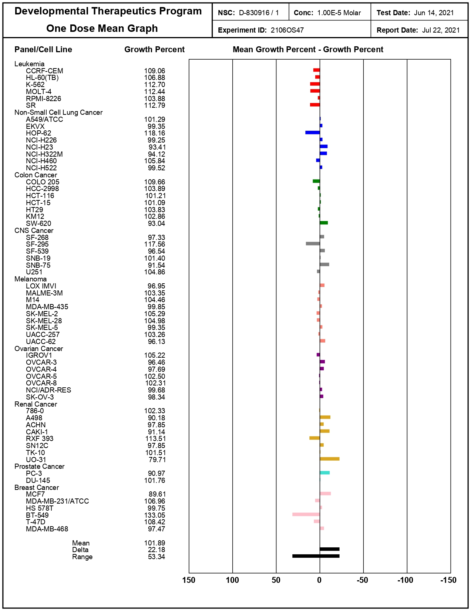
5d

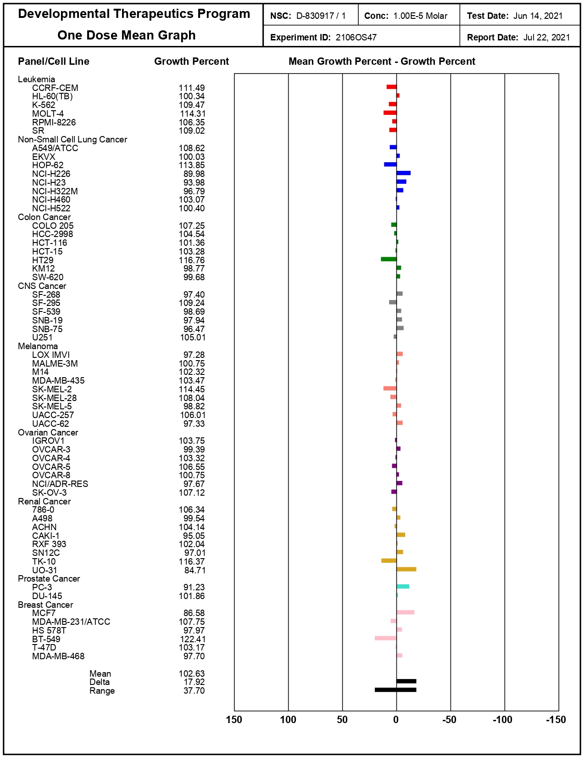
5e

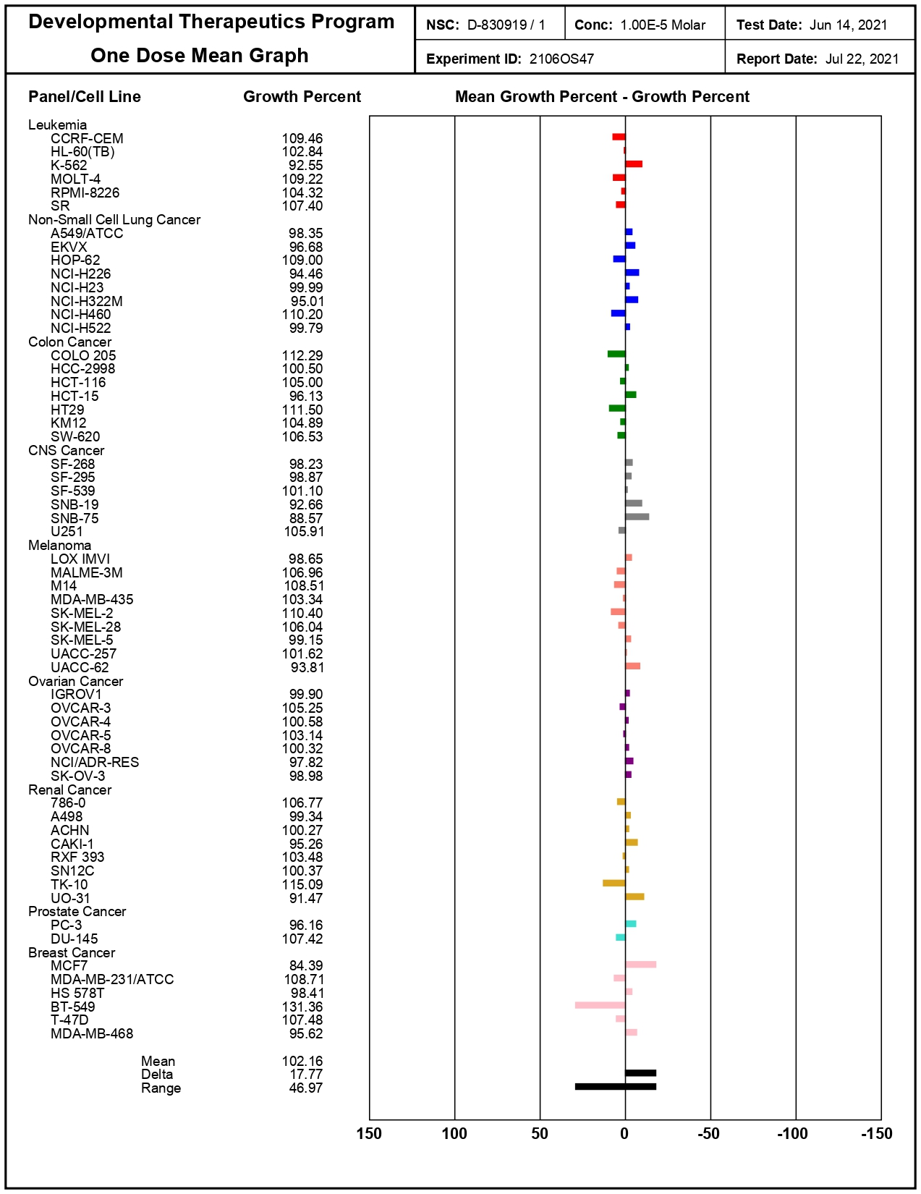
5f

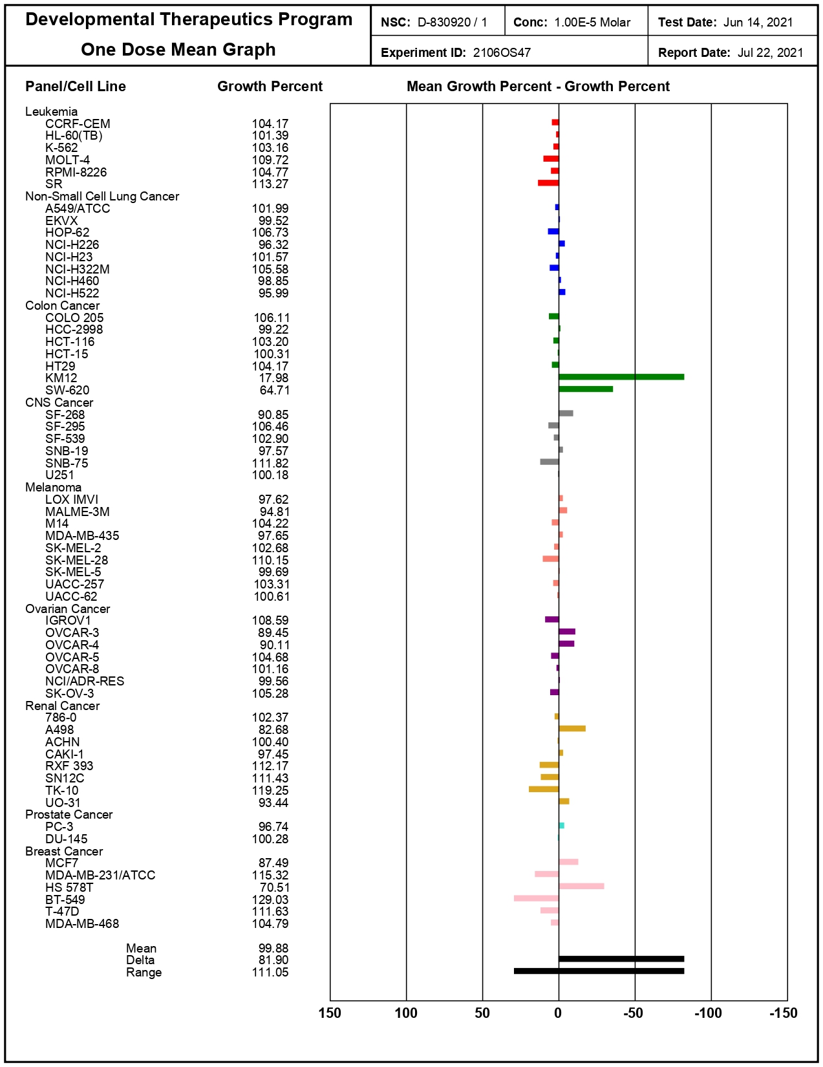
5g

Supplementary Table S1:Drug-likeness studies of novel spirooxindole-pyranopyrazoles (5a-g).
Molecular descriptors | Novel spirooxindole-pyranopyrazole
Molecular descriptors | 5a | 5b | 5c | 5d | 5e | 5f | 5g
MW | 421.29 | 382.29 | 430.21 | 351.32 | 337.29 | 365.34 | 351.32
HBD | 3 | 3 | 3 | 2 | 3 | 2 | 3
HBA | 10 | 8 | 6 | 6 | 6 | 6 | 6
LogP | 1.41 | -0.20 | 1.45 | 0.71 | 0.50 | 1.06 | 0.85
TPSA (Å²) | 152.35 | 188.94 | 143.12 | 134.33 | 143.12 | 134.33 | 143.12
Rotatable bonds (RB) | 4 | 3 | 3 | 2 | 2 | 3 | 3
Lipinski’s violations | 0 | 0 | 0 | 0 | 0 | 0 | 0
Veber’s violations | 1 | 1 | 1 | 0 | 1 | 0 | 1

Supplementary Table S2: ADME indices of novel spirooxindole-pyranopyrazole (5a-g).
S.N. | Compounds | Aq. Solubility  (mg/L) | BBB (C. Brain/C. Blood | Caco2 cell permeability (nm/sec) | MDCK cell Permeability (nm/sec) | Skin permeability  (logKp; cm/h) | PPB (%) | HIA (%) | CYT. p450 2D6 inhibition | CYT. p450 2D6 substrate
 | 5a | 1.798 | 0.190 | 20.017 | 23.698 | -3.526 | 90.614 | 64.610 | Non | Non
 | 5b | 1.083 | 0.021 | 20.924 | 0.827 | -4.847 | 68.890 | 24.023 | Non | Non
 | 5c | 0.754 | 0.151 | 20.074 | 0.552 | -4.794 | 80.084 | 85.070 | Non | Non
 | 5d | 15.283 | 0.529 | 11.324 | 2.176 | -4.834 | 65.206 | 80.909 | Non | Non
 | 5e | 9.206 | 0.270 | 6.778 | 1.751 | -4.901 | 59.533 | 69.171 | Non | Non
 | 5f | 7.602 | 0.113 | 10.543 | 3.770 | -4.747 | 67.906 | 82.682 | Non | Non
 | 5g | 4.586 | 0.083 | 9.080 | 2.869 | -4.838 | 63.043 | 71.598 | Non | Non
 |  |  |  |  |  |  |  |  | Non | Non
 | Cetuximab | 432.118 | 0.163 | 52.46 | 23.145 | -3.073 | 68.210 | 96.024 | Non | Non
*Plasma protein binding (PPB); Blood brain barrier (BBB); Human intestinal absorption (HIA)

