Appendix

Table A.1. Error component model results.
Variables | EC model
 | Est. | (SE)
Choice model
$ASC_{train}$ (ref = plane) | -0.696 | (0.651)
$${ASC}_{Origin}$$ | 0.617** | (0.274)
$${ASC}_{Destination}$$ | 0.617** | (0.274)
Comfort level | 1.451*** | (0.147)
One change (ref = direct train) | -1.699*** | (0.233)
Two changes (ref = direct train) | -2.459*** | (0.281)
Travel time (night train) | -0.262*** | (0.037)
Travel time (day train) | -0.229*** | (0.040)
Travel time (plane) | -0.299** | (0.117)
Travel cost | -0.002*** | (<0.001)
Model fit
Number of individuals | 1,571
Number of observations | 11,440
Number of draws | 500
BIC | 6,403.97
$$ρ^{2}$$ | 0.604

A.1. Travel demand layer – mode characteristics
The travel time values, number of transfers, ticket prices and comfort levels were estimated as follows. The travel time by train was estimated based on travel distances and average travel speed by type of train (night train, day train, and high-speed day train). Travel distances were measured using Google Maps (www.google.com/maps) and the information about the reduction in travel distances after 2029 following the construction of the Fehmarn Belt Fixed Link (Fehmarn Belt tunnel) was retrieved from the German Government (Federal Ministry of Transport and Digital Infrastructure, 2021). The average speed was calculated based on 16 current railway connections (Table A.2), resulting in an average speed of 75 km/h for night trains during the night and of 121 km/h during the day. The slower average speed during the night is due to night maintenance of railways and priority for freight transport (Lena Donat et al., 2021). Where available, high-speed trains with an empirical average speed of 178 km/h were considered. When transfers are involved, an average transfer time of 45 minutes was assumed. For the number of transfers, we considered direct connections, one, two or more transfers depending on origin-destination pairs. For prices, we considered a reference price level depending on distance ranges, and a relative change in the flight ticket price compared to night train journeys, depending on the scenarios. Origin-destination specific prices were based on prices of around 21,000 flights and 400 land connections (European Commission, 2021d).
Relative changes in flight ticket prices were estimated through Flygresor (www.flygresor.se). Flight prices were collected for direct flights including luggage and possibilities to reschedule. We identified connections where there is a relatively high number of Swedish air travel passengers, and where there are relatively good train options which include a night train (from Stockholm, Gothenburg or Malmö to Paris, London, Amsterdam, Vienna, and St. Anton – a popular Austrian ski resort). Prices were collected for trips 5 months in the future and for the month of July, which is the most common annual holidays month in Sweden. Both low-cost and standard airlines were included. Train prices were supplied by the booking agency, Resebutik (www.resebutik.se) and include interrail pass (4 days of travel) and the cost for a bed in a 3- or 4-person compartment (i.e., mid-range option). The average costs for travel to/from airports and train stations were also included. An analysis of the collected data showed a 30% higher price for night trains compared to flights, which has been used in the baseline travel demand scenario. In the altered scenario, equal price levels for night trains and flights tickets were considered. As for comfort level, we assumed that new, comfortable night trains will be available on the market by 2025.

Table A.2. Train corridors
Train | Corridor | Distance | Travel time | Average speed | Company
DT | Paris-Munich | 850 km | 5:50 h | 146 km/h | SNCF
DT | Amsterdam-Zurich | 816 km | 7:46 h | 105 km/h | OBB nightjet
DT | Zurich-Hamburg | 845 km | 7:37 h | 111 km/h | SBB
DT | Zurich-Milan | 280 km | 3:17 h | 85 km/h | SBB
HS | Paris-Lyon | 466 km | 1:58 h | 237 km/h | Oui
HS | Paris-Marseille | 775 km | 3:21 h | 231 km/h | Oui
HS | Berlin-Munich | 620 km | 4:26 h | 140 km/h | DB
HS | Milan-Rome | 580 km | 3:00 h | 193 km/h | Trenitalia, Italo
HS | Amsterdam-Paris | 520 km | 3:20 h | 156 km/h | Thalys
HS | Madrid-Barcelona | 630 km | 3:20 h | 202 km/h | Renfe
NT | Wien-Rome | 990 km | 13:37 h | 73 km/h | OBB nightjet
NT | Paris-Munich | 850 km | 9:49 h | 87 km/h | OBB nightjet
NT | Paris-Milan | 850 km | 10:45 h | 79 km/h | Thello
NT | Milan-Rome | 580 km | 7:57 h | 73 km/h | Trenitalia
NT | Amsterdam-Zurich | 816 km | 11:37 h | 70 km/h | OBB nightjet
NT | Zurich-Hamburg | 845 km | 12:15 h | 69 km/h | OBB nightjet

A.2. Carbon footprint layer – Energy use: technology shift in aviation and railway
Technology shifts in aviation. Electric planes were assumed to start taking market share from 2035 and onwards, increasing linearly until reaching 30% of travelled pkm in 2050. Schäfer et al. (2019) estimated that electric planes could service 15% of travelled pkm globally by 2060, assuming that electric planes can service distances up to slightly over 1,000 km. Since 30% of the trips analysed in this study fall within this range, a higher share of electric plane service was assumed. Planes using liquid fuels were assumed to gradually shift to biofuels/electro-fuels in line with the Swedish emissions reduction obligation quota policy (Swedish Government, 2021b) for flights departing from Sweden (i.e., the carbon intensity of the fuel used should be reduced by 27% in 2030, equivalent to a 34% share of alternative fuels). For the low-carbon technologies pathway, it was assumed that the proposed regulation for sustainable aviation fuel (European Commission, 2021c) would be adopted, resulting in an emissions reduction obligation quota policy (i.e., the share of alternative fuels would be 5% in 2030 and 63% in 2050) for all flights departing within the EU. For domestic flights in Sweden, the reduction obligation quota was assumed to increase in the decarbonization scenario, reaching 100% in 2045 in line with the adopted net-zero target (Swedish Government, 2020a). The non-CO₂ radiative forcing due to combustion at high altitudes of aviation fuel is still uncertain. This study assumes that the global warming potential over a 100-year time horizon is 70% higher than for the emissions of CO₂ from fuel combustion alone (Lee et al., 2021). In the low-carbon technologies pathway, it was assumed that measures would be put in place to reduce the non-CO₂ radiative forcing to 28% of the CO₂ emissions from fuel combustion alone up to 2050 (increasing linearly from 2019). Such measures include changing flight routes, which has been shown to potentially reduce the effect by half (Teoh, 2020), and reducing the aromatics in aviation fuel (European Commission, 2020).
Technology shifts in railways. Swedish passenger train operation is assumed to be 100% electric. For trains operated in other European countries, 80% of the passenger travel is assumed to be electric and 20% diesel-powered based on the European average for 2019 (European Commission, 2017), which shifts to 90% electric and 10% bio/electro-fuel-powered by 2050 in the low-carbon technologies pathway.

A.3. Carbon footprint layer – Carbon intensity: Electricity generation, fossil fuel production and use, production of alternative renewable fuels and use and battery manufacturing
Electricity generation. Direct emissions in 2019 for Sweden were based on the total emissions from electricity generation divided by the total end-use of electricity (Swedish Energy Agency, 2021; Swedish Environmental Protection Agency, 2020) and were assumed to decrease to zero by 2045 in both climate policy pathways given the adopted climate targets and intentions stated by the Swedish Government (Swedish Government, 2020a). Direct emissions in 2019 for the EU were based on the average greenhouse gas intensity for 2017−2019 (European Environment Agency, 2021) and were assumed to decrease in line with scenarios provided by the European Commission (2018), reaching zero by 2058 when the cap on the EU’s emissions trading scheme reaches zero. Note that distribution and transmission losses were accounted for in the carbon intensity. In addition to direct emissions, upstream emissions from the production of fuels and power stations (except for hydro and nuclear power stations due to their long lifetimes) were added using a weighted emissions factor. The weighted emissions factor was considered specifically for an electricity mix and year, based on estimates by Pehl et al. (2017) for different electricity generation technologies for the respective climate policy pathways.
Fossil fuel production and use. The combustion of fossil fuels was assumed to give rise to 249g CO₂/kWh for planes (Schäfer et al., 2016) and 259g CO₂/kWh for trains, equivalent to a diesel passenger car (Morfeldt et al., 2021). Upstream emissions for aviation fuel were estimated at 66g CO₂/kWh (Schäfer et al., 2016), which is close to the estimate of 63g CO₂/kWh estimated for liquid fossil fuels (Masnadi et al., 2018). Liquid fossil fuel production was assumed to decarbonize in the low-carbon technologies pathway by realizing emissions reduction potentials in refineries equivalent to 50% of current refinery-related emissions by 2070 (Jing et al., 2020), reaching a level of 54g CO₂/kWh by 2050.
Production of alternative renewable fuels and use. Both biofuels and electrofuels are eligible candidates for replacing aviation fuel and diesel in trains with internal combustion engines. In 2019, alternatives to diesel in the EU included biodiesel based mainly on rapeseed, used cooking oils and animal fats, and hydrogenated vegetable oils (HVO) based on mainly palm oil. Upstream emissions amounted to 89g CO₂/kWh and 50g CO₂/kWh in 2019, respectively, and if weighted by quantities results in 83g CO₂/kWh (Mellios and Gouliarou, 2021). The weighted carbon intensity was assumed for biofuels use in trains in 2019, that in the low-carbon technologies pathway decreases to 18g CO₂/kWh by 2070 assuming that Fischer-Tropsch diesel (second generation biofuels from wood feedstocks, based on the average of estimates reported on page 59 in the Annex to Directive 2009/28/EC (European Council, 2009)) gradually replaces current biofuel production. Upstream emissions for alternative aviation fuels vary significantly depending on the feedstock – in the case of biofuels – and the electricity mix – in the case of electrofuels (Pavlenko and Searle, 2021). For 2019, we assumed the average of the emissions factors estimated by O’Connell et al. (2019) for non-palm oil feedstocks of 158g CO₂/kWh for renewable fuels, which gradually shifts to 18g CO₂/kWh by 2070 in the low-carbon technologies pathway. Direct emissions from the combustion of biofuels and electrofuels were considered to be zero since the emitted CO₂ will be captured and stored again by vegetation or direct air capture. Note that while emissions related to indirect land-use change were excluded in this study, they may be high for biofuels with certain feedstocks and that supply may become significantly limited in the future if regulations are put in place.
Battery manufacturing (electric planes). Battery manufacturing was assumed to increase emissions by 6g CO₂/kWh per passenger-km in 2019; the median estimate by Schäfer et al. (2019). The carbon intensity in battery manufacturing is likely to drop as the industry matures, and as electricity generation and raw material production decarbonize. Hence, the factor was assumed to decrease at the same rate as emissions per unit of battery capacity for cars in the low-carbon technologies pathway, as estimated by Morfeldt et al. (2021). Other vehicle-related emissions were not considered in this study since they were assumed to be unaffected by the scenarios.

A.4. Detailed results

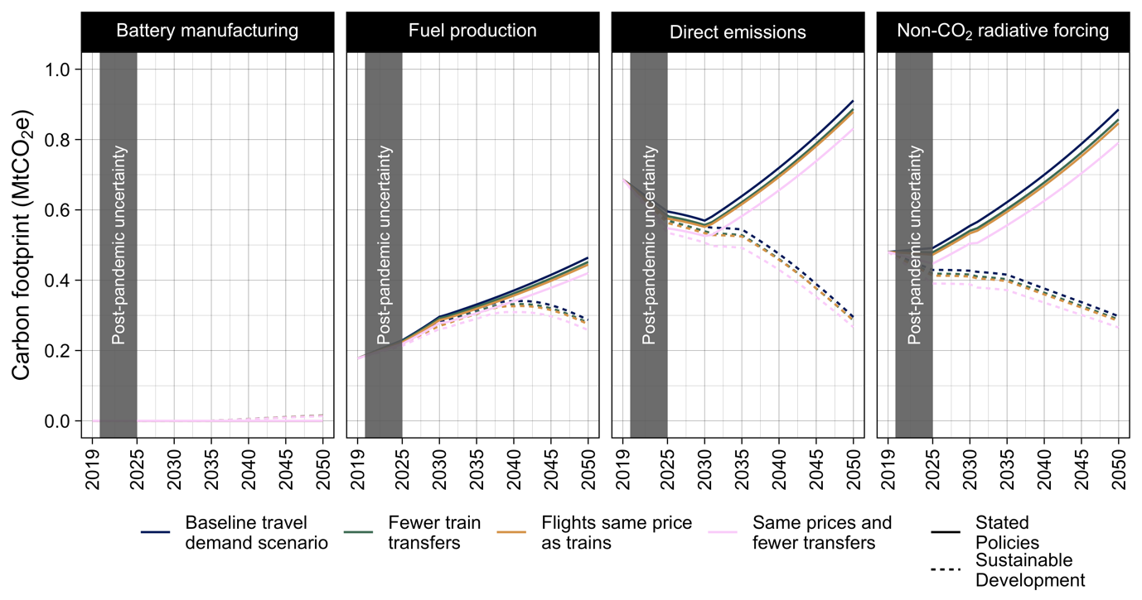
Figure A.1. Annual carbon footprints associated with battery manufacturing, fuel production, direct and non-CO₂ radiative forcing.
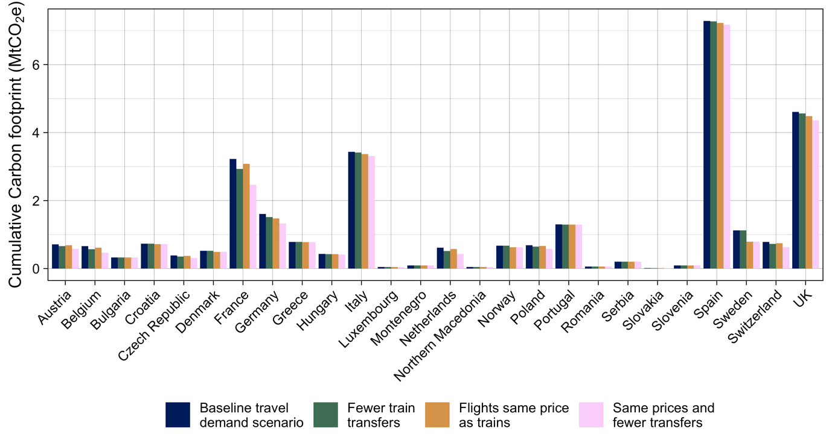
Figure A.2. Cumulative carbon footprint 2025−2050 assuming decarbonization in line with Sustainable Development, by country and scenarios.

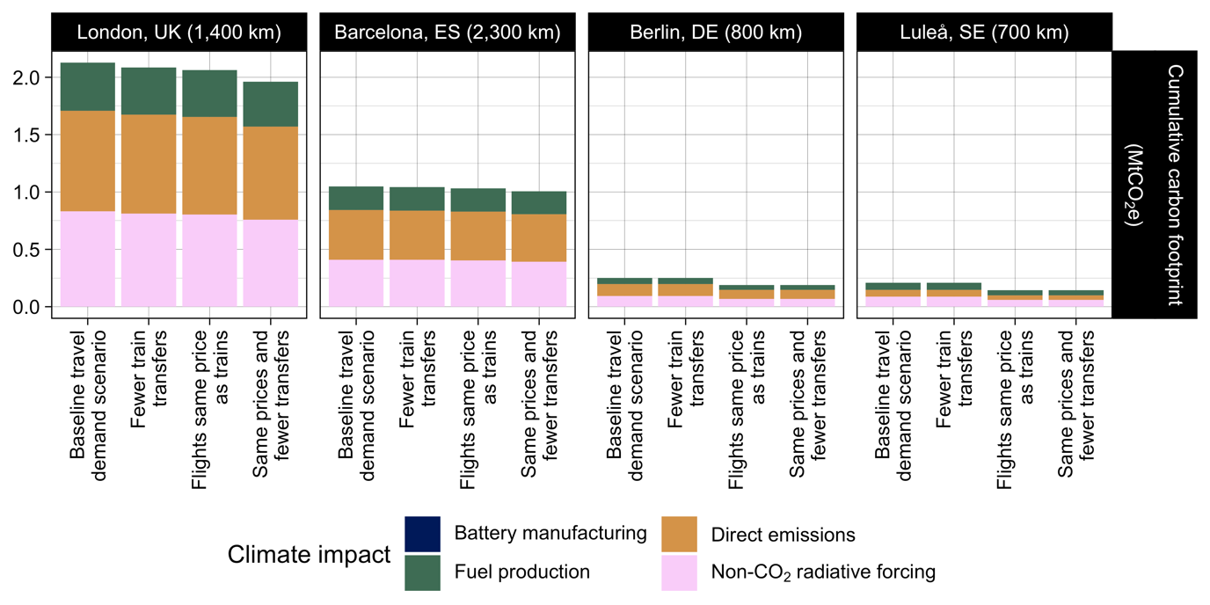
Figure A.3. Impact of tourism from Stockholm, Sweden to four destinations (columns – linear distance from origin in thousand kilometres) on carbon footprint. The results assume the current technology trends decarbonization pathway.
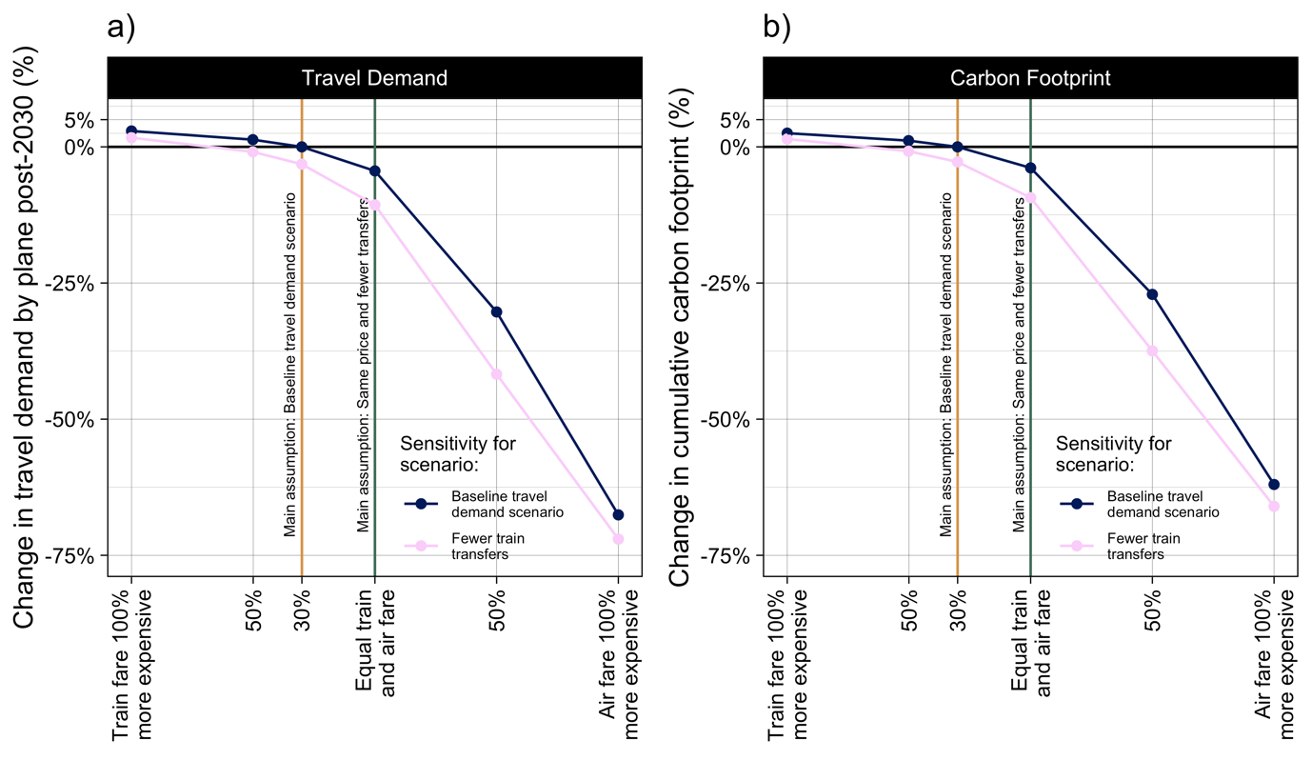
Figure A.4. Sensitivity analysis of the impact of the ticket price difference on travel demand (a) and cumulative carbon footprint (b). The results for the carbon footprint assume the low-carbon technologies decarbonization pathway. The results for the current technology trends pathway are almost identical and therefore not displayed in this figure.

