Generation of DNA Oligomers with Similar Chemical Kinetics via In-Silico Optimization
Supplemental Material

Contents
Section 1: Analysis of Existing Experimental Data 1
Section 2: Calculation of Fitness Scores (DevPro Program) 4
Section 3: Generation of New Oligomers (SeqEvo Program) 7
Section 4: Characterization of New Oligomers 12
Section 5: New Oligomers for Existing Designs 96

Section 1: Analysis of Existing Experimental Data

Table S1-01. Select properties of the five datasets. Properties include: the number of samples (n), the mean of the natural log of the rates (mean log k), and kinetic dispersion – the interquartile range of the natural log of the rates.
DataSet | n | T | Reaction | Units of k | Buffer | Mean  Log k | Kinetic Dispersion  (IQRNL) | Median ΔN | Median ΔO
H25F | 47 | 25C | Duplex-Formation | M⁻¹s⁻¹ | 1x saline-sodium-citrate (150mM NaCl, 15mM sodium citrate) | 13.1 | 2.56 | 63100 | 5000
O25C | 51 | 25C | Catalysis | M⁻²s⁻¹ | 1 x TE (10mM Tris-HCl, 1 mM ethylenediaminetetraacetic acid, 12.5 mM MgCl₂) | 28.8 | 3.25 | 1061598 | 74840
O25L | 51 | 25C | Leak | M⁻¹s⁻¹ | 1 x TE (10mM Tris-HCl, 1 mM ethylenediaminetetraacetic acid, 12.5 mM MgCl₂) | 1.14 | 1.09 | 1061598 | 74840
Z37F | 98 | 37C | Duplex-Formation | M⁻¹s⁻¹ | 5 x Phosphate-Buffered-Saline | 14.0 | 1.86 | 2851380 | 113510
Z55F | 95 | 55C | Duplex-Formation | M⁻¹s⁻¹ | 5 x Phosphate-Buffered-Saline | 15.4 | 1.29 | 2808020 | 118940

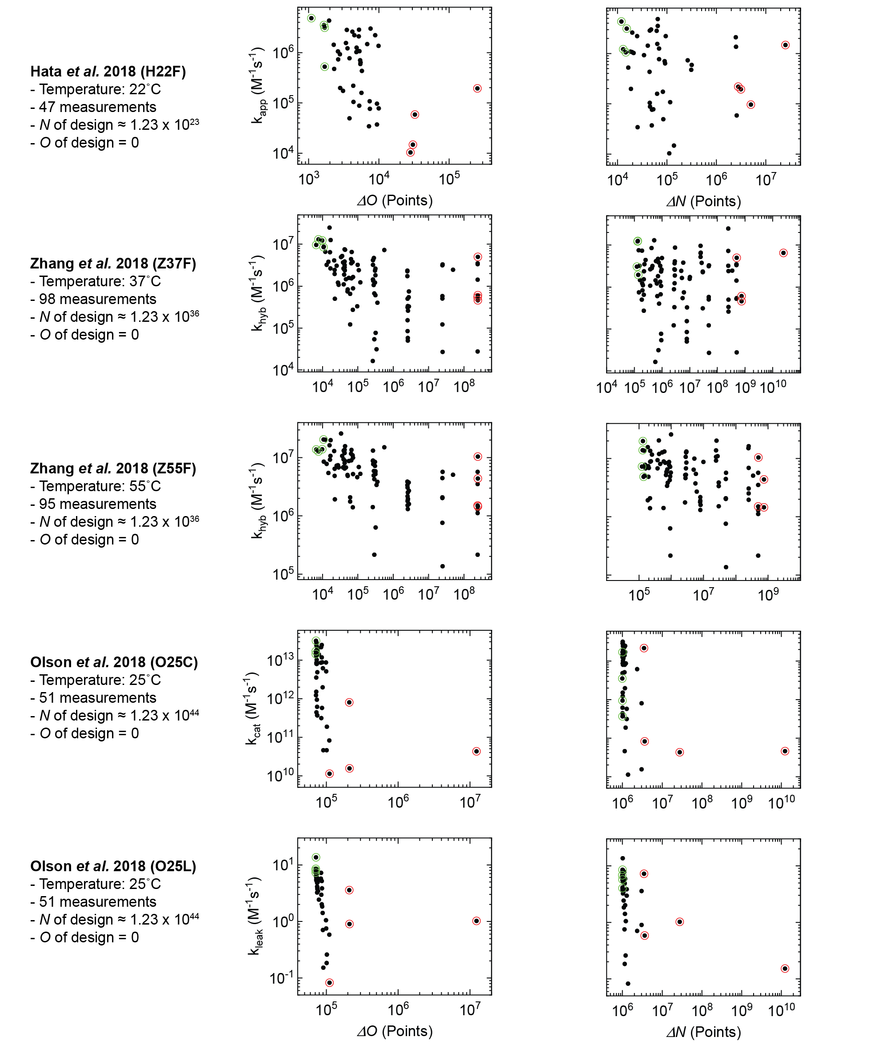
Figure S1-01. Correlation plots for rate constant as a function of ΔN and ΔO. Green circles indicate the value of the four most-fit samples, and red circles indicate the value of the four least-fit samples.

Table S1-02. Kinetic dispersion and unnecessary duplexes for populations selected from datasets. Reported values include the number of samples in the population (n) and kinetic dispersion. Kinetic dispersion is calculated as the interquartile range of the natural logarithm of rate-constant values (IQRNL). The three values reported for IQRNL represent the 25th, 50th, and 75th percentiles of 1,000 random resamplings of the values.
Dataset | Units of k | Population | n | Kinetic Dispersion  (25th, 50th, 75th of IQRNL) |  |  | Median ΔN | Median ΔO
H22F | M⁻¹s⁻¹
H22F | M⁻¹s⁻¹ | Random | 3 | 0.89 | 1.5 | 2.0 | 6.3 x 10⁴ | 5.0 x 10³
H22F | M⁻¹s⁻¹ | N-Fit | 3 | 0.09 | 0.95 | 1.1 | 1.3 x 10⁴ | 2.6 x 10³
H22F | M⁻¹s⁻¹ | O-Fit | 3 | 0.091 | 0.24 | 0.33 | 6.5 x 10⁴ | 1.7 x 10³
O25C | M⁻²s⁻¹
O25C | M⁻²s⁻¹ | Random | 3 | 0.85 | 2.1 | 3.1 | 1.1 x 10⁶ | 7.8 x 10⁴
O25C | M⁻²s⁻¹ | N-Fit | 3 | 1.2 | 1.7 | 2.9 | 1.0 x 10⁶ | 7.4 x 10⁴
O25C | M⁻²s⁻¹ | O-Fit | 3 | 0.0052 | 0.12 | 0.13 | 1.0 x 10⁶ | 7.1 x 10⁴
O25L | M⁻¹s⁻¹
O25L | M⁻¹s⁻¹ | Random | 3 | 0.33 | 0.80 | 1.5 | 1.1 x 10⁶ | 7.8 x 10⁴
O25L | M⁻¹s⁻¹ | N-Fit | 3 | 0.17 | 0.39 | 0.56 | 1.0 x 10⁶ | 7.4 x 10⁴
O25L | M⁻¹s⁻¹ | O-Fit | 3 | 0.052 | 0.067 | 0.12 | 1.0 x 10⁶ | 7.1 x 10⁴
Z37F | M⁻¹s⁻¹
Z37F | M⁻¹s⁻¹ | Random | 3 | 0.75 | 1.3 | 1.9 | 2.9 x 10⁶ | 1.1 x 10⁵
Z37F | M⁻¹s⁻¹ | N-Fit | 3 | 0.025 | 1.0 | 1.1 | 1.3 x10⁵ | 1.7 x 10⁴
Z37F | M⁻¹s⁻¹ | O-Fit | 3 | 0.047 | 0.18 | 0.23 | 5.3 x 10⁵ | 7.8 x 10³
Z55F | M⁻¹s⁻¹
Z55F | M⁻¹s⁻¹ | Random | 3 | 0.48 | 0.80 | 1.2 | 2.8 x 10⁶ | 1.2 x 10⁵
Z55F | M⁻¹s⁻¹ | N-Fit | 3 | 0.27 | 0.49 | 0.76 | 1.3 x10⁵ | 1.7 x 10⁴
Z55F | M⁻¹s⁻¹ | O-Fit | 3 | 0.0086 | 0.059 | 0.067 | 5.3 x 10⁵ | 7.8 x 10³

Section 2: Calculation of Fitness Scores (DevPro Program)
The “Device Profiler” (abbreviated DevPro) computer program was created for calculating the fitness of a given network. This program was implemented in the java programing language and calculates unnecessary states using an exhaustive linear search which considers all possible base pairings. Pseudo code describing the linear search is provided below. Example calculations of N and O for a simple network consisting of two oligomers are illustrated in figures S2-01 and S2-02. DevPro outputs values for N, O, W, ΔN, ΔO, ΔW, and the Sequence Symmetry criterion (SS). The SS criterion is a fitness metric sometimes used in DNA nanotechnology which is equal to the number of base pairs in the largest unnecessary duplex.
Algorithm pseudo-code for identifying inter-oligo unnecessary duplexes.
- For each oligomer-combination (e.g. Oligomer-1 and Oligomer-2)
  - For each possible alignment of the oligomers: (e.g. first base of oligomer-1 aligned with first base of oligomer 2).
    - L = 0
    - For each possible base-pair in this alignment: (e.g. first base of oligomer 1 and first base of oligomer 2)
      - If the bases are complementary:
        - L = L + 1
      - If the bases are not complementary and L > 0:
        - Record an inter-oligomer duplex of length L.
        - L = 0
    - If L > 0:
      - Record a inter-oligomer duplex of length L.

Algorithm pseudo-code for identifying intra-oligo unnecessary duplexes.
- For each oligomer (e.g. oligomer 1)
  - For each possible alignment of the bases: (e.g. the first base of oligomer 1 aligned with the last base of oligomer 1)
    - L = 0
    - For each possible base-pair in the alignment: (e.g. the first base of oligomer 1 and the last base of oligomer 1)
      - If the bases are complementary:
        - L = L + 1
      - If the bases are not complementary and L > 0:
        - Record an intra-oligomer duplex of length L.
        - L = 0
    - If L > 0:
      - Record an intra-oligomer duplex of length L
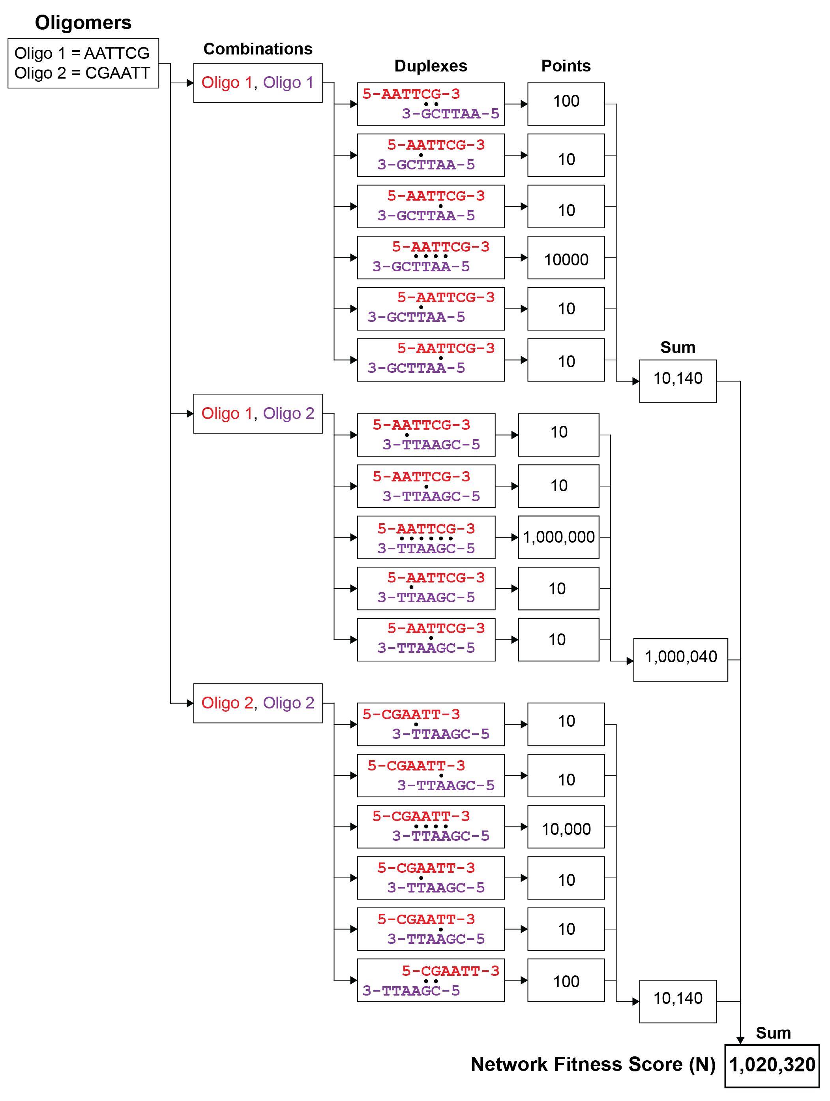
Figure S2-01. Example calculation of Network Fitness Score (N) for a network consisting of two oligomers.
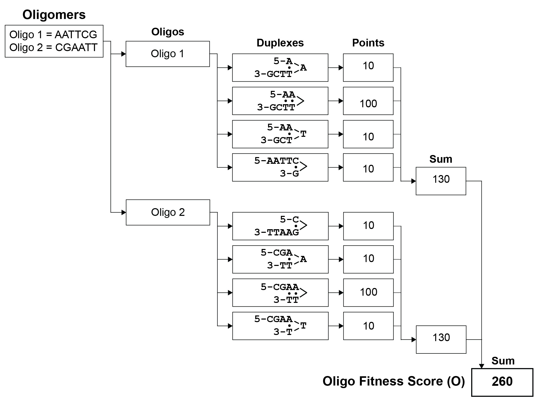
Figure S2-02. Example calculation of Oligomer Fitness Score (O) for a network consisting of two oligomers.

Section 3: Generation of New Oligomers (SeqEvo Program)
Oligomers were generated using the custom written “Sequence Evolver” (abbreviated SeqEvo) computer program.
This program starts by reading three input files. The first file contains a list of base-sequences referred to as binding domains or simply domains. Each of these domains has a name, a base-sequence, and a declaration as either fixed or variable. The second file contains a list of oligomers. Each oligomer has a name and a list of one or more domains composing it. Values may only be either a domain provided in the first file, or the binding complement of a domain provided in the first file. The third file is a list of runtime parameters for the program. This includes values of the following parameters, several of which are explained below: 1) The value for x in the W_{x} calculations 2) the thresholds for consecutive bases 3) NL, 4) CPL, 5) NMPC, 6) GPC, and 7) NDPM.
Based on these three input files, the program conducts an evolution-inspired search for fit oligomers by executing a series of staged mutation-selection cycles. Mutation events include: 1) a random shuffling of a variable domain’s sequence, 2) a relocation of a sub-sequence within a variable domain, and 3) the swapping of two bases within a variable domain. Selection events are based on the W_{x} fitness of the oligomers. The algorithm conducts a pre-determined number of mutation-selection events, and then returns the fittest set of oligomers encountered. New oligomers produced by SeqEvo are subject to several constraints. First, the base-sequence in each “fixed” binding domain is unchanged. Second, the base-sequence in each “variable” binding domain may vary, but the total number of Adenine (A), Cytosine (C), Guanine (G), and Thymine (T) in the domain is conserved. Third, no oligonucleotides in the set may contain stretches of consecutive A’s, C’s, G’s or T’s longer than thresholds declared at runtime. For oligomers generated in this manuscript, thresholds of 6, 3, 3, and 6 were used for the bases A, C, G, T, respectively;
Heuristic algorithm
The evolution-inspired heuristic algorithm is as follows and is depicted visually in Figure S3-01 below.
Algorithm Start. An initial network and network design are provided to the algorithm. Networks termed lineage mothers are created which include a clone of the original network and Number-of-Lineages (NL) minus one additional clones which have been altered by shuffle mutations (below). Loop one (below) is iterated Cycles-Per-Lineage (CPL) times on each of the lineage mothers. After each iteration of loop one, if the returned network is more fit than the lineage mother, it replaces that lineage mother. After the last iteration of loop one, the fittest lineage mother is declared the victor and returned to the user.
Loop One. This loop is provided an initial network termed the lineage-mother. Networks termed cycle-mothers are created, including a clone of the lineage mother and New-Mothers-Per-Cycle (NMPC) additional clones, which have been altered by cut-and-paste mutations (below). Loop two (below) is iterated Generations-Per-Cycle (GPC) times on each cycle-mother. After each iteration of loop two, if the returned network is more fit than the cycle mother, it replaces that cycle mother. After the final iteration of loop two, the current cycle-mother is returned.
Loop Two. This loop is performed on an initial network termed the cycle-mother. Networks termed cycle-daughters are created, including a clone of the selected design and New-Daughters-Per-Mother (NDPM) additional clones which have been altered by swap mutations (below). The fittest cycle-daughter is returned.
Shuffle Mutation. The sequence of each variable domain is shuffled using a pseudo-random number generator. This leads to a new design where all variable domains have been changed.
Cut-and-paste Mutation. A variable domain is selected. Two bases are selected at random from the domain. The sequence of bases between and including these bases is removed from the domain. A position within or at the ends of the remaining sequence is selected at random. The removed sequence is reintroduced to the domain at the chosen position.
Swap Mutation. A variable domain is selected. From this domain, two bases are chosen at random. The identity of these bases is exchanged.

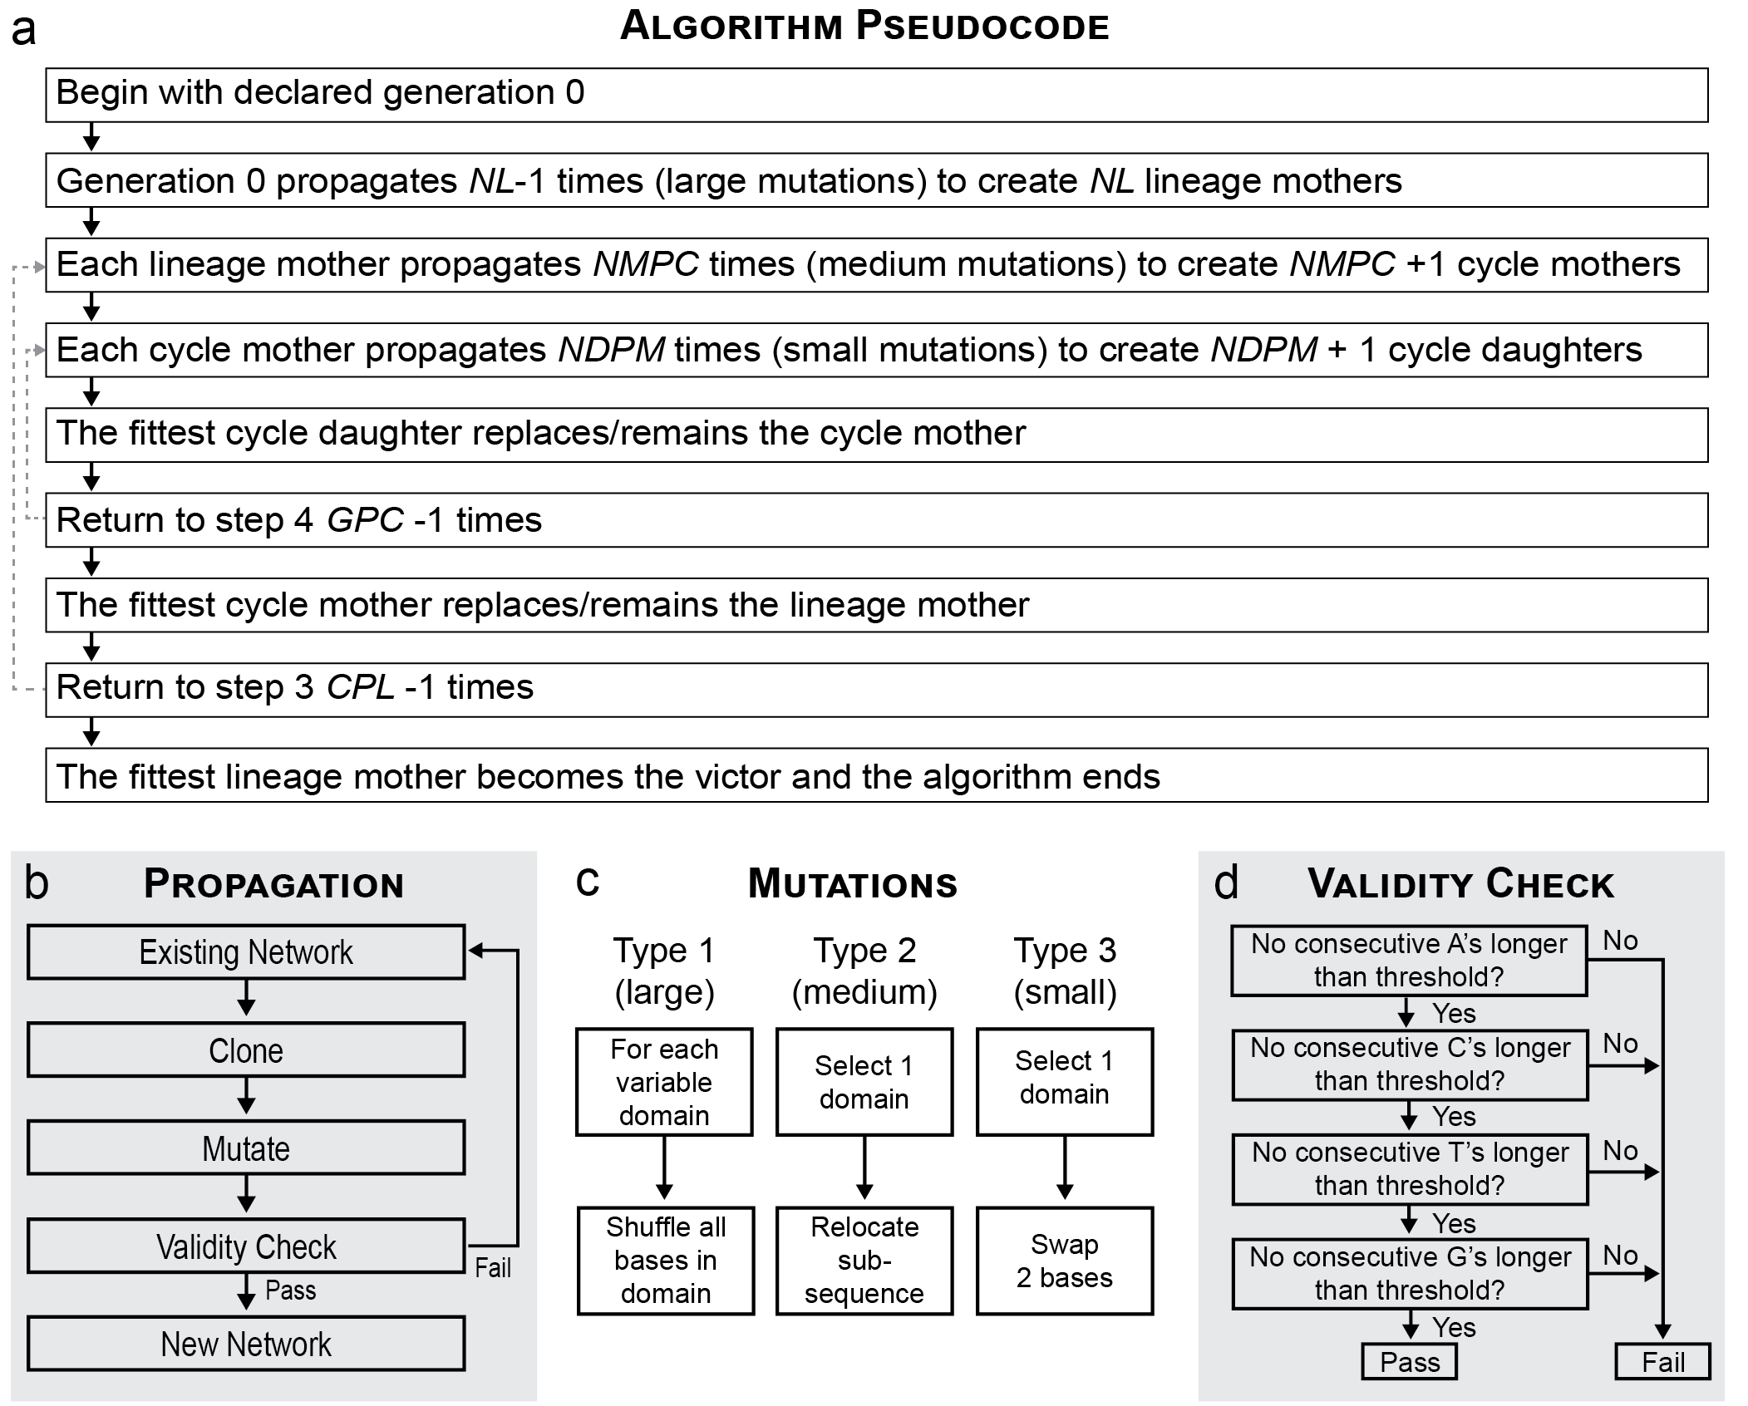
Figure S3-01. Architecture of the sequence generation algorithm. (a) A visual depiction of the process followed by the algorithm. Key parameters, which control the frequency and duration of branching events, are denoted in italics. (b) During algorithm execution, networks propagate via a clone-then-mutate process, which utilizes one of three types of mutation (c) and a validity check (d). The architecture is designed to modularly interface with fitness functions necessary in the fifth, seventh and ninth steps in (a).
Algorithm Tuning and Optimization
It was observed that algorithm efficiency varies substantially depending on the value of key algorithm parameters. Consequently, a search for optimal algorithm parameters was conducted. SeqEvo was challenged to identify a pair of oligomers which form a single 34 base-pair duplex with no unnecessary inter-oligomer duplexes larger than 2 base-pairs (referred to below as the “design problem”). Using a trial-and-error approach, initial algorithm parameters were identified which solved the design problem (Parameter set #0 in Table S3-01). The efficiency of a given set of algorithm parameters was defined to be the inverse of the total number of oligo-sets scored prior to identifying a valid solution to the design problem. Since SeqEvo performance is limited by the time necessary to score each network, this quantity is a reasonable representation of the total computation required by the program.
Global Search. Building on the knowledge that parameter set #0 could reliably solve the design problem after considering ~256,000 networks, the search for efficient parameter sets was narrowed to parameters-sets which considered up to ~2,560,000 oligo-sets. Starting with the minimal parameters of CPL=1, GPC=1, NDPM=1, NL=8, and NMPC=1, parameter-sets representing equal investment of 2,560,000 networks worth of resources into 1, 2, 3, 4 or all 5 parameters were generated (Parameter Sets #1-31 in Table S3-01). The resulting 31 parameter sets are expected to sample parameter space in a course-grained fashion. The efficiency of each parameter set was determined in 81 independent trials. Of the 31 parameter sets, 24 reliably identified a solution to the problem (> 80% success). A statistical summary of the observed efficiencies is reported in Figure S2-02b, where data from the 7 ineffective parameters is omitted (*). For effective parameter sets, median efficiencies were observed to vary more than 2 orders of magnitude. The most efficient parameter set was observed to be #5 (CPL = 80000, GPC = 1, NDPM = 1, NL = 8, NMPC = 1), which has been marked in orange in Figure S3-02. A typical instance of this algorithm considered ~14,000 networks before arriving at a solution, whereas the next most efficient parameter set (#27 in Table S3-01) typically required ~43,000 considerations.
Local Search. The area surrounding parameter set #5 was further explored to confirm a local maximum in efficiency. Parameter set #5 resides on the boundary of parameter space, with a CPL value of 80,000 and all other parameters at their minimal value. Each of the five key parameters was systematically increased while holding all the other parameters fixed. The ranges over which the parameters were varied are specified in Figure S3-02b. The efficiency of these additional 21 algorithms were determined using a similar 81 trials-per-algorithm approach. A statistically significant decrease in efficiency was observed immediately for the NL, NDPM, and GPC parameters. Efficiency appears to be relatively stable for NMPC values up to 32, above which a decrease in efficiency was resolvable. No variation in efficiency was observed for the CPL parameter, which was anticipated since CPL controls algorithm duration, but has minimal effect on the structure of the evolutionary search. These results suggest that the region of high efficiency encompasses parameter sets with the following parameter values; NL of 8, NDPM of 1, GPC of 1, NMPC between (and including) 1 to 32, and no observed limitation on CPL. It is suggested that parameters of NL = 8, NDPM =1, GPC =1, and NMPC = 2 be used as default values, and that CPL be tuned depending on the algorithm runtime/device quality desired.
Table S3-01. 31 parameter sets used for during the “Global” sampling of algorithm efficiencies. Initially, a parameter set capable of solving the design problem was identified in a trial-and-error fashion (parameter-set 0). Based on this result, 31 sets of parameters were identified which span the finite region of parameter space inhabited by parameter sets consuming approximately 10x the resources of parameter set 0 (parameter-sets 1-31).
 | Parameter Values
Parameter-Set | CPL | GPC | NDPM | NL | NMPC
0 | 1000 | 1 | 1 | 64 | 1
1 | 1 | 1 | 1 | 8 | 160000
2 | 1 | 1 | 1 | 512000 | 1
3 | 1 | 1 | 160000 | 8 | 1
4 | 1 | 160000 | 1 | 8 | 1
5 | 80000 | 1 | 1 | 8 | 1
6 | 1 | 1 | 1 | 1131 | 1131
7 | 1 | 1 | 565 | 8 | 565
8 | 1 | 565 | 1 | 8 | 565
9 | 400 | 1 | 1 | 8 | 400
10 | 1 | 1 | 1131 | 1131 | 1
11 | 1 | 1131 | 1 | 1131 | 1
12 | 800 | 1 | 1 | 800 | 1
13 | 1 | 400 | 400 | 8 | 1
14 | 400 | 1 | 400 | 8 | 1
15 | 400 | 400 | 1 | 8 | 1
16 | 1 | 1 | 137 | 137 | 137
17 | 1 | 137 | 1 | 137 | 137
18 | 109 | 1 | 1 | 109 | 109
19 | 1 | 69 | 69 | 8 | 69
20 | 68 | 1 | 68 | 8 | 68
21 | 68 | 68 | 1 | 8 | 68
22 | 1 | 109 | 109 | 109 | 1
23 | 109 | 1 | 109 | 109 | 1
24 | 109 | 109 | 1 | 109 | 1
25 | 55 | 55 | 55 | 8 | 1
26 | 1 | 40 | 40 | 40 | 40
27 | 40 | 1 | 40 | 40 | 40
28 | 40 | 40 | 1 | 40 | 40
29 | 24 | 24 | 24 | 8 | 24
30 | 34 | 34 | 34 | 34 | 1
31 | 19 | 19 | 19 | 19 | 19

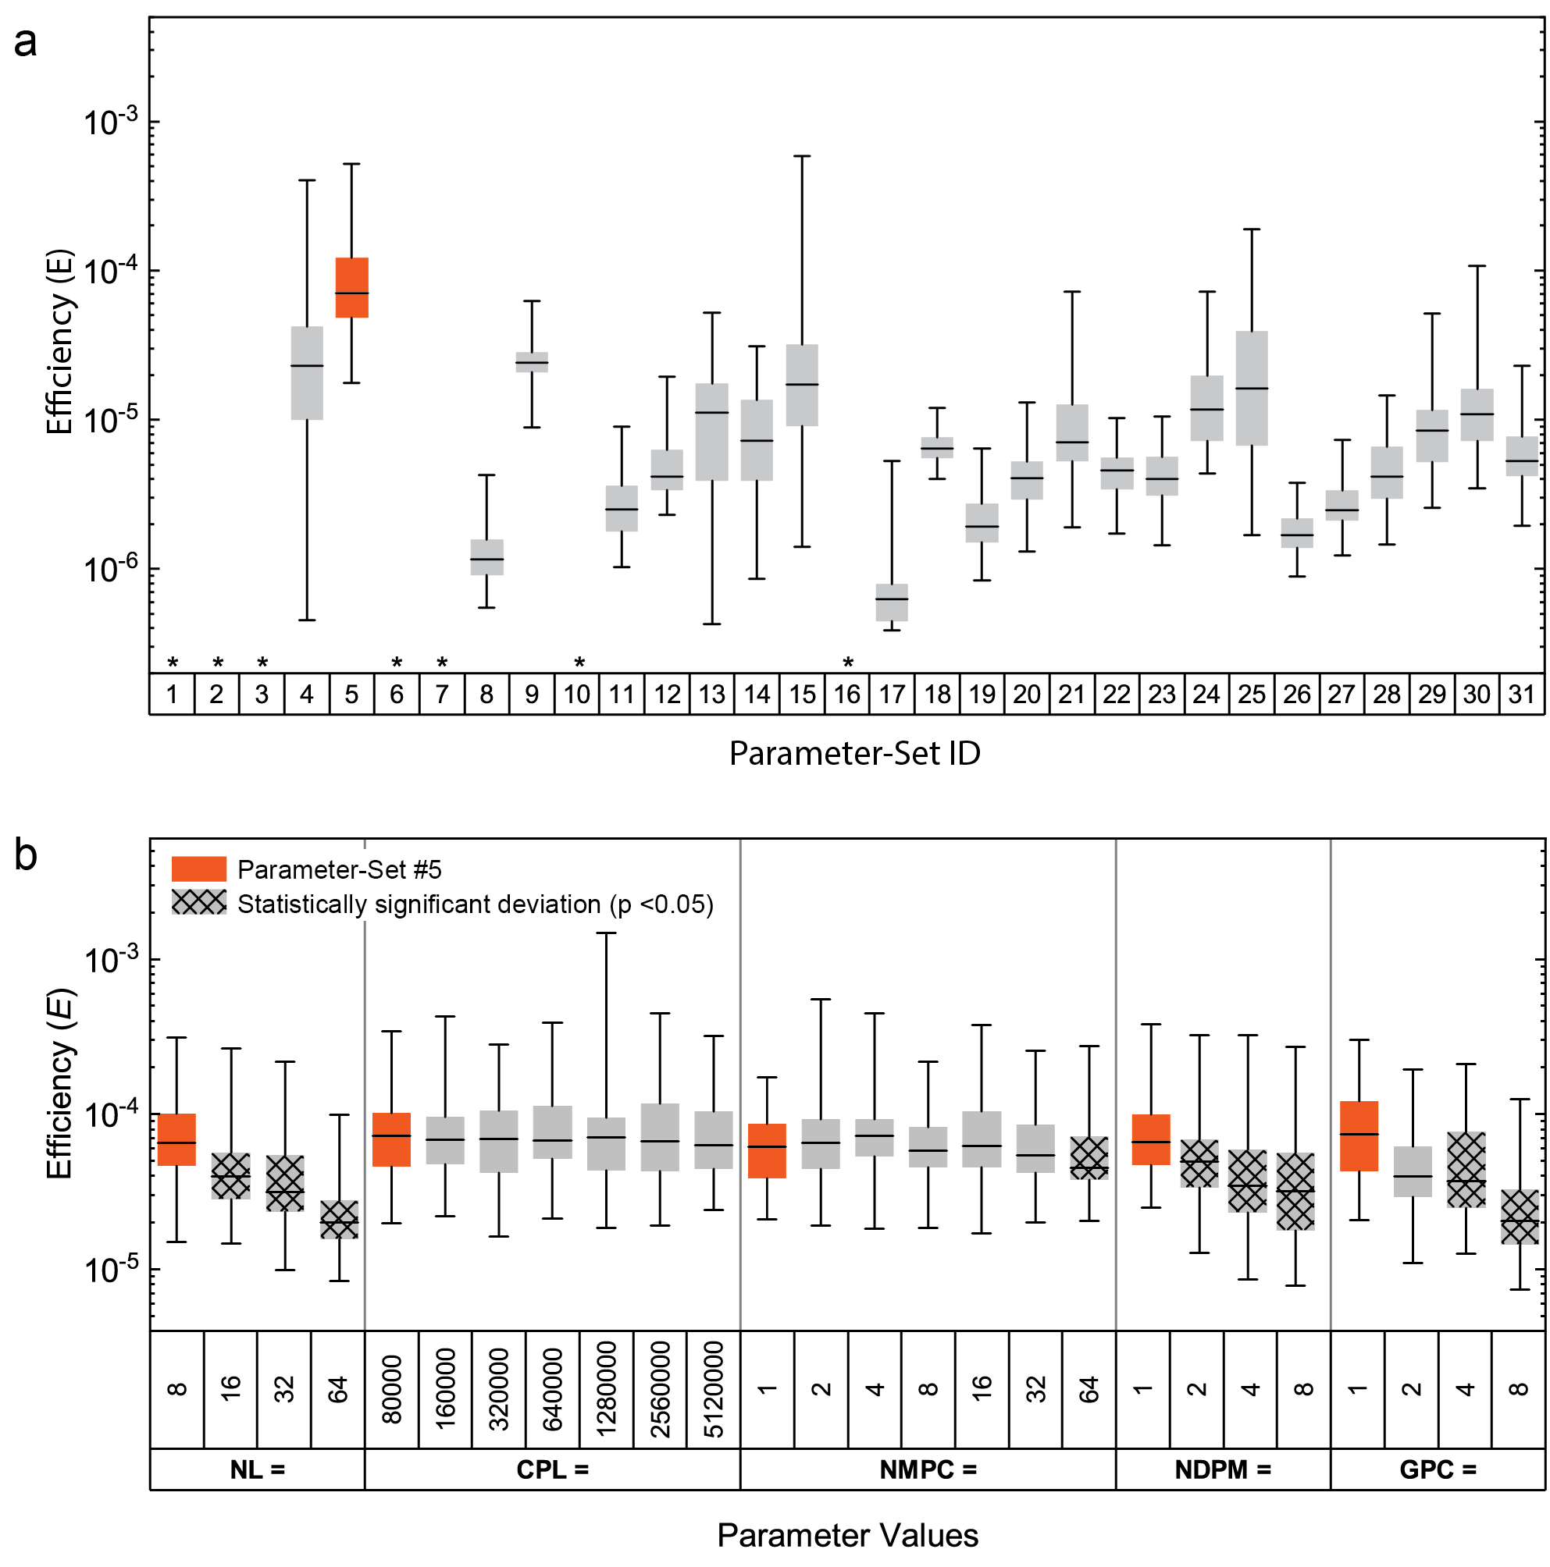
Figure S3-02. Efficiencies of the algorithm with varying parameters. Efficiency is a metric where higher efficiencies are more favorable. (a) Global sampling of efficiencies. Efficiencies of 31 parameter sets sampling a cross section of parameter space were determined using 81 independent design-trials. The efficiencies observed are summarized by a median line, a box spanning the 25th-75th percentiles, and bars connecting the minimum and maximum values. Several parameter sets did not reliably solve the design problem given the finite resources and were termed inefficient, their results have been replaced with an asterisk (*). The region surrounding the most efficient parameter set observed (#5, colored orange) was further studied. (b) Localized sampling of efficiencies proximal to parameter set #5. Starting with the parameter values of set 5, each parameter was individually and systematically increased until a decrease in efficiency could be resolved. Statistical significance was evaluated using a 2-sided Kolmogorov-Smirnov test with p < 0.05.

Section 4: Characterization of New Oligomers

Experimental process
Networks were characterized using the following procedure. HPLC purified oligomers were purchased from Integrated DNA Technologies. S₁ and S₃ were purchased with Cy3 and Cy5 dye modifications at their 5’ ends, respectively. S₂ was purchased with a “Black Hole Quencher 1” modification at its 3’ end. Oligomers were resuspended in 1x TE buffer (pH 8.0) at approximately 100 micromolar (µM) concentration. The concentration of each solution of oligomers was calculated using absorption measurements at 260nm (Thermo Nanodrop One spectrophotometer) and the absorbance coefficients were reported by Integrated DNA Technologies. Diluted working stocks containing approximately 1 µM S₁, 1 µM S₂, or 1 µM of both S₂ & S₃ were created by drawing from the 100 µM samples (the buffer for these samples was 1x TE buffer containing 1 M NaCl). These samples were allowed to incubate for at least 24 hours, and then sample concentration was again calculated using absorbance measurements. For the duplex formation reaction, aliquots from the 1 µM S₁, 1 µM S₂, and 1x TE (1 M NaCl) samples were incubated at the experimental temperature and then combined to create a 4 milliliter (mL) sample of 10 nM S₁, 10 nM S₂ and 1x TE (1M NaCl). For the displacement reaction, samples were incubated at the experimental temperature and then aliquots from the 1 µM S₁, 1 µM S₂ + S₃, and 1x TE (1 M NaCl) samples were combined to create a 4 mL sample of 10 nM S₁, 10 nM S₂, 10 nM S₃, and 1x TE (1M NaCl). A control sample was also created containing 4 mL of 10 nM S₁ in 1x TE (1M NaCl). Following the addition of the last aliquot, the 4 mL samples were mixed using a pipette, and immediately transferred to one of two Cary Eclipse spectrophotometers where fluorescence was monitored. Sample temperature was controlled using a temperature-controlled sample holder and this is also where reactants were incubated to reach experimental temperature. The concentration of unquenched Cy3 dye, which was proportional to the concentration of unreacted S₁, was monitored using excitation and emission wavelengths of 548 nanometers and 574 nanometers, respectively.

Table S4-01. New networks generated for experimental characterization. Strands S₁,S₂, and S₃ in the text are labeled O₁, O₂ and O₃. /5Cy3/ indicates the location of a 5’ Cy3 modification. /3BHQ_1/ indicates the location 3’ black hole quencher. /5Cy5/ indicates the location of a 5’ Cy5 modification.

Name | Base Sequence (5’-3’)
Network W-Fit-1
W-Fit-1_O1 | /5Cy3/TCC AAT CGC CCG TCG TAG GTG TGT CAG TAA TAA AGC AGT TCT CTC CAT G
W-Fit-1_O2 | CAT GGA GAG AAC TGC TTT ATT ACT GAC ACA CCT ACG ACG GGC GAT TGG A/3BHQ_1/
W-Fit-1_O3 | /5Cy5/TCC AAT CGC CCG TCG TAG GTG TGT CAG TAA TAA AGC AGT TC
Network W-Fit-2
W-Fit -2_O1 | /5Cy3/TAG TGT ATC CAA AGC CCG TAA GTC GCA GGT TCG TGT CAA TCT CTC CAT G
W-Fit-2_O2 | CAT GGA GAG ATT GAC ACG AAC CTG CGA CTT ACG GGC TTT GGA TAC ACT A/3BHQ_1/
W-Fit-2_O3 | /5Cy5/TAG TGT ATC CAA AGC CCG TAA GTC GCA GGT TCG TGT CAA TC
Network W-Fit-3
W-Fit-3_O1 | /5Cy3/TCG TAG TGT GTC AGC AAA GTC CAA TAG GTT CGC CCG TAA TCT CTC CAT G
W-Fit-3_O2 | CAT GGA GAG ATT ACG GGC GAA CCT ATT GGA CTT TGC TGA CAC ACT ACG A/3BHQ_1/
W-Fit-3_O3 | /5Cy5/TCG TAG TGT GTC AGC AAA GTC CAA TAG GTT CGC CCG TAA TC
Network N-Fit-1
N-Fit-1_O1 | /5Cy3/TTA TCG TCA CAG TTC GGT TCC AAA GGG CAA TCA GCG TAG TCT CTC CAT G
N-Fit-1_O2 | CAT GGA GAG ACT ACG CTG ATT GCC CTT TGG AAC CGA ACT GTG ACG ATA A/3BHQ_1/
N-Fit-1_O3 | /5Cy5/TTA TCG TCA CAG TTC GGT TCC AAA GGG CAA TCA GCG TAG TC
Network N-Fit-2
N-Fit-2_O1 | /5Cy3/TCG GCG TAA GCA ATA GGT TTC ACA ATC CCA GGT AGT CGT TCT CTC CAT G
N-Fit-2_O2 | CAT GGA GAG AAC GAC TAC CTG GGA TTG TGA AAC CTA TTG CTT ACG CCG A/3BHQ_1/
N-Fit-2_O3 | /5Cy5/TCG GCG TAA GCA ATA GGT TTC ACA ATC CCA GGT AGT CGT TC
Network N-Fit-3
N-Fit-3_O1 | /5Cy3/TGT AAA TCC CGT GCT AAA GTA TCG TCG CCA AGG TTC AGG TCT CTC CAT G
N-Fit-3_O2 | CAT GGA GAG ACC TGA ACC TTG GCG ACG ATA CTT TAG CAC GGG ATT TAC A/3BHQ_1/
N-Fit-3_O3 | /5Cy5/TGT AAA TCC CGT GCT AAA GTA TCG TCG CCA AGG TTC AGG TC
Network O-Fit-1
O-Fit-1_O1 | /5Cy3/TAA AAG TGT GTA AAA AAG TCC CGT GTC CGT GTG TCC GTC CCT CTC CAT G
O-Fit -1_O2 | CAT GGA GAG GGA CGG ACA CAC GGA CAC GGG ACT TTT TTA CAC ACT TTT A/3BHQ_1/
O-Fit -1_O3 | /5Cy5/TAA AAG TGT GTA AAA AAG TCC CGT GTC CGT GTG TCC GTC CC
Network O-Fit-2
O-Fit -2_O1 | /5Cy3/TCG TGT GTG TGT CCC GTA AAA GTA AAA AAG TCC CGT GTC CCT CTC CAT G
O-Fit -2_O2 | CAT GGA GAG GGA CAC GGG ACT TTT TTA CTT TTA CGG GAC ACA CAC ACG A/3BHQ_1/
O-Fit -2_O3 | /5Cy5/TCG TGT GTG TGT CCC GTA AAA GTA AAA AAG TCC CGT GTC CC
Network O-Fit-3
O-Fit -3_O1 | /5Cy3/TGT GTA AAA GTG TCC CGT GTC GTA AAA AAG TCC CGT GTC CCT CTC CAT G
O-Fit -3_O2 | CAT GGA GAG GGA CAC GGG ACT TTT TTA CGA CAC GGG ACA CTT TTA CAC A/3BHQ_1/
O-Fit -3_O3 | /5Cy5/TGT GTA AAA GTG TCC CGT GTC GTA AAA AAG TCC CGT GTC CC
Network RND-1
RND-1_O1 | /5Cy3/GTG TCA ACA CCT CGC TAG AGA TGG TGC GCT AAA TTA CGC TTC TCC ATG
RND-1_O2 | CAT GGA GAA GCG TAA TTT AGC GCA CCA TCT CTA GCG AGG TGT TGA CAC /3BHQ_1/
RND-1_O3 | /5Cy5/GTG TCA ACA CCT CGC TAG AGA TGG TGC GCT AAA TTA CGC T
Network RND-2
RND-2_O1 | /5Cy3/GAT TAG TCA TTA AGG GAT CGA CAC CAC GGG CTT CTT CCG ATC TCC ATG
RND-2_O2 | CAT GGA GAT CGG AAG AAG CCC GTG GTG TCG ATC CCT TAA TGA CTA ATC /3BHQ_1/
RND-2_O3 | /5Cy5/GAT TAG TCA TTA AGG GAT CGA CAC CAC GGG CTT CTT CCG A
Network RND-3
RND-3_O1 | /5Cy3/TCC TAT GTA CAG TCG TAC GGA CTA TTG CGG AAC CCT GAG ATC TCC ATG
RND-3_O2 | CAT GGA GAT CTC AGG GTT CCG CAA TAG TCC GTA CGA CTG TAC ATA GGA /3BHQ_1/
RND-3_O3 | /5Cy5/TCC TAT GTA CAG TCG TAC GGA CTA TTG CGG AAC CCT GAG A

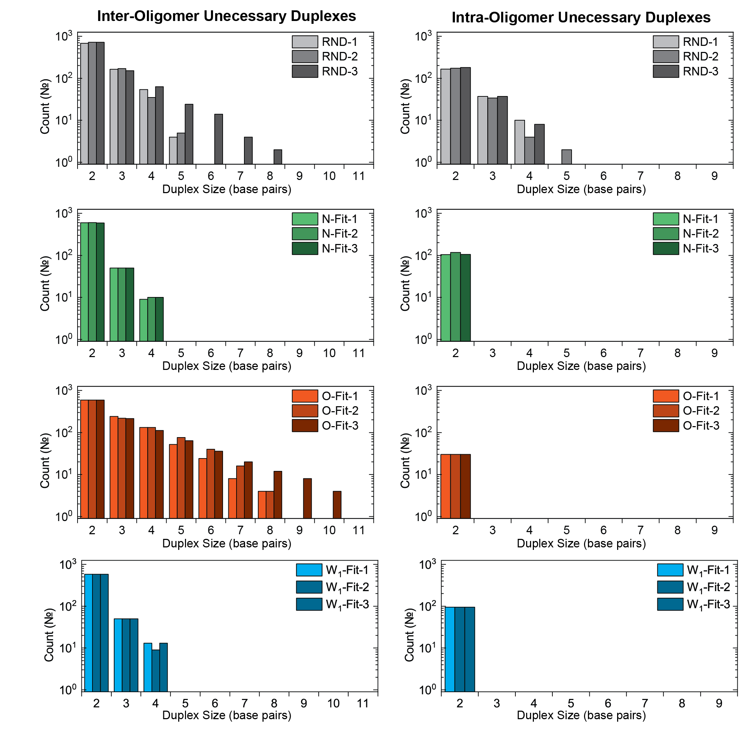

Figure S4-01. Profile of the unnecessary duplexes for each of the generated networks.

Fluorescence Data and Fits
All oligomers were ordered HPLC purified from Integrated DNA Technologies (www.idtdna.com). Strands S₁,S₂, and S₃ are labeled O₁, O₂ and O₃, respectively. Working stocks of reactants O₁, O₂, and O₃ were diluted to approximately 1 micromolar concentrations in 1x TE buffer. The concentration of these working stocks were calculated using absorbance at 260 nm (measured using a Thermo Nanodrop One) and the extinction coefficient reported by IDT. A working stock of the S₂ complex was prepared by combining stoichiometric amounts of O₂ and O₃ in 1x TE (1M NaCl added) and allowing to react for at least 24 hours. For fluorescent measurement, reactants were combined at 10 nanomolar concentrations in 1x TE containing 1M NaCl. Each sample was approximately 1 mL of buffer/strand solution in a 1cm x 1cm x 4cm disposable cuvette. Cuvettes were pre-treated with blocking buffer to prevent DNA adhesion to container walls.
Each report below consists of the following:
- Top Left: A plot of the recorded fluorescence for each sample. Samples began with oligomer “O₁” slightly above 10nM concentration. Sample fluorescence was monitored as the sample came to the same temperature as the sample holder. This was referred to as the first stage of the experiment – Stage A. Samples were then removed from the machine, during which the fluorescence dropped to approximately zero. While samples were removed, either the second reactant or an equivalent amount of buffer were added and the sample was mixed using a pipette. Following injection and mixing, reactant concentrations were 10nM. This was referred to as the second stage of the reaction – Stage B. During this stage a decrease in fluorescence is observed as the fluorescent dye localizes with the quenching molecule. This is expected to occur for both strand hybridization and strand displacement reactions, but not the control sample. The stability of the control sample provided confidence that the spectrophotometer and temperature controller is working as expected.
- Top Middle: Fluorescence vs time of the first stage of the experiment (Stage A). Fluorescence change during this stage is due to a change sample temperature while it equilibrates with the sample holder.
- Top right: Fluorescence vs time for the second stage of the reaction (Stage B). Fluorescence change during this stage is a result of the target reaction.
- Bottom Left: Plot of inverse strand concentration versus time for the second stage of the reaction. Linear fits were applied to the first 5s, 10s, 20s, 50s, 100s, 200s, and 500s of data (colored lines).
- Bottom Middle: R² for the seven linear fits. The slope of the fit with the largest R² was taken to be the measured rate.
- Bottom Right: Comparison of the best fit model (line) to the experimental data (points).
Experiment numbers were assigned based on the following assignments:

Network | Temperature (°C) | Experiment No.
RND-1 | 10 | 1
RND-1 | 20 | 2
RND-1 | 30 | 3
RND-1 | 40 | 4
RND-1 | 50 | 5
RND-1 | 60 | 6
RND-2 | 10 | 7
RND-2 | 20 | 8
RND-2 | 30 | 9
RND-2 | 40 | 10
RND-2 | 50 | 11
RND-2 | 60 | 12
RND-3 | 10 | 13
RND-3 | 20 | 14
RND-3 | 30 | 15
RND-3 | 40 | 16
RND-3 | 50 | 17
RND-3 | 60 | 18
W₁-Fit-1 | 10 | 19
W₁-Fit-1 | 20 | 20
W₁-Fit-1 | 30 | 21
W₁-Fit-1 | 40 | 22
W₁-Fit-1 | 50 | 23
W₁-Fit-1 | 60 | 24
W₁-Fit-2 | 10 | 25
W₁-Fit-2 | 20 | 26
W₁-Fit-2 | 30 | 27
W₁-Fit-2 | 40 | 28
W₁-Fit-2 | 50 | 29
W₁-Fit-2 | 60 | 30
W₁-Fit-3 | 10 | 31
W₁-Fit-3 | 20 | 32  33  34  35  36  37
W₁-Fit-3 | 30 | 38
W₁-Fit-3 | 40 | 39  40  41  42  43  44
W₁-Fit-3 | 50 | 45
W₁-Fit-3 | 60 | 46
O-Fit-1 | 10 | 47
O-Fit-1 | 20 | 48
O-Fit-1 | 30 | 19
O-Fit-1 | 40 | 50
O-Fit-1 | 50 | 51
O-Fit-1 | 60 | 52
O-Fit-2 | 10 | 53
O-Fit-2 | 20 | 54
O-Fit-2 | 30 | 55
O-Fit-2 | 40 | 56
O-Fit-2 | 50 | 57
O-Fit-2 | 60 | 58
O-Fit-3 | 10 | 59
O-Fit-3 | 20 | 60
O-Fit-3 | 30 | 61
O-Fit-3 | 40 | 62
O-Fit-3 | 50 | 63
O-Fit-3 | 60 | 64
N-Fit-1 | 10 | 65
N-Fit-1 | 20 | 66
N-Fit-1 | 30 | 67
N-Fit-1 | 40 | 68
N-Fit-1 | 50 | 69
N-Fit-1 | 60 | 70
N-Fit-2 | 10 | 71
N-Fit-2 | 20 | 72
N-Fit-2 | 30 | 73
N-Fit-2 | 40 | 74
N-Fit-2 | 50 | 75
N-Fit-2 | 60 | 76
N-Fit-3 | 10 | 77
N-Fit-3 | 20 | 78
N-Fit-3 | 30 | 79
N-Fit-3 | 40 | 80
N-Fit-3 | 50 | 81
N-Fit-3 | 60 | 82

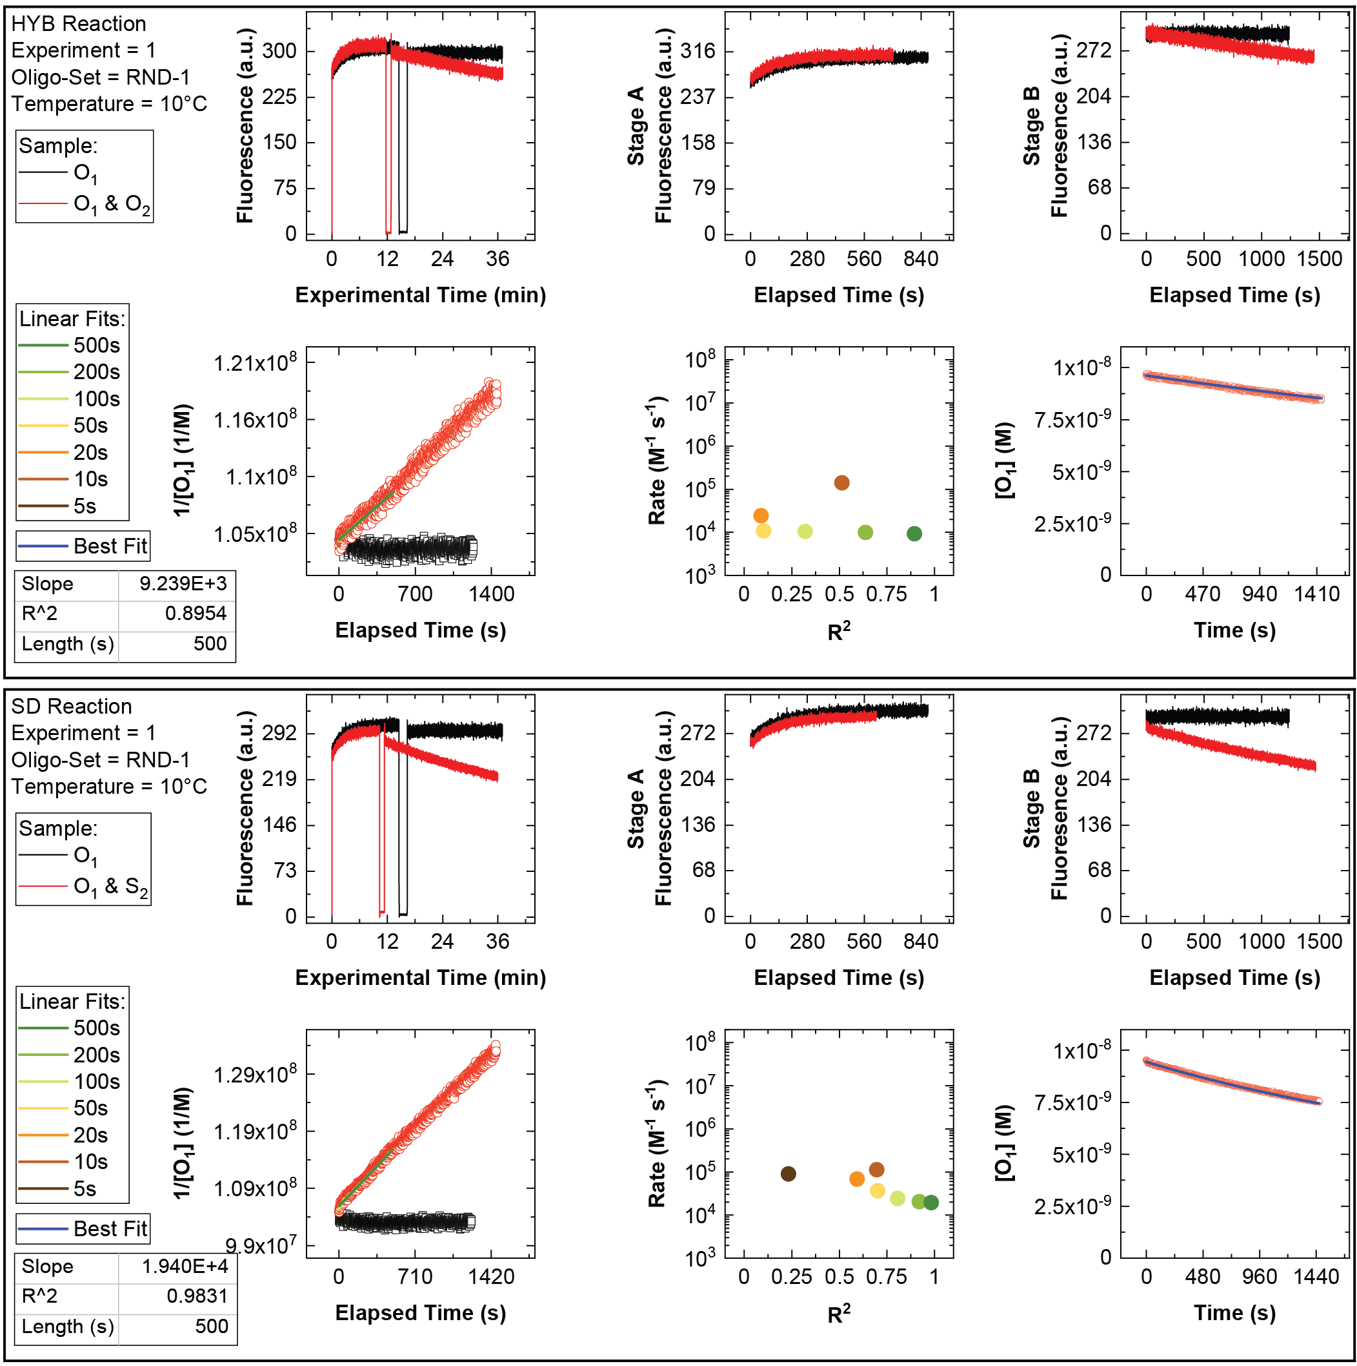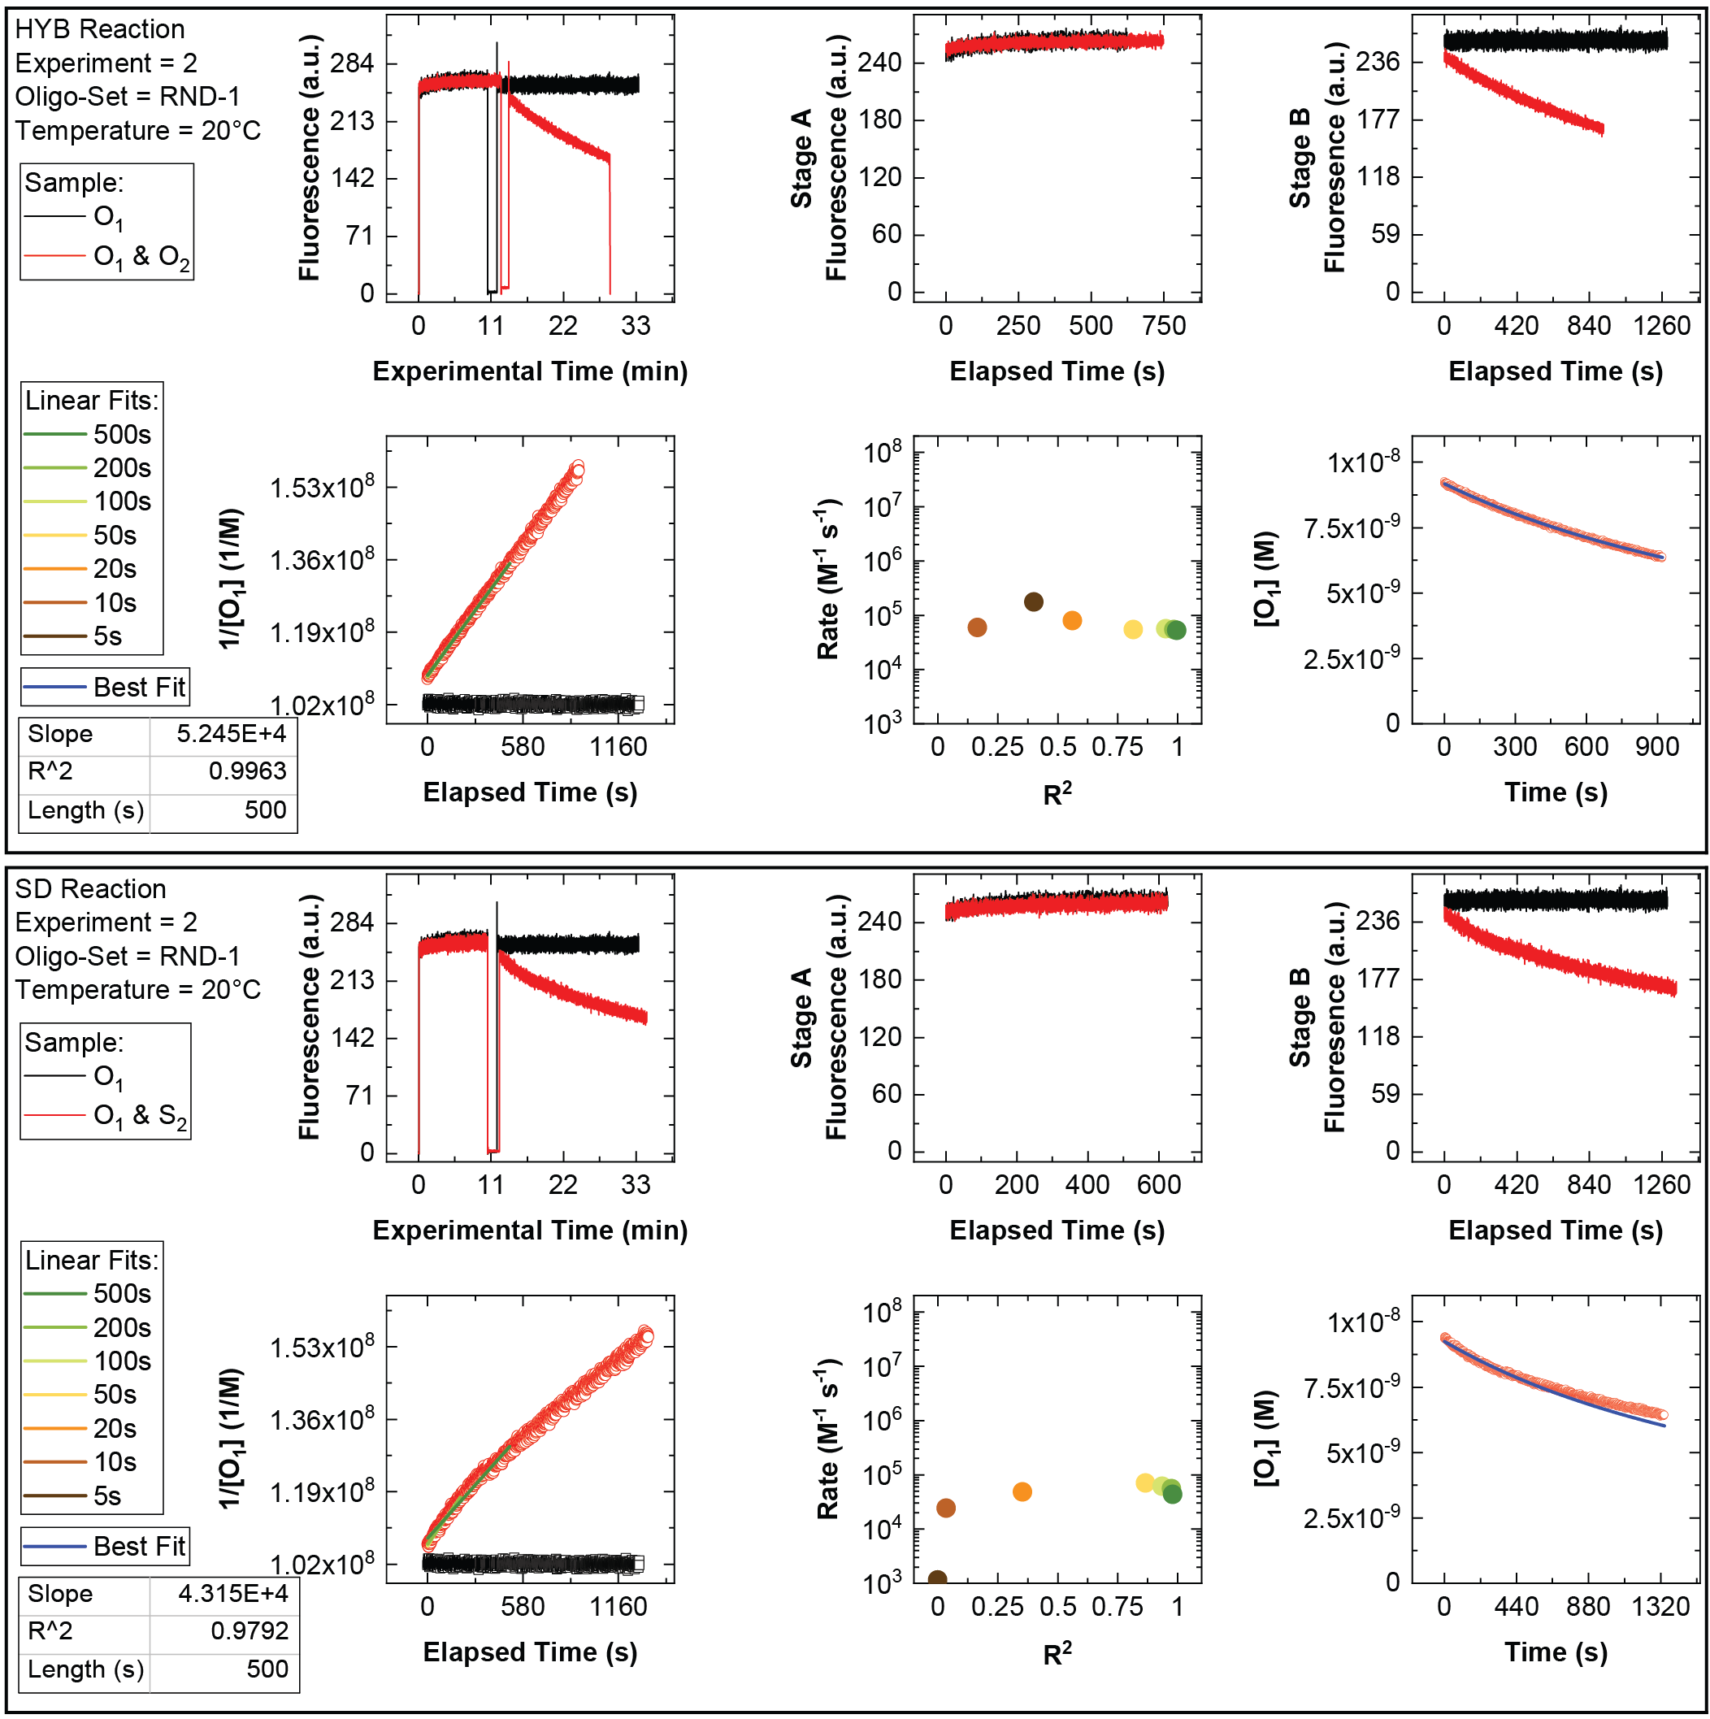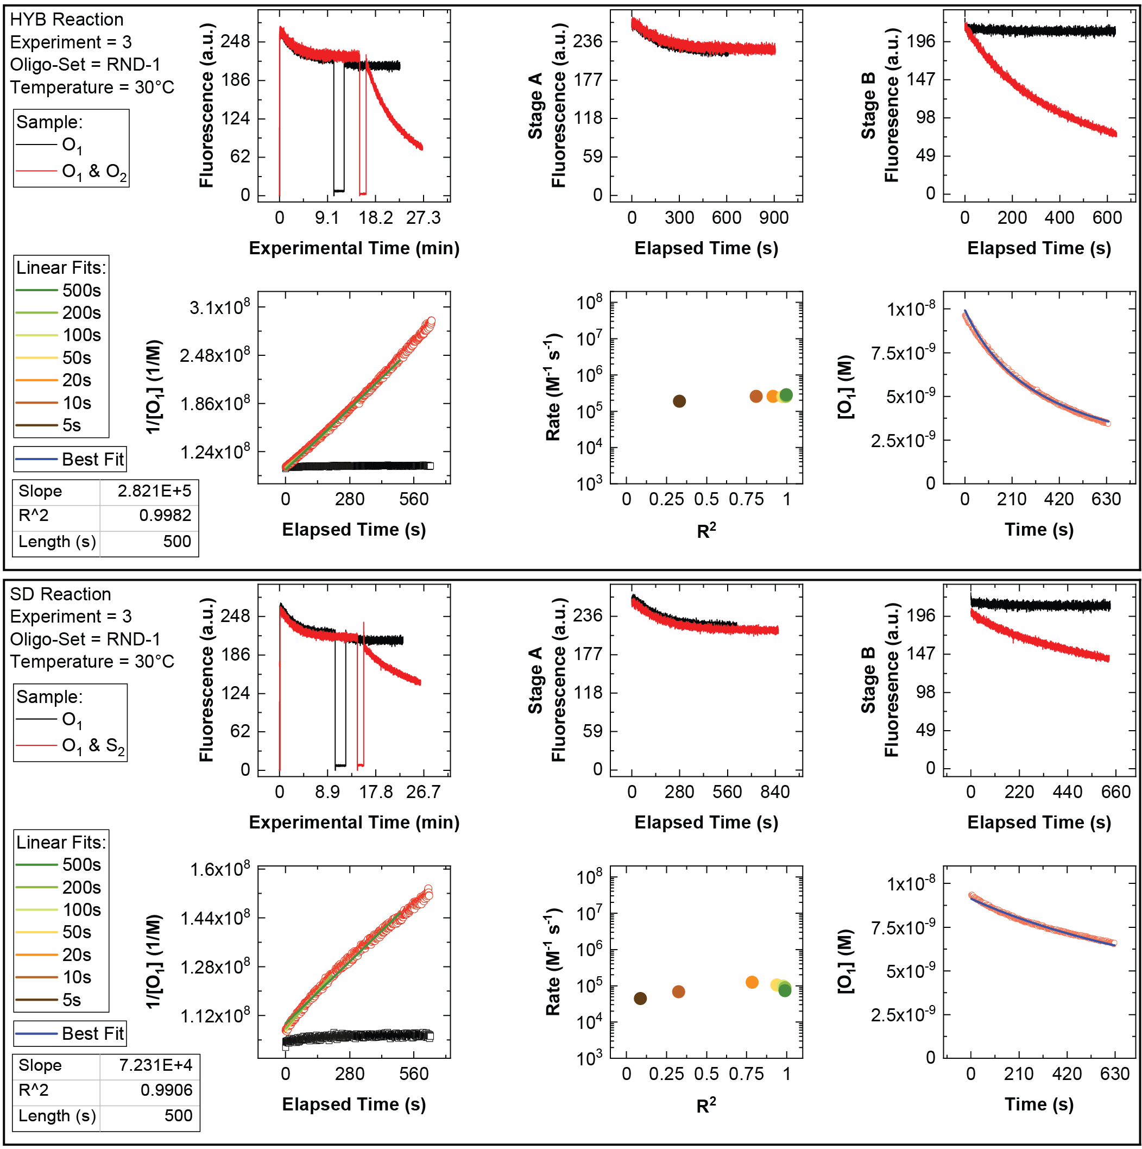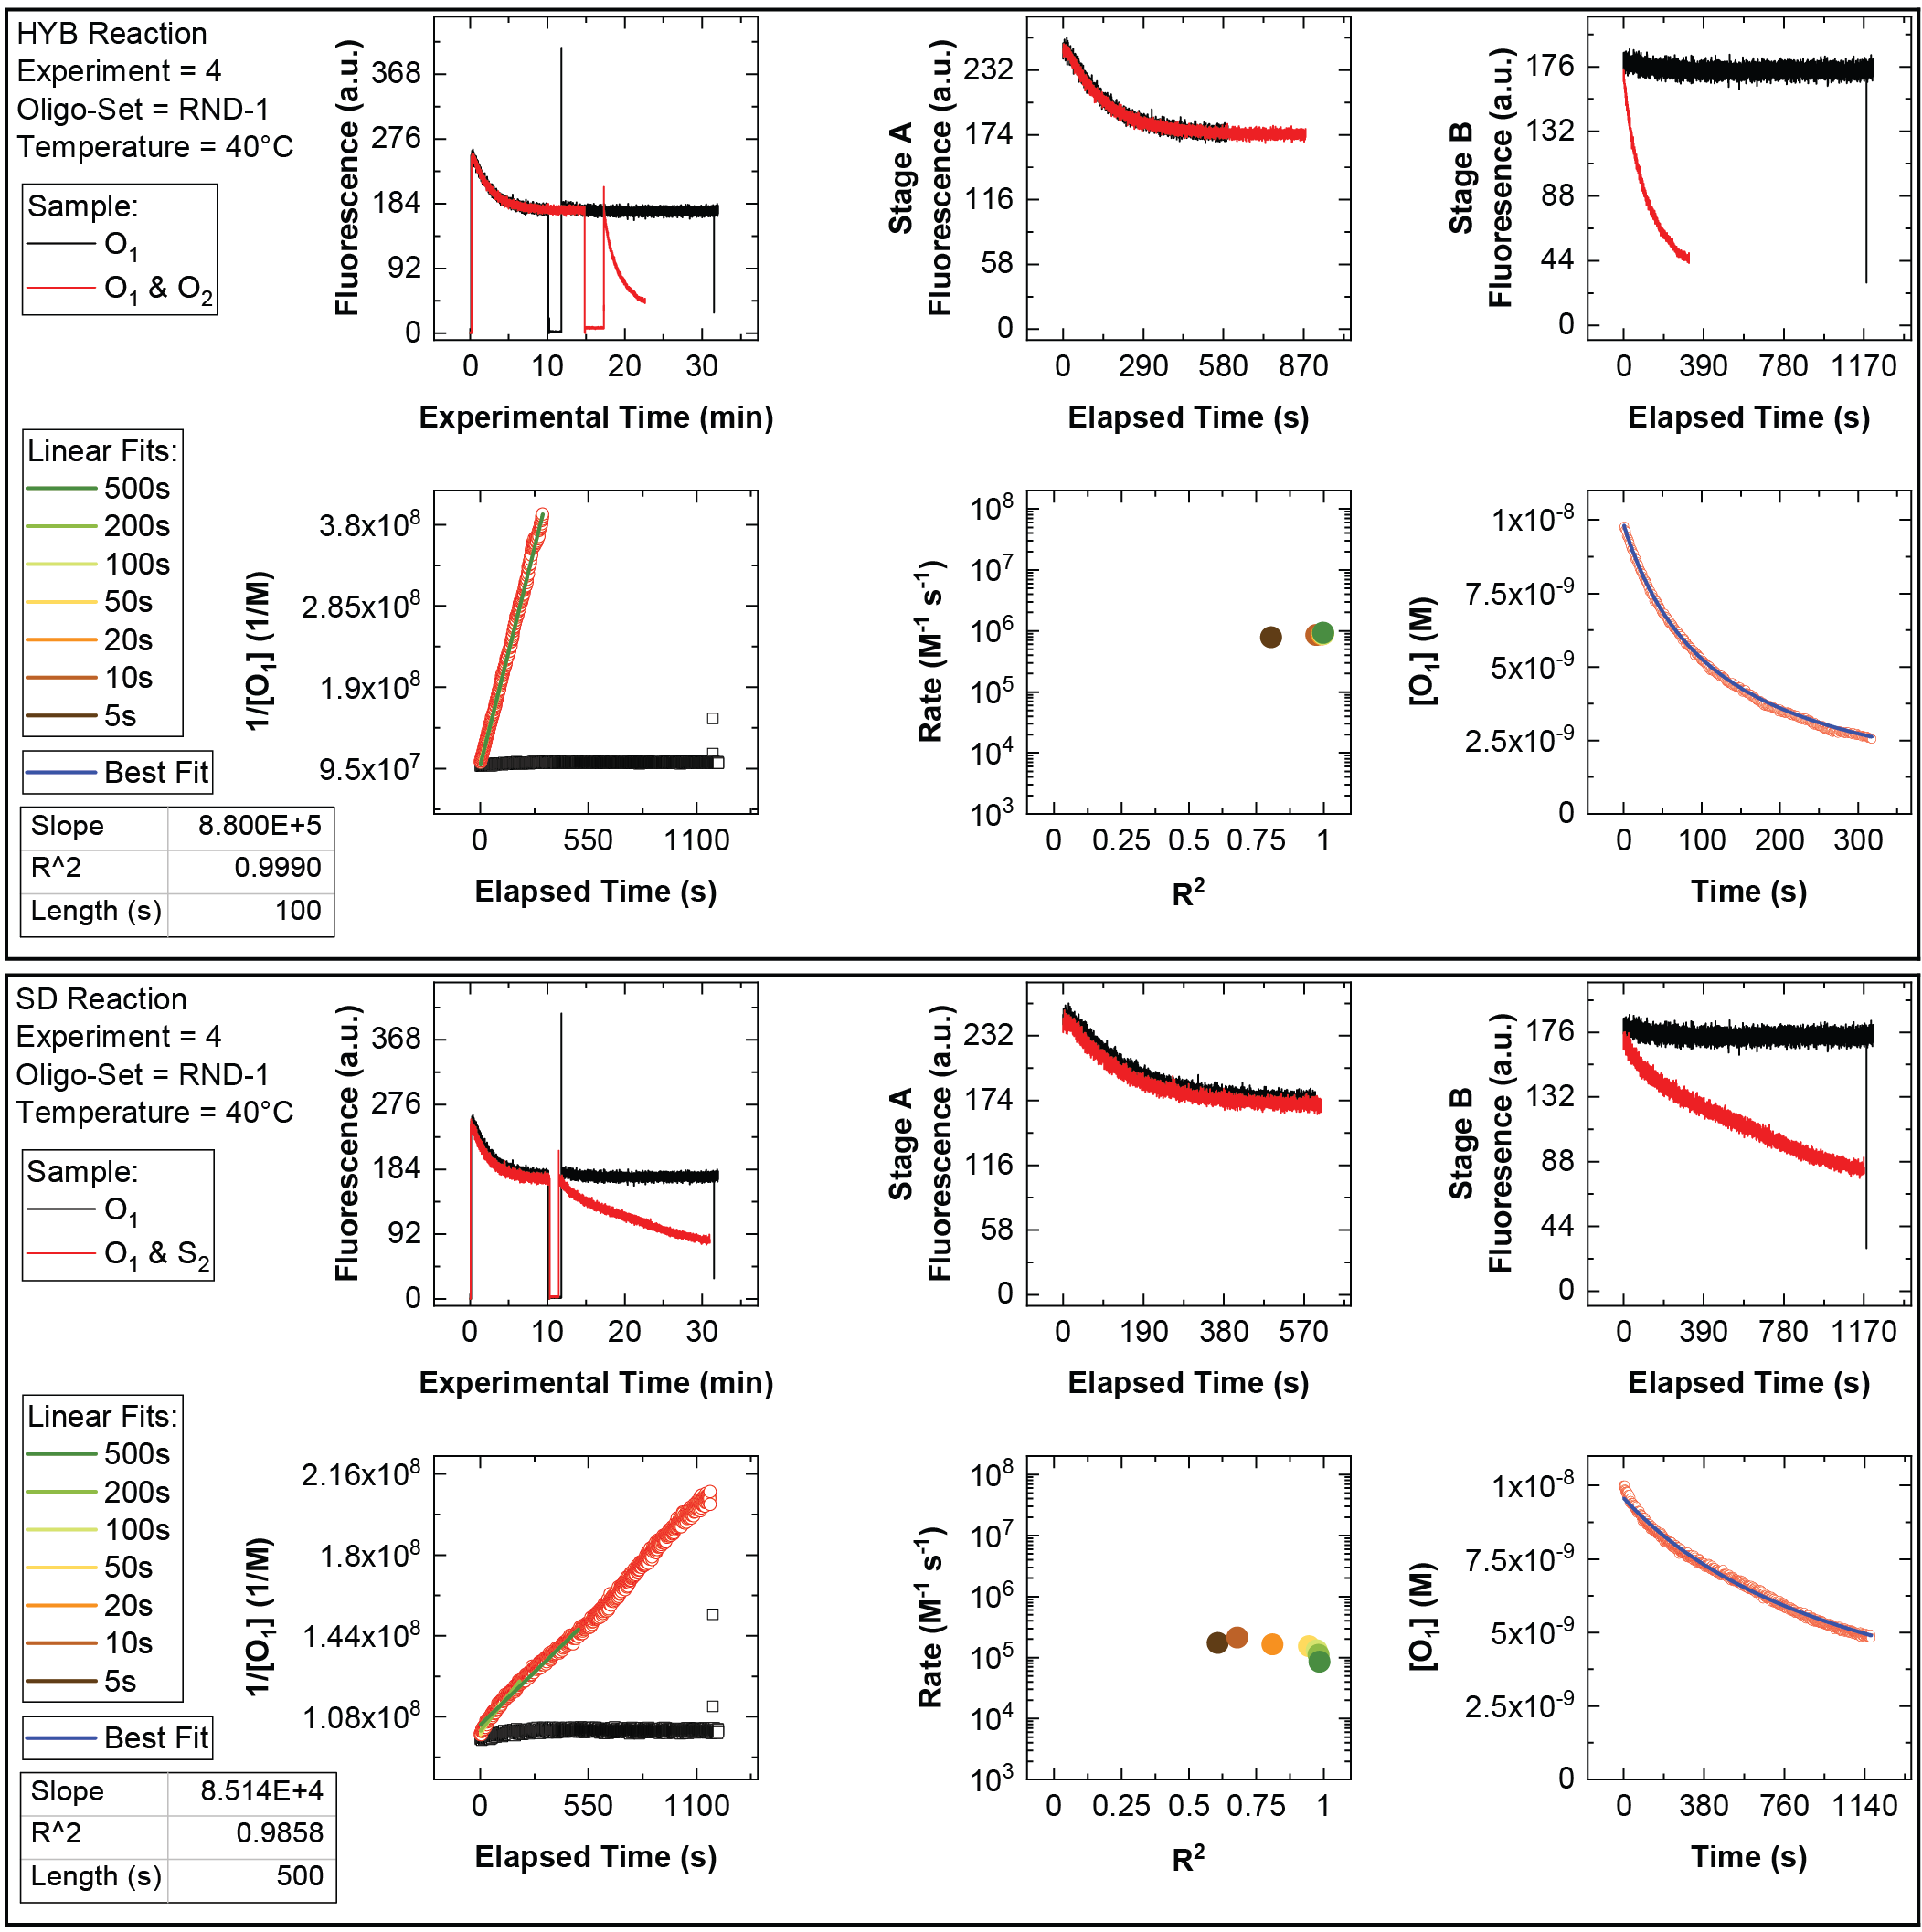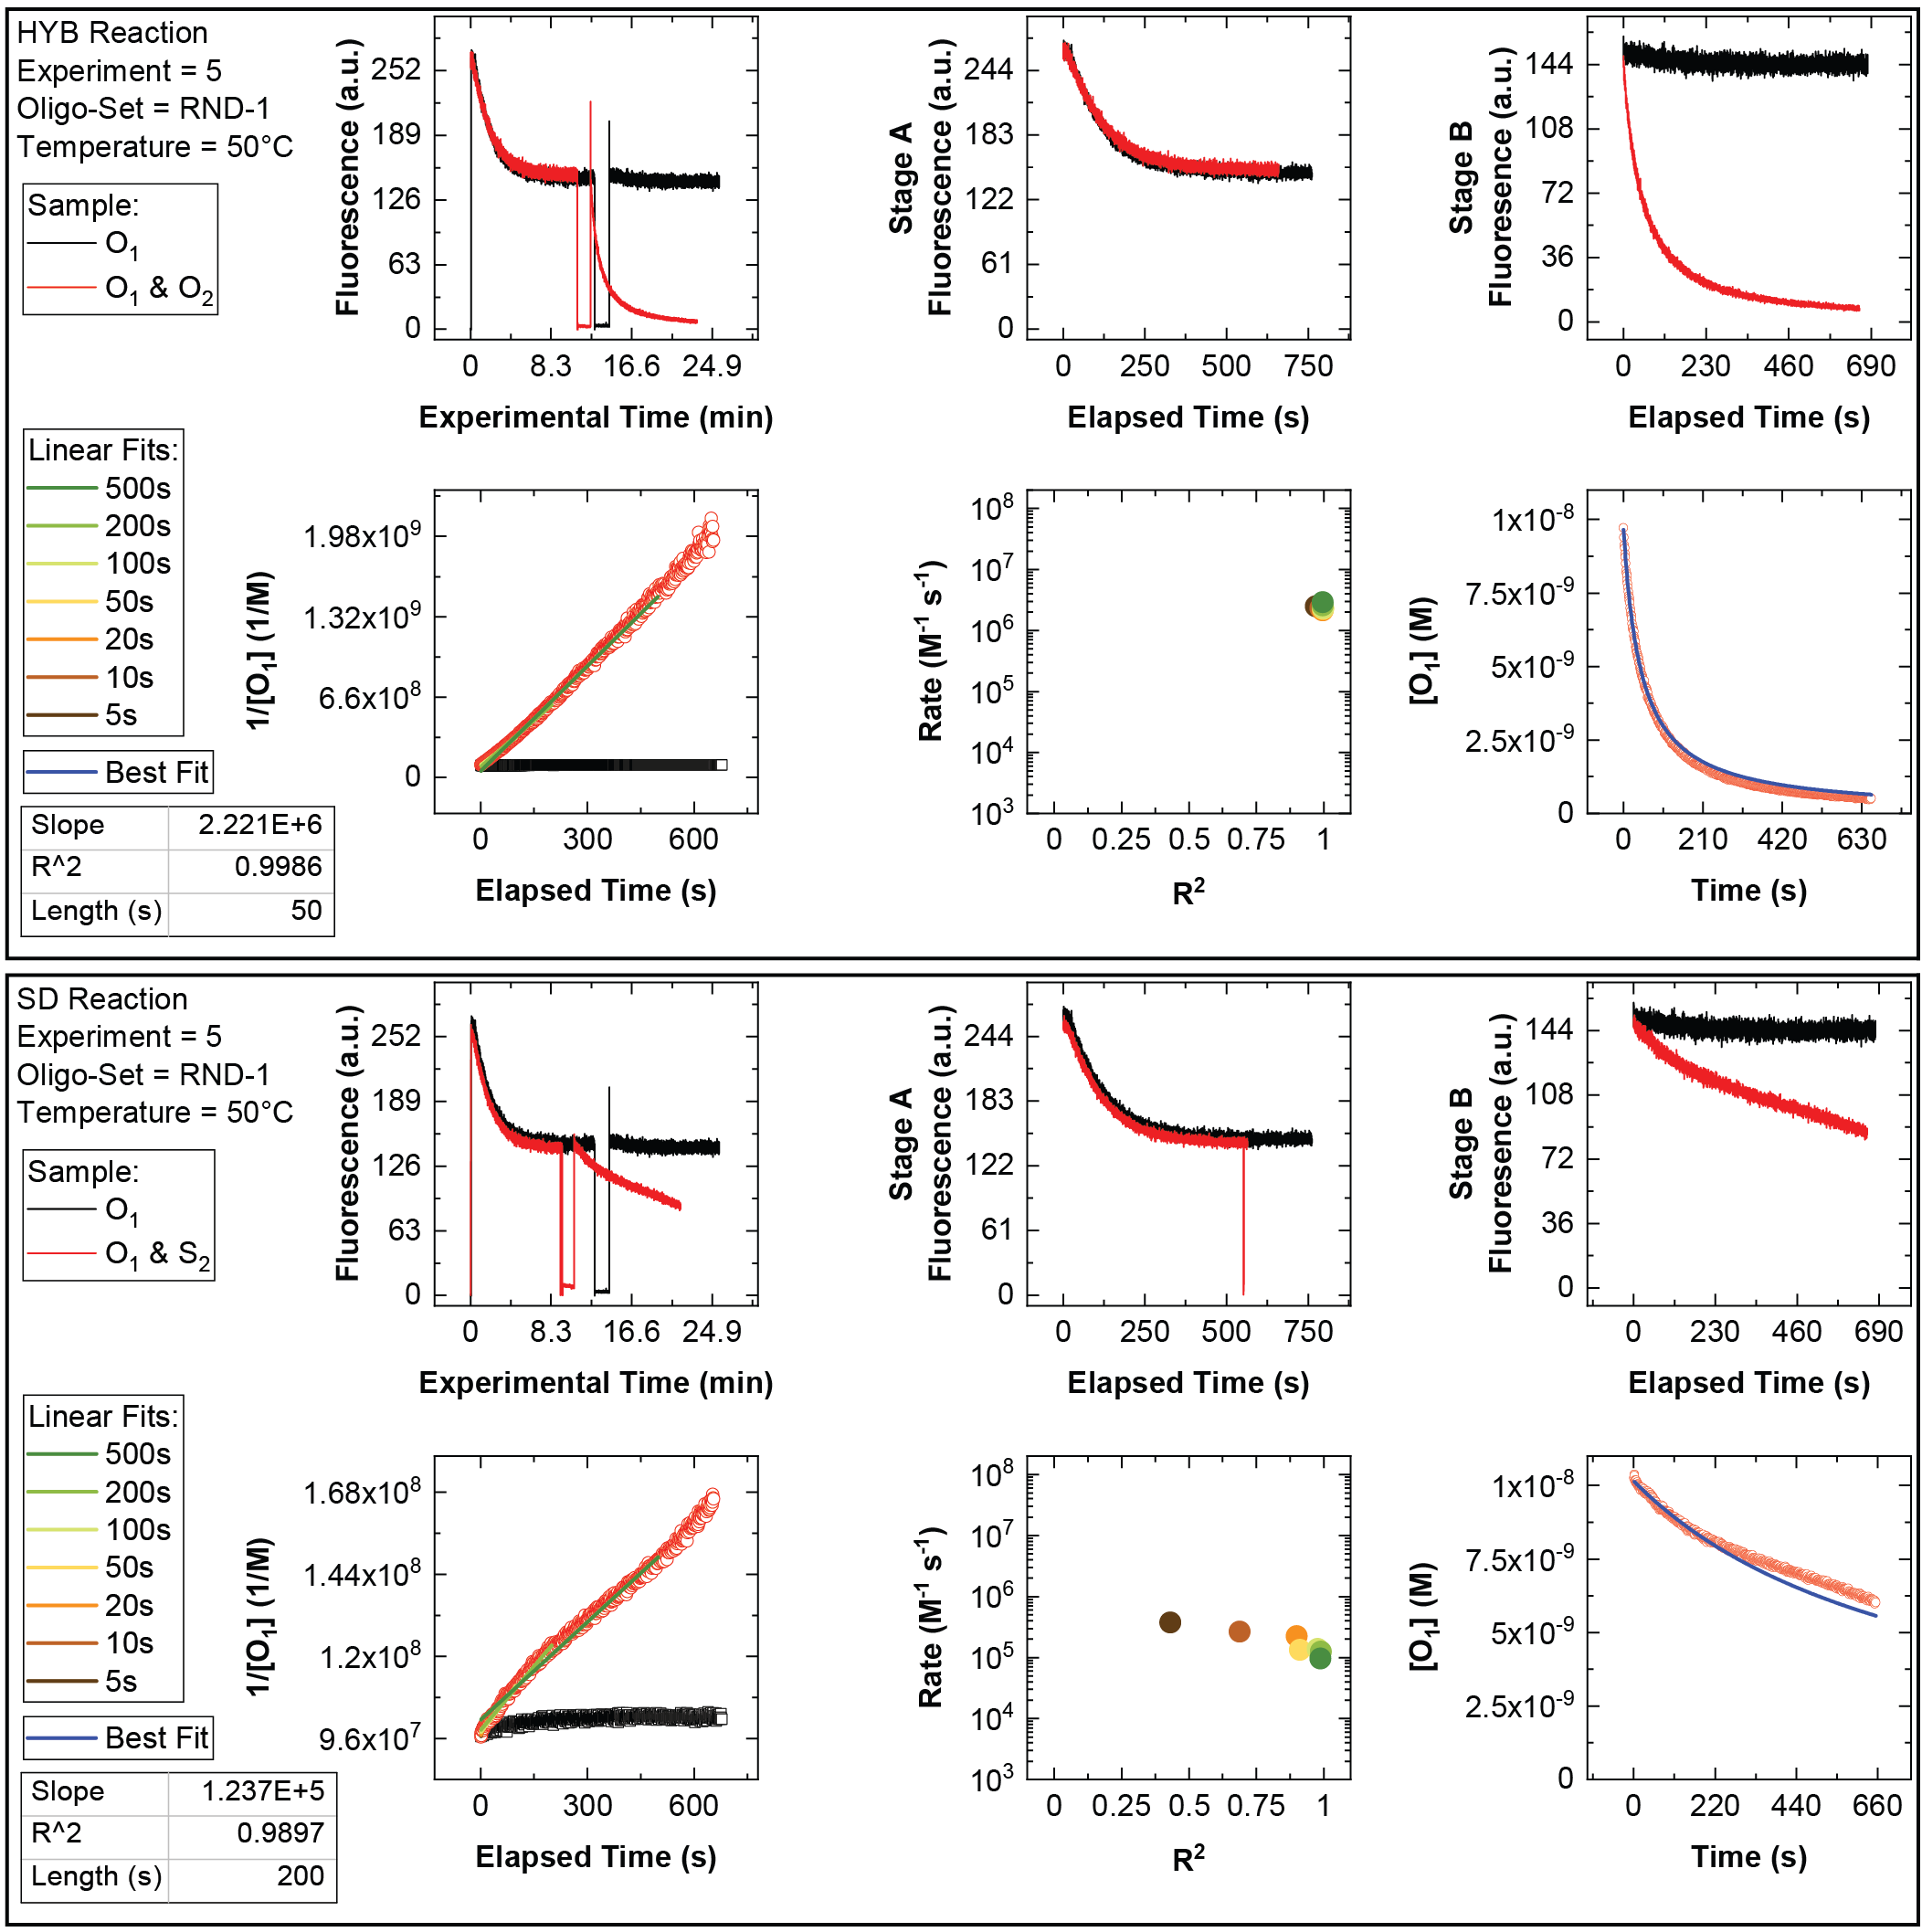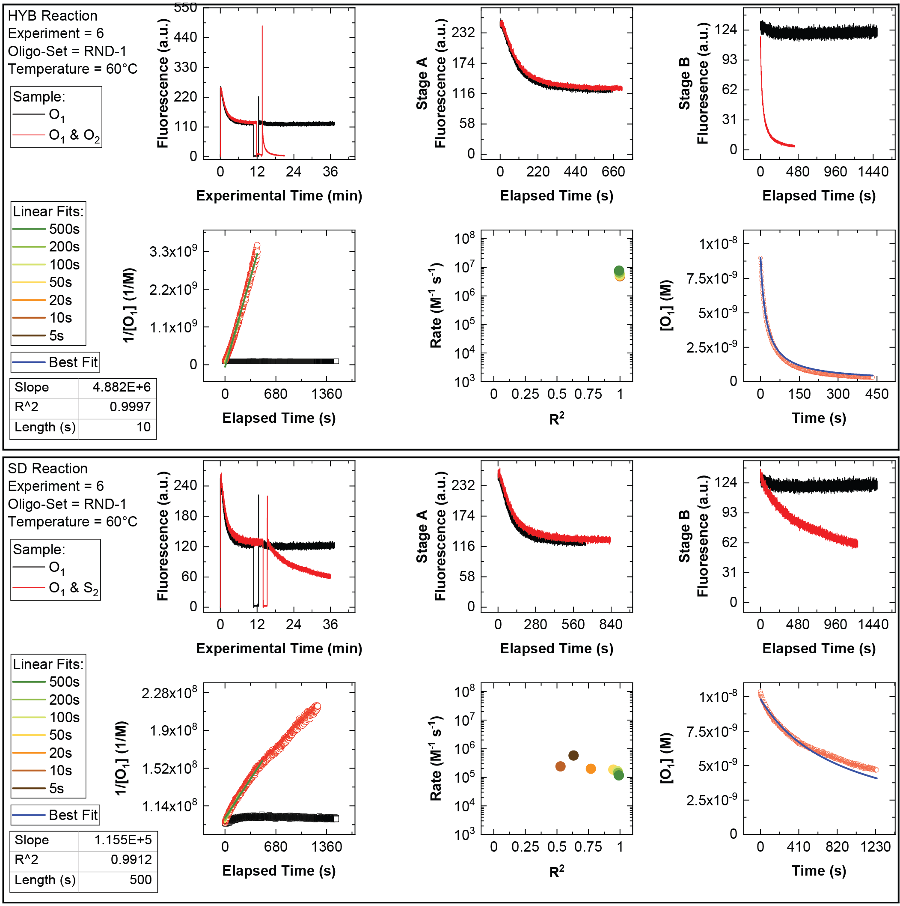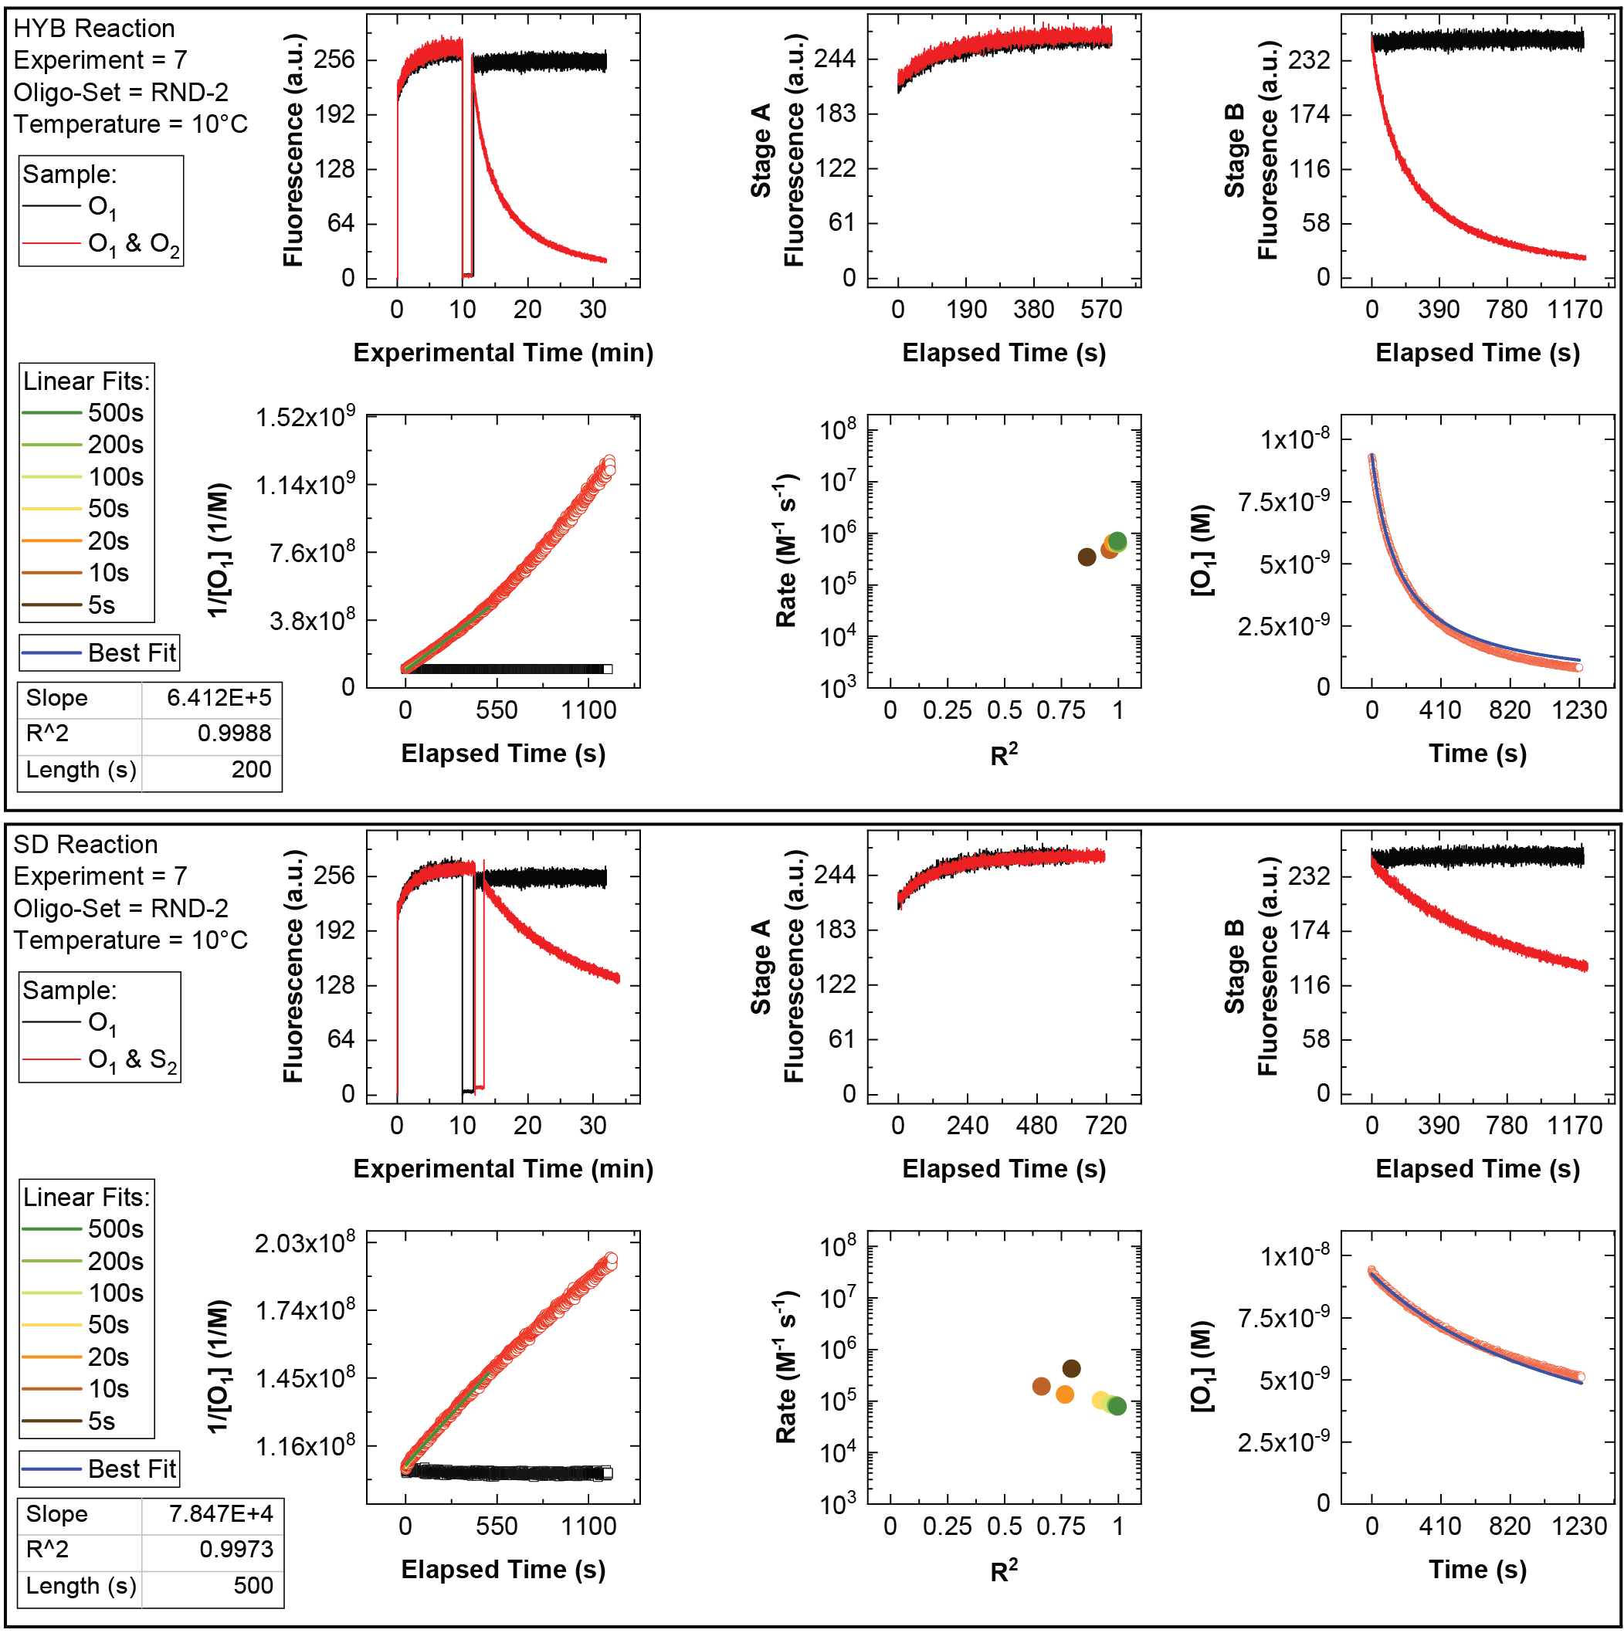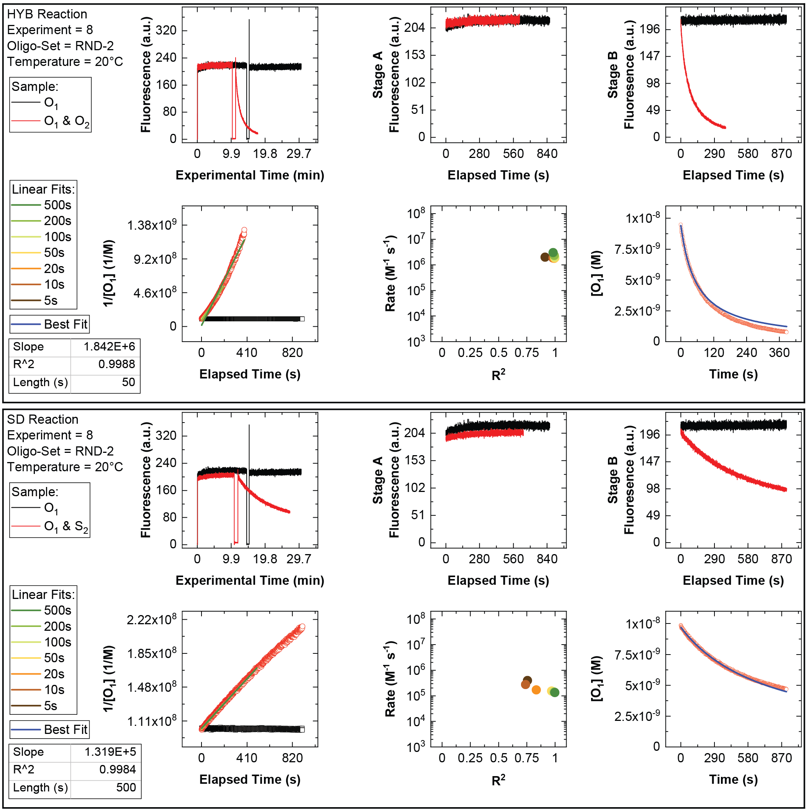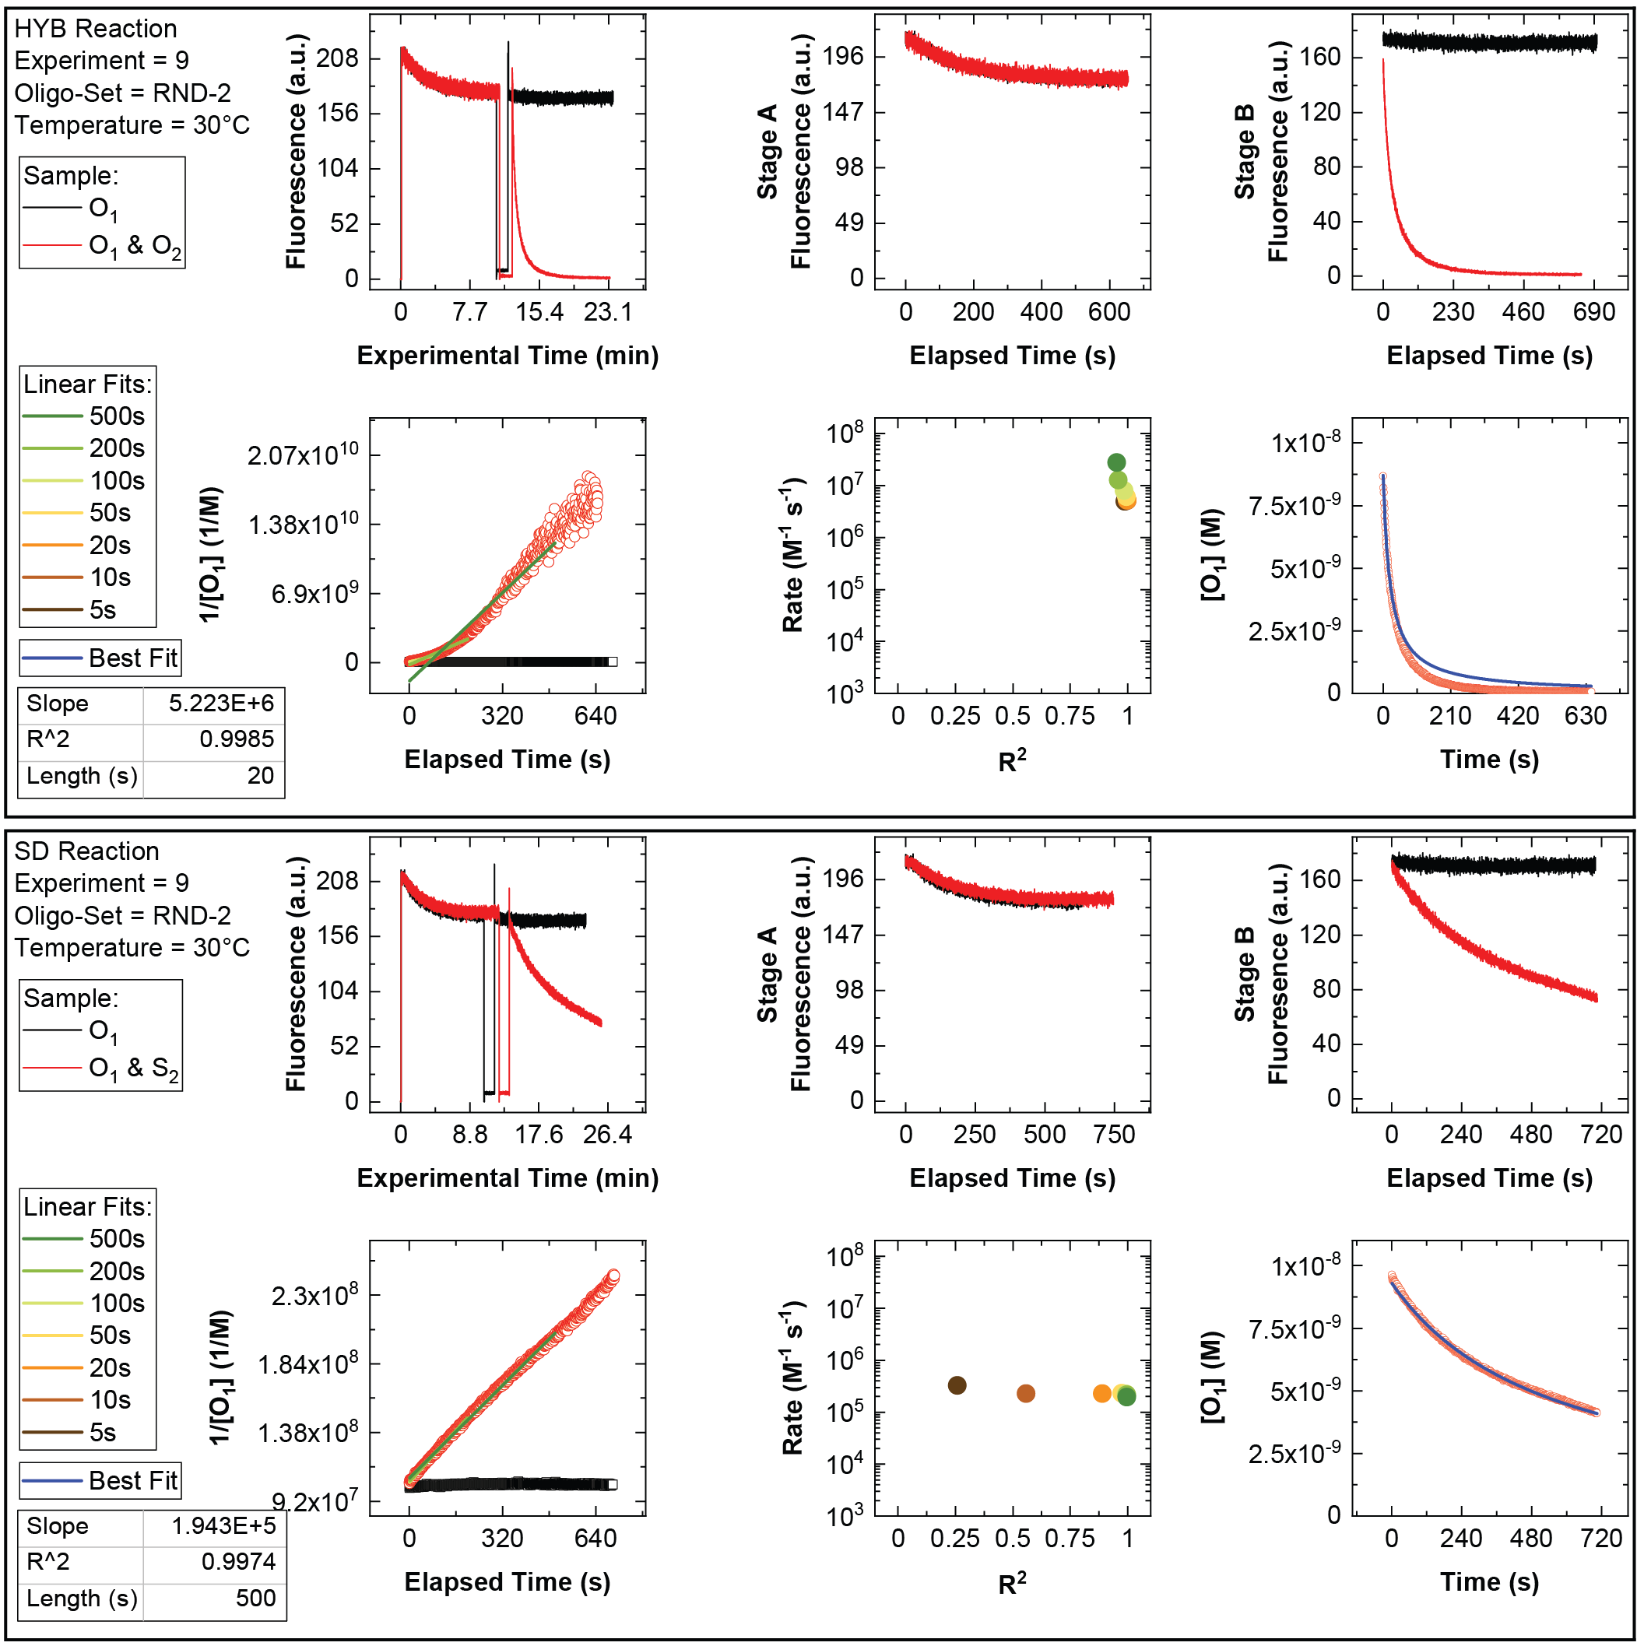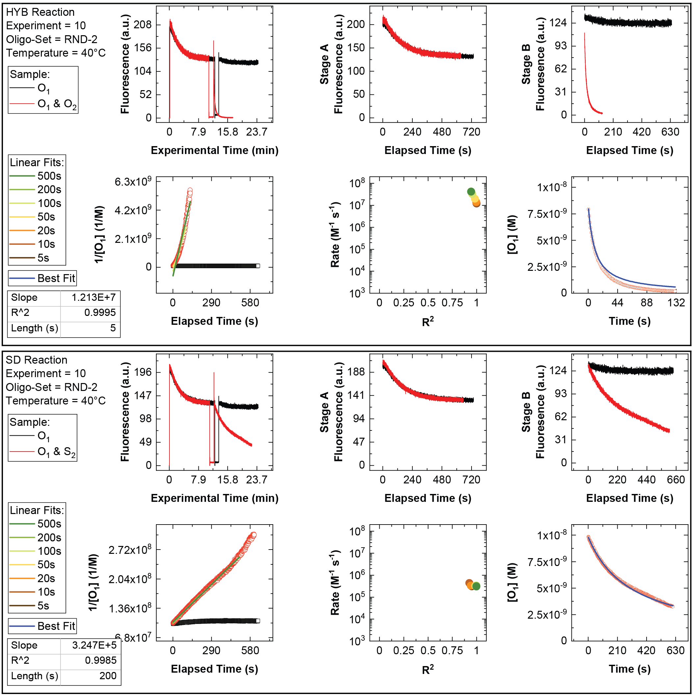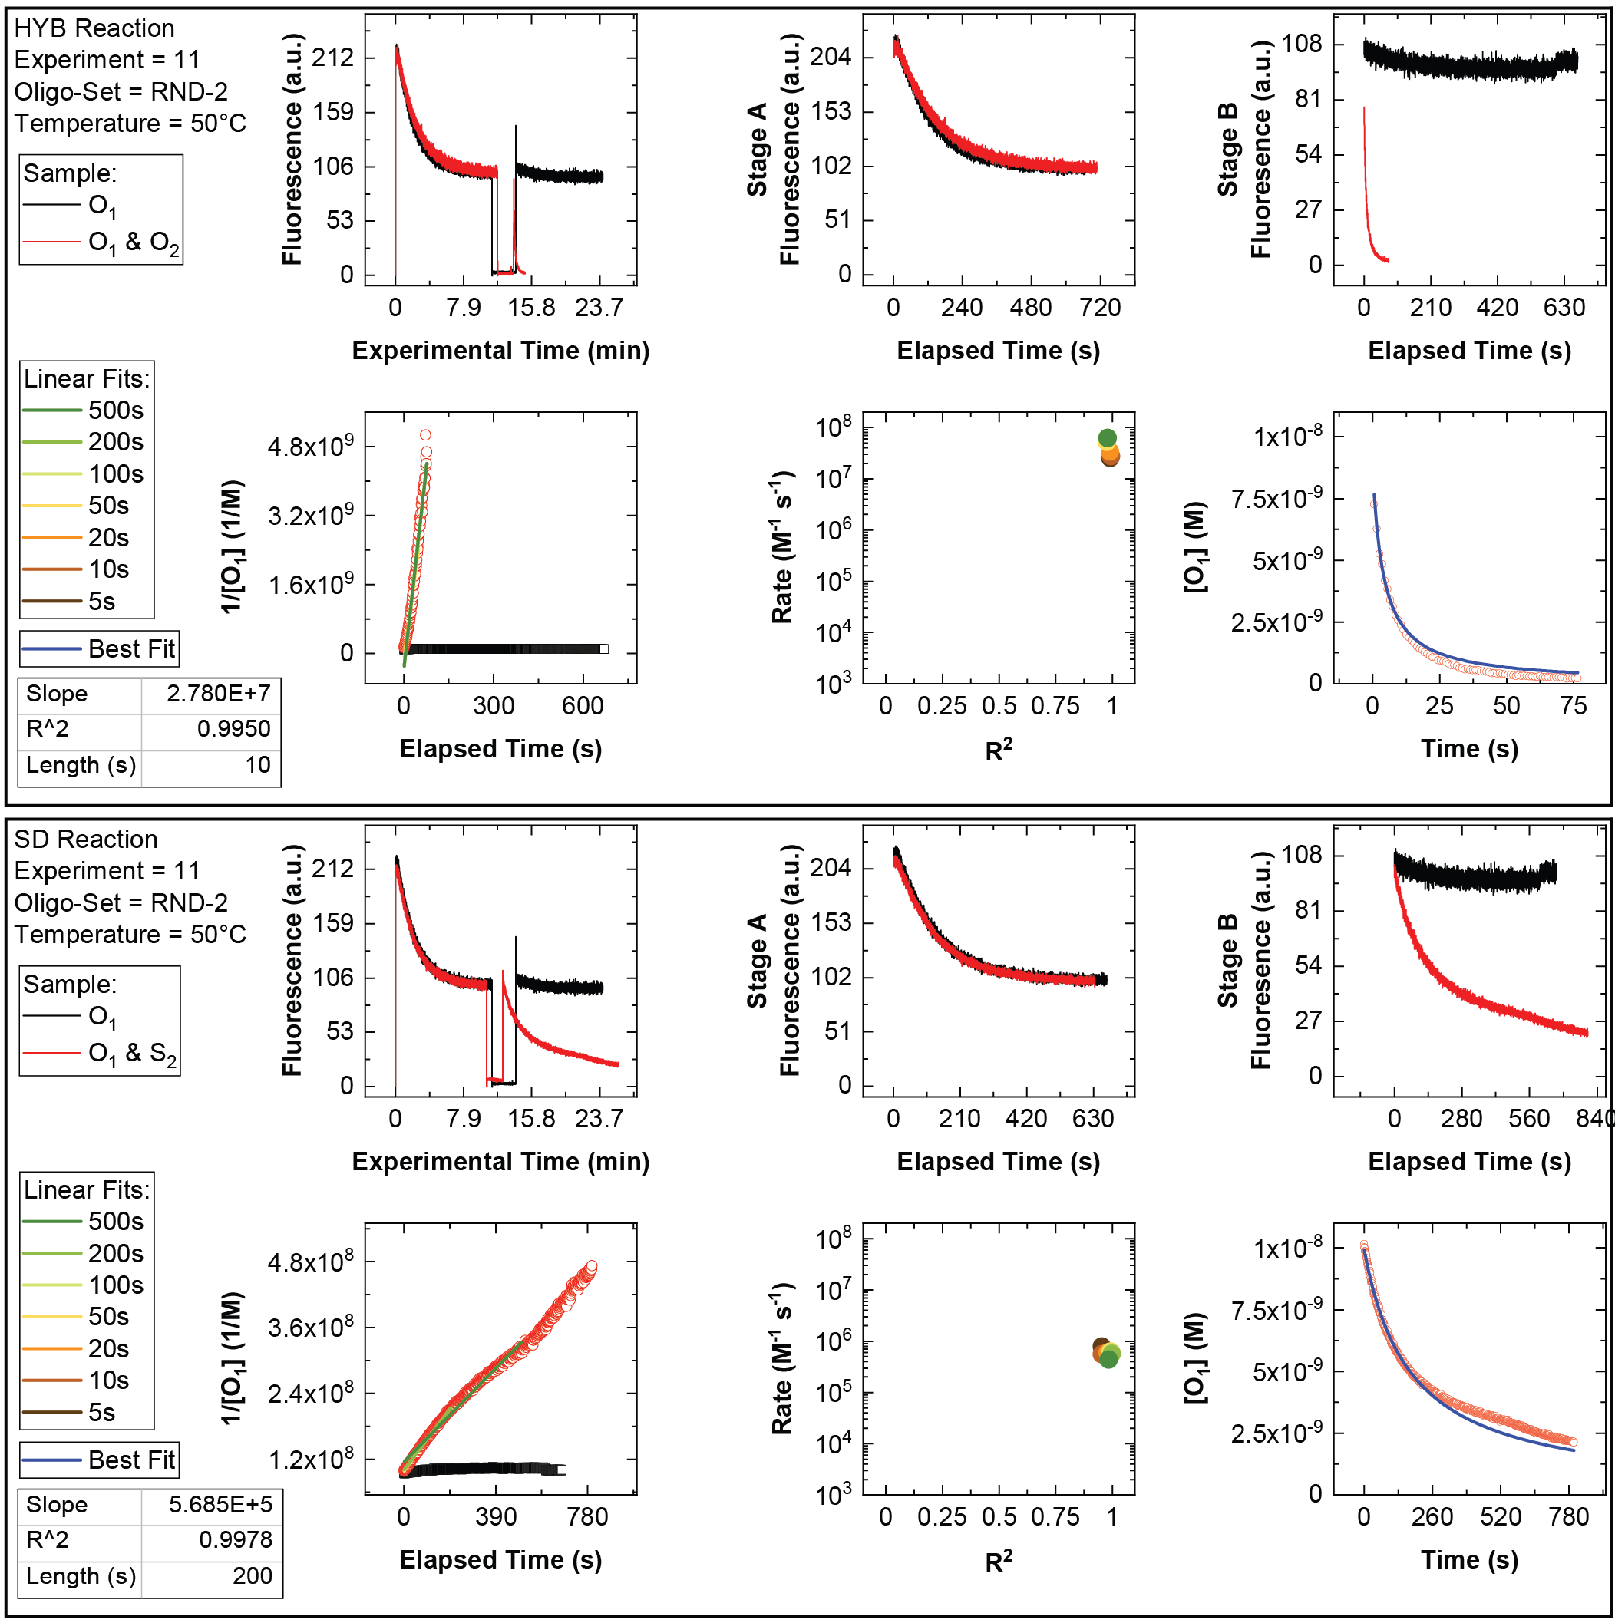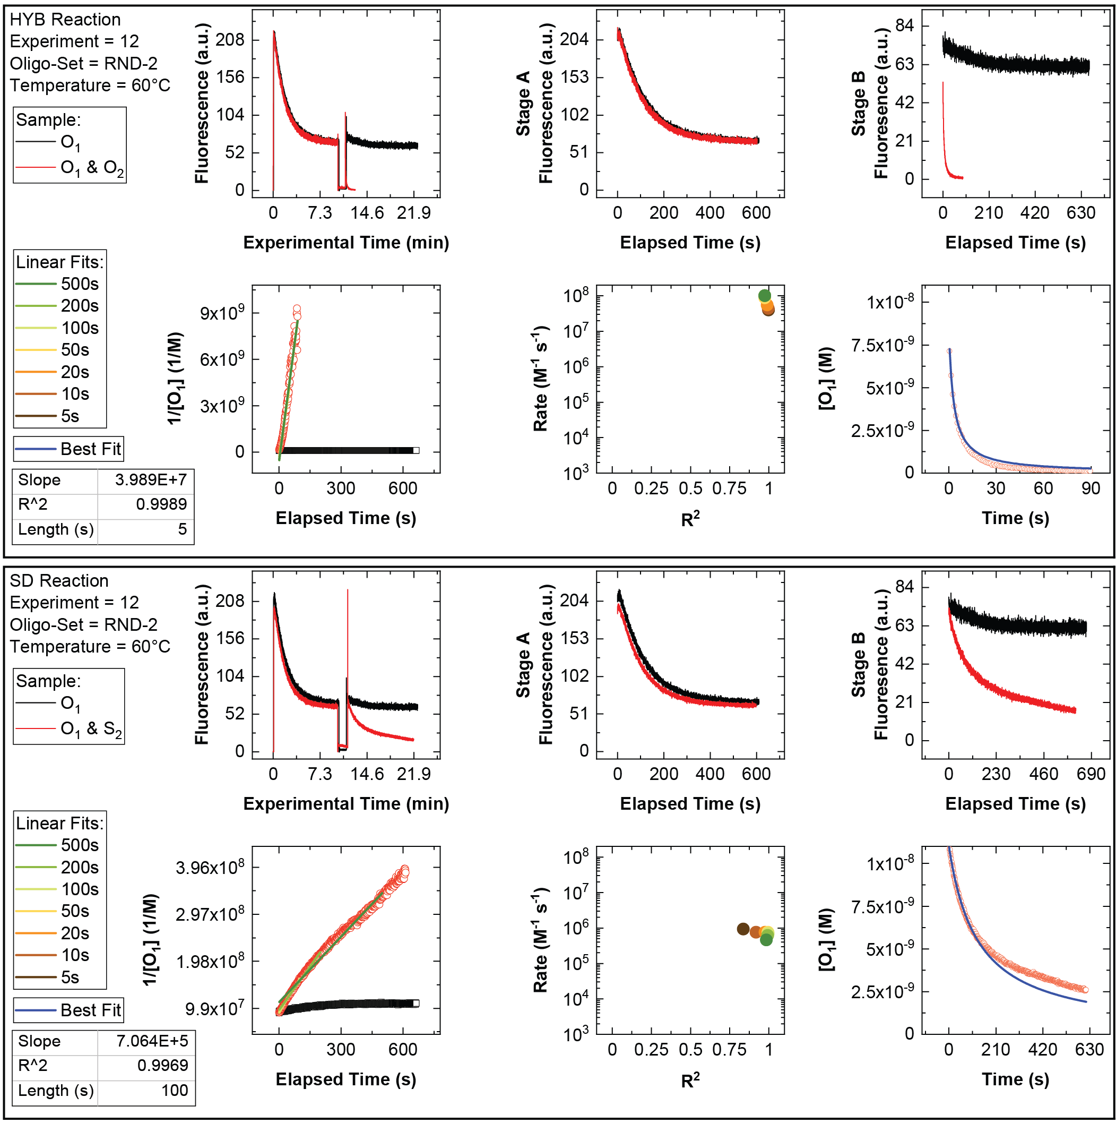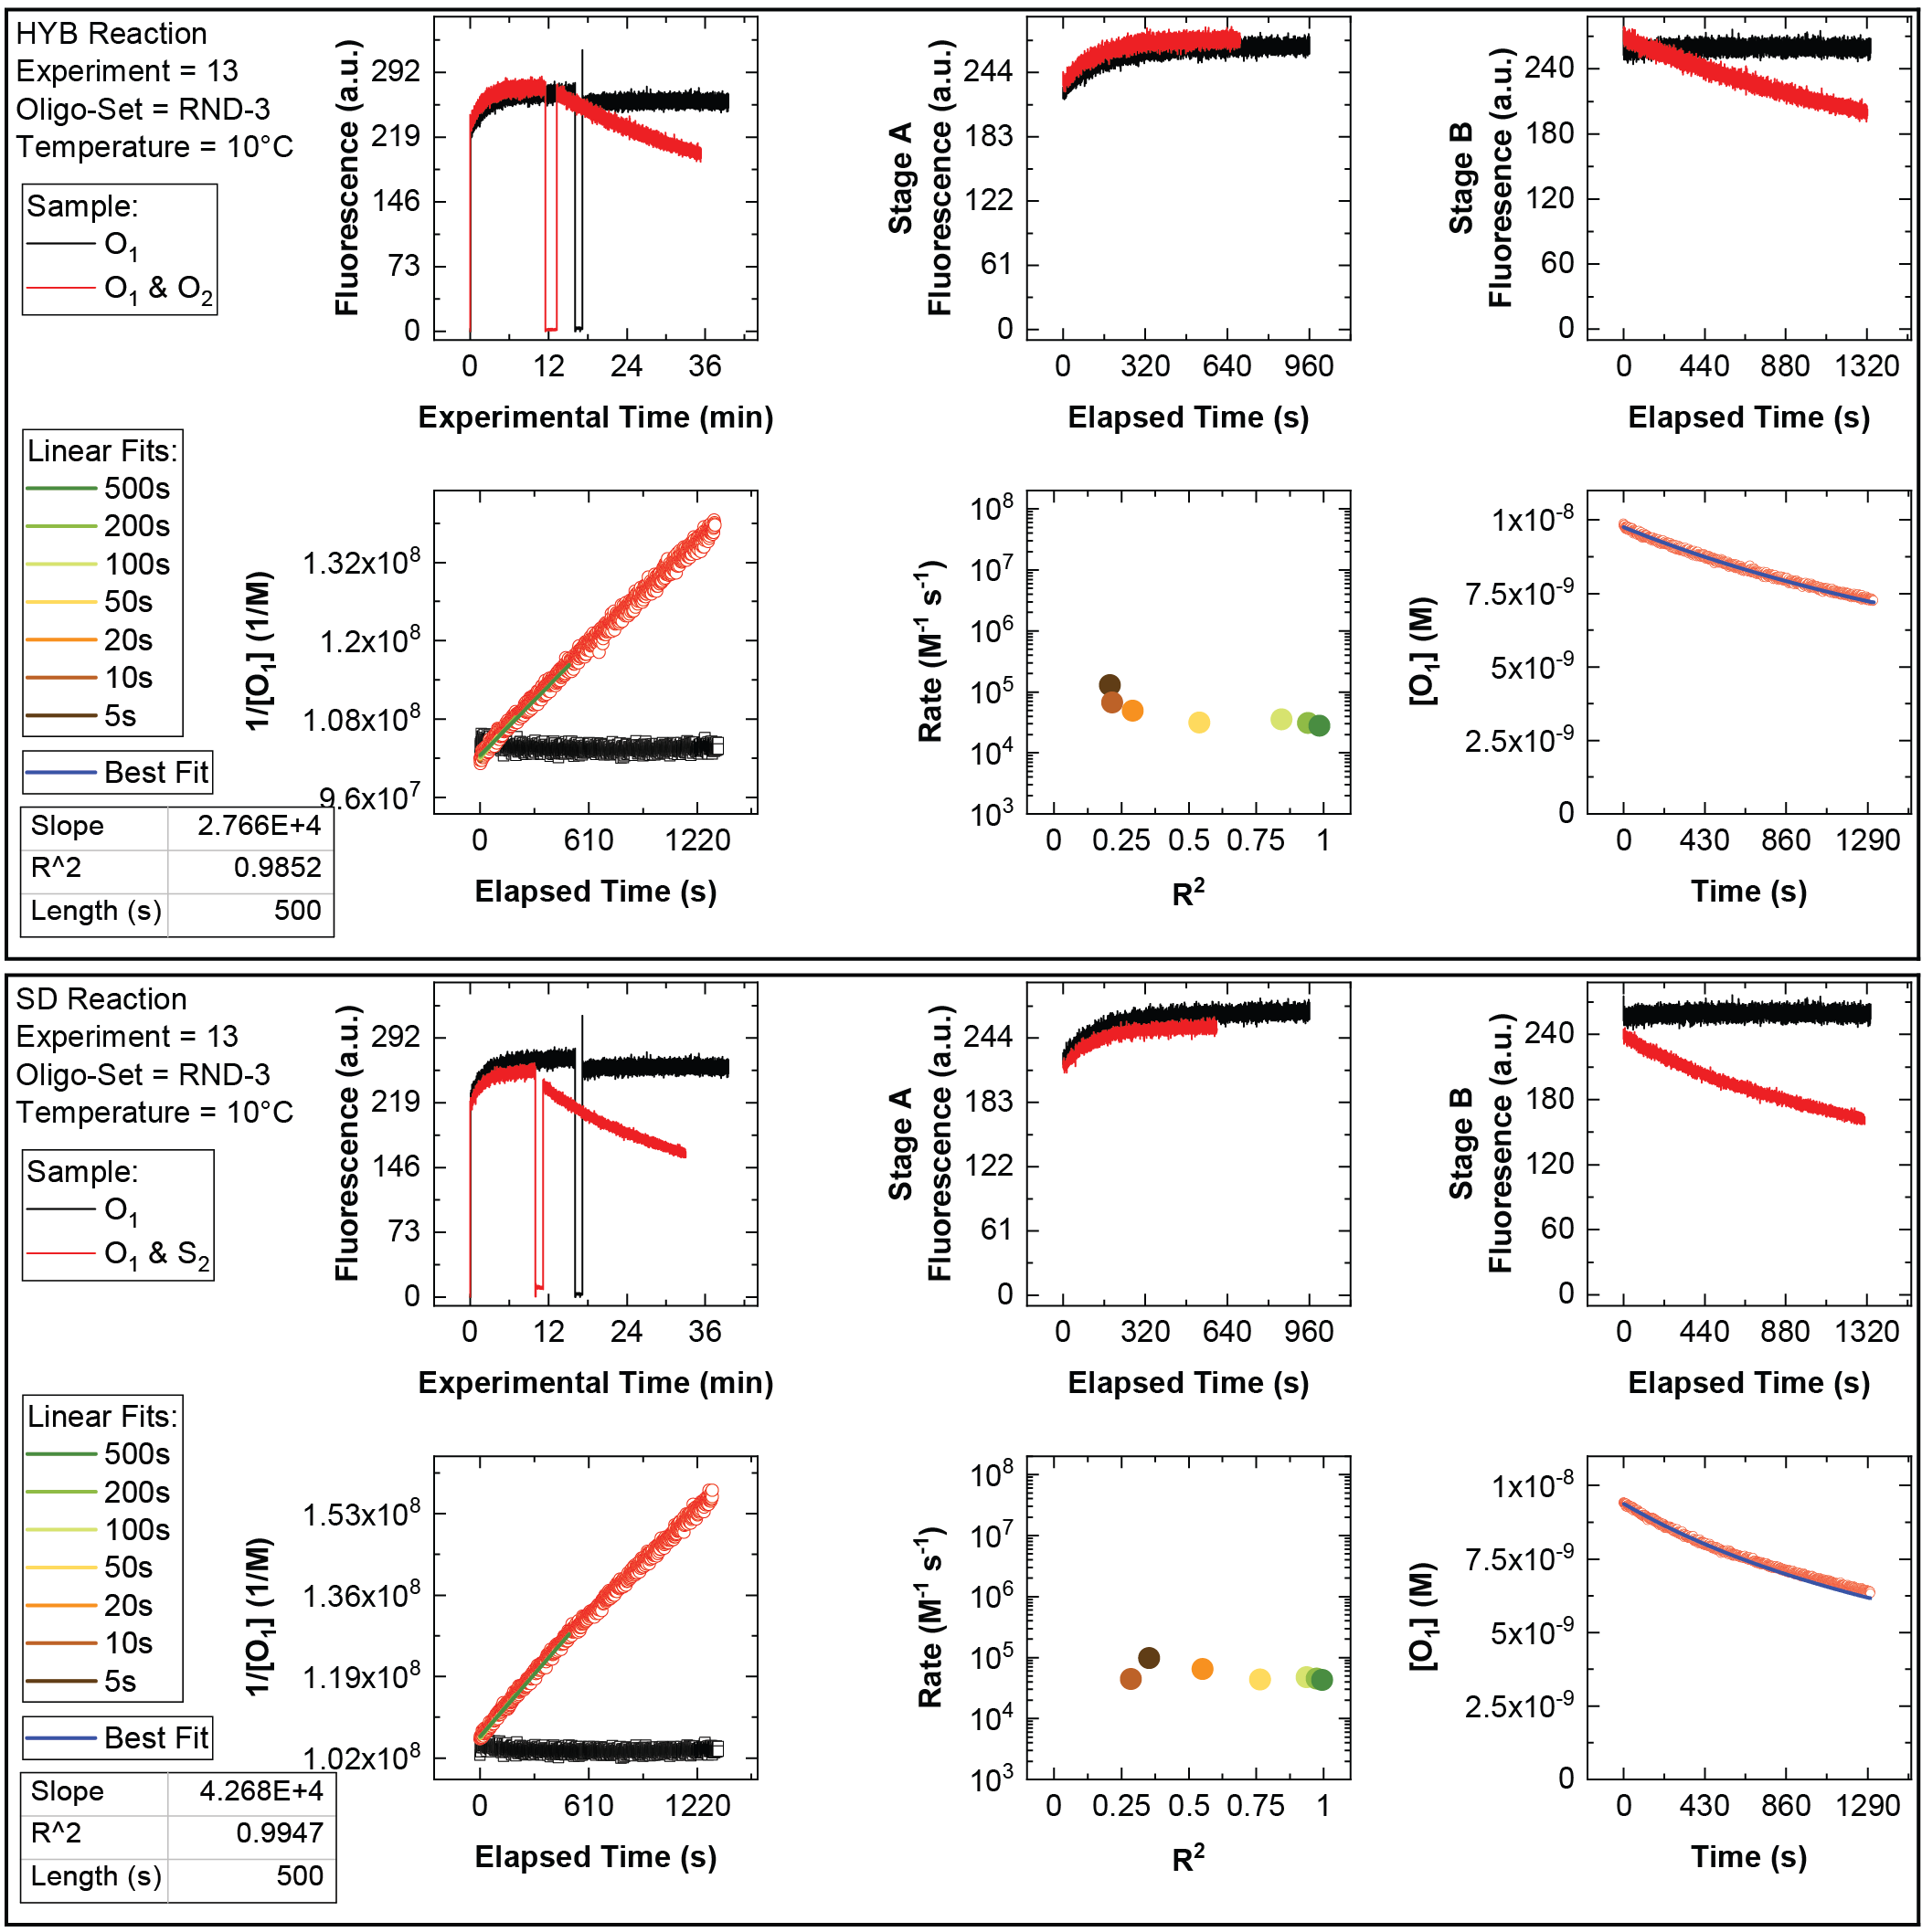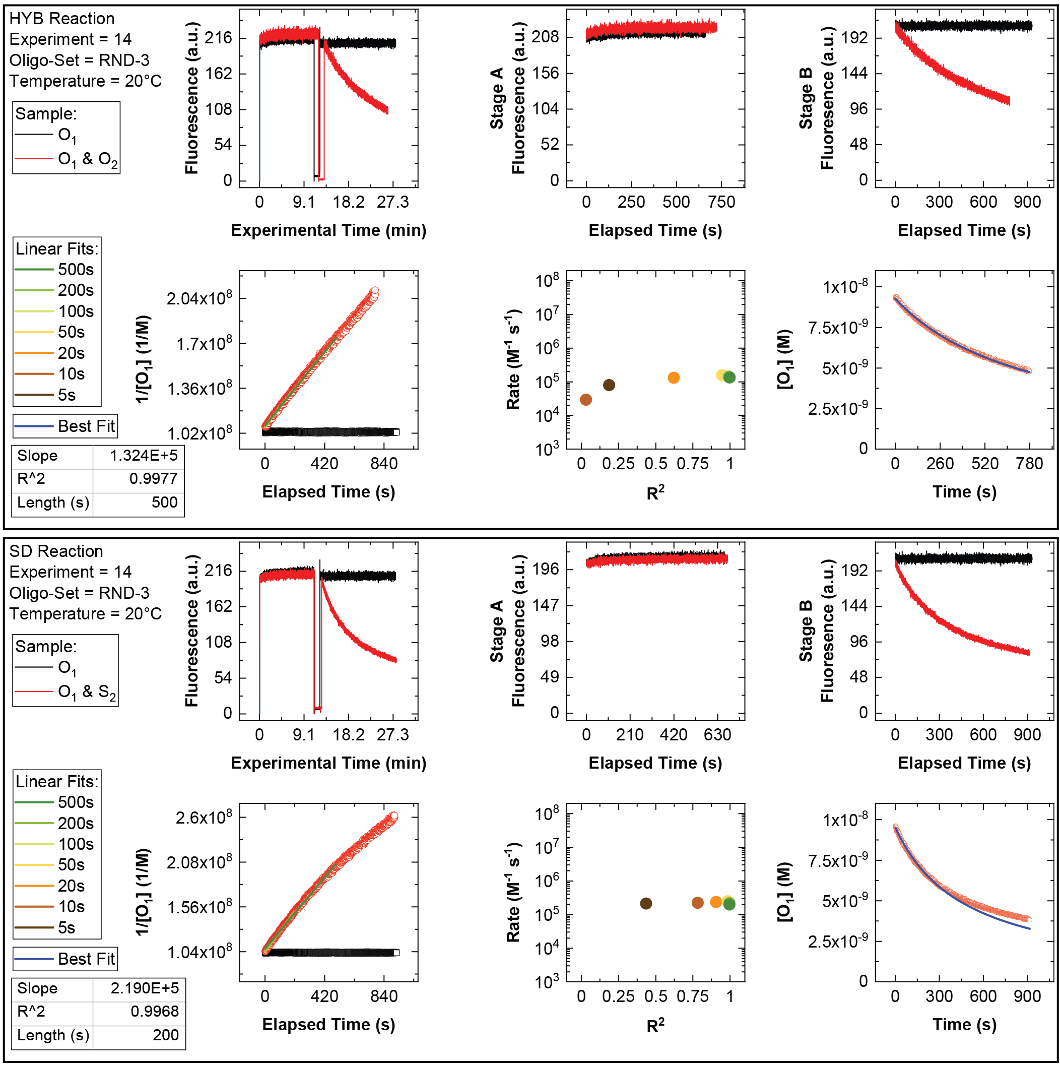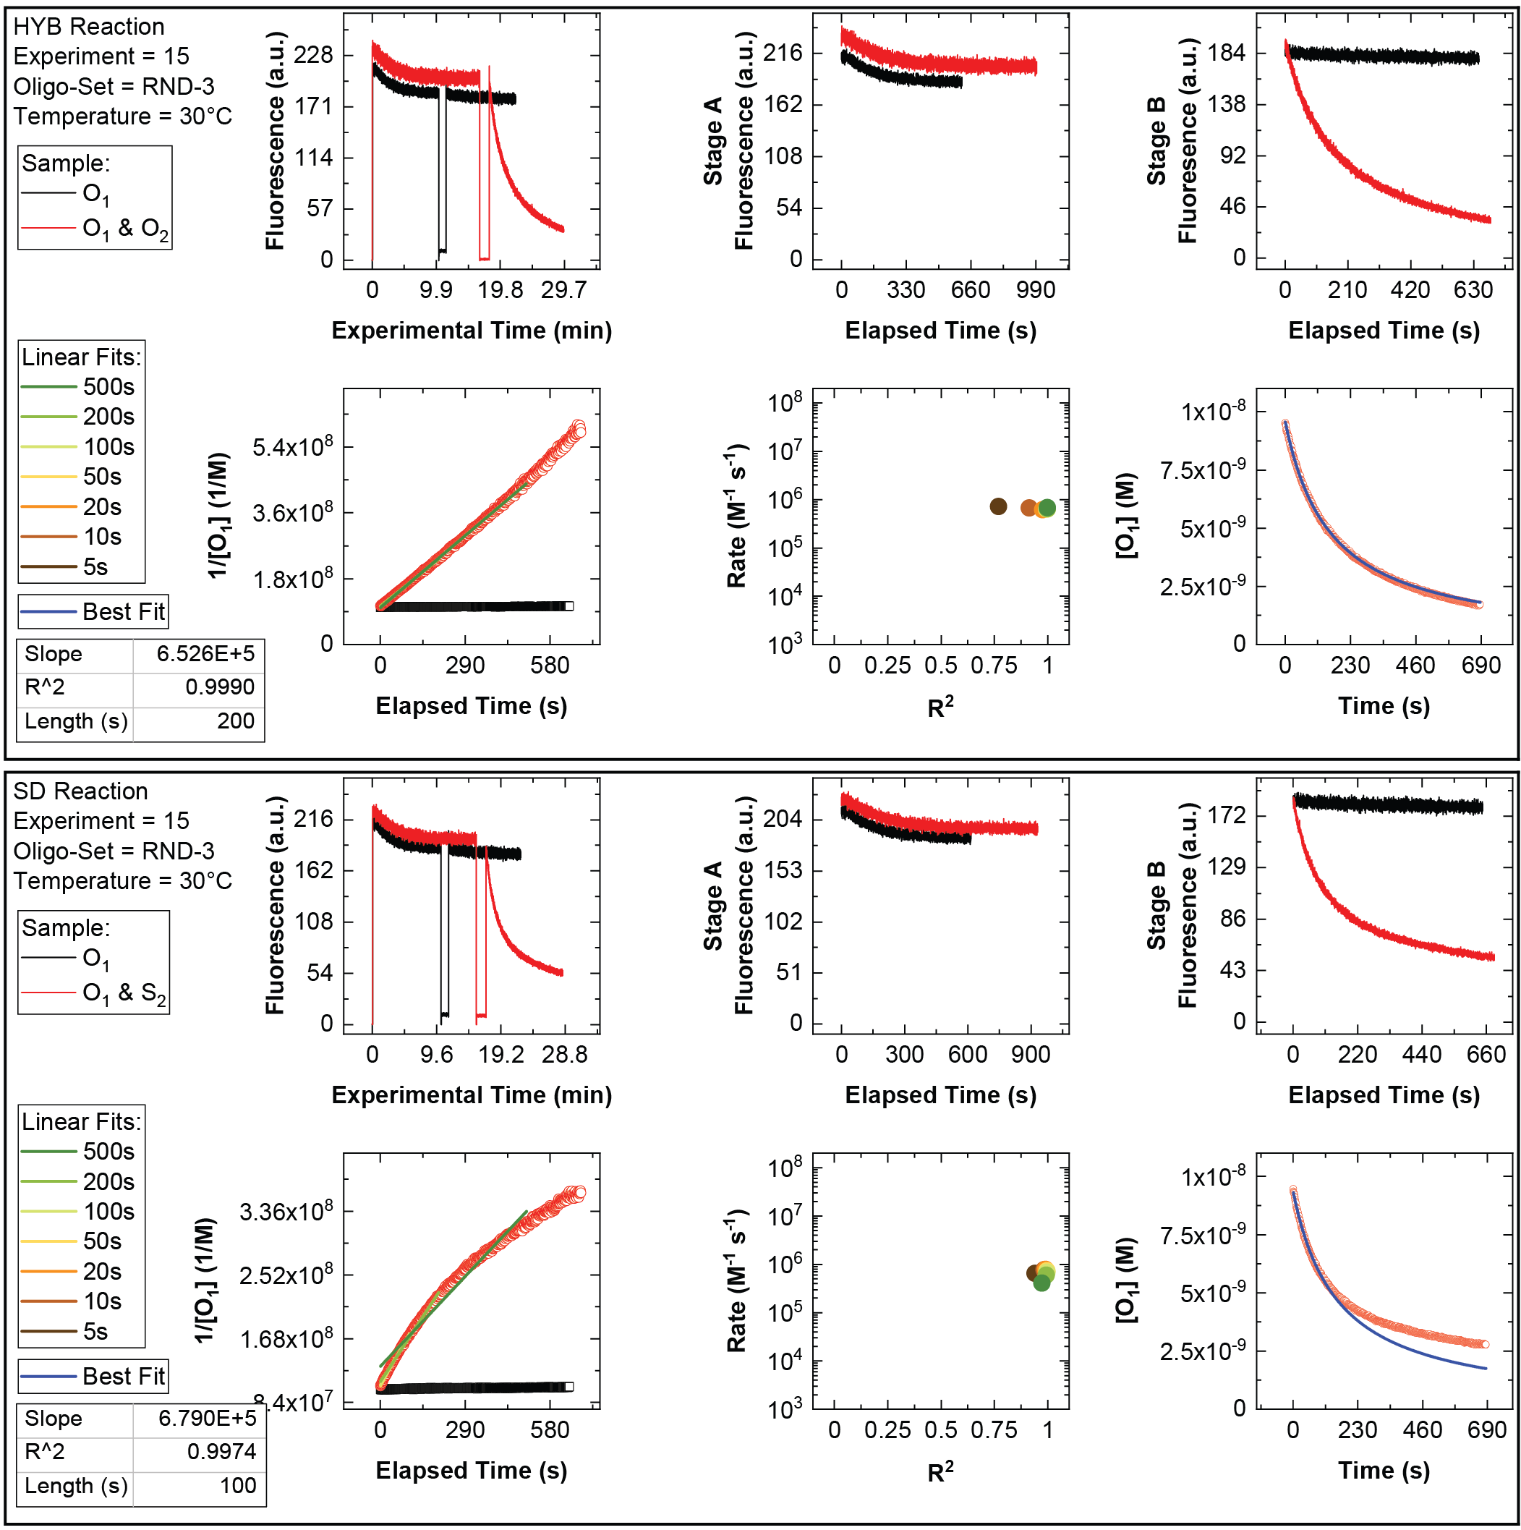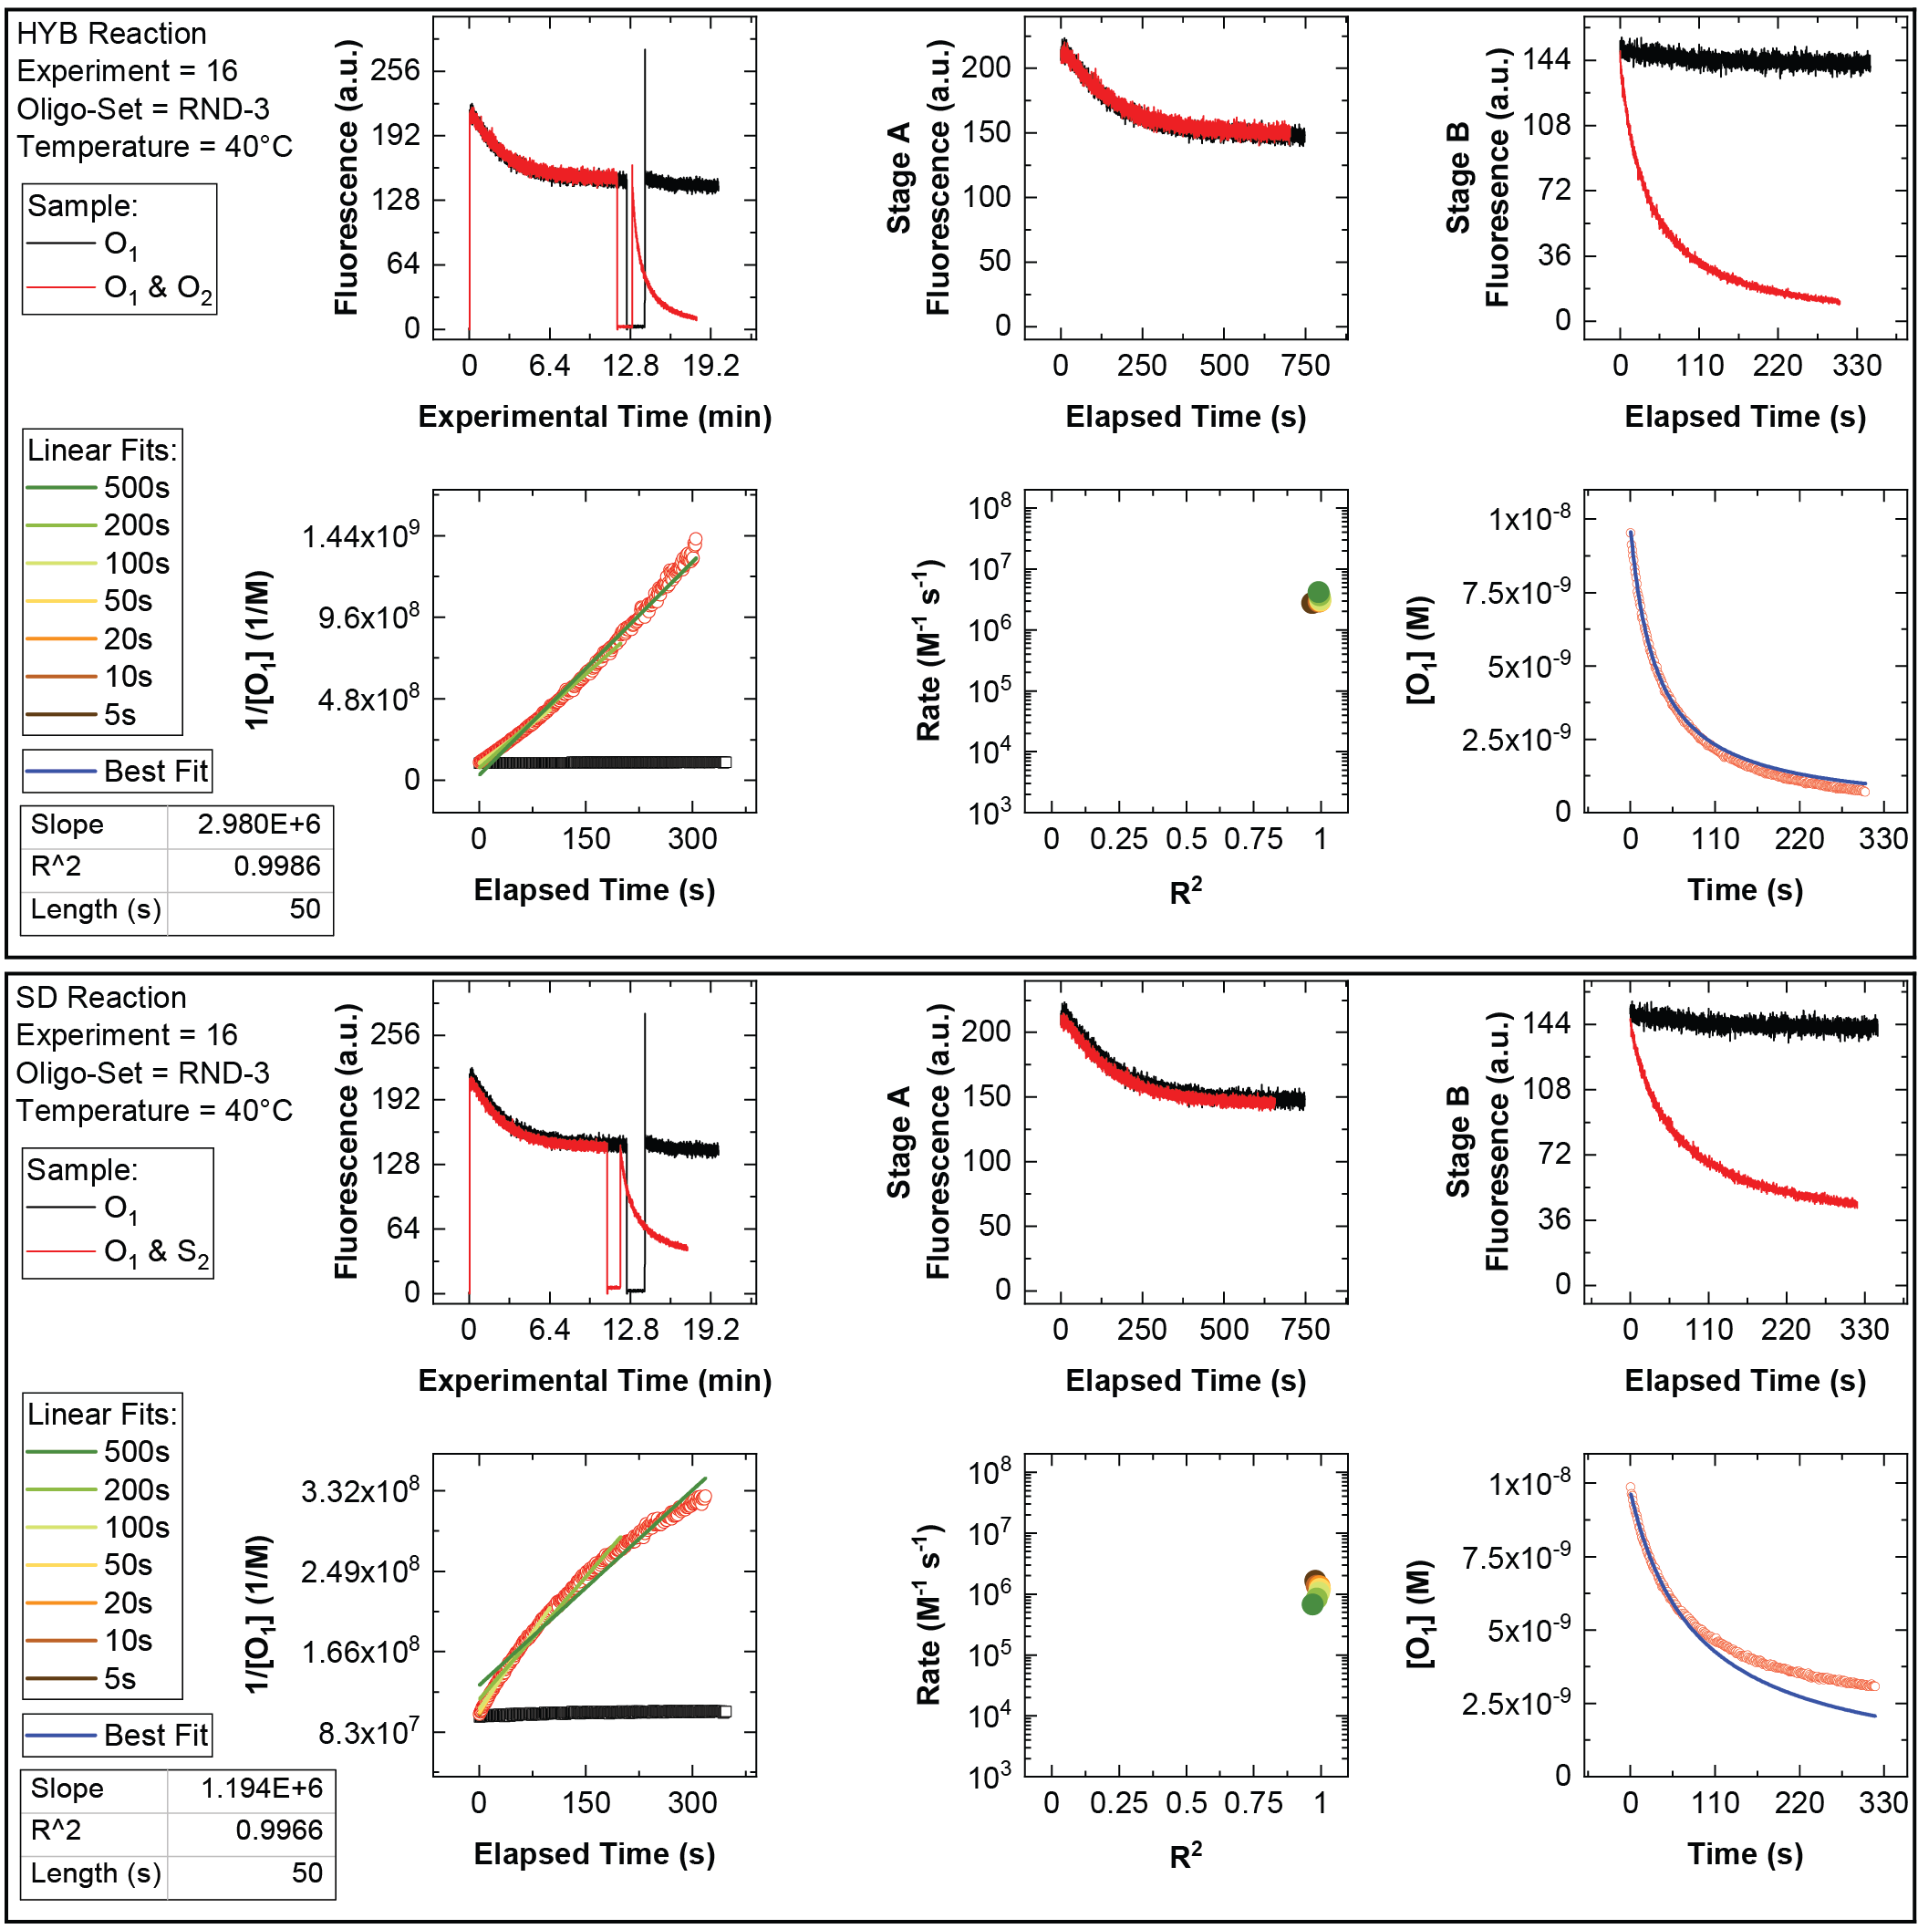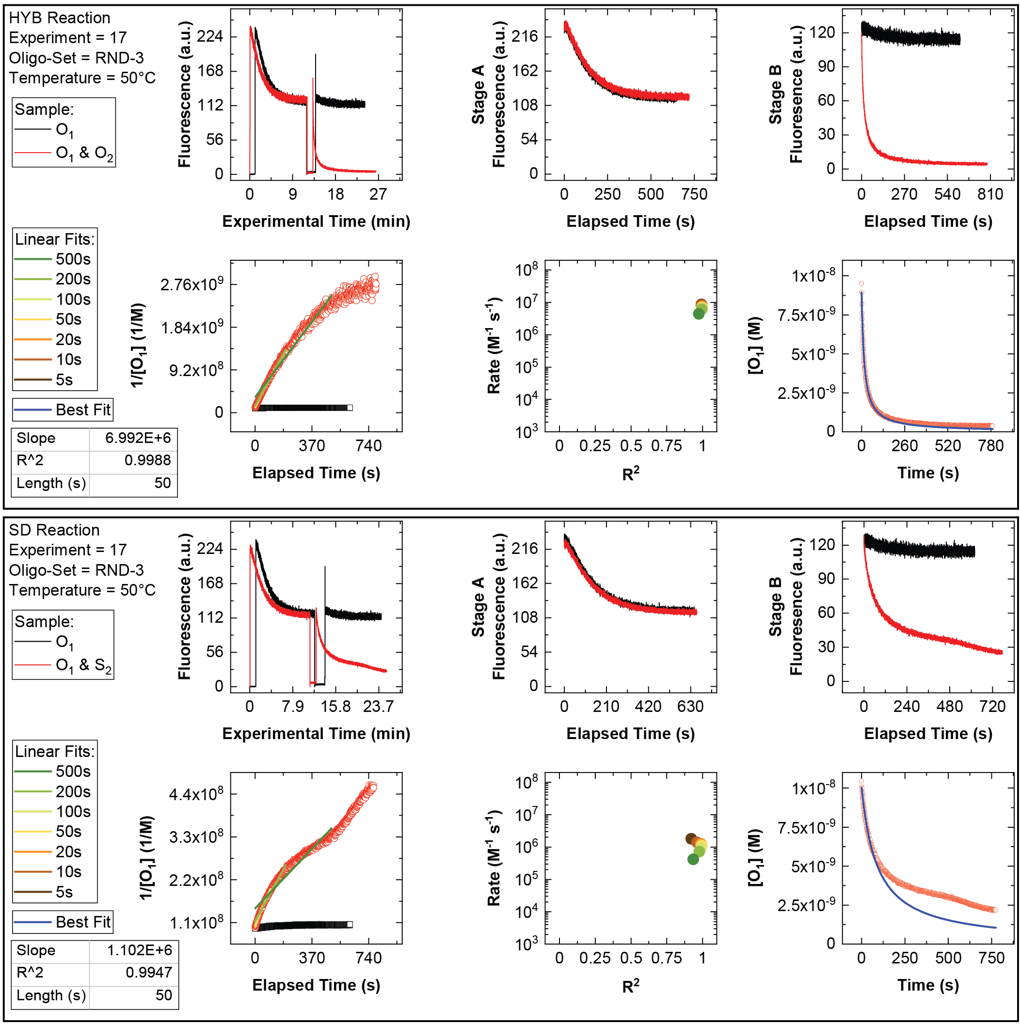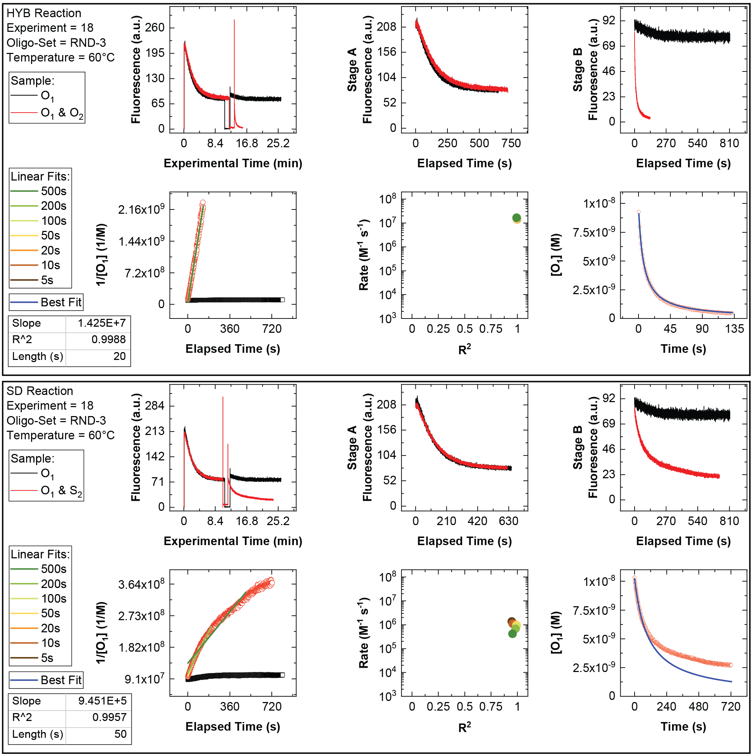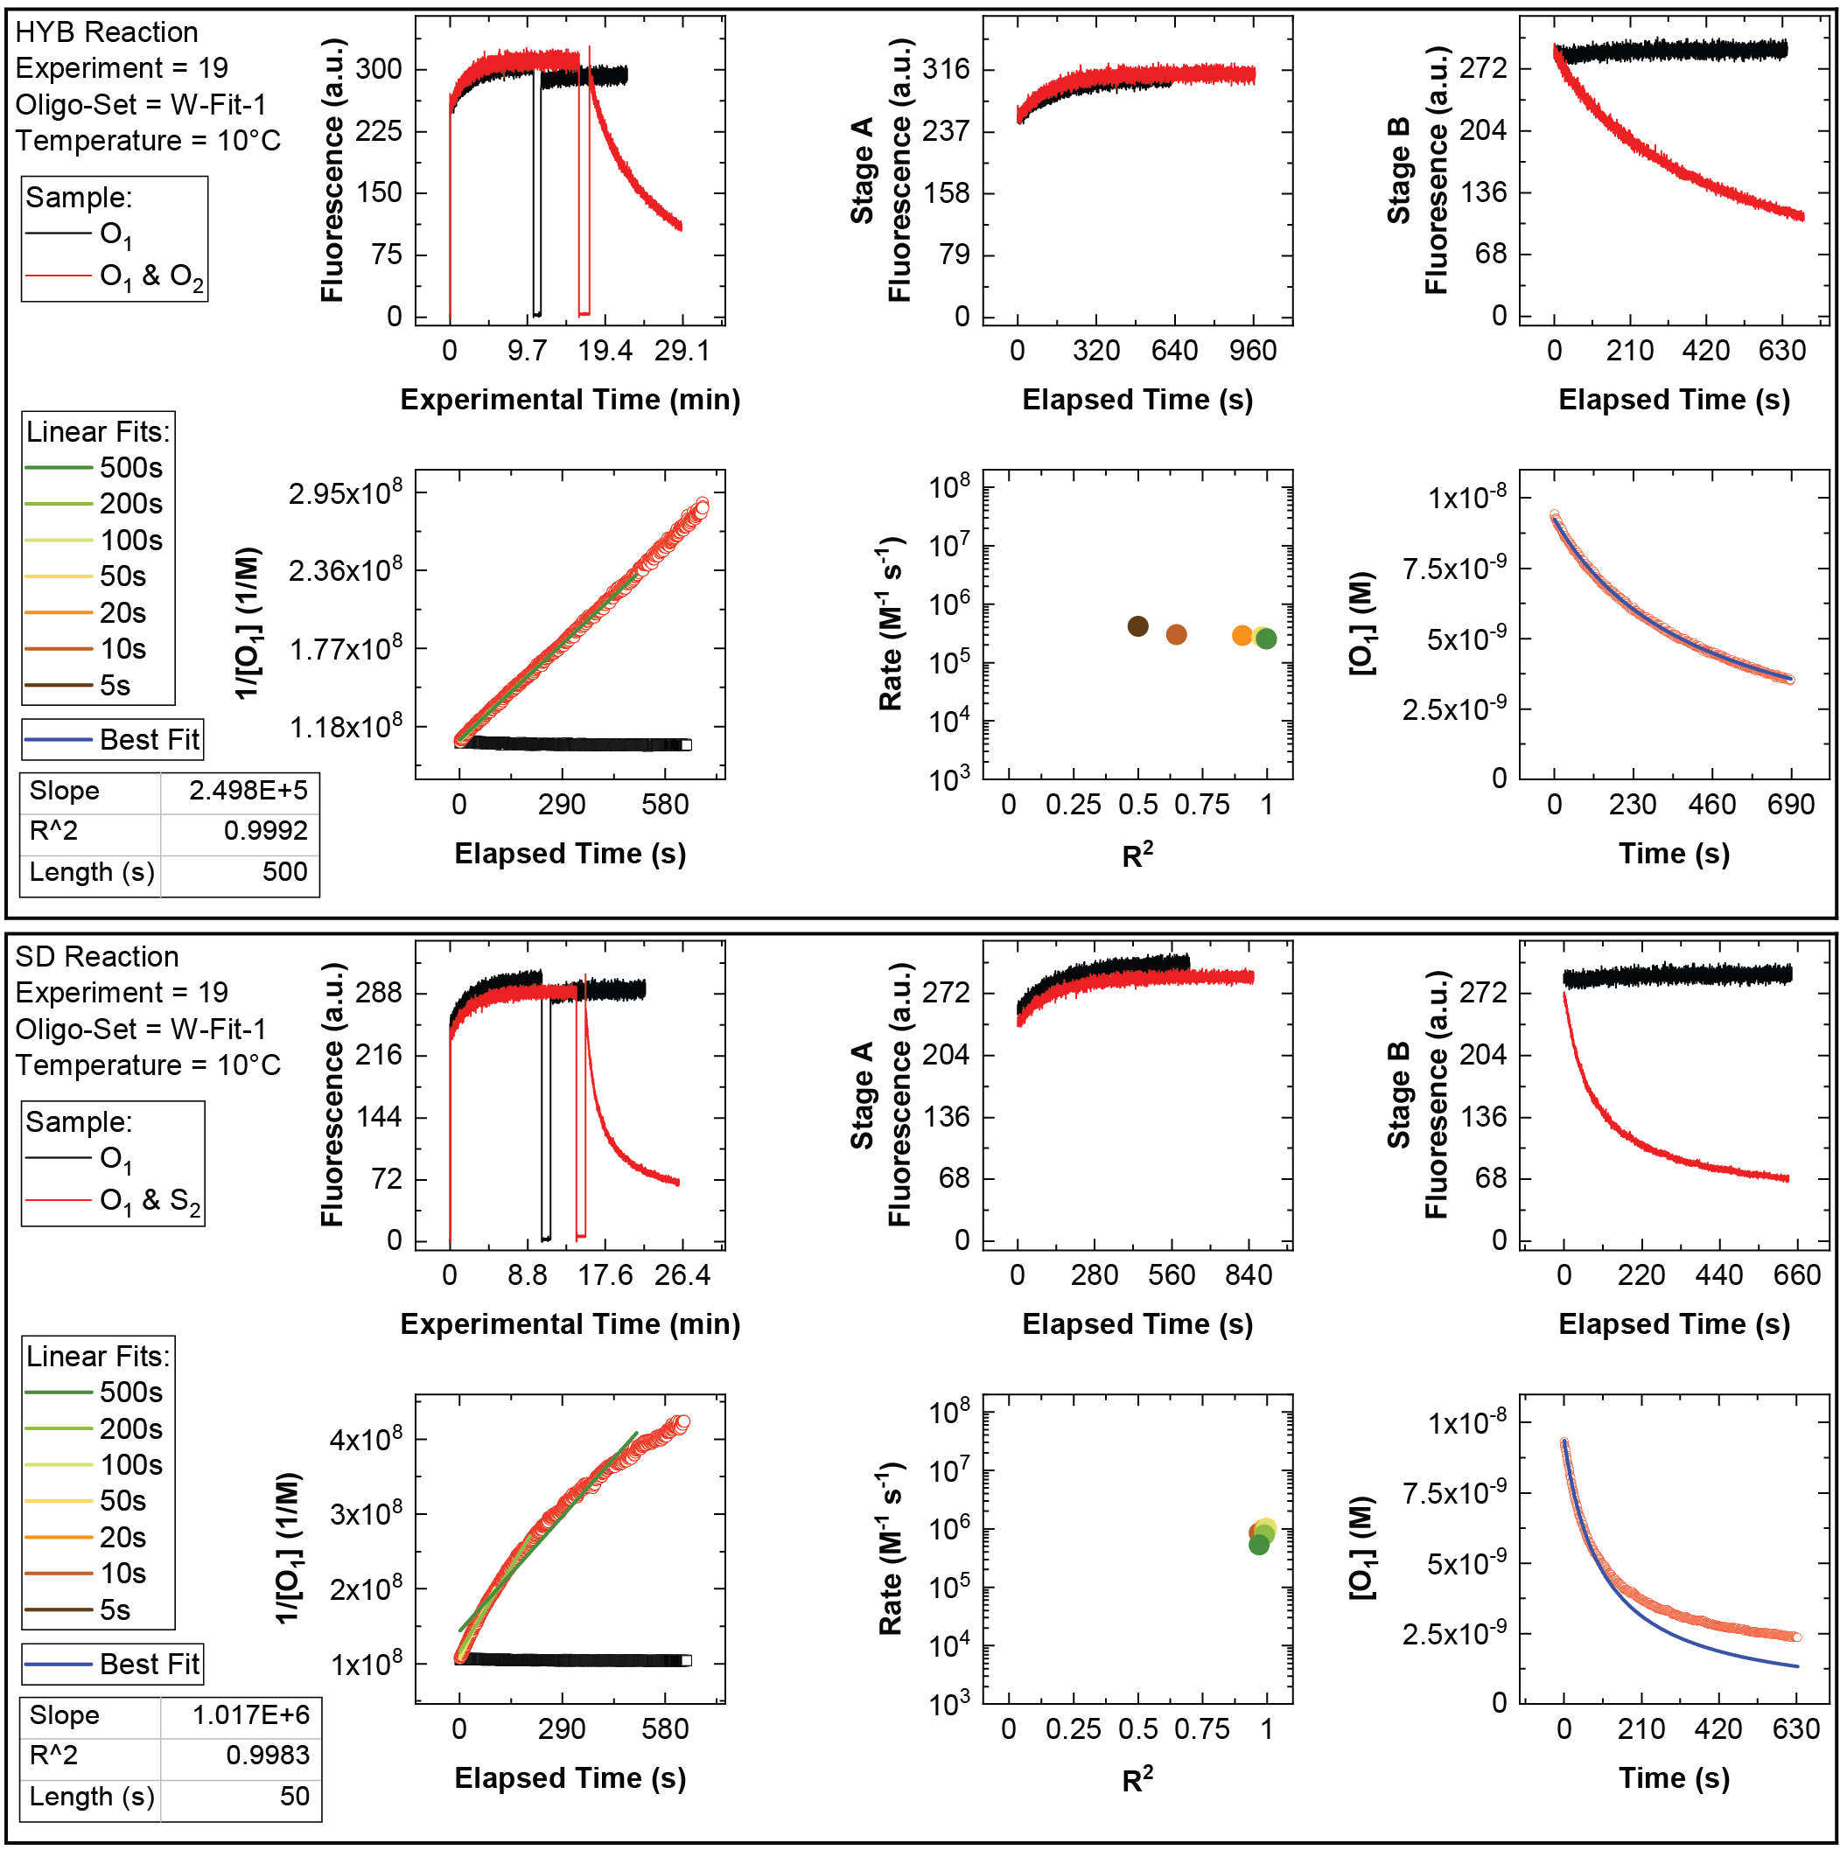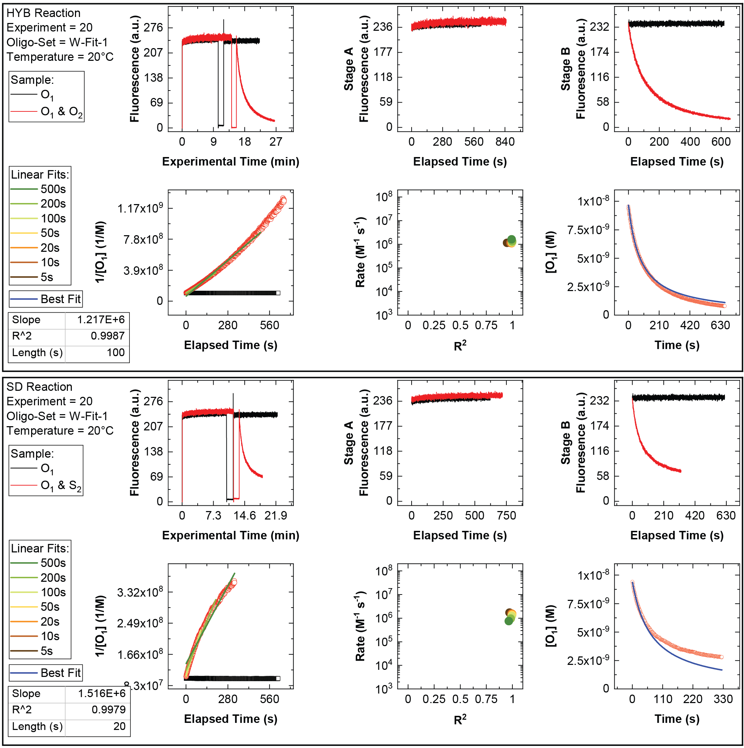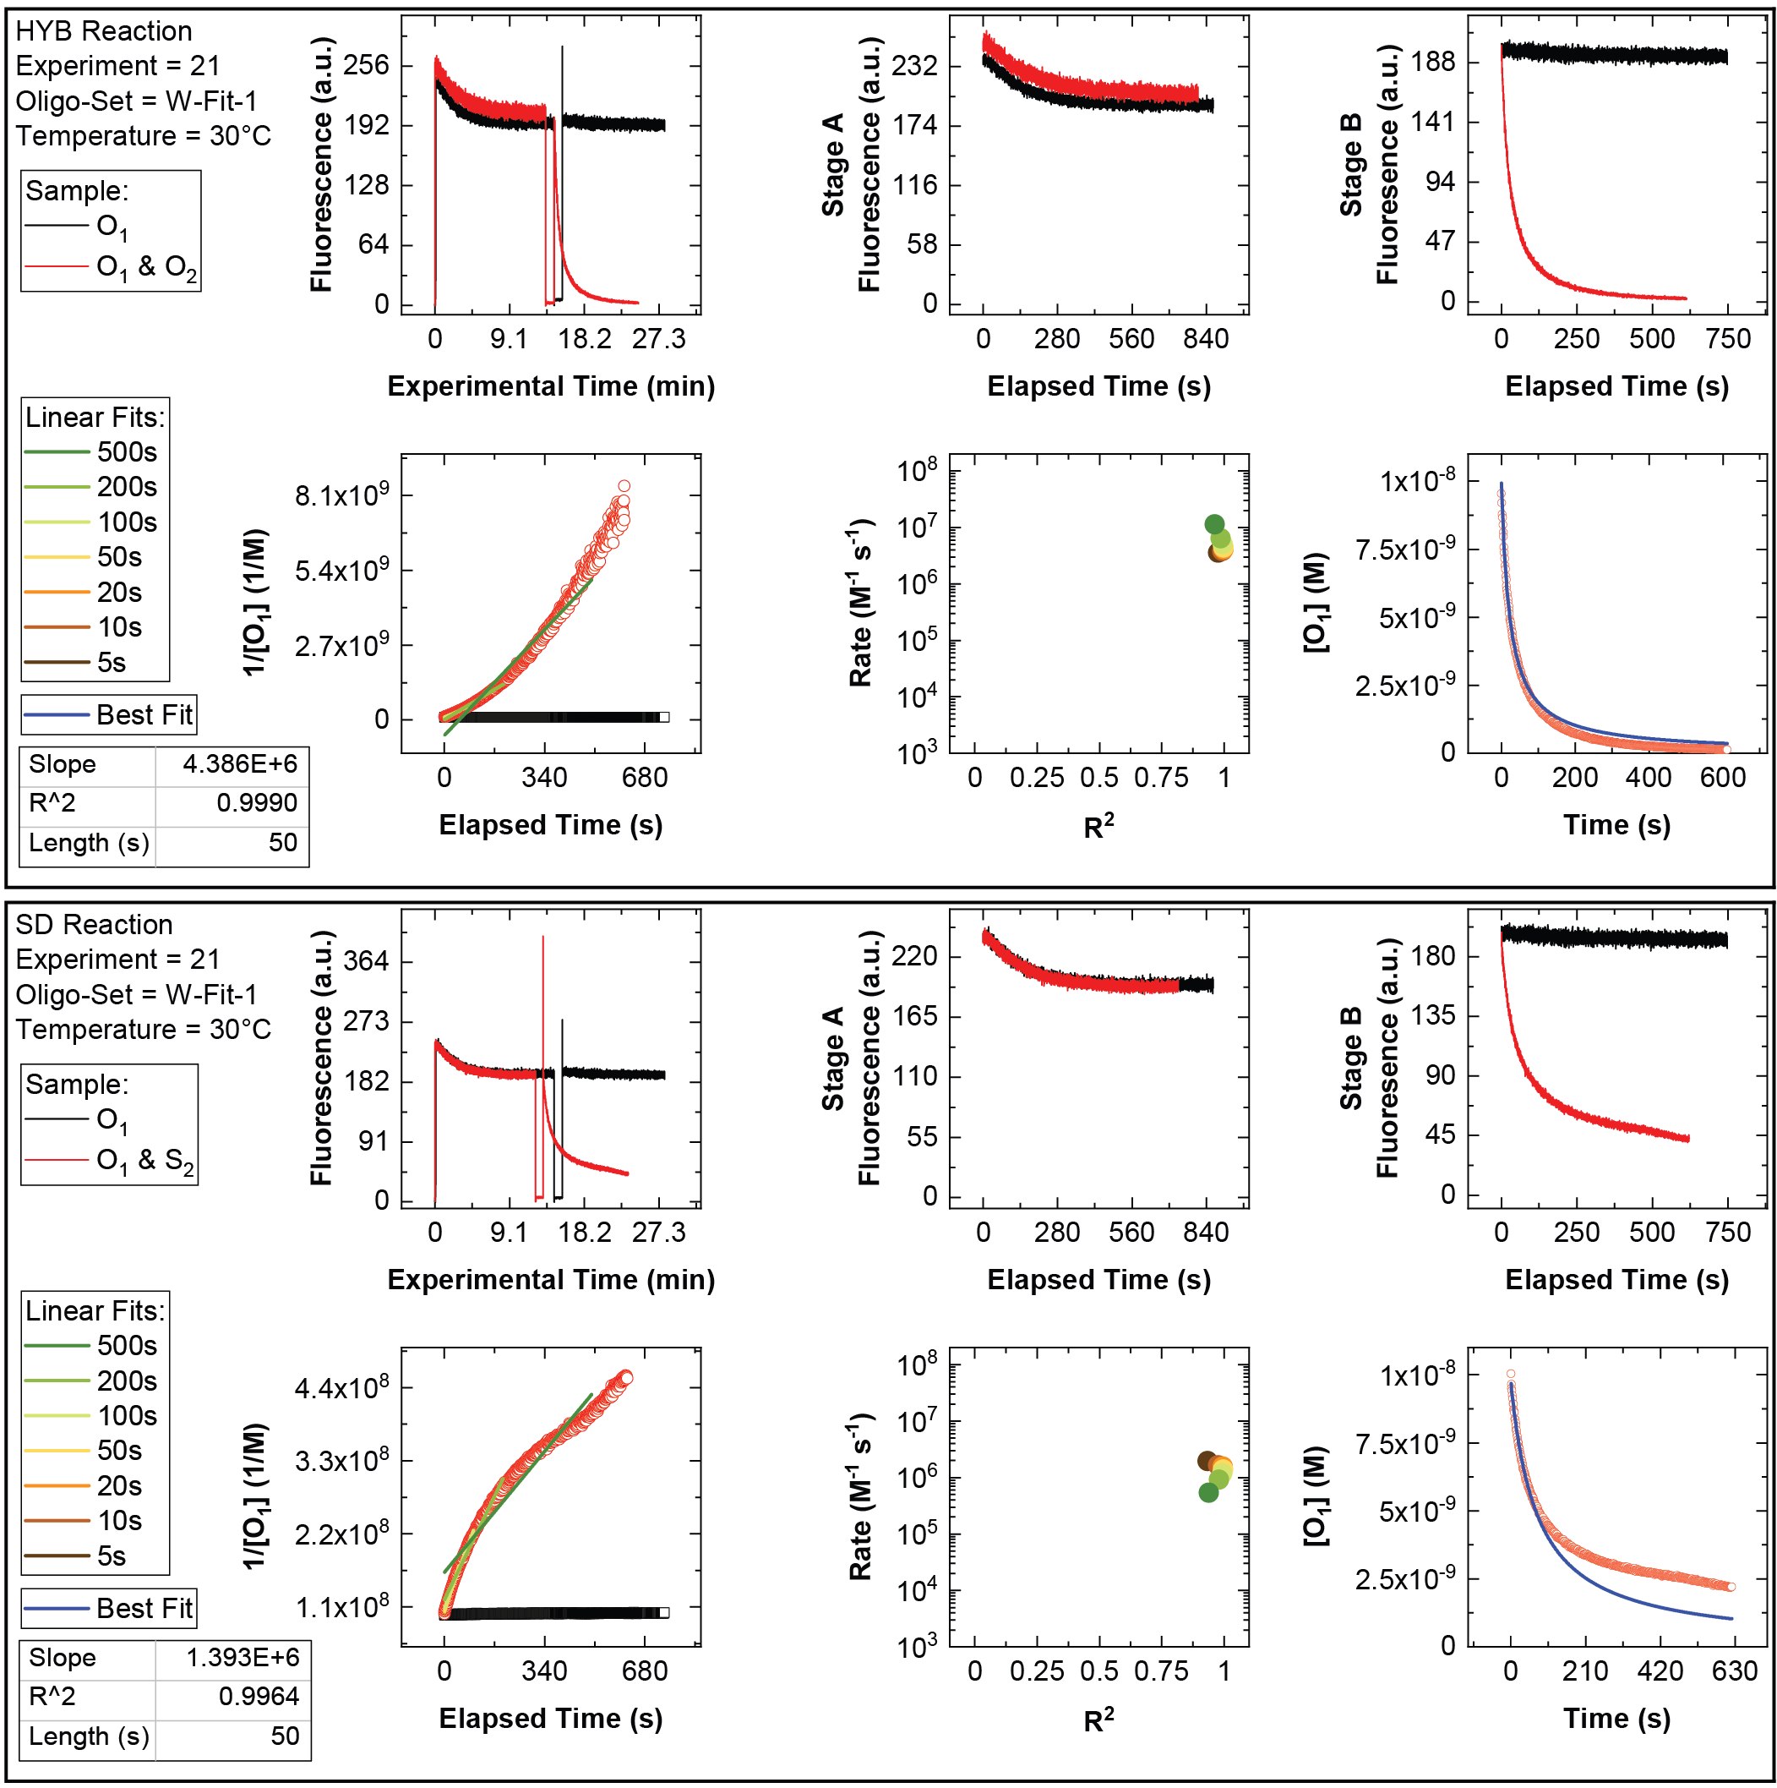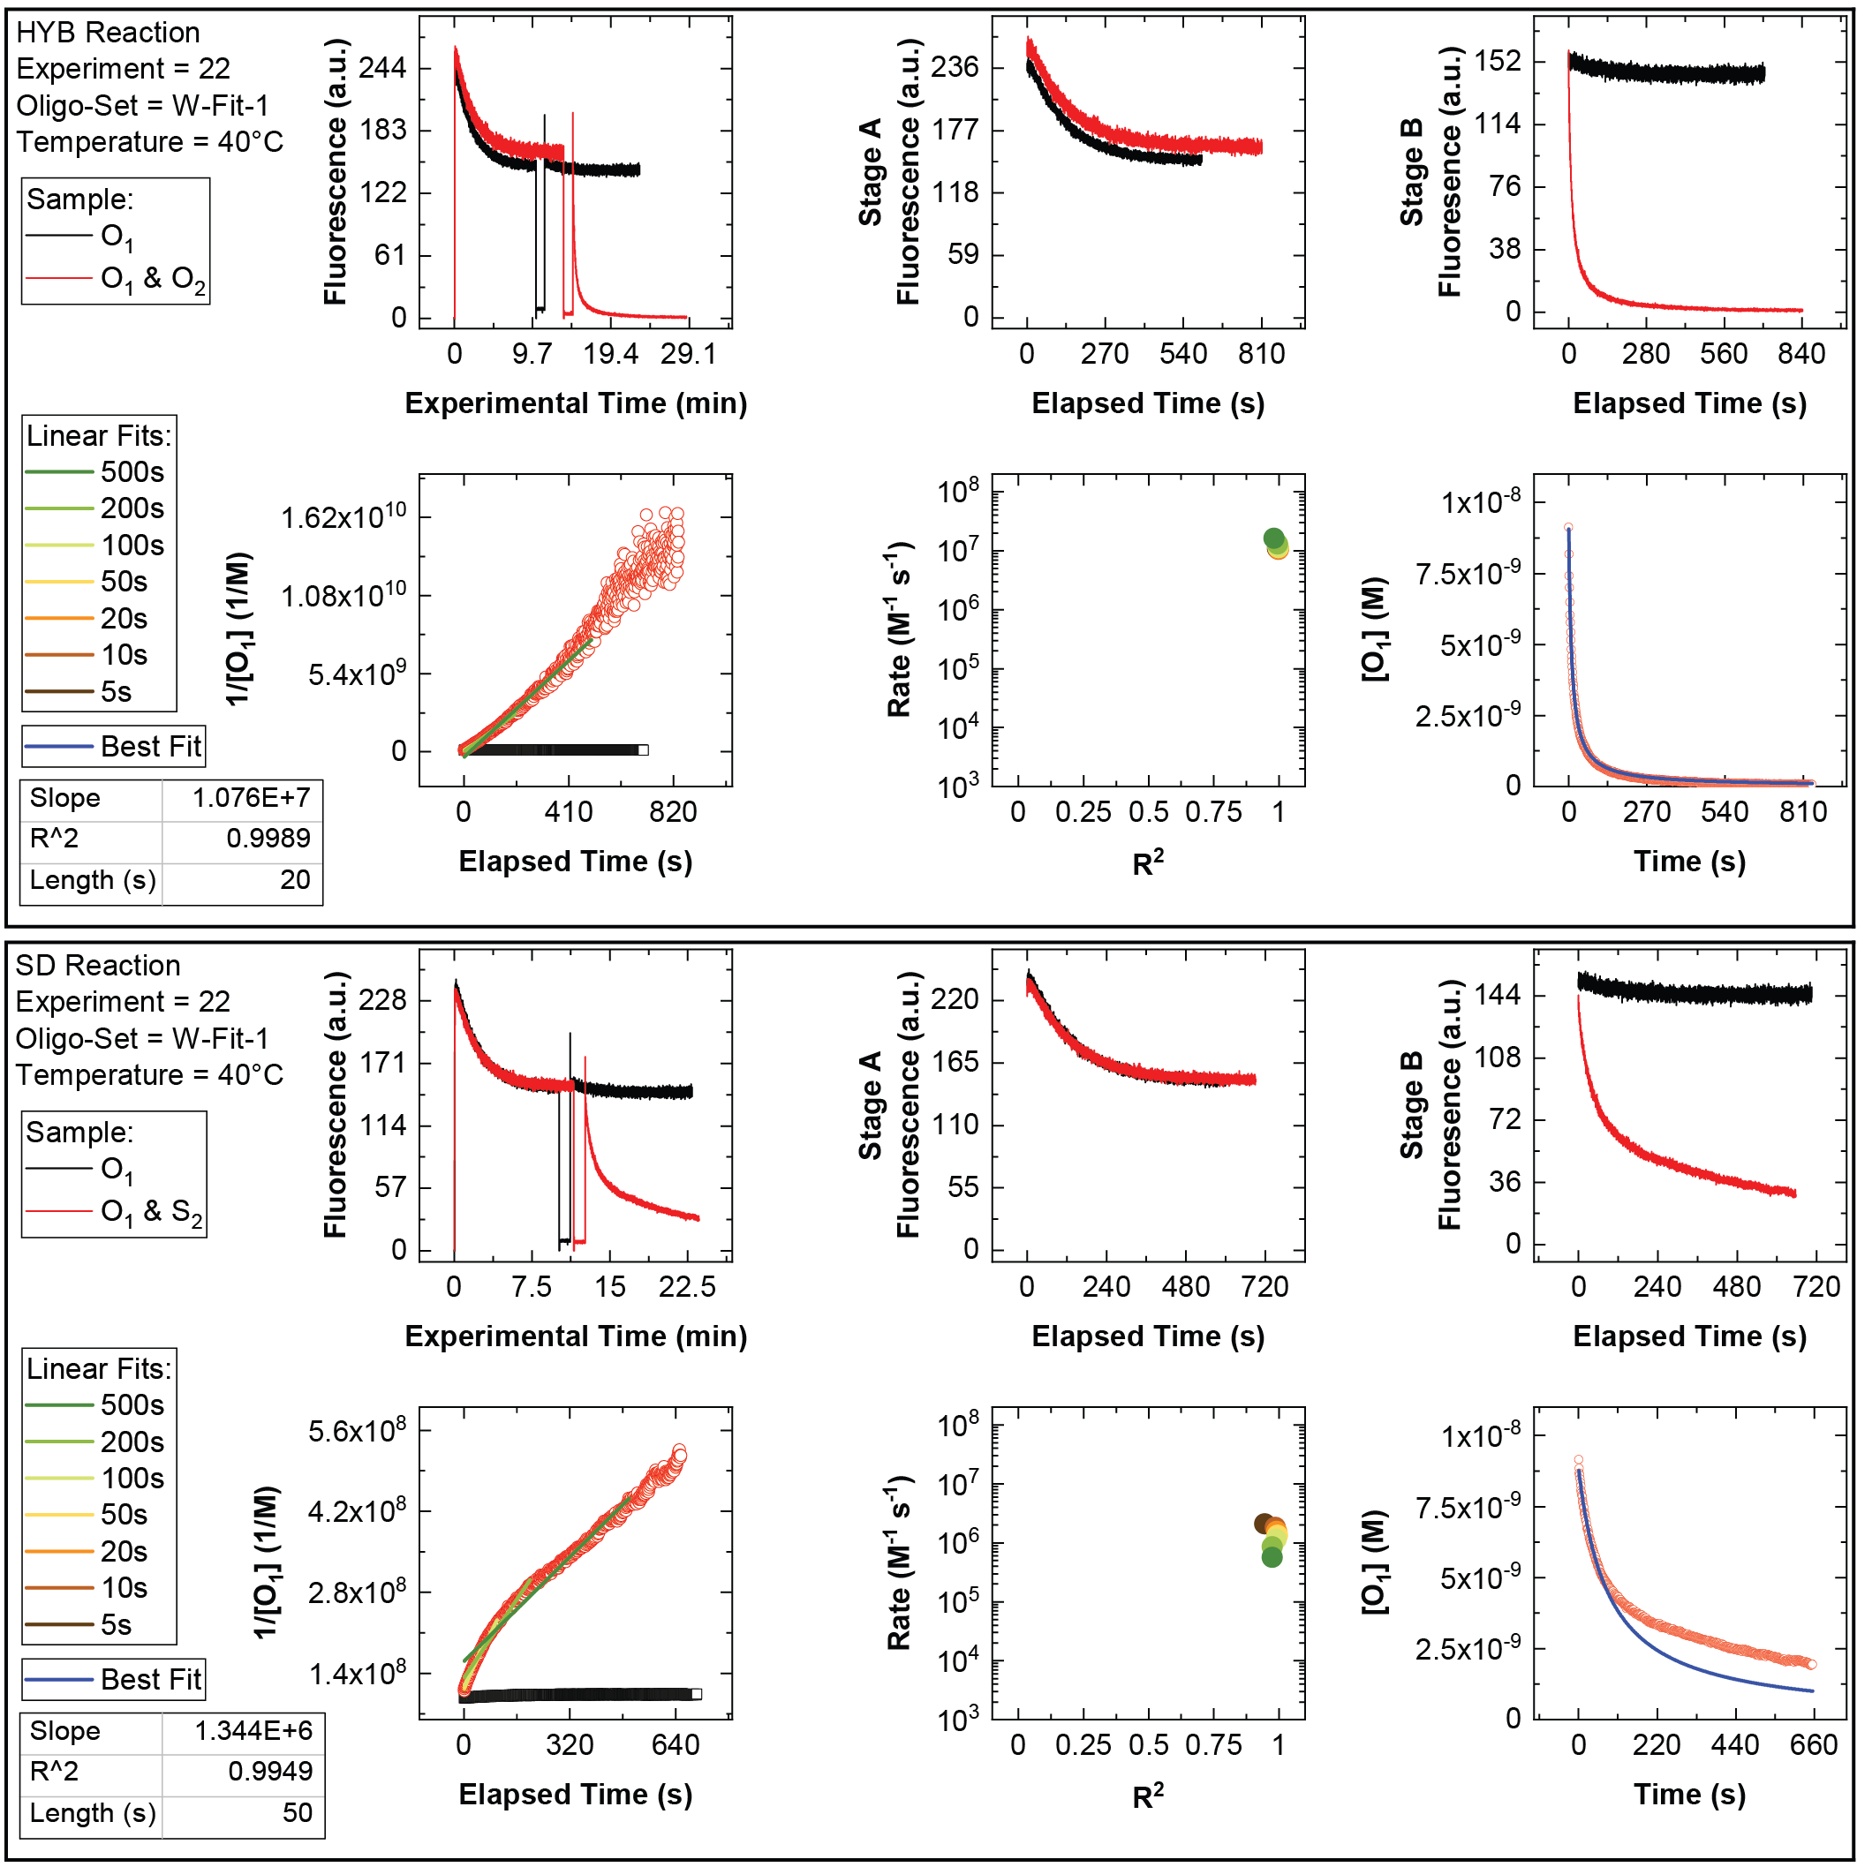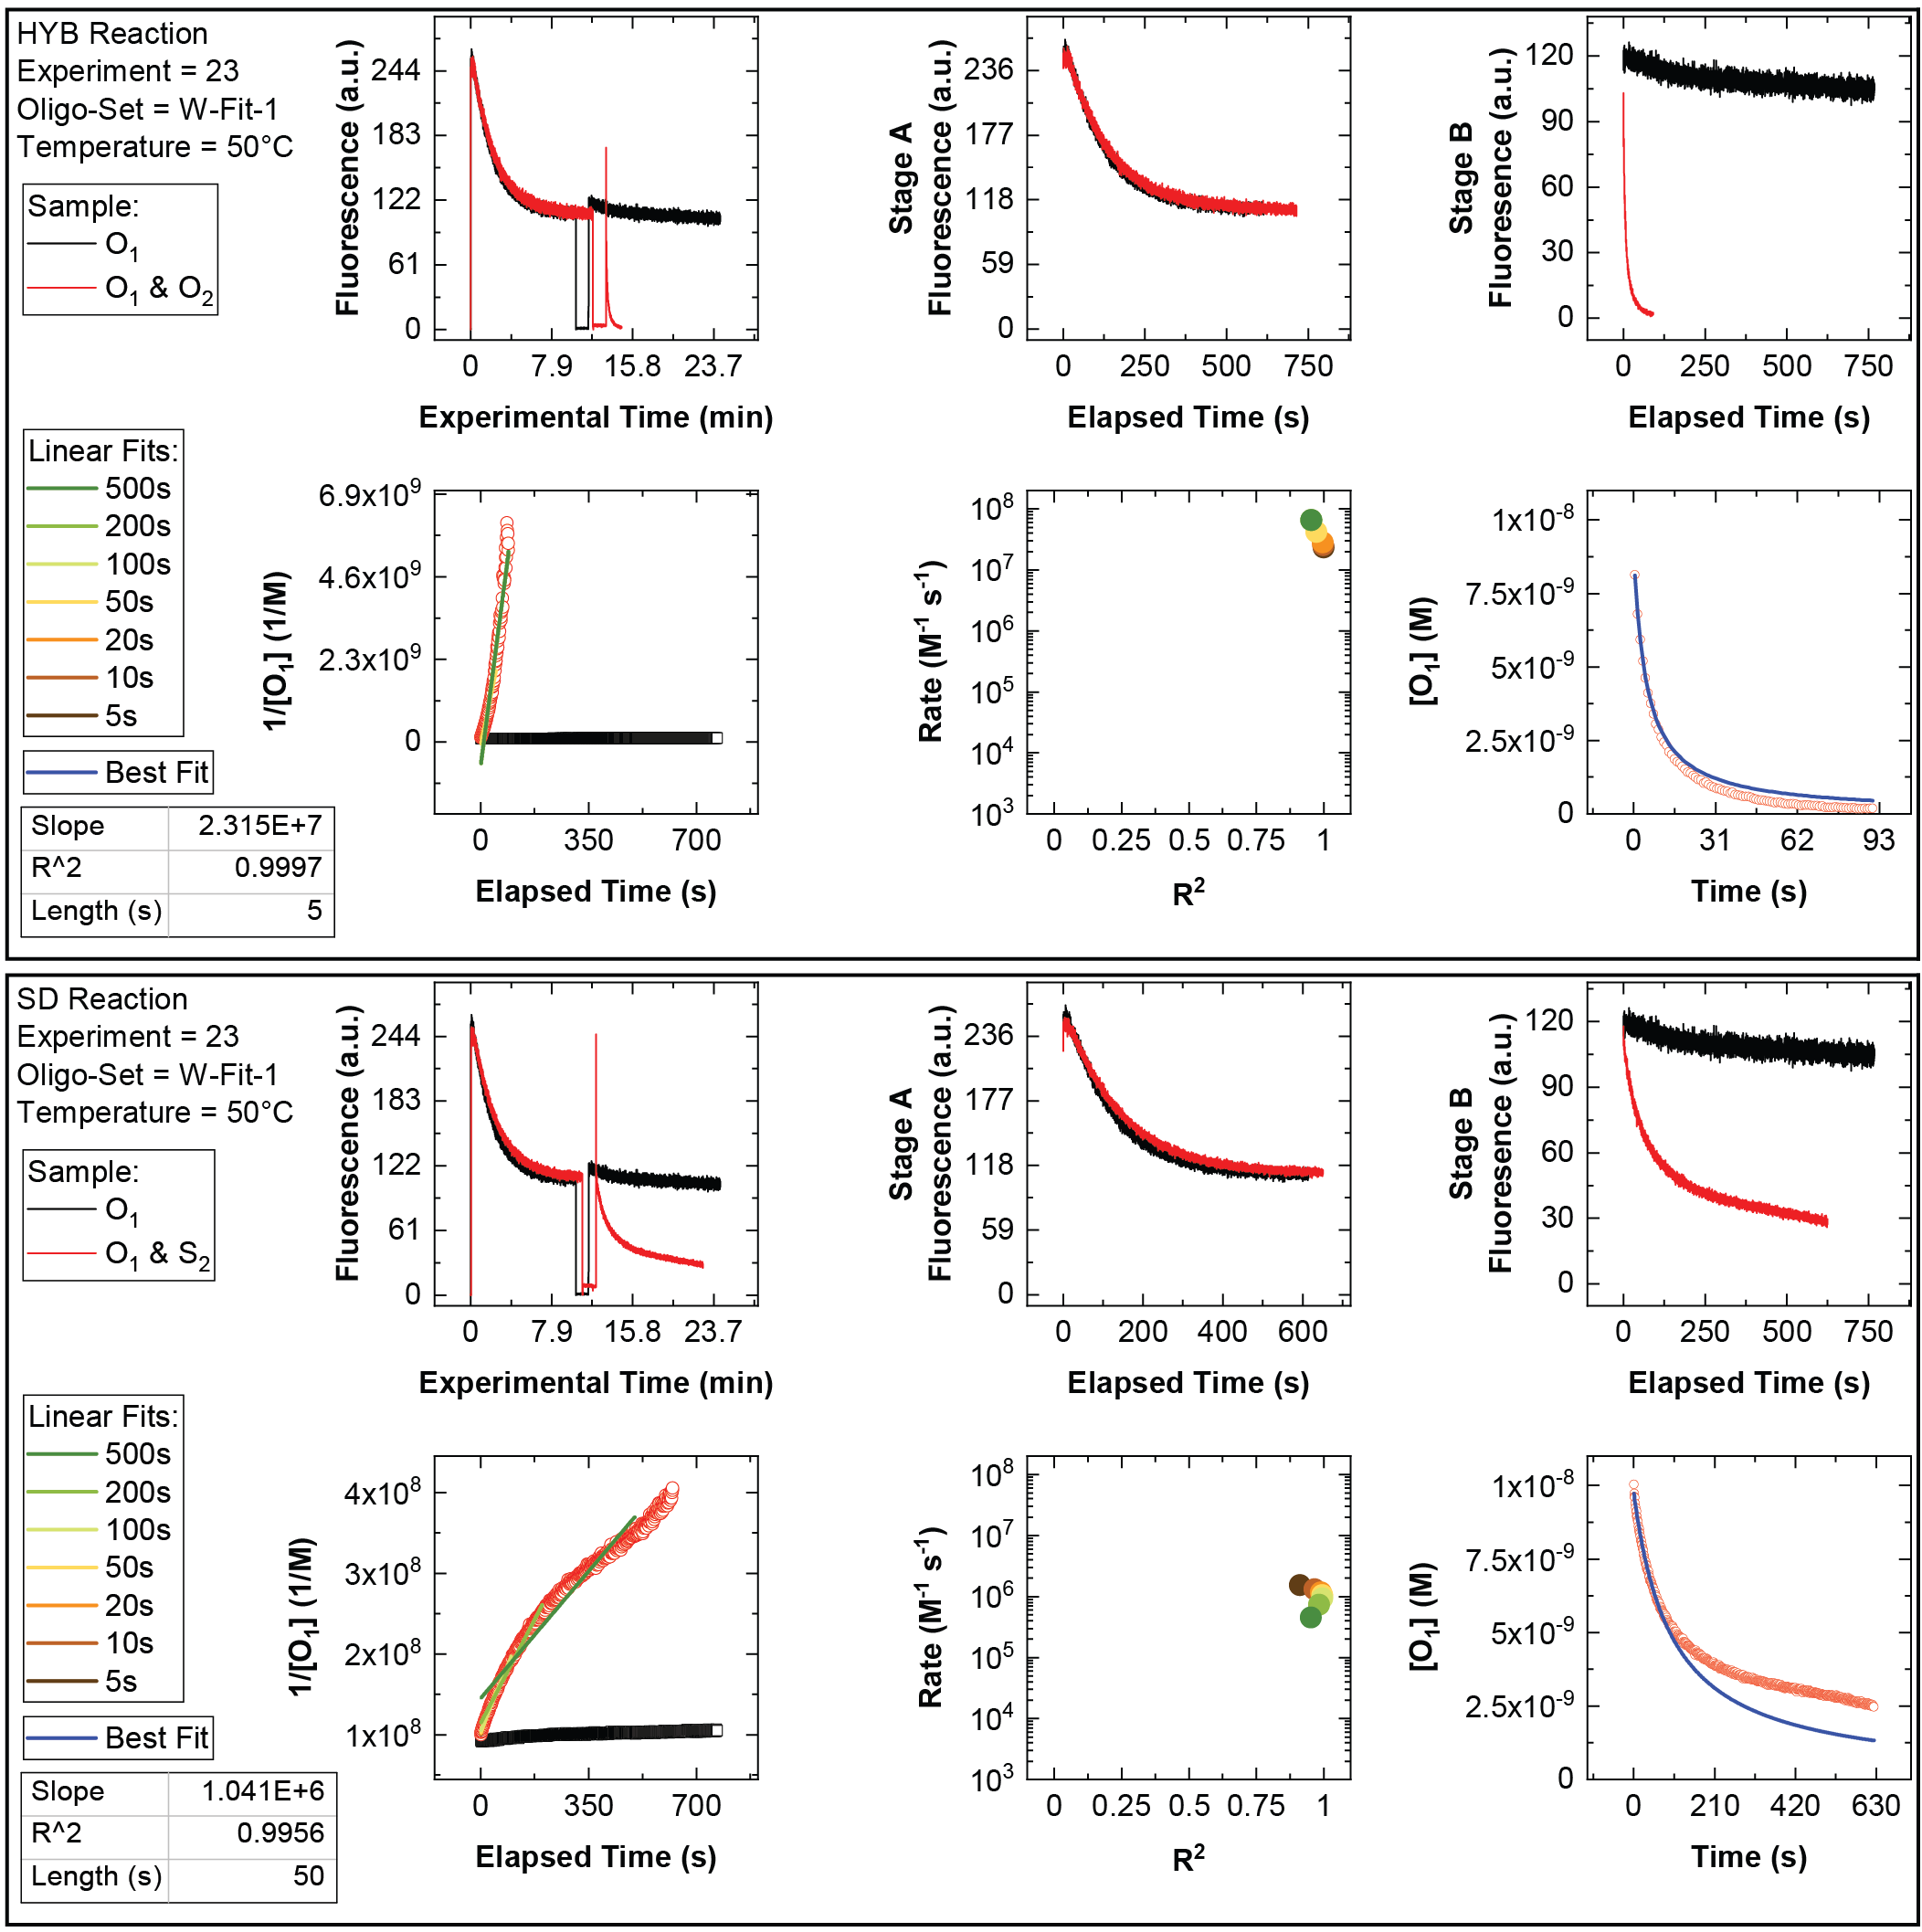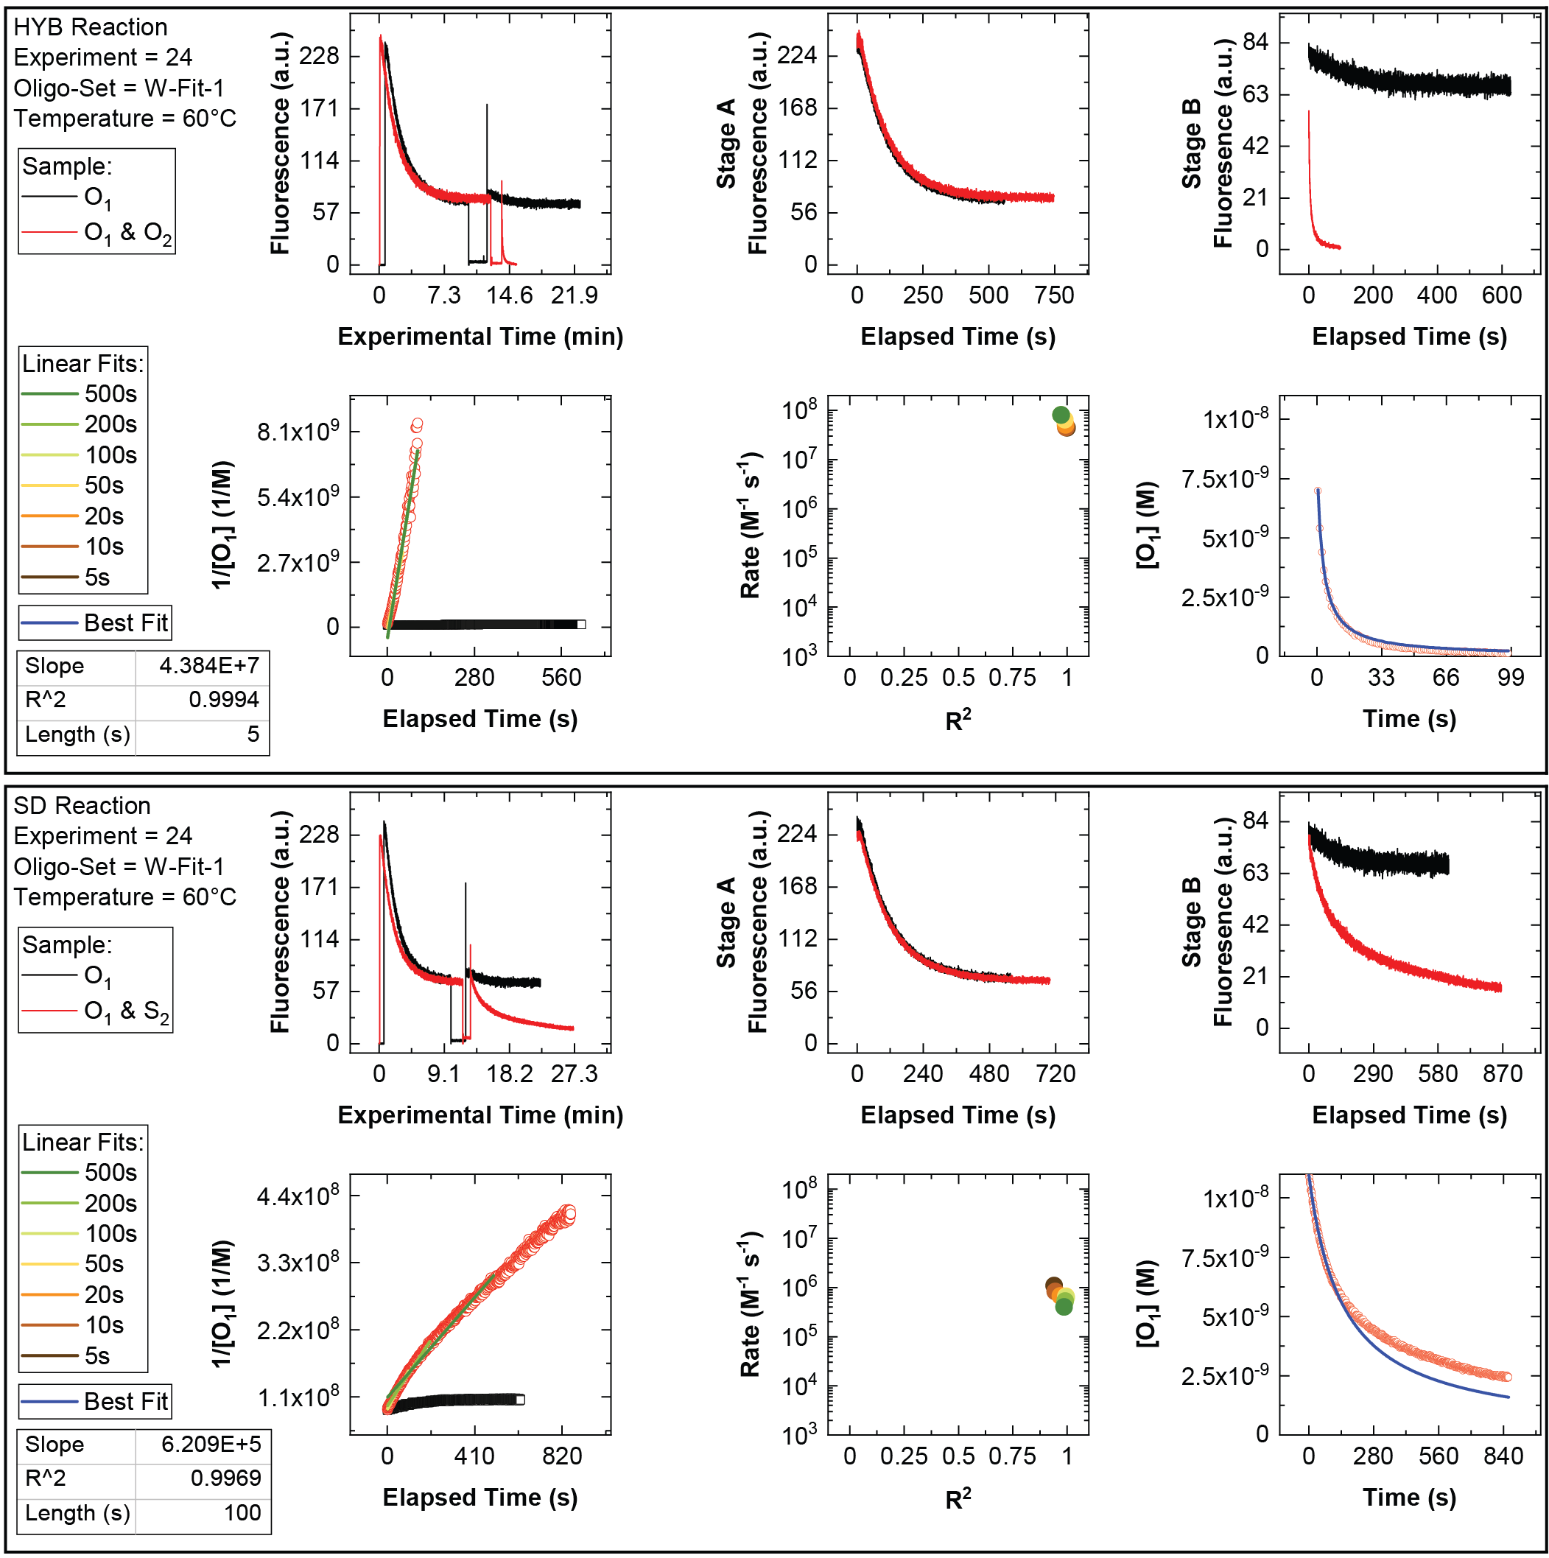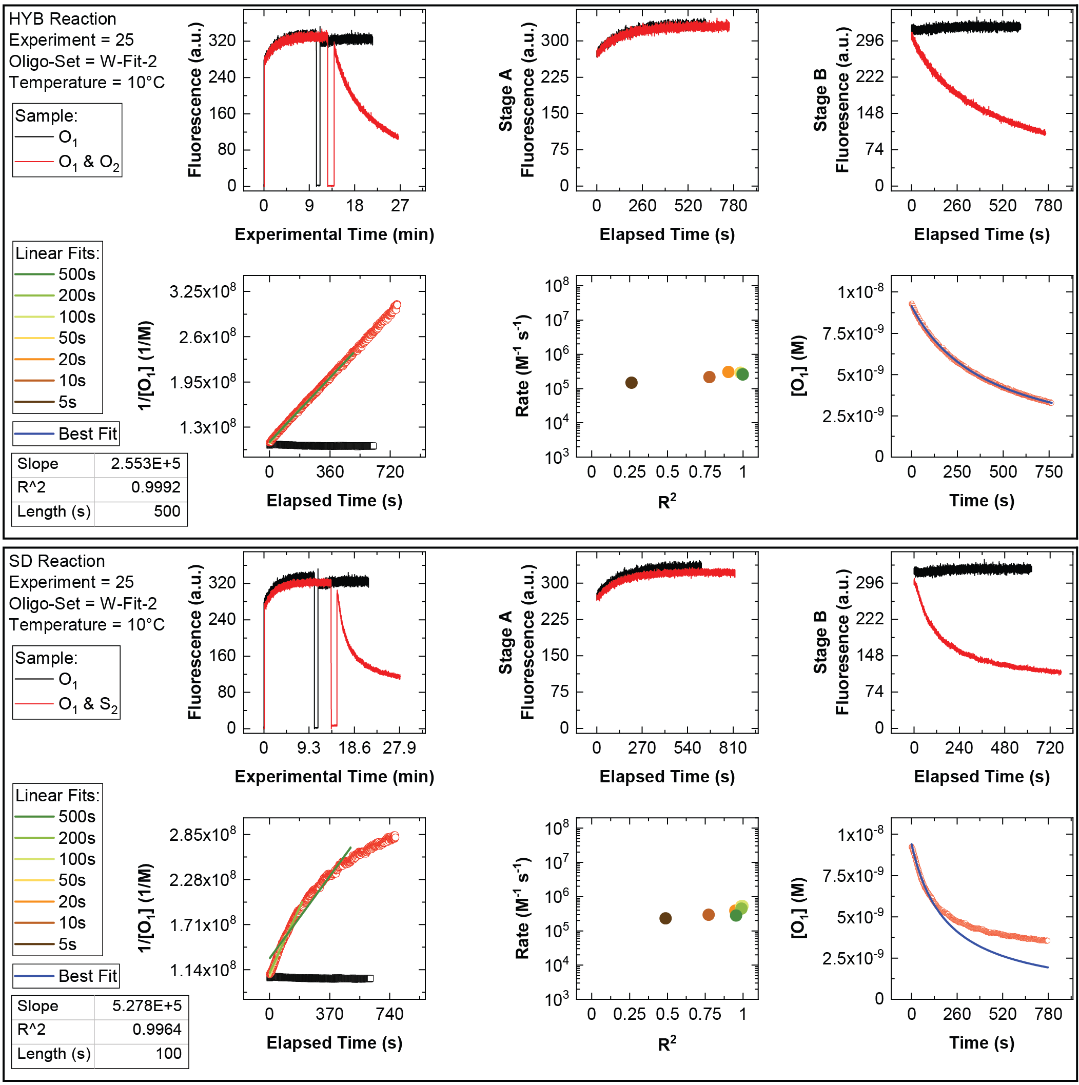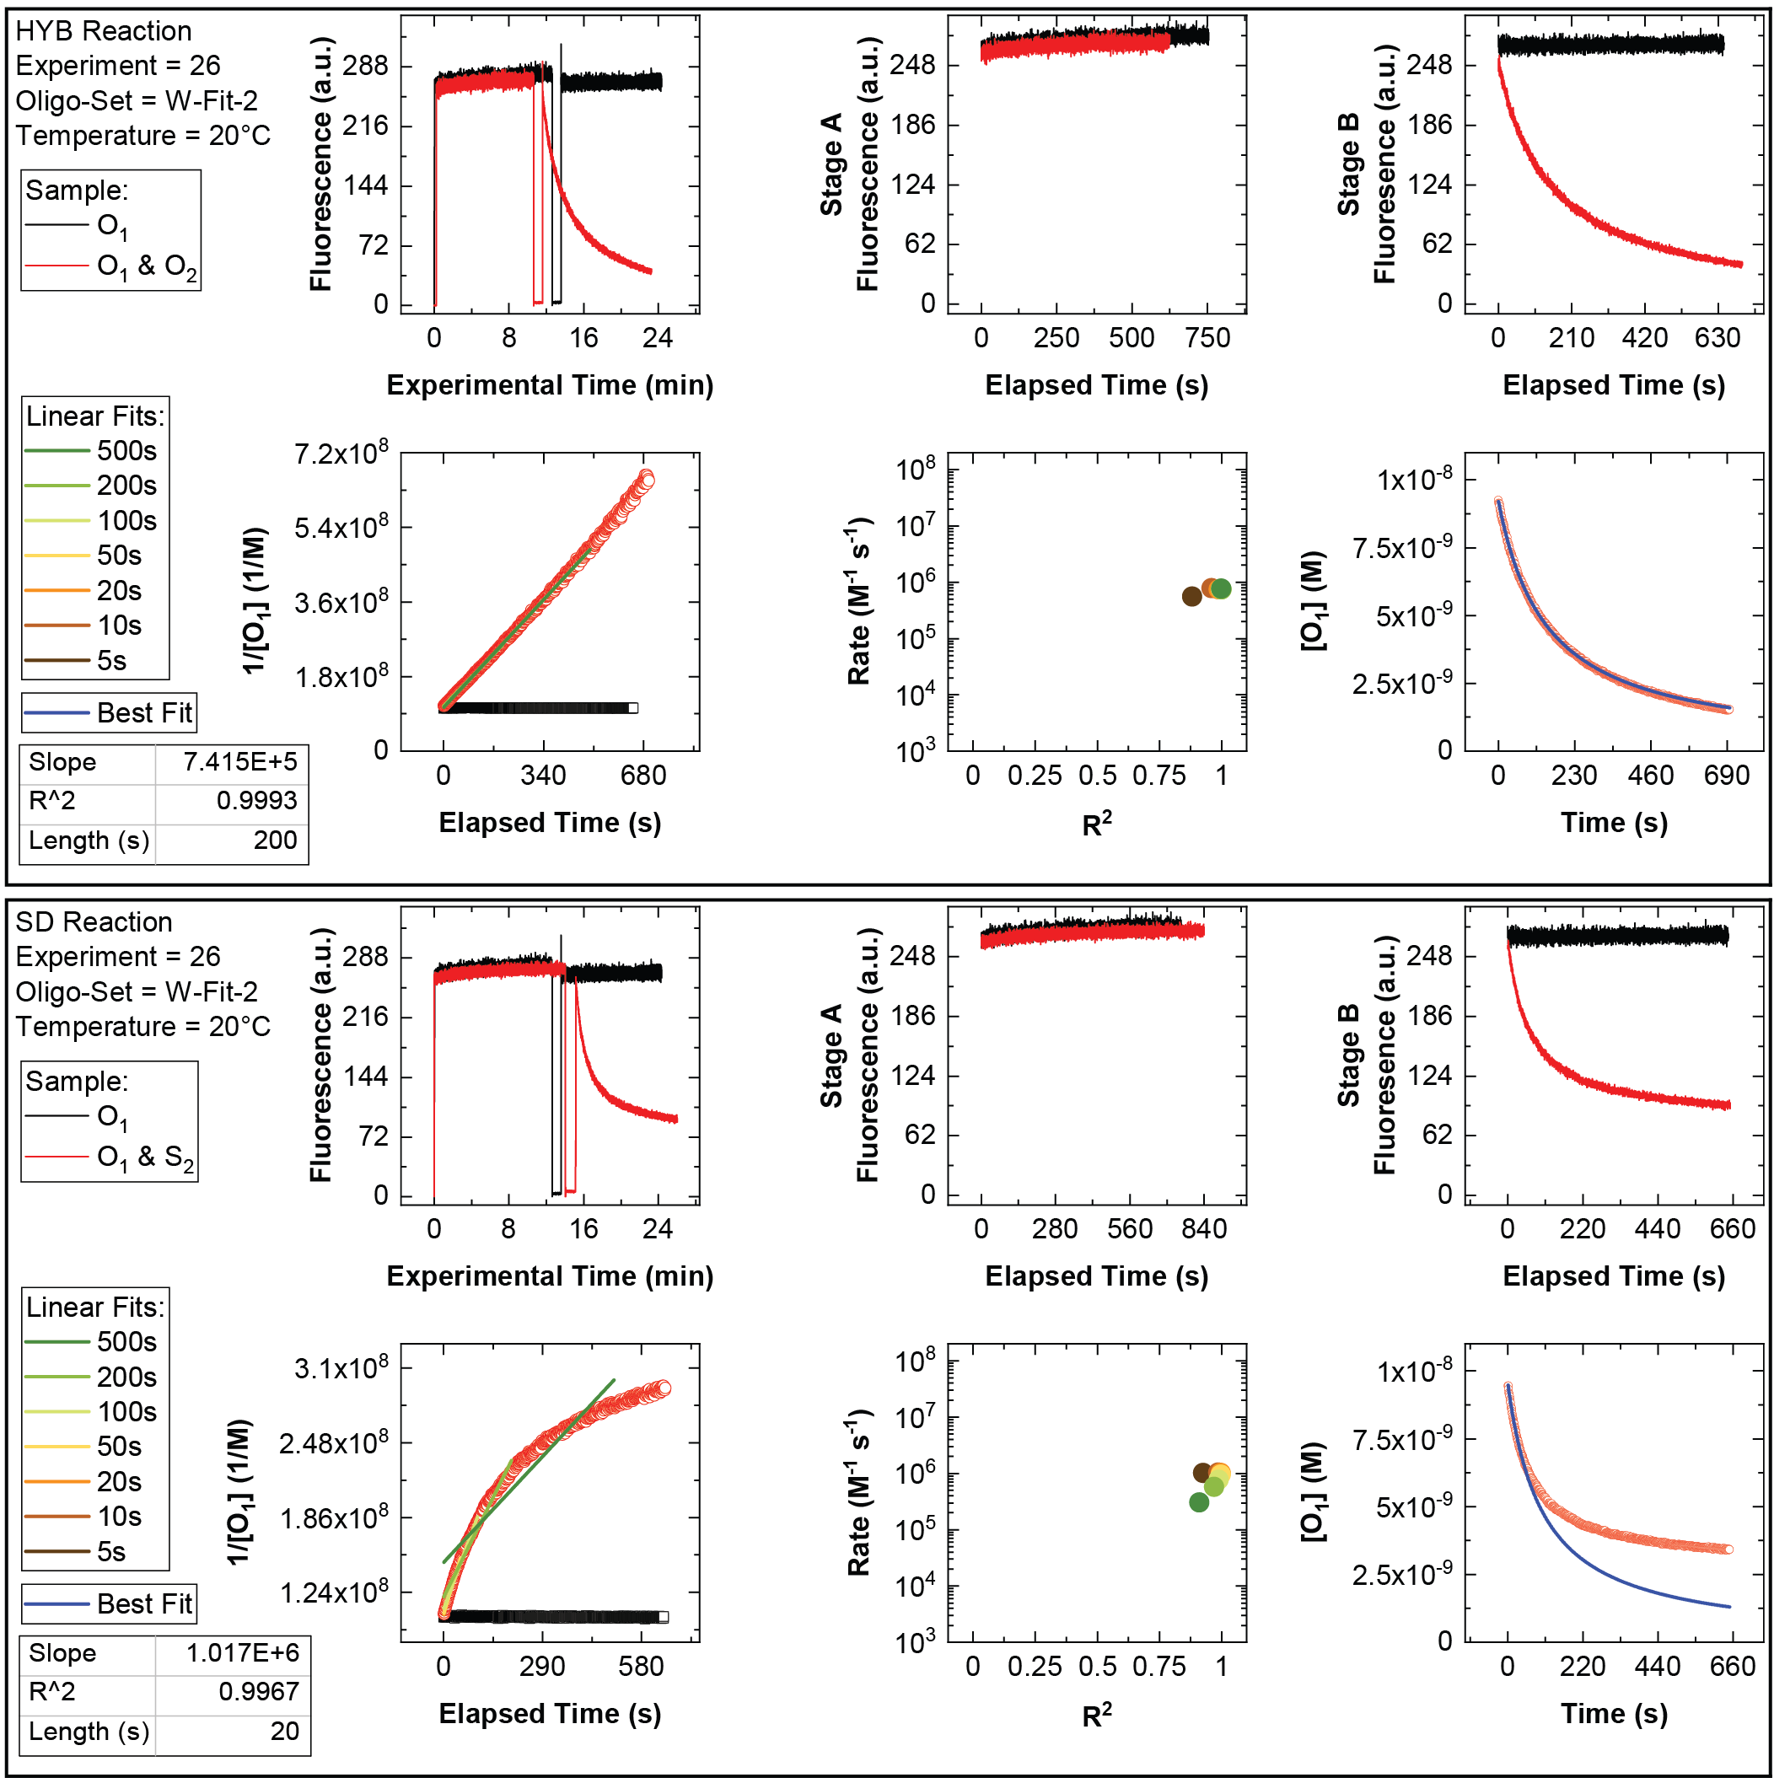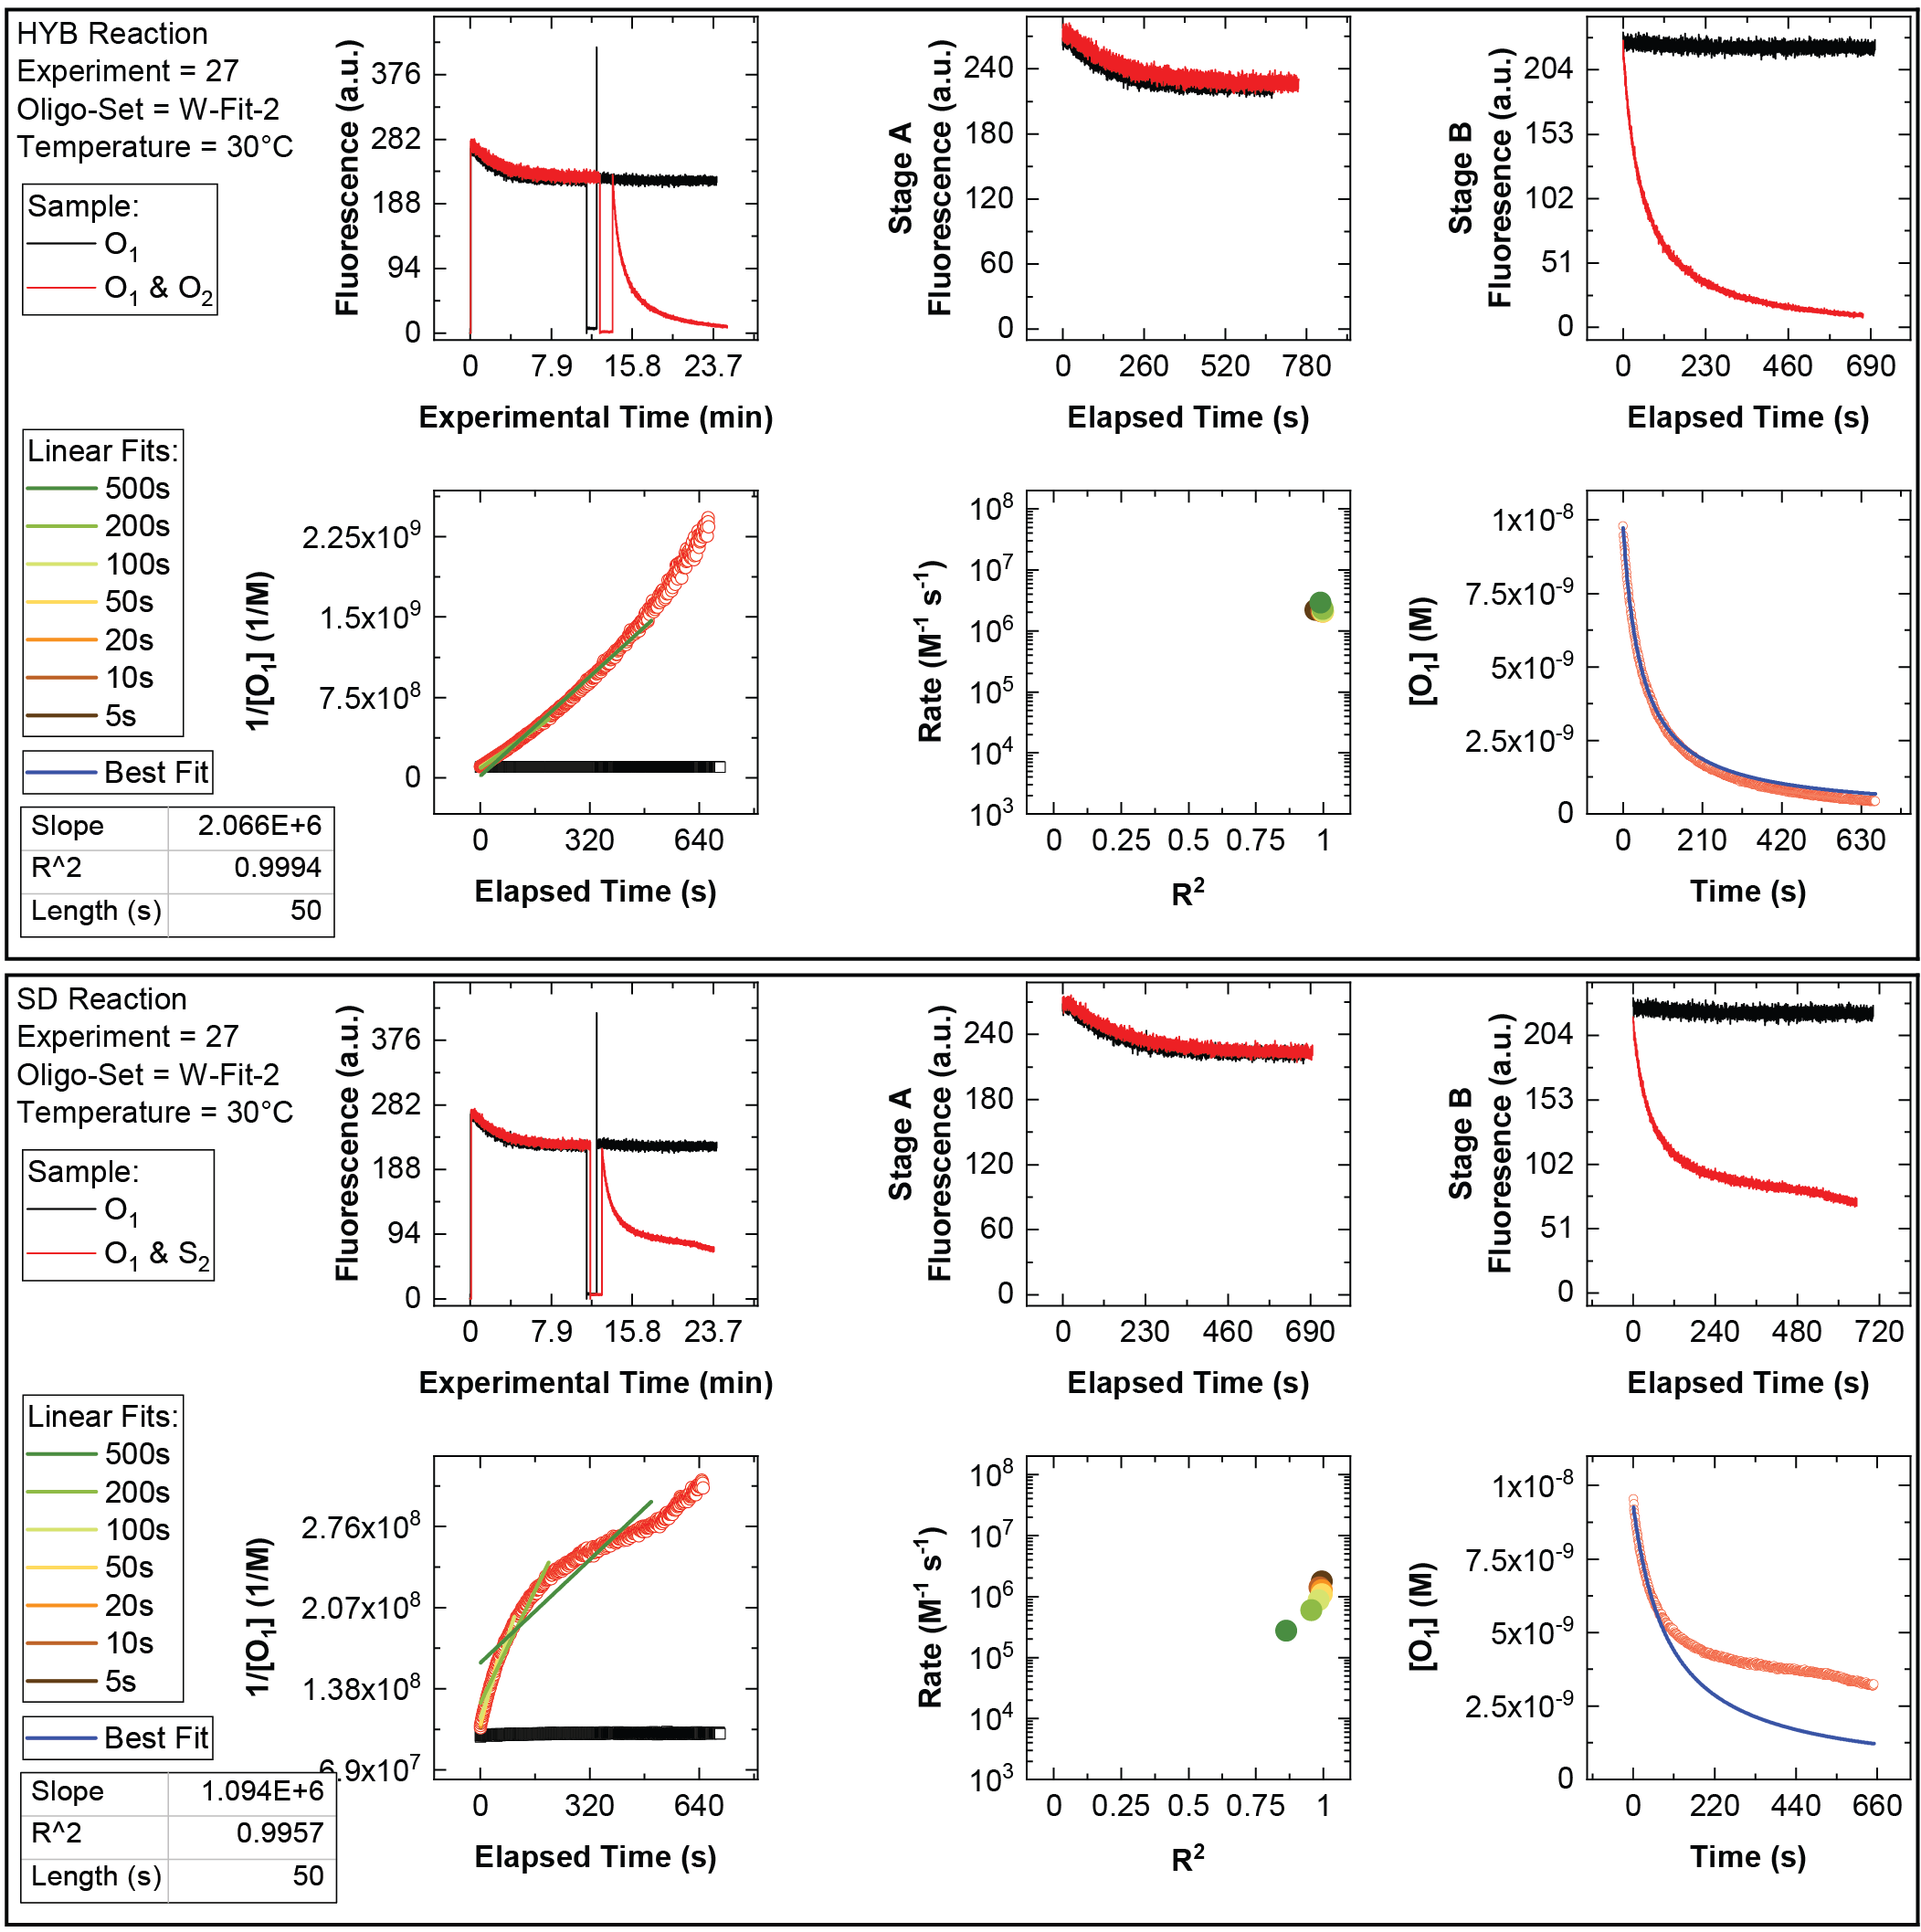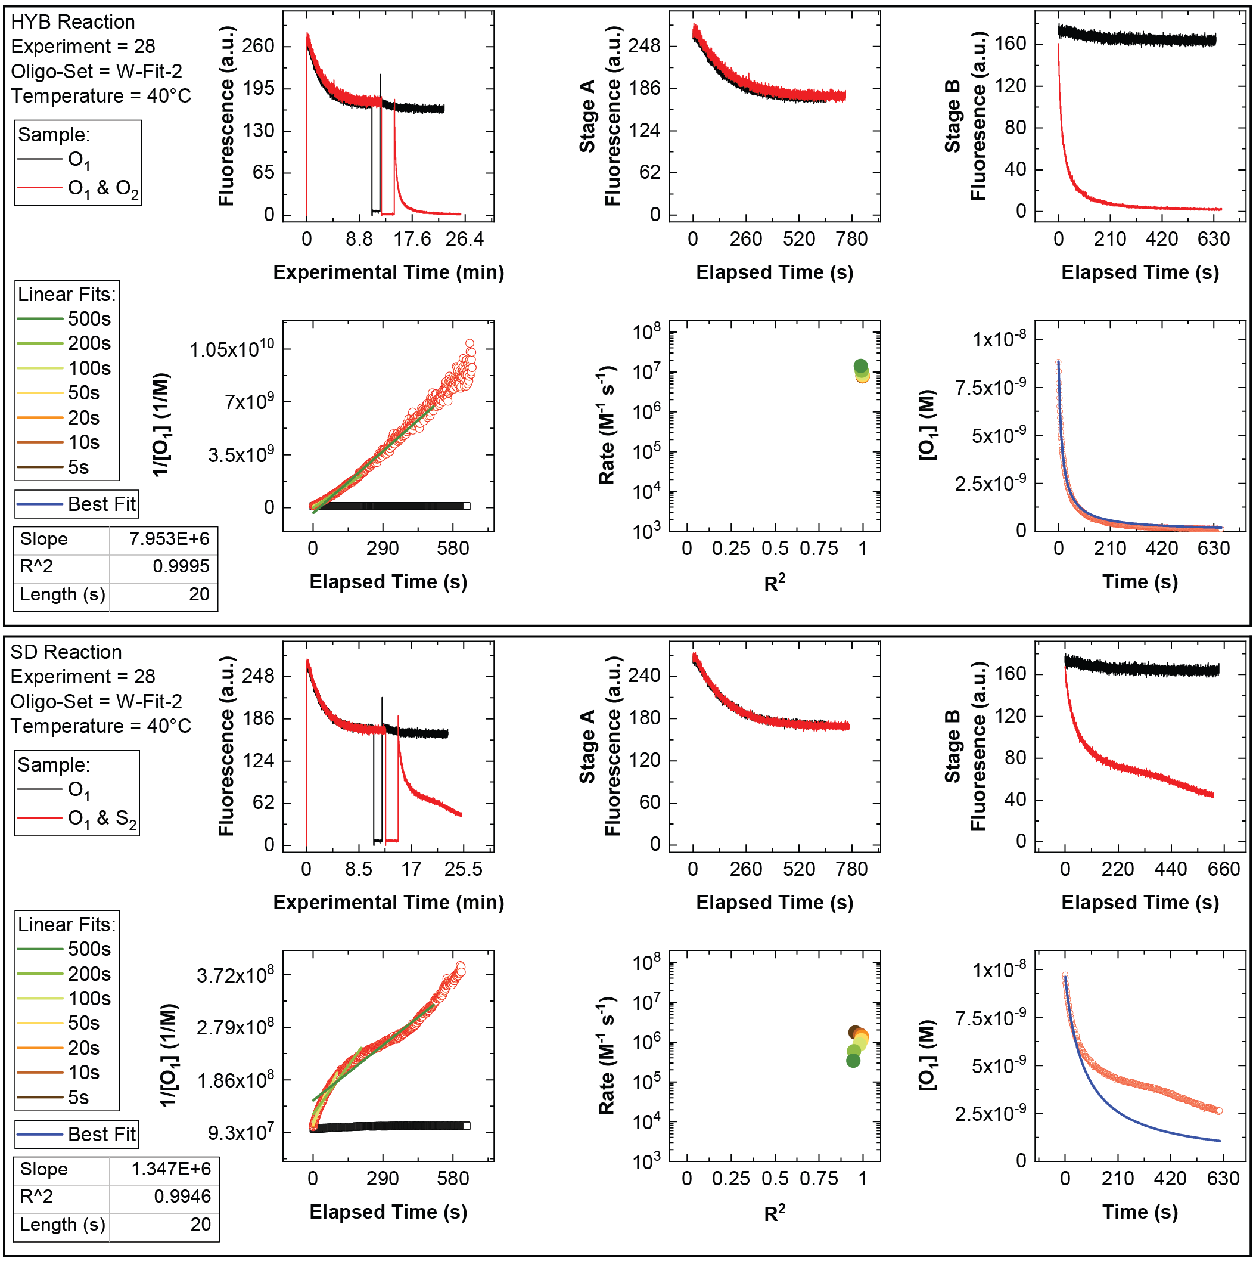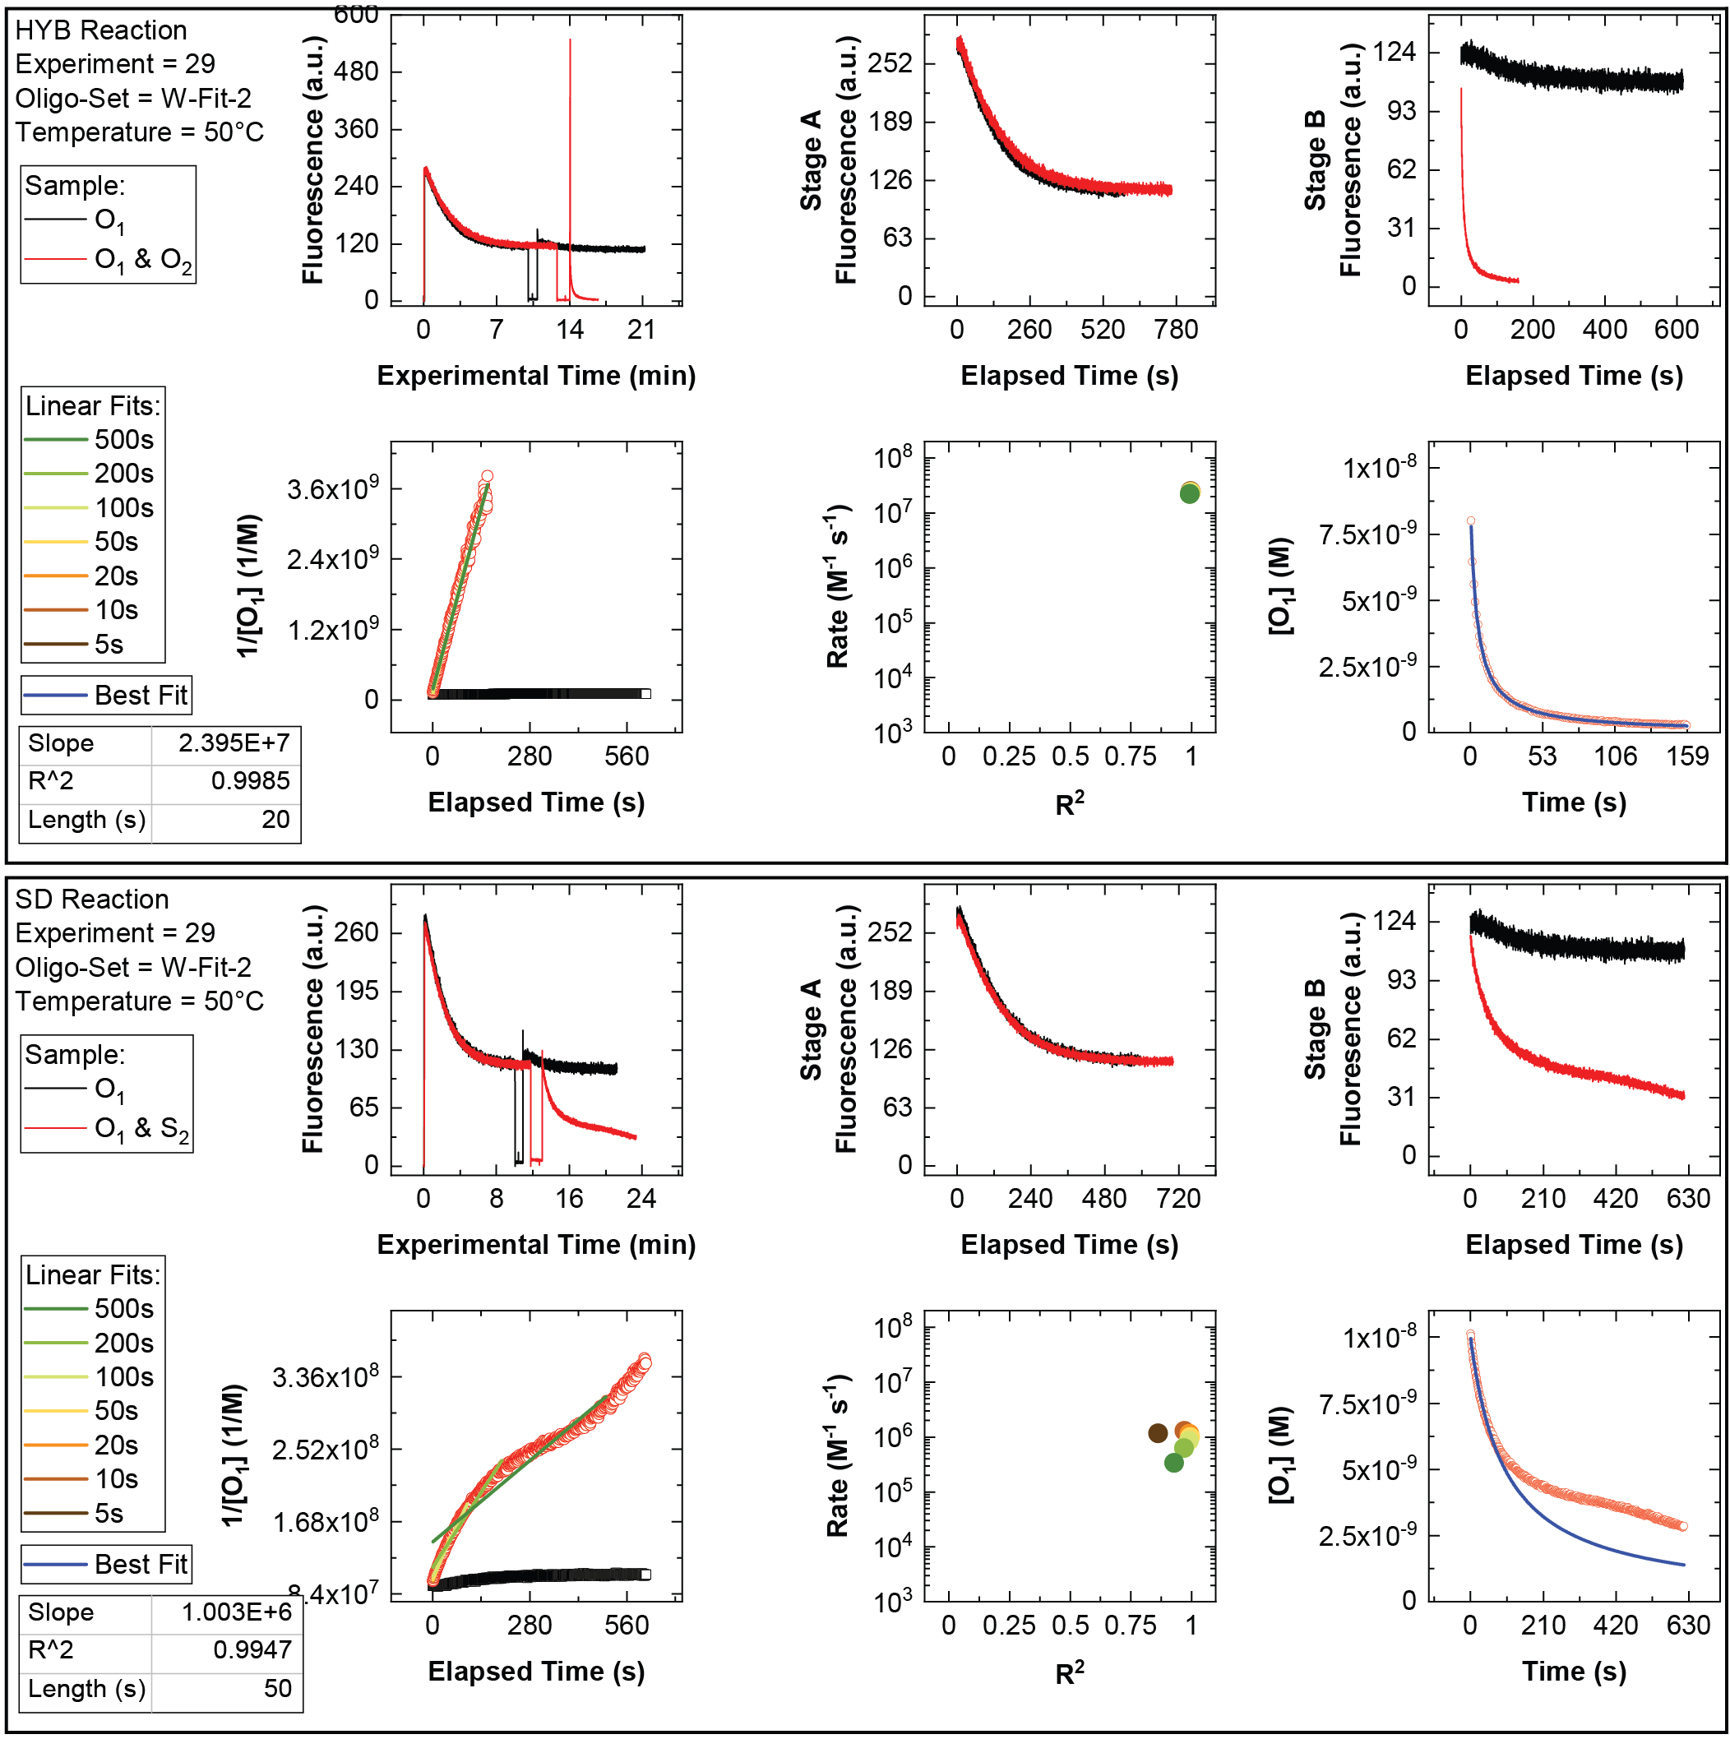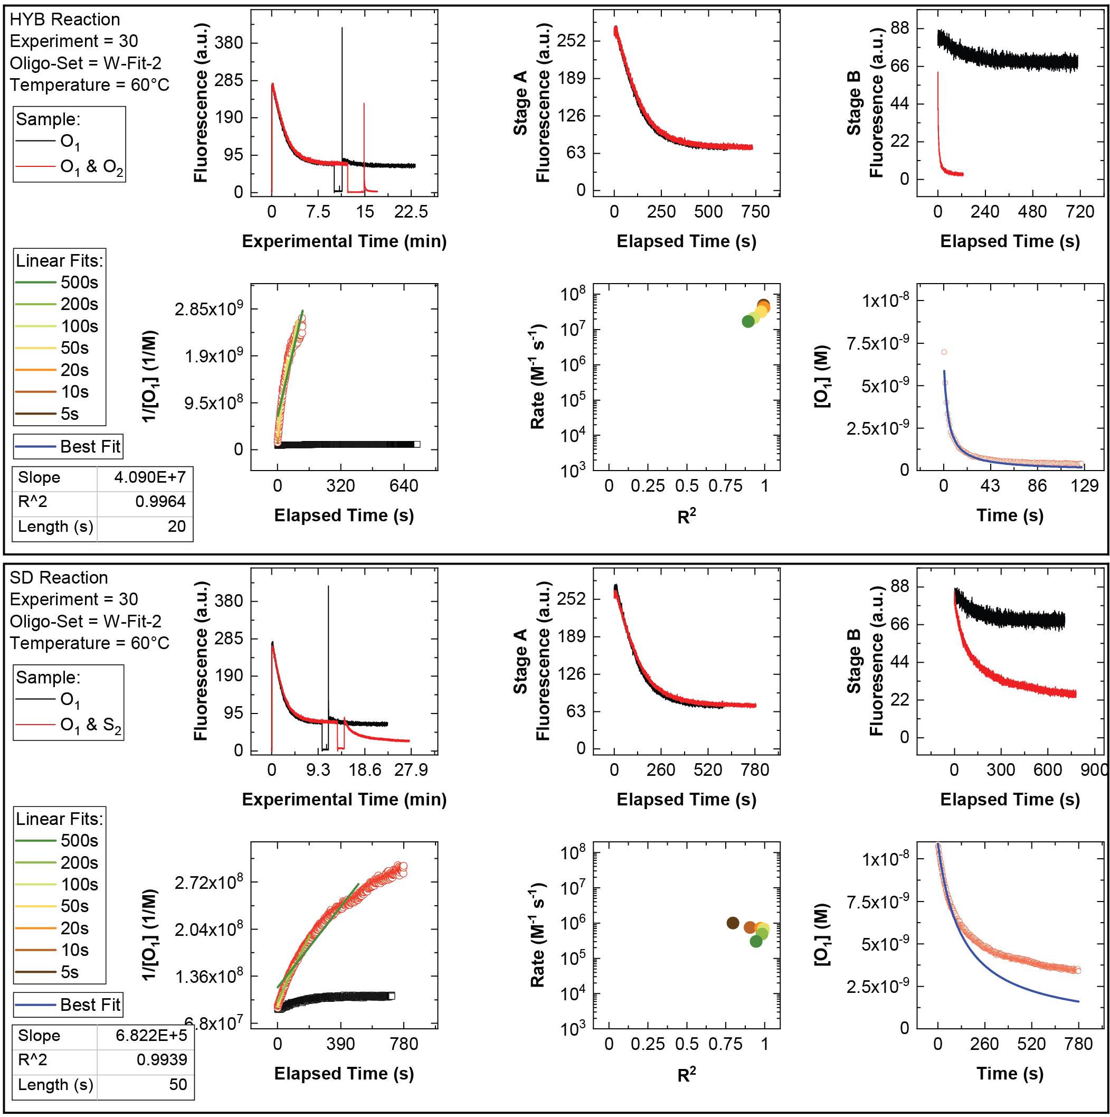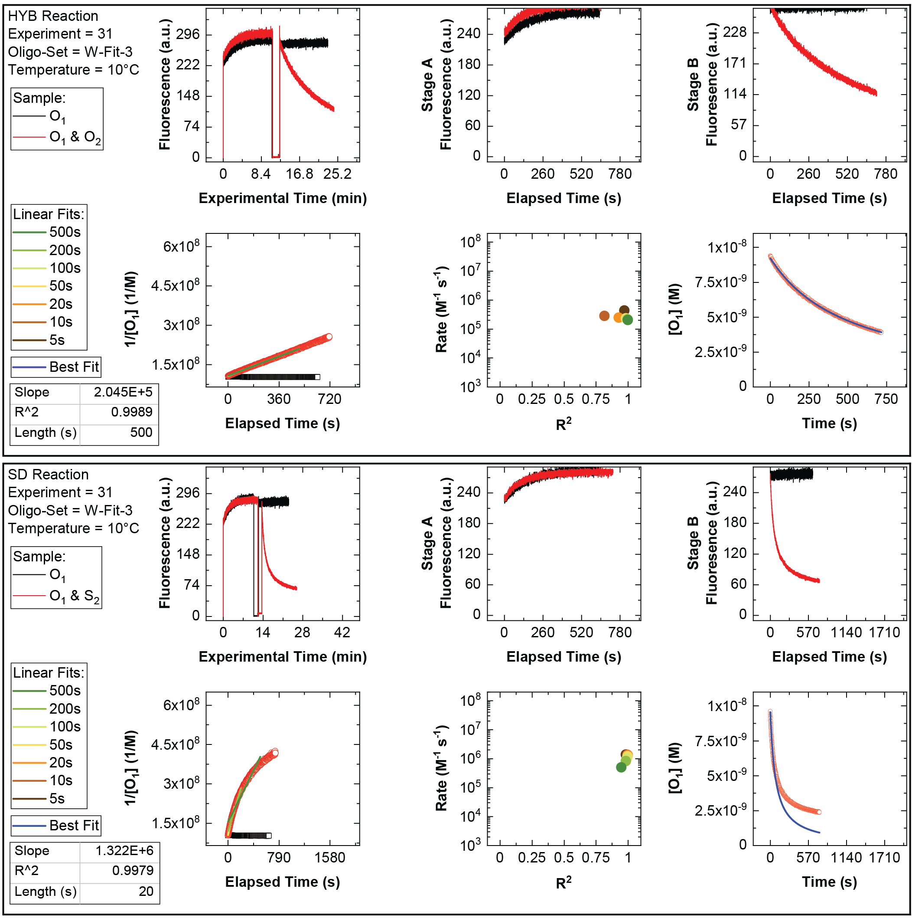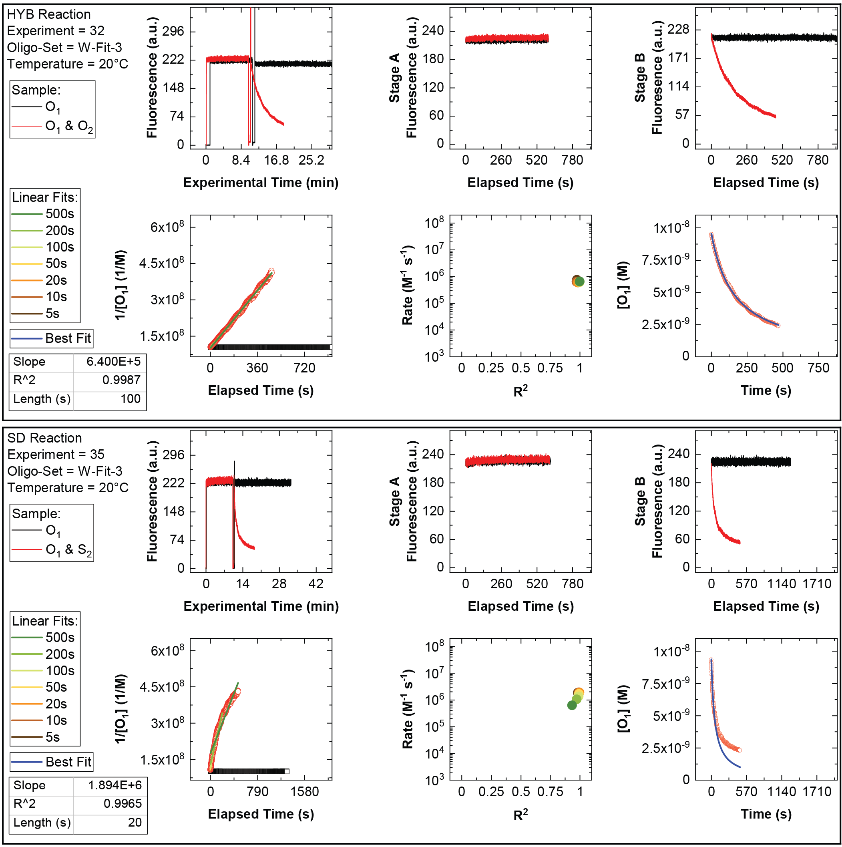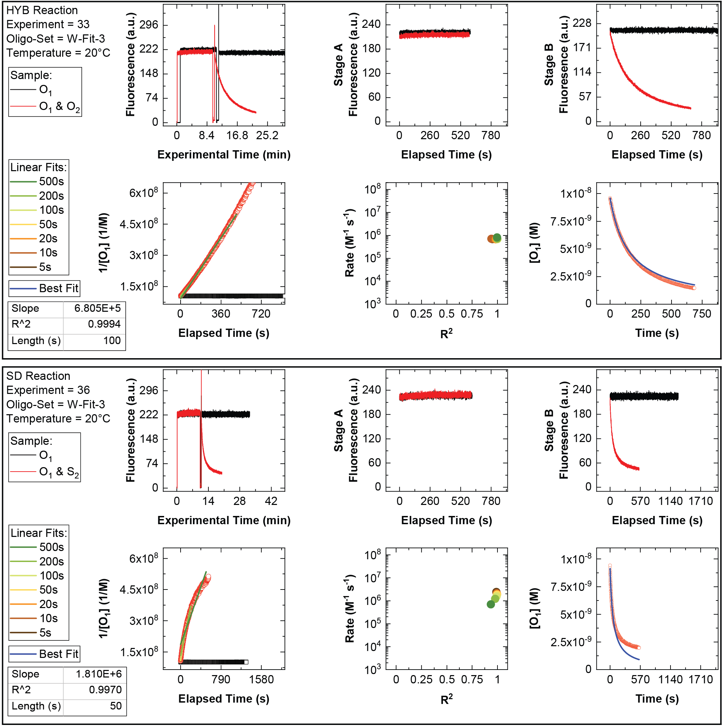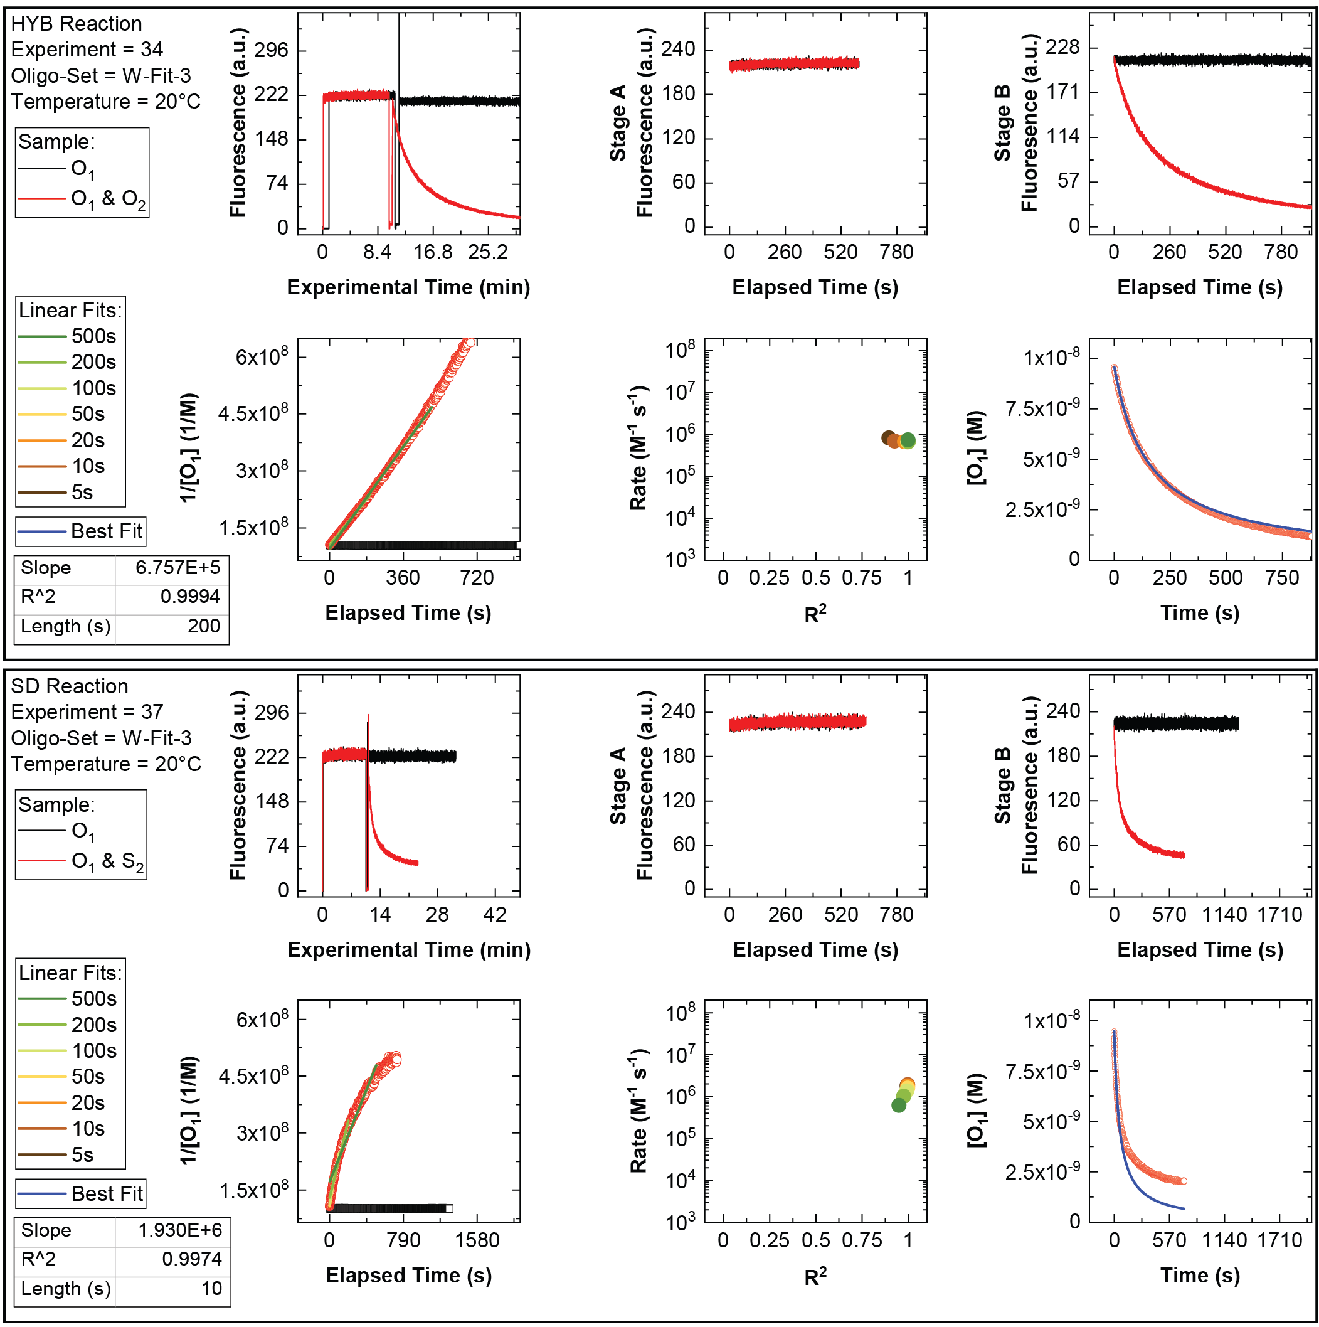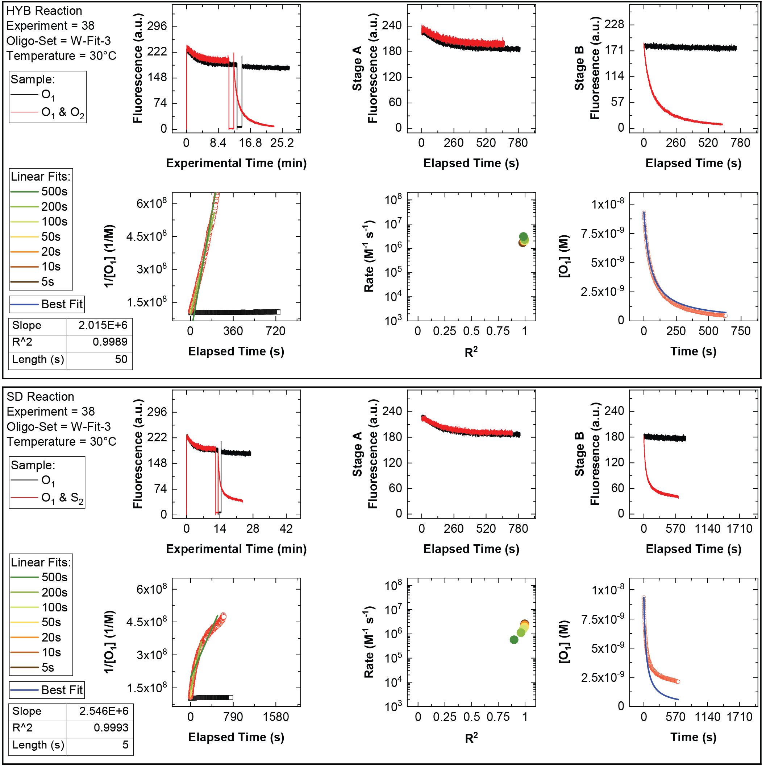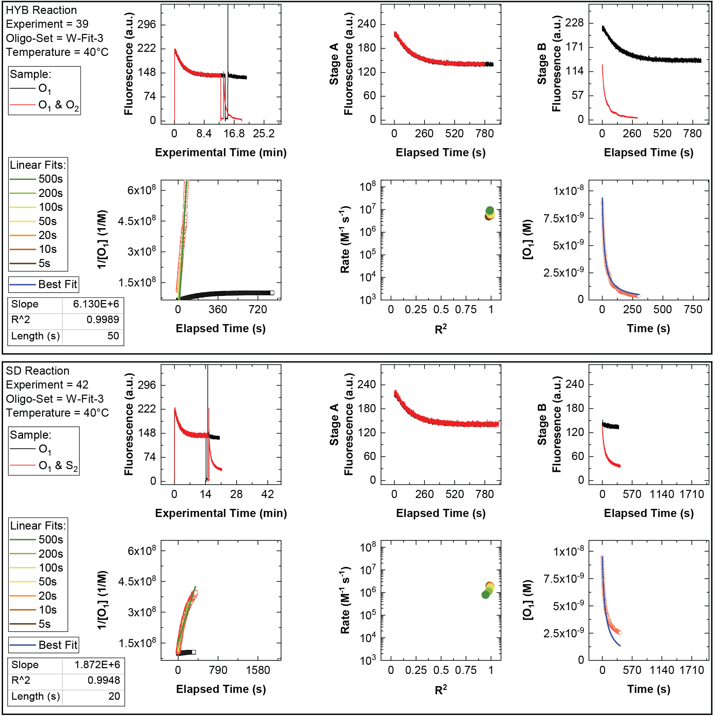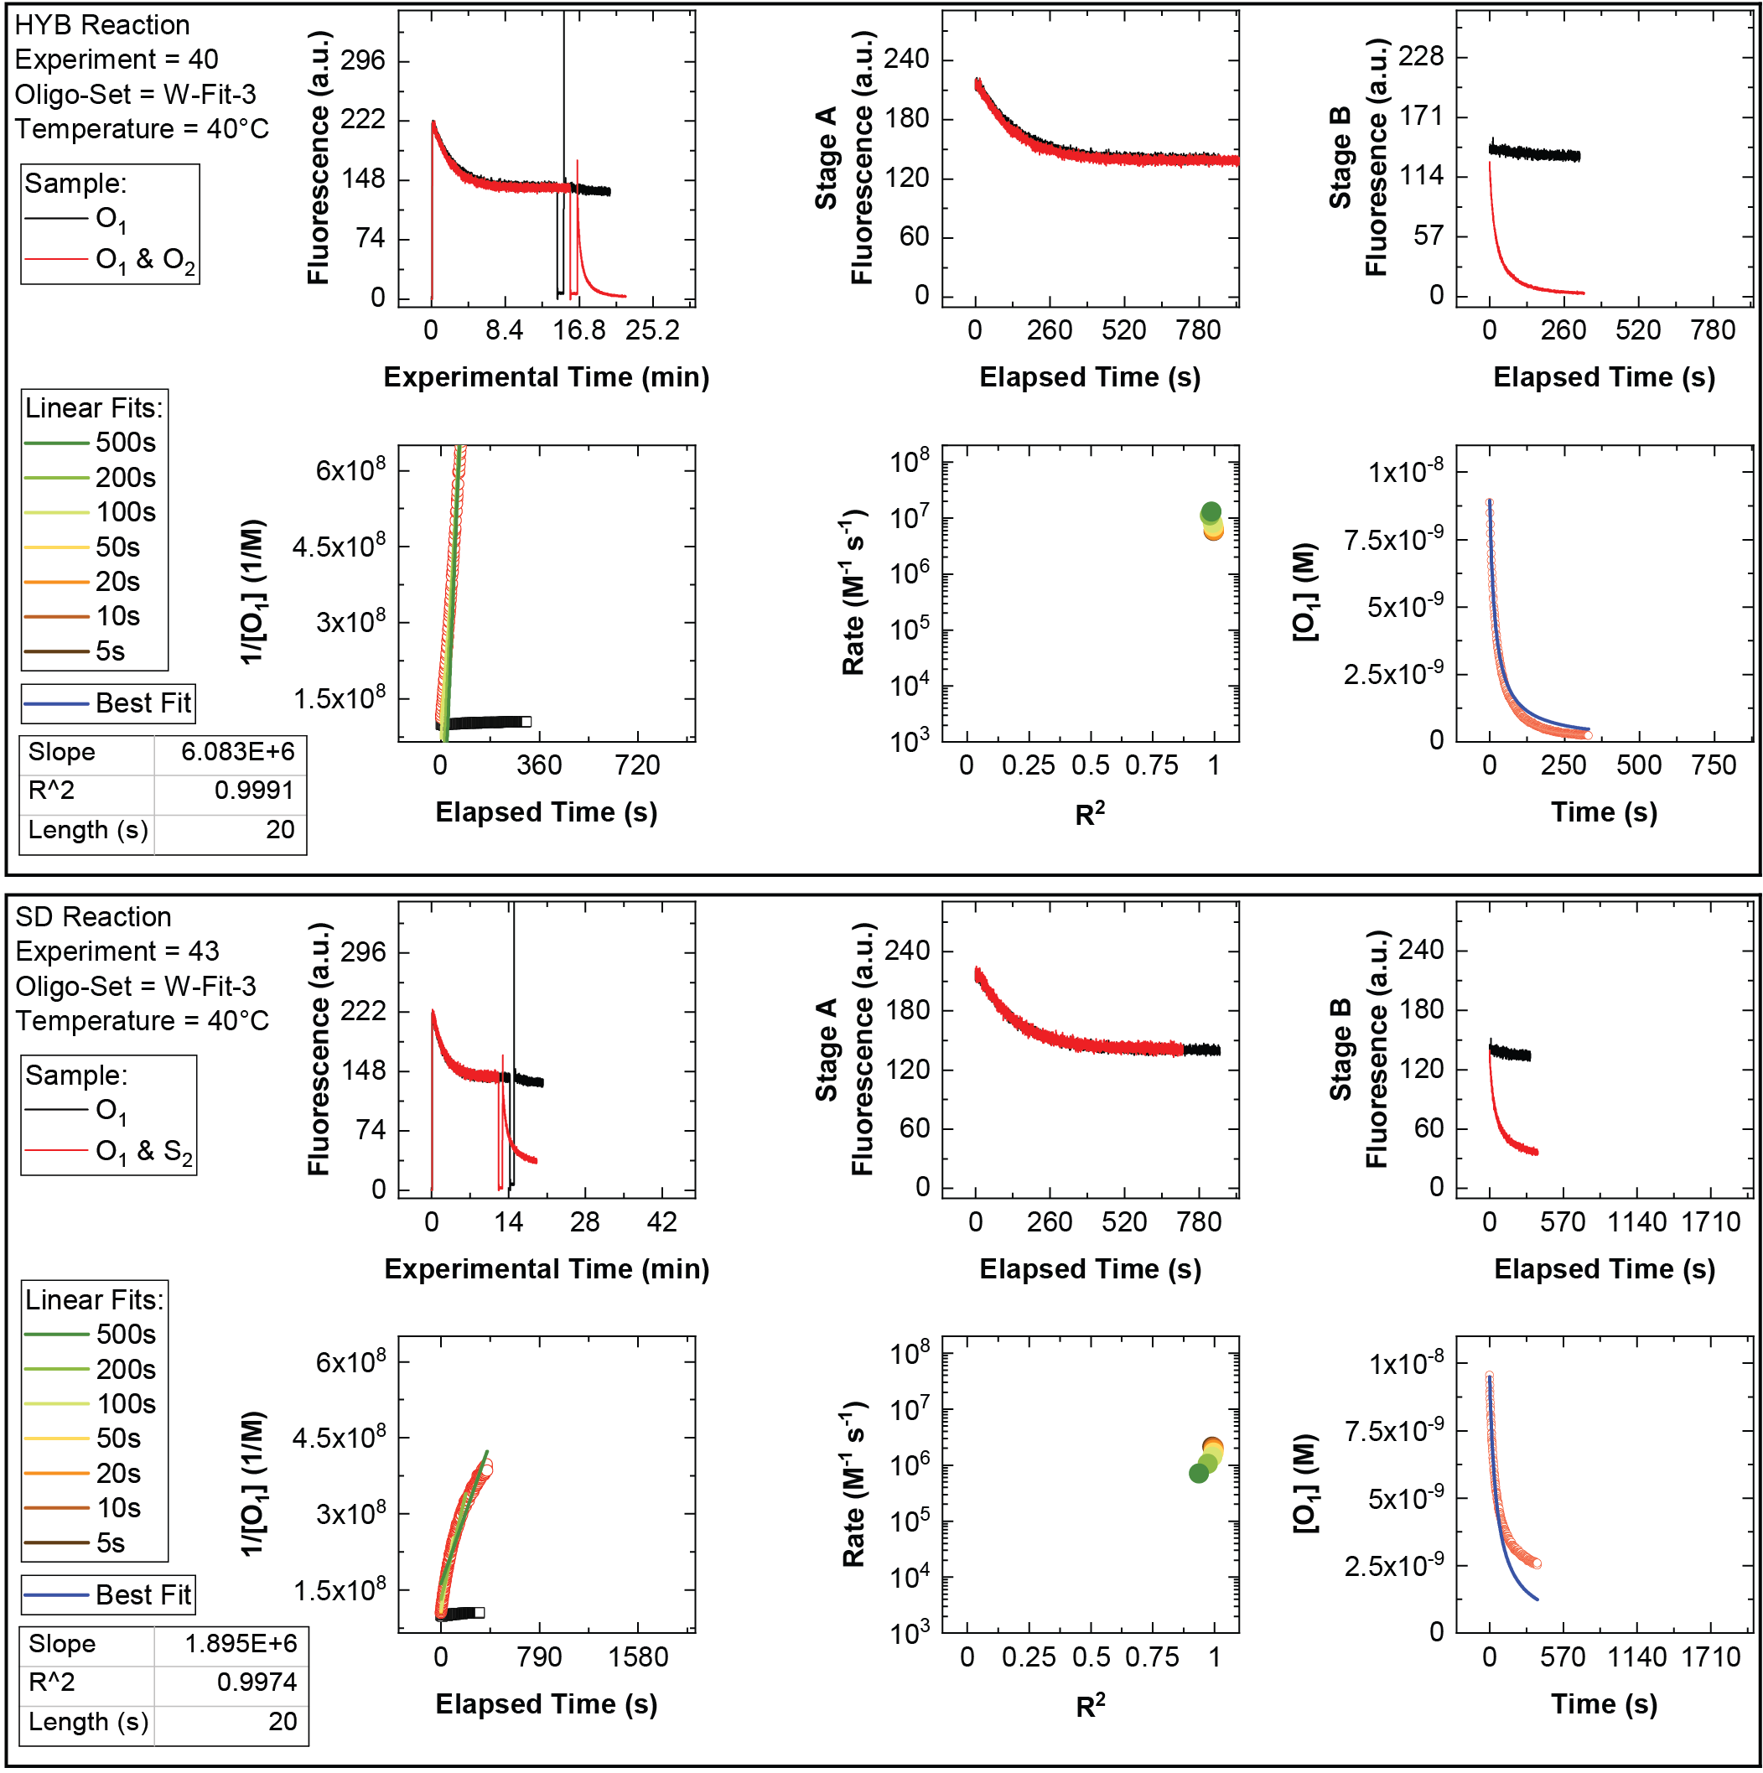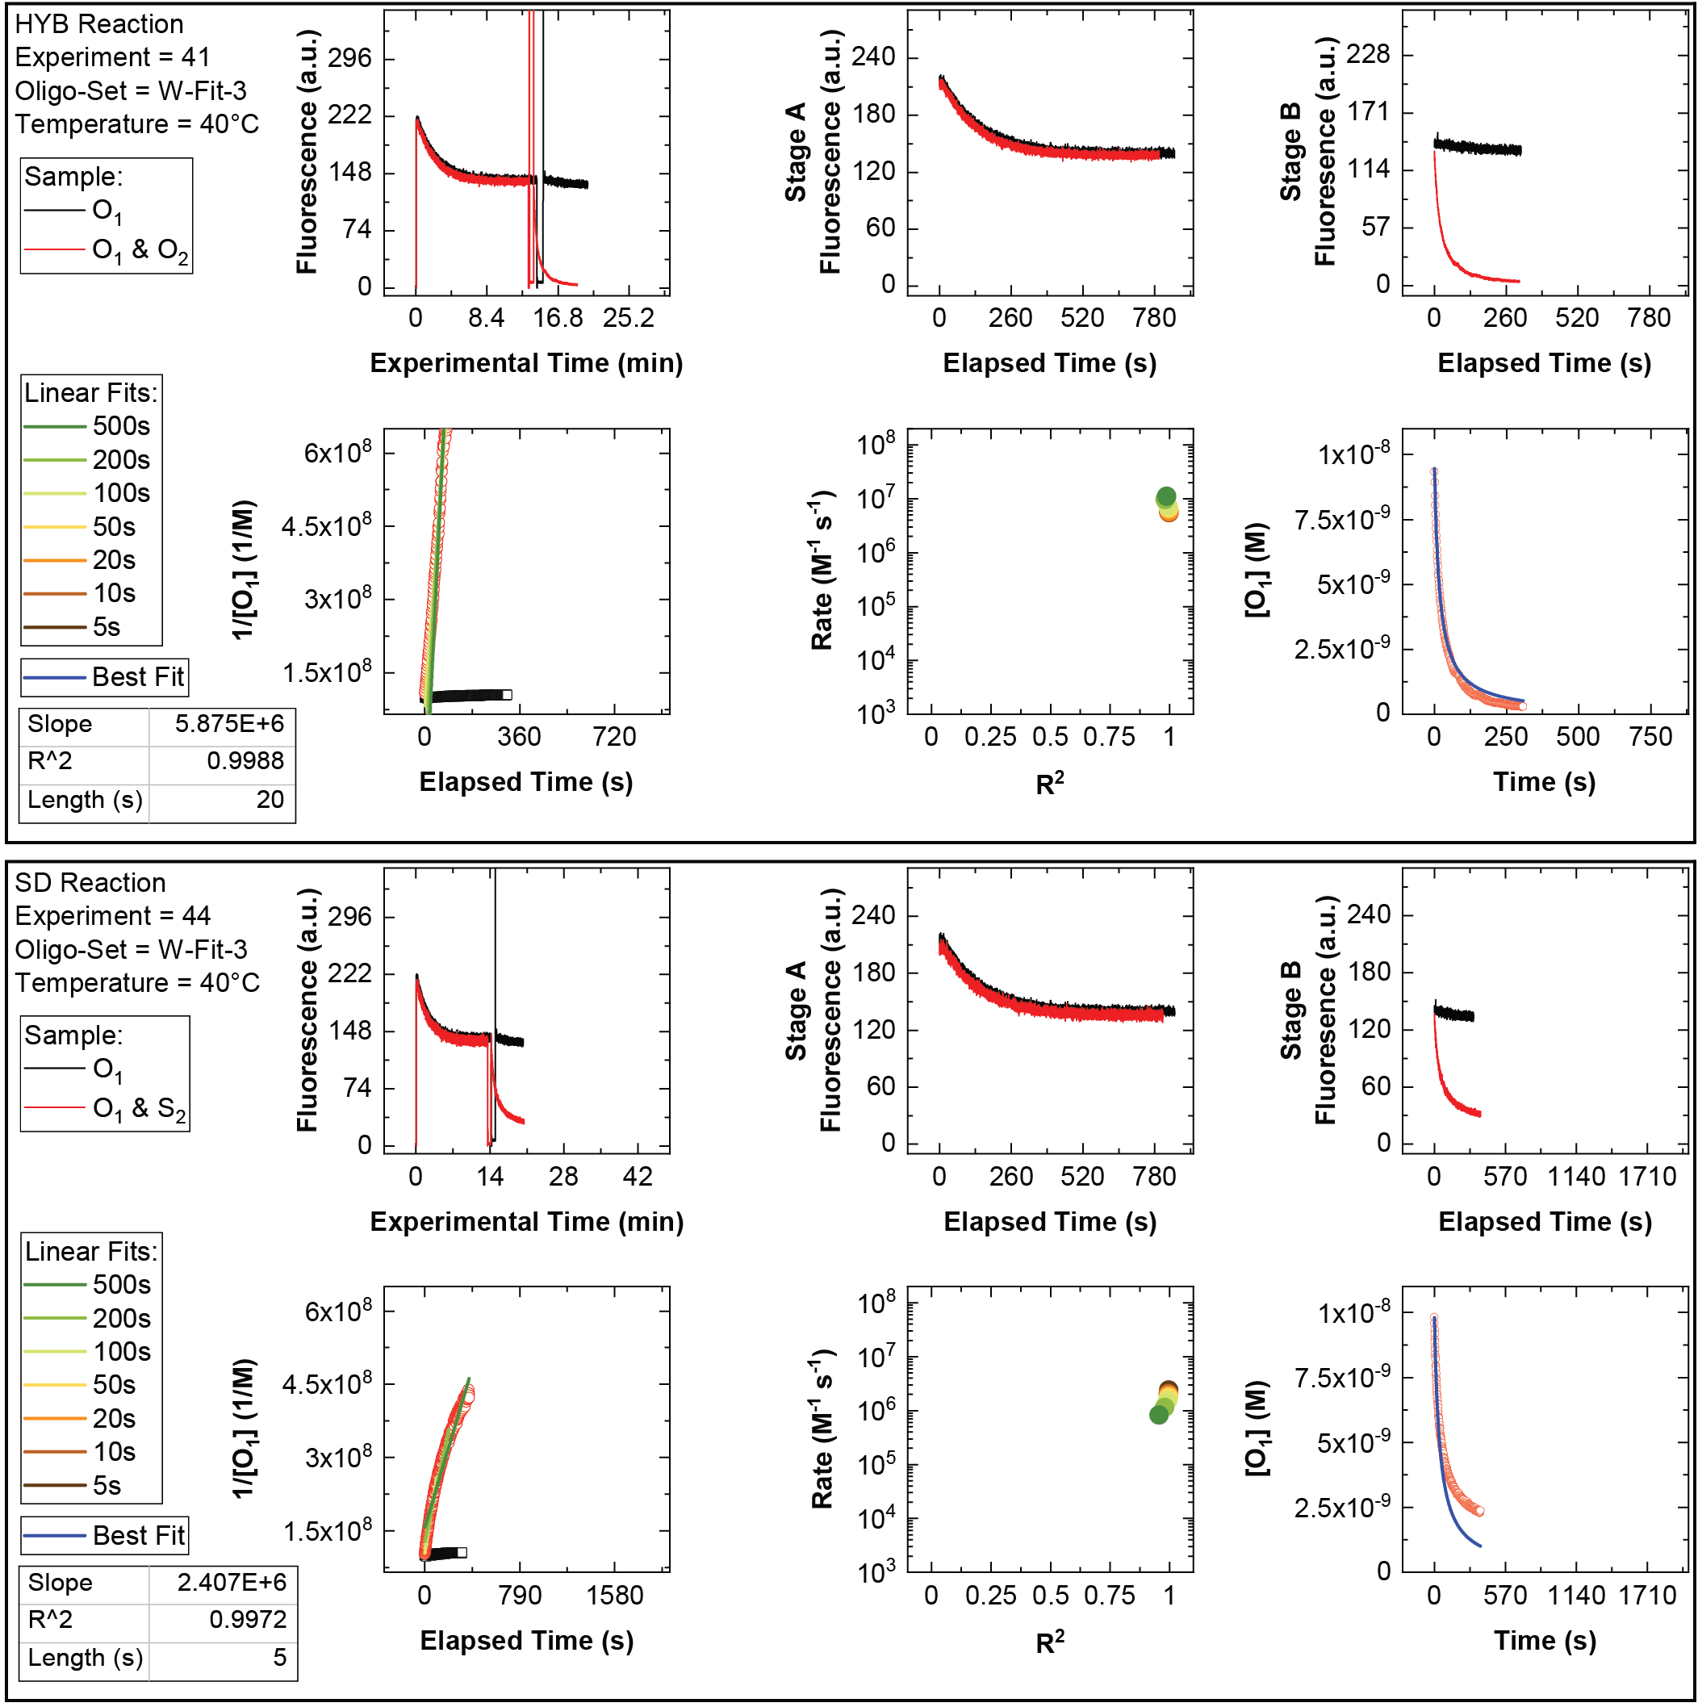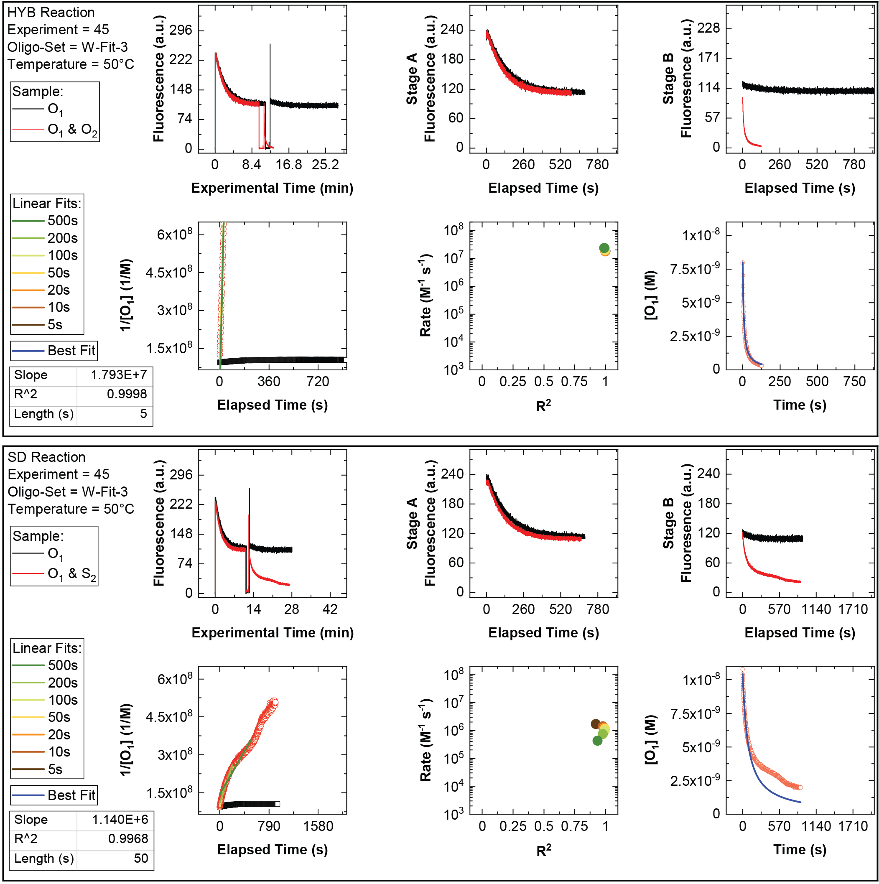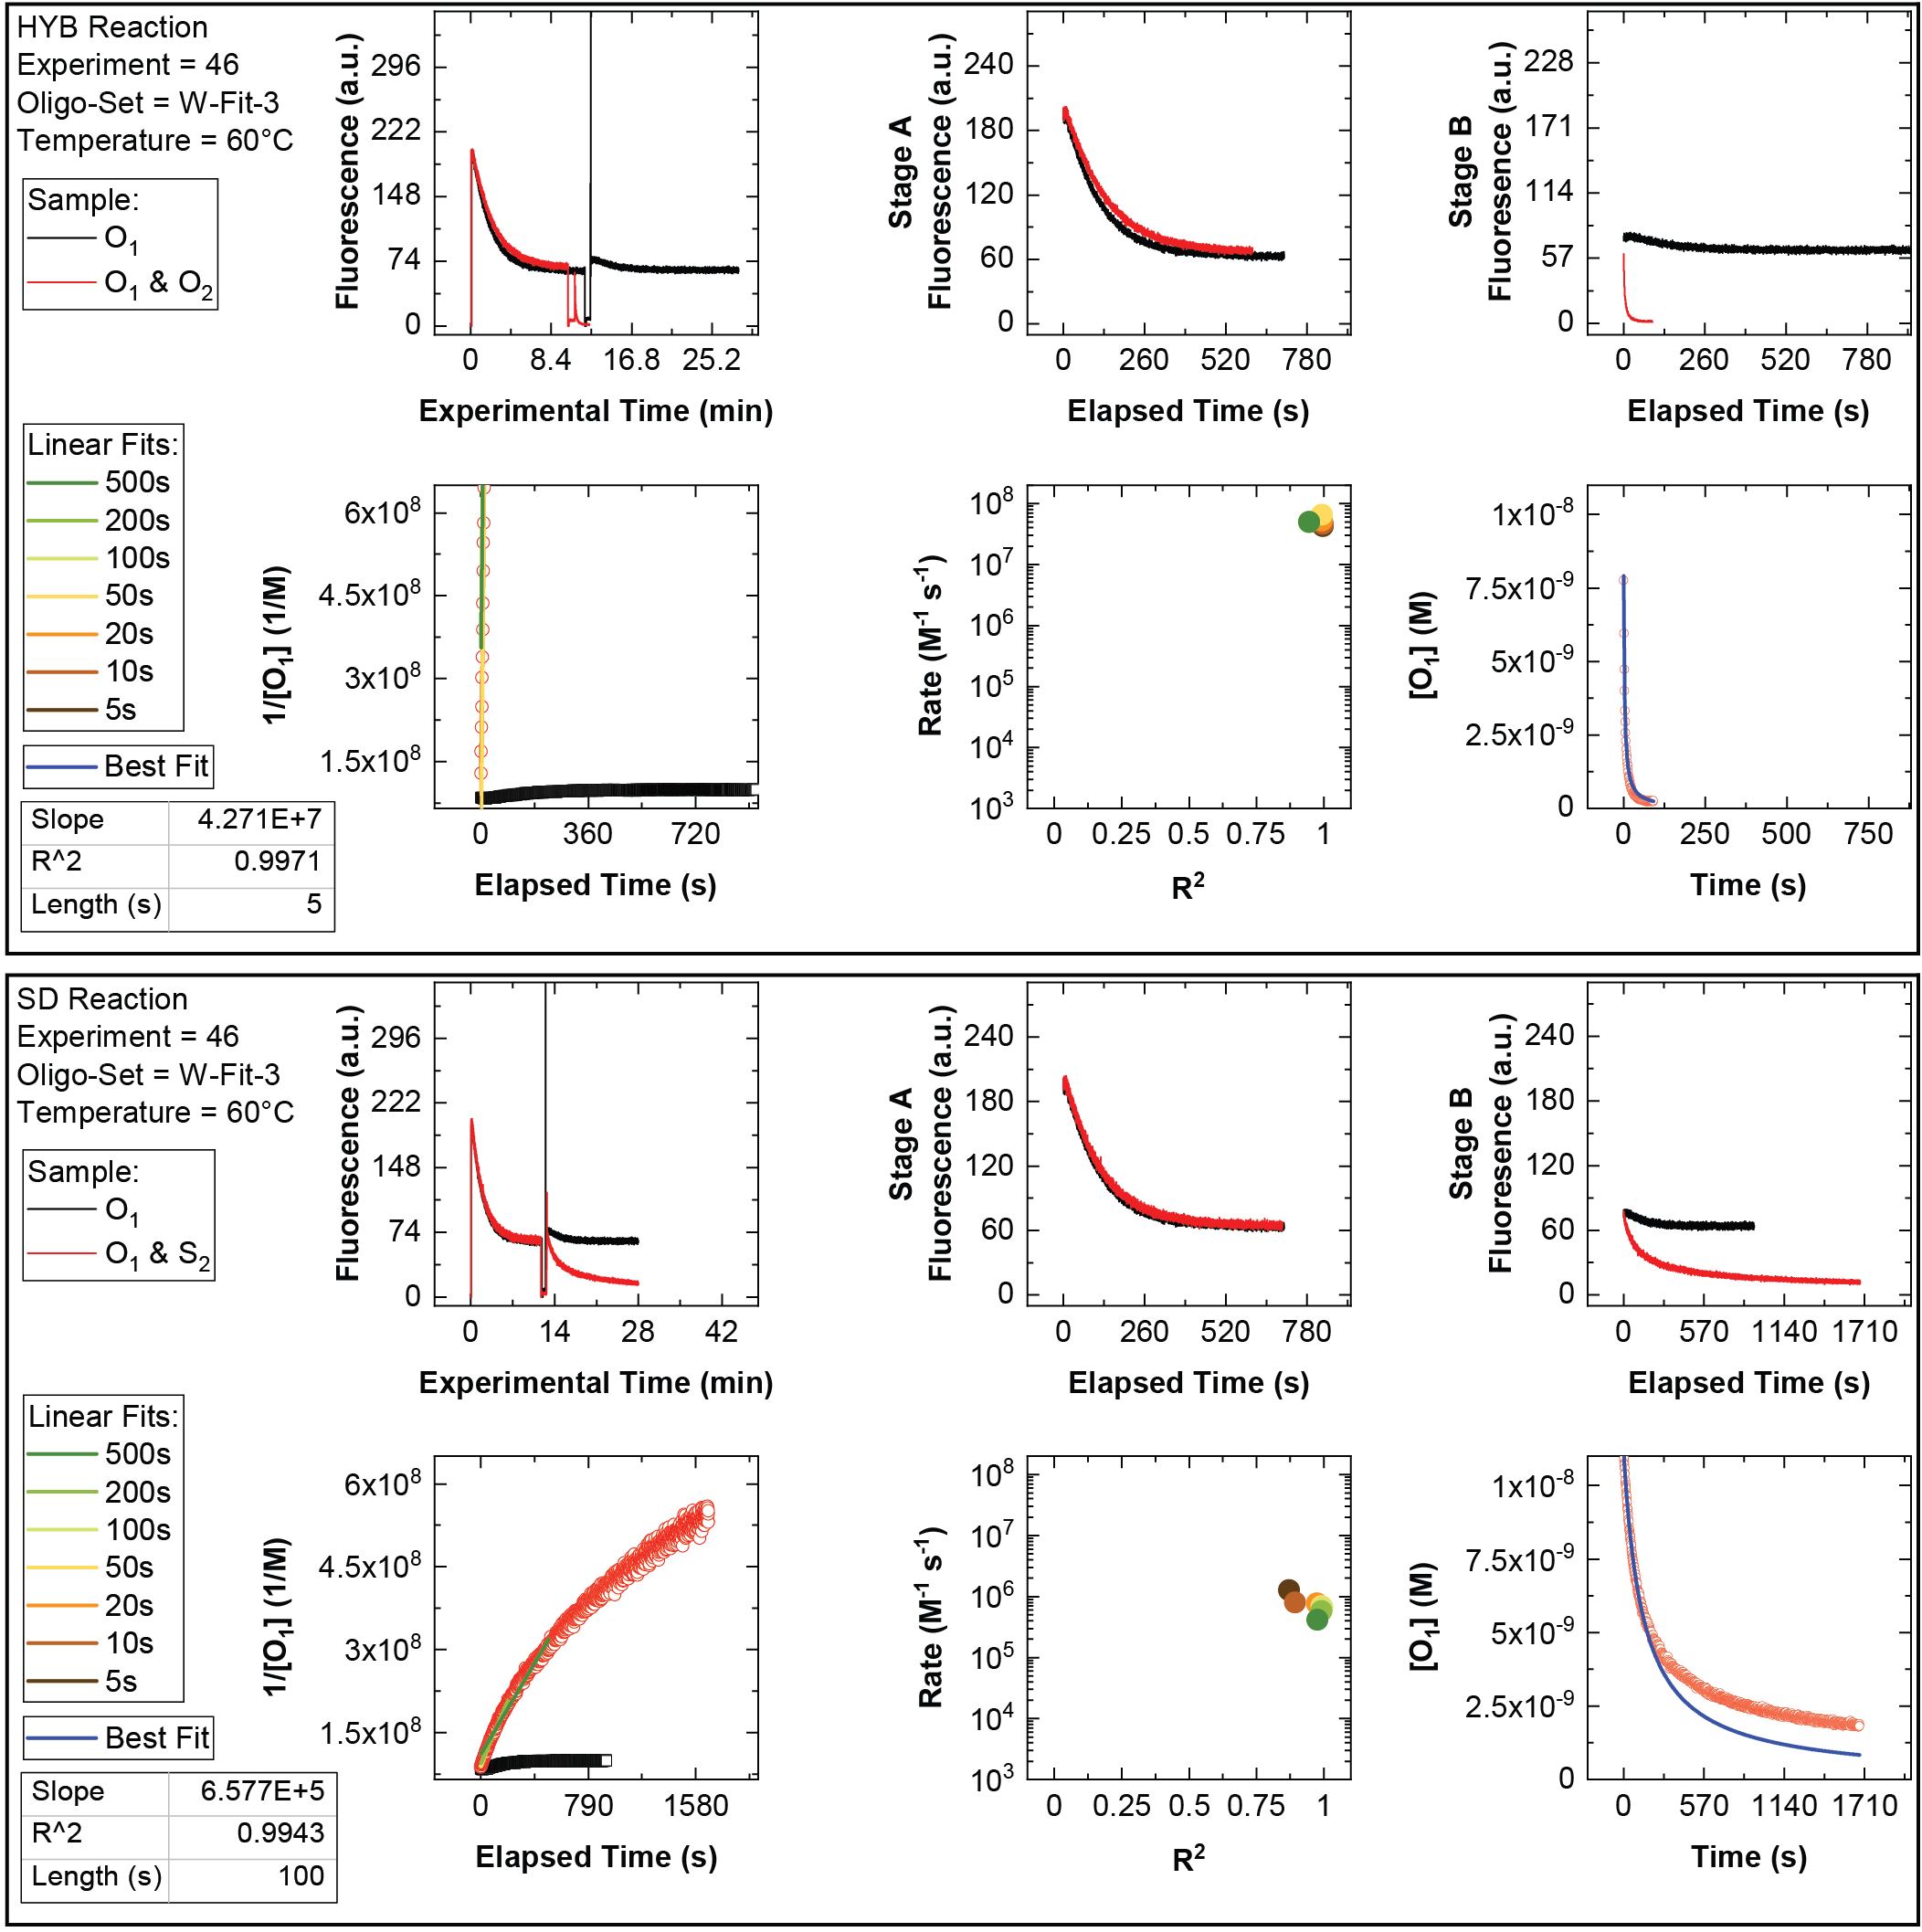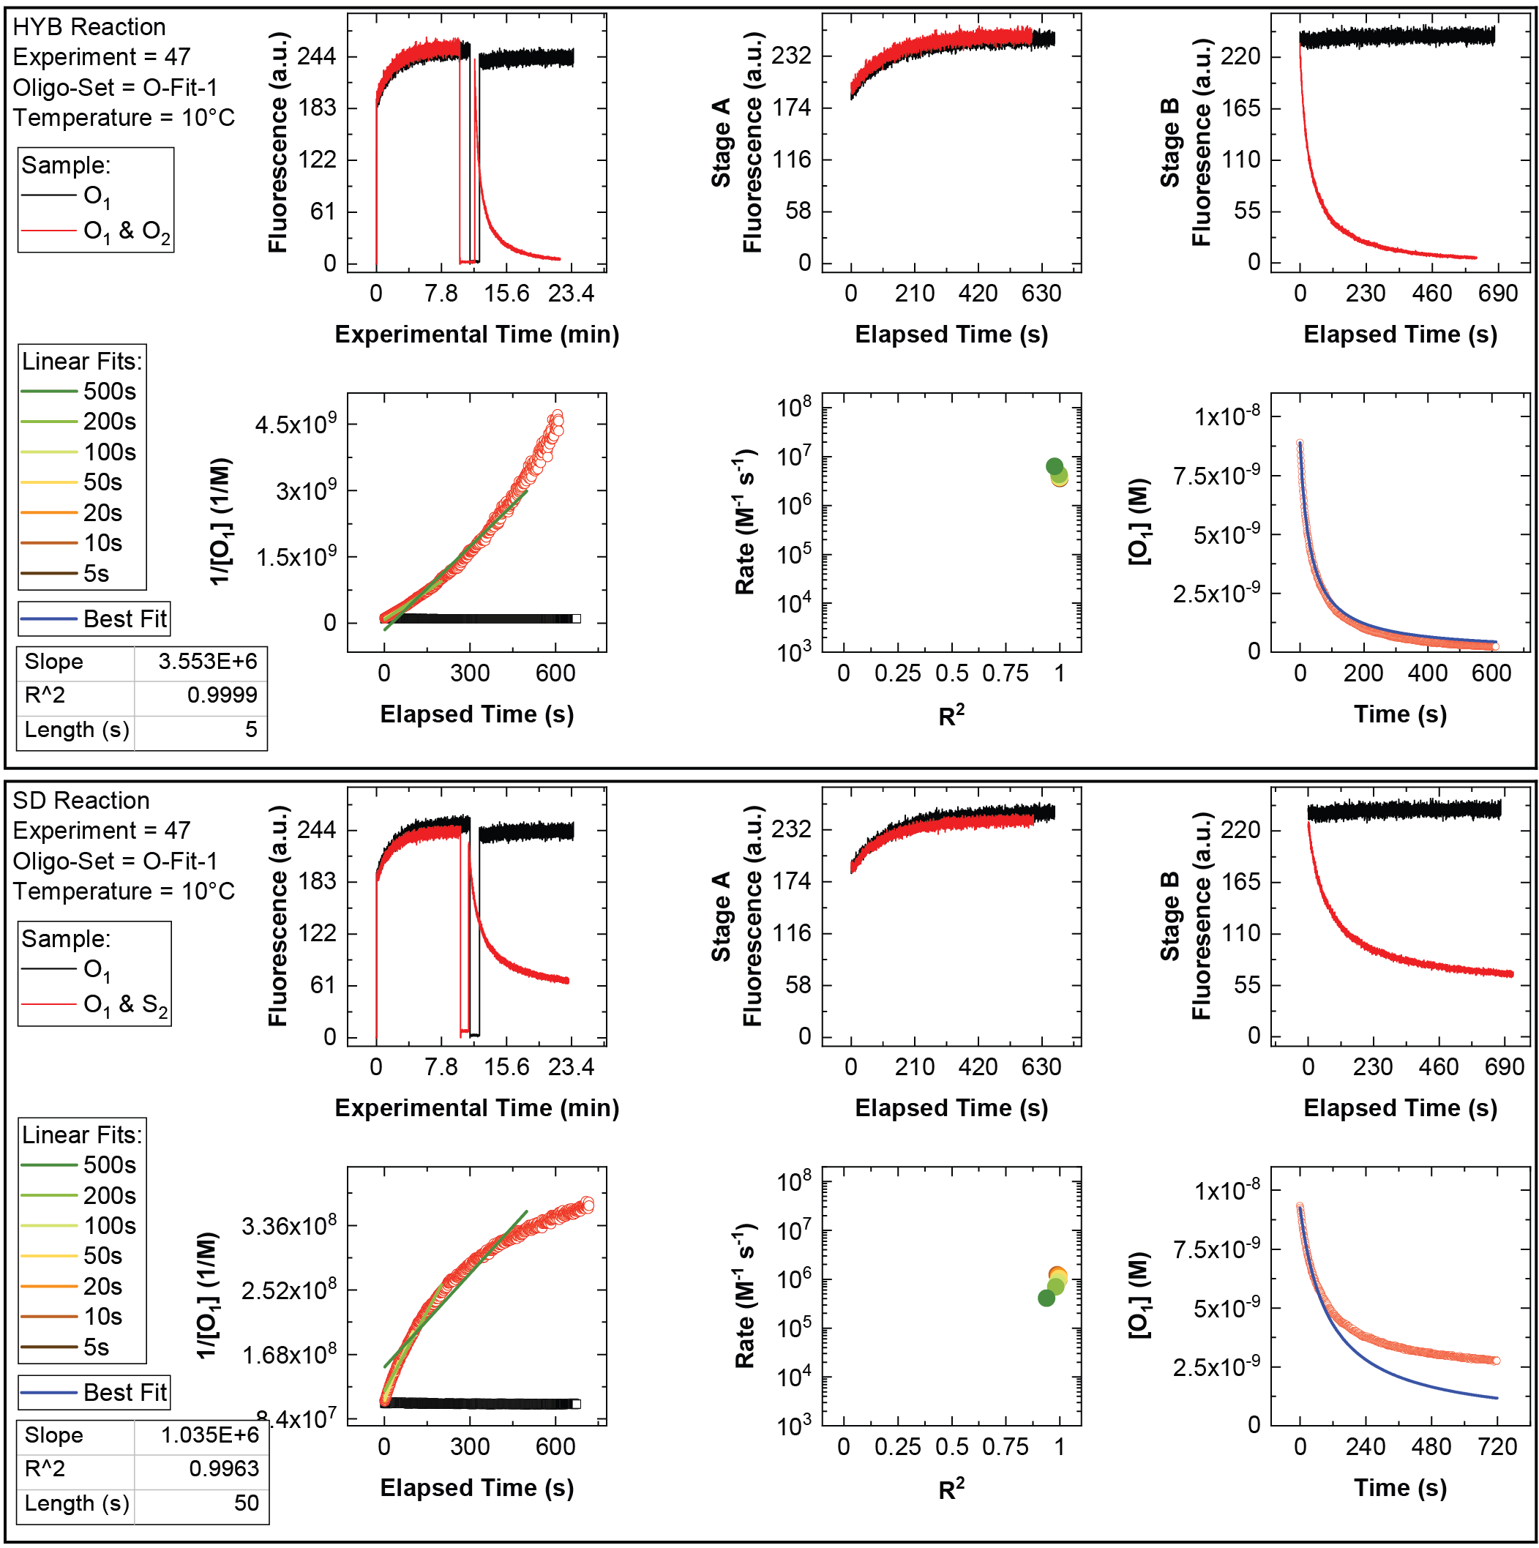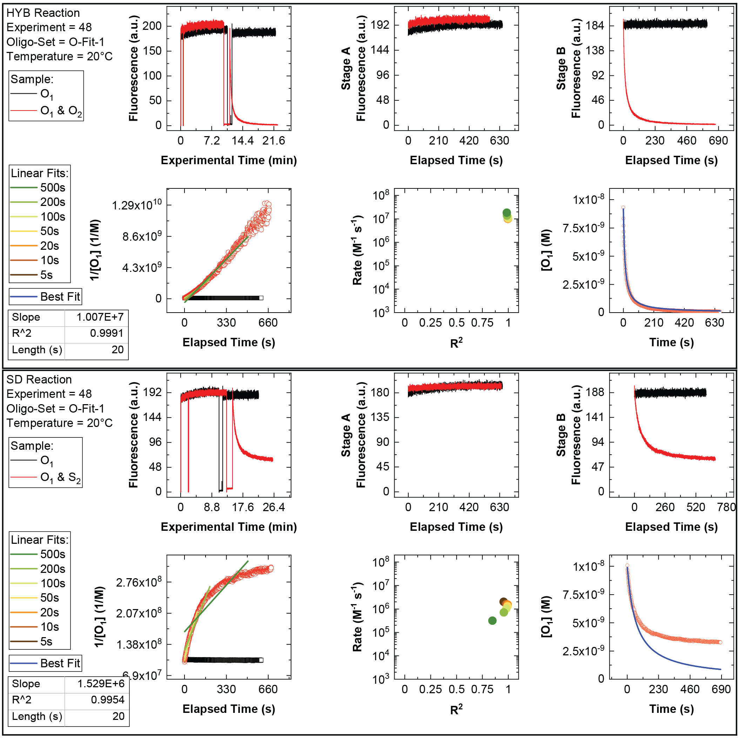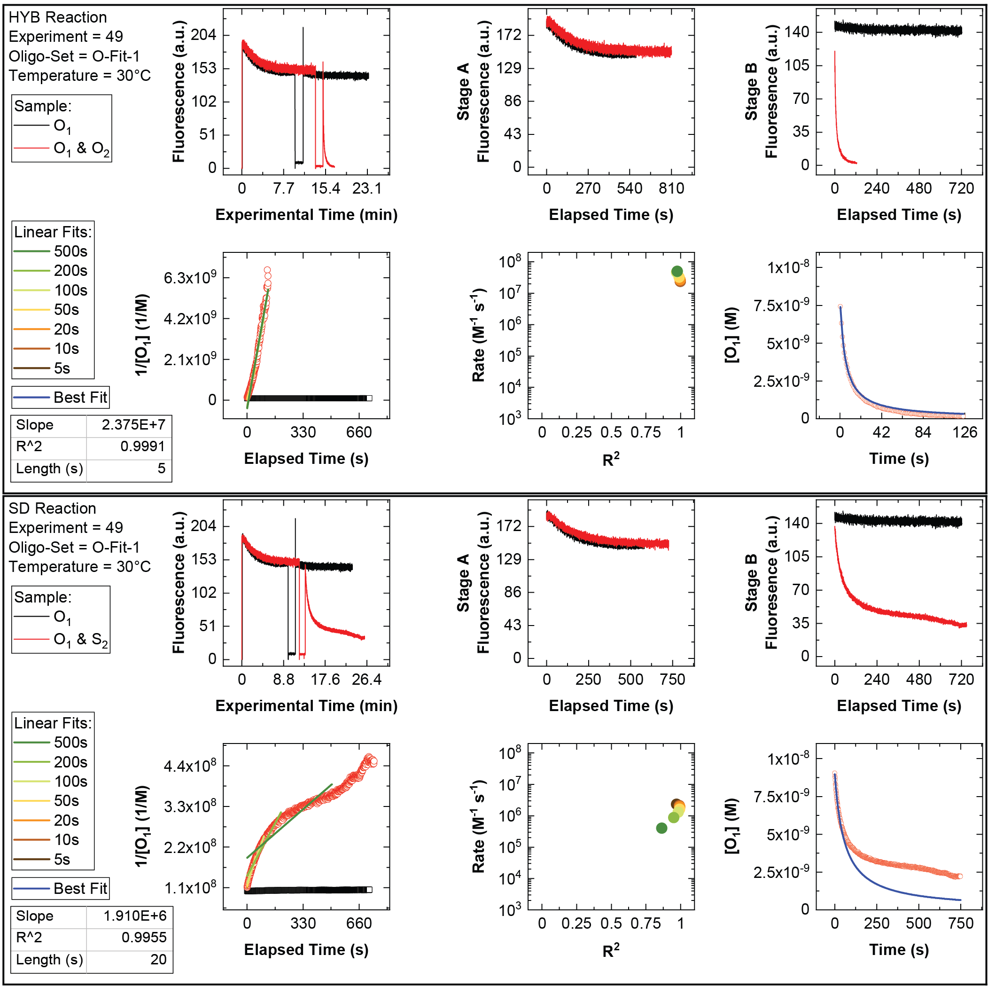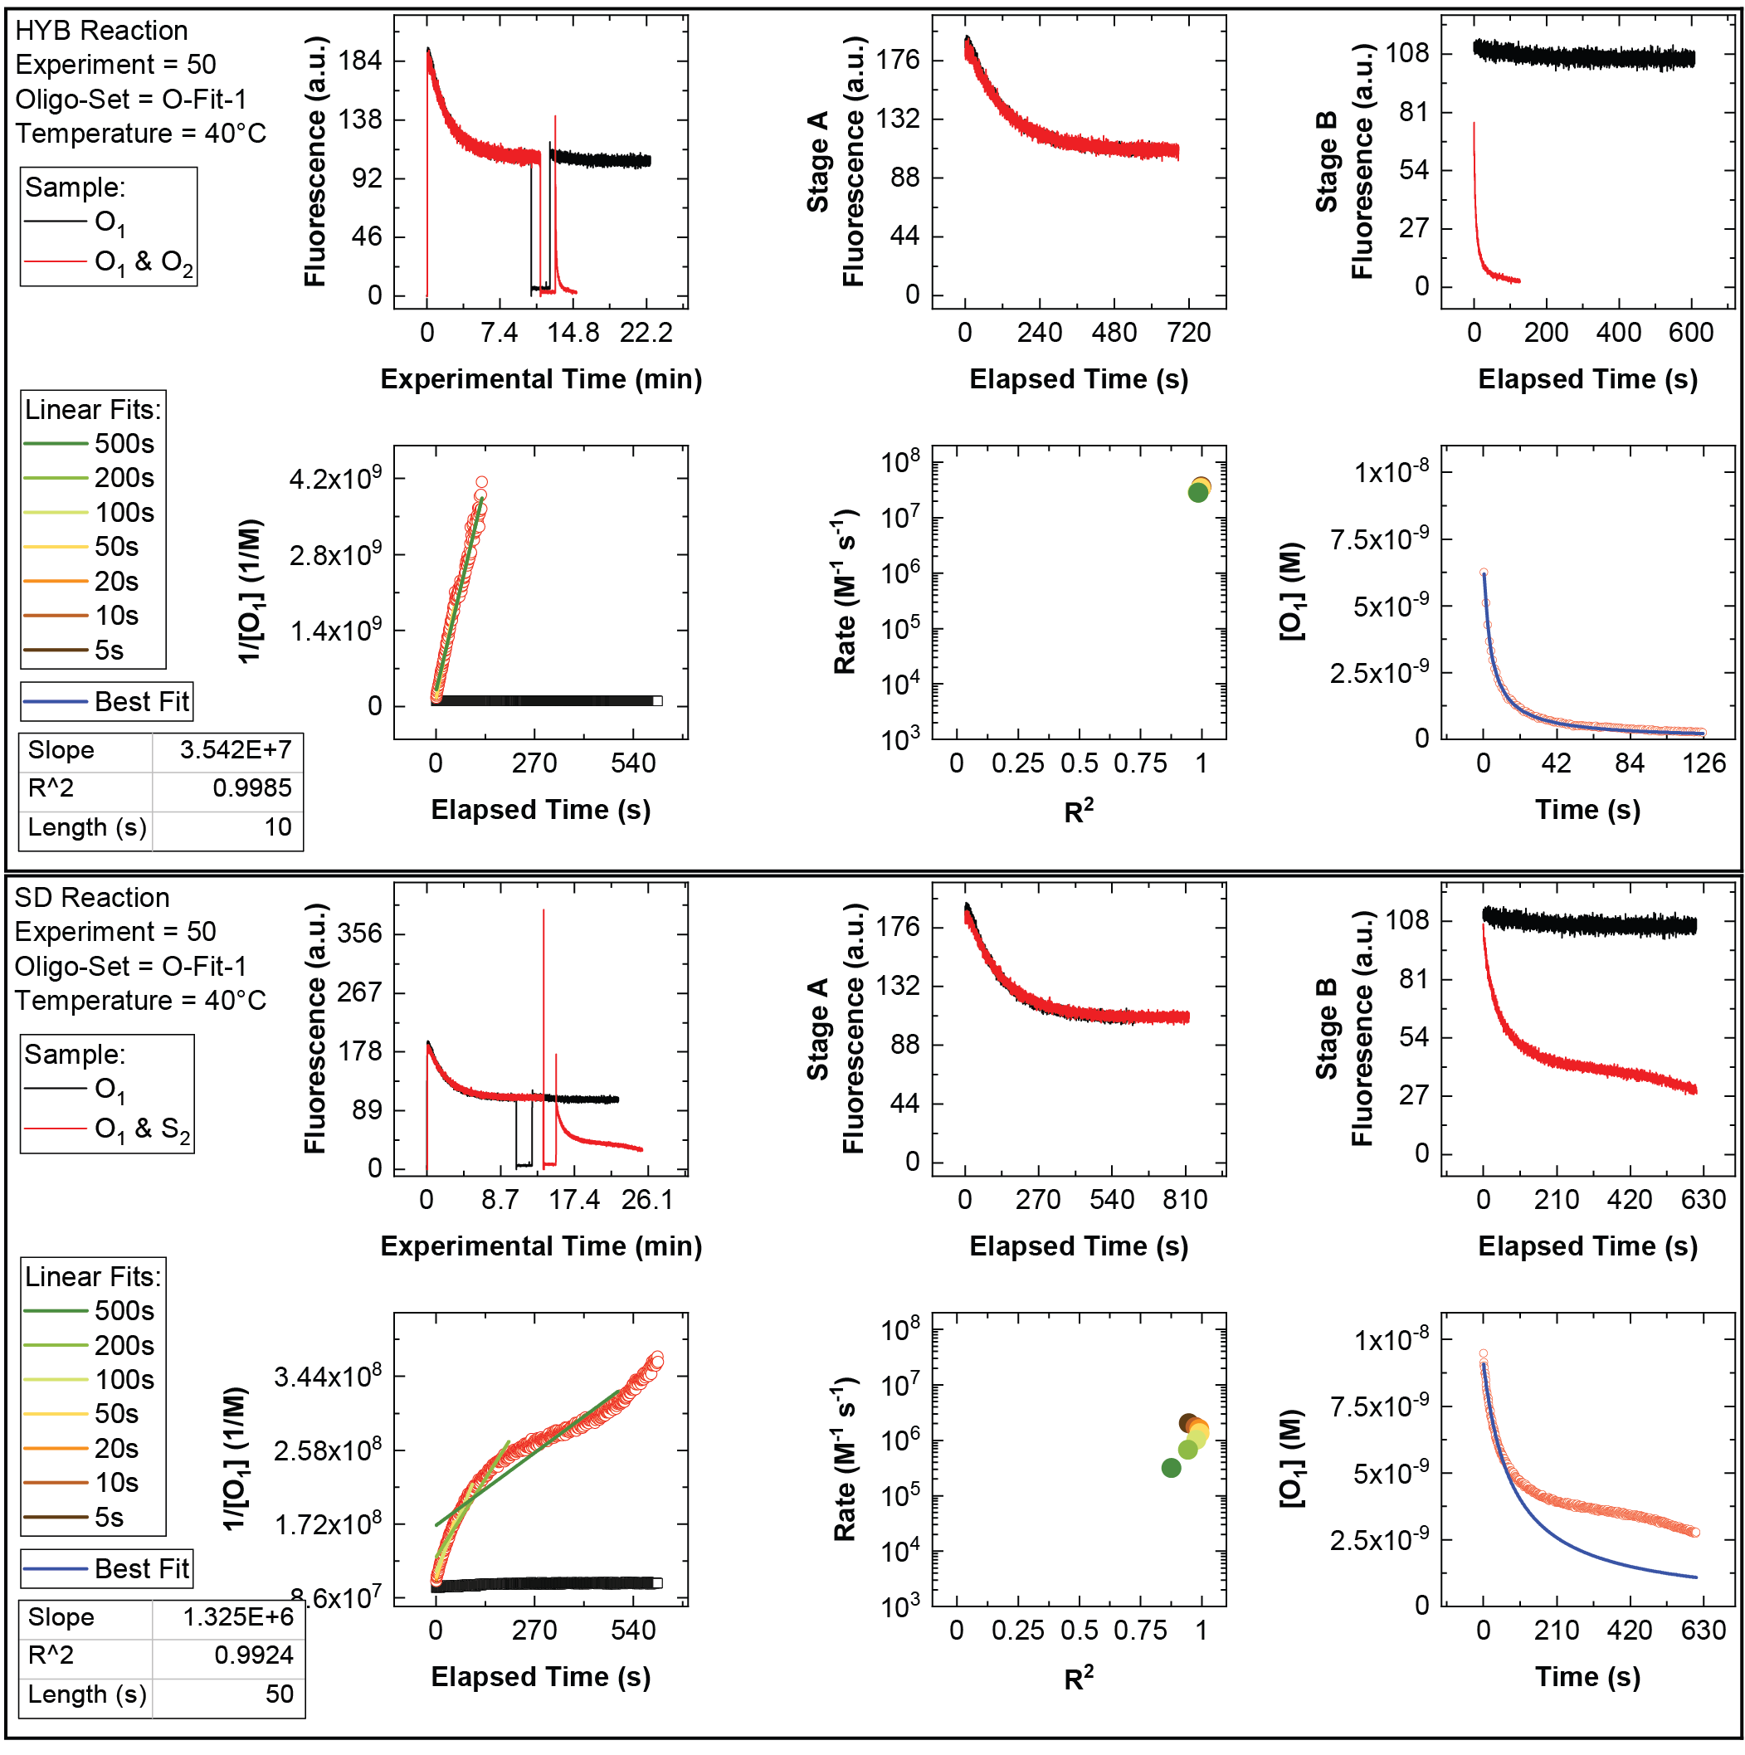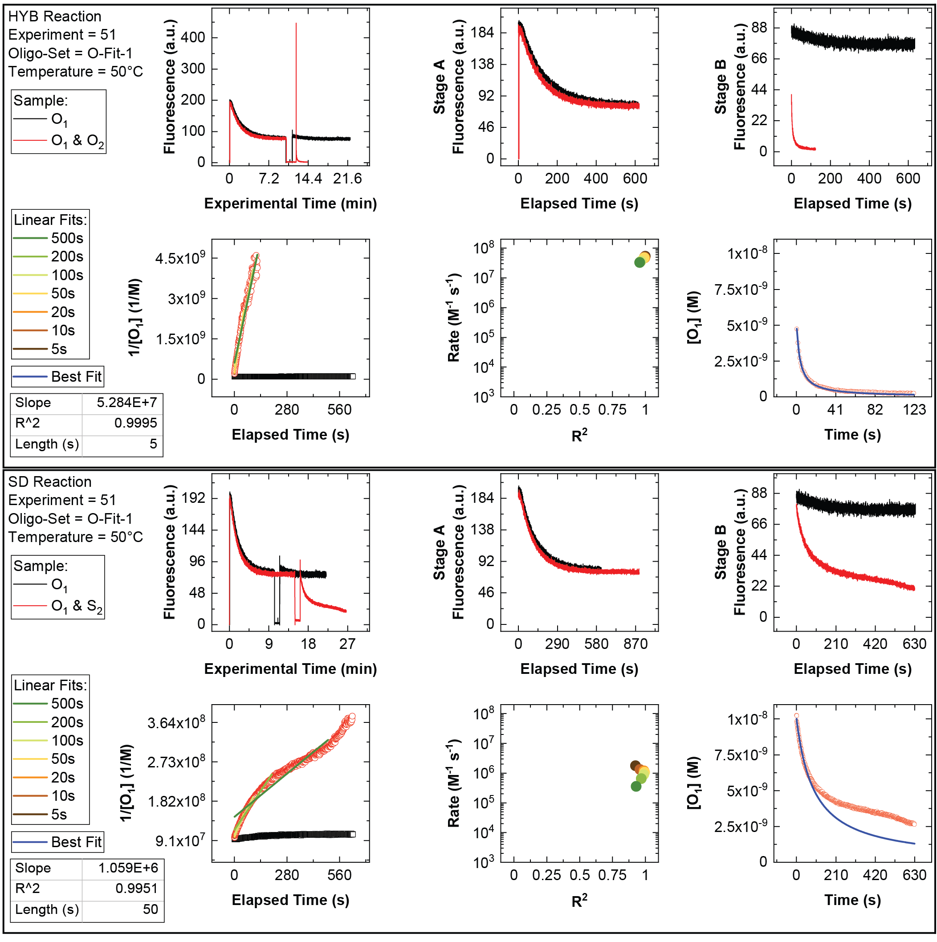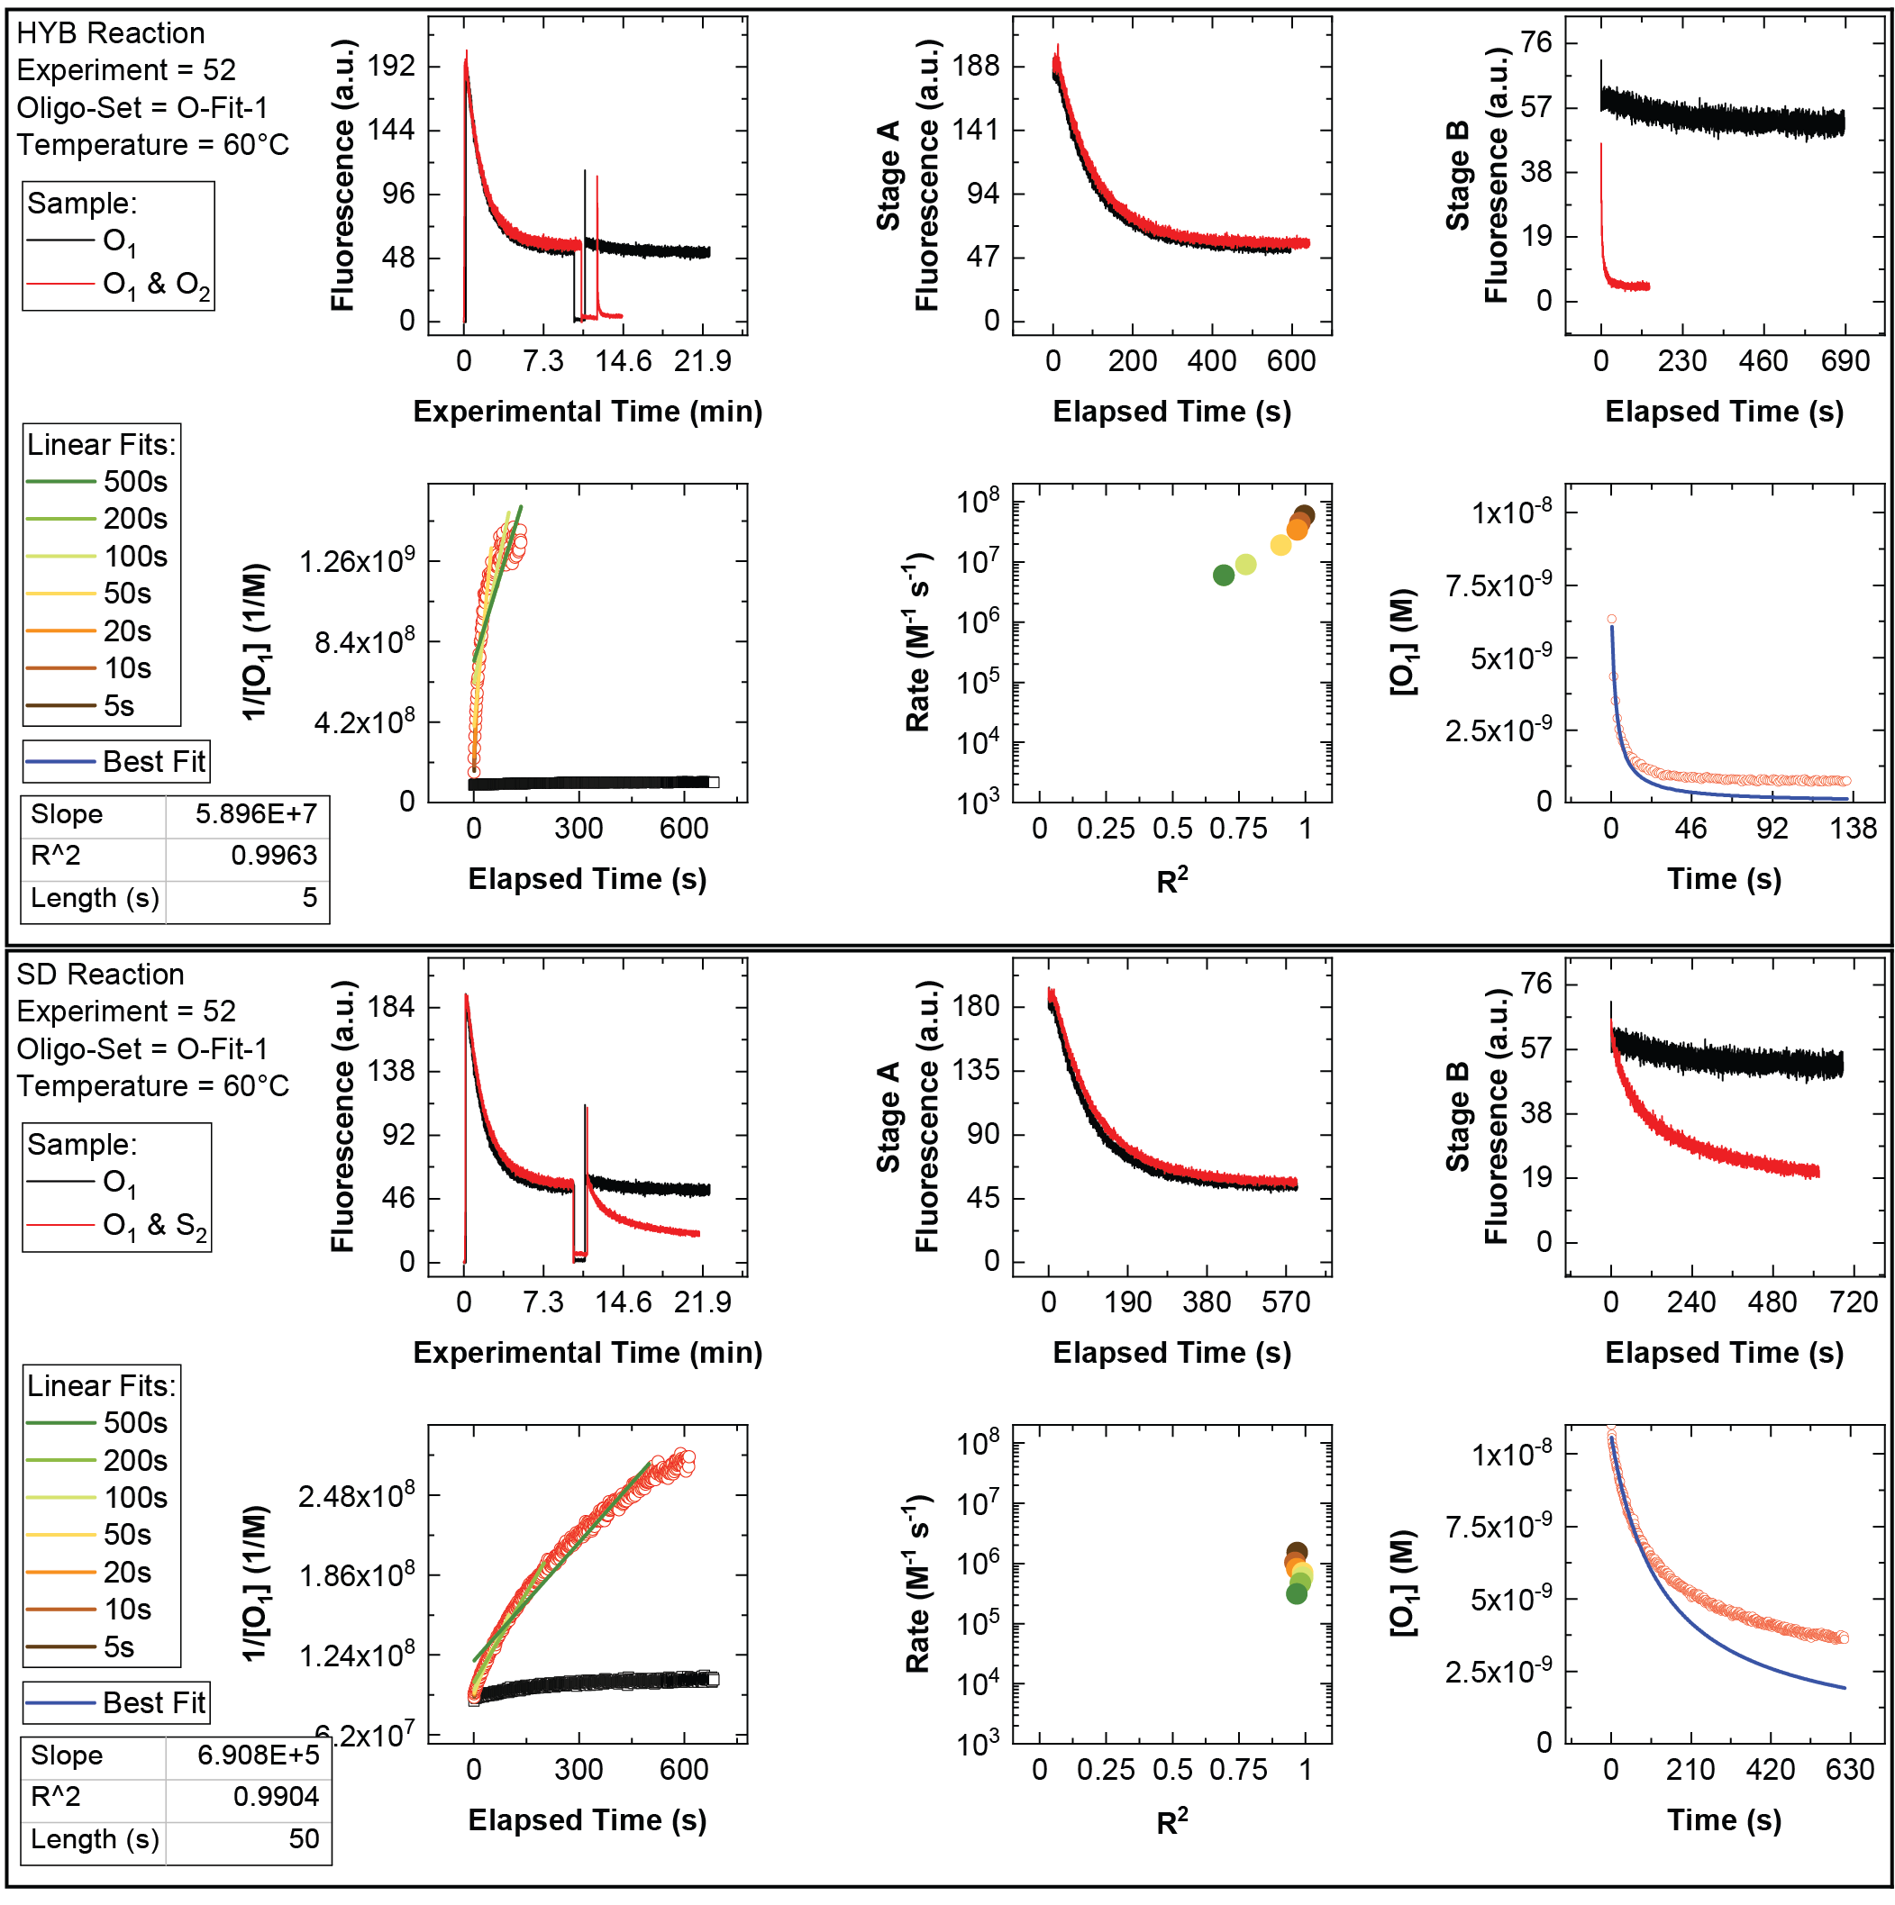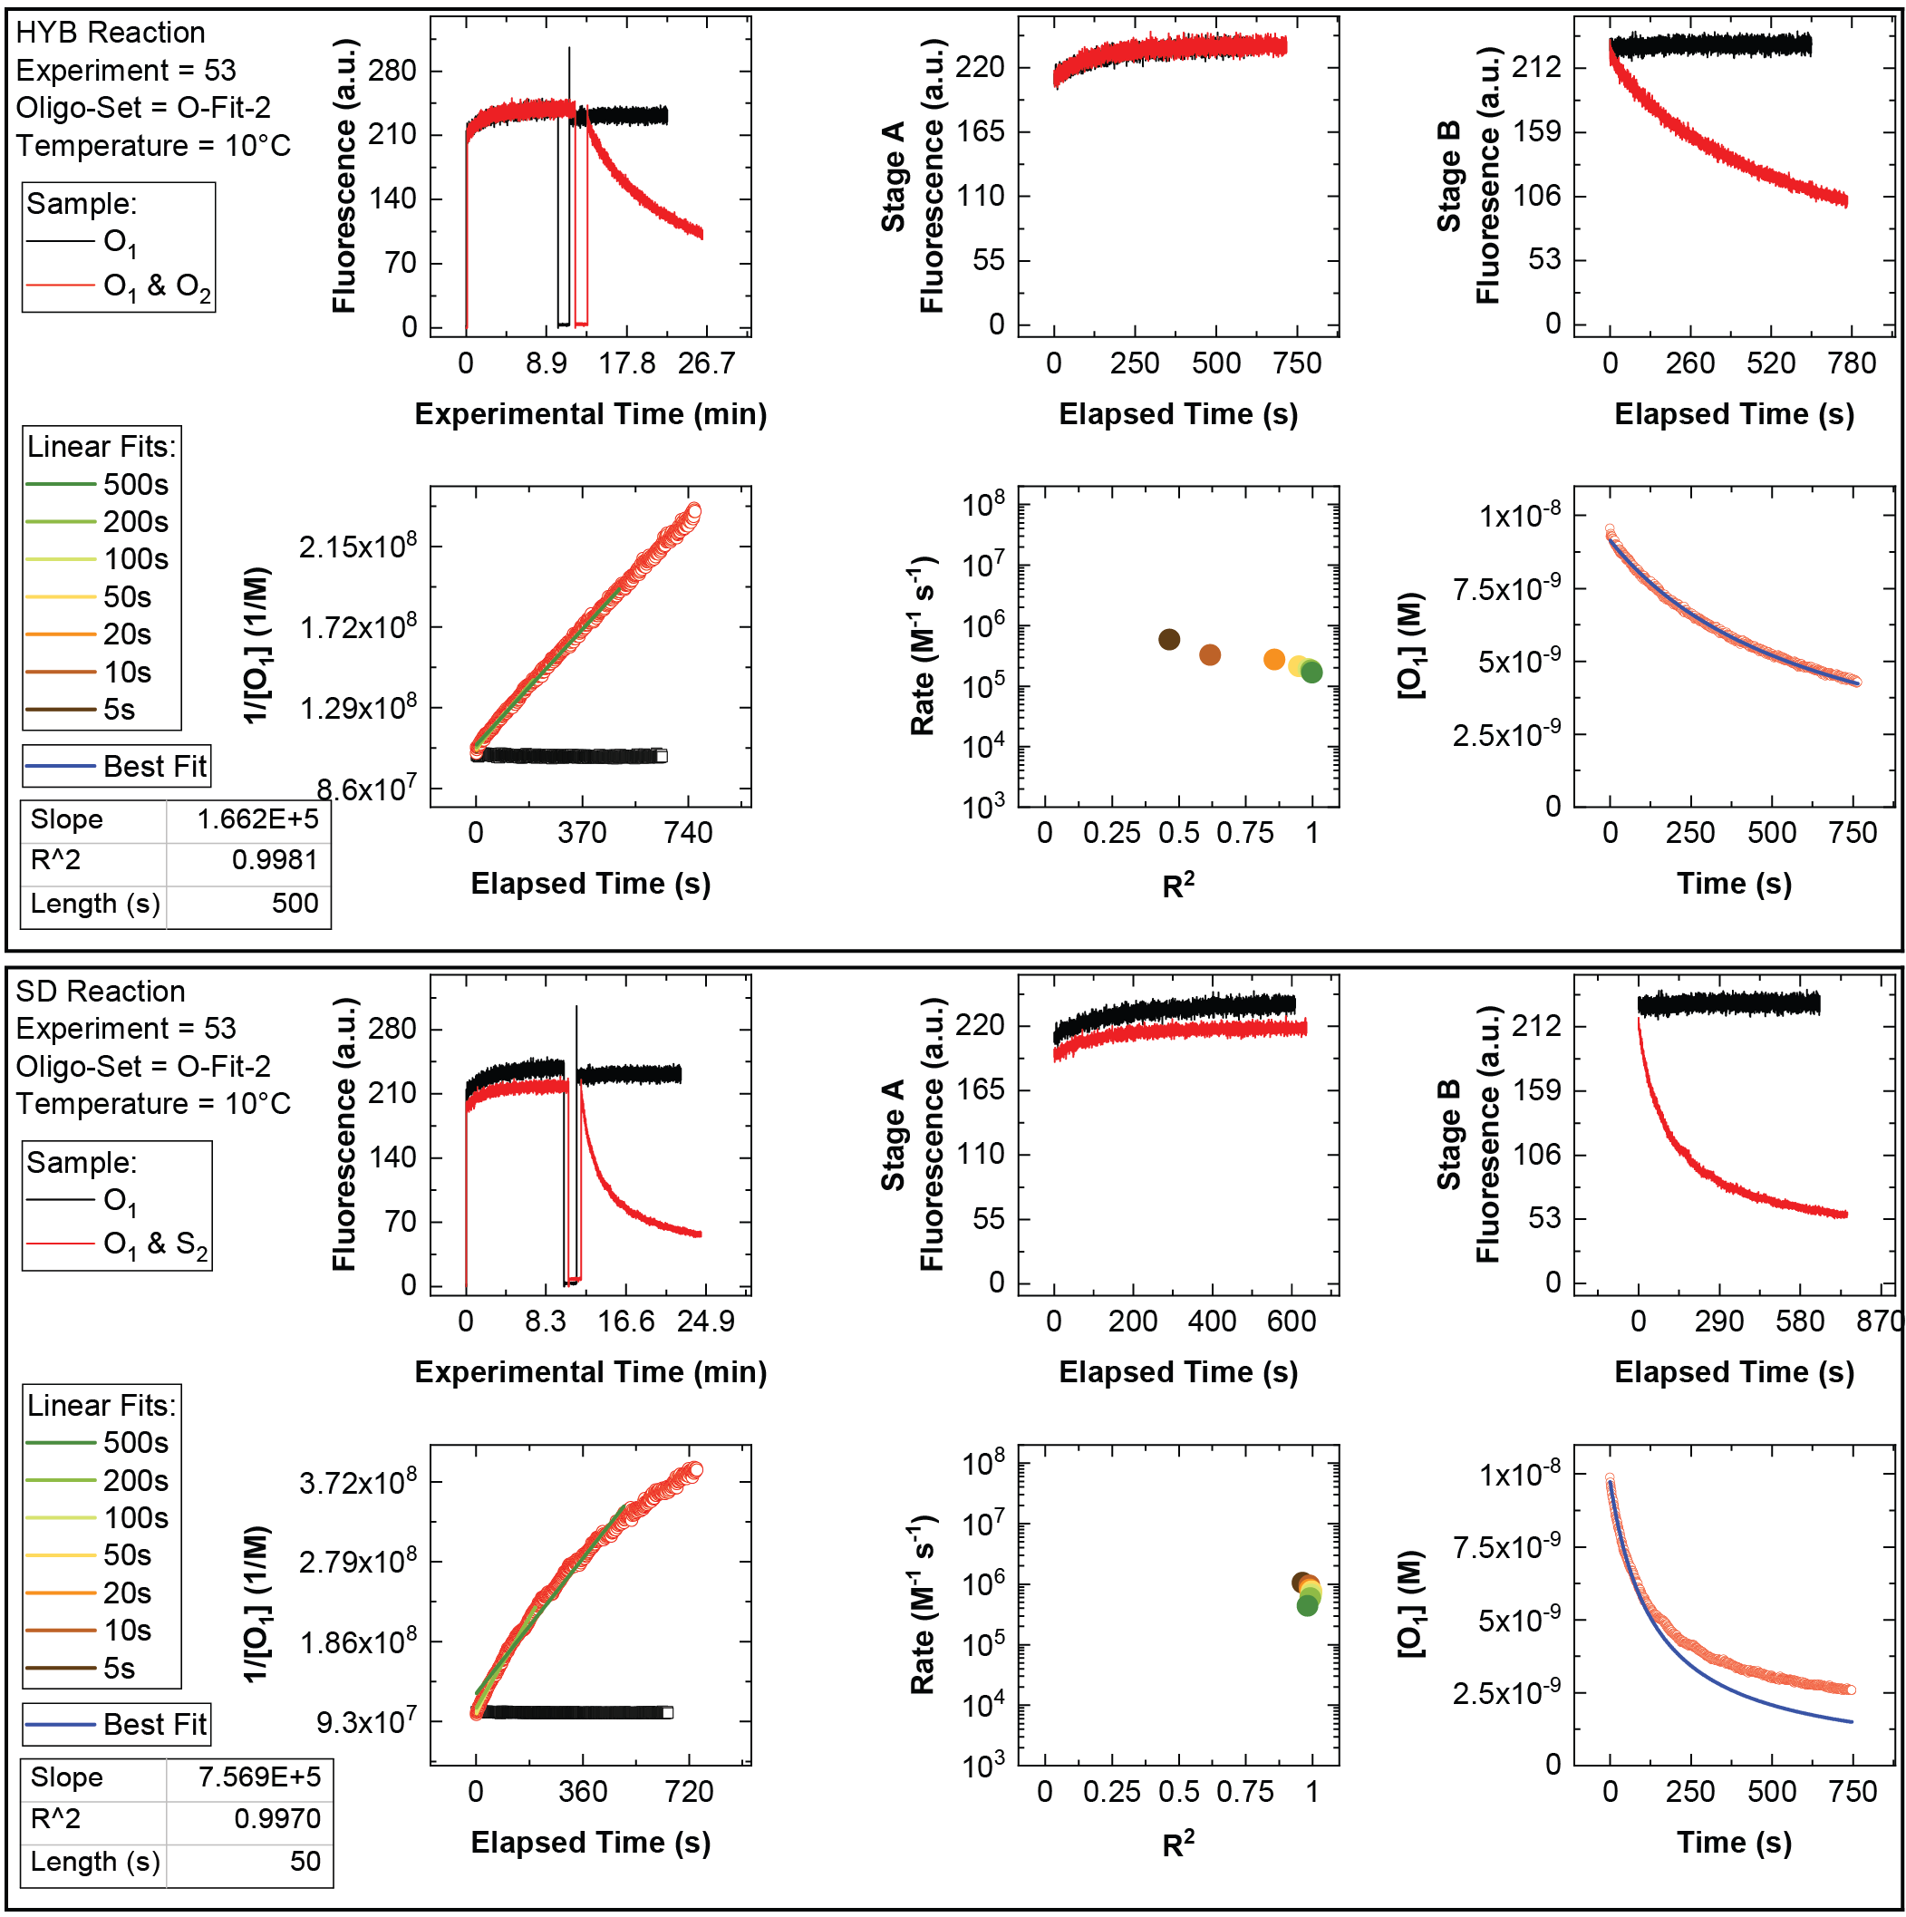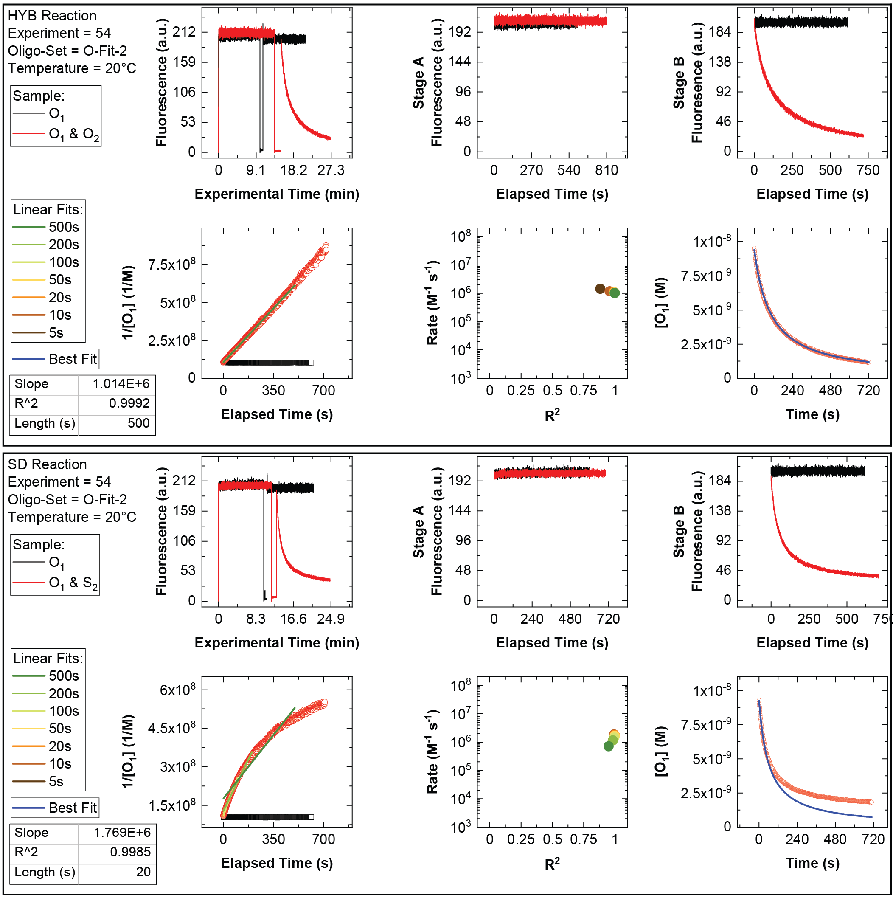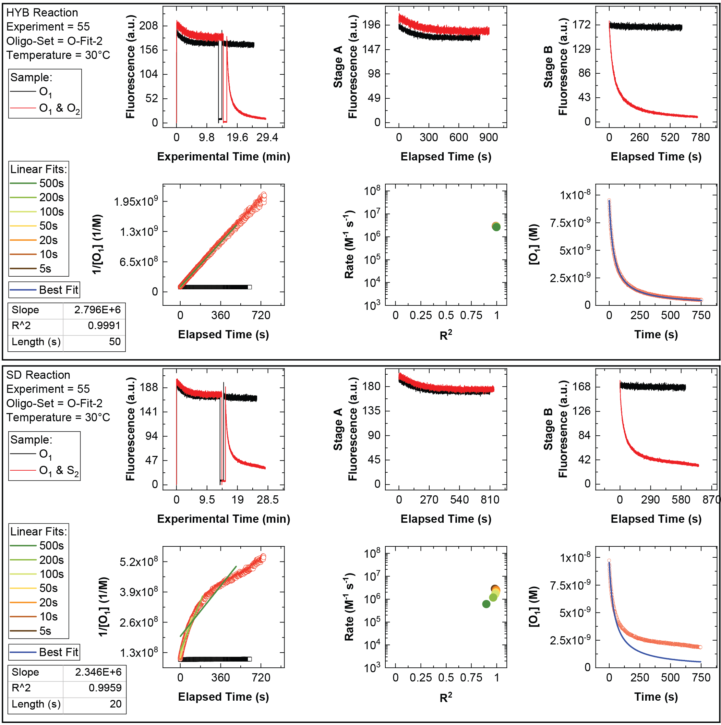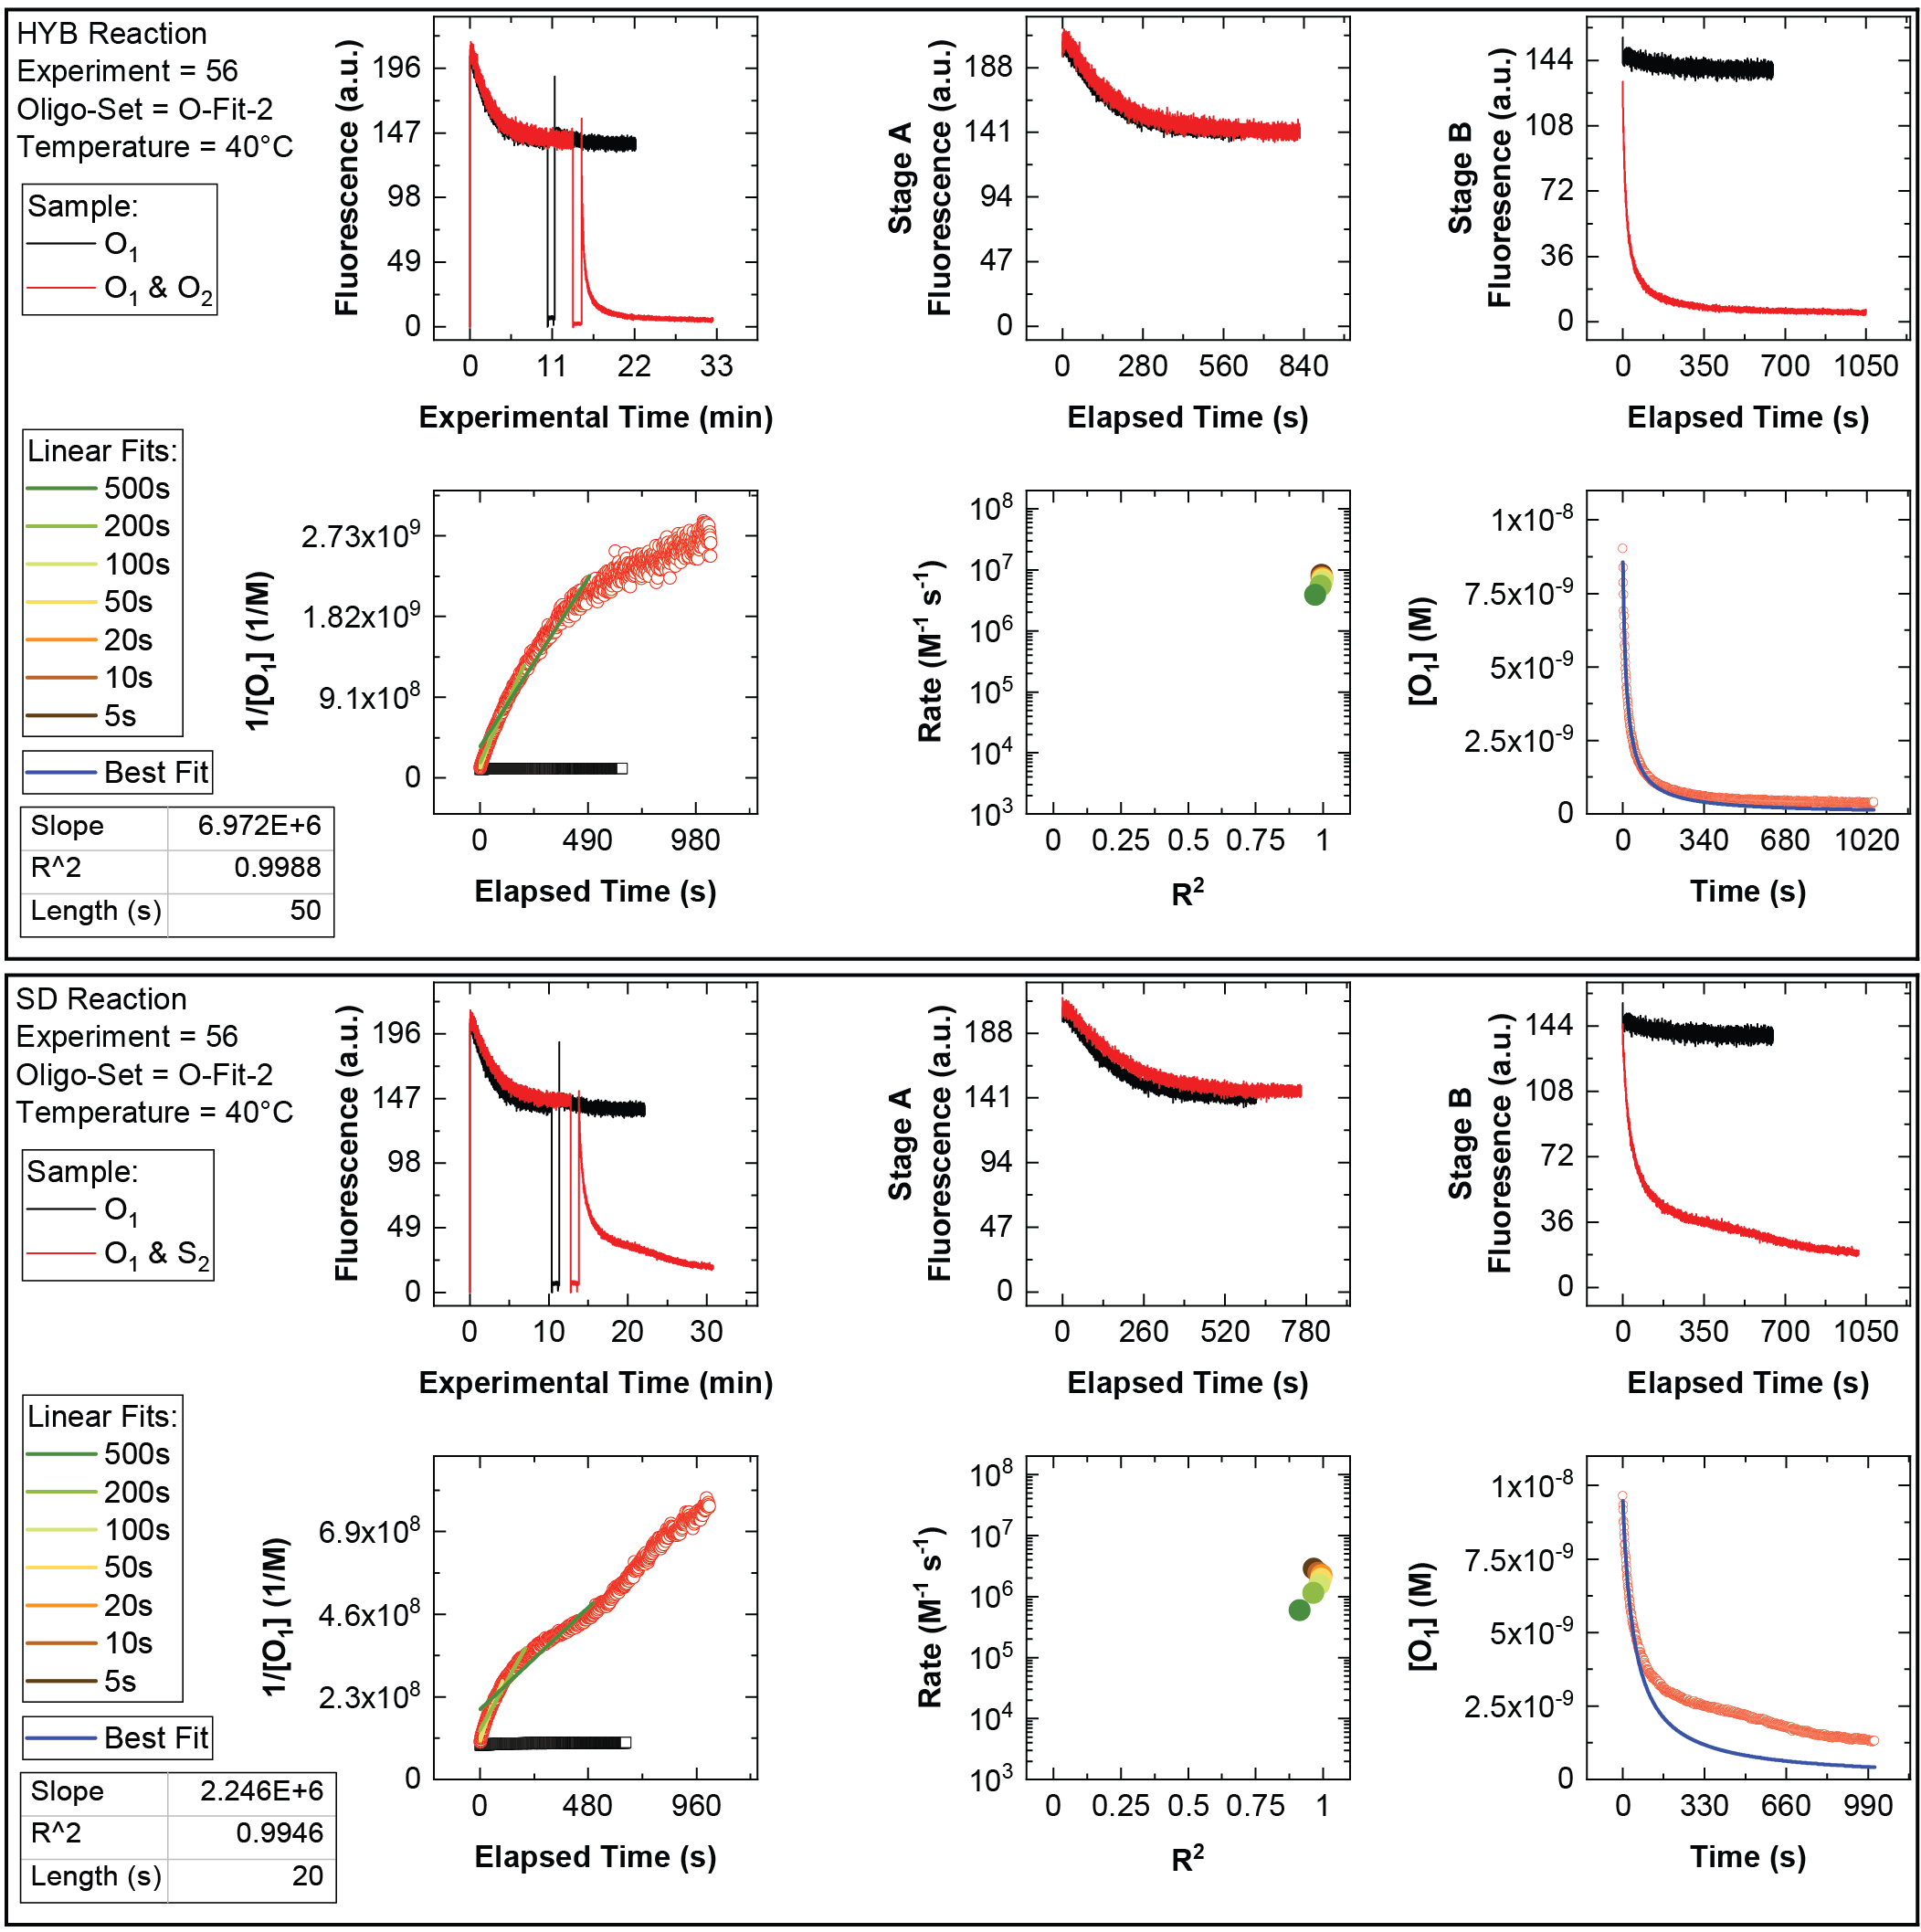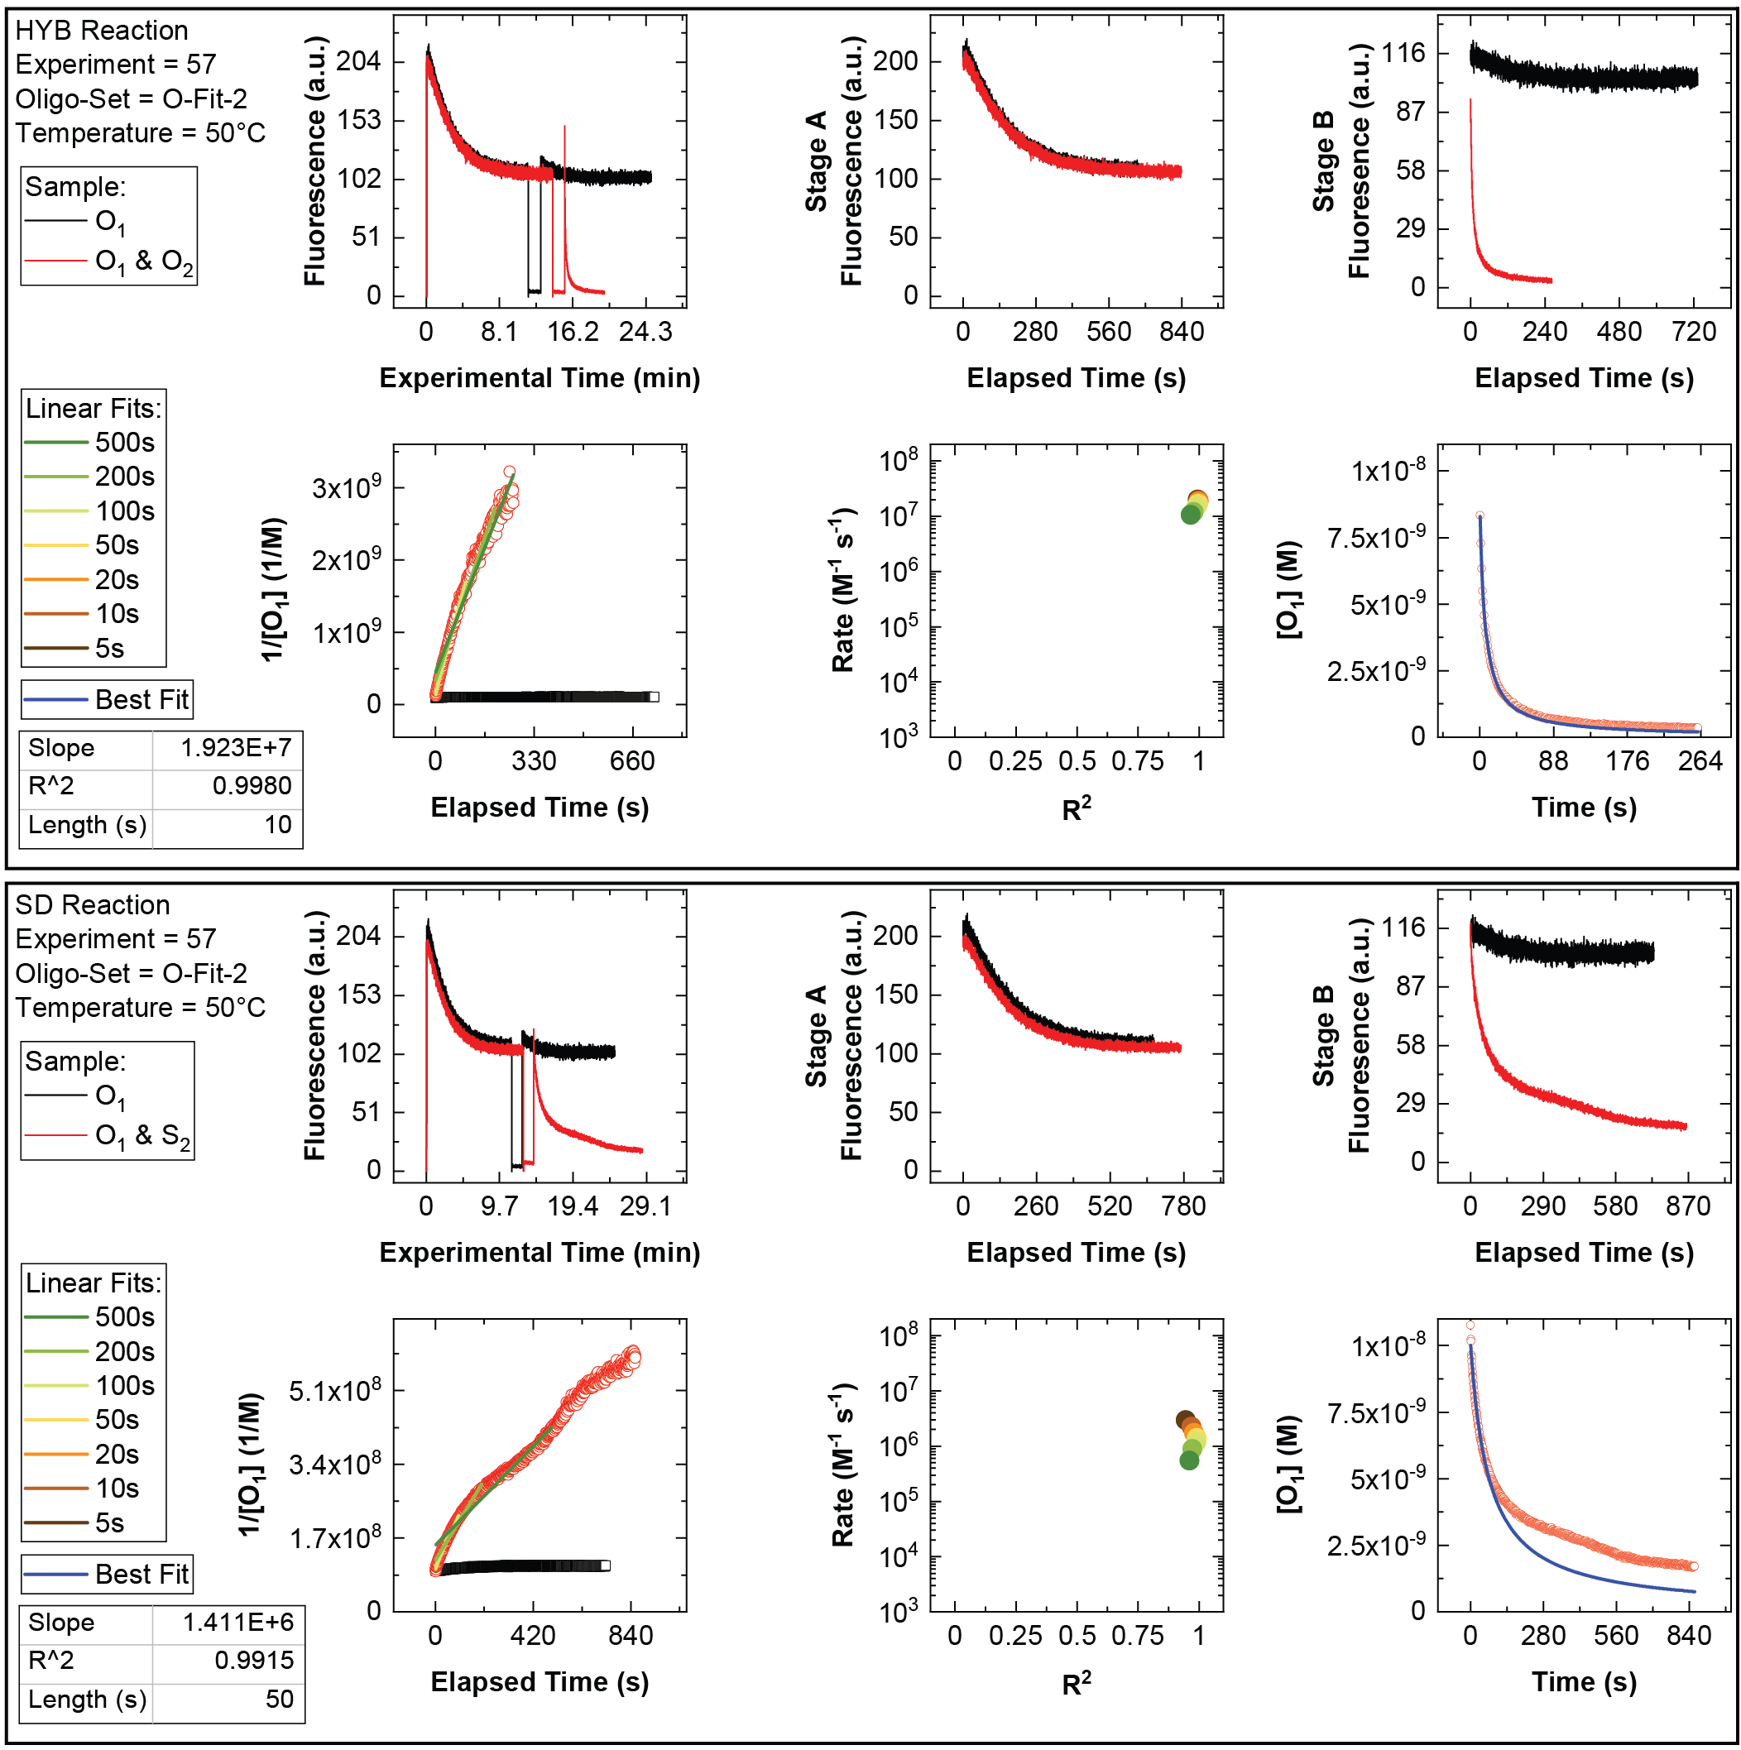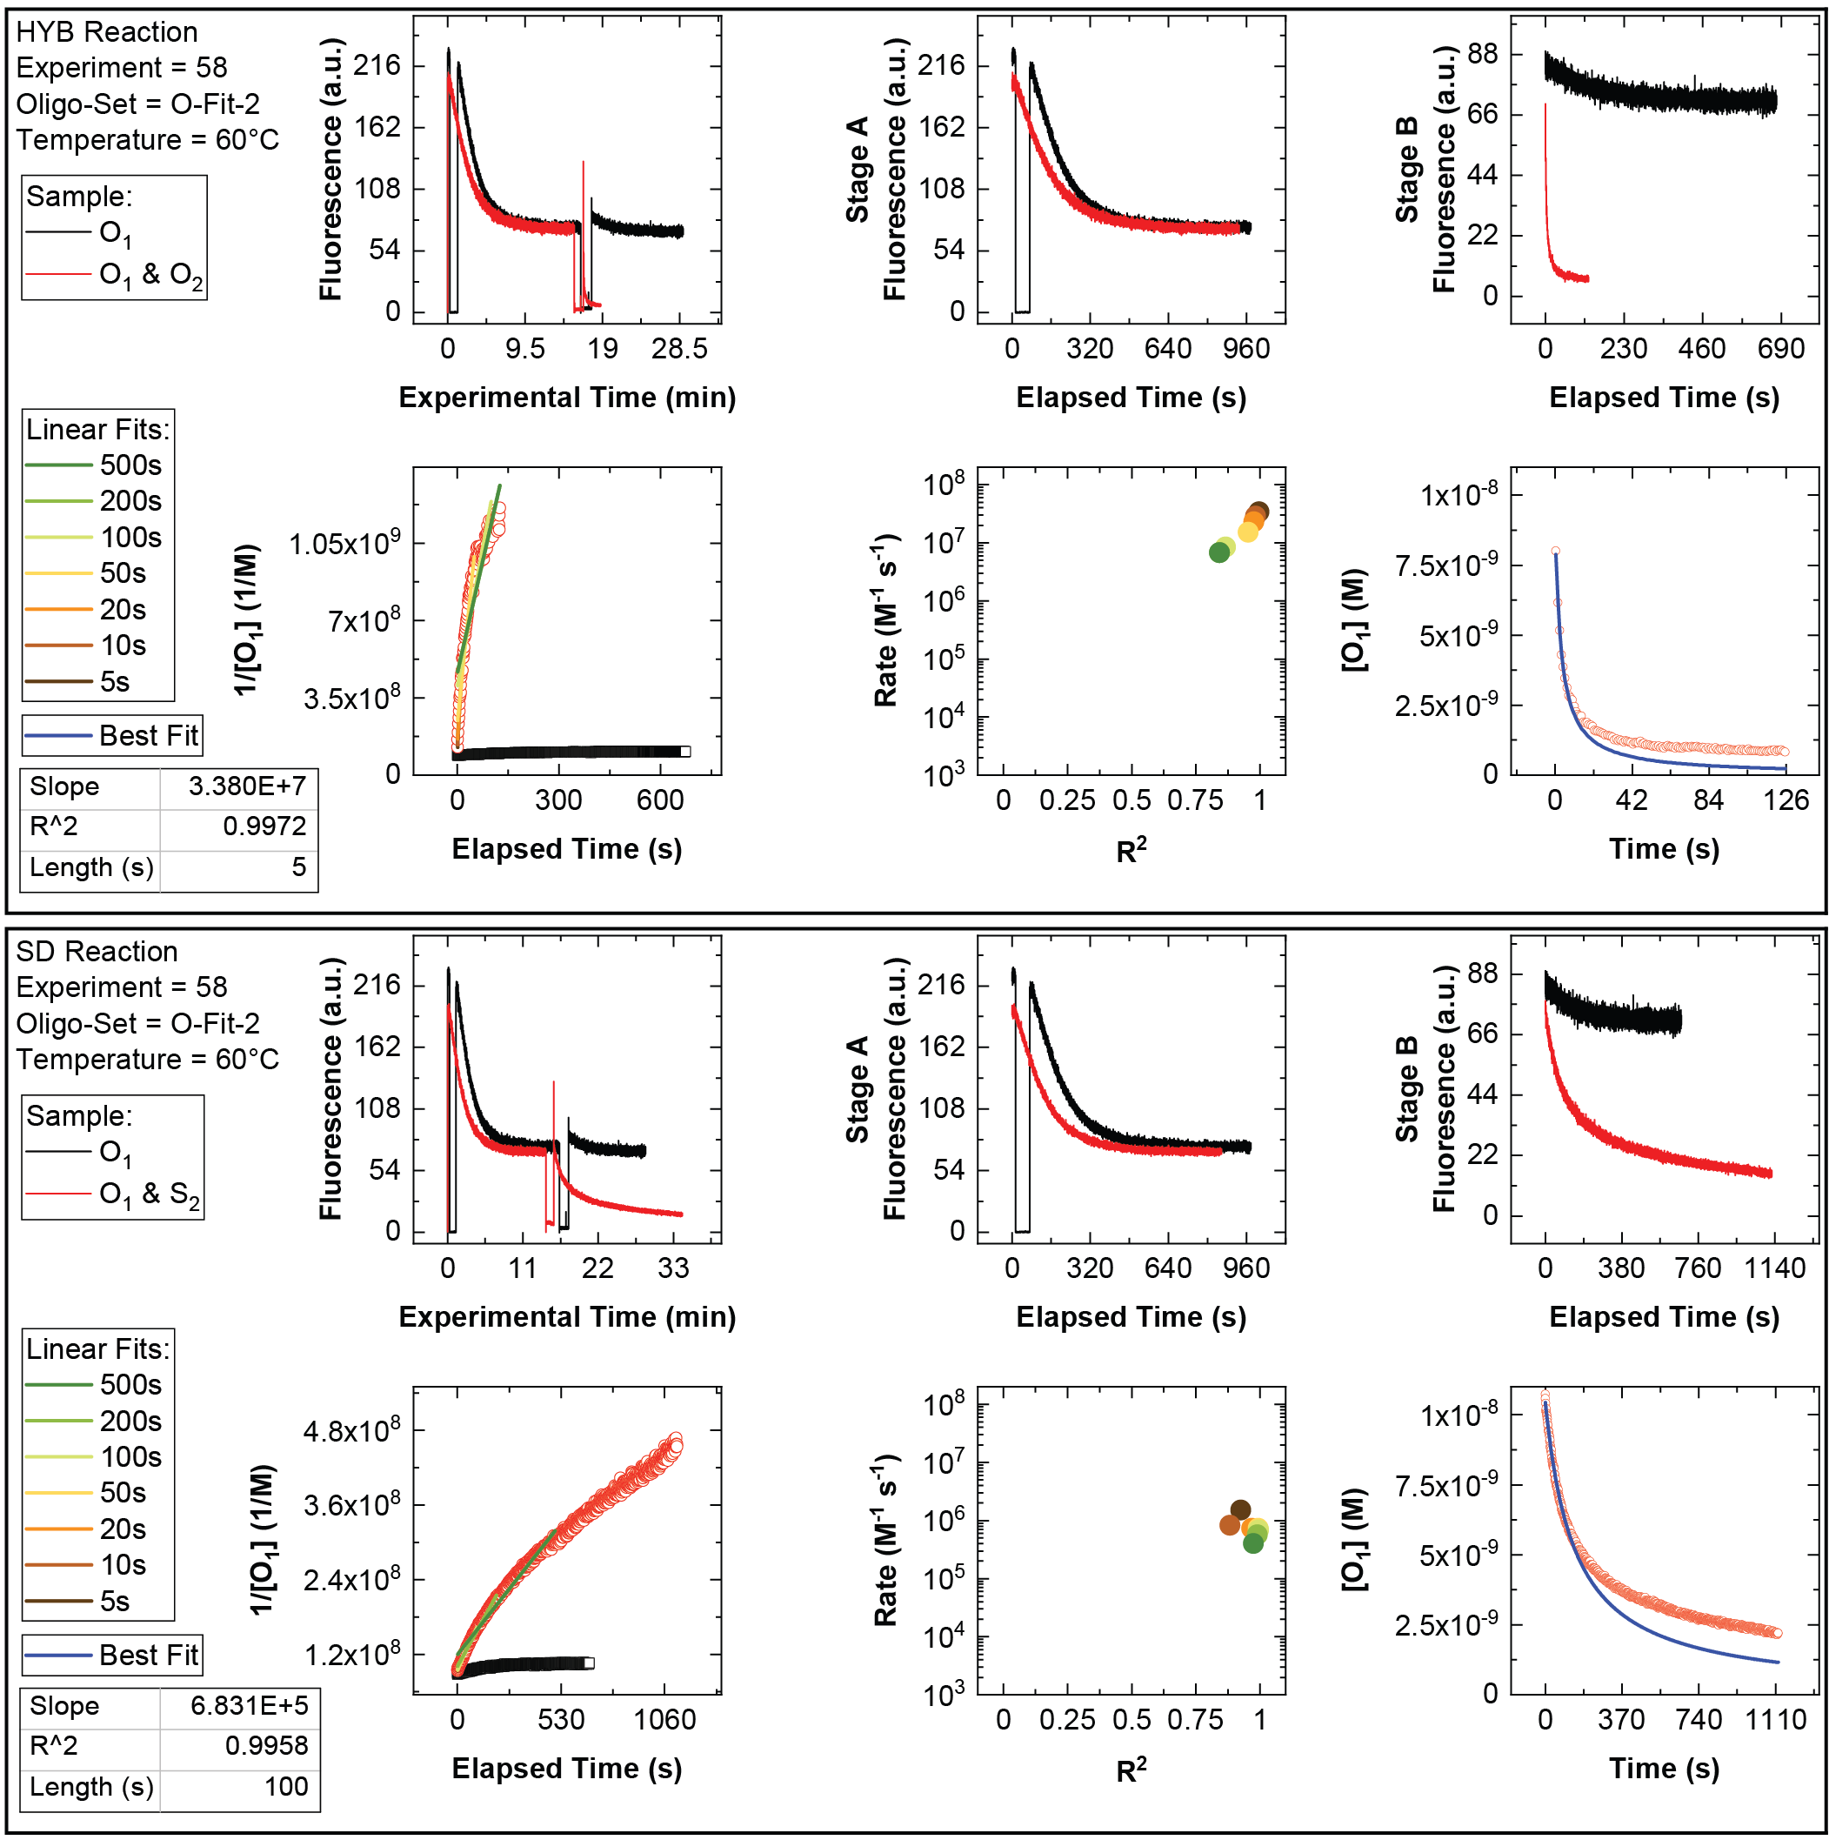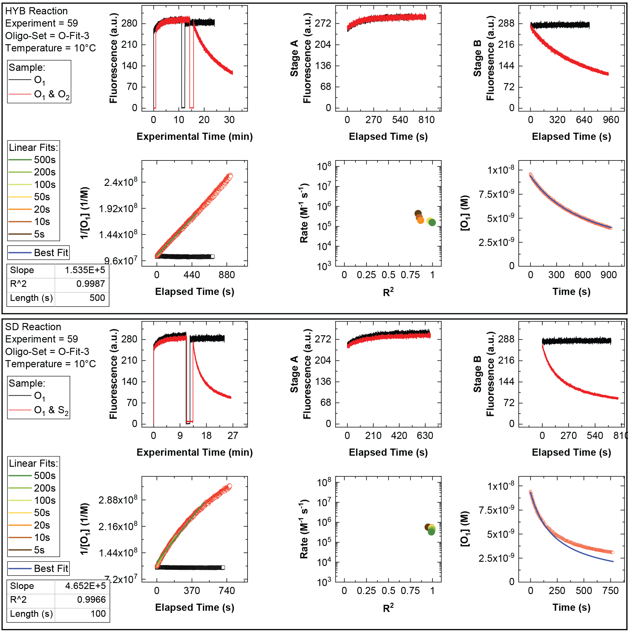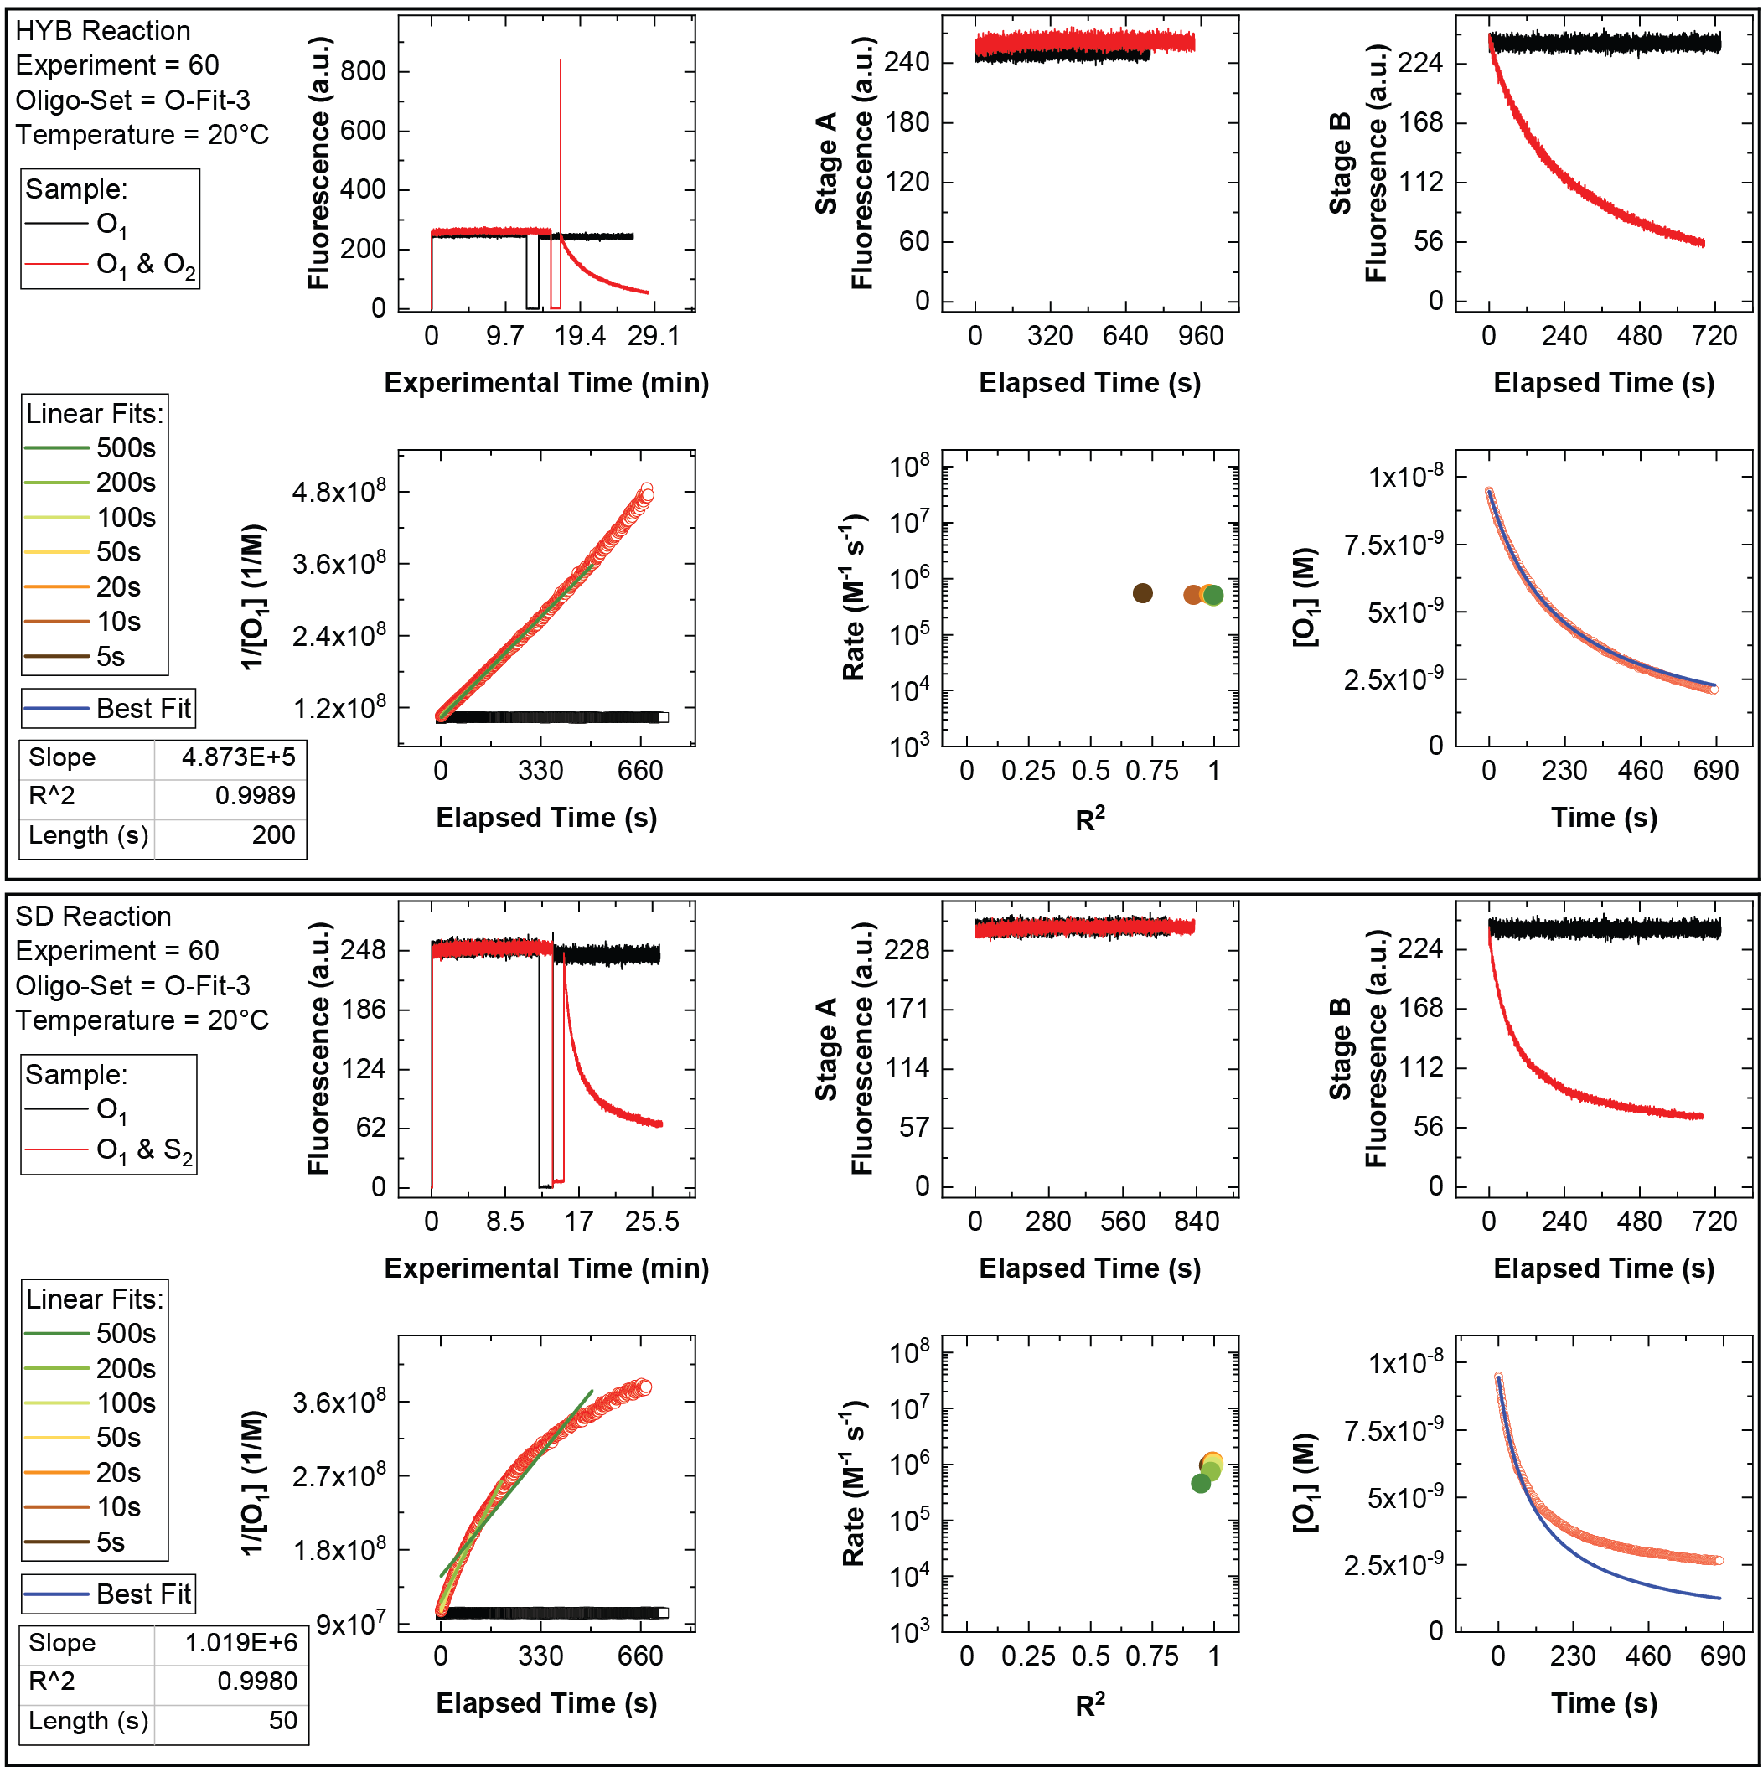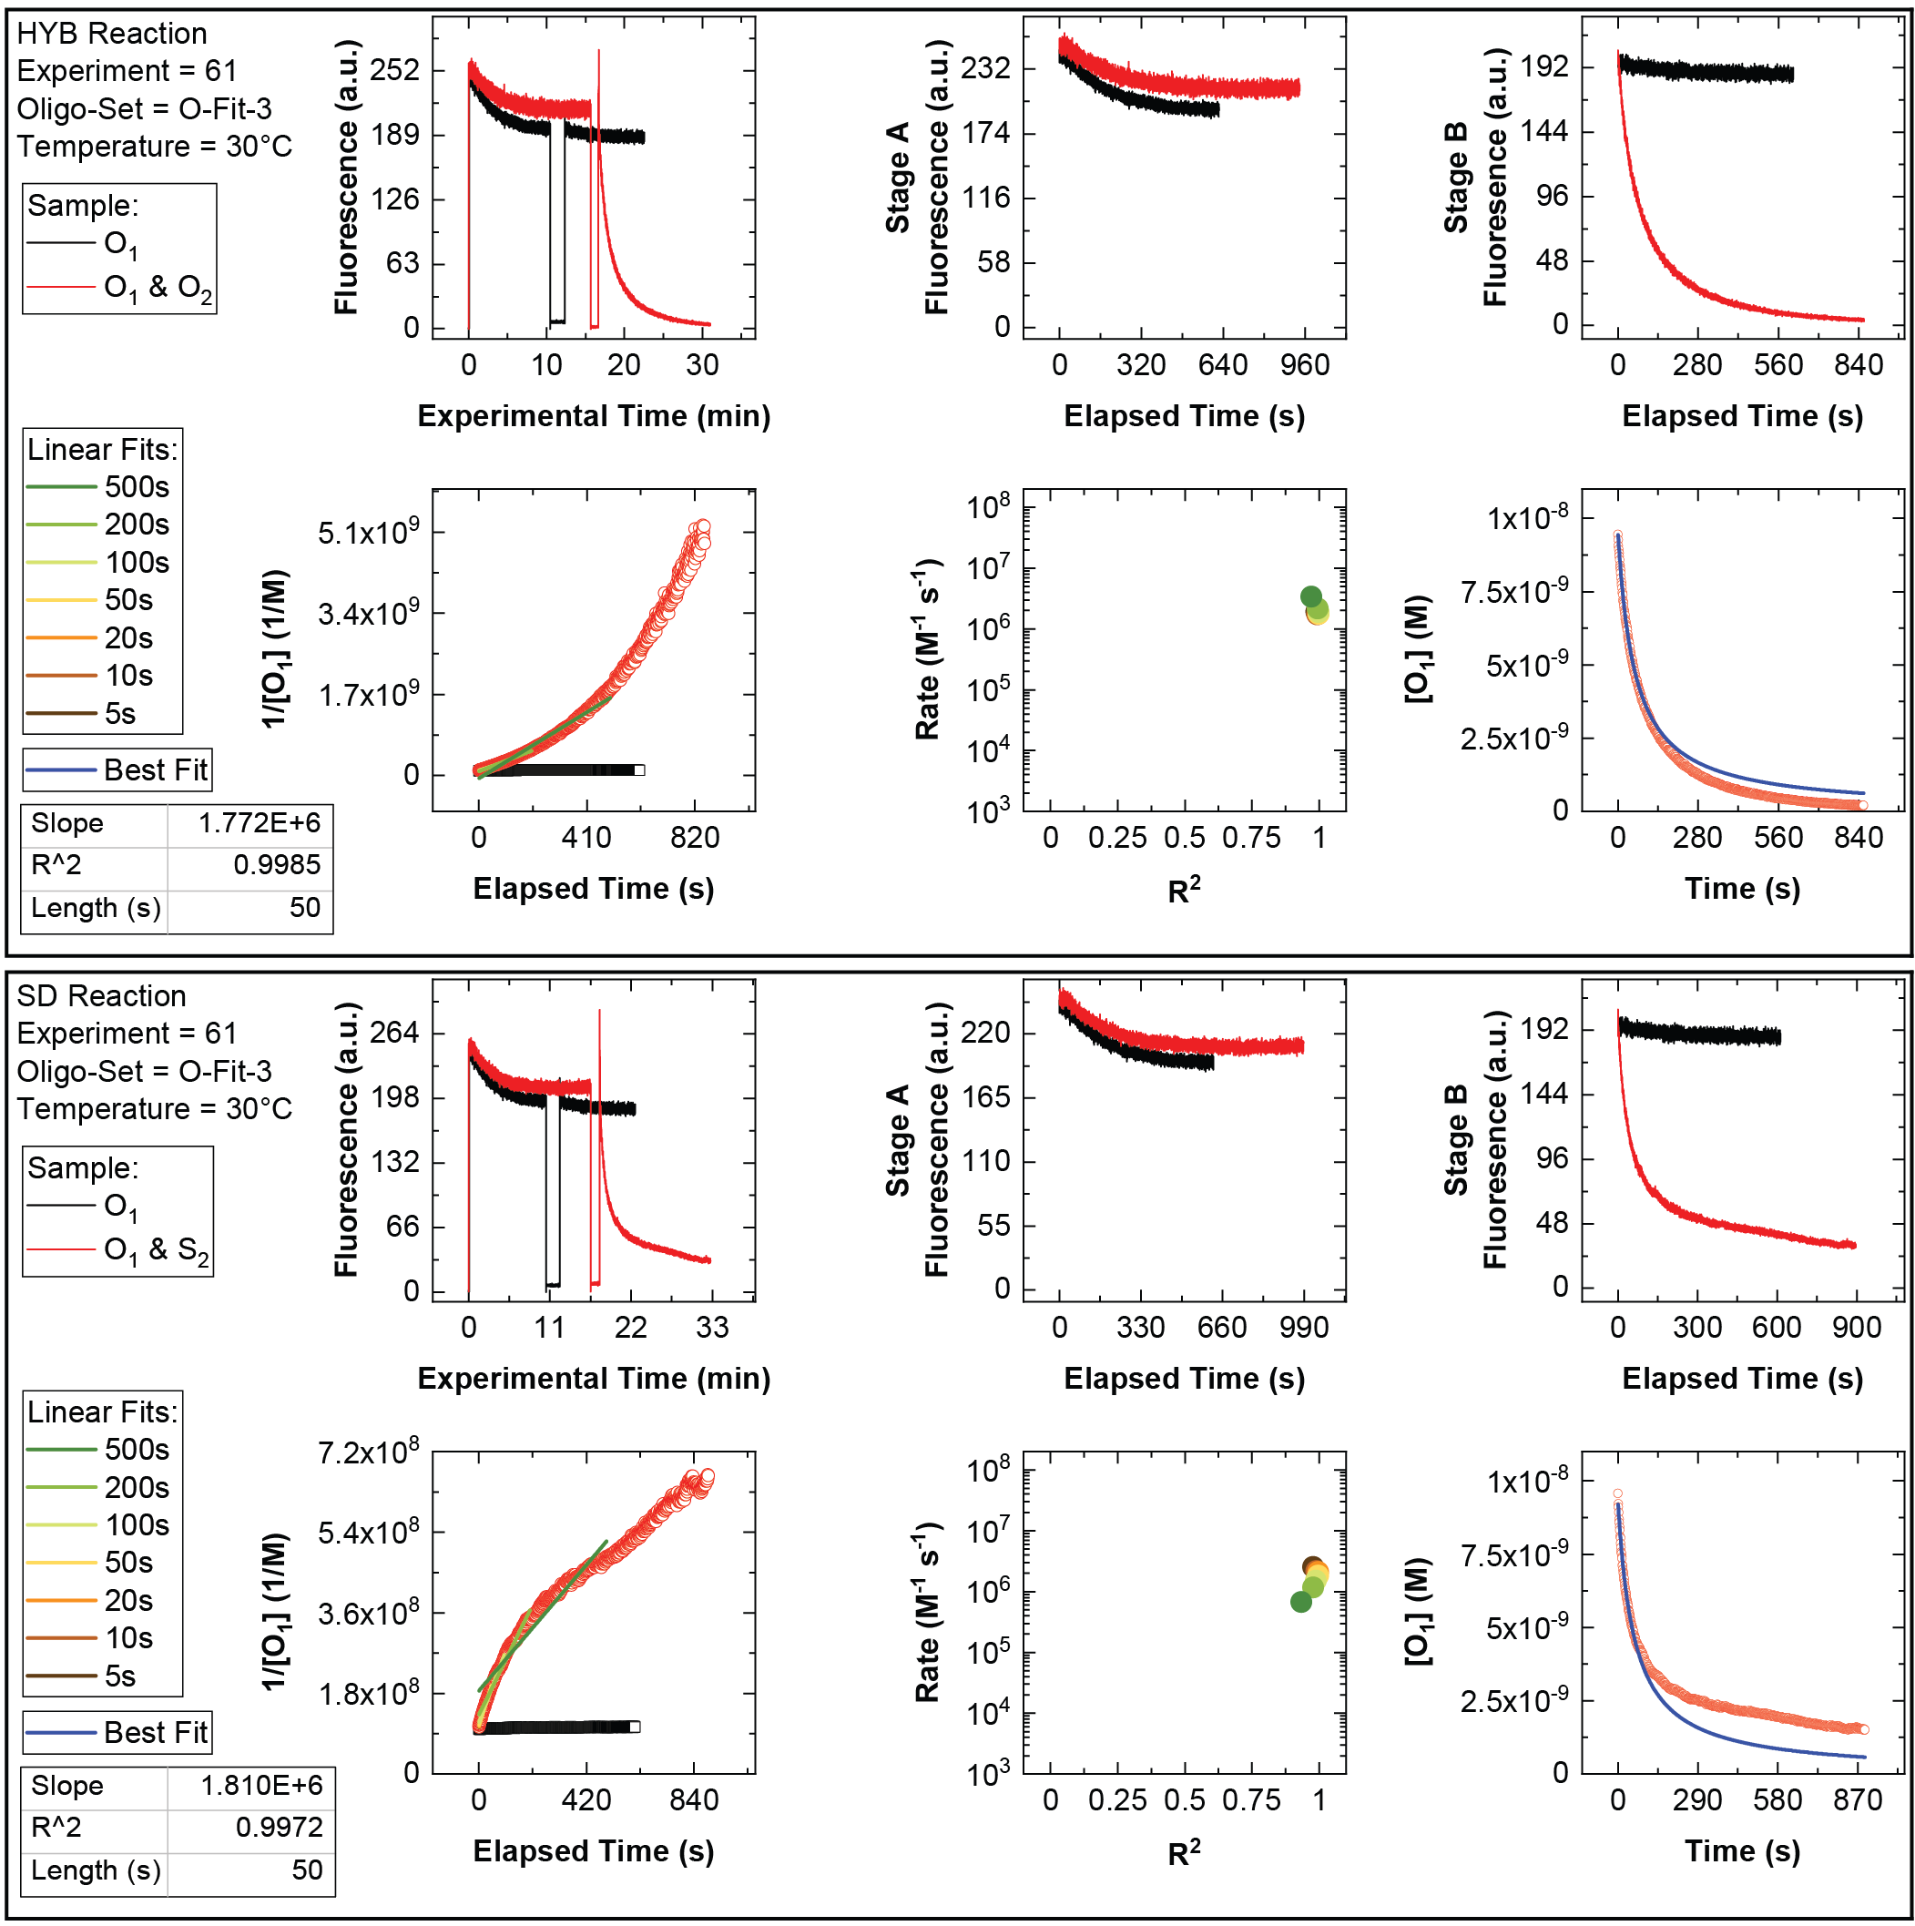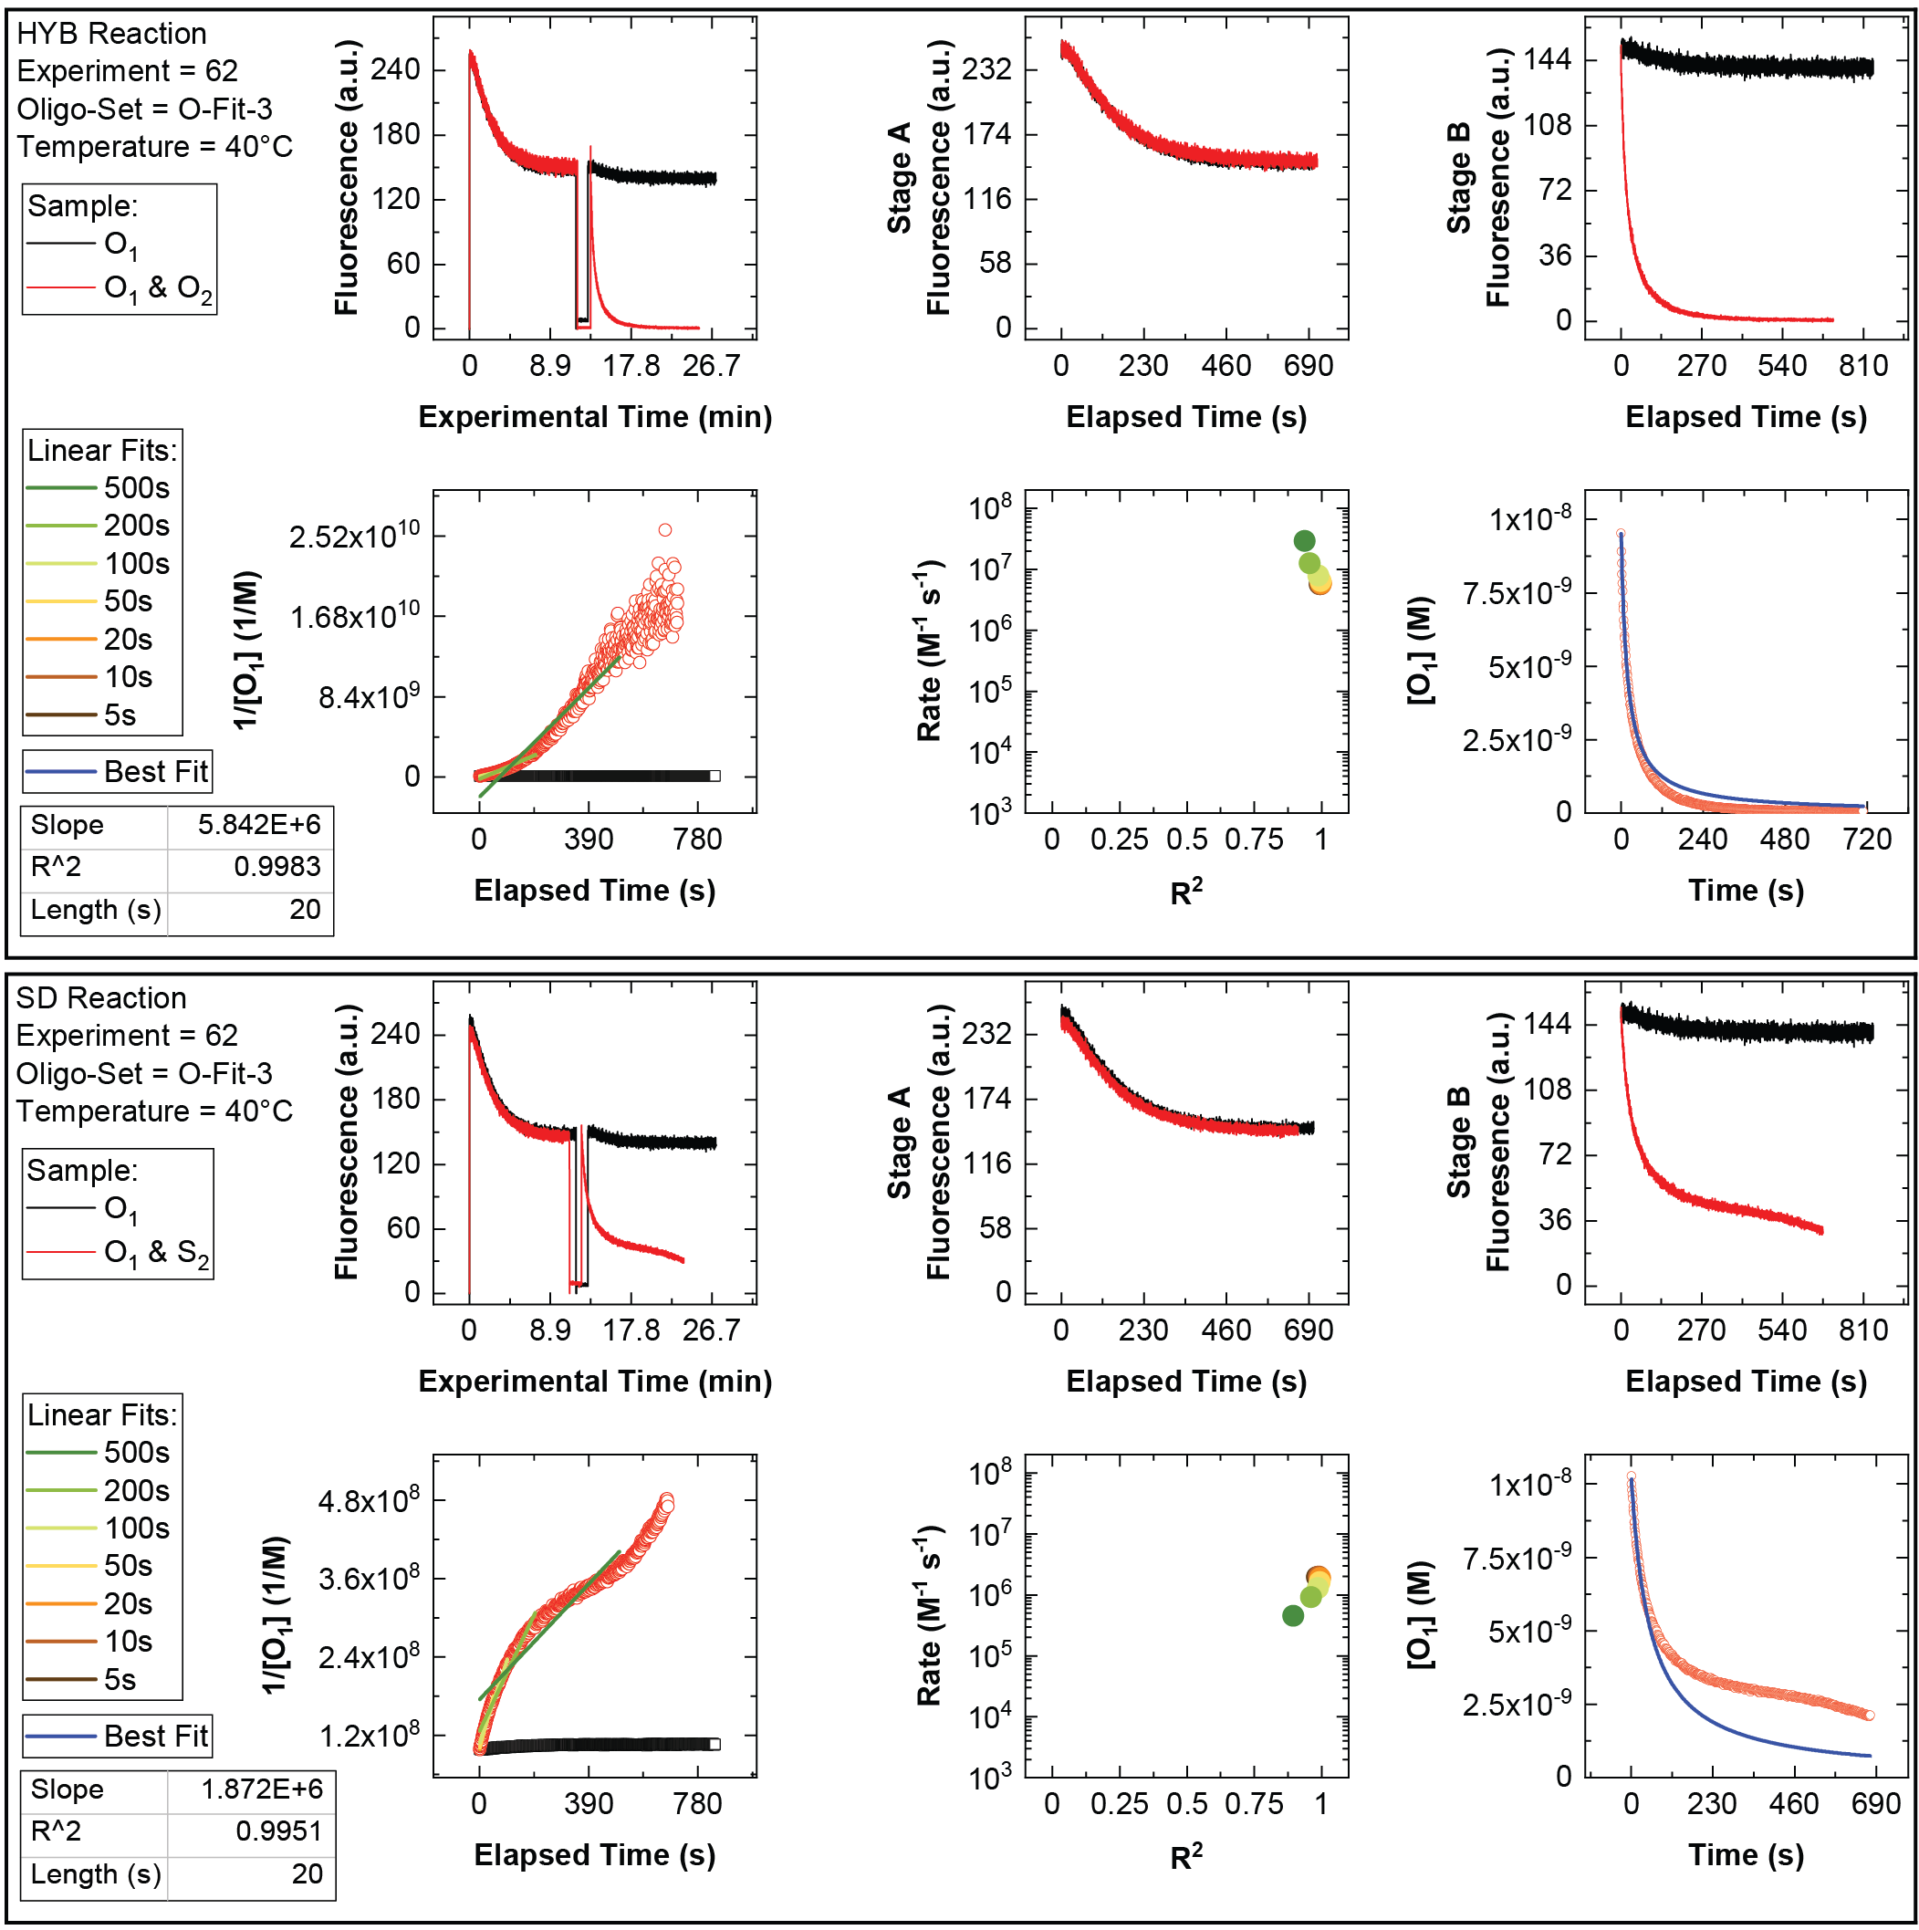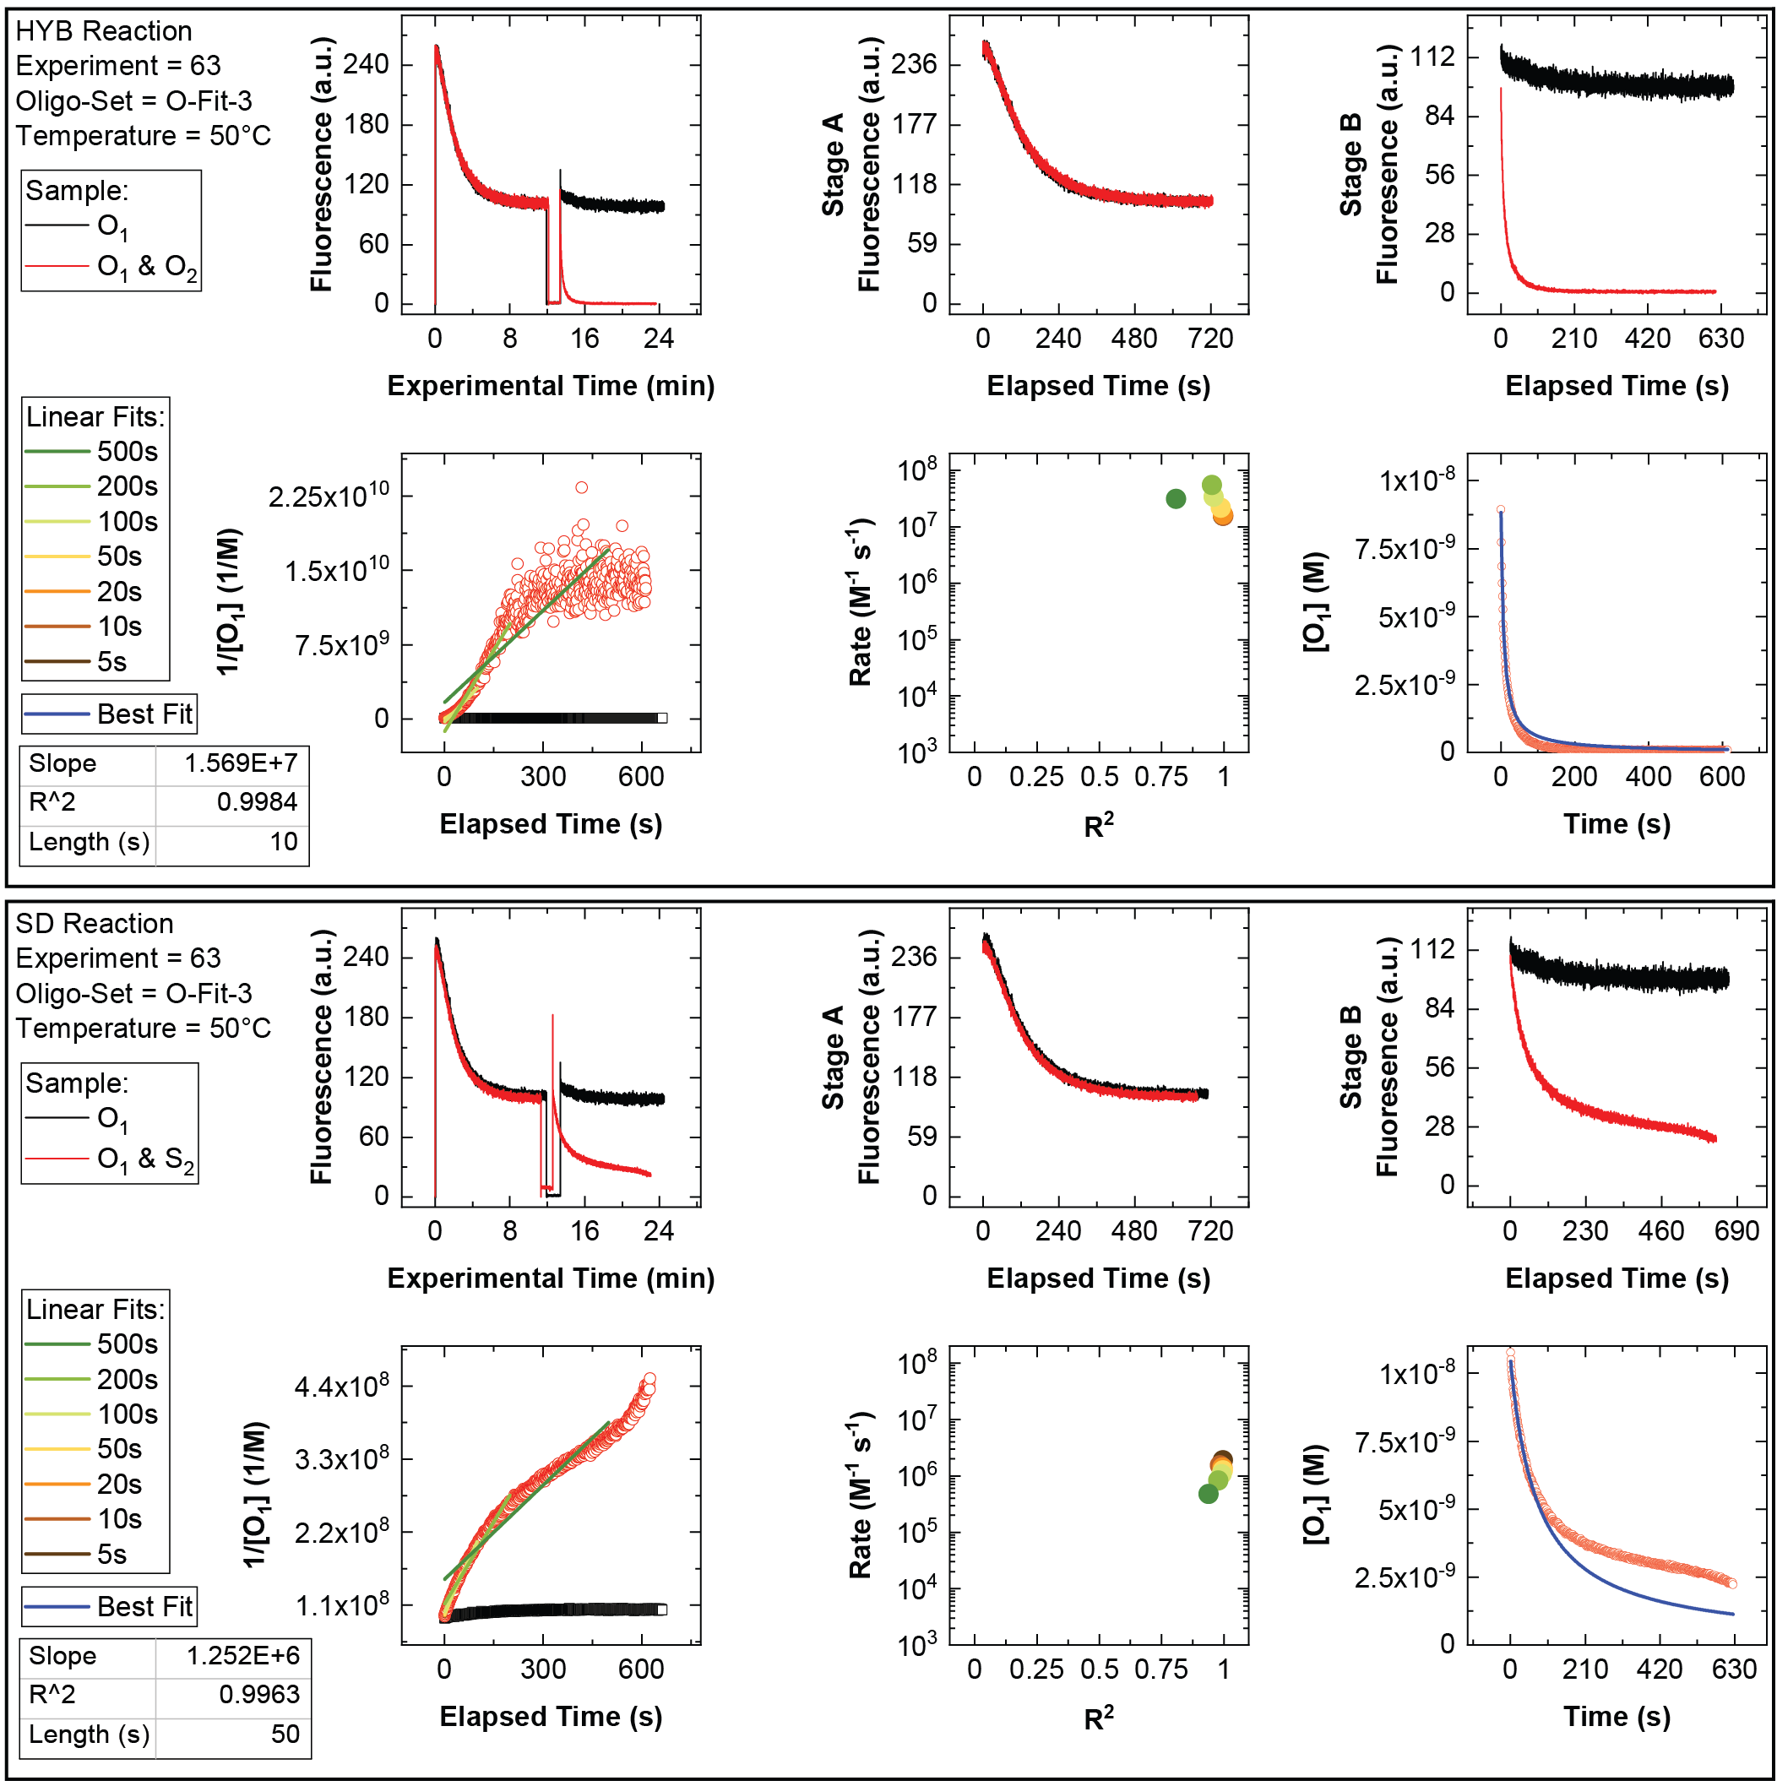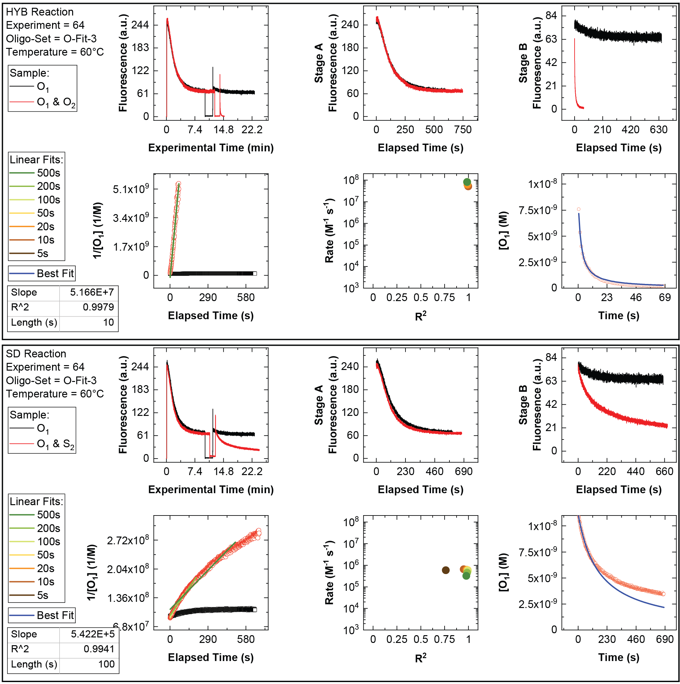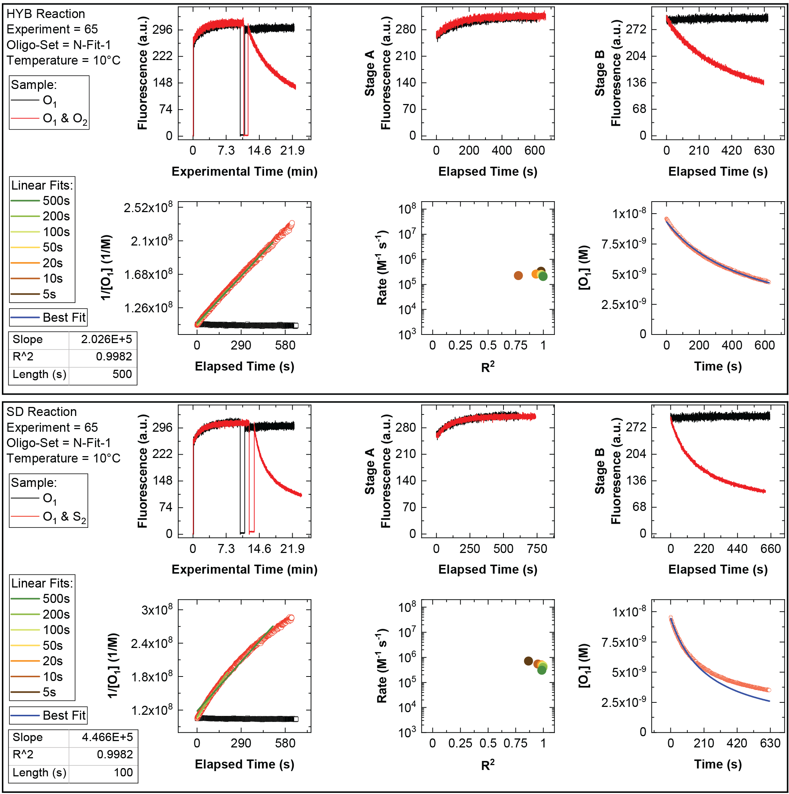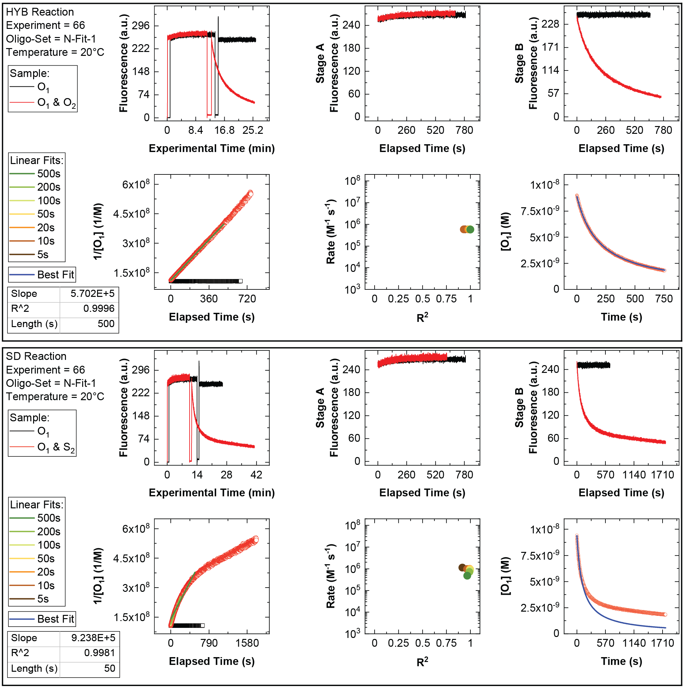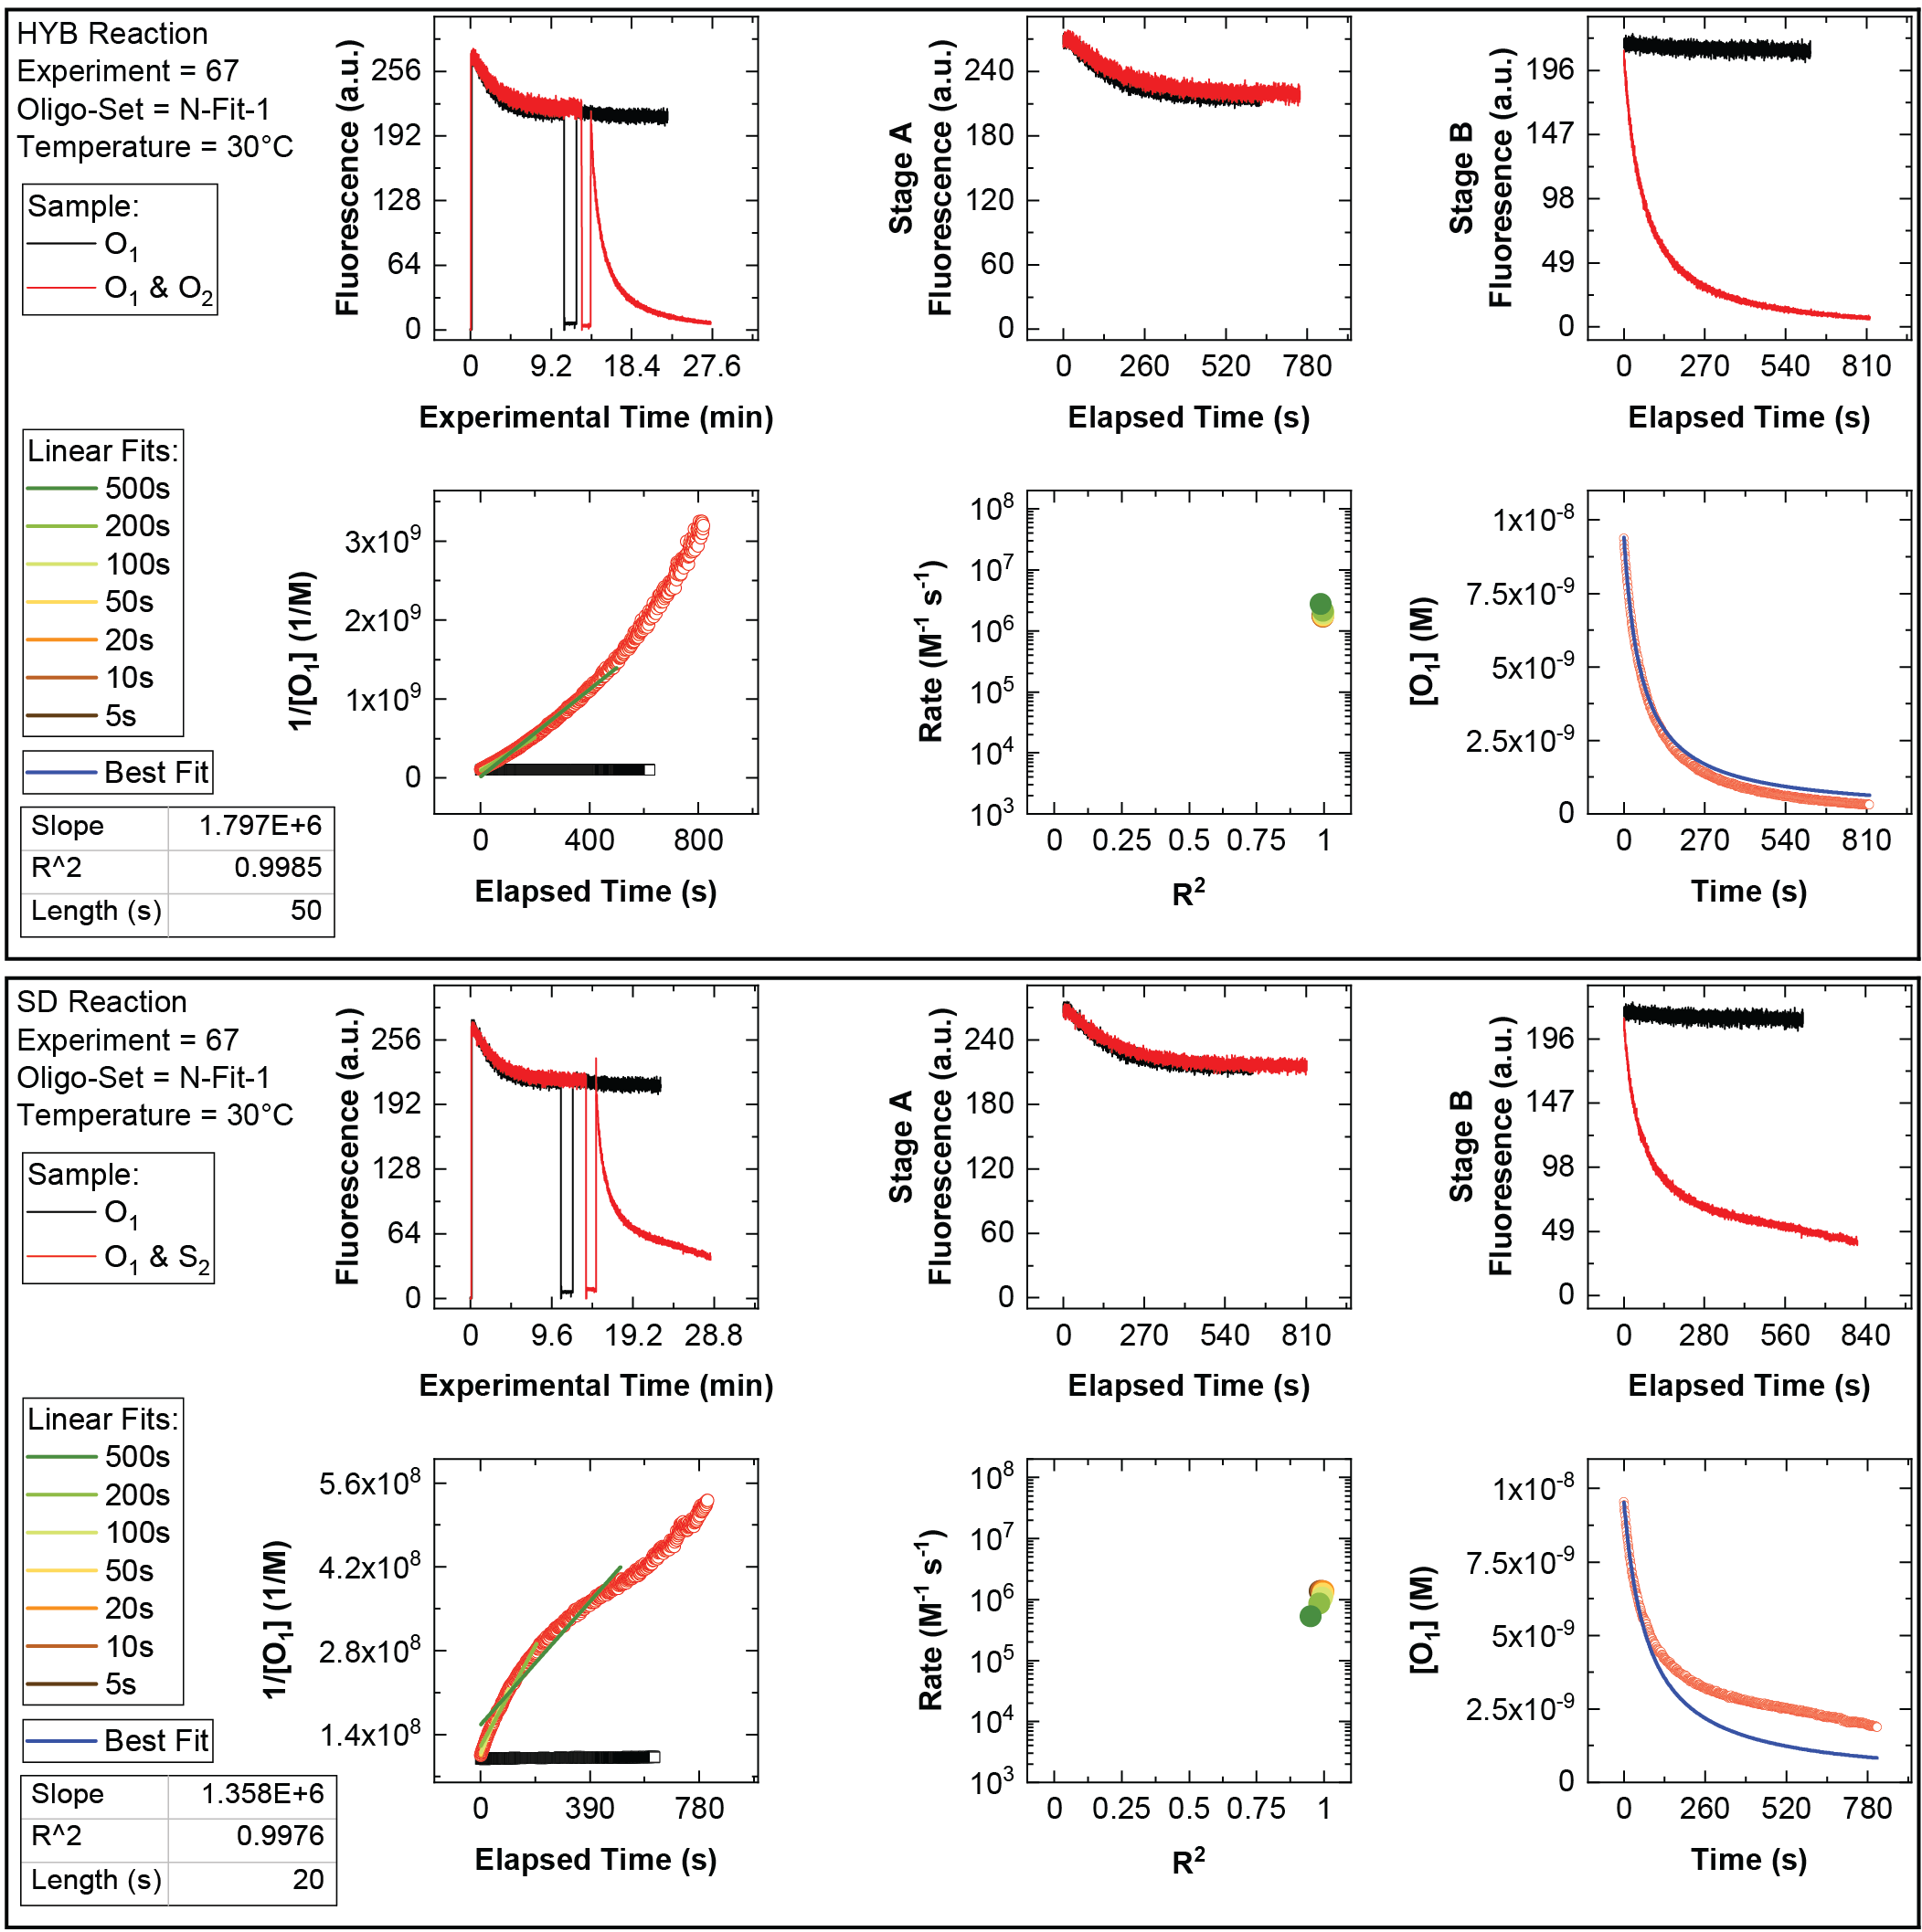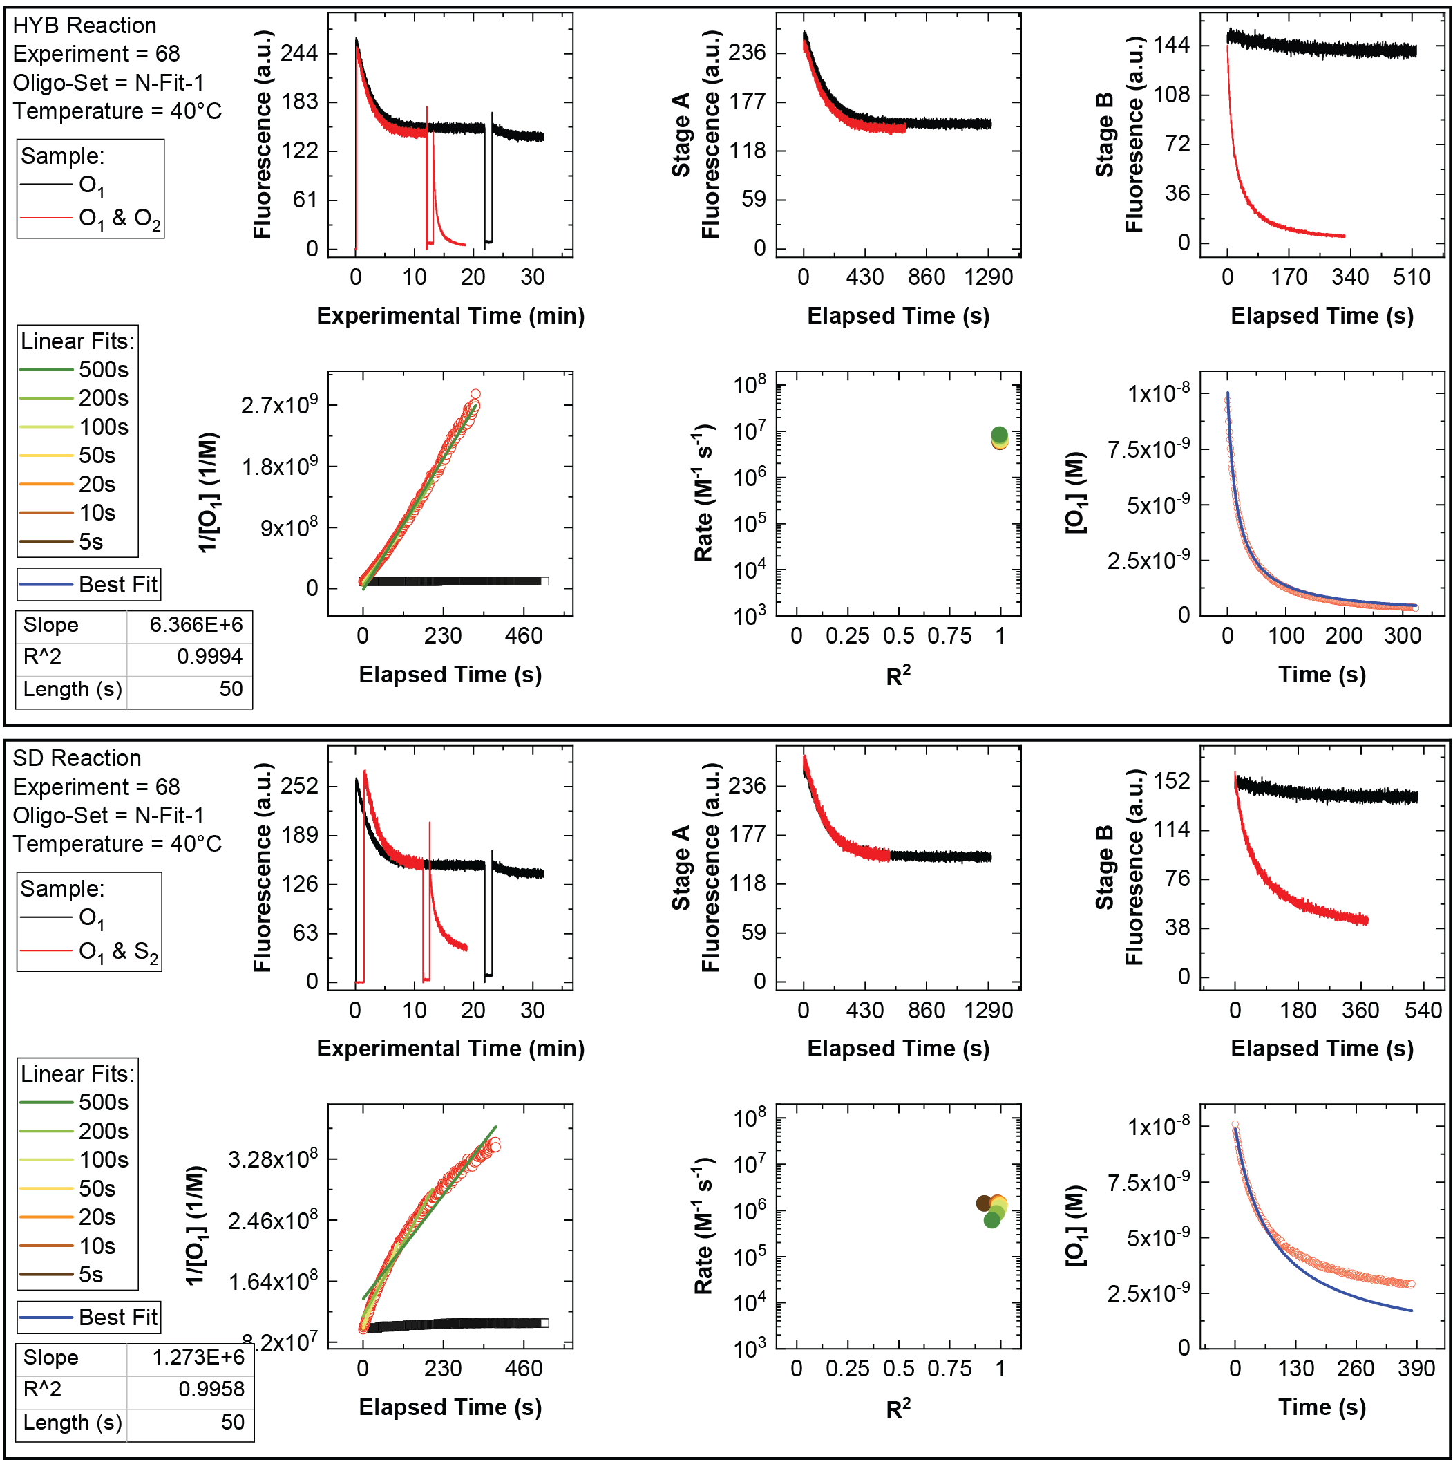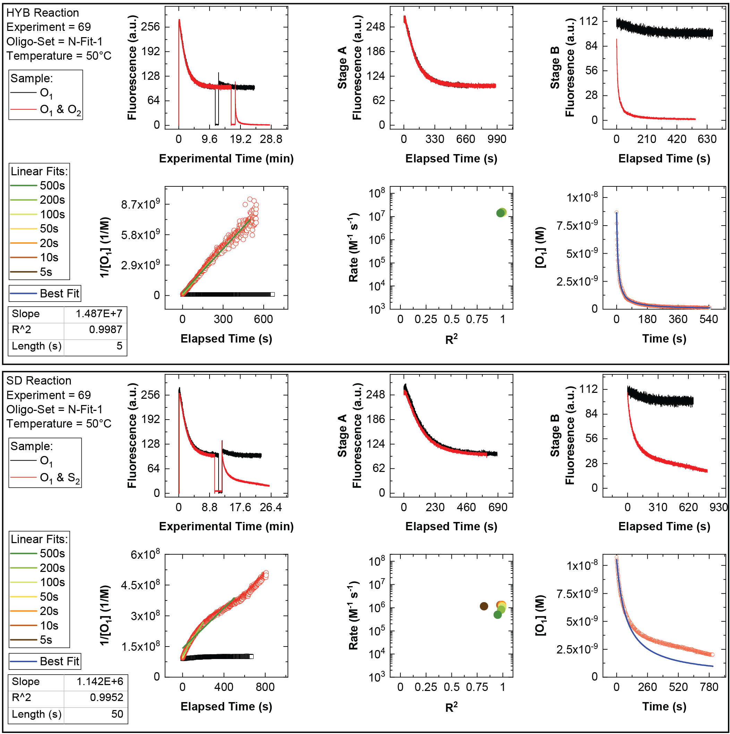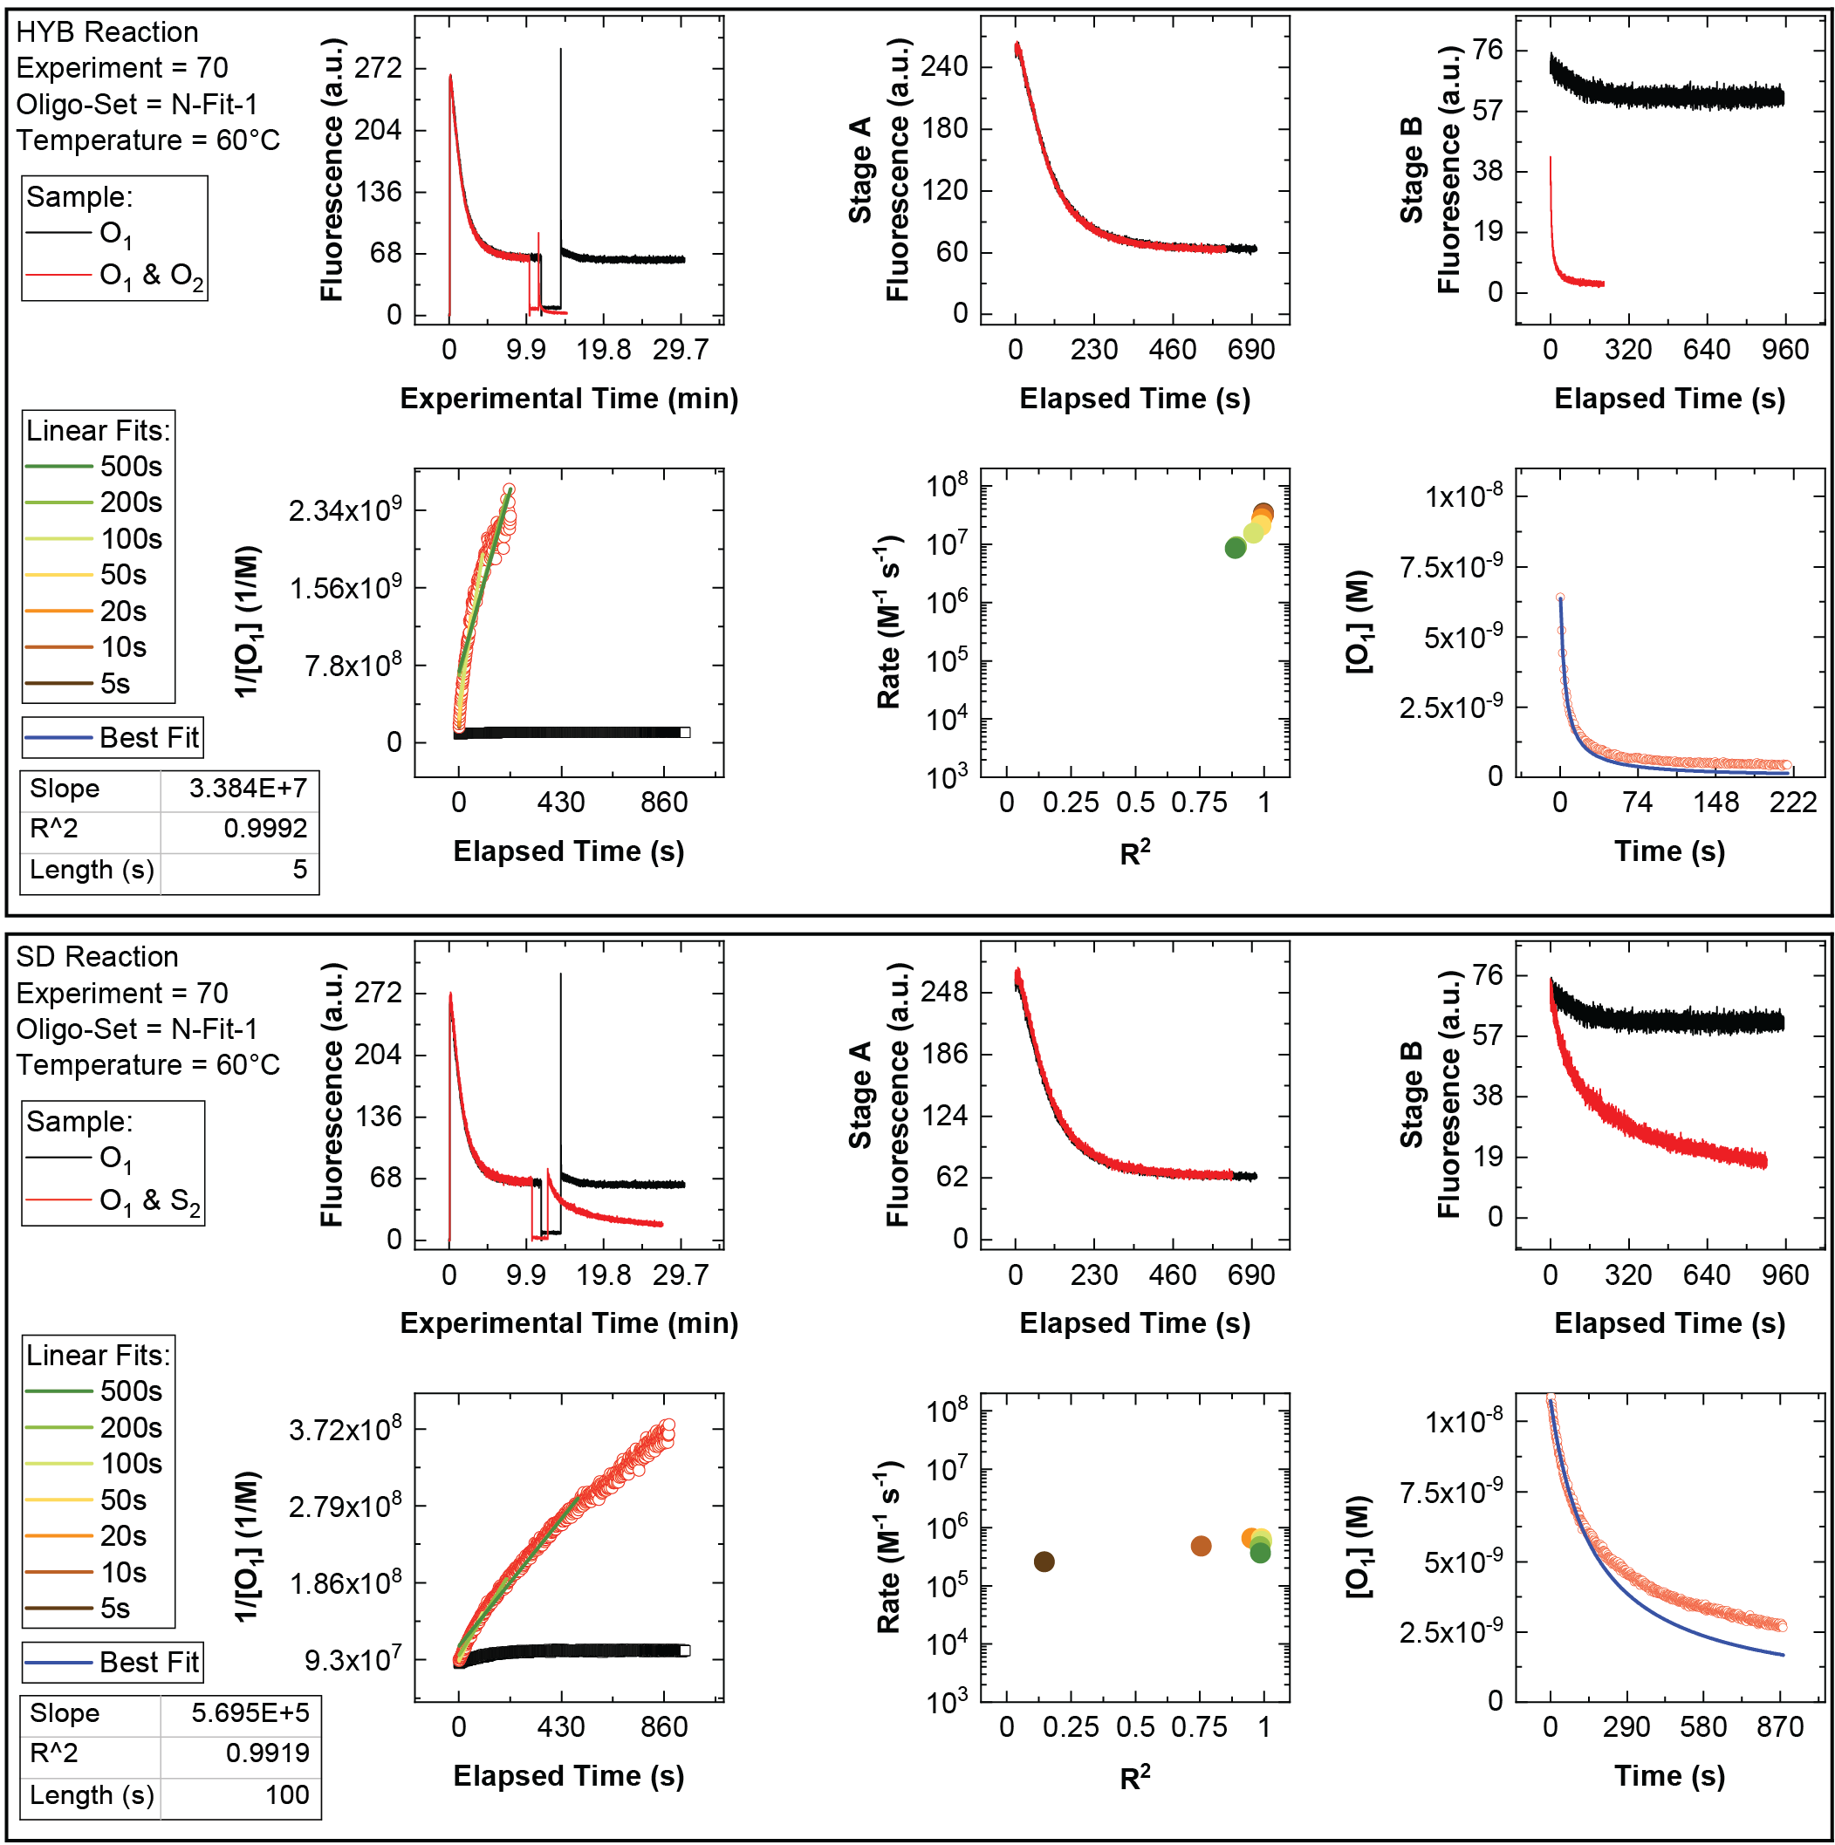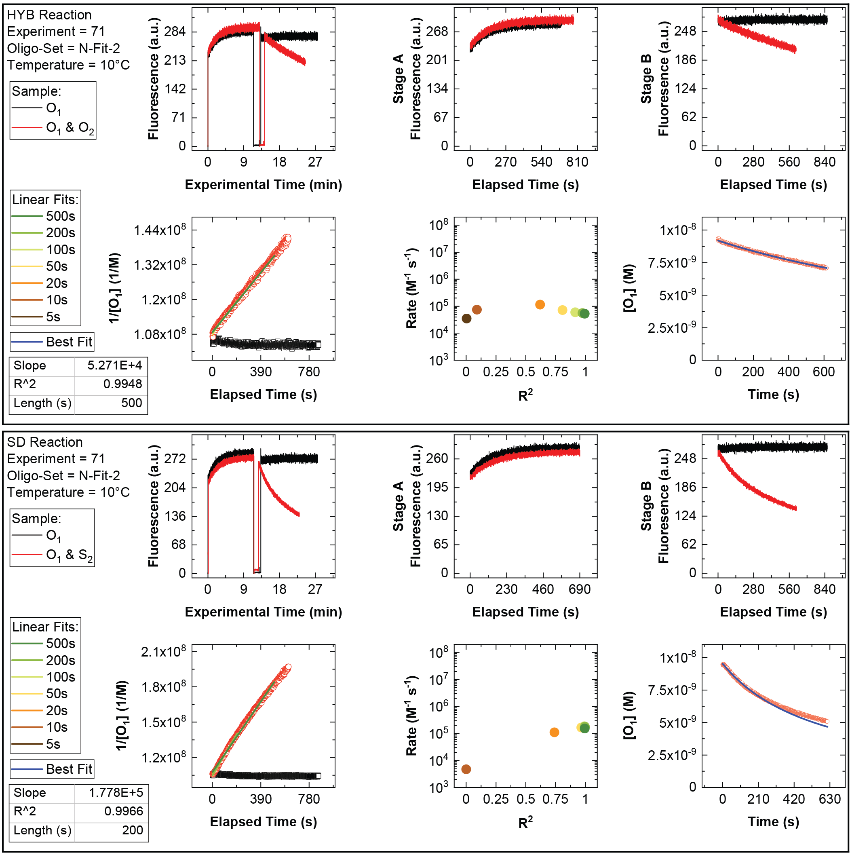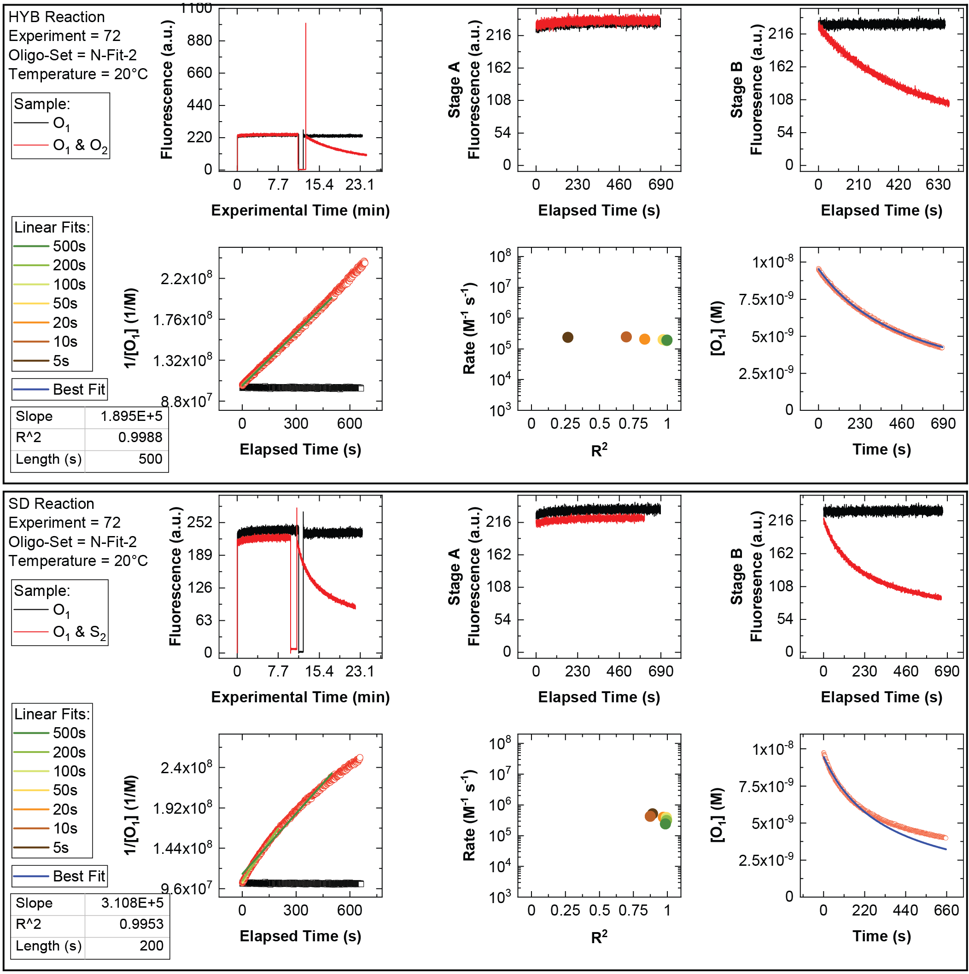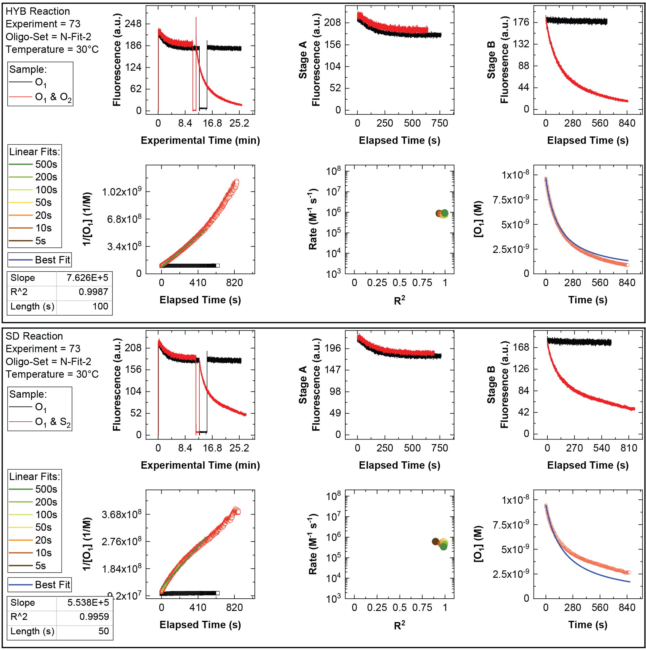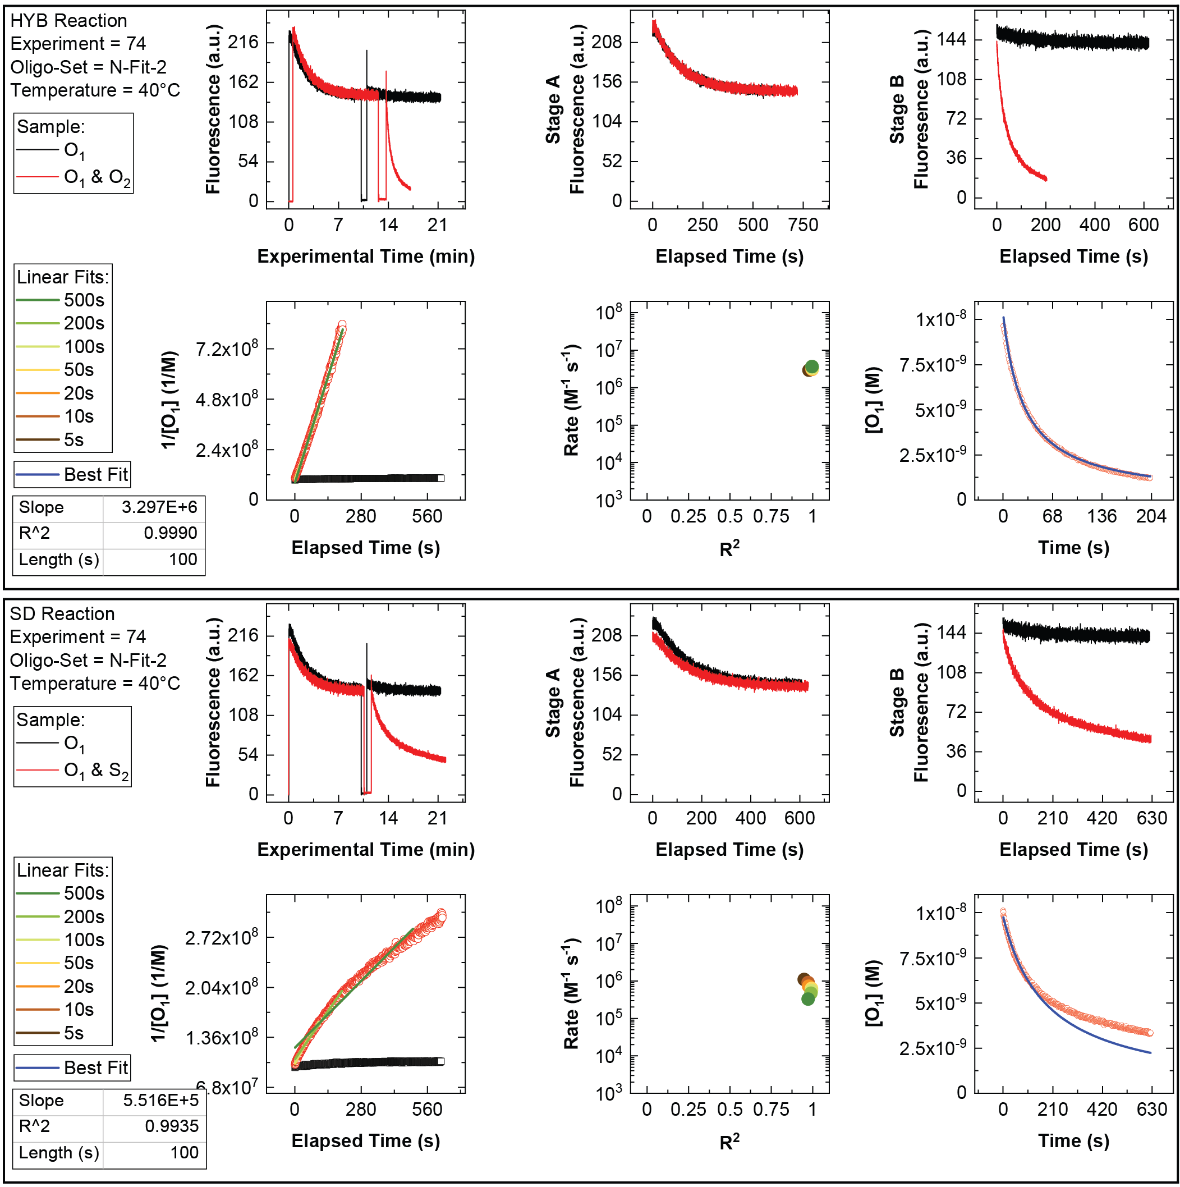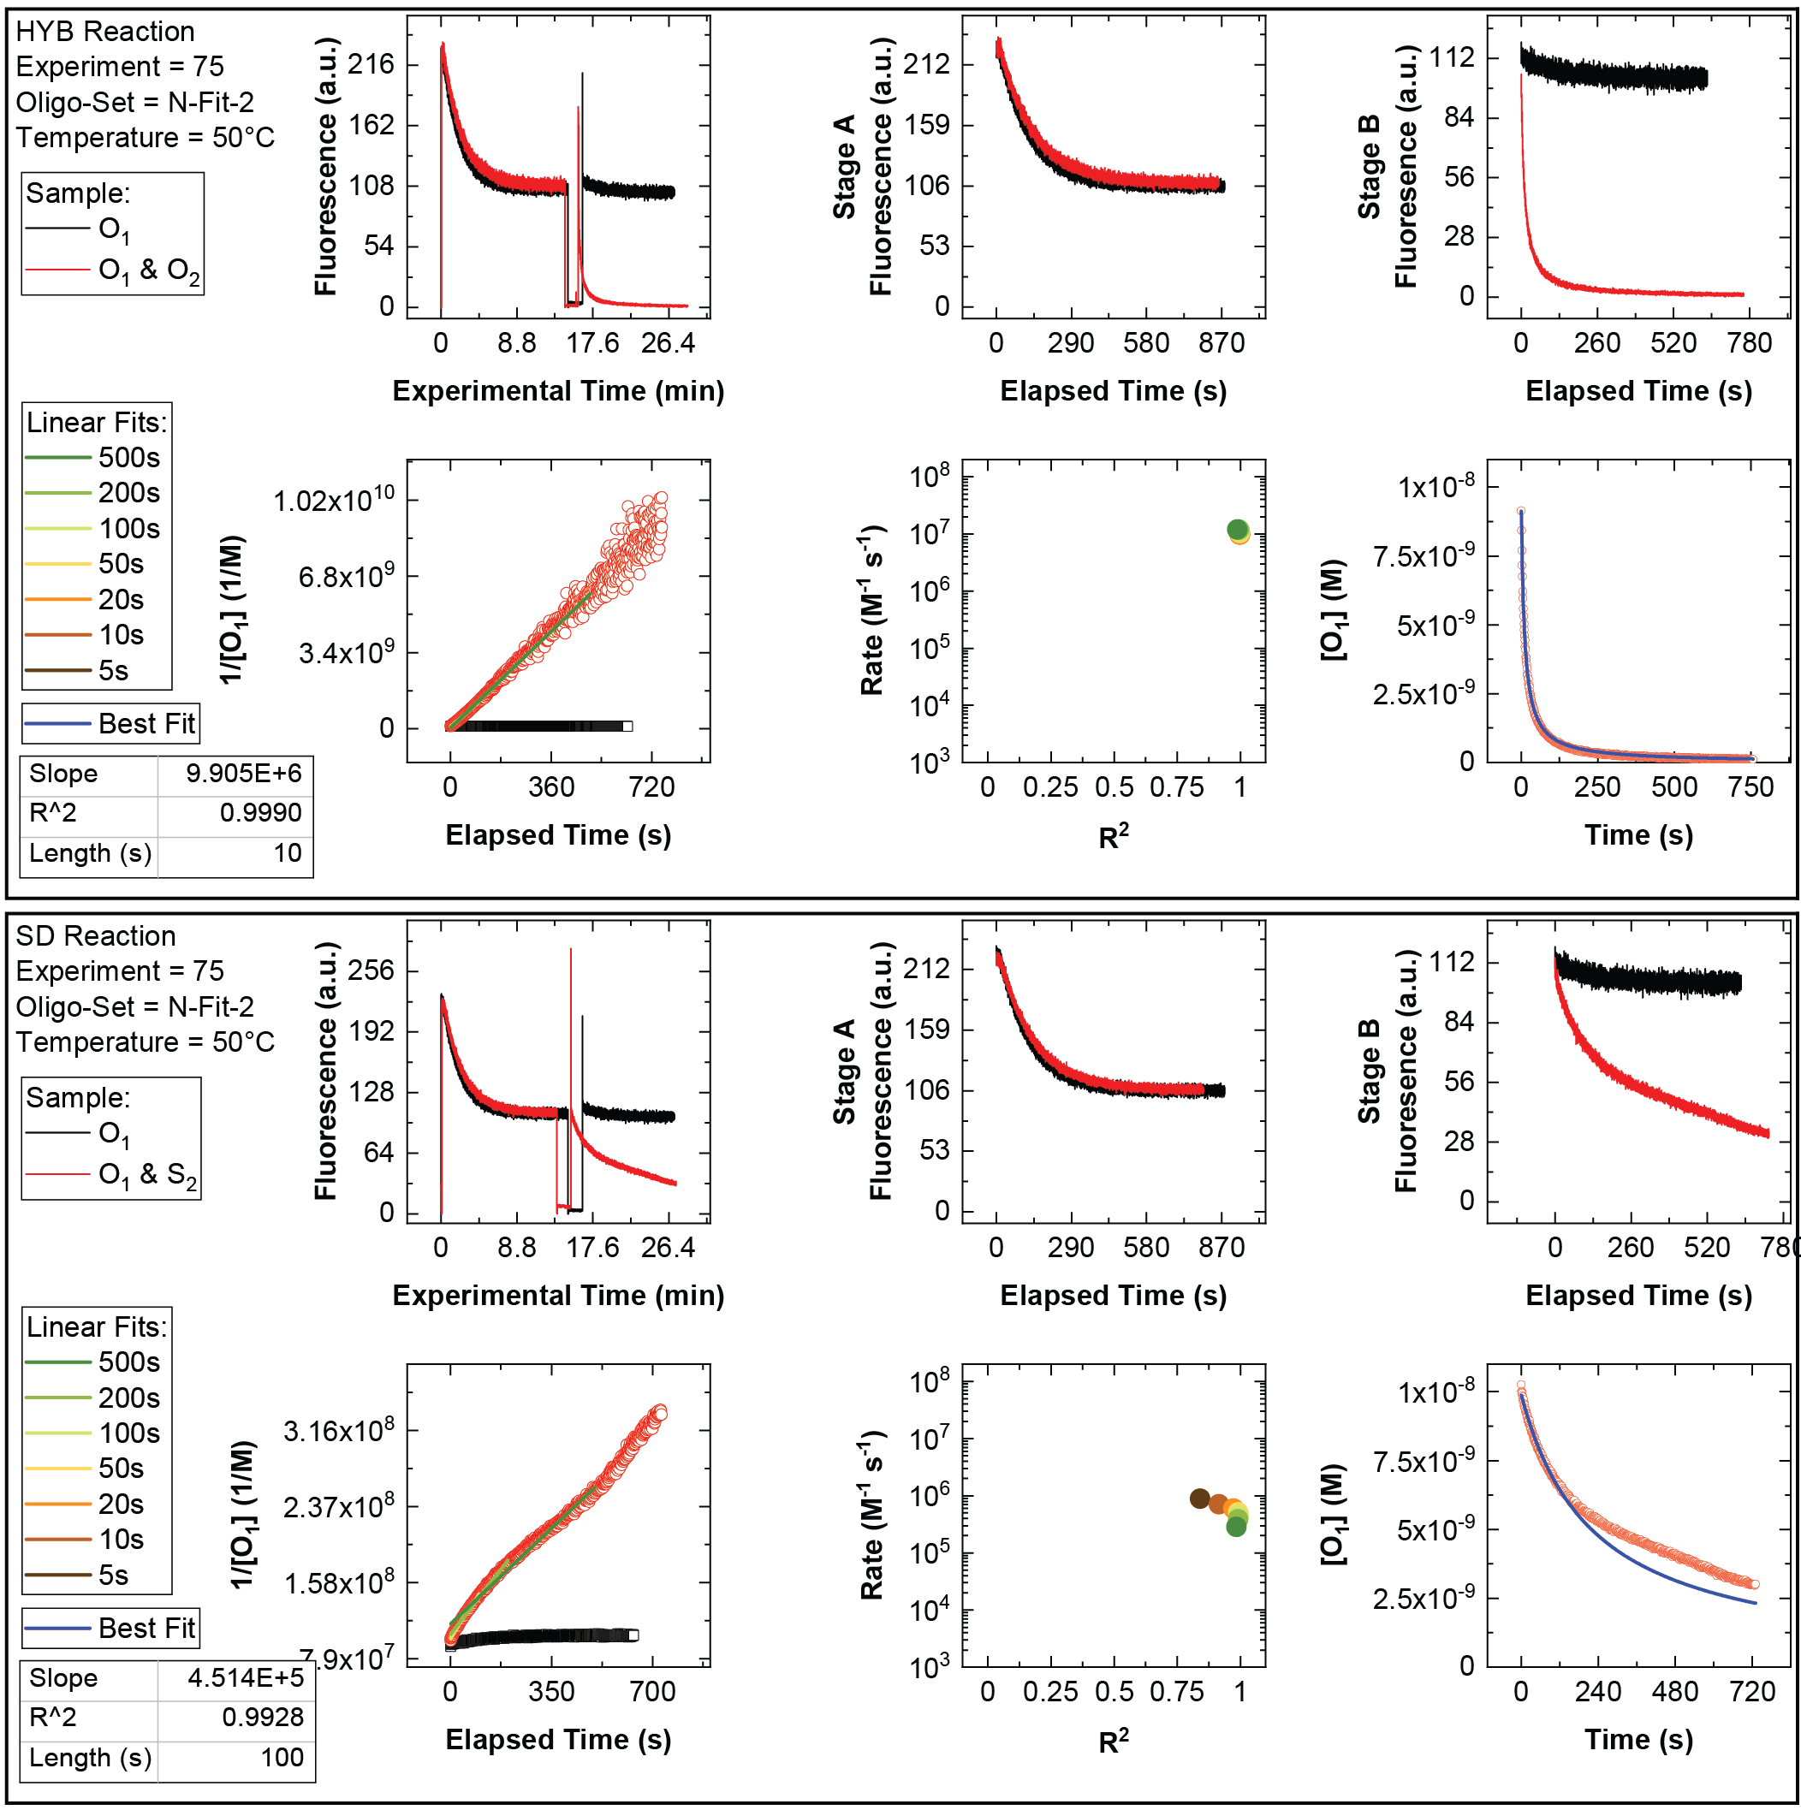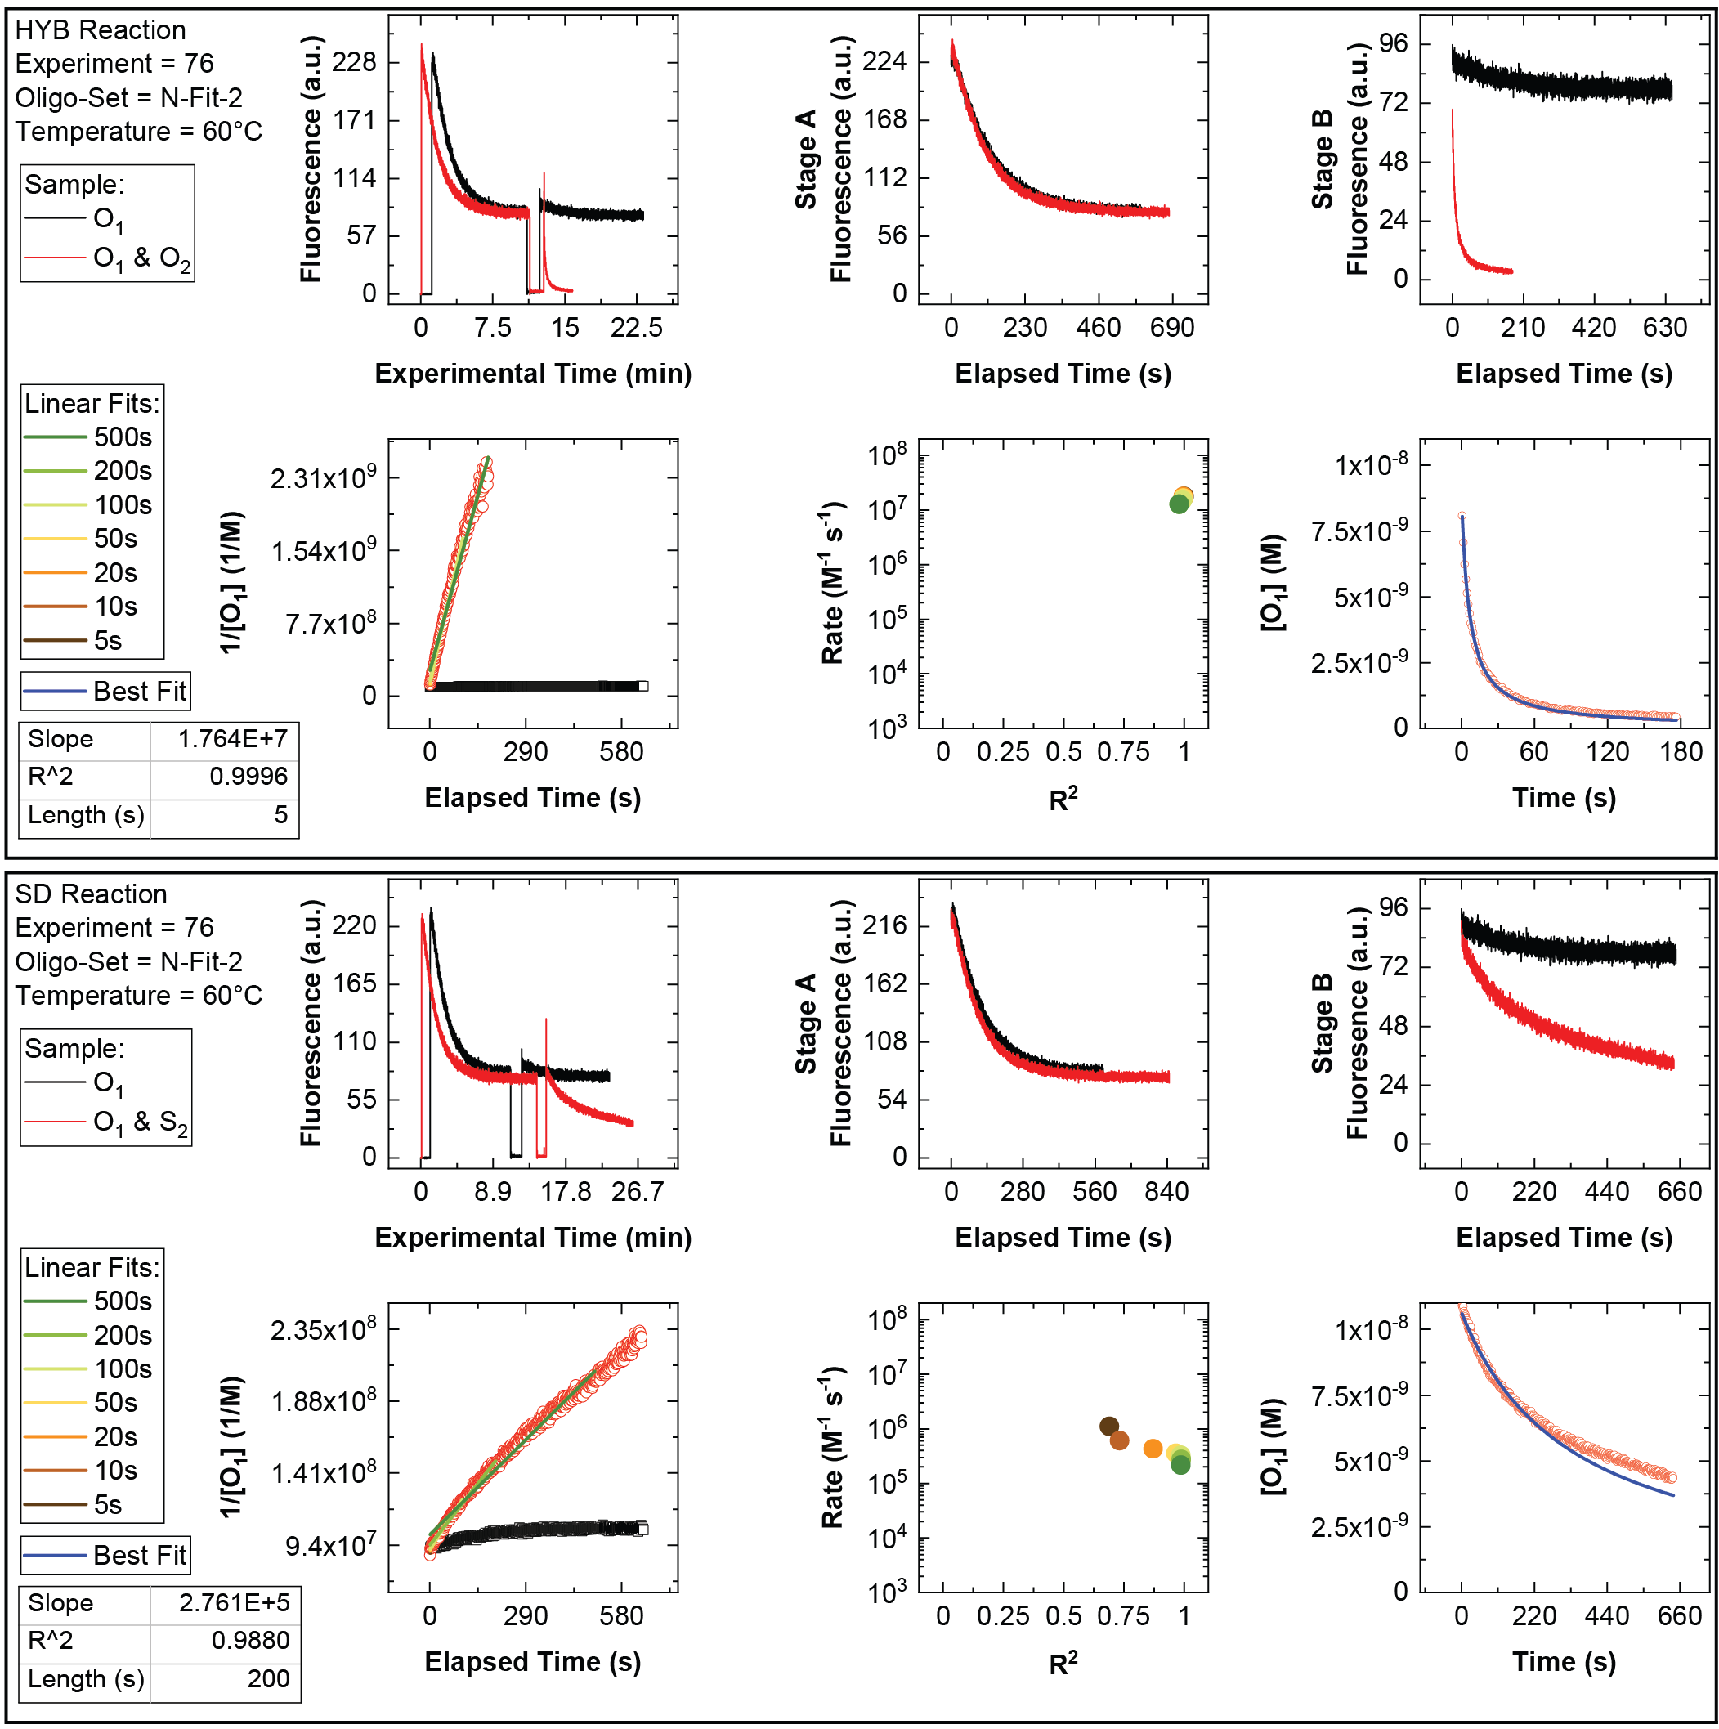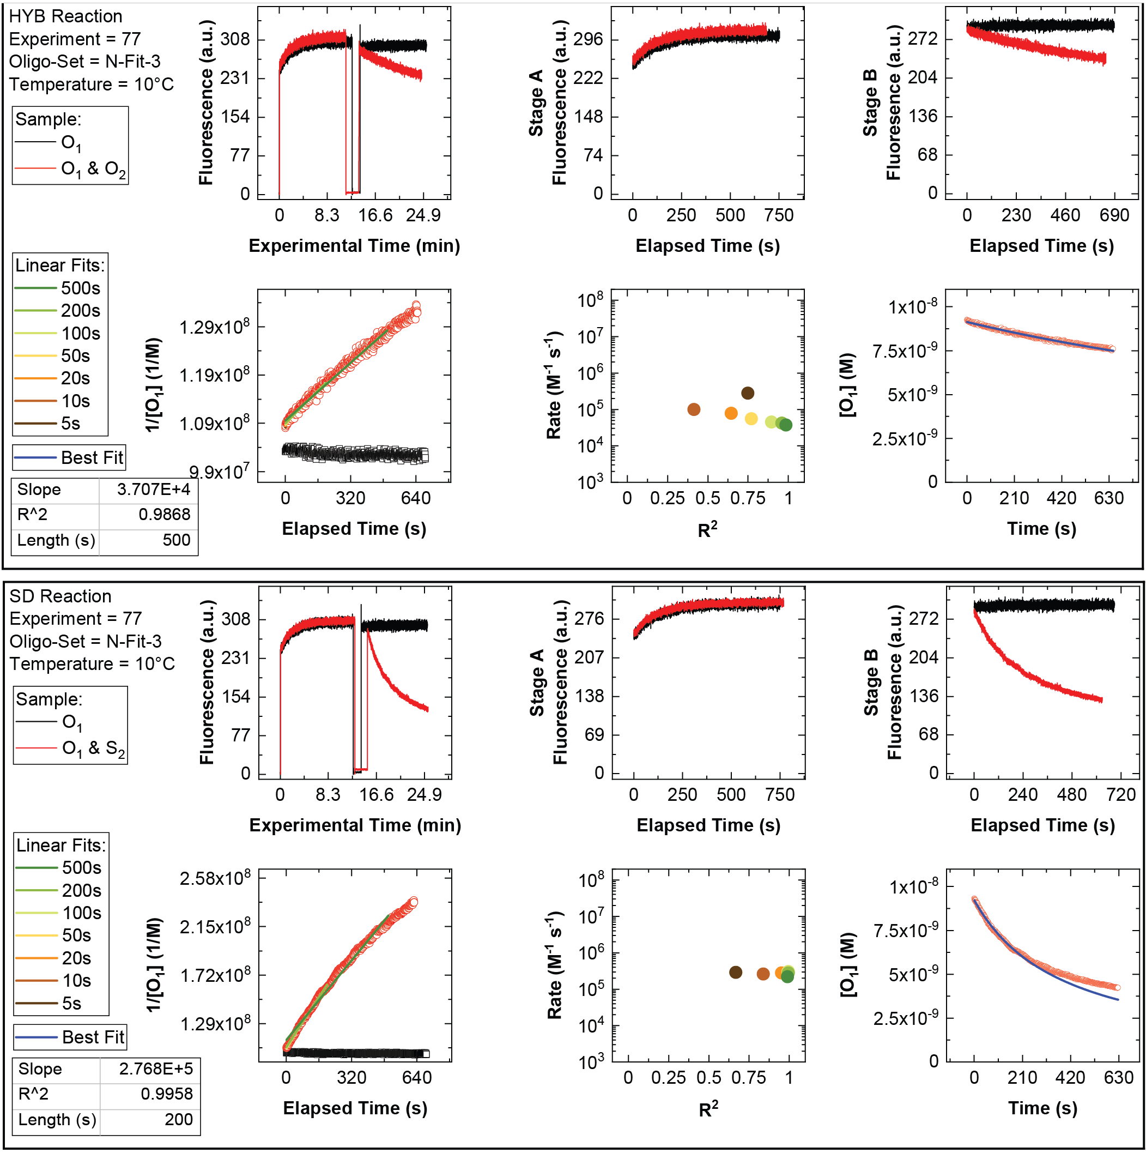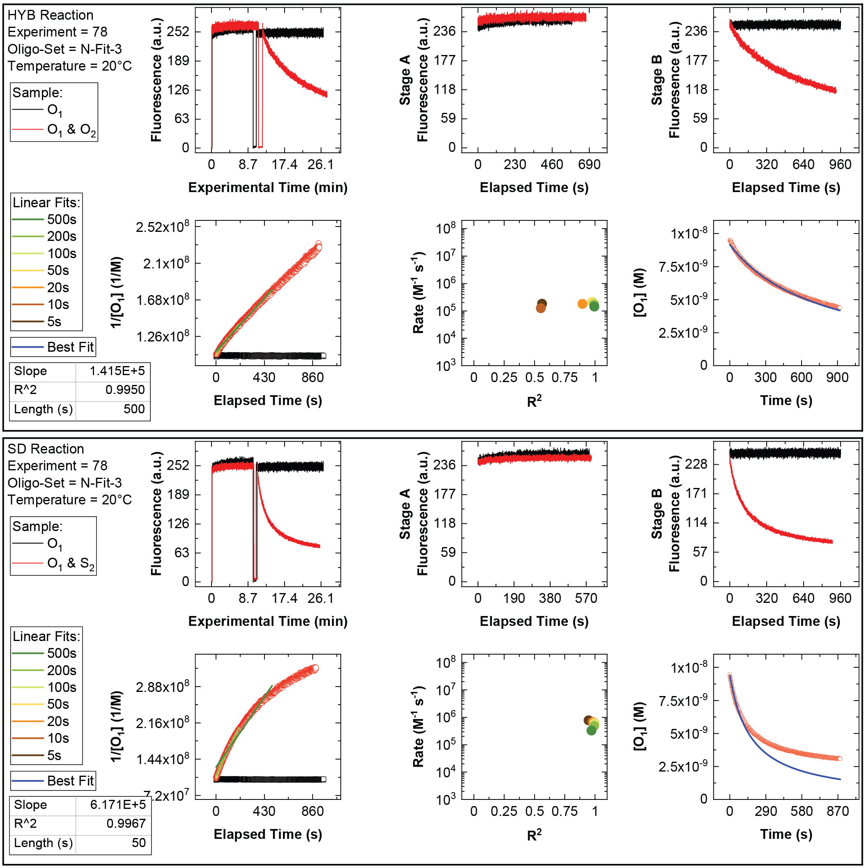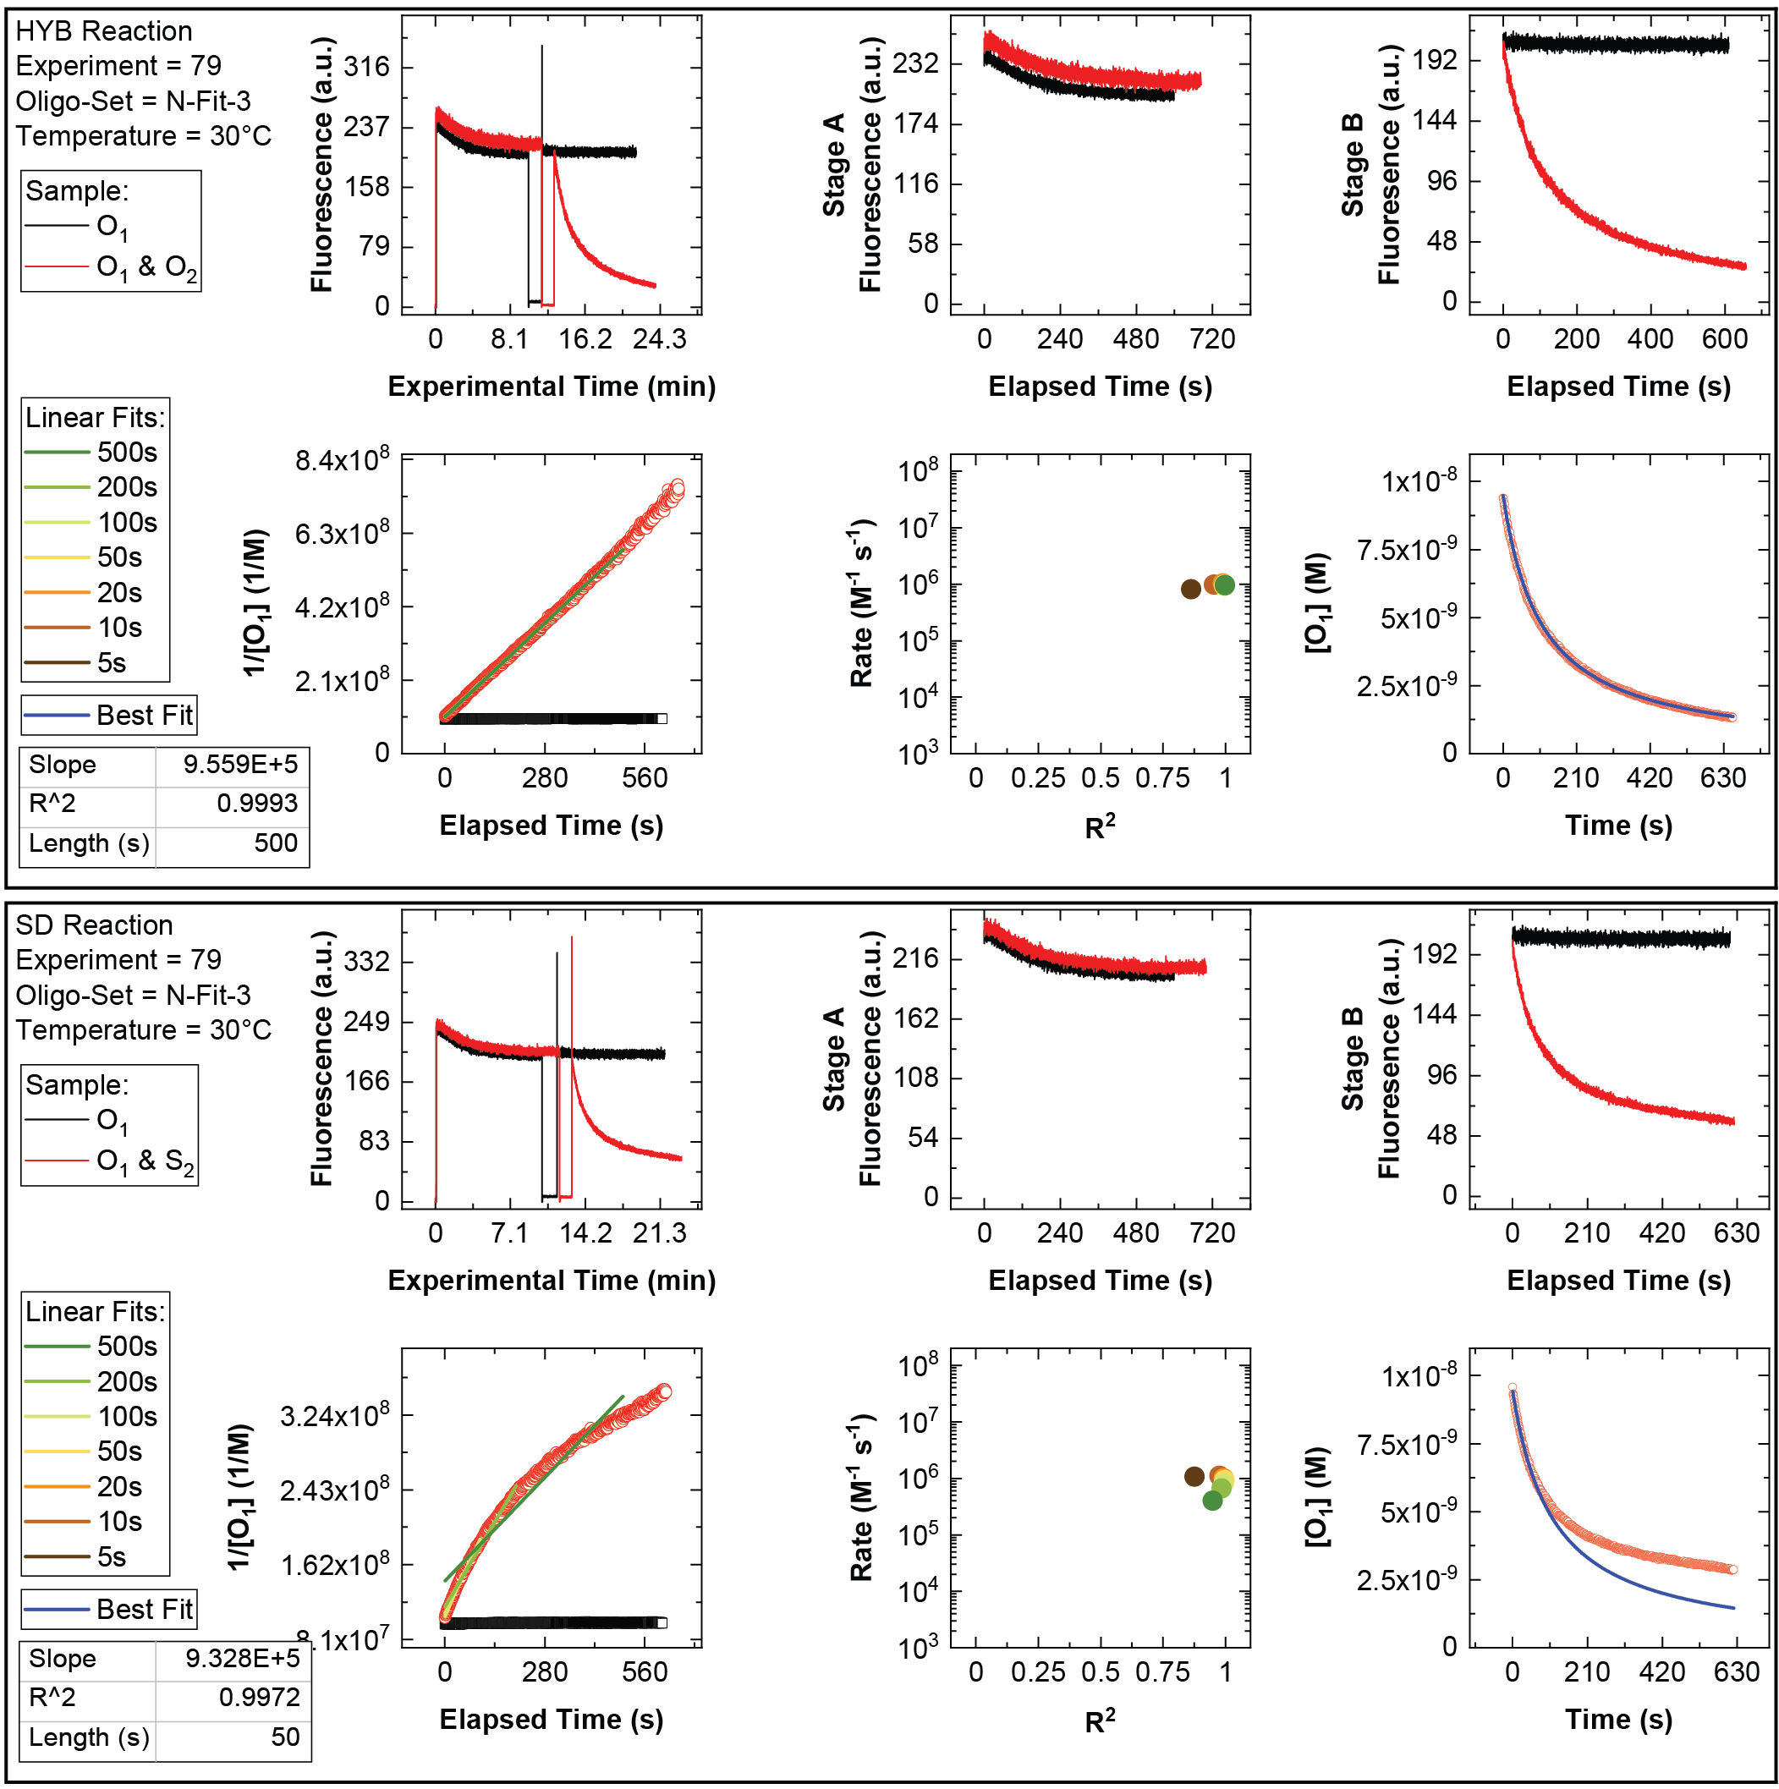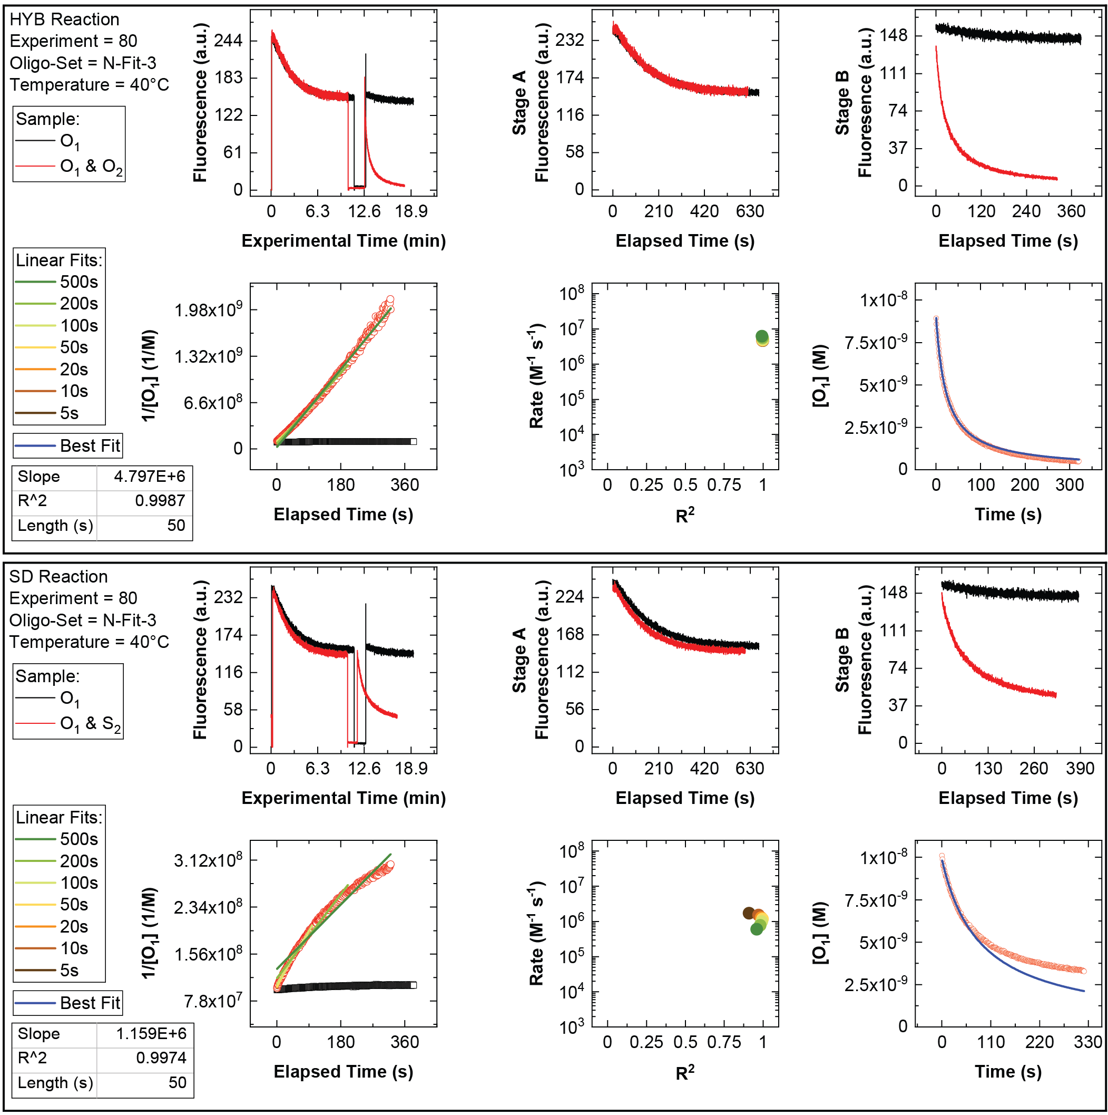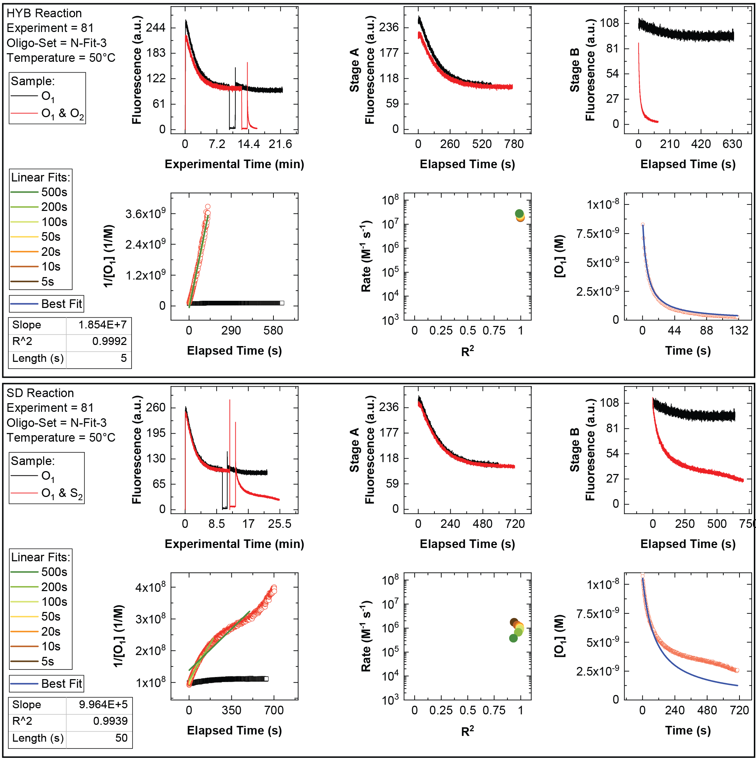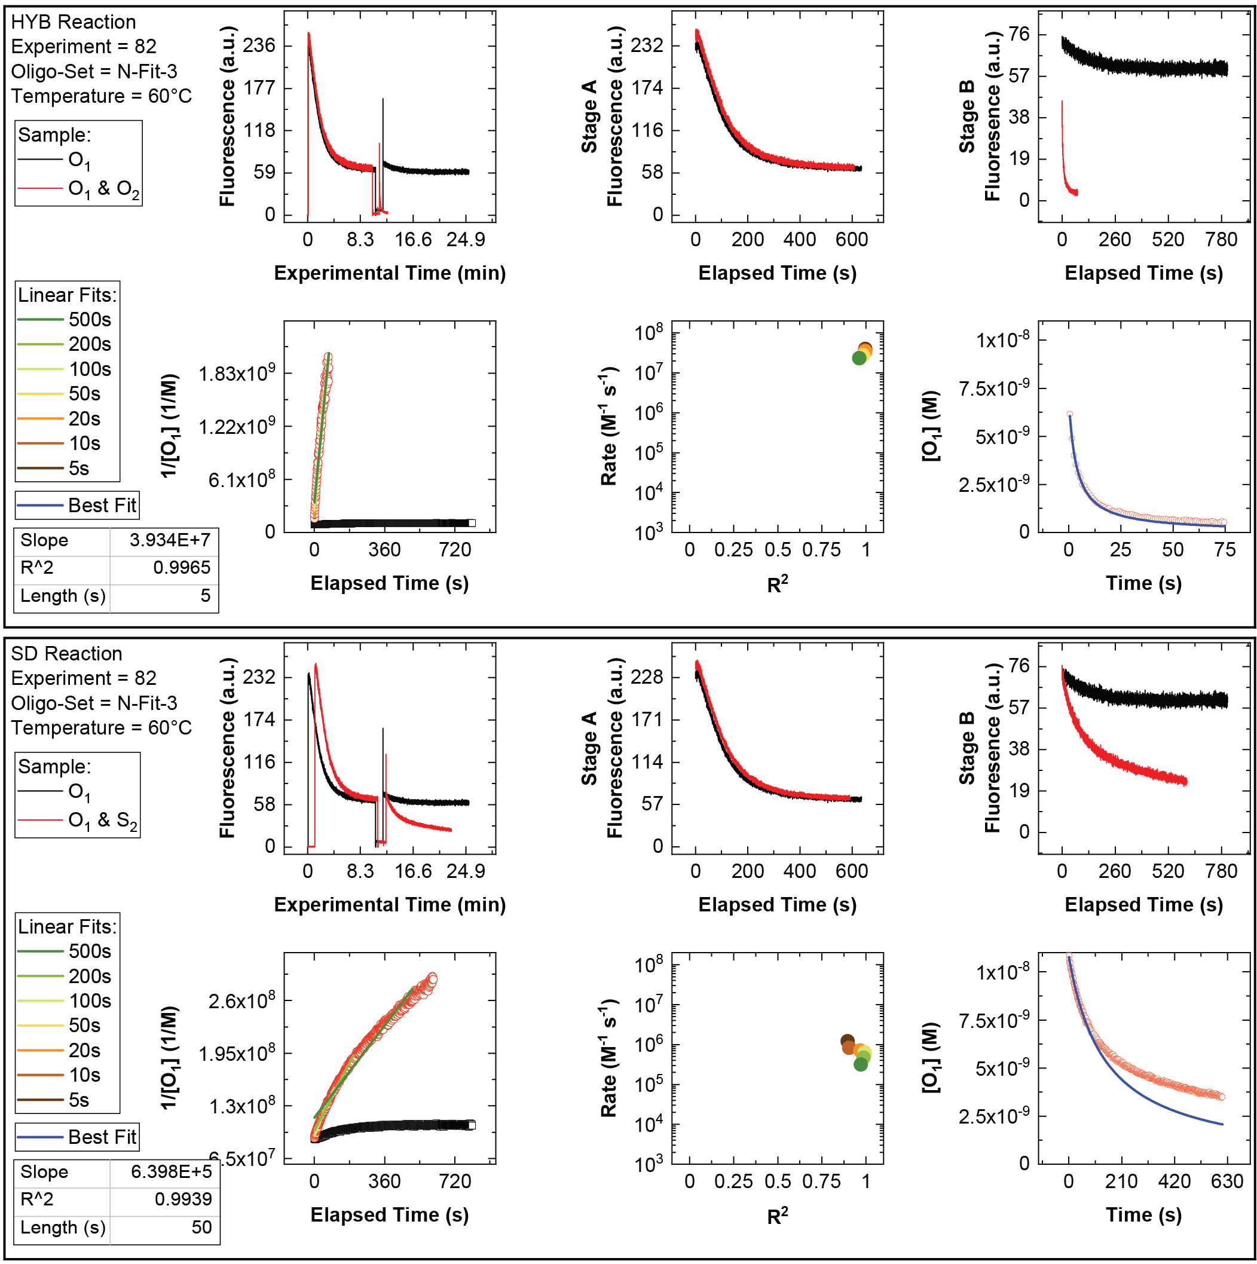

Section 5: New Oligomers for Existing Designs

Table S5-01. Unncessary duplexes in 10x10x10 DNA brick reported by Ke et al..
 | Unnecessary intra-oligomer duplexes (count) |  |  | Unnecessary inter-oligomer duplexes (count)
Size | As-published | Optimized |  | As-published | Optimized
1 bp | 69479 | 69479 |  | 36915671 | 36915671
2 bp | 15118 | 11775 |  | 8632911 | 8620755
3 bp | 3197 | 67 |  | 2021642 | 2010751
4 bp | 687 |  |  | 478168 | 465815
5 bp | 143 |  |  | 114059 | 104831
6 bp | 28 |  |  | 27783 | 22261
7 bp | 6 |  |  | 5868 | 3846
8 bp | 1 |  |  | 1612 | 339
9 bp |  |  |  | 593 | 63
10 bp |  |  |  | 160 | 2
11 bp |  |  |  | 46
12 bp |  |  |  | 21
13 bp |  |  |  | 13
14 bp |  |  |  | 12
15 bp |  |  |  | 12
16 bp |  |  |  | 12
17 bp |  |  |  | 12
18 bp |  |  |  | 3
19 bp |  |  |  | 2
20 bp |  |  |  | 2
21 bp |  |  |  | 2
22 bp |  |  |  | 2
23 bp |  |  |  | 2
24 bp |  |  |  | 2
25 bp |  |  |  | 2

Table S5-02. New oligomers for the 10x10x10 DNA brick design reported by Ke et al..
Oligo Name | Oligo Sequence (5’ - 3’)
Strand-1 CAAATGCTCCGAAACCCGTGCGTGATCCTGAA
Strand-3 ATGTCAAAACCTCTCGCAGTCGTAAGTAAGTC
Strand-6 GGCTTCTGGGCGCGAGGCTTCCCGATTGACAC
Strand-7 TCCGCAACGTCTGTGTCCGAATATGTGAGGCC
Strand-8 TTATGCGTGGCTGTGGCTTGTTGAGACCCGAA
Strand-11 GTTGTGCAGAGGTCCATCCCGCTTAGGCTTAG
Strand-12 CGTGTCGAAAGGAAGTAGAGGTTGAGATGAGC
Strand-13 TGTCGCCGTATCTGTATGCACTGGTAAATGGT
Strand-16 ATCTTTGCGGAATGTTAATGACCTTTGTGTGT
Strand-17 AGGTCGAACATCAGTCTTGCTTGGAATCACAC
Strand-18 GCCCTCGAATAGTGCCCTTTAATAGTCTCATG
Strand-23 GCCCAGATCGTAAAGCCGGTGTATTCAAGCAT
Strand-25 ACAATAGGGCGGCAGGCGTCTCTCTTCGGGCA
Strand-27 GAGCTATTTGGTAAGTGCGGTTGGAAGTATCT
Strand-28 ATCACATCTTCCACTCGGTATTAAACATTCGG
Strand-29 ATATCACCCAGAGAAACACTACGTCATCCTTA
Strand-30 TTGGGAAAGCATCGACTCTAGCCGCACTGTAC
Strand-31 CTTAGCAATAGGGCGGCGTCATCTCGAAATAC
Strand-32 TGAAAGTTATGAGACAATGCCAAGAAGCGAGT
Strand-33 TTTGACACACCGATGGCACTGATTAGGCGAGG
Strand-34 TCTGCGAATACGACATAGTGAGCCTGGTTAAA
Strand-35 AGACCGTTGTTAGTAGAAATCCTTGCATGAAA
Strand-36 GCCAGAATATGCCGCCGTAGAAGAGTCGCCAA
Strand-37 TATGACAACTCCCTATTATCGGTGGTGAACGT
Strand-38 AAAGACTAACGAAAGCGGCAGACATAATTGAC
Strand-39 ATCTCCGGTAAACATGGTATTGACGCTATCTT
Strand-40 CCGTTTGCAGAAGCCAGGGAATCGCCCACTCC
Strand-41 TTACACATGCGTTCGTTATACTGATTTTCTCC
Strand-42 TGGCGTCCTAGTCTGAATCTGCTGTATAATCT
Strand-46 TCACCCTAGTTTTGTAAGAGTCCTGTCCATAA
Strand-48 ACCTCCTGGGCTGCTGATAGTTCCTCTCTGAT
Strand-49 TCCTGTACGATGGCGATATAACCTCCTAACTG
Strand-50 GTTGAGTGGTGAATGGGCCTGAATAGTCGGTT
Strand-51 GTAGTAGTATCCATTAAGTTCTGTATCATCAA
Strand-52 TAGGGACCAAATCATGCTGTGCGACCGAGGCG
Strand-53 CCACGGTAGCCACTGTCTGTATTATGAAGCGG
Strand-54 GCCTCCTAATGATGCTATACAAACAGTCGCGG
Strand-55 GCGTGGAGAAGCGTCGTTATACTAGCCTGCAT
Strand-56 CTAATTTGAGATCGTTTTGACTATGGGAGGCA
Strand-57 TGTCGGAGGCCACGCTTAGTCACGCAACCAAC
Strand-58 CGTATGGCGGGATTGTGCGGCGGACCTGGGCG
Strand-59 TTCATGTATCAAGGAGTTAAAAGTCTGTATCG
Strand-60 AGGTCACAAATCTCGGCCACAACACTACACTC
Strand-61 TCTCAGCATCTCTATATTTTAAGTACACCACA
Strand-62 TACACAGGCTTACCAGGGACGTTCTCTTATCG
Strand-63 GTTATGCAAAGGTTCAATCCAAATCGTCAAAA
Strand-64 CCAGTCGCTACGTTGTTATTTTCCGGGCCATG
Strand-67 TAGAAGCATCCCATCAACAAAGAACGTATTAG
Strand-68 TACATTTCGGGTGGCGGGTCGGCAGCTCCTCA
Strand-70 ACGAGTCCTTATAGCACGCCATCTTACCGCAG
Strand-72 CAAACCGTGGCAGTGATACCCTAGATGGAGAG
Strand-73 CTGCTAACGTAACAAGGAAAGAAATATGATGA
Strand-74 GATTCTGGTACACGATTTCATTGGGTTAGCAC
Strand-75 TACTGCGGATGGAGCGACGAACTTGGACCTTA
Strand-76 TACTGTCTAACGGGTCAAAGGGCTGCTCGGAT
Strand-77 GAAAGACAAACGCTAAGGTATCGGAATCAAGT
Strand-78 GATCGGTCCTTCTAGTTCGGCAGTACGGTTCA
Strand-79 CGGGACAAACGCTCTTAACGGGACTCTATGCC
Strand-80 GCTCGGACTCAGACGCGCTTAAAATGGTGCCT
Strand-81 CCGATTTATAGACTTCCGTTACAGAGCACAGC
Strand-82 TTAGCAACGGGTCACGGATGTCGCAGATGTCG
Strand-83 CACATCCATCCCAGACGTAATCGGTTGAGAGA
Strand-84 AGTCCATCGGCGCGGTAGTTCACGGTCAGTCA
Strand-85 GGCAGCTTTATCCGAACCCTCACTCCGTCAAC
Strand-86 ACACACGCGGGTCATGCCAAAGCCAGTCCAAT
Strand-87 TACAGTGATTCTTGATTATGGCTTGGACGGCT
Strand-91 CTGTGGGAGCGATAGGTAATGTGATGTTGCCG
Strand-93 ATGGATACAATGGGATGAGTCTTACAGCTTCT
Strand-94 TTCACAAGCCCTAAAGTACGTCGCCTATATGC
Strand-95 ATGCGGCCCTGTGAATTTAACGACTGATCCAA
Strand-96 CGCTGTTACCCAATACGAGAGATCCCTACGCT
Strand-97 TTAGAAAGTCATTATCAAAGGTACACAGCGAG
Strand-98 ATCAGTTAAGTCGAAGGAAGAGCCCGCCAGTT
Strand-99 GAATAGAACGCGCAGCTTAATGATCCCGGCCG
Strand-100 ACTATTGGCCCGCACGTTGTATCGCTAAGACT
Strand-101 TATATTCTAAAACTCGTGCGGTTCAGGCGGCG
Strand-102 CAGTTTTCCATGATCGCGCAAGAGAGTATAGT
Strand-103 CCTGGCTGGCTAGACAAACTCGCGGGCAATAC
Strand-104 TATATGTAATGAATGTGCTCCTCCAGTAGATG
Strand-105 AGTAAACCAGCGGAGTCACCCATCAGGCCATT
Strand-106 CCGCGACGTTCATCACTCAGGCTAATTTCCAC
Strand-107 AGGGACCACTGCTAGGGCGTTCGACAATTACC
Strand-108 ACATTGCGCTCATCACCTCGTCTAGTACCGGA
Strand-109 TGGCGCTTGGACTACTTCATGGGATACACGAC
Strand-112 GTCCCTAGAAATCCTCGTTGAATCCGCCGTCG
Strand-113 CCCATAACAGGCATACGGGAGGTGAGAATTTT
Strand-115 TGATCTGACGAGCGCCAATTCTGTTCTGAGCA
Strand-117 GATAGGTGACAAGGATAAAGGCTGAATACTGC
Strand-118 ACACAGCTATGCGGGTCCTTGATGCGTCCACT
Strand-119 TGAGATATTGAGTACGGTGTTTGAAGTTGTTA
Strand-120 GATACGTGAAAGAGATGGGTTGAGTCGAAATT
Strand-121 GAACATCGTCTGAAAGTAGGAACATTATCTGA
Strand-122 TGCAAATCAGGAGCTACTACTATATCTTAATG
Strand-123 ACAAGAACGGGAATACGACGAATCAAAGCAAG
Strand-124 GACAGACCCTACCCGACTTCACCCGTGTTGGA
Strand-125 AGCCGACCGTGGGATGTACTTCTGCCTGAGCC
Strand-126 TATCCTTGGTGTAGCGGTAAACTCAGAAAATG
Strand-127 TATAAGCAGTGTGTAACCTAGCCGCGTAAATG
Strand-128 CTAAACGGGTGCCTTCCTACAGAGATTCATTC
Strand-129 GCAGTTCGTGTCGCAAATACCTCGTCATCGTT
Strand-130 ATTCTATTATTACATTATATTAAACCTGCGTG
Strand-131 AGACTGCGACGATTACTAGAGACTTCATTTGT
Strand-132 CGACGACAAGGCCATACTGCTGCTAAACTGCG
Strand-136 GGTAAAGCCAGTCGATTCAGCGCCATAGATAA
Strand-138 TGTCGAGCTTGATTAGGGCAGTCCATTCCACC
Strand-139 CCGTCTAAGGGAAAGGAGTGCTGCCGTCATGG
Strand-140 ATGTTAGAGAATGCCGTATCAATCGTTTTTTA
Strand-141 AATCGAATCCAGTCAGTGTCTCTTTAGTGCCG
Strand-142 CATTTATCGCCCGCAGAGTCAGTTGGTCGTCC
Strand-143 TTCACGCCATTACGCAACGCTTACTTCAGACT
Strand-144 CAAGAGGCTAACGGATGATAAAACTAAAATTC
Strand-145 GCAATCGTAAAGGCGGGTCAAGCTAATCACTA
Strand-146 CAATCAAAAGGCGTCGTGTGGTCAGCGGAGGG
Strand-147 AGCGTATAGCCAATCCCTCGTTCACTCCACTG
Strand-148 AGTATCTCTTGTCTAATCCCTATCTGGTAAAA
Strand-149 CAGGGTAGAAACAAAATCCATGCTCGCTCGCT
Strand-150 CTAGCATATCTTACTGTCAACCACTGTCTTTA
Strand-151 GATCTGTTTAAGCATAGTCGGCGCGTGTCCCA
Strand-152 TTGAGGAGCCGAGCGCAGCCACCAGAGCCATG
Strand-153 GTATAGGTTAAGCCATGCGTTCAATCAGGAGT
Strand-154 TGAAATACCAAAACAGAACAAACTCGCGTCGT
Strand-157 TTGTCACTATATTAAACGGTCATGCAGCGGCC
Strand-158 CAACTATTTAAGCTATCGGCCATTCTACTCTA
Strand-160 GACCGTACATGGCTGGCGTTCACCCTCGATCC
Strand-162 GAAGGTCAGCTCCCGTCCCGCAAGGCCACACT
Strand-163 GGTCGTTGAGCATCCTTGAGTTGGCAGTAAAA
Strand-164 CCTTCGGGCGGCTCTCCTTCTCGGGTTGGCAC
Strand-165 GCCGCGCCTCAAACTATGTGTAAATCCGTGCA
Strand-166 TGAGTGATCGAAGTAATAAAGCAGCATGGTCT
Strand-167 TTGTAACCTCGTAGCCAGTCGGATAGAAGAAG
Strand-168 GGGCGGAAGCGATCTCTAAGCGACCACGGACT
Strand-169 CTCCAGGCTAAATCTTCCGCTTGTTGCAGGTG
Strand-170 TCTTCGCAAATTCGGGCCTTAACGTAGTCAGC
Strand-171 TATCCGCCAATGACACTTCGAGCTGCACGCCT
Strand-172 TGAAGGACTAAAAGCACTCTATGTTGGTACTG
Strand-173 ACGGAGGACTGGTGTTCATCGGACGGCATCGC
Strand-174 AAGTCCTATACAAGCCCGCCTGCAATGAGAAA
Strand-175 GTATCGTAGCGCCCGTGAATGACAGCCGTAGG
Strand-176 GAAACAGAGTCCAGCAAATCGCGGCAAGTACG
Strand-177 CACCTTCGTTATTATTCGGATTGCGGCCTGGG
Strand-181 CAAGGTGAGGACAACAGCGCCCGGATCTAAGT
Strand-183 TCTAAATGCTGACTGCGCCGGACCCTTGCCTT
Strand-184 GATAACGTCTAATGAGCTTCCCAGGCGCAGGC
Strand-185 TCTCATCTTAATCAGCTTGGCCTCGAATACTC
Strand-186 ACACTCACGGGTAAGCGGACATCAACGGGCAT
Strand-187 GTCAGGTCGCCGGATGCAGCCCACTTGTACGT
Strand-188 ATTGGTAGGTAAAAACAGCCGATTCTCATTCC
Strand-189 GCAAATTACGAACACGGACGAAACTGGAGCTG
Strand-190 AACGTGCTAGAGAGACTTATGCTTCCAGTGCG
Strand-191 TTGATGGTCCTTCTATTGTGCCCGATGCGCTG
Strand-192 CCGTACCGCTAGTGTGCTCGCTCGTGTTCTTG
Strand-193 GTTTCACTACTAAGATGCAGGACAATTCGTTC
Strand-194 TCCTATCCTTTCAGAGCATTGTTGGGCGAGAG
Strand-195 GATGCAACTGTGTCCCGTACCCGCGCCTGATG
Strand-196 AGAGATTTACGTGATGATTAACTATATGAATT
Strand-197 GTCCTCTATGAACGGCCCACTCTGTCTCTACG
Strand-198 ATTTAGGCGCAACCACTAGGCAAGGCTGACCC
Strand-199 TCACGTATGTAGACCACTTTAGCCCGATCCGC
Strand-202 TTGCCTTACTACTCGGGATATTTGCCTACATT
Strand-205 TCGCGCACGGGACTGGGAGGGTAGGACACACT
Strand-206 CCCAAGAACTCCCAGCGGCGATGTGATGCGTC
Strand-209 GCCCGAGTACCGCGAGCCCGAGAGTTGGACAC
Strand-210 GCTCATACAAGACCCTAAATACGAAGATACGA
Strand-211 TGGGTTTTGGATTTGGTTGGACATACTTCATA
Strand-214 ATAGGACCAGGCGGCTCGATGTTGTGTGAAGG
Strand-215 GCATACCTAACGGCTCTTGGACGAACTGGACT
Strand-216 GAGCACCCTGTCCACCAAAATGTCTACGCCGC
Strand-219 GACACGCCTGGACACTACATGATAACCCTACT
Strand-220 CATCGACCACTAGCTGTACGCGCATAAAAAGA
Strand-221 ACTGTGCCCTGGAAATAATGCTGCCCTGCGGT
Strand-227 TTTTTTTTGTTATAGGTTGAGCGATTTTTTTT
Strand-230 TTTTTTTTCTTACTCGGGACGCCATTTTTTTT
Strand-233 TTTTTTTTGGGAGGCTTTGTCATATTTTTTTT
Strand-236 TTTTTTTTCATATTGTAACTTTCATTTTTTTT
Strand-239 TTTTTTTTCCACCCGCAATAGCTCTTTTTTTT
Strand-240 CAGCGTGGTTTTTTTTTTTTTTTTGGTCGGTG
Strand-241 CCTGCGAACGAAGCGAGAACTGAGACGGCCCA
Strand-243 TTTCCCTTGTGAGTGATTGAGTTGACCAGTTC
Strand-244 GCGAGACCCACGACCCACACTTGAGAGGACAG
Strand-245 TTTTTTTTGGCGACATTGCTTCTATTTTTTTT
Strand-246 ATACACCGTTTTTTTTTTTTTTTTGATGAGGG
Strand-247 ACGTAGTGATGCTTGATGTGACCTTATAGAGA
Strand-249 AGATGACGTGCCCGAACCTGTGTATGAACCTT
Strand-250 CCAACCGCGTATTTCGTCGAGGGCAGATCCAG
Strand-251 TTTTTTTTAGATACTTGCGACTGGTTTTTTTT
Strand-252 TTAATACCTTTTTTTTTTTTTTTTCTTCGCGC
Strand-253 GGCTCACTCCGAATGTCTCCACGCAACGATCT
Strand-255 TCTTCTACGTACAGTGCTCCGACAACAATCCC
Strand-256 CTTGGCATTTGGCGACCGGCGACAGTGAGACG
Strand-257 TTTTTTTTACTCGCTTTACATGAATTTTTTTT
Strand-258 AATCAGTGTTTTTTTTTTTTTTTTCAATGCTT
Strand-259 GTCAATACCCTCGCCTCACTCAACTAATGGAT
Strand-261 TCAGTATATTTCATGCGGTCCCTAACAGTGGC
Strand-262 CACCGATAGGAGAAAAACGCATAATACGCTTG
Strand-263 TTTTTTTTACGTTCACTAGGAGGCTTTTTTTT
Strand-264 TGTCTGCCTTTTTTTTTTTTTTTTGAATAACG
Strand-265 GAGCCGTGGTCAATTACTACTGCCTACAAAAC
Strand-267 GCGTTACAGGAGTGGGTTTATAGACAGCAGCC
Strand-268 CAGCAGATCGAAGAAGTTTGACATACAGGAAG
Strand-269 TTTTTTTTAGATTATAGTACAGGATTTTTTTT
Strand-270 TACCGACGTTTTTTTTTTTTTTTTGCTCTCTC
Strand-271 AGACCTAAACCCTAACGCGGCAAACATAAAAG
Strand-272 GTCAGCCAATGTGCCGTCCCTCCCGCGCAGTG
Strand-273 AAGTCCGATCCAATGCTGAGGCGTAGTAGGCG
Strand-274 AGGTTATATTTAGTTCGGCGGGCATTGAGCGT
Strand-275 TTTTTTTTCAGTTAGGCCACCGTCTTTTTTTT
Strand-276 ATTCAGGCTTTTTTTTTTTTTTTTGCTTTCGT
Strand-277 AGGACTCTAACCGACTTGGATGTGACCGCGCC
Strand-278 TCGCACAGTTATGGACCCGGAGATTGGCTTCT
Strand-279 GGAACTATCGCCTCGGAAGCTGCCCATGACCC
Strand-280 GTTTGTATATCAGAGAATGTGTAATCAGACTA
Strand-281 TTTTTTTTCCGCGACTTCACTGTATTTTTTTT
Strand-282 TAGTATAATTTTTTTTTTTTTTTTCCATCGGT
Strand-283 ACAGAACTATGCAGGCGACCGATCAAGAGCGT
Strand-284 CGTGACTATTGATGATTTCGCAGACTACTAAC
Strand-285 TAATACAGGTTGGTTGGTCCGAGCGAAGTCTA
Strand-286 ACTTTTAACCGCTTCAATTCTGGCATAGGGAG
Strand-287 TTTTTTTTCGATACAGGTTGCTAATTTTTTTT
Strand-288 TGTTGTGGTTTTTTTTTTTTTTTTGAGTGGAA
Strand-289 ATAGTCAAGAGTGTAGGTTAGCAGATCGTGTA
Strand-290 GAACGTCCTGCCTCCCGGTGATATGTCGATGC
Strand-291 TCCGCCGCCGATAAGACCGCAGTAGACCCGTT
Strand-292 GGAAAATACGCCCAGGTTGCTAAGTGTCTCAT
Strand-293 TTTTTTTTCATGGCCCTGTCTTTCTTTTTTTT
Strand-294 CGCTACGGTTTTTTTTTTTTTTTTGCTTTACG
Strand-295 ACTTAAAAACGCACTAGAAATGTACTGGGACG
Strand-296 CGGGAGGGTGTGGTGTGCCAACATCCTGCCGC
Strand-297 ATTTGGATCGCTACATGGACTCGTTAATATGG
Strand-298 TTCTTTGTTTTTGACGGCTTGCGGACTTACCA
Strand-299 TTTTTTTTCTAATACGACGGTTTGTTTTTTTT
Strand-300 CCGGCCTATTTTTTTTTTTTTTTTAACACATT
Strand-301 ATCACGCTGTCTGCTATCAAAATCTGGTCACG
Strand-302 CCGGCATCTGGCTCTCTATCGCATCTTGACAT
Strand-303 CACTCTCTGAAGGGAAACGACACGCATTAGGG
Strand-304 TGGGCACACTCGCACGGCTTTCGCTGATGGGA
Strand-305 TTTTTTTTACAATCAACTAGGGACTTTTTTTT
Strand-306 TGCCGACCTTTTTTTTTTTTTTTTCCGAGATT
Strand-307 CCAATGAATGAGGAGCGGTTTACTGTGATGAA
Strand-308 AGATGGCGGTGCTAACTGCTGAGACTGGTAAG
Strand-309 AGCCCTTTCTGCGGTATGGTCCCTGTGATGAG
Strand-310 CTAGGGTAATCCGAGCTGCATAACACAACGTA
Strand-311 TTTTTTTTCTCTCCATAAGCGCCATTTTTTTT
Strand-312 TTTCTTTCTTTTTTTTTTTTTTTTCGACGCTT
Strand-313 GTCCCGTTTCATCATACCAATAGTCGAGTTTT
Strand-314 AAGTTCGTGGCATAGACAAATTAGAGCGTGGC
Strand-315 CTGTAACGTAAGGTCCGAAAACTGTGTCTAGC
Strand-316 CCGATACCGCTGTGCTGCCATACGCTCCTTGA
Strand-317 TTTTTTTTACTTGATTTACATATATTTTTTTT
Strand-318 ACTGCCGATTTTTTTTTTTTTTTTCCATTCAC
Strand-319 CGTGAACTTGAACCGTGGCCGCATGTATTGGG
Strand-320 TTTTAAGCTGACTGACACTACTACCATGATTT
Strand-321 GGCTTTGGAGGCACCACTTTCTAACTTCGACT
Strand-322 GCGACATCATTGGACTTACCGTGGAGCATCAT
Strand-323 TTTTTTTTCGACATCTTTCTATTCTTTTTTTT
Strand-324 CCGATTACTTTTTTTTTTTTTTTTCTGGACCG
Strand-325 TCGTAATCTCTCTCAAACAGTCGGCCTATCGC
Strand-326 AGTGAGGGTGCGTCCGTAGGGTGAGAGTTTAG
Strand-327 ACAGGCAGGTTGACGGCTCCGGCGATCCCATT
Strand-328 AAGCCATATCATCAGCCAGGAGGTTCGCCATC
Strand-329 TTTTTTTTAGCCGTCCCTTGTGAATTTTTTTT
Strand-330 TACAGTCATTTTTTTTTTTTTTTTCGGCAACG
Strand-331 ATTATACGGGTCGCCTCAACGCAACATGGTGG
Strand-332 GCAGCAGCCTACAGCAGTCCACAGTTCTAAGT
Strand-333 GGGCAGGGCGTCTCCACCTCTCCGTCTAATGT
Strand-334 GCGACGTAGGTTTTAATCAATCCGAGTTCCAT
Strand-335 TTTTTTTTGCATATAGCTTCACGATTTTTTTT
Strand-336 GTCGTTAATTTTTTTTTTTTTTTTGTCTGGGA
Strand-337 TCACATTATTGGATCACCGTTTAGTTGCGACA
Strand-338 GTACCTTTCGGCAACAGATGGACTTTCGGATA
Strand-339 TAAGACTCCTCGCTGTAATAGAATGTAATCGT
Strand-340 ATCATTAAAGAAGCTGGCGTGTGTATCAAGAA
Strand-341 TTTTTTTTCGGCCGGGTGTCGTCGTTTTTTTT
Strand-342 CGATACAATTTTTTTTTTTTTTTTACTAGAAG
Strand-343 GATCTCTCAGTCTTAGGTTCTTGTTCGGGTAG
Strand-344 CTCTTGCGAGCGTAGGTTGTCCCGGCGTCTGA
Strand-345 GGCTCTTCACTATACTGGTCGGCTCGCTACAC
Strand-346 GGAGGAGCAACTGGCGTAAATCGGCGTGACCC
Strand-347 TTTTTTTTCATCTACTTGCTTATATTTTTTTT
Strand-348 GATGGGTGTTTTTTTTTTTTTTTTCTTGTTAC
Strand-349 GAACCGCAAATGGCCTAGCTGTGTCGTACTCA
Strand-350 TCGAACGCCGCCGCCTCCAGAATCCGCTCCAT
Strand-351 CGCGAGTTGGTAATTGCACGTATCCTTTCAGA
Strand-352 TCCCATGAGTATTGCCAGACAGTATTAGCGTT
Strand-353 TTTTTTTTGTCGTGTAGATTTGCATTTTTTTT
Strand-354 AGCACACGTTTTTTTTTTTTTTTTCGCCACCC
Strand-355 TAGCCTGAAGCACGGAGTTATGGGAAGACAAT
Strand-356 GAACCGCCGTGGAAATCTCGAACCTGCTATAA
Strand-357 TAGACGAGAGTATTTTTCAGATCATTGTGTGG
Strand-358 GATTCAACTCCGGTACTTTCGCTGTCACTGCC
Strand-359 TTTTTTTTCGACGGCGCACCTATCTTTTTTTT
Strand-360 TTACGAGCTTTTTTTTTTTTTTTTGGTTCTGG
Strand-361 TAGACTTTAGAATTAGCGGAACGGAACATACA
Strand-362 GGTTTTTCCTGGTTCCCGCACTCGACACATTG
Strand-363 CCGACTTATGACGCTGTGATGTAGGGCTGTAG
Strand-364 CTGGAACTACGCGCTAAGAACATTGAGGATTT
Strand-365 TTTTTTTTCTTTTATGAGTGACAATTTTTTTT
Strand-366 CACCTCCCTTTTTTTTTTTTTTTTACTCCGCT
Strand-367 TCAAACACAAAATTCTTATGCTAGTATGCTTA
Strand-368 ACAGAATTTAACAACTCGTCGCGGCCTAGCAG
Strand-369 TGTTCCTATGCTCAGACTCCTCAAATGGCTTA
Strand-370 CAGCCTTTTCAGATAACGCAATGTAGTAGTCC
Strand-371 TTTTTTTTGCAGTATTGTATTTCATTTTTTTT
Strand-372 CATCAAGGTTTTTTTTTTTTTTTTCGTGCGGG
Strand-373 GGGTGAAGAGTGGACGACGATTGCCGACGCCT
Strand-374 CTCAACCCTCCAACACAGAATATACGATCATG
Strand-375 GAGTTTACAATTTCGATATACGCTTTAGACAA
Strand-376 TATAGTAGCATTTTCTCAGCCAGGACATTCAT
Strand-377 TTTTTTTTCATTAAGACTACCCTGTTTTTTTT
Strand-378 GATTCGTCTTTTTTTTTTTTTTTTATTCACAG
Strand-379 CGAGGTATCTTGCTTTTCTAACATCTGACTGG
Strand-380 CAGAAGTAAACGATGATAACAGCGGATAATGA
Strand-381 AGTCTCTAGGCTCAGGGATAAATGTGCGTAAT
Strand-382 CGGCTAGGACAAATGATAACTGATGCTGCGCG
Strand-383 TTTTTTTTCATTTACGGCCTCTTGTTTTTTTT
Strand-384 CTCTGTAGTTTTTTTTTTTTTTTTCATGGTTT
Strand-385 GGGTAGCGGAATGAATAGAGGTAGATCGACTG
Strand-386 TTTAATATCTTCAACTTCCCACAGGTACATCT
Strand-387 TAATAACTCACGCAGGCTCAAGGGCTAATCAA
Strand-388 AGCAGCAGGGCAACGAGTATCCATCTTTAGGG
Strand-389 TTTTTTTTCGCAGTTTTTAGACGGTTTTTTTT
Strand-390 AGTATTAATTTTTTTTTTTTTTTTGTATGGAA
Strand-391 ACATGGTTCAAGACGTTTCCTGGCGACACACT
Strand-392 TTTTCAAGGTATTCGCTATCAACTGTAACTCT
Strand-393 GGCGGGATGCACCACGACTACAATTTTCTACG
Strand-394 GCAGCACTTTCCAGCGACGACTTCTTTCAGGG
Strand-395 TTTTTTTTCCATGACGATACTTAATTTTTTTT
Strand-396 GATTGATATTTTTTTTTTTTTTTTGAAGGCAC
Strand-397 GGCGCTGATAAAAAACTCCTCCGTGGCTTGTA
Strand-398 AACTGACTTTATCTATCGAACTGCAATGTAAT
Strand-399 GGACTGCCGGACGACCTACGATACTGCTGGAC
Strand-400 GTTTTATCGGTGGAATCGCAGTCTTATGGCCT
Strand-401 TTTTTTTTGAATTTTACGAAGGTGTTTTTTTT
Strand-402 AGCTTGACTTTTTTTTTTTTTTTTGTATTCCC
Strand-403 AAGAGACATAGTGATTTTCCGCCCAAGATTTA
Strand-404 TGAACGAGCGGCACTAGGTCTGTCCATCCCAC
Strand-405 GTAAGCGTCAGTGGAGTGCGAAGAGTGTCATT
Strand-406 AGCATGGAAGTCTGAACAAGGATATTACACAC
Strand-407 TTTTTTTTAGCGAGCGGTCCTTCATTTTTTTT
Strand-408 GTGGTTGATTTTTTTTTTTTTTTTACCCGCAT
Strand-409 TGACCACATAAAGACACAACGACCGAGAGCCG
Strand-410 TGGTGGCTCCCTCCGCATATCTCAATCTCTTT
Strand-411 GATAGGGACATGGCTCGGCGCGGCTTACTTCG
Strand-412 AGTTTGTTTTTTACCACGATGTTCTAGCTCCT
Strand-413 TTTTTTTTACGACGCGGGTTACAATTTTTTTT
Strand-414 GGTGCTTGTTTTTTTTTTTTTTTTGTATGCCT
Strand-415 GCGCCGACGTGCTTGAAATAGTTGGATGACCT
Strand-416 CTGAAACTTGGGACACACGGCATGGGCGCTCG
Strand-417 TTGAACGCGATATTAAGTACGGTCCCTGCTCT
Strand-418 CATGACCGACTCCTGACTGAACTAATCCTTGT
Strand-419 TTTTTTTTGGCCGCTGTGACCTTCTTTTTTTT
Strand-420 TAGAGCAATTTTTTTTTTTTTTTTCCCAGTGA
Strand-421 ATGATGATTAACCACCCACCGCTGAGGACCGT
Strand-422 CCGTAATGACCCTATATCGACAGACCGCGCTC
Strand-423 TAACTCTAGGCTGGCATGTGAAAACTCTGACT
Strand-424 GCCTGCTGACACCGCCGCTCCACTTTTAATAT
Strand-425 TTTTTTTTCACGATACTAAGGCAATTTTTTTT
Strand-426 AATGGCCGTTTTTTTTTTTTTTTTCAGTAAGA
Strand-427 CCGAGAAGTAGAGTAGGTTGCATCCATCACGT
Strand-428 GGTGAACGGTGCCAACAACAGATCGCGCTCGG
Strand-429 CTGCTTTAGGATCGAGTAGAGGACGTGGTTGC
Strand-430 CTTGCGGGAGACCATGACCTATACCTGTTTTG
Strand-431 TTTTTTTTAGTGTGGCATACGTGATTTTTTTT
Strand-432 CCAACTCATTTTTTTTTTTTTTTTCCGCCTTT
Strand-433 ACAAGCGGTTTTACTGAGCACGTTATAGAAGG
Strand-434 TTTACACACACCTGCATTTGATTGGGATTGGC
Strand-435 AGCTCGAATGCACGGACGGTACGGATCTTAGT
Strand-436 ATCCGACTAGGCGTGCGAGATACTTTTTGTTT
Strand-437 TTTTTTTTCTTCTTCTGGATAGGATTTTTTTT
Strand-438 GTCGCTTATTTTTTTTTTTTTTTTCGGCATTC
Strand-439 TGCAGGCGAGTCCGTGAGATGAGAGCTTACCC
Strand-440 CGTTAAGGTTTCTCATATTCGATTCTGCGGGC
Strand-441 CCGCGATTGCTGACTAGACCTGACGTTTTTAC
Strand-442 ACATAGAGCGTACTTGGGCGTGAAATCCGTTA
Strand-443 TTTTTTTTCAGTACCATAATTTGCTTTTTTTT
Strand-444 GTCCGATGTTTTTTTTTTTTTTTTAAGATTCA
Strand-445 TTTCCTGAGCGATGCCTAGCCGTATGTTGTCC
Strand-446 TGTCATTCTACTTTACGCTTTACCATATATTA
Strand-447 TTCTCGCACCTACGGCCTATCTAAGCAGTCAG
Strand-448 GCAATCCGGCTGGCTGGCTCGACACCTTTCCC
Strand-449 TTTTTTTTCCCAGGCCACGTTATCTTTTTTTT
Strand-450 ATTGTAGCTTTTTTTTTTTTTTTTGCACCGCG
Strand-452 GGAACTAATGCACCTCGATGACACGGGCTGAT
Strand-454 CTGGGAAGACTACTATGACTGGACGGGATTTG
Strand-455 TTTTTTTTGCCTGCGCCTTGGAACTTTTTTTT
Strand-456 GAGGCCAATTTTTTTTTTTTTTTTAACACCAG
Strand-458 GTGGGCTGACTTAGATTAGGACTTACGGGCGC
Strand-460 GTTTCGTCAAGGCAAGTCTGTTTCAATAATAA
Strand-461 TTTTTTTTCAGCTCCATTCCACGATTTTTTTT
Strand-462 AAGCATAATTTTTTTTTTTTTTTTGAGATCGC
Strand-464 CGAGCGAGATGCCCGTGCCTGGAGCCCGAATT
Strand-466 CAACAATGGGAATGAGGGCGGATATGCTTTTA
Strand-467 TTTTTTTTCTCTCGCCGTATCTCATTTTTTTT
Strand-468 GCGGGTACTTTTTTTTTTTTTTTTAGGATGCT
Strand-470 CAGAGTGGCAGCGCATCCCGAAGGTAGTTTGA
Strand-472 GGCTAAAGGAACGAATATCACTCAGGCTACGA
Strand-473 TTTTTTTTGCGGATCGTAACTGACTTTTTTTT
Strand-474 ACCCGCCGTTTTTTTTTTTTTTTTATAGCTTA
Strand-476 AAACTCCTAATTCATACTAAACTTCCAGCCAT
Strand-478 CAAATATCGGGTCAGCGGAAATGCACGGGAGC
Strand-479 TTTTTTTTAATGTAGGTAGCAATCTTTTTTTT
Strand-480 GGACTCACTTTTTTTTTTTTTTTTCATCGCTT
Strand-483 CAGCTACGTTTTTTTTTTTTTTTTGGGACACA
Strand-485 TGAAACGATATGAAGTGCCTAAATTGGTCTAC
Strand-486 ATAATCGGTTTTTTTTTTTTTTTTGTCTCTCT
Strand-488 TGGAATCTGCGGCGTAAGTGAAACCTCTGAAA
Strand-489 TGATATACTTTTTTTTTTTTTTTTGCTGATTA
Strand-491 GCTCCAAGACCGCAGGCTACCAATCGTGTTCG
Strand-492 GAGGGATGTTTTTTTTTTTTTTTTCTTAGTTG
Strand-494 TTCAGGTAGGTAGCTTCATTTAGACTCATTAG
Strand-1305 ACCTGTGACTTCGGAG
Strand-1307 AGCGTGCCCGGCCCTC
Strand-1309 CCACGCTGTCGCTTCG
Strand-1312 ACGCCTACGAGAGAGC
Strand-1319 TAGGCCGGTAGCAGAC
Strand-1322 TTTGCCGCCGTTGCCG
Strand-1329 GCTCGTAACTAATTCT
Strand-1332 TTGCGTTGTTCCATAC
Strand-1339 TTGCTCTAGGTGGTTA
Strand-1342 GCCAGGAACGCGGTGC
Strand-1349 GTGAGTCCTTATACCG
Strand-1357 GTACAATCGGTTTCGG
Strand-1361 ACAACAGTCTCGCGCC
Strand-1365 AGACACGTTGGACCTC
Strand-1369 TCCACTTCAACATTCC
Strand-1373 CCCAGCGCGAGGGCCG
Strand-1375 GCAAAGCCCGGTATAA
Strand-1379 CTCTCGGGTATCCAGG
Strand-1383 CAACATCGCATCTAAT
Strand-1387 TATCATGTTGGGTTCC
Strand-1391 CTGACCGAGGCAACCG
Strand-1393 TACATTGGGCCTTGGG
Strand-2207 GATTGTACCGTTATTCTTTTTTTTGGGATGAG
Strand-2221 TTTTTTTTCTTCCTGTGATGCGAGCCTATAAC
Strand-2227 ACTGTTGTAAGCATTGTTTTTTTTGAGCCCTG
Strand-2241 TTTTTTTTCAAGCGTAGTCCCAGCCGAGTAAG
Strand-2247 ACGTGTCTGCGCGAAGTTTTTTTTGCTAGTTT
Strand-2261 TTTTTTTTCGTCTCACAATATACCAGCCTCCC
Strand-2267 GAAGTGGACCCTCATCTTTTTTTTGCTCATAG
Strand-2281 TTTTTTTTCTGGATCTCACACGTCACAATATG
Strand-2287 GCGCTGGGCACCGACCTTTTTTTTAGATACCG
Strand-2293 TTTTTTTTCTGTCCTCGTGCAATAGCGGGTGG
Strand-3018 TCTGACACTTTTTTTTCGTAGCTGCCTGGATA
Strand-3036 GATTGCTAGTGTCGGTTCGTTTCATTTTTTTT
Strand-3038 ACCAACGATTTTTTTTCCGATTATATTAGATG
Strand-3056 GTCAGTTATACACATTAGATTCCATTTTTTTT
Strand-3058 TTTGCGAATTTTTTTTGTATATCAGGAACCCA
Strand-3076 TGAGATACATACTACCCTTGGAGCTTTTTTTT
Strand-3078 TTGGTTTGTTTTTTTTCATCCCTCCGGTTGCC
Strand-3096 TCGTGGAAGTGCTCTATACCTGAATTTTTTTT
Strand-3707 CGCCTCATAGCCCGTCTTTTTTTTCCGCACCT
Strand-3789 TTTTTTTTGACGCATCCTTGACCACCGAGTAG
Strand-3826 GAAATGGACGGAATAAACTTGCTAACACGGAAACTAATACACTTGCTG
Strand-3859 TCAAGTGTCCTGTCATAACCGAGAATCATCCTGCCGCGCCAAATCAAT
Strand-3861 ATGTTGGCAGGAGCTTTTCGCAGGTCCGTAACTTGTAATATCACTCAC
Strand-3862 CCGCAAGCTCTCGTCAAAGGGAAAGGGTCGTGGGTCTCGCATGTCGCC
Strand-3894 CGGGCTACCACTGCGCGGGAGGGAACGGATAACACGGCTCGGGCGGCT
Strand-3896 TCGCTCAAACGCTCAATGCCCGCCTCTAATGGTGTAACGCCTTCTTCG
Strand-3897 GGCAGTAGCGGTCCAGCGTCGGTAGTTAGGGTTTAGGTCTCGGCACAT
Strand-3898 TCTATAAACTAAACTCTGGCTGACGCATTGGATCGGACTTGAACTAAA
Strand-3929 ATGCGATATGGGCCGTCTCAGTTCAATGTGTTCCGTAGCGTAGTGCGT
Strand-3931 GCGAAAGCGAACTGGTCAACTCAAATGTCAAGCCCTCCCGATGTAGCG
Strand-3933 GGTTCGAGCGTCCCAGAGCGTGATGAGAGCCAGATGCCGGTTCCCTTC
Strand-3934 CAGCGAAACCATATTAAGAGAGTGCGTGCGAGTGTGCCCATTGATTGT
Strand-3966 ACGCCTCAACTTAGAACTGTGGACCTTTTATGGATTACGACGGACGCA
Strand-3968 GACGGTGGATGGAACTCGGATTGACGCCTACTCTGCCTGTGCTGATGA
Strand-3969 CCGACTGTAAACCATGTGACTGTAAGGCGACCCGTATAATTGCTGTAG
Strand-3970 CGCCGGAGAGATGTACGCTGCTGCTGGAGACGCCCTGCCCTTAAAACC
Strand-4001 CGAGTGCGCGTGACCAGATTTTGACCAGAACCCGTGTGCTTCCGTGCT
Strand-4003 AATGTTCTCCCTAATGCGTGTCGTCAATGTGTGGCGGTTCAAAATACT
Strand-4005 CATGCCGTATTGTCTTAAAGTCTAGGAACCAGGAAAAACCCAGCGTCA
Strand-4006 TAGTTCAGCCACACAATAAGTCGGTAGCGCGTAGTTCCAGCATAAAAG
Strand-4038 CGGAGAGGAGAGTTACAGTTGATACCACCATGCGCTACCCAGTTGAAG
Strand-4040 TCGTGAAGCCCTGAAAGAAGTCGTACATTAGAAGTTATTATCGTTGCC
Strand-4041 CTACCTCTTGAATCTTTTAATACTACGTCTTGAACCATGTGCGAATAC
Strand-4042 CCCTTGAGTAATATATCTTGAAAACGTGGTGCATCCCGCCCGCTGGAA
Strand-4073 TCTGTCGATGTATGTTCCGTTCCGTCACTGGGCAAGCACCTCAAGCAC
Strand-4075 AGTGGAGCCTACAGCCCTACATCAGAGCGCGGAGTTTCAGTTAATATC
Strand-4077 AAGTTTAGAGGTCATCATCATCATTATAGGGTCATTACGGTGCCAGCC
Strand-4078 GCATTTCCAGAGCAGGTAGAGTTAGGCGGTGTCAGCAGGCGTATCGTG
Strand-4110 ATTGTAGTATCAGCCCGTGTCATCAGTGTGTCTCAGGAAAGTAAAGTA
Strand-4112 TTAAGTATCAAATCCCGTCCAGTCCGTAGAAATGCGAGAACAGCCAGC
Strand-4113 TACGGCTACAACTAAGGCTACAATGACGGGCTATGAGGCGGAGGTGCA
Strand-4114 TTAGATAGTGTGATAGTTAGTTCCGCCAGGTAGTAGCCCGATAGTAGT
Strand-4145 CCACAACTACGGTCCTCAGCGGTGAAGCGATGCGGCGGGTCTATACGA
Strand-4147 TGGTCAAGAGTCAGAGTTTTCACAAGCTAATAAGGAGTTTCAGATCAT
Strand-4149 GCTTGCTGCGACCTGCGGCTTTGCGACCCACCTAACCTGATGACTGCG
Strand-4182 AATAAGTTCCCAAGGCCCAATGTAAGGTGCGGTCGGTCAGCTCTCCCA
Strand-4184 GTTCCAAGAGTGTCGCGTGCCAGAGATCATGTTAATTCCCAAGCTACC
Strand-4185 TAGCAAGTCTCCGAAGTCACAGGTCTCATCCCGTAGGCGTTTATCCGT
Strand-4187 CTCGCATCCAGCAAGTGTATTAGTTTCCGTGTGTAGCCCGCCATTAGA
Strand-4188 CGATTCCCAGCCGCCCAGCATTTGTTATTCCGTCCATTTCCGAGAGGT
Strand-4189 ATATTCGGTTCAGGATCACGCACGCAGGGCTCTAGTCTTTCATGTTTA
Strand-4191 GCTGGGACGACTTACTTACGACTGGGCCTCACGCAAACGGACGAACGC
Strand-4192 AAGGATTTAAGATAGCCAGAAGCCACACAGACGTTGCGGACCACAGCC
Strand-4193 CAACCTCTGTGTCAATCGGGAAGCAAACTAGCGTGTCAAAATGTCGTA
Strand-4195 GGTATATTTTCGGGTCTCAACAAGGCTCATCTAACGGTCTGGCGGCAT
Strand-4196 CGGCTAGATTTAACCATGCACAACACTTCCTTTCGACACGTACAGATA
Strand-4197 CCAAGCAACTAAGCCTAAGCGGGACTATGAGCGATGTGATTTTCTCTG
Strand-4199 GACGTGTGACCATTTACCAGTGCAGTGTGATTTTTCCCAACCGCCCTA
Strand-4200 GAGAGACGTAAGGATGGCAAAGATGACTGATGTTCGACCTGGCACTAT
Strand-4201 GGCGCGGCACACACAAAGGTCATTCGGTATCTATCTGGGCAAGCTCCT
Strand-4203 TATTGCACCATGAGACTATTAAAGATTGATTTCCTATTGTTGACGAGA
Strand-4204 TATTACAAGTTACGGAGGCACGCTAGGATGATTCTCGGTTATGACAGG
Strand-4431 ACATCGCCCGCAGTCATCAGGTTAGGTGGGTCAGTTGTGGTATTAGCT
Strand-4433 TAGTTAATTCGTATAGGTGTCAGAGCAGGTCGCAGCAAGCCCAGTCCC
Strand-4434 CTTGCCTAATGATCTGGTGCGCGAGCTGGGAGTTCTTGGGACCGACAC
Strand-4436 ATGTCCAAAGTGTGTCCTACCCTCGTGTCCAAAAATCTCTGCCGTTCA
Strand-4438 CGGGCACACATCAGGCTCGTTGGTCTCGCGGTACTCGGGCAGGGTCTT
Strand-4439 TGTCCTGCCGTAGAGAGTATGAGCCCAAATCCAAAACCCAAATGTGTA
Strand-4441 GACATTTTTCGTATCTTCGTATTTCCTTCACAACCATCAACACACTAG
Strand-4443 TGATGTCCCGCACTGGTTCGCAAAAGCCGCCTGGTCCTATGAGCCGTT
Strand-4444 AATCGGCTCAAGAACAAGGTATGCGGTGGACAGGGTGCTCGGTAGTAT
Strand-4446 GCAGCATTAGTCCAGTTCGTCCAAAGTAGGGTGTGAGTGTCATCCGGC
Strand-4448 CCGGGCGCGAGTATTCCAAACCAAAGTGTCCAGGCGTGTCCAGCTAGT
Strand-4449 GGTCCGGCACGTACAAGGTCGATGATTTCCAGGGCACAGTTAGAGCAC
Strand-4451 GGGAATTATCTTTTTATGCGCGTATGGGAGAGTCACCTTGCTATCACA
Strand-4454 CGGGCTACTACCTGGCAACTTATTACATGATCTCTGGCACGCGACACT
Table S5-03. Unecessary duplexes in the “four-input OR gate” seesaw-gate network reported by Qian et al..
 | Unnecessary intra-oligomer duplexes (Count) |  |  | Unnecessary inter-oligomer duplexes (count)
Size | As-published | Optimized |  | As-published | Optimized
1 bp | 3004 | 3004 |  | 182624 | 182624
2 bp | 308 | 218 |  | 46094 | 42771
3 bp | 10 |  |  | 13915 | 12998
4 bp | 1 |  |  | 4375 | 3422
5 bp |  |  |  | 1438 | 680
6 bp |  |  |  | 635 | 204
7 bp |  |  |  | 319 | 182
8 bp |  |  |  | 283 | 182
9 bp |  |  |  | 85 | 11
10 bp |  |  |  | 20
11 bp |  |  |  | 16
12 bp |  |  |  | 15
13 bp |  |  |  | 14
14 bp |  |  |  | 14
15 bp |  |  |  | 14
16 bp |  |  |  | 14
17 bp |  |  |  | 14
18 bp |  |  |  | 14
19 bp |  |  |  | 14
20 bp |  |  |  | 9
21 bp |  |  |  | 6
22 bp |  |  |  | 2

Table S5-04. New oligomers for the “four-input OR gate” seesaw-gate network design reported by Qian et al..
Oligo Name | Oligo Sequence (5’ - 3’)
w5,6 | CAACCACAATAATCATCTCACCTCTAACCAACA
G5-b | TGAGATGTTGGTTAGAGGTGAGATG
w5,7 | CAACTCTATAAATCATCTCACCTCTAACCAACA
Th2,5:5-t | CACCTCTAACCAACA
Th2,5:5-b | TGTTGGTTAGAGGTGAGATGTGTTGAGTTTT
w2,5 | CACCTCTAACCAACATCTCAAAAACTCAACACA
G2-b | TGAGATGTGTTGAGTTTTTGAGATG
w1,2 | CAAAAACTCAACACATCTCATTCTCCTACACCA
G1-b | TGAGATGGTGTAGGAGAATGAGATG
w1,10 | CAAACAACTCTTACATCTCATTCTCCTACACCA
Th4,1:1-t | CATTCTCCTACACCA
Th4,1:1-b | TGGTGTAGGAGAATGAGATGGGTGTTTTAGT
w4,1 | CATTCTCCTACACCATCTCAACTAAAACACCCA
G4-b | TGAGATGGGTGTTTTAGTTGAGATG
w3,2 | CAAAAACTCAACACATCTCAATCCACACTATCA
G3-b | TGAGATGATAGTGTGGATTGAGATG
w3,11 | CACTTACAAACTACATCTCAATCCACACTATCA
Th12,3:3-t | CAATCCACACTATCA
Th12,3:3-b | TGATAGTGTGGATTGAGATGAGGATTTTGTG
w12,3 | CAATCCACACTATCATCTCACACAAAATCCTCA
G12-b | TGAGATGAGGATTTTGTGTGAGATG
G8-b | TGAGATGTTATTTGGTGATGAGATG
w8,15 | CAAATCTACTCTACATCTCATCACCAAATAACA
Th16,8:8-t | CATCACCAAATAACA
Th16,8:8-b | TGTTATTTGGTGATGAGATGAAGATTAGGTT
w16,8 | CATCACCAAATAACATCTCAAACCTAATCTTCA
G16-b | TGAGATGAAGATTAGGTTTGAGATG
G17-b | TGAGATGGTAGAAGTTTATGAGATG
w17,19 | CAACAACTCTCTACATCTCATAAACTTCTACCA
Th20,17:17-t | CATAAACTTCTACCA
Th20,17:17-b | TGGTAGAAGTTTATGAGATGGAGTTAGTATG
w20,17 | CATAAACTTCTACCATCTCACATACTAACTCCA
G20-b | TGAGATGGAGTTAGTATGTGAGATG
w21,20 | CACATACTAACTCCATCTCACTCTAAACAAACA
w22,20 | CACATACTAACTCCATCTCACTTTCATTTCACA
w18,16 | CAAACCTAATCTTCATCTCACTACTCTATATCA
w9,4 | CAACTAAAACACCCATCTCACTACAAACAATCA
w13,12 | CACACAAAATCCTCATCTCACTCTCTACAAACA
w14,12 | CACACAAAATCCTCATCTCACTCTATCTAAACA
w8,2 | CAAAAACTCAACACATCTCATCACCAAATAACA
w17,2 | CAAAAACTCAACACATCTCATAAACTTCTACCA
w23,4 | CAACTAAAACACCCATCTCACTCTCTACAATCA
w24,16 | CAAACCTAATCTTCATCTCACTCTCTCTATACA
Rep6-t | CAACCACAATAATCA
Rep6-b | TGATTATTGTGGTTGAGATG
Table S5-05. Uneccessary duplexes in the autocatalytic-four-arm-junction network reported by Kotani et al..
 | Unnecessary intra-oligomer duplexes (Count) |  |  | Unnecessary inter-oligomer duplexes (count)
Size | As-published | Optimized |  | As-published | Optimized
1 bp | 4051 | 4051 |  | 43874 | 43874
2 bp | 779 | 573 |  | 10395 | 10272
3 bp | 157 |  |  | 2516 | 2269
4 bp | 26 |  |  | 622 | 666
5 bp | 1 |  |  | 137 | 133
6 bp |  |  |  | 46 | 16
7 bp |  |  |  | 13
8 bp |  |  |  | 11
9 bp |  |  |  | 11
10 bp |  |  |  | 11
11 bp |  |  |  | 11
12 bp |  |  |  | 11
13 bp |  |  |  | 7
14 bp |  |  |  | 3
15 bp |  |  |  | 3
16 bp |  |  |  | 3
17 bp |  |  |  | 3
18 bp |  |  |  | 1
19 bp |  |  |  | 1
20 bp |  |  |  | 1
21 bp |  |  |  | 1
22 bp |  |  |  | 1
23 bp |  |  |  | 1
24 bp |  |  |  | 1
25 bp |  |  |  | 1
26 bp |  |  |  | 1
27 bp |  |  |  | 1
28 bp |  |  |  | 1
29 bp |  |  |  | 1
30 bp |  |  |  | 1
31 bp |  |  |  | 1
32 bp |  |  |  | 1
33 bp |  |  |  | 1
34 bp |  |  |  | 1
35 bp |  |  |  | 1
36 bp |  |  |  | 1
37 bp |  |  |  | 1
38 bp |  |  |  | 1
39 bp |  |  |  | 1
40 bp |  |  |  | 1
41 bp |  |  |  | 1
42 bp |  |  |  | 1
43 bp |  |  |  | 1
44 bp |  |  |  | 1
45 bp |  |  |  | 1

Table S5-06. New oligomers for the autocatalytic-four-arm-junction network reported by Kotani et al..
Oligomer | Oligomer Sequence (5’ -> 3’)
A1x | GGTGTAGCGTGCGTAGAGATGCGTGTGTCAAGGTAAGCGGTAGGTTCGTCCAAAGGTG
fA2au | CGCTTACCTTGGACCGGACCTGGGCTGACCTGAACACACGCATCTCTACGCACGCTACACCTC
fA3au | CAGCAGTCCCATTCCCAGCCAGTCAGGTCAGCCCAGGTCCGGTCTTACACACGCATCTCTACGCACGC
fA4au | GACGAACCTACCGCTTACCTTGCTGGCTGGGAATGGGACTGCTGCTACTGCTCTCACTCA
B1x | CACCTTTGGACGAACCTACCGCTTACCTTGACACACGCATCTCTACGCACGC
fB2au | GAGGTGTAGCGTGCGTAGAGATGCGTGTGTTCAGGTCAGCCCAGGTCCGGTCCAAGGTAAGCG
fB3au | CACCTTTGGACGAACCTACGACGAACCTACGACCGGACCTGGGCTGACCTGACTGGCTGGGAATGGGACTGCTG
fB4au | TTCTCCATCCACATCATTCAGCAGTCCCATTCCCAGCCAGCAAGGTAAGCGGTAGGTTCGTCCAAAGG
dye | CTTTCTCCATCCACATCACTACTG
quencher | TGAGTGAGAGCAGTAGTGATGTGGATGGAGAAAG

Table S5-07. Unecessary duplexes in the autotacalytic network reported by Zhang et al..
 | Unnecessary intra-oligomer duplexes (Count) |  |  | Unnecessary inter-oligomer duplexes (count)
Size | As-published | Optimized |  | As-published | Optimized
1 bp | 843 | 843 |  | 6657 | 6657
2 bp | 146 | 67 |  | 1542 | 1372
3 bp | 22 |  |  | 328 | 206
4 bp | 3 |  |  | 77

Table S5-08. New oligomers for the autocatalytic network published by Zhang et al..
Oligomer Name | Oligomer Sequence (5’ - 3’)
Catalyst | ACCATTACTACACGCTTCCACTTATTCAGACGAC
Signal | TCTCTATCAACAAACTCCTCACCATTACTACACGCT
Backbone | AGTGGAAGCGTGTAGTAATGGTGAGGGTCGTCTGAATAAGTGGAAGCGTG
Fuel | CACGCTTCCACTTATTCAGACGACCCTCACCATTACTACACGCT
Dye | TCTCTATCAACAAACTCCTC
Quencher | AGCGTGTAGTAATGGTGAGGAGTTTGTTGATAGAGA

