Supplementary Information for submission to Reproductive Sciences

Mitochondrial DNA Quantification Correlates with the Developmental Potential of Human Euploid Blastocysts but not with that of Mosaic Blastocysts
W. Luo^{a,c}, YM.Zheng ^{a,b},Y. Hao^{a,c}, Y. Zhangª, P. Zhou^{a,b,c}, Z. Wei^{a,b,c}, Y. Cao^{a,b,c}* , D. Chen^{a,b}*

aDepartment of Obstetrics and Gynecology, the First Affiliated Hospital of Anhui Medical University, no 218 Jixi Road, Hefei 230022, Anhui, China
bNHC Key Laboratory of Study on Abnormal Gametes and Reproductive Tract (Anhui Medical University), no 81 Meishan Road, Hefei 230032, Anhui, China
cAnhui Provincial Engineering Technology Research Center for Biopreservation and Artificial Organs, Anhui Medical University, no 81 Meishan Road, Hefei 230032, Anhui, China

*Corresponding authors

chendawei0930@163.com (D.C.) (ORCID ID: 0000-0002-8201-0549)
caoyunxia6@126.com (Y.C.) (ORCID ID: 0000-0002-8715-0874)

Supplementary Fig. S1
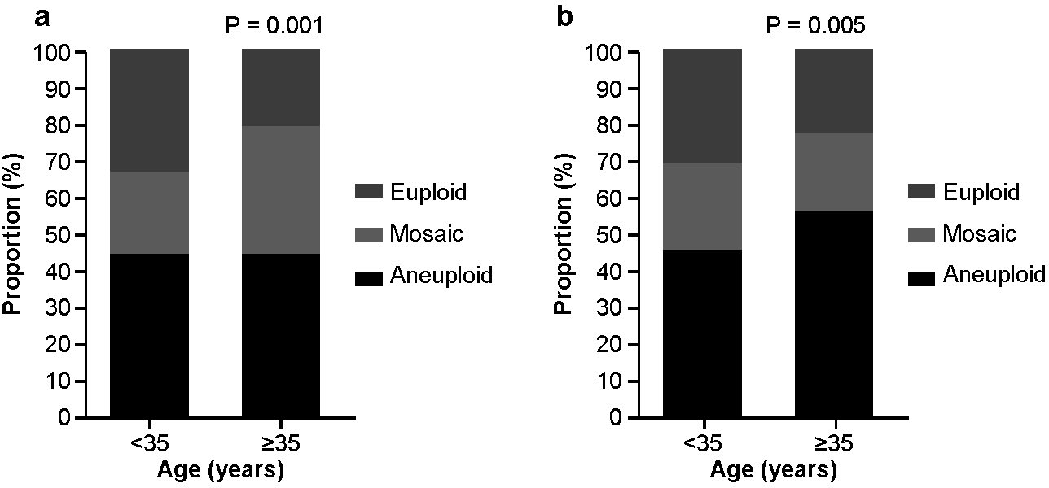
Samples were divided into two groups based on maternal age above or below 35 years old at oocyte retrieval. Significant differences in the proportion of aneuploid embryos between both groups were observed using both NextSeq550 (P = 0.001) and Ion Proton (P = 0.005) .

Supplementary Table S1. Percentiles of mtDNA scores measured on the Illumina NextSeq 550 platform
Ploidy | Biopsy day | Median | Third quartile | IQR
Euploid | Day 5 | 0.071847 | 0.107000 | 0.054918
Euploid | Day 6 | 0.054066 | 0.081197 | 0.041197
Mosaic | Day 5 | 0.082828 | 0.130708 | 0.075445
Mosaic | Day 6 | 0.070299 | 0.101345 | 0.055824
Note: IQR, Interquartile range

Supplementary Table S2. Percentiles of mtDNA scores measured on the Ion Proton platform
Ploidy | Biopsy day | Median | Third quartile | IQR
Euploid | Day 5 | 0.083000 | 0.121058 | 0.063889
 | Day 6 | 0.070000 | 0.098804 | 0.053349
Mosaic | Day 5 | 0.085973 | 0.128359 | 0.069694
 | Day 6 | 0.077440 | 0.115611 | 0.064427
Note: IQR, Interquartile range

