Supplementary Information

Enabling low-drift flexible perovskite photodetectors by electrical modulation for wearable health monitoring and weak light imaging

Yingjie Tang^{1,2†}, Peng Jin^{3†}, Yan Wang^{1,2}, Dingwei Li^{1,2}, Yitong Chen^{2,4}, Peng Ran³, Wei Fan^{2,4}, Kun Liang^{1,2}, Huihui Ren^{2,4}, Xuehui Xu³, Rui Wang^{2,5}, Yang (Michael) Yang³*, Bowen Zhu^{2,5}*
†Those authors contributed equally to this work.

- College of Information Science and Electronic Engineering, Zhejiang University, Hangzhou 310027, China.
- Key Laboratory of 3D Micro/Nano Fabrication and Characterization of Zhejiang Province, School of Engineering, Westlake University, Hangzhou 310024, China.
- State Key Laboratory of Modern Optical Instrumentation, College of Optical Science and Engineering, Zhejiang University, Hangzhou 310007, Zhejiang, China.
- School of Materials Science and Engineering, Zhejiang University, Hangzhou 310027, China
- Institute of Advanced Technology, Westlake Institute for Advanced Study, Hangzhou 310024, China.

*Corresponding authors.
Email: zhubowen@westlake.edu.cn (B.Z.); yangyang15@zju.edu.cn (Y.Y.)

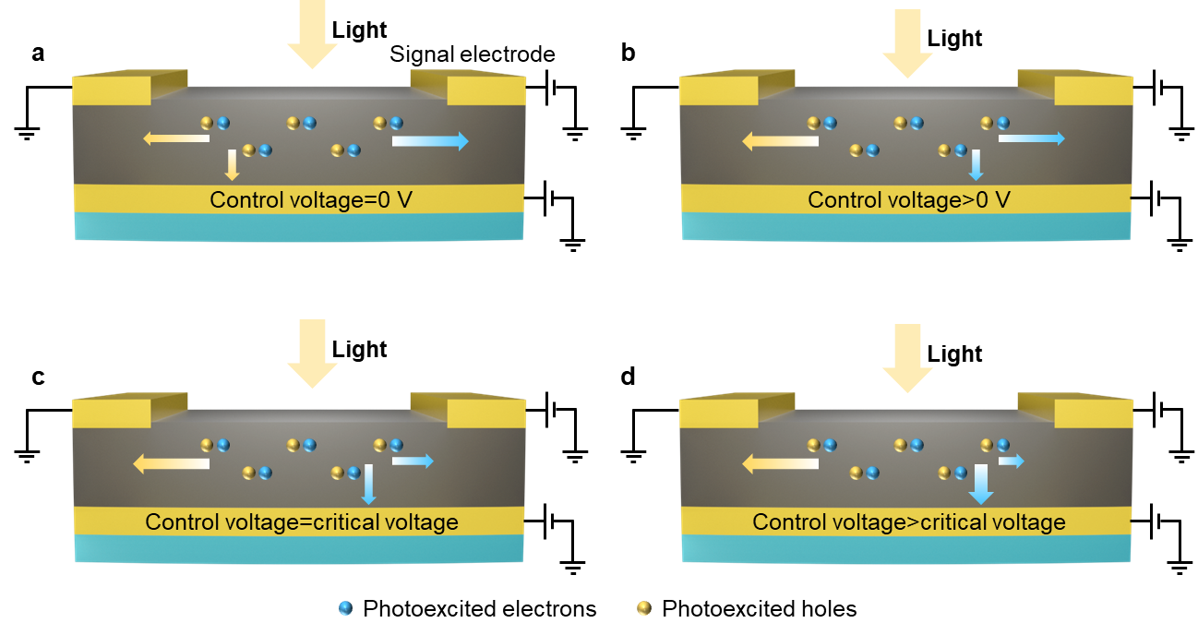

Supplementary Figure 1 | The photoexcited carriers (electrons and holes) transport process under different applied control voltage. a, When the control voltage is set as 0 V, the photoexcited electrons are transported to the signal electrode and the photoexcited holes are transported to the ground and control electrode. b-d, When the control voltage increases (> 0 V), some photoexcited electrons will be attracted by the control electrode. The transport of photogenerated electrons depends on the competition between the control voltage and the working voltage. Overall, the SNR of the signal electrode can be significantly improved when the control voltage is set as CV (c).

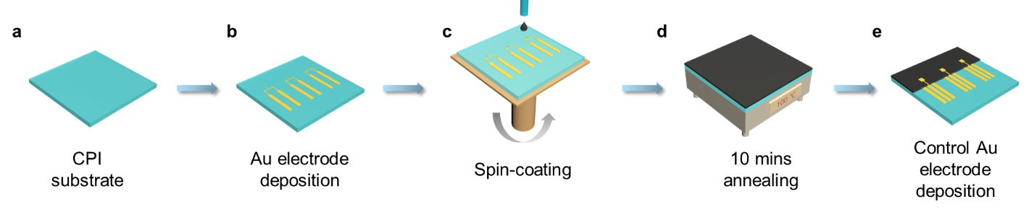

Supplementary Figure 2 | Fabrication process of the MHPs-based FPD with CE. a, A CPI film was deposited on a silicon wafer as the substrate. b, The Ni/Au (5/50 nm) electrode was deposited on the CPI substrate forming a channel with a width/length of 1000/100 μm. c,d, The perovskite precursor solution was spin-coated on the Ni/Au electrode and then annealed on the hot plate at 100 ◦C for 10 minutes to form a perovskite film. e, The perovskite film was wiped off with a clean cotton swab dampened with DMF to expose the test electrode. And the Ni/Au (5/100 nm) control electrode was deposited with a shadow mask.

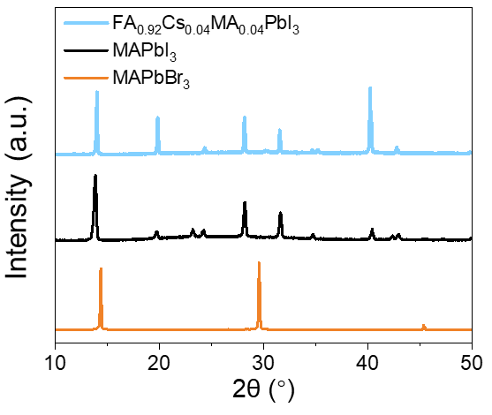

Supplementary Figure 3 | The XRD spectra of FA_{0.92}Cs_{0.04}MA_{0.04}PbI₃, MAPbI₃, and MAPbBr₃ films.

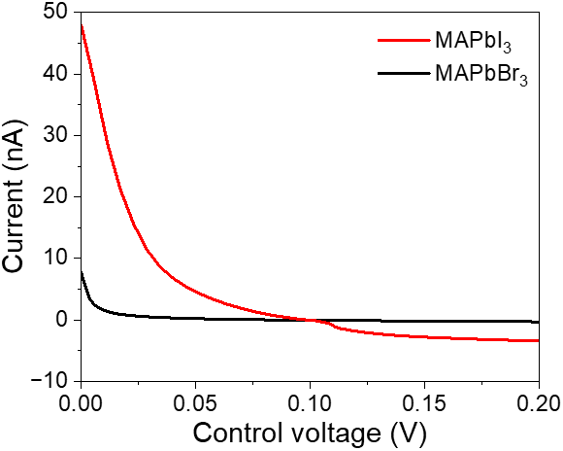

Supplementary Figure 4 | Dark current collected by the signal electrode of the MAPbI₃ and MAPbBr₃ based FPD (thickness=500 nm) varies with the control voltage when the signal electrode is set as 0.1 V (Critical voltage=0.1 V).

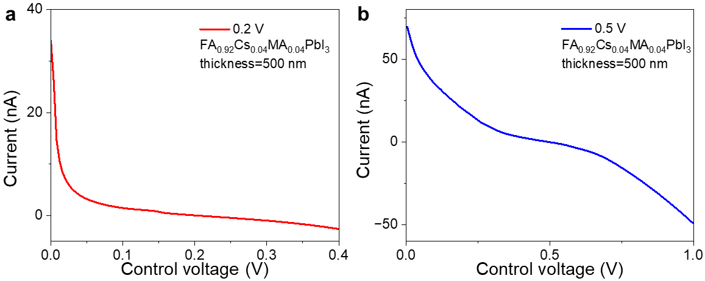

Supplementary Figure 5 | The dark current variation of FPD along with control voltage under specific driving voltage values (0.2, and 0.5 V). The corresponding critical voltage was 0.2 V (a) and 0.5 V (b), respectively.

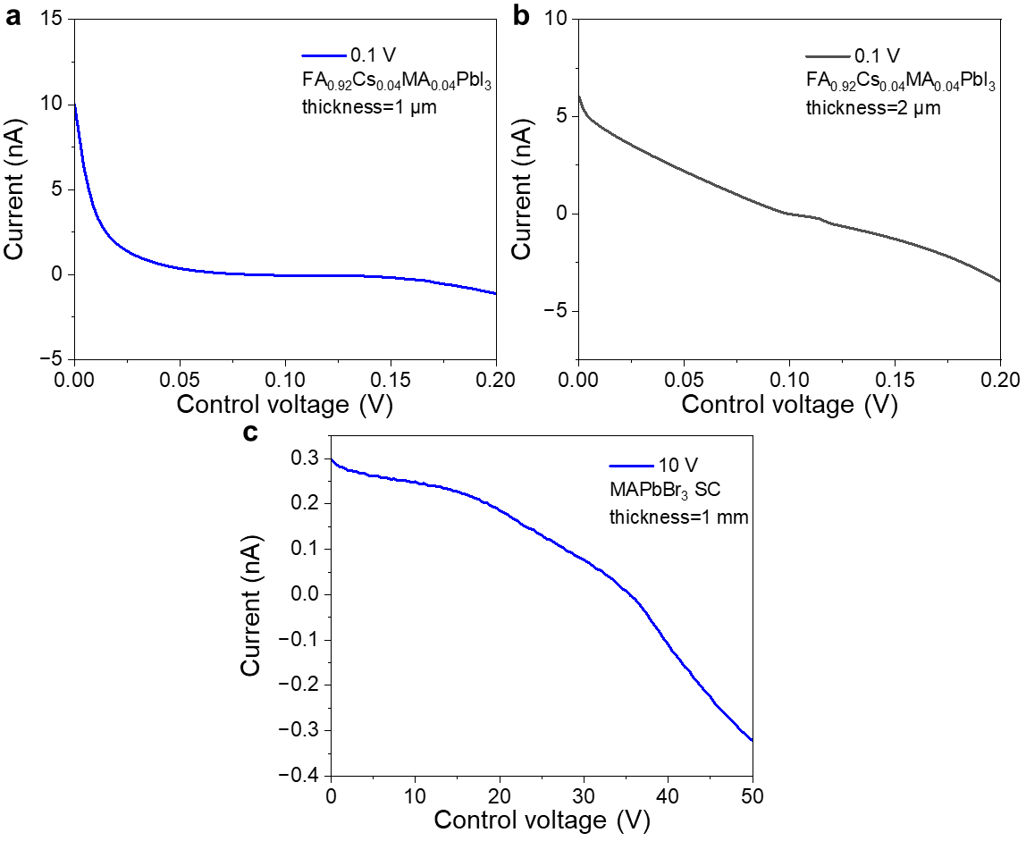

Supplementary Figure 6 | Current-voltage curves in terms of dark current collected by the signal electrode and control voltage. a-c, The FPDs with 1 μm FA_{0.92}Cs_{0.04}MA_{0.04}PbI₃ film (a) 2 μm FA_{0.92}Cs_{0.04}MA_{0.04}PbI₃ film (b) and 1 mm MAPbBr₃ single crystal (c). When the thickness of perovskite reaches 1mm, the critical voltage (35 V) is greater than the working voltage (10 V).

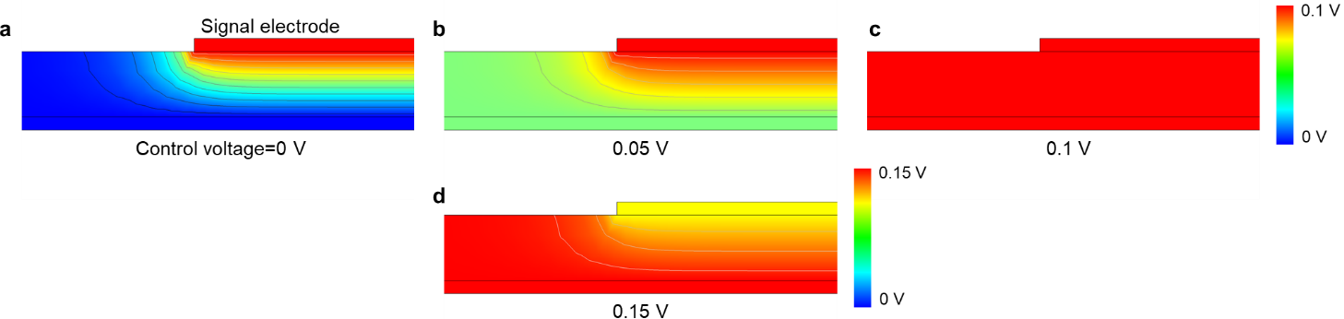

Supplementary Figure 7 | Electric field distributions in perovskite film (thickness=500 nm) under different control voltages (0, 0.05, 0.1 and 0.15 V) when the working voltage is 0.1 V.

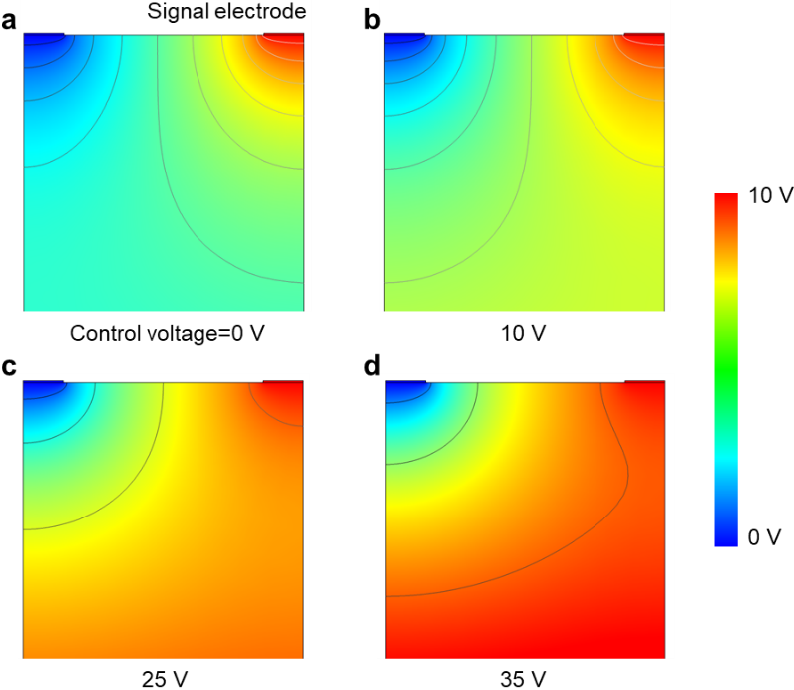

Supplementary Figure 8 | Electric field distributions in perovskite film (thickness=1 mm) under different control voltage (0, 10, 25 and 35 V) when the working voltage is 10 V.

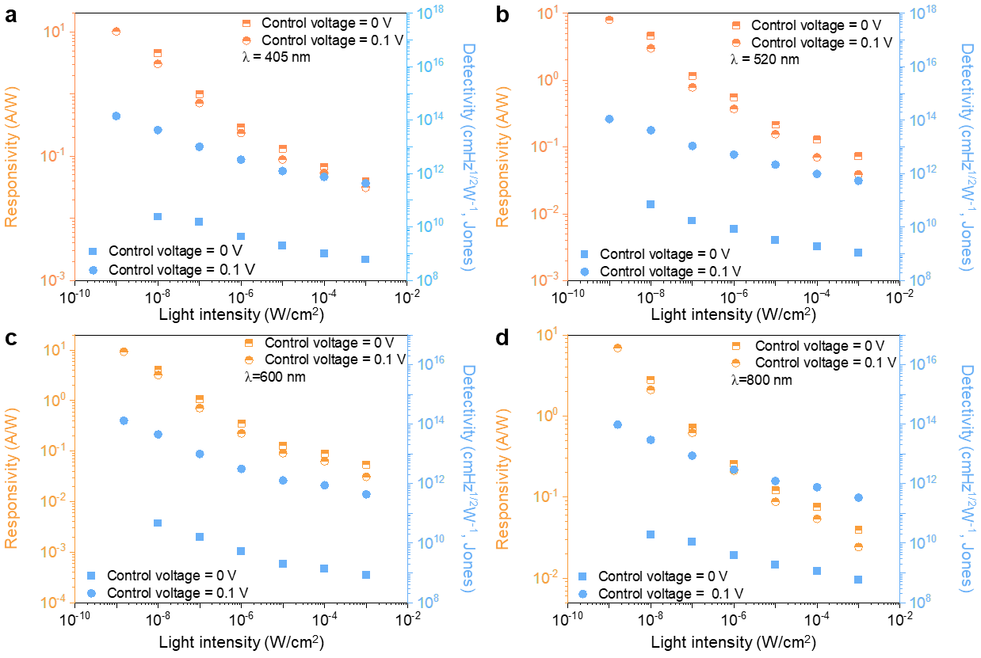
Supplementary Figure 9 | Dependence of responsivity and detectivity on the light intensity at wavelengths of 405 (a), 520 (b), 600 (c), and 800 nm (d).
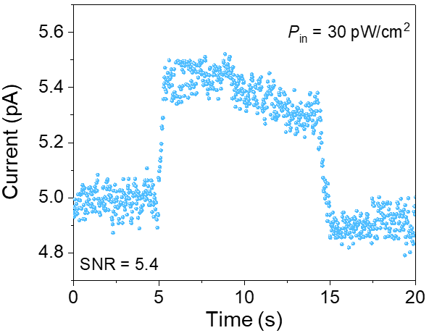
Supplementary Figure 10 | Time-resolved photocurrent response of FPDs under weak light illumination (520 nm, 30 pW/cm²) when the control voltage was 0.1 V.

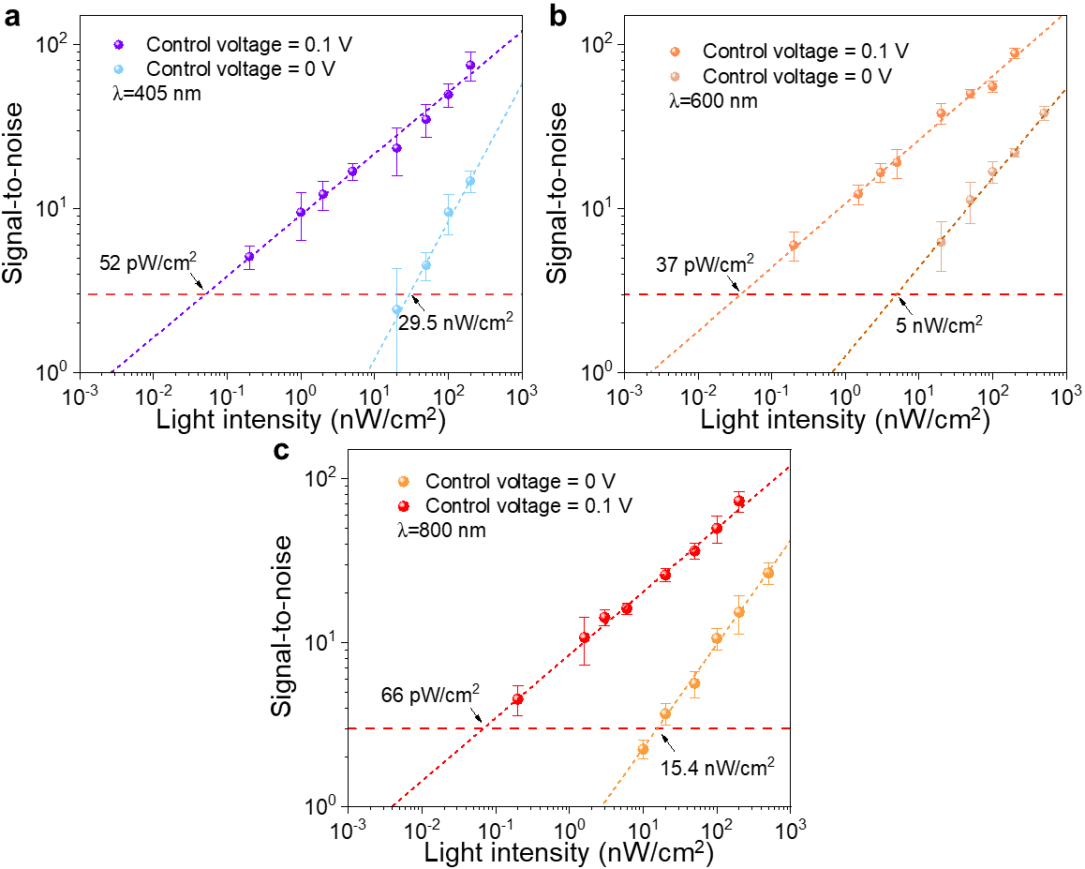
Supplementary Figure 11 | SNR of the FPD under different light intensities and the error bars are calculated according to variations in the current signal. The SNR of the FPD under the light wavelengths of 405 (a), 600 (b), and 800 nm (c) illumination. The red dashed line represents an SNR of 3.

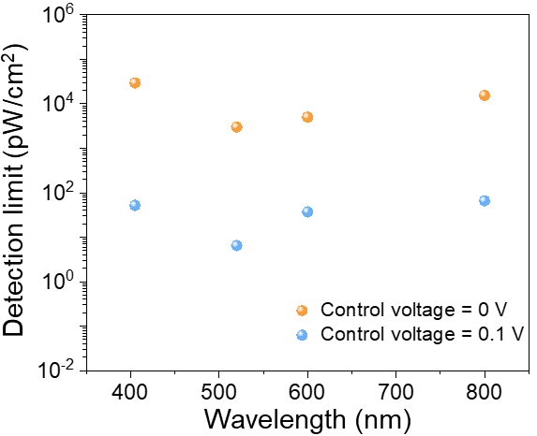
Supplementary Figure 12 | LoD of the FPD at different light wavelengths.

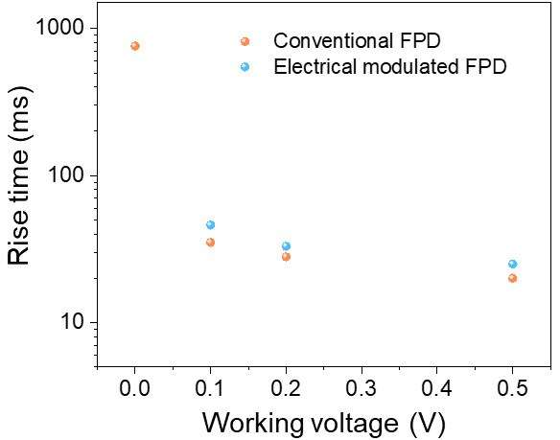
Supplementary Figure 13 | Relationship between the response time and working voltage of FPD with/without control voltage modulation.

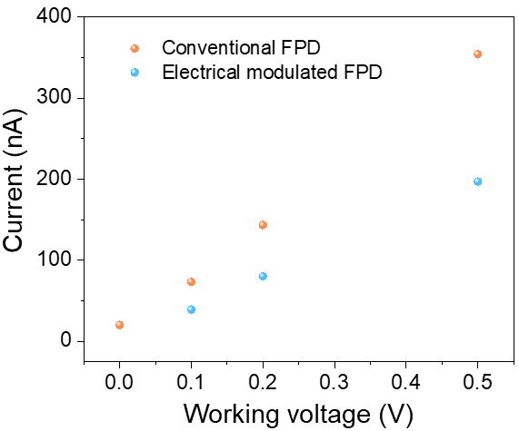
Supplementary Figure 14 | Photocurrent of conventional and electrical modulated FPD under different working voltage.

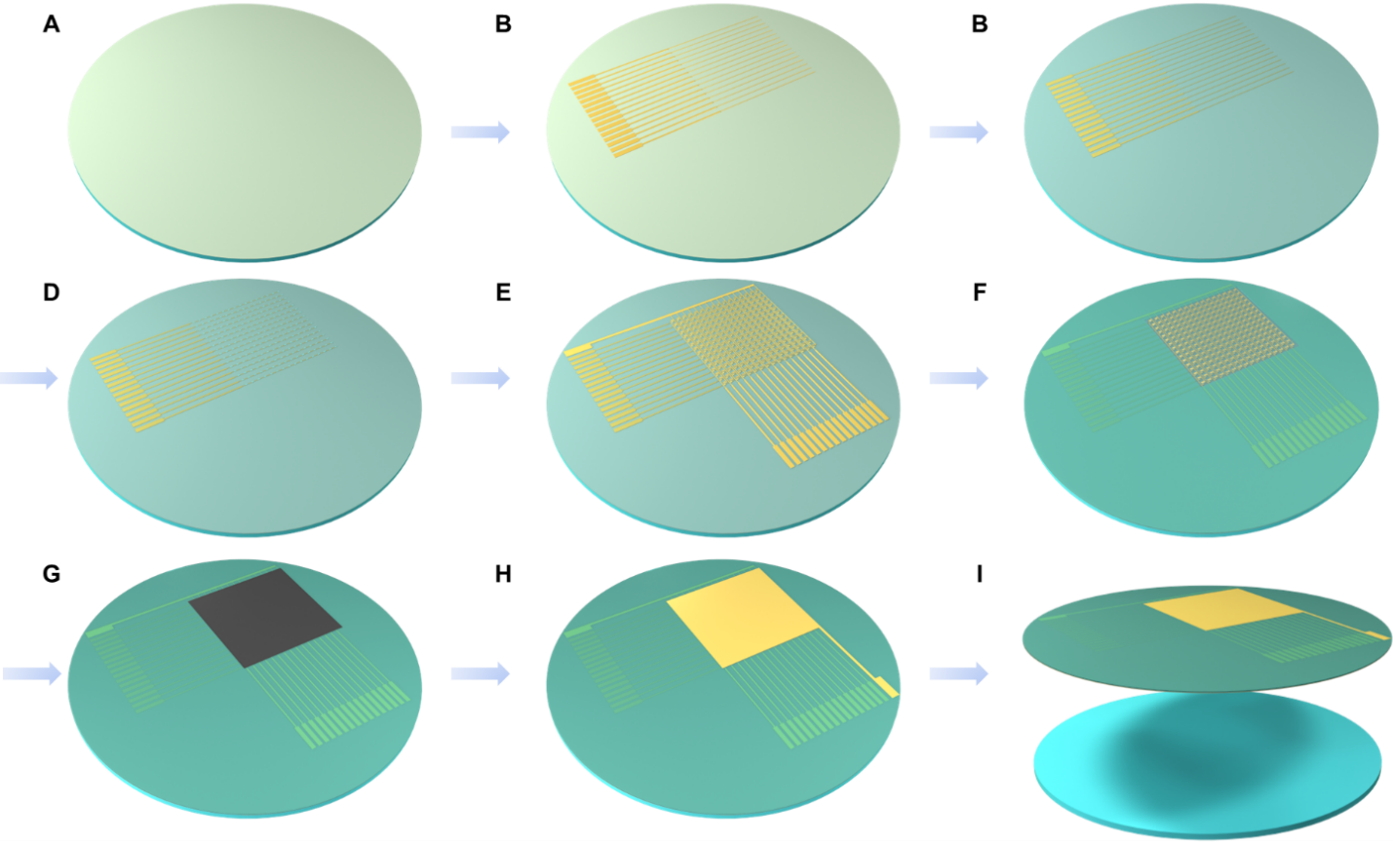

Supplementary Figure 15 | Fabrication process of the AM-FPD array. a, The CPI film deposited on Si/SiO₂ substrate. b, Deposition and patterning of gate electrodes (Ni/Au, 5/30 nm) c, Deposition of SiO₂ (100 nm) dielectric layer. d, Deposition, patterning and annealing (300℃, 1 h) of the In₂O₃ channel layer. e, Deposition and pattering of Ni/Au (5/50 nm) source and drain electrodes. f, Deposition and patterning of the SU-8 passivation layer and CYTOP layer (for patterning perovskite). g, Deposition and patterning of the perovskite for light-sensing. h, Deposition and patterning of the Ni/Au (5/100 nm) control electrode. i, Peel-off of the AM-FPD array from the silicon wafer by electrochemical delamination method¹.

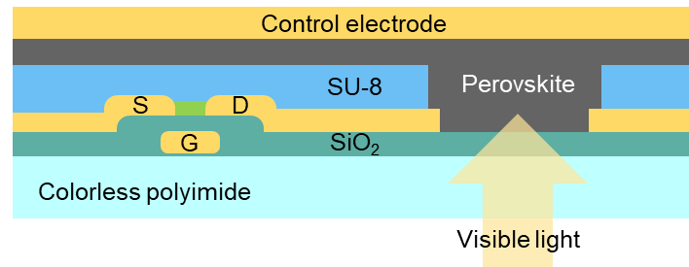

Supplementary Figure 16. Cross-sectional of a single pixel of AM-PFD array.

Supplementary Table S1. Summary of the reported flexible photoconductive-type perovskite photodetector arrays for image sensing (NS: nanosheet; MW: microwire; NW: nanowire).
Materials | Bias (V) | Electric field (V μm⁻¹) | D* (Jones) | R (A W⁻¹) | Wavelength (nm) | Dark current (pA) | Sensor area (cm²) | Pixel number | ref
MAPbI₃ MW network | 10 | 0.05 | 1.02 ×10¹² | 0.1 | 650 | 70 | 2.5×2.5 | 7×7 | 2
single-crystalline aligned MAPbI₃ MW array | -5 | -0.2 | 5.25 ×10¹² | 13.5 | 420 | >1000 | 1×1 | 21×21 | 3
MAPbI₃ NW | 0.3 | - | $≈$1×10¹⁰ | $≈$0.035 | 450-780 | - | 1.28×1.28 | 32×32 | 4
CsPbBr₃ NSs | 10 | 0.2 | 6.4×10⁸ | 0.0449 | 450 | - | 72 | 1665 | 5
MAPbI_{3-x}Cl_{x} | 5 | - | 9.4×10¹¹ | 2.17 | 650 | 1.14 $±$0.64×10³ | $≈$0.5×0.5 | 10×10 | 6
CsPbBr₃ | 5 | - | 3.94×10¹² | 3.15 | 450 | 0.33$±$ 0.19×10³ | $≈$0.5×0.5 | 10×10 | 7
CsPbBr₃ | 9 | 0.045 | - | 2.1 | 442 | 10000 (under 5 V) | - | 8×4 | 8
MAPbI₃ | 5 | - | 7.1×10¹⁰ | 0.0341 | 405 | - | - | 8×10 | 9
MAPbX₃ | 3 | 1.5 | 1.41×10¹² | 14.97 | 530 | - | - | 10×10 | 10
MAPbI_{3-x}Cl_{x} | 3 | - | 2.45×10⁸ | 1.24×10⁻⁵ | 300-800 | - | $≈$2.5×2.5 | 10×10 | 11c
FAMAPb(Br_{0.4}I_{0.6})₃ | 3 | 0.04 | 3.25×10¹¹ | 0.0452 | - | 9.6 × 10⁴ | - | 10×10 | 12
CsPbBr₃ | 10 | 0.1 | 3.5×10¹² | 1.1 | 500 | 20 | - | 5×5 | 13
MAPbBr₃ MW crystal | 1 | 0.01 | 1.2×10¹⁴ | 414 | 365 | >20 | - | 5×4 | 14
Cs₂SnI₆ | 5 | 0.05 | 3.02×10¹⁰ | 1.58 | 455 | >10⁶ | 2×2 | 3×3 | 15
MAPbBr₃ | 3 | 0.01 | - | 0.0042 | 405 | - | - | 6×6 | 16
FA_{0.92}Cs_{0.04}MA_{0.04}PbI₃ | 0.1 | 0.001 | 1.12×10¹⁴ | 8 | 520 | ~5 | 2×2 | 16×16 | This work

REFERENCES
1. Zhang H, Liu Y, Yang C, Xiang L, Hu Y, Peng LM. Wafer-scale fabrication of ultrathin flexible electronic systems via capillary-assisted electrochemical delamination. Adv. Mater. 30, e1805408 (2018).
2. Deng H, et al. Flexible and semitransparent organolead triiodide perovskite network photodetector arrays with high stability. Nano Lett. 15, 7963-7969 (2015).
3. Deng W, et al. Aligned single-crystalline perovskite microwire arrays for high-performance flexible image sensors with long-term stability. Adv. Mater. 28, 2201-2208 (2016).
4. Gu L, et al. 3D arrays of 1024-pixel image sensors based on lead halide perovskite nanowires. Adv. Mater. 28, 9713-9721 (2016).
5. Deng W, et al. All-sprayed-processable, large-area, and flexible perovskite/MXene-based photodetector arrays for photocommunication. Adv. Opt. Mater. 7, 1801521 (2019).
6. Wu W, et al. Flexible photodetector arrays based on patterned CH₃NH₃PbI_{3-x}Cl_{x} perovskite film for real-time photosensing and imaging. Adv. Mater. 31, e1805913 (2019).
7. Wu W, et al. Ultrathin and conformable lead halide perovskite photodetector arrays for potential application in retina-like vision sensing. Adv. Mater. 33, e2006006 (2021).
8. Cao F, et al. Highly stable and flexible photodetector arrays based on low dimensional CsPbBr₃ microcrystals and on-paper pencil-drawn electrodes. J. Mater. Chem. C 5, 7441-7445 (2017).
9. Xia B, et al. Flexible metal halide perovskite photodetector arrays via photolithography and dry lift-off patterning. Adv. Eng. Mater. 24, 2100930 (2021).
10. Wang Q, Zhang G, Zhang H, Duan Y, Yin Z, Huang Y. High-resolution, flexible, and full-color perovskite image photodetector via electrohydrodynamic printing of ionic-liquid-based ink. Adv. Funct. Mater. 31, 2100857 (2021).
11. Jang J, et al. 3D heterogeneous device arrays for multiplexed sensing platforms using transfer of perovskites. Adv. Mater. 33, 2101093 (2021).
12. Kim T, Jeong S, Kim KH, Shim H, Kim D, Kim HJ. Engineered surface halide defects by two-dimensional perovskite passivation for deformable intelligent photodetectors. ACS Appl. Mater. Interfaces 14, 26004-26013 (2022).
13. Chen Y, Zhao C, Zhang T, Wu X, Zhang W, Ding SJ. Flexible and filter‐free color‐imaging sensors with multicomponent perovskites deposited using enhanced vapor technology. Small 17, 2007543 (2021).
14. Li SX, Xia H, Sun XC, An Y, Zhu H, Sun HB. Curved photodetectors based on perovskite microwire arrays via in situ conformal nanoimprinting. Adv. Funct. Mater. 32, 2202277 (2022).
15. Krishnaiah M, Kim S, Kumar A, Mishra D, Seo SG, Jin SH. Physically detachable and operationally stable Cs₂SnI₆ photodetector arrays integrated with µ-LEDs for broadband flexible optical systems. Adv. Mater. 34, e2109673 (2022).
16. Zhang T, et al. Pen-writing high-quality perovskite films and degradable optoelectronic devices. RSC Adv. 12, 3924-3930 (2022).

