Extended Data Figures

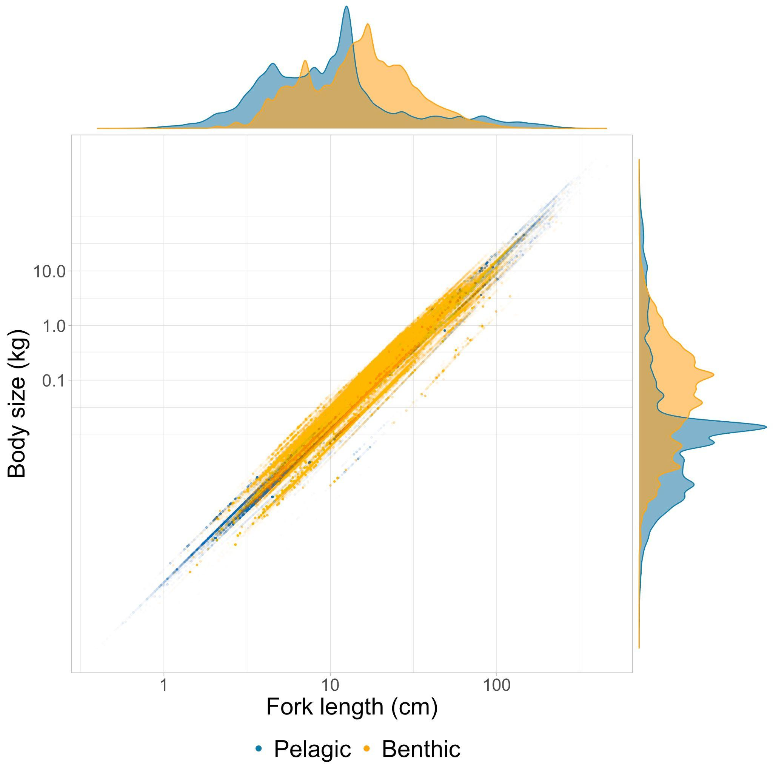
Extended Data Fig. 1 | Allometric scaling conversion between fork lengths and body size (kg) in pelagic and benthic habitats. Taxa specific allometric conversion parameters from fishbase were used for conversion of individual body lengths.
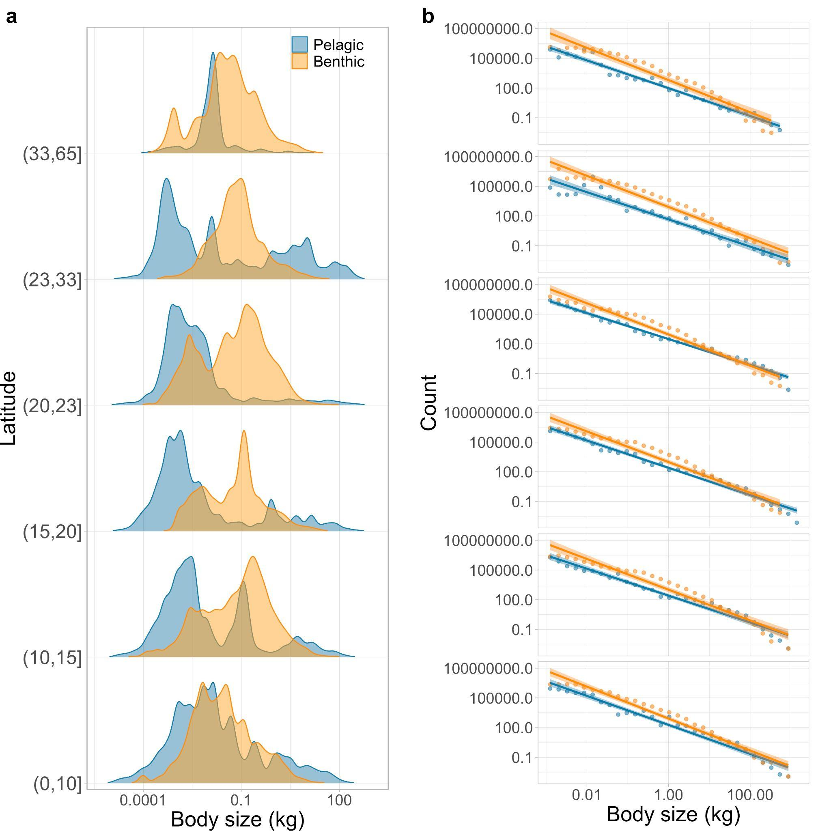
Extended Data Fig. 2 | Biogeographical patterns in pelagic and benthic body sizes across latitudinal scales. a, Frequency distribution of body sizes aggregated into six absolute latitude brackets (0-10, 10-15, 15-20, 20-23, 23-33, 33-65) of equal numbers of body sizes (n = 146,707). b, Normalised abundance size-spectra, with lines and shaded areas representing fit and confidence intervals of linear regressions.

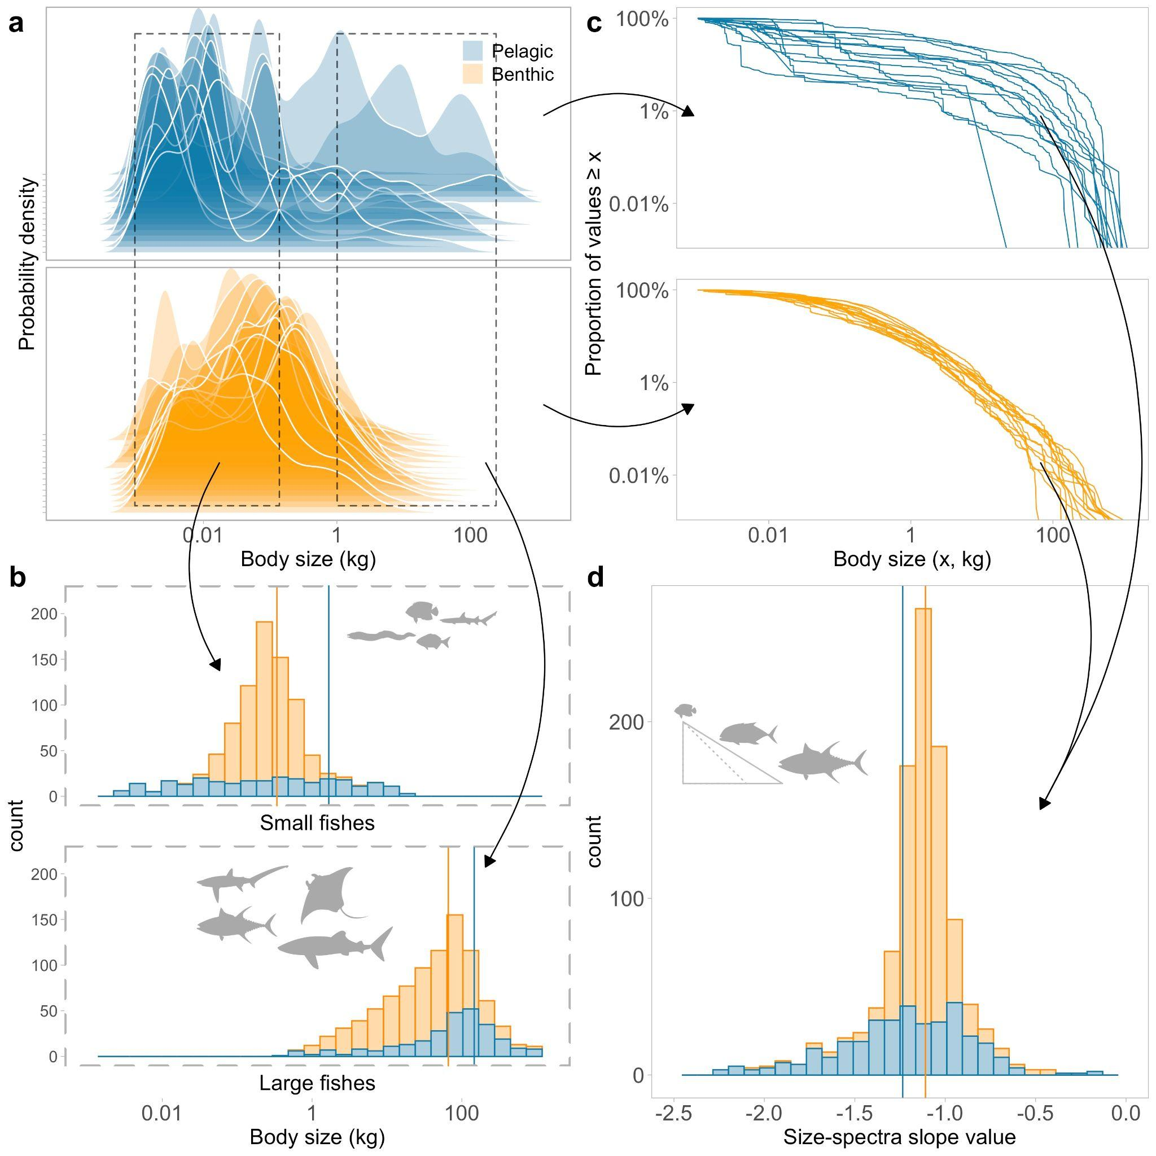
Extended Data Fig. 3 | Deriving three body size indicators of marine fish assemblages. a, Body size frequency distributions (kg) were derived for different locations in pelagic and benthic habitats, aggregated by the date of sampling, illustrated here using probability density distribution grouped by latitudinal brackets (n=15). b, Frequency distribution of body sizes of relatively small and large individuals for when two modes in body sizes were significantly detected (n = 919, P<0.001). c, Body sizes (x) from different locations were ranked to produce log cumulative distributions (LCD), where rank (x)/n is the fraction of values ≥ x. d, Size-spectra slope values of LCD for pelagic and benthic body sizes (n=1,041). Vertical lines represent mean values for each size-based indicator.

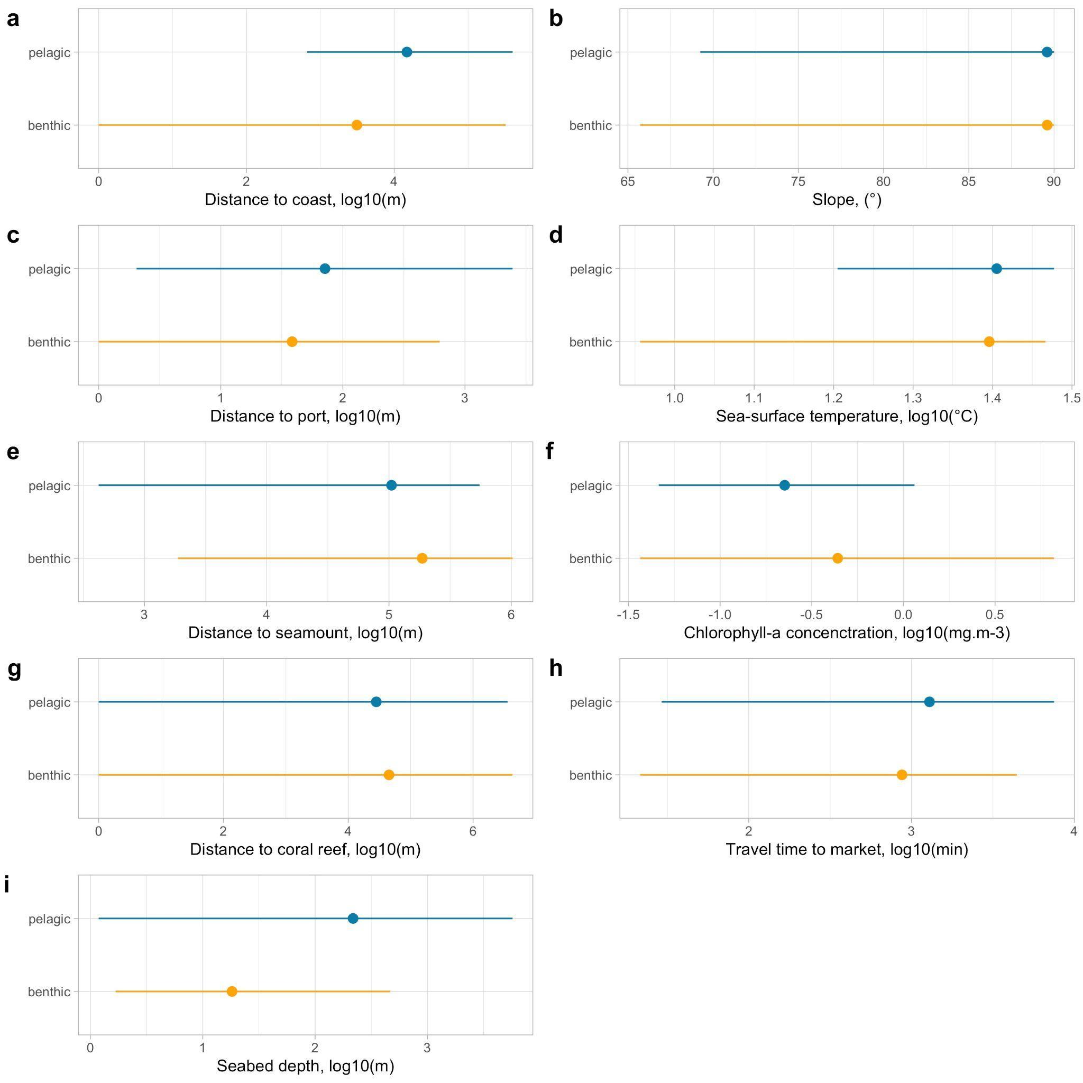
Extended Data Fig. 4 | Range and mean value of explanatory variables in sampling locations in pelagic and benthic habitats.

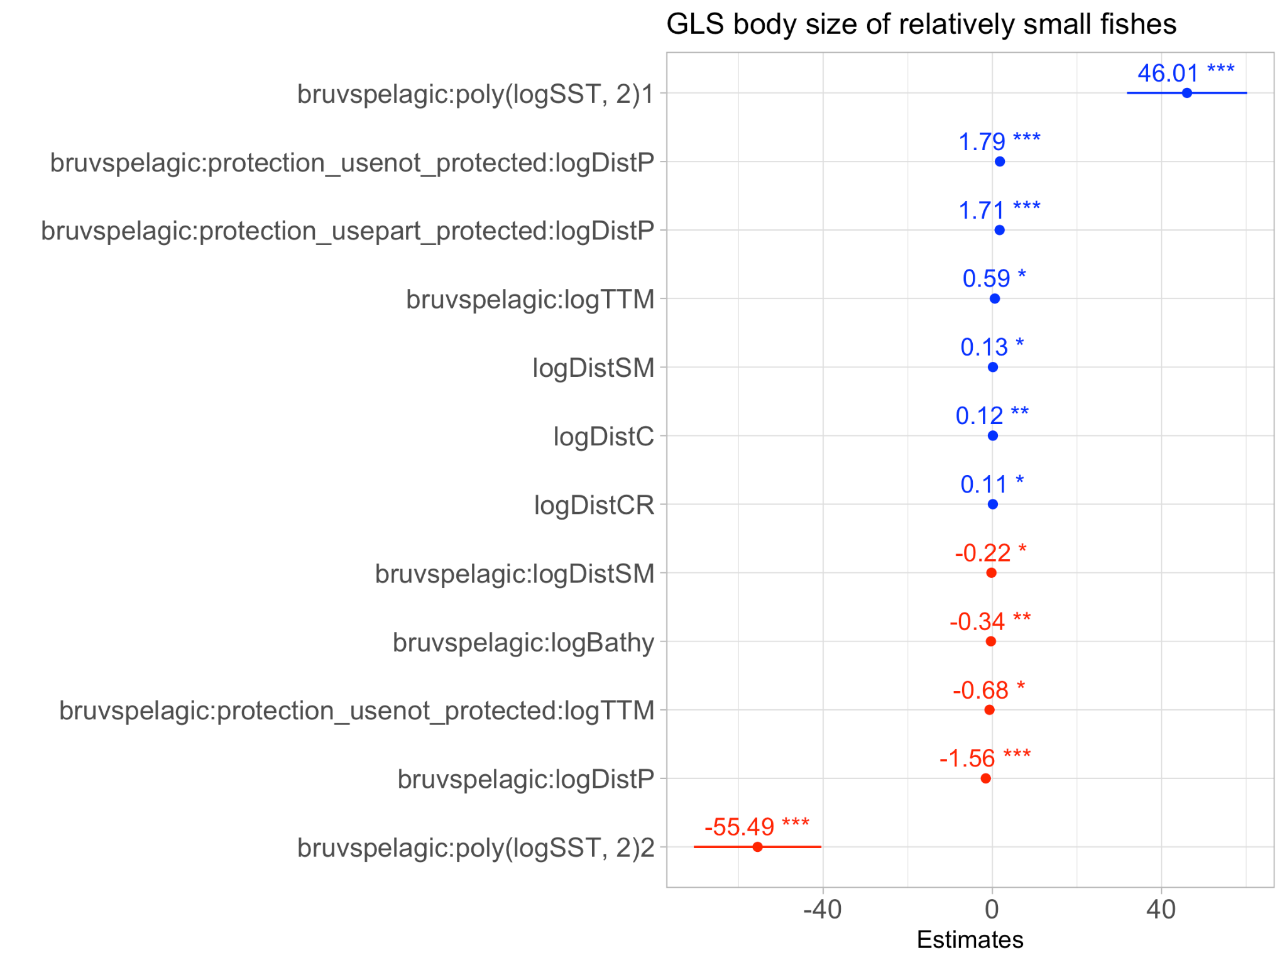
Extended Data Fig. 5 | Explanatory variables influence on relatively small sizes. Standardised coefficient plot for generalised least square models of body size of relatively small fishes, showing significant terms and their interactions. Points and tails, model estimates and upper and lower confidence interval, significance indicated by asterisks p<.05;*, p<.01**, p<.001*** .
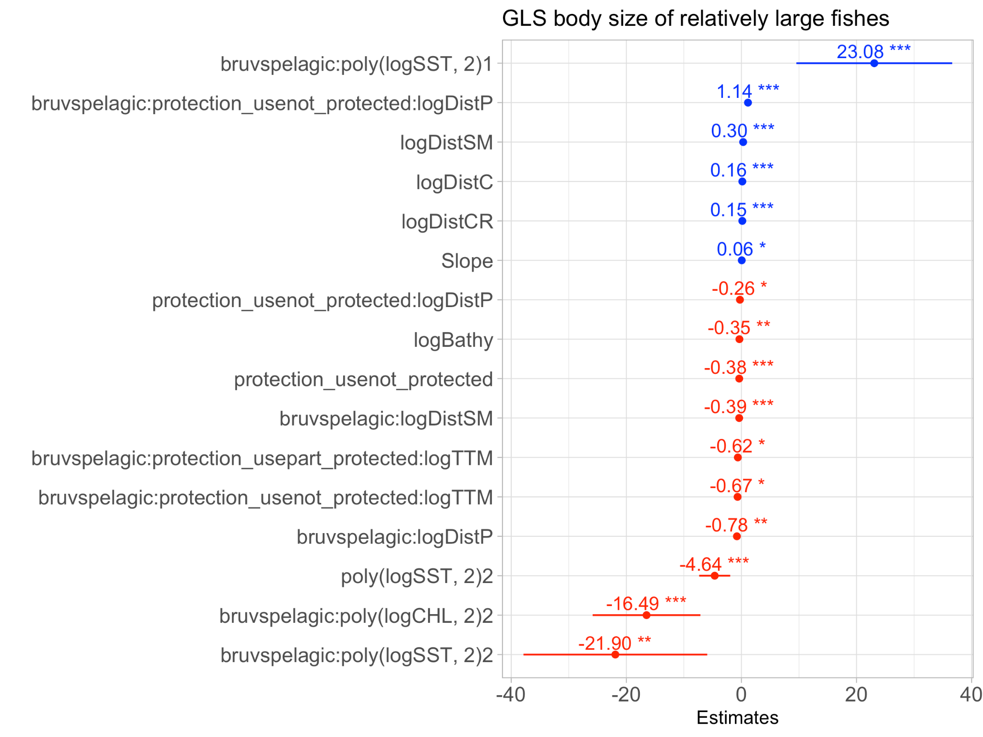
Extended Data Fig. 6 | Explanatory variables influence on relatively large sizes. Explanatory variables of relatively fishes. Standardised coefficient plot for generalised least square model of body size of relatively large fishes, showing significant terms and their interactions. Points and tails, model estimates and upper and lower confidence interval, significance indicated by asterisks p<.05;*, p<.01**, p<.001*** .

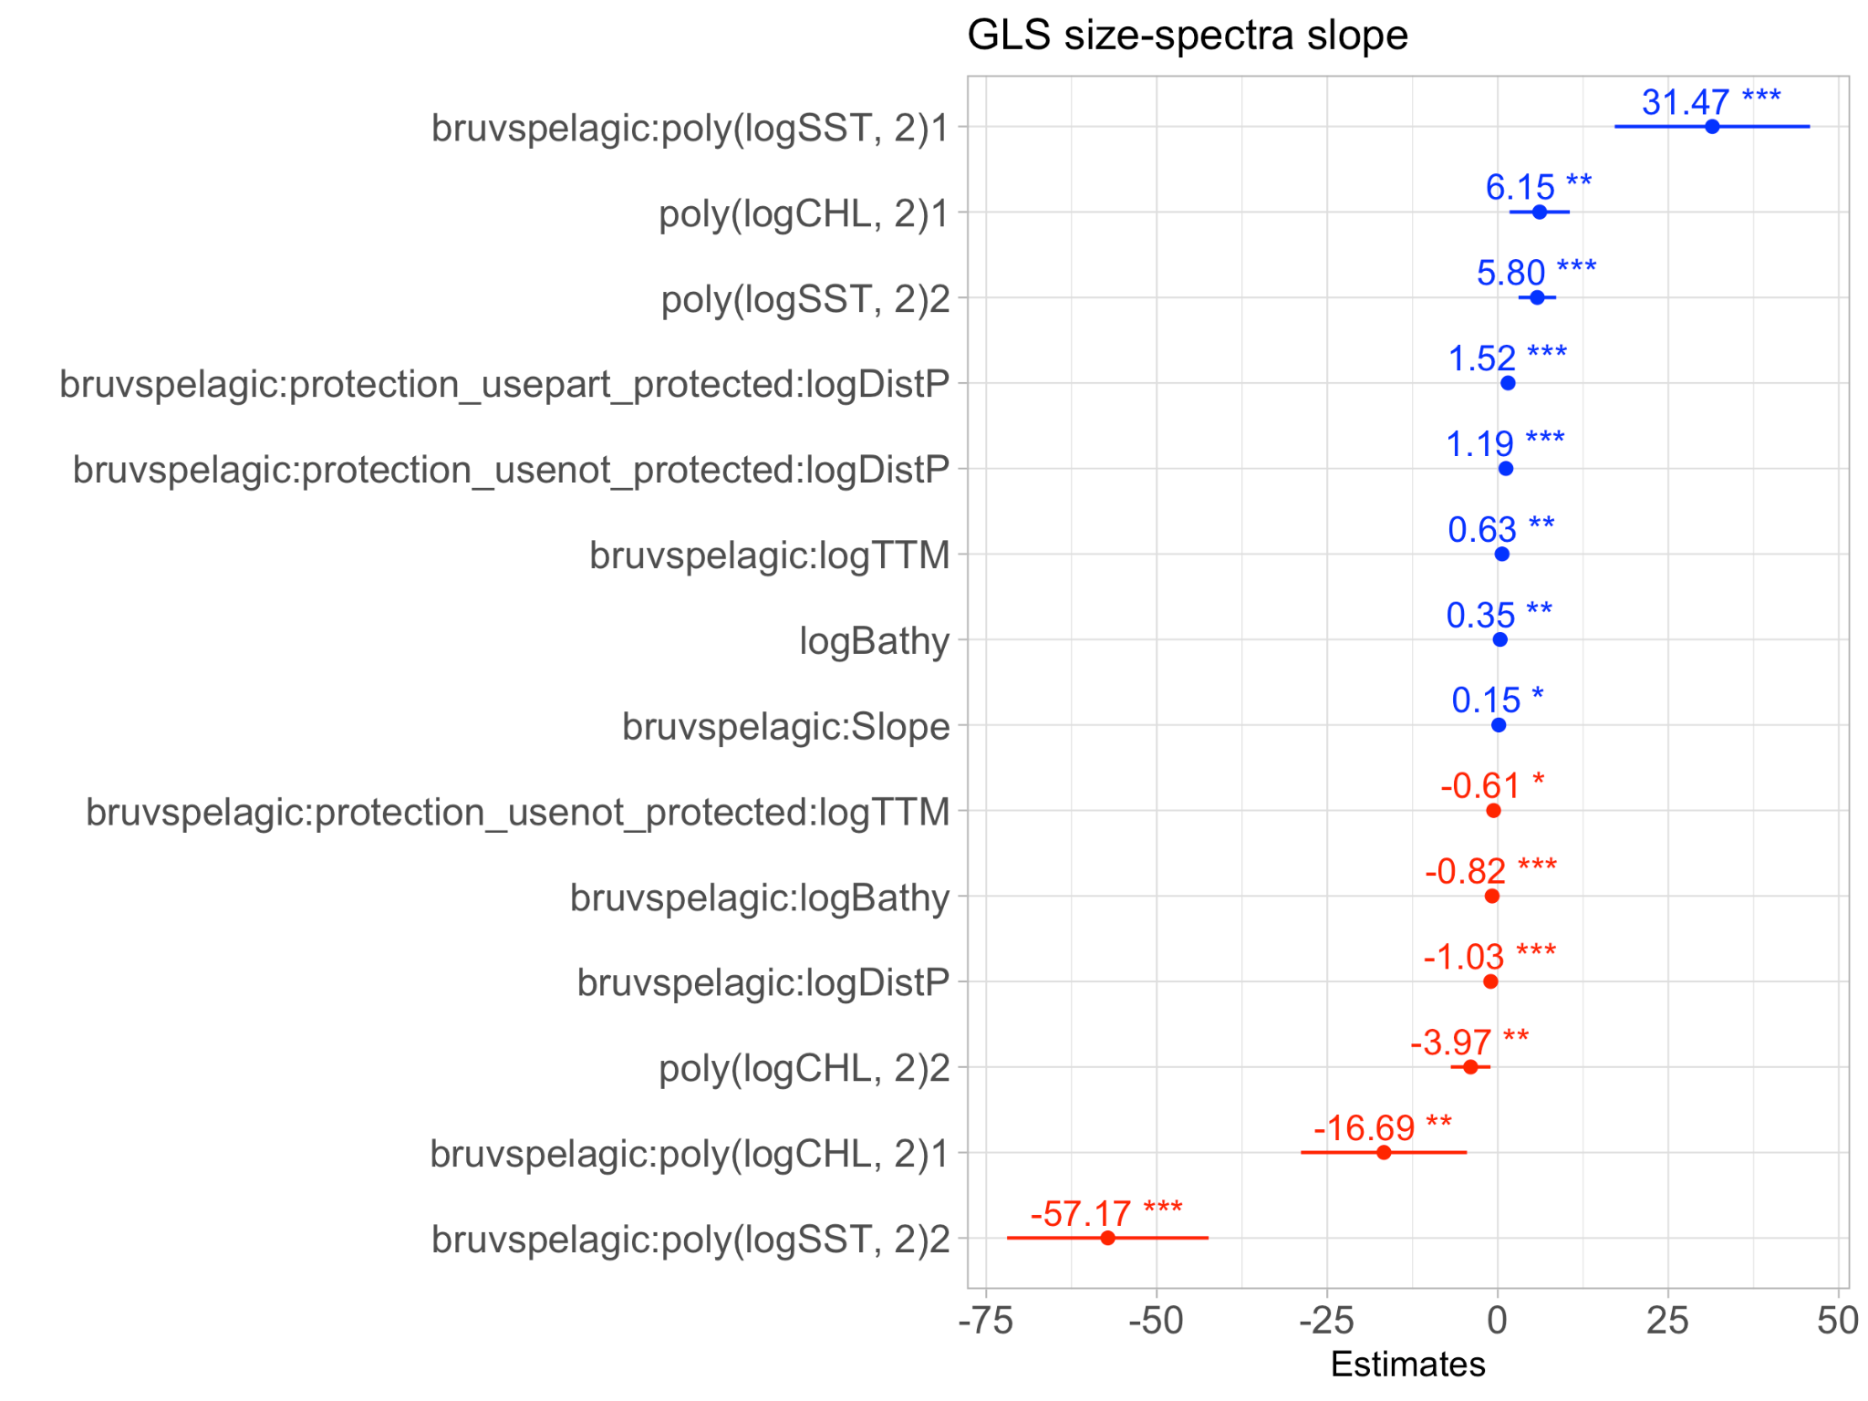
Extended Data Fig. 7 | Explanatory variables influence on size-spectra slope. Standardised coefficient plot for generalised least square model of size-spectra slope, showing significant terms and their interactions. Points and tails, model estimates and upper and lower confidence interval, significance indicated by asterisks p<.05;*, p<.01**, p<.001*** .
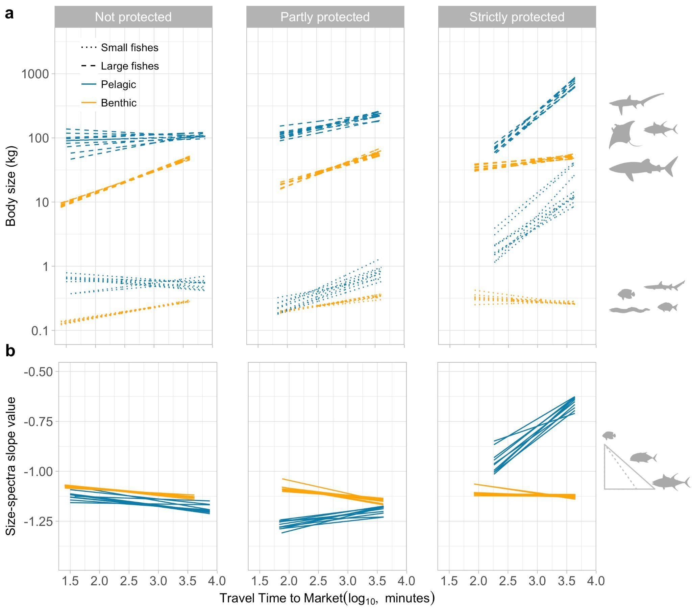
Extended Data Fig. 8 | Sensitivity analysis showing marginal plots of 10 GLS of each size-based indicator after randomly removing 10% of the size-based indicators records. a, Size of relatively small and large fishes. b, Slope of the size-spectra. Lines indicate predictions, and band indicates 95% confidence intervals.

Extended Data Tables

Extended Data Table 1 | Linear regression parameters of normalised size-spectra within latitudinal brackets. Slope, y-intercept, and confidence intervals

Parameter | Type | Latitude bracket | Estimate | Upper CI 2.50% | Lower CI 97.50%
Intercept | Pelagic | (33, 65] | 5.23 | 4.79 | 5.67
Slope estimate | Pelagic | (33, 65] | -1.06 | -1.31 | -0.81
Intercept | Pelagic | (23, 33] | 5.55 | 5.13 | 5.98
Slope estimate | Pelagic | (23, 33] | -0.82 | -1.06 | -0.57
Intercept | Pelagic | (20, 23] | 5.53 | 5.17 | 5.88
Slope estimate | Pelagic | (20, 23] | -0.87 | -1.06 | -0.67
Intercept | Pelagic | (15, 20] | 5.72 | 5.43 | 6.02
Slope estimate | Pelagic | (15, 20] | -0.71 | -0.88 | -0.54
Intercept | Pelagic | (10,15] | 3.81 | 3.25 | 4.36
Slope estimate | Pelagic | (10,15] | -0.85 | -1.18 | -0.53
Intercept | Pelagic | (0,10] | 4.57 | 4.18 | 4.95
Slope estimate | Pelagic | (0,10] | -0.92 | -1.15 | -0.70
Intercept | Benthic | (33, 65] | 6.71 | 6.21 | 7.21
Slope estimate | Benthic | (33, 65] | -1.41 | -1.70 | -1.11
Intercept | Benthic | (23, 33] | 6.93 | 6.32 | 7.55
Slope estimate | Benthic | (23, 33] | -1.26 | -1.63 | -0.90
Intercept | Benthic | (20, 23] | 6.86 | 6.31 | 7.42
Slope estimate | Benthic | (20, 23] | -1.26 | -1.58 | -0.93
Intercept | Benthic | (15, 20] | 6.79 | 6.27 | 7.31
Slope estimate | Benthic | (15, 20] | -1.32 | -1.63 | -1.01
Intercept | Benthic | (10,15] | 6.69 | 6.07 | 7.31
Slope estimate | Benthic | (10,15] | -1.31 | -1.67 | -0.96
Intercept | Benthic | (0,10] | 6.45 | 5.74 | 7.16
Slope estimate | Benthic | (0,10] | -1.44 | -1.87 | -1.00

Extended Data Table 2 | Environmental, geomorphic, and socioeconomic explanatory variables.
 | Mean | Max | Min | Unit | Period | Spatial resolution and model transformation | Source
Environmental variables (acronyms)
*Primary production | 545 | 2318 | 114 | ?? | 2012-2020 | 11µm 4km (log₁₀) | ⁸⁰
Chlorophyll-a (logCHL) | 0 | 7 | 0 | mg. m⁻³ | 2012-2020 | 4km (log₁₀) | http://marine.copernicus.eu/services-portfolio/access-to-products/?option=com_csw&view=details&product_id=OCEANCOLOUR_GLO_CHL_L4_REP_OBSERVATIONS_009_082
SST weekly median (logSST) | 25 | 30 | 9 | °C | 2012-2020 | 11µm 4km (log₁₀) | https://oceancolor.gsfc.nasa.gov/atbd/sst/
*SST standard deviation (SST_sd) | 1 | 3 | 0 | NA | 2012-2020 | 11µm 4km | https://oceancolor.gsfc.nasa.gov/atbd/sst/
Geomorphic variables (acronyms)
Seabed depth (logBathy) | -397 | -1 | -5,725 | m | NA | 15 arcsecond (log₁₀) | https://www.gebco.net/data_and_products/gridded_bathymetry_data/
Seabed slope | 90 | 90 | 66 | ° | NA | 15 arcsecond | Qgis tool (using GEBCO layer)
Distance to seamount (logDistSM) | 219,065 | 1,024,009 | 423 | m | NA | NA (log₁₀) | Yesson, C. et al. Improved bathymetry leads to >4000 new seamount predictions in the global ocean – but beware of phantom seamounts! UCL Open Environ 4, (2021).
Distance to coast (logDistC) | 35,062 | 405,280 | 0 | m | NA | NA (log₁₀) | GADM 3.6 website
Distance to coral reef (logDistCR) | 479,770 | 4,465,125 | 0 | m | NA | NA (log₁₀) | https://data.unep-wcmc.org/datasets/1
Socioeconomic (acronym)
*Government Effectiveness | 1.1 | 2 | -1 | index | 2012-2020 | National | https://papers.ssrn.com/sol3/papers.cfm?abstract_id=1682130
*Number of year of conflict | 12 | 48 | 0 | count | 1946-2018 | National | https://ucdp.uu.se/downloads/ucdpprio/ucdp-prio-acd-191.pdf
*Rule of Law | 1.2 | 2 | -1 | index | 2012-2020 | National | https://papers.ssrn.com/sol3/papers.cfm?abstract_id=1682130
*Absence of violence | 0.51 | 1 | -2 | index | 2012-2020 | National | https://papers.ssrn.com/sol3/papers.cfm?abstract_id=1682130
*Voice and accountability | 0.97 | 2 | -2 | index | 2012-2020 | National | https://papers.ssrn.com/sol3/papers.cfm?abstract_id=1682130
*Control of corruption | 1.2 | 2 | -1 | index | 2012-2020 | National | https://papers.ssrn.com/sol3/papers.cfm?abstract_id=1682130
*Human development index (HDI) | 0.86 | 1 | 0 | index | 2012-2020 | National | http://hdr.undp.org/en/
*NGO active | 1,185 | 2,830 | 0 | count | NA | National
*Marine ecosystem dependency | 0.13 | 1 | 0 | index | NA | National | Selig, E. R. et al. Mapping global human dependence on marine ecosystems. Conservation Letters 12, (2019).
*Total reconstructed catch | 399 | 7,355 | 0 | tonnes | 2000-2016 | ½ (log₁₀) | www.seaaroundus.org
Travel time to market (logTTM) | 1,867 | 8,290 | 18 | min | NA | 1 km (log₁₀) | Maire, E. et al. How accessible are coral reefs to people? A global assessment based on travel time. Ecol Lett 19, 351–360 (2016).
*Linear distance to cities | 711,022 | 2,763,244 | 2,944 | m | NA | 1 km (log₁₀) | Maire, E. et al. How accessible are coral reefs to people? A global assessment based on travel time. Ecol Lett 19, 351–360 (2016).
*Travel time to population | 396 | 3,418 | 0 | min | NA | 1 km (log₁₀) | Maire, E. et al. How accessible are coral reefs to people? A global assessment based on travel time. Ecol Lett 19, 351–360 (2016).
*Linear distance to population | 128,728 | 1,139,491 | 102 | m | NA | 1 km (log₁₀) | Maire, E. et al. How accessible are coral reefs to people? A global assessment based on travel time. Ecol Lett 19, 351–360 (2016).
*AIS fishing effort | 2 | 34 | 0 | hr.km⁻² | 2015-2020 | 100th degree (log₁₀) | https://globalfishingwatch.org/map-and-data/
Distance to port (logDistP) | 0 | 2,515 | 0 | km | NA | 100th degree (log₁₀) | https://globalfishingwatch.org/map-and-data/
Asterisk (*) denote variables that were discounted due to high correlation (r>0.7) or due to high variance inflation factor (VIF >10).

Extended Data Table 3| Standardised coefficient for GLS models of body sizes of relatively small fishes, showing significant terms and their interactions.

Term | Estimate | Std.error | Conf.level | Conf.low | Conf.high | Statistic | P.value
logDistSM | 0.13 | 0.06 | 0.95 | 0.012 | 0.248 | 2.165 | 0.031
logDistC | 0.117 | 0.04 | 0.95 | 0.039 | 0.196 | 2.923 | 0.004
logDistCR | 0.113 | 0.051 | 0.95 | 0.013 | 0.214 | 2.208 | 0.027
bruvspelagic:logDistP | -1.559 | 0.253 | 0.95 | -2.055 | -1.063 | -6.165 | 0
bruvspelagic:logTTM | 0.587 | 0.24 | 0.95 | 0.115 | 1.059 | 2.443 | 0.015
bruvspelagic:logDistSM | -0.218 | 0.087 | 0.95 | -0.389 | -0.047 | -2.495 | 0.013
bruvspelagic:logBathy | -0.339 | 0.119 | 0.95 | -0.573 | -0.105 | -2.843 | 0.005
bruvspelagic:poly(logSST, 2)1 | 46.015 | 7.233 | 0.95 | 31.818 | 60.212 | 6.362 | 0
bruvspelagic:poly(logSST, 2)2 | -55.494 | 7.678 | 0.95 | -70.564 | -40.424 | -7.227 | 0
bruvspelagic:protection_usepart_protected:logDistP | 1.714 | 0.294 | 0.95 | 1.137 | 2.292 | 5.824 | 0
bruvspelagic:protection_usenot_protected:logDistP | 1.786 | 0.27 | 0.95 | 1.256 | 2.316 | 6.61 | 0
bruvspelagic:protection_usenot_protected:logTTM | -0.679 | 0.272 | 0.95 | -1.214 | -0.145 | -2.496 | 0.013

​​

Extended Data Table 4| Standardised coefficients for GLS models of body sizes of relatively large fishes, showing significant terms and their interactions.

Term | Estimate | Std.error | Conf.level | Conf.low | Conf.high | Statistic | P.value
protection_usenot_protected | -0.382 | 0.109 | 0.95 | -0.596 | -0.167 | -3.489 | 0.001
logDistSM | 0.304 | 0.076 | 0.95 | 0.155 | 0.452 | 4.008 | 0
logDistC | 0.157 | 0.038 | 0.95 | 0.082 | 0.232 | 4.092 | 0
logBathy | -0.35 | 0.109 | 0.95 | -0.564 | -0.137 | -3.217 | 0.001
logDistCR | 0.154 | 0.045 | 0.95 | 0.066 | 0.243 | 3.425 | 0.001
Slope | 0.059 | 0.028 | 0.95 | 0.003 | 0.114 | 2.076 | 0.038
poly(logSST, 2)2 | -4.644 | 1.374 | 0.95 | -7.34 | -1.948 | -3.381 | 0.001
bruvspelagic:logDistP | -0.784 | 0.245 | 0.95 | -1.265 | -0.303 | -3.201 | 0.001
protection_usenot_protected:logDistP | -0.257 | 0.11 | 0.95 | -0.472 | -0.042 | -2.348 | 0.019
bruvspelagic:logDistSM | -0.39 | 0.107 | 0.95 | -0.601 | -0.179 | -3.629 | 0
bruvspelagic:poly(logSST, 2)1 | 23.083 | 6.899 | 0.95 | 9.541 | 36.624 | 3.346 | 0.001
bruvspelagic:poly(logSST, 2)2 | -21.905 | 8.134 | 0.95 | -37.869 | -5.941 | -2.693 | 0.007
bruvspelagic:poly(logCHL, 2)2 | -16.486 | 4.773 | 0.95 | -25.853 | -7.118 | -3.454 | 0.001
bruvspelagic:protection_usenot_protected:logDistP | 1.139 | 0.263 | 0.95 | 0.623 | 1.655 | 4.332 | 0
bruvspelagic:protection_usepart_protected:logTTM | -0.619 | 0.283 | 0.95 | -1.175 | -0.064 | -2.188 | 0.029
bruvspelagic:protection_usenot_protected:logTTM | -0.667 | 0.263 | 0.95 | -1.183 | -0.151 | -2.538 | 0.011

Extended Data Table 5| Standardised coefficients for GLS models of size-spectra slope, showing significant terms and their interactions.

Term | Estimate | Std.error | Conf.level | Conf.low | Conf.high | Statistic | P.value
logBathy | 0.35 | 0.106 | 0.95 | 0.141 | 0.559 | 3.285 | 0.001
poly(logSST, 2)2 | 5.797 | 1.408 | 0.95 | 3.034 | 8.561 | 4.117 | 0
poly(logCHL, 2)1 | 6.148 | 2.253 | 0.95 | 1.726 | 10.569 | 2.729 | 0.006
poly(logCHL, 2)2 | -3.975 | 1.488 | 0.95 | -6.894 | -1.056 | -2.672 | 0.008
bruvspelagic:logDistP | -1.034 | 0.235 | 0.95 | -1.494 | -0.573 | -4.407 | 0
bruvspelagic:logTTM | 0.631 | 0.219 | 0.95 | 0.2 | 1.061 | 2.875 | 0.004
bruvspelagic:logBathy | -0.823 | 0.134 | 0.95 | -1.086 | -0.56 | -6.149 | 0
bruvspelagic:Slope | 0.149 | 0.058 | 0.95 | 0.034 | 0.263 | 2.553 | 0.011
bruvspelagic:poly(logSST, 2)1 | 31.467 | 7.3 | 0.95 | 17.142 | 45.791 | 4.311 | 0
bruvspelagic:poly(logSST, 2)2 | -57.17 | 7.531 | 0.95 | -71.948 | -42.392 | -7.592 | 0
bruvspelagic:poly(logCHL, 2)1 | -16.691 | 6.204 | 0.95 | -28.865 | -4.516 | -2.69 | 0.007
bruvspelagic:protection_usepart_protected:logDistP | 1.516 | 0.27 | 0.95 | 0.986 | 2.046 | 5.609 | 0
bruvspelagic:protection_usenot_protected:logDistP | 1.194 | 0.252 | 0.95 | 0.699 | 1.69 | 4.733 | 0
bruvspelagic:protection_usenot_protected:logTTM | -0.608 | 0.244 | 0.95 | -1.087 | -0.128 | -2.488 | 0.013

