Supplementary table 1. Group Characteristics.
 |  | Discovery | Replication 1 | Replication 2
Sex
 | Female (N) | 466 | 202 | 337
 | Male (N) | 141 | 77 | 0
 | M:F ratio | 0.30 | 0.38 | 0
Group
 | MS Case (N) | 208 | 140 | 235
 | Non-MS Control (N) | 402 | 139 | 102
 | Case:Control ratio | 0.52 | 1.01 | 2.30
Age
 | Mean (± SD) | 38.8 (± 9.4) | 41.2 (± 11.2) | 51.8 (± 11.0)
Smoker Status (cases only)
 | Ever (N) | 131 | 71 | N/A
 | Never (N) | 75 | 69 | N/A
 | No data | 2 | 0 | N/A

Supplementary Table 2 – IFN-related DMPs in Ausimmune before and after removal of IFN treated samples
CpG | Chromosome | Position | Gene | Only Untreated Δβ | Only Untreated p-value | All Samples Δβ | All Samples p-value
cg01028142 | 2 | 7004578 | CMPK2 | -0.02 | 3.50E-07 | -0.036 | 6.28E-12
cg01533966 | 1 | 90363165 | LRRC8D | 0.03 | 2.21E-11 | 0.03 | 1.41E-12
cg10778971 | 14 | 94577101 | IFI27 | -0.01 | 2.06E-08 | -0.02 | 4.43E-12
cg22930808 | 3 | 122281881 | PARP9 | -0.03 | 3.26E-04 | -0.043 | 6.66E-08

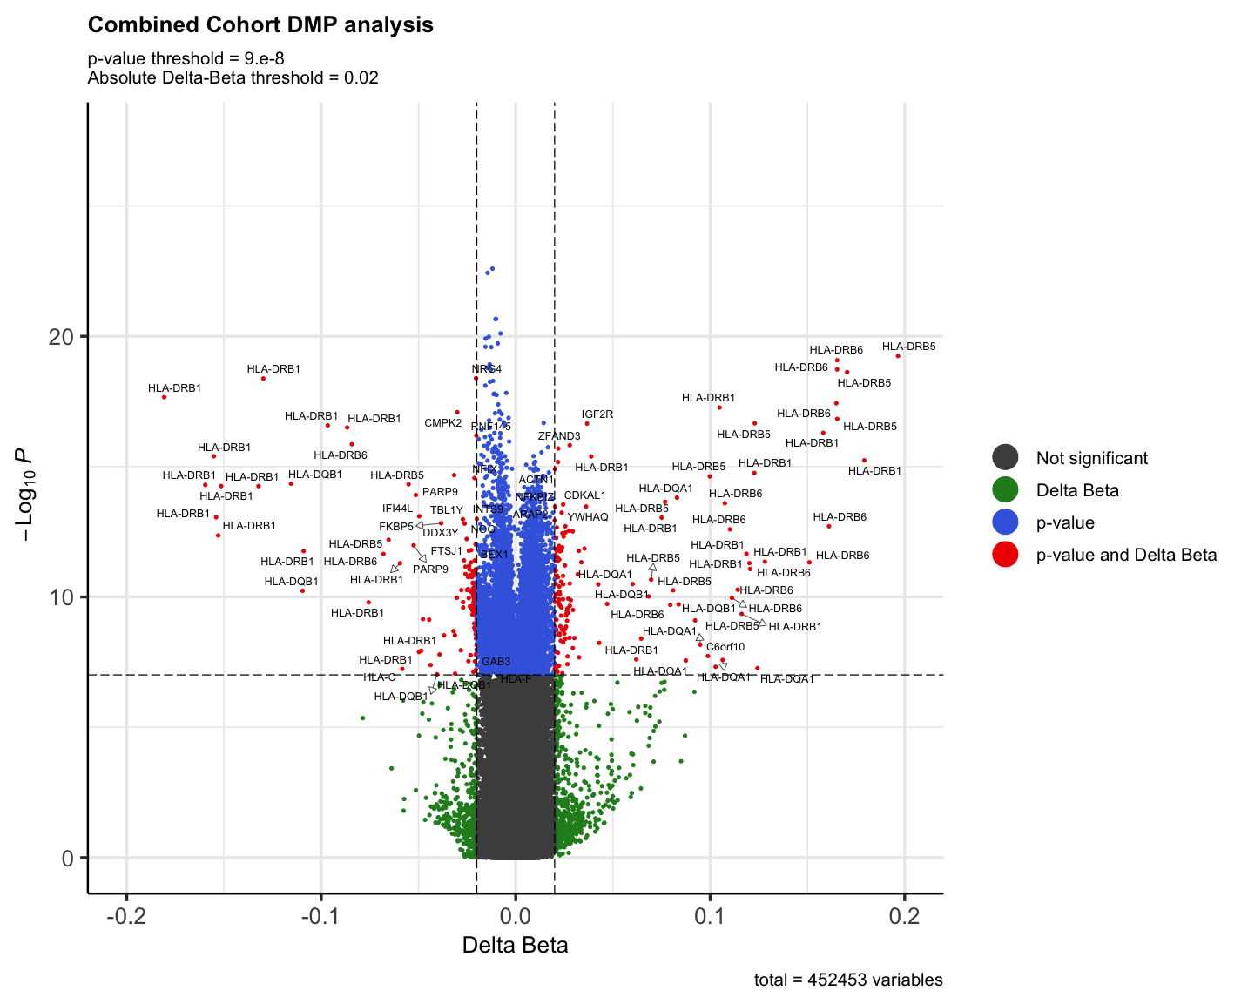

Supplemental Figure 1. Combined analysis of all three cohorts identifies DMPs associated with MS
Volcano plot representing the 452,453 CpGs analyzed in the combined cohort DMP analysis. Red dots indicate DMPs that passed both the adjusted p-value (-log10(p) ≤ 7) and delta-beta (± 0.02) thresholds. Blue dots represented DMPs which pass the p-value threshold only and green dots indicate DMPs which pass the delta-beta threshold only. The loci which each DMP maps to is indicated for genes which pass both p-value and delta beta thresholds only.
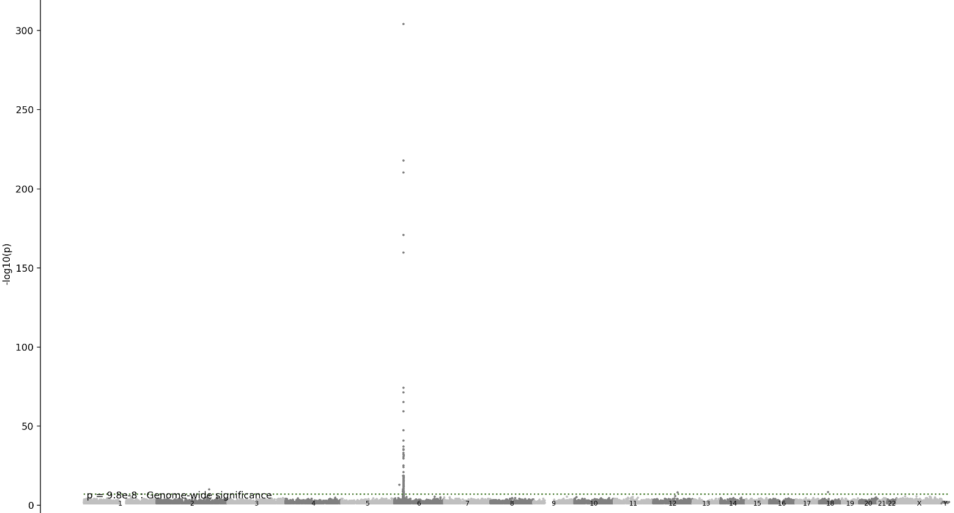Supplementary figure 2: Manhattan plot showing the magnitude of the HLA-DRB1 15:01 Haplotype on methylation. Each dot represents the –log10(p-value) of the ANOVA test between Risk Haplotype HLA-DRB1 15:01 (Presence/Absence) and CpG. Chromosomes are shown with alternating shades of grey)
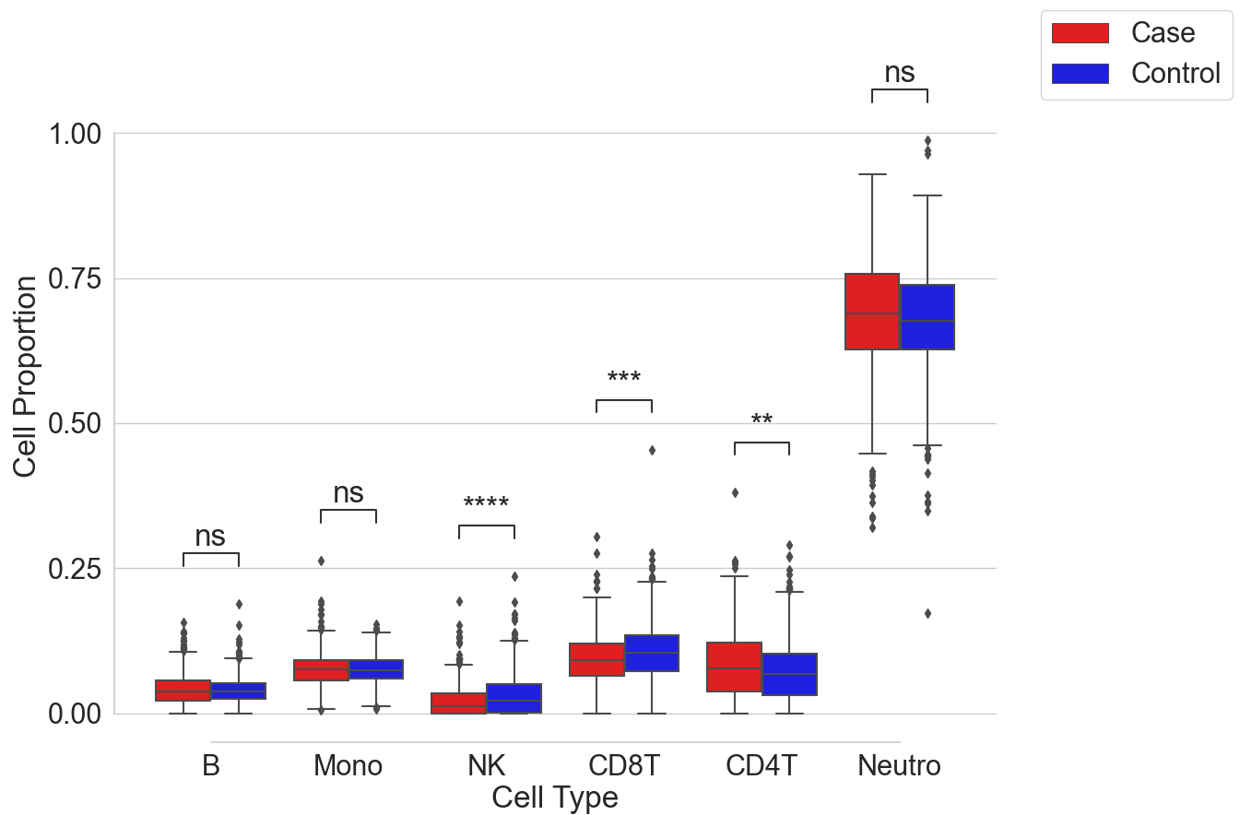

Supplemental Figure 3: Cell proportion differences between cases and controls using the combined
Tukey Box Plot showing mean and interquartile range of cases (blue) and controls (orange) in all datasets. Black diamonds indicate outliers. ** P<0.01, ***P<0.001, ****P<0.0001, ns = not significant.

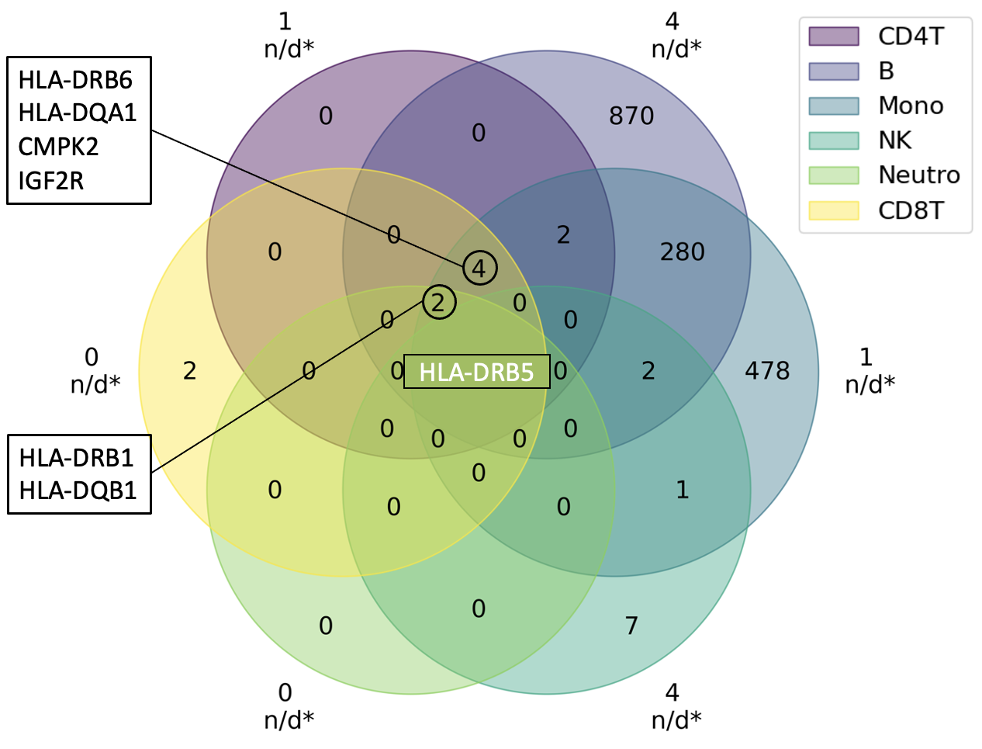Supplementary Figure 4. Overlap of DMPs among cell subtypes. Venn diagram showing overlap of csDMPs in the combined cohort, between all the cell types. *denotes elements of set intersections that are not displayed. For example, only shared between CD4+T cells and NK cells.

Supplementary Table 3: Overlapping csDMP effect size. Effect size, chromosome location (CHR) and gene name for the 28 csDMPs which overlap between all 4 major cell types. Red = hypomethylated blue = hypermethylated. Darker shade indicates larger effect size.
csDMP | B Cell | Mono | CD8⁺ T Cells | CD4⁺ T Cells | CHR | Position | gene
cg01028142 | -4.70 | -3.61 | -2.06 | -2.65 | 2 | 7004578 | CMPK2
cg10187879 | 4.61 | 2.57 | 2.14 | 2.20 | 6 | 32223208
cg17369694 | 23.92 | 18.85 | 11.44 | 12.80 | 6 | 32485396 | HLA-DRB5
cg01341801 | 26.79 | 21.29 | 12.76 | 14.76 | 6 | 32489203 | HLA-DRB5
cg26981746 | 12.24 | 9.82 | 5.46 | 6.64 | 6 | 32490012 | HLA-DRB5
cg27362989 | 16.56 | 12.99 | 7.63 | 9.32 | 6 | 32492198 | HLA-DRB5
cg19516921 | 8.63 | 6.97 | 3.90 | 5.11 | 6 | 32493994 | HLA-DRB5
cg19774683 | 18.72 | 14.64 | 8.71 | 10.18 | 6 | 32522400 | HLA-DRB6
cg25140213 | 16.27 | 12.93 | 7.61 | 8.88 | 6 | 32522683 | HLA-DRB6
cg06559318 | 17.40 | 12.78 | 7.29 | 9.57 | 6 | 32526260 | HLA-DRB6
cg10104420 | -11.81 | -8.97 | -5.31 | -5.91 | 6 | 32526414 | HLA-DRB6
cg04422742 | 20.09 | 14.78 | 8.70 | 10.26 | 6 | 32527793 | HLA-DRB6
cg26590106 | 16.53 | 12.43 | 7.58 | 9.28 | 6 | 32548321 | HLA-DRB1
cg12867728 | 4.89 | 2.69 | 2.30 | 2.62 | 6 | 32549283 | HLA-DRB1
cg20022036 | -8.67 | -5.39 | -3.94 | -4.52 | 6 | 32549496 | HLA-DRB1
cg13910785 | 20.98 | 16.20 | 10.21 | 10.69 | 6 | 32549849 | HLA-DRB1
cg11404906 | -19.94 | -14.89 | -9.26 | -10.79 | 6 | 32551749 | HLA-DRB1
cg19575208 | -10.61 | -8.05 | -4.95 | -5.70 | 6 | 32551888 | HLA-DRB1
cg08845336 | -12.48 | -9.78 | -5.94 | -6.93 | 6 | 32551891 | HLA-DRB1
cg15568074 | -22.68 | -16.42 | -9.60 | -11.01 | 6 | 32551949 | HLA-DRB1
cg16514085 | -22.42 | -17.84 | -10.42 | -11.51 | 6 | 32552152 | HLA-DRB1
cg14645244 | -15.93 | -13.15 | -7.17 | -8.67 | 6 | 32552205 | HLA-DRB1
cg10632894 | -16.62 | -13.47 | -7.92 | -9.55 | 6 | 32552453 | HLA-DRB1
cg05383619 | 11.50 | 9.67 | 5.23 | 6.40 | 6 | 32553920 | HLA-DRB1
cg17416722 | 16.44 | 13.60 | 7.80 | 9.03 | 6 | 32554385 | HLA-DRB1
cg02919082 | 8.48 | 6.21 | 3.87 | 4.22 | 6 | 32605694 | HLA-DQA1
cg05341252 | -24.25 | -17.33 | -10.70 | -11.03 | 6 | 32632715 | HLA-DQB1
cg04733681 | 4.81 | 3.41 | 2.21 | 2.53 | 6 | 160423822 | IGF2R

 | NK | B cell | Monocytes | Neutrophils | CD8T | CD4T
Total | 0 | 924 | 1327 | 4 | 475 | 48
Hypo | 0 | 517 | 816 | 1 | 361 | 23
Hyper | 0 | 407 | 511 | 3 | 114 | 25
b)
a)
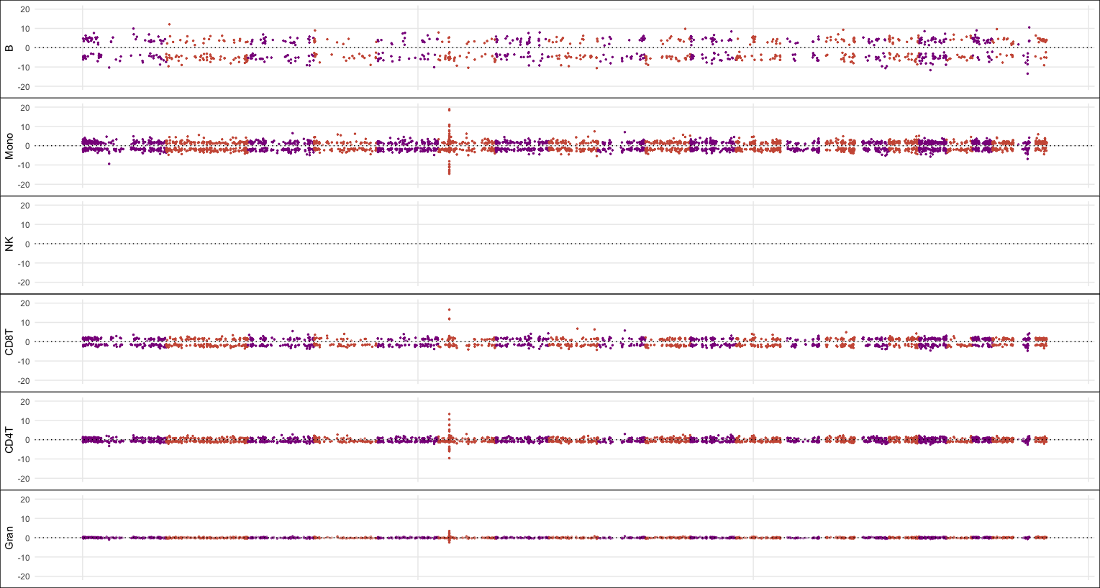
Supplementary Figure 5: Genome-wide cell-specific DNA methylation profile in discovery group only.
a) Total number of csDMPs by cell type and breakdown by hyper and hypomethylated. b) Manhattan plot representing genome-wide effect size for all csDMPs, by cell type. The Y axis represents the model estimate for effect size and X axis represents genome-coordinates, chromosomes are in chronological order and represented by alternating shades of grey.

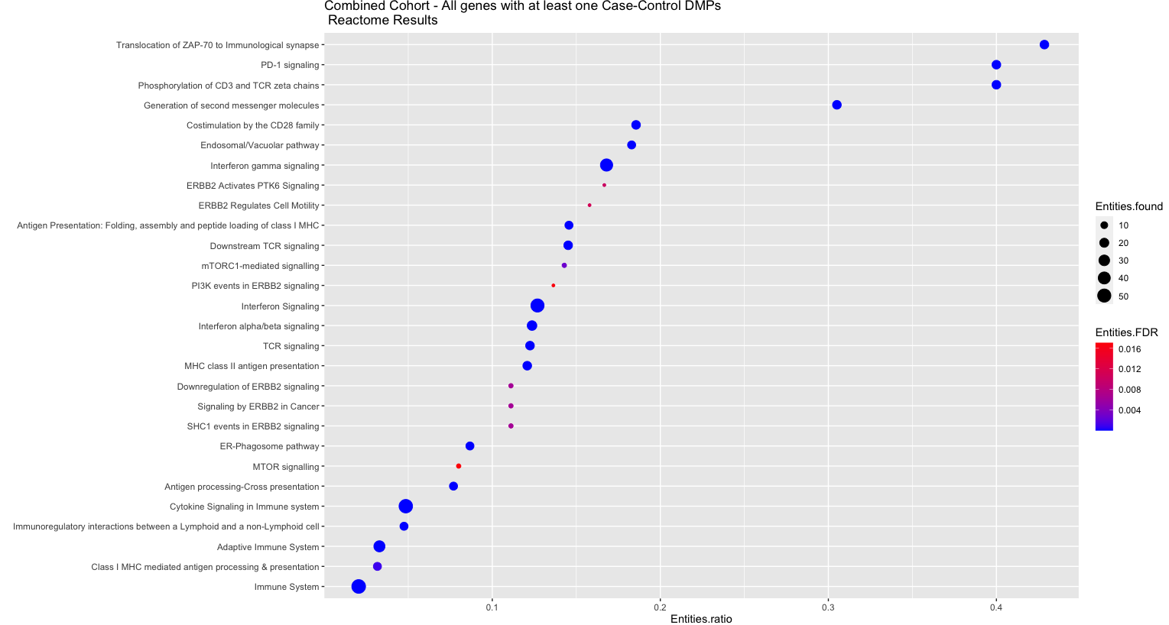

Supplementary Figure 6: Whole-Blood over-representation analysis
Using a ranked gene-list with 92 genes containing at least one DMP mapped to a gene with absolute Δβ above 2%. Y axis represents all pathways identified. X axis represents the gene ratio (number of entities in gene list vs number of entities in the pathway) for a specific pathway. Marker size represents the number of Entities. Colour represents significance.

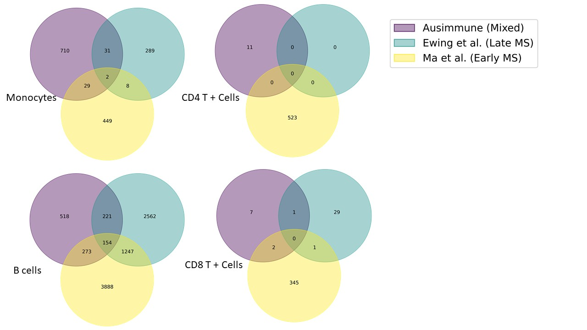
Supplementary Figure 7 overlap of Genes containing at least one csDMP identified in this study, Ewing et al. and Ma et al. Study.

