Supplementary Information: Physics Guided Heat Source for Quantitative Prediction of the Laser Track Measurements of IN718 in 2022 NIST AM Benchmark Test
Abdullah Al Amin¹, Yangfan Li¹, Ye Lu², Xiaoyu Xie¹, Zhengtao Gan³, Satyajit Mojumder⁴, Gregory J. Wagner¹, Wing Kam Liu^{1*}
¹Department of Mechanical Engineering, Northwestern University, Evanston, 60208, IL, USA
²Department of Mechanical Engineering, University of Maryland, Baltimore County
³Department of Aerospace & Mechanical Engineering, University of Texas at El Paso, El Paso, TX USA
⁴Theoritical and Applied Mechanics, Northwestern University, Evanston, 60208, IL, USA

This file includes:
- Supplementary Methods 1 to 3
- Supplementary Figures 1 to 2
Other Supplementary Files for this manuscript include the following
- Supplementary movies 1 to 9

Supplementary Method 1
Mathematical Derivation of the Scaling Law-Based Heat Source Parameterization Scheme
The proposed scaling law-based heat source parameterization is derived from the experimental finding of the keyhole study for different materials [1]. From the study, a relationship between keyhole aspect ratio and a dimensionless number ‘Keyhole Number’ is established. The keyhole number (Ke) is discovered based on non-dimensional analysis utilizing data analysis techniques. According to this heat source parameterization scheme, the cylindrical heat source is assumed to be represented by the keyhole dimensions. The dimensions of the keyhole is thought to accurately represent the dimension of the cylindrical heat source when a keyhole is stable. The relationship between the keyhole aspect ratio $e^{*}$ is defined as the ratio between the laser spot radius $r_{0}$ and the depth of the keyhole $e$.
 | $$e^{*}=\frac{e}{r_{0}}$$ | (1)
The dimensionless keyhole number (Ke) is defined as
 | $$Ke=\frac{ηP}{\left(T_{l}-T_{0}\right)πρC_{p}\sqrt{αVr_{0}^{3}}}$$ | (2)
In this equation, $C_{p}$ is the heat capacity, $T_{l}$ is the liquidus temperature, $T_{0}$ is the ambient temperature. $η$ is the laser absorption, $α$ is the thermal diffusivity, $V$ is the laser scan speed. The thermal diffusivity is defined as
 | $$α=\frac{k}{ρC_{p}}$$ | (3)
Here, $k$ is the thermal conductivity, $ρ$ is the density of the material.
The linear relationship between the keyhole number relating to he minimum absorptivity and the keyhole aspect ratio is described with
 | $$e^{*}=0.4(Ke-1.4)$$ | (4)
As the heat source depth d is assumed to have a similar depth of the keyhole, the assumption is $d=e=e^{*}r_{0}$.
The minimum absorption is estimated from a relationship that involved characteristic diffusion length $L_{d}^{*}$
 | $$L_{d}^{*}=\frac{δ_{z}}{r_{0}}=\sqrt{\frac{α}{r_{0}V_{s}}}$$ | (5)
Where $δ_{z}$ is the thermal diffusion length that is defined as $δ_{z}=\sqrt{\frac{αr_{0}}{V_{s}}}$. The relationship that is used to estimate $η$ is through ${{Ke}_{m}L}_{d}^{*}$ that is quantified from [1] as
 | $${{Ke}_{m}L}_{d}^{*}=\frac{η_{m}P}{\left(T_{l}-T_{0}\right)πρC_{p}V_{s}r_{0}^{2}}$$ | (6)
And the absorptivity is estimated from the experimental observation as
 | $$η=0.7\left[1-e^{-0.6Ke_{m}L_{d}^{*}}\right]$$ | (7)
For given process condition and a given material system it can be established that the minimum keyhole and thermal diffusion length is a function of minimum absorptivity,
 | $${{Ke}_{m}L}_{d}^{*}=f(η_{m})$$ | (8)
And subsequently, the absorptivity $η$ can also be expressed as a function of minimum absorptivity $η_{m}$
 | $$η=f(η_{m})$$ | (9)
Using equation (2) and (9), it can be established that the keyhole number is a function of minimum absorptivity
 | $$Ke=f(η_{m})$$ | (10)
At this point, rewriting (4) with minimum absorptivity being considered with the second parameter variable (p₂) and a parameterization variable can be expressed as
 | $$d=p_{1}[Ke(p_{2})-1.4]$$ | (11)
In this equation, the $p_{2}$ is a representation of minimum absorption and this equation is the first parameterization equation of the scaling law-based heat source parameterization scheme.
Now considering minimum absorptivity $η_{m}$ as a lower bound and the absorptivity estimate defined by equation (7), we get
 | $$η=\max{\{η_{m}, }0.7\left[1-e^{-0.6Ke_{m}L_{d}^{*}}\right]\}$$ | (12)
Based on the estimated minimum keyhole number and minimum absorption, the second equation of the parameterization scheme is established which is the correlation between the absorptivity and keyhole number,
 | $$η=\max{\{}0.7\left[1-e^{-{0.6Ke\left(p_{2}\right)L}_{d}^{*}}\right],p_{2}\}$$ | (13)
Next, based on the relationship between the keyhole aspect ratio and characteristic diffusion length, as discussed in [1], the third equation of the parameterization scheme which relates the spot radius of the heat source is established as
 | $$r_{b}={p_{3}L_{d}^{*}r}_{0}$$ | (14)
Now these three equations (11), (13), and (14) are the parameterization equation for the scaling law-based heat source scheme.
Supplementary Methods 2
Mathematical Derivation of the Physics Based Heat Source Parameterization Scheme
The heuristic calibration scheme is established based on literature data studying the melt pool depth and width correlating the volumetric energy density (VED_{σ}). The depth, absorptivity, and spot radius of the cylindrical heat source is given as

 | $$d=p_{1}\frac{P}{Vσ^{2}}RHF^{2}$$ | (15)

 | $$η=\max\left(p_{2}\frac{P}{Vσ^{2}}RHF^{2}, 0.28\right)$$ | (16)

 | $$r_{b}=p_{3}\frac{P}{Vσ^{2}}RHF^{2}$$ | (17)
It is understood that the penetration of the laser increases as the VED increases. In addition, the keyhole aspect ratio also increases as the keyhole number increases. Based on this observation, it is established that there is a linear relationship between the aspect ratio of the melt pool and the VED_{σ}. Therefore, the relationship is assumed linear as
 | $$AR=\frac{P}{Vσ^{2}}$$ | (18)
The aspect ratio is defined as
 | $$AR=\frac{W}{D}≈\frac{2r_{b}}{d}$$ | (19)
Now substituting the estimate of AR in equation (18) the relationship is established as
 | $$AR=\frac{P}{Vσ^{2}}$$ | (20)
And eventually as
 | $$r_{b}=\frac{P}{Vσ^{2}}d=p_{3}{\left(\frac{P}{Vσ^{2}}\right)}^{2}RHF^{2}$$ | (21)
Combining equations (15), (16), and (21) gives the physics guided heat source parameterization scheme.
Supplementary Methods 3
Methods to determine the reduced simulation domain for accelerated analysis of melt pool prediction
The evolution of the melt pool length is studied based on the simulation. The estimated time above melting and melt pool length is plotted for all the cases with respect to time. From the plot, it is observed that the highest VED_{σ} case needs ~3 ms to reach to a steady state. All the other VED_{σ} cases reach steady state beyond 2 ms. Thus a much smaller computational domain than 10 mm longer test track is considered for the simulation, that has reduced the computational effort to simulate and study the experiment in details.
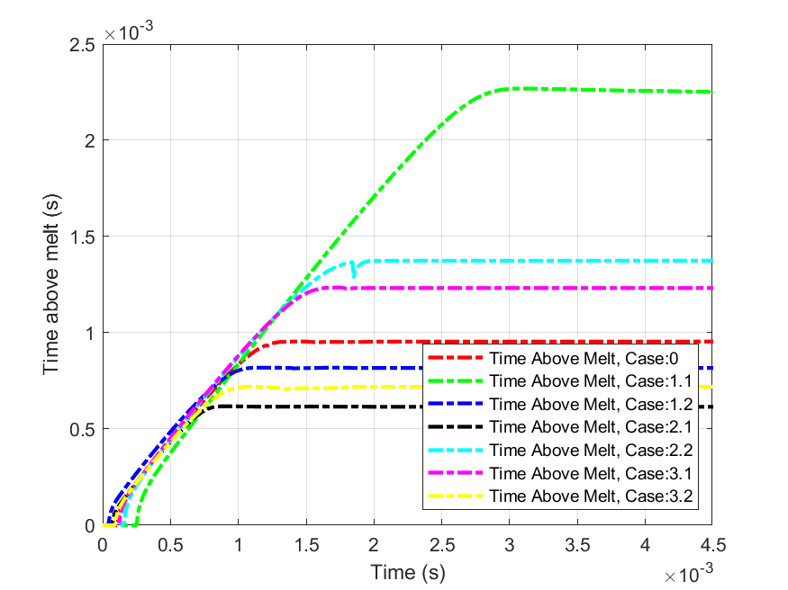
Supplementary Figure 1. Time above melting time in seconds for different process conditions.

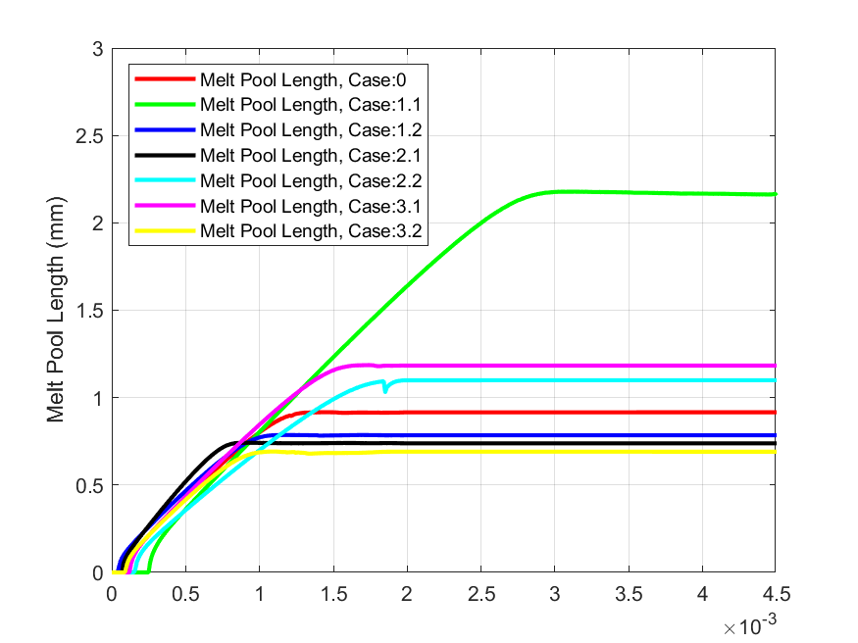
Supplementary Figure 2. Melt pool length in mm for different process conditions.

References
[1] Z. Gan, O.L. Kafka, N. Parab, C. Zhao, L. Fang, O. Heinonen, T. Sun, W.K. Liu, Universal scaling laws of keyhole stability and porosity in 3D printing of metals, Nature Communications. 12 (2021) 1–8.

