ADDITIONAL FILE 2

S2 SUPPLEMENTARY RESULTS

ALPHA AND BETA DIVERSITY FOR 16S rRNA GENE DATA
Prokaryotic community composition was determined by host species. Alpha diversity did not yield significant differences within species between B vs NB pairs, or across time points (Tables S4). Graphically, Mcap reflected the most variable diversity; Mcap_B and Mcap_NB pairs exhibited similar Shannon indexes in the bleaching events (M0 and M12), with N corals having slightly higher values. In M1 and M3 B colonies displayed higher diversities; whereas in M6 N reported the highest indexes. Pcom showed disparity between B and NB corals only in M1 (Fig. S1).
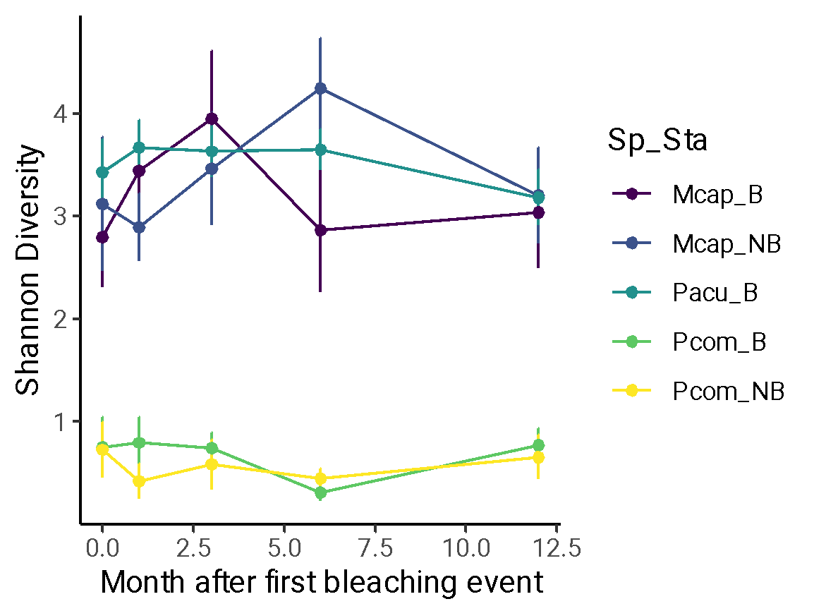
Fig. S1. Alpha diversity (Shannon index) of coral associated prokaryotic communities over the five sampling time points coloured by species and bleaching susceptibility. Mcap: M.capitata; Pcom: P. compressa; Pacu: P. acuta; Y: Bleaching susceptible; N: Bleaching resistant. *Significance p < 0.05 was found between Pcom B–NB vs Mcap B–NB and Pacu B.
Significance in beta diversity was found in the interaction Species:TimePoint with Bray Curtis, for TimePoint on Jaccard, and for TimePoint:Bleaching using DEICODE distance matrices. Mcap B and NB corals recorded different beta diversity values across time points based on Jaccard (Tables S5).
The only change in beta diversity across time points was detected in Mcap_N corals from M12 vs M0 according to DEICODE, and also with respect to M1, M3 and M6 for Jaccard (Tables S6). No significant difference was found within species at each time point by bleaching susceptibility (Tables S7; Fig. S3.2- S3.4).

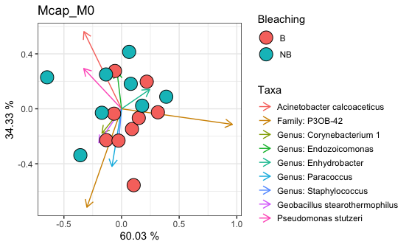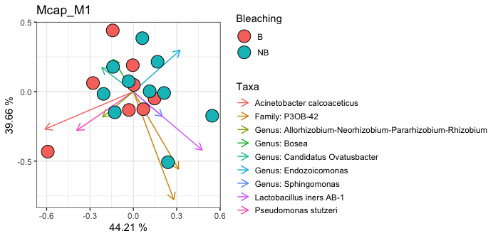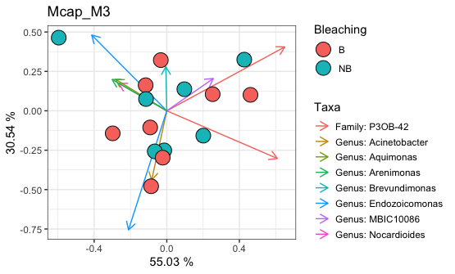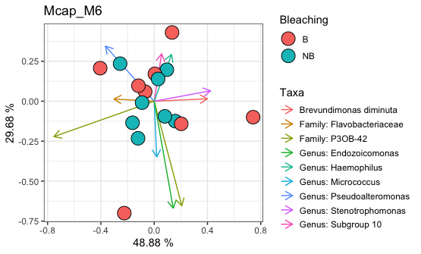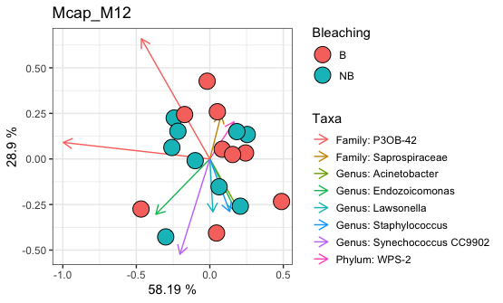

Fig. S2.1. RPCA compositional biplots based on Aitchison distances (DEICODE) of the total 16S rRNA gene bacterial sequences from coral fragments belonging to Montipora capitata (Mcap) corals at four time points –0 (M0), 1 (M1), 3 (M3) and 6 (M6) months after the bleaching event. Samples (circles) were distinguished by colour according to Bleaching susceptibility. Mcap showed no differences in bacterial communities in B vs NB colonies across time M0–M12 (PERMANOVA, p > 0.05). The most relevant ASVs driving differences in the ordination space are illustrated by the vectors in each plot.
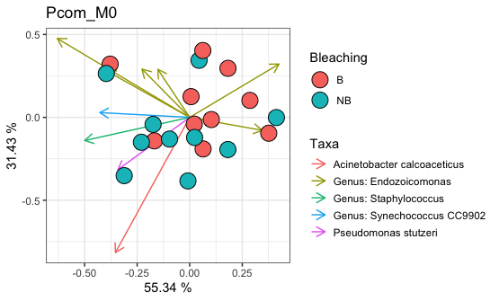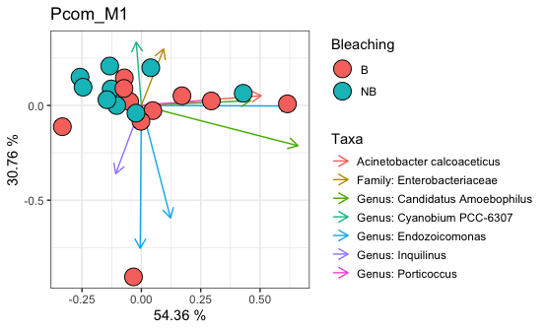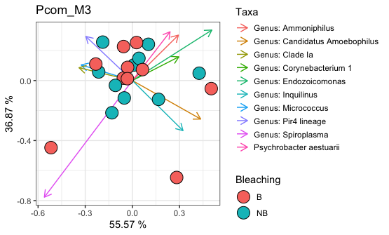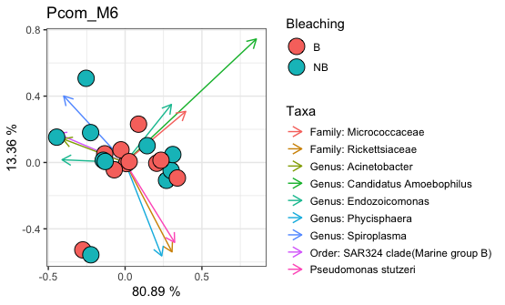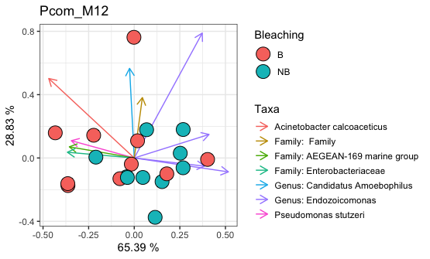

Fig. S2.2. RPCA RPCA compositional biplots based on Aitchison distances (DEICODE) of the total 16S bacterial sequences from coral fragments belonging to Porites compressa (Pcom) corals at four time points –0 (M0), 1 (M1), 3 (M3) and 6 (M6) months after the bleaching event. Samples (circles) were distinguished by colour according to Bleaching susceptibility. Pcom revealed no differences in B vs NB colonies across time M0–M12 (PERMANOVA, p > 0.05). The most relevant ASVs driving differences in the ordination space are illustrated by the vectors in each plot.

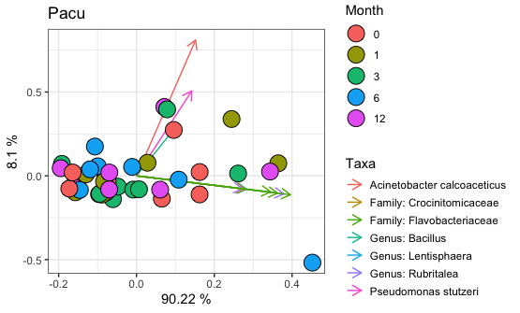

Fig. S2.3. RPCA compositional biplot based on Aitchison distances (DEICODE) of the total 16S bacterial sequences from coral fragments belonging to Pocillopora acuta (Pacu) corals at four time points –0 (M0), 1 (M1), 3 (M3) and 6 (M6) months after the bleaching event. Pacu revealed no differences across time M0–M12 (PERMANOVA, p > 0.05). The most relevant ASVs driving differences in the ordination space are illustrated by the vectors in each plot.
TAXA BAR PLOTS AT ASV LEVEL WITH BEST ANNOTATED TAXONOMY
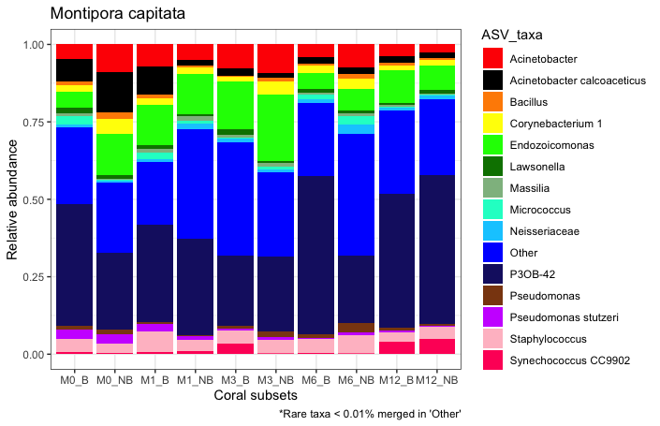
Fig. S3.1. Prokaryotic composition at the ASV level (> 0.01 % detection) in the coral colonies of Montipora capitata. Bars are collapsed by month after bleaching event and bleaching susceptibility phenotypes. Species: Mcap:, Pcom:s Porites compressa, Pacu: Pocillopora acuta. Bleaching susceptibility: B: susceptible colonies; NB: resistant colonies. Month after bleaching event: M0: Oct 2014; M1: Nov 2014; M3: Jan 2015, M6: May 2015, M12: Aug 2015 (Table S1).
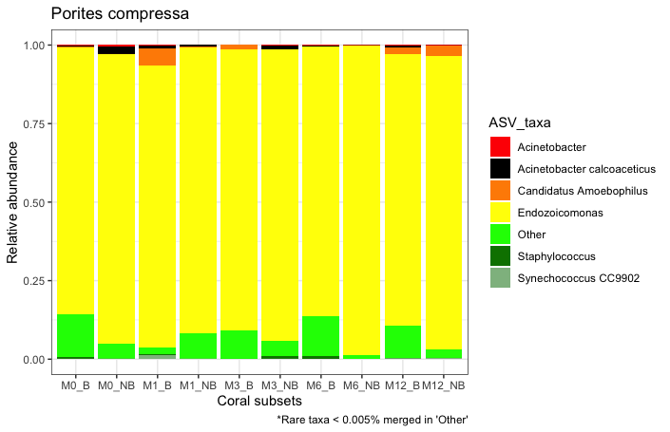
Fig. S3.2. Prokaryotic composition at the ASV level (> 0.005 % detection) in the coral colonies of Porites compressa. Bars are collapsed by month after bleaching event and bleaching susceptibility phenotypes. Bleaching susceptibility: B: susceptible colonies; NB: resistant colonies. Month after bleaching event: M0: Oct 2014; M1: Nov 2014; M3: Jan 2015, M6: May 2015, M12: Aug 2015 (Table S1).

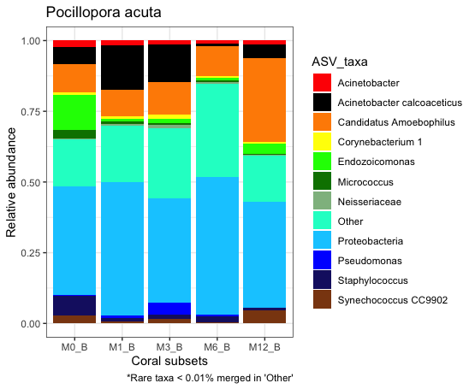
Fig. S3.3. Prokaryotic composition at the ASV level (> 0.01 % detection) in the coral colonies of Pocillopora acuta. Bars are collapsed by month after bleaching event and bleaching susceptibility phenotypes. Bleaching susceptibility: B: susceptible colonies; NB: resistant colonies. Month after bleaching event: M0: Oct 2014; M1: Nov 2014; M3: Jan 2015, M6: May 2015, M12: Aug 2015 (Table S1).

LONGITUDINAL APPROACHES

Longitudinal analysis pipeline
In order to track changes in certain microbiome metrics over time, we applied tools within the q2-longitudinal plugin (https://github.com/qiime2/q2-longitudinal) for paired and longitudinal analyses (Bokulich et al. 2018b). Pairwise differences in alpha diversity values and log-ratios of differential taxa consortia selected on Songbird (pairwise difference tests with Wilcoxon signed rank, pairwise group comparison tests with Mann Whitney U tests; FDR p-value < 0.05), as well pairwise distances (Bray Curtis, Jaccard and DEICODE) were calculated for all time points with respect to M0 (multiple Kruskal Wallis test p-value < 0.05). Linear-mixed-effects (LME; significance set P > |z| < 0.05) modeling was used to test the relationship between a single response variable (the microbiome metrics mentioned above) and one or more independent variables (e.g., Species, Bleaching) across time points –Months from initial bleaching. To assess the significance of the relationships, P values are computed based on each variable’s Z-score estimate with respect to the standard normal distribution (two-tailed, alpha = 0.05). The temporal behavior of each response variable was visualized on volatility plots. The same metrics were used to investigate how the rate of change differs over time between successive time points with “first differences/distances” tests, and from a static point, setting as baseline M0 – Month 0 (the initial bleaching event – Oct 2014). LME and volatility plots were then applied on the calculated difference/distance values. Differential Bacteria features identified by Songbird and selected by Qurro across species and beaching susceptibility were extracted into a new subset table. Frequency counts were transformed to centered log ratios (defined by clr (p^{i}_{j}) = log (p^{i}_{j} / gm (p^{i})) –where gm() indicates the geometric mean Gloor and Reid 2016. CLR were then plotted in trajectory graphs on R using microbiome (Lahti et al. 2017) and ggploM3 packages (Fig. 2). CLR of differential Endozoicomonas microbes (ASVs) associated to P. compressa were additionally plotted in trajectory graphs (Fig. S5).

References:
Bokulich NA, Dillon MR, Zhang Y, Rideout R, Bolyen E, Li H, et al. q2-longitudinal : Longitudinal and Paired-Sample Analyses of Microbiome Data. mSystems. 2018b;3:1–9.
Gloor GB, Reid G. Compositional analysis: a valid approach to analyze microbiome high-throughput sequencing data. Can J Microbiol. 2016 62(8):692-703.
Hume BCC, Smith EG, Ziegler M et al. SymPortal: A novel analytical framework and platform for coral algal symbiont next-generation sequencing ITS2 profiling. Mol. Ecol. Resour. 2019;9:1063–80. https://doi.org/10.1111/1755-0998.13004.
Lahti L, Shetty S. et al. Tools for microbiome analysis in R. 2017. https://github.com/microbiome/microbiome/
Longitudinal analyses for the 16S rRNA gene data

In the longitudinal pipeline, there were no significant differences found in bacterial beta diversity tracked across nor between timepoints in B vs NB corals; either testing pairwise-distances between any time point respect to M0 (Multiple Kruskal Wallis test, p > 0.05); or with linear mixed models (LME; P<[z] > 0.05) tracking changes across consecutive time points, or from any time point to a static baseline set on M0.
Applying linear model effects and volatility plots it was detected that in Mcap log-ratio ranks of differential taxa were significantly influenced by Bleaching (susceptibility: B vs NB; P>[z] = 0.053) and by TimePoint (P>[z] = 0.000), but not by the interaction TimePoint:Bleaching (P>[z] = 0.106). For Pcom Bleaching had a significant effect on log-ratios (P>[z] = 0.037), but no significance was reported for TimePoint (P>[z] = 0.343) nor for the interaction TimePoint:Bleaching (P>[z] > 0.05).
Log-ratios of microbial balances formed by differential taxa tracked from one timepoint to the consecutive (with first-differences method), and from any point to a static baseline set on M0, revealed shifts over time by species and bleaching susceptibility (LME; P<[z] < 0.05). Mcap_NB colonies experimented a significant decrease in log-ratio from Month 0 to 1, and this swift was maintained throughout Month 12. Initial increases in log-ratios from Month 0 to 1 were detected in Pacu_B and more mildly in Pcom_B, to then decrease in Month 6, and over Months 6 and 12 the ranks were sustained between the initial Month 0 and 1 values. In Mcap_B there was a log-ratio increase over Months 1 and 3, to then decrease in Month 6, and conclude with an increase towards Month 12, returning to similar values as those in Month 0. Pcom-NB maintained practically unchanged log-ratio ranks across all time points (see bellow).

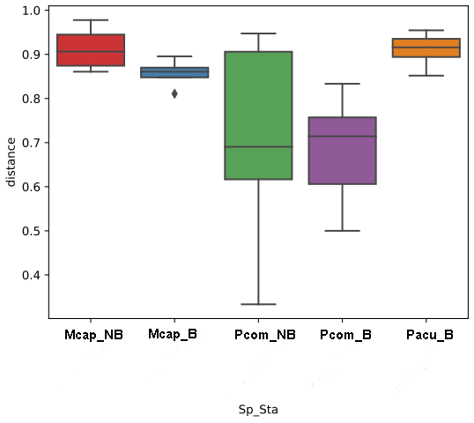
Fig S4.1. Box plot of pairwise distances using Jaccard beta diversity of 16S data index on coral colonies from time point M6 respect M0 (Multiple Kruskal Wallis test, p = 0.009864; significant pairwise comparisons were found between Pcom_B against Pacu_B, Mcap-N and Mcap_B, FDR P-value < 0.05). All other pairwise distance comparisons were not significant for M1, M3, M12 against M0. Mcap: M capitata; Pcom: P. compressa; Pacu: P. acuta. B: beaching susceptible; NB: bleaching resistant.

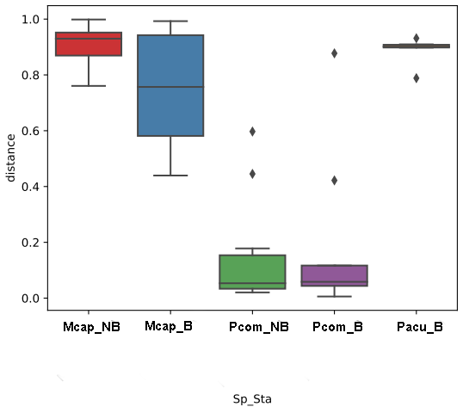
Fig S4.2. Box plot of pairwise distances using Bray Curtis beta diversity index of 16S data on coral colonies from any time point respect M0. Results here are from the distance between M12 – M0 (Multiple Kruskal Wallis test, P = 0.0001; and significance in pairwise comparisons are found between Pcom_B and Pcom_NB against Mcap_B, Mcap_NB and Pacu_B, FDR P-value < 0.05). All other comparisons yielded similar results for M1, M3, M6 against M0. Mcap: M capitata; Pcom: P. compressa; Pacu: P acuta. B: beaching susceptible; NB: bleaching resistant.

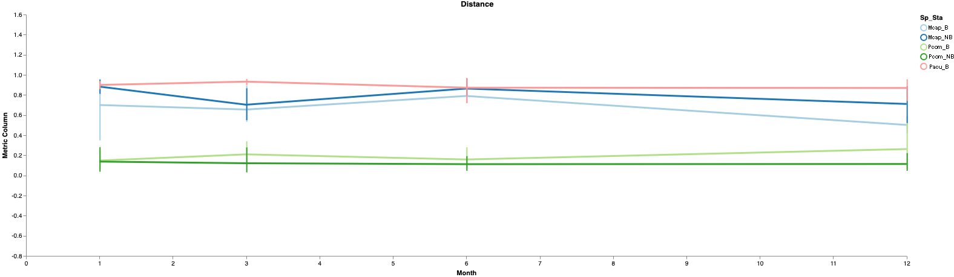
Fig S4.3. Volatility plot tracking changes on beta diversity based on Bray Curtis distances of 16S data on coral colonies from one timepoint to the consecutive. Metric on the Y axis was calculated with “First-distances” method. Mcap: M capitata; Pcom: P. compressa; Pacu: P acuta. B: beaching susceptible; NB: bleaching resistant.

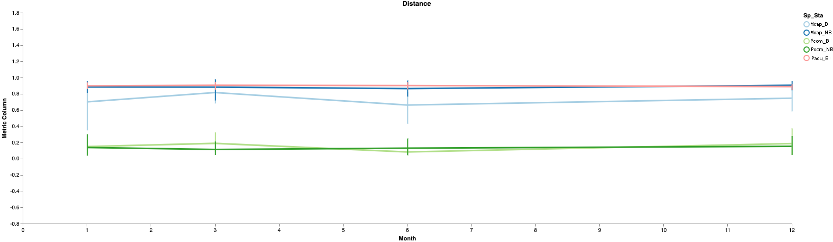
Fig S4.4. Volatility plot tracking changes on beta diversity based on Bray Curtis distances of 16S data on coral colonies from any time point respect to M0. Metric on the Y axis was calculated with “First-distances” method setting as static baseline point M0. Mcap: M capitata; Pcom: P. compressa; Pacu: P acuta. B: beaching susceptible; NB: bleaching resistant.

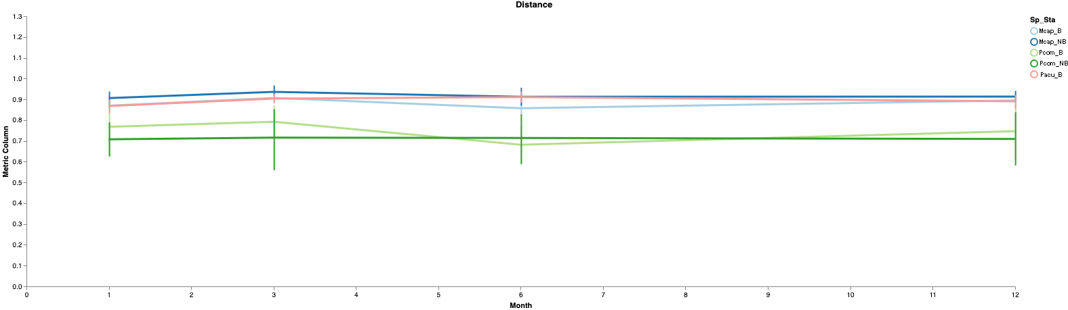
Fig S4.5. Volatility plot tracking the amount of features of 16S data shared in coral colonies from any time point respect to M0. Metric on the Y axis was calculated with “First-distances” method on Jaccard beta, setting as static baseline point M0. Mcap: M capitata; Pcom: P. compressa; Pacu: P acuta. B: beaching susceptible; NB: bleaching resistant.

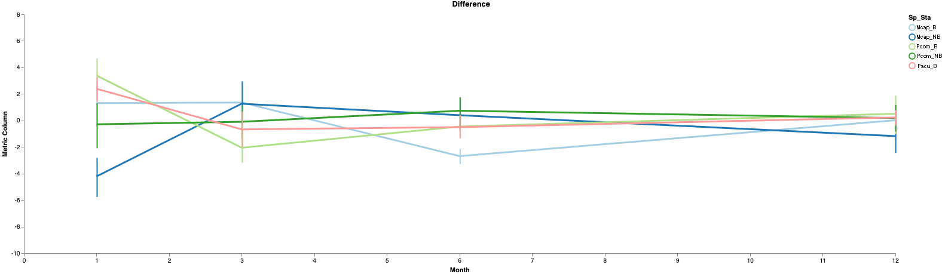
Fig S4.6. Volatility plot tracking changes in log-ratio rakings of microbial balances formed by differential taxa in coral colonies from one timepoint to the consecutive. Metric on the Y axis was calculated with “First-differences” method. Mcap: M capitata; Pcom: P. compressa; Pacu: P acuta. B: beaching susceptible; NB: bleaching resistant.

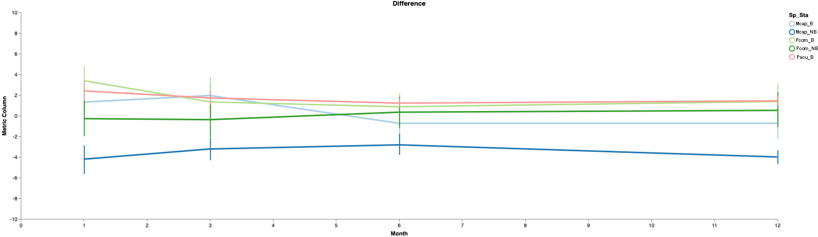
Fig S4.7. Volatility plot tracking changes in log-ratio rakings of microbial balances formed by differential taxa in coral colonies from any time point respect to Month 0. Metric on the Y axis was calculated with “First- differences” method setting as static baseline point Month 0. Mcap: M capitata; Pcom: P. compressa; Pacu: P acuta. B: beaching susceptible; NB: bleaching resistant.

Longitudinal analyses for the ITS2 data

Longitudinal approaches demonstrated no swifts in ITS2 underlying sequence composition in P. acuta (Pacu_B) corals. While tracking changes in DEICODE and Bray Curtis based diversities from any time point to a static baseline set at Month 0, differences in Mcap corals were pinpointed by Month and the interaction Month:Bleaching. No significance was instead found for Pcom according to LME (P<[z] < 0.05).

Within species, Mcap_NB had higher number of DIVs than Mcap_B colonies in all months except for Month 6 –upon bleaching recovery. Instead, Pcom recorded no evident differences between NB and Y, except in Month 6 when Pcom_B corals revealed more DIVs (opposite from Mcap). Pacu displayed no differences across time (Kruskal Wallis tests, P-value < 0.05).

Log-ratios on feature rankings of balances formed by differentially abundant ITS2 sequences tracked longitudinally no significant shifts by Bleaching susceptibility nor over time in any coral species (LME; P<[z] < 0.05; Tables S13). In Pcom, though, log-ratios between Months 0 – 3 and 0 – 6 were significantly different in B corals, and pairwise differences were in consequence larger with respect to NB colonies.

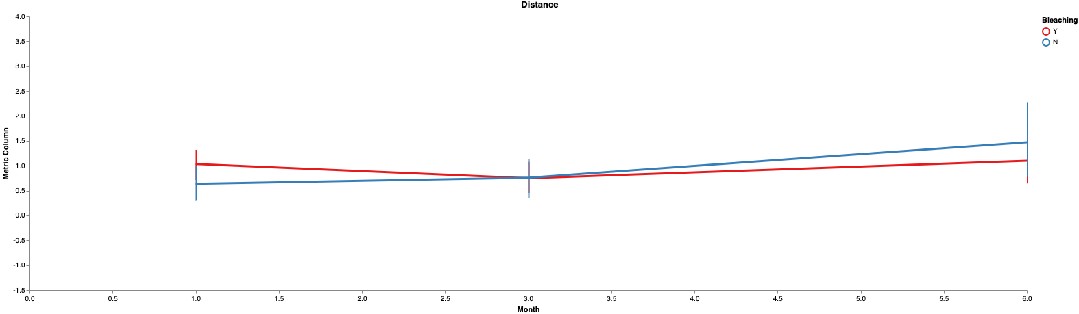
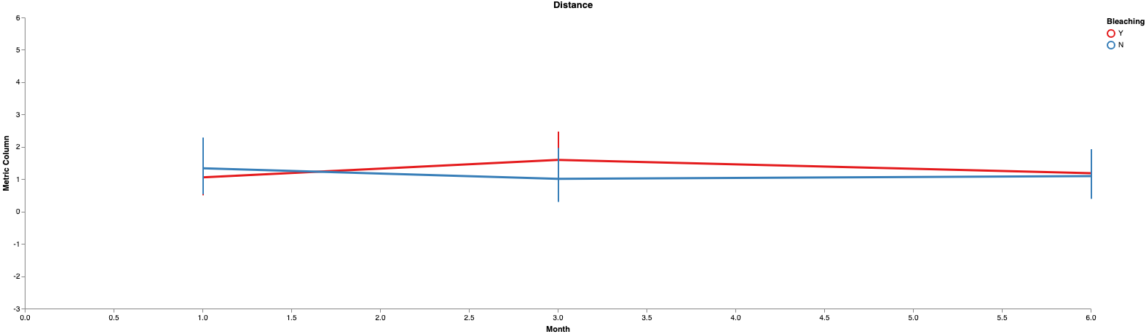
Fig. S4.8. Volatility plots of first distances with DEICODE of ITS2 sequences from any time point to a static baseline set at Month 0 in A) Montipora capitata and B) Porites compressa by Bleaching susceptibility –Y vs NB corals (Bleaching: Y vs N). Only Mcap revealed significant shifts by Bleaching and Month:Bleaching (LME P<[z] < 0.05).

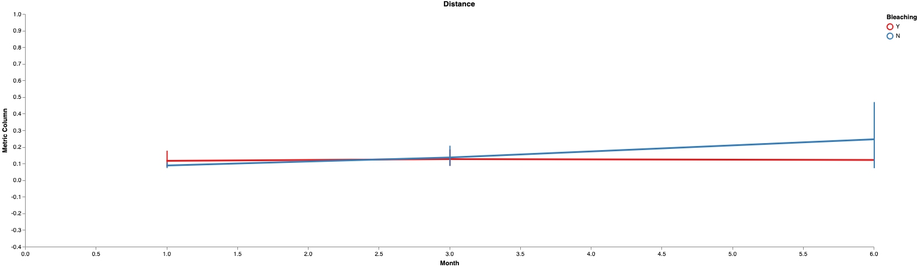
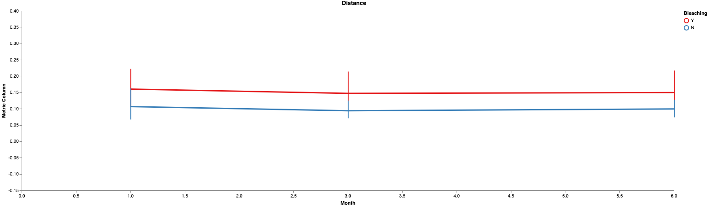
Fig. S4.9. Volatility plots of first distances from any time point to a static baseline set at Month 0 of Bray Curtis metric of ITS2 sequences in A) Montipora capitata and B) Porites compressa by Bleaching susceptibility –B vs NB corals (Bleaching: Y vs N). Only Mcap revealed significant shifts by Bleaching and Month:Bleaching (LME P<[z] < 0.05).

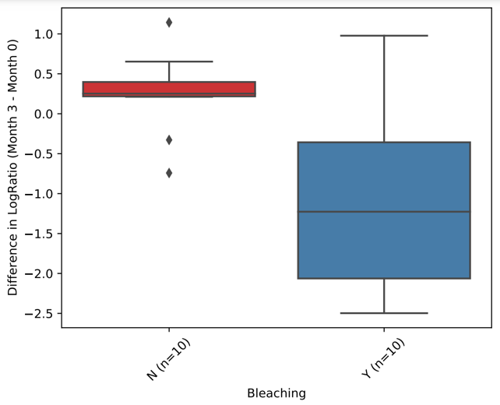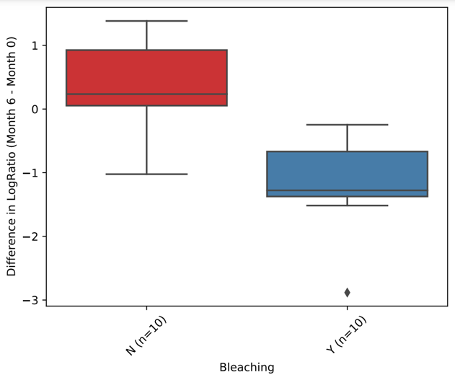
Fig. 4.10. Pairwise differences on LogRatios of balances formed by differential ITS2 sequences in Porites compressa showed larger changes in Bleaching susceptible B colonies with respect to resistant NB corals (Bleaching: Y vs N) between Months 0 and 3, and 0 and 6 (Kruskal Wallis, P < 0.05).

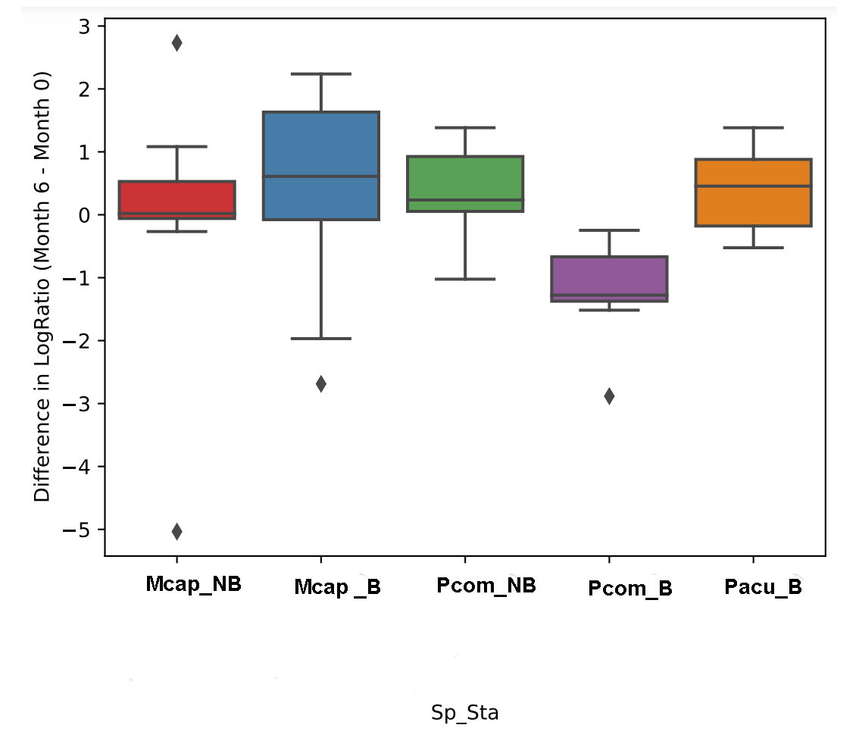
Fig. S4.11. Pairwise differences on LogRatios of balances formed by differentially abundant ITS2 sequences between Month 0 and 6. The boxplot shows that corals from the three species and bleaching status do not show differences from month 0 to 6 (difference close to 0), except for Pcom_B (with negative values). The overall Kruskal Wallis test yielded significance p = 0.005679, and in pairwise comparisons, Pcom_B showed larger shifts between both time points with respect to changes experienced in groups Mcap_NB (P = 0.020777), Pcom_NB (p = 0.006575) and Pacu (p = 0.006575) (this is all except for Mcap_B). Mcap: M capitata; Pcom: P. compressa; Pacu: P acuta. B: beaching susceptible; NB: bleaching resistant.

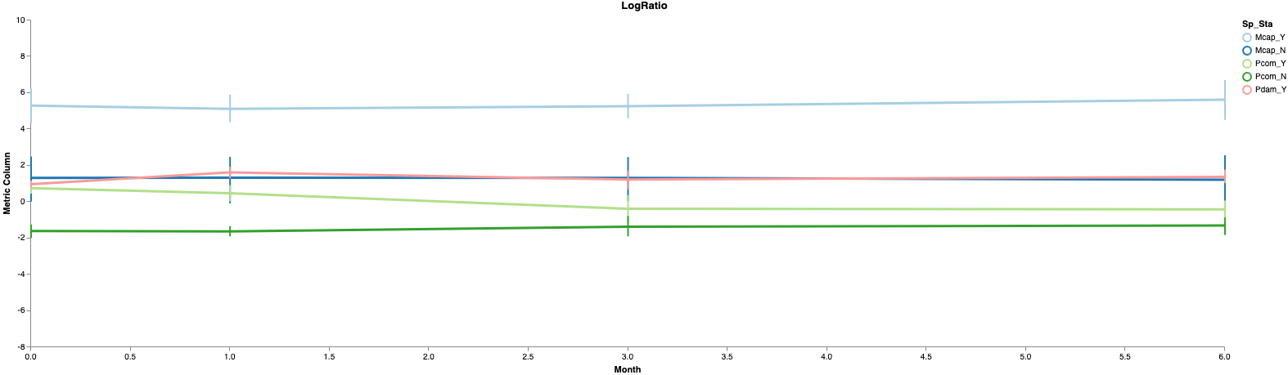
Fig. 4.12 Volatility plot of log-ratios ranks of balances formed by differential ITS2 sequences from corals across time points M0–M6. Log-ratios tracked longitudinally with linear mixed models revealed no significant shifts in any of the coral species by Bleaching susceptibility nor Month (LME; P<[z] < 0.05). Mcap: M capitata; Pcom: P. compressa; Pacu: P acuta. B: beaching susceptible; NB: bleaching resistant.

LONGITUDINAL TRAJECTORIES OF DIFFERENTIAL BACTERIAL TAXA

The longitudinal behaviour (across time points) of differential bacterial genera for the three coral species and bleaching susceptibility phenotypes were inspected in trajectory plots using centered log ratio (CLR) abundances. The investigated genera included: Endozoicomonas, Acinetobacter, Bacillus, Candidatus Amoebophilus, Cyanobium, Lawsonella, Micrococcus, Pseudomonas, Staphylococcus, Synechococcus and Roseitalea. Other features among the differential consortia appertaining to family Neisseriaceae and order Myxococcales could not be assigned to the genus level, and hence were not included in this analysis.

Endozoicomonas and Acinetobacter (leaded by A. calcoaceticus) were predominant differential genera in M. capitata corals, with higher overall values in NB colonies. Acinetobacter reported higher records in M0, but then both taxa converged in M1 and followed an akin pattern towards M12. A slight divergence was found in M6 for NB corals, with lowered Endozoicomonas ratios. Comparable CLR were found in Staphylococcus with an almost linear behaviour in B, and two mild peaks of abundance in M1 and M6 in NB. Pseudomonas had higher ratios in NB, and reported a general decrease from M0 to M3 in both phenotypes. B colonies displayed enhanced values of Micrococcus through M1, these dropped in M3 to equal those of NB, to then follow a parallel growth at M6 and a decline at M12. Lawsonella experienced two peaks of abundance in M0 and M3 in B corals, versus a moderate decrease, followed by a soft increase from M3 in N. Mcap_B displayed a net scaled increase of Synechococcus, while in Mcap_N this genus reported fluctuant CLR peaking from M0 to M1, dropping at M3 and M6, to then increase towards M12. Cyanobium in the B phenotype revealed null presence in M0, it peaked in M1 and M3, faded in M3, and increased again from M6 to M12. Instead, NB had void records of this genus until a moderate escalation from M6 to M12. Candidatus Amoebophilus remained low across time for both B and NB (Fig. S4.1).

Porites compressa was characterized by an indisputable predominance of Endozoicomonas, displaying CLR 4 to 5-fold over the rest of differential genera. Ratios were higher in B corals and majorly linear, saving a small depression in NB at M1. On M1 there was a conspicuous peak of Candidatus Amoebophilus in Pcom_B in contraposition with a very mild increase in NB, then values faded in M6 and grew moderately over M12 in B, and decreased in M3 to recover over M12 in NB. Instead, Staphylococcus exhibited a preeminent peak at M3 in N corals, preceded by a drop from M0 to M1, and depletion over M12. In Y this genus and Lawsonella were almost linear (Staphylococcus displaying higher CLR), saving a mild depression detected in M3. Lawsonella in NB diminished from M0 to M6, and then recovered slowly. Acinetobacter (dominated by A. calcoaceticus) decreased from M0 to M3, and then recovered on M6 in NB, and on M12 in B. A moderate increase in Synechococcus was observed in B from M0 to M1, then a decline in M6 and a final recovery; in lieu, NB reported a scaled loss till M6, and an increase in M12. In Pcom_B Pseudomonas and Bacillus decreased over M1 and M3, and recovered over M12; whereas in Pcom_NB Pseudomonas decreased abruptly in M1, and then fluctuated augmenting, decreasing and augmenting over M12, while Bacillus declined until M6, and then increased moderately in M12. Initial declines in Micrococcus were followed by a peak at M6 in B, and by a mild recovery from M6 in NB. Roseitalea peaked in M1 in N and in M3 in Y. In Pcom_B Cyanobium had low initial values, increasing mildly in M1, to then fade through M6, and grow over M12.

In P. acuta corals Acinetobacter (leaded by A. calcoaceticus) and Candidatus Amoebophilus were predominant taxa. The first increased from M0 to M1 and decreased mildly over M6. Instead, the second experienced an initial decrease, followed by a mild recover in M3, to then decrease softly in M6 and increase again towards M12. Staphylococcus started with similar CLR, but had a more linear behaviour. Pseudomonas increased in M1 and then declined from M3. In this coral host Endozoicomonas was not dominant, CLR dropped from M0 to M1, mildly augmented in M3, diminished in M6 and grew again moderately at M12. In M1 Cyanobium registered a notable peak, to then deplete to original levels in M3, and increase again from M6 to M12. Increased CLR were recorded in Synechococcus at M0 and M12, with lower values at M1 and M6, and a mild peak at M3. Lawsonella had a mild increase in M1, and then a scaled decrease. Bacillus maintained trajectories that tended to increase from M0 to M3 and then slowly decrease towards M12. Micrococcus was for the most part stable across time points (Fig. 2).

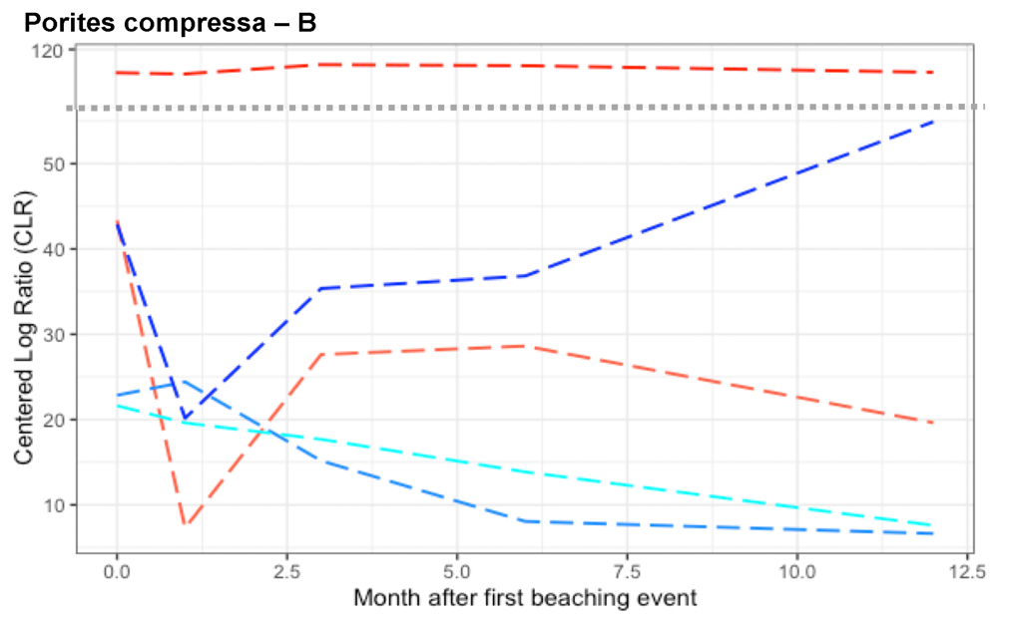
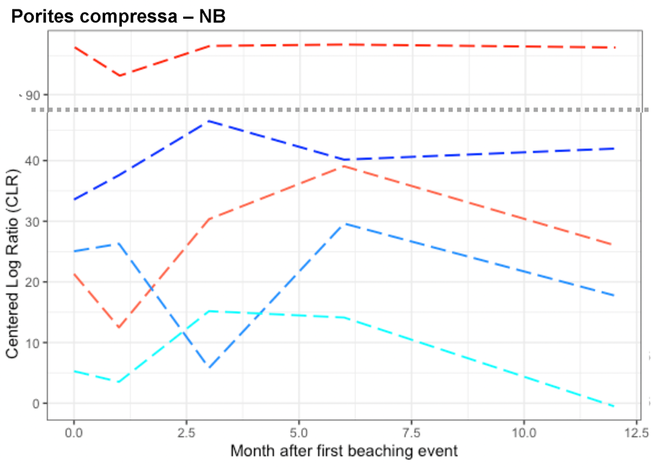
In P. compressa five defining Endozoicomonas taxa were found acting in antagonistic manner in correlation with Bleaching by TimePoint co-variates. Two of the features were positively ranked and took part of the numerator taxa in the Songbird analysis, whereas the other three were negatively ranked and took part of the denominator group. One of the numerator Endozoicomonas was remarkably predominant and linear in behaviour over time. The other differential features reported more fluctuating patterns. In particular, one of the main antagonistic denominator taxa showed peak CLR values in M12 for Pcom_B and in M3 for Pcom_NB (Fig. S5).

FUNGAL COMMUNITY INSPECTION

Fungi composition across coral species and host co-amplification based on ITS1 data
Untargeted host co-amplification was a major constraint when characterizing fungal communities, in spite the new designed reverse primer intended to bypass metazoan DNA. We found 94.8 % of coral co-amplification, retrieving only 5.2 % of fungal sequences. The rate of co-amplification varied among species, with P. compressa displaying the largest untargeted co-amplification (98.4 %), followed by M. capitata (95.6 %), and P. acuta (56 %). No further statistical analyses could be performed due to insufficient coverage of diversity. The most represented fungal species retrieved belonged to Malassezia restricta, M. globosa, Hortaea_werneckii, Aspergillus penicillioides, Phellinus gilvus.
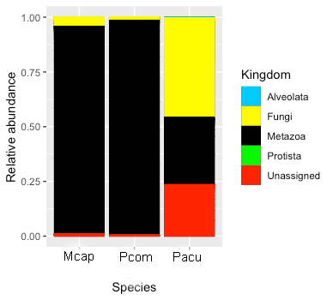
Fig. S6. Taxa bar plots for the ITS1 data showing the relative abundance of ASVs taxonomically annotated to the Kingdom level from all three coral species: Montipora capitata (Mcap), Porites compressa (Pcom) and Pocillopora acuta (Pacu). *Metazoa reads in black recovered mostly co-amplified sequences from the corresponding coral host – > 30 % untargeted co-amplification in Pdam and > 95 % in Mcap and Pcom.

CROSS CO-OCCURRENCE NETWORKS ANALYSIS

Cross co-occurrence networks between 16S rRNA gene bacterial features and Symbiodiniaceae ITS2 profiles
Co-occurrence cross networks provide information on potential interaction patterns of diverse microbes such as co-occurrence and co-exclusion. This may allow to detect changes in the structure of the corals microbiomes across time and by bleaching susceptibility. Mcap_B displayed a simple network (24 nodes, 25 edges) in M0 formed by two C31 Cladocopium ITS2 type profiles and several bacteria microbes mostly interacting in co-occurrence (9 negative/16 positive interactions). The network became more complex (37 nodes, 47 edges), starting in M1 with the inclusion of more bacteria with negative and few positive interactions (28 negative/19 positive). In M3 another C31 ITS2 profile conformed the net (35 nodes, 64 edges), with no relevant increase of other bacteria (30 negative/34 positive interactions); while in M6 a Durusdinium D4/D1 with predominant positive co-occurrence connections (38 negative/46 positive interactions) got included in the net (50 nodes, 84 edges). Mcap_NB started with a complex cross network (65 nodes, 174 edges) composed by four C31 and two C17d/C31 Cladocopium ITS2 type profiles, and two Durusdinium D4/D1 connected with a dense cloud of bacteria in predominant co-occurrence (67 negative/107 positive interactions). The bacterial cloud became looser towards M1 (56 nodes, 120 edges; 43 negative/77 positive interactions) and M3 (51 nodes, 138 edges), and increased in complexity again in M6 (60 nodes, 136 edges). Along with the simplification of the bacterial net in M3, two of the C31 profiles were excluded. In M6, the two C31 profiles were recovered in the network but one of the C17d/C31 got excluded. The two D4/D1 profiles exhibited distinct patterns of interactions, one displaying majorly negative and the other positive interactions with bacteria in M3 (49 negative/89 positive interactions) and M6 (42 negative/94 positive interactions). Pcom_B began with a simple network (28 nodes, 31 edges) of three C15 Cladocopium ITS2 type profiles and a reduced group of bacterial taxa (4 negative/27 positive interactions). An additional C15 profile got involved in M1 (47 nodes, 48 edges) and M3, while bacterial interconnections experienced an increase in M1 (7 negative/42 positive interactions) and a decline in M3 (34 nodes, 39 edges; 8 negative/32 positive interactions). By M6, the cross net turned simpler (20 nodes, 27 edges), with three C15 profiles connected to a loose cloud of bacteria (12 negative/15 positive interactions). In Pcom_NB corals, cross networks were formed similarly by three C15 Cladocopium ITS2 type profiles, and revealed certain simplicity and stability across M0 (28 nodes, 35 edges; 12 negative/23 positive interactions), M1 (25 nodes, 34 edges; 14 negative/20 positive interactions), and M3 (36 nodes, 44 edges; 11 negative/33 positive interactions). Subsequently, an additional C1d profile was added to the net, while the bacterial compartment declined, yielding a much simpler network in M6 (19 nodes, 26 edges; 10 negative/16 positive interactions). A clear increase in network complexity was observed in Pacu_B from M0 (44 nodes, 49 edges; 15 negative/34 positive interactions) to M1 (60 nodes, 112 edges; 40 negative/72 positive interactions), where the cloud of bacterial representatives became much denser, and the ITS2 type profiles increased from three to four C1d. Networks augmented in complexity towards M3 (64 nodes, 154 edges; 80 negative/77 positive interactions) and M6 (68 nodes, 119 edges), in particular by increasing the number of positive co-occurrence interconnections (47 negative/73 positive interactions). Co-occurrence interconnections were predominant over co-exclusion, except in two cases: Mcap_B in M1 and Pacu_B in M3. B colonies in the three species increased in positive interactions during the recovery, but Pcom_B returned to simpler networks and lower positive interactions over M6. NB corals tended to maintain or slightly decrease their co-occurrence interactions –as in Mcap_NB, or fluctuate and become simpler over M6 –as in Pcom_NB (refer also to Fig. 6).

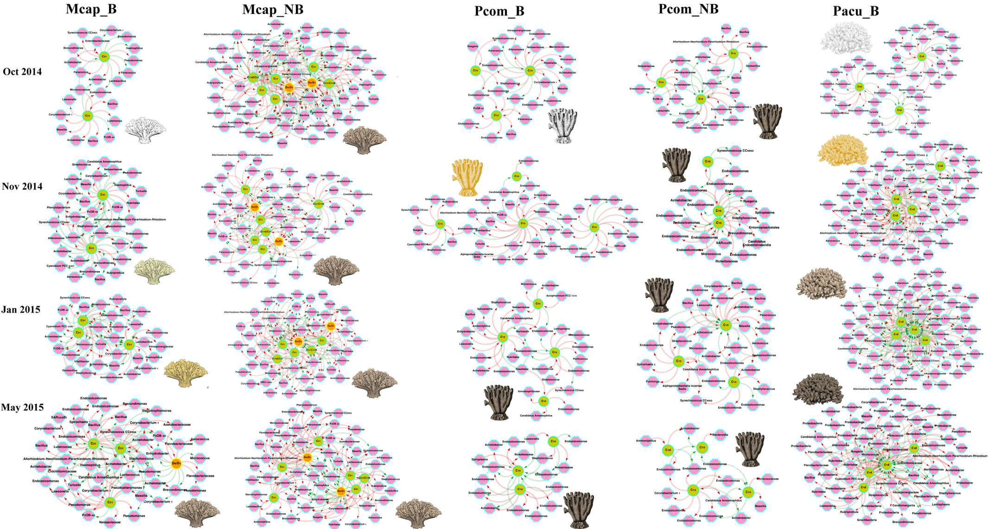
Fig. 6. Cross co-occurrence networks of ASV bacteria features vs ITS2 type profiles by bleaching susceptibility phenotypes. Mcap: Montipora capitata, Pcom Porites compressa, Pacu: Pocillopora acuta; B: Bleaching susceptible colonies, NB: Bleaching resistant colonies. In the networks bacterial ASVs are represented by pink hexagons and annotated to the best taxonomy, Symbiodiniaceae type profiles of the Cladocopium clade are green circles and Durusdinium are orange circles.

Genetic BLAST alignment of prevalent Endozoicomonas

BLAST alignment between the prevalent Endozoicomonas ASV 694df3c7f8b6b66c922ed51a965d75d0a from the present study and a symbiont Oceanospirillaceae-OTU C7-A01: FJ930289.1 broadly documented in Porites spp. and other hermatypic corals from Australia, Hawai‘i, and Bermuda, taken from Speck and Donachie (2012).

Query: ASV: 694df3c7f8b6b66c922ed51a965d75d0 Endozoicomonas from Núñez-Pons et al.: lcl|Query_21881 Length: 253

>Uncultured bacterium clone C7-A01c 16S small subunit ribosomal RNA gene, partial sequence
Sequence ID: FJ930289.1 Length: 1412
Range 1: 479 to 731

Score:468 bits(253), Expect:1e-127,
Identities:253/253(100%), Gaps:0/253(0%), Strand: Plus/Plus

Query 1 TACGGAGGGTGCAAGCGTTAATCGGAATTACTGGGCGTAAAGCGTGCGTAGGCGGCCTTT 60
||||||||||||||||||||||||||||||||||||||||||||||||||||||||||||
Sbjct 479 TACGGAGGGTGCAAGCGTTAATCGGAATTACTGGGCGTAAAGCGTGCGTAGGCGGCCTTT 538

Query 61 TAAGTTGGATGTGAAAGCCCCGGGCTCAACCTGGGAACGGCATCCAAAACTGAGAGGCTC 120
||||||||||||||||||||||||||||||||||||||||||||||||||||||||||||
Sbjct 539 TAAGTTGGATGTGAAAGCCCCGGGCTCAACCTGGGAACGGCATCCAAAACTGAGAGGCTC 598

Query 121 GAGTGCGGAAGAGGAGTGTGGAATTTCCTGTGTAGCGGTGAAATGCGTAGATATAGGAAA 180
||||||||||||||||||||||||||||||||||||||||||||||||||||||||||||
Sbjct 599 GAGTGCGGAAGAGGAGTGTGGAATTTCCTGTGTAGCGGTGAAATGCGTAGATATAGGAAA 658

Query 181 GAACACCAGTGGCGAAGGCGACACTCTGGTCTGACACTGACGCTGAGGTACGAAAGCGTG 240
||||||||||||||||||||||||||||||||||||||||||||||||||||||||||||
Sbjct 659 GAACACCAGTGGCGAAGGCGACACTCTGGTCTGACACTGACGCTGAGGTACGAAAGCGTG 718

Query 241 GGGAGCAAACAGG 253
|||||||||||||
Sbjct 719 GGGAGCAAACAGG 731

Reference:
Speck M, Donachie SP. Widespread Oceanospirillaceae Bacteria in Porites spp. Journal of Marine Biology 2012; ID 746720. doi:10.1155/2012/746720.

