Liquid Application Dosing Alters the Physiology of Air-Liquid Interface Primary Bronchial Epithelial Cultures and In Vitro Testing Relevant Endpoints

Nicholas M. Mallek¹, Elizabeth M. Martin², Lisa A. Dailey³, and Shaun D. McCullough^{3*}

1: Curriculum in Toxicology & Environmental Medicine, UNC-Chapel Hill, Chapel Hill, NC, USA
2: Epigenetics & Stem Cell Biology Laboratory, National Institute of Environmental Health Sciences, National Institutes of Health, Department of Health and Human Services, Durham, NC, USA
3: Public Health & Integrated Toxicology Division, Center for Public Health & Environmental Assessment, United States Environmental Protection Agency, Chapel Hill, NC, USA
*: corresponding author

Corresponding Author:
Shaun D. McCullough, PhD
US EPA Human Studies Facility
104 Mason Farm Road, CB #7315
Chapel Hill, NC 27599
mccullough.shaun@epa.gov
1-919-843-8031 (office)
1-919-966-6271 (fax)
ORCID ID: 0000-0001-6660-346X

Competing Financial Interests: The authors declare they have no actual or potential competing financial interests.

Keywords: in vitro to in vivo extrapolation (IVIVE), new approach methods (NAMs), inhalation risk assessment, air-liquid interface (ALI)

Running head: Liquid application alters ALI cultures

Supplementary Method CBF
Images for ciliary beat frequency and total ciliated area analyses were taken at 20x magnification with transmitted light using an ImageXpress Micro4 High Content Imager (Molecular Devices). Tiff stacks were acquired via the “StreamAcquisition” journal built by Molecular Devices and compatible for use in Meta Series Imaging Version 6.6.2.46 Software. Tiff stacks were generated at 4 sites/well and acquired over 2 seconds at 100 frames per second, to give a 200 total frame tiff stack. The Tiff stacks were imported into Sisson-Ammons Video Analysis (SAVA) software (Ammons Engineering) in order to analyze average ciliary beat frequency and percent ciliated area, with a 2 Hz frequency threshold. Cultures were kept in a climate and atmospheric controlled environment for the duration of imaging.

Supplemental Table 1. Demographics of individual pHBEC donors.
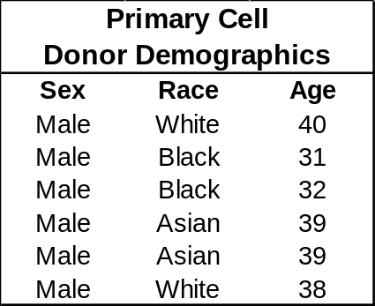
Supplemental Table 2. Primer and Probe sequences used for gene expression analysis.
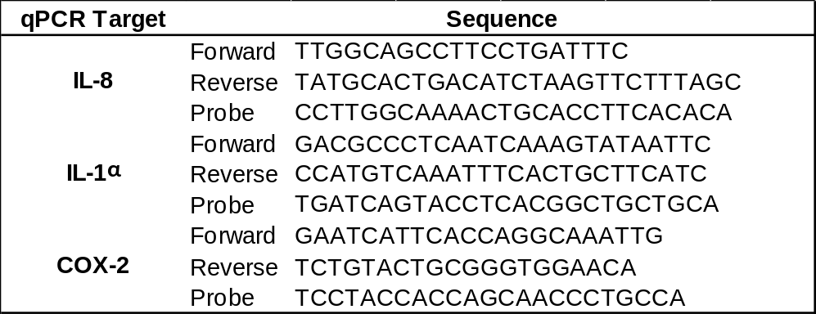
Supplemental Table 3. Antibodies used in immunoblotting
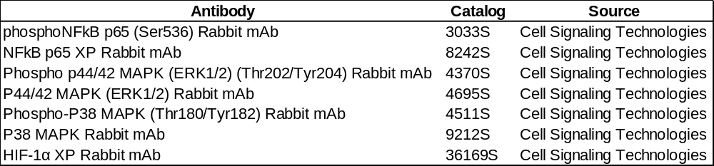
Supplemental Figure 1. STR authentication of the IMR90 cell line. As per guidance indicated in the “NOTE” section of the report, calls from alleles indicated in white have been redacted.
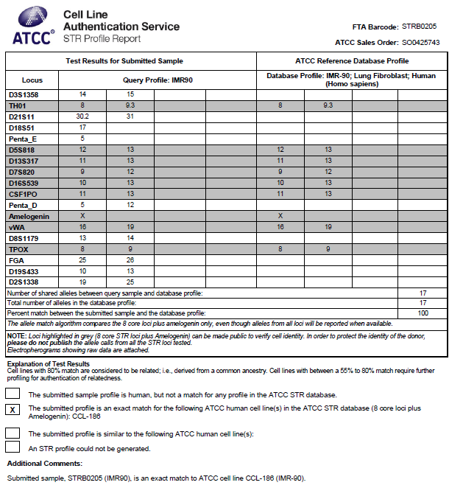

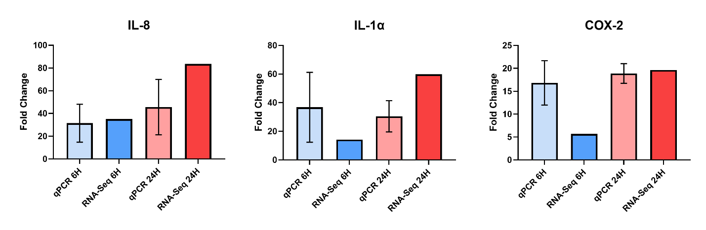
Supplemental Figure 2. qPCR validation of three pro-inflammatory transcripts identified as highly upregulated by RNA-Sequencing following liquid application for either 6 or 24 hours. qPCR data is presented as the mean of N=3 biological replicates, and error bars represent SD
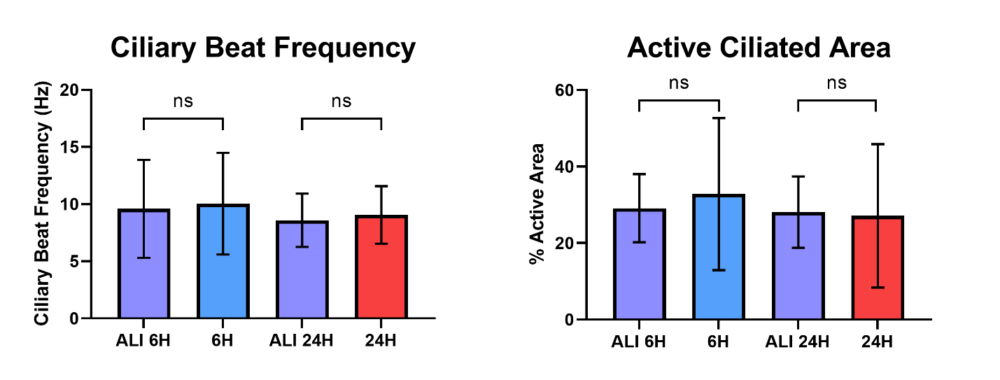
Supplemental Figure 3. Ciliary beat frequency (CBF) and active ciliated area of dpHBEC-ALI cultures following either 6 or 24 hours of liquid application. (A) There was no change in CBF after either 6 or 24 hours of liquid application. (B) There was no change in active ciliated area after either 6 or 24 hours of liquid application. (A-B) The data presented for each condition are the mean of n=3 biological replicates, and error bars represent SD. ns indicates not significant by unpaired t-test.

