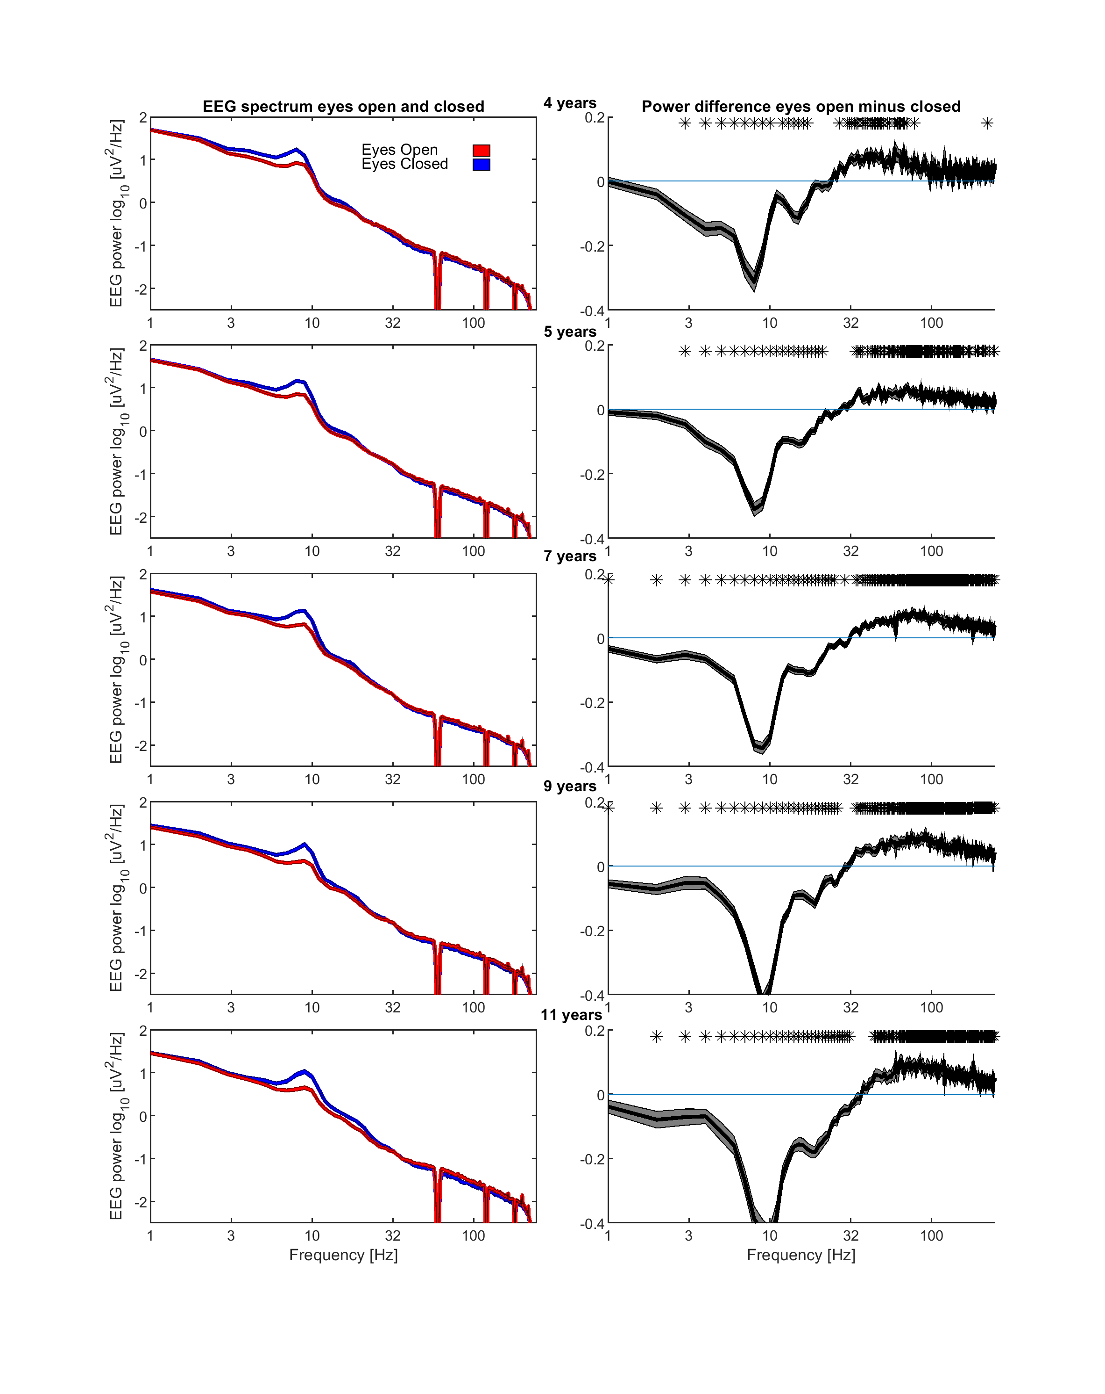

Supplemental Figure 1. The same format as in Figure 1, except spectra were averaged over only parietal regions.

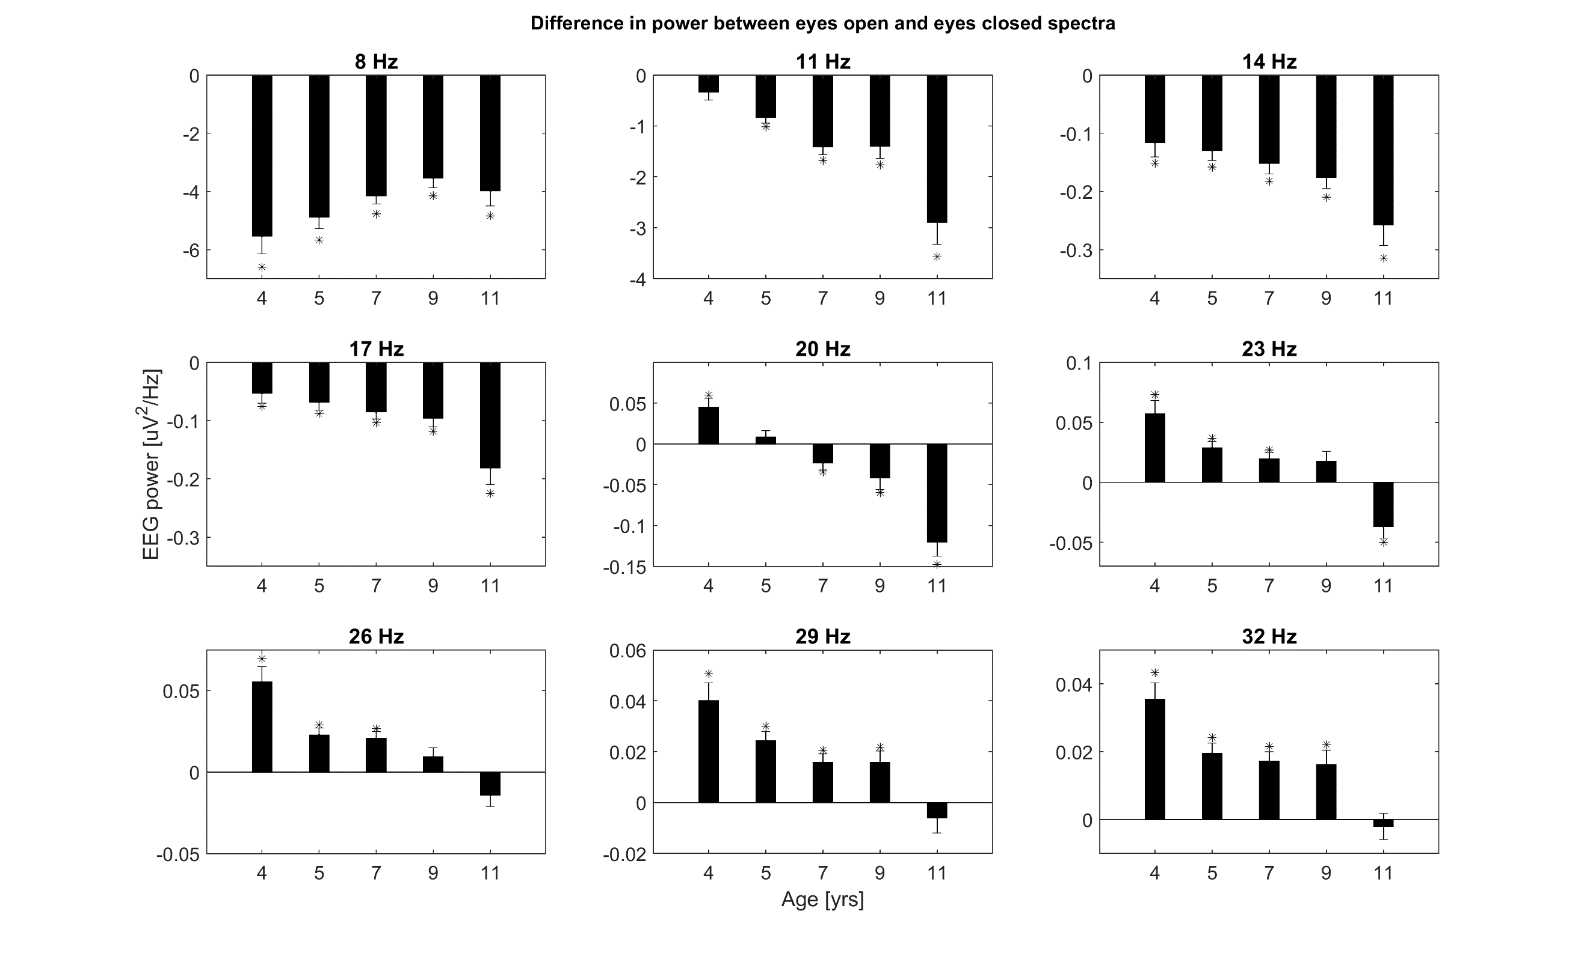

Supplemental Figure 2. The same format as in Figure 2, but for a wider range of frequencies.

.
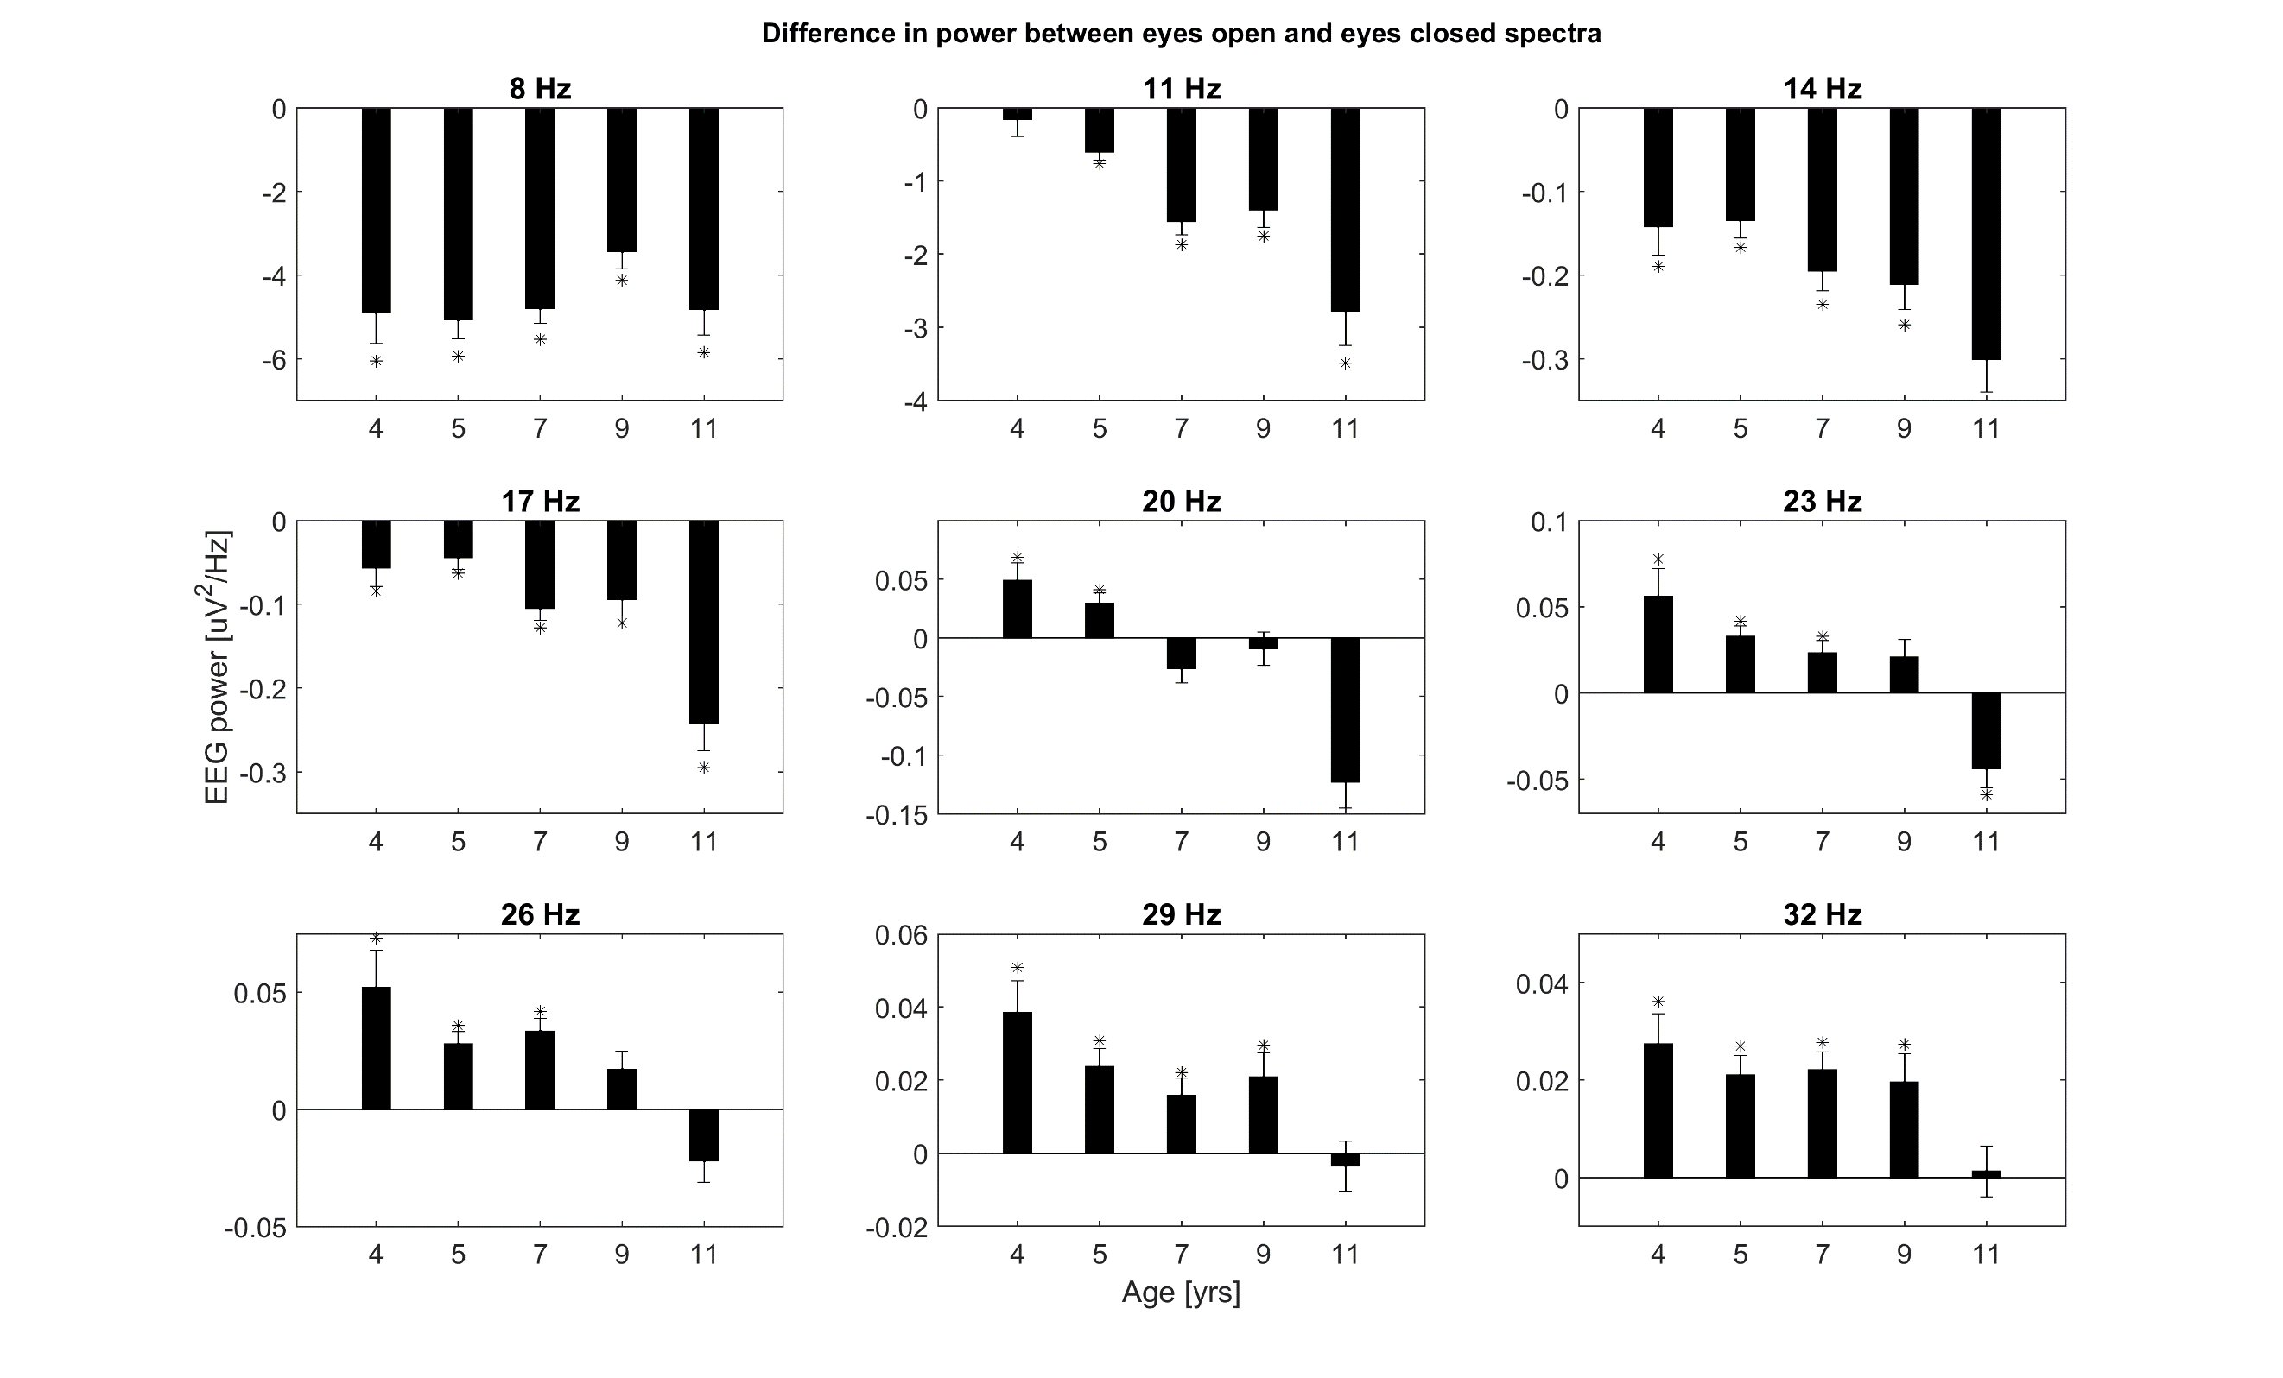

Supplemental Figure 3. The same format as in Supplemental Figure 2, but using only the first eyes open and eyes closed epochs.

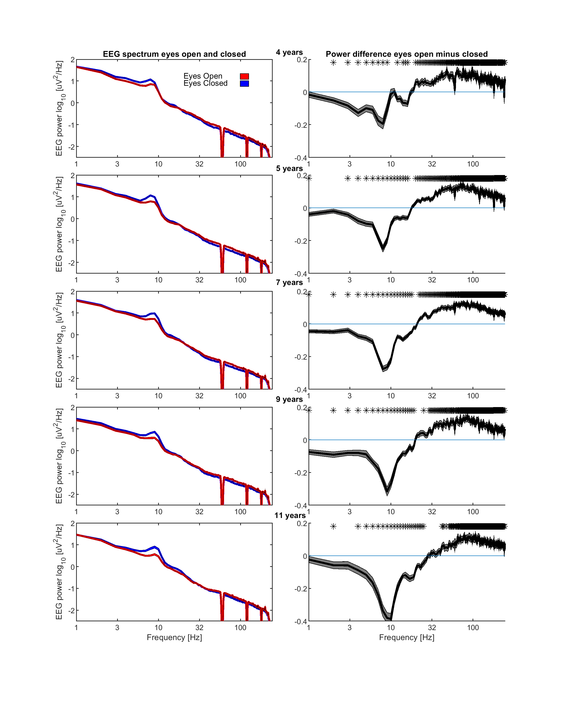

Supplemental Figure 4. The same format as in Figure 1, but using only the first eyes open and eyes closed epochs.

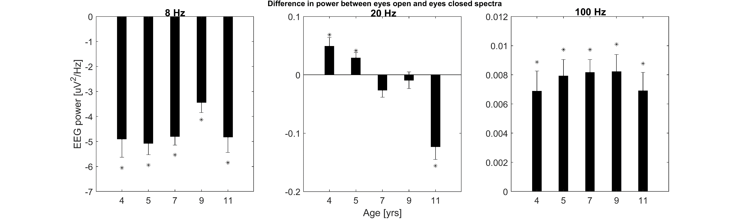

Supplemental Figure 5. The same format as in Figure 2, but using only the first eyes open and eyes closed epochs.

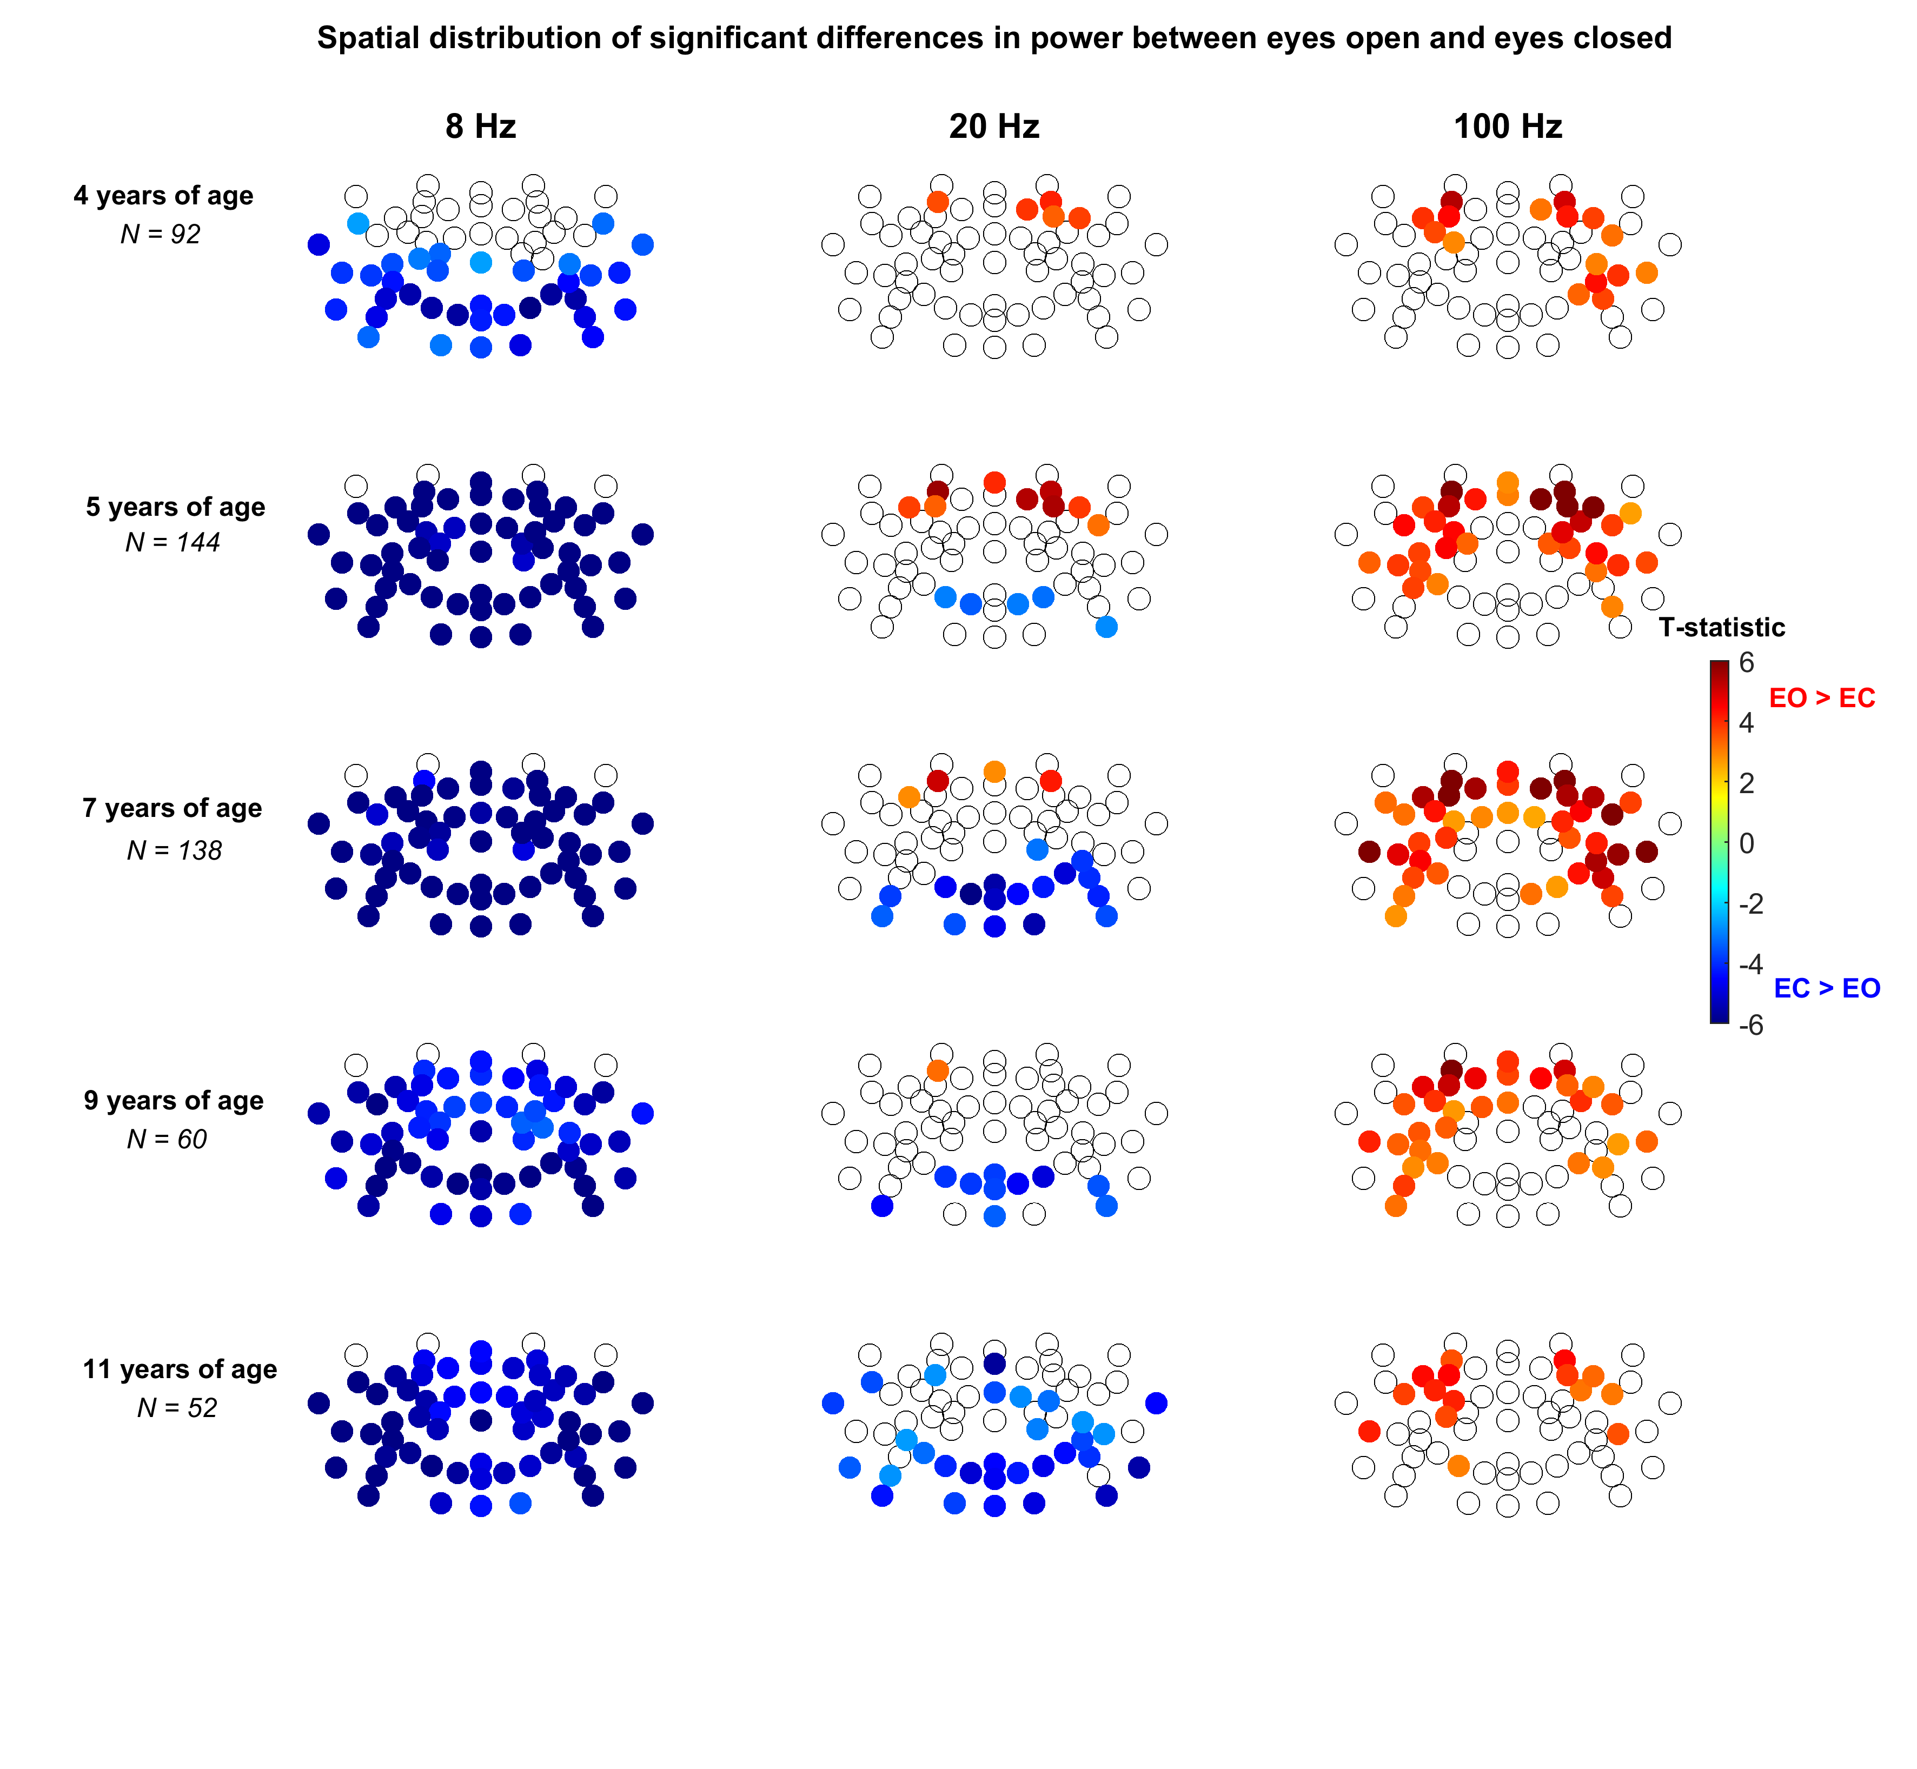

Supplemental Figure 6. The same format as in Figure 3, but using only the first eyes open and eyes closed epochs.

