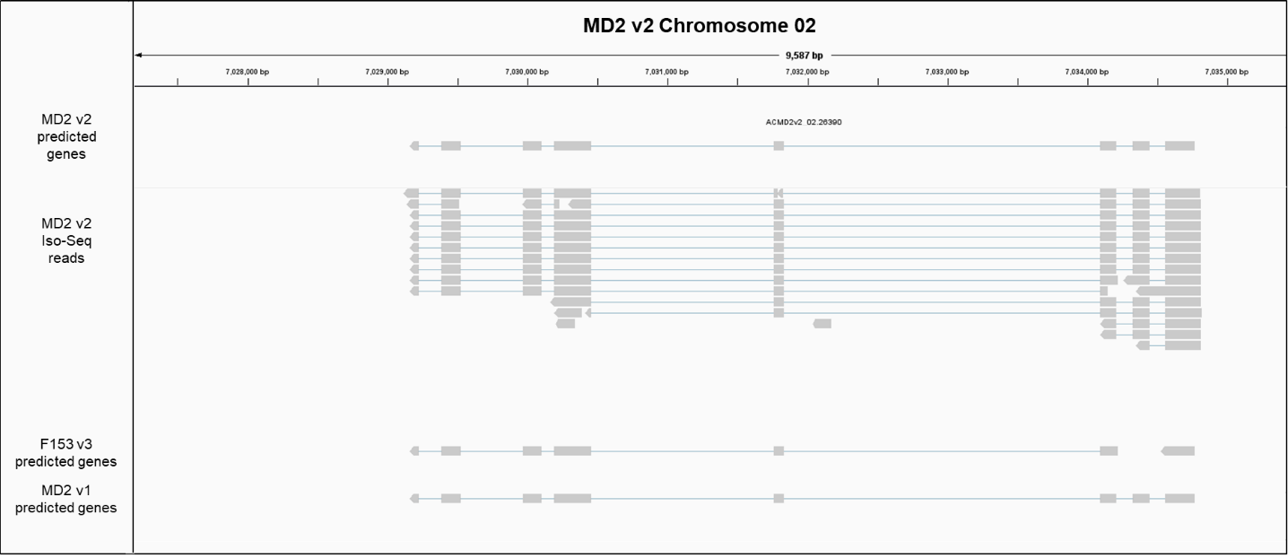
Supplementary Figure 1. Predicted structure of a C1A family protease gene in MD2 v2. Alignment of MD2 v2 predicted genes, PacBio Iso-Seq reads derived from MD2, and predicted genes from previous pineapple genomes (F153 v3 and MD2 v1) to the MD2 v2 genome validates the correctness of predicted gene structures of C1As in MD2 v2. In this example, one gene predicted in MD2 v2 was predicted as two different genes in F153 v3. IsoSeq data supported the presence of a single gene model for this locus.

